

Page 1 of 14
TRANSISTORS, LOW POWER, NPN
BASED ON TYPE 2ST15300
ESCC Detail Specification No. 5201/020

Issue 1 | February 2020


Document Custodian: European Space Agency – see https://escies.org

Legal Disclaimer and Copyright
European Space Agency, Copyright © 2020. All rights reserved.
The European Space Agency disclaims any liability or responsibility, to any person or entity, with respect to any loss or damage caused, or alleged to be caused, directly or indirectly by the use and application of this ESCC publication.
This publication, without the prior permission of the European Space Agency and provided that it is not used for a commercial purpose, may be:
- copied in whole, in any medium, without alteration or modification.
- copied in part, in any medium, provided that the ESCC document identification, comprising the ESCC symbol, document number and document issue, is removed.

DOCUMENTATION CHANGE NOTICE
(Refer to https://escies.org for ESCC DCR content)
DCR No. | CHANGE DESCRIPTION

TABLE OF CONTENTS
1 General 5
1.1 SCOPE 5
1.2 APPLICABLE DOCUMENTS 5
1.3 TERMS, DEFINITIONS, ABBREVIATIONS, SYMBOLS AND UNITS 5
1.4 THE ESCC COMPONENT NUMBER AND COMPONENT TYPE VARIANTS 5
1.4.1 The ESCC Component Number 5
1.4.2 Component Type Variants 5
1.5 MAXIMUM RATINGS 6
1.6 PHYSICAL DIMENSIONS AND TERMINAL IDENTIFICATION 7
1.6.1 Surface Mount Package (SMD.5) - 3 terminal 7
1.7 FUNCTIONAL DIAGRAM 7
1.8 MATERIALS AND FINISHES 8
2 REQUIREMENTS 8
2.1 GENERAL 8
2.1.1 Deviations from the Generic Specification 8
2.2 MARKING 8
2.3 TERMINAL STRENGTH 8
2.4 ELECTRICAL MEASUREMENTS AT ROOM, HIGH AND LOW TEMPERATURES 8
2.4.1 Room Temperature Electrical Measurements 9
2.4.2 High and Low Temperatures Electrical Measurements 11
2.5 PARAMETER DRIFT VALUES 11
2.6 INTERMEDIATE AND END-POINT ELECTRICAL MEASUREMENTS 11
2.7 HIGH TEMPERATURE REVERSE BIAS BURN-IN CONDITIONS 12
2.8 POWER BURN-IN CONDITIONS 12
2.9 OPERATING LIFE CONDITIONS 12
Appendix A 14

General

SCOPE
This specification details the ratings, physical and electrical characteristics and test and inspection data for the component type variants and/or the range of components specified below. It supplements the requirements of, and shall be read in conjunction with, the ESCC Generic Specification listed under Applicable Documents.

APPLICABLE DOCUMENTS
The following documents form part of this specification and shall be read in conjunction with it:
          - ESCC Generic Specification No. 5000
          - MIL-STD-750, Test Methods and Procedures for Semiconductor Devices
          - MIL-STD-883, Test Methods and Procedures for Micro-electronics.

TERMS, DEFINITIONS, ABBREVIATIONS, SYMBOLS AND UNITS
For the purpose of this specification, the terms, definitions, abbreviations, symbols and units specified in ESCC Basic Specification No. 21300 shall apply.

THE ESCC COMPONENT NUMBER AND COMPONENT TYPE VARIANTS

The ESCC Component Number
The ESCC Component Number shall be constituted as follows:
Example: 520102001
- Detail Specification Reference: 5201020
- Component Type Variant Number: 01 (as required)
- Total Dose Radiation Level Letter: R (as required)

Component Type Variants
The component type variants applicable to this specification are as follows:
Variant Number | Based on Type | Case | Terminal Material and Finish | Weight  max g | Total Dose Radiation Level Letter
01 | 2ST15300 | SMD.5 | Q14 | 2 | R [100krad(Si)]
The terminal material and finish shall be in accordance with the requirements of ESCC Basic Specification No. 23500.
Total dose radiation level letters are defined in ESCC Basic Specification No. 22900. If an alternative radiation test level is specified in the Purchase Order, the letter shall be changed accordingly.

MAXIMUM RATINGS
The maximum ratings shall not be exceeded at any time during use or storage.
Maximum ratings shall only be exceeded during testing to the extent specified in this specification and when stipulated in Test Methods and Procedures of the ESCC Generic Specification.
Characteristics | Symbols | Maximum Ratings | Units | Remarks
Collector-Base Voltage | V_{CBO} | 300 | V | Over entire operating temperature range
Collector-Emitter Voltage | V_{CEO} | 100 | V | Over entire operating temperature range
Emitter-Base Voltage | V_{EBO} | 6 | V | Over entire operating temperature range
Collector Current | I_{C} | 5 | A | Continuous
Power Dissipation | P_{tot1} | 2 | W | At T_{amb} ≤ +25°C  Note 1
 | P_{tot2} | 54 | W | At T_{case} ≤ +25°C  Note 1
Thermal Resistance,  Junction-to-Ambient | R_{th(j-a)} | 80 | °C/W
Thermal Resistance,  Junction-to-Case | R_{th(j-c)} | 2.3 | °C/W
Junction Temperature | T_{j} | +200 | °C
Operating Temperature Range | T_{op} | -65 to +200 | °C
Storage Temperature Range | T_{stg} | -65 to +200 | °C
Soldering Temperature | T_{sol} | +245 | °C | Note 2
NOTES:
            - For T_{amb} or T_{case} > +25ºC, derate linearly to 0W at +200ºC.
            - Duration 5 seconds maximum and the same terminal shall not be resoldered until 3 minutes have elapsed.

PHYSICAL DIMENSIONS AND TERMINAL IDENTIFICATION

Surface Mount Package (SMD.5) - 3 terminal
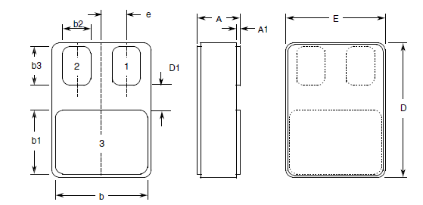
Symbols | Dimensions mm |  | Remarks
Symbols | Min | Max | Remarks
A | 2.84 | 3.15
A1 | 0.25 | 0.51
b | 7.13 | 7.39
b1 | 5.58 | 5.84
b2 | 2.28 | 2.54 | 2 places
b3 | 2.92 | 3.18 | 2 places
D | 10.03 | 10.28
D1 | 0.76 | - | 2 places
E | 7.39 | 7.64
e | 1.91 BSC |  | 2 places
NOTES:
            - Terminal identification is specified by the components geometry where Terminal 1 = base, Terminal 2 = emitter and Terminal 3 = collector.

FUNCTIONAL DIAGRAM
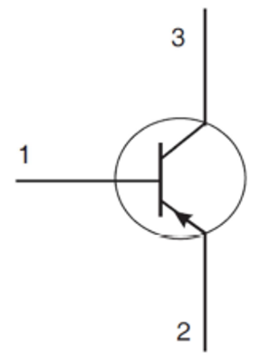 | - Base  - Emitter  - Collector
NOTES:
            - The lid is not connected to any terminal.

MATERIALS AND FINISHES
Materials and finishes shall be as follows:
          - Case
The case shall be hermetically sealed and have a ceramic body with a Kovar lid.
          - Terminals
As specified in Para. 1.4.2 Component Type Variants.

REQUIREMENTS

GENERAL
The complete requirements for procurement of the components specified herein are as stated in this specification and the ESCC Generic Specification. Permitted deviations from the Generic Specification, applicable to this specification only, are listed below.
Permitted deviations from the Generic Specification and this Detail Specification, formally agreed with specific Manufacturers on the basis that the alternative requirements are equivalent to the ESCC requirement and do not affect the component’s reliability, are listed in the appendices attached to this specification.

Deviations from the Generic Specification
None.

MARKING
The marking shall be in accordance with the requirements of ESCC Basic Specification No. 21700 and as follows.
The information to be marked on the component or its primary package shall be:
          - The ESCC qualified components symbol (for ESCC qualified components only).
          - The ESCC Component Number (see Para. 1.4.1).
          - Traceability information.

TERMINAL STRENGTH
The test conditions for terminal strength, tested as specified in the ESCC Generic Specification, shall be in accordance with MIL-STD-883, Test Method 2004, Test Condition D.

ELECTRICAL MEASUREMENTS AT ROOM, HIGH AND LOW TEMPERATURES
Electrical measurements shall be performed at room, high and low temperatures.

Room Temperature Electrical Measurements
The measurements shall be performed at T_{amb} = +22 ±3°C.
Characteristics | Symbols | MIL-STD-750  Test Method | Test Conditions | Limits |  | Units
 |  |  |  | Min | Max | Units
Collector-Emitter Breakdown Voltage | V_{(BR)CEO} | 3011 | I_{C} = 10mA  Bias condition D  Note 1 | 100 | - | V
Collector-Base Breakdown Voltage | V_{(BR)CBO} | 3001 | I_{C} = 10mA  Bias condition D | 300 | - | V
Emitter-Base Breakdown Voltage | V_{(BR)EBO} | 3026 | I_{E} = 10µA  Bias condition D | 6 | - | V
Collector-Emitter Cut-off Current | I_{CEO} | 3041 | V_{CE} = 100V  Bias condition D | - | 500 | nA
Collector-Base Cut-off Current | I_{CBO} | 3036 | V_{CE} = 240V  Bias condition D | - | 500 | nA
Emitter-Base Cut-off Current | I_{EBO} | 3061 | V_{EB} = 6V  Bias condition D | - | 100 | nA
Forward-Current Transfer Ratio | h_{FE1} | 3076 | V_{CE} = 0.6V; I_{C} = 50mA | 50 | - | -
Forward-Current Transfer Ratio | h_{FE2} | 3076 | V_{CE} = 0.6V; I_{C} = 250mA | 55 | - | -
Forward-Current Transfer Ratio | h_{FE3} | 3076 | V_{CE} = 5V; I_{C} = 1A | 55 | - | -
Forward-Current Transfer Ratio | h_{FE4} | 3076 | V_{CE} = 5V; I_{C} = 5A | 35 | - | -
Collector-Emitter Saturation Voltage | V_{CE(sat)} | 3071 | I_{C} = 5A, I_{B} = 1A  Note 1 | - | 0.7 | V
Base-Emitter Saturation Voltage | V_{BE(sat)} | 3066 | I_{C} = 5A, I_{B} = 1A  Test condition A  Note 1 | - | 1.4 | V
Output Capacitance | C_{obo} | 3236 | V_{CB} = 10V, I_{E} = 0A  100kHz ≤ f ≤ 1MHz  Note 2 | - | 100 | pF
Turn-on Time | t_{on} | - | V_{CC} = 6.5V, V_{BB} = -8V  Ic = 1A  I_{B1} = I_{B2} = 100mA  Notes 2, 3 | - | 0.2 | µs
Turn-off Time | t_{off} | - |  | - | 3 | µs
NOTES:
            - Pulse measurement: Pulse Width ≤ 300µs, Duty Cycle ≤ 2%.
            - For AC characteristics, read and record measurements shall be performed on a sample of 32 components with 0 failures allowed. Alternatively a 100% inspection may be performed.
            - t_{on} and t_{off} shall be measured as follows:
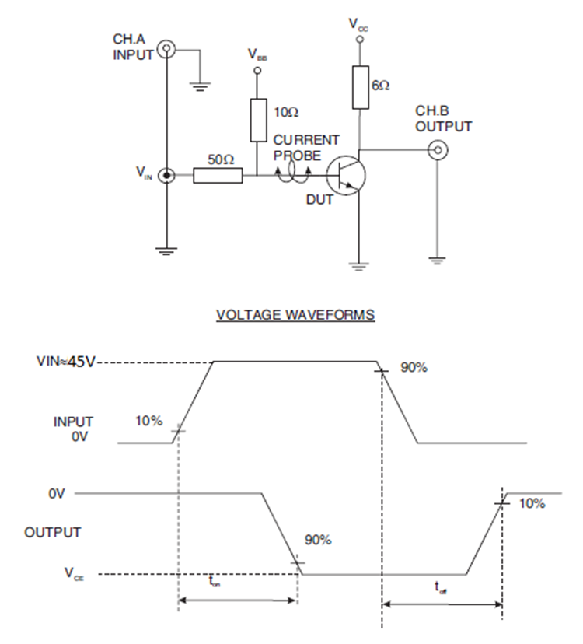

High and Low Temperatures Electrical Measurements
Characteristics | Symbols | MIL-STD-750  Test Method | Test Conditions  Note 1 | Limits |  | Units
 |  |  |  | Min | Max | Units
Collector-Base Cut-off Current | I_{CBO} | 3036 | T_{amb} = +150 (+0 -5)°C  V_{CB} = 240V  Bias condition D | - | 1 | µA
Forward-Current Transfer Ratio 2 | h_{FE2} | 3076 | T_{amb} = -55 (+5 -0)°C  V_{CE} = 0.6V; I_{C} = 250mA | 25 | - | -
NOTES:
            - Read and record measurements shall be performed on a sample of 5 components with 0 failures allowed. Alternatively a 100% inspection may be performed.

PARAMETER DRIFT VALUES
Unless otherwise specified, the measurements shall be performed at T_{amb} = +22 ±3°C.
The test methods and test conditions shall be as per the corresponding test defined in Para. 2.4.1 Room Temperature Electrical Measurements.
The drift values (Δ) shall not be exceeded for each characteristic specified. The corresponding absolute limit values for each characteristic shall not be exceeded.
Characteristics | Symbols | Limits |  |  | Units
Characteristics | Symbols | Drift  Value  Δ | Absolute |  | Units
Characteristics | Symbols | Drift  Value  Δ | Min | Max | Units
Collector-Base Cut-off Current | I_{CBO} | ±100  or (1) ±100% | - | 500 | nA
Collector-Emitter Saturation Voltage | V_{CE(sat)} | ±30mV  or (1) ±15% | - | 0.7 | V
Forward-Current Transfer Ratio 2 | h_{FE2} | ±15% | 55 | - | -
NOTES:
            - Whichever is the greater referred to initial value.

INTERMEDIATE AND END-POINT ELECTRICAL MEASUREMENTS
Unless otherwise specified, the measurements shall be performed at T_{amb} = +22 ±3°C.
The test methods and test conditions shall be as per the corresponding test defined in Para. 2.4.1 Room Temperature Electrical Measurements.
The limit values for each characteristic shall not be exceeded.
Characteristics | Symbols | Limits |  | Units
Characteristics | Symbols | Min | Max | Units
Collector-Base Cut-off Current | I_{CBO} | - | 500 | nA
Collector-Emitter Saturation Voltage | V_{CE(sat)} | - | 0.7 | V
Forward-Current Transfer Ratio 2 | h_{FE2} | 55 | - | -

HIGH TEMPERATURE REVERSE BIAS BURN-IN CONDITIONS
Characteristics | Symbols | Test Conditions | Units
Ambient Temperature | T_{amb} | +150 (+0 -5) | °C
Collector-Base Voltage | V_{CB} | 100 | V
Duration | t | 48 minimum | Hours

POWER BURN-IN CONDITIONS
Characteristics | Symbols | Test Conditions | Units
Ambient Temperature | T_{amb} | +20 to +50 | °C
Power Dissipation | P_{tot} | As per Para. 1.5 Maximum Ratings.  Derate P_{tot1} at the chosen T_{amb} using the specified R_{th(j-a)}. | W
Collector-Base Voltage | V_{CB} | 20 to 50 | V

OPERATING LIFE CONDITIONS
The conditions shall be as specified in Para. 2.8 Power Burn-in Conditions.
  - TOTAL DOSE RADIATION TESTING
All lots shall be irradiated in accordance with ESCC Basic Specification No. 22900, low dose rate (window 2: 36 to 360 rad(Si)/hour).
    - Bias Conditions and Total Dose Level for Total dose Radiation Testing
The following bias conditions shall be used for Total Dose Radiation Testing:
Characteristics | Symbols | Test Conditions | Units
Ambient Temperature | T_{amb} | +20 ±5 | °C
Bias Condition 1:  Collector-Emitter Voltage | V_{CES} | ≥ 80% V_{(BR)CEO} | V
Bias Condition 2:  Collector-Emitter Voltage | V_{CES} | 0 | V
The total dose level applied shall be as specified in Para. 1.4.2 or in the Purchase Order.
    - Electrical Measurements for Radiation Testing
Prior to irradiation testing, the devices shall have successfully met Para. 2.4.1 Room Temperature Electrical Measurements.
Unless otherwise stated, the measurements shall be performed at T_{amb} = +22 ±3°C.
Unless otherwise specified, the test methods and test conditions shall be as per the corresponding test defined in Para. 2.4.1 Room Temperature Electrical Measurements.
The parameters to be measured during and on completion of irradiation testing are shown below.
Characteristics | Symbols | MIL-STD-750  Test Method | Test Conditions | Limits |  | Units
 |  |  |  | Min | Max | Units
Collector-Emitter Breakdown Voltage | V_{(BR)CEO} | See Para. 2.4.1 | See Para. 2.4.1 | 100 | - | V
Collector-Base Breakdown Voltage | V_{(BR)CBO} | See Para. 2.4.1 | See Para. 2.4.1 | 300 | - | V
Emitter-Base Breakdown Voltage | V_{(BR)EBO} | See Para. 2.4.1 | See Para. 2.4.1 | 6 | - | V
Collector-Emitter Cut-off Current | I_{CEO} | See Para. 2.4.1 | See Para. 2.4.1 | - | 500 | nA
Collector-Base Cut-off Current | I_{CBO} | See Para. 2.4.1 | See Para. 2.4.1 | - | 1 | µA
Emitter-Base Cut-off Current | I_{EBO} | See Para. 2.4.1 | See Para. 2.4.1 | - | 200 | nA
Forward-Current  Transfer Ratio  (post irradiation gain calculation) (Note 1) | [h_{FE1}] | 3076 | V_{CE} = 0.6V; I_{C} = 50mA | [25] | - | -
 | [h_{FE2}] | 3076 | V_{CE} = 0.6V; I_{C} = 250mA | [27.5] | - | -
 | [h_{FE3}] | 3076 | V_{CE} = 5V; I_{C} = 1A | [27.5] | - | -
 | [h_{FE4}] | 3076 | V_{CE} = 5V; I_{C} = 5A | [17.5] | - | -
Collector-Emitter Saturation Voltage | V_{CE(sat)} | See Para. 2.4.1 | See Para. 2.4.1 | - | 0.7 | V
Base-Emitter Saturation Voltage | V_{BE(sat)} | See Para. 2.4.1 | See Para. 2.4.1 | - | 1.4 | V
NOTES:
            - The post-irradiation gain calculation of [h_{FE}], made using h_{FE} measurements from prior to and on completion of irradiation testing and after each annealing step if any, shall be as specified in MIL-STD-750 Method 1019.

Appendix A
Agreed deviations for STMICROELECTRONICS (F)
ITEMS AFFECTED | DESCRIPTION OF DEVIATIONS
Para. 2.1.1 Deviations from the Generic Specification:  Deviations from Screening Tests - Chart F3 | Solderability is not applicable unless specifically stipulated in the Purchase Order.
Para. 2.4.1 Room Temperature Electrical Measurements | All AC characteristics (see Para. 2.4.1 Note 2) may be considered guaranteed but not tested if successful pilot lot testing has been performed on the wafer lot which includes AC characteristic measurements per the Detail Specification.  A summary of the pilot lot testing shall be provided if required by the Purchase Order.
Para. 2.4.2 High and Low Temperatures Electrical Measurements | All characteristics specified may be considered guaranteed but not tested if successful pilot lot testing has been performed on the wafer lot which includes characteristic measurements at high and low temperatures per the Detail Specification.  A summary of the pilot lot testing shall be provided if required by the Purchase Order.

