

Page 1 of 13
ISOLATORS, HIGH POWER, S-BAND (2.0GHz to 2.7GHz), WITH NON-INTEGRAL TNC COAXIAL CONNECTORS
BASED ON TYPEs BE11E2-105 and BE12E2-105
ESCC Detail Specification No. 225 (3202/0##)

Issue 1 Draft C | January 2017



Document Custodian: European Space Agency – see https://escies.org

Legal Disclaimer and Copyright
European Space Agency, Copyright © 2017. All rights reserved.
The European Space Agency disclaims any liability or responsibility, to any person or entity, with respect to any loss or damage caused, or alleged to be caused, directly or indirectly by the use and application of this ESCC publication.
This publication, without the prior permission of the European Space Agency and provided that it is not used for a commercial purpose, may be:
- copied in whole, in any medium, without alteration or modification.
- copied in part, in any medium, provided that the ESCC document identification, comprising the ESCC symbol, document number and document issue, is removed.

DOCUMENTATION CHANGE NOTICE
(Refer to https://escies.org for ESCC DCR content)
DCR No. | CHANGE DESCRIPTION
Draft 1A  S.Thacker (TW)  02/12/2016 | Initial revision. Sent for Cobham review 02/12/2016
Draft 1B  S.Thacker (TW)  09/01/2017 | New revision to implement Cobham review comments per email dated 09/01/2017.  Note: previous comments have been removed.
Draft 1C  S.Thacker (TW)  19/01/2017 | New revision to implement Cobham review comments per email dated 19/01/2017.  Note: previous comments have been removed.

TABLE OF CONTENTS
1 General 5
1.1 SCOPE 5
1.2 APPLICABLE DOCUMENTS 5
1.3 TERMS, DEFINITIONS, ABBREVIATIONS, SYMBOLS AND UNITS 5
1.4 THE ESCC COMPONENT NUMBER and COMPONENT TYPE VARIANTS 5
1.4.1 The ESCC Component Number 5
1.4.1.1 Characteristics Codes 5
1.4.2 Component Type Variants 6
1.5 MAXIMUM RATINGS 6
1.6 Handling Precautions 7
1.7 PHYSICAL DIMENSIONS AND PORT IDENTIFICATION 8
1.8 functional diagram 9
1.9 MATERIALS AND FINISHES 9
2 REQUIREMENTS 9
2.1 GENERAL 9
2.1.1 Deviations from the Generic Specification 10
2.1.1.1 Deviations from Special In-Process Controls (Chart F2) 10
2.1.1.2 Deviations from Screening Tests (Chart F3) 10
2.2 MARKING 10
2.3 ELECTRICAL MEASUREMENTS AT ROOM, HIGH AND LOW TEMPERATURES 11
2.3.1 Room Temperature Electrical Measurements 11
2.3.2 High and Low Temperatures Electrical Measurements 11
2.4 INTERMEDIATE AND END-POINT ELECTRICAL MEASUREMENTS 12
APPENDIX A 13

General

SCOPE
This specification details the ratings, physical and electrical characteristics and test and inspection data for the component type variants and/or the range of components specified below. It supplements the requirements of, and shall be read in conjunction with, the ESCC Generic Specification listed under Applicable Documents.

APPLICABLE DOCUMENTS
The following documents form part of this specification and shall be read in conjunction with it:
          - ESCC Generic Specification No. 3202.
          - ESCC Detail Specification No. 3402/009, RF Coaxial Connectors Type TNC (Female Contact).

TERMS, DEFINITIONS, ABBREVIATIONS, SYMBOLS AND UNITS
For the purpose of this specification, the terms, definitions, abbreviations, symbols and units specified in ESCC Basic Specification No. 21300 shall apply.

THE ESCC COMPONENT NUMBER and COMPONENT TYPE VARIANTS

The ESCC Component Number
The ESCC Component Number shall be constituted as follows:
Example: 32020##012.0
- Detail Specification Reference: 32020##
- Component Type Variant Number: 01 (as required)
- Characteristic code: Centre Frequency (2GHz): 2.0 (as required)

Characteristics Codes
Characteristics to be codified as part of the ESCC Component Number shall be as follows:
          - Centre Frequency expressed by means of the following codes. The unit quantity shall be GHz:
Centre Frequency (GHz) | Code
X | X.0
X.X | X.X

Component Type Variants
The component type variants applicable to this specification are as follows:
Variant Number | Based on Type | Description  (Note 1) | Centre Frequency Range f_{C}  (GHz) (Note 2) | Maximum Weight  (g)
01 | BE11E2-105 | Clockwise Isolator with Non-integral Female TNC Coaxial Connectors | 2 to 2.7 | 300
02 | BE12E2-105 | Anti-clockwise Isolator with Non-integral Female TNC Coaxial Connectors | 2 to 2.7 | 300
NOTES:
            - Direction of circulation as viewed from above; see Physical Dimensions and Port Identification.
            - Any centre frequency in the range, to 2 significant figures, is available.

MAXIMUM RATINGS
The maximum ratings shall not be exceeded at any time during use or storage.
Maximum ratings shall only be exceeded during testing to the extent specified in this specification and when stipulated in Test Methods and Procedures of the ESCC Generic Specification.
Characteristics | Symbols | Maximum Ratings | Units | Remarks
Operating Frequency Range | f_{op} | f_{C} ± 0.2 | GHz | Over T_{op}, Note 1
Rated RF Power (Forward) | P_{F} | 200 | W | Over f_{op} and T_{op}
Rated RF Power (Reverse) | P_{R} | 200 | W | Over f_{op} and T_{op}, Note 2
Nominal Impedance | Z | 50 | Ω
Multipaction Level (Output Port Loaded) | M_{L} | 600 | W | Multipaction Classification Type: 2
Corona level (Output Port Loaded) | C_{L} | 60 | W
Functional Temperature Range | T_{func} | -30 to +120 | °C | T_{amb,} Notes 2, 3
Operating Temperature Range | T_{op} | -30 to +90 | °C | Without derating. T_{amb}
Storage Temperature Range | T_{stg} | -40 to +125 | °C
NOTES:
            - f_{C} = centre frequency; see Component Type Variants.
            - Derate reverse power for T_{amb} > +110°C at 5W/°C
            - The electrical performance of the components at T_{amb} > +90°C is neither guaranteed nor measured.

Handling Precautions
These devices are susceptible to damage by strong magnetic fields. Therefore suitable precautions shall be employed for protection during all phases of manufacture, testing, packaging, shipment and any handling.
The load contains Beryllium Oxide (BeO) and therefore it must not be ground, machined, sandblasted or subjected to any mechanical operation which will produce dust. The case must not be subjected to any chemical process (e.g. etching) which will produce fumes.

PHYSICAL DIMENSIONS AND PORT IDENTIFICATION
All dimensions shown below are critical dimensions.
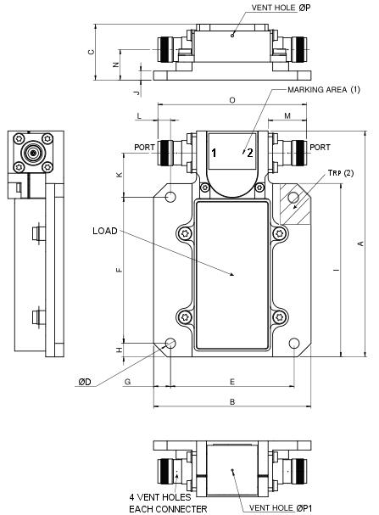
 | Symbol |  | Millimetres
 |  |  | Min |  | Max
 | A |  | 100.1 |  | 100.7
 | B |  | 69.7 |  | 70.3
 | C |  | 24.5 |  | 25.1
 | ØD |  | 4.5 |  | 4.6
 | E |  | 54.8 |  | 55.2
 | F |  | 64.8 |  | 65.2
 | G |  | 7.3 |  | 7.7
 | H |  | 5.8 |  | 6.2
 | I |  | 76.9 |  | 77.1
 | J |  | 3.8 |  | 4.2
 | K |  | 19.05 |  | 20.05
 | L |  | 5.3 |  | 5.9
 | M |  | 17.1 |  | 17.3
 | N |  | 13.2 |  | 13.8
 | O |  | 65.9 |  | 66.5
 | ØP |  | 1.1 |  | 1.3
 | ØP1 |  | 0.7 |  | 0.9
NOTES:
            - Port identification and direction of circulation is specified by reference to the port number marking, 1 or 2, in the marking area shown. The figure above shows the port identification for Variant 01 as an example.
            - The location of the reference point for measurement of surface temperature (T_{RP}) shall be within the area shown.
            - The TNC interface dimensions for the 2 connectors are as specified in ESCC Detail Specification No. 3402/009.
            - The body is painted black except around the mounting holes, in the T_{RP} area, around the vent holes and on the mounting foot surface.

functional diagram
Variant 01 Variant 02
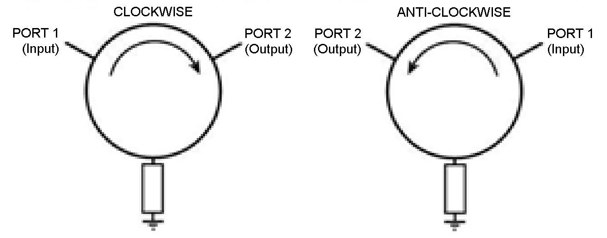
NOTES:
            - The 2 ports may be configured as either the Input (Port 1) or Output (Port 2). The direction of circulation is given by the port number marking (1 to 2); see Physical Dimensions and Port Identification.
            - Grounding via mounting foot.

MATERIALS AND FINISHES
          - Main Body: Aluminium, silver plated, plating thickness 13µm minimum, painted black (see Para. 1.7).
          - Yoke: Steel, nickel plated, plating thickness 5µm minimum, painted black (see Para. 1.7).
          - Connectors: Non-integral TNC (female contact) connectors, amagnetic stainless steel, electro-passivated with copper alloy contacts, gold, 1.27µm, over nickel, 2µm.
          - Load block: The load block shall be made of a Beryllium Oxide substrate with a suitable resistive material.

REQUIREMENTS

GENERAL
The complete requirements for procurement of the components specified herein are as stated in this specification and the ESCC Generic Specification. Permitted deviations from the Generic Specification, applicable to this specification only, are listed below.
Permitted deviations from the Generic Specification and this Detail Specification, formally agreed with specific Manufacturers on the basis that the alternative requirements are equivalent to the ESCC requirement and do not affect the component’s reliability, are listed in the appendices attached to this specification.

Deviations from the Generic Specification

Deviations from Special In-Process Controls (Chart F2)
          - Resistive Load Element Operating Life:
4 assembled load blocks shall be subjected to a DC power life test with the following conditions. If any failure occurs, the load block production lot shall be considered as failed:
- Duration: 1000 hours minimum.
- Test Temperature: T_{amb} = +125 (+0 -3)°C.
- DC Power Applied: 125Wdc (equivalent DC rated power at +125°C) (in a permanently ‘on’ condition).
- Load Resistance Limits: 47.5Ω minimum, 52.5Ω maximum.
- Data Points:
Load Resistance and Change in Load Resistance shall be measured at 0 hours and after 1000 hours. Change in Load Resistance shall be ≤ 5%, related to the 0 hour measurement.
          - Resistive Load Element Burn-in (performed after assembly):
Each isolator shall be subjected to a DC power burn-in with the following conditions. Any failures shall be rejected:
- Duration: 168 hours minimum.
- Test Temperature: T_{amb} = +90 (+0 -3)°C.
- DC Power Applied: 200Wdc.
- Load Resistance Limits: 47.5Ω minimum, 52.5Ω maximum.
- Data Points:
Load Resistance and Change in Load Resistance shall be measured at 0 hours and after 168 hours. Change in Load Resistance shall be ≤ 5%, related to the 0 hour measurement.

Deviations from Screening Tests (Chart F3)
          - Multipaction: shall not be performed.
          - Corona Level: shall not be performed.
          - Radiographic Inspection: shall be performed only on the load block. It may be performed prior to isolator assembly.

MARKING
The marking shall be in accordance with the requirements of ESCC Basic Specification No. 21700 and as follows.
The information to be marked on the component shall be:
          - The Port identification.
          - The ESCC qualified components symbol (for ESCC qualified components only).
          - The ESCC Component Number.
          - Traceability information.
          - Warning sign for Beryllium Oxide.

ELECTRICAL MEASUREMENTS AT ROOM, HIGH AND LOW TEMPERATURES
The measurements shall be performed at room, high and low temperatures.

Room Temperature Electrical Measurements
The measurements shall be performed at T_{amb} = +22 ±3ºC.
Characteristics | Symbols | Test Method and Conditions  (Note 1) | Limits |  | Units
Characteristics | Symbols | Test Method and Conditions  (Note 1) | Min | Max | Units
Voltage Standing Wave Ratio | VSWR | ESCC No. 3202 | - | 1.22 | -
Isolation | ISO | ESCC No. 3202 | 20 | - | dB
Insertion Loss | I_{L} | ESCC No. 3202 | - | 0.3 | dB
NOTES:
            - Tested over the full operating frequency range as applicable.

High and Low Temperatures Electrical Measurements
The measurements shall be performed at T_{amb} = +90 (+0 -3)°C and T_{amb} = -30 (+3 -0)°C.
Characteristics | Symbols | Test Method and Conditions  (Note 1) | Limits |  | Units
Characteristics | Symbols | Test Method and Conditions  (Note 1) | Min | Max | Units
Voltage Standing Wave Ratio | VSWR | ESCC No. 3202 | - | 1.22 | -
Isolation | ISO | ESCC No. 3202 | 20 | - | dB
Insertion Loss | I_{L} | ESCC No. 3202 | - | 0.3 | dB
Reference Point Temperature | T_{RP} | ESCC No. 3202  Note 2 | - | +90 | °C
NOTES:
            - Tested over the full operating frequency range as applicable.
            - Only tested during Screening Tests, Power Thermal Vacuum. See Para. 1.7.

INTERMEDIATE AND END-POINT ELECTRICAL MEASUREMENTS
Unless otherwise specified, the measurements shall be performed at T_{amb} = +22 ±3°C.
Unless otherwise specified, test methods and test conditions shall be as per the corresponding test defined in Room Temperature Electrical Measurements.
The drift values (Δ) shall not be exceeded for each characteristic where specified. The corresponding absolute limit values for each characteristic shall not be exceeded.
Test Reference per  ESCC No. 3202 | Characteristics | Symbols | Limits |  | Units
Test Reference per  ESCC No. 3202 | Characteristics | Symbols | Min | Max | Units
Random Vibration  Final Measurements | Voltage Standing Wave Ratio  Isolation  Insertion Loss | VSWR  ISO  I_{L} | As per Para. 2.3.1  As per Para. 2.3.1  As per Para. 2.3.1 |  | -  dB  dB
Shock  Final Measurements | Voltage Standing Wave Ratio  Isolation  Insertion Loss | VSWR  ISO  I_{L} | As per Para. 2.3.1  As per Para. 2.3.1  As per Para. 2.3.1 |  | -  dB  dB
Thermal Shock  Final Measurements | Voltage Standing Wave Ratio  Isolation  Insertion Loss | VSWR  ISO  I_{L} | As per Para. 2.3.1  As per Para. 2.3.1  As per Para. 2.3.1 |  | -  dB  dB
Thermal Stability of Insertion Loss | Continuous monitoring of:  Insertion Loss (at f_{C}) | IL | As per ESCC No. 3202 |  | -
Radiated Emission Sniff Test | Shielding Effectiveness | SE | 70 | - | dBi
Power Thermal Vacuum (Test #2) | Continuous monitoring of:  Voltage Standing Wave Ratio (at f_{C}) | VSWR | As per Para. 2.3.1 |  | -
Power Thermal Vacuum (Test #2) | Reference Point Temperature | T_{RP} | - | +90 | °C

APPENDIX A
AGREED DEVIATIONS FOR COBHAM MICROWAVE (F)
Items Affected | Description of Deviations
Deviations from Requirements for Non-Integral Coaxial Connectors | Non-Integral connectors may not be ESCC Qualified but shall comply with the requirements specified in ESCC Generic Specification No. 3402.  For qualified isolators, the detail specification used to procure the connectors shall be agreed by the ESCC Executive and shall form part of the PID.

