

Page 1 of 13
FUSES, 5 TO 15 AMPS
BASED ON TYPE HCSF
ESCC Detail Specification No. 185 (4008/002)

Issue 1 Draft D | July 2015



Document Custodian: European Space Agency – see https://escies.org

Legal Disclaimer and Copyright
European Space Agency, Copyright © 2015. All rights reserved.
The European Space Agency disclaims any liability or responsibility, to any person or entity, with respect to any loss or damage caused, or alleged to be caused, directly or indirectly by the use and application of this ESCC publication.
This publication, without the prior permission of the European Space Agency and provided that it is not used for a commercial purpose, may be:
- copied in whole, in any medium, without alteration or modification.
- copied in part, in any medium, provided that the ESCC document identification, comprising the ESCC symbol, document number and document issue, is removed.

DOCUMENTATION CHANGE NOTICE
(Refer to https://escies.org for ESCC DCR content)
DCR No. | CHANGE DESCRIPTION

TABLE OF CONTENTS
1 General 5
1.1 SCOPE 5
1.2 APPLICABLE DOCUMENTS 5
1.3 TERMS, DEFINITIONS, ABBREVIATIONS, SYMBOLS AND UNITS 5
1.4 THE ESCC COMPONENT NUMBER AND COMPONENT TYPE VARIANTS 5
1.4.1 The ESCC Component Number 5
1.4.2 Component Type Variants and Range of Components 5
1.5 MAXIMUM RATINGS 6
1.6 PARAMETER DERATING INFORMATION 7
1.7 PHYSICAL DIMENSIONS 7
1.8 MATERIALS AND FINISHES 8
2 REQUIREMENTS 8
2.1 GENERAL 8
2.1.1 Deviations from the Generic Specification 8
2.1.1.1 Deviations from Chart F4 - Qualification and Periodic Tests 8
2.2 MARKING 8
2.3 Test conditions for CURRENT CARRYING CAPACITY 8
2.4 test conditions and limits for OVERLOAD OPERATION 9
2.5 Test conditions and limits for VERIFICATION OF OVERLOAD OPERATION AT DC RATED VOLTAGE 9
2.6 test conditions and limits for INSULATION RESISTANCE 10
2.7 test conditions and limits for Thermal Vacuum 10
2.8 ROOM TEMPERATURE ELECTRICAL MEASUREMENTS 10
2.9 INTERMEDIATE AND END-POINT ELECTRICAL MEASUREMENTS 11
2.10 BURN-IN CONDITIONS 12
2.11 OPERATING LIFE CONDITIONS 12
APPENDIX ‘A’ 13

General

SCOPE
This specification details the ratings, physical and electrical characteristics and test and inspection data for the component type variants and/or the range of components specified below. It supplements the requirements of, and shall be read in conjunction with, the ESCC Generic Specification listed under Applicable Documents.

APPLICABLE DOCUMENTS
The following documents form part of this specification and shall be read in conjunction with it:
          - ESCC Generic Specification No. 4008.

TERMS, DEFINITIONS, ABBREVIATIONS, SYMBOLS AND UNITS
For the purpose of this specification, the terms, definitions, abbreviations, symbols and units specified in ESCC Basic Specification No. 21300 shall apply.

THE ESCC COMPONENT NUMBER AND COMPONENT TYPE VARIANTS

The ESCC Component Number
The ESCC Component Number shall be constituted as follows:
Example: 400800224
- Detail Specification Reference: 4008002
- Component Type Variant Number: 24 (as required)

Component Type Variants and Range of Components
The component type variants and range of components applicable to this specification are as follows:
Variant Number | Rated  Current I_{R} at  T_{amb} = +23°C  (Note 1)  (A) | AC Rated Voltage  (V) | DC Rated Voltage  (V) | Cold Resistance  (mΩ) |  | Voltage Drop at I_{R}  (mV) |  | Weight  Max  (g)
 |  |  |  | Min | Max | Min | Max | Weight  Max  (g)
24 | 5 | 63 | 125 | 12.4 | 15.4 | 70 | 140 | 0.8
26 | 7.5 | 63 | 125 | 8.6 | 12.2 | 75 | 140 | 0.8
28 | 10 | 63 | 125 | 7.5 | 9.3 | 75 | 140 | 0.8
32 | 15 | 63 | 125 | 3.9 | 4.7 | 75 | 110 | 0.8
NOTES:
            - The Rated Current I_{R} is the maximum continuous current a fuse is capable of carrying without blowing. See Parameter Derating Information.

MAXIMUM RATINGS
The maximum ratings shall not be exceeded at any time during use or storage.
Maximum ratings shall only be exceeded during testing to the extent specified in this specification and when stipulated in Test Methods and Procedures of the ESCC Generic Specification.
Characteristics | Symbols | Maximum Ratings | Units | Remarks
Rated Current | l_{R} | Note 1 | A | At T_{amb} = +23°C  AC and DC  Note 2
Rated Voltage | U_{R} | Note 1 | V | AC or DC
AC Interrupt Current | - | 200 | A | At maximum AC Rated Voltage.  Power factor > 0.999
DC Interrupt Current | - | 1000 | A | At maximum DC Rated Voltage.  Time Constant ≤ 1ms
Operating Temperature Range | T_{op} | -50 to +125 | °C | T_{amb}  106% I_{R} to 80% I_{R}  Note 2
Storage Temperature Range | T_{stg} | -55 to +150 | °C
Soldering Temperature | T_{sol} | +260 | °C | Note 3
NOTES:
            - The Rated Current and maximum AC and DC Rated Voltage are specified in Component Type Variants and Range of Components.
            - See Parameter Derating Information.
            - 10 seconds maximum and the same terminal may only be resoldered on one more occasion and after a minimum of 10 minutes have elapsed.

PARAMETER DERATING INFORMATION
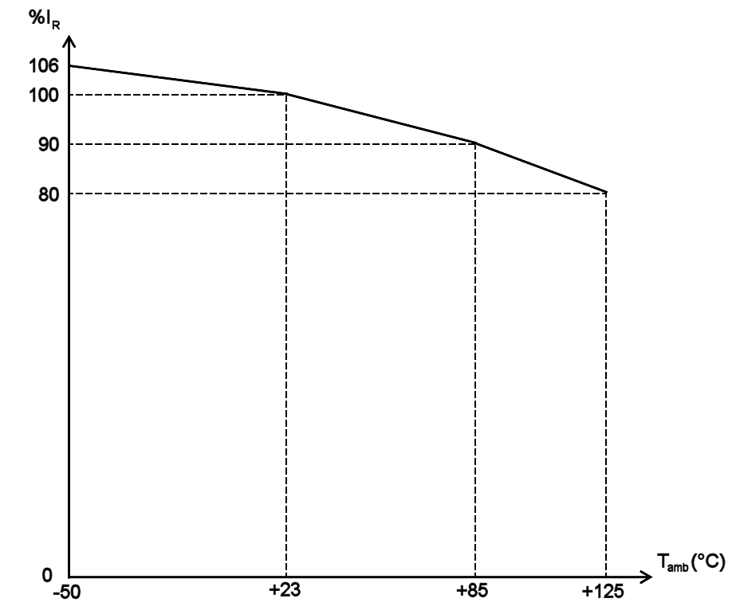
Maximum Continuous Current vs. Operating Temperature

PHYSICAL DIMENSIONS
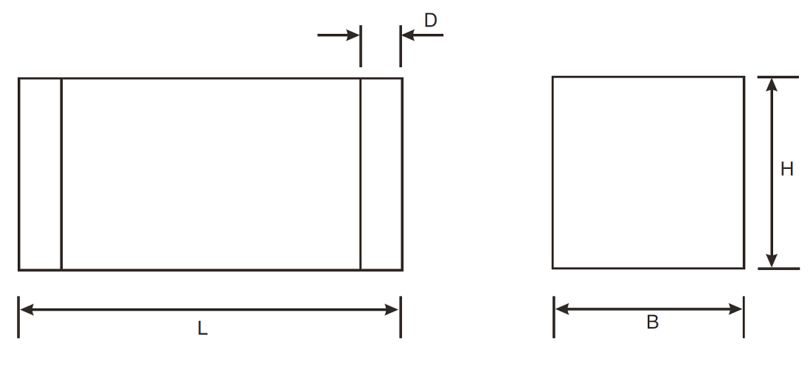
Symbols | Dimensions mm
Symbols | Min | Max
L | 7.9 | 8.2
B | 4.9 | 5.1
H | 4.9 | 5.1
D | 2 | 2.2

MATERIALS AND FINISHES
Materials and finishes shall be as follows:
          - Body: Ceramic
          - Terminal material: Copper alloy
          - Terminal plating: Electrolytic nickel of thickness 1µm minimum and 5µm maximum, with an electrolytic tin-lead final finish of thickness 5µm minimum and 15µm maximum. The composition of the tin-lead shall be 65 to 95% tin, remainder lead.

REQUIREMENTS

GENERAL
The complete requirements for procurement of the components specified herein are as stated in this specification and the ESCC Generic Specification. Permitted deviations from the Generic Specification, applicable to this specification only, are listed below.
Permitted deviations from the Generic Specification and this Detail Specification, formally agreed with specific Manufacturers on the basis that the alternative requirements are equivalent to the ESCC requirement and do not affect the component’s reliability, are listed in the appendices attached to this specification.

Deviations from the Generic Specification

Deviations from Chart F4 - Qualification and Periodic Tests
          - Vibration: Not applicable.

MARKING
The marking shall be in accordance with the requirements of ESCC Basic Specification No. 21700.
The information to be marked and the order of precedence shall be as follows:
          - The ESCC qualified components symbol (for ESCC qualified components only).
          - The ESCC Component Number.
          - Traceability information.

Test conditions for CURRENT CARRYING CAPACITY
Ref. Current Carrying Capacity in the ESCC Generic Specification.
- Test Current: 125% I_{R} (DC). See Component Type Variants and Range of Components for value of I_{R}.
- Duration: 1 hour minimum.
- Test temperature: +22 ±3ºC.

test conditions and limits for OVERLOAD OPERATION
Ref. Overload Operation in the ESCC Generic Specification.
Overload current conditions and pre-arcing times shall be as follows:
Sample | Overload Current  (DC) | Pre-arcing Time (ms)
Sample | Overload Current  (DC) | Min | Max
i | 400% I_{R} (Note 1) | 2 | 50
ii | 600% I_{R} (Note 1) | 1 | 10
iii | 1000% I_{R} (Note 1) | 0.1 | 2
notes:
            - See Component Type Variants and Range of Components for value of I_{R}.
After each fuse has blown, the test circuit shall remain energized for 30 seconds minimum without any indication of closing. The fuses shall be visually examined and there shall be no evidence of damage to the body or terminals.

Test conditions and limits for VERIFICATION OF OVERLOAD OPERATION AT DC RATED VOLTAGE
Ref. Verification of Overload Operation at DC Rated Voltage in the ESCC Generic Specification.
Overload current conditions and pre-arcing times shall be as follows:
At T_{amb} = +22 ±3ºC
Sample | Overload Current  (DC) | Pre-arcing Time (ms)
Sample | Overload Current  (DC) | Min | Max
i | 250% I_{R} (Note 1) | 5 | 5000
ii | 400% I_{R} (Note 1) | 2 | 50
iii | 600% I_{R} (Note 1) | 1 | 10
iv | 1000A | N/A
At T_{amb} = -50 (+5, -0)ºC
Sample | Overload Current  (DC) | Pre-arcing Time (ms)
Sample | Overload Current  (DC) | Min | Max
i | 265% I_{R} (Note 1) | 5 | 5000
ii | 424% I_{R} (Note 1) | 2 | 50
iii | 636% I_{R} (Note 1) | 1 | 10
iv | 1000A | N/A
notes:
            - See Component Type Variants and Range of Components for value of I_{R}.
After each fuse has blown, the test circuit shall remain energized for 30 seconds minimum without any indication of closing. The fuses shall be visually examined and there shall be no evidence of damage to the body or terminals.

test conditions and limits for INSULATION RESISTANCE
Ref. Insulation Resistance in the ESCC Generic Specification.
- Test Voltage: 250V (DC).
- Test Temperature: T_{amb} = +22 ±3ºC.
- Test Limit: 100kΩ minimum.

test conditions and limits for Thermal Vacuum
Ref. Thermal Vacuum in the ESCC Generic Specification.
The maximum limit of the current clearing I²t value for each component type variant is given below.
Variant Number | Maximum Current Clearing I²t  (A²s)  (Note 1)
24 | 20
26 | 45
28 | 80
32 | 180
notes:
            - Tested at 400% I_{R} (DC). See Component Type Variants and Range of Components for value of I_{R}.

ROOM TEMPERATURE ELECTRICAL MEASUREMENTS
The measurements shall be performed at T_{amb} = +22 ±3ºC.
Characteristics | Symbols | Test Method and Conditions | Limits |  | Units
Characteristics | Symbols | Test Method and Conditions | Min | Max | Units
Cold Resistance | R | ESCC No. 4008 | Note 1 |  | mΩ
Voltage Drop | VD | ESCC No. 4008 | Note 1 |  | mV
notes:
            - See Component Type Variants and Range of Components for the applicable limits.

INTERMEDIATE AND END-POINT ELECTRICAL MEASUREMENTS
Unless otherwise specified, the measurements shall be performed at T_{amb} = +22 ±3ºC.
Unless otherwise specified, the test methods and test conditions shall be as per the corresponding test defined in Room Temperature Electrical Measurements.
The drift values (Δ) shall not be exceeded for each characteristic where specified. The corresponding absolute limit values for each characteristic shall not be exceeded.
Test Reference per ESCC No. 4008 | Characteristics | Symbols | Limits |  | Units
Test Reference per ESCC No. 4008 | Characteristics | Symbols | Min | Max | Units
Resistance to Soldering Heat
Final Measurements | Cold Resistance | R | Note 1 |  | mΩ
Final Measurements | Voltage Drop | VD | Note 1 |  | mV
Rapid Change of Temperature
Final Measurements | Cold Resistance | R | Note 1 |  | mΩ
 | Voltage Drop | VD | Note 1 |  | mV
Vibration
Final Measurements | Cold Resistance | R | Note 1 |  | mΩ
Final Measurements | Voltage Drop | VD | Note 1 |  | mV
Shock
Final Measurements | Cold Resistance | R | Note 1 |  | mΩ
 | Voltage Drop | VD | Note 1 |  | mV
Damp Heat, Steady State
Final Measurements | Cold Resistance | R | Note 1 |  | mΩ
Final Measurements | Voltage Drop | VD | Note 1 |  | mV
Thermal Vacuum
Final Measurements  Blown fuses | Insulation Resistance (Note 2) | R_{i} | Note 2 | - | kΩ
Remaining fuses | Cold Resistance | R | Note 1 |  | mΩ
Operating Life
Initial Measurements | Cold Resistance (Note 3) | R | Note 1 |  | mΩ
 | Voltage Drop (Note 3) | VD | Note 1 |  | mV
Intermediate Measurements (1000h) | Cold Resistance | R | Note 1 |  | mΩ
Final Measurements (2000h) | Cold Resistance | R | Note 1 |  | mΩ
 | Voltage Drop | VD | Note 1 |  | mV
 | Voltage Drop Drift (from initial measurement) | $$\frac{∆\text{V}}{\text{VD}}$$ | - | ±20 | %
Robustness of
Terminations
Final Measurements | Cold Resistance | R | Note 1 |  | mΩ
Final Measurements | Voltage Drop | VD | Note 1 |  | mV
NOTES:
            - See Component Type Variants and Range of Components for the applicable limits.
            - See Test Conditions and Limits for Insulation Resistance.
            - This test need not be repeated. The most recent result from the previous test may be used instead.

BURN-IN CONDITIONS
Characteristics | Symbols | Test Conditions | Units
Ambient Temperature | T_{amb} | +80 (+0 -3) | ºC
Test Current | I | 90.8% I_{R} (DC) (Note 1) | A
NOTES:
            - See Component Type Variants and Range of Components for value of I_{R}.

OPERATING LIFE CONDITIONS
Characteristics | Symbols | Test Conditions | Units
Ambient Temperature | T_{amb} | +125 (+0 -3) | ºC
Test Current | I | 80% I_{R} (DC) (Note 1) | A
NOTES:
            - See Component Type Variants and Range of Components for value of I_{R}.

APPENDIX ‘A’
AGREED DEVIATIONS FOR SCHURTER (CH)
Items Affected | Description of Deviations
Deviations from Screening Tests - Chart F3 | External Visual Inspection:  - Any void in the ceramic with a maximum surface diameter and depth of ≤ 0.7mm shall be considered acceptable.  - Any discoloured areas on the ceramic with a diameter ≤ 0.5mm shall be considered acceptable.  - Any metallic particle on the ceramic with an area ≤ 0.02mm² shall be considered acceptable.
Deviations from Qualification and Periodic Tests - Chart F4 | Rapid Change of Temperature: Number of cycles shall be 200.
Deviations from Qualification and Periodic Tests - Chart F4 | External Visual Inspection:  - Any void in the ceramic with a maximum surface diameter and depth of ≤ 0.7mm shall be considered acceptable.  - Any discoloured areas on the ceramic with a diameter ≤ 0.5mm shall be considered acceptable.  - Any metallic particle on the ceramic with an area ≤ 0.02mm² shall be considered acceptable.
Deviations from Qualification and Periodic Tests - Chart F4 | Thermal Vacuum: The vacuum chamber pressure during Thermal Vacuum test shall be ≤ 5 x10⁻² torr (6.7Pa).
Deviations from Qualification and Periodic Tests - Chart F4 | Solderability: Any void in the solder which is ≤ 0.3mm deep shall be considered acceptable.

