 ` PAGE 0 OF 49
REQUIREMENTS FOR THE
PROCESS CAPABILITY APPROVAL
FOR
MANUFACTURING LINES
OF
HERMETIC HYBRID MICROCIRCUITS
ESCC BASIC SPECIFICATION No. 102

Legal Disclaimer and Copyright
European Space Agency, Copyright 2013, All rights reserved.
The European Space Agency disclaims any liability or responsibility, to any person or entry, with respect to any loss or damage caused, or alleged to be caused, directly by the use and application of this ESCC publication.
This publication, without prior permission of the European Space Agency and provided it is not used for a commercial purpose, may be:
Copied in whole, or in any medium, without alteration or modification.
Copied in part, in any medium, provided that the ESCC document identification, comprising the ESCC symbol, document number and document issue, is removed.
Issue 1 Draft K | Jan. 2013

Document Custodian: European Space Agency – see https://escies.org

DOCUMENTATION CHANGE NOTICE
(Refer to https://escies.org for ESCC DCR content
DCR No. | CHANGE DESCRIPTION

Table of Contents
1 purpose and scope 4
2 APPLICABLE DOCUMENTS 4
2.1 eSCC SPECIFICATIONS 4
2.2 OTHER APPLICABLE DOCUMENTS 5
3 terms, definitions, abbreviations, symbols and units 5
3.1 Terms from other standards 5
3.2 Terms specific to the present standard 5
Statistical Process Control (SPC) 6
4 DEFINITION OF PROCESS CAPABILITY APPROVAL for hybrid lines 7
5 definition of the process capability domain and its boundaries 9
5.1 general 9
5.1.1 Materials and processes 9
5.1.2 Physical Design 9
5.1.3 Inspection and test 10
5.1.4 Traceability 10
5.2 The pid of an hybrid manufacturer 10
5.2.1 General 10
5.2.2 Review and approval of the PID 10
5.2.3 Requirements for the preparation of the PID 11
6 Manufacturer evaluation 11
7 evaluation of the process capability domain 11
7.1 general 11
7.2 Evaluation test programme 11
7.2.1 General 11
7.2.2 Description of Test Vehicles (TVE) 12
7.2.3 Examples of the two Evaluation Test Vehicles 14
18
7.3 Manufacturer’s audit 18
7.4 Evaluation testing 18
7.4.1 General 18
7.4.2 Control samples 19
7.4.3 Test plans 19
7.4.4 Test methods and conditions 22
7.4.5 Evaluation test report 25
8 process capability approval (pca) phase 25
8.1 general 25
8.2 process capability approval testing 26
8.2.1 Definition and requirements for test vehicles for PCA testing 26
8.2.2 Hermetic Hybrids PCA test plans 26
8.2.3 Hermetic Hybrids PCA test methods and conditions 28
8.2.4 PCA test report 31
8.3 procedures specific to the pca of hybrid manufaCturing lines 32
8.3.1 Manufacturing Line under TRB management 32
8.3.2 Extension or change of the Process Capability Approval Domain 32
8.3.3 Maintenance, suspension, withdrawal of the Process Capability Approval 33
9 ANNEX 1 requirements guidelines for the materials and processes description 35
9.1 Definition of proposed sub-techniques in the PCA domain 35
9.1.1 Definition of sub-techniques depending on the substrate technology 35
9.1.2 Assembly of added-on components, substrates and carriers 38
9.1.3 Encapsulation 40
10 ANNEX 2 Overview of the PCA extension APPLICATION 41
11 ANNEX 3 APPLICATION FOR ESCC process Capability APPROVAL 42
12 ANNEX 4: Application of ESCC PCA Extension 43

purpose and scope
The purpose of this specification is to define the requirements for the Process Capability Approval (PCA) of a manufacturing line of Hermetic Hybrid Microcircuits intended for space application.
Scope. This specification:
- provides the specific requirements which a manufacturer has to fulfill in order to be successfully evaluated and capability approved for a set of materials and processes used on a manufacturing line to construct hermetic Hybrid Microcircuits and for this capability to be described and published in the ESCC REP007 (ESCC List of CA certificates).
- is applicable to substrate and interconnect technologies including: thick film, thin film, high and low temperature co-fired ceramic hybrids used for linear, mixed signal, digital, analog applications
- shall be read in conjunction with ESCC Basic Specification [draft 101] which provides the general requirements for Process Capability Approval.

NOTES:
- This specification does not provide requirements for the PCA of a manufacturing line of any devices which are not designed to be hermetic.

APPLICABLE DOCUMENTS
The following specifications form part and shall be read in conjunction with, this specification. The relevant issues shall be those in effect at the date of commencement of a particular task, as applicable and as required for each stage of the sequence of activities which may lead to the PCA certification of the manufacturing line.

eSCC SPECIFICATIONS
ESCC draft 101 Requirements for the Process Capability Approval
ESCC 21300 Terms, Definitions, Abbreviations, Symbols and Units
ESCC 21500 Calibration System Requirements
ESCC 24600 MINIMUM QUALITY MANAGEMENT SYSTEM REQUIREMENTS

ESCC 22700 Requirements and Guidelines for the Process Identification Document
ESCC 22800 ESCC Non-Conformance Control System
ESCC draft 140 Checklist for Hybrids Manufacturers and Line survey
ESCC draft 154 Guidelines for the PID of Hybrid manufacturers

OTHER APPLICABLE DOCUMENTS
The following documents are applicable to the extent specified herein. The relevant issues shall be those in effect at the date of commencement of a particular task, as applicable and as required for each stage of the sequence of activities which may lead to the PCA certification of the manufacturing line.
ECSS-Q-ST-60-05 Generic procurement requirements for hybrids
ECSS-S-ST-00-01 Glossary of terms
MIL-STD-883 Test Method Standard Microcircuits
MIL-STD-750 Test Method Standard Test Methods for Semiconductor Devices
ISO 14644-1 Cleanrooms and Associated Controlled Environments - Part 1: Classification of Air Cleanliness
IPC-9191 General Guidelines for Implementation of Statistical Process Control
IPC-9199 Statistical Process Control (SPC) Quality Rating

terms, definitions, abbreviations, symbols and units

Terms from other standards
For the purpose of this Standard, the terms, definitions, abbreviations, symbols and units defined in ESCC Basic Specification No. 21300 and ECSS-S-ST-00-01 apply, plus specific terms as in 3.2..

Terms specific to the present standard
Hybrid microcircuit
Hybrid circuits (also used: hybrids)
Combination of elements (interconnection substrate, added active or passive parts sealed inside an hermetic package, in order to perform an electronic function
Note 1: Interconnection substrate can be with or without integrated passive components (e.g. thick film, thin film, co-fired, DBC).
Note 2: Active parts can be monolithic or discrete, chips or packaged components.
Note 3: Passive parts can be chips (e.g. single or network thin film resistor), SMDs (e.g. 0805 ceramic multilayer capacitor), other heterogeneous passive parts (e.g. Circulators)
Note 4: Electronic functions that are performed by hybrids include digital or analog, low frequency or radiofrequency, low power or high power functions. These functions may be mixed according to the application.
Note 5: A hybrid module consisting primarily of closely-spaced monolithic integrated circuit dice that have a total silicon area ≥30% of substrate area can also be called Multichip Module (MCM).

Production lot
Number of units of a single device type manufactured on the same production line using the same production techniques, in one uninterrupted period, according to the same component or part design and having the same chip lots and the same materials (as defined in ECSS-Q-60-05)
Representative production lot
Lot that represents several production lots grouping products from the same family, covered by one SEC type, manufactured on the same production line, in one uninterrupted period, using the same materials and processes
Standard Evaluation Circuit (SEC)
Device that represents a family of products using the same materials and processes and which is processed on the same production line with the same manufacturing equipment and tools
Technology Review Board (TRB)
Formal group at manufacturer level where design, materials and parts procurement, manufacturing, testing, reliability, and quality assurance functions are represented

Statistical Process Control (SPC)
Statistical Process Control is the use of statistical techniques and tools for monitoring a process through the use of control charts, to warn when the process is moving away from predetermined limits always before non conformance occurrence.
Design of Experiments (DoE)
Design of Experiments is a structured, organized method for determining, with a reduced number of experiments based on Tagushi’s method, the effect of process parameters on a process result (for determination of influent parameters) and the correlation between parameters (for process optimization).
Semi-finished Product
A Semi-finished product is a product performing a specific function procured from an external sub-contractor entering the fabrication flow of an hybrid (for example: package, interconnection substrate etc) not produced by the hybrid manufacturer itself.
External Sub-contractor
A company different from the hybrid manufacturer that performs a particular process step or provides a semi-finished product used in the hybrid fabrication flow mentioned in the PID

Rework
action to correct a defect of a product that does not lead to a configuration item change
1 Unlike repair, rework does not affect or modify parts of the defective product.
2 No NCR needs to be raised.

Repair
action to correct a defect of a product that leads to a configuration item change
1Unlike rework, repair affects or modifies parts of the defective product.
2An NCR needs to be raised for the configuration item change.
Abbreviated terms
The following abbreviations are used within this document:

Abbreviation Meaning

DBC Direct Bond Copper
DoE Design of Experiments
DPA Destructive Physical Analysis
ECSS European Cooperation for Space Standardisation
ESCC European Space Components Cooperation
HTCC High Temperature Co-fired Ceramic
HTIF Hybrid Technology Identification Form
I/O Input / Output
ISP Integrated Substrate Package
LF Low Frequency
LTCC Low Temperature Co-fired Ceramic
PID Process Identification Document
RF Radio Frequency
SEC Standard Evaluation Circuit
SPC Statistical Process Control
TCR Temperature Coefficient of Resistance
TRB Technology Review Board
TVCA Test Vehicle for Capability Approval
TVE Test Vehicle for Evaluation

DEFINITION OF PROCESS CAPABILITY APPROVAL for hybrid lines
The ESCC Process Capability Approval (PCA) of Hermetic Hybrid Manufacturing Lines shall include the 4 stages specified in Draft 101, namely Manufacturer Evaluation, Definition of the Capability Domain, Evaluation Phase and PCA Phase testing. The successful completion of these stages requires, therefore, the definition of the PCA and its boundaries, the preparation, review and approval of the relevant PID and the actual completion of test sequences specified for Evaluation testing and PCA testing.
The flow to reach the PCA of an Hybrid Line is described in Flow Chart 1.

Flow Chart 1

definition of the process capability domain and its boundaries
In addition to the requirements of Draft 101, the following is specific and applicable to the Definition of the capability domain, and the preparation of the Capability Abstract, of Hybrid Manufacturers for the purpose of PCA.

general
The Manufacturer shall define the process capability domain for which process capability approval is sought as required in Draft 101. This definition shall result in the Capability Abstract and the PID.
The Capability Abstract and the PID have to demonstrate that the Process capability domain represents a structured, properly controlled and monitored manufacturing process for hybrid microcircuits.
The definition of the process capability domain shall address the areas listed in the rest of this paragraph at least to the extent detailed therein. Additional information shall be supplied whenever necessitated by the particular capability domain under approval.
Within the definition of the PCA for Hybrid manufacturing lines, the following areas are of particular concern and are therefore the object of specific requirements in the rest of this paragraph:
- Materials, Processes and add-on parts
- Physical design
- Inspection and test
- Traceability

- The manufacturer shall describe the type of functions / products which are planned to be developed and manufactured, in term of power dissipation (Low/ High Power), maximum current / voltage, signal frequency (Low / Radio Frequency), digital / analog functions, mixed functions, etc.

Materials and processes
Annex 1 gives requirements guidelines for the materials and processes description anticipated to be included in the PCA application (Annex 3)..

Physical Design
The manufacturer shall specify physical design rules that define the construction and composition of all structures foreseen for the production of hybrid microcircuits or multichip modules within the process capability domain. Methodologies and procedures used by the manufacturer to validate their design shall also be addressed.
The design rules shall at least cover the following:
- Substrate and carrier physical constraints
- Conductor, termination and wire bonding physical constraints
- Thick film, thin film circuit physical constraints
- Package Assembly and encapsulation

Inspection and test
The Manufacturer shall describe the methods applicable for inspections and test, including references to the documents specifying those methods.
At least the following areas shall be covered:
- Material Incoming Inspection
- In-process inspections
- Internal and external visual inspection

Traceability
The Manufacturer shall describe his methods for assuring traceability of materials, test structure and manufactured structures. At least the following points shall be covered:
- The use of purchase orders and specifications
- The use of route sheets and travellers
- The traceability of materials
- The traceability of test structures
- The traceability of manufactured structures

The pid of an hybrid manufacturer

General
A PID for the process capability domain to be approved shall be prepared per ESCC draft 154
Regarding materials, the PID shall contain:
- The selection and approval of materials used.
- A list of procurement specifications for selected materials and associated supplier(s)
- List of incoming inspection procedures and other documents used to ensure the consistent quality of materials used
- Procedures for traceability and control of limited shelf-life items.
Regarding processes, the PID shall describe the processes within the process capability domain. It shall also give reference to the documents specifying the processes. At least the following areas shall be covered including a statement on the equipment used:
- Substrate and carrier preparation
- Conductor, termination and wire bonding process
- Thick film, thin film circuit processes
- Package assembly and encapsulation processes
- Rework procedures
The PID shall also contain a list of all package types and sizes with type of pin/connectors/transitions and their number to be included in the process capability domain, The package with the largest mechanical dimensions of each type represents a boundary of the process capability domain (both for add-ons and the hybrid package itself).

Review and approval of the PID
The PID will contain the complete definition of the Capability Domain and will be updated into a stable state at the end of the Evaluation phase so that its review and approval by the ESCC Executive becomes a mandatory pre-requisite for the commencement of the PCA testing phase.
The complete PID, comprising all called-up specifications, shall be kept by the manufacturer at the production plant. It shall be made available to the ESCC Executive or its designated representative for review.
Any deviation from PID shall be subjected to the ESCC Executive for approval.
A condensed PID, comprising all basic information, e.g. flow-charts, lists of specifications, materials, processes, organization/responsibility, equipments and layouts but complemented by copies of only the agreed specifications, shall be kept by the ESCC Executive and treated as proprietary information.

Requirements for the preparation of the PID
The PID shall be arranged into sections as per ESCC draft 154.

Manufacturer evaluation
In addition to the requirements of Draft 101, the following is specific and applicable to the Evaluation of Hybrid Manufacturers for the purpose of PCA.
The following activities shall be carried out during the manufacturer evaluation phase:
- Capability survey. This survey is made to assess a manufacturer's general capability for the production of reliable Hybrid Microcircuits.
- Line survey. This survey consists of an assessment of a manufacturer’s technology and production line based on applied processes and controls and a detailed review of existing test data.
In general, to enable the survey team of the ESCC Executive to carry out the capability survey, the line survey and the manufacturer audit, the manufacturer shall grant free access to the facilities concerned. He shall also enable the team to witness any development, engineering, production and quality assurance operations involved in the processes for which approval is sought.
To facilitate the evaluation procedure for capability survey, line survey and manufacturer audit, the checklist based on Draft 140 shall be used.

evaluation of the process capability domain

general

Evaluation test programme

General
The Evaluation testing to be performed on test structures representative of the hybrid process under approval shall be in accordance with an Evaluation Test Programme (ETP) which shall, as a minimum, conform to the requirements of this paragraph.
The test structures used for Evaluation testing are called Test vehicles (TVE). The quantity and type of samples to be used for the ETP shall be agreed by the ESCC Executive and the manufacturer. The samples shall also be the most suitable for highlighting those characteristics and parameters that are pertinent to an investigation on failure modes and weaknesses.
Upon completion of evaluation testing, the final definition of the process capability domain and its boundaries shall be agreed between the Manufacturer and the ESCC Executive, and the Process Capability Abstract shall be issued.

Description of Test Vehicles (TVE)

General
On the basis of materials, processes and sub-techniques proposed by the manufacturer for approval, the manufacturer shall define the test vehicles implementing the different sub-techniques and their related limits.
To cover all the different sub-techniques, a minimum of two types of test vehicles shall be designed:
- One type addressing the substrate technology (TVE1)
- One type addressing the assembly of added-on parts and the actual packaging technique (TVE2)
TVE1 test vehicle shall consist of the main substrate mounted and connected encapsulated with a selected packaging technology that is representative of the packaging technique used for the hybrid process. The number of I/O pins shall be enough to perform the electrical measurements.
TVE2 test vehicle shall be encapsulated with the actual packaging technique . The package used for TVE2 may be different from the actual package planned for the hybrid but shall in any case cover the technology domain under approval
In order to cover the full Process Capability Domain it might be necessary to define several Test Vehicles of the type TVE1 and/or TVE2 above.
If proposed by the manufacturer, and in accordance with the ESCC Executive, some Evaluation test vehicles may be intentionally repaired (and/or reworked) and the traceability of the various repair/rework operations established accordingly. These repaired/reworked devices shall be clearly identified and submitted to the same test campaign as the non-repaired/reworked hybrid components.
The manufacturer shall write a specification in accordance with ECSS-Q-ST-60-05, Annex B, for each test vehicle to be evaluated and submit it to the ESCC Executive for approval.

Definition of TVE1 test vehicle
This test vehicle shall be representative in term of:
- Maximum X Y dimensions, minimum thickness package and bulk substrates
- Maximum number of conductive layers and associated dielectric layers
- Typical thicknesses of conductive and dielectric layers
- Minimum and typical line width/space
- Minimum and typical via/holes dimensions and typical density
- Minimum and maximum dimensions of resistors in all paste decades for both trimmed and no- trimmed resistors
- Protective coverglaze on conductive and/or resistive layer (if any): material, deposition process, thickness,
Note: In case of matrix production, the vendor shall assess the worst position on the tile and include in the test vehicles configuration
This type of test vehicle shall be designed with specific patterns to assess the performance of :
- The conductor/dielectric network (multilayer structure) :
  - Conductor resistance
    - On each conductor layer through Greek pattern (about one substrate perimeter long) with a minimum of two different line widths (see example TVE1, pattern A1, A2)
    - On a chain of a minimum of 200 vias between two adjacent conductive layers (one chain on the substrate and one chain on the top of the multilayer network) with a minimum of two different line widths (see example TVE1, pattern B)
    - On a chain of a minimum of N* vias interconnecting all the conductive layers with a minimum of two different line widths (* N = 100 x number of conductive layers) (see example TVE1, pattern D)
- Insulation resistance
    - Between two coplanar adjacent lines through Greek pattern (about one substrate perimeter long) with different space widths (see example TVE1, pattern A1, A2)
    - Between one couple of interlaced lines (about one substrate perimeter long) with different space widths (one couple on the substrate and one couple on the top of the multilayer network) (see example TVE1, pattern B)
    - Between two ground planes (about 10 % of the total substrate area) located on each conductor layer (see example TVE1, pattern E)
- Capacitance
    - Between coplanar adjacent lines in Greek pattern (about one substrate perimeter long) with two different line widths (see example TVE1, pattern A1, A2)
    - Between each Greek line and a ground plane separated by one dielectric level (see example TVE1, pattern A1, A2)
    - Between two ground planes (about 10 % of the total substrate area) separated by one dielectric level (see example TVE1, pattern E)
- Dielectric strength
    - Between all ground planes (about 10 % of the total substrate area) separated by one dielectric level

- The conductor network (monolayer structure) for high power and/or high current applications
- Conductor resistance on the conductor layer with different line width
- Current density on the conductor layer with different line width for long term current density evaluation and for destructive test on specific patterns.

- The resistor network (deposited directly on substrate or on dielectric/ trimmed or not/encapsulated or not):
- Resistor value
- Temperature coefficient of resistance (TCR)
- Maximum power dissipation
For minimum/medium/maximum resistivity, the minimum number of resistors shall be: 4 resistors of minimum length and 4 resistors of maximum length.
Note: Each combination of resistor / conductor termination shall be evaluated.

Definition of TVE2 test vehicle
This test vehicle shall be representative in terms of:
- Maximum X Y, Minimum Z dimensions.
- Representative substrate in terms of :
  - Total number of dielectric layers for multilayer structures
  - Total thickness (Z)
  - External conductor layers
  - Configurations of wire interconnections at different conductor layer level (if applicable)
  - Metallized holes in contact with attachment medium (grounding connections, if applicable)
- Added-on parts (active and passive components/carrier/substrate)
  - Types and manufacturers
  - Minimum and maximum dimensions (two components per size)
- Added-on parts assembly
  - Attachment medium
  - Interconnection technologies
    - Each part shall be connected to the substrate/package
    - In addition, a “daisy” chain consisting of a minimum of 100 loops per process/material/diameter wire (or ribbon) shall be implemented in the case of Chip & Wire technology (according to the manufacturer technology the number of loops may be reduced in case of heavy wires)
- Encapsulation
  - Hermetic

This test vehicle shall be designed to evaluate :
- The main electrical parameters related to the added-on passive and discrete active components (and integrated circuits, if possible)
- The mechanical (and electrical, when applicable) performance of attachment medium (adhesive bonded or soldered joints)
- The mechanical and electrical performance of bonding wires or ribbons
- The behavior of the encapsulation with respect to the environmental stresses (thermo-mechanical, humidity, contamination)

Examples of the two Evaluation Test Vehicles
The following drawings are provided for general guidance. The manufacturer shall propose, for its evaluation, layouts that cover the full domain of technologies and added-on parts that he wishes to evaluate.
TVE1 test vehicle (thick film multilayer, 3 conductive levels)
Overview
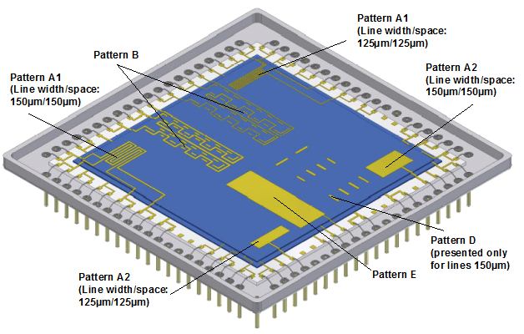

Detail TVE1 | Description
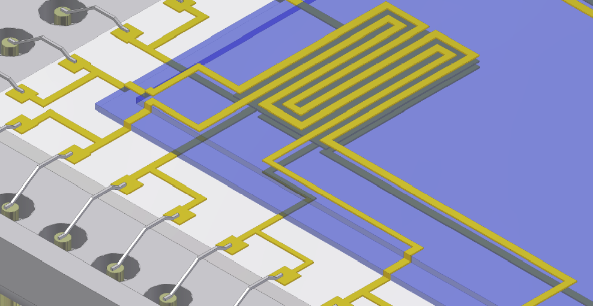  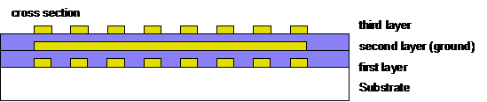 | Pattern A1  Measurement of :  - Conductor resistance at first layer (conductor on substrate) and third layer (conductor on top dielectric layer)  - Insulation resistance between the adjacent coplanar lines  - Capacitance between the adjacent coplanar lines  - Capacitance between each line and the ground plane (second layer)
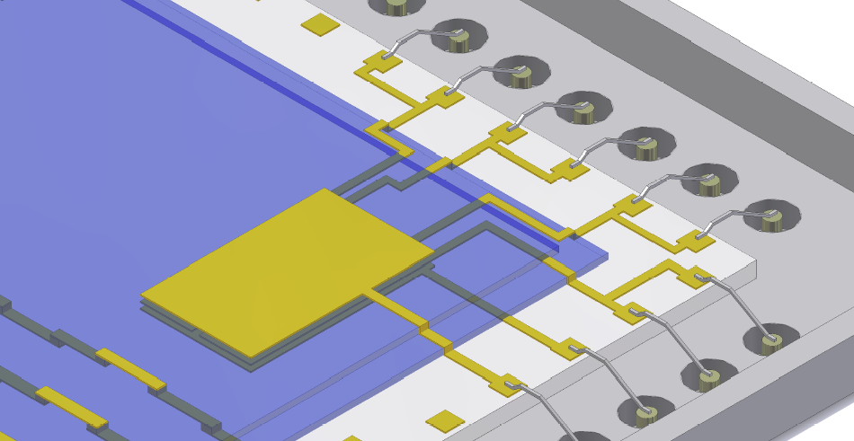  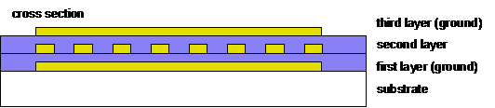 | Pattern A2  Measurement of :  - Conductor resistance at the Greek pattern on second layer (same as in pattern A1)  - Insulation resistance between the coplanar adjacent lines  - Capacitance between the coplanar adjacent lines  - Capacitance between each line and the ground planes (first and third layer)

Detail TVE1 | Description
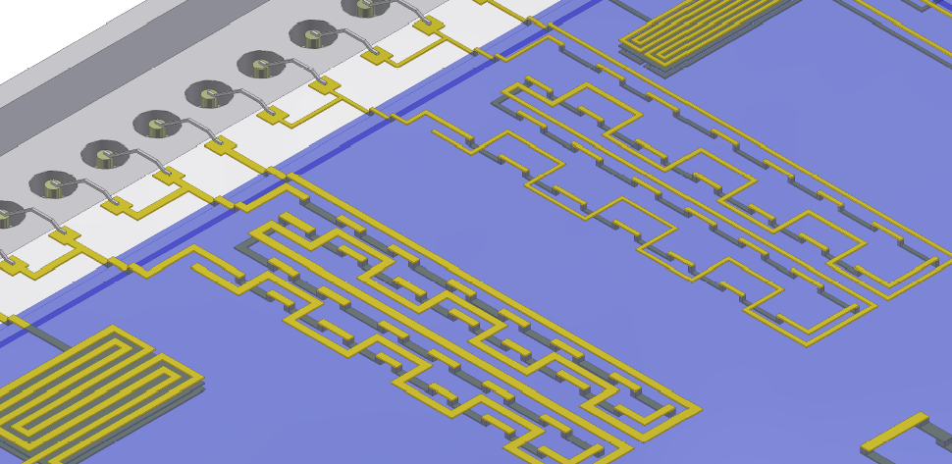 | Pattern B  Measurement of :  - Resistance of a chain of vias between second and third conductive layer (on top of the multilayer network)  - Insulation resistance between different interlaced lines on coplanar adjacent and superposed adjacent layers  (on top of the multilayer network)
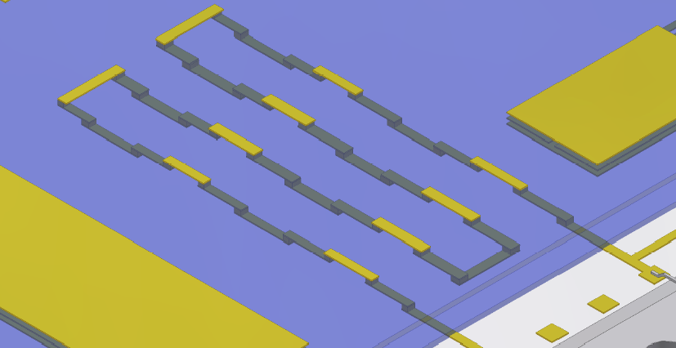 | Pattern D  Measurement of the conductor resistance of a chain (lines and vias), interconnecting all of the three conductive layers .
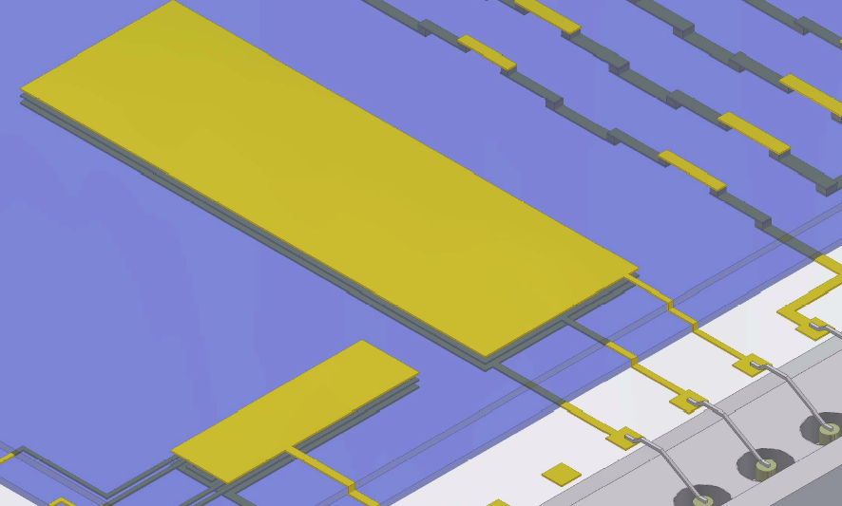 | Pattern E  Measurement of :  - Insulation resistance between the ground planes on the different conductive layers (first-second, second-third)  - Capacitance between the superposed adjacent ground planes

TVE2 test vehicle (thick film multilayer, 3 conductive levels)

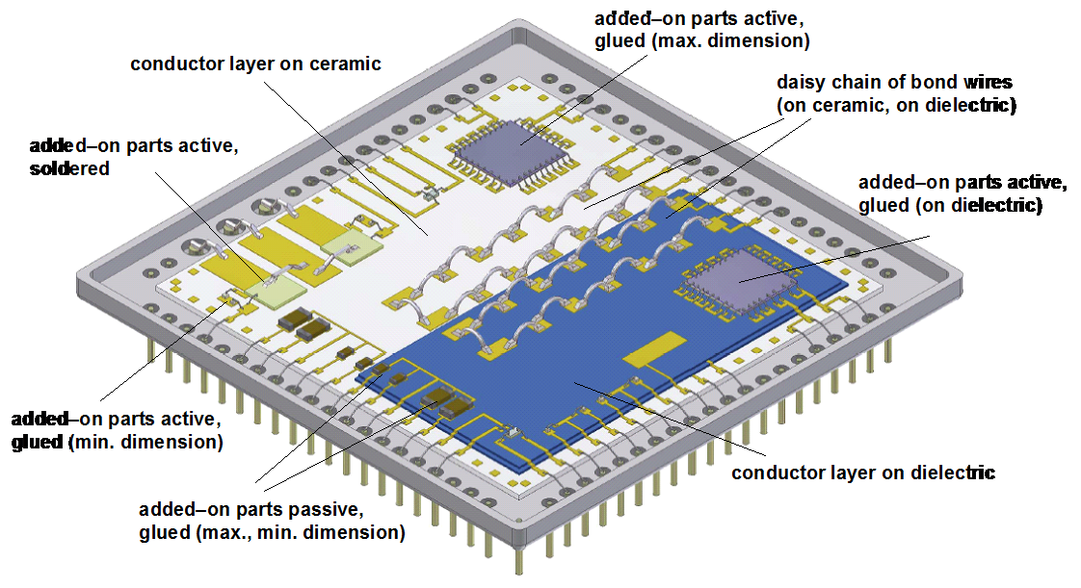

Manufacturer’s audit
The Manufacturer Quality Management System Audit shall take place as part of the PCA Evaluation stage. This audit shall assess the manufacturer's quality management system and his ability to successfully execute a contract for the supply of high reliability Hybrid Microcircuits. The manufacturer shall have in place a Quality System according to ESCC 24600. The Line Survey, shall take place in parallel to the QMS Audit, and shall be performed against the Check List ESCC 140 Draft.

Evaluation testing

General
Evaluation testing of test structures shall generally consist of the tests and subgroups given in Chart 2.1 of this specification. Samples to be submitted to Chart 2.2 shall be test structures as defined in Para. 7.2.2 of this specification and the PID. Test structures shall be randomly divided into the various test subgroups. Unless otherwise agreed with the ESCC Executive, when different types of test structure are being tested, each type shall be represented in each subgroup.
All test structures shall be serialized prior to testing. For each measurement or inspection performed, the results shall be recorded and summarized in terms of serials number and quantity tested, quantity passed and quantity rejected failed. If test structures are rejected failed, the reason shall be clearly identified through an adequate failure analysis.
All failed test structures shall be subjected to failure analysis. The depth of the analysis shall depend on the circumstances in which failure occurred and upon whether useful information can be gained. As a minimum, the failure mode shall be determined in each case. Test structures not failing catastrophically, i.e. those displaying out of tolerance electrical rejects, shall not be removed from the test sequence but may be used, with the agreement of the ESCC, as additional test samples for evaluation testing as defined in chart 1 in order to monitored to and observe the degradation trends. In no case these parts shall substitute for good parts.

Control samples
A control sample of each type of test structure shall be kept as a reference for comparison purposes. Whenever electrical measurements are performed on any test structure during evaluation testing the control sample of the same type shall also be measured.
A control device consisting in a supplementary test vehicle shall be kept as a reference if verification of measuring equipment is required. Another supplementary test vehicle shall be used for initial DPA without burn-in simulation (TVE1) or with burn-in simulation (TVE2) for internal water-vapor content test

Test plans
Testing, analysis of test results and definition of the evaluation test programme shall be in accordance with the test plan and tables specified herein for each test vehicle.
The test plans and the definition of test vehicles proposed by the manufacturer shall be submitted to the ESCC Executive for approval prior to commencing the tests.
The following test plans shall be applicable to the test vehicles TVE1 and TVE2.
The numbers in brackets for each test correspond to the test number of the table “test methods and conditions” (paragraph 7.4.4).
Chart 2.1. Evaluation Test Plan for test structures TVE1 (Note 0).

Chart 2.2. Evaluation Test Plan for test structures TVE2.

Note 0: The TVE1 technology/configuration drives the specific Evaluation Plan. The tailoring has to analyze the applicability (e.g. seal test is NA for just a substrate), and eventual replacement of a test (e.g. if solderability is NA then it has to be replaced by other test e.g. bondability).
Note 1 : The hybrid manufacturer shall fabricate additional TVE1/TVE2 vehicles or define and fabricate specific test vehicles for evaluation of specific application (on/off or power cycling, high voltage, high current,…) and perform related specific tests.
Note 2: Step stressing requires the performance of each test (test No 10, 11 and 12) in the loop for each step.
Note 3: For DPA in SG1 and SG3 test 16e Residual Gas Analysis requirement (max 5000ppm moisture) is not applicable. The hybrids manufacturer can use the RGA measurements together with other observations (e.g. a current drift) to define its own requirements (e.g. hydrogen<300ppm) for later specifications (including TVCA in Chart 3).
Note 4: Step stressing requires the performance of each test (test No 11, 12,13,14 and 15) in the loop for each step

Test methods and conditions
The test methods and conditions pertinent to TVE1 and TVE2 test plans are listed in following Table 2 together with the reference of the applicable specifications and each detail specification. The number of each test corresponds to that shown in brackets for each test in the evaluation test plans.

Table 2
N° | Test | MIL-STD | Method | Test conditions and remarks
1 | Thermal cycling | 883 | 1010 | Condition B, 100 cycles per step up to  500 or failure
2a | Endurance | 883 | 1005 | Temperature: 125 °C, 1000 h + 1000 h, electrical load as specified in test vehicle detail specification. If the temperature is lower than 125 °C (e.g. high power applications), duration shall be as defined in MIL-STD-883 method 1005, and additional samples shall be submitted to HTS per 2b below.
2b | High Temperature Storage | 883 | 1008 | Condition B: +125°C; 2000 hours
3 | Mechanical shock | 883 | 2002 | Step1 : Condition B (1500g) for packages up to 1” x 2” and 1000 g 0,5 ms for packages above.  Step 2 : Condition C (3000g) for packages up to 1” x 2” and Condition B (1500g) for packages above.  Shocks performed on Y1, Y2, X, Z axis
4a | Random vibration | 883 | 2026 | Condition I K, Random Vibration 44.8 g RMS, 3 axis
4b | Sinus vibration | 883 | 2007 | Condition B, 50 g
5 | External Visual | 883 | 2009
6 | Thermal vacuum |  |  | 20 cycles -30 + 70 °C at 10-5 Pa, dwell time : 2 hours, slope 2°C/mn
7 | Burn-in simulation |  |  | Bake during 240 h at 125 °C, no voltage
8 | Solvent Resistance | 883 | 2015
9 | Moisture resistance | 883 | 1004 | 10 V DC between all terminals connected together and package (+ on terminals)
10 | Visual inspection | 883 | 2017
11 | Physical dimensions | 883 | 2016 | According to test vehicle detail specification.  e.g. for TVE1 : line width, space, vias diameter, substrate camber,…  e.g. for TVE2 : external dimensions, lid and package deformation,…
12 | Electrical measurements  - Resistance  - TCR  - Capacitance  - Insulation resistance  - Semiconductor components  - Voltage coefficient of resistance | 202  202  202  202  202 | 303  304  305  302  309 | Test accuracy +/- 0,02 %  Maximum temperature : + 125 °C  Minimum temperature : - 55 °C  Frequency: 1 MHz. Test accuracy +/- 0,1 %. Loss factor 0,001  Condition A, 100 V  Electrical Measurements and conditions as per Detail Specification of TVE2.  For thick film only
13 | PIND test | 883 | 2020 | Condition A. Only applicable to cavity type devices
14 | Leak test | 883 | 1014 | Fine leak : condition A  Gross leak : condition C  Only applicable to hermetically sealed, cavity type, devices
15 | - None-
16 | DPA (initial or final) |  |  | Note 1, Note 2
16a | External Visual inspection | 883 | 2009
16b | Delidding | 883 | 5009
16c | Radiography | 883 | 2012 | When soldered items or gold wires are present
16d | SAM inspection | 883 | 2030
16e | Internal water vapour content | 883 | 1018 | After burn-in simulation for TVE2 initial and final DPA.
16f | Internal visual | 883  883  750  750  750  883 | 2017  2010  2072  2073  2074  2032 | Class K  Condition B. Or ESCC equivalent for monolithic devices
16g | Dielectric strength | 202 | 301 | 100 V DC between conductive layers in a multilayer system, between conductors on same layer in a monolayer system
16h | SEM Inspection | 883 | 2018 | Provide photos of typical assemblies, non  conformances and anomalies
16i | Bond pull test | 883 | 2011 | On TVE2 only. Pull all wires and ribbons
16j | Die shear test | 883 | 2019 | On TVE2 only. Shear all chips
16l | Substrate attach strength | 883 | 2027 | When shear test cannot be performed in case of substrates or large chips
16m | Adhesion test | - |  | Peeling test on metallization according to the hybrid manufacturer specification and agreed by ESCC executive
16n | Micro-sections | - |  | Micro-sectioning shall be performed to evaluate : multilayer substrates (conductors, dielectric, vias), assembly of added-on parts, cross-overs, local encapsulations, hermetic sealing (seal joint and feed-through).
17 | Solderability | 202 | 208 | Three terminals per test item
18 | Soldering heat | 883 | 2036 | Visual inspection (x 30 minimum) to verify  that terminals, glass seals, connections or  substrate are not damaged. Conditions as per test method to be defined according to application.
19 | Terminal strength | 883 | 2004 | Flexible leads :  condition A, F (N) = 30 x S (mm²)  (F : strength, S : lead section)  Rigid feed-throughs in packages :  - Diameter ≤ 1mm as above  - Diameter > 1mm, condition C1,  torque :1,5 N.cm

Note1: the DPA (test number 16 in the table above) shall be performed by an independent third party laboratory.
Note 2: Initial DPA shall contain also Soldering Heat (test nr 18), before RGA (test Nr 16e).

Evaluation test report
On completion of the evaluation testing, the manufacturer shall prepare an evaluation report. This report shall include:
- Description of the process capability domain technology tested: processes, materials and sub-techniques and how these were implemented in the devices tested.
- The Detail Specification for each Test Vehicle or circuit
- Production data for the test structures including details of any failures during production
- The evaluation test programme (ETP) giving details of all test methods and conditions and the number of test structures tested
- ETP detailed test results including: all electrical measurements and statistical analysis of the results, DPA reports, Failure Analysis reports (as applicable)
- Reference to the Manufacturer’s alternative test data accepted as satisfying part or all of the ETP (as applicable)
- ETP summary and conclusions
The Evaluation report shall be sent to the ESCC Executive for review and acceptance.

process capability approval (pca) phase

general
The PCA phase of Hybrid Manufacturing Lines shall be as specified in Draft 101 with additional requirements set in the rest of this paragraph.
The objective of the Process Capability Approval Phase is to demonstrate, on the operational manufacturing line, the ability of the manufacturer to produce high reliability hybrids for space applications.
To this end the following prerequisites shall be satisfied:
- The Evaluation Phase has been completed successfully and the Capability Domain with its boundaries has been agreed between the Manufacturer and the ESCC Executive.
- The materials and processes and related specifications have been frozen in a PID agreed by the ESCC Executive
- The facilities and equipment and tools are operational and under control
- The training and certification of personnel is completed and surveyed
- An ESD control plan, meeting the minimum requirements of ESCC 24900, is frozen. Such control plan shall include provisions for the handling of Class 0 devices as per MIL-STD-883, Method 3015.

process capability approval testing
Process capability approval testing to be performed on test vehicles in accordance with the PID shall conform to Draft 101 and the rest this paragraph.
This phase shall consist in the fabrication and testing of either test structures or actual circuit types covering the full technology domain defined in the PID.
The test vehicles used for PCA testing are called Test vehicles (TVCA) in the rest of this document.

Definition and requirements for test vehicles for PCA testing
The capability approval test vehicles (TVCA) shall be one or several functional products and additional test structures, if necessary, able to cover the capability domain boundaries defined in the PID.

For each TVCA:
- The Hybrid Technology Identification Form (HTIF) shall be established according to the format defined in Annex A of ECSS-Q-ST-60-05. The HTIF shall be checked against the Technology Domain boundaries defined in the PID.
- The Detail Specification has been written according to Annex B of ECSS-Q-ST-60-05 and agreed by the ESCC Executive.
- The capability approval test vehicles shall be manufactured in accordance with the PID and screened to Level 1 of ECSS-Q-ST-60-05.

In order to validate rework and repair procedures and limits, some of the TVCAs shall be intentionally reworked and repaired according to the methods described in the PID.
The ESCC Executive shall be notified 3 weeks in advance of the following key points: Pre-cap Inspection and End of screening (for a review of screening results).

Hermetic Hybrids PCA test plans

General
The PCA programme of tests shall be reviewed and approved by the ESCC Executive prior to the start of the PCA testing.
The PCA test programme shall generally consist of the tests and subgroups given in Chart 3 of this specification. Samples to be submitted to Chart 3 shall be test structures as defined in Para. 8.2.1 of this specification and the PID. These test structures shall be randomly divided into the various test subgroups. Unless otherwise agreed with the ESCC Executive, when different types of test structure are being tested, each type shall be represented in each subgroup. In Chart 3, the numbers in brackets for each test correspond to the test number of the table “test procedures and conditions”.
All test structures shall be serialized prior to testing. For each measurements or inspection performed, the results shall be recorded and summarized in terms of serials numbers and quantity tested, quantity passes and quantity rejected.
A control sample of each type of test structure shall be kept as a reference for comparison purposes. Whenever electrical measurements are performed on any test structure during PCA testing the control sample of the same type shall also be measured.
The manufacturer shall prepare and submit to the ESCC Executive a test plan specifying:
- The tests sub-groups (sequences, conditions, limits)
- The electrical measurement steps as per Detail Specification
- The inspection steps with related accept / reject criteria
- The sample size and the accept and reject criteria per sub-group
- The distribution of repaired hybrids per sub-group

Sample size
The following table defines the sample size and the accept/reject criteria per Subgroup (to be read together with Chart 3 under Para 8.2.2.3):

Table 3
Nr of TVCA  type | “N” TVCA’s required per subgroup (Note 1) |  |  |  |  |  | Additional Samples | Total per type | T  O  T  A  L  Nr | Accept/ reject criteria
 | SG I | SG II | SG III | SG IV | SG V | SG VI
 | Mecha-nical tests | Thermal  cycling | Workman-ship | QA/  DPA | Life  Test | HTS  if req. | Reference device
1 | 6 | 6 | 2 | 1 | 10 | 6 | 1 | 32 | 32 | a=0, r≥1
2 | 3 | 3 | 1 | 1 | 5 | 3 | 1 | 17 | 34 | a=0, r≥1
3 | 2 | 2 | 1 | 1 | 3 | 2 | 1 | 12 | 36 | a=0, r≥1

Note 1: For large MCMs or complex hybrids sample size may be reduced provided that the design of TVCA include in them a statistically meaningful number of each subtechniques. A proposal of sample size shall be introduced in the PCA test plan to be submitted to ESCC Executive approval.

PCA test plan
Chart 3. Process Capability Approval testing of TVCA test vehicles

Note: ONLY in the case of RF multi-cavity hybrids, the electrical measurements to be performed at the end of SUBGROUPS I and II shall be made in Thermal Vacuum (6)

Hermetic Hybrids PCA test methods and conditions
The test methods and conditions applicable to Chart 3 are listed in the following Table 4 together with the reference of the applicable specifications and each detail specification. The number of each test corresponds to that shown in brackets for each test in the Chart 3.
The manufacturer’s test procedures derived from the following table shall be submitted to the ESCC Executive for approval.

Table 4
N° | Test | MIL-STD | Method | Test conditions and remarks
1 | Thermal cycling | 883 | 1010 | Condition B, 100 cycles
2a | Operating life test | 883 | 1005 | Temperature: 125 °C, 1000 h + 1000 h, electrical load as specified in test vehicle detail specification. If the temperature is lower than 125 °C (e.g. high power applications), duration shall be as defined in MIL-STD-883 method 1005, and additional samples shall be submitted to HTS per 2b below.
2b | High Temperature Storage | 883 | 1008 | Condition B: +125°C; 2000 hours
3a | Mechanical shock | 883 | 2002 | Condition B for packages up to 1” x 2”  1000 g 0,5 ms for packages above.  Shocks on Y1, plus shocks on Y2, X, Z axis if required by the configuration.
3b | Constant acceleration | 883 | 2001 | Condition B for packages up to 1” x 1”. Y1 axis  Condition A for packages above. Y1 axis, Y2 axis as needed  Note : Constant acceleration is not applicable for packages > 1”x 2”
4 | Vibration Sinus | 883 | 2007 | Condition A, 20g
5 | Vibration Random | 883 | 2026 | Condition I F, Random Vibration 20 g RMS, 3 axis
6 | Thermal vacuum |  |  | 10 cycles -30 + 70 °C at 10-5 Pa, dwell time : 2 hours, slope 2°C/mn  Electrical test during TVAC for RF multi-cavity at the end of SG I and SGII
7 | Not used
8 | Moisture resistance | 883 | 1004 | 10 V DC between all terminals connected together and package (+ on terminals)
9 | Resistance to solvents | 883  ESCC | 2015  24800
10 | Physical dimensions |  |  | According to hybrid detail specification.
11 | Electrical measurements |  |  | According to the hybrid detail specification.  Note : Initial electrical measurements can be the final measurements performed after screening
12 | DPA (initial or final) |  |  | DPA on 1 sample per SG  Subgroup IV DPA to be performed by executive third party in independence…
12a | External visual inspection | 883 | 2009.8
12b | Radiography | 883 | 2012 | If soldered items or gold wires are present
12c | SAM inspection | 883 | 2030
12d | Seal test | 883 | 1014 | Fine leak : condition A  Gross leak : condition C
12e | PIND test | 883 | 2020 | Condition A
12f | Internal water vapor content | 883 | 1018 | Only for information after the Subgroup V “Endurance test” and Subgroup VI (HTS)
12g | Internal visual | 883  883  750  750  750  883 | 2017  2010  2072  2073  2074  2032 | Class K  Condition B. Or ESCC equivalent for monolithic devices
12h | SEM Inspection | 883 | 2018 | Provide photos of typical assemblies, non  conformances and anomalies
12i | Bond pull test | 883 | 2011 | Pull all wires and ribbons
12j | Die shear test | 883 | 2019 | Shear all chips
12k | Substrate attach strength | 883 | 2027 | When shear test cannot be achieved for  substrates or large chips
12l | Terminal strength | 883 | 2004 | Only for Subgroup III “Workmanship tests”  Flexible leads : condition A, F (N) = 30 x S (mm²)  (F : strength, S : lead section)  Rigid feed-throughs in packages :  - Diameter ≤ 1mm as above  - Diameter > 1mm, condition C1, torque :1,5 N.cm
12m | Solderability | 202 | 208 | Only for Subgroup III “Workmanship tests”  Three terminals per test item.

PCA test report
On completion of the PCA testing, the manufacturer shall collect all test data and documentation in the form of a report. This report shall be sent to the ESCC Executive for review and acceptance.
The report shall contain the following information:
- Description of the process capability domain tested:, including processes, materials and subtechniques and how these were implemented in the devices tested.
- The Specification for each test structure. The Detail Specification for each Test Vehicle or hybrid circuit type written according to Annex B of ECSS-Q-ST--60-05
- A description of the test vehicle(s) or actual hybrid type(s) used for approval testing in the form of the HTIF(s) according to Annex A of ECSS-Q-ST-60-05
- Production data for the test structures including details of any failures during production
- The PCA test programme giving details of all test methods and conditions and the number of test structures tested
- The Test Plans carried out for Capability Approval Testing with indication of the allowable number of failed devices per test file. The Test Methods and conditions used
- Detailed test results including: all electrical measurements and statistical analysis of the results, DPA reports, Failure Analysis reports (as applicable and if requested by the ESCC Executive)
- Reference to the Manufacturer’s alternative test data accepted as satisfying part or all of the PCA test programme (as applicable)
- PCA testing summary and conclusions

procedures specific to the pca of hybrid manufaCturing lines
The following provisions, see Annex 2 for an overview, are specific to PCA of Hybrid Lines and supplement related requirements in Draft 101.

Manufacturing Line under TRB management
A manufacturing hybrid line can be under TRB management and SPC (Category 1 Option 2 of ECSS-Q-ST-60-05) only after having first achieved the PCA per this specification.
The migration to Category 1 Option 2 status shall be approved by the ESCC executive after that a proper system is in place based on IPC-9191 and verified by ESCC executive or his expert delegate against IPC-9199.

Extension or change of the Process Capability Approval Domain
By change of the Capability Approval Domain it is intended the addition or change of materials and/or processes and/or boundaries that were included in the previous PID.
The Extension of Capability Domain is a particular case of change.
Changes of the Capability Approval domain are categorized into two classifications:
- Major change (materials, processes, production equipment, move of line location, etc)
- Minor change
Upon application for change of the Capability Approval Domain by the manufacturer concerned, the ESCC Executive will decide whether the change is major or minor.
Changes shall be validated by tests programmes according to tests plan reviewed and approved by the ESCC Executive.
As a minimum, major changes in the PID, as listed in Table 5, will be the object of Evaluation of test as in the table. A reduced testing may be used in case of minor changes. Inspection tests after environmental tests shall be adapted in accordance to the changes.

Table 5. Testing requirements for major changes
Major changes |  |  | Environmental tests  Chart 2.1 and/or 2.2
1. Change of substrate material | SG1 | SG2 | SG3
2. Change of material deposited on substrate  - conductor  - resistor  - dielectric  - deposit method | SG1  SG1  SG1  SG1 |  | SG3  SG3  SG3  SG3
3. Changes to substrate mask design that reduce nominal design dimensions, spacing or isolation  or changes to electrical parameters of the deposited elements beyond the design limits |  |  | SG3
4. Change of trimming method | SG1 |  | SG3
5. Increase in substrate fabrication multi-layer conductor levels, more than one level | SG1 | SG2 | SG3
6. Change of attach material  or of attachment method | SG1 | SG2 | SG3
7. Increase in element attach area | SG1 | SG2
8. Change of wire bond method and or material | SG1 | SG2 | SG3
9. Increase in substrate attach perimeter | SG1 | SG2 |  |  | SG5
10. Change of package or lid base material | SG1 | SG2 | SG3 |  | SG5
11. Change of seal method or seal material | SG1 | SG2 |  |  | SG5
12. Increase in package seal perimeter | SG1 | SG2 |  |  | SG5
13. Increase in lead count per package type | SG1 | SG2 |  |  | SG5
14. Change of element backside or topside finish material | SG1 |  | SG3
15. Change in package/lead finish | SG1 | SG2 |  | SG4 | SG5 | SG6
Description of environmental test according to the Evaluation test plans
SG1 (Subgroup 1) : - Thermal cycling
SG2 (Subgroup 2): - Vibration / Mechanical shock
SG3 (Subgroup 3) : - Steady life test
SG4 (Subgroup 4) : - Workmanship test
SG5 (Subgroup 5) : - Thermal vacuum / Moisture resistance
SG6 (Subgroup 6) : - Moisture resistance

Maintenance, suspension, withdrawal of the Process Capability Approval

Maintenance of process capability approval.

The certification of PCA of hybrid manufacturing lines shall be maintained by the successful repetition of the PCA test programme after a lapse period of 2 years.

Alternatively, Process Capability Approval may be maintained by:
- the continuous production of devices according to the capability domain defined in the PID.
At least two months prior to the expiry date of line approval, the manufacturer shall send a letter to the ESCC executive with the details of lots processed to ECSS-Q-ST-60-05
The letter will identify: lot numbers, delivered hybrids and numbers and a synthesis of failures during burn-in, environmental and life testing (LAT) .
If considered necessary, the ESCC executive may require further details or a repetition of some tests on suitable test vehicles.
- If Hybrids have been manufactured and tested within the capability domain (including SEC, LAT, CTA, User LAT, Delta Qualification TVs), and having a complexity covering the domain boundaries or part of them, these tests may be substituted for corresponding tests in the capability programme.

Modifications, additions or changes to the PID (domain), shall be submitted at the time of maintenance. Inclusion in the PID will be justified and supported by relevant Delta Qualifications.

The minimum requirement for capability approval is that, during the last 12- month lapse period, one lot of hybrids has been manufactured, screened and tested for lot acceptance in accordance with ECSS-Q-60-05..
The ESCC Executive shall be provided with documented evidence of the lot in question having passed successfully the specified tests and inspections. The ESCC Executive shall be provided with DPA test reports on three hybrids successfully screened as part of the lot proposed to sustain the maintenance of PCA. Such DPA exercise shall be consistent with requirements for DPA found at the end of PCA test as defined in this document.

Renewal of capability approval shall be valid either from the date on which:
1. The previous approval expired or,
2. The date on which lot acceptance testing was completed successfully if this date occurred more than 6 months prior to 1.

Suspension of process capability approval.

The ESCC executive reserves its right to suspend the approval status of a production line, or any part thereof, for the following reasons:

1. failure(s) which cannot be remedied within a reasonable short period of time
2. failures of more than two consecutive lots.
Note: failures due to causes external to the PCA domain are not considered (e.g. Hybrid containing an ASIC failing due to its design).

In the event of 1. and / or 2. , the manufacturer shall initiate any corrective action considered appropriate and, in order to achieve reinstatement of approval status, supply the ESCC Executive with evidence that the cause of failure has been eliminated.
During the suspension period, the line shall not be considered as approved and not be used for the production of high reliability circuits unless they serve for approval purposes.

Withdrawal of process capability approval

Process Capability Approval status shall be withdrawn:

1. at the request of the manufacturer

2. in case of persistent non-conformances to the PID requirements

Renewal after lapse of process capability approval
Following the lapse of capability approval, a renewal of approval can be affected within a reasonable
time period or the order of 24 months. Provided the Manufacturer can demonstrate that the original evaluation of the capability domain is still valid, this renewal procedure shall comprise a destructive physical analysis
of sample test structures and/or components, a Manufacturer audit and a survey of test records
generated in the lapse period. If this survey shows that the Manufacturer's data, equivalent to
PCA testing are available and acceptable, the Qualifying Space Agency may take such data into consideration for renewal of the capability approval. Where such data is not available or not acceptable, the testing of a limited number of test structures and/or components to Testing Level 1 and LAT will be required for the renewal.
Failure to satisfy the Qualifying Space Agency regarding the validity of the original evaluation of a
capability domain will necessitate a completely new capability approval.

ANNEX 1 requirements guidelines for the materials and processes description
The manufacturer shall describe the type of functions / products which are planned to be developed and manufactured within the perimeter of the process capability domain under approval. Such description shall include basic electrical characteristics as pertinent. For the purpose of fabricating these types of products, the manufacturer shall define the extent of his capability domain for which approval is sought in terms of construction technologies also called sub-techniques (type of substrates, components mounting and interconnection techniques, encapsulation,…) and their associated boundaries.
The manufacturer shall describe the procedures for selection, procurement and control of materials used for production of structures within the process capability domain.
The manufacturer shall describe the processes within the process capability domain. He shall also give reference to the documents specifying the processes. At least the following areas shall be covered including a statement on the equipment used:
- Substrate and carrier preparation
- Conductor, termination and wire bonding process
- Thick film, thin film circuit processes
- Package assembly and encapsulation processes
- Rework procedures

Definition of proposed sub-techniques in the PCA domain
The different sub-techniques are defined by:
- The materials (composition, designation, manufacturer)
- The processes (process owner- if subcontracted)
- The associated limits in terms of Dimensions and density of integration
The definition of the sub-techniques within a process capability domain depends of the substrate technology involved (e.g. thick film) and the related needs for assembly and encapsulation. It is specified in the following paragraphs.

Definition of sub-techniques depending on the substrate technology
This paragraph lists some substrate technologies and the applicable requirements, in each case, for the appropriate definition of the related necessary sub-techniques.

Screen Printed Thick film

Substrate(s)
- Composition, designation, manufacturer
- Surface characteristics (as fired…)
- Minimum/maximum size, thicknesses, shape…
- Cutting method
- Holes drilling method, dimensions and number per square unit

Conductive ink(s)
- Composition, designation, manufacturer, application (conductive layer, via filling, holes/edges metallization, …)
- Minimum track width/space for different layers (if applicable), thickness
- Resistivity, current density
- Maximum number of layers
- Minimum vias/holes dimensions

Dielectric ink(s)
- Composition, designation, manufacturer, application (multi layer, cross over, overglaze, capacitor dielectric, …)
- Thickness
- Maximum number of layers
- Number of printings per layer
- Withstanding voltage, insulation resistance

Resistive ink(s)
- Composition, designation, manufacturer, application (printed on dielectric or directly on the bare substrate, …)
- Associated specific conductive ink used as resistor terminations (if applicable)
- Resistivity range (ohm/square), TCR, long term stability, power rating
- Blending of resistor inks (if applicable)
- Minimum dimensions
- Minimum/maximum number of squares
- Trimming methods

Thin film deposition

Substrates
- Composition, designation, manufacturer
- Surface characteristics (as fired, lapped and polished…)
- Minimum/maximum size, thicknesses, shape…
- Cutting method
- Holes drilling method, dimensions and number per square unit

Metallization(s): resistive, barrier, conductive layer
- Deposition and etching method
- Composition, target designation and manufacturer
- Minimum track width/space, thicknesses
- Resistivity, current density for conductive layer
- Resistivity range (ohm/square), TCR, long term stability, power rating for resistive layer
- Conductive layer over-plating (if any)
- Resistor trimming methods
- Holes metallization method (if any)

Dielectric layer
- Composition, designation, manufacturer, application (multi layer, cross over, overglaze, capacitor dielectric, …)
- Deposition and etching method
- Thickness
- Maximum number of layers
- Withstanding voltage, insulation resistance

HTCC (High Temperature Cofired Ceramic)
- Manufacturer
- Ceramic type (Al2O3, AlN), composition
- Minimum/maximum size and thickness, shape, …
- Minimum dimensions of punched via holes
- Maximum number of layers
- Maximum numbers of green tapes per layer
- Typical shrinkage (after firing)
- Minimum dielectric thickness as fired
- Withstanding voltage, insulation resistance
- Conductor (internal and external)
  - Composition
  - Minimum track width/space, thickness
  - Resistivity, current density
- External conductor plating
  - Plating method
  - Composition
  - Different layers and thicknesses
- Brazed elements (carrier, frame, leadframe,…)
  - Element function (thermal dissipation, hermetic cavity, interconnection, mechanical carrier, …)
  - Element composition (raw material and plating)
  - Maximum dimensions, thickness
  - Attachment medium composition

LTCC (Low Temperature Co-fired Ceramic)
- Tape material, designation, manufacturer
- Minimum/maximum size, thicknesses after firing
- Minimum dimensions of punched via holes
- Maximum number of layers
- Typical shrinkage (after firing)
- Minimum dielectric thickness as fired
- Withstanding voltage, insulation resistance
- Conductive ink(s) (internal and external)
  - Composition, designation, manufacturer, application (conductive layer, via filling, holes/edges metallization, …)
  - Minimum track width/space, thickness
  - Resistivity, current density

- Resistive ink(s)
  - Composition, designation, manufacturer
  - Resistivity range (ohm/square), TCR, long term stability, power rating
  - Blending of resistor inks (if applicable)
  - Minimum dimensions
  - Minimum/maximum number of squares
  - Trimming methods
- Substrate cutting method
- Holes drilling method, dimensions and number per square unit
- Brazed elements (carrier, frame, leadframe,…)
  - Element function (thermal dissipation, hermetic cavity, interconnection, mechanical carrier, …)
  - Element composition (raw material and plating)
  - Maximum dimensions, thickness
  - Attachment medium composition

Organic substrate(s)
- Substrate manufacturer
- Raw material: designation, manufacturer
- External maximum dimensions, total thickness
- Maximum number of layers
- Conductors (internal and external)
  - Composition
  - Minimum track width/space and thickness for internal and external layers
  - Minimum dimensions of via holes
  - Resistivity, current density
  - External conductor plating
    - Types
    - Thicknesses
- Embedded passives

DBC (Direct Bonded Copper)
- Manufacturer
- Ceramic type (Al2O3, AlN), composition
  - Minimum/maximum size and thickness, shape, …
  - Minimum/maximum dimensions of via holes
  - Minimum/maximum dimensions of plaggged holes
  - Minimum track width/space, thickness
  - Minimum width and maximum length of flying leads
- Withstanding voltage, insulation resistance
- Conductor plating
  - Plating method
  - Composition
  - Different layers and thicknesses
- Brazed elements (carrier, frame, leadframe,…)
  - Element function (thermal dissipation, hermetic cavity, interconnection, mechanical carrier, …)
  - Element composition (raw material and plating)
  - Maximum dimensions, thickness
  - Attachment medium composition

Assembly of added-on components, substrates and carriers

Passive components assembly
- Type (resistor, capacitor, inductance, …)
  - Packaging (chip, package type, …)
    - Materials
      - Substrate (silicon, ceramic,…)
      - passive part material (NiCr, Ta2N, …)
      - Interconnecting metallization ( Ni/Au, Ag/Pd, …)
    - Minimum/maximum dimensions

  - Attachment medium
    - Mechanical
      - Material
        - Type (non conductive adhesive, solder, …)
        - Thickness
      - Process (dispensing, preform reflow,…)
    - Electrical
      - Material
        - Type (conductive adhesive, solder, wires, ribbons, …)
        - Dimensions (diameter, thickness, width)
      - Process (dispensing, preform reflow, wire bonding, …)

- Attachment substrate
    - Composition (thick film main substrate or carrier, package base, …)
    - Material
      - Raw material ( alumina, Kovar, …)
      - Metallization (thick film gold pad, Ni/Au, …)

Active components assembly
- Type of active components

  - Type (diode, transistor, integrated circuit, …)
  - Packaging (bare chip, beam lead, flip chip, package type, …)
    - Materials
      - Silicon, Gallium Arsenide,…
      - Interconnecting metallization (Al, Au…)
    - Minimum/maximum dimensions
  - Attachment medium
    - Mechanical
      - Material
        - Type (non conductive adhesive, solder, …)
        - Thickness
      - Process (dispensing, preform reflow,…)

    - Electrical
      - Material
        - Type (conductive adhesive, solder, wires, ribbons, …)
        - Dimensions (diameter, thickness, width)
      - Process (dispensing, preform reflow, wire bonding, …)

  - Attachment substrate
    - Composition (Thick film main substrate or carrier, package base, …)
    - Material
      - Raw material ( alumina, Kovar, Cu/W, …)
      - Metallization (thick film gold pad, Ni/Au, …)

  - Wire/ribbon bonding
    - Material
      - Composition
      - Dimensions
    - Process (Thermocompression, thermosonic, ultrasonic, parallel gap,…)

Substrate and carrier assembly
  - Substrate assembly
    - Material (adhesive, solder, …)
    - Process (preform curing, reflow,…)
    - Details of package base to which the substrate is attached
      - Composition
      - Metallization
    - Interconnection substrate/package
      - Material
      - Process

  - Carrier assembly
    - Material (adhesive, solder,…)
    - Process (preform curing, reflow,…)
    - Details of main substrate or package base
      - Composition
      - Metallization
    - Interconnection carrier/main substrate or carrier/package base
      - Material
      - Process

Encapsulation

Hermetic packaging
- Package technology (metallic with glass or ceramic feed-throughs, HTCC or LTCC without or with interconnection in the package base (ISP), …)
- Application (low power, high power, LF, RF, …)
- Package manufacturer
- Body
  - Base
    - Material
    - Minimum/maximum dimensions
    - Plating (composition, thicknesses,…)
  - Wall/frame
    - Material
    - Minimum/maximum dimensions
    - Plating (composition, thicknesses, …)
  - Base/frame attachment
    - Attachment medium
    - Process
  - Feedthroughs
    - Material
      - Dielectric (glass, ceramic, …)
      - Conductor (metal, ink, …)
    - Dimensions
    - Sealing technology (matched seal, …)
  - Leads
    - Material
    - Dimensions
    - Plating (composition, process, thicknesses, …)
    - Number and pitch
    - Leads to package attachment
      - Attachment medium (Au/Sn, Ag/Cu,…)
      - Process
  - Lid
    - Material
    - Lid manufacturer
    - Minimum/maximum dimensions
    - Thickness and design
    - Plating (composition, process, thicknesses,…)

  - Sealing
    - Process (parallel seam welding, laser,…)
    - Sealing atmosphere
    - Getter/absorber

ANNEX 2 Overview of the PCA extension APPLICATION

ANNEX 3 APPLICATION FOR ESCC process Capability APPROVAL

To:

(Insert name and address of relevant Qualifying Space Agency)

We are interested in obtaining ESA/ESCC Process Capability Approval for Hybrids Microcircuits in accordance with ESA/ESCC Basic Specification XXXXX(draft 102) for the under mentioned hybrids technology. Brief details and relevant documentation are forwarded herewith, and we request that you initiate the necessary action.
__________________________________________________________________________________________

HYBRIDS TECHNOLOGY AND DOMAIN

Description:

Similar to:

Other details:
___________________________________________________________________________________________

MANUFACTURER
Company:
Address:
Location of manufacture:
Contact for liaison:
__________________________________________________________________________________________

ACCOMPANYING DOCUMENTATION (1)
◌ Domain Boundaries
◌ Facilities
◌ Management and Organisation
◌ Production Identification Document
◌ Test Data
◌ Quality Assurance
__________________________________________________________________________________________ Signature

…………………….
Title:

Date:
NOTES
1. Please tick to indicate type of documentation forwarded.

ANNEX 4: Application of ESCC PCA Extension

