VARIANT 03 - Square Flange Female Receptacle, for PCB TRANSMISSION Line WITH Ø PIN 1.73mm
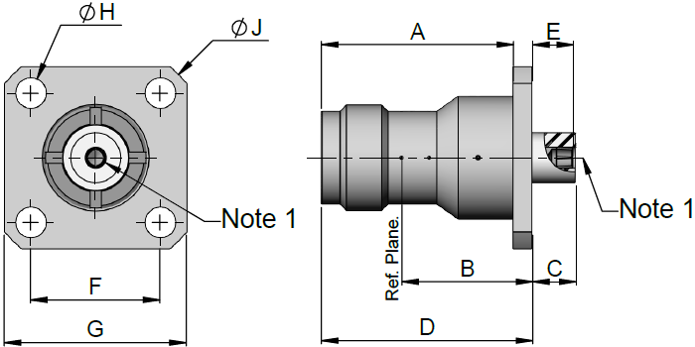  NOTES:  - Accept pin Ø 1.73mm.
  Symbols | Dimensions (mm) |  | Remarks
  Symbols | Min | Max | Remarks
  A | 19.9 | 20.3
  B | 13.6 | 13.8
  C | 4.4 | 4.6
  D | 21.9 | 22.2
  E | 4.15 | 4.35
  F | 13.45 | 13.55
  G | 18.9 | 19.1
  ØH | 3.1 | 3.3 | 4 Holes
  ØJ | 24.3 | 24.6
Electrical Characteristics | Values | Units
Voltage Standing Wave Ratio (VSWR) | ≤ 1.1 + 0.02 x f (GHz) | -
RF Insertion loss | ≤ 0.04 x √f (GHz) | dB
RF Leakage | ≤ -115 + f (GHz) | dBi
Voltage Proof | ≥ 1500 | Vrms
Corona | ≥ P_{co} at 1GHz (see Table 1(b)) | W
Multipaction Threshold (pulse width 20µs; PRF: 1kHz) | ≥ 2000 at 1GHz | Wpp
Mechanical Characteristics | Values | Units
Centre Contact Retention Force (Axial) | ≥ 27.2 | N
Centre Contact Retention Torque (Rotational) | ≥ 2.8 | N.cm
Cable Retention Force (Axial) | Not applicable | N
Cable Retention Torque (Rotational) | Not applicable | N.cm
Weight | ≤ 16 | g
Other Characteristics | Values | Units
Operating Temperature Range | -65 to +165 | °C
Leakage Rate (Panel-sealed Connectors) | Not applicable | -
Leakage Rate (Hermetic Sealed Connector) | Not applicable | -
Solderability | Not Applicable | -
Soldering Proof | Not Applicable | -
Cables used | Not applicable | -

