

Page 1 of 15
DIODE, POWER, SCHOTTKY RECTIFIER
BASED ON TYPES STPS80A150C, STPS60A150C AND STPS40A150C
ESCC Detail Specification No. 5106/023

Issue 8 Draft A | November 2025


Document Custodian: European Space Agency – see https://escies.org

Legal Disclaimer and Copyright
European Space Agency, Copyright © 2025. All rights reserved.
The European Space Agency disclaims any liability or responsibility, to any person or entity, with respect to any loss or damage caused, or alleged to be caused, directly or indirectly by the use and application of this ESCC publication.
This publication, without the prior permission of the European Space Agency and provided that it is not used for a commercial purpose, may be:
- copied in whole, in any medium, without alteration or modification.
- copied in part, in any medium, provided that the ESCC document identification, comprising the ESCC symbol, document number and document issue, is removed.

DOCUMENTATION CHANGE NOTICE
(Refer to https://escies.org for ESCC DCR content)
DCR No. | CHANGE DESCRIPTION
tba | Specification upissued to incorporate changes per DCR.

TABLE OF CONTENTS
1 General 5
1.1 SCOPE 5
1.2 APPLICABLE DOCUMENTS 5
1.3 TERMS, DEFINITIONS, ABBREVIATIONS, SYMBOLS AND UNITS 5
1.4 THE ESCC COMPONENT NUMBER AND COMPONENT TYPE VARIANTS 5
1.4.1 The ESCC Component Number 5
1.4.2 Component Type Variants 5
1.5 MAXIMUM RATINGS 6
1.6 HANDLING PRECAUTIONS 7
1.7 PHYSICAL DIMENSIONS AND TERMINAL IDENTIFICATION 7
1.7.1 Surface Mount Package (SMD.5) - 3 Terminal (Variants 01, 02, 05, 06) 7
1.7.2 Metal Flange Mount Package (TO-254AA) - 3 Lead (Variants 03, 04) 8
1.7.3 Notes to Para. 1.7 Physical Dimensions and Terminal Identification 9
1.8 FUNCTIONAL DIAGRAM 9
1.9 MATERIALS AND FINISHES 9
2 REQUIREMENTS 10
2.1 GENERAL 10
2.1.1 Deviations from the Generic Specification 10
2.2 MARKING 10
2.3 CASE ISOLATION 10
2.4 TERMINAL STRENGTH 10
2.5 ELECTRICAL MEASUREMENTS AT ROOM, HIGH AND LOW TEMPERATURES 10
2.5.1 Room Temperature Electrical Measurements 11
2.5.2 High and Low Temperatures Electrical Measurements 12
2.5.3 Notes to Electrical Measurements Tables 12
2.6 PARAMETER DRIFT VALUES 13
2.7 INTERMEDIATE AND END-POINT ELECTRICAL MEASUREMENTS 14
2.8 HIGH TEMPERATURE REVERSE BIAS BURN-IN CONDITIONS 14
2.9 POWER BURN-IN CONDITIONS 14
2.10 OPERATING LIFE CONDITIONS 14
Appendix A 15

General

SCOPE
This specification details the ratings, physical and electrical characteristics and test and inspection data for the component type variants and/or the range of components specified below. It supplements the requirements of, and shall be read in conjunction with, the ESCC Generic Specification listed under Applicable Documents.

APPLICABLE DOCUMENTS
The following documents form part of this specification and shall be read in conjunction with it:
          - ESCC Generic Specification No. 5000
          - MIL-STD-750, Test Methods and Procedures for Semiconductor Devices

TERMS, DEFINITIONS, ABBREVIATIONS, SYMBOLS AND UNITS
For the purpose of this specification, the terms, definitions, abbreviations, symbols and units specified in ESCC Basic Specification No. 21300 shall apply.

THE ESCC COMPONENT NUMBER AND COMPONENT TYPE VARIANTS

The ESCC Component Number
The ESCC Component Number shall be constituted as follows:
Example: 510602301
- Detail Specification Reference: 5106023
- Component Type Variant Number: 01 (as required)

Component Type Variants
The component type variants applicable to this specification are as follows:
Variant Number | Based on Type | Case | Average Output Rectified Current per Device (I_{O})  (A) | Description | Lead/Terminal Material and Finish | Weight  Max  (g)
01 | STPS80A150C | SMD.5 | 80 | Dual diode, common cathode | Q14 | 0.92
02 | STPS60A150C | SMD.5 | 60 | Dual diode, common cathode | Q14 | 0.92
03 | STPS40A150C | TO-254AA | 40 | Dual diode, common cathode | S14 | 9.4
04 | STPS40A150C | TO-254AA | 40 | Dual diode, common cathode | S4 | 9.4
05 | STPS80A150C | SMD.5 | 80 | Dual diode, common cathode | Q4 | 0.92
06 | STPS60A150C | SMD.5 | 60 | Dual diode, common cathode | Q4 | 0.92
The lead/terminal material and finish shall be in accordance with the requirements of ESCC Basic Specification No. 23500.

MAXIMUM RATINGS
The maximum ratings shall not be exceeded at any time during use or storage.
Maximum ratings shall only be exceeded during testing to the extent specified in this specification and when stipulated in Test Methods and Procedures of the ESCC Generic Specification.
Characteristics | Symbols | Maximum Ratings | Unit | Remarks
Forward Surge Current (per diode)  Variants 01, 02, 05, 06  Variants 03, 04 | I_{FSM} | 190  220 | A | Notes 1, 2
Working Peak Reverse Voltage | V_{RWM} | 150 | V
Repetitive Peak Reverse Voltage | V_{RRM} | 150 | V
Average Output Rectified Current  Variants 01, 05 (per diode)  Variants 01, 05 (per device)  Variants 02, 06 (per diode)  Variants 02, 06 (per device)  Variants 03, 04 (per diode)  Variants 03, 04 (per device) | I_{O} | 40  80  30  60  40  40 | A | Note 3
Operating Temperature Range (Case Temperature) | T_{op} | -65 to +175 | °C
Junction Temperature | T_{j} | +175 | °C | Note 4
Storage Temperature Range | T_{stg} | -65 to +175 | °C
Soldering Temperature | T_{sol} | +245 | °C | Note 5
Thermal Resistance, Junction to Case  Variants 01, 02, 05, 06 (per diode)  Variants 01, 02, 05, 06 (per device)  Variants 03, 04 (per diode)  Variants 03, 04 (per device) | R_{th(j-c)} | 3.4  2.2  1.8  1.3 | °C/W
Thermal Resistance, Junction to Ambient  Variants 01, 02, 05, 06  Variants 03, 04 | R_{th(j-a)} | 95  50 | °C/W | Note 4
NOTES:
            - Sinusoidal pulse of 10ms duration.
            - At T_{amb} ≤ 25°C.
            - For Variants 01, 05 per diode: At T_{case} > +33.5°C, derate linearly to 0A at +175°C.
For Variants 01, 05 per device: At T_{case} > -8°C, derate linearly to 0A at +175°C.
For Variants 02, 06 per diode: At T_{case} > +74°C, derate linearly to 0A at +175°C.
For Variants 02, 06 per device: At T_{case} > +44°C, derate linearly to 0A at +175°C.
For Variants 03, 04 per diode: At T_{case} > +99°C, derate linearly to 0A at +175°C.
For Variants 03, 04 per device: At T_{case} > +126°C, derate linearly to 0A at +175°C.
            - To avoid the risk of thermal runaway of a diode, on its own heatsink, the following condition shall be applied: (dP_{tot}/dT_{j}) < (1/R_{th(j-a)})
            - Duration 5s maximum and the same package shall not be resoldered until 3 minutes have elapsed.

HANDLING PRECAUTIONS
These devices are susceptible to damage by electrostatic discharge. Therefore, suitable precautions shall be employed for protection during all phases of manufacture, testing, packaging, shipment and any handling.
These components are categorised as Class 3 per ESCC Basic Specification No. 23800 with a Minimum Critical Path Failure Voltage of 8kV.
The TO-254AA package contains Beryllium Oxide (BeO) and therefore must not be ground, machined, sandblasted or subjected to any mechanical operation which will produce dust. The case must not be subjected to any chemical process (e.g. etching) which will produce fumes.

PHYSICAL DIMENSIONS AND TERMINAL IDENTIFICATION

Surface Mount Package (SMD.5) - 3 Terminal (Variants 01, 02, 05, 06)
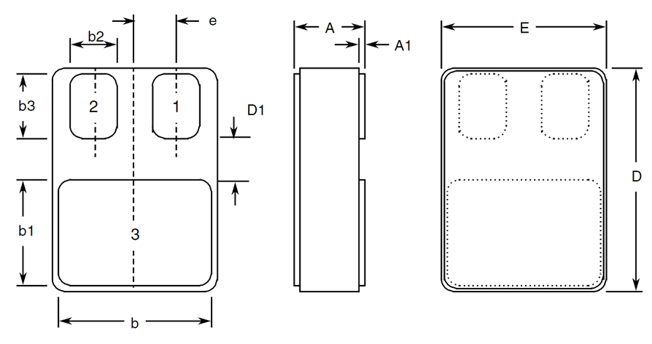
Symbols | Dimensions mm |  | Notes
Symbols | Min | Max | Notes
A | 2.84 | 3.3
A1 | 0.25 | 0.51
b | 7.13 | 7.39
b1 | 5.58 | 5.84
b2 | 2.28 | 2.54 | 2
b3 | 2.92 | 3.18 | 2
D | 10.03 | 10.28
D1 | 0.76 | - | 2
E | 7.39 | 7.64
e | 1.91 BSC |  | 2

Metal Flange Mount Package (TO-254AA) - 3 Lead (Variants 03, 04)
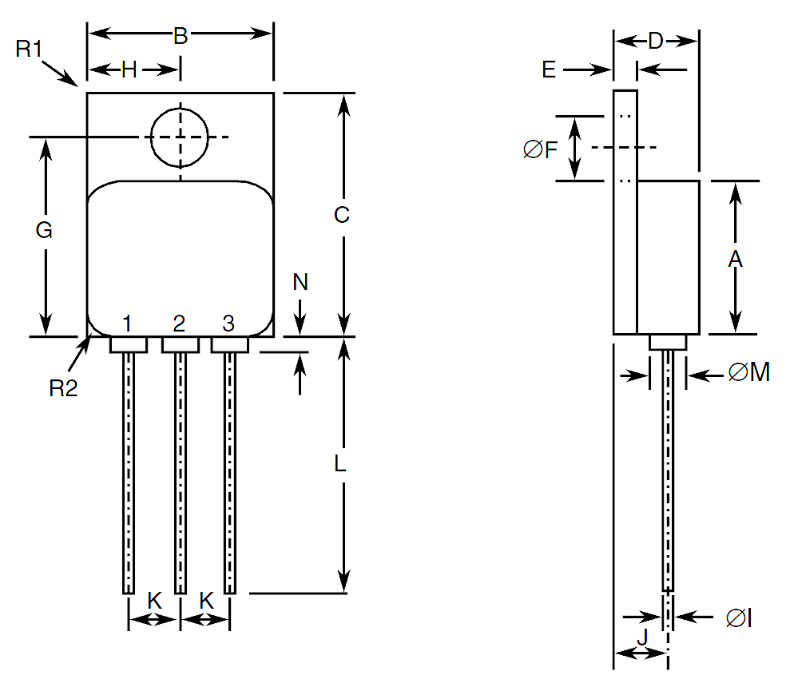
Symbols | Dimensions mm |  | Notes
Symbols | Min | Max | Notes
A | 13.59 | 13.84
B | 13.59 | 13.84
C | 20.07 | 20.32
D | 6.3 | 6.7
E | 1 | 1.35
ØF | 3.5 | 3.9
G | 16.89 | 17.4
H | 6.86 BSC
ØI | 0.89 | 1.14 | 3
J | 3.81 BSC
K | 3.81 BSC
L | 12.95 | 14.5
ØM | 3.05 Typical |  | 3
N | - | 0.71 | 3
R1 | - | 1 | 4
R2 | 1.65 Typical |  | 5

Notes to Para. 1.7 Physical Dimensions and Terminal Identification
            - Terminal identification is specified by the component’s geometry. See Para. 1.8 Functional Diagram for the terminal connections.
            - 2 places.
            - 3 places.
            - Radius of heatsink flange corner, 4 places.
            - Radius of body corner, 4 places.

FUNCTIONAL DIAGRAM
Variants 01, 02, 05, 06
Terminal 1: Anode 1  Terminal 2: Anode 2  Terminal 3: Common cathode | 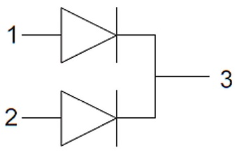
Variants 03, 04
Terminal 1: Anode 1  Terminal 2: Common Cathode  Terminal 3: Anode 2 | 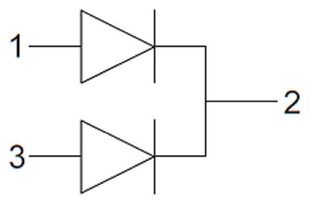
NOTES:
            - For Variants 01, 02, 05, 06 the lid is not connected to any terminal.
            - For Variants 03, 04, the case is not connected to any lead.

MATERIALS AND FINISHES
Materials and finishes shall be as follows:
          - Case
For the surface mount package, the case shall be hermetically sealed and have a ceramic body with a Kovar lid.
For the metal flange mount package the case shall be hermetically sealed and have a metal body. The leads pass through ceramic eyelets brazed into the frame and the lid shall be welded.
          - Lead/Terminal Finish
As specified in Para. 1.4.2 Component Type Variants.

REQUIREMENTS

GENERAL
The complete requirements for procurement of the components specified herein are as stated in this specification and the ESCC Generic Specification. Permitted deviations from the Generic Specification, applicable to this specification only, are listed below.
Permitted deviations from the Generic Specification and this Detail Specification, formally agreed with specific Manufacturers on the basis that the alternative requirements are equivalent to the ESCC requirement and do not affect the component’s reliability, are listed in the appendices attached to this specification.

Deviations from the Generic Specification
None.

MARKING
The marking shall be in accordance with the requirements of ESCC Basic Specification No. 21700 and as follows.
The information to be marked on the component shall be:
          - The ESCC qualified components symbol (for ESCC qualified components only).
          - The ESCC Component Number (see Para. 1.4.1).
          - Traceability information.
          - Warning sign for beryllium oxide (applicable to Variants 03 and 04 only).

CASE ISOLATION
For Variants 03 and 04, Case Isolation shall be performed as specified in the ESCC Generic Specification and as follows:
- Test Conditions:
- Test voltage: 500Vdc
- Duration of application of test voltage: 1s
- Points of application of test voltage: between case metal tab and all terminals connected together.
- Maximum leakage current: 10nA

TERMINAL STRENGTH
For Variants 03 and 04, the test conditions for Terminal Strength, tested as specified in the ESCC Generic Specification, shall be as follows:
- Test Condition: A, tension, with an applied force of 10N for a duration of 10s.

ELECTRICAL MEASUREMENTS AT ROOM, HIGH AND LOW TEMPERATURES
Electrical measurements shall be performed at room, high and low temperatures. Consolidated notes are given in Para. 2.5.3.

Room Temperature Electrical Measurements
The measurements shall be performed at T_{amb} = +25 ±3°C.
Characteristics | Symbols | MIL-STD-750  Test Method | Test Conditions  Note 1 | Limits |  | Units
 |  |  |  | Min | Max | Units
Reverse Current | I_{R} | 4016 | DC Method, V_{R} = 150V | - | 14 | µA
Forward Voltage 1 | V_{F1} | 4011 | I_{F} = 5A, Note 2 | - | 0.78 | V
Forward Voltage 2 | V_{F2} | 4011 | I_{F} = 10A, Note 2 | - | 0.85 | V
Forward Voltage 3 | V_{F3} | 4011 | I_{F} = 20A, Note 2  Variants 01, 02, 05, 06  Variants 03, 04 | -  - | 0.93  0.94 | V
Forward Voltage 4 | V_{F4} | 4011 | I_{F} = 30A, Note 2  Variants 01, 02, 05, 06  Variants 03, 04 | -  - | 0.99  1 | V
Forward Voltage 5 | V_{F5} | 4011 | I_{F} = 40A, Note 2  Variants 01, 05  Variants 03, 04 | -  - | 1.04  1.05 | V
Capacitance | C | 4001 | V_{R} = 10V  V_{sig} = 30mV (p-p) max  f = 1MHz | - | 310 | pF
Critical Rate of Rise of Reverse Voltage | dV/dt | - | Note 3 | - | 10000 | V/µs
Thermal Impedance, Junction to Case | Z_{th(j-c)} | 3101 | Note 4 | ΔV_{F}, Note 5 |  | °C/W

High and Low Temperatures Electrical Measurements
Characteristics | Symbols | MIL-STD-750  Test Method | Test Conditions  Notes 1 and 6 | Limits |  | Units
 |  |  |  | Min | Max | Units
Reverse Current | I_{R} | 4016 | T_{amb} = +125 (+0 -5) °C  DC Method, V_{R} = 150V | - | 8 | mA
Forward Voltage 1 | V_{F1} | 4011 | T_{amb} = +125 (+0 -5) °C I_{F} = 5A, Note 2 | - | 0.62 | V
Forward Voltage 1 | V_{F1} | 4011 | T_{amb} = -55 (+5 -0) °C  I_{F} = 5A, Note 2 | - | 0.84 | V
Forward Voltage 2 | V_{F2} | 4011 | T_{amb} = +125 (+0 -5) °C I_{F} = 10A, Note 2  Variants 01, 02, 05, 06  Variants 03, 04 | -  - | 0.69  0.7 | V
Forward Voltage 2 | V_{F2} | 4011 | T_{amb} = -55 (+5 -0) °C  I_{F} = 10A, Note 2  Variants 01, 02, 05, 06  Variants 03, 04 | -  - | 1.03  1.04 | V
Forward Voltage 3 | V_{F3} | 4011 | T_{amb} = +125 (+0 -5) °C I_{F} = 20A, Note 2  Variants 01, 02, 05, 06  Variants 03, 04 | -  - | 0.78  0.79 | V
Forward Voltage 3 | V_{F3} | 4011 | T_{amb} = -55 (+5 -0) °C  I_{F} = 20A, Note 2  Variants 01, 02, 05, 06  Variants 03, 04 | -  - | 1.435  1.455 | V
Forward Voltage 4 | V_{F4} | 4011 | T_{amb} = +125 (+0 -5) °C I_{F} = 30A, Note 2  Variants 01, 02, 05, 06  Variants 03, 04 | -  - | 0.83  0.85 | V
Forward Voltage 4 | V_{F4} | 4011 | T_{amb} = -55 (+5 -0) °C  I_{F} = 30A, Note 2  Variants 01, 02, 05, 06  Variants 03, 04 | -  - | 1.87  1.89 | V
Forward Voltage 5 | V_{F5} | 4011 | T_{amb} = +125 (+0 -5) °C I_{F} = 40A, Note 2  Variants 01, 05  Variants 03, 04 | -  - | 0.88  0.91 | V
Forward Voltage 5 | V_{F5} | 4011 | T_{amb} = -55 (+5 -0) °C  I_{F} = 40A, Note 2  Variants 01, 05  Variants 03, 04 | -  - | 2.33  2.37 | V

Notes to Electrical Measurements Tables
            - Measurement per each diode.
            - Pulsed measurement: Pulse Width ≤ 680µs, Duty Cycle ≤ 2%.
            - Turn-off rate from a stationary state with no conduction. Reverse voltage < V_{RWM}
            - Performed only during Screening Tests Parameter Drift Values (Initial Measurements), go-no-go.
            - The limits for ΔV_{F} shall be defined by the Manufacturer on every lot in accordance with MIL-STD-750 Method 3101 and shall guarantee the R_{th(j-c)} limits specified in Para. 1.5 Maximum Ratings.
            - Read and record measurements shall be performed on a sample of 5 components with 0 failures allowed. Alternatively a 100% inspection may be performed.

PARAMETER DRIFT VALUES
Unless otherwise specified, the measurements shall be performed at T_{amb} = +25 ±3°C.
The test methods and test conditions shall be as per the corresponding test defined in Para. 2.5.1, Room Temperature Electrical Measurements.
The drift values (Δ) shall not be exceeded for each characteristic specified. The corresponding absolute limit values for each characteristic shall not be exceeded.
Characteristics | Symbols | Limits |  |  | Units
Characteristics | Symbols | Drift  Value  Δ | Absolute |  | Units
Characteristics | Symbols | Drift  Value  Δ | Min | Max | Units
Reverse Current | I_{R} | ±5  or (1) ±100% | - | 14 | µA
Forward Voltage 1 | V_{F1} | ±0.05 | - | 0.78 | V
Forward Voltage 2 | V_{F2} | ±0.05 | - | 0.85 | V
Forward Voltage 3  Variants 01, 02, 05, 06  Variants 03, 04 | V_{F3} | ±0.05 | -  - | 0.93  0.94 | V
Forward Voltage 4  Variants 01, 02, 05, 06  Variants 03, 04 | V_{F4} | ±0.05 | -  - | 0.99  1 | V
Forward Voltage 5  Variants 01, 05  Variants 03, 04 | V_{F5} | ±0.05 | -  - | 1.04  1.05 | V
NOTES:
            - Whichever is the greater referred to the initial value.

INTERMEDIATE AND END-POINT ELECTRICAL MEASUREMENTS
Unless otherwise specified, the measurements shall be performed at T_{amb} = +25 ±3°C.
The test methods and test conditions shall be as per the corresponding test defined in Para. 2.5.1, Room Temperature Electrical Measurements.
The drift values (Δ) shall not be exceeded for each characteristic specified. The corresponding absolute limit values for each characteristic shall not be exceeded.
Characteristics | Symbols | Limits |  | Units
Characteristics | Symbols | Min | Max | Units
Reverse Current | I_{R} | - | 14 | µA
Forward Voltage 1 | V_{F1} | - | 0.78 | V
Forward Voltage 2 | V_{F2} | - | 0.85 | V
Forward Voltage 3  Variants 01, 02, 05, 06  Variants 03, 04 | V_{F3} | -  - | 0.93  0.94 | V
Forward Voltage 4  Variants 01, 02, 05, 06  Variants 03, 04 | V_{F4} | -  - | 0.99  1 | V
Forward Voltage 5  Variants 01, 05  Variants 03, 04 | V_{F5} | -  - | 1.04  1.05 | V

HIGH TEMPERATURE REVERSE BIAS BURN-IN CONDITIONS
Characteristics | Symbols | Test Conditions | Units
Ambient Temperature | T_{amb} | +80 (+0 -5) | °C
Reverse Voltage | V_{R} | 120 | V
Duration | t | ≥ 48 | Hours

POWER BURN-IN CONDITIONS
Characteristics | Symbols | Test Conditions | Units
Ambient Temperature | T_{amb} | +25 (+0 -5) | °C
Junction Temperature | T_{J} | +175 (+0 -5) | °C
Average Output Rectified Current | I_{O} | Note 1 | A
Duration | t | ≥ 168 | Hours
NOTES:
            - The output current may be adjusted, within the given limit range, to attain the specified junction temperature.

OPERATING LIFE CONDITIONS
The conditions shall be as specified in Para. 2.9, Power Burn-in Conditions.

Appendix A
Agreed deviations for STMICROELECTRONICS (F)
ITEMS AFFECTED | DESCRIPTION OF DEVIATIONS
Para. 2.1.1, Deviations from the Generic Specification: Para. 8, Test Methods and Procedures | For qualification and qualification maintenance, or procurement of qualified or unqualified components, the following replacement test method specifications shall be used instead of the following ESCC Basic Specifications:  - No. 20400, Internal Visual Inspection: replaced by MIL-STD-750 Test Method 2078.  - No. 20500, External Visual Inspection: replaced by MIL-STD-750 Test Method 2071.  No. 20900, Radiographic Inspection of Electronic Components: replaced by MIL-STD-750 Test Method 2076.
Para. 2.1.1, Deviations from the Generic Specification: Deviations from Production Control – Chart F2 | Special In-Process Controls - Internal Visual Inspection: Wedge bonds equal to 1.1 wire diameter are acceptable for bonding with a V-Groove tool.
Para. 2.1.1, Deviations from the Generic Specification: Deviations from Screening Tests for Packaged Components – Chart F3A | Solderability: Solderability is not applicable unless specifically stipulated in the Purchase Order.
Room Temperature Electrical Measurements: Capacitance and Critical Rate of Rise of Reverse Voltage may be considered guaranteed but not tested if successful pilot lot testing has been performed in accordance with STMicroelectronics “Acceptation wafers” internal procedure as specified in the PID, which includes AC characteristic measurements per the Detail Specification.
A summary of the pilot lot testing shall be provided if required by the Purchase Order.
ADDITIONAL DATA – STMICROELECTRONICS (F)
          - Derating for Space Application
The derating for space applications was originally obtained on STPS60A150 devices under the following test conditions. A Post-Irradiation Gate Stress (PIGS) test has been done after irradiation. The testing was performed in a vacuum at UCL (Louvain-la-Neuve, Belgium):
Ions used: Xe and Kr
LET = 62.5 and 32.4MeV/(mg/cm²) respectively
Energy = 995 and 769MeV resp.
Range = 73.1 and 94.2 µm(Si) respectively
These components are susceptible to Single Event Burn-out (SEB) if operated in a space environment unless the following derating is applied:
 | V_{R} (V) | 150 | 127.5 | 85
LET (MeV.cm²/mg) |  | 150 | 127.5 | 85
32.4 |  | OK
62.5 |  | SEB | PIST * | OK
* Test samples found to be out-of-spec for Reverse Leakage Current parameter during Post-Irradiation STress testing.

