

Page 1 of 12
DIODES, POWER RECTIFIER, SCHOTTKY BARRIER
BASED ON TYPE STPS1045
ESCC Detail Specification No. 5106/017

Issue 8 Draft A | November 2025



Document Custodian: European Space Agency – see https://escies.org

Legal Disclaimer and Copyright
European Space Agency, Copyright © 2025. All rights reserved.
The European Space Agency disclaims any liability or responsibility, to any person or entity, with respect to any loss or damage caused, or alleged to be caused, directly or indirectly by the use and application of this ESCC publication.
This publication, without the prior permission of the European Space Agency and provided that it is not used for a commercial purpose, may be:
- copied in whole, in any medium, without alteration or modification.
- copied in part, in any medium, provided that the ESCC document identification, comprising the ESCC symbol, document number and document issue, is removed.

DOCUMENTATION CHANGE NOTICE
(Refer to https://escies.org for ESCC DCR content)
DCR No. | CHANGE DESCRIPTION
tba | Specification updated to incorporate changes per DCR.

TABLE OF CONTENTS
1 General 5
1.1 SCOPE 5
1.2 APPLICABLE DOCUMENTS 5
1.3 TERMS, DEFINITIONS, ABBREVIATIONS, SYMBOLS AND UNITS 5
1.4 THE ESCC COMPONENT NUMBER AND COMPONENT TYPE VARIANTS 5
1.4.1 The ESCC Component Number 5
1.4.2 Component Type Variants 5
1.5 MAXIMUM RATINGS 6
1.6 PHYSICAL DIMENSIONS AND TERMINAL IDENTIFICATION 7
1.6.1 Surface Mount Package (SMD.5) - 3 terminal 7
1.7 FUNCTIONAL DIAGRAM 8
1.8 MATERIALS AND FINISHES 8
2 REQUIREMENTS 8
2.1 GENERAL 8
2.1.1 Deviations from the Generic Specification 8
2.1.1.1 Deviation from Screening Tests - Chart F3 8
2.2 MARKING 9
2.3 ELECTRICAL MEASUREMENTS AT ROOM, HIGH AND LOW TEMPERATURES 9
2.3.1 Room Temperature Electrical Measurements 9
2.3.2 High and Low Temperatures Electrical Measurements 10
2.3.3 Notes to Electrical Measurement Tables 10
2.4 PARAMETER DRIFT VALUES 11
2.5 INTERMEDIATE AND END-POINT ELECTRICAL MEASUREMENTS 11
2.6 POWER BURN-IN CONDITIONS 11
2.7 OPERATING LIFE CONDITIONS 11
APPENDIX ‘A’ 12

General

SCOPE
This specification details the ratings, physical and electrical characteristics and test and inspection data for the component type variants and/or the range of components specified below. It supplements the requirements of, and shall be read in conjunction with, the ESCC Generic Specification listed under Applicable Documents.

APPLICABLE DOCUMENTS
The following documents form part of this specification and shall be read in conjunction with it:
          - ESCC Generic Specification No. 5000
          - MIL-STD-750, Test Methods and Procedures for Semiconductor Devices

TERMS, DEFINITIONS, ABBREVIATIONS, SYMBOLS AND UNITS
For the purpose of this specification, the terms, definitions, abbreviations, symbols and units specified in ESCC Basic Specification No. 21300 shall apply.

THE ESCC COMPONENT NUMBER AND COMPONENT TYPE VARIANTS

The ESCC Component Number
The ESCC Component Number shall be constituted as follows:
Example: 510601701
- Detail Specification Reference: 5106017
- Component Type Variant Number: 01 (as required)

Component Type Variants
The component type variants applicable to this specification are as follows:
Variant Number | Based on Type | Case | Description | Terminal Material and Finish | Weight  max g
01 | STPS1045 | SMD.5 | Single diode | Q14 | 2
02 | STPS1045 | SMD.5 | Dual diode, common cathode | Q14 | 2
The terminal material and finish shall be in accordance with the requirements of ESCC Basic Specification No. 23500.

MAXIMUM RATINGS
The maximum ratings shall not be exceeded at any time during use or storage.
Maximum ratings shall only be exceeded during testing to the extent specified in this specification and when stipulated in Test Methods and Procedures of the ESCC Generic Specification.
Characteristics | Symbols | Maximum Ratings | Unit | Remarks
Forward Surge Current (per Diode) | I_{FSM} | 200 | A | Note 1
Repetitive Peak Reverse Voltage | V_{RRM} | 45 | V | Note 2
Repetitive Peak Reverse Current | I_{RRM} | 1 | A | Note 3
Average Output Rectified Current  Variants 01 and 02 (per Diode)  Variant 02 (per Device) | I_{O} | 10  20 | A | 50% Duty Cycle Notes 4, 7
RMS Forward Current (per Diode) | I_{F(rms)} | 15 | A
Operating Temperature Range (Case Temperature) | T_{op} | -65 to +175 | °C
Junction Temperature | T_{J} | +175 | °C
Storage Temperature Range | T_{stg} | -65 to +175 | °C
Soldering Temperature | T_{sol} | +245 | °C | Note 5
Critical Rate of Rise of  Reverse Voltage | dV/dt | 10000 | V/µs
Thermal Resistance,  Junction to Case  Variant 01 and 02 (per Diode)  Variant 02 (per Device) | R_{th(j-c)} | 2.8  1.6 | °C/W | Notes 6, 7
NOTES:
            - Sinusoidal pulse of 10ms duration.
            - Pulsed, duration 5ms, f = 50Hz.
            - Pulsed, duration 2µs, f = 1kHz.
            - For Variants 01 and 02 per Diode at T_{case} > +154°C, or Variant 02 per Device at T_{case} > +151°C, derate linearly to 0A at +175°C.
            - Duration 5 seconds maximum and the same package shall not be resoldered until 3 minutes have elapsed.
            - Package mounted on infinite heatsink.
            - For Variant 02 the “per Device” ratings apply only when both anode terminals are tied together.

PHYSICAL DIMENSIONS AND TERMINAL IDENTIFICATION

Surface Mount Package (SMD.5) - 3 terminal
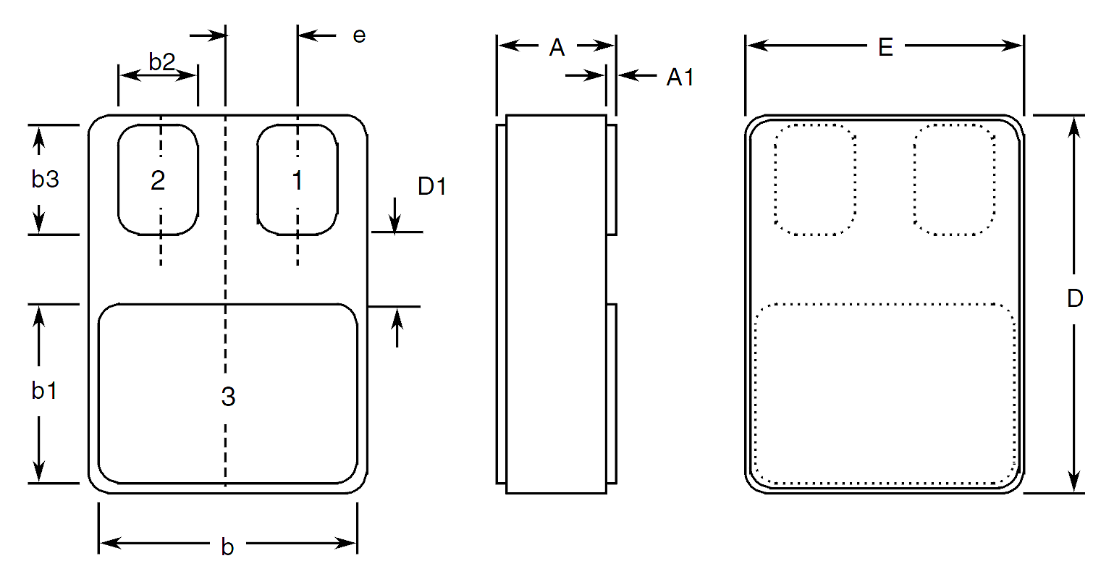
Symbols | Dimensions mm |  | Notes
Symbols | Min | Max | Notes
A | 2.84 | 3.3
A1 | 0.25 | 0.51
b | 7.13 | 7.39
b1 | 5.58 | 5.84
b2 | 2.28 | 2.54 | 5
b3 | 2.92 | 3.18 | 5
D | 10.03 | 10.28
D1 | 0.76 | - | 5
E | 7.39 | 7.64
e | 1.91 BSC |  | 5
NOTES:
            - The terminal identification is specified by the component’s geometry. See Para. 1.7 Functional Diagram for the terminal connections.
            - 2 places.

FUNCTIONAL DIAGRAM
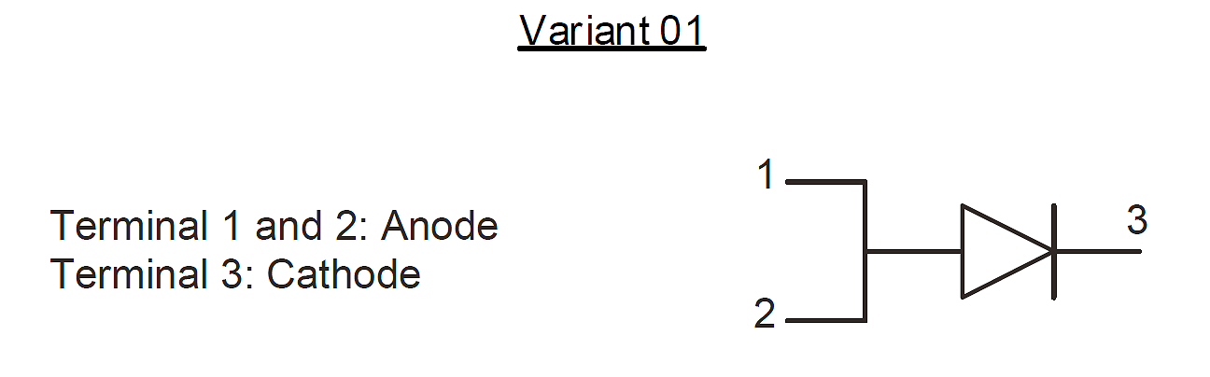
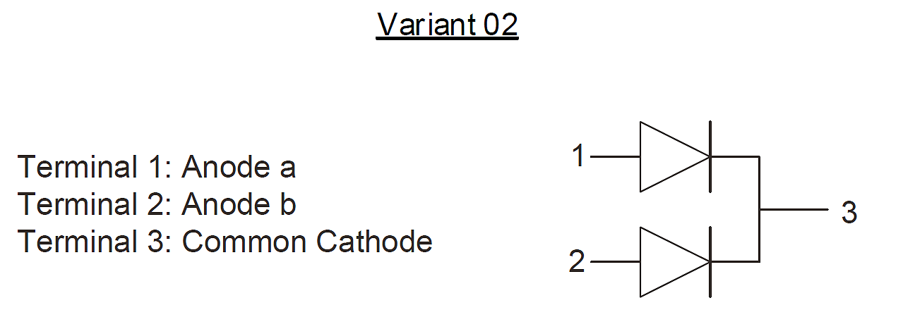
NOTES:
            - The lid is not connected to any terminal.

MATERIALS AND FINISHES
Materials and finishes shall be as follows:
          - Case
The case shall be hermetically sealed and have a ceramic body with a Kovar lid.
          - Terminals
As specified in Para. 1.4.2.

REQUIREMENTS

GENERAL
The complete requirements for procurement of the components specified herein are as stated in this specification and the ESCC Generic Specification. Permitted deviations from the Generic Specification, applicable to this specification only, are listed below.
Permitted deviations from the Generic Specification and this Detail Specification, formally agreed with specific Manufacturers on the basis that the alternative requirements are equivalent to the ESCC requirement and do not affect the component’s reliability, are listed in the appendices attached to this specification.

Deviations from the Generic Specification

Deviation from Screening Tests - Chart F3
          - High Temperature Reverse Bias Burn-in and the subsequent Final Measurements for HTRB shall be omitted.

MARKING
The marking shall be in accordance with the requirements of ESCC Basic Specification No. 21700 and as follows.
The information to be marked on the component shall be:
          - The ESCC qualified components symbol (for ESCC qualified components only).
          - The ESCC Component Number (see Para. 1.4.1).
          - Traceability information.

ELECTRICAL MEASUREMENTS AT ROOM, HIGH AND LOW TEMPERATURES
Electrical measurements shall be performed at room, high and low temperatures. Consolidated notes are given in Para. 2.3.3.

Room Temperature Electrical Measurements
The measurements shall be performed at T_{amb} = +22 ±3°C.
Characteristics | Symbols | MIL-STD-750  Test Method | Test Conditions  Note 1 | Limits |  | Units
 |  |  |  | Min | Max | Units
Reverse Current | I_{R} | 4016 | DC Method  V_{R} = 45V | - | 100 | µA
Forward Voltage | V_{F1} | 4011 | Pulse Method  I_{F} = 3A, Note 2 | - | 620 | mV
Forward Voltage | V_{F2} | 4011 | Pulse Method  I_{F} = 10A, Note 2 | - | 750 | mV
Forward Voltage | V_{F3} | 4011 | Pulse Method  I_{F} = 20A, Note 2 | - | 880 | mV
Capacitance | C | 4001 | V_{R} = 5V  f = 1MHz | - | 500 | pF
Thermal Impedance, Junction to Case | Z_{th(j-c)} | 3101 | I_{H} = 15 to 40A  t_{H} = 50ms  I_{M} = 50mA  t_{md} = 100µs  Note 3 | (Calculate ΔV_{F}, see Note 4) |  | °C/W

High and Low Temperatures Electrical Measurements
Characteristics | Symbols | MIL-STD-750  Test Method | Test Conditions  Notes 1 and 5 | Limits |  | Units
 |  |  |  | Min | Max | Units
Reverse Current | I_{R} | 4016 | T_{case} = +125 (+0 -5)°C  DC Method  V_{R} = 45V | - | 15 | mA
Forward Voltage | V_{F1} | 4011 | T_{case} = +125 (+0 -5)°C  Pulse Method  I_{F} = 3A, Note 3 | - | 570 | mV
Forward Voltage | V_{F2} | 4011 | T_{case} = +125 (+0 -5)°C  Pulse Method  I_{F} = 10A, Note 3 | - | 700 | mV
Forward Voltage | V_{F2} | 4011 | T_{case} = -55 (+5 -0)°C  Pulse Method  I_{F} = 10A, Note 3 | - | 850 | mV
Forward Voltage | V_{F3} | 4011 | T_{case} = +125 (+0 -5)°C  Pulse Method  I_{F} = 20A, Note 3 | - | 800 | mV

Notes to Electrical Measurement Tables
            - Measurement per each diode.
            - Pulse Width ≤ 680µs, Duty Cycle ≤ 2%.
            - Performed only during Screening Tests Parameter Drift Values (Initial Measurements), go-no-go.
            - The limits for ΔV_{F} shall be defined by the Manufacturer on every lot in accordance with MIL-STD-750 Method 3101 and shall guarantee the R_{th(j-c)} limits specified in Para. 1.5 Maximum Ratings.
            - Read and record measurements shall be performed on a sample of 5 components with 0 failures allowed. Alternatively a 100% inspection may be performed.

PARAMETER DRIFT VALUES
Unless otherwise specified, the measurements shall be performed at T_{amb} = +22 ±3°C.
The test methods and test conditions shall be as per the corresponding test defined in Para. 2.3.1, Room Temperature Electrical Measurements.
The drift values (Δ) shall not be exceeded for each characteristic specified. The corresponding absolute limit values for each characteristic shall not be exceeded.
Characteristics | Symbols | Limits |  |  | Units
Characteristics | Symbols | Drift  Value  Δ | Absolute |  | Units
Characteristics | Symbols | Drift  Value  Δ | Min | Max | Units
Reverse Current | I_{R} | ±25  or (1) ±100% | - | 100 | µA
Forward Voltage | V_{F1} | ±50 | - | 620 | mV
Forward Voltage | V_{F3} | ±50 | - | 880 | mV
NOTES:
            - Whichever is the greater referred to the initial value.

INTERMEDIATE AND END-POINT ELECTRICAL MEASUREMENTS
Unless otherwise specified, the measurements shall be performed at T_{amb} = +22 ±3°C.
The test methods and test conditions shall be as per the corresponding test defined in Para. 2.3.1, Room Temperature Electrical Measurements.
The limit values for each characteristic shall not be exceeded.
Characteristics | Symbols | Limits |  | Units
Characteristics | Symbols | Min | Max | Units
Reverse Current | I_{R} | - | 100 | µA
Forward Voltage | V_{F1} | - | 620 | mV
Forward Voltage | V_{F2} | - | 750 | mV
Forward Voltage | V_{F3} | - | 880 | mV

POWER BURN-IN CONDITIONS
Characteristics | Symbols | Test Conditions | Units
Case Temperature | T_{case} | +125 | °C
Reverse Voltage | V_{R} | 36 | V

OPERATING LIFE CONDITIONS
The conditions shall be as specified in Para. 2.6 Power Burn-in Conditions.

APPENDIX ‘A’
AGREED DEVIATIONS FOR STMICROELECTRONICS (F)
ITEMS AFFECTED | DESCRIPTION OF DEVIATIONS
Para. 2.1.1, Deviations from the Generic Specification: Para. 8, Test Methods and Procedures | For qualification and qualification maintenance, or procurement of qualified or unqualified components, the following replacement test method specifications shall be used instead of the following ESCC Basic Specifications:  - No. 20400, Internal Visual Inspection: replaced by MIL-STD-750 Test Method 2078.  - No. 20500, External Visual Inspection: replaced by MIL-STD-750 Test Method 2071.  - No. 20900, Radiographic Inspection of Electronic Components: replaced by MIL-STD-750 Test Method 2076.
Para. 2.1.1, Deviations from the Generic Specification: Deviations from Production Control - Chart F2 | Special In-Process Controls - Internal Visual Inspection.  Wedge bonds equal to 1.1 wire diameter are acceptable for bonding with a V-Groove tool.
Para. 2.1.1.1, Deviations from the Generic Specification: Deviations from Screening Tests - Chart F3 | Solderability is not applicable unless specifically stipulated in the Purchase Order.

