

Page 1 of 16
DIODES, POWER RECTIFIER, SCHOTTKY BARRIER
BASED ON TYPE STPS20100
ESCC Detail Specification No. 5106/016

Issue 11 Draft A | November 2025



Document Custodian: European Space Agency – see https://escies.org

Legal Disclaimer and Copyright
European Space Agency, Copyright © 2025. All rights reserved.
The European Space Agency disclaims any liability or responsibility, to any person or entity, with respect to any loss or damage caused, or alleged to be caused, directly or indirectly by the use and application of this ESCC publication.
This publication, without the prior permission of the European Space Agency and provided that it is not used for a commercial purpose, may be:
- copied in whole, in any medium, without alteration or modification.
- copied in part, in any medium, provided that the ESCC document identification, comprising the ESCC symbol, document number and document issue, is removed.

DOCUMENTATION CHANGE NOTICE
(Refer to https://escies.org for ESCC DCR content)
DCR No. | CHANGE DESCRIPTION
tba | Specification updated to incorporate changes per DCR.

TABLE OF CONTENTS
1 General 5
1.1 SCOPE 5
1.2 APPLICABLE DOCUMENTS 5
1.3 TERMS, DEFINITIONS, ABBREVIATIONS, SYMBOLS AND UNITS 5
1.4 THE ESCC COMPONENT NUMBER AND COMPONENT TYPE VARIANTS 5
1.4.1 The ESCC Component Number 5
1.4.2 Component Type Variants 5
1.5 MAXIMUM RATINGS 6
1.6 HANDLING PRECAUTIONS 7
1.7 PHYSICAL DIMENSIONS AND TERMINAL IDENTIFICATION 8
1.7.1 Metal Flange Mount Package (TO-254) - 3 lead 8
1.7.2 Surface Mount Package (SMD.5) - 3 terminal 9
1.7.3 Surface Mount Package (SMD1) - 3 terminal 10
1.7.4 Notes to Physical Dimensions and Terminal Identification 10
1.8 FUNCTIONAL DIAGRAM 11
1.9 MATERIALS AND FINISHES 12
2 REQUIREMENTS 12
2.1 GENERAL 12
2.1.1 Deviations from the Generic Specification 12
2.1.1.1 Deviation from Screening Tests - Chart F3 12
2.2 MARKING 12
2.3 CASE ISOLATION 12
2.4 TERMINAL STRENGTH 13
2.5 ELECTRICAL MEASUREMENTS AT ROOM, HIGH AND LOW TEMPERATURES 13
2.5.1 Room Temperature Electrical Measurements 13
2.5.2 High and Low Temperatures Electrical Measurements 13
2.5.3 Notes to Electrical Measurement Tables 14
2.6 PARAMETER DRIFT VALUES 14
2.7 INTERMEDIATE AND END-POINT ELECTRICAL MEASUREMENTS 14
2.8 POWER BURN-IN CONDITIONS 15
2.9 OPERATING LIFE CONDITIONS 15
APPENDIX ‘A’ 16

General

SCOPE
This specification details the ratings, physical and electrical characteristics and test and inspection data for the component type variants and/or the range of components specified below. It supplements the requirements of, and shall be read in conjunction with, the ESCC Generic Specification listed under Applicable Documents.

APPLICABLE DOCUMENTS
The following documents form part of this specification and shall be read in conjunction with it:
          - ESCC Generic Specification No. 5000
          - MIL-STD-750, Test Methods and Procedures for Semiconductor Devices

TERMS, DEFINITIONS, ABBREVIATIONS, SYMBOLS AND UNITS
For the purpose of this specification, the terms, definitions, abbreviations, symbols and units specified in ESCC Basic Specification No. 21300 shall apply.

THE ESCC COMPONENT NUMBER AND COMPONENT TYPE VARIANTS

The ESCC Component Number
The ESCC Component Number shall be constituted as follows:
Example: 510601601
- Detail Specification Reference: 5106016
- Component Type Variant Number: 01 (as required)

Component Type Variants
The component type variants applicable to this specification are as follows:
Variant Number | Based on Type | Case | Description | Lead/Terminal Material and Finish | Weight  max g
01 | STPS20100 | TO-254 | Single diode | H9 | 10
02 | STPS20100 | TO-254 | Dual diode, common anode | H9 | 10
03 | STPS20100 | TO-254 | Dual diode, common cathode | H9 | 10
04 | STPS20100 | TO-254 | Dual diode, series, centre tapped | H9 | 10
05 | STPS20100 | SMD.5 | Single diode | Q14 | 2
06 | STPS20100 | SMD1 | Single diode | Q14 | 3
07 | STPS20100 | SMD1 | Dual diode, common cathode | Q14 | 3
08 | STPS20100 | TO-254 | Dual diode, common anode | H14 | 10
09 | STPS20100 | TO-254 | Dual diode, common anode | H4 | 10
10 | STPS20100 | TO-254 | Dual diode, common cathode | H14 | 10
11 | STPS20100 | TO-254 | Dual diode, common cathode | H4 | 10
The lead/terminal material and finish shall be in accordance with the requirements of ESCC Basic Specification No. 23500.

MAXIMUM RATINGS
The maximum ratings shall not be exceeded at any time during use or storage.
Maximum ratings shall only be exceeded during testing to the extent specified in this specification and when stipulated in Test Methods and Procedures of the ESCC Generic Specification.
Characteristics | Symbols | Maximum Ratings | Unit | Remarks
Forward Surge Current (per  Diode) | I_{FSM} | 250 | A | Note 1
Repetitive Peak Reverse Voltage | V_{RRM} | 100 | V | Note 2
Repetitive Peak Reverse Current | I_{RRM} | 1 | A | Note 3
Average Output Rectified Current | I_{O} |  | A | 50% duty cycle  Notes 4, 9
All Variants (per Diode) |  | 20
Variants 02, 03, 07, 08, 09, 10, 11 (per Device) |  | 40
RMS Forward Current (Per Diode) | I_{F(rms)} | 30 | A
Operating Temperature Range (Case Temperature) | T_{op} | -65 to +175 | °C | Note 5
Junction Temperature | T_{J} | +175 | °C
Storage Temperature Range | T_{stg} | -65 to +175 | °C | Note 5
Soldering Temperature | T_{sol} |  | °C
For TO-254 | T_{sol} | +260 | °C | Note 6
For SMD.5 and SMD1 | T_{sol} | +245 | °C | Note 7
Critical Rate of Rise of Reverse  Voltage | dV/dt | 10000 | V/µs
Thermal Resistance, Junction to Case | R_{th(j-c)} |  | °C/W | Notes 8, 9
Variants 01, 05 and 06 | R_{th(j-c)} | 1.65 | °C/W
Variants 02, 03, 04, 07, 08, 09,10, 11 (per Diode) | R_{th(j-c)} | 1.65 | °C/W
Variants 02, 03, 07, 08, 09, 10, 11 (per Device) | R_{th(j-c)} | 0.85 | °C/W
NOTES:
            - Sinusoidal pulse of 10ms duration.
            - Pulsed, duration 5ms, f = 50Hz.
            - Pulsed, duration 2µs, f = 1kHz.
            - For T_{case} > +140ºC, derate linearly to 0A at +175ºC.
            - For Variants with hot solder dip lead finish all testing performed at T_{amb} > +125ºC shall be carried out in a 100% inert atmosphere.
            - Duration 10 seconds maximum at a distance of not less than 1.5mm from the device body and the same lead shall not be resoldered until 3 minutes have elapsed.
            - Duration 5 seconds maximum and the same package shall not be resoldered until 3 minutes have elapsed.
            - Package mounted on infinite heatsink.
            - The “per Device” ratings apply only as follows:
Variant 02, 08 and 09: when both cathode terminals are tied together.
Variants 03, 07, 10 and 11: when both anode terminals are tied together.

HANDLING PRECAUTIONS
The TO-254 package contains Beryllium Oxide (BeO) and therefore it must not be ground, machined, sandblasted or subjected to any mechanical operation which will produce dust. The case must not be subjected to any chemical process (e.g. etching) which will produce fumes.

PHYSICAL DIMENSIONS AND TERMINAL IDENTIFICATION
Consolidated Notes are given in Para. 1.7.4.

Metal Flange Mount Package (TO-254) - 3 lead
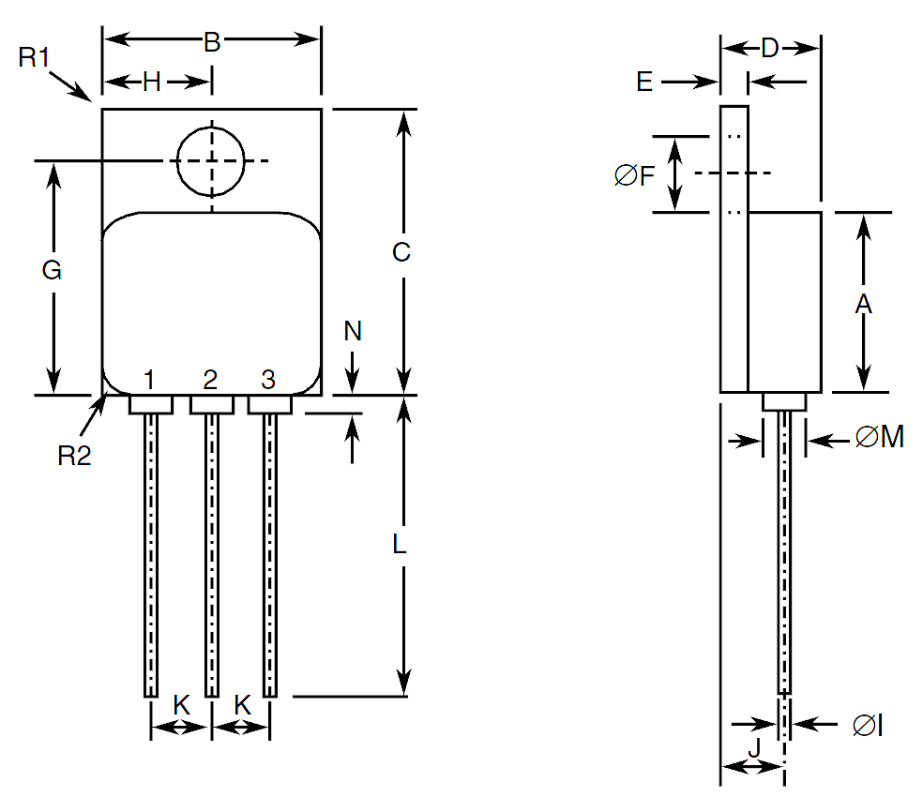
Symbols | Dimensions mm |  | Notes
Symbols | Min | Max | Notes
A | 13.59 | 13.84
B | 13.59 | 13.84
C | 20.07 | 20.32
D | 6.3 | 6.7
E | 1 | 1.35
ØF | 3.5 | 3.9
G | 16.89 | 17.4
H | 6.86 BSC
ØI | 0.89 | 1.14 | 2
J | 3.81 BSC
K | 3.81 BSC
L | 12.95 | 14.5
ØM | 3.05 Typical |  | 2
N | - | 0.71 | 2
R1 | - | 1 | 3
R2 | 1.65 Typical |  | 4

Surface Mount Package (SMD.5) - 3 terminal
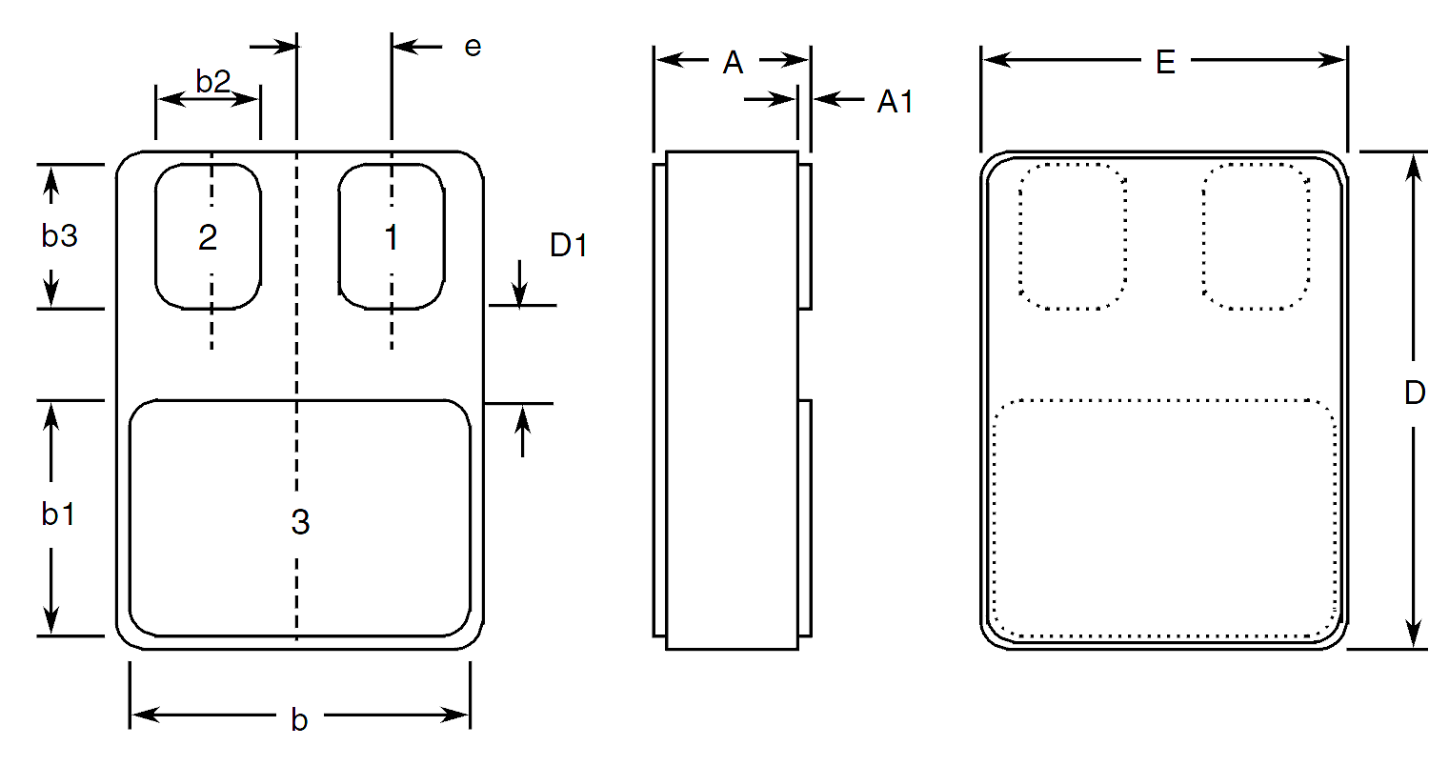
Symbols | Dimensions mm |  | Notes
Symbols | Min | Max | Notes
A | 2.84 | 3.3
A1 | 0.25 | 0.51
b | 7.13 | 7.39
b1 | 5.58 | 5.84
b2 | 2.28 | 2.54 | 5
b3 | 2.92 | 3.18 | 5
D | 10.03 | 10.28
D1 | 0.76 | - | 5
E | 7.39 | 7.64
e | 1.91 BSC |  | 5

Surface Mount Package (SMD1) - 3 terminal
Symbols | Dimensions mm |  | Notes
Symbols | Min | Max | Notes
A | 3.3 | 3.61
A1 | 0.25 | 0.51
b | 9.4 | 9.65
b1 | 10.41 | 10.67
b2 | 3.43 | 3.68 | 5
b3 | 3.86 | 4.11 | 5
D | 15.75 | 16
D1 | 0.76 | - | 5
E | 11.3 | 11.56
e | 2.67 BSC |  | 5

Notes to Physical Dimensions and Terminal Identification
            - The terminal identification is specified by the component’s geometry. See Para. 1.8 Functional Diagram for the terminal connections.
            - 3 places.
            - Radius of heatsink flange corner, 4 places.
            - Radius of body corner, 4 places.
            - 2 places.

FUNCTIONAL DIAGRAM
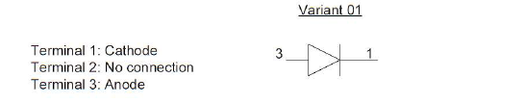
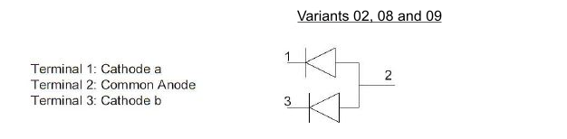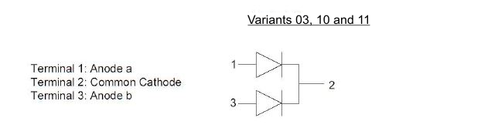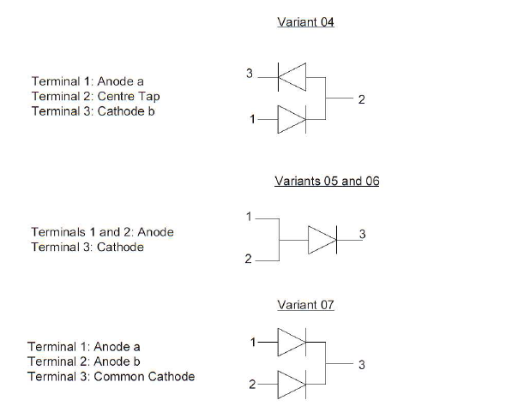
NOTES:
            - For TO-254, the case is not connected to any lead.
            - For SMD.5 and SMD1, the lid is not connected to any terminal.

MATERIALS AND FINISHES
Materials and finishes shall be as follows:
          - Case
For the metal flange mount package the case shall be hermetically sealed and have a metal body. The leads pass through ceramic eyelets brazed into the frame and the lid shall be welded.
For the surface mount packages the case shall be hermetically sealed and have a ceramic body with a Kovar lid.
          - Leads/Terminals
As specified in Para. 1.4.2.

REQUIREMENTS

GENERAL
The complete requirements for procurement of the components specified herein are as stated in this specification and the ESCC Generic Specification. Permitted deviations from the Generic Specification, applicable to this specification only, are listed below.
Permitted deviations from the Generic Specification and this Detail Specification, formally agreed with specific Manufacturers on the basis that the alternative requirements are equivalent to the ESCC requirement and do not affect the component’s reliability, are listed in the appendices attached to this specification.

Deviations from the Generic Specification

Deviation from Screening Tests - Chart F3
          - High Temperature Reverse Bias Burn-in and the subsequent Final Measurements for HTRB shall be omitted.

MARKING
The marking shall be in accordance with the requirements of ESCC Basic Specification No. 21700 and as follows.
The information to be marked on the component shall be:
          - The ESCC qualified components symbol (for ESCC qualified components only).
          - The ESCC Component Number (see Para. 1.4.1).
          - Traceability information.
          - Warning sign for Beryllium Oxide (TO-254 only).

CASE ISOLATION
For Variants 01, 02, 03, 04, 08, 09, 10 and 11, Case Isolation shall be performed as specified in the ESCC Generic Specification and as follows:
- Test Conditions:
- Test voltage: 500Vdc
- Duration of application of test voltage: 1s
- Points of application of test voltage: between case metal tab and all terminals connected together.
- Maximum leakage current: 10nA

TERMINAL STRENGTH
The test conditions for Terminal Strength, tested as specified in the ESCC Generic Specification, shall be as follows:
For TO-254, Test Condition: A, tension, with an applied force of 10N and a duration of 10s.

ELECTRICAL MEASUREMENTS AT ROOM, HIGH AND LOW TEMPERATURES
Electrical measurements shall be performed at room, high and low temperatures. Consolidated notes are given in Para. 2.5.3.

Room Temperature Electrical Measurements
The measurements shall be performed at T_{amb} = +22 ±3ºC.
Characteristics | Symbols | MIL-STD-750  Test Method | Test Conditions  Note 1 | Limits |  | Units
 |  |  |  | Min | Max | Units
Reverse Current | I_{R} | 4016 | DC Method  V_{R} = 100V | - | 30 | µA
Forward Voltage | V_{F1} | 4011 | Pulse Method  I_{F} = 10A  Note 2 | - | 780 | mV
Forward Voltage | V_{F2} | 4011 | Pulse Method  I_{F} = 20A  Note 2 | - | 1 | V
Capacitance | C | 4001 | V_{R} = 10V  f = 1MHz | - | 700 | pF
Thermal Impedance, Junction to Case | Z_{th(j-c)} | 3101 | I_{H} = 15 to 40A  t_{H} = 50ms  I_{M} = 50mA  t_{md} = 100µs  Note 3 | (Calculate ΔV_{F}, see Note 4) |  | °C/W

High and Low Temperatures Electrical Measurements
Characteristics | Symbols | MIL-STD-750  Test Method | Test Conditions  Notes 1 and 5 | Limits |  | Units
 |  |  |  | Min | Max | Units
Reverse Current | I_{R} | 4016 | T_{case} = +125 (+0 -5)°C  DC Method  V_{R} = 100V | - | 20 | mA
Forward Voltage 2 | V_{F2} | 4011 | T_{case} = +125 (+0 -5)°C  Pulse Method  I_{F} = 20A  Note 2 | - | 900 | mV
Forward Voltage 2 | V_{F2} | 4011 | T_{case} =-55 (+5 -0)°C  Pulse Method  I_{F} = 20A  Note 2 | - | 1.1 | V

Notes to Electrical Measurement Tables
            - Measurement per each diode.
            - Pulse Width ≤ 680µs, Duty Cycle ≤ 2%.
            - Performed only during Screening Tests Parameter Drift Values (Initial Measurements), go-no-go.
            - The limits for ΔV_{F} shall be defined by the Manufacturer on every lot in accordance with MIL-STD-750 Method 3101 and shall guarantee the R_{th(j-c)} limits specified in Para. 1.5 Maximum Ratings.
            - Read and record measurements shall be performed on a sample of 5 components with 0 failures allowed. Alternatively a 100% inspection may be performed.

PARAMETER DRIFT VALUES
Unless otherwise specified, the measurements shall be performed at T_{amb} = +22 ±3ºC.
The test methods and test conditions shall be as per the corresponding test defined in Para. 2.5.1, Room Temperature Electrical Measurements.
The drift values (Δ) shall not be exceeded for each characteristic specified. The corresponding absolute limit values for each characteristic shall not be exceeded.
Characteristics | Symbols | Limits |  |  | Units
Characteristics | Symbols | Drift  Value  Δ | Absolute |  | Units
Characteristics | Symbols | Drift  Value  Δ | Min | Max | Units
Reverse Current | I_{R} | ±4  or (1) ±100% | - | 30 | µA
Forward Voltage 1 | V_{F1} | ±10 | - | 780 | mV
NOTES:
            - Whichever is the greater referred to the initial value.

INTERMEDIATE AND END-POINT ELECTRICAL MEASUREMENTS
Unless otherwise specified, the measurements shall be performed at T_{amb} = +22 ±3ºC.
The test methods and test conditions shall be as per the corresponding test defined in Para. 2.5.1, Room Temperature Electrical Measurements.
The limit values for each characteristic shall not be exceeded.
Characteristics | Symbols | Limits |  | Units
Characteristics | Symbols | Min | Max | Units
Reverse Current | I_{R} | - | 30 | µA
Forward Voltage 1 | V_{F1} | - | 780 | mV

POWER BURN-IN CONDITIONS
Characteristics | Symbols | Test Conditions | Units
Case Temperature | T_{case} | +125 | °C
Reverse Voltage | V_{R} | 80 | V

OPERATING LIFE CONDITIONS
The conditions shall be as specified in Para. 2.8 Power Burn-in Conditions.

APPENDIX ‘A’
AGREED DEVIATIONS FOR STMICROELECTRONICS (F)
ITEMS AFFECTED | DESCRIPTION OF DEVIATIONS
Para. 2.1.1, Deviations from the Generic Specification: Para. 8, Test Methods and Procedures | For qualification and qualification maintenance, or procurement of qualified or unqualified components, the following replacement test method specifications shall be used instead of the following ESCC Basic Specifications:  - No. 20400, Internal Visual Inspection: replaced by MIL-STD-750 Test Method 2078.  - No. 20500, External Visual Inspection: replaced by MIL-STD-750 Test Method 2071.  - No. 20900, Radiographic Inspection of Electronic Components: replaced by MIL-STD-750 Test Method 2076.
Para. 2.1.1, Deviations from the Generic Specification: Deviations from Production Control - Chart F2 | Special In-Process Controls - Internal Visual Inspection.  Wedge bonds equal to 1.1 wire diameter are acceptable for bonding with a V-Groove tool.
Para. 2.1.1.1, Deviations from the Generic Specification: Deviations from Screening Tests - Chart F3 | Solderability is not applicable unless specifically stipulated in the Purchase Order.

