

Page 1 of 35
CONNECTORS, ELECTRICAL, RECTANGULAR, NON-REMOVABLE PRESS-FIT SIGNAL CONTACTS AND REMOVABLE PRESS-FIT POWER CONTACTS
BASED ON TYPES SDD, SND, SCBM
ESCC Detail Specification No. 3401/098

Issue 3 Draft B | November 2024


Document Custodian: European Space Agency – see https://escies.org

Legal Disclaimer and Copyright
European Space Agency, Copyright © 2024. All rights reserved.
The European Space Agency disclaims any liability or responsibility, to any person or entity, with respect to any loss or damage caused, or alleged to be caused, directly or indirectly by the use and application of this ESCC publication.
This publication, without the prior permission of the European Space Agency and provided that it is not used for a commercial purpose, may be:
- copied in whole, in any medium, without alteration or modification.
- copied in part, in any medium, provided that the ESCC document identification, comprising the ESCC symbol, document number and document issue, is removed.

DOCUMENTATION CHANGE NOTICE
(Refer to https://escies.org for ESCC DCR content)
DCR No. | CHANGE DESCRIPTION
1698 | Specification updated to incorporate changes per DCR.
Draft 3A 21/10/24 S.Thacker | Initial revision to implement changes requested by Positronic in DCR1698 per emails dated 24/09/2024 & 17/10/24.  All changes are highlighted yellow for information; see Table 1(a) (& note 16); Paras. 4.2.4 (c) & (d), 4.5.2, 4.5.2.1(h), Figures 2(a) & 2(c), new Figure 2(d).  Several additional editorial changes are included (highlighted blue)
Draft 3B 12/11/24 S.Thacker | New revision to implement additional changes requested by Positronic in email dated 12/11/2024 (plus changes missed from original Positronic request).  All original changes are highlighted yellow for information; see Table 1(a) (& note 16); Paras. 4.2.4 (c) & (d), 4.5.2, 4.5.2.1(h), Figures 2(a) & 2(c), new Figure 2(d).  Several additional editorial changes are included (highlighted blue)  All additional technical changes included in Draft 3B are highlighted green: See new appendix A

TABLE OF CONTENTS
1 General 6
1.1 SCOPE 6
1.2 RANGE OF COMPONENTS AND COMPONENT TYPE VARIANTS 6
1.3 MAXIMUM RATINGS 6
1.4 PARAMETER DERATING INFORMATION 6
1.5 PHYSICAL DIMENSIONS 6
2 APPLICABLE DOCUMENTS 6
3 TERMS, DEFINITIONS, ABBREVIATIONS, SYMBOLS AND UNITS 7
4 REQUIREMENTS 23
4.1 GENERAL 23
4.2 DEVIATIONS FROM GENERIC SPECIFICATION 23
4.2.1 Deviations from Special In-Process Controls 23
4.2.2 Deviations from Final Production Tests (Chart II) 23
4.2.3 Deviations from Burn-in and Electrical Measurements (Chart III) 23
4.2.4 Deviations from Qualification Tests (Chart IV) 23
4.2.5 Deviations from Lot Acceptance Tests (Chart V) 25
4.3 MECHANICAL REQUIREMENTS 26
4.3.1 Dimension Check 26
4.3.2 Weight 26
4.3.3 Contact Capability 26
4.3.4 Contact Retention (in insert) 26
4.3.5 Mating and Unmating Forces 26
4.3.6 Insert Retention (in Shell) 26
4.3.7 Contact Insertion and Withdrawal Forces 26
4.3.8 Engagement and Separation Forces 27
4.3.9 Oversize Pin Exclusion 27
4.3.10 Probe Damage 27
4.3.11 Press-fit Insertion Force 27
4.4 MATERIALS AND FINISHES 28
4.4.1 Shells 28
4.4.2 Inserts, Additional Spacing Insert 28
4.4.3 Signal Contacts 28
4.4.4 Contact Retaining Clip 28
4.4.5 Guiding and Locking Devices 28
4.4.6 Magnetism Level 28
4.5 MARKING 28
4.5.1 General 28
4.5.2 The ESCC Component Number 29
4.5.2.1 Characteristics Codes 29
4.5.3 Traceability Information 30
4.6 ELECTRICAL MEASUREMENTS 30
4.6.1 Electrical Measurements at Room Temperature 30
4.7 ENVIRONMENTAL AND ENDURANCE TESTS (CHARTS IV AND V OF ESCC GENERIC SPECIFICATION No. 3401) 31
4.7.1 Measurements and Inspections on Completion of Environmental Tests 31
4.7.2 Measurements and Inspections on Completion of Endurance Tests 31
4.7.3 Conditions for High Temperature Storage Test (Part of Endurance Testing) 31
APPENDIX A 35

General

SCOPE
This specification details the ratings, physical and electrical characteristics, test and inspection data for Connectors, Electrical, Rectangular, Non-removable Press-fit Signal Contacts, Standard (Gauge 20), High Density (Gauge 22) and Removable Press-fit Contacts, Power (Gauge 8), based on types SDD, SND, SCBM.
It shall be read in conjunction with:
- ESCC Generic Specification No. 3401, Connectors, Electrical, Non-Filtered, Circular and Rectangular.
- ESCC Detail Specification No. 3401/022, Accessories for Rectangular Connectors 3401/001, 3401/002, 3401/098 and Connector Savers 3401/020, 3401/080.
- ESCC Detail Specification No. 3401/099, Contacts, Power, Press-fit Type for 3401/098 Connectors.
the requirements of which are supplemented herein.

RANGE OF COMPONENTS AND COMPONENT TYPE VARIANTS
The different sizes of the connectors and contact types specified herein, which are also covered by this specification, together with their mechanical characteristics, are given in Table 1(a).

MAXIMUM RATINGS
The maximum ratings, which shall not be exceeded at any time during use or storage, applicable to the connectors specified herein, are given in Table 1(b).

PARAMETER DERATING INFORMATION
The applicable derating information for the connectors specified herein is shown in Figure 1.

PHYSICAL DIMENSIONS
The physical dimensions of the connectors specified herein and the available contact arrangements are shown in Figure 2.

APPLICABLE DOCUMENTS
The following documents form part of this specification and shall be read in conjunction with it:
          - ESCC Generic Specification No. 3401 for Connectors, Electrical, Non-Filtered, Circular and Rectangular.
          - ESCC Detail Specification No. 3401/022, Accessories for Rectangular Connectors, 3401/001, 3401/002 and Connector Savers 3401/020 and 3401/080.
          - ESCC Detail Specification No. 3401/099, Contacts, Power, Press-fit Type for 3401/098 Connectors.
          - ESCC Basic Specification No. 20500, External Visual Inspection.
          - MIL-DTL-24308, Rack and Panel Connectors, Miniature.
          - NASA/GSFC Specification S-311-P-10, Connectors, Electrical, Rectangular, Miniature, Polarised Shell, Rack and Panel, for Space Flight Use.
          - IEC 60352-5, Solderless connections – Part 5: Press-in connections – General requirements, test methods and practical guidance.

TERMS, DEFINITIONS, ABBREVIATIONS, SYMBOLS AND UNITS
For the purpose of this specification, the terms, definitions, abbreviations, symbols and units specified in ESCC Basic Specification No. 21300 shall apply.
TABLE 1(a) - RANGE OF COMPONENTS AND TYPE VARIANTS
VARIANTS and SHELL SIZES
Variant | Shell Size  (1) | Max. Weight (g)  (2) (3) |  | Mating Force  (N max)  (16) | Unmating Force  (16)
Variant | Shell Size  (1) | Male | Female | Mating Force  (N max)  (16) | N min | N max
01  (Gauge 20 Signal Contacts) | E | 4.5 | 5 | 30 | 3.5 | 20
01  (Gauge 20 Signal Contacts) | A | 5.5 | 7 | 50 | 4.5 | 34
01  (Gauge 20 Signal Contacts) | B | 9 | 10 | 83 | 8 | 55
01  (Gauge 20 Signal Contacts) | C | 12.5 | 13.5 | 123 | 11 | 83
01  (Gauge 20 Signal Contacts) | D | 13.5 | 15 | 166 | 14.5 | 120
02  (Gauge 22 Signal Contacts) | E | 5.2 | 6 | 46 | 3.4 | 28
02  (Gauge 22 Signal Contacts) | A | 7.4 | 8 | 77 | 4.5 | 46
02  (Gauge 22 Signal Contacts) | B | 11 | 12 | 127 | 7.9 | 77
02  (Gauge 22 Signal Contacts) | C | 15.6 | 17 | 177 | 11.3 | 109
02  (Gauge 22 Signal Contacts) | D | 18.2 | 20 | 222 | 14.7 | 136
03  (Gauge 8 Power Contacts) | A | 6.1 (4) | 7 (4) | 55 | 4.5 | 44.5
03  (Gauge 8 Power Contacts) | A | 6.5 (5) | 7.5 (5) | 55 | 4.5 | 44.5
03  (Gauge 8 Power Contacts) | B | 8.6 | 10.1 | 85 | 8 | 70
03  (Gauge 8 Power Contacts) | C | 12 | 14 | 130 | 11 | 93

CONTACT TYPES
Contact Termination Code | Contact Type Description  (6) | Maximum Weight of Contacts (g)
Contact Termination Code | Contact Type Description  (6) | Variant 01 |  | Variant 02 |  | Variant 03
Contact Termination Code | Contact Type Description  (6) | Male | Female | Male | Female | Male | Female
SND97 | Gauge 20 straight press-fit signal contact | 0.16 | 0.2 | - | - | - | -
SDD97 | Gauge 22 straight press-fit signal contact | - | - | 0.12 | 0.14 | - | -
SND62 | Gauge 20 90° press-fit signal contact equipped with 90° bracket and screwlocks 4-40 (14) | - | 0.23 (7)  0.29 (8)  0.34 (9) | - | - | - | -
SDD62 | Gauge 22 90° press-fit signal contact equipped with 90° bracket and screwlocks 4-40 (14) | - | - | - | 0.2 (10)  0.24 (11)  0.29 (12)  0.33 (13) | - | -
SCBM97 | Gauge 8 power press-fit contact | - | - | - | - | 2 (15) | 1.8 (15)
NOTES:
            - See Figures 2(a), 2(b)
            - Weights without contacts or accessories.
            - Total maximum weight, in grammes, may be calculated from:
- connector weight.
- contact weight for all contacts including brackets and nuts (as applicable) (see Table 1(a) Contact Types and/or the relevant Detail Specification).
- Accessories weight given in ESCC Detail Specification No. 3401/022 (if applicable).
            - Weight applicable to contact arrangement 3W3. See Figure 2(b).
            - Weight applicable to contact arrangement 3WK3. See Figure 2(b).
            - See Figure 2(c)
            - Weight of contact in row nearest the connector mounting plane (Ref. Plane).
            - Weight of contact in row farthest from connector mounting plane (Ref. Plane), except for size D, where it is the middle row.
            - For size D only, weight of contact in row farthest from connector mounting plane (Ref. Plane).
            - Weight of contact in row nearest the connector mounting plane (Ref. Plane).
            - Weight of contact in row after the row specified in (10).
            - Weight of contact in row after the row specified in (11).
            - Weight of contact in row after the row specified in (12).
            - Maximum Weight of brackets and nuts:
- Shell sizes E, A, B, C : 3.1g (Var. 01), 3.95g (Var. 02)
- Shell size D : 3.8g (Var. 01), 4.4g (Var. 02)
            - Power contacts shall be ordered separately in accordance with ESCC Detail Specification No. 3401/099.
            - For mating of connectors that include a plug connector (with male contacts) with a dimpled shell (see Figure 2(d) and Para. 4.5.2.1(i)), the maximum mating and unmating force shall be increased by 20N
TABLE 1(b) - MAXIMUM RATINGS
No. | Characteristics | Symbol | Maximum Ratings | Unit | Remarks
1 | Working Voltage (Sea Level)  - Variant 01  - Variant 02  - Variant 03 | U_{R} | 300  250  250 | Vrms  Vrms  Vrms | Note 1
2 | Rated Current  - Variant 01  - Variant 02  - Variant 03 | I_{R} | 7.5  3  40 | A  A  A | -
3 | Operating Temperature Range | T_{op} | -55 to +125 | °C | T_{amb}
4 | Storage Temperature Range | T_{stg} | -65 to +125 | °C | -
NOTES:
            - Between each contact and the shell.
FIGURE 1 - PARAMETER DERATING INFORMATION
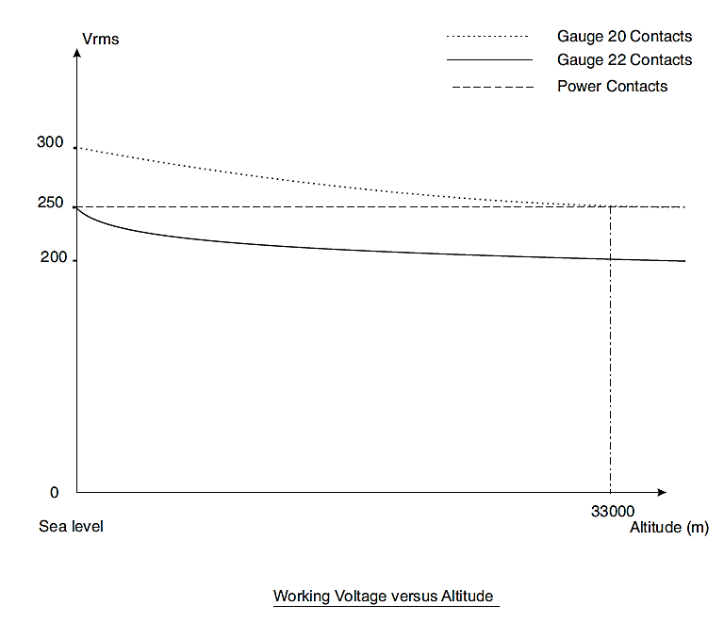

FIGURE 2 - PHYSICAL DIMENSIONS
FIGURE 2(a) - RECEPTACLES AND PLUGS

VARIANTS 01, 02 – Shell SIZE E
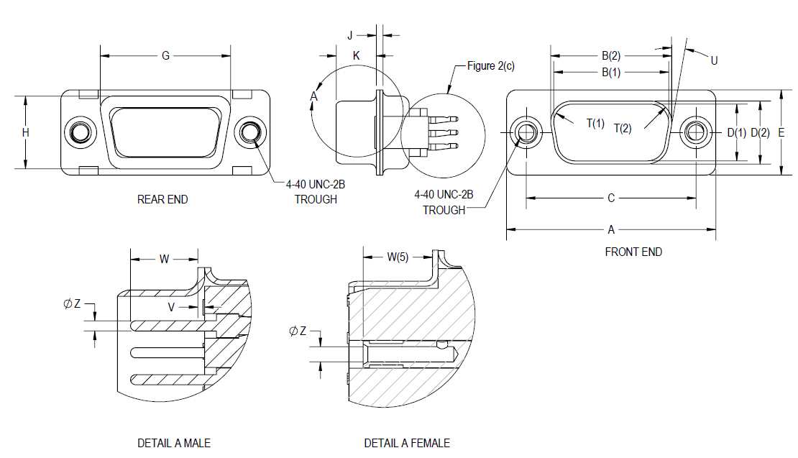
Contact  Type | Connector  Type | Symbol/  Dim. | A | B | C | D | E | G | H | J | K | T | U  ° | V | W | ØZ
 |  |  |  |  |  |  |  |  |  |  |  |  |  |  |  | V.01 | V.02
Male | Plug | Min | 30.43 | 16.79 | 24.87 | 8.23 | 12.17 | 19.02 | 10.46 | 0.51 | 5.82 | 2.59 | 9 | 0 | 4.03 | 0.99 | 0.75
Male | Plug | Max | 31.19 | 17.04 | 25.12 | 8.48 | 12.93 | 19.53 | 10.97 | 1.02 | 6.05 | 2.69 | 11 | 0.6 | - | 1.04 | 0.77
Female | Receptacle | Min | 30.43 | 16.21 | 24.87 | 7.77 | 12.07 | 19.02 | 10.46 | 0.51 | 6.05 | 2.46 | 9 | - | 3.63 | 1.07 | 0.78
Female | Receptacle | Max | 31.19 | 16.46 | 25.12 | 8.03 | 12.93 | 19.53 | 10.97 | 1.02 | 6.3 | 2.62 | 11 | - | - | 1.14 | -

VARIANTS 01, 02, 03 – SHELL SIZE A
Contact  Type | Connector  Type | Symbol/  Dim. | A | B | C | D | E | G | H | J | K | T | U  ° | V | W  (6) | ØZ (6)
 |  |  |  |  |  |  |  |  |  |  |  |  |  |  |  | V.01 | V.02
Male | Plug | Min | 38.76 | 25.12 | 33.2 | 8.23 | 12.17 | 27.25 | 10.46 | 0.51 | 5.82 | 2.59 | 9 | 0 | 4.03 | 0.99 | 0.75
Male | Plug | Max | 39.52 | 25.37 | 33.45 | 8.48 | 12.93 | 27.76 | 10.97 | 1.02 | 6.05 | 2.69 | 11 | 0.6 | - | 1.04 | 0.77
Female | Receptacle | Min | 38.76 | 24.54 | 33.2 | 7.77 | 12.17 | 27.25 | 10.46 | 0.51 | 6.05 | 2.46 | 9 | - | 3.63 | 1.07 | 0.78
Female | Receptacle | Max | 39.52 | 24.79 | 33.45 | 8.03 | 12.93 | 27.76 | 10.97 | 1.02 | 6.3 | 2.62 | 11 | - | - | 1.14 | -

VARIANTS 01, 02, 03 – SHELL SIZE B
Contact  Type | Connector  Type | Symbol/  Dim. | A | B | C | D | E | G | H | J | K | T | U  ° | V | W  (6) | ØZ (6)
 |  |  |  |  |  |  |  |  |  |  |  |  |  |  |  | V.01 | V.02
Male | Plug | Min | 52.65 | 38.84 | 46.91 | 8.23 | 12.17 | 41.02 | 10.46 | 0.51 | 5.69 | 2.59 | 9 | 0 | 4.03 | 0.99 | 0.75
Male | Plug | Max | 53.42 | 39.09 | 47.17 | 8.48 | 12.93 | 41.53 | 10.97 | 1.24 | 5.99 | 2.69 | 11 | 0.6 | - | 1.04 | 0.77
Female | Receptacle | Min | 52.65 | 38.25 | 46.91 | 7.77 | 12.17 | 41.02 | 10.46 | 0.51 | 6.05 | 2.46 | 9 | - | 3.63 | 1.07 | 0.78
Female | Receptacle | Max | 53.42 | 38.51 | 47.17 | 8.03 | 12.93 | 41.53 | 10.97 | 1.02 | 6.3 | 2.62 | 11 | - | - | 1.14 | -

VARIANTS 01, 02, 03 – SHELL SIZE C
Contact  Type | Connector  Type | Symbol/  Dim. | A | B | C | D | E | G | H | J | K | T | U  ° | V | W  (6) | ØZ (6)
 |  |  |  |  |  |  |  |  |  |  |  |  |  |  |  | V.01 | V.02
Male | Plug | Min | 68.94 | 55.3 | 63.37 | 8.23 | 12.17 | 57.45 | 10.46 | 0.51 | 5.69 | 2.59 | 9 | 0 | 4.03 | 0.99 | 0.75
Male | Plug | Max | 69.7 | 55.55 | 63.63 | 8.48 | 12.93 | 57.96 | 10.97 | 1.24 | 5.99 | 2.69 | 11 | 0.6 | - | 1.04 | 0.77
Female | Receptacle | Min | 68.94 | 54.71 | 63.37 | 7.77 | 12.17 | 57.45 | 10.46 | 0.51 | 6.05 | 2.46 | 9 | - | 3.63 | 1.07 | 0.78
Female | Receptacle | Max | 69.7 | 54.97 | 63.63 | 8.03 | 12.93 | 57.96 | 10.97 | 1.02 | 6.3 | 2.62 | 11 | - | - | 1.14 | -

VARIANTS 01, 02 – SHELL SIZE D
Contact  Type | Connector  Type | Symbol/  Dim. | A | B | C | D | E | G | H | J | K | T | U  ° | V | W | ØZ
 |  |  |  |  |  |  |  |  |  |  |  |  |  |  |  | V.01 | V.02
Male | Plug | Min | 66.55 | 52.68 | 60.99 | 11.07 | 14.99 | 55.07 | 13.31 | 0.51 | 5.69 | 2.59 | 9 | 0 | 4.03 | 0.99 | 0.75
Male | Plug | Max | 67.31 | 52.93 | 61.24 | 11.33 | 15.75 | 55.58 | 13.82 | 1.24 | 5.99 | 2.69 | 11 | 0.6 | - | 1.04 | 0.77
Female | Receptacle | Min | 66.55 | 52.3 | 60.99 | 10.62 | 14.99 | 55.07 | 13.31 | 0.51 | 6.05 | 2.46 | 9 | - | 3.63 | 1.07 | 0.78
Female | Receptacle | Max | 67.31 | 52.55 | 61.24 | 10.87 | 15.75 | 55.58 | 13.82 | 1.02 | 6.3 | 2.62 | 11 | - | - | 1.14 | -
NOTES TO FIGURE 2(a):
            - Inside dimension for connectors with male contacts.
            - Outside dimension for connectors with female contacts.
            - All dimensions are in mm (angles in degrees).
            - Underlined dimensions, in table, are critical to ensure intermateability.
            - Electrical contact position in female contact.
            - Not applicable to Variant 03.

FIGURE 2(b) - CONTACT ARRANGEMENTS
variant 01 – standard PRESS-FIT SIGNAL contact arrangements
front view male insert
(See Notes 1, 2)
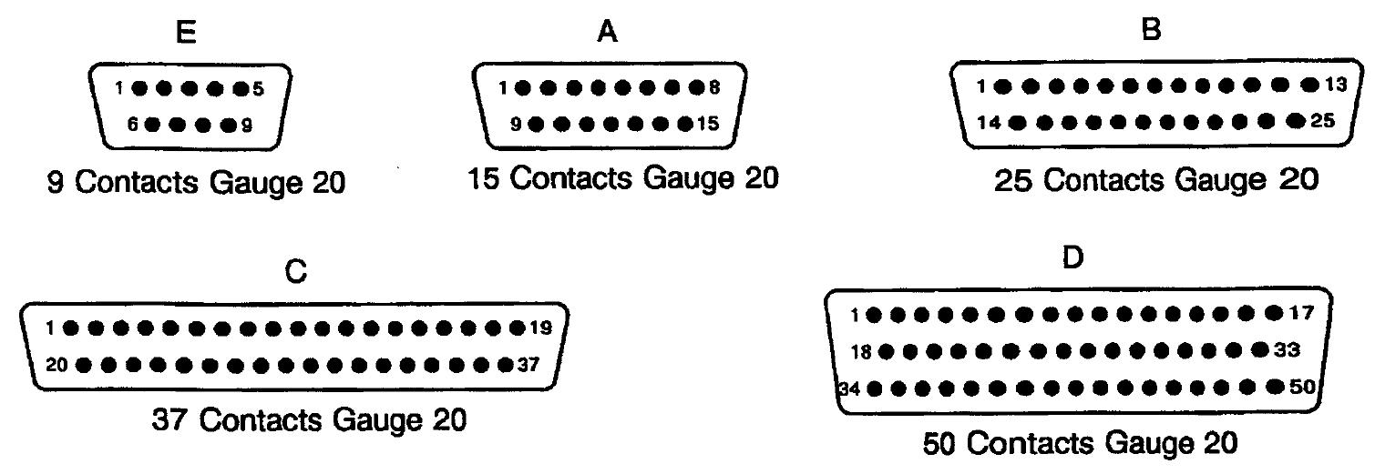
variant 02 – high density PRESS-FIT SIGNAL contact arrangements
front view male insert
(See Notes 1, 2)
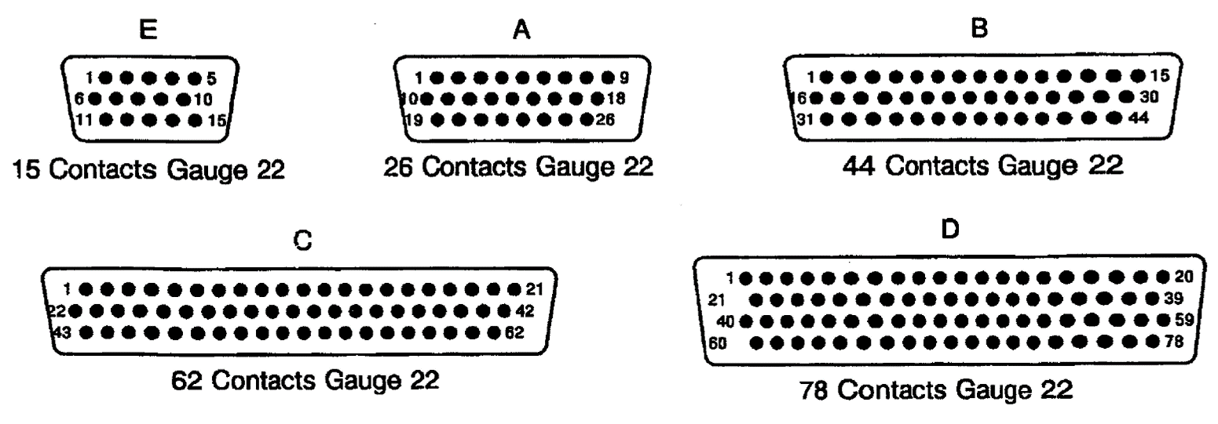
VARIANT 03 – PRESS-FIT POWER CONTACT ARRANGEMENTS
front view male insert
(See Notes 1, 2)
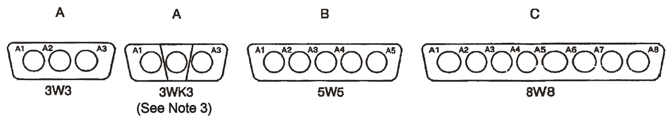
NOTES TO FIGURE 2(b):
            - Contact locations are in conformity with MIL-DTL-24308 specification sheets for signal contact arrangements and NASA/GSFC Specification S-311-P-10 for power contact arrangements, and shall not be checked during procurement.
            - The front side of the insert shall be marked with the minimum marking shown.
            - 3WK3 insulator with built-in keying (middle part recessed or protruding with respect to each side depending on the Contact Gender code) to avoid mismounting (K = keyed); see Para. 4.5.2.1(d) and (e).

FIGURE 2(c) - REAR END
VARIANT 01 - (Gauge 20) STrAIGHT PRESS-FIt SIGNAL Contacts (CONTACT TERMINATION CODE: SND97)
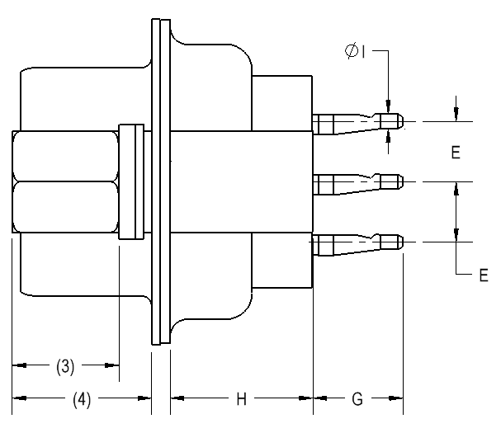
Pitch between contacts:
- Connector shell sizes E, A: 2.74mm
- Connector shell sizes B, C, D: 2.76mm
Symbol /  Dimension (1) | E  (2) (5) | G | H | ØI
Min | 2.77 | 4 | 6.5 | 0.5
Max | 2.91 | 4.5 | 7 | 1
NOTES:
            - All dimensions are in mm.
            - Typical = 2.84mm.
            - According to ESCC 3401/022, Figure 2(a), dimension K.
            - According to ESCC 3401/022, Figure 2(a), dimension G.
            - The example figure shown is for shell size D with 3 rows of rear contacts; shell sizes E, A, B, C have 2 rows of rear contacts.
VARIANT 02 - (Gauge 22) STrAIGHT PRESS-FIt SIGNAL Contacts (CONTACT TERMINATION CODE: SDD97)
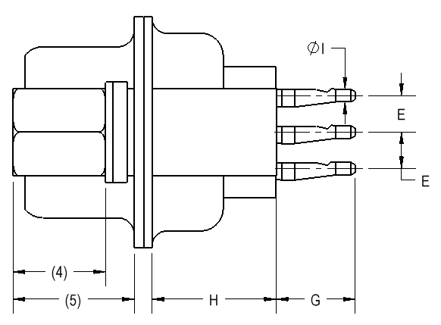
Pitch between contacts:
- Connector shell sizes E, A, B: 2.29mm
- Connector shell sizes C, D: 2.41mm
Symbol /  Dimension (1) | E (6) |  | G | H | ØI
Symbol /  Dimension (1) | Sizes:  E, A, B, C  (2) | Size D (3) | G | H | ØI
Min | 1.91 | 2.01 | 4 | 6.5 | 0.5
Max | 2.05 | 2.15 | 4.5 | 7 | 1
NOTES:
            - All dimensions are in mm.
            - Typical = 1.98mm.
            - Typical = 2.08mm.
            - According to ESCC 3401/022, Figure 2(a), dimension K.
            - According to ESCC 3401/022, Figure 2(a), dimension G.
            - The example figure shown is for shell sizes E, A, B, C with 3 rows of rear contacts; shell size D has 4 rows of rear contacts.
VARIANT 03 - (Gauge 8) PrESS-FIT POWER Contacts (CONTACT TERMINATION Code: SCBM97)
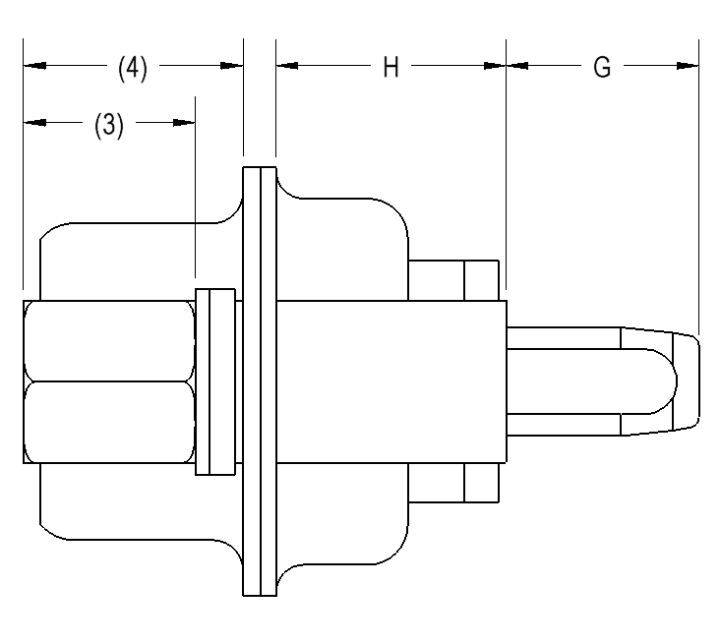
Symbol /  Dimension (1) | G | H
Min | 4 | 6.5
Max | 6 | 7
NOTES:
            - All dimensions are in mm.

VARIANT 01 - (Gauge 20) 90° PRESS-FIT SIGNAL Contacts
(CONTACT TERMINATION Code: SND62)
SHELL SIZES E, A, B, C SHELL SIZE D
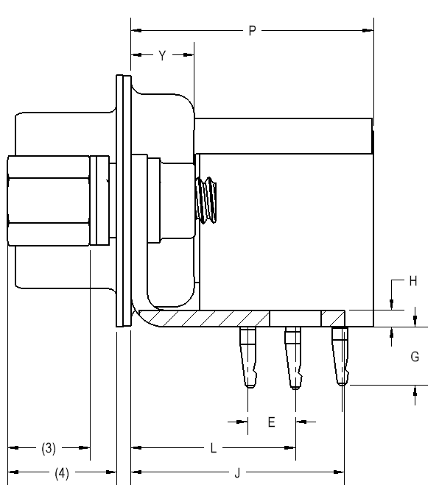
Pitch between contacts:
- Connector shell sizes E, A, B, C, D: 2.76mm
Symbol /  Dimension (1) | E  (2) | H | J | L |  | G | P | Y
 |  |  |  | Sizes:  E, A, B, C | Size D | G | P | Y
Min | 2.79 | 1 | - | 8.54 | 9.96 | 3.5 | - | -
Max | 2.89 | 3.2 | 15 | 8.68 | 10.1 | 4 | 16 | 7
NOTES:
            - All dimensions are in mm.
            - Typical = 2.84mm.
            - According to ESCC 3401/022, Figure 2(a), dimension K.
            - According to ESCC 3401/022, Figure 2(a), dimension G.

VARIANT 02 - (Gauge 22) 90° PRESS-FIT SIGNAL Contacts
(CONTACT TERMINATION Code: SDD62)
SHELL SIZES E, A, B, C SHELL SIZE D
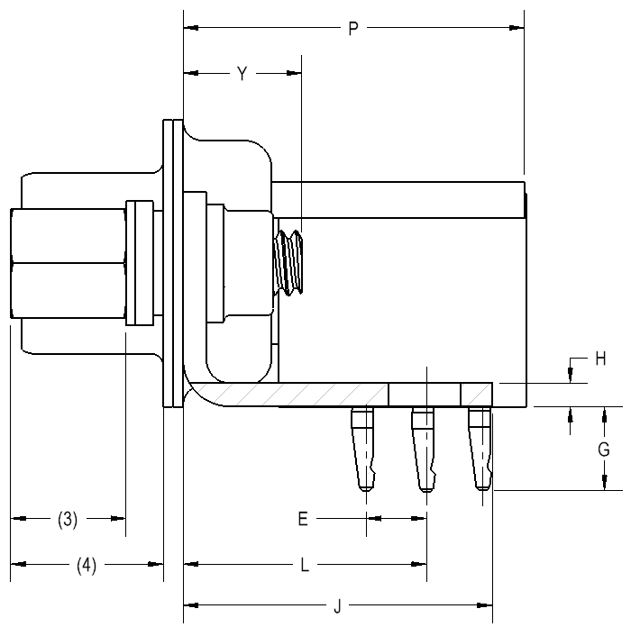 | 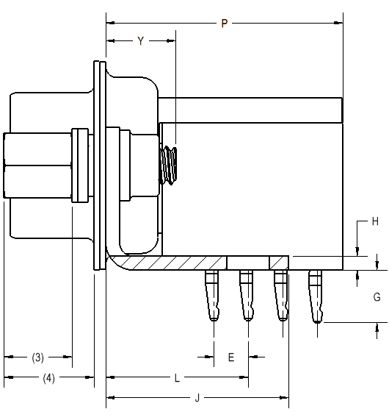
Pitch between contacts:
- Connector shell sizes E, A, B, C: 2.29mm
- Connector shell size D: 2.41mm
Symbol /  Dimension (1) | E  (2) | H | J | L |  | G | P | Y
 |  |  |  | Sizes:  E, A, B, C | Size D | G | P | Y
Min | 2.49 | 1 | - | 10.39 | 10.45 | 3.5 | - | -
Max | 2.59 | 3.2 | 15 | 10.53 | 10.59 | 4 | 19 | 7
NOTES:
            - All dimensions are in mm.
            - Typical = 2.54mm.
            - According to ESCC 3401/022, Figure 2(a), dimension K.
            - According to ESCC 3401/022, Figure 2(a), dimension G.

FIGURE 2(d) – PLUG CONNECTORS WITH DIMPLED SHELL
Notes:
            - All dimensions are in mm.

REQUIREMENTS

GENERAL
The complete requirements for procurement of the connectors specified herein are stated in this specification and ESCC Generic Specification No. 3401. Deviations from the Generic Specification, applicable to this specification only, are listed in Para. 4.2.
Deviations from the applicable Generic Specification and this Detail Specification, formally agreed with specific Manufacturers on the basis that the alternative requirements are equivalent to the ESCC requirements and do not affect the components’ reliability, are listed in the appendices attached to this specification.

DEVIATIONS FROM GENERIC SPECIFICATION

Deviations from Special In-Process Controls
None.

Deviations from Final Production Tests (Chart II)
          - Para. 9.9, Seal Test: Not applicable.

Deviations from Burn-in and Electrical Measurements (Chart III)
None (Chart III is not applicable).

Deviations from Qualification Tests (Chart IV)
          - Para. 9.9, Seal Test: Not applicable.
          - Para. 9.10, Wiring: The following Press-Fit Insertion Force Test shall be performed in lieu of Wiring:
Choice of PCB
The PCB to be used during the press-fit insertion force test shall have the following characteristics:
- 12 layers, internal layer thickness: 17µm typical.
- PCB thickness: 2.4 ±1mm
- PCB material: Polyimide, suitable for space application (e.g. Arlon 35N, Arlon 85N, Ventec VT-901).
- PCB surface finish:
  - 0.05μm min. immersion gold over 4.5 ±1.5μm electroless nickel over 25μm min. copper
or
  - 15μm min. Solder (≤ 95% tin, remainder lead) over 25μm min. copper
Press-Fit Insertion Force Test Procedure
The connectors shall be inserted into the PCB with an insertion speed of between 25mm/minute and 50mm/minute as per IEC 60352-5, clause 5.2.2.2. The insertion forces shall be monitored and reported. The proper insertion of the press-fit terminations shall then be examined under 5× magnification in accordance with ESCC Basic Specification No. 20500.
Any plating defects shall be reported. Scratches showing any base metal are not acceptable.
The terminations shall be checked following insertion to verify they have remained straight. Burrs are not acceptable.
The connectors shall then be removed from the PCB by pushing on the termination tails with a plane surface.
The connectors shall be re-inserted, removed and then inserted once more in accordance with the procedure described above.
Final Measurements (Data Points)
For each connector, the contact resistance between the press-fit terminations and the PCB shall be measured and reported as per IEC 60352-5, clause 5.2.3.1.
Sampling: 10% of all connector’s contacts or 5 contacts, whichever is less.
          - Para. 9.11.2, Sinusoidal Vibration: The following test conditions shall apply:
- Number of cycles: 1 (25Hz to 200Hz)
- Sweep rate: 1 octave/minute
- Vibration Amplitude (Power Specral Density):
- 25g for 25Hz to 100Hz
- 15g for 100Hz to 200Hz
          - Para. 9.11.3, Random Vibration: The following 2 test conditions shall apply to all test samples:
- Condition 1:
- Axis of Vibration: Parallel to PCB mounting plane
- Vibration Amplitude (Power Specral Density):
Global Envelope: 27.1grms
20 to 100 Hz | +6dB/Octave
100 to 800 Hz | 0.5g²/Hz
800 to 2000 Hz | -3dB/Octave
- Duration: 5 minutes
- Condition 2:
- Axis of Vibration: Perpendicular to PCB mounting plane
- Vibration Amplitude (Power Specral Density):
Global Envelope: 28.5grms
20 to 100 Hz | +6dB/Octave
100 to 500 Hz | 1g²/Hz
500 to 2000 Hz | -6dB/Octave
- Duration: 5 minutes
          - Para. 9.13, Climatic Sequence: At the end of the test, the contact resistance between the press-fit terminations and the PCB shall be measured and reported as per IEC 60352-5, clause 5.2.3.1.
Sampling: 10% of all connector’s contacts or 5 contacts, whichever is less.
          - Para 9.15, Joint Strength: Not applicable.
          - Para. 9.16, Rapid Change of Temperature: At the end of the test, the contact resistance between the press-fit terminations and the PCB shall be measured and reported as per IEC 60352-5, clause 5.2.3.1.
Sampling: 10% of all connector’s contacts or 5 contacts, whichever is less.
The connectors shall then be removed from the PCB for the remainder of the test path.
          - Para. 9.22, Corrosion: At the end of the test, the contact resistance between the press-fit terminations and the PCB shall be measured and reported as per IEC 60352-5, clause 5.2.3.1.
Sampling: 10% of all connector’s contacts or 5 contacts, whichever is less.
          - Para. 9.24, Jackscrew Retention: Not applicable.
          - Para. 9.31, Solderability: Not applicable.

Deviations from Lot Acceptance Tests (Chart V)
          - Para. 9.9, Seal Test: Not applicable.
          - Para. 9.10, Wiring: The following Press-Fit Insertion Force Test shall be performed in lieu of Wiring:
Choice of PCB
The PCB to be used during the press-fit insertion force test shall have the following characteristics:
- 12 layers, internal layer thickness: 17µm typical.
- PCB thickness: 2.4 ±1mm
- PCB material: Polyimide, suitable for space application (e.g. Arlon 35N, Arlon 85N, Ventec VT-901).
- PCB surface finish:
  - 0.05μm min. immersion gold over 4.5 ±1.5μm electroless nickel over 25μm min. copper
or
  - 15μm min. Solder (≤ 95% tin, remainder lead) over 25μm min. copper
Press-Fit Insertion Force Test Procedure
The connectors shall be inserted into the PCB with an insertion speed of between 25mm/minute and 50mm/minute as per IEC 60352-5, clause 5.2.2.2. The insertion forces shall be monitored and reported. The proper insertion of the press-fit terminations shall then be examined under 5× magnification in accordance with ESCC Basic Specification No. 20500.
Any plating defects shall be reported. Scratches showing any base metal are not acceptable.
The terminations shall be checked following insertion to verify they have remained straight. Burrs are not acceptable.
The connectors shall then be removed from the PCB by pushing on the termination tails with a plane surface.
The connectors shall be re-inserted, removed and then inserted once more in accordance with the procedure described above.
Final Measurements (Data Points)
For each connector, the contact resistance between the press-fit terminations and the PCB shall be measured and reported as per IEC 60352-5, clause 5.2.3.1.
Sampling: 10% of all connector’s contacts or 5 contacts, whichever is less.
          - Para. 9.13, Climatic Sequence: At the end of the test, the contact resistance between the press-fit terminations and the PCB shall be measured and reported as per IEC 60352-5, clause 5.2.3.1.
Sampling: 10% of all connector’s contacts or 5 contacts, whichever is less.
          - Para 9.15, Joint Strength: Not applicable.
          - Para. 9.16, Rapid Change of Temperature: At the end of the test, the contact resistance between the press-fit terminations and the PCB shall be measured and reported as per IEC 60352-5, clause 5.2.3.1.
Sampling: 10% of all connector’s contacts or 5 contacts, whichever is less.
The connectors shall then be removed from the PCB for the remainder of the test path.
          - Para. 9.22, Corrosion: At the end of the test, the contact resistance between the press-fit terminations and the PCB shall be measured and reported as per IEC 60352-5, clause 5.2.3.1.
Sampling: 10% of all connector’s contacts or 5 contacts, whichever is less.

MECHANICAL REQUIREMENTS

Dimension Check
The dimensions of the connectors specified herein shall be verified in accordance with the requirements set out in Para. 9.6 of ESCC Generic Specification 3401 and shall conform to those shown in Figure 2 of this specification. Only the underlined dimensions shall be checked during procurement.

Weight
The maximum weight of the connectors specified herein, with contacts where applicable, shall be as specified in Table 1(a).

Contact Capability
For the purpose of this test, the pick-up and drop weights shall be as follows:
Signal Contacts | Measurements | Pick-Up Weight | Drop Weight
Gauge 20 | Weight (g) | 28.35 | 226.8
Gauge 20 | Pin diameter (mm) | 0.99 to 0.993 | 1.039 to 1.04
Gauge 20 | Insertion depth (mm) | 4 | 4
Gauge 22 | Weight (g) | 19.84 | 226.8
Gauge 22 | Pin diameter (mm) | 0.749 to 0.751 | 0.773 to 0.775
Gauge 22 | Insertion depth (mm) | 4 | 4
See ESCC Detail Specification No. 3401/099 for power contacts.

Contact Retention (in insert)
For gauge 20 and 22 signal contacts the contact retention force shall be 40N.
See ESCC Detail Specification No. 3401/099 for power contacts.

Mating and Unmating Forces
The forces applied for mating and unmating of the connectors shall conform to the values specified in Table 1(a).

Insert Retention (in Shell)
Connector inserts shall withstand a pressure of 42.8N/cm² without being dislodged from the shell.

Contact Insertion and Withdrawal Forces
See ESCC Detail Specification No. 3401/099 for power contacts. Not applicable to signal contacts.

Engagement and Separation Forces
The engagement and separation forces of the female signal contacts shall be tested with the applicable test pin and shall not exceed the values of the table hereunder.
Signal Contacts | Measurements | Diameter (mm) |  | Engagement  Max  (N) | Separation (N)
Signal Contacts | Measurements | Min | Max |  | Min | Max
Gauge 20 | Max Ø Test Pin | 1.039 | 1.04 | 3.33 | - | 2.22
Gauge 20 | Min Ø Test Pin | 0.99 | 0.993 | - | 0.28 | -
Gauge 22 | Max Ø Test Pin | 0.773 | 0.775 | 3.33 | - | 2.22
Gauge 22 | Min Ø Test Pin | 0.749 | 0.751 | - | 0.2 | -
See ESCC Detail Specification No. 3401/099 for power contacts.

Oversize Pin Exclusion
The diameter of the test pin and the force applied to it shall be as follows:
Signal Contacts | Test Pin Diameter (mm) |  | Force (N) Max
Signal Contacts | Min | Max | Force (N) Max
Gauge 20 | 1.166 | 1.17 | 3.33
Gauge 22 | 0.905 | 0.907 | 2.43
See ESCC Detail Specification No. 3401/099 for power contacts.

Probe Damage
The probe diameter and the moment at the end of the probe shall be as follows:
Signal Contacts | Probe Diameter (mm) |  | Moment (N.cm)
Signal Contacts | Min | Max | Moment (N.cm)
Gauge 20 | 1.007 | 1.033 | 5.65
Gauge 22 | 0.749 | 0.774 | 1.3
See ESCC Detail Specification No. 3401/099 for power contacts.

Press-fit Insertion Force
Receiving holes for press-fit terminations and the insertion force shall be as follows:
Signal Contacts | Receiving Hole Diameter (mm) |  | Max. Insertion Force (N)
Signal Contacts | Min | Max | Max. Insertion Force (N)
Gauge 20 | 1.04 | 1.14 | 50
Gauge 22 | 1.04 | 1.14 | 50
See ESCC Detail Specification No. 3401/099 for power contacts.

MATERIALS AND FINISHES
The materials and finishes shall be as specified herein. Where a definite material is not specified, a material which will enable the connectors specified herein to meet the performance requirements of this specification shall be used. Acceptance or approval of any constituent material does not guarantee acceptance of the finished product.

Shells
Shells shall be made of brass. The standard plating finish (i.e. no Modification Code) shall be 1.27µm minimum of gold over 1µm minimum of copper. An alternative plating finish is 12.7µm minimum electroless nickel (Modification Code A175).

Inserts, Additional Spacing Insert
Inserts shall be made of glass-fibre filled diallylphthalate resin or a suitable thermoplastic material.
For Variant 03, the additional spacing insert which provides the required increased insulation shall be made of a suitable thermoplastic material.

Signal Contacts
The contact body shall be made of copper alloy with an underplate of 1µm minimum of copper, gold plated with 1.27µm minimum of gold.
The female contact spring element shall be made of copper alloy with an underplate of 1µm minimum of nickel or copper, gold plated with 1.27µm minimum of gold.

Contact Retaining Clip
Not applicable to gauge 20 and 22 signal contacts.
See ESCC Detail Specification No. 3401/099 for power contacts.

Guiding and Locking Devices
As specified in ESCC Detail Specification No. 3401/022.

Magnetism Level
The allowable value of magnetism shall not exceed that specified for the relevant level (see Para. 4.5.2.1(f)). Only magnetism levels NMC and NMD are verified.

MARKING

General
The marking of all components delivered to this specification shall be in accordance with the requirements of ESCC Basic Specification No. 21700 and the following paragraphs.
Each component and/or the component’s primary package shall be marked in respect of:
          - Contact number marking (see Figure 2(b)).
          - The ESCC qualified components symbol (for ESCC qualified components only).
          - The ESCC Component Number (see Para. 4.5.2).
          - Traceability information.

The ESCC Component Number
The ESCC Component Number shall be constituted as follows (note 1):
Example: 340109801BDAM15PNMBSND97A175D
- Detail Specification Reference: 3401098
- Component Type Variant Number: 01 (as required; see Table 1(a))
- Testing Level: B
- Characteristic code: Series: D
- Characteristic code: Shell Size: A (as required)
- Characteristic code: Insert Type: M
- Characteristic code: Contact Arrangement: 15 (as required)
- Characteristic code: Contact Gender: P (as required)
- Characteristic code: Magnetism Level: NMB (as required)
- Characteristic code: Contact Termination Code: SND97 (as required)
- Characteristic code: Modification Code(s): A175D (if/as required)
NOTES:
            - A dash (-) or space may be included as part of the ESCC Component Number marking in order to separate one or more of the individual characteristic codes.

Characteristics Codes
Characteristics to be codified as part of the ESCC Component Number shall be as follows:
          - Series
The connector series shall be indicated by the code letter: D.
          - Shell Size
The shell size shall be indicated by the following code letters: E, A, B, C, D. See Table 1(a).
          - Insert Type
The type of insert shall be indicated by the code letter: M.
          - Contact Arrangement
The contact arrangement shall be indicated by the following codes; see Figure 2(b):
Code | Shell Size | Number of Signal Contacts Gauge 20 | Number of Signal Contacts Gauge 22 | Number of Power Contact  Cavities (Note 1)
9 | E | 9 | 0 | 0
15 | A | 15 | 0 | 0
15 | E | 0 | 15 | 0
3W3 | A | 0 | 0 | 3
3WK3 | A | 0 | 0 | 3 (Note 2)
25 | B | 25 | 0 | 0
26 | A | 0 | 26 | 0
5W5 | B | 0 | 0 | 5
37 | C | 37 | 0 | 0
8W8 | C | 0 | 0 | 8
44 | B | 0 | 44 | 0
50 | D | 50 | 0 | 0
62 | C | 0 | 62 | 0
78 | D | 0 | 78 | 0
NOTES:
            - For Variant 03, the power contacts shall be ordered separately in accordance with ESCC Detail Specification No. 3401/099.
Power contacts must be from the same Manufacturer as the connector in which they are mounted and this shall be verified prior to assembly.
            - Either 2 male plus 1 female power contact, or 2 female plus1 male power contact (see Para. 4.5.2.1(e)).
          - Contact Gender
The gender of the contacts shall be indicated by the following code letters:
- P: male contact
- S: female contact
For Contact Arrangement Code 3WK3, the gender of the power contacts installed in cavities A1 and A3 (see Figure 2(b)) shall determine the code letter to be used.
          - Magnetism Level
The magnetism level shall be indicated by the following codes:
Code | Definition
NMB | Magnetism Level: ≤ 200 gamma (1)
NMC | Magnetism Level: ≤ 20 gamma
NMD | Magnetism Level: ≤ 2 gamma
NOTES:
            - Guaranteed, but not measured.
          - Contact Termination Code
The contact termination codes are specified in Table 1(a).
          - Modification Code
A modification code shall be included in the ESCC Component Number when required, otherwise it shall be omitted. When more than a single code is applicable, all codes shall be concatenated together.
Finish codes: the following modification codes shall apply when required (see Para. 4.4.1):
- A175: electroless nickel finish.
Other codes: the following modification codes shall apply when required:
- D: plug connector (with male contacts) with dimpled shell (see Figure 2(d))

Traceability Information
Traceability information shall be marked in accordance with the requirements of ESCC Basic Specification No. 21700.

ELECTRICAL MEASUREMENTS

Electrical Measurements at Room Temperature
The parameters to be measured in respect of electrical characteristics are scheduled in Table 2. Unless otherwise specified, these measurements shall be performed at T_{amb} = +22 ±3°C.
Table 2 - ELECTRICAL MEASUREMENTS AT ROOM TEMPERATURE
No. | Characteristic | Symbol | ESCC 3401  Test Method and Test Conditions | Limits |  | Unit
 |  |  |  | Min | Max | Unit
1 | Insulation Resistance | R_{I} | Para. 9.1.1.1 | 5000 | - | MΩ
2 | Voltage Proof Leakage Current  - Variant 01  - Variants 02, 03 | I_{L} | Para. 9.1.1.2  1250Vrms  1000Vrms | -  - | 2  2 | mA
3 | Low Level Contact Resistance  - Gauge 20 Signal Contacts  - Gauge 22 Signal Contacts  - Gauge 8 Power Contacts | R_{CL} | Para. 9.1.1.3 | -  -  - | 6  12  Note 1 | mΩ
4 | Rated Current Contact  Resistance  - Gauge 20 Signal Contacts  - Gauge 22 Signal Contacts  - Gauge 8 Power Contacts | R_{CR} | Para. 9.1.1.3  7.5A  3A  Note 1 | -  -  - | 5  10  Note 1 | mΩ
NOTES:
            - See ESCC Detail Specification No. 3401/099 for power contacts.

ENVIRONMENTAL AND ENDURANCE TESTS (CHARTS IV AND V OF ESCC GENERIC SPECIFICATION No. 3401)

Measurements and Inspections on Completion of Environmental Tests
The parameters to be measured and inspections to be performed on completion of environmental testing shall be those specified in Table 6. Unless otherwise specified, the measurements shall be performed at T_{amb} = +22 ±3°C.

Measurements and Inspections on Completion of Endurance Tests
The parameters to be measured and inspections to be performed on completion of endurance tests shall be those specified in Table 6. Unless otherwise specified, the measurements shall be performed at T_{amb},= +22 ±3°C.

Conditions for High Temperature Storage Test (Part of Endurance Testing)
The requirements for the high temperature storage test are specified in Section 9 of ESCC Generic Specification No. 3401. The conditions for high temperature storage testing shall be the maximum storage temperature specified in Table 1(b) of this specification.
Table 6 - MEASUREMENTS AND INSPECTIONS ON COMPLETION OF ENVIRONMENTAL AND ENDURANCE TESTING
No. | ESCC Generic Spec. No. 3401 |  | Measurements and Inspections |  | Symbol | Limits |  | Unit
No. | Environmental and Endurance Tests (1) | Test Method and Conditions | Identification | Conditions | Symbol | Min | Max | Unit
01 | Wiring | Paras. 4.2.4, 4.2.5 and 4.3.11 of this Spec. | Press-fit Insertion Force | Para. 4.3.11 of this Spec. | - | Para. 4.3.11 of this Spec. |  | -
01 | Wiring | Paras. 4.2.4, 4.2.5 and 4.3.11 of this Spec. | Final Measurements
01 | Wiring | Paras. 4.2.4, 4.2.5 and 4.3.11 of this Spec. | Low Level Contact Resistance | Table 2 Item 3 | R_{CL} | Table 2 Item 3 |  | mΩ
01 | Wiring | Paras. 4.2.4, 4.2.5 and 4.3.11 of this Spec. | Rated Current Contact Resistance | Table 2 Item 4 | R_{CR} | Table 2 Item 4 |  | mΩ
02 | Vibration | Para. 9.11 and Para. 4.2.4 of this Spec. | Initial Measurements
02 | Vibration | Para. 9.11 and Para. 4.2.4 of this Spec. | Coupling Screw(s) Unlocking Torque | - | - | Record Values
02 | Vibration | Para. 9.11 and Para. 4.2.4 of this Spec. | Final Measurements | Full Engagement
02 | Vibration | Para. 9.11 and Para. 4.2.4 of this Spec. | Coupling Screw(s) Unlocking Torque Drift | - | Δ | -25 | +25 | %
02 | Vibration | Para. 9.11 and Para. 4.2.4 of this Spec. | Visual Examination | - | - | - | -
03 | Shock or Bump | Para. 9.12 | Final Measurements | Full Engagement
03 | Shock or Bump | Para. 9.12 | Visual Examination | - | - | - | -
04 | Climatic Sequence | Para. 9.13 and Paras. 4.2.4 and 4.2.5 of this Spec. | Dry Heat
04 | Climatic Sequence | Para. 9.13 and Paras. 4.2.4 and 4.2.5 of this Spec. | Insulation Resistance | At high temperature Table 2 Item 1 | R_{I} | 1000 | - | MΩ
04 | Climatic Sequence | Para. 9.13 and Paras. 4.2.4 and 4.2.5 of this Spec. | Low Air Pressure
04 | Climatic Sequence | Para. 9.13 and Paras. 4.2.4 and 4.2.5 of this Spec. | Voltage Proof Leakage Current | Figure 1 | I_{L} | Table 2 Item 2 |  | mA
04 | Climatic Sequence | Para. 9.13 and Paras. 4.2.4 and 4.2.5 of this Spec. | Damp Heat
04 | Climatic Sequence | Para. 9.13 and Paras. 4.2.4 and 4.2.5 of this Spec. | Insulation Resistance | Immediately after test Table 2 Item 1 | R_{I} | 100 | - | MΩ
04 | Climatic Sequence | Para. 9.13 and Paras. 4.2.4 and 4.2.5 of this Spec. | Final Measurements | After 1 - 24hrs Recovery
04 | Climatic Sequence | Para. 9.13 and Paras. 4.2.4 and 4.2.5 of this Spec. | External Visual Inspection | ESCC 3401 Para. 9.7 | - | ESCC 3401  Para. 9.7
04 | Climatic Sequence | Para. 9.13 and Paras. 4.2.4 and 4.2.5 of this Spec. | Insulation Resistance | Table 2 Item 1 | R_{I} | Table 2 Item 1 |  | MΩ
04 | Climatic Sequence | Para. 9.13 and Paras. 4.2.4 and 4.2.5 of this Spec. | Voltage Proof Leakage Current | Table 2 Item 2 | I_{L} | Table 2 Item 2 |  | mA
05 | Plating Thickness | Para. 9.14 | Thickness | - | - | Para. 4.4.3 of this Spec.
06 | Rapid Change of Temperature | Para. 9.16 and Paras. 4.2.4 and 4.2.5 of this Spec. | Visual Examination | - | - | - | -
06 | Rapid Change of Temperature | Para. 9.16 and Paras. 4.2.4 and 4.2.5 of this Spec. | Insulation Resistance | Table 2 Item 1 | R_{I} | Table 2 Item 1 |  | MΩ
06 | Rapid Change of Temperature | Para. 9.16 and Paras. 4.2.4 and 4.2.5 of this Spec. | Voltage Proof Leakage Current | Table 2 Item 2 | I_{L} | Table 2 Item 2 |  | mA
07 | Contact Retention (In Insert) | Para. 9.17 and Para. 4.3.4 of this spec | Contact Displacement | - | - | ESCC 3401  Para. 9.17
08 | Endurance | Para. 9.18 | Initial Measurements
08 | Endurance | Para. 9.18 | Mating/Unmating Forces | - | F | Para. 4.3.5 of this Spec. |  | N
08 | Endurance | Para. 9.18 | Low Level Contact Resistance | Table 2 Item 3 | R_{CL} | Record Values |  | mΩ
08 | Endurance | Para. 9.18 | Final Measurements
08 | Endurance | Para. 9.18 | Visual Examination | - | - | - | -
08 | Endurance | Para. 9.18 | Mating/Unmating Forces | - | F | Para. 4.3.5 of this Spec. |  | N
08 | Endurance | Para. 9.18 | Low Level Contact Resistance Drift | Table 2 Item 3 | ΔR_{CL} | - | 3 | mΩ
08 | Endurance | Para. 9.18 | Insulation Resistance | Table 2 Item 1 | R_{I} | Table 2 Item 1 |  | MΩ
08 | Endurance | Para. 9.18 | Voltage Proof Leakage Current | Table 2 Item 2 | I_{L} | Table 2 Item 2 |  | mA
09 | Permanence of Marking | Para. 9.19 | As applicable | - | - | - | - | -
10 | Mating and Unmating Forces | Para. 9.20 | Force | - | F | Para. 4.3.5 of this Spec. |  | N
11 | High Temperature Storage | Para. 9.21 | Initial Measurements
11 | High Temperature Storage | Para. 9.21 | Low Level Contact Resistance | Table 2 Item 3 | R_{CL} | Record Values |  | mΩ
11 | High Temperature Storage | Para. 9.21 | Final Measurements
11 | High Temperature Storage | Para. 9.21 | Visual Examination | - | - | - | - | -
11 | High Temperature Storage | Para. 9.21 | Mating/Unmating Forces | - | F | Para. 4.3.5 of this Spec. |  | N
11 | High Temperature Storage | Para. 9.21 | Low Level Contact Resistance Drift | Table 2 Item 3 | ΔR_{CL} | - | 3 | mΩ
11 | High Temperature Storage | Para. 9.21 | Rated Current Contact Resistance | Table 2 Item 4 | R_{CR} | Table 2 Item 4 |  | mΩ
11 | High Temperature Storage | Para. 9.21 | Insulation Resistance | Table 2 Item 1 | R_{I} | Table 2 Item 1 |  | MΩ
11 | High Temperature Storage | Para. 9.21 | Voltage Proof Leakage Current | Table 2 Item 2 | I_{L} | Table 2 Item 2 |  | mA
11 | High Temperature Storage | Para. 9.21 | Contact Retention (In Insert) | Para. 4.3.4 of this Spec. | - | ESCC 3401  Para. 9.17 |  | N
12 | Corrosion | Para. 9.22 and Paras. 4.2.4 and 4.2.5 of this Spec. | Visual Examination | - | - | - | - | -
13 | Insert Retention (In Shell) | Para. 9.23 and Para. 4.3.6 of this Spec. | Visual Examination | - | - | Para. 4.3.6 of this Spec. |  | -
14 | High Temperature Measurements | Para. 9.25 | Insulation Resistance | Table 2 Item 1 | R_{I} | 500 | - | MΩ
15 | Overload Test | Para. 9.26 | Internal Temperature | - | T | - | +100 | °C
15 | Overload Test | Para. 9.26 | Rated Current Contact Resistance | Table 2 Item 4 | R_{CR} | Table 2 Item 4 |  | mΩ
15 | Overload Test | Para. 9.26 | Insulation Resistance | Table 2 Item 1 | R_{I} | Table 2 Item 1 |  | MΩ
15 | Overload Test | Para. 9.26 | Voltage Proof Leakage Current | Table 2 Item 2 | I_{L} | Table 2 Item 2 |  | mA
16 | Maintenance Ageing | Para. 9.27 | Visual Examination | - | - | - | - | -
16 | Maintenance Ageing | Para. 9.27 | Contact Retention | Para. 4.3.4 of this Spec. | - | ESCC 3401  Para. 9.17 |  | N
16 | Maintenance Ageing | Para. 9.27 | Contact Insertion & Withdrawal Forces | Para. 4.3.7 of this Spec. | F | Para. 4.3.7 of this Spec. |  | N
17 | Engagement and  Separation Forces | Para. 9.28 and Para. 4.3.8 of this Spec. | Force | - | F | Para. 4.3.8 of this Spec. |  | -
18 | Oversize Pin Exclusion | Para. 9.29 and Para. 4.3.9 of this Spec. | - | - | - | ESCC 3401  Para. 9.29 |  | -
19 | Probe Damage | Para. 9.30 and Para. 4.3.10 of this Spec. | Contact Separation Force | Para. 4.3.8 of this Spec. | F | Para. 4.3.8 of this Spec. |  | -
NOTES:
            - The tests in this table refer to either Chart IV or V and shall be used as applicable.

APPENDIX A
Agreed deviations for POSITRONIC (F)
Items Affected | Description of Deviations
Para. 4.2.2 Deviations from Final Production Tests (Chart II(b)) | Contact Capability:  100% Contact Capability Test may be omitted for non-removable standard and high density signal contacts provided that a 100% visual inspection of the contact and a 10% Contact Capability test are performed in accordance with the Positronic PID requirements.  The results of the Contact Capability test shall be considered for PDA.
Electrical Measurements at Room Temperature:
Low Level Contact Resistance and Rated Current Contact Resistance measurements performed in accordance with Table 2 of the Detail Specification may be omitted for non-removable standard and high density signal contacts provided that Low Level Contact Resistance measurements are performed on 10 contacts per contact batch in accordance with the Positronic PID requirements.
The results of the Low Level Contact Resistance measurements shall be considered for PDA.
Para. 4.2.4 Deviations from Qualification Tests (Chart IV) | As part of Qualification testing in accordance with Chart IV, additional test requirements have been applied as detailed in Positronic Procedure 170035 (Adapted qualification program for press-fit connectors and Positronic product range).  This included:  - Adapted tests:  - PCB insertion added at wiring step.  - Supplementary vibration level (at Spacecraft severity) as per ECSS-Q-ST-70-61, High reliability assembly for surface mount and through hole connections.  - New tests/steps:  - Press-fit contact resistance.  - PCB removal and Destructive Physical Analysis between PCB and press-fit termination.

