Page 1 of 27
CONNECTORS, ELECTRICAL, RECTANGULAR, REMOVABLE CRIMP CONTACTS
BASED ON TYPE D*MA
ESCC Detail Specification No. 3401/002

Issue 14 Draft A3 | December 2024



Document Custodian: European Space Agency – see https://escies.org

Legal Disclaimer and Copyright
European Space Agency, Copyright © 2024, All rights reserved.
The European Space Agency disclaims any liability or responsibility, to any person or entity, with respect to any loss or damage caused, or alleged to be caused, directly or indirectly by the use and application of this ESCC publication.
This publication, without the prior permission of the European Space Agency and provided that it is not used for a commercial purpose, may be:
- copied in whole, in any medium, without alteration or modification.
- copied in part, in any medium, provided that the ESCC document identification, comprising the ESCC symbol, document number and document issue, is removed.

DOCUMENTATION CHANGE NOTICE
(Refer to https://escies.org for ESCC DCR content)
DCR No. | CHANGE DESCRIPTION
1593, TBA | Specification upissued to incorporate changes per DCR.
Draft 14A 18/12/24 S.Thacker | Initial revision to implement changes requested by C&K and Souriau  All changes are highlighted yellow for information; see Figure 2(a), Appendix A & B.  Several additional editorial changes are included (highlighted blue)  Note: changes per approved DCR1593 are also included; see Figure 2(c) highlighted green

TABLE OF CONTENTS
1 GENERAL 6
1.1 SCOPE 6
1.2 COMPONENT TYPE VARIANTS 6
1.3 MAXIMUM RATINGS 6
1.4 PARAMETER DERATING INFORMATION 6
1.5 PHYSICAL DIMENSIONS 6
2 APPLICABLE DOCUMENTS 7
3 TERMS, DEFINITIONS, ABBREVIATIONS, SYMBOLS AND UNITS 7
4 REQUIREMENTS 17
4.1 GENERAL 17
4.2 DEVIATIONS FROM GENERIC SPECIFICATION 17
4.2.1 Deviations from Special In-process Controls 17
4.2.2 Deviations from Final Production Tests - Chart II 17
4.2.3 Deviations from Burn-in and Electrical Measurements - Chart III 17
4.2.4 Deviations from Qualification Tests - Chart IV 17
4.2.5 Deviations from Lot Acceptance Tests - Chart V 17
4.3 MECHANICAL REQUIREMENTS 17
4.3.1 Dimension Check 17
4.3.2 Weight 17
4.3.3 Contact Capability 17
4.3.4 Contact Retention (In Insert) 17
4.3.5 Mating and Unmating Forces 18
4.3.6 Insert Retention (In Shell) 18
4.3.7 Jackscrew Retention 18
4.3.8 Contact Insertion and Withdrawal Forces 18
4.3.9 Engagement and Separation Forces 18
4.3.10 Oversize Pin Exclusion 18
4.3.11 Probe Damage 18
4.3.12 Solderability 18
4.4 MATERIALS AND FINISHES 18
4.4.1 Shells 18
4.4.2 Inserts 18
4.4.3 Contacts 18
4.4.4 Contact Retaining Clip 18
4.4.5 Guiding and Locking Devices 18
4.4.6 Magnetism Level 19
4.5 MARKING 19
4.5.1 General 19
4.5.2 The ESCC Component Number 19
4.5.3 Traceability Information 21
4.6 ELECTRICAL MEASUREMENTS 21
4.6.1 Electrical Measurements at Room Temperature 21
4.6.2 Electrical Measurements at High and Low Temperatures (Table 3) 21
4.6.3 Circuits for Electrical Measurements (Figure 4) 21
4.7 BURN-IN AND ELECTRICAL MEASUREMENTS (TABLES 4 AND 5) 21
4.8 ENVIRONMENTAL AND ENDURANCE TESTS 21
4.8.1 Measurements and Inspections on Completion of Environmental Tests 21
4.8.2 Measurements and Inspections at Intermediate Points during Endurance Tests 21
4.8.3 Measurements and Inspections on Completion of Endurance Tests 21
4.8.4 Conditions for Operating Life Test (Part of Endurance Testing) 22
4.8.5 Electrical Circuits for Operating Life Test 22
4.8.6 Conditions for High Temperature Storage Test (Part of Endurance Testing) 22
Appendix A 26
Appendix B 27

GENERAL

SCOPE
This specification details the ratings, physical and electrical characteristics, test and inspection data for Connectors, Electrical, Rectangular with Removable Crimp Contacts, Standard (Gauge 20) and High Density (Gauge 22) Contact Arrangements, based on Type D*MA.
It shall be read in conjunction with:
- ESCC Generic Specification No. 3401, Connectors, Electrical, Non-Filtered, Circular and Rectangular.
- ESCC Detail Specification No. 3401/005, Contacts, Electrical, Crimp, for 3401/002 Connectors.
- ESCC Detail Specification No. 3401/022, Accessories for Rectangular Connectors 3401/001, 3401/002 and Connector Savers 3401/020, 3401/080.
- ESCC Detail Specification No. 3401/072, Lightweight Accessories for Rectangular Connectors 3401/001 and 3401/002.
- ESCC Detail Specification No. 3401/085, Fast-Locking Screw Lock Assemblies for Rectangular Connectors 3401/001, 3401/002 and Connector Savers 3401/020, 3401/080.
the requirements of which are supplemented herein.

COMPONENT TYPE VARIANTS
The different sizes of connectors specified herein, which are also covered by this specification, together with their mechanical characteristics, are given in Table 1(a).

MAXIMUM RATINGS
The maximum ratings, which shall not be exceeded at any time during use or storage, applicable to the connectors specified herein, are scheduled in Table 1(b).

PARAMETER DERATING INFORMATION
The applicable derating information for the connectors specified herein is shown in Figure 1.

PHYSICAL DIMENSIONS
The physical dimensions of the connectors specified herein are shown in Figure 2.

APPLICABLE DOCUMENTS
The following documents form part of this specification and shall be read in conjunction with it:
          - ESCC Generic Specification No. 3401 for Connectors, Electrical, Non-Filtered, Circular and Rectangular.
          - ESCC Detail Specification No. 3401/005, Contacts, Electrical, Crimp, for 3401/002 Connectors.
          - ESCC Detail Specification No. 3401/022, Accessories for Rectangular Connectors 3401/001, 3401/002 and Connector Savers 3401/020, 3401/080.
          - ESCC Detail Specification No. 3401/072, Lightweight Accessories for Rectangular Connectors 3401/001 and 3401/002.
          - ESCC Detail Specification No. 3401/085, Fast-Locking Screw Lock Assemblies for Rectangular Connectors 3401/001, 3401/002 and Connector Savers 3401/020, 3401/080.
          - MIL-DTL-24308, Rack and Panel Connectors, Miniature.

TERMS, DEFINITIONS, ABBREVIATIONS, SYMBOLS AND UNITS
For the purpose of this specification, the terms, definitions, abbreviations, symbols and units specified in ESCC Basic Specification No. 21300 shall apply.
TABLE 1(a) – TYPE VARIANTS
Variant | Shell Size  (1) | Max. Weight  (g) (2) |  | Max Weight With Grommet  (g) (3) |  | Mating Force  (N. max) | Unmating Force
Variant | Shell Size  (1) | Male | Female | Male | Female |  | N. min | N. max
01  (Gauge 20 Contacts) | E | 5.5 | 6 | 6.5 | 7 | 30 | 3.5 | 20
01  (Gauge 20 Contacts) | A | 7.6 | 8.3 | 9 | 9.7 | 50 | 4.5 | 34
01  (Gauge 20 Contacts) | B | 12.5 | 13.6 | 14.6 | 15.7 | 83 | 8 | 55
01  (Gauge 20 Contacts) | C | 17.4 | 18.9 | 20.4 | 21.9 | 123 | 11 | 83
01  (Gauge 20 Contacts) | D | 20.5 | 22.3 | 24 | 25.8 | 166 | 14.5 | 120
02  (Gauge 22 Contacts) | E | 5.2 | 6 | 6.15 | 6.95 | 46 | 3.4 | 28
02  (Gauge 22 Contacts) | A | 7.4 | 8 | 8.7 | 9.3 | 77 | 4.5 | 46
02  (Gauge 22 Contacts) | B | 11 | 12 | 13 | 14 | 127 | 7.9 | 77
02  (Gauge 22 Contacts) | C | 15.6 | 17 | 18.35 | 19.75 | 177 | 11.3 | 109
02  (Gauge 22 Contacts) | D | 18.2 | 20 | 21.6 | 23.4 | 222 | 14.7 | 136
02  (Gauge 22 Contacts) | F | 23 | 25 | - | - | 295 | 20.3 | 177
NOTES:
            - See Figure 2(b)
            - For connectors without contacts and without rear grommet, but see Para. 4.5.2.1(i). See ESCC Detail Specification No. 3401/005 for contact weights.
            - For connectors with rear grommet, without contacts, but see Para. 4.5.2.1(i). See ESCC Detail Specification No. 3401/005 for contact weights.
TABLE 1(b) MAXIMUM RATINGS
No. | Characteristics | Symbol | Maximum Rating |  | Unit
 |  |  | Min | Max
1 | Working Voltage  (Sea Level) | U_{R}
 | Variant 01 |  | - | 300 | Vrms
 | Variant 02 |  | - | 250 | Vrms
2 | Operating Temperature Range | T_{op} | -55 | +125 | °C
3 | Storage Temperature Range | T_{stg} | -65 | +125 | °C
FIGURE 1 - PARAMETER DERATING INFORMATION
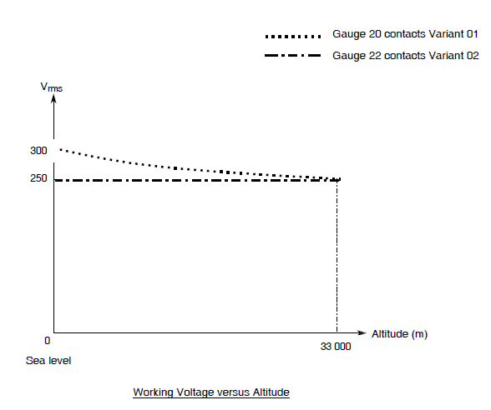

FIGURE 2 – PHYSICAL DIMENSIONS
FIGURE 2(a) - RECEPTACLES AND PLUGS
SHELL SIZE E
STANDARD MOUNTING HOLES
FIXED MOUNT
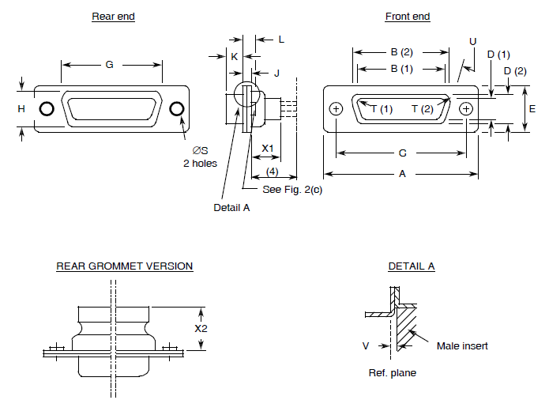
Contact  Type | Connector  Type | Symbol/  Dim. | A | B | C | D | E | G | H | J | K | L | ØS | T | U  ° | V | X1 | X2
Male | Plug | Min | 30.43 | 16.79 | 24.87 | 8.23 | 12.17 | 19.02 | 10.46 | 0.51 | 5.82 | 0.89 | 2.92 | 2.59 | 9 | 0 | - | -
Male | Plug | Max | 31.19 | 17.04 | 25.12 | 8.48 | 12.93 | 19.53 | 10.97 | 1.02 | 6.05 | 1.52 | 3.2 | 2.69 | 11 | 0.6 | 9.53 | 15.18
Female | Receptacle | Min | 30.43 | 16.21 | 24.87 | 7.77 | 12.07 | 19.02 | 10.46 | 0.51 | 6.05 | 0.89 | 2.92 | 2.46 | 9 | - | - | -
 |  | Max | 31.19 | 16.46 | 25.12 | 8.03 | 12.93 | 19.53 | 10.97 | 1.02 | 6.3 | 1.52 | 3.2 | 2.62 | 11 | - | 9.53 | 15.8
notes:
            - Inside dimension for connectors with male contacts.
            - Outside dimension for connectors with female contacts.
            - All dimensions are in millimetres (angles in degrees).
            - Contacts 340100505B, 340100506B, 340100515B and 340100516B protrude 16.5mm maximum.
            - Underlined dimensions, in table, are critical to ensure intermateability.
SHELL SIZE A
STANDARD MOUNTING HOLES
FIXED MOUNT
Contact  Type | Connector  Type | Symbol/  Dim. | A | B | C | D | E | G | H | J | K | L | ØS | T | U  ° | V | X1 | X2
Male | Plug | Min | 38.76 | 25.12 | 33.2 | 8.23 | 12.17 | 27.25 | 10.46 | 0.51 | 5.82 | 0.89 | 2.92 | 2.59 | 9 | 0 | - | -
Male | Plug | Max | 39.52 | 25.37 | 33.45 | 8.48 | 12.93 | 27.76 | 10.97 | 1.02 | 6.05 | 1.52 | 3.2 | 2.69 | 11 | 0.6 | 9.53 | 15.18
Female | Receptacle | Min | 38.76 | 24.54 | 33.2 | 7.77 | 12.17 | 27.25 | 10.46 | 0.51 | 6.05 | 0.89 | 2.92 | 2.46 | 9 | - | - | -
 |  | Max | 39.52 | 24.79 | 33.45 | 8.03 | 12.93 | 27.76 | 10.97 | 1.02 | 6.3 | 1.52 | 3.2 | 2.62 | 11 | - | 9.53 | 15.18
notes:
            - Inside dimension for connectors with male contacts.
            - Outside dimension for connectors with female contacts.
            - All dimensions are in millimetres (angles in degrees).
            - Contacts 340100505B, 340100506B, 340100515B and 340100516B protrude 16.5mm maximum.
            - Underlined dimensions, in table, are critical to ensure intermateability.
SHELL SIZE B
STANDARD MOUNTING HOLES
FIXED MOUNT
Contact  Type | Connector  Type | Symbol/  Dim. | A | B | C | D | E | G | H | J | K | L | ØS | T | U  ° | V | X1 | X2
Male | Plug | Min | 52.65 | 38.84 | 46.91 | 8.23 | 12.17 | 41.02 | 10.46 | 0.51 | 5.69 | 1.05 | 2.92 | 2.59 | 9 | 0 | - | -
Male | Plug | Max | 53.42 | 39.09 | 47.17 | 8.48 | 12.93 | 41.53 | 10.97 | 1.24 | 5.99 | 1.78 | 3.2 | 2.69 | 11 | 0.6 | 9.53 | 15.18
Female | Receptacle | Min | 52.65 | 38.25 | 46.91 | 7.77 | 12.17 | 41.02 | 10.46 | 0.51 | 6.05 | 0.89 | 2.92 | 2.46 | 9 | - | - | -
Female | Receptacle | Max | 53.42 | 38.51 | 47.17 | 8.03 | 12.93 | 41.53 | 10.97 | 1.02 | 6.3 | 1.52 | 3.2 | 2.62 | 11 | - | 9.53 | 15.18
notes:
            - Inside dimension for connectors with male contacts.
            - Outside dimension for connectors with female contacts.
            - All dimensions are in millimetres (angles in degrees).
            - Contacts 340100505B, 340100506B, 340100515B and 340100516B protrude 16.5mm maximum.
            - Underlined dimensions, in table, are critical to ensure intermateability.
SHELL SIZE C
STANDARD MOUNTING HOLES
FIXED MOUNT
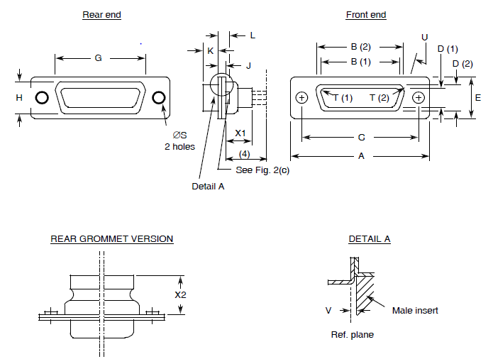
Contact  Type | Connector  Type | Symbol/  Dim. | A | B | C | D | E | G | H | J | K | L | ØS | T | U  ° | V | X1 | X2
Male | Plug | Min | 68.94 | 55.3 | 63.37 | 8.23 | 12.17 | 57.45 | 10.46 | 0.51 | 5.69 | 1.05 | 2.92 | 2.59 | 9 | 0 | - | -
Male | Plug | Max | 69.7 | 55.55 | 63.63 | 8.48 | 12.93 | 57.96 | 10.97 | 1.24 | 5.99 | 1.78 | 3.2 | 2.69 | 11 | 0.6 | 9.53 | 15.18
Female | Receptacle | Min | 68.94 | 54.71 | 63.37 | 7.77 | 12.17 | 57.45 | 10.46 | 0.51 | 6.05 | 0.89 | 2.92 | 2.46 | 9 | - | - | -
 |  | Max | 69.7 | 54.97 | 63.63 | 8.03 | 12.93 | 57.96 | 10.97 | 1.02 | 6.3 | 1.52 | 3.2 | 2.62 | 11 | - | 9.53 | 15.18
notes:
            - Inside dimension for connectors with male contacts.
            - Outside dimension for connectors with female contacts.
            - All dimensions are in millimetres (angles in degrees).
            - Contacts 340100505B, 340100506B, 340100515B and 340100516B protrude 16.5mm maximum.
            - Underlined dimensions, in table, are critical to ensure intermateability.
SHELL SIZE D
STANDARD MOUNTING HOLES
FIXED MOUNT
Contact  Type | Connector  Type | Symbol/  Dim. | A | B | C | D | E | G | H | J | K | L | ØS | T | U  ° | V | X1 | X2
Male | Plug | Min | 66.55 | 52.68 | 60.99 | 11.07 | 14.99 | 55.07 | 13.31 | 0.51 | 5.69 | 1.05 | 2.92 | 2.59 | 9 | 0 | - | -
Male | Plug | Max | 67.31 | 52.93 | 61.24 | 11.33 | 15.75 | 55.58 | 13.82 | 1.24 | 5.99 | 1.78 | 3.2 | 2.69 | 11 | 0.6 | 9.53 | 15.18
Female | Receptacle | Min | 66.55 | 52.3 | 60.99 | 10.62 | 14.99 | 55.07 | 13.31 | 0.51 | 6.05 | 0.89 | 2.92 | 2.46 | 9 | - | - | -
Female | Receptacle | Max | 67.31 | 52.55 | 61.24 | 10.87 | 15.75 | 55.58 | 13.82 | 1.02 | 6.3 | 1.52 | 3.2 | 2.62 | 11 | - | 9.53 | 15.18
notes:
            - Inside dimension for connectors with male contacts.
            - Outside dimension for connectors with female contacts.
            - All dimensions are in millimetres (angles in degrees).
            - Contacts 340100505B, 340100506B, 340100515B and 340100516B protrude 16.5mm maximum.
            - Underlined dimensions, in table, are critical to ensure intermateability.
SHELL SIZE F
STANDARD MOUNTING HOLES
FIXED MOUNT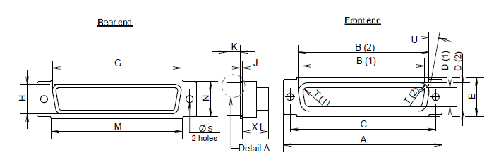
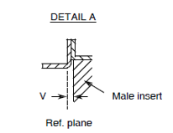
Contact  Type | Connector  Type | Symbol/  Dim. | A | B | C | D | E | G | H | J | K | M | N | ØS | T | U  ° | V | X1
Male | Plug | Min | 68.94 | 56.06 | 63.37 | 12.65 | 16.92 | 58.75 | 15.45 | 0.74 | 5.69 | 57.25 | 15 | 2.92 | 2.59 | 9 | 0 | -
Male | Plug | Max | 69.7 | 56.31 | 63.63 | 12.9 | 17.68 | 59.25 | 15.95 | 1.24 | 5.99 | 57.75 | 15.5 | 3.2 | 2.69 | 11 | 0.6 | 9.53
Female | Receptacle | Min | 68.94 | 55.47 | 63.37 | 12.19 | 16.92 | 58.75 | 15.45 | 0.51 | 6.05 | 57.25 | 15 | 2.92 | 2.46 | 9 | - | -
Female | Receptacle | Max | 69.7 | 55.73 | 63.63 | 12.45 | 17.68 | 59.25 | 15.95 | 1.02 | 6.3 | 57.75 | 15.5 | 3.2 | 2.62 | 11 | - | 9.53
notes:
            - Inside dimension for connectors with male contacts.
            - Outside dimension for connectors with female contacts.
            - All dimensions are in millimetres (angles in degrees).
            - Underlined dimensions, in table, are critical to ensure intermateability.
FIGURE 2(b) - CONTACT ARRANGEMENTS
VARIANT 01 - STANDARD CONTACT ARRANGEMENTS
FRONT VIEW MALE INSERT
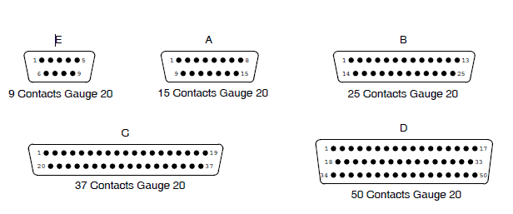
VARIANT 02 - HIGH DENSITY CONTACT ARRANGEMENTS
FRONT VIEW MALE INSERT
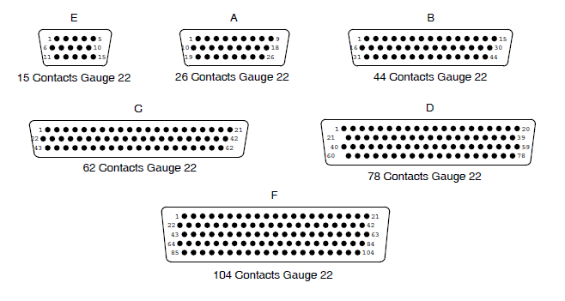
NOTES:
            - Contact locations are in conformity with MIL-DTL-24308 specification sheets and shall not be checked during procurement.
            - Both sides of the insert shall be marked with the minimum marking shown.
FIGURE 2(c) - RECEPTACLES AND PLUGS
OTHER MOUNTING TYPES
FLOATING MOUNT - TYPE Y
SHELL SIZES E, A, B, C, D, F
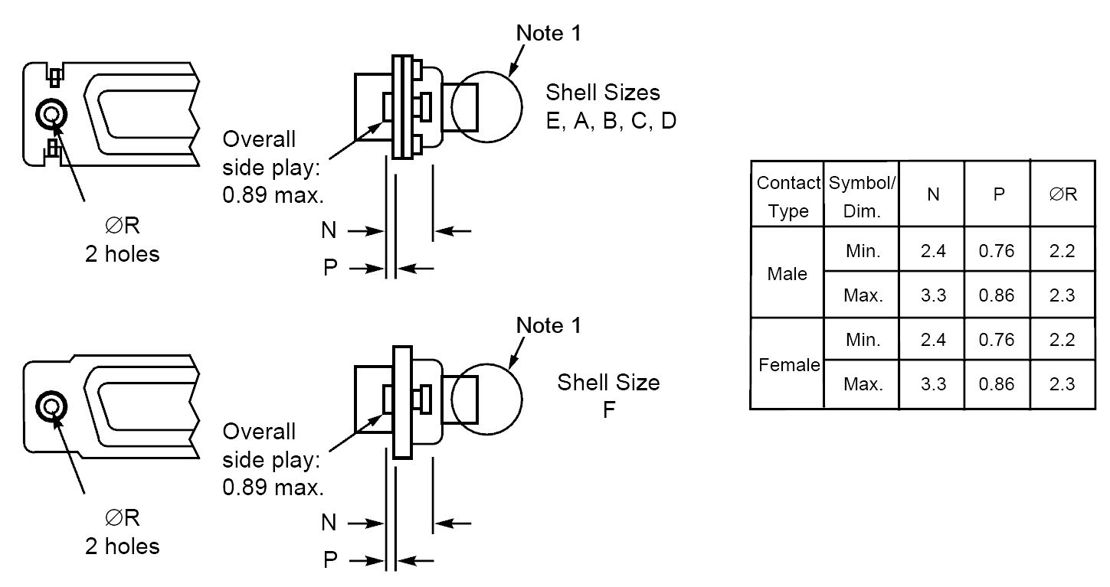
CAPTIVE NUTS - TYPE E
SHELL SIZES E, A, B, C, D, F
Contact Type | Symbol/  Dim. | N | P | R | ∅S
Male | Min. | 3.4 | 0 | 4.3 | -
Male | Max. | 4.2 | 0.5 | 4.7 | 5.2
Female | Min. | 3.4 | 0 | 4.3 | -
Female | Max. | 4.2 | 0.5 | 4.7 | 5.2
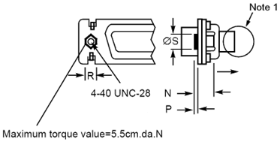

NOTES:
            - See Figure 2(a) for other dimensions.

REQUIREMENTS

GENERAL
The complete requirements for procurement of the connectors specified herein are stated in this specification and ESCC Generic Specification No. 3401. Deviations from the Generic Specification, applicable to this specification only, are listed in Para. 4.2.
Deviations from the applicable Generic Specification and this Detail Specification, formally agreed with specific Manufacturers on the basis that the alternative requirements are equivalent to the ESCC requirements and do not affect the components' reliability, are listed in the appendices attached to this specification.

DEVIATIONS FROM GENERIC SPECIFICATION

Deviations from Special In-process Controls
None.

Deviations from Final Production Tests - Chart II
          - Para. 9.1.1.4, Mated Shell Conductivity: Not applicable.

Deviations from Burn-in and Electrical Measurements - Chart III
Not applicable.

Deviations from Qualification Tests - Chart IV
          - Para. 9.1.1.4, Mated Shell Conductivity: Not applicable.
          - Para. 9.9, Seal Test: Not applicable.
          - Para. 9.24, Jackscrew Retention: Not applicable.

Deviations from Lot Acceptance Tests - Chart V
          - Para. 9.1.1.4, Mated Shell Conductivity: Not applicable.
          - Para. 9.9, Seal Test: Not applicable.

MECHANICAL REQUIREMENTS

Dimension Check
The dimensions of the connectors specified herein shall be verified in accordance with the requirements set out in Para. 9.6 of ESCC Generic Specification 3401 and shall conform to those shown in Figure 2 of this specification. Only the underlined dimensions shall be checked during procurement.

Weight
The maximum weight of the connectors specified herein, without contacts, shall be as specified in Table 1(a).

Contact Capability
As specified in ESCC Detail Specification No. 3401/005.

Contact Retention (In Insert)
As specified in ESCC Detail Specification No. 3401/005.

Mating and Unmating Forces
The forces applied for mating and unmating of the connectors shall conform to the values specified in Table 1(a).

Insert Retention (In Shell)
Connector inserts shall withstand a pressure of 42.8N/cm² without being dislodged from the shell.

Jackscrew Retention
Not applicable.

Contact Insertion and Withdrawal Forces
As specified in ESCC Detail Specification No. 3401/005.

Engagement and Separation Forces
As specified in ESCC Detail Specification No. 3401/005.

Oversize Pin Exclusion
As specified in ESCC Detail Specification No. 3401/005.

Probe Damage
As specified in ESCC Detail Specification No. 3401/005.

Solderability
As specified in ESCC Detail Specification No. 3401/005.

MATERIALS AND FINISHES
The materials and finishes shall be as specified herein. Where a definite material is not specified, a material which will enable the connectors specified herein to meet the performance requirements of this specification shall be used. Acceptance or approval of any constituent material does not guarantee acceptance of the finished product.

Shells
Shells of shell sizes E, A, B, C, D shall be made of brass. The standard plating finish (i.e. no Modification Code) shall be 0.7µm minimum of gold over 1µm minimum of copper. An alternative plating finish is 12.7µm minimum electroless nickel (Modification Code A175).
Shells of shell size F shall be made of aluminium alloy. The plating finish shall be either 25.4µm minimum of electroless nickel (Modification Code A174) or 0.7µm minimum of gold with 25.4µm minimum electroless nickel underplating (Modification Code FR172).

Inserts
Inserts shall be made of glass-fibre filled diallylphthalate resin or a suitable thermoplastic material. The rear grommet shall be made of silicone elastomer.

Contacts
As specified in ESCC Detail Specification No. 3401/005.

Contact Retaining Clip
The retaining clip shall be made of beryllium copper.

Guiding and Locking Devices
As specified in ESCC Detail Specification Nos. 3401/022, 3401/072 and 3401/085

Magnetism Level
The allowable value of magnetism shall not exceed that specified for the relevant level (see Para. 4.5.2.1(g)). Only magnetism levels NMC and NMD are verified.

MARKING

General
The marking of all components delivered to this specification shall be in accordance with the requirements of ESCC Basic Specification No. 21700 and the following paragraphs.
Each component and/or the component’s primary package shall be marked in respect of:
          - Contact number marking (see Figure 2(b)).
          - The ESCC qualified components symbol (for ESCC qualified components only).
          - The ESCC Component Number (see Para. 4.5.2).
          - Traceability information

The ESCC Component Number
The ESCC Component Number shall be constituted as follows (note 1):
Example: 340100201BDAMAY15PNMBA175FO
- Detail Specification Reference: 3401002
- Component Type Variant Number: 01 (as required; see Table 1(a))
- Testing Level: B
- Characteristic code: Series: D
- Characteristic code: Shell Size: A (as required)
- Characteristic code: Insert Type: MA
- Characteristic code: Alternative Design: Y (as required)
- Characteristic code: Contact Arrangement: 15 (as required)
- Characteristic code: Contact Gender: P (as required)
- Characteristic code: Magnetism Level: NMB (as required)
- Characteristic code: Modification Code: A175 (if/as required)
- Characteristic code: Contact Information: FO
NOTES:
            - A dash (-) or space may be included as part of the ESCC Component Number marking in order to separate one or more of the individual characteristic codes.

Characteristics
The characteristics to be codified as part of the ESCC Component Number shall be as follows:
          - Series
This connector series shall be indicated by the code D.
          - Shell Size
The shell size shall be indicated by the following code letters: E, A, B, C, D, F. See Table 1(a).
          - Insert Type
The type of insert shall be indicated by the code letters: MA.
          - Alternative Design
Alternative design shall be indicated by the following code letters:
- E: captive nuts; see Figure 2(c) (see note)
- Y: floating mount; see Figure 2(c) (see note)
- G: rear dust proof grommet; see Figure 2(a) (with standard mounting holes)
- YG: floating mount and rear dust proof grommet; see Figures 2(a) and 2(c)
NOTE:
If the shell has standard mounting holes, this code letter shall be omitted.
          - Contact Arrangement
The contact arrangement shall be indicated by the following codes; see Figure 2(b):
Code | Shell Size | Number of Contacts Gauge 20 | Number of Contacts Gauge 22
9 | E | 9 | N/A
15 | A | 15 | N/A
15 | E | N/A | 15
25 | B | 25 | N/A
26 | A | N/A | 26
37 | C | 37 | N/A
44 | B | N/A | 44
50 | D | 50 | N/A
62 | C | N/A | 62
78 | D | N/A | 78
104 | F | N/A | 104
          - Contact Gender
The gender of the contacts shall be indicated by the following code letters:
- P: male contact
- S: female contact
          - Magnetism Level
The magnetism level shall be indicated by the following codes:
Code | Definition
NMB | Magnetism Level: ≤ 200 gamma (1)
NMC | Magnetism Level: ≤ 20 gamma
NMD | Magnetism Level: ≤ 2 gamma
NOTES:
            - Guaranteed, but not measured.
          - Modification Code
A modification code shall be included in the ESCC Component Number when required, otherwise it shall be omitted.
Finish codes: the following modification codes shall apply when required (see Para. 4.4.1):
- A175: electroless nickel finish for shell sizes E, A, B, C, D only.
- A174: electroless nickel finish for shell size F only.
- FR172: gold over electroless nickel finish for shell size F only.
          - Contact Information
These connectors shall be ordered without contacts as indicated by the code FO.
This code shall not be marked on the component but shall be marked on the component’s primary package.
NOTE: Contacts must be from the same Manufacturer as the connector in which they are mounted and this shall be verified prior to assembly

Traceability Information
Traceability information shall be marked in accordance with the requirements of ESCC Basic Specification No. 21700.

ELECTRICAL MEASUREMENTS

Electrical Measurements at Room Temperature
The parameters to be measured in respect of electrical characteristics are scheduled in Table 2. Unless otherwise specified, these measurements shall be performed at T_{amb} = +22 ±3°C.

Electrical Measurements at High and Low Temperatures (Table 3)
Not applicable.

Circuits for Electrical Measurements (Figure 4)
Not applicable.

BURN-IN AND ELECTRICAL MEASUREMENTS (TABLES 4 AND 5)
Not applicable.

ENVIRONMENTAL AND ENDURANCE TESTS

Measurements and Inspections on Completion of Environmental Tests
The parameters to be measured and inspections to be performed on completion of environmental testing shall be those specified in Table 6. Unless otherwise specified, the measurements shall be performed at Tamb = +22 ±3°C.

Measurements and Inspections at Intermediate Points during Endurance Tests
Not applicable.

Measurements and Inspections on Completion of Endurance Tests
The parameters to be measured and inspections to be performed on completion of endurance tests shall be those specified in Table 6. Unless otherwise specified, the measurements shall be performed at Tamb = +22 ±3°C.

Conditions for Operating Life Test (Part of Endurance Testing)
Not applicable.

Electrical Circuits for Operating Life Test
Not applicable.

Conditions for High Temperature Storage Test (Part of Endurance Testing)
The requirements for the high temperature storage test are specified in Section 9 of ESCC Generic Specification No. 3401. The conditions for high temperature storage testing shall be the maximum storage temperature specified in Table 1(b) of this specification.
TABLE 2 – ELECTRICAL MEASUREMENTS AT ROOM TEMPERATURE
No. | Characteristic | Symbol | Specification and  Test Method | Test Condition | Limits |  | Unit
 |  |  |  |  | Min | Max
1 | Insulation Resistance | Ri | ESCC 3401 Para. 9.1.1.1 | Para. 9.1.1.1 | 5000 | - | MΩ
2 | Voltage Proof  Leakage Current | I_{L} | ESCC 3401  Para. 9.1.1.2 |  |  |  | mA
 | Variant 01 |  |  | 1250Vrms (1) | - | 2
 | Variant 02 |  |  | 1000Vrms | - | 2
3 | Mated Shell Conductivity  (Voltage Drop) (2) | Vd | ESCC 3401  Para. 9.1.1.4 | Para. 9.1.1.3 | Not applicable |  | mV
notes:
            - When connectors are equipped with 340100505B and 340100506B contacts, each crimp barrel shall be isolated from adjacent contacts with insulation material.
            - Applicable to mated connectors with grounding option.
TABLES 3, 4 AND 5
Not applicable.
TABLE 6 – MEASUREMENTS AND INSPECTIONS ON COMPLETION OF ENVIRONMENTAL AND ENDURANCE TESTING
No. | ESCC Generic Spec. No. 3401 |  | Measurements and Inspections |  | Symbol | Limits |  | Unit
 | Environmental and Endurance Tests (1) | Test Method and Conditions | Identification | Conditions |  | Min | Max
01 | Wiring | Para. 9.10 | ESCC 3401/005 | - | - | - | -
02 | Vibration | Para. 9.11 | Initial Measurements
 |  |  | Coupling Screw(s) Unlocking Torque | - | - | Record Values
 |  |  | Final Measurements | Full Engagement
 |  |  | Coupling Screw(s) Unlocking Torque Drift | - | Δ | -25 | +25 | %
 |  |  | Visual Examination | - | - | - | -
03 | Shock or Bump | Para. 9.12 | Final Measurements | Full Engagement
 |  |  | Visual Examination | - | - | - | -
04 | Climatic Sequence | Para. 9.13 | Dry Heat
 |  |  | Insulation Resistance | Table 2 Item 1 | Ri | 1000 | - | MΩ
 |  |  | Low Air Pressure
 |  |  | Voltage Proof Leakage Current | Figure 1 | I_{L} | Table 2 Item 2
 |  |  | Damp Heat | Immediately after test
 |  |  | Insulation Resistance | Table 2 Item 1 | Ri | 100 | - | MΩ
 |  |  |  | After 1 - 24hrs Recovery
 |  |  | External Visual Inspection | ESCC 3401 Para. 9.7 | - | ESCC 3401  Para. 9.7
 |  |  | Insulation Resistance | Table 2 Item 1 | Ri | Table 2 Item 1
 |  |  | Voltage Proof Leakage Current | Table 2 Item 2 | I_{L} | Table 2 Item 2
05 | Seal Test | Para. 9.9 | ESCC 3401 Para. 9.9 |  |  | Not applicable
06 | Plating Thickness | Para. 9.14 | Thickness | - | - | ESCC 3401/005
07 | Joint Strength | Para. 9.15 | ESCC 3401 Para. 9.15 | - | - | ESCC 3401 Para. 9.15
08 | Rapid Change of Temperature | Para. 9.16 | Visual Examination | - | - | - | -
 | Rapid Change of Temperature |  | Insulation Resistance | Table 2 Item 1 | Ri | Table 2 Item 1
 | Rapid Change of Temperature |  | Voltage Proof Leakage Current | Table 2 Item 2 | I_{L} | Table 2 Item 2
09 | Contact Retention (In Insert) | Para. 9.17 & Para. 4.3.4 of this spec | Contact Displacement | - | - | ESCC 3401  Para. 9.17
10 | Endurance | Para. 9.18 | Initial Measurements
 |  |  | Mating/Unmating Forces | - | F | Para. 4.3.5 of this spec.
 |  |  | Low Level Contact Resistance | ESCC 3401/005 | Rcl | Record Values
 |  |  | Mated Shell Conductivity | Table 2 Item 3 | Vd | Not applicable
 |  |  | Final Measurements
 |  |  | Visual Examination | - | - | - | -
 |  |  | Mating/Unmating Forces | - | F | Para. 4.3.5 of this spec.
 |  |  | Low Level Contact Resistance Drift | ESCC 3401/005 | ΔRcl | ESCC 3401/005
 |  |  | Mated Shell Conductivity | Table 2 Item 3 | Vd | Not applicable
 |  |  | Insulation Resistance | Table 2 Item 1 | Ri | Table 2 Item 1
 |  |  | Voltage Proof Leakage Current | Table 2 Item 2 | I_{L} | Table 2 Item 2
11 | Permanence of Marking | Para. 9.19 | As applicable | - | - | - | -
12 | Mating Unmating Forces | Para. 9.20 | Force | - | F | Para. 4.3.5 of this spec.
13 | High Temperature Storage | Para. 9.21 | Initial Measurements
 | High Temperature Storage |  | Low Level Contact Resistance | ESCC 3401/005 | Rcl | Record Values
 | High Temperature Storage |  | Mated Shell Conductivity | Table 2 Item 3 | Vd | Not applicable
 | High Temperature Storage |  | Final Measurements
 | High Temperature Storage |  | Visual Examination | - | - | - | -
 |  |  | Mating/Unmating Forces | - | F | Para. 4.3.5 of this spec.
 |  |  | Low Level Contact Resistance Drift | ESCC 3401/005 | ΔRcl | ESCC 3401/005
 |  |  | Rated Current Contact Resistance | ESCC 3401/005 | Rcr | ESCC 3401/005
 |  |  | Mated Shell Conductivity | Table 2 Item 3 | Vd | Not applicable
 |  |  | Insulation Resistance | Table 2 Item 1 | Ri | Table 2 Item 1
 |  |  | Voltage Proof Leakage Current | Table 2 Item 2 | I_{L} | Table 2 Item 2
 |  |  | Contact Retention (In Insert) | Para. 4.3.4 of this spec. | - | ESCC 3401  Para. 9.17
14 | Corrosion | Para. 9.22 | Visual Examination | - | - | - | -
15 | Insert Retention (In Shell) | Para. 9.23 & Para. 4.3.6 of this spec. | Visual Examination | - | - | Para. 4.3.6
16 | Jackscrew Retention | Para. 9.24 & Para. 4.3.7 of this spec. | Visual Examination | - | - | Not applicable
17 | High Temperature Measurements | Para. 9.25 | Insulation Resistance | Table 2 Item 1 | Ri | 500 | - | MΩ
18 | Overload Test | Para. 9.26 | Internal Temperature | - | T | - | +100 | ºC
 |  |  | Rated Current Contact Resistance | ESCC 3401/005 | Rcr | ESCC 3401/005
 |  |  | Mated Shell Conductivity | Table 2 Item 3 | Vd | Not applicable
 |  |  | Insulation Resistance | Table 2 Item 1 | Ri | Table 2 Item 1
 |  |  | Voltage Proof Leakage Current | Table 2 Item 2 | I_{L} | Table 2 Item 2
19 | Maintenance Ageing | Para. 9.27 | Visual Examination | - | - | - | -
 |  |  | Contact Retention | Para. 4.3.4 of this spec. |  | ESCC 3401  Para. 9.17
 |  |  | Contact Insertion & Withdrawal Forces | Para. 4.3.8 of this spec. |  | Para. 4.3.8
20 | Engage/Separation Forces | Para. 9.28 & Para. 4.3.9 of this spec. | Force | - | - | Para. 4.3.9
21 | Oversize Pin Exclusion | Para. 9.29 & Para. 4.3.10 of this spec. | - | - | - | ESCC 3401  Para. 9.29
22 | Probe Damage | Para. 9.30 & Para. 4.3.11 of this spec. | Contact Separation Force | Para. 4.3.9 of this spec. |  | Para. 4.3.9
23 | Solderability | Para. 9.31 & Para. 4.3.12 of this spec. | - | - | - | Para. 4.3.12
notes:
            - The tests in this Table refer to either Chart IV or V and shall be used as applicable.
Appendix A
AGREED DEVIATIONS FOR C&K CONNECT (F)
ITEMS AFFECTED | DESCRIPTION OF DEVIATIONS
Para. 4.2.2 Deviations from Final Production Tests - Chart II | Para. 9.3, Contact Retainer Test may be omitted provided that a 100% external visual inspection of the contact retainer clips positioned within the insert is performed in accordance with the C&K CONNECT PID requirements.
Para. 4.5.2 The ESCC Component Number | Connectors may be ordered without the contact information characteristic code (i.e. -FO) being included in the ESCC Component Number. In which case, unless otherwise advised by C&K CONNECT during the Ordering process, the contacts, of the appropriate quantity, to be supplied with the connectors shall be as follows:
  Ordered Connector (without -FO) | Contacts
  340100201BD*MA*P* (with Male Contacts) | 340100511B
  340100201BD*MA*S* (with Female Contacts) | 340100512B
  340100202BD*MA*P* (with Male Contacts) | 340100517B
  340100202BD*MA*S* (with Female Contacts) | 340100518B

Appendix B
AGREED DEVIATIONS FOR SOURIAU (F)
ITEMS AFFECTED | DESCRIPTION OF DEVIATIONS
Para. 4.2.2 Deviations from Final Production Tests - Chart II | Para. 9.3, Contact Retainer Test may be omitted provided that a 100% external visual inspection of the contact retainer clips positioned within the insert is performed in accordance with the SOURIAU PID requirements.
Para. 4.5.2 The ESCC Component Number | Connectors may be ordered without the contact information characteristic code (i.e. -FO) being included in the ESCC Component Number. In which case, unless otherwise advised by SOURIAU during the Ordering process, the contacts, of the appropriate quantity, to be supplied with the connectors shall be as follows:
  Ordered Connector (without -FO) | Contacts
  340100201BD*MA*P* (with Male Contacts) | 340100501B
  340100201BD*MA*S* (with Female Contacts) | 340100502B
  340100202BD*MA*P* (with Male Contacts) | 340100507B
  340100202BD*MA*S* (with Female Contacts) | 340100508B

