

Page 1 of 9

EXTERNAL VISUAL INSPECTION OF
ELECTROMAGNETIC RELAYS

ESCC Basic Specification No. 2053600

Issue 5 Draft A | December 2024


Document Custodian: European Space Agency – see https://escies.org

Legal Disclaimer and Copyright
European Space Agency, Copyright © 2024. All rights reserved.
The European Space Agency disclaims any liability or responsibility, to any person or entity, with respect to any loss or damage caused, or alleged to be caused, directly or indirectly by the use and application of this ESCC publication.
This publication, without the prior permission of the European Space Agency and provided that it is not used for a commercial purpose, may be:
- copied in whole, in any medium, without alteration or modification.
- copied in part, in any medium, provided that the ESCC document identification, comprising the ESCC symbol, document number and document issue, is removed.

DOCUMENTATION CHANGE NOTICE
(Refer to https://escies.org for ESCC DCR content)
DCR No. | CHANGE DESCRIPTION
tba | Specification upissued to incorporate changes per DCR.

TABLE OF CONTENTS
1 SCOPE 5
2 GENERAL REQUIREMENTS 5
2.1 APPLICABILITY 5
2.2 PROCEDURE 5
3 EQUIPMENT REQUIRED 5
3.1 MAGNIFICATION 5
3.2 MOUNTING FIXTURES 5
4 DETAILED REQUIREMENTS 5
4.1 REJECT CRITERIA 5
4.2 Terminals 6
4.2.1 Flexible Terminals 6
4.2.2 Rigid Terminals 6
4.3 GLASS SEALS 7
4.4 HEADERS 7
4.5 CASE OR PACKAGE SEALING 7
4.6 CASE CONCENTRICITY 7
5 FIGURES 8
5.1 FIGURE 1: TERMINAL ECCENTRICITY 8
5.2 FIGURE 2: TERMINAL TILT 8
5.3 FIGURE 3: CASE CONCENTRICITY 9
5.4 FIGURE 4: PARTICLES IN THE GLASS SEAL 9

SCOPE
This Specification to be read in conjunction with ESCC Basic Specification No. 20500, External Visual Inspection, contains additional specific requirements for Electromagnetic Relays.

GENERAL REQUIREMENTS

APPLICABILITY
The following criteria may not be varied or modified after commencing an inspection stage. Any ambiguity or proposed minor deviation shall be referred to the ESCC Executive for resolution and approval.

PROCEDURE
All items shall be examined in such a manner that a minimum of handling and movement of the component is involved.

EQUIPMENT REQUIRED

MAGNIFICATION
All items shall be examined using a binocular or stereoscopic microscope with a minimum range of magnification X8 to X20. Minimum magnification shall be X8. Maximum magnification shall be X20.

MOUNTING FIXTURES
Suitable fixtures may be used to assist in the inspection process, provided that they do not themselves cause damage to the device. Care shall be taken that adequate provision is made to avoid accidental damage.

DETAILED REQUIREMENTS

REJECT CRITERIA
A component shall be rejected if it exhibits one or more of the defects listed in any of the following paragraphs. Where applicable, drawings have been included to provide additional explanatory material, but they shall be considered as examples only.

Terminals

Flexible Terminals
Unless a terminal is described as rigid in the Detail Specification, the terminal is designed to be flexible and the following rejection criteria shall apply:
          - Condition:
- Exposed base material, in excess of terminal diameter or thickness, caused by chipped glass meniscus.
- Exposed base material anywhere on the terminal within a distance of 20mm of the case, other than that caused by 1) above.
- Exposed base material in excess of 5% of the surface area anywhere on the terminal, beyond a distance of 20mm from the case.
- Non-conductive material on the terminal, beyond a distance of 1.5mm from the case.
- Reduction of terminal diameter, width or thickness by more than 10% within 20mm of the case.
- Nicks, fractures, non-uniformity or discolouration of coating, or abrasions exposing base material.
          - Configuration:
- Straight round terminals twisted more than 1 revolution per 30mm of length.
- Terminals kinked, or bent and re-bent within 20mm of the case.
- Terminals deviating from the specified direction by more than 1mm per any 5mm of length.
- Eccentricity of the terminal passing through the centre of a glass-to-metal seal greater than 10% of the seal diameter (see Figure 1 Para. 5.1).
- Terminals tilted by more than five degrees (5°) (see Figure 2 Para. 5.2).

Rigid Terminals
When a terminal is described as rigid in the Detail Specification, the following rejection criteria shall apply:
          - Condition:
- Exposed base material, in excess of terminal diameter or thickness, caused by chipped glass meniscus.
- Exposed base material in excess of 5% of the surface area anywhere on the terminal other than that caused by (a); see also note below.
Note:
Exposed base material within 2.5mm from the body, resulting from wire wrappings during the terminal plating operation, is acceptable.
- Non-conductive material on the terminal, beyond a distance of 2.5mm from the case.
- Reduction of terminal diameter, width or thickness by more than 10%.
- Nicks, fractures, non-uniformity or discolouration of coating, or abrasions exposing base material.
          - Configuration:
- Terminals kinked or bent by more than 5°.
- Eccentricity of the terminal passing through the centre of a glass-to-metal seal greater than 10% of the seal diameter (see Figure 1 Para. 5.1).
- Terminals tilted by more than five degrees (5°) (see Figure 2 Para. 5.2).

GLASS SEALS
          - Filling, in glass-filled cases, protruding above the level of the case flange.
          - Single bubbles in a glass seal, the diameter of the minor ones of which exceeds one eighth of the seal diameter, or a collection of smaller bubbles which cannot be separated from each other or whose spatial distribution cannot be determined.
          - Any foreign material in the glass seal with a maximum dimension greater than half the distance between the lead and the edge of the seal, or a grouping of smaller foreign materials whose overall maximum dimension exceeds 50% of the glass seal. See Figure 4 Para. 5.4.
NOTE:
This criterion shall not apply if the foreign material is successfully removed. The glass seal shall be re-examined to verify there are no other induced or hidden defects as specified in (d) and (e) below.
          - Surface chips, the diameter of which exceeds in any one place 20% of the glass seal diameter or whose depth is greater than one quarter of the header thickness.
          - Cracks of any shape, length or position.
          - Incomplete wetting of terminal by glass.

HEADERS
          - At least 98% of the headers shall be covered by a protective plating as defined in the Detail Specification.
          - Header/can junctions shall be free from voids or pits.
          - Tinning shall be smooth and bright.

CASE OR PACKAGE SEALING
          - Lack of solder continuity around the complete perimeter of the case or solder protruding beyond the edge of the case.
          - Weld spatters, lack of uniformity or continuity of weld.
          - Reduction of design sealing area by more than 20% due to undercutting of sealing material or misalignment of case parts.

CASE CONCENTRICITY
          - Minimum case perimeter to header perimeter clearance, in plan view, less than 70% of the maximum clearance (see Figure 3 Para. 5.3).

FIGURES

FIGURE 1: TERMINAL ECCENTRICITY
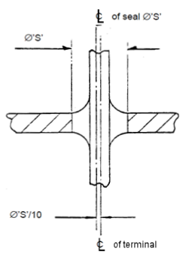

FIGURE 2: TERMINAL TILT
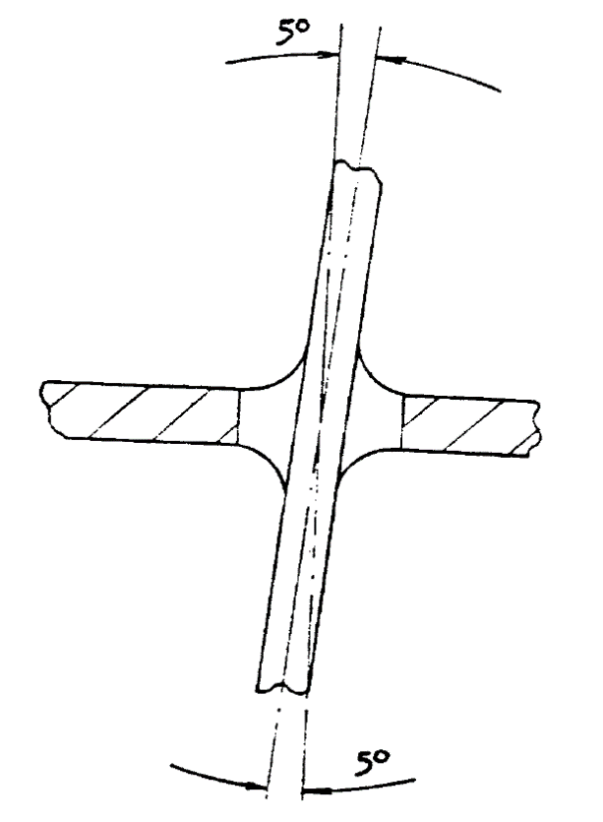

FIGURE 3: CASE CONCENTRICITY
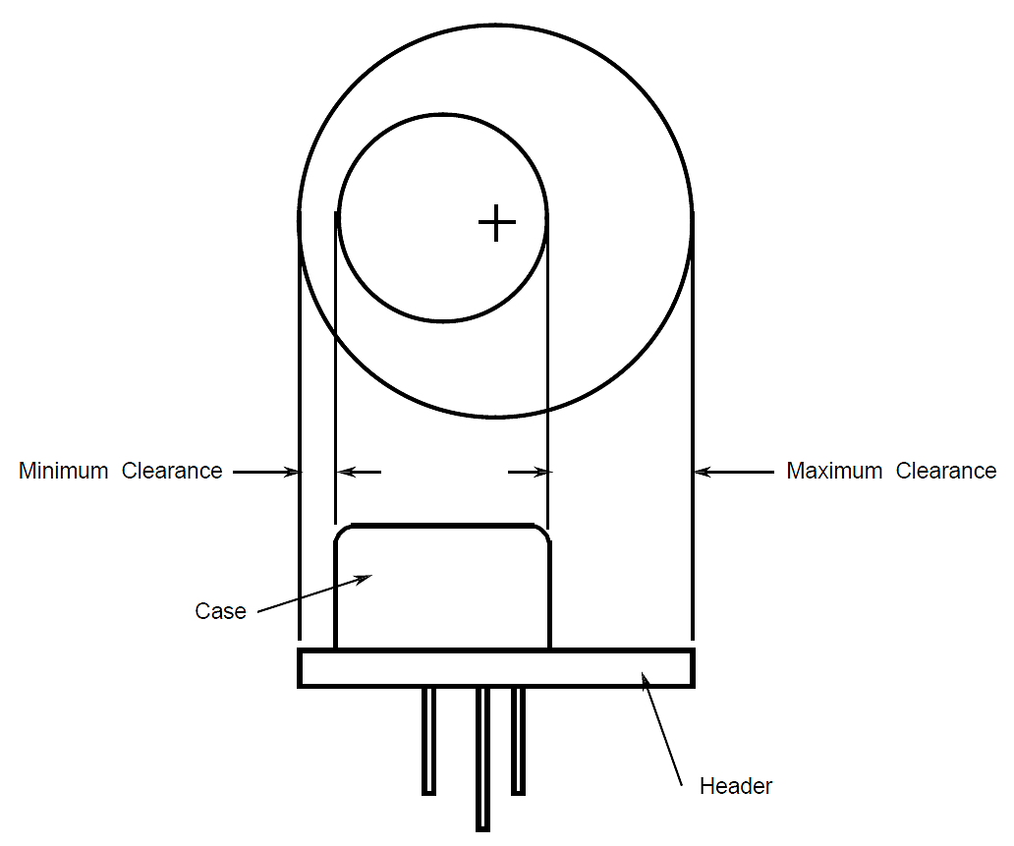

FIGURE 4: PARTICLES IN THE GLASS SEAL


