

Page 1 of 20

INTERNAL VISUAL INSPECTION OF ELECTROMAGNETIC RELAYS

ESCC Basic Specification No. 2043600

Issue 3 Draft A | December 2024


Document Custodian: European Space Agency – see https://escies.org

Legal Disclaimer and Copyright
European Space Agency, Copyright © 2024. All rights reserved.
The European Space Agency disclaims any liability or responsibility, to any person or entity, with respect to any loss or damage caused, or alleged to be caused, directly or indirectly by the use and application of this ESCC publication.
This publication, without the prior permission of the European Space Agency and provided that it is not used for a commercial purpose, may be:
- copied in whole, in any medium, without alteration or modification.
- copied in part, in any medium, provided that the ESCC document identification, comprising the ESCC symbol, document number and document issue, is removed.

DOCUMENTATION CHANGE NOTICE
(Refer to https://escies.org for ESCC DCR content)
DCR No. | CHANGE DESCRIPTION
tba | Specification upissued to incorporate changes per DCR.

TABLE OF CONTENTS
1 SCOPE 6
2 General Requirements 6
2.1 APPLICABILITY 6
2.2 PROCEDURE 6
3 EQUIPMENT REQUIRED 6
3.1 MAGNIFICATION 6
3.2 MOUNTING FIXTURES 6
3.3 ELECTRICAL EQUIPMENT 6
4 DETAILED REQUIREMENTS 6
4.1 REJECT CRITERIA 6
4.2 GENERAL 7
4.3 CoILS 7
4.4 ELECTRICAL WELDS 7
4.5 MAGNETIC CIRCUITS, ARMATURE, ACTUATOR 7
4.6 CONTACTS 8
4.7 HEADERS 8
4.8 HOUSINGS 9
5 FIGURES 10
5.1 FIGURE I – COIL DEFECTS 10
5.2 FIGURE II – FLATTENING OF WELD PROJECTION 10
5.3 FIGURE III – FRAME TO HEADER WELD 11
5.4 FIGURE IV – FRAME TO HEADER WELD CROSS-SECTION 11
5.5 FIGURE V – LEAD WIRE TO TERMINAL WELD CROSS-SECTION 11
5.6 FIGURE VI – LEAD WIRE TO TERMINAL WELD 12
5.7 FIGURE Vii – armATURE/POLE PIECE CONTACT AREA AND GAP 12
5.8 FIGURE VIII – POLE PIECE / FRAME GAP 13
5.9 FIGURE IX – actUATOR POSITION 13
5.10 FIGURE X – ACTUATOR / ARMATURE WELD 13
5.11 FIGURE XI – actUATOR GLASS BEAD 14
5.12 FIGURE XII – CONTACT / TERMINAL BRAZE 14
5.13 FIGURE XIII – CONTACT / TERMINAL WELD 15
5.14 FIGURE XIV – EXAMPLE OF CONTACT ALIGNMENTS 16
5.15 FIGURE XV – ACTUATOR / CONTACT POSITION 17
5.16 FIGURE XVI – HEADER DEFECTS 17
5.17 FIGURE XVII – GLASS-TO-METAL SEAL CRACKS AND CHIP-OUTS 18
5.18 FIGURE XVIII – BUBBLES IN GLASS BEAD 18
5.19 FIGURE XIX – LEAD POSITION WITHIN GlASS-TO-METAl SEAL 19
5.20 FIGURE XX – TILT OF TERMINAL IN GlASS-TO-METAl SEAL 19
5.21 FIGURE XXI – GLASS MENISCUS 20
5.22 FIGURE XXII – BRACKET TO HOUSING WELD 20
5.23 FIGURE XXIII – PARTICLES IN THE GLASS SEAL 20

SCOPE
This specification, to be read in conjunction with ESCC Basic Specification No. 20400, "Internal Visual Inspection", contains additional requirements for electromagnetic relays. They shall apply, where relevant, to each device inspected.

General Requirements

APPLICABILITY
The following criteria may not be varied or modified after commencing any inspection stage. Any ambiguity or proposed minor deviation shall be referred to the ESCC Executive for resolution and approval.

PROCEDURE
Before encapsulation, the relays shall be inspected on a laminar flow bench. The workbench shall fulfil adequate cleanliness conditions. All items shall be examined in such a manner that a minimum of handling and movement of the component is involved. Apart from the clothing normally prescribed for wear in clean rooms, inspectors shall wear gloves or finger-cots when manipulating relays.

EQUIPMENT REQUIRED

MAGNIFICATION
The optical equipment necessary for the inspection should be a stereozoom with a magnification of X10.

MOUNTING FIXTURES
Suitable fixtures may be used to assist in the inspection process provided they do not of themselves cause damage to the device. Care shall be taken that adequate provision is made to avoid accidental damage.

ELECTRICAL EQUIPMENT
The appropriate electrical equipment shall be provided for energising relay coils and visualising contact opening and closing.

DETAILED REQUIREMENTS

REJECT CRITERIA
A component shall be rejected if it exhibits any of the defects listed in any of the following paragraphs. Where applicable, drawings have been included to provide additional explanatory material.

GENERAL
          - Loose particles (in particular, free particles of insulating material or detachable metal particles shall not be accepted).
          - Chemical contamination (grease, varnish, ink, etc.).
          - Blistering or flaking of plating on any metal part.
N.B. If cleanliness requirements for relay and housings are not met, further cleaning operations shall be allowed, followed by another inspection.

CoILS
          - Tool or fixture nicks on coil insulation and lead wire insulation (see Figure I Para. 5.1).
          - Evidence of cracks, holes or marks in coil insulation exposing copper wires of the coil winding (see Figure I Para. 5.1).
          - Incomplete coverage of coil winding by an insulation tape (see Figure I Para. 5.1).
          - Finishing end of wrapping not adhering to coil.
          - Loose particles of insulating material.
          - Embedded metal particles in coil insulation.
          - Incorrect position of lead wires, so that they are in the way of moving parts or within 0.2mm of their furthest travel.
          - Dirty coil insulation. (Recleaning is permitted).

ELECTRICAL WELDS
          - Weld point missing.
          - Burnt welds.
          - Weld flashes. (They can be accepted if they are firmly attached).
          - Welds with cracks.
          - Weld projection (dimple) not flattened (see Figure II Para. 5.2).
          - Weld point overlapping frame and header (see Figure III Para. 5.3).
          - Any gap (except by design) between frame and header, where indicated (see Figure III Para. 5.3).
          - Bent frame leg (see Figure IV Para. 5.4).
          - Welding pressure too high, leg deformed by more than 50% of its thickness (see Figure IV Para. 5.4).
          - Lead wire deformed by more than 50% or less than 25% of its initial thickness (see Figure V Para. 5.5).
          - Incorrect position of lead wire on terminal relative to header (see Figure VI Para. 5.6).

MAGNETIC CIRCUITS, ARMATURE, ACTUATOR
          - The physical contact area between pole piece and armature is less than two thirds of the design contact area or > 0.05mm where indicated (see Figure VII Para. 5.7).
          - Gap greater than 0.4mm between pole piece and frame (see Figure VIII Para. 5.8).
          - Armature is not moving freely.
          - End or side play in excess of design.
          - Lack of parallelism between armature and actuator arm (unless by design) (see Figure IX Para. 5.9).
          - The actuator arm stands proud of the armature, unless by design (see Figure IX Para. 5.9).
          - Excessive deformation of actuator at weld point (> 50%) of its initial thickness (see Figure X Para. 5.10).
          - Deformation of armature.
          - Actuator bead asymmetrically located (see Figure XI Para. 5.11).
          - Irregular shape of actuator bead (see Figure XI Para. 5.11).
          - Cracks or chip-outs in bead (see Figure XI Para. 5.11).
          - Bubbles of dimension and location weakening the bead (see Figure XVIII Para. 5.18).
          - Foreign materials (black dots).

CONTACTS
          - Tool marks.
          - Scratches or visible damage.
          - Any corrosion, unsmooth surface.
          - Deformation of contacts in excess of design.
          - Deformation of terminals in excess of design.
          - Bad adherence of plating around brazing area.
          - Brazing alloy (braze construction) in excess of design (see Figure XII Para. 5.12).
          - Weld splash (weld construction) (see Figure XIII Para. 5.13).
          - Incorrect contact alignment (see Figure XIV Para. 5.14):
            - The plane containing the surfaces of the contacts are misaligned by more than one third of the design contact area.
            - The physical contact area is less than two thirds of the design contact area.
          - Incorrect parallelism between header and contacts (see Figure XIV Para. 5.14).
          - Incorrect parallelism between contacts (see Figure XIV Para. 5.14).
          - Clearance between actuator and contacts less than design.
          - Incorrect position of actuator bead relative to contacts (see Figure XV Para. 5.15).

HEADERS
          - Nicks, dents on periphery of header, where the can is Tungsten-Inert Gas, Electron Beam, Laser Beam, welded.
          - Glass on the flange or the side of the header (see Figure XVI Para. 5.16).
          - Blistering or flaking of gold or nickel plating.
          - Header post bent more than 10° (see Figure XVI Para. 5.16).
          - Metal shavings on the flange or side of the header longer than the width of the flange.
          - Bent or deformed flanges (see Figure XVI Para. 5.16).
          - Grease, varnish, ink or similar stain on the flange or side of the header.
          - Any conductive material overlapping the glass seal.
          - Cracked or chipped glass seal (see Figure XVII Para. 5.17).
          - Non-uniformity of finish of lead or pillar, particularly at the glass seal.
          - Nicks or bulges in the wire diameter outside stated lead tolerance.
          - Individual bubbles diameter more than a third of the minimum distance between the terminal and the header, or an area of adjacent bubbles in the seal area bigger than 12.5% of the seal area.
          - Any foreign material in the glass seal with a maximum dimension greater than half the distance between the lead and the edge of the seal, or a grouping of smaller foreign materials whose overall maximum dimension exceeds 50% of the glass seal (see Figure XXIII Para. 5.23).
NOTE:
This criterion shall not apply if the foreign material is successfully removed. The glass seal shall be re-examined to verify there are no other induced or hidden defects as specified in (i) above.
          - Eccentricity of lead passing through the centre of the glass-to-seal greater than 10% of the glass feedthrough diameter (see Figure XIX Para. 5.19).
          - Lead tilted more than 5° (see Figure XX Para. 5.20).
          - Incorrect position of solder hooks (see Detail Specification).
          - Glass seal protruding above or below header along terminal by more than 0.5mm (see Figure XXI Para. 5.21).

HOUSINGS
          - Tool marks.
          - Scratches or visible damage.
          - Corrosion.
          - Dents.
          - Deformation by shocks.
If applicable:
          - Electrically welded brackets (see Figure XXII Para. 5.22).
          - Incorrect position of mounting brackets (see PID).
          - Excess brazing alloy on bracket, causing change of dimensions.
          - Granular brazing alloy.
          - Microholes in brazing alloy.
          - General lack of alloy around bracket/housing.

FIGURES

FIGURE I – COIL DEFECTS
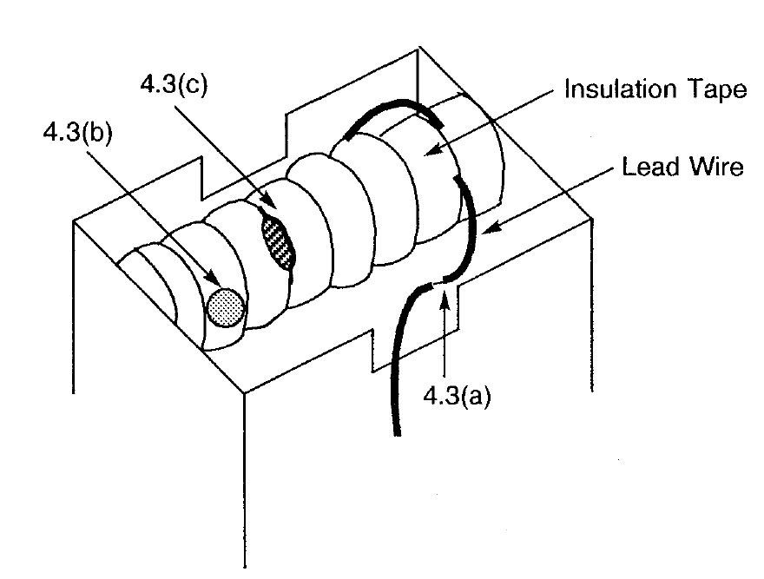

FIGURE II – FLATTENING OF WELD PROJECTION
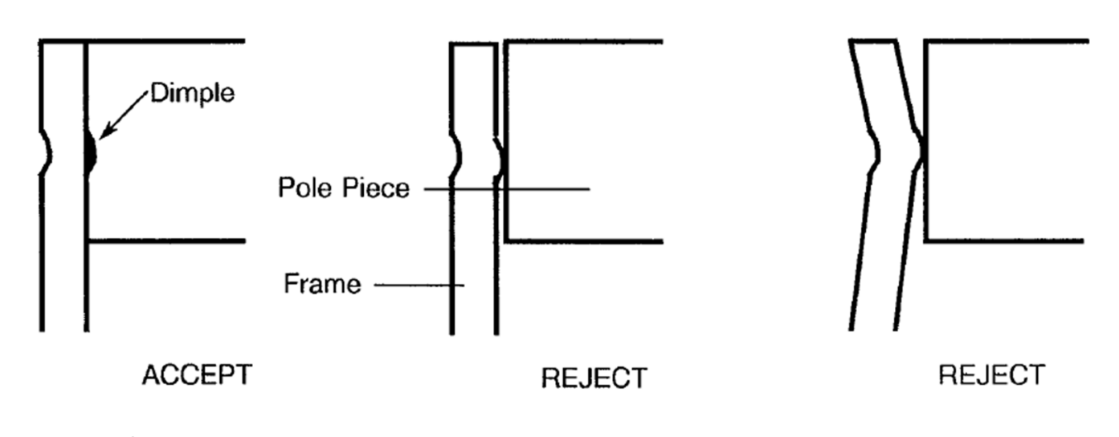

FIGURE III – FRAME TO HEADER WELD
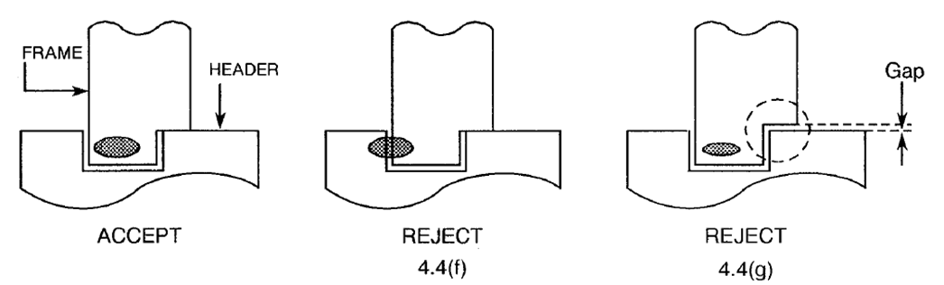

FIGURE IV – FRAME TO HEADER WELD CROSS-SECTION
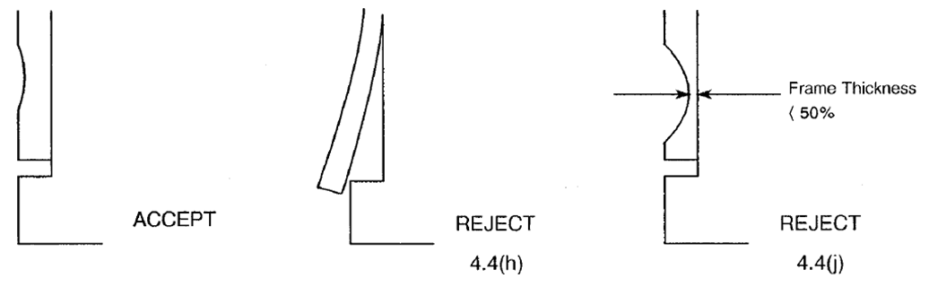
4.4(i)

FIGURE V – LEAD WIRE TO TERMINAL WELD CROSS-SECTION
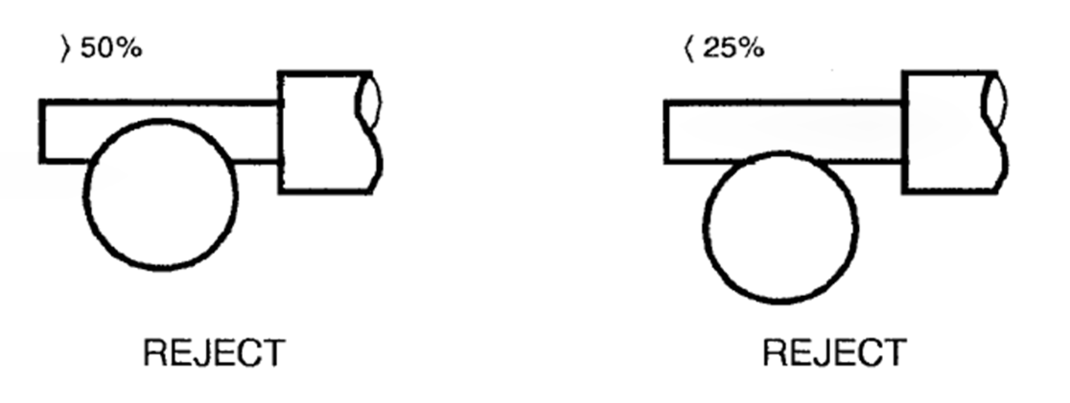

FIGURE VI – LEAD WIRE TO TERMINAL WELD
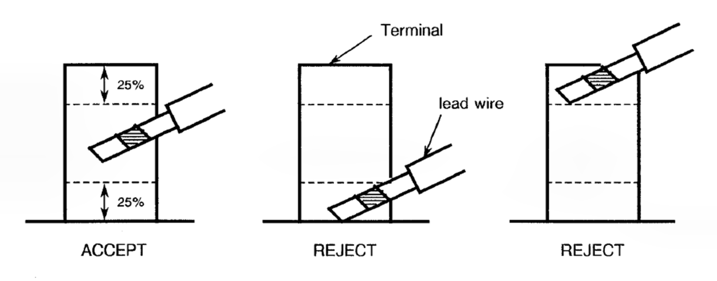

FIGURE Vii – armATURE/POLE PIECE CONTACT AREA AND GAP
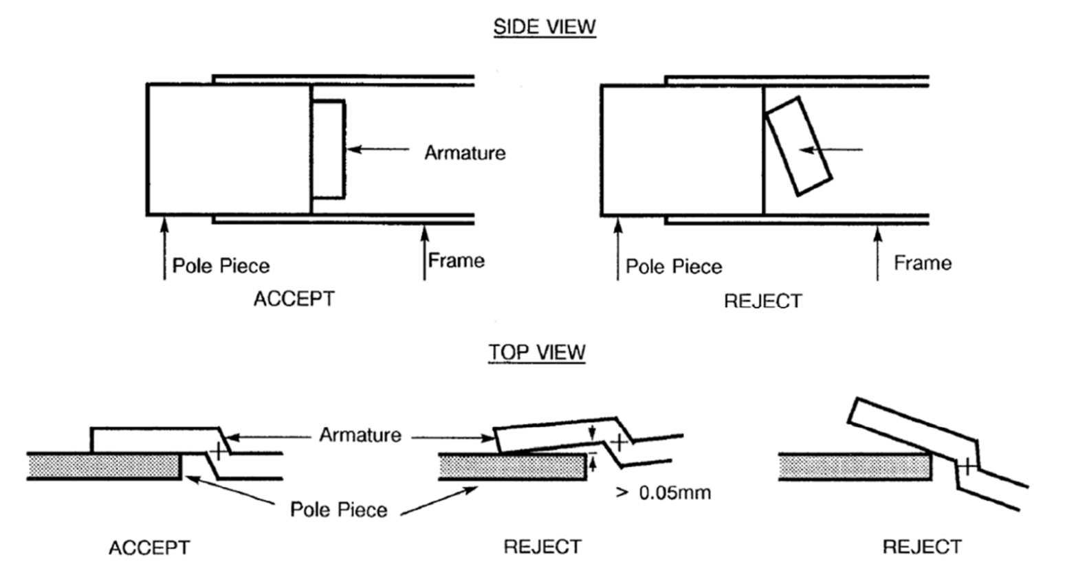

FIGURE VIII – POLE PIECE / FRAME GAP
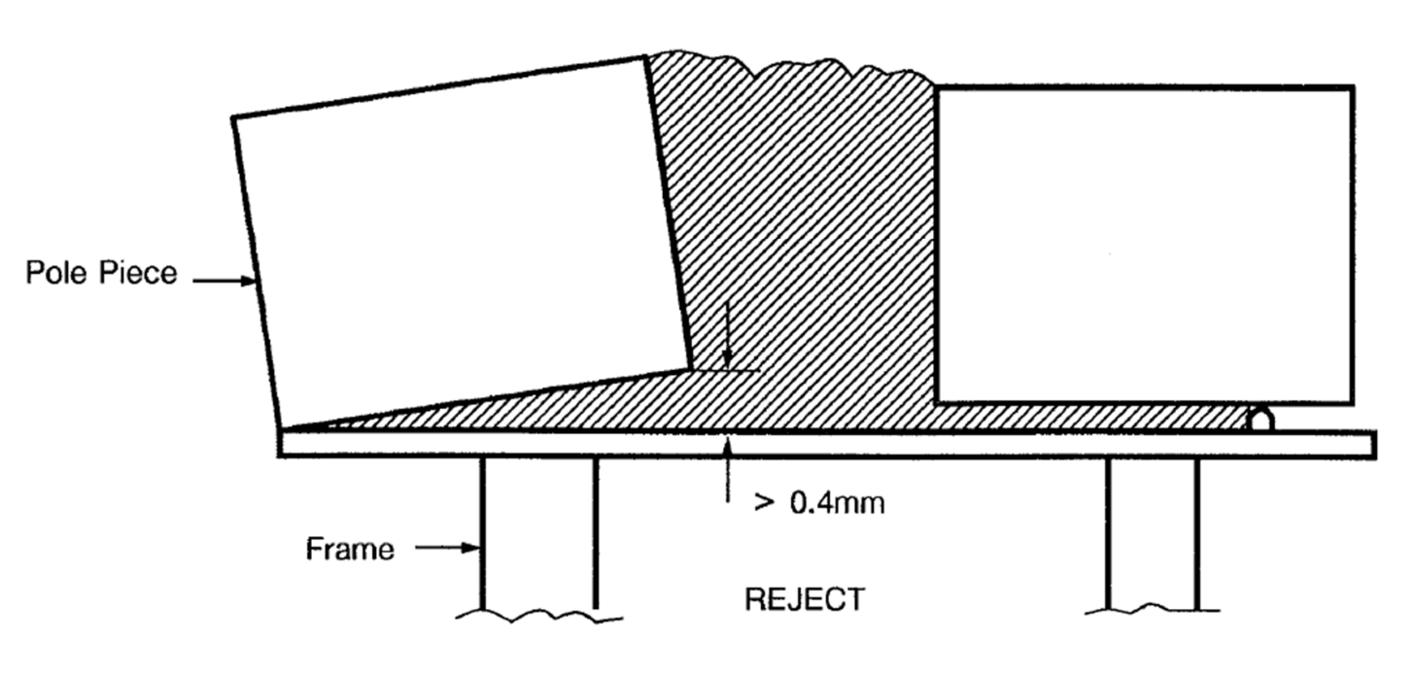

FIGURE IX – actUATOR POSITION
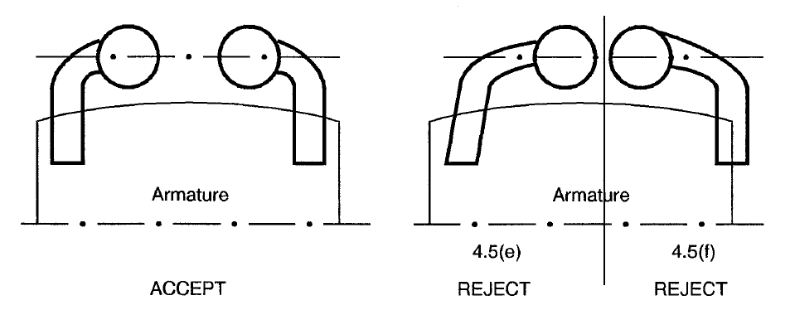

FIGURE X – ACTUATOR / ARMATURE WELD
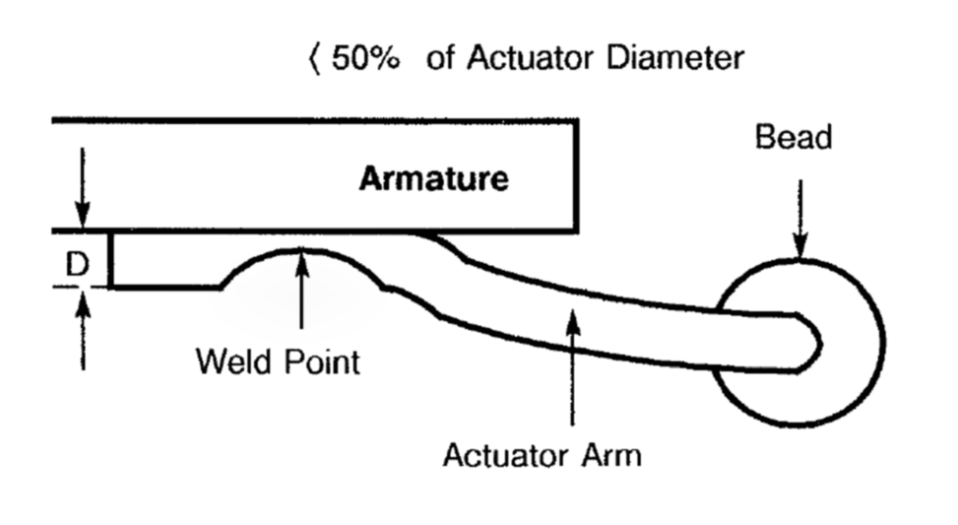

FIGURE XI – actUATOR GLASS BEAD
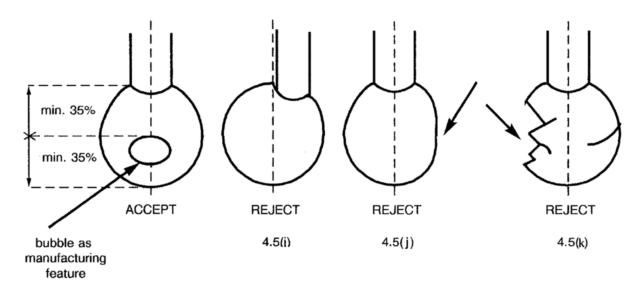

FIGURE XII – CONTACT / TERMINAL BRAZE
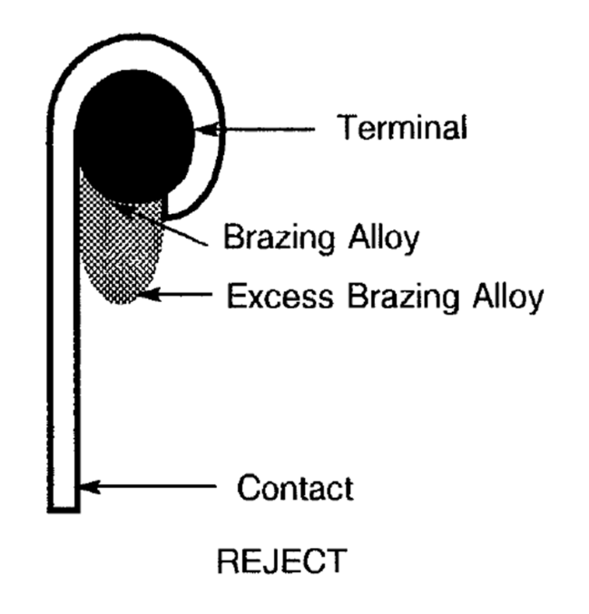

FIGURE XIII – CONTACT / TERMINAL WELD
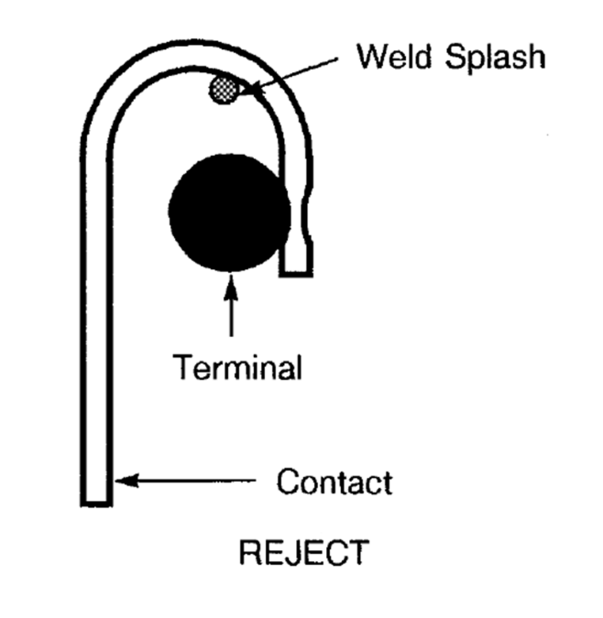

FIGURE XIV – EXAMPLE OF CONTACT ALIGNMENTS
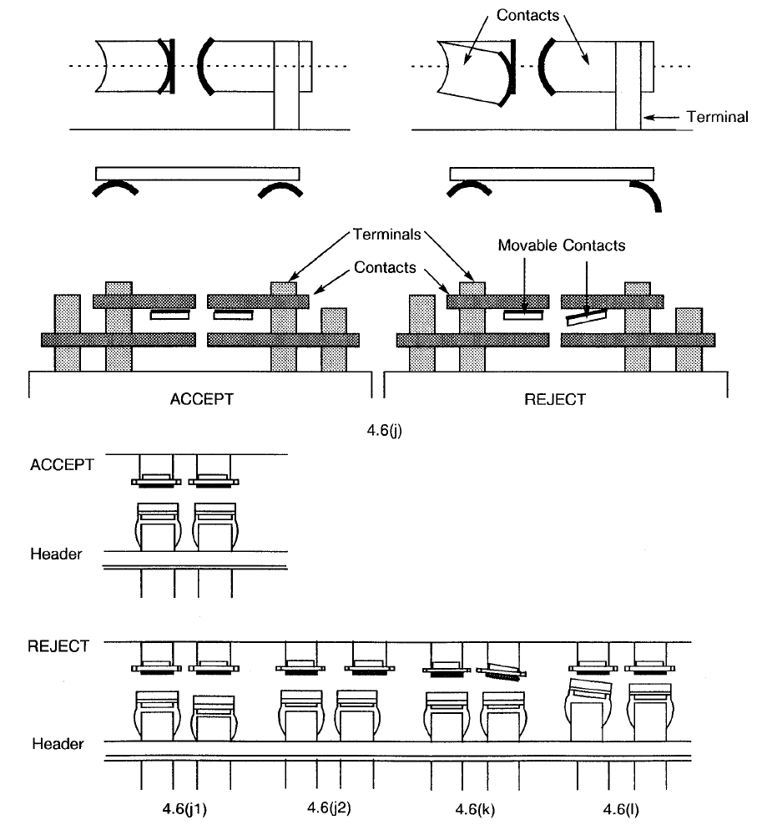
4.6(i)
4.6(i1)
4.6(i2)
4.6(j)
4.6(k)

FIGURE XV – ACTUATOR / CONTACT POSITION
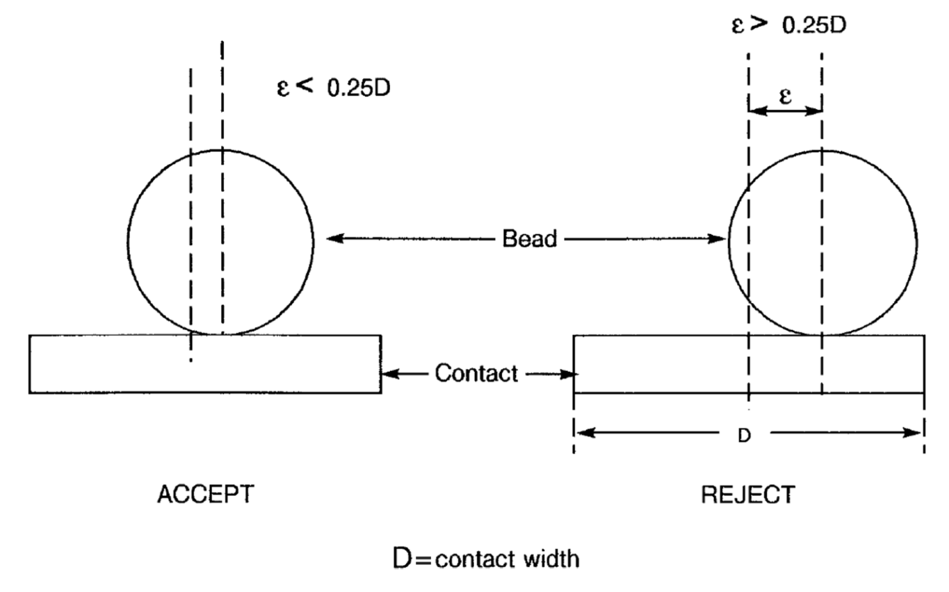

FIGURE XVI – HEADER DEFECTS
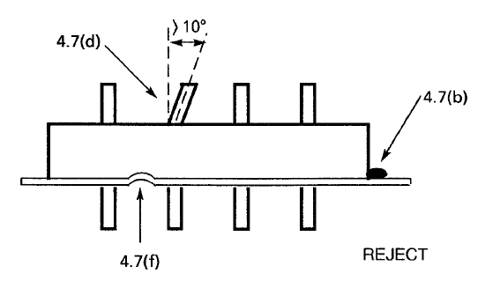

FIGURE XVII – GLASS-TO-METAL SEAL CRACKS AND CHIP-OUTS
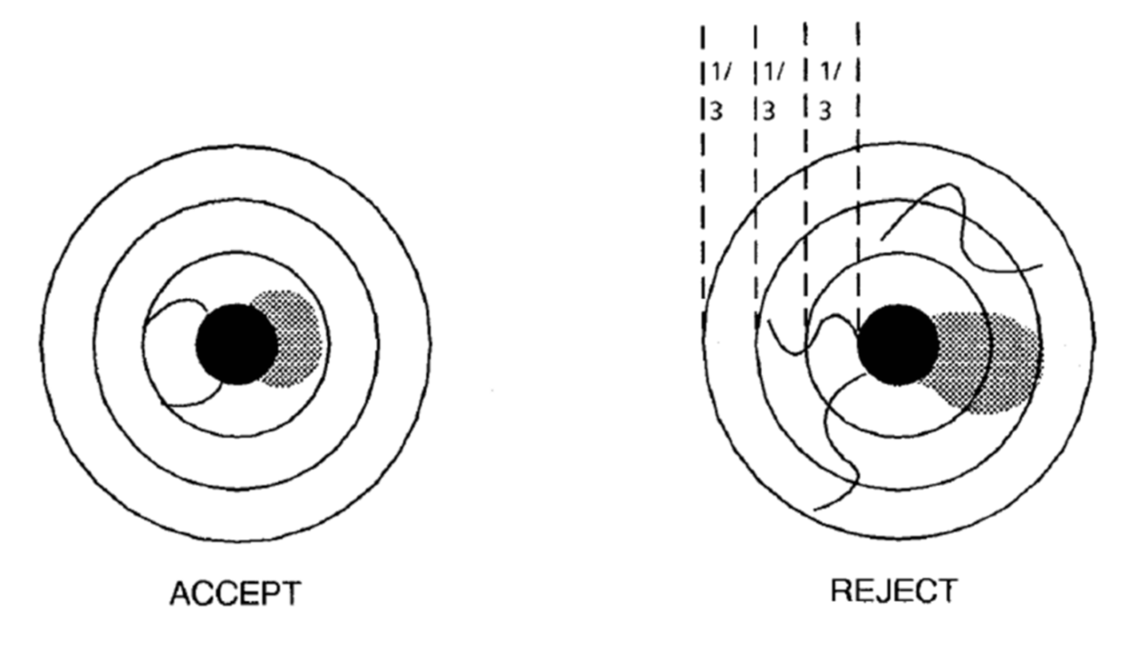

FIGURE XVIII – BUBBLES IN GLASS BEAD
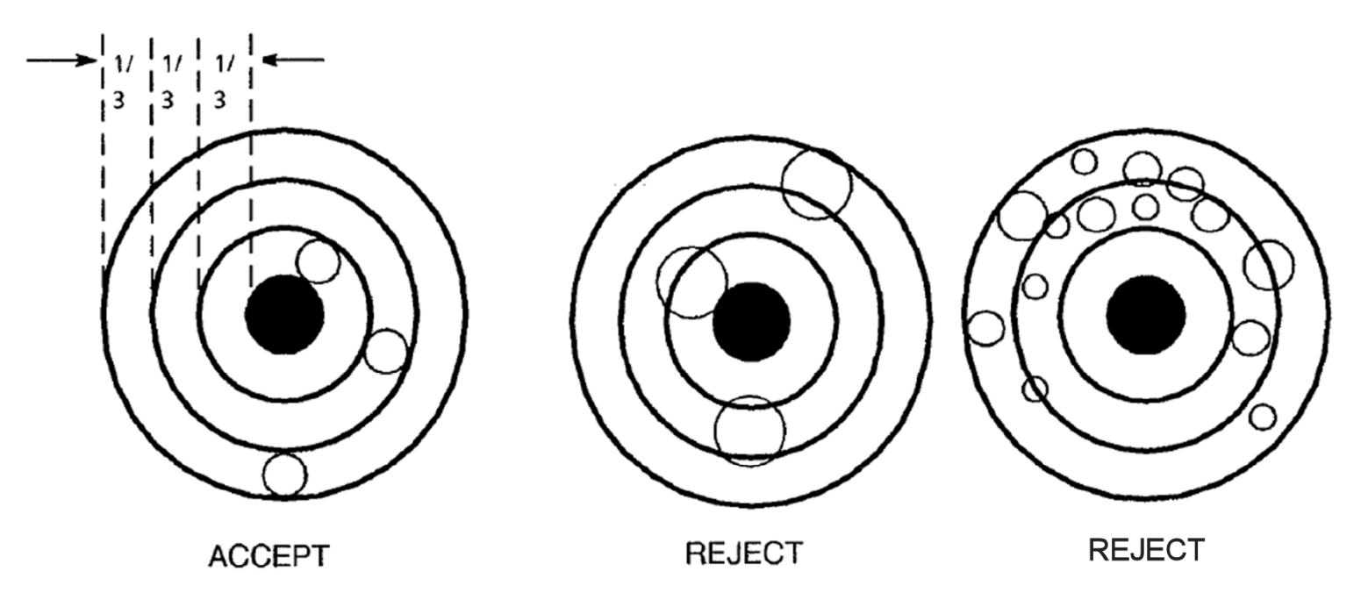

FIGURE XIX – LEAD POSITION WITHIN GlASS-TO-METAl SEAL
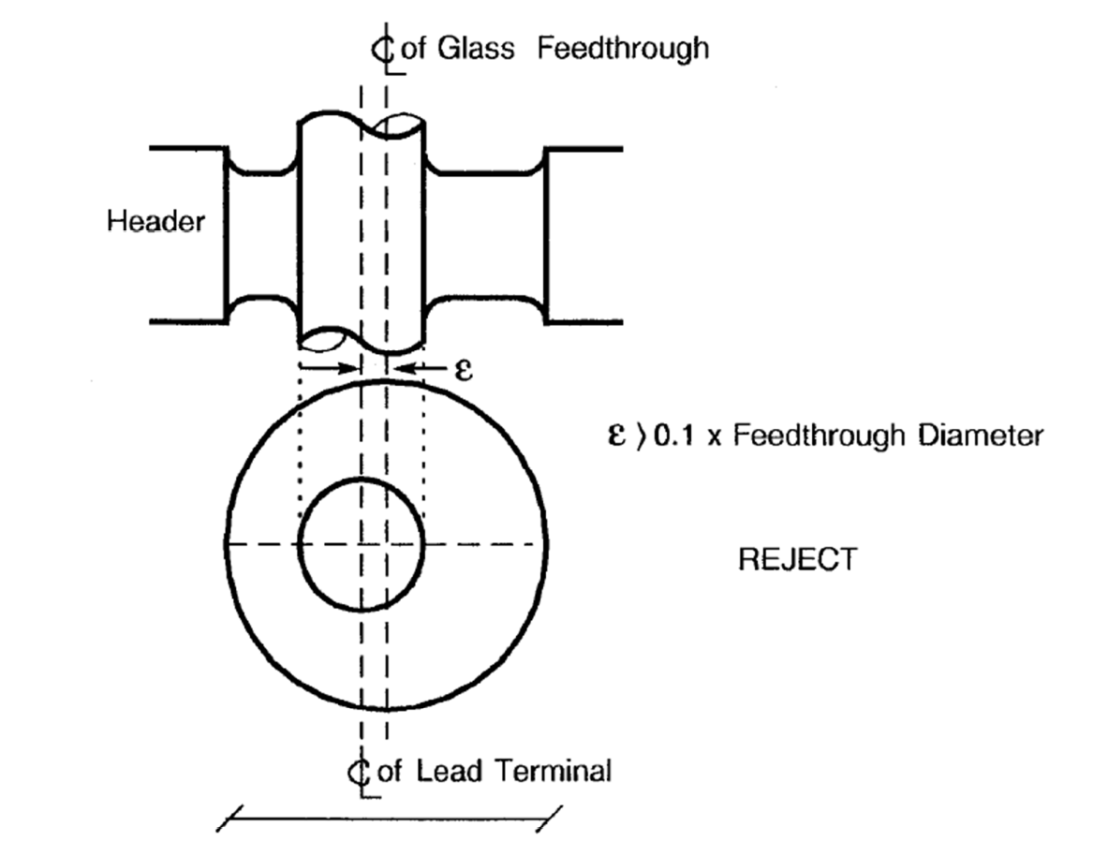

FIGURE XX – TILT OF TERMINAL IN GlASS-TO-METAl SEAL
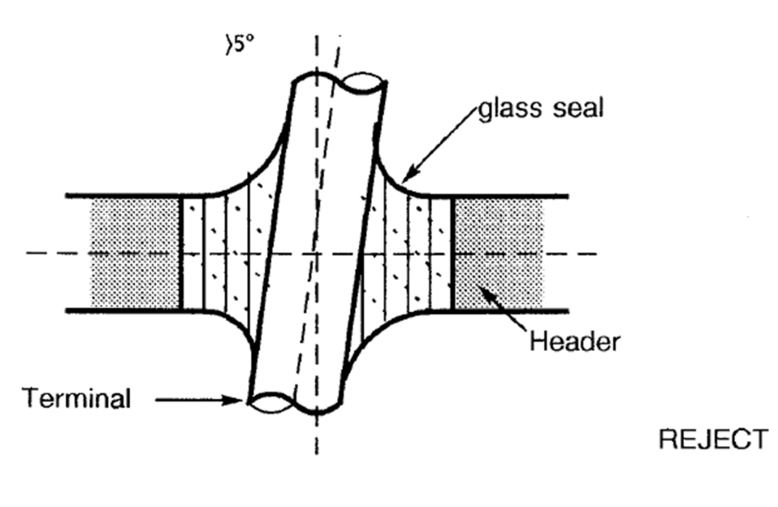

FIGURE XXI – GLASS MENISCUS
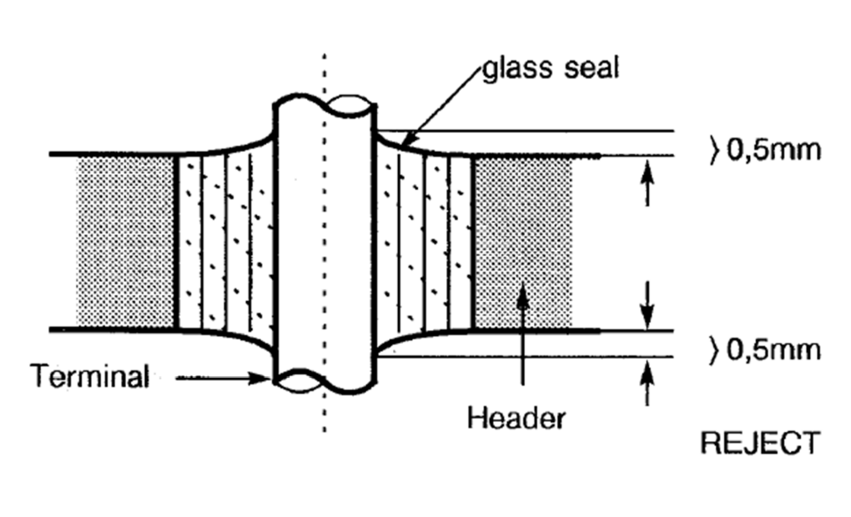

FIGURE XXII – BRACKET TO HOUSING WELD
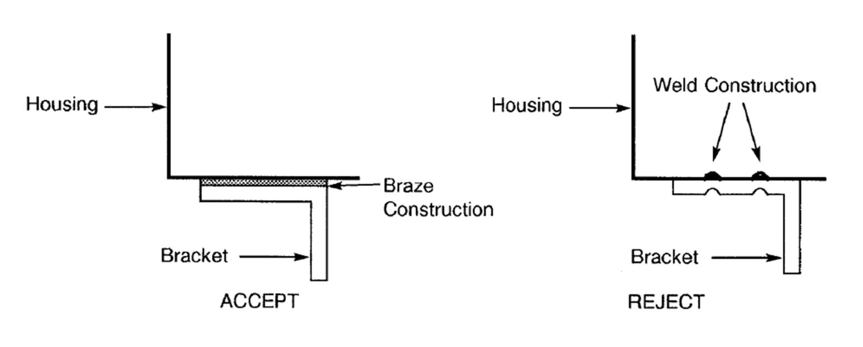

FIGURE XXIII – PARTICLES IN THE GLASS SEAL


