

Page 1 of 14

EXTERNAL VISUAL INSPECTION OF RESISTORS

ESCC Basic Specification No. 2054000

Issue 4 Draft A | August 2024



Document Custodian: European Space Agency – see https://escies.org

Legal Disclaimer and Copyright
European Space Agency, Copyright © 2024. All rights reserved.
The European Space Agency disclaims any liability or responsibility, to any person or entity, with respect to any loss or damage caused, or alleged to be caused, directly or indirectly by the use and application of this ESCC publication.
This publication, without the prior permission of the European Space Agency and provided that it is not used for a commercial purpose, may be:
- copied in whole, in any medium, without alteration or modification.
- copied in part, in any medium, provided that the ESCC document identification, comprising the ESCC symbol, document number and document issue, is removed.

DOCUMENTATION CHANGE NOTICE
(Refer to https://escies.org for ESCC DCR content)
DCR No. | CHANGE DESCRIPTION
TBA | Specification upissued to incorporate changes per DCR.
Draft 4A 29/08/2024 S.Thacker | Initial revision based on range of published ESCC specs for resistors (i.e. SMD/Chip film resistors) and ESCC2053000 Para 3.4, & MIL-PRF-55342J1 Appendix B.  Note: This spec has been totally re-written.  Note: See Para 4.4.4 for questions to be considered during review of this DCR/spec update

TABLE OF CONTENTS
1 SCOPE 5
2 GENERAL REQUIREMENTS 5
2.1 APPLICABILITY 5
2.2 PROCEDURE 5
2.3 MAGNIFICATION 5
2.4 MOUNTING FIXTURES 5
3 TERMS AND DEFINITIONS 5
4 DETAILED REQUIREMENTS 6
4.1 DIMENSIONS AND MARKING 6
4.2 MATERIALS 6
4.3 SURFACE MOUNT MOULDED BODY RESISTORS 6
4.3.1 Terminal Condition (See Figure 1) 6
4.3.2 Terminal Configuration (See Figures 2 and 3) 7
4.3.3 Body Moulding 7
4.4 SURFACE MOUNT CHIP RESISTORS 7
4.4.1 Terminal Metallization Defects 7
4.4.2 Resistor Element Defects 9
4.4.3 Substrate Defects 12
4.4.4 Foreign and/or Extraneous Material or Marks 13
4.4.5 Coating/Passivation Defects 14

SCOPE
This specification, to be read in conjunction with ESCC Basic Specification No. 20500 External Visual Inspection, contains additional specific requirements for Resistors.
They shall apply, where relevant, to each device inspected.

GENERAL REQUIREMENTS

APPLICABILITY
The following criteria may not be varied or modified after commencing an inspection stage. Any ambiguity or proposed minor deviation shall be referred to the ESCC Executive for resolution and approval.

PROCEDURE
All components shall be examined in such a manner that a minimum of handling and movement of the component is involved. During handling of components, lint-free gloves/finger cots shall be used.

MAGNIFICATION
Unless otherwise specified, all components shall be examined with a binocular or stereoscopic microscope under a magnification of 30x to 60x.

MOUNTING FIXTURES
Suitable fixtures may be used to assist in the inspection process. They must not themselves cause damage to the component.

TERMS AND DEFINITIONS
Metallization Void | - | Any region where the underlying material is exposed.
Resistor Element Void | - | Any region where the underlying material or substrate is exposed which is not caused by a resistor element scratch.
Metallization Scratch | - | Any tearing defect that disturbs the original surface and may result in a void.
Resistor Element Scratch | - | Either a disturbance of the surface of the resistor element, or extraneous, shiny material remaining from the instrument causing the scratch.
Resistor Element Active Region | - | Resistive material that conducts current between the terminals.
Resistor Element Non-Active Region | - | Resistive material that does not conduct any current between the terminals.
Foreign Material | - | Any material that is not a material used in the construction of the component.
Extraneous Material | - | Any material used in the construction of the component that is not in its intended location by design.
Light Metal Marks | - | Deposits of discontinuous small (less than 25.4µm) particles of extraneous termination material on the surface of the substrate or passivation.

DETAILED REQUIREMENTS
A component shall be rejected if it exhibits one or more of the defects listed in any of the following paragraphs of this specification. Where applicable, drawings are included to provide additional explanatory material, but these shall be considered as examples only.
The lot inspected shall be homogeneous. A component shall therefore also be rejected if it exhibits a significant deviation within the limits of this specification, from the rest of the lot. However, such components shall not be counted as a failure in any other lot definition.
The external visual inspection includes the verification of:
- · Dimensions.
- · Marking.
- · Materials.
- · Mechanical defects.

DIMENSIONS AND MARKING
Dimensions and marking shall be inspected in accordance with the requirements of ESCC Basic Specification No. 20500.
All letters and numbers shall be clearly legible without the use of optical resources.
Dimensional tolerances shall be as specified in the relevant ESCC Detail Specification.

MATERIALS
The materials used shall be verified for conformance to the requirements of the applicable ESCC Detail Specification. The production records shall be checked to ensure that the specific material‍‍requirements are met.

SURFACE MOUNT MOULDED BODY RESISTORS

Terminal Condition (See Figure 1)
          - Corrosion is evident.
          - Exposed base material.
          - Non-conductive material on the terminals beyond H/2 of tab from the body moulding/termination interface.
          - Reduction of terminal width or thickness by more than 10%.
FIGURE 1: NON-CONDUCTIVE MATERIAL ON TERMINALS
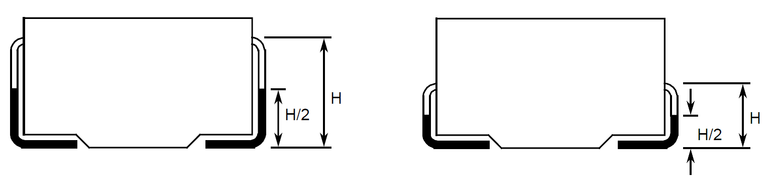
NOTES:
Rejected if non-conductive material is on the shaded parts of the terminals (H/2).

Terminal Configuration (See Figures 2 and 3)
          - Terminals twisted more than 5°.
          - Terminal bends around the body moulding are not the nominal 90°.
          - Terminals projecting from body.
          - Terminals kinked or bent and re-bent, other than for design, such that the indicated distance shown in Figure 3 is more than 1mm.
FIGURE 2: TERMINALS PROJECTING FROM BODY
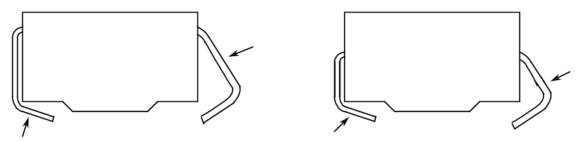
NOTES:
Rejected if terminals projecting from body.
FIGURE 3: KINKED TERMINAL
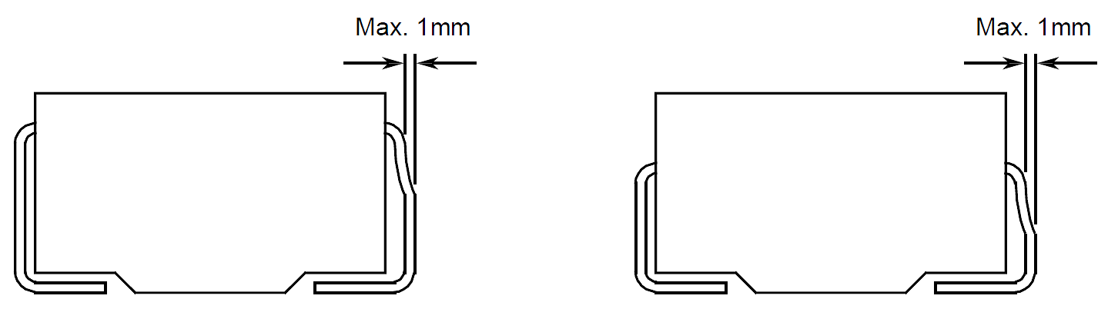
NOTES:
Rejected if the indicated distance is more than 1mm.

Body Moulding
          - Any holes, voids or cracks visible at a magnification of maximum 10x.
          - Device body or body terminal connections not covered by moulding material.
          - Any chipping of the moulding material when the chipped area exceeds 5% of the affected case side.
          - Embedded foreign material.
          - Discolouration of the moulding.

SURFACE MOUNT CHIP RESISTORS

Terminal Metallization Defects
          - Voids in the metallization which leave less than 50% of the original width:
y > 0.5d
- Voids in the metallization larger than 5% of the affected metallization surface area | 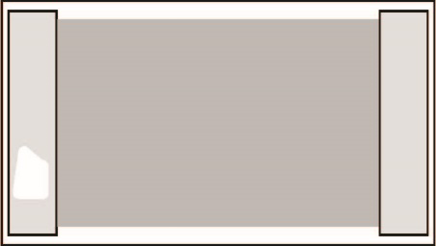
          - Voids that reduce the connection between any metallization surfaces to less than 75% of the original width:
y < 0.75d
          - Any lifting, peeling, or blistering of the metallization
          - Any protrusions of the metallization that reduce the distance between any two metallization areas to < 50% of the original gap:
x < 0.5d
          - Any protrusions of the metallization between the metallization and the resistor pattern that reduces the distance to < 50% of the original gap:
x < 0.5d
          - Any protrusions or buildup on the surface of the metallization that extends greater than 76.2µm beyond the average thickness of the metallization:
y > 76.2µm
          - Any stain or heavy discolouration on the surface of the metallization.

Resistor Element Defects
          - Any lifting, peeling, or blistering in the active or non-active regions of the resistor element.
          - Any chip out or crack in the active or non-active regions of the resistor element
- Any localized stains or heavy discolouration in the active and non-active regions of the resistor element  Note: Discoloration of the active and non-active regions of the resistor element due to thermal stabilization is not cause for rejection. Discoloration of resistor elements in and around trim kerfs is not cause for rejection. | 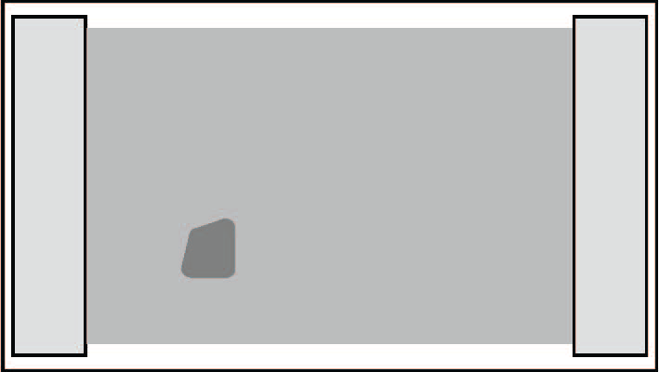
          - Any scratch in the active region of the resistor element ≥ 25.4µm in any direction or that reduces the line width to < 50% of the design line width:
y > 25.4µm or y > 0.5d
Note: Scratches in the non-active regions of serpentine resistor elements are not cause for rejection

          - Any voids or neckdown in the resistor element area of a block pattern resistor element reducing the width of the resistor element to < 90% of the original width:
y < 0.9d
          - Any voids or neckdown in the active region of a serpentine pattern which reduces the width of the resistor element to < 50% of the original width:
x < 0.5d
Note: Voids in the non-active regions of serpentine resistor elements are not cause for rejection
- Any bridging defect in the resistor element when the width of the bridge is less than 50% of the smallest line width in the pattern:  y < 0.5d  Note: Bridging defects in the non-active regions of serpentine resistor elements are not cause for rejection. | 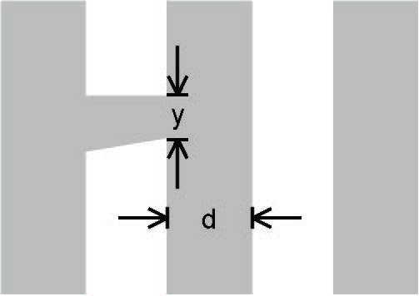
          - Any resistor element protrusion that reduces the distance between adjacent active resistance areas to < 50% of the design separation:
x < 0.5d
Note: Protrusion defects in the non-active regions of serpentine resistor elements are not cause for rejection.
- Any detritus (fragments of original or trim-modified material) in the resistor element trim kerf  Note: Accept attached detritus in the kerf of thin film resistor materials that are self-passivating (such as tantalum nitride resistor material) provided that a clear path ≥ 2.54µm in width exists in the kerf.  Reject attached detritus in the trim kerf of self-passivating resistor material with separation < 2.54µm between the detritus particles:  x < 2.54µm | 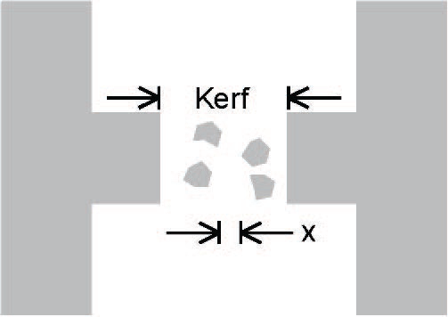
- Any resistor element trim kerfs with cracks, or similar damage in the underlying material  Note: Microcracks confined to the slag region of the trim kerf are not cause for rejection. | 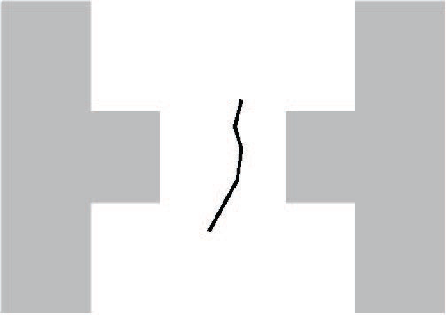
- For thin film resistors:  Any resistor element trim kerf with a width x < 2.54µm  Note: Discoloration of resistor and passivation material in and around the laser trim kerfs is not cause for rejection. | 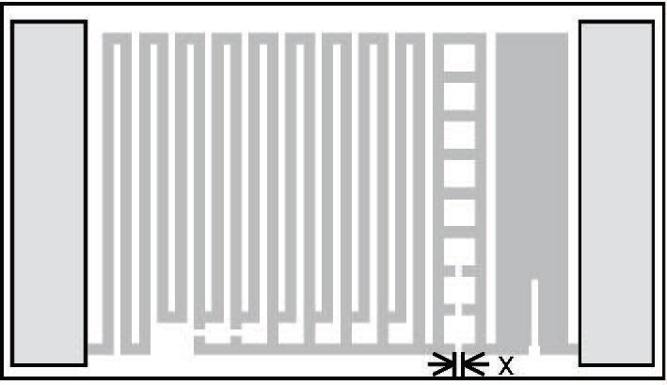
- For thick film resistors:  Any resistor element trim kerf with a width x < 12.7µm  Note: Discoloration of resistor and passivation material in and around the laser trim kerfs is not cause for rejection. | 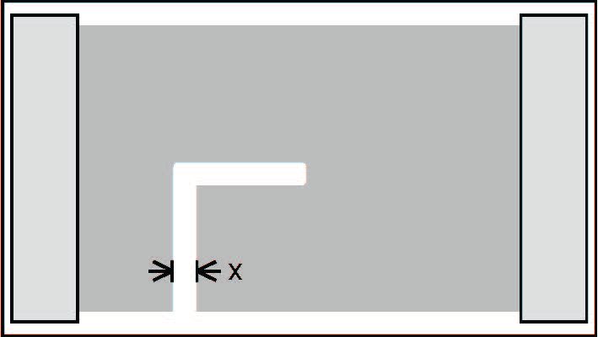
- Any resistor element trims that do not originate at the edge of the resistor element | 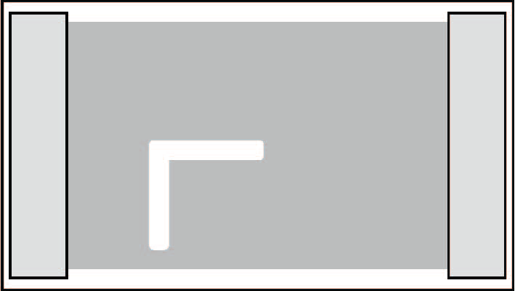
- Any resistor element trims that extend into conductor metallization that leave < 75% of the conductor undisturbed:  x < 0.75d | 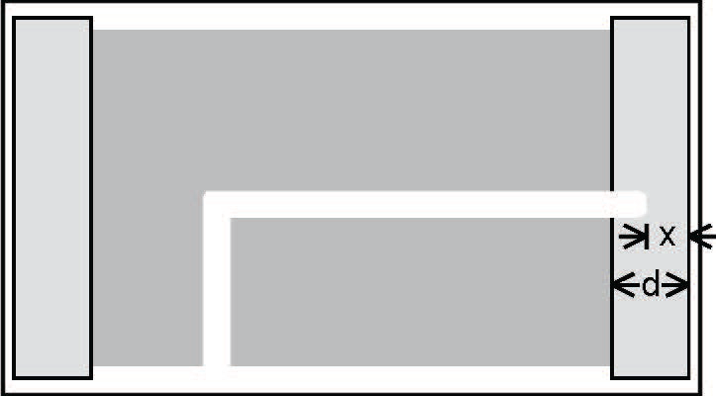
          - Resistor element trim depth for resistors with a block pattern:
Any resistor element trims that leave < 50% of the width of the narrowest line in the pattern remaining
          - Resistor element trim depth for resistors with a serpentine pattern:
Accept block patterns trimmed to create serpentine patterns.
Reject plunge cuts that leave remaining path (y) less than path width (x).
Reject if resistor path width (x) is less than laser kerf (k).
Reject if plunge cut span (b) is less than 50% of the length of resistor element (a)
          - For link and ladder resistor element trims:
Any trim that does not completely open any link or ladder
- Any discontinuous resistor element trim kerfs | 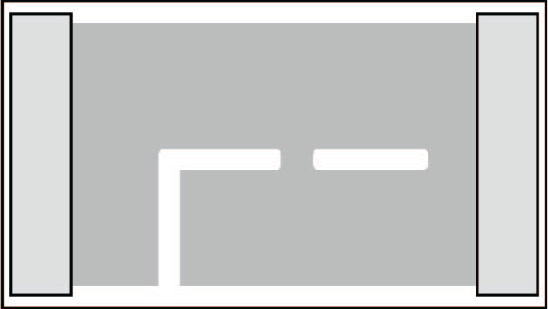

Substrate Defects
          - Any crack in the substrate that exceeds 76.2µm in length or comes closer than 25.4µm to an active resistor or bonding pad area on the substrate:
x > 76.2µm or y < 25.4µm
- Any crack in the substrate that exceeds 25.4µm in length and points towards the active resistor area:  y > 25.4µm | 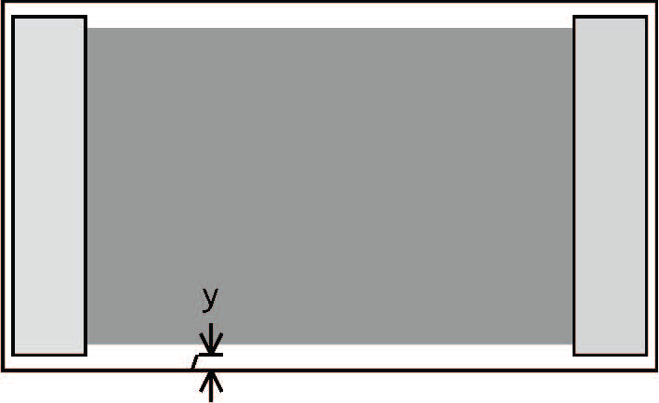
- Any attached portions of an adjacent substrate which contains metallization or resistor material | 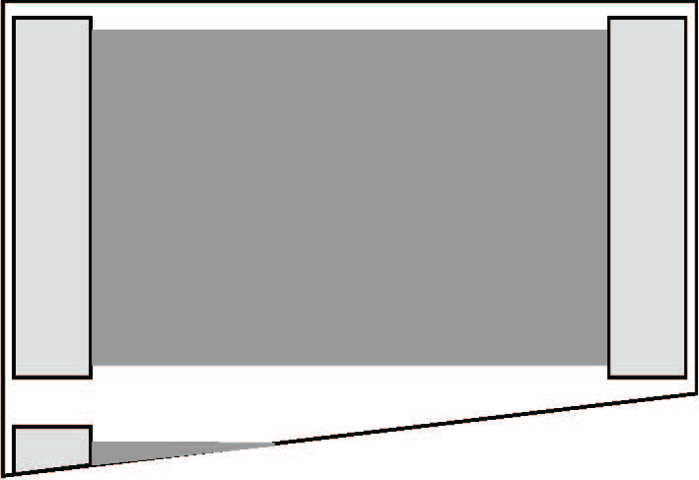
- Any crack in the substrate not originating at a substrate edge  Note: Microcracks confined to the slag region of the trim kerf are not cause for rejection. | 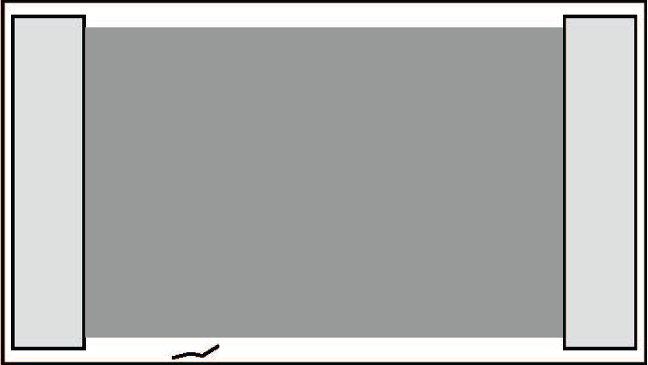

Foreign and/or Extraneous Material or Marks
          - Any attached foreign and/or extraneous material, in either single or multiple locations, on any surface, that reduces the separation between metallization areas to be less than 50% between the terminations:
x/d > 0.5
NOTE: Material that can be removed with a soft bristled brush or a nominal gas blow (of 14N/cm²) of dry nitrogen or air is not rejectable.
          - Any attached foreign and/or extraneous material occurring on greater than 10% of any homogeneous material surface
NOTE: Material that can be removed with a soft bristled brush or a nominal gas blow (of 14N/cm²) of dry nitrogen or air is not rejectable
          - The aggregate total of light metal marks that affect greater than 25% of the exposed surface on which it occurs
- Any protrusions or solder spikes from the metallization edge that are longer than 254µm or reduces the conductor separation to less than 50% of the design gap.  x > 254µm or x > 0.5d  NOTE: Reject Accept if attached solder spike can be removed with a soft bristled brush or a nominal gas blow (of 14N/cm²) of dry nitrogen or air | 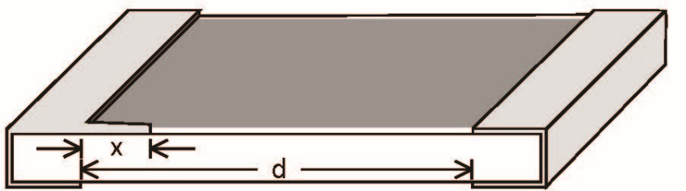

Coating/Passivation Defects
- Any damage to the protective coating applied over the resistor element that exposes the underlying resistor element  NOTE: Trim kerfs may be visible or may be coated. Accept exposed resistor material along the edge of the trim kerf. | 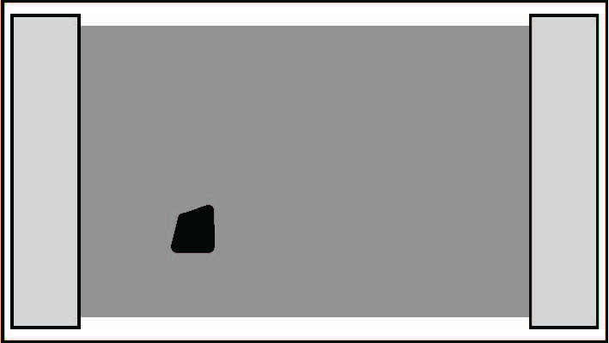
- Any cracks in the protective coating applied over the resistor element  NOTE: Accept microcracks confined to the slag region of the trim kerf. | 

