

Page 1 of 22

RELAY, ELECTROMAGNETIC, LATCHING, 50VDC, 50A, 1PDT
ESCC Detail Specification No. 3602/014
Issue 6 Draft A | March 2024



Document Custodian: European Space Agency – see https://escies.org

Legal Disclaimer and Copyright
European Space Agency, Copyright © 2024. All rights reserved.
The European Space Agency disclaims any liability or responsibility, to any person or entity, with respect to any loss or damage caused, or alleged to be caused, directly or indirectly by the use and application of this ESCC publication.
This publication, without the prior permission of the European Space Agency and provided that it is not used for a commercial purpose, may be:
- copied in whole, in any medium, without alteration or modification.
- copied in part, in any medium, provided that the ESCC document identification, comprising the ESCC symbol, document number and document issue, is removed.

DOCUMENTATION CHANGE NOTICE
(Refer to https://escies.org for ESCC DCR content)
DCR No. | CHANGE DESCRIPTION
TBA | Specification updated to incorporate changes per DCR.
Draft 6A 20/03/2024 S.Thacker | Mark-up specification implementing changes to Appendix A due to Manufacturer being no longer ESCC Qualified for this spec.  i.e. Coil Life deviations in Appendix A for REL-STPI is deleted.

TABLE OF CONTENTS
1 GENERAL 5
1.1 SCOPE 5
1.2 APPLICABLE DOCUMENTS 5
1.3 TERMS, DEFINITIONS, ABBREVIATIONS, SYMBOLS AND UNITS 5
1.4 THE ESCC COMPONENT NUMBER AND COMPONENT TYPE VARIANTS 5
1.4.1 The ESCC Component Number 5
1.4.1.1 Characteristics and/or Ratings Codes 5
1.4.2 Component Type Variants and Range of Components 6
1.5 MAXIMUM RATINGS 6
1.6 PHYSICAL DIMENSIONS AND TERMINAL IDENTIFICATION 7
1.6.1 Vertical Stud Mount (Variant 01) 7
1.6.2 Horizontal Flange Mount (Variant 04) 8
1.7 FUNCTIONAL DIAGRAM 9
1.8 MATERIALS AND FINISHES 9
1.8.1 Case 9
1.8.2 Terminals 9
1.8.3 Mounting Studs (Variant 01) 9
2 REQUIREMENTS 9
2.1 GENERAL 9
2.1.1 Deviations from the Generic Specification 9
2.1.1.1 Deviations from Special In-Process Controls - Chart F2 9
2.1.1.2 Deviations from Screening Tests - Chart F3 10
2.1.1.3 Deviations from Qualification and Periodic Tests - Chart F4 10
2.2 MARKING 10
2.3 TERMINAL STRENGTH 10
2.4 ELECTRICAL MEASUREMENTS AT ROOM, HIGH AND LOW TEMPERATURES 11
2.4.1 Room Temperature Electrical Measurements 11
2.4.2 High and Low Temperatures Electrical Measurements 12
2.4.3 Notes to Electrical Measurements Tables 12
2.5 PARAMETER DRIFT VALUES 13
2.6 INTERMEDIATE AND END-POINT ELECTRICAL MEASUREMENTS 13
2.7 RUN-IN CONDITIONS 21
APPENDIX A 22

GENERAL

SCOPE
This specification details the ratings, physical and electrical characteristics, and test and inspection data for the component type variants and/or the range of components specified below. It supplements the requirements of, and shall be read in conjunction with, the ESCC Generic Specification listed under Applicable Documents.

APPLICABLE DOCUMENTS
The following documents form part of this specification and shall be read in conjunction with it:
          - ESCC Generic Specification No. 3602.

TERMS, DEFINITIONS, ABBREVIATIONS, SYMBOLS AND UNITS
For the purpose of this specification, the terms, definitions, abbreviations, symbols and units specified in ESCC Basic Specification No. 21300 shall apply.

THE ESCC COMPONENT NUMBER AND COMPONENT TYPE VARIANTS

The ESCC Component Number
The ESCC Component Number shall be constituted as follows:
Example: 36020140128V
- Detail Specification Reference: 3602014
- Component Type Variant Number: 01 (as required)
- Characteristic code: Rated Coil Voltage (28Vdc): 28V (as required)

Characteristics and/or Ratings Codes
Characteristics and/or ratings to be codified as part of the ESCC Component Number shall be as follows:
          - Rated Coil Voltage expressed by means of the following codes:
Rated Coil Voltage (Vdc) | Code
48 | 48V
28 | 28V
12 | 12V

Component Type Variants and Range of Components
The component type variants and range of components applicable to this specification are as follows:
Variant Number | Case Description  (Note 1) | Rated Coil Voltage  (Vdc) | Weight max  (g)
01 | Vertical 4 Stud Mount | 48, 28, 12 | 150
04 | Horizontal Flange Mount | 48, 28, 12 | 165
NOTES:
            - See Para. 1.6.

MAXIMUM RATINGS
The maximum ratings shall not be exceeded at any time during use or storage.
Maximum ratings shall only be exceeded during testing to the extent specified in this specification and when stipulated in Test Methods and Procedures of the ESCC Generic Specification.
Characteristics | Symbols | Maximum Ratings | Units | Remarks
Coil Voltage Range | V_{CR} |  | Vdc
 |  | 45.5 to 55 |  | Rated Coil Voltage: 48Vdc
 |  | 26.5 to 32 |  | Rated Coil Voltage: 28Vdc
 |  | 11 to 14 |  | Rated Coil Voltage: 12Vdc
Rated Resistive Load Contact Current | I_{CR} |  | A | Note 1
Rated Resistive Load Contact Current |  | 50 |  | Main Contacts; 50Vdc resistive
Rated Resistive Load Contact Current |  | 2 |  | Auxiliary Contacts; 28Vdc resistive
Rated Inductive Load Contact Current | I_{CL} | 20 | A | Main Contacts; 50Vdc inductive  Note 1
Overload Current | I_{OVERLOAD} |  | A
 |  | 100 |  | Main Contacts; 50Vdc resistive
Terminal Nut Torque | - |  | mN
 |  | 1 |  | Main Contact Terminal Studs
 |  | 0.5 |  | Mounting Studs (Variant 01)
Operating Temperature Range | T_{op} | -65 to +125 | °C | T_{amb}
Storage Temperature Range | T_{stg} | -65 to +125 | °C | T_{amb}
Soldering Temperature | T_{sol} | +260 | °C | Auxiliary Contact Solder Hook Terminals; Note 2
NOTES:
            - Relays should not be used in change-over mode where the potential difference between stationary contacts is greater than 10V and the switched current is greater than 100mA.
            - Duration 10 seconds maximum at a distance not less than 3mm from the device body. The same terminal shall not be resoldered until 3 minutes have elapsed.

PHYSICAL DIMENSIONS AND TERMINAL IDENTIFICATION

Vertical Stud Mount (Variant 01)
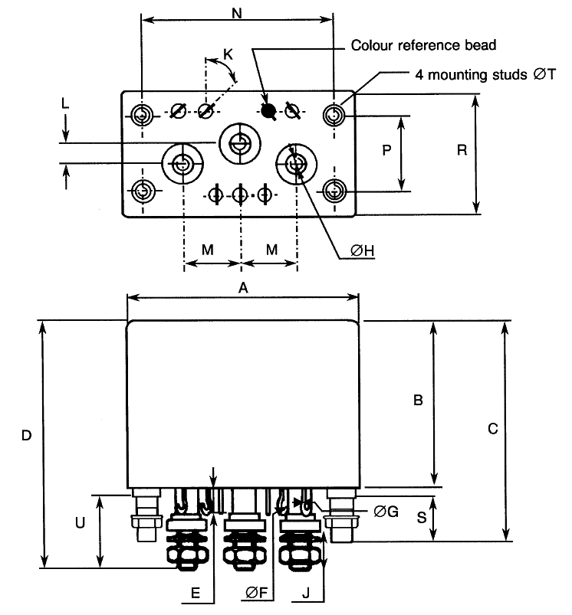
Symbols | Dimensions (mm) |  |  | Symbols | Dimensions (mm) |  |  | Symbols | Dimensions (mm)
Symbols | Min | Max |  | Symbols | Min | Max |  | Symbols | Min | Max
A | - | 47.8 |  | ØG | 0.71 | 0.84 |  | N | 37.85 | 38.35
B | - | 34.6 |  | ØH | M4 |  |  | P | 14.8 | 15.35
C | - | 44.7 |  | J | 8.4 | 9.4 |  | R | - | 26.2
D | - | 51.6 |  | K | 40° | 50° |  | S | 8.2 | 8.8
E | 4.5 | 5.7 |  | L | 3.8 | 4.4 |  | ØT | M3
ØF | 1.3 | 1.7 |  | M | 10.9 | 11.5 |  | U | 15 | 16.5
NOTES:
            - Terminal identification is specified by reference to the colour reference bead and the terminals’ configuration. See Para. 1.7.

Horizontal Flange Mount (Variant 04)
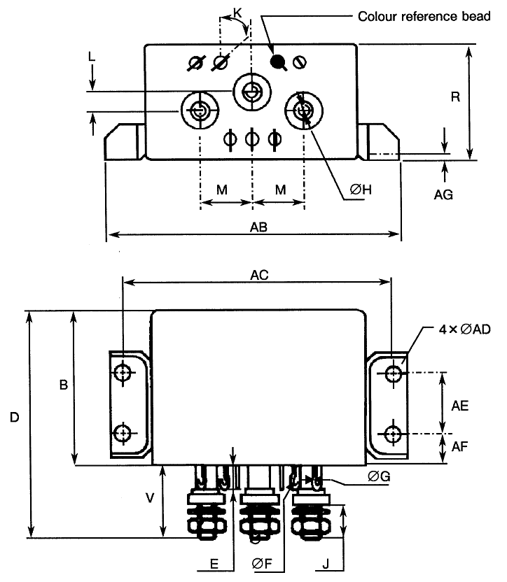
Symbols | Dimensions (mm) |  |  | Symbols | Dimensions (mm) |  |  | Symbols | Dimensions (mm)
Symbols | Min | Max |  | Symbols | Min | Max |  | Symbols | Min | Max
B | - | 34.6 |  | J | 8.4 | 9.4 |  | AB | - | 70
D | - | 51.6 |  | K | 40° | 50° |  | AC | 60.2 | 60.4
E | 4.5 | 5.7 |  | L | 3.8 | 4.4 |  | ØAD | 3.1 | 3.5
ØF | 1.3 | 1.7 |  | M | 10.9 | 11.5 |  | AE | 15.8 | 16
ØG | 0.71 | 0.84 |  | R | - | 26.2 |  | AF | 6.9 | 7.1
ØH | M4 |  |  | V | 16.5 | 17.5 |  | AG | 1.95 | 2.05
NOTES:
            - Terminal identification is specified by reference to the colour reference bead and the terminals’ configuration. See Para. 1.7.

FUNCTIONAL DIAGRAM
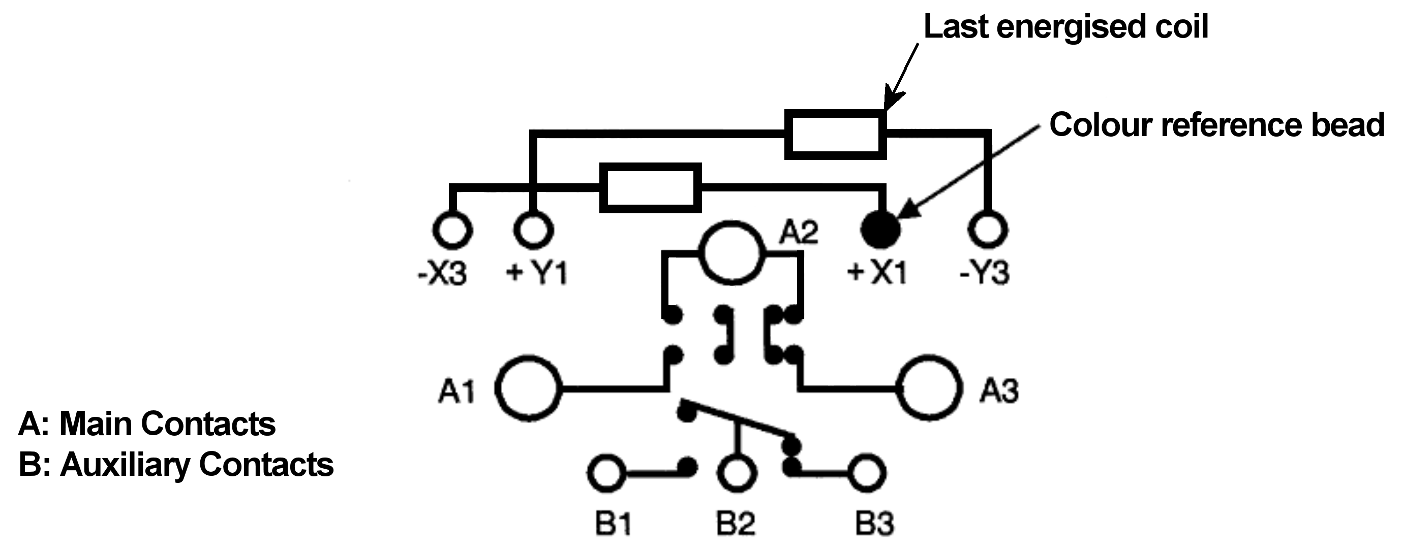
NOTES:
            - As viewed from the terminal side.
            - Individual terminal designations are for reference purposes only.

MATERIALS AND FINISHES

Case
Copper nickel, tin-lead alloy plated, hermetically sealed.

Terminals
Main contact studs terminal material and finish shall be type H10, and the auxiliary and coil contacts terminal material and finish shall be type F3 or F19, all in accordance with the requirements of ESCC Basic Specification No. 23500.
Main contact studs shall be equipped with stainless steel nuts and silver plated beryllium copper washers.

Mounting Studs (Variant 01)
Fe-Ni alloy.

REQUIREMENTS

GENERAL
The complete requirements for procurement of the components specified herein are as stated in this specification and the ESCC Generic Specification. Permitted deviations from the Generic Specification, applicable to this specification only, are listed below.
Permitted deviations from the Generic Specification and this Detail Specification, formally agreed with specific Manufacturers on the basis that the alternative requirements are equivalent to the ESCC requirement and do not affect the component’s reliability, are listed in the appendices attached to this specification.

Deviations from the Generic Specification

Deviations from Special In-Process Controls - Chart F2
          - Seal, Fine Leak: Duration of Pressurisation shall be 5 hours minimum at a pressure of 200kPa.

Deviations from Screening Tests - Chart F3
          - Vibration Scan : MIL-STD-202, Test Method 214, Test Condition II-E with the following details:
- Method of Mounting: The relays shall be mounted rigidly by normal mounting means.
- Duration: 1 minute in the latch position and 1 minute in the reset position. Rated Coil Voltage shall be applied only for contact switch over.
- Vibration direction: In each of three mutually perpendicular directions.
- Contact Chatter Monitoring: Closed and open contacts shall be monitored per MIL-STD-202, Test Method 310, Test-circuit B, Test Condition A.
          - Seal, Fine Leak: Duration of Pressurisation shall be 5 hours minimum at a pressure of 200kPa.

Deviations from Qualification and Periodic Tests - Chart F4
          - Seal, Fine Leak: Duration of Pressurisation shall be 5 hours minimum at a pressure of 200kPa.
          - Low Level Life (& Inductive Life) : Low Level Life shall be performed on auxiliary contacts at the same time and on the same samples being subjected to Inductive Life, with the following details:
- Test Temperature shall be T_{amb} = +125 (+0 -3)°C.
- Number of Cycles of Operation of auxiliary contacts shall be 5000.
- The cycling rate specified for Inductive Life shall be applied.
          - Resistive Life: Number of Cycles of Operation shall be 20000 minimum.
          - Mechanical Life: Number of Cycles of Operation shall be 90000 minimum.

MARKING
The marking shall be in accordance with the requirements of ESCC Basic Specification No. 21700 and as follows.
The information to be marked on the component shall be:
          - The ESCC qualified components symbol (for ESCC qualified components only).
          - The ESCC Component Number (see Para. 1.4.1).
          - Traceability information.

TERMINAL STRENGTH
The terminals of all Variants are defined as rigid.
The test conditions for Terminal Strength, tested as specified in the ESCC Generic Specification, shall be as follows:
          - Pull Test: Applied Force:
- 15N for auxiliary contact solder hook terminals
- 160N for main contact terminal studs
- 50N for mounting studs (Variant 01)
          - Torque Test per MIL-STD-202, Test Method 211, Test Condition E with the following details:
Applied Torque:
- 1.5Nm for main contact terminal studs
- 0.65Nm for mounting studs (Variant 01)

ELECTRICAL MEASUREMENTS AT ROOM, HIGH AND LOW TEMPERATURES
Electrical measurements shall be performed at room, high and low temperatures. Consolidated notes are given in Para. 2.4.3.

Room Temperature Electrical Measurements
The measurements shall be performed at T_{amb} = +22 ±3°C.
Characteristics | Symbols | Test Method and Conditions | Rated Coil Voltage  (Vdc) | Limits |  | Units
 |  |  |  | Min | Max | Units
Latch Voltage | U_{L} | ESCC No. 3602  Note 1 |  |  |  | V
Latch Voltage | U_{L} | ESCC No. 3602  Note 1 | 48 | 14.3 | 24 | V
Latch Voltage | U_{L} | ESCC No. 3602  Note 1 | 28 | 9.1 | 14 | V
Latch Voltage | U_{L} | ESCC No. 3602  Note 1 | 12 | 3.6 | 6 | V
Reset Voltage | U_{R} | ESCC No. 3602  Note 1 |  |  |  | V
 |  | ESCC No. 3602  Note 1 | 48 | 14.3 | 24
 |  | ESCC No. 3602  Note 1 | 28 | 9.1 | 14
 |  | ESCC No. 3602  Note 1 | 12 | 3.6 | 6
Latch Time | t_{L} | ESCC No. 3602 | All | - | 20 | ms
Reset Time | t_{R} | ESCC No. 3602 | All | - | 20 | ms
Bounce Time | t_{B} | ESCC No. 3602 | All | - | 2 | ms
Insulation Resistance | R_{I} | ESCC No. 3602  V_{TEST} = 100Vdc | All | 100 | - | MΩ
Voltage Proof  (Test Voltage) | VP | ESCC No. 3602  Maximum Leakage Current I_{LVP} = 1mA | All | 1250 | - | Vrms
 |  |  |  | 1000 (Note 2) | - | Vrms
 |  |  |  | 500 (Note 3) | - | Vrms
Voltage Proof Leakage Current | I_{LVP} | ESCC No. 3602  Note 4 | All | - | 1 | mA
Contact Voltage Drop | V_{D} | ESCC No. 3602 | All |  |  | V
Contact Voltage Drop |  | Main Contacts: 100mA ≤ I_{TEST} ≤ 10A |  | - | 0.0025 x I_{TEST}
Contact Voltage Drop |  | Auxiliary Contacts: I_{TEST} = 100mA max |  | - | 0.05 x I_{TEST}
Coil Resistance | R_{B} | ESCC No. 3602  Both coils |  |  |  | Ω
Coil Resistance | R_{B} | ESCC No. 3602  Both coils | 48 | 382 | 486 | Ω
Coil Resistance | R_{B} | ESCC No. 3602  Both coils | 28 | 130 | 160 | Ω
Coil Resistance | R_{B} | ESCC No. 3602  Both coils | 12 | 24 | 30 | Ω

High and Low Temperatures Electrical Measurements
Characteristics | Symbols | Test Method and Conditions | Rated Coil Voltage  (Vdc) | Limits |  | Units
 |  |  |  | Min | Max | Units
Latch Voltage | U_{L} | ESCC No. 3602  T_{amb} = +125 (+0 -5)°C and -65 (+5 -0)°C Note 1 |  |  |  | V
Latch Voltage | U_{L} |  | 48 | - | 36
Latch Voltage | U_{L} |  | 28 | - | 18
Latch Voltage | U_{L} |  | 12 | - | 9
Reset Voltage | U_{R} | ESCC No. 3602  T_{amb} = +125 (+0 -5)°C and -65 (+5 -0)°C Note 1 |  |  |  | V
Reset Voltage | U_{R} |  | 48 | - | 36
Reset Voltage | U_{R} |  | 28 | - | 18
Reset Voltage | U_{R} |  | 12 | - | 9
Latch Time | t_{L} | ESCC No. 3602  T_{amb} = +125 (+0 -5)°C and -65 (+5 -0)°C | All | - | 20 | ms
Reset Time | t_{R} | ESCC No. 3602  T_{amb} = +125 (+0 -5)°C and -65 (+5 -0)°C | All | - | 20 | ms
Bounce Time | t_{B} | ESCC No. 3602  T_{amb} = +125 (+0 -5)°C and -65 (+5 -0)°C | All | - | 2 | ms
Insulation Resistance | R_{I} | ESCC No. 3602  T_{amb} = +125 (+0 -5)°C  V_{TEST} = 100Vdc | All | 50 | - | MΩ
Contact Voltage Drop | V_{D} | ESCC No. 3602  T_{amb} = +125 (+0 -5)°C and -65 (+5 -0)°C | All |  |  | V
Contact Voltage Drop | V_{D} | Main Contacts: 100mA ≤ I_{TEST} ≤ 10A |  | - | 0.0025 x I_{TEST}
Contact Voltage Drop | V_{D} | Auxiliary Contacts: I_{TEST} = 100mA max |  | - | 0.05 x I_{TEST}

Notes to Electrical Measurements Tables
            - The coil voltage rise time shall be less than 0.1t_{L} or 0.1t_{R}. The coil voltage shall be maintained for a minimum duration of 10t_{L} or 10t_{R}.
            - Between coil and case, between open main contacts, between latch and reset coils.
            - Between open auxiliary contacts.
            - Measured during Voltage Proof test.

PARAMETER DRIFT VALUES
Parameter Drift Values shall be measured as specified in the ESCC Generic Specification.
Unless otherwise specified, the measurements shall be performed at T_{amb} = +22 ±3°C.
The test methods and test conditions shall be as per the corresponding test defined in Para. 2.4.1 Room Temperature Electrical Measurements.
The corresponding absolute limit values for each characteristic shall not be exceeded.
Characteristics | Symbols | Limits |  |  | Units
Characteristics | Symbols | Drift Value  Δ | Absolute |  | Units
Characteristics | Symbols | Drift Value  Δ | Min | Max | Units
Latch Voltage | U_{L} | Note 1 | Note 2 | Note 2 | V
Reset Voltage | U_{R} | Note 1 | Note 2 | Note 2 | V
NOTES:
            - Drift Value (Δ) limits are not specified. Drift Values shall be recorded for information purposes only.
            - The limit specified in Para. 2.4.1 shall apply.

INTERMEDIATE AND END-POINT ELECTRICAL MEASUREMENTS
Unless otherwise specified, the measurements shall be performed at T_{amb} = +22 ±3°C.
Unless otherwise specified the test methods and test conditions shall be as per the corresponding test defined in Para. 2.4.1 Room Temperature Electrical Measurements.
Test Reference per ESCC No. 3602 | Characteristics  (Note 1) | Symbols | Limits |  | Units
Test Reference per ESCC No. 3602 | Characteristics  (Note 1) | Symbols | Min | Max | Units
Thermal Shock | During 5th Cycle
Thermal Shock | Latch Voltage | U_{L} | Note 2 |  | V
Thermal Shock | Reset Voltage | U_{R} | Note 2 |  | V
Thermal Shock | Latch Time | t_{L} | Note 2 |  | ms
Thermal Shock | Reset Time | t_{R} | Note 2 |  | ms
Thermal Shock | Final Measurements
Thermal Shock | Voltage Proof | VP | Note 3 |  | Vrms
Thermal Shock | Voltage Proof Leakage Current | I_{LVP} | Note 3 |  | mA
Low Level Sine Vibration | Final Measurements
Low Level Sine Vibration | Latch Voltage | U_{L} | Note 3 |  | V
Low Level Sine Vibration | Latch Voltage Drift | ΔU_{L}/U_{L} | Note 1 |  | %
Low Level Sine Vibration | Reset Voltage | U_{R} | Note 3 |  | V
Low Level Sine Vibration | Reset Voltage Drift | ΔU_{R}/U_{R} | Note 1 |  | %
High Level Sine Vibration | Final Measurements
High Level Sine Vibration | Latch Voltage | U_{L} | Note 3 |  | V
High Level Sine Vibration | Latch Voltage Drift | ΔU_{L}/U_{L} | Note 1 |  | %
High Level Sine Vibration | Reset Voltage | U_{R} | Note 3 |  | V
High Level Sine Vibration | Reset Voltage Drift | ΔU_{R}/U_{R} | Note 1 |  | %
Low Level Mechanical Shock | Final Measurements
Low Level Mechanical Shock | Contact Voltage Drop: | V_{D} |  |  | V
Low Level Mechanical Shock | main contacts |  | Note 3
Low Level Mechanical Shock | auxiliary contacts |  | Note 3
Low Level Mechanical Shock | Latch Voltage | U_{L} | Note 3 |  | V
Low Level Mechanical Shock | Latch Voltage Drift | ΔU_{L}/U_{L} | Note 1 |  | %
Low Level Mechanical Shock | Reset Voltage | U_{R} | Note 3 |  | V
Low Level Mechanical Shock | Reset Voltage Drift | ΔU_{R}/U_{R} | Note 1 |  | %
Low Level Mechanical Shock | Voltage Proof | VP | Note 3 |  | Vrms
Low Level Mechanical Shock | Voltage Proof Leakage Current | I_{LVP} | Note 3 |  | mA
High Level Mechanical Shock | Final Measurements
High Level Mechanical Shock | Contact Voltage Drop: | V_{D} |  |  | V
High Level Mechanical Shock | main contacts |  | Note 3
High Level Mechanical Shock | auxiliary contacts |  | Note 3
High Level Mechanical Shock | Latch Voltage | U_{L} | Note 3 |  | V
High Level Mechanical Shock | Latch Voltage Drift | ΔU_{L}/U_{L} | Note 1 |  | %
High Level Mechanical Shock | Reset Voltage | U_{R} | Note 3 |  | V
High Level Mechanical Shock | Reset Voltage Drift | ΔU_{R}/U_{R} | Note 1 |  | %
High Level Mechanical Shock | Voltage Proof | VP | Note 3 |  | Vrms
High Level Mechanical Shock | Voltage Proof Leakage Current | I_{LVP} | Note 3 |  | mA
Resistance to Soldering Heat | Final Measurements
Resistance to Soldering Heat | Insulation Resistance | R_{I} | Note 3 |  | MΩ
Resistance to Soldering Heat | Contact Voltage Drop: | V_{D} |  |  | V
Resistance to Soldering Heat | main contacts |  | Note 3
Resistance to Soldering Heat | auxiliary contacts |  | Note 3
Resistance to Soldering Heat | Latch Voltage | U_{L} | Note 3 |  | V
Resistance to Soldering Heat | Reset Voltage | U_{R} | Note 3 |  | V
Resistance to Soldering Heat | Coil Resistance | R_{B} | Note 3 |  | Ω
Low Level Life  (on Auxiliary Contacts only) | Final Measurements
Low Level Life  (on Auxiliary Contacts only) | Contact Voltage Drop: | V_{D} |  |  | V
Low Level Life  (on Auxiliary Contacts only) | main contacts |  | Note 3
Low Level Life  (on Auxiliary Contacts only) | auxiliary contacts |  | - | 0.1 x I_{TEST}
Low Level Life  (on Auxiliary Contacts only) | Insulation Resistance | R_{I} | 50 | - | MΩ
Low Level Life  (on Auxiliary Contacts only) | Voltage Proof: | VP |  |  | Vrms
Low Level Life  (on Auxiliary Contacts only) | between auxiliary contacts |  | 500 | -
Low Level Life  (on Auxiliary Contacts only) | all other points |  | 1000 | -
Low Level Life  (on Auxiliary Contacts only) | Voltage Proof Leakage Current | I_{LVP} | Note 3 |  | mA
Low Level Life  (on Auxiliary Contacts only) | Latch Voltage | U_{L} | Note 3 |  | V
Low Level Life  (on Auxiliary Contacts only) | Latch Voltage Drift | ΔU_{L}/U_{L} | Note 1 |  | %
Low Level Life  (on Auxiliary Contacts only) | Reset Voltage | U_{R} | Note 3 |  | V
Low Level Life  (on Auxiliary Contacts only) | Reset Voltage Drift | ΔU_{R}/U_{R} | Note 1 |  | %
Low Level Life  (on Auxiliary Contacts only) | Latch Time | t_{L} | Note 3 |  | ms
Low Level Life  (on Auxiliary Contacts only) | Reset Time | t_{R} | Note 3 |  | ms
Low Level Life  (on Auxiliary Contacts only) | Bounce Time | t_{B} | Note 3 |  | ms
Low Level Life  (on Auxiliary Contacts only) | Coil Resistance | R_{B} | Note 3 |  | Ω
Inductive Life  (on Main Contacts only) | During Monitoring
Inductive Life  (on Main Contacts only) | Contact Voltage Drop: | V_{D} |  |  | V
Inductive Life  (on Main Contacts only) | main contacts |  | - | 5
Inductive Life  (on Main Contacts only) | Final Measurements
Inductive Life  (on Main Contacts only) | Contact Voltage Drop: | V_{D} |  |  | V
Inductive Life  (on Main Contacts only) | main contacts |  | - | 0.003 x I_{TEST}
Inductive Life  (on Main Contacts only) | auxiliary contacts |  | Note 3
Inductive Life  (on Main Contacts only) | Insulation Resistance | R_{I} | 50 | - | MΩ
Inductive Life  (on Main Contacts only) | Voltage Proof: | VP |  |  | Vrms
Inductive Life  (on Main Contacts only) | between auxiliary contacts |  | 500 | -
Inductive Life  (on Main Contacts only) | all other points |  | 1000 | -
Inductive Life  (on Main Contacts only) | Voltage Proof Leakage Current | I_{LVP} | Note 3 |  | mA
Inductive Life  (on Main Contacts only) | Latch Voltage | U_{L} | Note 3 |  | V
Inductive Life  (on Main Contacts only) | Latch Voltage Drift | ΔU_{L}/U_{L} | Note 1 |  | %
Inductive Life  (on Main Contacts only) | Reset Voltage | U_{R} | Note 3 |  | V
Inductive Life  (on Main Contacts only) | Reset Voltage Drift | ΔU_{R}/U_{R} | Note 1 |  | %
Inductive Life  (on Main Contacts only) | Latch Time | t_{L} | Note 3 |  | ms
Inductive Life  (on Main Contacts only) | Reset Time | t_{R} | Note 3 |  | ms
Inductive Life  (on Main Contacts only) | Bounce Time | t_{B} | Note 3 |  | ms
Inductive Life  (on Main Contacts only) | Coil Resistance | R_{B} | Note 3 |  | Ω
Resistive Life | During Monitoring
Resistive Life | Contact Voltage Drop: | V_{D} |  |  | V
Resistive Life | main contacts |  | - | 5
Resistive Life | auxiliary contacts |  | - | 2.8
Resistive Life | Final Measurements
Resistive Life | Contact Voltage Drop: | V_{D} |  |  | V
Resistive Life | main contacts |  | - | 0.003 x I_{TEST}
Resistive Life | auxiliary contacts |  | - | 0.1 x I_{TEST}
Resistive Life | Insulation Resistance | R_{I} | 50 | - | MΩ
Resistive Life | Voltage Proof: | VP |  |  | Vrms
Resistive Life | between auxiliary contacts |  | 500 | -
Resistive Life | all other points |  | 1000 | -
Resistive Life | Voltage Proof Leakage Current | I_{LVP} | Note 3 |  | mA
Resistive Life | Latch Voltage | U_{L} | Note 3 |  | V
Resistive Life | Latch Voltage Drift | ΔU_{L}/U_{L} | Note 1 |  | %
Resistive Life | Reset Voltage | U_{R} | Note 3 |  | V
Resistive Life | Reset Voltage Drift | ΔU_{R}/U_{R} | Note 1 |  | %
Resistive Life | Latch Time | t_{L} | Note 3 |  | ms
Resistive Life | Reset Time | t_{R} | Note 3 |  | ms
Resistive Life | Bounce Time | t_{B} | Note 3 |  | ms
Resistive Life | Coil Resistance | R_{B} | Note 3 |  | Ω
Coil Life | During Step 1 of each Cycle
Coil Life | Contact Voltage Drop: | V_{D} |  |  | V
Coil Life | main contacts |  | Note 3
Coil Life | auxiliary contacts |  | Note 3
Coil Life | Coil Resistance | R_{B} | Note 3 |  | Ω
Coil Life | During Step 3 of 1st Cycle
Coil Life | Contact Voltage Drop | V_{D} | Note 2 |  | V
Coil Life | Latch Time | t_{E} | Note 2 |  | ms
Coil Life | Reset Time | t_{D} | Note 2 |  | ms
Coil Life | During Steps 4 & 5 of 4th Cycle
Coil Life | Latch Voltage | U_{L} | Note 2 |  | V
Coil Life | Reset Voltage | U_{R} | Note 2 |  | V
Coil Life | Final Measurements
Coil Life | Voltage Proof | VP | Note 3 |  | Vrms
Coil Life | Voltage Proof Leakage Current | I_{LVP} | Note 3 |  | mA
Coil Life | Insulation Resistance | R_{I} | Note 3 |  | MΩ
Coil Life | Contact Voltage Drop: | V_{D} |  |  | V
Coil Life | main contacts |  | Note 3
Coil Life | auxiliary contacts |  | Note 3
Coil Life | Coil Resistance | R_{B} | Note 3 |  | Ω
Coil Life | Latch Time | t_{L} | Note 3 |  | ms
Coil Life | Reset Time | t_{R} | Note 3 |  | ms
Coil Life | Bounce Time | t_{B} | Note 3 |  | ms
Intermediate Current | During Monitoring
Intermediate Current | Contact Voltage Drop: | V_{D} |  |  | mV
Intermediate Current | main contacts |  | - | 200
Intermediate Current | auxiliary contacts |  | - | 300
Intermediate Current | Final Measurements
Intermediate Current | Insulation Resistance | R_{I} | 50 | - | MΩ
Intermediate Current | Voltage Proof: | VP |  |  | Vrms
Intermediate Current | between auxiliary contacts |  | 500 | -
Intermediate Current | all other points |  | 1000 | -
Intermediate Current | Voltage Proof Leakage Current | I_{LVP} | Note 3 |  | mA
Intermediate Current | Latch Voltage | U_{L} | Note 3 |  | V
Intermediate Current | Latch Voltage Drift | ΔU_{L}/U_{L} | Note 1 |  | %
Intermediate Current | Reset Voltage | U_{R} | Note 3 |  | V
Intermediate Current | Reset Voltage Drift | ΔU_{R}/U_{R} | Note 1 |  | %
Intermediate Current | Latch Time | t_{L} | Note 3 |  | ms
Intermediate Current | Reset Time | t_{R} | Note 3 |  | ms
Intermediate Current | Bounce Time | t_{B} | Note 3 |  | ms
Intermediate Current | Coil Resistance | R_{B} | Note 3 |  | Ω
Intermediate Current | Contact Voltage Drop: | V_{D} |  |  | V
Intermediate Current | main contacts | V_{D} | - | 0.003 x I_{TEST}
Intermediate Current | auxiliary contacts | V_{D} | - | 0.1 x I_{TEST}
Mechanical Life | Final Measurements
 | Contact Voltage Drop: | V_{D} |  |  | V
 | main contacts |  | - | 0.003 x I_{TEST}
 | auxiliary contacts |  | - | 0.1 x I_{TEST}
 | Latch Voltage | U_{L} | Note 3 |  | V
 | Latch Voltage Drift | ΔU_{L}/U_{L} | Note 1 |  | %
 | Reset Voltage | U_{R} | Note 3 |  | V
 | Reset Voltage Drift | ΔU_{R}/U_{R} | Note 1 |  | %
 | Latch Time | t_{L} | Note 3 |  | ms
 | Reset Time | t_{R} | Note 3 |  | ms
 | Bounce Time | t_{B} | Note 3 |  | ms
 | Coil Resistance | R_{B} | Note 3 |  | Ω
Overload | During Monitoring
Overload | Contact Voltage Drop: | V_{D} |  |  | V
Overload | main contacts |  | - | 5
Overload | auxiliary contacts |  | - | 1.4
Overload | Final Measurements
Overload | Contact Voltage Drop: | V_{D} |  |  | V
Overload | main contacts |  | - | 0.003 x I_{TEST}
Overload | auxiliary contacts |  | - | 0.1 x I_{TEST}
Overload | Insulation Resistance | R_{I} | 50 | - | MΩ
Overload | Voltage Proof: | VP |  |  | Vrms
Overload | between auxiliary contacts |  | 500 | -
Overload | all other points |  | 1000 | -
Overload | Voltage Proof Leakage Current | I_{LVP} | Note 3 |  | mA
Overload | Latch Voltage | U_{L} | Note 3 |  | V
Overload | Latch Voltage Drift | ΔU_{L}/U_{L} | Note 1 |  | %
Overload | Reset Voltage | U_{R} | Note 3 |  | V
Overload | Reset Voltage Drift | ΔU_{R}/U_{R} | Note 1 |  | %
Overload | Latch Time | t_{L} | Note 3 |  | ms
Overload | Reset Time | t_{R} | Note 3 |  | ms
Overload | Bounce Time | t_{B} | Note 3 |  | ms
Overload | Coil Resistance | R_{B} | Note 3 |  | Ω
NOTES:
            - Parameter Drift shall be calculated referenced to the measurement immediately prior to the test in question. An additional initial measurement may be performed prior to the test in question if considered necessary. Drift limits are not specified. Drift Values shall be recorded for information purposes only.
            - The limits specified in Para. 2.4.2, as applicable to the same test temperature, shall apply.
            - The limits specified in Para. 2.4.1 shall apply.

RUN-IN CONDITIONS
The test conditions for Run-in, tested as specified in the ESCC Generic Specification, shall be as follows:
          - Test Temperature: +22 ±3°C.

APPENDIX A
AGREED DEVIATIONS FOR REL STPI (F)
ITEMS AFFECTED | DESCRIPTION OF DEVIATIONS
Para. 2.1.1 Deviations from the Generic Specification:  Lot Validation Testing – Chart F4 | High Level Sine Vibration: Not Applicable
 | High Level Mechanical Shock: Not Applicable

