

Page 1 of 25

RELAY, ELECTROMAGNETIC, LATCHING, 28VDC, 15A, 2PDT
ESCC Detail Specification No. 3602/009
Issue 8 Draft B | March 2024



Document Custodian: European Space Agency – see https://escies.org

Legal Disclaimer and Copyright
European Space Agency, Copyright © 2024. All rights reserved.
The European Space Agency disclaims any liability or responsibility, to any person or entity, with respect to any loss or damage caused, or alleged to be caused, directly or indirectly by the use and application of this ESCC publication.
This publication, without the prior permission of the European Space Agency and provided that it is not used for a commercial purpose, may be:
- copied in whole, in any medium, without alteration or modification.
- copied in part, in any medium, provided that the ESCC document identification, comprising the ESCC symbol, document number and document issue, is removed.

DOCUMENTATION CHANGE NOTICE
(Refer to https://escies.org for ESCC DCR content)
DCR No. | CHANGE DESCRIPTION
1619 tbd | Specification updated to incorporate changes per DCR.
Draft 8B 20/03/2024 S.Thacker | Mark-up specification implementing changes to Appendix A due to Manufacturer being no longer ESCC Qualified for this spec.  i.e. Coil Life deviation in Appendix A for Leach is deleted  Note: The draft also implements the approved changes per DCR1619.

TABLE OF CONTENTS
1 GENERAL 5
1.1 SCOPE 5
1.2 APPLICABLE DOCUMENTS 5
1.3 TERMS, DEFINITIONS, ABBREVIATIONS, SYMBOLS AND UNITS 5
1.4 THE ESCC COMPONENT NUMBER AND COMPONENT TYPE VARIANTS 5
1.4.1 The ESCC Component Number 5
1.4.1.1 Characteristics and/or Ratings Codes 5
1.4.2 Component Type Variants and Range of Components 6
1.5 MAXIMUM RATINGS 7
1.6 PHYSICAL DIMENSIONS AND TERMINAL IDENTIFICATION 8
1.6.1 Raised Vertical Flange Mount and Solder Pin Terminals (Variants 03, 13) 8
1.6.2 Raised Vertical Flange Mount and Solder Hook Terminals (Variants 04, 14) 9
1.6.3 Horizontal Flange Mount and Solder Pin Terminals (Variants 05, 15) 10
1.6.4 Horizontal Flange Mount and Solder Hook Terminals (Variants 06, 16) 11
1.6.5 Raised Vertical Flange Mount and Solder Pin Terminals with Polarizing Pin (Variants 08, 18) 12
1.6.6 Horizontal Flange Mount and Solder Pin Terminals with Polarizing Pin (Variants 09, 19) 13
1.7 FUNCTIONAL DIAGRAM 14
1.8 MATERIALS AND FINISHES 14
1.8.1 Case 14
1.8.2 Terminals 14
2 REQUIREMENTS 14
2.1 GENERAL 14
2.1.1 Deviations from the Generic Specification 14
2.2 MARKING 14
2.3 TERMINAL STRENGTH 15
2.4 ELECTRICAL MEASUREMENTS AT ROOM, HIGH AND LOW TEMPERATURES 15
2.4.1 Room Temperature Electrical Measurements 15
2.4.2 High and Low Temperatures Electrical Measurements 16
2.4.3 Notes to Electrical Measurements Tables 16
2.5 PARAMETER DRIFT VALUES 17
2.6 INTERMEDIATE AND END-POINT ELECTRICAL MEASUREMENTS 17
2.7 RUN-IN CONDITIONS 23
APPENDIX A 24
APPENDIX B 25

GENERAL

SCOPE
This specification details the ratings, physical and electrical characteristics, and test and inspection data for the component type variants and/or the range of components specified below. It supplements the requirements of, and shall be read in conjunction with, the ESCC Generic Specification listed under Applicable Documents.

APPLICABLE DOCUMENTS
The following documents form part of this specification and shall be read in conjunction with it:
          - ESCC Generic Specification No. 3602.

TERMS, DEFINITIONS, ABBREVIATIONS, SYMBOLS AND UNITS
For the purpose of this specification, the terms, definitions, abbreviations, symbols and units specified in ESCC Basic Specification No. 21300 shall apply.

THE ESCC COMPONENT NUMBER AND COMPONENT TYPE VARIANTS

The ESCC Component Number
The ESCC Component Number shall be constituted as follows:
Example: 36020090328V
- Detail Specification Reference: 3602009
- Component Type Variant Number: 03 (as required)
- Characteristic code: Rated Coil Voltage (28Vdc): 28V (as required)

Characteristics and/or Ratings Codes
Characteristics and/or ratings to be codified as part of the ESCC Component Number shall be as follows:
          - Rated Coil Voltage expressed by means of the following codes:
Rated Coil Voltage (Vdc) | Code
28 | 28V
12 | 12V

Component Type Variants and Range of Components
The component type variants and range of components applicable to this specification are as follows:
Variant Number | Case and Terminal Description  (Note 1) | Rated Coil Voltage  (Vdc) | Coil Resistance  (Ω) | Weight max  (g)
03 | Raised Vertical Flange Mount  Solder Pin Terminals | 28 | 300 | 46
03 | Raised Vertical Flange Mount  Solder Pin Terminals | 12 | 60 | 46
04 | Raised Vertical Flange Mount  Solder Hook Terminals | 28 | 300 | 46
04 | Raised Vertical Flange Mount  Solder Hook Terminals | 12 | 60 | 46
05 | Horizontal Flange Mount  Solder Pin Terminals | 28 | 300 | 46
05 | Horizontal Flange Mount  Solder Pin Terminals | 12 | 60 | 46
06 | Horizontal Flange Mount  Solder Hook Terminals | 28 | 300 | 46
06 | Horizontal Flange Mount  Solder Hook Terminals | 12 | 60 | 46
08 | Raised Vertical Flange Mount  Solder Pin Terminals with Polarizing Pin | 28 | 300 | 46
08 |  | 12 | 60 | 46
09 | Horizontal Flange Mount  Solder Pin Terminals with Polarizing Pin | 28 | 300 | 46
09 |  | 12 | 60 | 46
13 | Raised Vertical Flange Mount  Solder Pin Terminals | 28 | 600 | 46
13 | Raised Vertical Flange Mount  Solder Pin Terminals | 12 | 150 | 46
14 | Raised Vertical Flange Mount  Solder Hook Terminals | 28 | 600 | 46
14 | Raised Vertical Flange Mount  Solder Hook Terminals | 12 | 150 | 46
15 | Horizontal Flange Mount  Solder Pin Terminals | 28 | 600 | 46
15 | Horizontal Flange Mount  Solder Pin Terminals | 12 | 150 | 46
16 | Horizontal Flange Mount  Solder Hook Terminals | 28 | 600 | 46
16 | Horizontal Flange Mount  Solder Hook Terminals | 12 | 150 | 46
18 | Raised Vertical Flange Mount  Solder Pin Terminals with Polarizing Pin | 28 | 600 | 46
18 |  | 12 | 150 | 46
19 | Horizontal Flange Mount  Solder Pin Terminals with Polarizing Pin | 28 | 600 | 46
19 |  | 12 | 150 | 46
NOTES:
            - See Para. 1.6.

MAXIMUM RATINGS
The maximum ratings shall not be exceeded at any time during use or storage.
Maximum ratings shall only be exceeded during testing to the extent specified in this specification and when stipulated in Test Methods and Procedures of the ESCC Generic Specification.
Characteristics | Symbols | Maximum Ratings | Units | Remarks
Coil Voltage Range | V_{CR} |  | Vdc
 |  | 26.5 to 32 |  | Rated Coil Voltage: 28Vdc
 |  | 11 to 14.5 |  | Rated Coil Voltage: 12Vdc
Rated Resistive Load Contact Current | I_{CR} | 15 | A | 28Vdc resistive  Note 1
Rated Inductive Load Contact Current | I_{CL} | 8 | A | 28Vdc inductive  Note 1
Overload Current | I_{OVERLOAD} | 40 | A | 28Vdc resistive
Operating Temperature Range | T_{op} | -65 to +125 | °C | T_{amb}
Storage Temperature Range | T_{stg} | -65 to +125 | °C | T_{amb}
Soldering Temperature | T_{sol} | +260 | °C | Note 2
NOTES:
            - Relays should not be used in change-over mode where the potential difference between stationary contacts is greater than 10V and the switched current is greater than 100mA.
            - Duration 10 seconds maximum at a distance not less than 3mm from the device body. The same terminal shall not be resoldered until 3 minutes have elapsed.

PHYSICAL DIMENSIONS AND TERMINAL IDENTIFICATION

Raised Vertical Flange Mount and Solder Pin Terminals (Variants 03, 13)
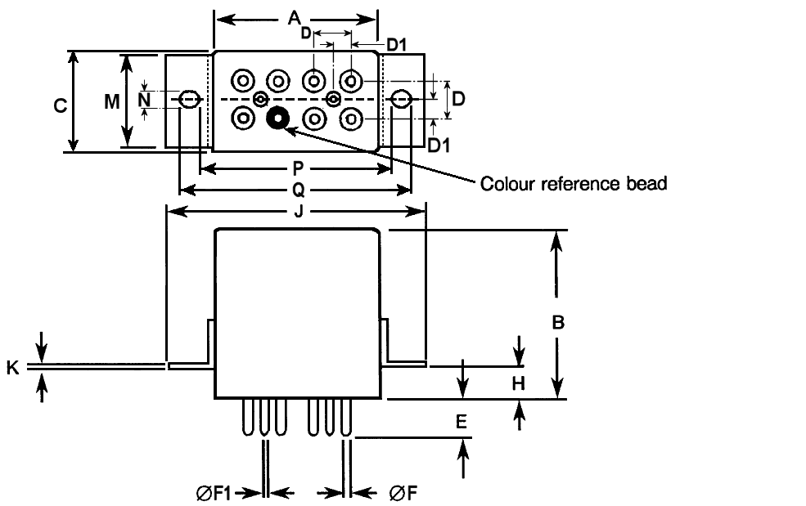
Symbols | Dimensions (mm)
Symbols | Min | Max
A | - | 26
B | - | 25.7
C | - | 13.3
D | 4.88 | 5.28
D1 | 2.44 | 2.64
E | 6.7 | 7.1
ØF | 1.55 | 1.62
ØF1 | 0.73 | 0.81
H | 3.8 | 4.2
J | - | 43.6
K | 0.9 | 1.1
M | - | 12.3
N | 3.7 | 3.9
P | 31.15 | 32.15
Q | 40 | 41
NOTES:
            - Terminal identification is specified by reference to the colour reference bead. See Para. 1.7.

Raised Vertical Flange Mount and Solder Hook Terminals (Variants 04, 14)
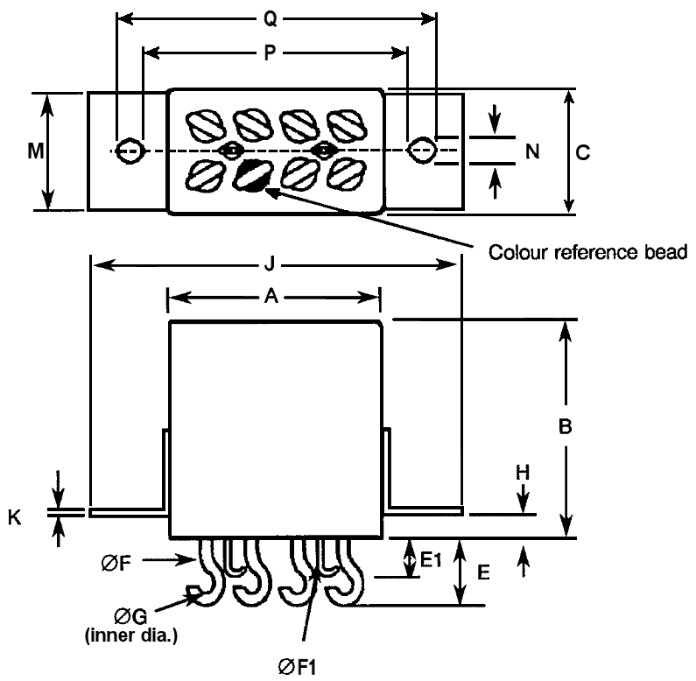
Symbols | Dimensions (mm)
Symbols | Min | Max
A | - | 26
B | - | 25.7
C | - | 13.3
E | - | 8
E1 | - | 4.5
ØF | 1.54 | 1.62
ØF1 | 0.71 | 0.81
ØG | 1.75 | 2.25
H | 3.8 | 4.2
J | - | 43.6
K | 0.9 | 1.1
M | - | 12.3
N | 3.7 | 3.9
P | 31.15 | 32.15
Q | 40 | 41
NOTES:
            - Terminal identification is specified by reference to the colour reference bead. See Para. 1.7.
            - For Variants 04, 14, see Para. 1.6.1 (Variants 03, 13) dimensions D and D1, for the An, Bn, Xn, Yn pins’ terminal spacing on the header.

Horizontal Flange Mount and Solder Pin Terminals (Variants 05, 15)
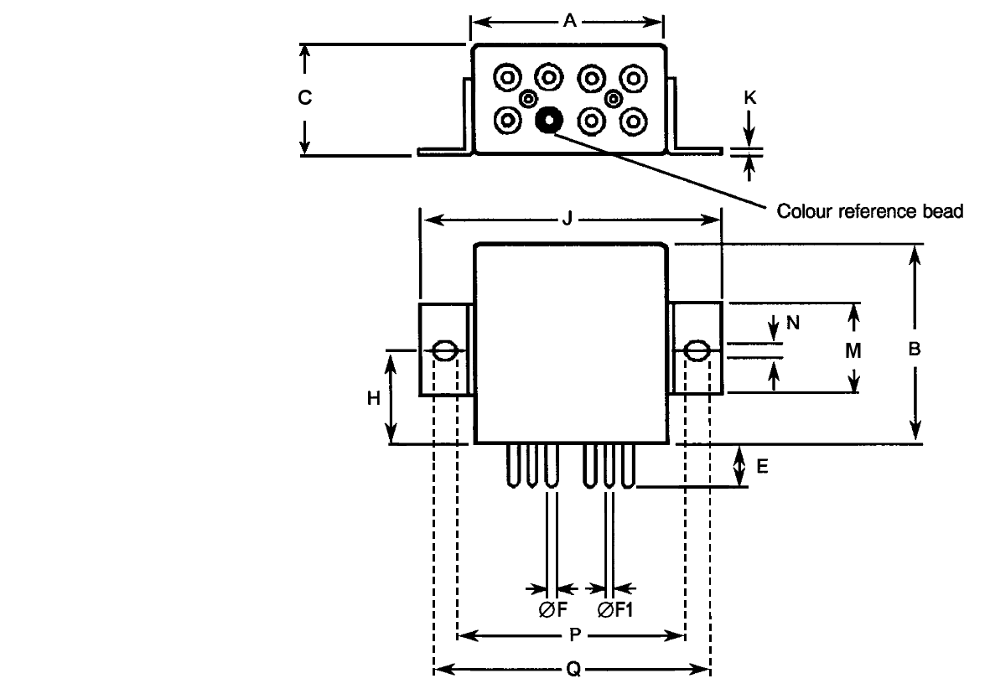
Symbols | Dimensions (mm)
Symbols | Min | Max
A | - | 26
B | - | 25.7
C | - | 13.3
E | 6.7 | 7.1
ØF | 1.55 | 1.62
ØF1 | 0.73 | 0.81
H | 12.5 | 12.9
J | - | 43.6
K | 0.9 | 1.1
M | - | 12.3
N | 3.7 | 3.9
P | 31.15 | 32.15
Q | 40 | 41
NOTES:
            - Terminal identification is specified by reference to the colour reference bead. See Para. 1.7.
            - For Variants 05, 15, see Para. 1.6.1 (Variants 03, 13) dimensions D and D1, for the An, Bn, Xn, Yn pins’ terminal spacing on the header.

Horizontal Flange Mount and Solder Hook Terminals (Variants 06, 16)
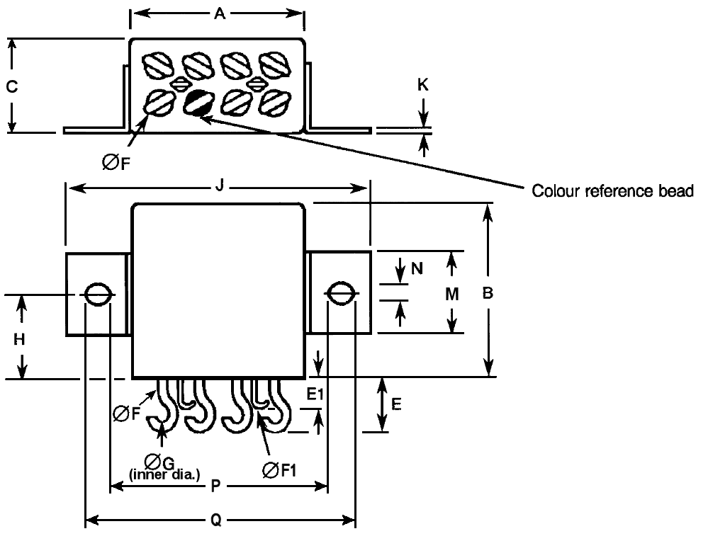
Symbols | Dimensions (mm)
Symbols | Min | Max
A | - | 26
B | - | 26
C | - | 13.3
E | - | 8
E1 | - | 4.5
ØF | 1.54 | 1.62
ØF1 | 0.71 | 0.81
ØG | 1.75 | 2.25
H | 12.5 | 12.9
J | - | 43.6
K | 0.9 | 1.1
M | - | 12.3
N | 3.7 | 3.9
P | 31.15 | 32.15
Q | 40 | 41
NOTES:
            - Terminal identification is specified by reference to the colour reference bead. See Para. 1.7.
            - For Variants 06, 16, see Para. 1.6.1 (Variants 03, 13) dimensions D and D1, for the An, Bn, Xn, Yn pins’ terminal spacing on the header.

Raised Vertical Flange Mount and Solder Pin Terminals with Polarizing Pin (Variants 08, 18)
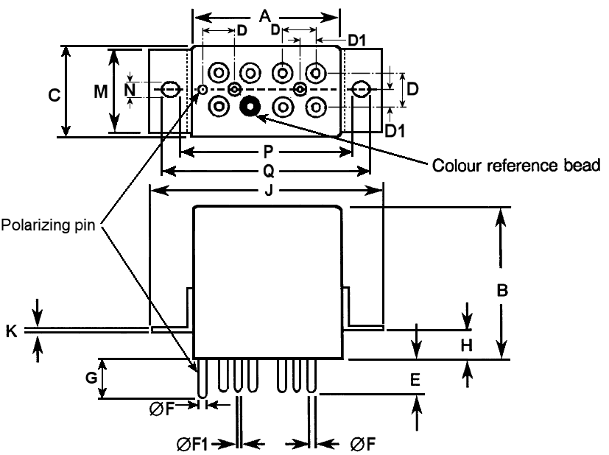
Symbols | Dimensions (mm)
Symbols | Min
A | - | 26
B | - | 25.7
C | - | 13.3
D | 4.88 | 5.28
D1 | 2.44 | 2.64
E | 6.7 | 7.1
ØF | 1.55 | 1.62
ØF1 | 0.73 | 0.81
G | 7.4 | 8
H | 3.8 | 4.2
J | - | 43.6
K | 0.9 | 1.1
M | - | 12.3
N | 3.7 | 3.9
P | 31.15 | 32.15
Q | 40 | 41
NOTES:
            - Terminal identification is specified by reference to the colour reference bead. See Para. 1.7.

Horizontal Flange Mount and Solder Pin Terminals with Polarizing Pin (Variants 09, 19)
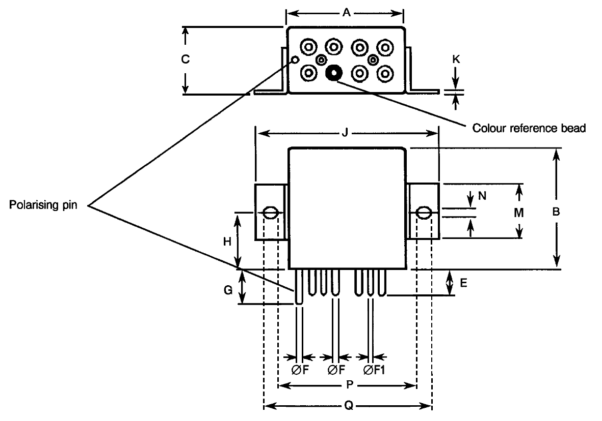
Symbols | Dimensions (mm)
Symbols | Min
A | - | 26
B | - | 25.7
C | - | 13.3
E | 6.7 | 7.1
ØF | 1.55 | 1.62
ØF1 | 0.73 | 0.81
G | 7.4 | 8
H | 12.5 | 12.9
J | - | 43.6
K | 0.9 | 1.1
M | - | 12.3
N | 3.7 | 3.9
P | 31.15 | 32.15
Q | 40 | 41
NOTES:
            - Terminal identification is specified by reference to the colour reference bead. See Para. 1.7.
            - For Variants 09, 19, see Para. 1.6.5 (Variants 08, 18) dimensions D and D1, for the An, Bn, Xn, Yn pins’ and the Polarising pin’s terminal spacing on the header.

FUNCTIONAL DIAGRAM
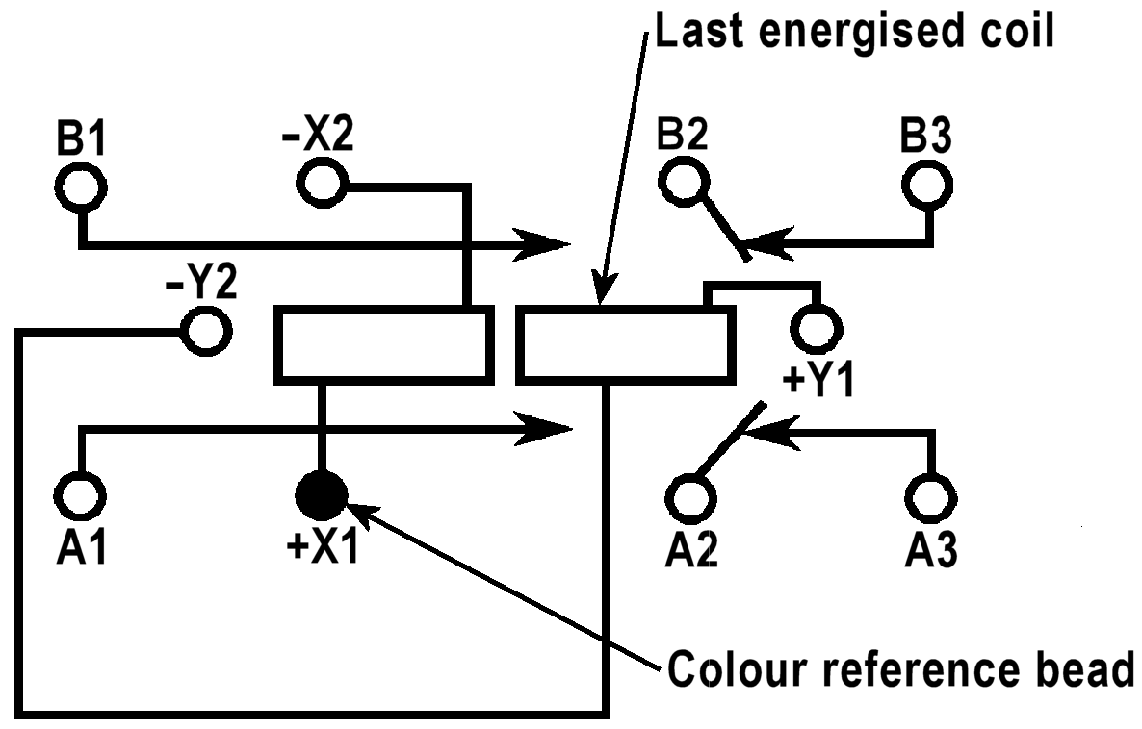
NOTES:
            - As viewed from the terminal side.
            - Individual terminal designations are for reference purposes only.

MATERIALS AND FINISHES

Case
Copper nickel, tin-lead alloy plated, hermetically sealed.

Terminals
The lead material and finish shall by type H3, H4 or H19 in accordance with the requirements of ESCC Basic Specification No. 23500.

REQUIREMENTS

GENERAL
The complete requirements for procurement of the components specified herein are as stated in this specification and the ESCC Generic Specification. Permitted deviations from the Generic Specification, applicable to this specification only, are listed below.
Permitted deviations from the Generic Specification and this Detail Specification, formally agreed with specific Manufacturers on the basis that the alternative requirements are equivalent to the ESCC requirement and do not affect the component’s reliability, are listed in the appendices attached to this specification.

Deviations from the Generic Specification
None

MARKING
The marking shall be in accordance with the requirements of ESCC Basic Specification No. 21700 and as follows.
The information to be marked on the component shall be:
          - The ESCC qualified components symbol (for ESCC qualified components only).
          - The ESCC Component Number (see Para. 1.4.1).
          - Traceability information.

TERMINAL STRENGTH
The terminals of all Variants are defined as rigid.
The test conditions for Terminal Strength, tested as specified in the ESCC Generic Specification, shall be as follows:
          - Pull Test: Applied Force:
- 50N for 1.6mm diameter terminals
- 15N for 0.7mm diameter terminals

ELECTRICAL MEASUREMENTS AT ROOM, HIGH AND LOW TEMPERATURES
Electrical measurements shall be performed at room, high and low temperatures. Consolidated notes are given in Para. 2.4.3.

Room Temperature Electrical Measurements
The measurements shall be performed at T_{amb} = +22 ±3°C.
Characteristics | Symbols | Test Method and Conditions | Rated Coil Voltage  (Vdc) | Limits |  | Units
 |  |  |  | Min | Max | Units
Latch Voltage | U_{L} | ESCC No. 3602  Note 1 |  |  |  | V
 |  | ESCC No. 3602  Note 1 | 28 | 8 | 14
 |  | ESCC No. 3602  Note 1 | 12 | 3.6 | 6.6
Reset Voltage | U_{R} | ESCC No. 3602  Note 1 |  |  |  | V
 |  | ESCC No. 3602  Note 1 | 28 | 8 | 14
 |  | ESCC No. 3602  Note 1 | 12 | 3.6 | 6.6
Latch Time | t_{L} | ESCC No. 3602 | All | - | 15 | ms
Reset Time | t_{R} | ESCC No. 3602 | All | - | 15 | ms
Bounce Time | t_{B} | ESCC No. 3602 | All | - | 1 | ms
Insulation Resistance | R_{I} | ESCC No. 3602  V_{TEST} = 500Vdc | All | 100 | - | MΩ
Voltage Proof  (Test Voltage) | VP | ESCC No. 3602  Maximum Leakage Current I_{LVP} = 1mA | All | 1250 | - | Vrms
 |  |  |  | 1000 (Note 2) | - | Vrms
 |  |  |  | 350 (Note 3) | - | Vrms
Voltage Proof Leakage Current | I_{LVP} | ESCC No. 3602  Note 4 | All | - | 1 | mA
Contact Voltage Drop | V_{D} | ESCC No. 3602  100mA ≤ I_{TEST} ≤ 15A | All | - | 0.01 x I_{TEST} | V
Coil Resistance | R_{B} | ESCC No. 3602  Both coils |  |  |  | Ω
 |  | Variants 03, 04, 05, 06, 08, 09 | 28 | 270 | 330
 |  | Variants 03, 04, 05, 06, 08, 09 | 12 | 54 | 66
 |  | Variants 13, 14, 15, 16, 18, 19 | 28 | 540 | 660
 |  | Variants 13, 14, 15, 16, 18, 19 | 12 | 135 | 165

High and Low Temperatures Electrical Measurements
Characteristics | Symbols | Test Method and Conditions | Rated Coil Voltage  (Vdc) | Limits |  | Units
 |  |  |  | Min | Max | Units
Latch Voltage | U_{L} | ESCC No. 3602  T_{amb} = +125 (+0 -5)°C and -65 (+5 -0)°C  Note 1 |  |  |  | V
Latch Voltage | U_{L} |  | 28 | - | 18
Latch Voltage | U_{L} |  | 12 | - | 9
Reset Voltage | U_{R} | ESCC No. 3602  T_{amb} = +125 (+0 -5)°C and -65 (+5 -0)°C  Note 1 |  |  |  | V
Reset Voltage | U_{R} |  | 28 | - | 18
Reset Voltage | U_{R} |  | 12 | - | 9
Latch Time | t_{L} | ESCC No. 3602  T_{amb} = +125 (+0 -5)°C and -65 (+5 -0)°C | All | - | 15 | ms
Reset Time | t_{R} | ESCC No. 3602  T_{amb} = +125 (+0 -5)°C and -65 (+5 -0)°C | All | - | 15 | ms
Bounce Time | t_{B} | ESCC No. 3602  T_{amb} = +125 (+0 -5)°C and -65 (+5 -0)°C | All | - | 1 | ms
Insulation Resistance | R_{I} | ESCC No. 3602  T_{amb} = +125(+0 -5)°C  V_{TEST} = 500Vdc | All | 50 | - | MΩ
Contact Voltage Drop | V_{D} | ESCC No. 3602  T_{amb} = +125 (+0 -5)°C and -65 (+5 -0)°C  100mA ≤ I_{TEST} ≤ 15A | All | - | 0.01 x I_{TEST} | V

Notes to Electrical Measurements Tables
            - The coil voltage rise time shall be less than 0.1t_{L} or 0.1t_{R}. The coil voltage shall be maintained for a minimum duration of 10t_{L} or 10t_{R}.
            - Between coil and case.
            - Between latch and reset coils.
            - Measured during Voltage Proof test.

PARAMETER DRIFT VALUES
Parameter Drift Values shall be measured as specified in the ESCC Generic Specification.
Unless otherwise specified, the measurements shall be performed at T_{amb} = +22 ±3°C.
The test methods and test conditions shall be as per the corresponding test defined in Para. 2.4.1 Room Temperature Electrical Measurements.
The corresponding absolute limit values for each characteristic shall not be exceeded.
Characteristics | Symbols | Limits |  |  | Units
Characteristics | Symbols | Drift Value  Δ | Absolute |  | Units
Characteristics | Symbols | Drift Value  Δ | Min | Max | Units
Latch Voltage | U_{L} | Note 1 | Note 2 | Note 2 | V
Reset Voltage | U_{R} | Note 1 | Note 2 | Note 2 | V
NOTES:
            - Drift Value (Δ) limits are not specified. Drift Values shall be recorded for information purposes only.
            - The limit specified in Para. 2.4.1 shall apply.

INTERMEDIATE AND END-POINT ELECTRICAL MEASUREMENTS
Unless otherwise specified, the measurements shall be performed at T_{amb} = +22 ±3°C.
Unless otherwise specified the test methods and test conditions shall be as per the corresponding test defined in Para. 2.4.1 Room Temperature Electrical Measurements.
Test Reference per ESCC No. 3602 | Characteristics | Symbols | Limits |  | Units
Test Reference per ESCC No. 3602 | Characteristics | Symbols | Min | Max | Units
Thermal Shock | During 5th Cycle
Thermal Shock | Latch Voltage | U_{L} | Note 2 |  | V
Thermal Shock | Reset Voltage | U_{R} | Note 2 |  | V
Thermal Shock | Latch Time | t_{L} | Note 2 |  | ms
Thermal Shock | Reset Time | t_{R} | Note 2 |  | ms
Thermal Shock | Final Measurements
Thermal Shock | Voltage Proof | VP | Note 3 |  | Vrms
Thermal Shock | Voltage Proof Leakage Current | I_{LVP} | Note 3 |  | mA
Low Level Sine Vibration | Final Measurements
Low Level Sine Vibration | Latch Voltage | U_{L} | Note 3 |  | V
Low Level Sine Vibration | Latch Voltage Drift | ΔU_{L}/U_{L} | Note 1 |  | %
Low Level Sine Vibration | Reset Voltage | U_{R} | Note 3 |  | V
Low Level Sine Vibration | Reset Voltage Drift | ΔU_{R}/U_{R} | Note 1 |  | %
High Level Sine Vibration | Final Measurements
High Level Sine Vibration | Latch Voltage | U_{L} | Note 3 |  | V
High Level Sine Vibration | Latch Voltage Drift | ΔU_{L}/U_{L} | Note 1 |  | %
High Level Sine Vibration | Reset Voltage | U_{R} | Note 3 |  | V
High Level Sine Vibration | Reset Voltage Drift | ΔU_{R}/U_{R} | Note 1 |  | %
Low Level Mechanical Shock | Final Measurements
Low Level Mechanical Shock | Contact Voltage Drop | V_{D} | Note 3 |  | V
Low Level Mechanical Shock | Latch Voltage | U_{L} | Note 3 |  | V
Low Level Mechanical Shock | Latch Voltage Drift | ΔU_{L}/U_{L} | Note 1 |  | %
Low Level Mechanical Shock | Reset Voltage | U_{R} | Note 3 |  | V
Low Level Mechanical Shock | Reset Voltage Drift | ΔU_{R}/U_{R} | Note 1 |  | %
Low Level Mechanical Shock | Voltage Proof | VP | Note 3 |  | Vrms
Low Level Mechanical Shock | Voltage Proof Leakage Current | I_{LVP} | Note 3 |  | mA
High Level Mechanical Shock | Final Measurements
High Level Mechanical Shock | Contact Voltage Drop | V_{D} | Note 3 |  | V
High Level Mechanical Shock | Latch Voltage | U_{L} | Note 3 |  | V
High Level Mechanical Shock | Latch Voltage Drift | ΔU_{L}/U_{L} | Note 1 |  | %
High Level Mechanical Shock | Reset Voltage | U_{R} | Note 3 |  | V
High Level Mechanical Shock | Reset Voltage Drift | ΔU_{R}/U_{R} | Note 1 |  | %
High Level Mechanical Shock | Voltage Proof | VP | Note 3 |  | Vrms
High Level Mechanical Shock | Voltage Proof Leakage Current | I_{LVP} | Note 3 |  | mA
Resistance to Soldering Heat | Final Measurements
Resistance to Soldering Heat | Insulation Resistance | R_{I} | Note 3 |  | MΩ
Resistance to Soldering Heat | Contact Voltage Drop | V_{D} | Note 3 |  | V
Resistance to Soldering Heat | Latch Voltage | U_{L} | Note 3 |  | V
Resistance to Soldering Heat | Reset Voltage | U_{R} | Note 3 |  | V
Resistance to Soldering Heat | Coil Resistance | R_{B} | Note 3 |  | Ω
Inductive Life | During Monitoring
Inductive Life | Contact Voltage Drop | V_{D} | - | 2.8 | V
Inductive Life | Final Measurements
Inductive Life | Contact Voltage Drop | V_{D} | - | 0.015 x I_{TEST} | V
Inductive Life | Insulation Resistance | R_{I} | 50 | - | MΩ
Inductive Life | Voltage Proof: | VP |  |  | Vrms
Inductive Life | Between latch and reset coils |  | 350 | -
Inductive Life | All other points |  | 1000 | -
Inductive Life | Voltage Proof Leakage Current | I_{LVP} | Note 3 |  | mA
Inductive Life | Latch Voltage | U_{L} | Note 3 |  | V
Inductive Life | Latch Voltage Drift | ΔU_{L}/U_{L} | Note 1 |  | %
Inductive Life | Reset Voltage | U_{R} | Note 3 |  | V
Inductive Life | Reset Voltage Drift | ΔU_{R}/U_{R} | Note 1 |  | %
Inductive Life | Latch Time | t_{L} | Note 3 |  | ms
Inductive Life | Reset Time | t_{R} | Note 3 |  | ms
Inductive Life | Bounce Time | t_{B} | Note 3 |  | ms
Inductive Life | Coil Resistance | R_{B} | Note 3 |  | Ω
Resistive Life | During Monitoring
Resistive Life | Contact Voltage Drop | V_{D} | - | 2.8 | V
Resistive Life | Final Measurements
Resistive Life | Contact Voltage Drop | V_{D} | - | 0.015 x I_{TEST} | V
Resistive Life | Insulation Resistance | R_{I} | 50 | - | MΩ
Resistive Life | Voltage Proof: | VP |  |  | Vrms
Resistive Life | Between latch and reset coils |  | 350 | -
Resistive Life | All other points |  | 1000 | -
Resistive Life | Voltage Proof Leakage Current | I_{LVP} | Note 3 |  | mA
Resistive Life | Latch Voltage | U_{L} | Note 3 |  | V
Resistive Life | Latch Voltage Drift | ΔU_{L}/U_{L} | Note 1 |  | %
Resistive Life | Reset Voltage | U_{R} | Note 3 |  | V
Resistive Life | Reset Voltage Drift | ΔU_{R}/U_{R} | Note 1 |  | %
Resistive Life | Latch Time | t_{L} | Note 3 |  | ms
Resistive Life | Reset Time | t_{R} | Note 3 |  | ms
Resistive Life | Bounce Time | t_{B} | Note 3 |  | ms
Resistive Life | Coil Resistance | R_{B} | Note 3 |  | Ω
Coil Life | During Step 1 of each Cycle
Coil Life | Contact Voltage Drop | V_{D} | Note 3 |  | V
Coil Life | Coil Resistance | R_{B} | Note 3 |  | Ω
Coil Life | During Step 3 of 1st Cycle
Coil Life | Contact Voltage Drop | V_{D} | Note 2 |  | V
Coil Life | Latch Time | t_{E} | Note 2 |  | ms
Coil Life | Reset Time | t_{D} | Note 2 |  | ms
Coil Life | During Steps 4 & 5 of 4th Cycle
Coil Life | Latch Voltage | U_{L} | Note 2 |  | V
Coil Life | Reset Voltage | U_{R} | Note 2 |  | V
Coil Life | Final Measurements
Coil Life | Voltage Proof | VP | Note 3 |  | Vrms
Coil Life | Voltage Proof Leakage Current | I_{LVP} | Note 3 |  | mA
Coil Life | Insulation Resistance | R_{I} | Note 3 |  | MΩ
Coil Life | Contact Voltage Drop | V_{D} | Note 3 |  | V
Coil Life | Coil Resistance | R_{B} | Note 3 |  | Ω
Coil Life | Latch Time | t_{L} | Note 3 |  | ms
Coil Life | Reset Time | t_{R} | Note 3 |  | ms
Coil Life | Bounce Time | t_{B} | Note 3 |  | ms
Intermediate Current | During Monitoring
Intermediate Current | Contact Voltage Drop: | V_{D} |  |  | mV
Intermediate Current | Pole 1; Group 1, 2, 3 (15A) |  | - | 175
Intermediate Current | Pole 2; Group 1 (0.5A) |  | - | 30
Intermediate Current | Pole 2; Group 2 (0.3A) |  | - | 18
Intermediate Current | Pole 2; Group 3 (0.1A) |  | - | 6
Intermediate Current | Final Measurements
Intermediate Current | Insulation Resistance | R_{I} | 50 | - | MΩ
Intermediate Current | Voltage Proof: | VP |  |  | Vrms
Intermediate Current | Between latch and reset coils |  | 350 | -
Intermediate Current | All other points |  | 1000 | -
Intermediate Current | Voltage Proof Leakage Current | I_{LVP} | Note 3 |  | mA
Intermediate Current | Latch Voltage | U_{L} | Note 3 |  | V
Intermediate Current | Latch Voltage Drift | ΔU_{L}/U_{L} | Note 1 |  | %
Intermediate Current | Reset Voltage | U_{R} | Note 3 |  | V
Intermediate Current | Reset Voltage Drift | ΔU_{R}/U_{R} | Note 1 |  | %
Intermediate Current | Latch Time | t_{L} | Note 3 |  | ms
Intermediate Current | Reset Time | t_{R} | Note 3 |  | ms
Intermediate Current | Bounce Time | t_{B} | Note 3 |  | ms
Intermediate Current | Coil Resistance | R_{B} | Note 3 |  | Ω
Intermediate Current | Contact Voltage Drop | V_{D} | - | 0.015 x I_{TEST} | V
Mechanical Life | Final Measurements
 | Contact Voltage Drop | V_{D} | - | 0.015 x I_{TEST} | V
 | Latch Voltage | U_{L} | Note 3 |  | V
 | Latch Voltage Drift | ΔU_{L}/U_{L} | Note 1 |  | %
 | Reset Voltage | U_{R} | Note 3 |  | V
 | Reset Voltage Drift | ΔU_{R}/U_{R} | Note 1 |  | %
 | Latch Time | t_{L} | Note 3 |  | ms
 | Reset Time | t_{R} | Note 3 |  | ms
 | Bounce Time | t_{B} | Note 3 |  | ms
 | Coil Resistance | R_{B} | Note 3 |  | Ω
Overload | During Monitoring
Overload | Contact Voltage Drop | V_{D} | - | 2.8 | V
Overload | Final Measurements
Overload | Contact Voltage Drop | V_{D} | - | 0.015 x I_{TEST} | V
Overload | Insulation Resistance | R_{I} | 50 | - | MΩ
Overload | Voltage Proof: | VP |  |  | Vrms
Overload | Between latch and reset coils |  | 350 | -
Overload | All other points |  | 1000 | -
Overload | Voltage Proof Leakage Current | I_{LVP} | Note 3 |  | mA
Overload | Latch Voltage | U_{L} | Note 3 |  | V
Overload | Latch Voltage Drift | ΔU_{L}/U_{L} | Note 1 |  | %
Overload | Reset Voltage | U_{R} | Note 3 |  | V
Overload | Reset Voltage Drift | ΔU_{R}/U_{R} | Note 1 |  | %
Overload | Latch Time | t_{L} | Note 3 |  | ms
Overload | Reset Time | t_{R} | Note 3 |  | ms
Overload | Bounce Time | t_{B} | Note 3 |  | ms
Overload | Coil Resistance | R_{B} | Note 3 |  | Ω
NOTES:
            - Parameter Drift shall be calculated referenced to the measurement immediately prior to the test in question. An additional initial measurement may be performed prior to the test in question if considered necessary. Drift limits are not specified. Drift Values shall be recorded for information purposes only.
            - The limits specified in Para. 2.4.2, as applicable to the same test temperature, shall apply.
            - The limits specified in Para. 2.4.1 shall apply.

RUN-IN CONDITIONS
The test conditions for Run-in, tested as specified in the ESCC Generic Specification, shall be as follows:
          - Test Temperature: +22 ±3°C.

APPENDIX A
AGREED DEVIATIONS FOR LEACH INTERNATIONAL EUROPE (F)
ITEMS AFFECTED | DESCRIPTION OF DEVIATIONS
Para. 1.8.2 Materials and Finishes: Terminals | Terminal material shall be Iron-Cobolt.

APPENDIX B
AGREED DEVIATIONS FOR REL STPI (F)
ITEMS AFFECTED | DESCRIPTION OF DEVIATIONS
Para. 2.1.1 Deviations from the Generic Specification:  Qualification and Periodic Tests - Chart F4 | Chart F4: Coil Life subgroup test sequence (under Endurance Subgroup 1):  Coil Life and the subsequent tests shall only be performed for Qualification. They are not required for Periodic Testing except in the case of any significant change to the design.

