

Page 1 of 25

RELAY, ELECTROMAGNETIC, NON-LATCHING, 28VDC, 1A, 2PDT, 1/6 CRYSTAL CAN
ESCC Detail Specification No. 3601/012
Issue 8 Draft A | March 2024



Document Custodian: European Space Agency – see https://escies.org

Legal Disclaimer and Copyright
European Space Agency, Copyright © 2024. All rights reserved.
The European Space Agency disclaims any liability or responsibility, to any person or entity, with respect to any loss or damage caused, or alleged to be caused, directly or indirectly by the use and application of this ESCC publication.
This publication, without the prior permission of the European Space Agency and provided that it is not used for a commercial purpose, may be:
- copied in whole, in any medium, without alteration or modification.
- copied in part, in any medium, provided that the ESCC document identification, comprising the ESCC symbol, document number and document issue, is removed.

DOCUMENTATION CHANGE NOTICE
(Refer to https://escies.org for ESCC DCR content)
DCR No. | CHANGE DESCRIPTION
TBA | Specification updated to incorporate changes per DCR.
Draft 8A 20/03/2024 S.Thacker | Mark-up specification implementing changes to Appendix A due to Manufacturer being no longer ESCC Qualified for this spec.  i.e. Coil Life deviation in Appendix A for Leach is deleted

TABLE OF CONTENTS
1 GENERAL 5
1.1 SCOPE 5
1.2 APPLICABLE DOCUMENTS 5
1.3 TERMS, DEFINITIONS, ABBREVIATIONS, SYMBOLS AND UNITS 5
1.4 THE ESCC COMPONENT NUMBER AND COMPONENT TYPE VARIANTS 5
1.4.1 The ESCC Component Number 5
1.4.1.1 Characteristics and/or Ratings Codes 5
1.4.2 Component Type Variants and Range of Components 6
1.5 MAXIMUM RATINGS 7
1.6 PHYSICAL DIMENSIONS AND TERMINAL IDENTIFICATION 8
1.6.1 Plain Case (No Mount) and Solder Pin Terminals (Variant 01) 8
1.6.2 Plain Case (No Mount) and Long Lead Terminals (Variant 02) 9
1.6.3 Raised Vertical Flange Mount and Solder Pin Terminals (Variant 04) 10
1.6.4 Raised Vertical Flange Mount and Long Lead Terminals (Variant 05) 11
1.6.5 Raised Vertical Flange Mount and Solder Hook Terminals (Variant 06) 12
1.6.6 Flush Vertical Flange Mount and Solder Pin Terminals (Variant 07) 13
1.6.7 Horizontal Flange Mount and Long Lead Terminals (Variant 10) 14
1.6.8 Horizontal Flange Mount and Solder Hook Terminals (Variant 11) 15
1.7 FUNCTIONAL DIAGRAM 16
1.8 MATERIALS AND FINISHES 16
1.8.1 Case 16
1.8.2 Terminals 16
2 REQUIREMENTS 16
2.1 GENERAL 16
2.1.1 Deviations from the Generic Specification 16
2.2 MARKING 16
2.3 TERMINAL STRENGTH 17
2.4 ELECTRICAL MEASUREMENTS AT ROOM, HIGH AND LOW TEMPERATURES 17
2.4.1 Room Temperature Electrical Measurements 17
2.4.2 High and Low Temperatures Electrical Measurements 18
2.5 PARAMETER DRIFT VALUES 19
2.6 INTERMEDIATE AND END-POINT ELECTRICAL MEASUREMENTS 19
2.7 RUN-IN CONDITIONS 24
APPENDIX A 25

GENERAL

SCOPE
This specification details the ratings, physical and electrical characteristics, and test and inspection data for the component type variants and/or the range of components specified below. It supplements the requirements of, and shall be read in conjunction with, the ESCC Generic Specification listed under Applicable Documents.

APPLICABLE DOCUMENTS
The following documents form part of this specification and shall be read in conjunction with it:
          - ESCC Generic Specification No. 3601.

TERMS, DEFINITIONS, ABBREVIATIONS, SYMBOLS AND UNITS
For the purpose of this specification, the terms, definitions, abbreviations, symbols and units specified in ESCC Basic Specification No. 21300 shall apply.

THE ESCC COMPONENT NUMBER AND COMPONENT TYPE VARIANTS

The ESCC Component Number
The ESCC Component Number shall be constituted as follows:
Example: 36010120126V
- Detail Specification Reference: 3601012
- Component Type Variant Number: 01 (as required)
- Characteristic code: Rated Coil Voltage (26.5Vdc): 26V (as required)

Characteristics and/or Ratings Codes
Characteristics and/or ratings to be codified as part of the ESCC Component Number shall be as follows:
          - Rated Coil Voltage expressed by means of the following codes:
Rated Coil Voltage (Vdc) | Code
26.5 | 26V
12 | 12V
6 | 6V

Component Type Variants and Range of Components
The component type variants and range of components applicable to this specification are as follows:
Variant Number | Case and Terminal Description  (Note 1) | Rated Coil Voltage (Vdc) | Weight max  (g)
01 | Plain Case (No Mount)  Solder Pin Terminals | 26.5, 12, 6 | 2.9
02 | Plain Case (No Mount)  Long Lead Terminals | 26.5, 12, 6 | 3.7
04 | Raised Vertical Flange Mount  Solder Pin Terminals | 26.5, 12, 6 | 3.1
05 | Raised Vertical Flange Mount  Long Lead Terminals | 26.5, 12, 6 | 4
06 | Raised Vertical Flange Mount  Solder Hook Terminals | 26.5, 12, 6 | 3.3
07 | Flush Vertical Flange Mount  Solder Pin Terminals | 26.5, 12, 6 | 3.1
10 | Horizontal Flange Mount  Long Lead Terminals | 26.5, 12, 6 | 4
11 | Horizontal Flange Mount  Solder Hook Terminals | 26.5, 12, 6 | 3.3
NOTES:
            - See Para. 1.6.

MAXIMUM RATINGS
The maximum ratings shall not be exceeded at any time during use or storage.
Maximum ratings shall only be exceeded during testing to the extent specified in this specification and when stipulated in Test Methods and Procedures of the ESCC Generic Specification.
Characteristics | Symbols | Maximum Ratings | Units | Remarks
Coil Voltage Range | V_{CR} |  | Vdc
 |  | 26.5 to 32 |  | Rated Coil Voltage: 26.5Vdc
 |  | 11 to 15 |  | Rated Coil Voltage: 12Vdc
 |  | 5.5 to 7.5 |  | Rated Coil Voltage: 6Vdc
Rated Resistive Load Contact Current | I_{CR} | 1 | A | 28Vdc resistive  Note 1
Overload Current | I_{OVERLOAD} | 2 | A | 28Vdc resistive
Operating Temperature Range | T_{op} | -65 to +125 | °C | T_{amb}
Storage Temperature Range | T_{stg} | -65 to +125 | °C | T_{amb}
Soldering Temperature | T_{sol} | +260 | °C | Note 2
NOTES:
            - Relays should not be used in change-over mode where the potential difference between stationary contacts is greater than 10V and the switched current is greater than 100mA.
            - Duration 10 seconds maximum at a distance not less than 1.5mm from the device body. The same terminal shall not be resoldered until 3 minutes have elapsed.

PHYSICAL DIMENSIONS AND TERMINAL IDENTIFICATION

Plain Case (No Mount) and Solder Pin Terminals (Variant 01)
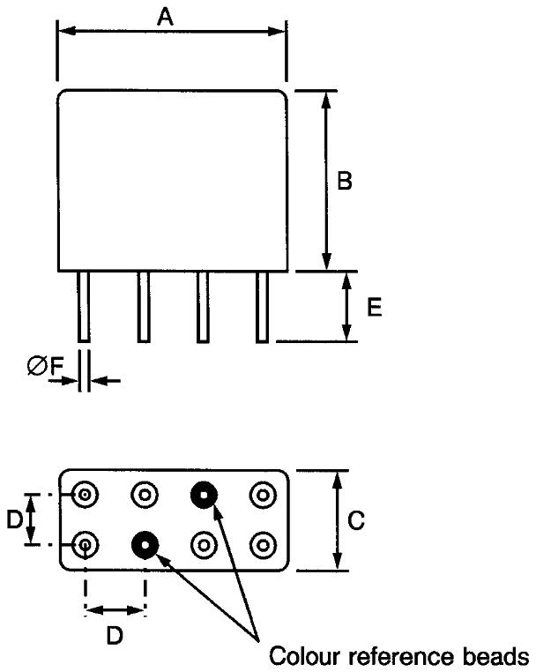
Symbols | Dimensions (mm)
Symbols | Min | Max
A | - | 13
B | - | 10.4
C | - | 6.1
D | 2.41 | 2.67
E | 4.5 | 5.2
ØF | 0.55 | 0.65
NOTES:
            - Terminal identification is specified by reference to the colour reference beads. See Para. 1.7.

Plain Case (No Mount) and Long Lead Terminals (Variant 02)
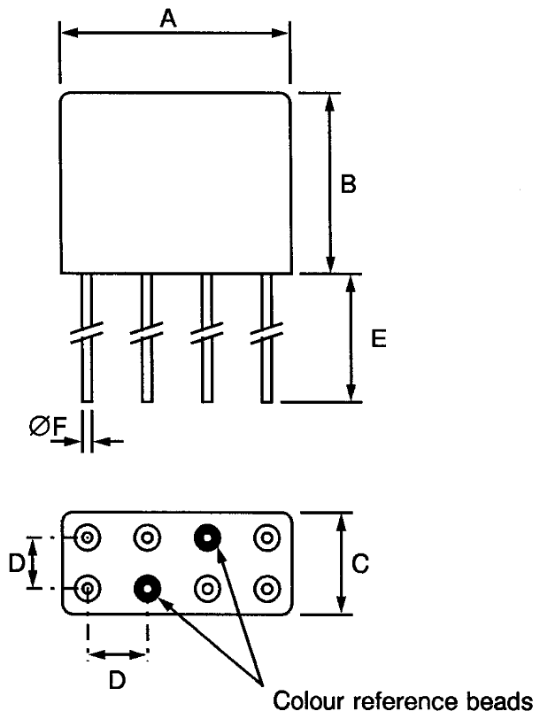
Symbols | Dimensions (mm)
Symbols | Min | Max
A | - | 13
B | - | 10.4
C | - | 6.1
D | 2.41 | 2.67
E | 37 | 39
ØF | 0.55 | 0.65
NOTES:
            - Terminal identification is specified by reference to the colour reference beads. See Para. 1.7.

Raised Vertical Flange Mount and Solder Pin Terminals (Variant 04)
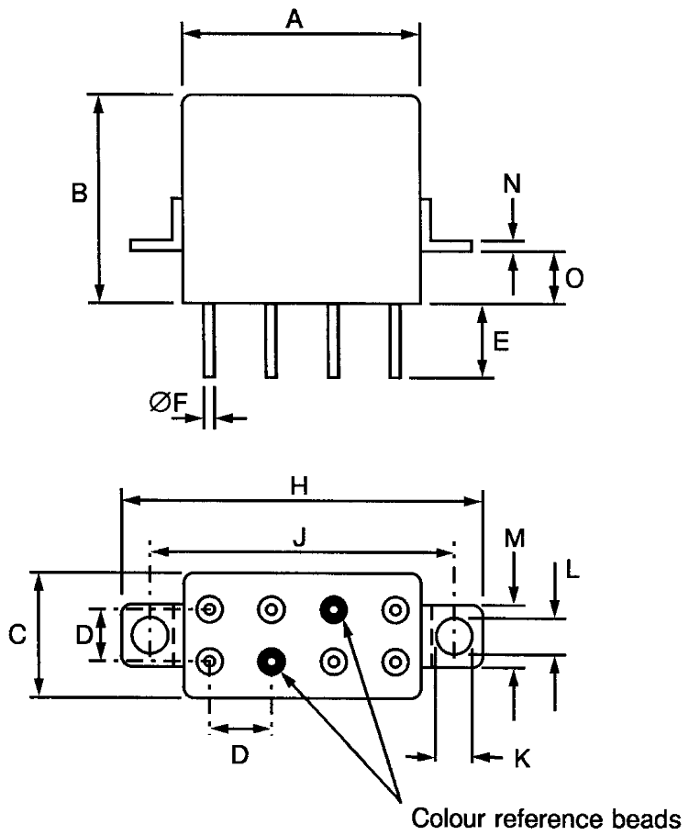
Symbols | Dimensions (mm)
Symbols | Min | Max
A | - | 13
B | - | 10.4
C | - | 6.1
D | 2.41 | 2.67
E | 4.5 | 5.2
ØF | 0.55 | 0.65
H | - | 22.85
J | 17.35 | 18.35
K | 3.1 | 3.3
L | 2.15 | 2.65
M | 4.5 | 4.9
N | 0.3 | 0.5
O | 3 | 3.4
NOTES:
            - Terminal identification is specified by reference to the colour reference beads. See Para. 1.7.

Raised Vertical Flange Mount and Long Lead Terminals (Variant 05)
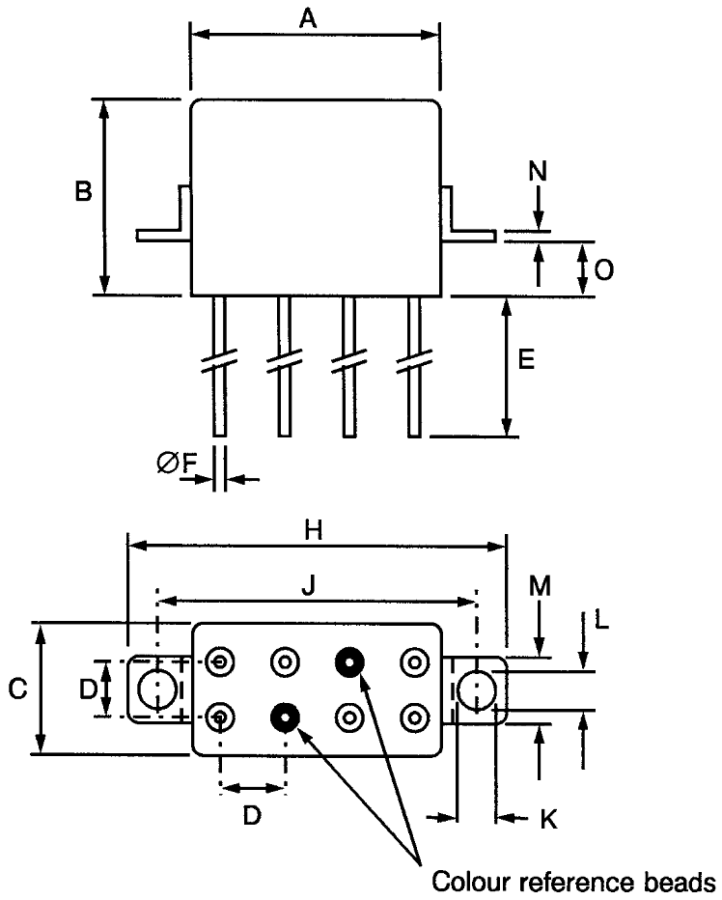
Symbols | Dimensions (mm)
Symbols | Min | Max
A | - | 13
B | - | 10.4
C | - | 6.1
D | 2.41 | 2.67
E | 37 | 39
ØF | 0.55 | 0.65
H | - | 22.85
J | 17.35 | 18.35
K | 3.1 | 3.3
L | 2.15 | 2.65
M | 4.5 | 4.9
N | 0.3 | 0.5
O | 3 | 3.4
NOTES:
            - Terminal identification is specified by reference to the colour reference beads. See Para. 1.7.

Raised Vertical Flange Mount and Solder Hook Terminals (Variant 06)
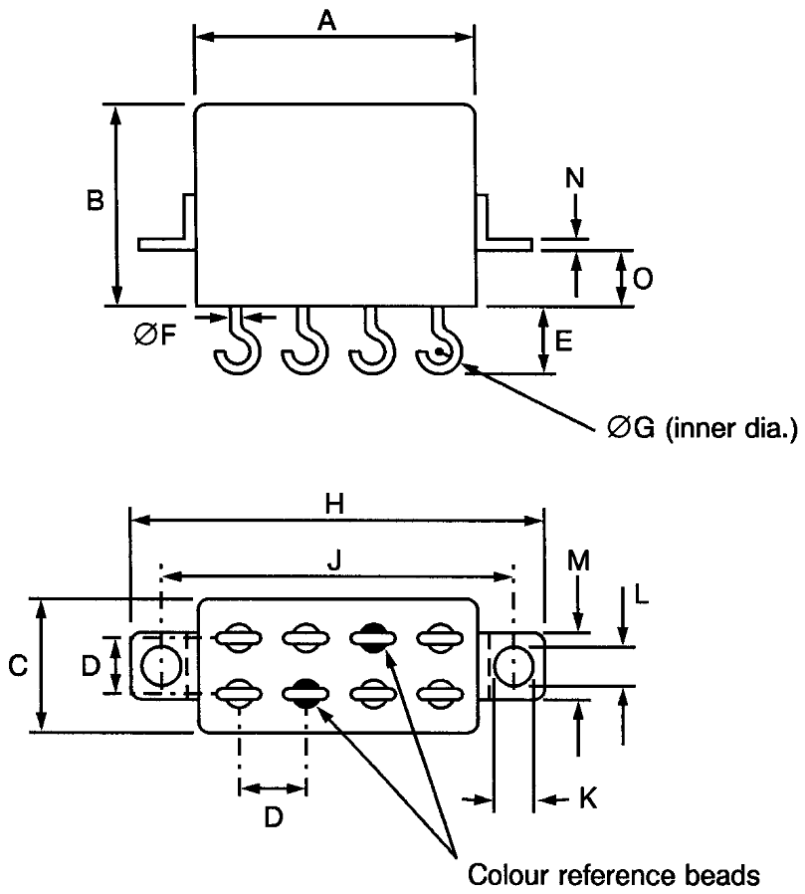
Symbols | Dimensions (mm)
Symbols | Min | Max
A | - | 13
B | - | 10.4
C | - | 6.1
D | 2.41 | 2.67
E | 2.9 | 3.9
ØF | 0.55 | 0.65
ØG | - | 1.1
H | - | 22.85
J | 17.35 | 18.35
K | 3.1 | 3.3
L | 2.15 | 2.65
M | 4.5 | 4.9
N | 0.3 | 0.5
O | 3 | 3.4
NOTES:
            - Terminal identification is specified by reference to the colour reference beads. See Para. 1.7.

Flush Vertical Flange Mount and Solder Pin Terminals (Variant 07)
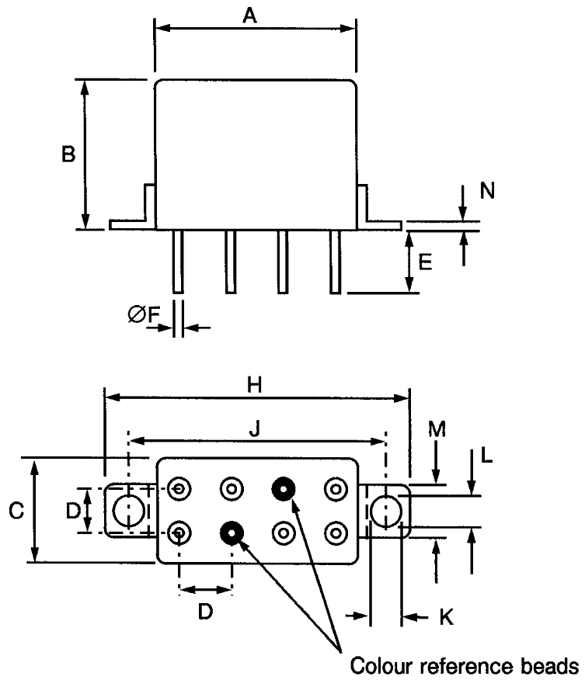
Symbols | Dimensions (mm)
Symbols | Min | Max
A | - | 13
B | - | 10.4
C | - | 6.1
D | 2.41 | 2.67
E | 4.5 | 5.2
ØF | 0.55 | 0.65
H | - | 22.85
J | 17.35 | 18.35
K | 3.1 | 3.3
L | 2.15 | 2.65
M | 4.5 | 4.9
N | 0.3 | 0.5
NOTES:
            - Terminal identification is specified by reference to the colour reference beads. See Para. 1.7.

Horizontal Flange Mount and Long Lead Terminals (Variant 10)
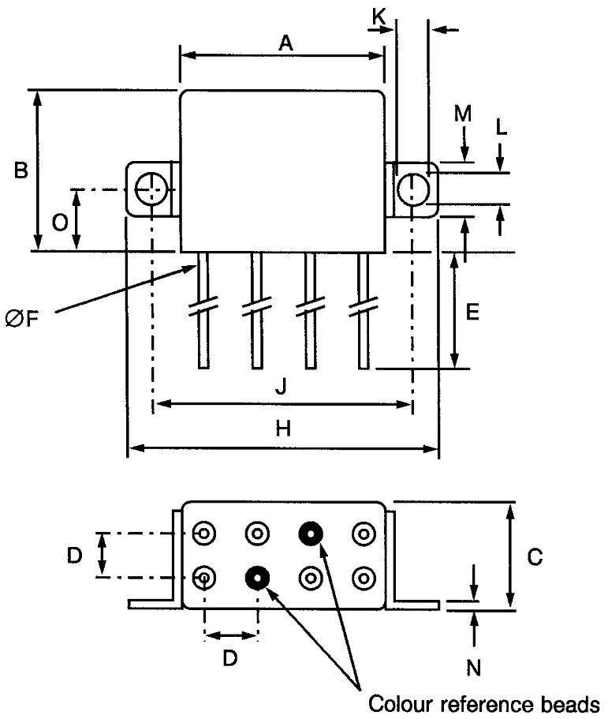
Symbols | Dimensions (mm)
Symbols | Min | Max
A | - | 13
B | - | 10.4
C | - | 6.1
D | 2.41 | 2.67
E | 37 | 39
ØF | 0.55 | 0.65
H | - | 22.85
J | 17.35 | 18.35
K | 3.1 | 3.3
L | 2.15 | 2.65
M | 4.5 | 4.9
N | 0.3 | 0.5
O | 5.2 | 5.6
NOTES:
            - Terminal identification is specified by reference to the colour reference beads. See Para. 1.7.

Horizontal Flange Mount and Solder Hook Terminals (Variant 11)
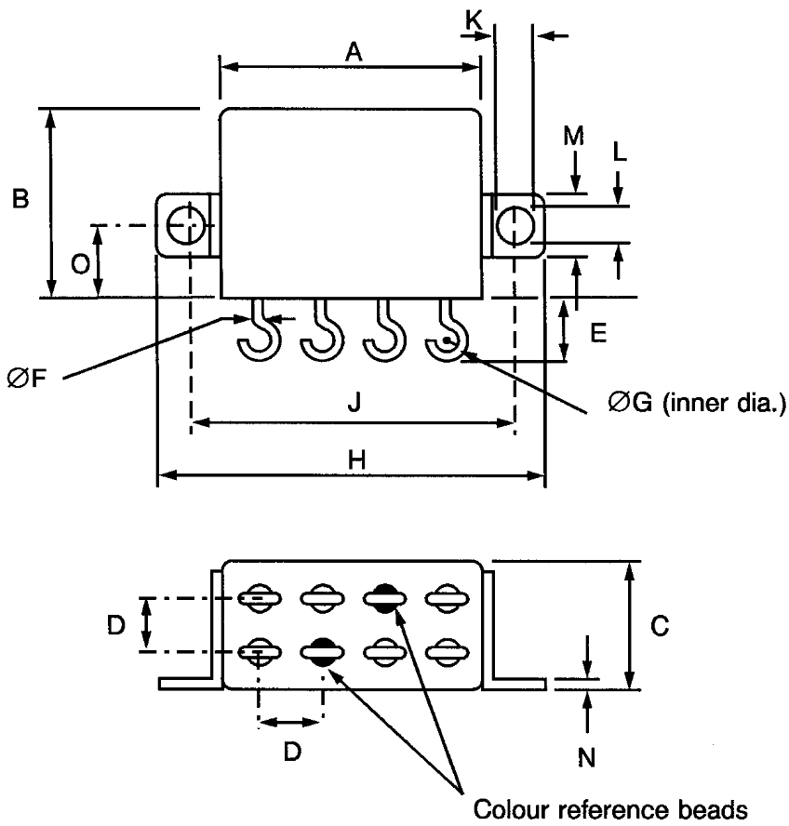
Symbols | Dimensions (mm)
Symbols | Min | Max
A | - | 13
B | - | 10.4
C | - | 6.1
D | 2.41 | 2.67
E | 2.9 | 3.9
ØF | 0.55 | 0.65
ØG | - | 1.1
H | - | 22.85
J | 17.35 | 18.35
K | 3.1 | 3.3
L | 2.15 | 2.65
M | 4.5 | 4.9
N | 0.3 | 0.5
O | 5.2 | 5.6
NOTES:
            - Terminal identification is specified by reference to the colour reference beads. See Para. 1.7.

FUNCTIONAL DIAGRAM
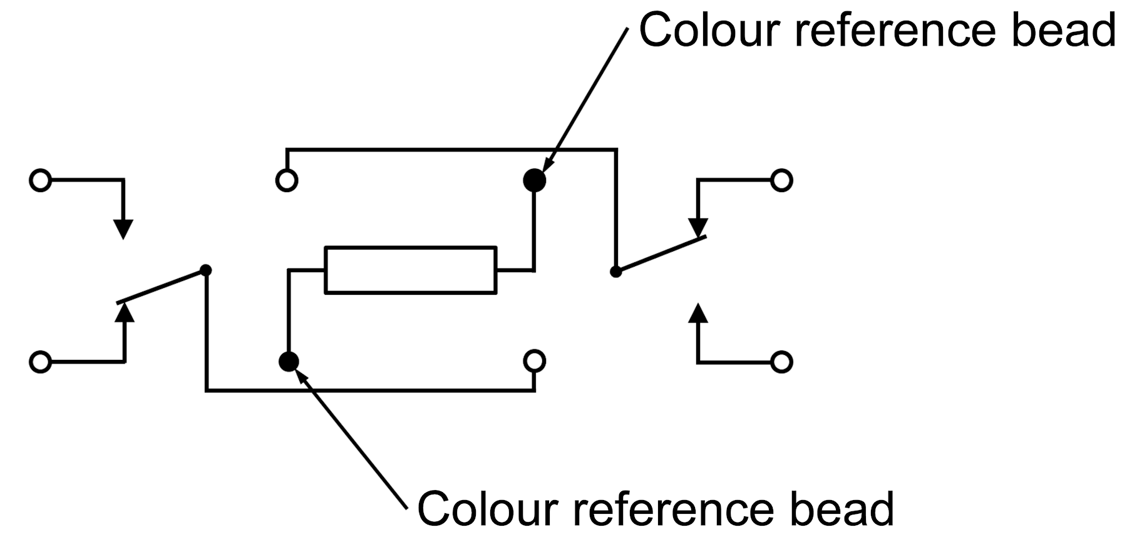
NOTES:
            - As viewed from the terminal side with coil de-energised.
            - Individual terminal designations are for reference purposes only.

MATERIALS AND FINISHES

Case
Copper nickel, hermetically sealed. Tin-lead alloy plating may be used.

Terminals
The lead material and finish shall by type D3, D4 or D19 in accordance with the requirements of ESCC Basic Specification No. 23500.

REQUIREMENTS

GENERAL
The complete requirements for procurement of the components specified herein are as stated in this specification and the ESCC Generic Specification. Permitted deviations from the Generic Specification, applicable to this specification only, are listed below.
Permitted deviations from the Generic Specification and this Detail Specification, formally agreed with specific Manufacturers on the basis that the alternative requirements are equivalent to the ESCC requirement and do not affect the component’s reliability, are listed in the appendices attached to this specification.

Deviations from the Generic Specification
None.

MARKING
The marking shall be in accordance with the requirements of ESCC Basic Specification No. 21700 and as follows.
The information to be marked on the component shall be:
          - The ESCC qualified components symbol (for ESCC qualified components only).
          - The ESCC Component Number (se Para. 1.4.1).
          - Traceability information.

TERMINAL STRENGTH
The terminals of all Variants are defined as rigid.
The test conditions for Terminal Strength, tested as specified in the ESCC Generic Specification, shall be as follows:
          - Pull Test
- Applied Force: 10N
          - Bend Test (Test Condition C)
- Load: 5N

ELECTRICAL MEASUREMENTS AT ROOM, HIGH AND LOW TEMPERATURES
Electrical measurements shall be performed at room, high and low temperatures.

Room Temperature Electrical Measurements
The measurements shall be performed at T_{amb} = +22 ±3°C.
Characteristics | Symbols | Test Method and Conditions | Rated Coil Voltage  (Vdc) | Limits |  | Units
 |  |  |  | Min | Max | Units
Pick-up Voltage | U_{C} | ESCC No. 3601 |  |  |  | V
 |  |  | 26.5 | - | 13.5
 |  |  | 12 | - | 6.4
 |  |  | 6 | - | 3.2
Drop-out Voltage | U_{D} | ESCC No. 3601 |  |  |  | V
 |  |  | 26.5 | 1.5 | 8
 |  |  | 12 | 1 | 4
 |  |  | 6 | 0.5 | 1.6
Operate Time | t_{E} | ESCC No. 3601 | All | - | 3 | ms
Release Time | t_{D} | ESCC No. 3601 | All | - | 3 | ms
Bounce Time | t_{B} | ESCC No. 3601 | All | - | 1.5 | ms
Insulation Resistance | R_{I} | ESCC No. 3601  V_{TEST} = 100Vdc | All | 10 | - | GΩ
Voltage Proof  (Test Voltage) | VP | ESCC No. 3601  Maximum Leakage Current I_{LVP} = 1mA | All | 500 | - | Vrms
 |  |  |  | 350 (Note 1) | - | Vrms
Voltage Proof Leakage Current | I_{LVP} | ESCC No. 3601  Note 2 | All | - | 1 | mA
Contact Voltage Drop | V_{D} | ESCC No. 3601  I_{TEST} = 100mA max | All | - | 0.1 x I_{TEST} | V
Coil Resistance | R_{B} | ESCC No. 3601 |  |  |  | Ω
 |  |  | 26.5 | 1350 | 1650
 |  |  | 12 | 297 | 363
 |  |  | 6 | 81 | 99
NOTES:
            - Points of application (350V):
- Between open contacts, coil de-energised.
- Between open contacts, coil energised with Rated Coil Voltage.
            - Measured during Voltage Proof test.

High and Low Temperatures Electrical Measurements
Characteristics | Symbols | Test Method and Conditions | Rated Coil Voltage  (Vdc) | Limits |  | Units
 |  |  |  | Min | Max | Units
Pick-up Voltage | U_{C} | ESCC No. 3601  T_{amb} = +125 (+0 -5)°C  and -65 (+5 -0)°C |  |  |  | V
 |  | ESCC No. 3601  T_{amb} = +125 (+0 -5)°C  and -65 (+5 -0)°C | 26.5 | - | 19.8
 |  | ESCC No. 3601  T_{amb} = +125 (+0 -5)°C  and -65 (+5 -0)°C | 12 | - | 9.9
 |  | ESCC No. 3601  T_{amb} = +125 (+0 -5)°C  and -65 (+5 -0)°C | 6 | - | 4.5
Drop-out Voltage | U_{D} | ESCC No. 3601  T_{amb} = +125 (+0 -5)°C  and -65 (+5 -0)°C |  |  |  | V
 |  | ESCC No. 3601  T_{amb} = +125 (+0 -5)°C  and -65 (+5 -0)°C | 26.5 | 1.2 | 14
 |  | ESCC No. 3601  T_{amb} = +125 (+0 -5)°C  and -65 (+5 -0)°C | 12 | 0.8 | 6.5
 |  | ESCC No. 3601  T_{amb} = +125 (+0 -5)°C  and -65 (+5 -0)°C | 6 | 0.4 | 3.2
Operate Time | t_{E} | ESCC No. 3601  T_{amb} = +125 (+0 -5)°C  and -65 (+5 -0)°C | All | - | 3 | ms
Release Time | t_{D} | ESCC No. 3601  T_{amb} = +125 (+0 -5)°C  and -65 (+5 -0)°C | All | - | 3 | ms
Bounce Time | t_{B} | ESCC No. 3601  T_{amb} = +125 (+0 -5)°C  and -65 (+5 -0)°C | All | - | 1.5 | ms
Insulation Resistance | R_{I} | ESCC No. 3601  T_{amb} = +125 (+0 -5)°C  V_{TEST} = 100Vdc | All | 100 | - | MΩ
Contact Voltage Drop | V_{D} | ESCC No. 3601  T_{amb} = +125 (+0 -5)°C  and -65 (+5 -0)°C  I_{TEST} = 100mA max | All | - | 0.1 x I_{TEST} | V

PARAMETER DRIFT VALUES
Parameter Drift Values shall be measured as specified in the ESCC Generic Specification.
Unless otherwise specified, the measurements shall be performed at T_{amb} = +22 ±3°C.
The test methods and test conditions shall be as per the corresponding test defined in Para. 2.4.1 Room Temperature Electrical Measurements.
The corresponding absolute limit values for each characteristic shall not be exceeded.
Characteristics | Symbols | Limits |  |  | Units
Characteristics | Symbols | Drift Value  Δ | Absolute |  | Units
Characteristics | Symbols | Drift Value  Δ | Min | Max | Units
Pick-up Voltage | U_{C} | Note 1 | Note 2 | Note 2 | V
Drop-out Voltage | U_{D} | Note 1 | Note 2 | Note 2 | V
NOTES:
            - Drift Value (Δ) limits are not specified. Drift Values shall be recorded for information purposes only.
            - The limit specified in Para. 2.4.1 shall apply.

INTERMEDIATE AND END-POINT ELECTRICAL MEASUREMENTS
Unless otherwise specified, the measurements shall be performed at T_{amb} = +22 ±3°C.
Unless otherwise specified the test methods and test conditions shall be as per the corresponding test defined in Para. 2.4.1 Room Temperature Electrical Measurements.
Test Reference per ESCC No. 3601 | Characteristics  (Note 1) | Symbols | Limits |  | Units
Test Reference per ESCC No. 3601 | Characteristics  (Note 1) | Symbols | Min | Max | Units
Thermal Shock | During 5th Cycle
Thermal Shock | Pick-up Voltage | U_{C} | Note 2 |  | V
Thermal Shock | Drop-out Voltage | U_{D} | Note 2 |  | V
Thermal Shock | Operate Time | t_{E} | Note 2 |  | ms
Thermal Shock | Release Time | t_{D} | Note 2 |  | ms
Thermal Shock | Final Measurements
Thermal Shock | Voltage Proof | VP | Note 3 |  | Vrms
Thermal Shock | Voltage Proof Leakage Current | I_{LVP} | Note 3 |  | mA
Low Level Sine Vibration | Final Measurements
Low Level Sine Vibration | Pick-up Voltage | U_{C} | Note 3 |  | V
Low Level Sine Vibration | Pick-up Voltage Drift | ΔU_{C}/U_{C} | Note 1 |  | %
Low Level Sine Vibration | Drop-out Voltage | U_{D} | Note 3 |  | V
Low Level Sine Vibration | Drop-out Voltage Drift | ΔU_{D}/U_{D} | Note 1 |  | %
Random Vibration | Final Measurements
Random Vibration | Pick-up Voltage | U_{C} | Note 3 |  | V
Random Vibration | Pick-up Voltage Drift | ΔU_{C}/U_{C} | Note 1 |  | %
Random Vibration | Drop-out Voltage | U_{D} | Note 3 |  | V
Random Vibration | Drop-out Voltage Drift | ΔU_{D}/U_{D} | Note 1 |  | %
High Level Sine Vibration | Final Measurements
High Level Sine Vibration | Pick-up Voltage | U_{C} | Note 3 |  | V
High Level Sine Vibration | Pick-up Voltage Drift | ΔU_{C}/U_{C} | Note 1 |  | %
High Level Sine Vibration | Drop-out Voltage | U_{D} | Note 3 |  | V
High Level Sine Vibration | Drop-out Voltage Drift | ΔU_{D}/U_{D} | Note 1 |  | %
Low Level Mechanical Shock | Final Measurements
Low Level Mechanical Shock | Contact Voltage Drop | V_{D} | Note 3 |  | V
Low Level Mechanical Shock | Pick-up Voltage | U_{C} | Note 3 |  | V
Low Level Mechanical Shock | Pick-up Voltage Drift | ΔU_{C}/U_{C} | Note 1 |  | %
Low Level Mechanical Shock | Drop-out Voltage | U_{D} | Note 3 |  | V
Low Level Mechanical Shock | Drop-out Voltage Drift | ΔU_{D}/U_{D} | Note 1 |  | %
Low Level Mechanical Shock | Voltage Proof | VP | Note 3 |  | Vrms
Low Level Mechanical Shock | Voltage Proof Leakage Current | I_{LVP} | Note 3 |  | mA
High Level Mechanical Shock | Final Measurements
High Level Mechanical Shock | Contact Voltage Drop | V_{D} | Note 3 |  | V
High Level Mechanical Shock | Pick-up Voltage | U_{C} | Note 3 |  | V
High Level Mechanical Shock | Pick-up Voltage Drift | ΔU_{C}/U_{C} | Note 1 |  | %
High Level Mechanical Shock | Drop-out Voltage | U_{D} | Note 3 |  | V
High Level Mechanical Shock | Drop-out Voltage Drift | ΔU_{D}/U_{D} | Note 1 |  | %
High Level Mechanical Shock | Voltage Proof | VP | Note 3 |  | Vrms
High Level Mechanical Shock | Voltage Proof Leakage Current | I_{LVP} | Note 3 |  | mA
Resistance to Soldering Heat | Final Measurements
Resistance to Soldering Heat | Insulation Resistance | R_{I} | Note 3 |  | GΩ
Resistance to Soldering Heat | Contact Voltage Drop | V_{D} | Note 3 |  | V
Resistance to Soldering Heat | Pick-up Voltage | U_{C} | Note 3 |  | V
Resistance to Soldering Heat | Drop-out Voltage | U_{D} | Note 3 |  | V
Resistance to Soldering Heat | Coil Resistance | R_{B} | Note 3 |  | Ω
Low Level Life | Final Measurements
Low Level Life | Contact Voltage Drop | V_{D} | - | 0.2 x I_{TEST} | V
Low Level Life | Insulation Resistance | R_{I} | 5000 | - | MΩ
Low Level Life | Voltage Proof | VP | Note 3 |  | Vrms
Low Level Life | Voltage Proof Leakage Current | I_{LVP} | Note 3 |  | mA
Low Level Life | Pick-up Voltage | U_{C} | Note 3 |  | V
Low Level Life | Pick-up Voltage Drift | ΔU_{C}/U_{C} | Note 1 |  | %
Low Level Life | Drop-out Voltage | U_{D} | Note 3 |  | V
Low Level Life | Drop-out Voltage Drift | ΔU_{D}/U_{D} | Note 1 |  | %
Low Level Life | Operate Time | t_{E} | Note 3 |  | ms
Low Level Life | Release Time | t_{D} | Note 3 |  | ms
Low Level Life | Bounce Time | t_{B} | Note 3 |  | ms
Low Level Life | Coil Resistance | R_{B} | Note 3 |  | Ω
Resistive Life | During Monitoring
Resistive Life | Contact Voltage Drop | V_{D} | - | 2.8 | V
Resistive Life | Final Measurements
Resistive Life | Contact Voltage Drop | V_{D} | - | 0.2 x I_{TEST} | V
Resistive Life | Insulation Resistance | R_{I} | 5000 | - | MΩ
Resistive Life | Voltage Proof | VP | Note 3 |  | Vrms
Resistive Life | Voltage Proof Leakage Current | I_{LVP} | Note 3 |  | mA
Resistive Life | Pick-up Voltage | U_{C} | Note 3 |  | V
Resistive Life | Pick-up Voltage Drift | ΔU_{C}/U_{C} | Note 1 |  | %
Resistive Life | Drop-out Voltage | U_{D} | Note 3 |  | V
Resistive Life | Drop-out Voltage Drift | ΔU_{D}/U_{D} | Note 1 |  | %
Resistive Life | Operate Time | t_{E} | Note 3 |  | ms
Resistive Life | Release Time | t_{D} | Note 3 |  | ms
Resistive Life | Bounce Time | t_{B} | Note 3 |  | ms
Resistive Life | Coil Resistance | R_{B} | Note 3 |  | Ω
Coil Life | During Step 1 of each Cycle
Coil Life | Contact Voltage Drop | V_{D} | Note 3 |  | V
Coil Life | Coil Resistance | R_{B} | Note 3 |  | Ω
Coil Life | During Step 3 of 1st Cycle
Coil Life | Contact Voltage Drop | V_{D} | Note 2 |  | V
Coil Life | Operate Time | t_{E} | Note 2 |  | ms
Coil Life | Release Time | t_{D} | Note 2 |  | ms
Coil Life | During Steps 4 & 5 of 4th Cycle
Coil Life | Pick-up Voltage | U_{C} | Note 2 |  | V
Coil Life | Drop-out Voltage | U_{D} | Note 2 |  | V
Coil Life | Final Measurements
Coil Life | Voltage Proof | VP | Note 3 |  | Vrms
Coil Life | Voltage Proof Leakage Current | I_{LVP} | Note 3 |  | mA
Coil Life | Insulation Resistance | R_{I} | Note 3 |  | GΩ
Coil Life | Contact Voltage Drop | V_{D} | Note 3 |  | V
Coil Life | Coil Resistance | R_{B} | Note 3 |  | Ω
Coil Life | Operate Time | t_{E} | Note 3 |  | ms
Coil Life | Release Time | t_{D} | Note 3 |  | ms
Coil Life | Bounce Time | t_{B} | Note 3 |  | ms
Intermediate Current | During Monitoring
Intermediate Current | Contact Voltage Drop | V_{D} | - | 300 | mV
Intermediate Current | Final Measurements
Intermediate Current | Insulation Resistance | R_{I} | 5000 | - | MΩ
Intermediate Current | Voltage Proof | VP | Note 3 |  | Vrms
Intermediate Current | Voltage Proof Leakage Current | I_{LVP} | Note 3 |  | mA
Intermediate Current | Pick-up Voltage | U_{C} | Note 3 |  | V
Intermediate Current | Pick-up Voltage Drift | ΔU_{C}/U_{C} | Note 1 |  | %
Intermediate Current | Drop-out Voltage | U_{D} | Note 3 |  | V
Intermediate Current | Drop-out Voltage Drift | ΔU_{D}/U_{D} | Note 1 |  | %
Intermediate Current | Operate Time | t_{E} | Note 3 |  | ms
Intermediate Current | Release Time | t_{D} | Note 3 |  | ms
Intermediate Current | Bounce Time | t_{B} | Note 3 |  | ms
Intermediate Current | Coil Resistance | R_{B} | Note 3 |  | Ω
Intermediate Current | Contact Voltage Drop | V_{D} | - | 0.2 x I_{TEST} | V
Overload | During Monitoring
Overload | Contact Voltage Drop | V_{D} | - | 1.4 | V
Overload | Final Measurements
Overload | Contact Voltage Drop | V_{D} | - | 0.2 x I_{TEST} | V
Overload | Insulation Resistance | R_{I} | 5000 | - | MΩ
Overload | Voltage Proof | VP | Note 3 |  | Vrms
Overload | Voltage Proof Leakage Current | I_{LVP} | Note 3 |  | mA
Overload | Pick-up Voltage | U_{C} | Note 3 |  | V
Overload | Pick-up Voltage Drift | ΔU_{C}/U_{C} | Note 1 |  | %
Overload | Drop-out Voltage | U_{D} | Note 3 |  | V
Overload | Drop-out Voltage Drift | ΔU_{D}/U_{D} | Note 1 |  | %
Overload | Operate Time | t_{E} | Note 3 |  | ms
Overload | Release Time | t_{D} | Note 3 |  | ms
Overload | Bounce Time | t_{B} | Note 3 |  | ms
Overload | Coil Resistance | R_{B} | Note 3 |  | Ω
NOTES:
            - Parameter Drift shall be calculated referenced to the measurement immediately prior to the test in question. An additional initial measurement may be performed prior to the test in question if considered necessary. Drift limits are not specified. Drift Values shall be recorded for information purposes only.
            - The limits specified in Para. 2.4.2, as applicable to the same test temperature, shall apply.
            - The limits specified in Para. 2.4.1 shall apply.

RUN-IN CONDITIONS
The test conditions for Run-in, tested as specified in the ESCC Generic Specification, shall be as follows:
          - Test Temperature: +22 ±3°C.

APPENDIX A
AGREED DEVIATIONS FOR LEACH INTERNATIONAL EUROPE (F)
ITEMS AFFECTED | DESCRIPTION OF DEVIATIONS
Para. 2.1.1 Deviations from the Generic Specification:  Lot Validation Testing – Chart F4 | High Level Sine Vibration: Not Applicable
 | High Level Mechanical Shock: Not Applicable

