

Page 1 of 23

RELAY, ELECTROMAGNETIC, NON-LATCHING, 28VDC, 2A, 2PDT, HALF-SIZE CRYSTAL CAN
ESCC Detail Specification No. 3601/003
Issue 10 Draft A | March 2024



Document Custodian: European Space Agency – see https://escies.org

Legal Disclaimer and Copyright
European Space Agency, Copyright © 2024. All rights reserved.
The European Space Agency disclaims any liability or responsibility, to any person or entity, with respect to any loss or damage caused, or alleged to be caused, directly or indirectly by the use and application of this ESCC publication.
This publication, without prior the permission of the European Space Agency and provided that it is not used for a commercial purpose, may be:
- copied in whole, in any medium, without alteration or modification.
- copied in part, in any medium, provided that the ESCC document identification, comprising the ESCC symbol, document number and document issue, is removed.

DOCUMENTATION CHANGE NOTICE
(Refer to https://escies.org for ESCC DCR content)
DCR No. | CHANGE DESCRIPTION
TBA TBA | Specification updated to incorporate changes per DCR.
Draft 10A S.Thacker 20/03/2024 | Initial draft revision based on request from Leach in email dated 18/03/2024.  All changes from issue 9 are highlighted yellow for information purposes; see Appendix A.  Note: Additional change to Appendix A included for 2nd DCR raised for non-qualified Manufacturer(s) i.e. Deviation on Coil Life for Leach is removed.

TABLE OF CONTENTS

1 GENERAL 5
1.1 SCOPE 5
1.2 APPLICABLE DOCUMENTS 5
1.3 TERMS, DEFINITIONS, ABBREVIATIONS, SYMBOLS AND UNITS 5
1.4 THE ESCC COMPONENT NUMBER AND COMPONENT TYPE VARIANTS 5
1.4.1 The ESCC Component Number 5
1.4.1.1 Characteristics and/or Ratings Codes 5
1.4.2 Component Type Variants and Range of Components 6
1.5 MAXIMUM RATINGS 7
1.6 PHYSICAL DIMENSIONS AND TERMINAL IDENTIFICATION 8
1.6.1 Plain Case (No Mount) with Solder Pin Terminals (Variant 01) 8
1.6.2 Raised Vertical Flange Mount and Solder Pin Terminals (Variant 02) 9
1.6.3 Horizontal Flange Mount and Solder Hook Terminals (Variant 03) 10
1.6.4 Horizontal Flange Mount and Solder Pin Terminals (Variant 04) 11
1.6.5 Plain Case (No Mount) and Solder Hook Terminals (Variant 05) 12
1.6.6 Raised Vertical Flange Mount and Solder Hook Terminals (Variant 06) 13
1.6.7 Plain Case (No Mount) with Long Solder Pin Terminals (Variant 09) 14
1.7 FUNCTIONAL DIAGRAM 15
1.8 MATERIALS AND FINISHES 15
1.8.1 Case 15
1.8.2 Terminals 15
2 REQUIREMENTS 15
2.1 GENERAL 15
2.1.1 Deviations from the Generic Specification 15
2.2 MARKING 15
2.3 TERMINAL STRENGTH 16
2.4 ELECTRICAL MEASUREMENTS AT ROOM, HIGH AND LOW TEMPERATURES 16
2.4.1 Room Temperature Electrical Measurements 16
2.4.2 High and Low Temperatures Electrical Measurements 17
2.5 PARAMETER DRIFT VALUES 17
2.6 INTERMEDIATE AND END-POINT ELECTRICAL MEASUREMENTS 18
2.7 RUN-IN CONDITIONS 22
APPENDIX A 23

GENERAL

SCOPE
This specification details the ratings, physical and electrical characteristics, and test and inspection data for the component type variants and/or the range of components specified below. It supplements the requirements of, and shall be read in conjunction with, the ESCC Generic Specification listed under Applicable Documents.

APPLICABLE DOCUMENTS
The following documents form part of this specification and shall be read in conjunction with it:
          - ESCC Generic Specification No. 3601.

TERMS, DEFINITIONS, ABBREVIATIONS, SYMBOLS AND UNITS
For the purpose of this specification, the terms, definitions, abbreviations, symbols and units specified in ESCC Basic Specification No. 21300 shall apply.

THE ESCC COMPONENT NUMBER AND COMPONENT TYPE VARIANTS

The ESCC Component Number
The ESCC Component Number shall be constituted as follows:
Example: 36010030126V1
- Detail Specification Reference: 3601003
- Component Type Variant Number: 01 (as required)
- Characteristic code: Rated Coil Voltage and Coil Resistance (26.5Vdc, 900Ω): 26V1 (as required)

Characteristics and/or Ratings Codes
Characteristics and/or ratings to be codified as part of the ESCC Component Number shall be as follows:
          - The Rated Coil Voltage and Coil Resistance are expressed by means of the following codes:
Rated Coil Voltage (Vdc) | Coil Resistance (Ω) | Code
26.5 | 900 | 26V1
26.5 | 700 | 26V2
12 | 190 | 12V1
12 | 150 | 12V2

Component Type Variants and Range of Components
The component type variants and range of components applicable to this specification are as follows:
Variant Number | Case and Terminal Description  (Note 1) | Coil Characteristics | Weight max  (g)
01 | Plain Case (No Mount)  Solder Pin Terminals | Note 2 | 8.1
02 | Raised Vertical Flange Mount  Solder Pin Terminals | Note 2 | 8.8
03 | Horizontal Flange Mount  Solder Hook Terminals | Note 2 | 10
04 | Horizontal Flange Mount  Solder Pin Terminals | Note 2 | 9.7
05 | Plain Case (No Mount)  Solder Hook Terminals | Note 2 | 8.4
06 | Raised Vertical Flange Mount  Solder Hook Terminals | Note 2 | 9.1
09 | Plain Case (No Mount)  Long Solder Pin Terminals | Note 2 | 8.5
NOTES:
            - See Para. 1.6.
            - The following Rated Coil Voltages and Coil Resistances are available and selectable for each Variant:
Rated Coil Voltage | Coil Resistance
26.5Vdc | 900Ω
26.5Vdc | 700Ω
12Vdc | 190Ω
12Vdc | 150Ω

MAXIMUM RATINGS
The maximum ratings shall not be exceeded at any time during use or storage.
Maximum ratings shall only be exceeded during testing to the extent specified in this specification and when stipulated in Test Methods and Procedures of the ESCC Generic Specification.
Characteristics | Symbols | Maximum Ratings | Units | Remarks
Coil Voltage Range | V_{CR} |  | Vdc
Coil Voltage Range | V_{CR} | 25 to 32 | Vdc | Rated Coil Voltage: 26.5Vdc
Coil Voltage Range | V_{CR} | 11 to 15 | Vdc | Rated Coil Voltage: 12Vdc
Rated Resistive Load Contact Current | I_{CR} | 2 | A | 28Vdc resistive  Note 1
Rated Inductive Load Contact Current | I_{CL} | 400 | mA | 28Vdc inductive  Inductance: 320mH  Note 1
Overload Current | I_{OVERLOAD} | 4 | A | 28Vdc resistive
Operating Temperature Range | T_{op} | -65 to +125 | °C | T_{amb}
Storage Temperature Range | T_{stg} | -65 to +125 | °C | T_{amb}
Soldering Temperature | T_{sol} | +260 | °C | Note 2
NOTES:
            - Relays should not be used in change-over mode where the potential difference between stationary contacts is greater than 10V and the switched current is greater than 100mA.
            - Duration 10 seconds maximum at a distance not less than 3mm from the device body. The same terminal shall not be resoldered until 3 minutes have elapsed.

PHYSICAL DIMENSIONS AND TERMINAL IDENTIFICATION

Plain Case (No Mount) with Solder Pin Terminals (Variant 01)
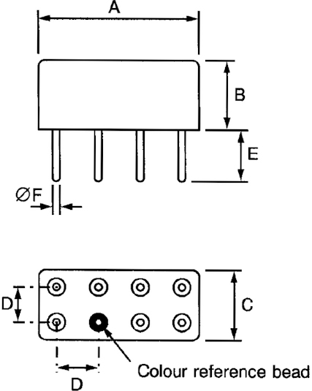
Symbols | Dimensions (mm)
Symbols | Min | Max
A | - | 20.57
B | - | 10.41
C | - | 10.41
D | 4.95 | 5.21
E | 4.24 | 5.4
ØF | 0.66 | 0.86
NOTES:
            - Terminal identification is specified by reference to the colour reference bead. See Para. 1.7.

Raised Vertical Flange Mount and Solder Pin Terminals (Variant 02)
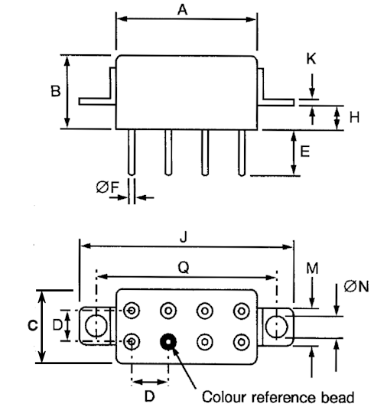
Symbols | Dimensions (mm)
Symbols | Min | Max
A | - | 20.57
B | - | 10.41
C | - | 10.41
D | 4.95 | 5.21
E | 4.24 | 5.4
ØF | 0.66 | 0.86
H | 3.1 | 3.3
J | - | 32.9
K | 0.5 | 0.8
M | 6.22 | 8.1
ØN | 3 | 3.55
Q | 26.6 | 27.4
NOTES:
            - Terminal identification is specified by reference to the colour reference bead. See Para. 1.7.

Horizontal Flange Mount and Solder Hook Terminals (Variant 03)
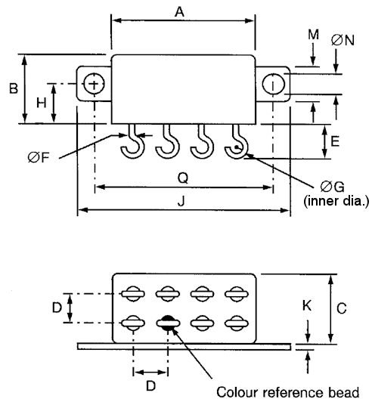
Symbols | Dimensions (mm)
Symbols | Min | Max
A | - | 20.57
B | - | 10.41
C | - | 10.41
D | 4.95 | 5.21
E | 4.11 | 4.83
ØF | 0.66 | 0.86
ØG | - | 1.8
H | 5.97 | 6.73
J | - | 32.64
K | 0.38 | 0.9
M | 6.22 | 8
ØN | 3 | 3.55
Q | 26.8 | 27.2
NOTES:
            - Terminal identification is specified by reference to the colour reference bead. See Para. 1.7.

Horizontal Flange Mount and Solder Pin Terminals (Variant 04)
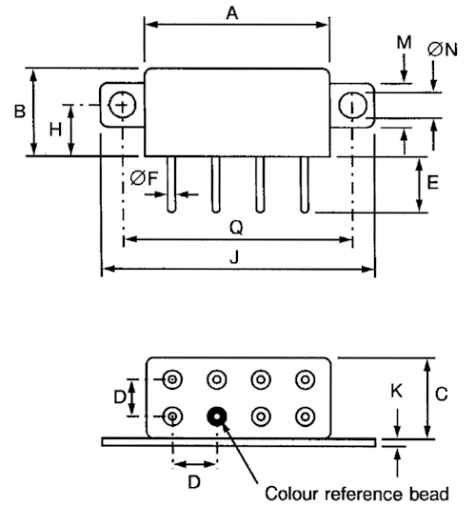
Symbols | Dimensions (mm)
Symbols | Min | Max
A | - | 20.57
B | - | 10.41
C | - | 10.41
D | 4.95 | 5.21
E | 4.24 | 5.4
ØF | 0.66 | 0.86
H | 5.97 | 6.73
J | - | 32.64
K | 0.38 | 0.9
M | 6.22 | 8
ØN | 3 | 3.55
Q | 26.8 | 27.2
NOTES:
            - Terminal identification is specified by reference to the colour reference bead. See Para. 1.7.

Plain Case (No Mount) and Solder Hook Terminals (Variant 05)
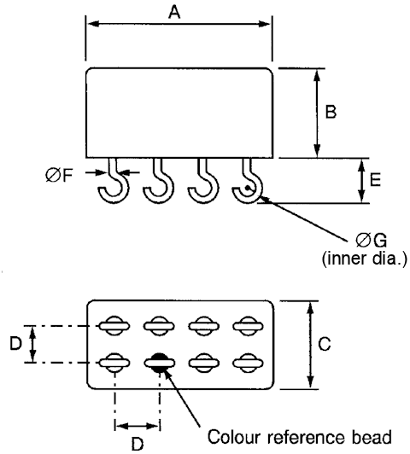
Symbols | Dimensions (mm)
Symbols | Min | Max
A | - | 20.57
B | - | 10.41
C | - | 10.41
D | 4.95 | 5.21
E | 4.11 | 4.83
ØF | 0.66 | 0.86
ØG | - | 1.8
NOTES:
            - Terminal identification is specified by reference to the colour reference bead. See Para. 1.7.

Raised Vertical Flange Mount and Solder Hook Terminals (Variant 06)
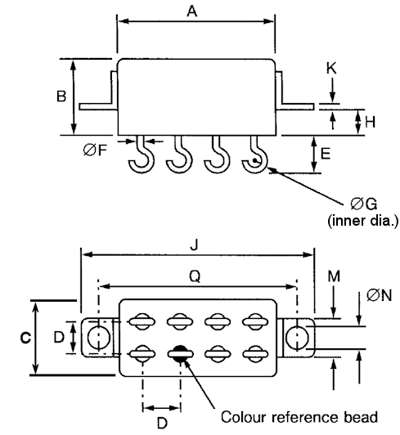
Symbols | Dimensions (mm)
Symbols | Min | Max
A | - | 20.57
B | - | 10.41
C | - | 10.41
D | 4.95 | 5.21
E | 4.11 | 4.83
ØF | 0.66 | 0.86
ØG | - | 1.8
H | 3.1 | 3.3
J | - | 32.9
K | 0.5 | 0.8
M | 6.22 | 8.1
ØN | 3 | 3.55
Q | 26.6 | 27.4
NOTES:
            - Terminal identification is specified by reference to the colour reference bead. See Para. 1.7.

Plain Case (No Mount) with Long Solder Pin Terminals (Variant 09)
Symbols | Dimensions (mm)
Symbols | Min | Max
A | - | 20.57
B | - | 10.41
C | - | 10.41
D | 4.95 | 5.21
E | 6.2 | 6.86
ØF | 0.66 | 0.86
NOTES:
            - Terminal identification is specified by reference to the colour reference bead. See Para. 1.7.

FUNCTIONAL DIAGRAM
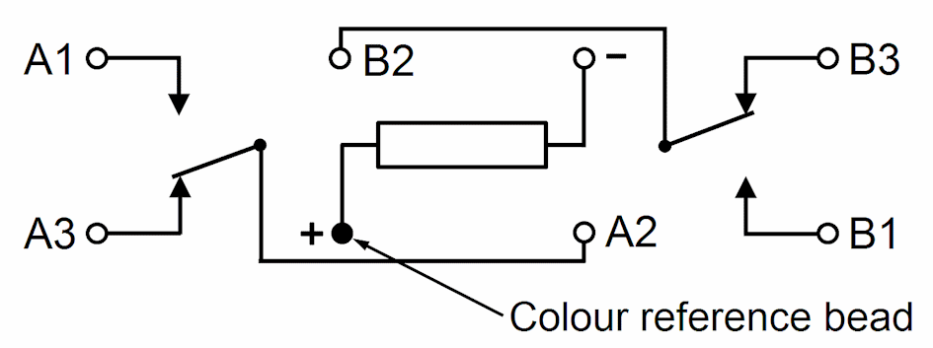
NOTES:
            - As viewed from the terminal side with coil de-energised.
            - Individual terminal designations are for reference purposes only.

MATERIALS AND FINISHES

Case
Copper nickel, hermetically sealed. Tin-lead alloy plating may be used.

Terminals
The lead material and finish shall by type D3, D4, D19, F3, F4 or F19 in accordance with the requirements of ESCC Basic Specification No. 23500.

REQUIREMENTS

GENERAL
The complete requirements for procurement of the components specified herein are as stated in this specification and the ESCC Generic Specification. Permitted deviations from the Generic Specification, applicable to this specification only, are listed below.
Permitted deviations from the Generic Specification and this Detail Specification, formally agreed with specific Manufacturers on the basis that the alternative requirements are equivalent to the ESCC requirement and do not affect the component’s reliability, are listed in the appendices attached to this specification.

Deviations from the Generic Specification
None.

MARKING
The marking shall be in accordance with the requirements of ESCC Basic Specification No. 21700 and as follows.
The information to be marked on the component shall be:
          - The ESCC qualified components symbol (for ESCC qualified components only).
          - The ESCC Component Number (see Para. 1.4.1).
          - Traceability information.

TERMINAL STRENGTH
The terminals of all Variants are defined as rigid.
The test conditions for Terminal Strength, tested as specified in the ESCC Generic Specification, shall be as follows:
          - Pull Test:
- Applied Force: 15N

ELECTRICAL MEASUREMENTS AT ROOM, HIGH AND LOW TEMPERATURES
Electrical measurements shall be performed at room, high and low temperatures.

Room Temperature Electrical Measurements
The measurements shall be performed at T_{amb} = +22 ±3°C.
Characteristics | Symbols | Test Method and Conditions | Rated Coil Voltage  (Vdc) | Limits |  | Units
 |  |  |  | Min | Max
Pick-up Voltage | U_{C} | ESCC No. 3601 |  |  |  | V
 |  |  | 26.5 | - | 13.5
 |  |  | 12 | - | 6.8
Drop-out Voltage | U_{D} | ESCC No. 3601 |  |  |  | V
 |  |  | 26.5 | 1.5 | 6.5
 |  |  | 12 | 0.7 | 3.5
Operate Time | t_{C} | ESCC No. 3601 | All | - | 4 | ms
Release Time | t_{D} | ESCC No. 3601 | All | - | 4 | ms
Bounce Time | t_{B} | ESCC No. 3601 | All | - | 2 | ms
Insulation Resistance | R_{I} | ESCC No. 3601  V_{TEST} = 100Vdc | All | 10 | - | GΩ
Voltage Proof  (Test Voltage) | VP | ESCC No. 3601  Maximum Leakage Current I_{LVP} = 1mA | All | 1000  (Note 1) | - | Vrms
 |  |  |  | 500  (Note 2) | -
Voltage Proof Leakage Current | I_{LVP} | ESCC No. 3601  Note 3 | All | - | 1 | mA
Contact Voltage Drop | V_{D} | ESCC No. 3601  I_{TEST} = 100mA max | All | - | 0.05 x I_{TEST} | V
Coil Resistance | R_{B} | ESCC No. 3601 |  |  |  | Ω
 |  | Coil resistance = 900Ω | 26.5 | 810 | 990
 |  | Coil resistance = 700Ω | 26.5 | 630 | 770
 |  | Coil resistance = 190Ω | 12 | 170 | 210
 |  | Coil resistance = 150Ω | 12 | 135 | 165
NOTES:
            - Points of application (1000V):
- Between terminals (except coil) and case, coil de-energised.
- Between terminals (except coil) and case, coil energised with Rated Coil Voltage.
- Between coil and other terminals.
- Between switching circuits, coil de-energised.
- Between switching circuits, coil energised with Rated Coil Voltage.
            - Points of application (500V):
- Between coil and case.
- Between open contacts, coil de-energised.
- Between open contacts, coil energised with Rated Coil Voltage.
            - Measured during Voltage Proof test.

High and Low Temperatures Electrical Measurements
Characteristics | Symbols | Test Method and Conditions | Rated Coil Voltage  (Vdc) | Limits |  | Units
 |  |  |  | Min | Max | Units
Pick-up Voltage | U_{C} | ESCC No. 3601  T_{amb} = +125(+0 -5)°C and -65 (+5 -0)°C |  |  |  | V
Pick-up Voltage | U_{C} | ESCC No. 3601  T_{amb} = +125(+0 -5)°C and -65 (+5 -0)°C | 26.5 | - | 19.8 | V
Pick-up Voltage | U_{C} | ESCC No. 3601  T_{amb} = +125(+0 -5)°C and -65 (+5 -0)°C | 12 | - | 9.9 | V
Drop-out Voltage | U_{D} | ESCC No. 3601  T_{amb} = +125(+0 -5)°C and -65 (+5 -0)°C |  |  |  | V
Drop-out Voltage | U_{D} | ESCC No. 3601  T_{amb} = +125(+0 -5)°C and -65 (+5 -0)°C | 26.5 | 1 | 14 | V
Drop-out Voltage | U_{D} | ESCC No. 3601  T_{amb} = +125(+0 -5)°C and -65 (+5 -0)°C | 12 | 0.6 | 6.5 | V
Operate Time | t_{C} | ESCC No. 3601  T_{amb} = +125 (+0 -5)°C and -65 (+5 -0)°C | All | - | 4 | ms
Release Time | t_{D} | ESCC No. 3601  T_{amb} = +125 (+0 -5)°C and -65 (+5 -0)°C | All | - | 4 | ms
Bounce Time | t_{B} | ESCC No. 3601  T_{amb} = +125 (+0 -5)°C and -65 (+5 -0)°C | All | - | 2 | ms
Insulation Resistance | R_{I} | ESCC No. 3601  T_{amb} = +125 (+0 -5)°C  V_{TEST} = 100Vdc | All | 100 | - | MΩ
Contact Voltage Drop | V_{D} | ESCC No. 3601  T_{amb} = +125 (+0 -5)°C and -65 (+5 -0)°C  I_{TEST} = 100mA max | All | - | 0.05 x I_{TEST} | V

PARAMETER DRIFT VALUES
Parameter Drift Values shall be measured as specified in the ESCC Generic Specification.
Unless otherwise specified, the measurements shall be performed at T_{amb} = +22 ±3°C.
The test methods and test conditions shall be as per the corresponding test defined in Para. 2.4.1 Room Temperature Electrical Measurements.
The corresponding absolute limit values for each characteristic shall not be exceeded.
Characteristics | Symbols | Limits |  |  | Units
Characteristics | Symbols | Drift Value  Δ | Absolute |  | Units
Characteristics | Symbols | Drift Value  Δ | Min | Max | Units
Pick-up Voltage | U_{C} | Note 1 | Note 2 | Note 2 | V
Drop-out Voltage | U_{D} | Note 1 | Note 2 | Note 2 | V
NOTES:
            - Drift Value (Δ) limits are not specified. Drift Values shall be recorded for information purposes only.
            - The limit specified in Para. 2.4.1 shall apply.

INTERMEDIATE AND END-POINT ELECTRICAL MEASUREMENTS
Unless otherwise specified, the measurements shall be performed at T_{amb} = +22 ±3°C.
Unless otherwise specified the test methods and test conditions shall be as per the corresponding test defined in Para. 2.4.1 Room Temperature Electrical Measurements.
Test Reference per ESCC No. 3601 | Characteristics | Symbols | Limits |  |  | Units
Test Reference per ESCC No. 3601 | Characteristics | Symbols | Min |  | Max | Units
Thermal Shock | During 5th Cycle
Thermal Shock | Pick-up Voltage | U_{C} | Note 2 |  |  | V
Thermal Shock | Drop-out Voltage | U_{D} | Note 2 |  |  | V
Thermal Shock | Operate Time | t_{C} | Note 2 |  |  | ms
Thermal Shock | Release Time | t_{D} | Note 2 |  |  | ms
Thermal Shock | Final Measurements
Thermal Shock | Voltage Proof | VP | Note 3 |  |  | Vrms
Thermal Shock | Voltage Proof Leakage Current | I_{LVP} | Note 3 |  |  | mA
Low Level Sine Vibration | Final Measurements
Low Level Sine Vibration | Pick-up Voltage | U_{C} | Note 3 |  |  | V
Low Level Sine Vibration | Pick-up Voltage Drift | ΔU_{C}/U_{C} | Note 1 |  |  | %
Low Level Sine Vibration | Drop-out Voltage | U_{D} | Note 3 |  |  | V
Low Level Sine Vibration | Drop-out Voltage Drift | ΔU_{D}/U_{D} | Note 1 |  |  | %
Random Vibration | Final Measurements
 | Pick-up Voltage | U_{C} | Note 3 |  |  | V
 | Pick-up Voltage Drift | ΔU_{C}/U_{C} | Note 1 |  |  | %
 | Drop-out Voltage | U_{D} | Note 3 |  |  | V
 | Drop-out Voltage Drift | ΔU_{D}/U_{D} | Note 1 |  |  | %
High Level Sine Vibration | Final Measurements
High Level Sine Vibration | Pick-up Voltage | U_{C} | Note 3 |  |  | V
High Level Sine Vibration | Pick-up Voltage Drift | ΔU_{C}/U_{C} | Note 1 |  |  | %
High Level Sine Vibration | Drop-out Voltage | U_{D} | Note 3 |  |  | V
High Level Sine Vibration | Drop-out Voltage Drift | ΔU_{D}/U_{D} | Note 1 |  |  | %
Low Level Mechanical Shock | Final Measurements
Low Level Mechanical Shock | Contact Voltage Drop | V_{D} | Note 3 |  |  | V
Low Level Mechanical Shock | Pick-up Voltage | U_{C} | Note 3 |  |  | V
Low Level Mechanical Shock | Pick-up Voltage Drift | ΔU_{C}/U_{C} | Note 1 |  |  | %
Low Level Mechanical Shock | Drop-out Voltage | U_{D} | Note 3 |  |  | V
Low Level Mechanical Shock | Drop-out Voltage Drift | ΔU_{D}/U_{D} | Note 1 |  |  | %
Low Level Mechanical Shock | Voltage Proof | VP | Note 3 |  |  | Vrms
Low Level Mechanical Shock | Voltage Proof Leakage Current | I_{LVP} | Note 3 |  |  | mA
High Level Mechanical Shock | Final Measurements
High Level Mechanical Shock | Contact Voltage Drop | V_{D} | Note 3 |  |  | V
High Level Mechanical Shock | Pick-up Voltage | U_{C} | Note 3 |  |  | V
High Level Mechanical Shock | Pick-up Voltage Drift | ΔU_{C}/U_{C} | Note 1 |  |  | %
High Level Mechanical Shock | Drop-out Voltage | U_{D} | Note 3 |  |  | V
High Level Mechanical Shock | Drop-out Voltage Drift | ΔU_{D}/U_{D} | Note 1 |  |  | %
High Level Mechanical Shock | Voltage Proof | VP | Note 3 |  |  | Vrms
High Level Mechanical Shock | Voltage Proof Leakage Current | I_{LVP} | Note 3 |  |  | mA
Resistance to Soldering Heat | Final Measurements
Resistance to Soldering Heat | Insulation Resistance | R_{I} | Note 3 |  |  | GΩ
Resistance to Soldering Heat | Contact Voltage Drop | V_{D} | Note 3 |  |  | V
Resistance to Soldering Heat | Pick-up Voltage | U_{C} | Note 3 |  |  | V
Resistance to Soldering Heat | Drop-out Voltage | U_{D} | Note 3 |  |  | V
Resistance to Soldering Heat | Coil Resistance | R_{B} | Note 3 |  |  | Ω
Low Level Life | Final Measurements
 | Contact Voltage Drop | V_{D} | - | 0.1 x I_{TEST} |  | V
 | Insulation Resistance | R_{I} | 5000 | - |  | MΩ
 | Voltage Proof | VP | Note 3 |  |  | Vrms
 | Voltage Proof Leakage Current | I_{LVP} | Note 3 |  |  | mA
 | Pick-up Voltage | U_{C} | Note 3 |  |  | V
 | Pick-up Voltage Drift | ΔU_{C}/U_{C} | Note 1 |  |  | %
 | Drop-out Voltage | U_{D} | Note 3 |  |  | V
 | Drop-out Voltage Drift | ΔU_{D}/U_{D} | Note 1 |  |  | %
 | Operate Time | t_{C} | Note 3 |  |  | ms
 | Release Time | t_{D} | Note 3 |  |  | ms
 | Bounce Time | t_{B} | Note 3 |  |  | ms
 | Coil Resistance | R_{B} | Note 3 |  |  | Ω
Resistive Life | During Monitoring
Resistive Life | Contact Voltage Drop | V_{D} | - |  | 2.8 | V
Resistive Life | Final Measurements
Resistive Life | Contact Voltage Drop | V_{D} | - |  | 0.1 x I_{TEST} | V
Resistive Life | Insulation Resistance | R_{I} | 5000 |  | - | MΩ
Resistive Life | Voltage Proof | VP | Note 3 |  |  | Vrms
Resistive Life | Voltage Proof Leakage Current | I_{LVP} | Note 3 |  |  | mA
Resistive Life | Pick-up Voltage | U_{C} | Note 3 |  |  | V
Resistive Life | Pick-up Voltage Drift | ΔU_{C}/U_{C} | Note 1 |  |  | %
Resistive Life | Drop-out Voltage | U_{D} | Note 3 |  |  | V
Resistive Life | Drop-out Voltage Drift | ΔU_{D}/U_{D} | Note 1 |  |  | %
Resistive Life | Operate Time | t_{C} | Note 3 |  |  | ms
Resistive Life | Release Time | t_{D} | Note 3 |  |  | ms
Resistive Life | Bounce Time | t_{B} | Note 3 |  |  | ms
Resistive Life | Coil Resistance | R_{B} | Note 3 |  |  | Ω
Coil Life | During Step 1 of each Cycle
 | Contact Voltage Drop | V_{D} | Note 3 |  |  | V
 | Coil Resistance | R_{B} | Note 3 |  |  | Ω
 | During Step 3 of 1st Cycle
 | Contact Voltage Drop | V_{D} | Note 2 |  |  | V
 | Operate Time | t_{C} | Note 2 |  |  | ms
 | Release Time | t_{D} | Note 2 |  |  | ms
 | During Steps 4 & 5 of 4th Cycle
 | Pick-up Voltage | U_{C} | Note 2 |  |  | V
 | Drop-out Voltage | U_{D} | Note 2 |  |  | V
 | Final Measurements
 | Voltage Proof | VP | Note 3 |  |  | Vrms
 | Voltage Proof Leakage Current | I_{LVP} | Note 3 |  |  | mA
 | Insulation Resistance | R_{I} | Note 3 |  |  | GΩ
 | Contact Voltage Drop | V_{D} | Note 3 |  |  | V
 | Coil Resistance | R_{B} | Note 3 |  |  | Ω
 | Operate Time | t_{C} | Note 3 |  |  | ms
 | Release Time | t_{D} | Note 3 |  |  | ms
 | Bounce Time | t_{B} | Note 3 |  |  | ms
Intermediate Current | During Monitoring
Intermediate Current | Contact Voltage Drop | V_{D} | - |  | 300 | mV
Intermediate Current | Final Measurements
Intermediate Current | Insulation Resistance | R_{I} | 5000 |  | - | MΩ
Intermediate Current | Voltage Proof | VP | Note 3 |  |  | Vrms
Intermediate Current | Voltage Proof Leakage Current | I_{LVP} | Note 3 |  |  | mA
Intermediate Current | Pick-up Voltage | U_{C} | Note 3 |  |  | V
Intermediate Current | Pick-up Voltage Drift | ΔU_{C}/U_{C} | Note 1 |  |  | %
Intermediate Current | Drop-out Voltage | U_{D} | Note 3 |  |  | V
Intermediate Current | Drop-out Voltage Drift | ΔU_{D}/U_{D} | Note 1 |  |  | %
Intermediate Current | Operate Time | t_{C} | Note 3 |  |  | ms
Intermediate Current | Release Time | t_{D} | Note 3 |  |  | ms
Intermediate Current | Bounce Time | t_{B} | Note 3 |  |  | ms
Intermediate Current | Coil Resistance | R_{B} | Note 3 |  |  | Ω
Intermediate Current | Contact Voltage Drop | V_{D} | - |  | 0.1 x I_{TEST} | V
Overload | During Monitoring
 | Contact Voltage Drop | V_{D} | - |  | 1.4 | V
 | Final Measurements
 | Contact Voltage Drop | V_{D} | - |  | 0.1 x I_{TEST} | V
 | Insulation Resistance | R_{I} | 5000 |  | - | MΩ
 | Voltage Proof | VP | Note 3 |  |  | Vrms
 | Voltage Proof Leakage Current | I_{LVP} | Note 3 |  |  | mA
 | Pick-up Voltage | U_{C} | Note 3 |  |  | V
 | Pick-up Voltage Drift | ΔU_{C}/U_{C} | Note 1 |  |  | %
 | Drop-out Voltage | U_{D} | Note 3 |  |  | V
 | Drop-out Voltage Drift | ΔU_{D}/U_{D} | Note 1 |  |  | %
 | Operate Time | t_{E} | Note 3 |  |  | ms
 | Release Time | t_{D} | Note 3 |  |  | ms
 | Bounce Time | t_{B} | Note 3 |  |  | ms
 | Coil Resistance | R_{B} | Note 3 |  |  | Ω
NOTES:
            - Parameter Drift shall be calculated referenced to the measurement immediately prior to the test in question. An additional initial measurement may be performed prior to the test in question if considered necessary. Drift limits are not specified. Drift Values shall be recorded for information purposes only.
            - The limits specified in Para. 2.4.2, as applicable to the same test temperature, shall apply.
            - The limits specified in Para. 2.4.1 shall apply.

RUN-IN CONDITIONS
The test conditions for Run-in, tested as specified in the ESCC Generic Specification, shall be as follows:
          - Test Temperature: +22 ±3°C.

APPENDIX A
AGREED DEVIATIONS FOR LEACH INTERNATIONAL EUROPE (F)
ITEMS AFFECTED | DESCRIPTION OF DEVIATIONS
Para. 2.1.1 Deviations from the Generic Specification:  Screening Tests - Chart F3 | Para. 8.6 Vibration Scan:  - The vibration amplitude and frequency range shall be:  - 30g (peak); 10 to 2000Hz  - 20g (peak); 2000 to 3000Hz
Para. 2.1.1 Deviations from the Generic Specification:  Lot Validation Testing - Chart F4 | Para. 8.8.1 Low Level Sine Vibration:  - The vibration amplitude and frequency range shall be:  - 30g (peak); 10 to 2000Hz  - 20g (peak); 2000 to 3000Hz

