
Page 1 of 20

CONTACTS, POWER, CRIMP-TYPE, SOLDER-TYPE AND PCB-TYPE FOR 3401/001 CONNECTORS AND MALE/FEMALE-TYPE FOR 3401/080 CONNECTOR SAVERS

ESCC Detail Specification No. 3401/040

Issue 7 Draft A+ | October 2023



Document Custodian: European Space Agency – see https://escies.org

Legal Disclaimer and Copyright
European Space Agency, Copyright © 2023. All rights reserved.
The European Space Agency disclaims any liability or responsibility, to any person or entity, with respect to any loss or damage caused, or alleged to be caused, directly or indirectly by the use and application of this ESCC publication.
This publication, without the prior permission of the European Space Agency and provided that it is not used for a commercial purpose, may be:
- copied in whole, in any medium, without alteration or modification.
- copied in part, in any medium, provided that the ESCC document identification, comprising the ESCC symbol, document number and document issue, is removed.

DOCUMENTATION CHANGE NOTICE
(Refer to https://escies.org for ESCC DCR content)
DCR No. | CHANGE DESCRIPTION
TBA | Specification upissued to incorporate changes per DCR.
Draft 7A 11/10/23  Draft 7A+ 12/10/23  S.Thacker | Mark-up spec that implements changes from Positronic per DCRTBA (see Table 1(a), Figure 2(b), and Paras 4.2.4, 4.3.3, 4.3.9, 4.3.12, 4.3.13; see blue highlights)

TABLE OF CONTENTS
1 General 6
1.1 SCOPE 6
1.2 TYPE VARIANTS 6
1.3 MAXIMUM RATINGS 6
1.4 PARAMETER DERATING INFORMATION (FIGURE 1) 6
1.5 PHYSICAL DIMENSIONS 6
2 APPLICABLE DOCUMENTS 14
3 TERMS, DEFINITIONS, ABBREVIATIONS, SYMBOLS AND UNITS 14
4 REQUIREMENTS 14
4.1 GENERAL 14
4.2 DEVIATIONS FROM GENERIC SPECIFICATION 14
4.2.1 Deviations from Special In-Process Controls 14
4.2.2 Deviations from Final Production Tests (Chart II) 14
4.2.3 Deviations from Burn-in and Electrical Measurements (Chart III) 14
4.2.4 Deviations from Qualification Tests (Chart IV) 14
4.2.5 Deviations from Lot Acceptance Tests (Chart V) 14
4.3 MECHANICAL REQUIREMENTS 15
4.3.1 Dimension Check 15
4.3.2 Weight 15
4.3.3 Contact Capability (Variants 02, 04, 06, 08, 10, 12, 14, 16, 17, 19, 21) 15
4.3.4 Contact Retention (in Insert) 15
4.3.5 Mating and Unmating Forces 15
4.3.6 Insert Retention (in Shell) 15
4.3.7 Jackscrew Retention 15
4.3.8 Contact Insertion and Withdrawal Forces 15
4.3.9 Engagement and Separation Forces (Variants 02, 04, 06, 08, 10, 12, 14, 16, 17, 19, 21) 15
4.3.10 Oversize Pin Exclusion 15
4.3.11 Probe Damage 15
4.3.12 Solderability 16
4.3.13 Joint Strength (Variants 07 to 12, 18 to 21) 16
4.4 MATERIALS AND FINISHES 16
4.4.1 Contact Body 16
4.4.2 Magnetism Level 16
4.5 MARKING 16
4.5.1 General 16
4.5.2 The ESCC Component Number 17
4.5.3 Traceability Information 17
4.6 ELECTRICAL MEASUREMENTS 17
4.6.1 Electrical Measurements at Room Temperature 17
4.6.2 Electrical Measurements at High and Low Temperatures (Table 3) 17
4.6.3 Circuits for Electrical Measurements 17
4.7 SCREENING TESTS (TABLES 4 AND 5) 17
4.8 ENVIRONMENTAL AND ENDURANCE TESTS 17
4.8.1 Measurements and Inspections on Completion of Environmental Tests 17
4.8.2 Measurements and Inspections at Intermediate Points During Endurance Tests 17
4.8.3 Measurements and Inspections on Completion of Endurance Tests 18
4.8.4 Conditions for Operating Life Test (Part of Endurance Testing) 18
4.8.5 Electrical Circuit for Operating Life Test 18
4.8.6 Conditions for High Temperature Storage Test (Part of Endurance Testing) 18

General

SCOPE
This specification details the ratings, physical and electrical characteristics, test and inspection data for Contacts, Power, Crimp-type, Solder-type and PCB-type for 3401/001 Connectors and Male/Female-type for 3401/080 Connector Savers.
The specification shall be read in conjunction with:
- ESCC Generic Specification No. 3401, Connectors, Electrical, Non-Filtered, Circular and Rectangular.
- ESCC Detail Specification No. 3401/001, Connectors, Electrical, Rectangular, Non-removable Solder bucket, PCB and Wire-wrap Contacts and Removable Coaxial and Power Contacts, Based on Type D*M.
- ESCC Detail Specification No. 3401/080, Connector Savers, Electrical Rectangular, Miniature, Non-Removable Signal Contacts, and Removable Coaxial and Power Contacts.
the requirements of which are supplemented herein.
These contacts are not mounted in the connectors and are therefore delivered separately.

TYPE VARIANTS
Variants of the basic type contacts specified herein, which are covered by this specification, together with their mechanical characteristics, are given in Table 1(a).

MAXIMUM RATINGS
The maximum ratings, which shall not be exceeded at any time during use or storage, applicable to the contacts specified herein, are scheduled in Table 1(b).

PARAMETER DERATING INFORMATION (FIGURE 1)
The derating information applicable to the contacts specified herein is shown in Figure 1.

PHYSICAL DIMENSIONS
The physical dimensions of the contacts specified herein are shown in Figure 2.
TABLE 1(a) - TYPE VARIANTS
Variant | Type | Max. Weight  (g) | Accepted Cable (AWG) | Rear End
01 | Male | 2.2 | 8 | Solder Bucket
02 | Female | 1.9 | 8 | Solder Bucket
03 | Male | 2.15 | 12 | Solder Bucket
04 | Female | 1.19 | 12 | Solder Bucket
05 | Male | 2.05 | 16 | Solder Bucket
06 | Female | 1.75 | 16 | Solder Bucket
07 | Male | 2.8 | 8 | Crimp Barrel
08 | Female | 2.45 | 8 | Crimp Barrel
09 | Male | 2.25 | 10 | Crimp Barrel
10 | Female | 2 | 10 | Crimp Barrel
11 | Male | 2 | 12-14 | Crimp Barrel
12 | Female | 1.65 | 12-14 | Crimp Barrel
13 | Male | 2.75 | N.A. | Straight PCB
14 | Female | 1.75 | N.A. | Straight PCB
15 | Male | 2.65 | N.A. | 90º PCB (Note 1)
16 | Female | 2.45 | N.A. | 90º PCB (Note 1)
17 | Male/Female | 2.15 | N.A. | N.A.
18 | Male | 2 | 16 | Crimp Barrel
19 | Female | 1.66 | 16 | Crimp Barrel
20 | Male | 2.34 | 12 | Crimp Barrel
21 | Female | 1.98 | 12 | Crimp Barrel
NOTES:
            - Applicable to shell sizes E, A, B and C only.
TABLE 1(b) - MAXIMUM RATINGS
No. | Characteristics | Symbol | Maximum Rating | Unit | Remarks
1 | Rated Current | I_{CR} | 40 | A | Note 1, Note 2
2 | Operating Temperature Range | T_{op} | -55 to +125 | °C | T_{amb}
3 | Storage Temperature Range | T_{stg} | -55 to +125 | °C
4 | Soldering Temperature | T_{sol} | +260 | °C | Note 3
NOTES:
            - This is limited either by the current carrying capability of the cable to which the contact is fitted or the derating.
            - At T_{amb} ≤ +60 °C. For derating at T_{amb} > +60 °C, see Figure 1.
            - 10 seconds maximum.
FIGURE 1 - PARAMETER DERATING INFORMATION
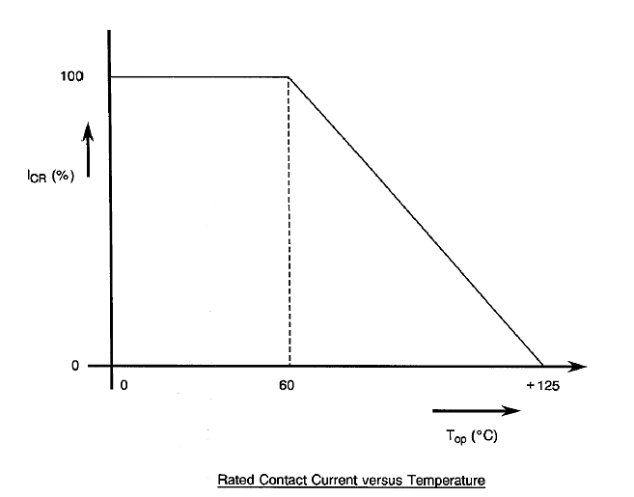

FIGURE 2 - PHYSICAL DIMENSIONS
FIGURE 2(a) - SOLDER TYPE
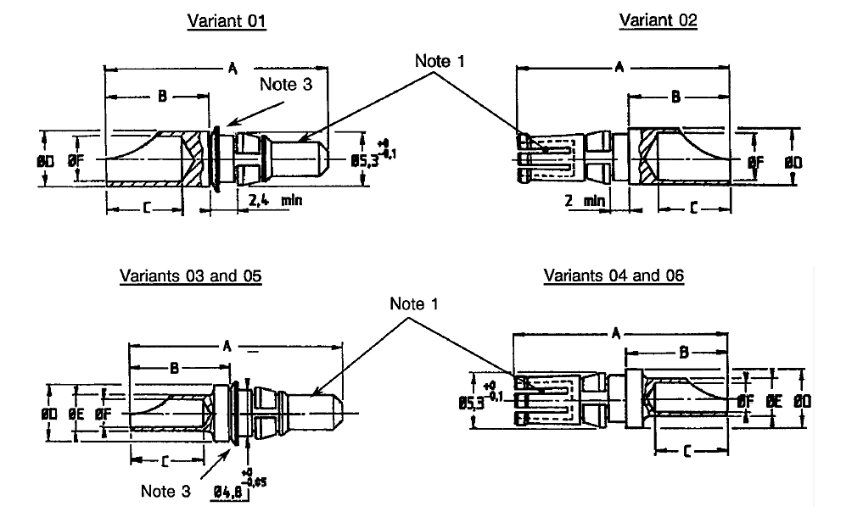
Variant  (Note 2) | Type | AWG | A  max. | B  max. | C  max. | ØD  max. | ØE  max. | ØF  max.
01 | Male | 8 | 22.1 | 10.8 | 8.13 | 5.66 | - | 4.9
02 | Female | 8 | 21.8 | 10.8 | 8.13 | 5.66 | - | 4.9
03 | Male | 12 | 22.1 | 10.8 | 8.13 | 5.66 | 3.76 | 3
04 | Female | 12 | 21.8 | 10.8 | 8.13 | 5.66 | 3.76 | 3
05 | Male | 16 | 22.1 | 10.8 | 8.13 | 5.66 | 2.67 | 1.9
06 | Female | 16 | 21.8 | 10.8 | 8.13 | 5.66 | 2.67 | 1.9
NOTES:
            - Measurement point for plating thickness.
            - All dimensions are in millimetres.
            - Washer is optional.
FIGURE 2(b) - CRIMP TYPE
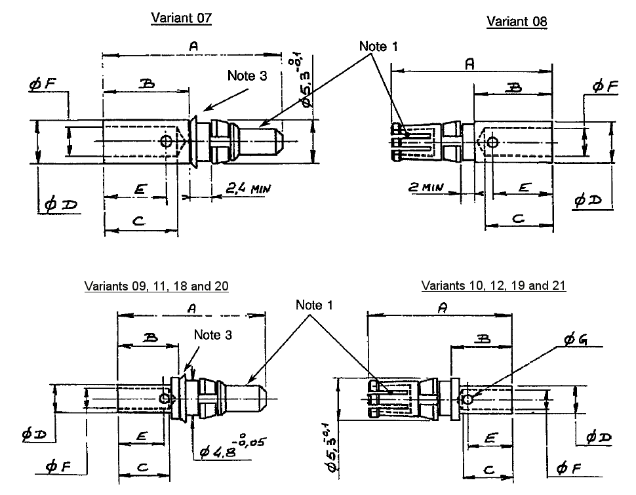
Variant  (Note 2) | Type | AWG | A  max. | B  max. | C  min. | ØD  max. | E  ref. | ØF  min. | ØG  ref.
07 | Male | 8 | 24.7 | 12.9 | 11.1 | 5.8 | 10 | 4.2 | 1.7
08 | Female | 8 | 24.6 | 12.9 | 11.1 | 5.8 | 10 | 4.2 | 1.7
09 | Male | 10 | 21.6 | 10 | 8.4 | 4.7 | 7.5 | 3.25 | 1.3
10 | Female | 10 | 21.5 | 10 | 8.4 | 4.7 | 7.5 | 3.25 | 1.3
11 | Male | 12/14 | 19.3 | 7.7 | 6.35 | 3.8 | 6 | 2.5 | 1
12 | Female | 12/14 | 19.2 | 7.7 | 6.35 | 3.8 | 6 | 2.5 | 1
18 | Male | 16 | 22.8 | 11.7 | 8.6 | 2.7 | 7.7 | 1.65 | 1
19 | Female | 16 | 22.2 | 10.5 | 8.6 | 2.7 | 7.7 | 1.65 | 1
20 | Male | 12 | 22.8 | 11.7 | 8.6 | 3.9 | 7.7 | 2.5 | 1
21 | Female | 12 | 22.2 | 10.5 | 8.6 | 3.9 | 7.7 | 2.5 | 1
NOTES:
            - Measurement point for plating thickness.
            - All dimensions are in millimetres.
            - Washer is optional.
FIGURE 2(c) - STRAIGHT AND 90° PCB TYPES
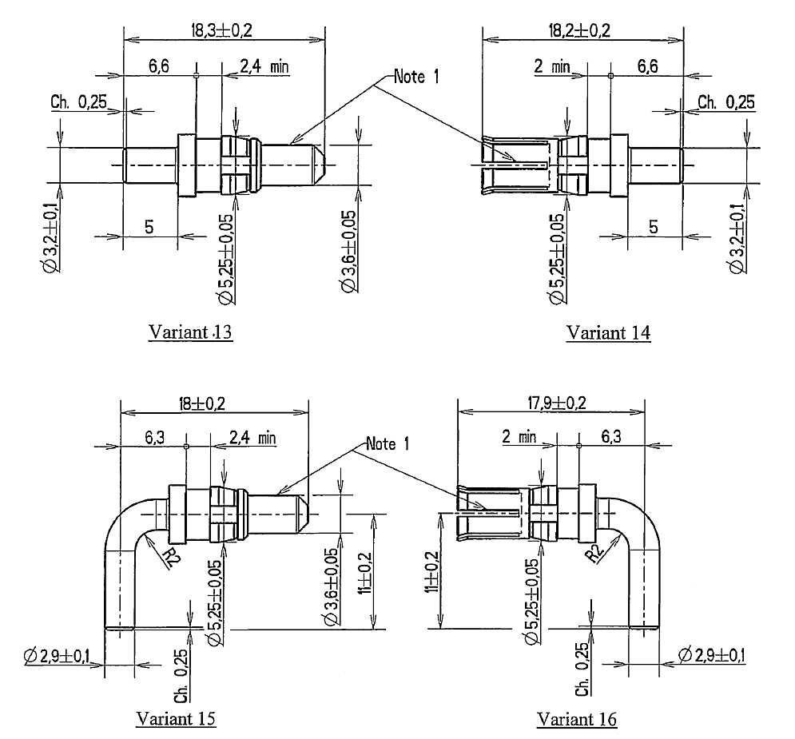
NOTES:
            - Measurement point for plating thickness.
            - All dimensions are in millimetres.
            - Variants 15 and 16 are applicable to shell sizes E, A, B and C only.
FIGURE 2(d) - SAVERS TYPE
variant 17
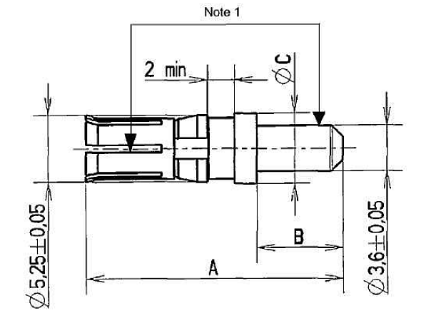
Variant  (Note 2) | Type | A  Max. | B  Min. | ØC  Max.
17 | Saver | 20.2 | 6.5 | 5.66
NOTES:
            - Measurement point for plating thickness.
            - All dimensions are in millimetres.
FIGURE 2(e) - PROTRUSION AND RECESS
MAXIMUM PROTRUSION OF CONTACTS RELATIVE TO REAR OF SHELL FLANGE
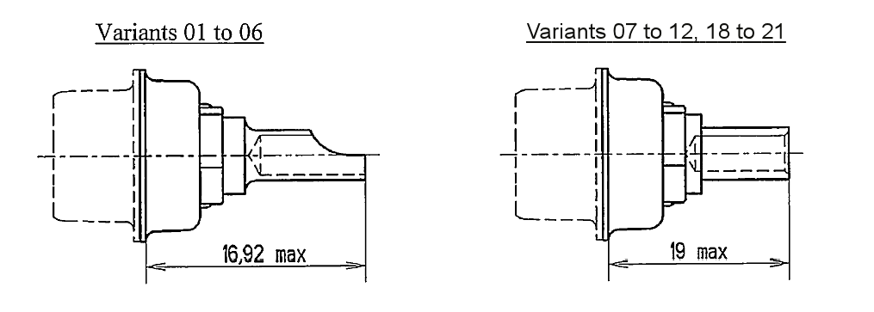
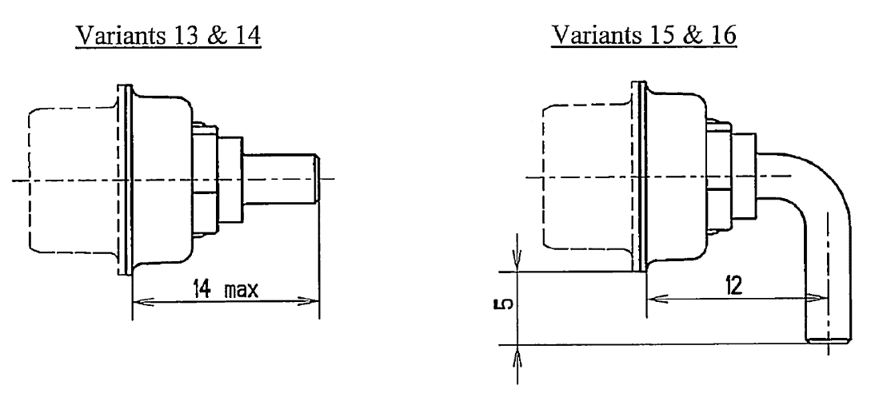
MAXIMUM RECESS OF CONTACTS RELATIVE TO FRONT OF SHELL
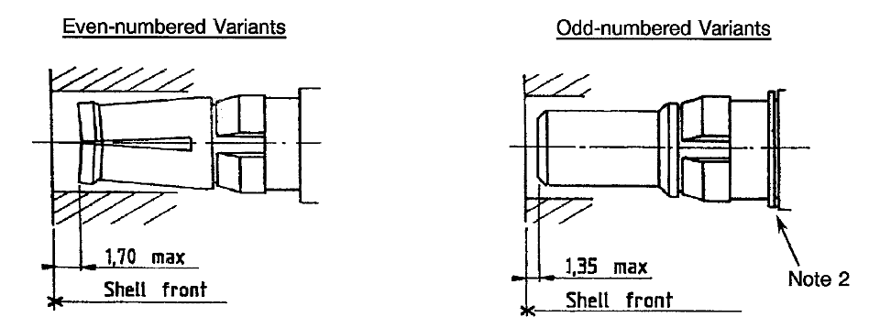
NOTES:
            - All dimensions are in millimetres.
            - The washer is optional (no change of the insert: the assembling dimension is compensated on the contact).

APPLICABLE DOCUMENTS
The following documents form part of this specification and shall be read in conjunction with it:
          - ESCC Generic Specification No. 3401 for Connectors, Electrical, Non-Filtered, Circular and Rectangular.
          - ESCC Detail Specification No. 3401/001, Connectors, Electrical, Rectangular, Non-removable Solder Bucket, PCB and Wire-wrap Contacts and Removable Coaxial and Power Contacts, Based on Type D*M.
          - ESCC Detail Specification No. 3401/080, Connector Savers, Electrical, Rectangular, Miniature, Non-Removable Signal Contacts, And Removable Coaxial and Power Contacts.

TERMS, DEFINITIONS, ABBREVIATIONS, SYMBOLS AND UNITS
For the purpose of this specification, the terms, definitions, abbreviations, symbols and units specified in ESCC Basic Specification No. 21300 shall apply.

REQUIREMENTS

GENERAL
The complete requirements for procurement of the contacts specified herein are stated in this specification and ESCC Generic Specification No. 3401. Deviations from the Generic Specification, applicable to this specification only, are detailed in Para. 4.2.
Deviations from the applicable Generic Specification and this Detail Specification, formally agreed with specific Manufacturers on the basis that the alternative requirements are equivalent to the ESCC requirements and do not affect the components’ reliability, are listed in the appendices attached to this specification.

DEVIATIONS FROM GENERIC SPECIFICATION

Deviations from Special In-Process Controls
None.

Deviations from Final Production Tests (Chart II)
None.

Deviations from Burn-in and Electrical Measurements (Chart III)
Chart III is not applicable.

Deviations from Qualification Tests (Chart IV)
          - Para. 9.29, Oversize Pin Exclusion: Not applicable.
          - Para. 9.30, Probe Damage: Not applicable.
          - Para. 9.31, Solderability: Not applicable to Variants 07 to 12, 17 and 18 to 21.
          - Para. 9.15, Joint Strength: The test shall be performed as specified in Para. 4.3.13.

Deviations from Lot Acceptance Tests (Chart V)
The deviations as listed in Para. 4.2.4 shall apply.

MECHANICAL REQUIREMENTS

Dimension Check
The dimensions of the contacts specified herein shall be verified in accordance with the requirements set out in Para. 9.6 of ESCC Generic Specification No. 3401 and they shall conform to those shown in Figure 2 of this specification. Overall dimensions are specified with compatible inserts in ESCC Detail Specification No. 3401/001 and 3401/080.

Weight
The maximum weight of the contacts specified herein shall be as given in Table 1(a).

Contact Capability (Variants 02, 04, 06, 08, 10, 12, 14, 16, 17, 19, 21)
For the purpose of this test, the pick-up and drop weights shall be as follows:
 | Pick-Up Weight | Drop Weight
Weight (g) | 85 | 567
Pin diameter (mm) | 3.581 (+0.0025, -0) | 3.632 (+0, -0.0025)
Insertion Depth (mm) | 3.17 | 3.17

Contact Retention (in Insert)
Contact retention within the insert shall be 40.86N. There shall be no displacement of the contact in excess of 0.3mm.

Mating and Unmating Forces
As specified in ESCC Detail Specification No. 3401/001.

Insert Retention (in Shell)
As specified in ESCC Detail Specification No. 3401/001.

Jackscrew Retention
Not applicable.

Contact Insertion and Withdrawal Forces
The contact insertion and withdrawal forces shall be 65N maximum.

Engagement and Separation Forces (Variants 02, 04, 06, 08, 10, 12, 14, 16, 17, 19, 21)
The engagement and separation forces of the female contacts shall be as specified hereunder.
 | Maximum Diameter Test Pin  3.632 (+0, -0.0025) mm | Minimum Diameter Test Pin  3.581 (+0.0025, -0) mm
Engagement Force (N) | 6.87 max | 0.83 min
Separation Force (N) | 5.56 max | 0.83 min

Oversize Pin Exclusion
Not applicable.

Probe Damage
Not applicable.

Solderability
Not applicable to Variants 07 to 12, 17 and 18 to 21. For all other Variants soldering iron bit size 7.5mm shall be used.

Joint Strength (Variants 07 to 12, 18 to 21)
The contacts shall be crimped to stranded wire of the appropriate size as shown below. The contact and the wire shall be separated from each other, using a tensile strength machine. The values of the force at separation of the contact and wire and the method of failure shall be recorded and shall be in accordance with the following values:
Variant | Wire Size  (AWG) | Minimum Value of Tensile Strength  (N)
07, 08 | 8 | > 500
09, 10 | 10 | > 500
11, 12 | 12 - 14 | > 500
18, 19 | 16 | > 200
20, 21 | 12 | > 500
i.e. “pull-out, “break in crimp”, “break in wire”.

MATERIALS AND FINISHES
The materials and finishes shall be as specified herein. Where a definite material is not specified, a material which will enable the contacts specified herein to meet the performance requirements of this specification shall be used. Acceptance or approval of any constituent material does not guarantee acceptance of the finished product.

Contact Body
The contacts shall be made of copper base alloy selected from raw materials with a minimum of impurities. Gold plating thickness shall be 1.27µm minimum over 1µm minimum of copper.

Magnetism Level
As specified in ESCC Detail Specification No. 3401/001.

MARKING

General
The marking of all components delivered to this specification shall be in accordance with the requirements of ESCC Basic Specification No. 21700 and the following paragraphs. These components being too small to accommodate the marking specified hereafter, the full marking information shall accompany the component in its primary package.
Such marking shall comprise:
          - The ESCC Component Number.
          - Traceability Information.
          - Quantity of Components.

The ESCC Component Number
The ESCC Component Number shall be constituted and marked as follows:
Example: 340104001B
- Detail Specification Number: 3401040
- Type Variant (See Table 1(a)): 01
- Testing Level: B

Traceability Information
Traceability information shall be marked in accordance with ESCC Basic Specification No. 21700.

ELECTRICAL MEASUREMENTS

Electrical Measurements at Room Temperature
The parameters to be measured in respect of electrical characteristics are scheduled in Table 2. Unless otherwise specified these measurements shall be performed at T_{amb} = +22 ±3 ºC.

Electrical Measurements at High and Low Temperatures (Table 3)
Not applicable.

Circuits for Electrical Measurements
Not applicable

SCREENING TESTS (TABLES 4 AND 5)
Not applicable.
TABLE 2 - ELECTRICAL MEASUREMENTS AT ROOM TEMPERATURE
No. | Characteristics | Symbol | ESCC 3401 Test Method | Test Conditions | Limits |  | Unit
 |  |  |  |  | Min | Max | Unit
1 | Low Level Contact Resistance | R_{CL} | Para. 9.1.1.3 | Para. 9.1.1.3 | - | 2.5 | mΩ
2 | Rated Current Contact  Resistance | R_{CR} | Para. 9.1.1.3 | Para. 9.1.1.3 | - | 2 | mΩ
TABLES 3, 4 AND 5
Not applicable.

ENVIRONMENTAL AND ENDURANCE TESTS

Measurements and Inspections on Completion of Environmental Tests
The parameters to be measured and inspections to be performed on completion of environmental tests are scheduled in Table 6. Unless otherwise specified, the measurements shall be performed at T_{amb} = +22 ±3°C.

Measurements and Inspections at Intermediate Points During Endurance Tests
Not applicable.

Measurements and Inspections on Completion of Endurance Tests
The parameters to be measured and inspections to be performed on completion of endurance tests shall be those specified in Table 6. Unless otherwise specified, these measurements shall be performed at T_{amb} = +22 ±3°C.

Conditions for Operating Life Test (Part of Endurance Testing)
Not applicable.

Electrical Circuit for Operating Life Test
Not applicable.

Conditions for High Temperature Storage Test (Part of Endurance Testing)
The requirements for the high temperature storage test are specified in Section 9 of ESCC Generic Specification No. 3401. The conditions for high temperature storage testing shall be the maximum storage temperature specified in Table 1(b) of this specification.
TABLE 6 - MEASUREMENTS AND INSPECTIONS ON COMPLETION OF ENVIRONMENTAL AND ENDURANCE TESTING
No. | ESCC Generic Spec. No. 3401 |  | Measurements and Inspections |  | Symbol | Limits |  | Unit
No. | Environmental and Endurance Tests (1) | Test Methods and Conditions | Identification | Conditions | Symbol | Min | Max | Unit
01 | Wiring | Para. 9.10 | Visual Examination | - | - | - | - | -
 |  |  | Low Level Contact Resistance | Table 2 Item 1 | R_{CL} | - | 2.5 | mΩ
02 | Vibration | Para. 9.11 | ESCC 3401/001 | - | - | - | - | -
03 | Shock or Bump | Para. 9.12 | ESCC 3401/001 | - | - | - | - | -
04 | Climatic Sequence | Para. 9.13 | ESCC 3401/001 | - | - | - | - | -
05 | Seal Test | Para. 9.9 | Not applicable | - | - | - | - | -
06 | Plating Thickness | Para. 9.14 & Para. 4.4.1 of this Spec. | Thickness | Para. 4.4.1 of this spec. | - | Para. 4.4.1 of this spec. |  | -
07 | Joint Strength | Para. 9.15 &  Para. 4.3.13 of this Spec. | Visual Examination | - | - | - | - | -
 |  | Para. 9.15 &  Para. 4.3.13 of this Spec. | Low Level Contact Resistance | Table 2 Item 1 | R_{CL} | - | 2.5 | mΩ
08 | Rapid Change of Temperature | Para. 9.16 | ESCC 3401/001 | - | - | - | - | -
09 | Contact Retention (in Insert) | Para. 9.17 & Para. 4.3.4 of this spec.  Force: 40.86N | Contact Displacement | Para. 4.3.4 of this spec. | - | Para. 4.3.4 of this spec. |  | -
10 | Endurance | Para. 9.18 | Initial Measurement
 |  |  | Low Level Contact Resistance | Table 2 Item 1 | R_{CL} | - | 2.5 | mΩ
 |  |  | Final Inspection
 |  |  | Visual Examination | - | - | - | -
 |  |  | Final Measurement
 |  |  | Low Level Contact Resistance Drift | Table 2 Item 1 | ΔR_{CL} | - | 0.5 | mΩ
11 | Permanence of Marking | Para. 9.19 | As applicable | - | - | - | - | -
12 | Mating/Unmating Forces | Para. 9.20 | ESCC 3401/001 | - | - | - | - | -
13 | High Temperature Storage | Para. 9.21 | Initial
 | High Temperature Storage |  | Low Level Contact Resistance | Table 2 Item 1 | R_{CL} | - | 2.5 | mΩ
 |  |  | Final Inspection
 |  |  | Visual Examination | - | - | - | - | -
 |  |  | Final Measurement
 |  |  | Low Level Contact Resistance Drift | Table 2 Item 1 | ΔR_{CL} | - | 0.5 | mΩ
 |  |  | Rated Current Contact Resistance | Table 2 Item 2 | R_{CR} | - | 2 | mΩ
 |  |  | Contact Retention (in Insert) | Para. 4.3.4 of this spec. | - | Para. 4.3.4 of this spec. |  | -
14 | Corrosion | Para. 9.22 | ESCC 3401/001 | - | - | - | - | -
15 | Insert Retention (in Shell) | Para. 9.23 | ESCC 3401/001 | - | - | - | - | -
16 | Jackscrew Retention | Para. 9.24 | Not applicable | - | - | - | - | -
17 | High Temperature Measurements | Para. 9.25 | ESCC 3401/001 | - | - | - | - | -
18 | Overload Test | Para. 9.26 | Rated Current Contact Resistance | Table 2 item 2 | R_{CR} | - | 2 | mΩ
19 | Maintenance Aging | Para. 9.27 | Final Measurements
 |  |  | Contact Retention  (in Insert) | Para. 4.3.4 of this spec. | - | Para. 4.3.4 of this spec. |  | -
 |  |  | Contact Insertion & Withdrawal Forces | Para. 4.3.8 of this spec. | - | Para. 4.3.8 of this spec. |  | -
20 | Engagement and Separation Forces | Para. 9.28 & para. 4.3.9 of this spec. | Force | - | - | Para. 4.3.9 of this spec. |  | -
21 | Oversize Pin Exclusion | Para. 9.29 & para. 4.3.10 of this spec. | Not applicable | - | - | - | - | -
22 | Probe Damage | Para. 9.30 & para. 4.3.11 of this spec. | Not applicable | - | - | - | - | -
23 | Solderability | Para. 9.31 & para. 4.3.12 of this spec. | Visual Examination | - | - | - | - | -
NOTES:
            - The tests in this table refer to either Chart IV or V and shall be used as applicable.

