

Page 1 of 56
CONNECTORS, ELECTRICAL, RECTANGULAR, NON-REMOVABLE SOLDER BUCKET, PCB AND WIRE-WRAP CONTACTS AND REMOVABLE COAXIAL AND POWER CONTACTS,
BASED ON TYPE D*M
ESCC Detail Specification No. 3401/001

Issue 12 Draft A | October 2023



Document Custodian: European Space Agency – see https://escies.org

Legal Disclaimer and Copyright
European Space Agency, Copyright © 2023. All rights reserved.
The European Space Agency disclaims any liability or responsibility, to any person or entity, with respect to any loss or damage caused, or alleged to be caused, directly or indirectly by the use and application of this ESCC publication.
This publication, without the prior permission of the European Space Agency and provided that it is not used for a commercial purpose, may be:
- copied in whole, in any medium, without alteration or modification.
- copied in part, in any medium, provided that the ESCC document identification, comprising the ESCC symbol, document number and document issue, is removed.

DOCUMENTATION CHANGE NOTICE
(Refer to https://escies.org for ESCC DCR content)
DCR No. | CHANGE DESCRIPTION
1593 TBA | Specification upissued to include changes per DCR.
Draft 12A 11/10/23 S.Thacker | Mark-up spec that implements changes per C&K DCR1593 (see Page 19, yellow highlights) plus changes from Positronic per DCRTBA (see Page 42, Paras. 4.4.1 & 4.5.4.9, blue highlights)

TABLE OF CONTENTS
1 General 6
1.1 SCOPE 6
1.2 RANGE OF COMPONENTS AND COMPONENT TYPE VARIANTS 6
1.3 MAXIMUM RATINGS 6
1.4 PARAMETER DERATING INFORMATION 6
1.5 PHYSICAL DIMENSIONS 6
2 APPLICABLE DOCUMENTS 7
3 TERMS, DEFINITIONS, ABBREVIATIONS, SYMBOLS AND UNITS 7
4 REQUIREMENTS 44
4.1 GENERAL 44
4.2 DEVIATIONS FROM GENERIC SPECIFICATION 44
4.2.1 Deviations from Special In-Process Controls 44
4.2.2 Deviations from Final Production Tests (Chart II) 44
4.2.3 Deviations from Burn-in and Electrical Measurements (Chart III) 44
4.2.4 Deviations from Qualification Tests (Chart IV) 44
4.2.5 Deviations from Lot Acceptance Tests (Chart V) 44
4.3 MECHANICAL REQUIREMENTS 44
4.3.1 Dimension Check 44
4.3.2 Weight 44
4.3.3 Contact Capability 45
4.3.4 Contact Retention (in insert) 45
4.3.5 Mating and Unmating Forces 45
4.3.6 Insert Retention (in Shell) 45
4.3.7 Jackscrew Retention 45
4.3.8 Contact Insertion and Withdrawal Forces 45
4.3.9 Engagement and Separation Forces 45
4.3.10 Oversize Pin Exclusion 46
4.3.11 Probe Damage 46
4.3.12 Solderability 46
4.4 MATERIALS AND FINISHES 46
4.4.1 Shells 46
4.4.2 Inserts 46
4.4.3 Contacts 46
4.4.4 Contact Retaining Clip 47
4.4.5 Guiding and Locking Devices 47
4.4.6 Magnetism Level 47
4.5 MARKING 47
4.5.1 General 47
4.5.2 Contact Position 47
4.5.3 The ESCC Component Number 47
4.5.4 Characteristics 48
4.5.4.1 Series 48
4.5.4.2 Shell Size 48
4.5.4.3 Insert Type 48
4.5.4.4 Mounting 48
4.5.4.5 Contact Arrangement 49
4.5.4.6 Type of Contact 50
4.5.4.7 Magnetism Level 50
4.5.4.8 Contact Termination Code 50
4.5.4.9 Modification Code 50
4.5.5 Traceability Information 50
4.6 ELECTRICAL MEASUREMENTS 50
4.6.1 Electrical Measurements at Room Temperature 50
4.6.2 Electrical Measurements at High and Low Temperatures 50
4.6.3 Circuit for Electrical Measurements (Figure 4) 51
4.7 BURN-IN AND ELECTRICAL MEASUREMENTS 51
4.8 ENVIRONMENTAL AND ENDURANCE TESTS (CHARTS IV AND V OF ESCC GENERIC SPECIFICATION No. 3401) 51
4.8.1 Measurements and Inspections on Completion of Environmental Tests 51
4.8.2 Measurements and Inspections at Intermediate Points during Endurance Tests 51
4.8.3 Measurements and Inspections on Completion of Endurance Tests 51
4.8.4 Conditions for Operating Life Test (Part of Endurance Testing) 52
4.8.5 Electrical Circuits for Operating Life Test (Figure 5) 52
4.8.6 Conditions for High Temperature Storage Test (Part of Endurance Testing) 52
APPENDIX A 55
APPENDIX b 56

General

SCOPE
This specification details the ratings, physical and electrical characteristics, test and inspection data for Connectors, Electrical, Rectangular, Non-removable Solder Bucket, PCB and Wire-wrap Contacts and removable Coaxial and Power Contacts, based on type D*M. It shall be read in conjunction with:
- ESCC Generic Specification No. 3401, Connectors, Electrical, Non-Filtered, Circular and Rectangular.
- ESCC Detail Specification No. 3401/004, Contacts, Coaxial, Crimp-Type, Solder-Type and PCB-Type for 3401/001 Connectors and Male/Female-Type for 3401/080 Connector Savers.
- ESCC Detail Specification No. 3401/022, Accessories for Rectangular Connectors 3401/001, 3401/002 and Connector Savers 3401/020 and 3401/080.
- ESCC Detail Specification No. 3401/040, Contacts, Power, Crimp-Type, Solder-Type and PCB-Type for 3401/001 Connectors and Male/Female-Type for 3401/080 Connector Savers.
- ESCC Detail Specification No. 3401/072, Lightweight Accessories for Rectangular Connectors 3401/001 and 3401/002.
- ESCC Detail Specification No. 3401/085, Fast-locking Screw Lock Assemblies for Rectangular Connectors 3401/001, 3401/002 and Connector Savers 3401/020, 3401/080.
the requirements of which are supplemented herein.

RANGE OF COMPONENTS AND COMPONENT TYPE VARIANTS
The different sizes of the connectors and contact types specified herein, which are also covered by this specification, together with their mechanical characteristics, are given in Table 1(a).

MAXIMUM RATINGS
The maximum ratings, which shall not be exceeded at any time during use or storage, applicable to the connectors specified herein, are given in Table 1(b).

PARAMETER DERATING INFORMATION
The applicable derating information for the connectors specified herein is shown in Figure 1.

PHYSICAL DIMENSIONS
The physical dimensions of the connectors specified herein and the available contact arrangements are shown in Figure 2.

APPLICABLE DOCUMENTS
The following documents form part of this specification and shall be read in conjunction with it:
          - ESCC Generic Specification No. 3401 for Connectors, Electrical, Non-Filtered, Circular and Rectangular.
          - ESCC Detail Specification No. 3401/004, Contacts, Coaxial, Crimp-Type, Solder-Type and PCB-Type for 3401/001 Connectors and Male/Female-Type for 3401/080 Connector Savers.
          - ESCC Detail Specification No. 3401/022, Accessories for Rectangular Connectors, 3401/001, 3401/002 and Connector Savers 3401/020 and 3401/080.
          - ESCC Detail Specification 3401/040, Contacts, Power, Crimp-Type, Solder-Type and PCB-Type for 3401/001 Connectors and Male/Female-Type for 3401/080 Connector Savers.
          - ESCC Detail Specification No. 3401/072, Lightweight Accessories for Rectangular Connectors 3401/001 and 3401/002.
          - ESCC Detail Specification No. 3401/085, Fast-locking Screw Lock Assemblies for Rectangular Connectors 3401/001, 3401/002 and Connector Savers 3401/020, 3401/080.
          - MIL-DTL-24308, Rack and Panel Connectors, Miniature.
          - NASA/GSFC Specification S-311-P-10, Connectors, Electrical, Rectangular, Miniature, Polarised Shell, Rack and Panel, for Space Flight Use.

TERMS, DEFINITIONS, ABBREVIATIONS, SYMBOLS AND UNITS
For the purpose of this specification, the terms, definitions, abbreviations, symbols and units specified in ESCC Basic Specification No. 21300 shall apply.
TABLE 1(a) - RANGE OF COMPONENTS AND TYPE VARIANTS
SHELL SIZES
Variant | Shell Size  (1) | Max. Weight  (g) (2) (3) |  | Mating Force  (N. max) | Unmating Force
Variant | Shell Size  (1) | Male | Female | Mating Force  (N. max) | N. min | N. max
01 (Gauge 20  Contacts) | E | 4.5 | 5 | 30 | 3.5 | 20
01 (Gauge 20  Contacts) | A | 5.5 | 7 | 50 | 4.5 | 34
01 (Gauge 20  Contacts) | B | 9 | 10 | 83 | 8 | 55
01 (Gauge 20  Contacts) | C | 12.5 | 13.5 | 123 | 11 | 83
01 (Gauge 20  Contacts) | D | 13.5 | 15 | 166 | 14.5 | 120
02 (Gauge 22  Contacts) | E | 5.2 | 6 | 46 | 3.4 | 28
02 (Gauge 22  Contacts) | A | 7.4 | 8 | 77 | 4.5 | 46
02 (Gauge 22  Contacts) | B | 11 | 12 | 127 | 7.9 | 77
02 (Gauge 22  Contacts) | C | 15.6 | 17 | 177 | 11.3 | 109
02 (Gauge 22  Contacts) | D | 18.2 | 20 | 222 | 14.7 | 136
02 (Gauge 22  Contacts) | F | 23 | 25 | 295 | 20.3 | 177

CONTACT TYPES
Contact Codes |  | Contact Types (4) | Maximum Weight of Contacts (g)
Tail 0.6 | Tail 0.76 | Contact Types (4) | Variant 01 |  | Variant 02
Tail 0.6 | Tail 0.76 | Contact Types (4) | Male | Female | Male | Female
- |  | Gauge 20 solder bucket contact for wire sizes AWG 20 to 24 | 0.19 | 0.22 | - | -
- |  | Gauge 22 solder bucket contact for wire sizes AWG 22 to 26 | -  -  - | -  -  - | 0.14 (5)  0.16 (6)  0.18 (7) | 0.19 (5)  0.21 (6)  0.23 (7)
OL3 | - | Straight PCB contact gauges 20 and 22 | 0.17 | 0.2 | 0.14 | 0.19
- | Z | Straight PCB contact gauges 20 | 0.17 | 0.2 | - | -
1A0N | 2A0N | Gauge 20 90° PCB solder contact (2.54mm row spacing) | 0.24 (8)  0.28 (9)  0.32 (10) | 0.29 (8)  0.34 (9)  0.37 (10) | -  -  - | -  -  -
1B0N | 2B0N | Gauge 20 90° PCB solder contact (2.84mm row spacing) | 0.24 (8)  0.28 (9)  0.32 (10) | 0.29 (8)  0.34 (9)  0.37 (10) | -  -  - | -  -  -
1C0N | - | Gauge 22 90° PCB solder contact (1.98mm row spacing shell sizes  E, A, B and C) | -  -  - | -  -  - | 0.16 (11)  0.18 (12)  0.2 (13) | 0.21 (11)  0.23 (12)  0.25 (13)
1D0N | - | Gauge 22 90° PCB solder contact (2.08mm row spacing shell sizes D  and F) | -  -  -  -  - | -  -  -  -  - | 0.16 (11)  0.18 (12)  0.2 (13)  0.22 (14)  0.24 (15) | 0.21 (11)  0.23 (12)  0.25 (13)  0.27 (14)  0.29 (15)
1(16)7N | 2(16)7N | Gauge 20 90° PCB solder contact equipped with 90° bracket and screwlocks 4-40 (17) | 0.24 (8)  0.28 (9)  0.32 (10) | 0.29 (8)  0.34 (9)  0.37 (10) | -  -  - | -  -  -
1(16)9N | 2(16)9N | Gauge 20 90° PCB solder contact equipped with 90° bracket and screwlocks M3 (17) | 0.24 (8)  0.28 (9)  0.32 (10) | 0.29 (8)  0.34 (9)  0.37 (10) | -  -  - | -  -  -
1C7N | - | Gauge 22 90° PCB solder contact equipped with 90° bracket and screwlocks 4-40 (1.98mm row spacing shell sizes E, A, B and C) (17) | -  -  - | -  -  - | 0.16 (11)  0.18 (12)  0.2 (13) | 0.21 (11)  0.23 (12)  0.25 (13)
1C9N | - | Gauge 22 90° PCB solder contact equipped with 90° bracket and screwlocks M3 (1.98mm row spacing shell sizes E, A, B and C) (17) | -  -  - | -  -  - | 0.16 (11)  0.18 (12)  0.2 (13) | 0.21 (11)  0.23 (12)  0.25 (13)
1D7N | - | Gauge 22 90° PCB solder contact equipped with 90° bracket and screwlocks 4-40 (2.08mm row spacing shell sizes D and F) (17) | -  -  -  -  - | -  -  -  -  - | 0.16 (11)  0.18 (12)  0.2 (13)  0.22 (14)  0.24 (15) | 0.21 (11)  0.23 (12)  0.25 (13)  0.27 (14)  0.29 (15)
1D9N | - | Gauge 22 90° PCB solder contact equipped with 90° bracket and screwlocks M3 (2.08mm row spacing shell sizes D and F) (17) | -  -  -  -  - | -  -  -  -  - | 0.16 (11)  0.18 (12)  0.2 (13)  0.22 (14)  0.24 (15) | 0.21 (11)  0.23 (12)  0.25 (13)  0.27 (14)  0.29 (15)
- | P | Gauge 20 90° PCB solder contact (2.84mm row spacing) Narrow Profile | 0.22 (8)  0.26 (9)  0.3 (10) | 0.27 (8)  0.32 (9)  0.35 (10) | -  -  - | -  -  -
- | L7 | Gauge 20 90° PCB solder contact equipped with 90° bracket and screwlocks 4-40 (18) Narrow Profile | 0.22 (8)  0.26 (9)  0.3 (10) | 0.27 (8)  0.32 (9)  0.35 (10) | -  -  - | -  -  -
- | L9 | Gauge 20 90° PCB solder contact equipped with 90° bracket and screwlocks M3 (18) Narrow Profile | 0.22 (8)  0.26 (9)  0.3 (10) | 0.27 (8)  0.32 (9)  0.35 (10) | -  -  - | -  -  -
F179A |  | Gauge 20 wire-wrap contact for wire sizes AWG 26 to 30 | 0.28 | 0.34 | - | -
- |  | Power and Coaxial contacts (19) | (20) | (20) | - | -
7N (21) |  | Power and Coaxial contacts (19) without signal contacts equipped with 90° bracket and screwlocks 4-40 (17) | (20) | (20) | - | -
9N (21) |  | Power and Coaxial contacts (19) without signal contacts equipped with 90° bracket and screwlocks M3 (17) | (20) | (20) | - | -
NOTES:
            - See Figure 2(b)
            - Weights without contacts or accessories
            - Total maximum weight may be calculated from:
- connector weight.
- contact weight for all contacts including brackets and nuts (as applicable) (see Table 1(a) Contact Types and/or the relevant Detail Specification).
- Accessories weight given in ESCC Detail Specification Nos. 3401/022, 3401/072 and 3401/085 (if applicable).
            - See Figure 2(c)
            - Weight of contact for the external rows (all sizes).
            - Weight of contact for the middle rows except for the middle row of size F.
            - For size F only, weight of contact in the middle row.
            - Weight of contact in row nearest the connector mounting plane (Ref. Plane)
            - Weight of contact in row farthest from connector mounting plane (Ref. Plane), except for size D, where it is the middle row.
            - For size D only, weight of contact in row farthest from connector mounting plane (Ref. Plane).
            - Weight of contact in row nearest the connector mounting plane (Ref. Plane)
            - Weight of contact in row after the row specified in (11).
            - Weight of contact in row after the row specified in (12).
            - Weight of contact in row after the row specified in (13).
            - For size F only, weight of contact in row farthest from connector mounting plane (Ref. Plane).
            - A or B, as applicable.
            - Maximum Weight of brackets and nuts:
- Shell sizes E, A, B and C : 3.1g (Var. 01), 3.95g (Var. 02)
- Shell size D : 3.8g (Var. 01), 4.4g (Var. 02)
- Shell size F : 5g (Var. 02)
            - Maximum Weight of brackets and nuts:
- Shell sizes E, A, B and C : 3g (Var. 01)
- Shell size D : 3.6g (Var. 01)
            - Power and coaxial contacts shall be ordered separately in accordance with ESCC Detail Specification Nos. 3401/040 and 3401/004 respectively.
            - See ESCC Detail Specification Nos. 3401/004 and 3401/040 for coaxial and power contacts.
            - Applicable only for Power or Coaxial contact arrangements 3W3, 3WK3 (size A), 5W5 (size B) and 8W8 (size C).
TABLE 1(b) - MAXIMUM RATINGS
No. | Characteristics | Symbol | Maximum Ratings | Unit | Remarks
1 | Working Voltage Sea Level  - Gauge 20 Contacts  - Gauge 22 Contacts  - Power Contacts  - Coaxial Contacts | U_{R} | 300  250  250  Note 2 | Vrms | Note 1
2 | Rated Current  - Gauge 20 Contacts  - Gauge 22 Contacts  - Power Contacts  - Coaxial Contacts | I_{R} | 7.5  3  Note 3  Note 2 | A | -
3 | Operating Temperature Range | T_{op} | -55 to +125 | ºC | T_{amb}
4 | Storage Temperature Range | T_{stg} | -65 to +125 | ºC | -
5 | Soldering Temperature | T_{sol} | +260 | ºC | Note 4
NOTES:
            - Between contact and shell.
            - See ESCC Detail Specification No. 3401/004 for coaxial contacts.
            - See ESCC Detail Specification No. 3401/040 for power contacts.
            - Duration 10 seconds maximum and the same contacts shall not be resoldered until 3 minutes have elapsed.
FIGURE 1 - PARAMETER DERATING INFORMATION
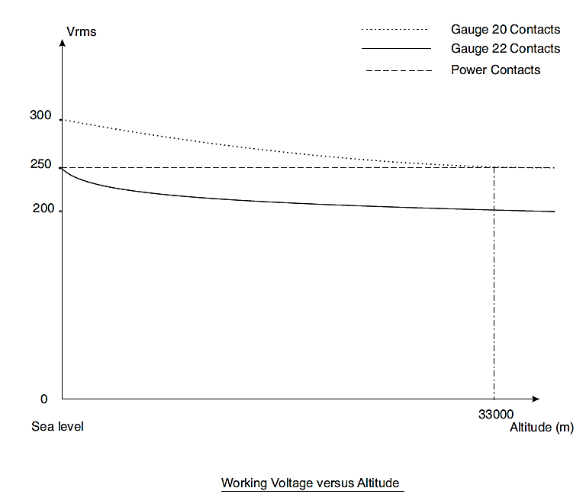

FIGURE 2 - PHYSICAL DIMENSIONS
FIGURE 2(a) - RECEPTACLES AND PLUGS

SHELL SIZE E
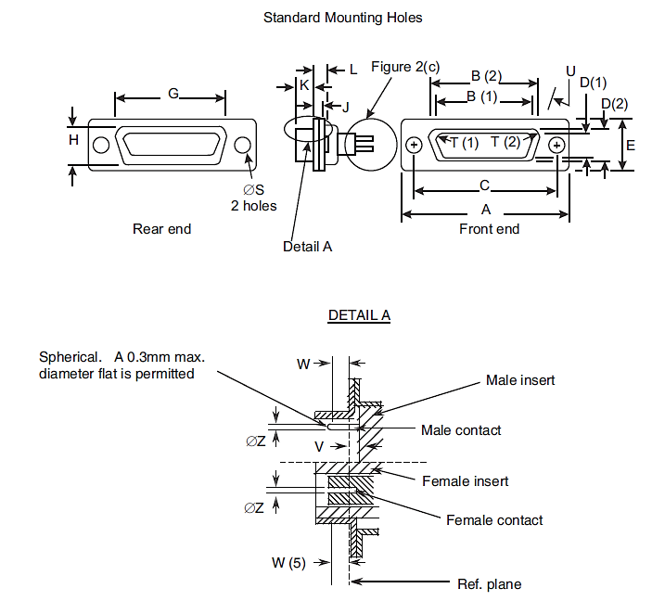
Connector  Type | Contact  Type | Symbol/ Dim. | A | B | C | D | E | G | H | J | K | L | ØS | T | U  ° | V | W | ØZ
 |  |  |  |  |  |  |  |  |  |  |  |  |  |  |  |  |  | V.01 | V.02
Plug | Male | min. | 30.43 | 16.79 | 24.87 | 8.23 | 12.17 | 19.02 | 10.46 | 0.51 | 5.82 | 0.89 | 2.92 | 2.59 | 9 | 0 | 4.03 | 0.99 | 0.75
Plug | Male | max. | 31.19 | 17.04 | 25.12 | 8.48 | 12.93 | 19.53 | 10.97 | 1.02 | 6.05 | 1.52 | 3.2 | 2.69 | 11 | 0.4 | - | 1.04 | 0.77
Receptacle | Female | min. | 30.43 | 16.21 | 24.87 | 7.77 | 12.17 | 19.02 | 10.46 | 0.51 | 6.05 | 0.89 | 2.92 | 2.46 | 9 | - | 3.63 | 1.07 | 0.89
Receptacle | Female | max. | 31.19 | 16.46 | 25.12 | 8.03 | 12.93 | 19.53 | 10.97 | 1.02 | 6.3 | 1.52 | 3.2 | 2.62 | 11 | - | - | 1.14 | 0.95

SHELL SIZE A
Connector  Type | Contact  Type | Symbol/ Dim. | A | B | C | D | E | G | H | J | K | L | ØS | T | U  ° | V | W | ØZ
 |  |  |  |  |  |  |  |  |  |  |  |  |  |  |  |  |  | V.01 | V.02
Plug | Male | min. | 38.76 | 25.12 | 33.2 | 8.23 | 12.17 | 27.25 | 10.46 | 0.51 | 5.82 | 0.89 | 2.92 | 2.59 | 9 | 0 | 4.03 | 0.99 | 0.75
Plug | Male | max. | 39.52 | 25.37 | 33.45 | 8.48 | 12.93 | 27.76 | 10.97 | 1.02 | 6.05 | 1.52 | 3.2 | 2.69 | 11 | 0.4 | - | 1.04 | 0.77
Receptacle | Female | min. | 38.76 | 24.54 | 33.2 | 7.77 | 12.17 | 27.25 | 10.46 | 0.51 | 6.05 | 0.89 | 2.92 | 2.46 | 9 | - | 3.63 | 1.07 | 0.89
Receptacle | Female | max. | 39.52 | 24.79 | 33.45 | 8.03 | 12.93 | 27.76 | 10.97 | 1.02 | 6.3 | 1.52 | 3.2 | 2.62 | 11 | - | - | 1.14 | 0.95

SHELL SIZE B
Connector  Type | Contact  Type | Symbol/ Dim. | A | B | C | D | E | G | H | J | K | L | ØS | T | U  ° | V | W | ØZ
 |  |  |  |  |  |  |  |  |  |  |  |  |  |  |  |  |  | V.01 | V.02
Plug | Male | min. | 52.65 | 38.84 | 46.91 | 8.23 | 12.17 | 41.02 | 10.46 | 0.51 | 5.69 | 1.05 | 2.92 | 2.59 | 9 | 0 | 3.81 | 0.99 | 0.75
Plug | Male | max. | 53.42 | 39.09 | 47.17 | 8.48 | 12.93 | 41.53 | 10.97 | 1.24 | 5.99 | 1.78 | 3.2 | 2.69 | 11 | 0.6 | - | 1.04 | 0.77
Receptacle | Female | min. | 52.65 | 38.25 | 46.91 | 7.77 | 12.17 | 41.02 | 10.46 | 0.51 | 6.05 | 0.89 | 2.92 | 2.46 | 9 | - | 3.63 | 1.07 | 0.89
Receptacle | Female | max. | 53.42 | 38.51 | 47.17 | 8.03 | 12.93 | 41.53 | 10.97 | 1.02 | 6.3 | 1.52 | 3.2 | 2.62 | 11 | - | - | 1.14 | 0.95

SHELL SIZE C
Connector  Type | Contact  Type | Symbol/ Dim. | A | B | C | D | E | G | H | J | K | L | ØS | T | U  ° | V | W | ØZ
 |  |  |  |  |  |  |  |  |  |  |  |  |  |  |  |  |  | V.01 | V.02
Plug | Male | min. | 68.94 | 55.3 | 63.37 | 8.23 | 12.17 | 57.45 | 10.46 | 0.51 | 5.69 | 1.05 | 2.92 | 2.59 | 9 | 0 | 3.81 | 0.99 | 0.75
Plug | Male | max. | 69.7 | 55.55 | 63.63 | 8.48 | 12.93 | 57.96 | 10.97 | 1.24 | 5.99 | 1.78 | 3.2 | 2.69 | 11 | 0.6 | - | 1.04 | 0.77
Receptacle | Female | min. | 68.94 | 54.71 | 63.37 | 7.77 | 12.17 | 57.45 | 10.46 | 0.51 | 6.05 | 0.89 | 2.92 | 2.46 | 9 | - | 3.63 | 1.07 | 0.89
Receptacle | Female | max. | 69.7 | 54.97 | 63.63 | 8.03 | 12.93 | 57.96 | 10.97 | 1.02 | 6.3 | 1.52 | 3.2 | 2.62 | 11 | - | - | 1.14 | 0.95

SHELL SIZE D
Connector  Type | Contact  Type | Symbol/ Dim. | A | B | C | D | E | G | H | J | L | K | ØS | T | U  ° | V | W | ØZ
 |  |  |  |  |  |  |  |  |  |  |  |  |  |  |  |  |  | V.01 | V.02
Plug | Male | min. | 66.55 | 52.68 | 60.99 | 11.07 | 14.99 | 55.07 | 13.31 | 0.51 | 1.05 | 5.69 | 2.92 | 2.59 | 9 | 0 | 3.81 | 0.99 | 0.75
Plug | Male | max. | 67.31 | 52.93 | 61.24 | 11.33 | 15.75 | 55.58 | 13.82 | 1.24 | 1.78 | 5.99 | 3.2 | 2.69 | 11 | 0.6 | - | 1.04 | 0.77
Receptacle | Female | min. | 66.55 | 52.3 | 60.99 | 10.62 | 14.99 | 55.07 | 13.31 | 0.51 | 0.89 | 6.05 | 2.92 | 2.46 | 9 | - | 3.63 | 1.07 | 0.89
Receptacle | Female | max. | 67.31 | 52.55 | 61.24 | 10.87 | 15.75 | 55.58 | 13.82 | 1.02 | 1.52 | 6.3 | 3.2 | 2.62 | 11 | - | - | 1.14 | 0.95

SHELL SIZE F
Standard Mounting Holes
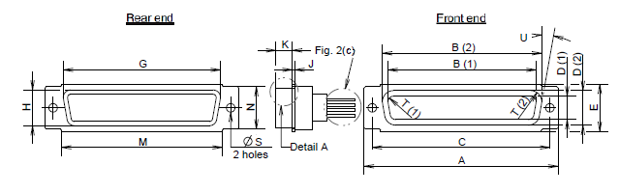

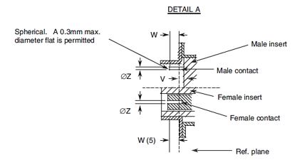
Connector  Type | Contact  Type | Symbol/ Dim. | A | B | C | D | E | G | H | J | K | M | N | ØS | T | U  ° | V | W | ØZ
Plug | Male | min. | 68.94 | 56.06 | 63.37 | 12.65 | 16.92 | 58.75 | 15.45 | 0.74 | 5.69 | 57.25 | 15 | 2.92 | 2.59 | 9 | 0 | 3.81 | 0.75
Plug | Male | max. | 69.7 | 56.31 | 63.63 | 12.9 | 17.68 | 59.25 | 15.95 | 1.24 | 5.99 | 57.75 | 15.5 | 3.2 | 2.69 | 11 | 0.6 | - | 0.77
Receptacle | Female | min. | 68.94 | 55.47 | 63.37 | 12.19 | 16.92 | 58.75 | 15.45 | 0.51 | 6.05 | 57.25 | 15 | 2.92 | 2.46 | 9 | - | 3.63 | 0.89
Receptacle | Female | max. | 69.7 | 55.73 | 63.63 | 12.45 | 17.68 | 59.25 | 15.95 | 1.02 | 6.3 | 57.75 | 15.5 | 3.2 | 2.62 | 11 | - | - | 0.95

OTHER MOUNTING TYPES
Floating Mount - Type ‘Y’
Shell Sizes E, A, B, C, D and F
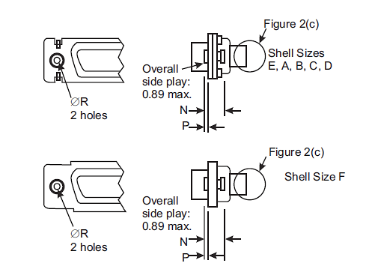
Contact Type | Symbol/Dim. | N | P | ØR
Male and Female | min. | 2.4 | 0.76 | 2.2
Male and Female | max. | 3.3 | 0.86 | 2.3
Captive Nut - Type ‘E’
Shell Sizes E, A, B, C, D and F
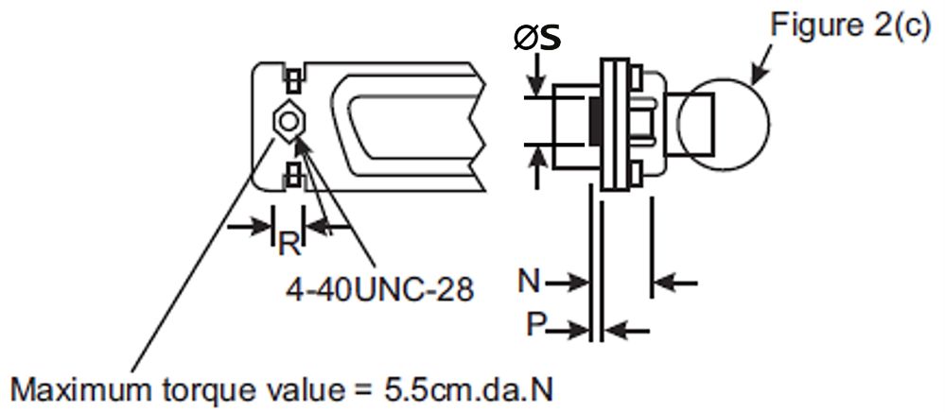
Contact Type | Symbol/Dim. | N | P | R | ∅S
Male and Female | min. | 3.4 | 0 | 4.3 | -
Male and Female | max. | 4.2 | 0.5 | 4.7 | 5.2
NOTES:
            - Inside dimension for connectors with male contacts.
            - Outside dimension for connectors with female contacts.
            - All dimensions are in millimetres (angles in degrees).
            - Underlined dimensions, in table, are critical to ensure intermateability.
            - Electrical contact position in female contact.

FIGURE 2(b) - CONTACT ARRANGEMENTS
variant 01 – standard contact arrangements
front view male insert
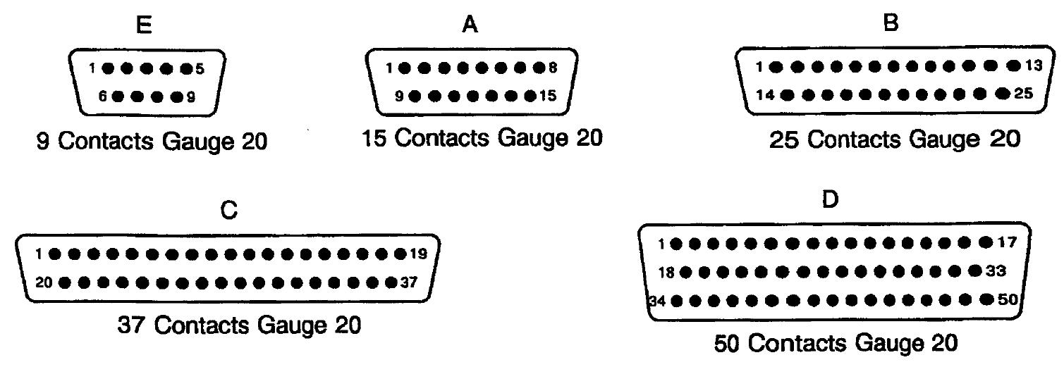
variant 02 – high density contact arrangements
front view male insert
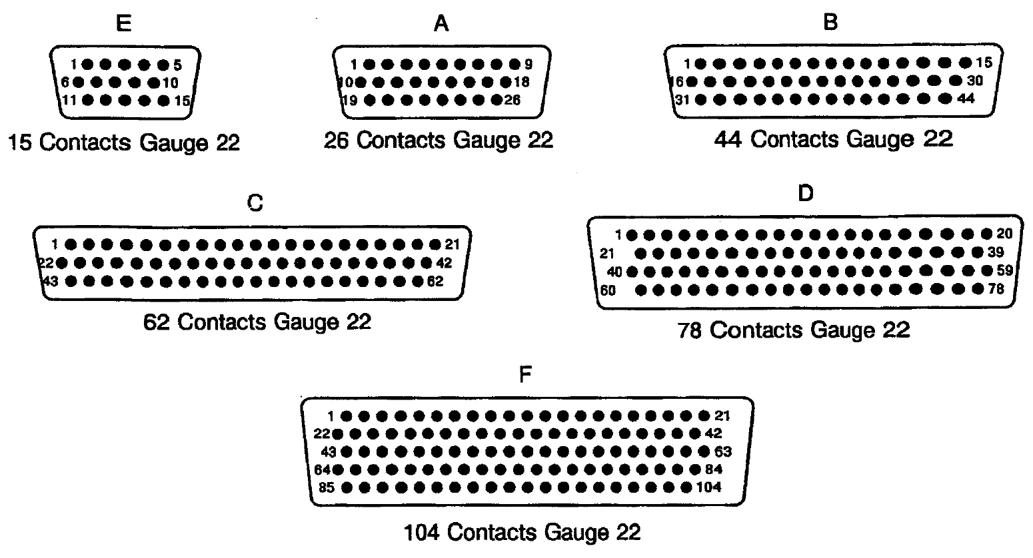
POWER AND COAXIAL CONTACT ARRANGEMENTS (Variant 01)
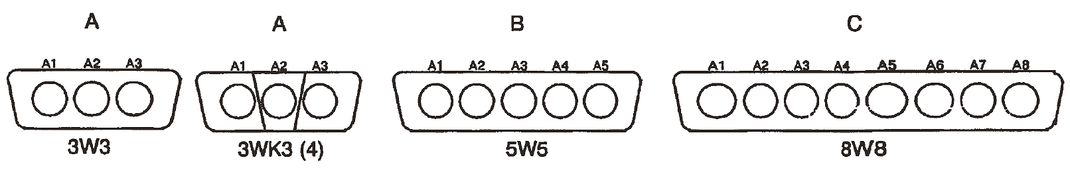
mixed contact arrangements for variant 01 only
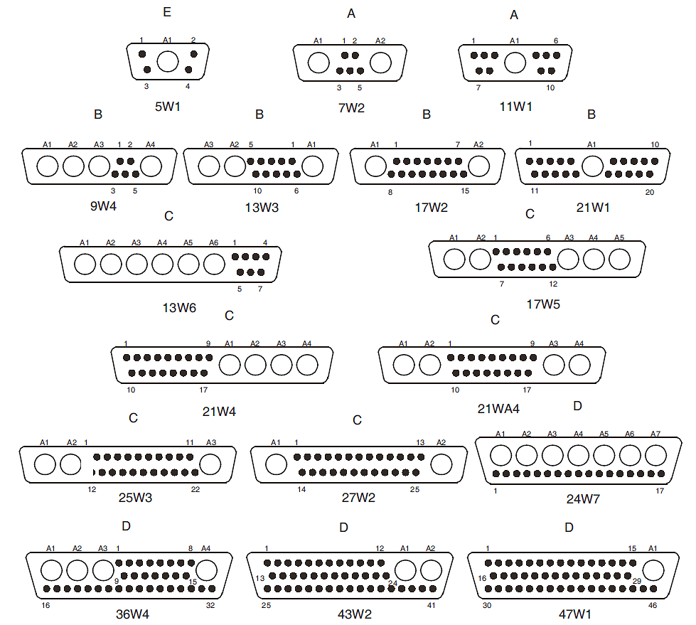
NOTES:
            - Contact locations are in conformity with MIL-DTL-24308 specification sheets for standard signal contact arrangements and NASA/GSFC Specification S-311-P-10 for coaxial, power and mixed contact arrangements, and shall not be checked during procurement.
            - Both sides of the insert shall be marked with the minimum marking shown. Contact numbers are shown outside the inserts for readability.
            - See Para. 4.5 for definition of letters and numbers.
            - 3WK3 insulator with built-in keying (middle part recessed or protruding with respect to each side), to avoid mismounting (K = keyed).
FIGURE 2(c) - REAR END

Gauge 20 Solder Bucket Contacts (CODE -)
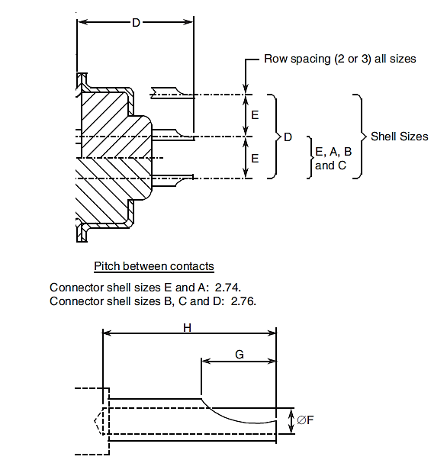
Symbol/Dim. | D |  | E  (5) | ØF | G | H
Symbol/Dim. | (2) (3) | (4)
min. | - | - | 2.77 | 1.1 | 1.4 | 2.4
max. | 10.71 | 10.91 | 2.91 | 1.15 | 2.5 | -
NOTES:
            - All dimensions are in mm.
            - Connectors equipped with female contacts all sizes.
            - Connectors equipped with male contacts sizes E and A.
            - Connectors equipped with male contacts sizes B, C, D.
            - Typical = 2.84.

Gauge 22 Solder Bucket Contacts (CODE -)
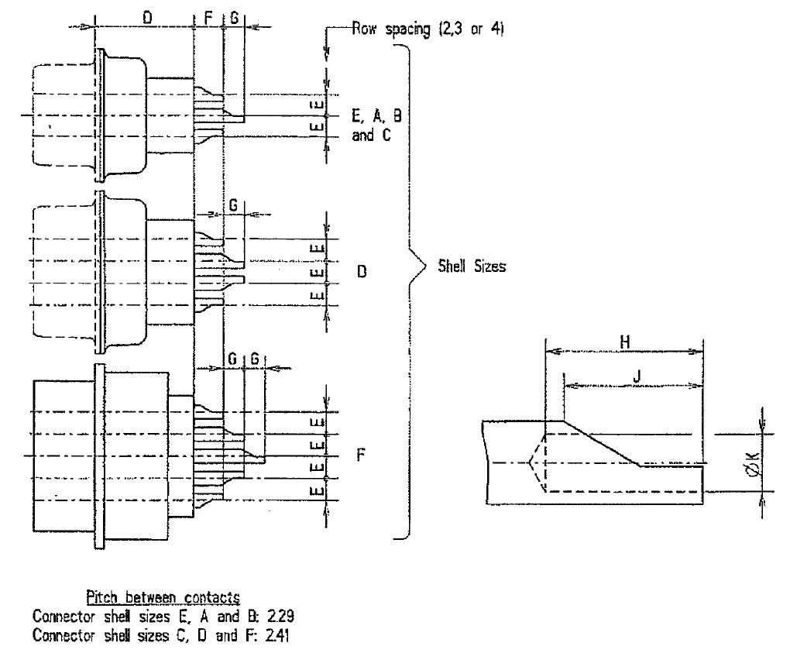
Symbol/Dim. | D |  | E |  | F | G | H | J | ØK
Symbol/Dim. | (2) (3) | (4) | Sizes E, A, B, C (5) | Sizes D, F  (6)
min. | - | - | 1.91 | 2.01 | 2.5 | 1.9 | 2.4 | 1.4 | 0.87
max. | 11.21 | 11.41 | 2.05 | 2.15 | 3.1 | 2.1 | - | 2.5 | 0.93
NOTES:
            - All dimensions are in mm.
            - Connectors equipped with female contacts all sizes.
            - Connectors equipped with male contacts sizes E and A.
            - Connectors equipped with male contacts sizes B, C, D and F.
            - Typical = 1.98.
            - Typical = 2.08.

Gauge 20 Straight PCB Solder Contacts (Codes OL3 and Z)
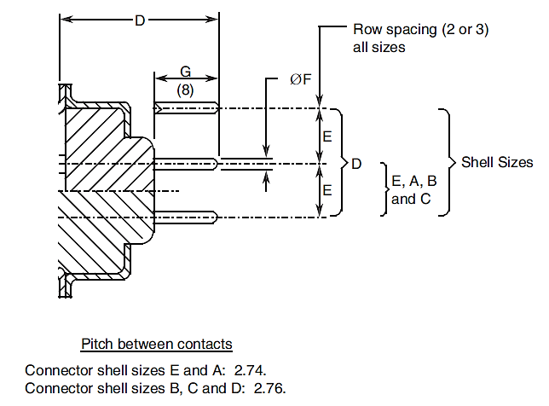
Symbol/Dim. | D |  | E  (5) | ØF |  | G  (8)
Symbol/Dim. | (2) (3) | (4) | E  (5) | CODE OL3  (6) | CODE Z (7) | G  (8)
min. | 9.7 | 9.9 | 2.77 | 0.5 | 0.69 | 3.1
max. | 11.5 | 11.7 | 2.91 | 0.65 | 0.84 | 5.3
NOTES:
            - All dimensions are in mm.
            - Connectors equipped with female contacts all sizes.
            - Connectors equipped with male contacts sizes E and A.
            - Connectors equipped with male contacts sizes B, C and D.
            - Typical = 2.84.
            - Typical = 0.6.
            - Typical = 0.76.
            - Dimension G is the length of the PCB tail extension of the contact.

Gauge 22 Straight PCB Solder Contacts (Code OL3)
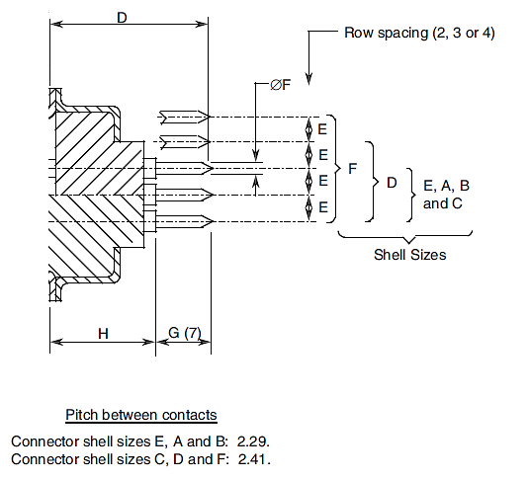
Symbol/Dim. | D |  |  | E |  | ØF | G  (7) | H
Symbol/Dim. | (2) | (3) | (4) | Sizes E, A, B, C (5) | Sizes D, F  (6) | ØF | G  (7) | (2) | (3) | (4)
min. | - | - | - | 1.91 | 2.01 | 0.5 | 4.6 | - | - | -
max. | 16.17 | 16.01 | 16.21 | 2.05 | 2.15 | 0.65 | 4.8 | 11.37 | 11.21 | 11.41
NOTES:
            - All dimensions are in mm.
            - Connectors equipped with female contacts all sizes.
            - Connectors equipped with male contacts sizes E and A.
            - Connectors equipped with male contacts sizes B, C, D and F.
            - Typical = 1.98.
            - Typical = 2.08.
            - Dimension G is the length of the PCB tail extension of the contact.

Gauge 20 90º PCB Solder Contacts (Sizes E, A, B and C) (Codes 1A0N, 1B0N, 2A0N and 2B0N)
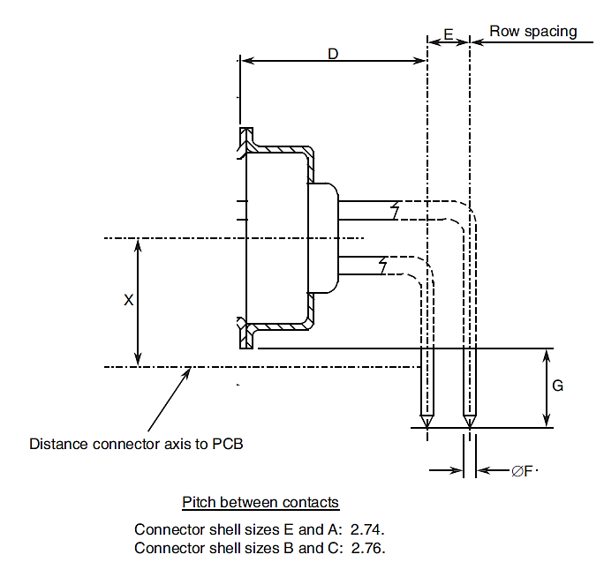
Symbol/Dim. | D |  | E |  | ØF |  | G | X  (9)
Symbol/Dim. | (2) (3) | (4) | (*)A0N (5) | (*)B0N (6) | 1A0N  1B0N (7) | 2A0N  2B0N (8) | G | X  (9)
min. | 10.1 | 10.3 | 2.49 | 2.79 | 0.5 | 0.69 | 4.7 | 7.2
max. | 10.3 | 10.5 | 2.59 | 2.89 | 0.65 | 0.84 | 5.3 | 7.5
NOTES:
            - All dimensions are in mm.
            - Connectors equipped with female contacts all sizes.
            - Connectors equipped with male contacts sizes E and A.
            - Connectors equipped with male contacts sizes B and C.
            - Typical = 2.54.
            - Typical = 2.84.
            - Typical = 0.6.
            - Typical = 0.76.
            - Typical = 7.35.

Gauge 20 90º PCB Solder Contacts (Size D) (Codes 1A0N, 1B0N, 2A0N and 2B0N)
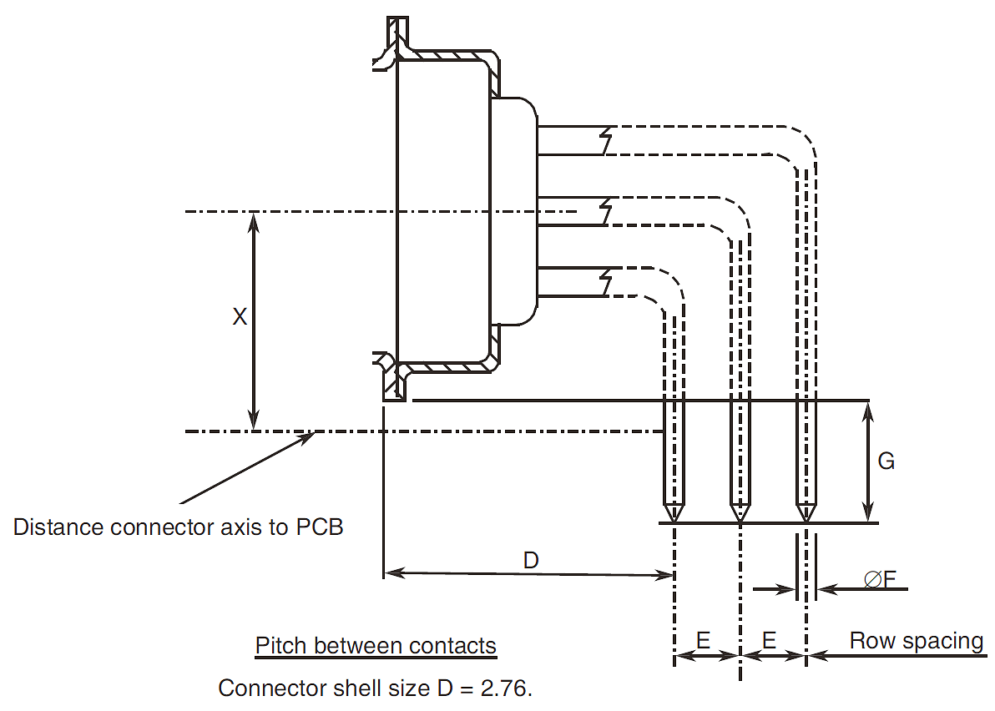
Symbol/Dim. | D |  | E |  | ØF |  | G | X  (8)
Symbol/Dim. | (2) | (3) | (*)A0N (4) | (*)B0N (5) | 1A0N  1B0N (6) | 2A0N  2B0N (7) | G | X  (8)
min. | 10.1 | 10.3 | 2.49 | 2.79 | 0.5 | 0.69 | 4.7 | 8.6
max. | 10.3 | 10.5 | 2.59 | 2.89 | 0.65 | 0.84 | 5.3 | 8.8
NOTES:
            - All dimensions are in mm.
            - Connectors equipped with female contacts.
            - Connectors equipped with male contacts.
            - Typical = 2.54.
            - Typical = 2.84.
            - Typical = 0.6.
            - Typical = 0.76.
            - Typical = 8.7.

Gauge 22 90º PCB Solder Contacts (For Sizes E, A, B, C code 1C0N and Size D code 1D0N)
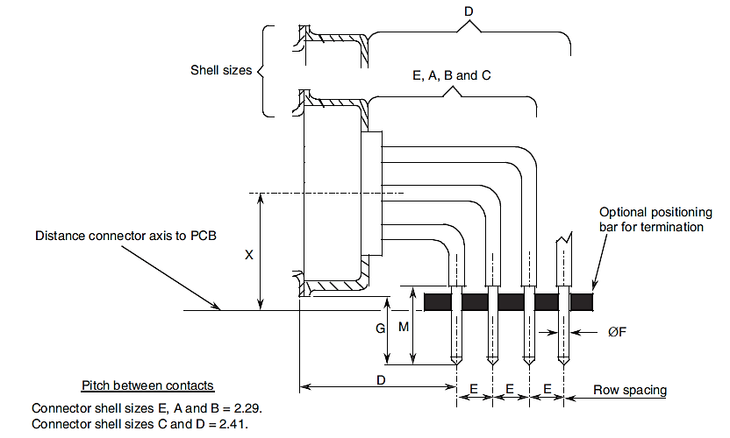
Code | Symbol/Dim. | D |  | E |  | ØF | G | M | X  (7) (8)
Code | Symbol/Dim. | (2) (3) | (4) | 1C0N (5) | 1D0N (6)
1C0N | min. | 11.98 | 12.18 | 1.93 | - | 0.5 | 4.7 | 5.3 | 7.2
1C0N | max. | 12.48 | 12.68 | 2.03 | - | 0.65 | 5.7 | - | 7.5
1D0N | min. | 11.98 | 12.18 | - | 2.03 | 0.5 | 4.7 | 5.3 | 8.6
1D0N | max. | 12.48 | 12.68 | - | 2.13 | 0.65 | 5.7 | - | 8.8
NOTES:
            - All dimensions are in mm.
            - Connectors equipped with female contacts all sizes.
            - Connectors equipped with male contacts sizes E and A.
            - Connectors equipped with male contacts sizes B, C and D.
            - Typical = 1.98.
            - Typical = 2.08
            - For sizes E, A, B and C, Typical = 7.35.
            - For size D, Typical = 8.7.

Gauge 22 90º PCB Solder Contacts (Size F code 1D0N)
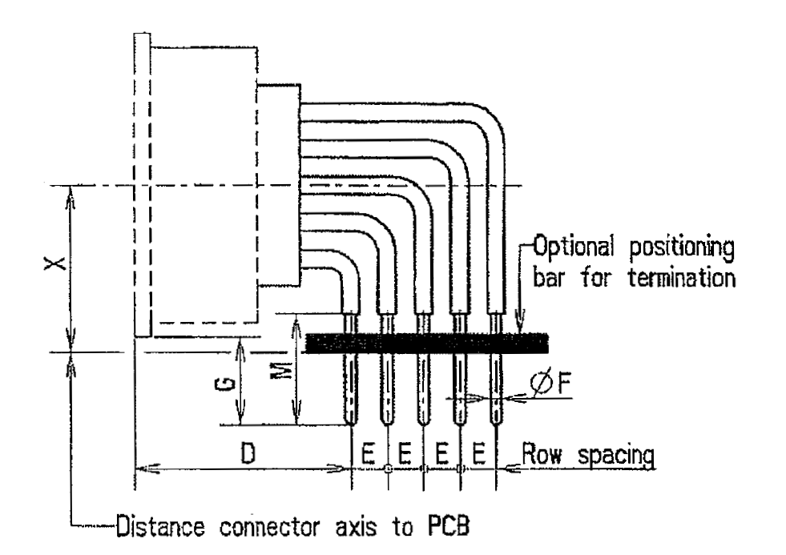
Pitch between contacts
Connector shell size F = 2.41
Symbol/Dim. | D | E  (2) | ØF | G | M | X  (3)
min. | 12.18 | 2.03 | 0.5 | 4.7 | 5.3 | 8.6
max. | 12.68 | 2.13 | 0.65 | 5.7 | - | 8.8
NOTES:
            - All dimensions are in mm.
            - Typical = 2.08.
            - Typical = 8.7.

Gauge 20 90° PCB Solder Contacts with 90° Bracket and Screw Locks (Sizes E, A, B and C) (Codes 1A7N, 1A9N, 1B7N, 1B9N, 2A7N, 2A9N, 2B7N and 2B9N)
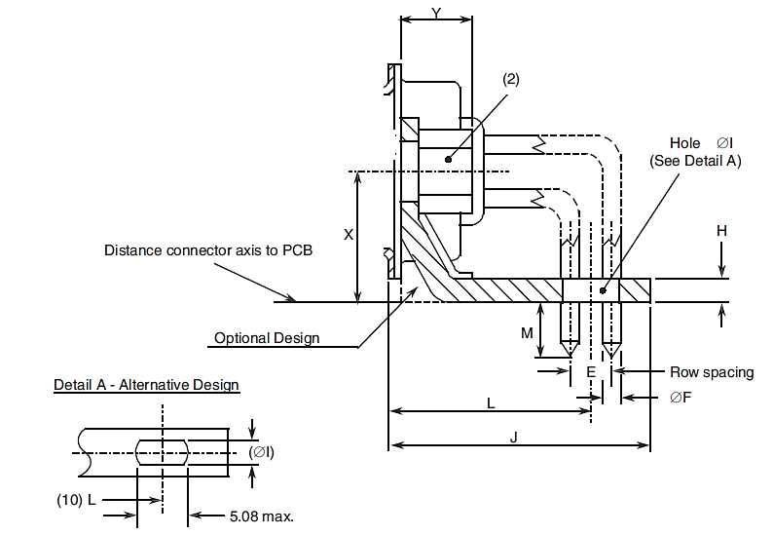
Symbol/ Dim. | E |  | ØF |  | H | ØI | J |  | L |  |  |  | M | X  (9) | Y
Symbol/ Dim. | (*)A7N (*)A9N (3) | (*)B7N (*)B9N (4) | 1(*)7N  1(*)9N (5) | 2(*)7N  2(*)9N (6) | H | ØI | (7) | (8) | (7) |  | (8) |  |  | X  (9)
 |  |  |  |  |  |  |  |  | (*)A7N (*)A9N | (*)B7N (*)B9N | (*)A7N (*)A9N | (*)B7N (*)B9N
min. | 2.49 | 2.79 | 0.5 | 0.69 | 1 | 3.12 | - | - | 11.37 | 11.52 | 11.57 | 11.72 | 3.6 | 7.2 | -
max. | 2.59 | 2.89 | 0.65 | 0.84 | 3.2 | 3.32 | 15.6 | 15.8 | 11.57 | 11.72 | 11.77 | 11.92 | 4.4 | 7.5 | 7
NOTES:
            - All dimensions are in mm.
            - Codes (*)A7N and (*)B7N: Nut 4-40.
Codes (*)A9N and (*)B9N: Nut M3.
            - Typical = 2.54.
            - Typical = 2.84.
            - Typical = 0.6.
            - Typical = 0.76.
            - Connectors equipped with female contacts all sizes and connectors equipped with male contacts sizes E and A.
            - Connectors equipped with male contacts sizes B and C.
            - Typical = 7.35.
            - This alternative design takes into account the different possible values of L.

Gauge 20 90° PCB Solder Contacts with 90° Bracket and Screw Locks

(Size D) (Codes 1A7N, 1A9N, 1B7N, 1B9N, 2A7N, 2A9N, 2B7N and 2B9N)
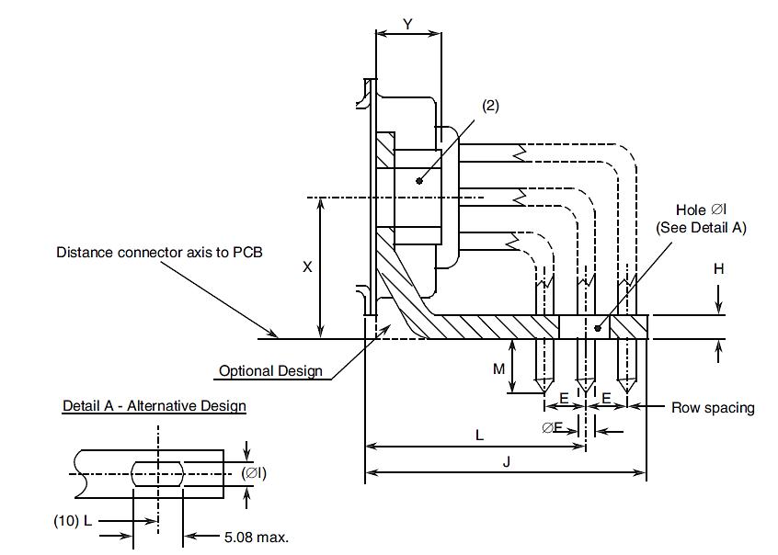
Symbol/ Dim. | E |  | ØF |  | H | ØI | J |  | L |  |  |  | M | X  (9) | Y
Symbol/ Dim. | (*)A7N (*)A9N (3) | (*)B7N (*)B9N (4) | 1(*)7N  1(*)9N (5) | 2(*)7N  2(*)9N (6) | H | ØI | (7) | (8) | (7) |  | (8) |  | M | X  (9) | Y
 |  |  |  |  |  |  |  |  | (*)A7N (*)A9N | (*)B7N (*)B9N | (*)A7N (*)A9N | (*)B7N (*)B9N | M | X  (9) | Y
min. | 2.49 | 2.79 | 0.5 | 0.69 | 1 | 3.12 | - | - | 12.64 | 12.94 | 12.84 | 13.14 | 3.6 | 8.6 | -
max. | 2.59 | 2.89 | 0.65 | 0.84 | 3.2 | 3.32 | 17.5 | 17.7 | 12.84 | 13.14 | 13.04 | 13.34 | 4.4 | 8.8 | 7
NOTES:
            - All dimensions are in mm.
            - Codes (*)A7N and (*)B7N: Nut 4-40.
Codes (*)A9N and (*)B9N: Nut M3.
            - Typical = 2.54.
            - Typical = 2.84.
            - Typical = 0.6.
            - Typical = 0.76.
            - Connectors equipped with female contacts.
            - Connectors equipped with male contacts.
            - Typical = 8.7.
            - This alternative design takes into account the different possible values of L.

Gauge 22 90º PCB Solder Contacts with 90º Bracket and Screw Locks (Sizes E, A, B and C) (Codes 1C7N and 1C9N)
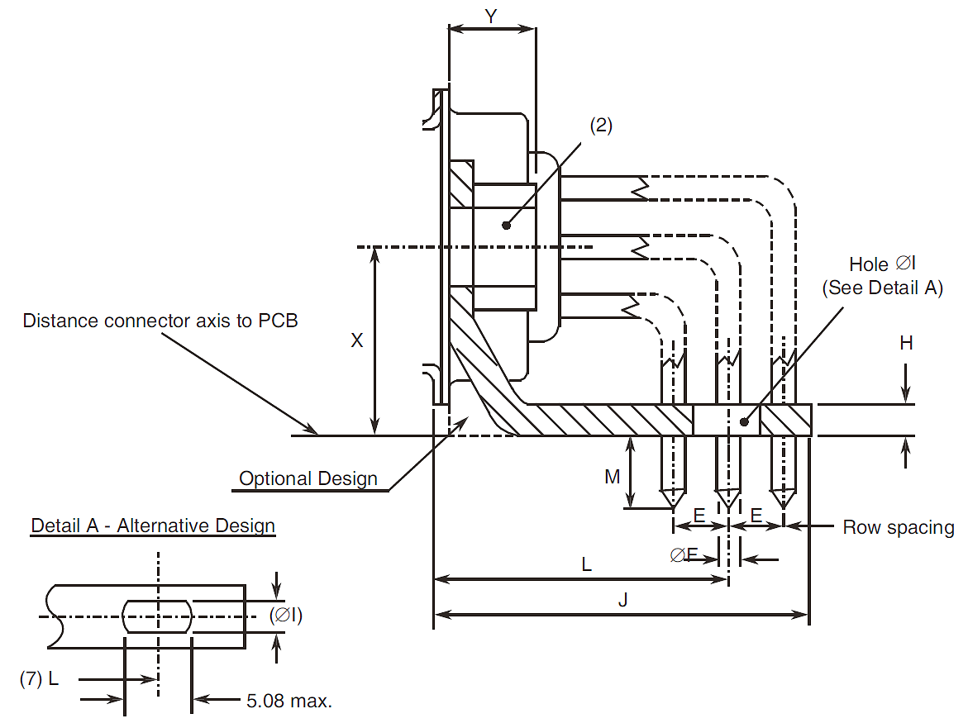
Symbol/ Dim. | E  (3) | ØF | ØI | H | J |  | L |  | M | X  (6) | Y
 |  |  |  |  | (4) | (5) | 1C7N  1C9N  (4) | 1C7N  1C9N  (5) | M | X  (6) | Y
min. | 1.93 | 0.5 | 3.12 | 1 | - | - | 14.11 | 14.31 | 3.6 | 7.2 | -
max. | 2.03 | 0.65 | 3.32 | 3.2 | 18.3 | 18.5 | 14.31 | 14.51 | 4.8 | 7.5 | 7
NOTES:
            - All dimensions are in mm.
            - Code 1C7N: Nut 4-40.
Code 1C9N: Nut M3.
            - Typical = 1.98.
            - Connectors equipped with female contacts all sizes and connectors equipped with male contacts sizes E and A.
            - Connectors equipped with male contacts sizes B and C.
            - Typical = 7.35.
            - This alternative design takes into account the different possible values of L.

Gauge 22 90º PCB Solder Contacts with 90º Bracket and Screw Locks (Size D) (Codes 1D7N and 1D9N)
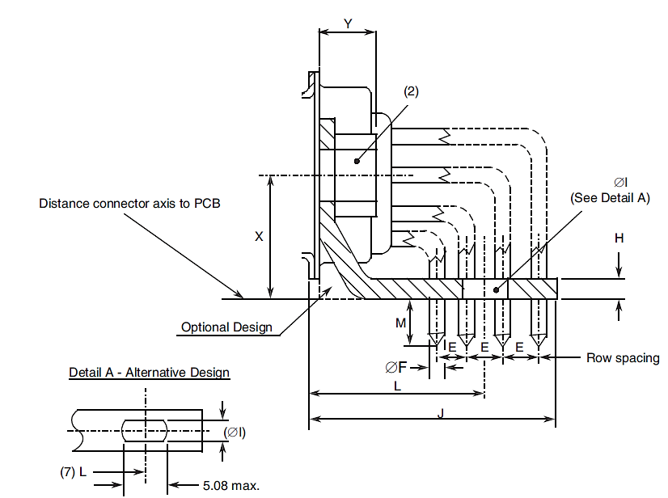
Symbol/ Dim. | E  (3) | ØF | ØI | H | J |  | L |  | M | X (6) | Y
 |  |  |  |  | (4) | (5) | 1C7N  1C9N | 1C7N  1C9N | M | X (6) | Y
min. | 2.03 | 0.5 | 3.12 | 1 | - | - | 15.25 | 15.45 | 3.6 | 8.6 | -
max. | 2.13 | 0.65 | 3.32 | 3.2 | 20.5 | 20.7 | 15.45 | 15.65 | 4.8 | 8.8 | 7
NOTES:
            - All dimensions are in mm.
            - Code 1D7N: Nut 4-40.
Code 1D9N: Nut M3.
            - Typical = 2.08.
            - Connectors equipped with female contacts.
            - Connectors equipped with male contacts.
            - Typical = 8.7.
            - This alternative design takes into account the different possible values of L.

Gauge 22 90º PCB Solder Contacts with 90º Bracket and Screw Locks (Size F) (Code 1D7N and 1D9N)
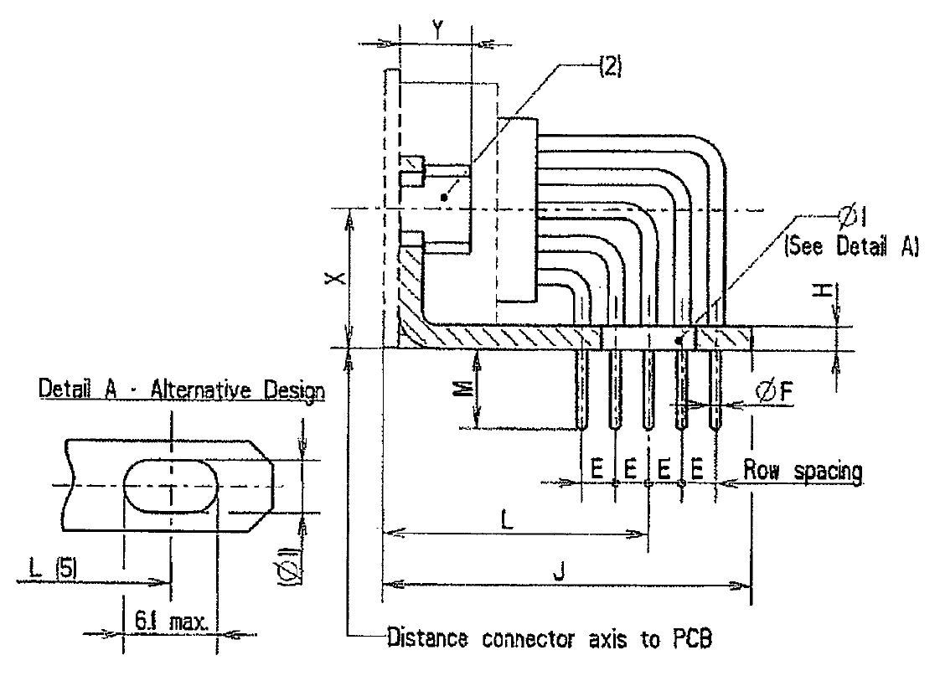
Symbol/Dim. | E  (3) | ØF | ØI | H | J | L | M | X  (4) | Y
min. | 2.03 | 0.5 | 3.12 | 1 | - | 16.15 | 4.6 | 8.6 | -
max. | 2.13 | 0.65 | 3.32 | 3.2 | 23.5 | 16.85 | 5.8 | 8.8 | 7
NOTES:
            - All dimensions are in mm.
            - Code 1D7N: Nut 4-40.
Code 1D9N: Nut M3.
            - Typical = 2.08.
            - Typical = 8.7.
            - This alternative design takes into account the different possible values of L.

Gauge 20 90º PCB Solder Contacts (Sizes E, A, B and C) (Code P)
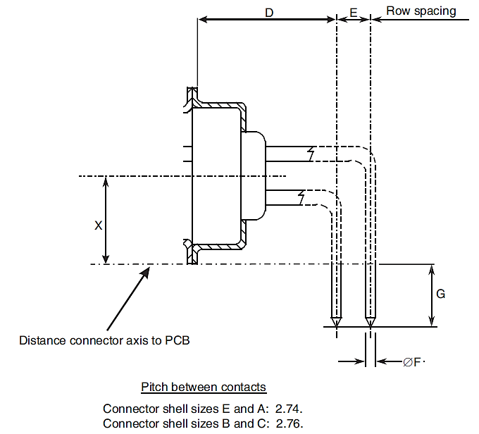
Symbol/Dim. | D  (2) | E  (3) | ØF  (4) | G | X  (5)
min. | 6.94 | 2.79 | 0.69 | 3.9 | 6.2
max. | 7.44 | 2.89 | 0.84 | 4.7 | 6.5
NOTES:
            - All dimensions are in mm.
            - Typical = 7.19.
            - Typical = 2.84.
            - Typical = 0.76.
            - Typical = 6.35.

Gauge 20 90º PCB Solder Contacts (Size D) (Code P)
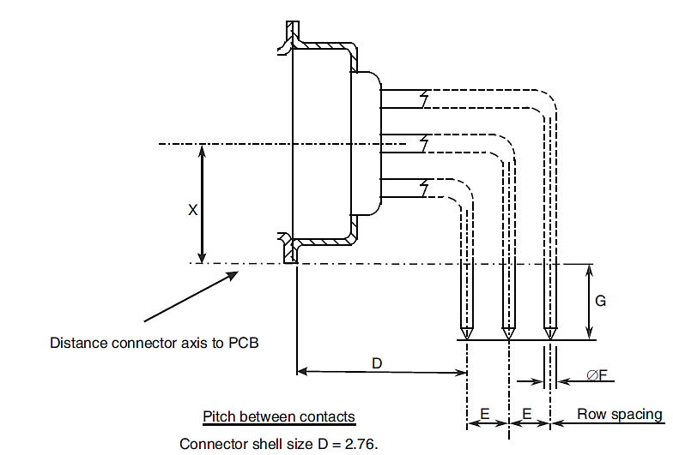
Symbol/Dim. | D  (2) | E  (3) | ØF  (4) | G | X  (5)
min. | 6.94 | 2.79 | 0.69 | 3.9 | 7.6
max. | 7.44 | 2.89 | 0.84 | 4.7 | 7.9
NOTES:
            - All dimensions are in mm.
            - Typical = 7.19.
            - Typical = 2.84.
            - Typical = 0.76.
            - Typical = 6.35.

Gauge 20 90º PCB Solder Contacts with 90º Bracket and Screw Locks (Sizes E, A, B and C) (Codes L7, L9)
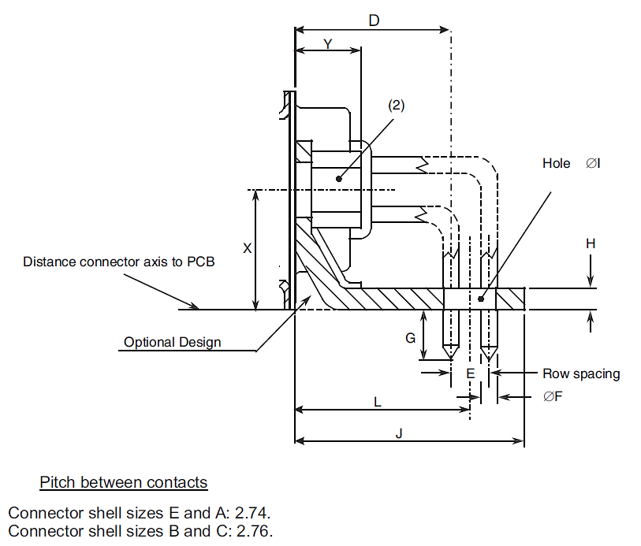
Symbol/Dim. | D  (3) | E  (4) | ØF  (5) | G | H | I | J | L | X  (6) | Y
min. | 6.94 | 2.79 | 0.69 | 3.9 | 1 | 3.12 | 11.4 | 8.5 | 6.2 | -
max. | 7.44 | 2.89 | 0.84 | 4.7 | 3.2 | 3.32 | 11.8 | 8.7 | 6.5 | 7
NOTES:
            - All dimensions are in mm.
            - Code L7: Nut 4-40.
Code L9: Nut M3.
            - Typical = 7.19.
            - Typical = 2.84.
            - Typical = 0.76.
            - Typical = 6.35.

Gauge 20 90º PCB Solder Contacts with 90º Bracket and Screw Locks (Size D) (Codes L7, L9)
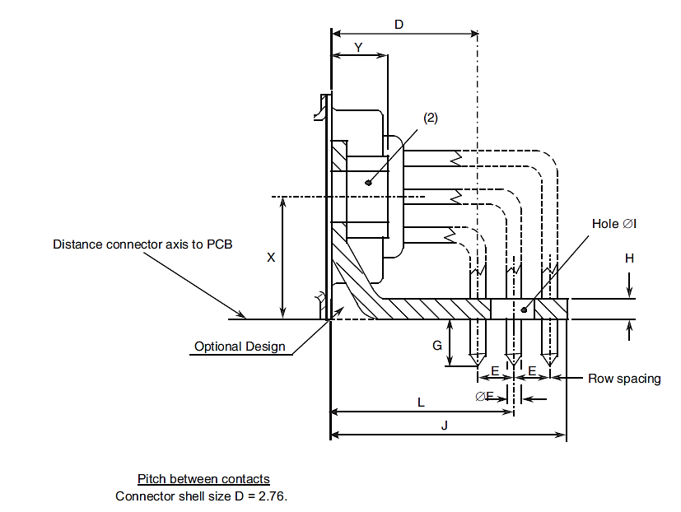
Symbol/Dim. | D  (3) | E  (4) | ØF  (5) | G | H | I | J | L | X  (6) | Y
min. | 6.94 | 2.79 | 0.69 | 3.9 | 1 | 3.12 | 11.4 | 8.5 | 6.2 | -
max. | 7.44 | 2.89 | 0.84 | 4.7 | 3.2 | 3.32 | 11.8 | 8.7 | 6.5 | 7
NOTES:
            - All dimensions are in mm.
            - Code L7: Nut 4-40.
Code L9: Nut M3.
            - Typical = 7.19.
            - Typical = 2.84.
            - Typical = 0.76.
            - Typical = 7.75.

Gauge 20 Wire-Wrap Contacts (Code F179A)
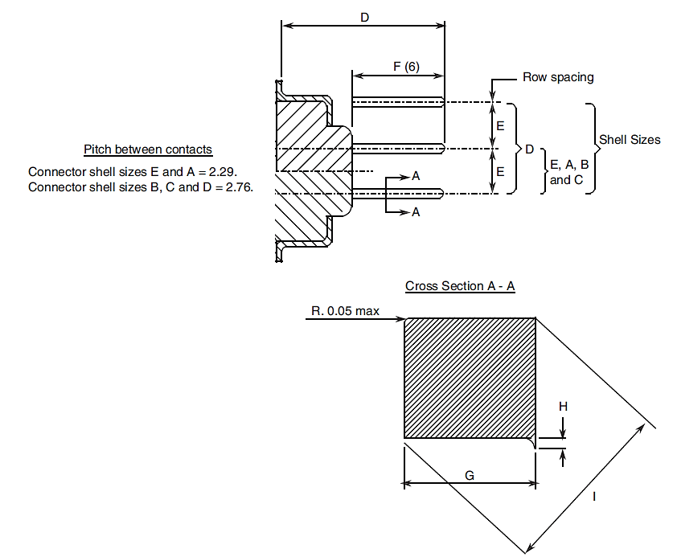
Symbol/Dim. | D |  | E  (5) | F  (6) | G | H | I
Symbol/Dim. | (2) (3) | (4)
min. | - | - | 2.77 | 12.6 | 0.59 | - | 0.787
max. | 20.1 | 20.3 | 2.91 | 12.8 | 0.61 | 0.02 | 0.864
NOTES:
            - All dimensions are in mm.
            - Connectors equipped with female contacts all sizes.
            - Connectors equipped with male contacts sizes E and A.
            - Connectors equipped with male contacts sizes B, C and D.
            - Typical = 2.84.
            - Dimension F is the length of the square part of the contact.

Power and Coaxial Contacts (Code -, 7N, 9N)
Straight coaxial contacts
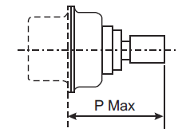
Symbol | Connectors equipped with Variant Number per 3401/004
Symbol | 3401/004 Variants 01-02-05-06-11-12-15-16 |  | 3401/004 Variants 09-10-19-20
P | 19.6 (2) (3) | 19.8 (4) | 22.3 (2) (3) | 22.5 (4)
90º coaxial contacts
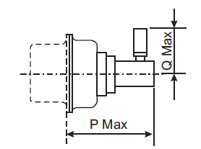
Symbol | Connectors equipped with  3401/004 Variants 03-04-07-08-13-14-17-18
P | 14.3 (2) (3) | 14.5 (4)
Q | 12.5
Straight coaxial PCB contacts
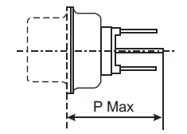
Symbol | Connectors equipped with  3401/004 Variants 21-22
P | 13.8 (2) (3) | 14 (4)
90° coaxial PCB contacts
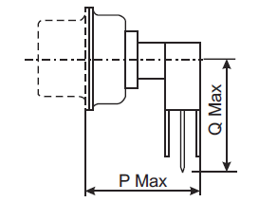
Symbol | Connectors equipped with  3401/004 Variants 23-24
P | 15.8 (2) (3) | 16 (4)
Q | 13

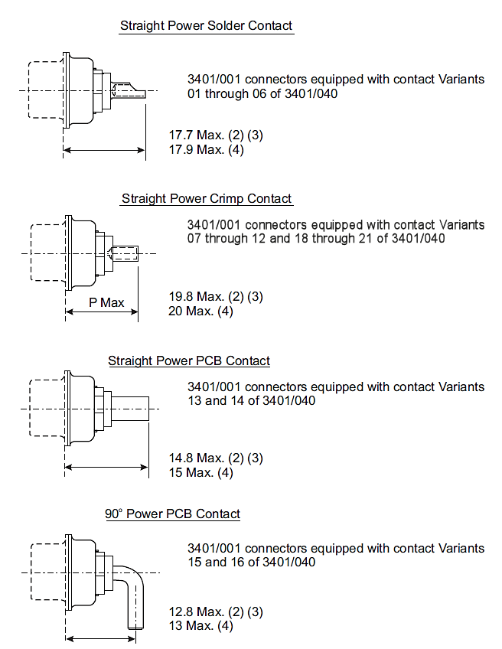
NOTES:
            - All dimensions are in mm.
            - Connectors equipped with female contacts all sizes.
            - Connectors equipped with male contacts sizes E and A.
            - Connectors equipped with male contacts sizes B, C and D.

POWER AND COAXIALS CONTACTS WITH 90° BRACKET AND SCREW LOCKS (SIZES A, B AND C) (CODES 7N, 9N)
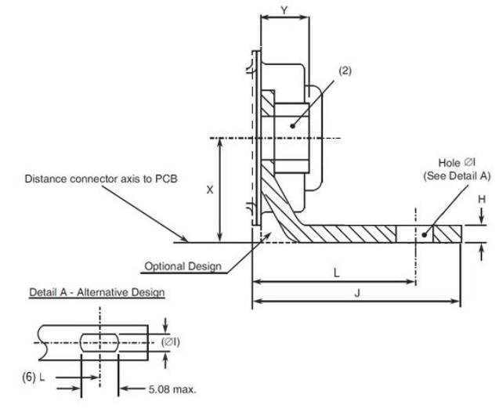
Symbol/  Dim. | H | Øl | J |  | L |  | X (5) | Y
Symbol/  Dim. | H | Øl | (3) | (4) | (3) | (4) | X (5) | Y
Min. | 1 | 3.12 | - | - | 11.37 | 11.57 | 7.2 | -
Max. | 3.2 | 3.32 | 15.6 | 15.8 | 11.72 | 11.92 | 7.5 | 7
Notes:
            - All dimensions are in millimetres.
            - Code 7N: Nut 4-40.
Codes 9N: Nut M3.
            - Connectors equipped with female contacts all sizes and connectors equipped with male contacts size A (Contact arrangements 3W3 and 3WK3).
            - Connectors equipped with male contacts sizes B (contact arrangement 5W5) and C (contact arrangement 8W8).
            - Typical = 7.35.
            - This alternative design takes into account the different possible values of L.
            - Figure is shown without contacts.

REQUIREMENTS

GENERAL
The complete requirements for procurement of the connectors specified herein are stated in this specification and ESCC Generic Specification No. 3401. Deviations from the Generic Specification, applicable to this specification only, are listed in Para. 4.2.
Deviations from the applicable Generic Specification and this Detail Specification, formally agreed with specific Manufacturers on the basis that the alternative requirements are equivalent to the ESCC requirements and do not affect the components’ reliability, are listed in the appendices attached to this specification.

DEVIATIONS FROM GENERIC SPECIFICATION

Deviations from Special In-Process Controls
None.

Deviations from Final Production Tests (Chart II)
          - Para. 9.9, Seal Test: Not applicable.

Deviations from Burn-in and Electrical Measurements (Chart III)
Chart III is not applicable.

Deviations from Qualification Tests (Chart IV)
          - Para. 9.1.1.4, Mated Shell Conductivity: Not applicable.
          - Para. 9.9, Seal Test: Not applicable.
          - Para. 9.2.4, Jackscrew Retention, Not applicable.
          - Para. 9.27, Maintenance Aging: Not applicable to gauge 20 and 22 contacts.

Deviations from Lot Acceptance Tests (Chart V)
          - Para. 9.1.1.4, Mated Shell Conductivity: Not applicable.
          - Para. 9.9, Seal Test: Not applicable.

MECHANICAL REQUIREMENTS

Dimension Check
The dimensions of the connectors specified herein shall be verified in accordance with the requirements set out in Para. 9.6 of ESCC Generic Specification 3401 and shall conform to those shown in Figure 2 of this specification. Only the underlined dimensions shall be checked during procurement.

Weight
The maximum weight of the connectors specified herein, with contacts, shall be as specified in Table 1(a).

Contact Capability
For the purpose of this test, the pick-up and drop weights shall be as follows:
CONTACTS | MEASUREMENTS | PICK-UP WEIGHT | DROP WEIGHT
Gauge 20 | Weight (g) | 28.35 | 226.8
Gauge 20 | Pin diameter (mm) | 0.99 to 0.993 | 1.039 to 1.04
Gauge 20 | Insertion depth (mm) | 4 | 4
Gauge 22 | Weight (g) | 19.84 | 226.8
Gauge 22 | Pin diameter (mm) | 0.749 to 0.751 | 0.773 to 0.775
Gauge 22 | Insertion depth (mm) | 4 | 4
See ESCC Detail Specifications Nos. 3401/004 and 3401/040 for coaxial and power contacts.

Contact Retention (in insert)
The contact retention force of gauge 20 and 22 contacts within the insert shall be 40N.
See ESCC Detail Specification Nos. 3401/004 and 3401/040 for coaxial and power contacts.

Mating and Unmating Forces
The forces applied for mating and unmating of the connectors shall conform to the values specified in Table 1(a).

Insert Retention (in Shell)
Connector inserts shall withstand a pressure of 42.8N/cm² without being dislodged from the shell.

Jackscrew Retention
Not applicable

Contact Insertion and Withdrawal Forces
See ESCC Detail Specification Nos. 3401/004 & 3401/040 for coaxial and power contacts. Not applicable to other contact types.

Engagement and Separation Forces
The engagement and separation forces of the female contacts shall be tested with the applicable test pin and shall not exceed the values of the table hereunder.
CONTACTS | MEASUREMENTS | DIAMETER (mm) |  | ENGAGEMENT MAX (N) | SEPARATION (N)
CONTACTS | MEASUREMENTS | MIN | MAX | ENGAGEMENT MAX (N) | MIN | MAX
Gauge 20 | Max Ø Test Pin | 1.039 | 1.04 | 3.33 | - | 2.22
Gauge 20 | Min Ø Test Pin | 0.99 | 0.993 | - | 0.28 | -
Gauge 22 | Max Ø Test Pin | 0.773 | 0.775 | 3.33 | - | 2.22
Gauge 22 | Min Ø Test Pin | 0.749 | 0.751 | - | 0.2 | -
See ESCC Detail Specifications Nos. 3401/004 and 3401/040 for coaxial and power contacts.

Oversize Pin Exclusion
The diameter of the test pin and the force applied to it shall be as follows:
CONTACTS | TEST PIN DIAMETER (mm) |  | FORCE (N) MAX
CONTACTS | MIN | MAX | FORCE (N) MAX
Gauge 20 | 1.166 | 1.17 | 3.33
Gauge 22 | 0.905 | 0.907 | 2.43
See ESCC Detail Specifications Nos. 3401/004 and 3401/040 for coaxial and power contacts.

Probe Damage
The probe diameter and the moment at the end of the probe shall be as follows:
CONTACTS | PROBE DIAMETER (mm) |  | MOMENT (N.cm)
CONTACTS | MIN | MAX | MOMENT (N.cm)
Gauge 20 | 1.007 | 1.033 | 5.65
Gauge 22 | 0.749 | 0.774 | 1.3
See ESCC Detail Specification Nos. 3401/004 and 3401/040 for coaxial and power contacts.

Solderability
Size A soldering iron shall be used.
See ESCC Detail Specification Nos. 3401/004 and 3401/040 for coaxial and power contacts.

MATERIALS AND FINISHES
The materials and finishes shall be as specified herein. Where a definite material is not specified, a material which will enable the connectors specified herein to meet the performance requirements of this specification shall be used. Acceptance or approval of any constituent material does not guarantee acceptance of the finished product.

Shells
Shells of shell sizes E, A, B, C and D shall be made of brass. The standard plating finish (i.e. no Modification Code) shall be 0.7µm minimum of gold over 1µm minimum of copper. An alternative plating finish is 12.7µm minimum electroless nickel (Modification Code A175).
Shells of shell size F shall be made of aluminium alloy. The plating finish shall be either 25.4µm minimum of electroless nickel (Modification Code A174) or 0.7µm minimum of gold with 25.4µm minimum electroless nickel underplating (Modification Code FR172).

Inserts
Inserts shall be made of glass-fibre filled diallylphthalate resin or a suitable thermoplastic material.

Contacts
The contact body shall be made of copper alloy with an underplate of 1µm minimum of copper, gold plated with 1.27µm minimum of gold.
The female contact spring element shall be made of copper alloy with an underplate of 1µm minimum of nickel or copper, gold plated with 1.27µm minimum of gold.

Contact Retaining Clip
Not applicable to gauge 20 and 22 contacts.
See ESCC Detail Specification Nos. 3401/004 and 3401/040 for coaxial and power contacts.

Guiding and Locking Devices
As specified in ESCC Detail Specification Nos. 3401/022, 3401/072 and 3401/085.

Magnetism Level
The allowable value of magnetism shall not exceed that specified for the relevant level (see Para. 4.5.4.7). Only magnetism levels NMC and NMD are verified.

MARKING

General
The marking of all components delivered to this specification shall be in accordance with the requirements of ESCC Basic Specification No. 21700 and the following paragraphs. When the component is too small to accommodate all of the marking specified, as much as space permits shall be marked and the marking information, in full, shall accompany the component in its primacy package.
The information to be marked and the order of precedence, shall be as follows:
          - Contact Position.
          - The ESCC Component Number.
          - Characteristics.
          - Traceability information.

Contact Position
Contact position shall be marked on the inserts in accordance with Figure 2(b).

The ESCC Component Number
The ESCC Component Number shall be constituted and marked as follows:
Example: 340100101B
- Detail Specification Number: 3401001
- Type Variant (see Table 1(a)): 01
- Testing Level: B

Characteristics
The characteristics to be marked in the following order of precedence are:
          - Series.
          - Shell size.
          - Insert type.
          - Mounting.
          - Contact arrangement.
          - Type of contact.
          - Magnetism level.
          - Contact termination code.
          - Modification code.
The information shall be constituted and marked as follows:
Example: DAMY7W2SNMCOL3
- Series: D
- Shell size: A
- Insert type: M
- Mounting: Y
- Contact arrangement: 7W2
- Type of contact: S
- Magnetism level: NMB
- Contact termination code (See Table 1(a)): OL3
- Modification code: (blank)

Series
This connector series shall be designated by the letter “D”.

Shell Size
The shell size shall be indicated by the code letters specified hereafter.
E | A | B | C | D | F

Insert Type
This insert type is defined by the letter “M”.

Mounting
The letter “E” indicates a captive nut.
The letter “Y” indicates a floating mount.
If the shell has fixed mounting holes, these letters shall be omitted.

Contact Arrangement
The number of contacts shall be as shown in Figure 2(b) and contact arrangements shall be indicated by the codes specified hereafter.
Code | Shell Size | Number of Contacts Gauge 20 | Number of Contacts Gauge 22 | Number of Coaxial  or Power Contact  Cavities (Note 1)
9 | E | 9 | 0 | 0
5W1 | E | 4 | 0 | 1
15 | A | 15 | 0 | 0
15 | E | 0 | 15 | 0
3W3 | A | 0 | 0 | 3
3WK3 | A | 0 | 0 | 3(2)
7W2 | A | 5 | 0 | 2
11W1 | A | 10 | 0 | 1
25 | B | 25 | 0 | 0
26 | A | 0 | 26 | 0
5W5 | B | 0 | 0 | 5
9W4 | B | 5 | 0 | 4
13W3 | B | 10 | 0 | 3
17W2 | B | 15 | 0 | 2
21W1 | B | 20 | 0 | 1
37 | C | 37 | 0 | 0
8W8 | C | 0 | 0 | 8
13W6 | C | 7 | 0 | 6
17W5 | C | 12 | 0 | 5
21WA4 | C | 17 | 0 | 4(3)
21W4 | C | 17 | 0 | 4(3)
25W3 | C | 22 | 0 | 3
27W2 | C | 25 | 0 | 2
44 | B | 0 | 44 | 0
50 | D | 50 | 0 | 0
24W7 | D | 17 | 0 | 7
36W4 | D | 32 | 0 | 4
43W2 | D | 41 | 0 | 2
47W1 | D | 46 | 0 | 1
62 | C | 0 | 62 | 0
78 | D | 0 | 78 | 0
104 | F | 0 | 104 | 0
NOTES:
            - For connectors with contact arrangements that include coaxial or power contact cavities, the coaxial or power contacts shall be ordered separately in accordance with ESCC Detail Specification Nos. 3401/004 and 3401/040respectively.
Coaxial and power contacts must be from the same Manufacturer as the connector in which they are mounted and this shall be verified prior to assembly.
            - 2 male plus 1 female or 2 female plus 1 male (see Para. 4.5.4.6).
            - See Figure 2(b) for physical differences.

Type of Contact
The contact types shall be indicated by the following code letters.
Code Letter | Contact Type
P | Male
S | Female
For the 3WK3 arrangement, the contact cavities A1 and A3 shall determine the code letter to be used.

Magnetism Level
The following codes shall be used for magnetism level.
Code | Definition
NMB | Magnetism Level: ≤ 200 gamma (1)
NMC | Magnetism Level: ≤ 20 gamma
NMD | Magnetism Level: ≤ 2 gamma
NOTES:
            - Guaranteed, but not measured.

Contact Termination Code
Contact terminations shall be indicated as given in Table 1(a), Contact Types. For mixed contact arrangements, (see Figure 2(b)), the gauge 20 contact type shall determine the contact code used.

Modification Code
The modification code for the finish (see Para. 4.4.1) shall be:
- A175 for the electroless nickel finish for shell sizes E, A, B, C and D
- A174 for the electroless nickel finish for shell size F.
- FR172 for the gold over electroless nickel finish for shell size F.
The modification code shall be omitted for shell sizes E, A, B, C and D with the gold over copper standard finish.

Traceability Information
Traceability information shall be marked in accordance with the requirements of ESCC Basic Specification No. 21700.

ELECTRICAL MEASUREMENTS

Electrical Measurements at Room Temperature
The parameters to be measured in respect of electrical characteristics are scheduled in Table 2. Unless otherwise specified, these measurements shall be performed at T_{amb} = +22 ±3ºC.

Electrical Measurements at High and Low Temperatures
Not applicable.
Table 2 - ELECTRICAL MEASUREMENTS AT ROOM TEMPERATURE
No. | Characteristic | Symbol | ESCC 3401  Test Method | Test Condition | Limits |  | Unit
 |  |  |  |  | Min | Max | Unit
1 | Insulation Resistance | RI | Para. 9.1.1.1 | Para. 9.1.1.1 | 5000 | - | MΩ
2 | Voltage Proof Leakage Current | IL | Para. 9.1.1.2 | (1) | - | 2 | mA
3 | Low Level Contact Resistance Gauge 20 Signal Contacts Gauge 22 Signal Contacts Coaxial Contacts  Power Contacts | RCL | Para. 9.1.1.3 | Para. 9.1.1.3 | -  -  -  - | 6  12  Note 2  Note 2 | mΩ
4 | Rated Current Contact  Resistance | RCR | Para. 9.1.1.3 | Gauge 20: 7.5A Gauge 22: 3A Coaxial and Power Contacts | -  - | 5  10  Note 2 | mΩ
NOTES:

- Gauge 20 contacts: 1250Vrms.
- Gauge 22 contacts, power and straight coaxial contacts: 1000Vrms.
- 90° coaxial contacts: 800Vrms.
- For mixed contact arrangements, the voltage applied between dissimilar contacts shall be the higher that would be applied between either of the contacts in question tested with an identical contact.
            - See ESCC Detail Specification Nos. 3401/004 and 3401/040 for coaxial and power contacts.
TABLES 3, 4 and 5
Not applicable.

Circuit for Electrical Measurements (Figure 4)
Not applicable.

BURN-IN AND ELECTRICAL MEASUREMENTS
Not applicable.

ENVIRONMENTAL AND ENDURANCE TESTS (CHARTS IV AND V OF ESCC GENERIC SPECIFICATION No. 3401)

Measurements and Inspections on Completion of Environmental Tests
The parameters to be measured and inspections to be performed on completion of environmental testing shall be those specified in Table 6. Unless otherwise specified, the measurements shall be performed at T_{amb} = +22 ±3ºC.

Measurements and Inspections at Intermediate Points during Endurance Tests
Not applicable.

Measurements and Inspections on Completion of Endurance Tests
The parameters to be measured and inspections to be performed on completion of endurance tests shall be those specified in Table 6. Unless otherwise specified, the measurements shall be performed at T_{amb},= +22 ±3ºC.

Conditions for Operating Life Test (Part of Endurance Testing)
Not applicable.

Electrical Circuits for Operating Life Test (Figure 5)
Not applicable.

Conditions for High Temperature Storage Test (Part of Endurance Testing)
The requirements for the high temperature storage test are specified in Section 9 of ESCC Generic Specification No. 3401. The conditions for high temperature storage testing shall be the maximum storage temperature specified in Table 1(b) of this specification.
Table 6 - MEASUREMENTS AND INSPECTIONS ON COMPLETION OF ENVIRONMENTAL AND ENDURANCE TESTING
No. | ESCC Generic Spec. No. 3401 |  | Measurements and Inspections |  | Symbol | Limits |  | Unit
No. | Environmental and Endurance Tests  (1) | Test Method and  Conditions | Identification | Conditions | Symbol | Min | Max | Unit
01 | Seal Test | Para. 9.9 | ESCC 3401 Para. 9.9 | - | - | Not applicable |  | -
02 | Wiring | Para. 9.10 & Table 1(a) of this spec. | Low Level Contact Resistance | Table 2 Item 3 | R_{CL} | Table 2 Item 3 |  | mΩ
03 | Vibration | Para. 9.11 | Initial Measurements
 |  |  | Coupling Screw(s) Unlocking Torque | - | - | Record Values |  | Nm
 |  |  | Final Measurements
 |  |  | Full Engagement
 |  |  | Coupling Screw(s) Unlocking Torque Drift | - | Δ | -25 | +25 | %
 |  |  | Visual Examination | - | - | - | - | -
04 | Shock or Bump | Para. 9.12 | Full Engagement
 |  |  | Visual Examination | - | - | - | - | -
05 | Climatic Sequence | Para. 9.13 | Dry Heat | At High Temperature
 |  |  | Insulation Resistance | Table 2 Item 1 | R_{I} | 1000 | - | MΩ
 |  |  | Low Air Pressure
 |  |  | Voltage Proof Leakage Current | Figure 1 | I_{L} | Table 2 Item 2 |  | mA
 |  |  | Damp Heat | Immediately after test
 |  |  | Insulation Resistance | Table 2 Item 1 | R_{I} | 100 | - | MΩ
 |  |  | Final Measurements | After 1 – 24hrs recovery
 |  |  | External Visual Inspection | ESCC 3401 Para. 9.7 | - | ESCC 3401  Para. 9.7 |  | -
 |  |  | Insulation Resistance | Table 2 Item 1 | R_{I} | Table 2 Item 1 |  | MΩ
 |  |  | Voltage Proof Leakage Current | Table 2 Item 2 | I_{L} | Table 2 Item 2 |  | mA
06 | Plating Thickness | Para. 9.14 | Thickness | - | - | Para. 4.4.3 of this spec. |  | -
07 | Joint Strength | Para. 9.15 | ESCC 3401 Para. 9.15 | - | - | ESCC 3401  Para. 9.15 |  | -
08 | Rapid Change of Temperature | Para. 9.16 | Visual Examination | - | - | - | - | -
 | Rapid Change of Temperature |  | Insulation Resistance | Table 2 Item 1 | R_{I} | Table 2 Item 1 |  | MΩ
 |  |  | Voltage Proof Leakage Current | Table 2 Item 2 | I_{L} | Table 2 Item 2 |  | mA
09 | Contact Retention (in insert) | Para. 9.17 & Para. 4.3.4 of this spec. | Contact Displacement | - | - | ESCC 3401  Para. 9.17 |  | -
10 | Endurance | Para. 9.18 | Initial Measurements
 |  |  | Mating/Unmating Forces | - | F | Para. 4.3.5 of this spec. |  | N
 |  |  | Low Level Contact Resistance | Table 2 Item 3 | R_{CL} | Record Values |  | mΩ
 |  |  | Mated Shell Conductivity | - | - | Not applicable |  | -
 |  |  | Final Measurements
 |  |  | Visual Examination | - | - | - | - | -
 |  |  | Mating/Unmating Forces | - | F | Para. 4.3.5 of this spec. |  | N
 |  |  | Low Level Contact Resistance Drift | Table 2 Item 3 | ΔR_{CL} | - | 3 | mΩ
 |  |  | Mated Shell Conductivity | - | - | Not applicable |  | -
 |  |  | Insulation Resistance | Table 2 Item 1 | R_{I} | Table 2 Item 1 |  | MΩ
 |  |  | Voltage Proof Leakage Current | Table 2 Item 2 | I_{L} | Table 2 Item 2 |  | mA
11 | Permanence of Marking | Para. 9.19 | As applicable | - | - | - | - | -
12 | Mating/Unmating Forces | Para. 9.20 | Force | - | F | Para. 4.3.5 of this spec. |  | N
13 | High Temperature Storage | Para. 9.21 | Initial Measurements
 | High Temperature Storage |  | Low Level Contact Resistance | Table 2 Item 3 | R_{CL} | Record Values |  | mΩ
 |  |  | Mated Shell Conductivity | - | - | Not applicable |  | -
 |  |  | Final Measurements
 |  |  | Visual Examination | - | - | - | - | -
 |  |  | Mating/Unmating Forces | - | F | Para. 4.3.5 of this spec. |  | N
 |  |  | Low Level Contact Resistance Drift | Table 2 Item 3 | ΔR_{CL} | - | 3 | mΩ
 |  |  | Rated Current Contact Resistance | Table 2 Item 4 | R_{CR} | Table 2 Item 4 |  | mΩ
 |  |  | Mated Shell Conductivity | - | - | Not applicable |  | -
 |  |  | Insulation Resistance | Table 2 Item 1 | R_{I} | Table 2 Item 1 |  | MΩ
 |  |  | Voltage Proof Leakage Current | Table 2 Item 2 | I_{L} | Table 2 Item 2 |  | mA
 |  |  | Contact Retention (in insert) | Para. 4.3.4 of this spec. | - | ESCC 3401  Para. 9.17 |  | N
14 | Corrosion | Para. 9.22 | Visual Examination | - | - | - | - | -
15 | Insert Retention (in shell) | Para. 9.23 & Para. 4.3.6 of this spec. | Visual Examination | - | - | Para. 4.3.6 of this spec. |  | -
16 | Jackscrew Retention | Para. 9.24 & Para. 4.3.7 of this spec. | Visual Examination | - | - | Not applicable |  | -
17 | High Temperature Measurements | Para. 9.25 | Insulation Resistance | Table 2 Item 1 | R_{I} | 500 | - | MΩ
18 | Overload Test | Para. 9.26 | Internal Temperature | - | T | - | +100 | °C
 |  |  | Rated Current Contact Resistance | Table 2 Item 4 | R_{CR} | Table 2 Item 4 |  | mΩ
 |  |  | Mated Shell Conductivity | - | - | Not applicable |  | -
 |  |  | Insulation Resistance | Table 2 Item 1 | R_{I} | Table 2 Item 1 |  | MΩ
 |  |  | Voltage Proof Leakage Current | Table 2 Item 2 | I_{L} | Table 2 Item 2 |  | mA
19 | Maintenance Aging | Para. 9.27 & Para. 4.2.4 of this spec. | Visual Examination | - | - | - | - | -
 |  | Para. 9.27 & Para. 4.2.4 of this spec. | Contact Retention (in insert) | Para. 4.3.4 of this spec. | - | ESCC 3401  Para. 9.17 |  | N
 |  | Para. 9.27 & Para. 4.2.4 of this spec. | Contact Insertion and Withdrawal Forces | Para. 4.3.8 of this spec. | F | Para. 4.3.8 of this spec. |  | N
20 | Engage/Separation Forces | Para. 9.28 & Para. 4.3.9 of this spec. | Force | - | F | Para. 4.3.9 of this spec. |  | -
21 | Oversize Pin Exclusion | Para. 9.29 & Para. 4.3.10 of this spec. | - | - | - | ESCC 3401  Para. 9.29 |  | -
22 | Probe Damage | Para. 9.30 & Para. 4.3.11 of this spec. | Contact Separation Force | Para. 4.3.9 of this spec. | F | Para. 4.3.9 of this spec. |  | -
23 | Solderability | Para. 9.31 & Para. 4.3.12 of this spec. | - | - | - | ESCC 3401  Para. 9.31 |  | -
NOTES:
            - The tests in this table refer to either Chart IV or V and shall be used as applicable.

APPENDIX A
AGREED DEVIATIONS FOR C&K COMPONENTS (F)
Items Affected | Description of Deviations
Para. 4.2.2, Deviations from Final Production Tests (Chart II) | Para. 9.4, Contact Capability:  100% Contact Capability Test may be omitted for solder bucket, PCB and wire-wrap contacts provided that a 100% visual inspection of the contact and a 10% Contact Capability test are performed in accordance with the C&K PID requirements. The results of the Contact Capability test shall be considered for PDA.

APPENDIX b
AGREED DEVIATIONS FOR Souriau (F)
Items Affected | Description of Deviations
Para. 4.2.2, Deviations from Final  Production Tests (Chart II) | Para. 9.1.4, Electrical Measurements at Room Temperature:  For solder bucket, PCB and wire-wrap contacts, Low Level Contact Resistance and Rated Current Contact Resistance measurements, performed in accordance with Table 2 of the Detail Specification, may be omitted provided that Low Level Contact Resistance measurements are performed on 10 contacts per contact batch, in accordance with the Souriau PID requirements. The results of the Low Level Contact Resistance measurements shall be considered for PDA.

