

Page 1 of 16
RESISTOR, FIXED, CHIP, METAL FOIL
BASED ON TYPE SMR-PW, SMV-PW
ESCC Detail Specification No. 4001/028

Issue 5 Draft A | July 2023



Document Custodian: European Space Agency – see https://escies.org

Legal Disclaimer and Copyright
European Space Agency, Copyright © 2023. All rights reserved.
The European Space Agency disclaims any liability or responsibility, to any person or entity, with respect to any loss or damage caused, or alleged to be caused, directly or indirectly by the use and application of this ESCC publication.
This publication, without the prior permission of the European Space Agency and provided that it is not used for a commercial purpose, may be:
- copied in whole, in any medium, without alteration or modification.
- copied in part, in any medium, provided that the ESCC document identification, comprising the ESCC symbol, document number and document issue, is removed.

DOCUMENTATION CHANGE NOTICE
(Refer to https://escies.org for ESCC DCR content)
DCR No. | CHANGE DESCRIPTION
TBA | Specification upissued to incorporate changes per DCR.

TABLE OF CONTENTS
1 General 5
1.1 SCOPE 5
1.2 APPLICABLE DOCUMENTS 5
1.3 TERMS, DEFINITIONS, ABBREVIATIONS, SYMBOLS AND UNITS 5
1.4 THE ESCC COMPONENT NUMBER AND COMPONENT TYPE VARIANTS 5
1.4.1 The ESCC Component Number 5
1.4.1.1 Characteristics and/or Ratings Codes 5
1.4.2 Component Type Variants and Range of Components 6
1.5 MAXIMUM RATINGS 6
1.6 PHYSICAL DIMENSIONS 7
1.6.1 Variant 01 (2 Terminal Package) 7
1.6.2 Variant 02 (4 Terminal Package) 8
1.7 FUNCTIONAL DIAGRAM 9
1.8 MATERIALS AND FINISHES 9
1.8.1 Terminals 9
2 REQUIREMENTS 9
2.1 GENERAL 9
2.1.1 Deviations from the Generic Specification 9
2.1.1.1 Deviations from Production Control - Chart F2 9
2.1.1.2 Deviations from Screening Tests - Chart F3 10
2.1.1.3 Deviations from Qualification and Periodic Tests - Chart F4 11
2.1.1.4 Deviations from Data Documentation - Section 9 11
2.2 MARKING 11
2.3 OVERLOAD 11
2.4 RESISTANCE TO SOLDERING HEAT 11
2.5 ELECTRICAL MEASUREMENTS AT ROOM, HIGH AND LOW TEMPERATURES 12
2.5.1 Room Temperature Electrical Measurements 12
2.5.2 High and Low Temperatures Electrical Measurements 12
2.6 INTERMEDIATE AND END-POINT ELECTRICAL MEASUREMENTS 13
2.7 BURN-IN CONDITIONS 14
2.7.1 No-Bias Burn-in Conditions for 100% Testing 14
2.7.2 Biased Burn-in Conditions for Screening Sub-lot Samples 14
2.8 OPERATING LIFE CONDITIONS 14
APPENDIX A 15

General

SCOPE
This specification details the ratings, physical and electrical characteristics and test and inspection data for the component type variants and/or the range of components specified below. It supplements the requirements of, and shall be read in conjunction with, the ESCC Generic Specification listed under Applicable Documents.

APPLICABLE DOCUMENTS
The following documents form part of this specification and shall be read in conjunction with it:
          - ESCC Generic Specification No. 4001.
          - A-QS-009, Isabellenhuette Test Procedure for Infrared Measurement.

TERMS, DEFINITIONS, ABBREVIATIONS, SYMBOLS AND UNITS
For the purpose of this specification, the terms, definitions, abbreviations, symbols and units specified in ESCC Basic Specification No. 21300 shall apply.

THE ESCC COMPONENT NUMBER AND COMPONENT TYPE VARIANTS

The ESCC Component Number
The ESCC Component Number shall be constituted as follows:
Example: 4001028012R7D
- Detail Specification Reference: 4001028
- Component Type Variant Number: 01 (as required)
- Characteristic code: Resistance Value (2.7Ω): 2R7 (as required)
- Characteristic code: Resistance Tolerance (±0.5%): D (as required)

Characteristics and/or Ratings Codes
Characteristics and/or ratings to be codified as part of the ESCC Component Number shall be as follows:
          - Resistance Value expressed by means of the following codes. The unit quantity shall be ohm (Ω):
Resistance Value (Ω) | Code
0.00XX | R00XX
0.0XX | R0XX
0.XX | RXX
X.X | XRX
          - Resistance Tolerance expressed by the following codes in accordance with ESCC Basic Specification No. 21700:
Tolerance (± %) | Code Letter
0.5 | D
1 | F

Component Type Variants and Range of Components
The component type variants and range of components applicable to this specification are as follows:
Variant Number | Type | Style  (Note 1) | Resistance Range R_{n} |  | Tolerance  (± %) | Temperature Coefficient TC  (± 10⁻⁶/°C) | Value Series | Weight max  (g)
Variant Number | Type | Style  (Note 1) | Min  (Ω) | Max  (Ω)
01 | SMR-PW | 4723  (2 Terminal) | 0.01 | 4.7 | 0.5, 1 | Note 2 | E12 | 0.6
02 | SMV-PW | 4723  (4 Terminal) | 0.0022 | 1 | 0.5, 1 | Note 2 | E12 | 0.6
NOTES:
            - See Para. 1.6.
            - Temperature Coefficient, TC, requirements:
Variant Number | Resistance  (Ω) | Temperature Coefficient  (10⁻⁶/°C) | Remarks
01 | 0.01 ≤ R_{n} ≤ 4.7 | -110, +0 | over T_{amb} = -55°C to + 22°C
01 | 0.01 ≤ R_{n} ≤ 4.7 | ±60 | over T_{amb} = +22°C to +140°C
01 | 0.01 ≤ R_{n} ≤ 4.7 | ±50 | over T_{amb} = +22°C to +60°C
02 | 0.0022 ≤ R_{n} ≤ 1 | -110, +0 | over T_{amb} = -55°C to +22°C
02 | 0.0022 ≤ R_{n} ≤ 1 | ±60 | over T_{amb} = +22°C to +140°C
02 | 0.0022 ≤ R_{n} < 0.01 | ±50 | over T_{amb} = +22°C to +60°C
02 | 0.01 ≤ R_{n} ≤ 1 | ±30 | over T_{amb} = +22°C to +60°C

MAXIMUM RATINGS
The maximum ratings shall not be exceeded at any time during use or storage.
Maximum ratings shall only be exceeded during testing to the extent specified in this specification and when stipulated in Test Methods and Procedures of the ESCC Generic Specification.
Characteristics | Symbols | Limits | Units | Remarks
Rated Dissipation | P_{n} | 3 | W | Note 1
Rated Voltage | U_{R} | √(P_{n} x R_{n}) | V | Note 2
Isolation Voltage | U_{I} | 1000 | V | -
Operating Temperature Range | T_{op} | -55 to +140 | °C | T_{amb}
Storage Temperature Range | T_{stg} | -55 to +140 | °C | -
Soldering Temperature | T_{sol} | +260 | °C | Note 3
NOTES:
            - At T_{amb} ≤ +80ºC. For T_{amb} > +80ºC, derate linearly to 0W at T_{amb} = +140ºC.
            - R_{n} = rated resistance.
            - Duration 5 seconds maximum.

PHYSICAL DIMENSIONS

Variant 01 (2 Terminal Package)
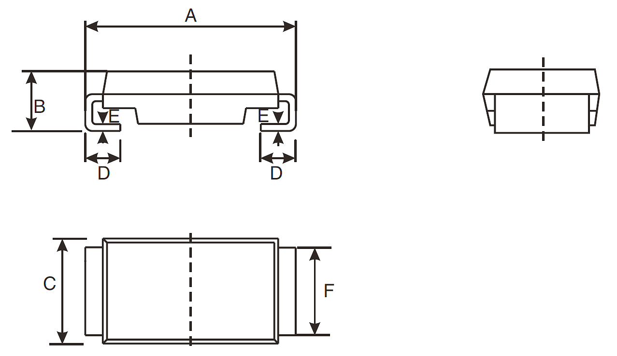
Symbols | Dimensions (mm) |  | Notes
Symbols | Min | Max | Notes
A | 11.9 | 12.3
B | 3.2 | 3.6
C | 5.9 | 6.6
D | 1.5 | 2.5 | both terminals
E | 0.3 | 0.5 | both terminals
F | 4.9 | 5.3 | both terminals

Variant 02 (4 Terminal Package)
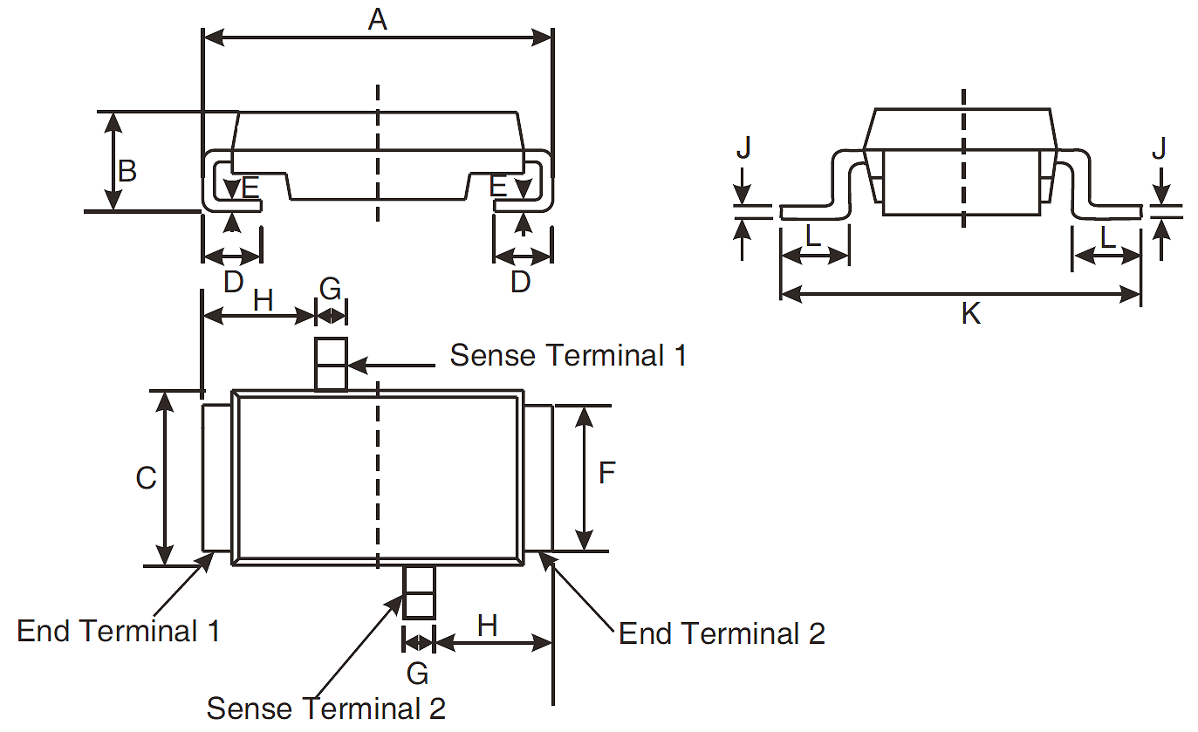
Symbols | Dimensions (mm) |  | Notes
Symbols | Min | Max | Notes
A | 11.9 | 12.3
B | 3.2 | 3.6
C | 5.9 | 6.6
D | 1.5 | 2.5 | both end terminals
E | 0.3 | 0.5 | both end terminals
F | 4.9 | 5.3 | both end terminals
G | 0.8 | 1.3 | both sense terminals
H | 4.3 | 4.9
J | 0.3 | 0.5 | both sense terminals
K | 8.8 | 9.6
L | 0.85 | 1.45 | both sense terminals

FUNCTIONAL DIAGRAM
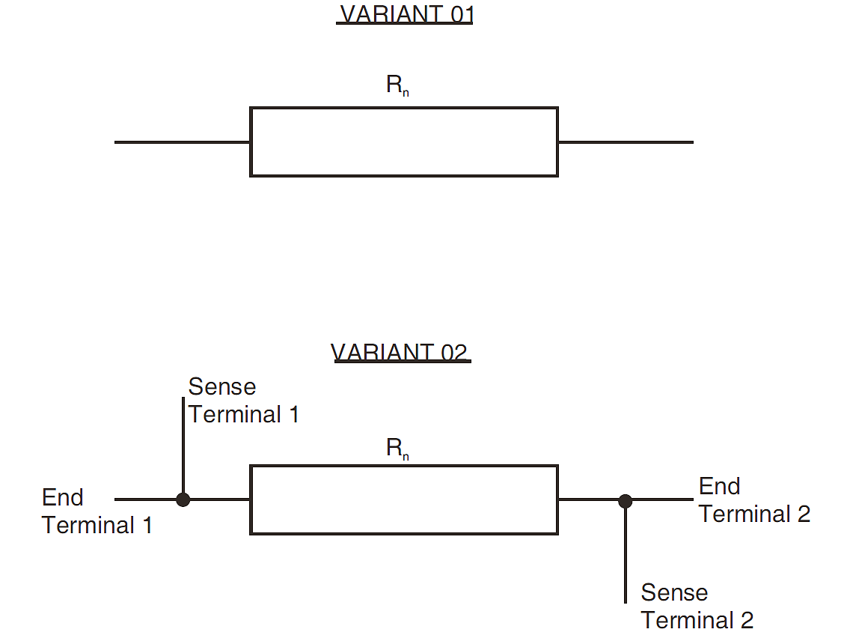

MATERIALS AND FINISHES

Terminals
The terminal finish shall be hot solder dip with Sn60 to a maximum thickness of 70μm.

REQUIREMENTS

GENERAL
The complete requirements for procurement of the components specified herein are as stated in this specification and the ESCC Generic Specification. Permitted deviations from the Generic Specification, applicable to this specification only, are listed below.
Permitted deviations from the Generic Specification and this Detail Specification, formally agreed with specific Manufacturers on the basis that the alternative requirements are equivalent to the ESCC requirement and do not affect the component’s reliability, are listed in the appendices attached to this specification.

Deviations from the Generic Specification

Deviations from Production Control - Chart F2
          - Prior to body moulding, a 100% Infrared Measurement in accordance with A-QS-009 shall be performed on each resistor element:
- Applied Voltage: √(5P_{n} x R_{n})
- Duration: 10ms

Deviations from Screening Tests - Chart F3
          - Screening Sub-lot Samples Selection, Mounting and Testing
A quantity of 20 components shall be selected at random from the production lot and mounted in accordance with ESCC Generic Specification No. 4001 Para. 8.7. These mounted Screening Sub-lot samples shall be serialised and subjected to tests and inspections of Chart F3 in parallel with the 100% testing. For each test requiring electrical measurements the results shall be recorded against component serial number. These samples shall not form part of the delivery lot.
          - Microsection Examination
A quantity of 10 components selected at random from the production lot at the same time as the Screening Sub-lot samples, shall be subjected to microsection examination of internal solder joints. These samples shall not form part of the delivery lot. The following requirements shall apply:
- The 10 samples shall be prepared for microsection examination by individually mounting them in suitable epoxy filled moulds.
- Each sample shall be cut, polished and examined sequentially in several parallel planes. The planes shall be chosen such that:
- All internal solder joints can be examined.
- Each internal solder joint is cur perpendicular to the joint plane thereby facilitating the examination for any voids in the solder joint.
- Each internal solder joint is sectioned and examined in 3 separate planes distributed along its length.
- Examination for any voids shall be performed for each solder joint in each of the 3 planes. Any voids identified in a solder joint in any of the 3 examinations, that total ≥ 50% of the visible solder joint area shall constitute a reject.
- A single reject shall be cause for production lot failure and the Manufacturer shall act in accordance with Lot Failure in ESCC Generic Specification No. 4001 Para. 4.3.3.
- Photographic results of all examinations traceable to the production lot, shall be included in the Screening Tests data documentation.
          - Para. 8.1 Overload
Overload shall only be performed on the mounted Screening Sub-lot samples. Resistance shall be measured as specified in Room Temperature Electrical Measurements both before and after Overload. Change in Resistance shall be calculated, recorded against component serial number, and shall not exceed the limit as follows:
- Change in Resistance during Overload: ±0.3% max
          - Para. 8.2, Non-Linearity: Not applicable.
          - Para. 8.3.2, Room Temperature Electrical Measurements
For the testing of the mounted Screening Sub-lot samples, Resistance shall be recorded against component serial number both before and after Burn-in. Change in Resistance shall be calculated, recorded against component serial number, and shall not exceed the limit as follows:
- Change in Resistance during Burn-in: ±0.2% max.
          - Para. 8.4 Burn-in:
For the 100% Testing during Chart F3, burn-in in accordance with No-Bias Burn-in of this specification shall be performed with a duration of 24 (+24, -0) hours.
For the testing of the mounted Screening Sub-lot samples, burn-in in accordance with Biased Burn-in of this specification shall be performed with a duration of 168 (+24 -0) hours.
          - Para. 6.4 Check for Lot Failure
0 failures are allowed during all Chart F3 testing of the mounted Screening Sub-lot samples. In the event of any failure the lot shall be considered as failed.

Deviations from Qualification and Periodic Tests - Chart F4
          - Para. 8.11, Robustness of Terminations: Not applicable.

Deviations from Data Documentation - Section 9
          - Para. 9.6, Screening Tests Data: For each test performed on the mounted Screening Sub-lot samples requiring electrical measurements, the results shall be recorded against component serial number. Component drift calculations shall be recorded for each specified test against component serial number.

MARKING
The marking of all components delivered to this specification shall be in accordance with the requirements of ESCC Basic Specification No. 21700. When the component is too small to accommodate all of the marking specified, as much as space permits shall be marked and the marking information, in full, shall accompany each component in its primary package.
The information to be marked and the order of precedence, shall be as follows:
          - The ESCC qualified components symbol (for ESCC qualified components only).
          - The ESCC Component Number.
          - Traceability information.

OVERLOAD
The test conditions for Overload, tested as specified in the ESCC Generic Specification, shall be as follows:
- Voltage: √(5P_{n} x R_{n})
- Duration: 5s

RESISTANCE TO SOLDERING HEAT
The test conditions for Resistance to Soldering Heat, tested as specified in the ESCC Generic Specification, shall be as follows:
- Temperature: 260ºC
- Duration: 5 (+0 −1)s

ELECTRICAL MEASUREMENTS AT ROOM, HIGH AND LOW TEMPERATURES

Room Temperature Electrical Measurements
The measurements shall be performed at T_{amb} = +22 ±3ºC.
Characteristics | Symbols | ESCC 4001 Test Method and Conditions | Tolerance  (± %) | Limits |  | Units
 |  |  |  | Min | Max | Units
Resistance | R_{A} | Para. 8.3.1.1 | 0.5 | 0.995 R_{n} | 1.005 R_{n} | Ω
Resistance | R_{A} | Para. 8.3.1.1 | 1 | 0.99 R_{n} | 1.01 R_{n} | Ω
Insulation Resistance | R_{I} | Para. 8.3.1.2  V = 500V, Note 1 | All | 1000 | - | MΩ
NOTES:
            - Guaranteed but not tested during Screening Tests.

High and Low Temperatures Electrical Measurements
Characteristics | Symbols | ESCC 4001 Test Method and Conditions | Limits |  | Units
Characteristics | Symbols | ESCC 4001 Test Method and Conditions | Min | Max | Units
Resistance Change between  -55 (+3 -0)°C and +22 ±3°C | ΔR_{A}/R_{A} | Para. 8.3.1.1 Note 1 |  |  | %
Resistance Change between  -55 (+3 -0)°C and +22 ±3°C | ΔR_{A}/R_{A} | TC = −110 x10⁻⁶/°C | -0.88 | +0
Resistance Change between +140 (+0 -3)°C and +22 ±3°C | ΔR_{A}/R_{A} | Para. 8.3.1.1 Note 1 |  |  | %
Resistance Change between +140 (+0 -3)°C and +22 ±3°C | ΔR_{A}/R_{A} | TC = ±60 x10⁻⁶/°C | -0.726 | +0.726
Resistance Change between +60 ±3°C and +22 ±3°C | ΔR_{A}/R_{A} | Para. 8.3.1.1 Note 2 |  |  | %
Resistance Change between +60 ±3°C and +22 ±3°C | ΔR_{A}/R_{A} | TC = ±30 x10⁻⁶/°C | -0.132 | +0.132
Resistance Change between +60 ±3°C and +22 ±3°C | ΔR_{A}/R_{A} | TC = ±50 x10⁻⁶/°C | -0.22 | +0.22
NOTES:
            - The measurements shall be performed on all the mounted Screening Sub-lot samples.
            - The measurements shall be performed on a sample of 5 components selected from the total production lot.

INTERMEDIATE AND END-POINT ELECTRICAL MEASUREMENTS
The components shall be mounted as specified in the ESCC Generic Specification.
Unless otherwise specified, the measurements shall be performed at T_{amb} = +22 ±3 ºC.
Unless otherwise specified the test methods and test conditions shall be as per the corresponding test defined in Para. 2.5.1 Room Temperature Electrical Measurements.
Test Reference per ESCC No. 4001 | Characteristics | Symbols | Limits |  | Units
Test Reference per ESCC No. 4001 | Characteristics | Symbols | Min | Max | Units
Rapid Change of Temperature
Initial Measurement | Resistance | R_{A} | Record Values
Final Measurement | Change in Resistance | ΔR_{A}/R_{A} | ±0.2 |  | %
Vibration
Initial Measurement | Resistance | R_{A} | Record Values
Final Measurement | Change in Resistance | ΔR_{A}/R_{A} | ±0.2 |  | %
Resistance to Soldering Heat
Initial Measurement | Resistance | R_{A} | Record Values
Final Measurement | Change in Resistance | ΔR_{A}/R_{A} | ±0.3 |  | %
Solderability
Initial Measurement | Resistance | R_{A} | Record Values
Final Measurement | Change in Resistance | ΔR_{A}/R_{A} | ±0.1 |  | %
Climatic Sequence
Initial Measurements (Procedure 1) | Resistance (after drying) | R_{A} | Record Values
Final Measurements | Change in Resistance | ΔR_{A}/R_{A} | ±0.3 |  | %
 | Insulation Resistance | R_{I} | 1000 | - | MΩ
Operating Life
Initial Measurement  (0 hour) | Resistance | R_{A} | Record Values
Intermediate Measurements (1000 hours) | Change in Resistance | ΔR_{A}/R_{A} | ±0.2 |  | %
Final Measurements (2000 hours) | Change in Resistance | ΔR_{A}/R_{A} | ±0.2 |  | %
Final Measurements (2000 hours) | Insulation Resistance | R_{I} | 1000 | - | MΩ

BURN-IN CONDITIONS

No-Bias Burn-in Conditions for 100% Testing
Characteristics | Symbols | Conditions (Note 1) | Units
Ambient Temperature | T_{amb} | +140 (+0 -5) | °C
Test Voltage | V_{T} | No Bias | V
NOTES:
            - No-Bias Burn-in (High Temperature Bake) shall be performed on components that are not mounted.
            - No-Bias Burn-in duration shall be 24 (+24 -0) hours.
            - After Burn-in, the components shall be removed from the chamber and allowed to cool under normal atmospheric conditions for a minimum of 1 hour. They shall then be visually examined. There shall be no evidence of damage and marking shall still be legible.

Biased Burn-in Conditions for Screening Sub-lot Samples
Characteristics | Symbols | Conditions (Note 1) | Units
Terminal Temperature | T_{term} | +80 (+0 -3) | °C
Test Voltage | V_{T} | √(P_{n} x R_{n}) | V
NOTES:
            - Biased Burn-in shall be performed on the applicable sample components that are mounted in accordance with ESCC Generic Specification No. 4001 Para. 8.7.
            - Biased Burn-in duration shall be 168 (+24 -0) hours.
            - After Burn-in, the components shall be removed from the chamber and allowed to cool under normal atmospheric conditions for a minimum of 1 hour. They shall then be visually examined. There shall be no evidence of damage and marking shall still be legible.

OPERATING LIFE CONDITIONS
The conditions shall be as specified in Para. 2.7.2 for Biased Burn-in.

APPENDIX A
AGREED DEVIATIONS FOR ISABELLENHUETTE (D)
Items Affected | Description of Deviations
Para. 2.1.1.1 Deviations from Generic Specification:  Production Control - Chart F2 | Para. 5.2.1, Dimension Check:  A 100% inspection may be performed.
Para. 2.1.1.2 Deviations from Generic Specification:  Screening Tests - Chart F3 | Para. 8.1, Overload:  For Variant 02, any holes or cracks identified during visual examination that do not fail the criteria of Para. 8.6, as below, shall not be considered as evidence of damage.
Para. 8.6, External Visual Inspection:
For Variant 02, the specific requirements of ESCC Basic Specification No. 2054000 shall apply with the following deviations:
- Para. 3.1, Magnification: All items shall be examined with a stereoscopic microscope with a magnification of between 5 and 20 power (x5 to x20).
- Paras. 4.4(b) & 4.4(c): These reject criteria are not applicable.
- Add new reject criteria to Para. 4.4 as follows:
  - Moulding material showing holes or cracks whose total surface area exceeds 3% of the total surface area of the moulding or coating material.
  - Any holes or cracks in the moulding material that bridge the space between any 2 terminals.
Para. 2.1.1.3 Deviations from Generic Specification:  Qualification and Periodic Tests - Chart F4 | Para. 8.6, External Visual Inspection: As for Screening Tests above.
Paras. 8.8, 8.9, 8.11 & 8.12, Rapid Change of Temperature, Vibration, Robustness of Terminations & Resistance to Soldering Heat:
For Variant 02, any holes or cracks identified during visual examination that do not fail the criteria of Para. 8.6, as above, shall not be considered as evidence of damage.
Para. 8.8, Rapid Change of Temperature:
A high temperature extreme of T_{amb} = +150 (+0 -3)°C may be applied during testing.
Para. 8.10, Climatic Sequence:
- Para. 8.10.5, Low Air Pressure: Not applicable.
- Para. 8.10.7, DC Load: Not applicable.
 | Para. 8.15, Permanence of Marking: Not applicable.
Para. 1.4.1.1 Characteristics Codes:  Resistance Value | Resistance Value shall be expressed by means of the following codes within the ESCC Component Number. The unit quantity shall be ohm (Ω):
Para. 1.4.1.1 Characteristics Codes:  Resistance Value | Resistance Value (Ω) | Code
Para. 1.4.1.1 Characteristics Codes:  Resistance Value | 0.00XX | R00XX
Para. 1.4.1.1 Characteristics Codes:  Resistance Value | 0.0XX | R0XX
Para. 1.4.1.1 Characteristics Codes:  Resistance Value | 0.XXX | RXXX
Para. 1.4.1.1 Characteristics Codes:  Resistance Value | X.XX | XRXX
Para. 1.4.2 Component Type Variants and Range of Components | For all Variants, additional resistance values, R_{n}, from within the specified Resistance Range, but outside of the specified Value Series, are available upon request from Isabellenhuette.
Para. 2.2 Marking:  Marking of Tolerance on Resistance Value | The tolerance on resistance value may be marked using the actual numeric value (0.5% or 1%) instead of the specified code letter.
Para. 2.2 Marking:  Marking of Traceability Information | The manufacturing date code may be marked using a three-digit code where:  - the first digit is a letter to indicate the year of manufacture in accordance with the first digit of the two-character code for year and month in a twenty-year cycle in IEC Publication No. 60062.  - the last two digits indicate the week of the year (i.e. 01 to 52) during which encapsulation or the final production process occurred.  For example: R41 for week 41 of 2023

