

Page 1 of 15

EVALUATION TEST PROGRAMME FOR RESISTORS

ESCC Basic Specification No. 2264000

Issue 4 Draft A | July 2023



Document Custodian: European Space Agency – see https://escies.org

Legal Disclaimer and Copyright
European Space Agency, Copyright © 2023. All rights reserved.
The European Space Agency disclaims any liability or responsibility, to any person or entity, with respect to any loss or damage caused, or alleged to be caused, directly or indirectly by the use and application of this ESCC publication.
This publication, without the prior permission of the European Space Agency and provided that it is not used for a commercial purpose, may be:
- copied in whole, in any medium, without alteration or modification.
- copied in part, in any medium, provided that the ESCC document identification, comprising the ESCC symbol, document number and document issue, is removed.

DOCUMENTATION CHANGE NOTICE
(Refer to https://escies.org for ESCC DCR content)
DCR No. | CHANGE DESCRIPTION
TBA | Specification upissued to incorporate changes per DCR.

TABLE OF CONTENTS
1 PURPOSE 6
2 APPLICABLE DOCUMENTS 6
2.1 GENERAL 6
2.2 ESCC SPECIFICATIONS 6
2.3 OTHER (REFERENCE) DOCUMENTS 6
3 PROCEDURE 6
4 TEST PROGRAMME SEQUENCE AND SAMPLE DISTRIBUTION (See Chart I) 7
5 TEST DESCRIPTION 8
5.1 EXTERNAL VISUAL INSPECTION 8
5.2 ELECTRICAL MEASUREMENTS 8
5.3 TEMPERATURE COEFFICIENT MEASUREMENT (SEE CHART II) 8
5.4 X-RAY INSPECTION 8
5.5 CONSTRUCTION ANALYSIS 8
5.5.1 Micro-section (1 resistor per value) 8
5.5.2 Destructive Physical Analysis (2 resistors per value) 9
5.6 STEP-STRESS TEST 9
5.6.1 Failure Criteria 9
5.6.2 Test Description 10
5.7 HIGH TEMPERATURE STORAGE TEST 10
5.8 MECHANICAL AND CLIMATIC TESTS (see CHART III) 12
5.8.1 Vibration Testing 12
5.8.2 Humidity Test 12
5.8.3 Electrical Measurements 12
5.8.4 Rapid Change in Temperature (50 cycles) 12
5.8.5 Dry Heat Test 12
5.8.6 Damp Heat (first cycle) 13
5.8.7 Cold Test 13
5.8.8 Low Air Pressure Test 13
5.8.9 Damp Heat Test 13
5.8.10 Electrical Measurements 13
5.8.11 External Visual Inspection 13
5.8.12 Robustness of Terminations 13
5.8.13 External Visual Inspection 13
5.9 LOAD LIFE TEST (SEE CHART IV) 13
5.10 MATERIALS AND FINISHES 14
6 ESD TESTING (10 COMPONENTS) 14
7 TEST RESULTS 14

PURPOSE
The purpose of this specification is to establish the procedure to be followed in the evaluation of component capabilities as required for space applications and thereby to anticipate, as far as possible, component behaviour during qualification testing. Therefore, the aim of such testing shall be to overstress specific characteristics of the component concerned with a view to the detection of possible failure modes. Additionally, a detailed destructive physical analysis shall be performed to detect any design and construction defects which may affect the lifetime of the component and to facilitate failure analysis activities. The evaluation shall also include a check of the susceptibility of the component to ESD damage.

APPLICABLE DOCUMENTS

GENERAL
The following documents form part of, and shall be read in conjunction with, this specification.

ESCC SPECIFICATIONS
- No. 4001, Resistors, Fixed, Film.
- No. 4006, Thermistors (Resistors, Thermally Sensitive).
- No. 4009, Resistors, Heaters, Flexible.
- No. 20400, Internal Visual Inspection.
- No. 20500, External Visual Inspection.
- No. 22600, Requirements for the Evaluation of Standard Electronic Components for Space Application.
- No. 23800, Electrostatic Discharge Sensitivity Test Method.
Unless otherwise stated herein, reference within the text of this specification to "the Detail Specification" shall mean the ESCC Detail Specification.

OTHER (REFERENCE) DOCUMENTS
- ECSS-Q-ST-70-02, A Thermal Vacuum Test for the Screening of Space Materials.
- IEC Publication No. 60068 Part 2, Basic Environmental Testing Procedures.

PROCEDURE
Standard components shall be selected from a homogeneous lot at the Manufacturer to be evaluated. These components shall not have been submitted to any screening or burn-in, but must have been manufactured in conformity with high reliability practice and an established Process Identification Document (PID).
The tests specified in the programme shall be performed in the sequence shown in Chart I. All results shall be recorded and failed components submitted to a failure analysis. Probable failure modes and mechanisms shall be determined.
The evaluation testing programme shall be performed under the supervision of the ESCC Executive.

TEST PROGRAMME SEQUENCE AND SAMPLE DISTRIBUTION (See Chart I)
Each resistor shall be identified by an individual number. Distribution of test samples shall be in accordance with Chart I. The component numbers shown in the Chart refer to one value only. There shall be three values per resistor type, viz. one from the top of the range, one from the middle and one from the bottom of the range.

Chart I - Test Programme Sequence and Sample Distribution
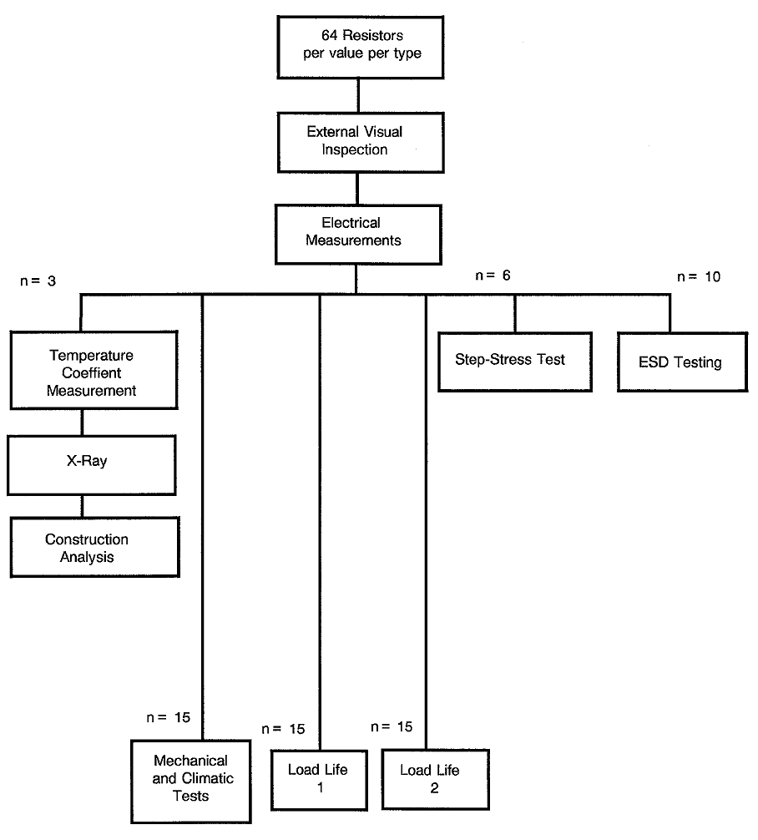
NOTES:
            - All numbers shown in this Chart refer to value per type.

TEST DESCRIPTION

EXTERNAL VISUAL INSPECTION
This inspection shall be performed according to ESCC Basic Specification No. 20500.

ELECTRICAL MEASUREMENTS
These measurements shall be performed in accordance with Table 2 of the relevant Detail Specification and in conjunction with a non-linearity measurement. They shall be performed according to the applicable ESCC Generic Specification.

TEMPERATURE COEFFICIENT MEASUREMENT (SEE CHART II)
This measurement shall be performed according the relevant paragraph of Section 8 of the applicable Generic Specification. The test sequence to be applied is shown in Chart II of this specification:
CHART II - TEMPERATURE COEFFICIENT MEASUREMENT
+22°C | Resistance Measurement
0°C | Resistance Measurement
-15°C | Resistance Measurement
-55°C | Resistance Measurement
+22°C | Resistance Measurement
+50°C | Resistance Measurement
+75°C | Resistance Measurement
+100°C | Resistance Measurement
+125°C | Resistance Measurement
+200°C | Resistance Measurement (if applicable)
+275°C | Resistance Measurement (if applicable)
Each temperature shall be established for 30 to 45 minutes before measurement.

X-RAY INSPECTION
During their submission to X-ray inspection, the resistors shall be positioned perpendicular to their horizontal axis.

CONSTRUCTION ANALYSIS
The sample of three resistors per value shall be divided as follows:

Micro-section (1 resistor per value)
Micro-sectioning shall be performed by an experienced metallographical laboratory. For evaluation purposes, photographs shall be taken of features such as winding uniformity, cap/lead junction and core/cap junction, distance between resistor element and case.

Destructive Physical Analysis (2 resistors per value)
The case and/or moulding shall be removed without causing damage to the resistor element. For this purpose, appropriate mechanical and chemical methods, not affecting the ceramic or metallic materials, shall be selected.
Subsequently, the devices shall be visually inspected in accordance with ESCC Basic Specification No. 20400. Three SEM photographs shall be taken of each resistor, viz. one of the cap and part of the winding; one of the weld connection between cap and wire, and one of the cap/lead junction. For analysis of the mechanical construction, the resistor shall be stripped to single elements showing the following features:
- Distribution of wire,
- Construction of cap/lead junction,
- Contact between wire and core with method of attachment,
- Protection against axial dislocation,
- Protection against twisting of cap.
All materials shall be identified and internal dimensions shall be measured.

STEP-STRESS TEST
Six resistors per value per type shall be submitted to a step-stress test consisting of increases in ambient temperature and power dissipation.

Failure Criteria
Failures are defined as:
- limit failures
- open circuit (interruption)
- short circuit (between case and resistor element)
- short circuit (e.g. between different layers of winding)

Test Description
The resistors shall be split into two equivalent subgroups. One subgroup shall be submitted to power increases, the other to ambient temperature increases. The following Figures serve as an example only:
Subgroup 1
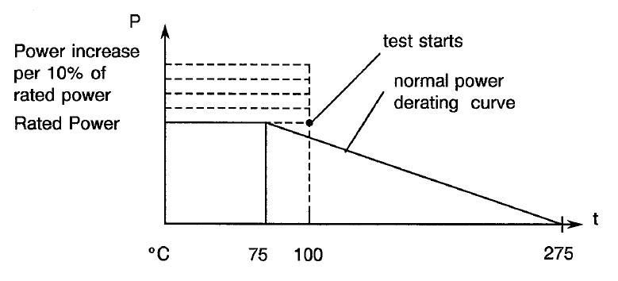
Subgroup 2
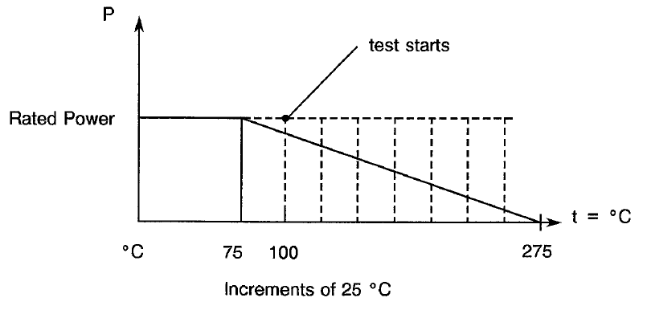
For each step, the temperature shall be allowed to stabilise and the resistors shall remain under these conditions for 1.5 hours. Case temperatures shall be monitored by means of thermocouples and be recorded after one hour of stabilised conditions. Following the 1.5 hour time lapse, the resistors shall be taken out of the chamber and allowed to cool at room temperature for a period of two hours. The resistance shall then be measured and the resistors be examined visually.
When all resistors have failed, the test shall be stopped and the results used for determination of the best conditions to detect the particular mode evidenced by this step-stress test.

HIGH TEMPERATURE STORAGE TEST
The resistors shall be placed in an oven of which the temperature is set at a temperature higher than the resistors’ rated temperature. The rated temperature shall be determined on the basis of the step­stress results, bearing in mind the limits imposed by the construction materials.
A resistance measurement shall be performed every 500 hours after the cooling-down of the resistors and the test shall last for 2000 hours in total.
Upon completion of the test, the resistors shall be inspected visually and electrical measurements shall be made in accordance with the requirements specified in Para. 5.2.
CHART III - MECHANICAL AND CLIMATIC TEST SEQUENCE
Para. 5.8.1
Vibration (Test 1)
Para. 5.8.2
Humidity (Test 1)
Para. 5.8.1
Vibration (Test 2)
Para. 5.8.2
Humidity (Test 2)
Para. 5.8.3
Electrical Measurements
Para. 5.8.4
Thermal Shock
Para. 5.8.5
Dry Heat (with Resistance Measurement)
Para. 5.8.6
First Damp Heat Cycle
Para. 5.8.7
Cold
Para. 5.8.8
Low Air Pressure
Para. 5.8.9
Damp Heat
Para. 5.8.10
Electrical Measurements
Para. 5.8.11
External Visual Inspection
Para. 5.8.12
Robustness of Terminations
Para. 5.8.13
External Visual Inspection
+ Resistance Measurement
2 hours R.T., + Resistance Measurement
+ Resistance Measurement
2 hours R.T.
2 hours R.T., + Resistance Measurement
2 hours R.T., + Resistance Measurement, 2 hours R.T.

3 hours R.T., + Resistance Measurement

2 hours R.T., + Resistance Measurement

2 hours R.T., + Resistance Measurement

2 hours R.T.
NOTES:
            - R.T. = Room Temperature

MECHANICAL AND CLIMATIC TESTS (see CHART III)

Vibration Testing
The resistors shall be submitted to Test Fc of IEC Publication No. 60068-2-6, with the following details and exceptions:
- Sweep frequency: 10 - 2000 Hz;
- 1.5mm double amplitude or 20g, whichever is less (test 1) or 30g (test 2);
- Sweep duration: 10 - 2000 - 10 Hz in 20 minutes;
- Number of sweeps: three in each axis;
- Axis: one perpendicular and the other parallel to the longitudinal axis of the resistor.
The resistor shall be mounted by their normal mounting means on a vibration test jig constructed so as to prevent any resonances within the test range. Resistors without specific mounting means shall be clamped in a test jig.

Humidity Test
This test shall be performed according to IEC Publication No. 60068-2-78 and the test conditions shall be as follows:
- Test chamber temperature: +40 ±2°C;
- Relative chamber humidity: 90 - 95%;
- Test duration:
- Test 1: 21 days - unloaded resistors,
- Test 2: 35 days with resistors polarised with 100Vdc.

Electrical Measurements
As specified in Para. 5.2.

Rapid Change in Temperature (50 cycles)
The resistors shall be tested as specified in Section 6 of the applicable ESCC Generic Specification, except that the time allowed for transfer from one temperature extreme to another shall be 5 to 10 seconds and that the upper temperature shall be the maximum rated temperature, or +200°C, whichever is less, for the components concerned. Following this test, the resistors shall be examined for evidence of mechanical damage.

Dry Heat Test
The resistors shall be stored in an oven set at the maximum rated temperature or +200°C, whichever is less, for a period of 16 hours. They shall be measured while at high temperature.
The influence of the contact resistances on resistors with a value lower than 100Ω will most probably exceed the changes in resistance and, therefore, they shall not be measured. Resistance measurements at high temperature shall be made and care shall be taken to prevent accuracy of measurements being affected by wire resistance.

Damp Heat (first cycle)
The resistors shall be placed in a climatic chamber with the following cycle:
- The temperature shall be increased to +55°C within 2.5 hours and have a relative humidity of 90 ± 10%. For the next 16 hours, the temperature shall remain at +55°C and the relative humidity between 95% and 99%.
- Subsequently, the chamber shall be cooled down for 6 hours until a temperature is reached of
+25°C, but with the relative humidity remaining at between 80% and 100%.
Upon completion of this cycle, the resistors shall be submitted to external visual inspection.

Cold Test
The resistors shall be stored in a low temperature chamber at -55°C for two hours. During the last hour, the full-rated continuous voltage shall be applied to devices in accordance with the Detail Specification. After this period, the resistors shall be allowed a 4-hour recovery time outside the chamber under room ambient conditions. They shall then be examined for mechanical damage.

Low Air Pressure Test
The resistors shall be stored in a vacuum chamber for one hour and a pressure equal to, or less than, 44torr shall be applied. The temperature within the chamber shall be +25 ±3°C.
Full-rated continuous voltage shall be applied to the resistors.

Damp Heat Test
The resistors shall be subjected to another damp heat test as specified in Para. 5.8.6 for five more cycles.
During the last two cycles, a DC voltage of 100V shall be applied between the resistors and their cases or support plates.

Electrical Measurements
As specified in Para. 5.2.

External Visual Inspection
As specified in Para. 5.1.

Robustness of Terminations
The resistors shall be tested according to the requirements of the Generic Specification. The relevant Detail Specification shall specify the applicable loads.

External Visual Inspection
As specified in Para. 5.1.

LOAD LIFE TEST (SEE CHART IV)
The load life test shall be performed as specified in the Generic Specification. The test temperature and operating condition shall be different from those specified for load life tests 1 and 2 and shall be derived from the step-stress test results.
A time interval of three hours shall be allowed at room temperature before performing intermediate and final resistance measurements.

MATERIALS AND FINISHES
All non-metallic materials and finishes, that are not within a hermetically sealed enclosure, of the components specified herein shall be tested in accordance with ECSS-Q-ST-70-02 to verify its outgassing requirements, unless relevant data is available.

ESD TESTING (10 COMPONENTS)
ESD testing shall be performed in accordance with ESCC Basic Specification No. 23800. If the component under examination is not categorised into one of the three Classes listed, then the component shall be termed "unclassified".
With the agreement of the ESCC Executive, the test structure may be used in place of the components.

TEST RESULTS
All test results shall be recorded and related to individual serial numbers; drifts shall be calculated and results compared.
All rejects and failures shall be submitted to detailed failure analysis.
CHART IV - LOAD LIFE TEST

Load Life (256 hrs)
3 hours R.T.
Resistance Measurement (R250)
Load Life (256 hrs)
3 hours R.T.
Resistance Measurement (R500)
Load Life (496 hrs)
3 hours R.T.
Resistance Measurement (R1000)
Load Life (1000 hrs)
3 hours R.T.
Resistance Measurement (R2000)
Para. 5.2 Electrical Measurements
NOTES:
            - R.T. = Room Temperature

