

Page 1 of 22
RF COAXIAL CONNECTORS, TNC, VERY HIGH POWER, 50 OHMS (FEMALE INTERFACE)
BASED ON TYPE TNC-VHP

ESCC Detail Specification No. 3402/027

Issue 3 Draft X | June 2023



Document Custodian: European Space Agency – see https://escies.org

Legal Disclaimer and Copyright
European Space Agency, Copyright © 2023. All rights reserved.
The European Space Agency disclaims any liability or responsibility, to any person or entity, with respect to any loss or damage caused, or alleged to be caused, directly or indirectly by the use and application of this ESCC publication.
This publication, without the prior permission of the European Space Agency and provided that it is not used for a commercial purpose, may be:
- copied in whole, in any medium, without alteration or modification.
- copied in part, in any medium, provided that the ESCC document identification, comprising the ESCC symbol, document number and document issue, is removed.

DOCUMENTATION CHANGE NOTICE
(Refer to https://escies.org for ESCC DCR content)
DCR No. | CHANGE DESCRIPTION
TBA | Specification upissued to incorporate changes per DCR.
Draft 3X 8/6/23  S.Thacker/ESCC-TW | Initial draft revision based on currently published issue 2 raised per Radiall request (related to DCR1578 raised on ESCC3408/001; ref. ESCC NCR Ref. NC-1-C-RAD-3-01).  Changes from issue 2 are highlighted yellow for information; see Appendix A for details.  Note: This DCR does not implement any conversion changes into this Detail spec that are currently under review per DCR1442 related to compliance with the newly published ESCC Generic 3402 issue 6)

TABLE OF CONTENTS
1 General 6
1.1 SCOPE 6
1.2 TYPE VARIANTS 6
1.3 MAXIMUM RATINGS 6
1.4 PARAMETER DERATING INFORMATION 6
1.5 PHYSICAL DIMENSIONS 6
1.6 STANDARD TEST CONNECTOR INTERFACE 6
2 APPLICABLE DOCUMENTS 11
3 TERMS, DEFINITIONS, ABBREVIATIONS, SYMBOLS AND UNITS 11
4 REQUIREMENTS 11
4.1 GENERAL 11
4.2 DEVIATIONS FROM GENERIC SPECIFICATION 11
4.2.1 Deviations from Special I-Process Controls 11
4.2.2 Deviations from final Production Tests (Chart II) 11
4.2.3 Deviations from Burn-in Tests (Chart III) 11
4.2.4 Deviations from Qualification Tests (Chart IV) 11
4.2.5 Deviations from Lot Acceptance Tests (Chart V) 12
4.3 ENVIRONMENTAL, MECHANICAL and Endurance REQUIREMENTS 12
4.3.1 Dimension Check 12
4.3.2 Weight 12
4.3.3 Contact Engagement and Separation Forces 12
4.3.4 Coupling Proof Torque 13
4.3.5 Mating and Unmating Forces 13
4.3.6 Centre Contact Retention 13
4.3.7 Cable Retention Force 13
4.3.8 Endurance 13
4.3.9 Residual Magnetism 13
4.3.10 Multipaction 13
4.3.11 RF Power Handing 14
4.3.12 Corona 14
4.4 MATERIALS AND FINISHES 14
4.4.1 Material and Plating 14
4.5 MARKING 14
4.5.1 General 14
4.5.2 The ESCC Component Number 15
4.5.2.1 Characteristics Codes 15
4.5.3 Traceability Information 15
4.6 ELECTRICAL MEASUREMENTS 15
4.6.1 Electrical Measurements at Room Temperature 15
4.7 ENVIRONMENTAL, MECHANICAL AND ENDURANCE TESTS 16
4.7.1 Measurements and Inspections on Completion of Environmental, Mechanical and Endurance Tests 16
APPENDIX A 21

General

SCOPE
This specification details the ratings, physical and electrical characteristics, test and inspection data for RF Coaxial Connectors, Type TNC-VHP, 50 Ohms (Female Interface). It shall be read in conjunction with ESCC Generic Specification No. 3402, the requirements of which are supplemented herein.

TYPE VARIANTS
A list of the type variants of the connectors specified herein, which are also covered by this specification, is given in Table 1(a).
For each type variant, specific electrical, mechanical and other relevant characteristics are given in individual Figures 2(b) at the end of this specification.

MAXIMUM RATINGS
The maximum ratings, which shall not be exceeded at any time during use or storage, applicable to the connectors specified herein, are as scheduled in Table 1(b).

PARAMETER DERATING INFORMATION
The derating information applicable to the connectors specified herein is shown in Figure 1.

PHYSICAL DIMENSIONS
The physical dimensions of the connectors specified herein are shown in Figure 2.

STANDARD TEST CONNECTOR INTERFACE
Whenever gauges are required for mating with the connectors under test, their physical dimensions shall be in accordance with those specified in Figure 3.

Table 1(a) – Type Variants
Variant Number | Description (1)
01 | Square Flange Female Receptacle, Round Post Termination
02 | Square Flange Female Receptacle, for PCB Transmission Line with Ø Pin 1.73mm
notes:
            - The Variants are described in Figure 2(b).
Table 1(b) - Maximum ratings
Characteristics | Symbols | Maximum Ratings | Units | Remarks
RF Power (Continuous) | P_{rf} | 400 | W | Notes 1, 2, 3
Nominal Impedance | Z | 50 | Ω | -
Operating Frequency Range | f | DC to 8 | GHz | -
Operating Voltage | V_{op} | 500 | Vrms | -
Corona Level | P_{co} | 120 | W | RF power level without corona breakdown
Operating Temperature Range | T_{op} | See Figure 2(b) | °C | T_{amb}
Storage Temperature Range | T_{stg} | As per Operating Temperature Range | °C | -
NOTES:
            - Derating with pressure is not required for ≤ 1.5mPa.
            - At f = 2GHz. For f > 2GHz, derate as shown in Figure 1(a). Load VSWR is better than 1.3.
            - At T_{amb} = +100°C. For T_{amb} > +100°C, derate as shown in Figure 1(b). For operation under vacuum, T_{amb} shall be the temperature of the equipment the component is mounted on.

FIGURE 1 - PARAMETER DERATING INFORMATION
FIGURE 1(a) - POWER VERSUS FREQUENCY
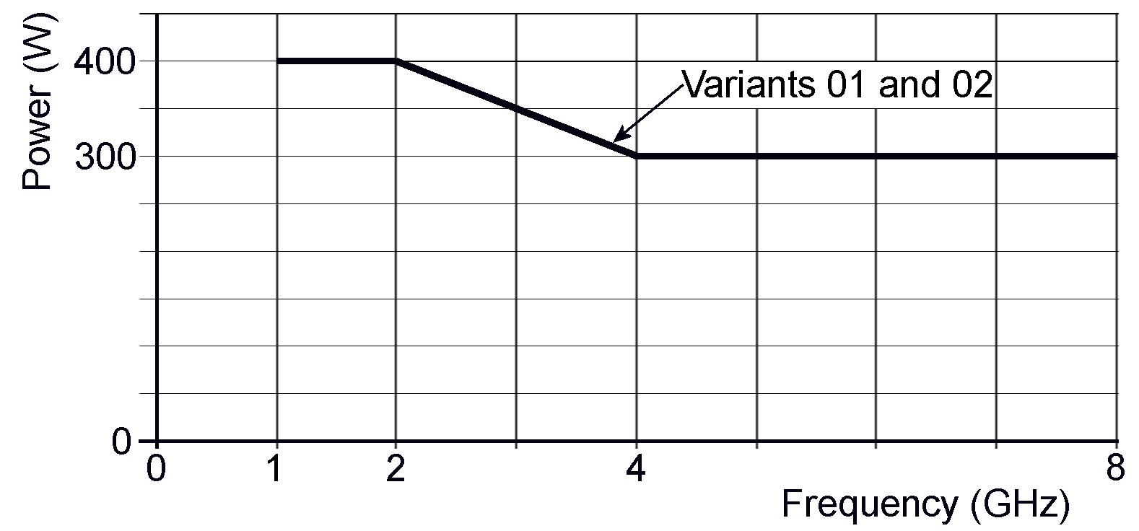
FIGURE 1(b) – RF POWER VERSUS AMBIENT TEMPERATURE
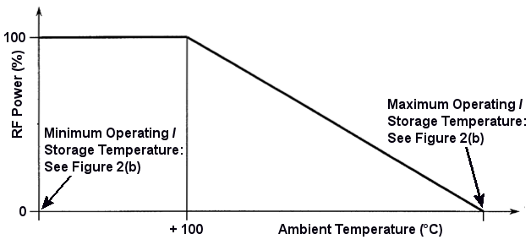

Figure 2 – Physical DimensionS
Figure 2(a) – Interface Dimensions
TNC Female interface
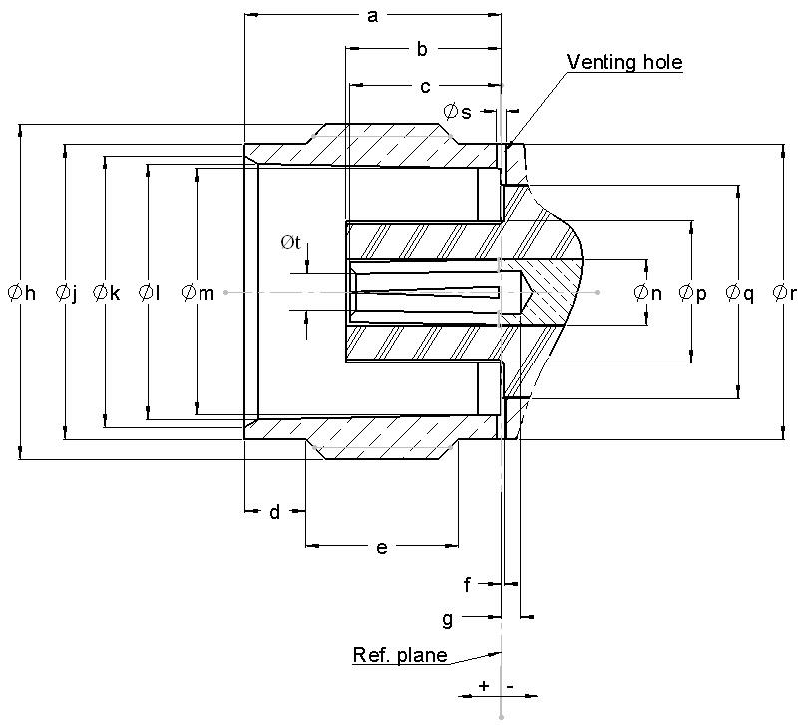
Symbols | Dimensions (mm) |  | Remarks |  | Symbols | Dimensions (mm) |  | Remarks
Symbols | Min | Max | Remarks |  | Symbols | Min | Max | Remarks
a | 8.36 | 8.46 |  |  | Øk | 8.8 | 9
b | 4.97 | 5.23 |  |  | Øl | 8.32 | 8.46
c | 4.72 | 5.22 |  |  | Øm | 8.1 | 8.15
d | 1.8 | 2.2 |  |  | Øn | 2.14 | 2.18
e | 4.75 | 5.25 |  |  | Øp | 4.62 | 4.72
f | -0.1 | +0.05 |  |  | Øq | 6.975 | 7.025
g | 0.08 | 1.18 |  |  | Ør | 9.61 | 9.68
Øh | 7/16-28 UNEF-2A |  |  |  | Øs | 0.25 | 0.35 | Venting hole
Øj | 9.61 | 9.68 |  |  | Øt | 1.4 | 1.45
Figure 3 - Mating Gauge Dimensions
TNC Male interface
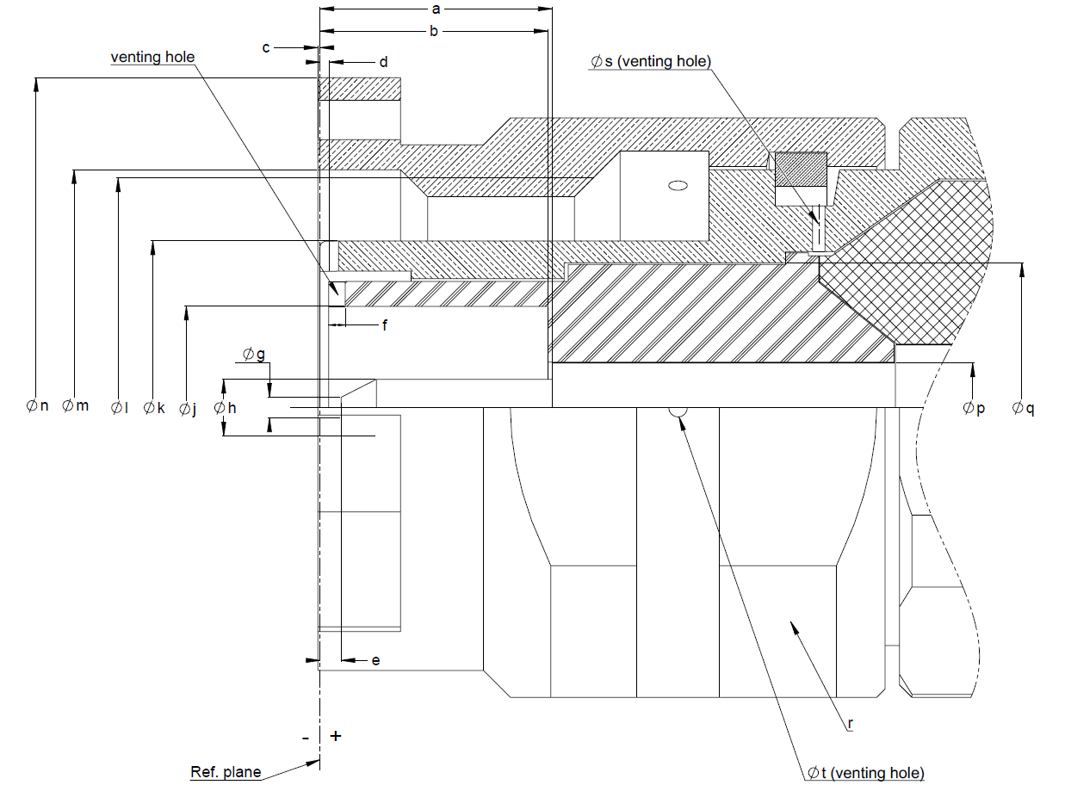
Symbols | Dimensions (mm) |  | Remarks |  | Symbols | Dimensions (mm) |  | Remarks
Symbols | Min | Max | Remarks |  | Symbols | Min | Max | Remarks
a | 5.35 | 5.85 |  |  | Øk | 8.03 | 8.09
b | 5.42 | 5.78 |  |  | Øl | 7/16-28 UNEF-2B
c | +0.3 | -0.55 |  |  | Øm | 11.4 | 11.6
d | 0.15 | 0.45 |  |  | Øn | - | 16
e | 0.1 | 0.9 |  |  | Øp | 2.14 | 2.18
f | 0.35 x 0.35 | 0.45 x 0.45 | Venting hole |  | Øq | 6.975 | 7.025
Øg | 0.35 | 0.65 |  |  | r | - | 14 | Square
Øh | 1.32 | 1.37 |  |  | Øs | 0.25 | 0.35 | Venting hole
Øj | 4.88 | 4.92 |  |  | Øt | 0.4 | 0.5 | Venting hole

APPLICABLE DOCUMENTS
The following documents form part of this specification and shall be read in conjunction with it:
          - ESCC Generic Specification No. 3402 for RF Coaxial Connectors.
          - ESCC Generic Specification No. 3408 for RF Cable Assemblies.

TERMS, DEFINITIONS, ABBREVIATIONS, SYMBOLS AND UNITS
For the purpose of this specification, the terms, definitions, abbreviations, symbols and units specified in ESCC Basic Specification No. 21300 shall apply.

REQUIREMENTS

GENERAL
The complete requirements for procurement of the connectors specified herein are stated in this specification and ESCC Generic Specification No. 3402. Deviations from the Generic Specification applicable to this specification only, are listed in Para. 4.2.
Deviations from the applicable Generic Specification and this Detail Specification, formally agreed with specific Manufacturers on the basis that the alternative requirements are equivalent to the ESCC requirements and do not affect the components' reliability, are listed in the appendices attached to this specification.

DEVIATIONS FROM GENERIC SPECIFICATION

Deviations from Special I-Process Controls
None.

Deviations from final Production Tests (Chart II)
          - Para. 9.4, Coupling Proof Torque: shall not be performed on connectors with a female contact (only during Chart II).

Deviations from Burn-in Tests (Chart III)
Not applicable.

Deviations from Qualification Tests (Chart IV)
          - The following additional subgroup test sequence shall be performed on a mated pair of connectors during Qualification Tests; no failures are allowed:
- Multipaction: Para. 4.3.10.
- RF Power Handling: Para. 4.3.11.
- Corona: Para. 4.3.12.
- External Visual Inspection: Para. 9.8 of the Generic Specification.
          - Para. 9.17, Corona Level: shall not be performed.

Deviations from Lot Acceptance Tests (Chart V)
The following additional subgroup test sequence shall be performed on a mated pair of connectors during Lot Acceptance Tests as part of the Environmental/Mechanical Subgroup; no failures are allowed:
          - Multipaction: Para. 4.3.10.
          - RF Power Handling: Para. 4.3.11.
          - Corona: Para. 4.3.12.
          - External Visual Inspection: Section 9 of the Generic Specification.
Note:
Testing per this additional subgroup is not required to be performed on ESCC qualified components if there is no change in the material, process and design of the component since initial qualification, subject to technical justification being provided by the Manufacturer and agreed by the ESCC Executive.

ENVIRONMENTAL, MECHANICAL and Endurance REQUIREMENTS

Dimension Check
The applicable test requirements are specified in Section 9 of ESCC Generic Specification No. 3402. The dimensions of the connectors specified herein shall conform to those shown in Figures 2(a) and 2(b) of this specification.

Weight
The maximum weight of the connectors specified herein shall be as specified in Figure 2(b).

Contact Engagement and Separation Forces
The applicable test requirements are specified in Section 9 of ESCC Generic Specification No. 3402. The following details shall apply:
          - Oversize Test Pin (See Figure 4):
- Steel test pin diameter: 1.384/1.388mm
- Insertion depth: 2/2.5mm
- Number of insertions: 3
          - Maximum Diameter Test Pin (See Figure 4):
- Steel test pin diameter: 1.372/1.376mm
- Engagement depth: 3/3.5mm
- Engagement force: ≤ 9N
          - Minimum Diameter Test Pin (See Figure 4):
- Steel test pin diameter: 1.308/1.321mm
- Separation depth: 3/3.5mm
- Separation force: ≥ 0.56N
Figure 4 – Test Pins Configuration
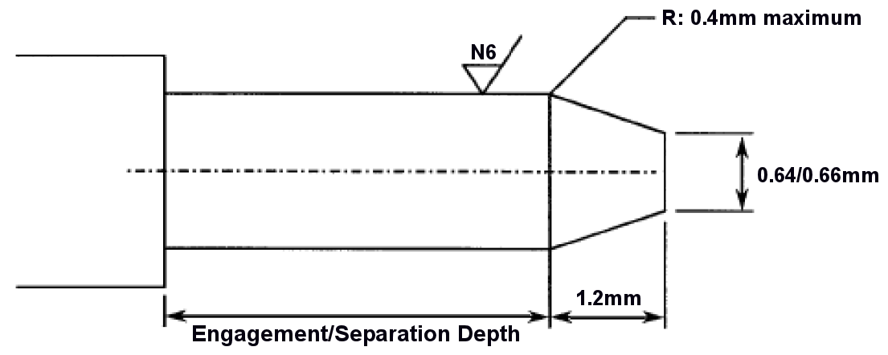

Coupling Proof Torque
The applicable test requirements are specified in Section 9 of ESCC Generic Specification No. 3402. The applied torque shall be 339N.cm.

Mating and Unmating Forces
The applicable test requirements are specified in Section 9 of ESCC Generic Specification No. 3402. The maximum torque during mating and unmating shall not exceed 22.6N.cm.
Whenever a test is performed on mated pairs of connectors, the pairs shall be torqued at
265N.cm.

Centre Contact Retention
The requirements for this test are specified in Section 9 of ESCC Generic Specification No. 3402. The test conditions are given in Figure 2(b). After testing, the connector interface dimensions shall be within the limits of Figure 2(a).

Cable Retention Force
The applicable test requirements are specified in Section 9 of ESCC Generic Specification No. 3402. The test conditions shall be as specified in Figure 2(b).

Endurance
The applicable test requirements are specified in Section 9 of ESCC Generic Specification No. 3402. The test conditions shall be as follows:
- Number of cycles: 500 for Qualification Tests (Chart IV); 100 for Lot Acceptance Tests (Chart V).
- Rate: 12 cycles/minute maximum.

Residual Magnetism
The applicable test requirements are specified in Section 9 of ESCC Generic Specification No. 3402. The residual magnetism shall not exceed 20 gamma.

Multipaction
Multipaction shall be performed as specified in Section 8 of ESCC Generic Specification No. 3408. The multipaction classification applicable to these components is type 2. The test requirements are specified in Figure 2(b) herein.

RF Power Handing
RF Power Handling shall be performed as specified in Section 8 of ESCC Generic Specification No. 3408. The following test conditions shall apply:
          - Test temperature: T_{amb} = +100°C.

Corona
Corona shall be performed as specified in Section 8 of ESCC Generic Specification No. 3408. The test requirements are specified in Figure 2(b) herein.

MATERIALS AND FINISHES
The materials and finishes shall be as specified herein. Where a definite material is not specified, a material which will enable the connectors specified herein to meet the performance requirements of this specification shall be used. Acceptance or approval of any constituent material does not guarantee acceptance of the finished product.

Material and Plating
          - Shell:
- Material: Beryllium copper
- Plating: Gold 2.5µm, over copper 2.5µm
          - Centre Contact:
- Material: Beryllium copper
- Plating: Gold 2.5µm, over copper 2.5µm
          - Insert:
- Material: PTFE and Fluoroloy H

MARKING

General
The marking of all components delivered to this specification shall be in accordance with the requirements of ESCC Basic Specification No. 21700 and the following paragraphs. Each component shall be marked in respect of:
          - The ESCC qualified components symbol (for ESCC qualified components only).
          - The ESCC Component Number.
          - Traceability Information.

The ESCC Component Number
Each component shall bear the ESCC Component Number which shall be constituted and marked as follows:
Example (for variable configuration: Variant 01): 340202701B13D002D5
- Detail Specification Number : 3402027
- Type Variant (see Table 1(a)): 01
- Testing Level: B
- Characteristic code: Length of Contact (Dim. E = 13.0mm): 13D0 (as required)
- Characteristic code: Length of Insert (Dim. D = 2.5mm): 02D5 (as required)
Example (for fixed configuration: Variant 02): 340202702B
- Detail Specification Number : 3402027
- Type Variant (see Table 1(a)): 02
- Testing Level: B

Characteristics Codes
Characteristics to be codified as part of the ESCC Component Number (as applicable) shall be as follows:
          - For Variant 01, the length of the contact and the insert (See Figure 2(b) Dimensions E and D respectively) shall be expressed by means of the following codes. The unit quantity shall be mm.
Length (mm) | Code
XX.X | XXDX

Traceability Information
Each component shall be marked in respect of traceability information in accordance with the requirements of ESCC Basic Specification No. 21700.

ELECTRICAL MEASUREMENTS

Electrical Measurements at Room Temperature
The parameters to be measured in respect of electrical characteristics are scheduled in Table 2. Unless otherwise specified, the measurements shall be performed at T_{amb} = +22 ±3°C.
TABLE 2 - ELECTRICAL MEASUREMENTS AT ROOM TEMPERATURE
Characteristics | Symbols | Test Method and  Conditions | Limits |  | Units
Characteristics | Symbols | Test Method and  Conditions | Min. | Max. | Units
Insulation Resistance | R_{I} | ESCC No. 3402  500Vdc | 5000 | - | MΩ
Voltage Proof (Dielectric Withstanding Voltage) | V_{P} | ESCC No. 3402 | Figure 2(b) | - | V
Voltage Proof Leakage Current | I_{VPL} | ESCC No. 3402  Note 1 | - | 2 | mA
NOTES:
            - Measured during Voltage Proof.
Tables 3, 4 and 5
Not applicable.

ENVIRONMENTAL, MECHANICAL AND ENDURANCE TESTS

Measurements and Inspections on Completion of Environmental, Mechanical and Endurance Tests
The parameters to be measured on completion of environmental tests are scheduled in Table 6 of this specification. Unless otherwise stated, the measurements shall be performed at T_{amb} = +22 ±3°C.
TABLE 6 - MEASUREMENTS AND INSPECTIONS ON COMPLETION OF ENVIRONMENTAL, Mechanical and ENDURANCE TESTs
ESCC Generic Spec. No. 3402 |  | Measurements and Inspections |  | Symbols | Limits |  | Units
Environmental, Mechanical and Endurance Test (1) | Test Method and Conditions | Identification | Conditions | Symbols | Min. | Max. | Units
Contact Resistance | Para. 9.9 | Contact Resistance | Centre Contact (20mV 10mA) | - | - | 4 | mΩ
 |  |  | Shell (20mV 10mA) | - | - | 4 | mΩ
Vibration | Para 9.10
During last cycles |  | Monitor Contacts | - | - | No intermittent contact, open or short circuit |  | -
Final Measurements |  | Contact Resistance | Centre Contact (20mV 10mA) | - | - | 4 | mΩ
 |  | Visual Examination | - | - | - | - | -
Shock or Bump | Para. 9.11 | Contact Resistance | Centre Contact (20mV 10mA) | - | - | 4 | mΩ
 |  | Visual Examination | - | - | - | - | -
Rapid Change of Temperature | Para. 9.12 | After recovery
Rapid Change of Temperature |  | Contact Resistance | Centre Contact (20mV 10mA) | - | - | 4 | mΩ
 |  | Voltage Proof | Table 2 | V_{P} | Table 2 | - | -
 |  | Voltage Proof Leakage Current | Table 2 | I_{VPL} | - | Table 2 | -
 |  | Visual Examination | - | - | - | - | -
Climatic Sequence | Para. 9.13
Low Air Pressure |  | Voltage Proof | 150Vrms at 44mbar |  | No Breakdown or flashover |  | -
Final Measurements |  | After recovery
Final Measurements |  | Insulation Resistance | Table 2 | R_{I} | Table 2 | - | -
 |  | Voltage Proof | Table 2 | V_{P} | Table 2 | - | -
 |  | Voltage Proof Leakage Current | Table 2 | I_{VPL} | - | Table 2 | -
 |  | External Visual Inspection | ESCC No. 3402 | - | - | - | -
Cable Retention Force | Para. 9.14 and Para. 4.3.7 of this spec. | Continuity | - | - | - | - | -
Cable Retention Force | Para. 9.14 and Para. 4.3.7 of this spec. | Visual Examination | - | - | - | - | -
Coupling Proof Torque | Para. 9.4 and Para. 4.3.4 of this spec. | Interface Dimensions | - | - | Figure 2(a) |  | -
Coupling Proof Torque | Para. 9.4 and Para. 4.3.4 of this spec. | Visual Examination | - | - | - | - | -
Mating/Unmating Forces | Para. 9.5 | Torque | Para. 4.3.5 | - | - | Para. 4.3.5 | -
Seal Test | Para. 9.7 | Not applicable | Not applicable | - | - |  | -
External Visual Inspection | Para. 9.8 | External Visual Inspection | ESCC No. 3402 | - | - | - | -
Cabling and Crimping Capability | Para. 9.15 | Visual Examination | ESCC No. 3402 | - | - | - | -
Cabling and Crimping Capability | Para. 9.15 | Dimensions | ESCC No. 3402 | - | Figures 2(a) & 2(b) |  | -
Cabling and Crimping Capability | Para. 9.15 | Insulation Resistance | Table 2 | R_{I} | Table 2 | - | -
Cabling and Crimping Capability | Para. 9.15 | Voltage Proof | Table 2 | V_{P} | Table 2 | - | -
Cabling and Crimping Capability | Para. 9.15 | Voltage Proof Leakage Current | Table 2 | I_{VPL} | - | Table 2 | -
VSWR or Reflection Coefficient | Para. 9.16 | VSWR | - | - | Figure 2(b) |  | -
RF Insertion Loss | Para. 9.19 | Insertion Loss | - | - | Figure 2(b) |  | -
Endurance | Para 9.18 and Para. 4.3.8 of this spec. | Mating/Unmating Forces | Para. 4.3.5 | - | - | Para. 4.3.5 | -
 | Para 9.18 and Para. 4.3.8 of this spec. | Contact Resistance | Centre Contact (20mV 10mA) | - | - | 4 | mΩ
 | Para 9.18 and Para. 4.3.8 of this spec. |  | Shell (20mV 10mA) | - | - | 4 | mΩ
 | Para 9.18 and Para. 4.3.8 of this spec. | Visual Examination | - | - | - | - | -
Corrosion | Para. 9.20 | Visual Examination | - | - | No exposure of base metal |  | -
Residual Magnetism | Para. 9.21 | Magnetism | - | - | - | Para. 4.3.9 | -
Soldering Proof | Para. 9.22 | Interface Dimensions | - | - | Figure 2(a) |  | -
 |  | Mating/Unmating Forces | Para. 4.3.5 | - | - | Para. 4.3.5 | -
 |  | Insulation Resistance | Table 2 | R_{I} | Table 2 | - | -
 |  | Voltage Proof | Table 2 | V_{P} | Table 2 | - | -
 |  | Voltage Proof Leakage Current | Table 2 | I_{VPL} | - | Table 2 | -
 |  | Contact Resistance | Centre Contact (20mV 10mA) | - | - | 4 | mΩ
 |  |  | Shell (20mV 10mA) | - | - | 4 | mΩ
 |  | External Visual Inspection | ESCC No. 3402 | - | - | - | -
RF Leakage | Para. 9.23 | RF Leakage | - | - | Figure 2(b) |  | -
High Temperature Storage | Para. 9.24 | After 1 to 2 hours
High Temperature Storage | Para. 9.24 | Mating/Unmating Forces | Para. 4.3.5 | - | - | Para. 4.3.5 | -
High Temperature Storage | Para. 9.24 | Insulation Resistance | Table 2 | R_{I} | Table 2 | - | -
 |  | Voltage Proof | Table 2 | V_{P} | Table 2 | - | -
 |  | Voltage Proof Leakage Current | Table 2 | I_{VPL} | - | Table 2 | -
 |  | Centre Contact Retention | Para. 4.3.6 | - | - | - | -
 |  | Interface Dimensions | - | - | Figure 2(a) |  | -
 |  | Contact Resistance | Centre Contact (20mV 10mA) | - | - | 4 | mΩ
 |  |  | Shell (20mV 10mA) | - | - | 4 | mΩ
 |  | External Visual Inspection | ESCC No. 3402 | - | - | - | -
Permanence of Marking | Para. 9.27 | - | - | - | - | - | -
Multipaction | Para. 4.3.10 of this spec. | - | - | - | - | - | -
RF Power Handling | Para. 4.3.11 of this spec.
During Testing |  | VSWR | ESCC No. 3402 | - | Figure 2(b) |  | -
 |  | Insertion Loss | ESCC No. 3402 | - | Figure 2(b) |  | -
Final Measurement |  | Insulation Resistance | Table 2 | R_{I} | Table 2 | - | -
 |  | Voltage Proof | Table 2 | V_{P} | Table 2 | - | -
 |  | Voltage Proof Leakage Current | Table 2 | I_{VPL} | - | Table 2 | -
 |  | VSWR | ESCC No. 3402 | - | Figure 2(b) |  | -
 |  | Insertion Loss | ESCC No. 3402 | - | Figure 2(b) |  | -
Corona | Para. 4.3.12 of this spec.
During Testing |  | VSWR | ESCC No. 3402 | - | Figure 2(b) |  | -
 |  | Insertion Loss | ESCC No. 3402 | - | Figure 2(b) |  | -
Final Measurement |  | Insulation Resistance | Table 2 | R_{I} | Table 2 | - | -
 |  | Voltage Proof | Table 2 | V_{P} | Table 2 | - | -
 |  | Voltage Proof Leakage Current | Table 2 | I_{VPL} | - | Table 2 | -
 |  | VSWR | ESCC No. 3402 | - | Figure 2(b) |  | -
 |  | Insertion Loss | ESCC No. 3402 | - | Figure 2(b) |  | -
External Visual Inspection | Para. 9.8 | External Visual Inspection | ESCC No. 3402 | - | - | - | -
NOTES
            - The tests in this Table refer to either Chart IV or V and shall be used as applicable.

Figure 2(b) – TYPE VariantS CHARACTERISTICS
VARIANT 01 - Square Flange Female Receptacle, Round Post Termination
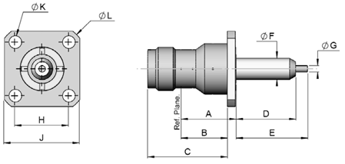  NOTES:  - Lengths D and E are variable; see Para. 4.5.2.1(a). The tolerance on specified length is ±0.1mm.
  Symbols | Dimensions (mm) |  | Remarks
  Symbols | Min | Max | Remarks
  A | 13.65 | 13.85
  B | 11.55 | 11.75
  C | 19.9 | 20.1
  D | 7.5 | 20 | Note 1
  E | 7.5 | 30 | Note 1
  ØF | 5.31 | 5.41
  ØG | 1.59 | 1.69
  H | 13.45 | 13.55
  J | 18.9 | 19.1
  ØK | 3.1 | 3.3 | 4 holes
  ØL | 24.4 | 24.6
Electrical Characteristics | Values | Units
Voltage Standing Wave Ratio (VSWR) | ≤ 1.1 + 0.02 x f (GHz) | -
RF Insertion loss | ≤ 0.04 x √f (GHz) | dB
RF Leakage | ≤ -115 + f (GHz) | dBi
Voltage Proof | ≥ 1500 | Vrms
Corona | ≥ P_{co} at 1GHz (see Table 1(b)) | W
Multipaction Threshold (pulse width 20µs; PRF: 1kHz) | ≥ 2000 at 1GHz | Wpp
Mechanical Characteristics | Values | Units
Centre Contact Retention Force (Axial) | ≥ 27.2 | N
Centre Contact Retention Torque (Rotational) | ≥ 2.8 | N.cm
Cable Retention Force (Axial) | Not applicable | N
Cable Retention Torque (Rotational) | Not applicable | N.cm
Weight | ≤ 18 | g
Other Characteristics | Values | Units
Operating Temperature Range | -65 to +165 | °C
Leakage Rate (Panel-sealed Connectors) | Not applicable | -
Leakage Rate (Hermetic Sealed Connector) | Not applicable | -
Solderability | On centre contact only | -
Soldering Proof | Applicable | -
Cables used | Not applicable | -
VARIANT 02 - Square Flange Female Receptacle, for PCB TRANSMISSION Line WITH Ø PIN 1.73mm
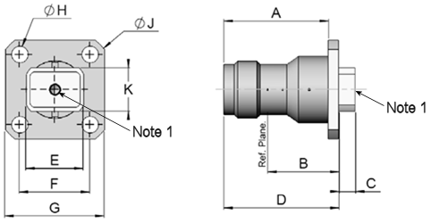  NOTES:  - Accept pin Ø 1.73mm.
  Symbols | Dimensions (mm) |  | Remarks
  Symbols | Min | Max | Remarks
  A | 19.9 | 20.1
  B | 13.6 | 13.8
  C | 3.05 | 3.25
  D | 21.9 | 22.1
  E | 10.95 | 11.05
  F | 13.45 | 13.55
  G | 18.9 | 19.1
  ØH | 3.1 | 3.3 | 4 holes
  ØJ | 24.4 | 24.6
  K | 8.2 | 8.4
Electrical Characteristics | Values | Units
Voltage Standing Wave Ratio (VSWR) | ≤ 1.1 + 0.02 x f (GHz) | -
RF Insertion loss | ≤ 0.04 x √f (GHz) | dB
RF Leakage | ≤ -115 + f (GHz) | dBi
Voltage Proof | ≥ 1500 | Vrms
Corona | ≥ P_{co} at 1GHz (see Table 1(b)) | W
Multipaction Threshold (pulse width 20µs; PRF: 1kHz) | ≥ 2000 at 1GHz | Wpp
Mechanical Characteristics | Values | Units
Centre Contact Retention Force (Axial) | ≥ 27.2 | N
Centre Contact Retention Torque (Rotational) | ≥ 2.8 | N.cm
Cable Retention Force (Axial) | Not applicable | N
Cable Retention Torque (Rotational) | Not applicable | N.cm
Weight | ≤ 16 | g
Other Characteristics | Values | Units
Operating Temperature Range | -65 to +165 | °C
Leakage Rate (Panel-sealed Connectors) | Not applicable | -
Leakage Rate (Hermetic Sealed Connector) | Not applicable | -
Solderability | Not Applicable | -
Soldering Proof | Not Applicable | -
Cables used | Not applicable | -

APPENDIX A
AGREED DEVIATIONS FOR RADIALL (F)
Items Affected | Description of Deviations
Para. 4.2.4 Deviations from Qualification Tests (Chart IV) | Para. 8.1 and Chart IV:  The test requirements applicable to Qualification Testing may be replaced by testing in accordance with Radiall test specification RAD-GEN-CONN-004 as specified in the PID and indicated in Chart F4 below. For each subgroup, the sample size is given in Chart F4. No failures are allowed.
Para. 4.2.5 Deviations from Lot Acceptance Tests (Chart V) | Para. 8.2 and Chart V:  The test requirements applicable to Lot Acceptance Level 1 Testing (LA1) performed for the purposes of maintenance of qualification may be replaced by testing in accordance with Radiall test specification RAD-GEN-CONN-004 as specified in the PID and indicated in Chart F4 below. For each subgroup, the sample size and the period between successive subgroup testing are given in Chart F4. No failures are allowed.
Note: The test methods and requirements for each test in Chart F4 are as specified in the PID. Unless otherwise specified, the measurements and inspections required (as applicable) to the tests of Chart F4 shall be as specified in Table 6 of the Detail Specification.
Chart F4 – Qualification and Maintenance of Qualification (total 20 connectors representative of the connector range)
- Subgroup I (8 connectors; 24 month period)
  - Endurance: 50 mating/unmating cycles
  - Vibration: sine and random (Table 6 requirements are not applicable)
  - Mechanical Shock (Table 6 requirements are not applicable)
  - Rapid Change of Temperature
  - Endurance: 450 mating/unmating cycles
  - Permanence of Marking
  - External Visual Inspection
  - DPA (on 2 connectors)
- Subgroup II (6 connectors; 12 month period)
  - RF Insertion Loss
  - VSWR
  - Coupling Proof Torque
  - Mating/Unmating Forces
  - Contact Resistance
  - External Visual Inspection
- Subgroup III (4 connectors per type; 24 month period)
  - Residual Magnetism
  - Soldering Proof
  - RF Leakage
  - High Temperature Storage
  - External Visual Inspection
- Subgroup IV (2 connectors; 24 month period)(Note 1)
  - Multipactor
  - Power Handling
  - Corona
  - External Visual Inspection
NOTES:
            - Applicable only during maintenance of qualification if there is a change of design or a change of sub-contractor since qualification, or if ordered by the Orderer.
Para. 4.3.11 RF Power Handing | Due to test equipment limitations, RF Power Handling may be performed at a reduced RF Power of 355W at 2GHz (instead of at the specified rated RF Power of 400W at 2GHz).  Note: The required performance of the components specified herein up to the specified rated RF Power: 400W at 2GHz, was confirmed during the initial ESCC Qualification in 2018 by the use of simulation techniques. The simulated results correlate with the real qualification test results at 355W at 2GHz.  There have been no changes in the material, process and design of the components since the initial qualification.

