

Page 1 of 24

APPLICATION OF
SCANNING ACOUSTIC MICROSCOPY
TO PLASTIC ENCAPSULATED DEVICES
ESCC Basic Specification No. 25200

Issue 4 Draft A | April 2023



Document Custodian: European Space Agency – see https://escies.org

Legal Disclaimer and Copyright
European Space Agency, Copyright © 2023. All rights reserved.
The European Space Agency disclaims any liability or responsibility, to any person or entity, with respect to any loss or damage caused, or alleged to be caused, directly or indirectly by the use and application of this ESCC publication.
This publication, without the prior permission of the European Space Agency and provided that it is not used for a commercial purpose, may be:
- copied in whole, in any medium, without alteration or modification.
- copied in part, in any medium, provided that the ESCC document identification, comprising the ESCC symbol, document number and document issue, is removed.

DOCUMENTATION CHANGE NOTICE
(Refer to https://escies.org for ESCC DCR content)
DCR No. | CHANGE DESCRIPTION
tbd | Specification upissued to incorporate changes per DCR.
Draft 4A 03/04/23 | Initial revision based on issue 3 plus changes to bring it in line with the contents of ESCC9030 & 2269030.  All changes from issue 3 are highlighted yellow for information.

TABLE OF CONTENTS
1 INTRODUCTION 6
1.1 SCOPE 6
1.2 PURPOSE 6
1.3 ALTERNATIVE STANDARDS 6
2 APPLICABLE DOCUMENTS 6
2.1 ESCC SPECIFICATIONS 6
2.2 OTHER (REFERENCE) DOCUMENTS 6
3 TERMS, DEFINITIONS, ABBREVIATIONS, SYMBOLS AND UNITS 6
3.1 A-MODE 6
3.2 B-MODE 7
3.3 C-MODE 7
3.4 THROUGH TRANSMISSION MODE 7
3.5 AMPLITUDE 7
3.6 PHASE/POLARITY 7
3.7 TIME OF FLIGHT (TOF)-MODE 7
4 REQUIREMENTS 8
4.1 EQUIPMENT 8
4.1.1 Reflective Acoustic Microscope System 8
4.1.2 Transmission Mode Acoustic Microscope System 8
4.1.3 Auxiliary Parts and Equipment 8
4.2 SAMPLE PREPaRATION AND HANDLING 8
4.2.1 Device Information 8
4.2.2 Previous Findings 8
4.2.3 Pre-Cleaning and Marking 9
4.2.4 Post Treatment 9
4.3 APPLIABLE INVESTIGATIONS 9
5 Procedure 9
5.1 MOUNTING 9
5.2 EQUIPMENT SETUP 9
5.2.1 Transducer 9
5.2.2 Alignment 9
5.2.3 Focussing 10
5.2.4 Testing of the Settings 10
5.2.5 Recording of the Instrument Settings 10
5.3 ACOUSTIC SCANNING 10
5.3.1 Anomaly/Defect Search 10
5.3.2 Image Interpretation Errors 10
5.3.3 Evaluation of the Images 10
5.3.4 Recording of the Results 10
6 TEST LOCATION AND DEFECTS 11
6.1 DELAMINATION 11
6.1.1 Lead Frame 11
6.1.2 Die Surface 11
6.1.3 Paddle, Heatsink 12
6.1.4 Embedded Polymeric Films/Adhesives 12
6.2 CRACKS 12
6.2.1 Cracks in the Encapsulation 12
6.2.2 Die Cracks 12
6.3 VOIDS 12
6.3.1 Voids in the Encapsulation 12
6.3.2 Voids in the Die Attach 12
6.4 TILT AND SHIFT OF THE DIE 12
6.5 DEFORMATION OF THE BOND WIRE LOOPS 13
6.6 FOREIGN MATERIAL 13
7 REJECT CRITERIA 13
7.1 DELAMINATION 13
7.2 CRACKS 13
7.3 VOIDS 14
7.4 TILT AND SHIFT OF THE DIE 14
7.5 BOND WIRE DEFORMATION 14
7.6 FOREIGN MATERIAL 14
7.7 Additional Requirements for WIRE-Bonded AND FLIP-CHIP INTEGRATED CIRCUITS 15
7.7.1 For Monolithic Microcircuits, Wire-Bonded, with a metal lead-frame, Plastic Encapsulated 15
7.7.2 For Monolithic Microcircuits, Wire-Bonded, with Organic Substrate, Plastic Encapsulated 15
7.7.3 For Flip-Chip Monolithic Microcircuits, with Organic Substrate 15
8 DOCUMENTATION 16
8.1 IMAGES AND GRAPHIC RESULTS 16
8.2 INFORMATION 16
8.3 DISTRIBUTION OF DOCUMENTATION 16
ANNEX I - POTENTIAL IMAGE PITFALLS 24

INTRODUCTION

SCOPE
This specification describes the equipment and procedures to be used for Scanning Acoustic Microscope (SAM) inspection of plastic encapsulated discrete semiconductor devices and integrated circuits. This method provides users with an acoustic microscopy process flow for non-destructive detection of defects in plastic encapsulated devices (PEDs).

PURPOSE
The method is applicable to all plastic encapsulated semiconductor devices which have to be inspected during Evaluation, Procurement, Destructive Physical Analysis, and/or Failure Analysis.

ALTERNATIVE STANDARDS
Where the configuration of an inspection method is not in accordance with the examples shown in this specification, or where current in-house inspection drawings or standards (accepted in the PID) are to be used, it shall be the manufacturer's responsibility to obtain the formal interpretation from the ONS, or its designated representative, of any deviation.

APPLICABLE DOCUMENTS
The following documents form part of, and shall be read in conjunction with, this specification. The relevant issues shall be those in effect on the date of performing the inspection.

ESCC SPECIFICATIONS
- No. 9030, Integrated Circuits: Monolithic Microcircuits, Wire-Bonded, Plastic Encapsulated and Flip-Chip Monolithic Microcircuits, with Organic Substrate.
- No. 2099000, Radiographic Inspection of Integrated Circuits.
- No. 2269030, Evaluation Test Programme for Integrated Circuits: Monolithic Microcircuits, Wire-Bonded, Plastic Encapsulated and Flip-Chip Monolithic Microcircuits, with Organic Substrate.
- No. 21300, Terms, Definitions, Abbreviations, Symbols and Units

OTHER (REFERENCE) DOCUMENTS
MIL-STD-883, Test Methods and Procedures for Micro-Electronics.

TERMS, DEFINITIONS, ABBREVIATIONS, SYMBOLS AND UNITS
The terms, definitions, abbreviations, symbols and units specified in ESCC Basic Specification No. 21300 shall apply. Furthermore, the following terms and definitions shall apply.

A-MODE
Acoustic data collected at a single point (X-Y position) defined by the resolution limitations of the used acoustic microscope. An A-mode display contains amplitude and phase/polarity information as a function of time of flight at a single point in the X-Y plane (see Figure IIA).

B-MODE
Acoustic data collected along an X-Y or Y-Z plane versus depth using a reflective acoustic microscope. A B-mode scan contains amplitude and phase/polarity information as a function of time of flight at each point along the scan line. A B-mode scan displays a two-dimensional (cross sectional) description along the scan line defined by the X or Y track (see Figure IIC1). This mode is limited to a focal stripe of the collection plane. The extension is the quantitative B-mode (see Figure IIC2) where the focal zone in moved successively in the Z direction covering the area of interest.

C-MODE
Acoustic data collected in an X-Y plane at a depth (Z) using a reflective acoustic microscope. A C-mode scan contains amplitude and phase/polarity information at each point in the scan plane. The C­mode displays a two-dimensional (area) image of echoes arising from reflections at a fixed depth (Z) (see Figure lID).

THROUGH TRANSMISSION MODE
Acoustic data collected in an X-Y plane throughout the sample using an acoustic microscope operating in through transmission mode - the receiver placed on the other side of the sample relative to the acoustic signal source (see Figure lIE).

AMPLITUDE
The magnitude of the received signal.

PHASE/POLARITY
The phase of the received signal relative to the transmitted signal, or the polarity of the received signal's amplitude (positive or negative).

TIME OF FLIGHT (TOF)-MODE
The time it takes for the transmitted signal pulse from entering the part under investigation (first interface) to the plane of interest and back to the receiver is used for modulation of the image signal (see Figure lIE).

REQUIREMENTS

EQUIPMENT

Reflective Acoustic Microscope System
The system should be composed of the following parts:
- Ultrasonic pulse generator/receiver head.
- Displays for the echo amplitude and phase/polarity vs. time (A-mode).
- A display system (B-mode and C-mode) controlled by a computer for image display, storage, retrieval, printing, and analysis. The system should be able to perform image processing for setting user defined signal levels. The stored information should be available in a suitable electronic format.
- An electromechanical X-Y-Z scanning stage (step motors under computer control) for movement and placement of the acoustic probe relative to the sample and for setting the focal plane (Z-direction).
- A fluid bath used for coupling the ultrasonic energy between the sample and the head/transducer. The preferred fluid to be used is clear water which should be degassed by heat treatment in advance.
- A broad-band acoustic transducer with the centre frequency in the range of 10 to 150 MHz or fixed narrow-band acoustic transducers (e.g. 15, 20, 30 MHz).

Transmission Mode Acoustic Microscope System
The system should be composed of the following parts:
- Displays, stage, and bath as defined in Para. 4.1.1.
- Receiving transducer or ultrasonic detection system.

Auxiliary Parts and Equipment
- Reference packages or standards for the equipment setup and calibration.
- Sample holders for a variety of samples which allow the pre-positioning of the samples as required and prevents them from moving during scanning.

SAMPLE PREPaRATION AND HANDLING

Device Information
The construction, history, and performed inspections should be available for review before the SAM inspection. A part information document for use by the SAM operators is recommended. This document should include the information needed for identifying the device under inspection and will be included in the inspection documentation. The construction information will help to set up the SAM in an appropriate way. The history of the device and the performed inspections document, the status of the part e.g. SAM investigations carried out before a stress test must be used as a basis for comparison of changes in the appearance of the defects.

Previous Findings
Any findings concerning the quality of the package such as cracks, gaps, or dimensional deviations should be listed and attached to the samples. X-ray viewgraphs showing anomalies are also recommended to be attached. Those findings will lead to the locations and failure modes which should be inspected by SAM.

Pre-Cleaning and Marking
- Any identification stickers, labels etc. attached to the packages and any adhesive residues, dust, fingerprints or other contamination should be removed.
- Marking of the parts is recommended by mechanical scribing in areas that will not be investigated by SAM.

Post Treatment
To prevent any influence on further investigations, or corrosion the parts must be baked to remove moisture as specified in the Detail Specification or as recommended by the manufacturer.

APPLIABLE INVESTIGATIONS
Table I - TESTS VS. APPLICATION
Application | Samples | Tests
Evaluation Testing | All specimens before stress testing. | One C-Mode scan through the die  and lead frame for each specimen. More specific investigations if defects are identified.
Evaluation Testing | Stress tested specimens. | same.
Failure Analysis | All failed parts before  decapsulation. | Depending on the suspected failure  mode (see Table II).
Destructive Physical Analysis | All parts for DPA before  decapsulation. | C-Mode scans through the die attach, and lead frame.

Procedure

MOUNTING
The samples should be mounted in an appropriate sample holder immersed in a fluid bath with an orientation so that the upper surface is parallel to the scanning plane of the acoustic head. Any air bubbles adhering to the upper surface of the sample and the lower side of the transducer head should be removed.

EQUIPMENT SETUP
The setup of the equipment may vary depending on the model of acoustic microscope being used but the same basic steps are applicable to all acoustic microscopes used for the investigation of PEDs. The manufacturer's operating manual will give details of the specific setup procedure.

Transducer
The transducer selected should be optimised for the required resolution and the best signal to noise ratio. This depends on the type of package under investigation (in particular its thickness) and the feature size (e.g. the size of the voids or gaps).

Alignment
Align the stage and acoustic head for the maximum reflected amplitude from the focal plane. The axis of the head must be perpendicular to the plane of the samples surface and the scan path must be parallel to the scan plane of the stage.

Focussing
The focus should be adjusted to maximise the amplitude of the signal obtained (using the A-mode display) of the interface to be imaged.

Testing of the Settings
The adjustment and correct operation of the instrument should be verified by imaging of reference samples. Incorrect operation should be analysed by means of the reflected waveform (A-mode display).

Recording of the Instrument Settings
The instrument settings should be recorded. It is recommended that a form sheet be set up by the users of the instrument. Those records will help to achieve reproducible conditions for operation of the instrument with new parts and ensure that the same conditions can be used later for the correlation to the status after stress tests.

ACOUSTIC SCANNING

Anomaly/Defect Search
The sample is scanned in detail for any anomalies. The operating modes used depend on the defects. It should be verified that detected anomalies are true defects and not artefacts of the imaging process. This has to be done by inspection of the waveforms (A-mode) received at the location of the anomaly. The area scanned shall cover the whole potential failure region (die surface, paddle etc.) to get the percentage of the failure affected area. The resolution shall reveal the details (e.g. significant voids) used for calculation of the defect percentage and change.

Image Interpretation Errors
A number of well-known pitfalls for the interpretation of the recorded images are listed in Annex I. These possible sources of error should be eliminated. If necessary, the sample should be re-scanned with modified settings or adjustments.

Evaluation of the Images
The images obtained have to be interpreted and evaluated according to the failure criteria specified for defects in PEDs.

Recording of the Results
The images obtained and the corresponding final settings of the SAM should be recorded as defined in Para. 8.

TEST LOCATION AND DEFECTS
The examination of the parts by SAM varies for each defect. The methods used are not strictly fixed and depend on the construction of the parts (e.g. package types), history of the parts, equipment used, and the experience of the operators. The defects should be verified from different sides of the part under investigation.
The following operation modes suggested for the typical defects are only a guideline:
Table II - SUGGESTED OPERATION MODES OF THE SAM
DEFECT | LOCATION | MODE | PARA.
Delamination | Leadframe | C-mode | 6.1.1
Delamination | Die Surface | C-mode | 6.1.2
Delamination | Paddle, Heat sink | C-mode | 6.1.3
Delamination | embedded films | C-mode | 6.1.4
Cracks | Moulding | Through Transmission, TOF | 6.2.1
Cracks | Die | Through Transmission, TOF | 6.2.2
Voids | Moulding | C-mode, A-mode | 6.3.1
Voids | Die Attach | C-mode, polarity check | 6.3.2
Tilt, Shift | Die | B-mode, quant. B-mode | 6.4
Deformation | Bond wire | C-mode | 6.5
Foreign material | Moulding | C-mode | 6.6
For typical defects and locations in PEDs, see Figures lA, IB, IC, ID, IE, IF, and IG.

DELAMINATION
Delamination is defined as lack of adhesion of the moulding compound to the internal parts (die surface, leadframe, paddle). The delaminated area shows lower acoustic impedance compared to the solid materials. This leads to a strong reflected acoustic signal. The location of the delaminated areas can be determined by doing C-mode SAM from the upper and the lower surfaces of the package.
The description of the delamination shall cover the following items (in addition to the recorded images):

Lead Frame
- affected lead number, length of delamination
- average percentage of area
- location: corner, edge, or centre
(See Figure IB)

Die Surface
- average percentage of area
- location: corner, edge, or centre
(See Figure ID)

Paddle, Heatsink
- average percentage of area
- location (corner, edge, or centre)
(See Figure IC)

Embedded Polymeric Films/Adhesives
- average percentage of area
- number of areas

CRACKS
Cracks should be verified by microsections if possible.

Cracks in the Encapsulation
- location of the cracks
- intersections of bond wire, ball bond, wedge bond, tab bump, tab lead
- connections between internal features
- extensions of the cracks

Die Cracks
- location of the cracks
- extension of the cracks

VOIDS
The nature of voids should be verified by careful phase/polarity analysis at the defect position using an A-mode scan.

Voids in the Encapsulation
- size
- distribution
- intersection of bond wire, ball bond, wedge bond, tab bump, tab lead
- connection between internal features

Voids in the Die Attach
- size
- distribution
(See Figure IG)

TILT AND SHIFT OF THE DIE
- angle and direction
- displacement to centre position
(See Figure IF)

DEFORMATION OF THE BOND WIRE LOOPS
- maximum shift and direction
- identification of the deformed wire(s)
(See Figure IE)

FOREIGN MATERIAL
- size and location

REJECT CRITERIA
The reject criteria are closely connected to the specifications for External and Internal Visual Inspection (e.g. the die tilt and shift, the classification of cracks etc.).

DELAMINATION
(See Figure IB)
Delaminations found at the front side of the die, at the paddle area, at embedded films, or at the bonding area may have an impact on the reliability of the parts. If there is a significant relation to known failure mode (e.g. open circuit to delaminations in the bonding areas) the appearance of the delamination shall be observed as rejection criteria.
All delaminations that extend over the entire length of any surface-breaking parts (lead frame fingers, tie bars, heat sinks) are not acceptable.
Complete delamination of die or die paddle is not acceptable.
Relative chances of the delamination area of more than 10% at stress tests are not acceptable.

CRACKS
(See Figure lA)
Not accepted are:
          - Any moulding material crack that intersects a bond wire, ball bond, wedge bond
          - Any moulding material crack that extends from any leadfinger to any other internal feature (leadfinger, chip, paddle)
          - Any crack extending more than 2/3 of the distance between any internal feature to the outside surface of the package
          - Any die cracks that are not limited to the scribe line of the die

VOIDS
(See Figure lA)
The nature of voids should be verified by a careful phase/polarity analysis at the defect position using an A-mode scan.
Not acceptable are:
          - Voids that extend from an internal feature through more than 2/3 of the covering moulding material
          - Voids that weaken the mechanical stability of the leadframe parts
Voids in the die attach should be evaluated according to the criteria defined for die attach in the Standard Specifications (e.g. MIL-STD-883 method 2030) - see Figure IG.
Not acceptable are:
          - Contact area voids in excess of 50 percent of the total intended contact area
          - A single void which exceeds 15 percent of the intended contact area, or a single corner void in excess of 10 percent of the total intended area
          - When the contact area is divided into four equal quadrants by bisecting both pairs of opposite edges, and quadrant exhibiting contact area voids in excess of 70 percent of the intended quadrant contact area

TILT AND SHIFT OF THE DIE
(See Figure IF)
The acceptance criteria defined in (MIL-STD-883 Test Method 2010 and 2099000) shall be applied.
Not acceptable are:
          - Lateral displacement of the die outside of the paddle area
          - Semiconductor die or die paddle not located or oriented in accordance with the applicable assembly drawing of the device
          - More than 10 degree tilt of the die relative to the plane of the mounting surface

BOND WIRE DEFORMATION
The acceptance criteria defined in (MIL-STD-883 Test Method 2010 and 2099000) shall be applied.
Not acceptable are:
          - Crossing of wires
          - Slack wire within 0.05mm of another wire or another leadframe structure
          - Crossing of a wire over a bond
          - Any bond wire that appears to be within 0.1mm from the package surface
A wire sweep observed in PEDs resulting from the flow of the epoxy material will not be acceptable, if the maximum deformation, d, of any wire is larger than 15% of the bond wire length l (see Figure IE).

FOREIGN MATERIAL
Not acceptable are:
          - Any foreign particle/inclusion greater than 0.0254mm, or at lesser size which is sufficient to bridge non-connected conducting parts of the device.
          - Any foreign particle/inclusion in contact with the die greater than 0.0254mm.
          - Any foreign particle/inclusion that has deformed any of the bond wires or is closer than 0.05mm to any bond wire.

Additional Requirements for WIRE-Bonded AND FLIP-CHIP INTEGRATED CIRCUITS
See ESCC Generic Specification No. 9030 and ESCC Basic Specification No. 2269030 for definitions.

For Monolithic Microcircuits, Wire-Bonded, with a metal lead-frame, Plastic Encapsulated
          - No delamination on the active side of the die.
          - No delamination on any wire bonding surface including the down-bond area or the lead-frame of lead-on-chip (LOC) components.
          - No surface-breaking feature delaminated over its entire length. A surface-breaking feature includes lead fingers, tie bars, heat-spreader alignment features, heat slugs, etc..
          - No delamination/cracking > 50% of the die attach area:
- in components with exposed die pad used for thermal conductivity.
- for components that require electrical contact to the backside of the die.
          - Delamination of more than half of the backside of the die paddle/plastic interface.
          - Any void in moulding compound crossing wire-bond.

For Monolithic Microcircuits, Wire-Bonded, with Organic Substrate, Plastic Encapsulated
          - No delamination on the active side of the die.
          - No delamination on any wire bonding surface including the down-bond area or the lead-frame of lead-on-chip (LOC) components.
          - No delamination on any electrical contact surface of the laminate.
          - No delamination within the substrate.
          - No delamination/cracking > 50% of the die attach area:
- in components with exposed die pad used for thermal conductivity.
- for components that require electrical contact to the backside of the die.
          - No surface-breaking feature delaminated over its entire length. A surface-breaking feature includes lead fingers, tie bars, heat-spreader alignment features, heat slugs, etc..
          - Any void in moulding compound crossing wire-bond.

For Flip-Chip Monolithic Microcircuits, with Organic Substrate
          - No delamination on the active side of the die.
          - No delamination on any electrical contact surface of the laminate.
          - No surface-breaking feature delaminated over its entire length. A surface-breaking feature includes lead fingers, laminate, laminate metallization, PTH, heat slugs, etc..
          - No delamination/cracking between underfill resin and chip, or underfill resin and substrate/solder mask.
          - No delamination within the substrate.

DOCUMENTATION

IMAGES AND GRAPHIC RESULTS
Each defect shall be recorded by a visualisation. The areas affected by the defect shall be marked or highlighted e.g. by image processing. The absolute area of the defect of the part under investigation can then be calculated. The setup conditions and the mounting, scale, and orientation shall be recorded with the images.

INFORMATION
The following information shall be included in the inspection report:
- Reference to this document, including issue and date
- Date of inspection
- Name and location of the inspection site
- Operator
- SAM type
- Part type, lot identification, serial number, or reference number
- Device setup conditions (for each inspection/failure mode performed) including display system mode, and magnification
The inspection report shall also include a description and evaluation of the identified defects as described in Paras. 6.1 to 6.6.

DISTRIBUTION OF DOCUMENTATION
The operator of the SAM shall store the setup information and the recorded data in agreement with the orderer of the inspection.

FIGURE IA - POTENTIAL DEFECTS IN PEDS
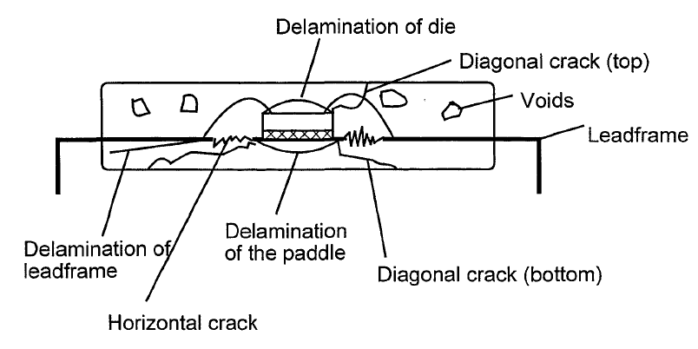
FIGURE iB - DELAMINATION OF THE LEADFRAME
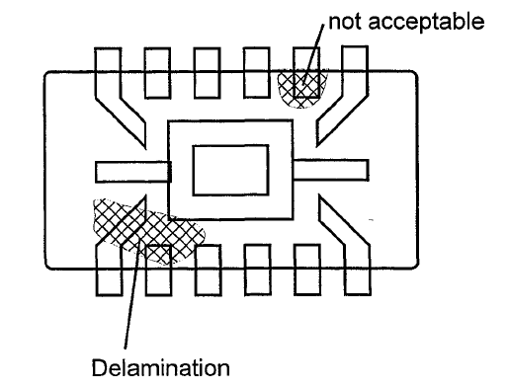

FIGURE IC - DELAMINATION OF THE PADDLE, OR HEATSINK
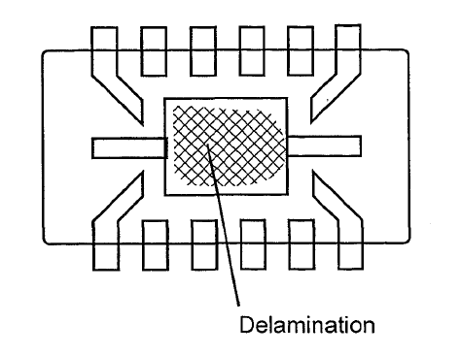
FIGURE ID - DELAMINATION OF THE DIE SURFACE
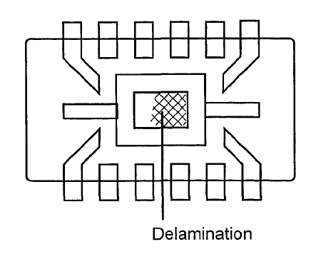

FIGURE IE - WIRE SWEEP
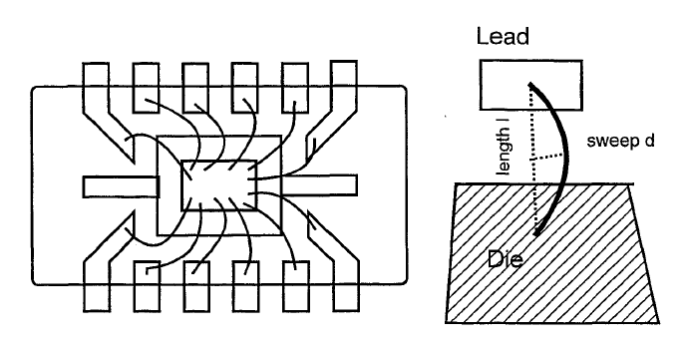
FIGURE IF - SHIFT OF THE DIE
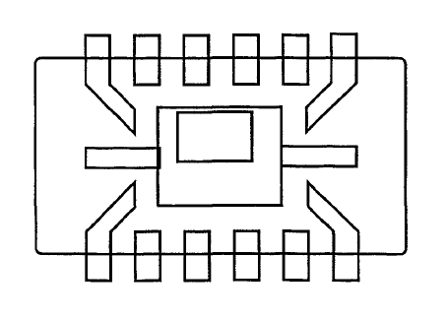

FIGURE IG - DIE ATTACH
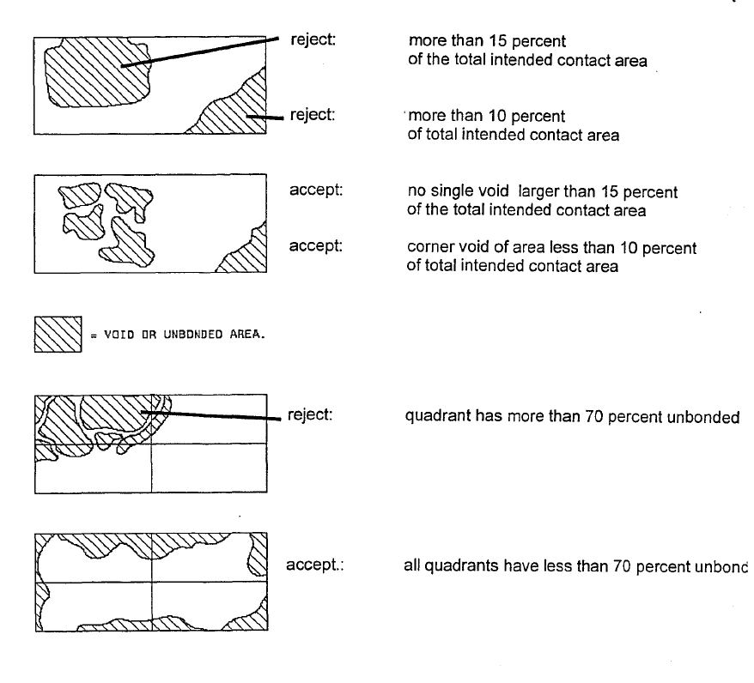

FIGURE IIA - SCHEMATIC OF AN A-MODE ACOUSTIC SCAN
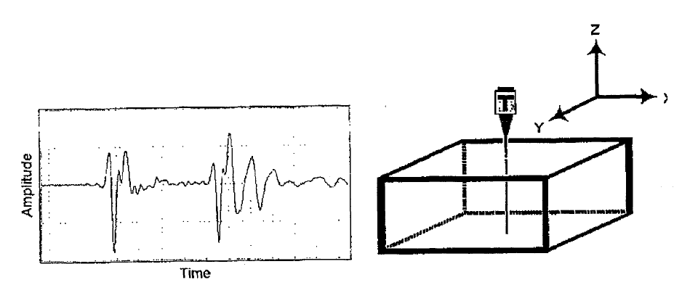
Figure IIB – Transmission scan
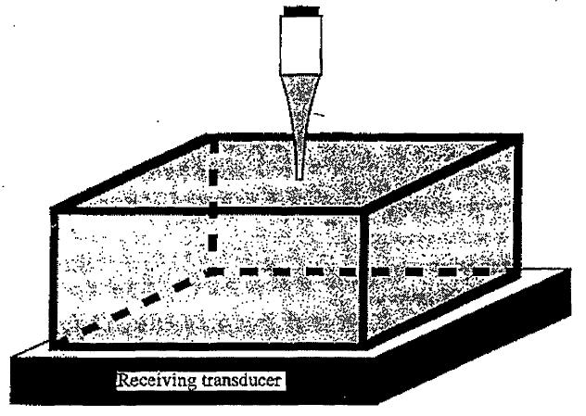

FIGURE IIC1 - SCHEMATIC OF A B-MODE ACOUSTIC SCAN
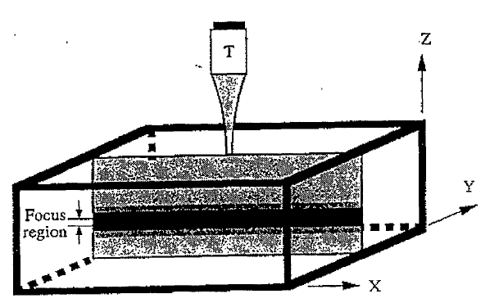
FIGURE IIC2 - SCHEMATIC OF A QUANTITATIVE B-MODE ACOUSTIC SCAN
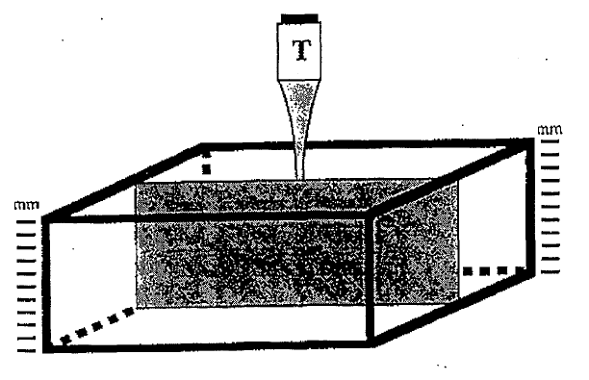

FIGURE IiD - SCHEMATIC OF A C-MODE ACOUSTIC SCAN
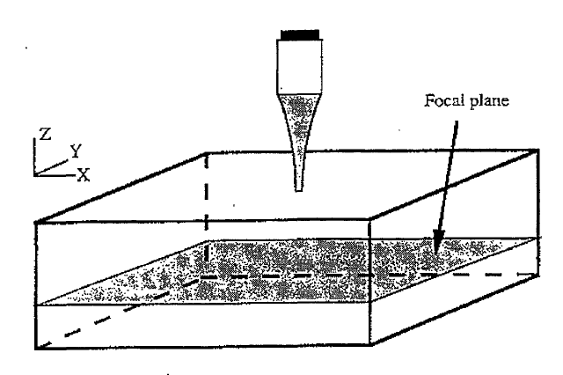
FIGURE IIE - SCHEMATIC OF A TOF-SCAN
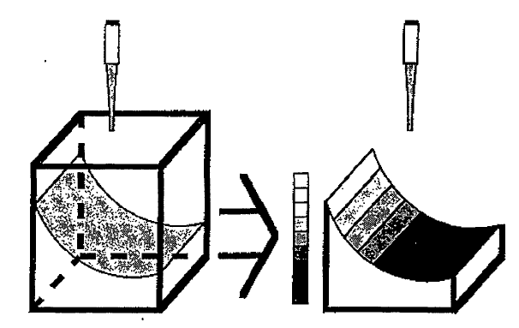

ANNEX I - POTENTIAL IMAGE PITFALLS
OBSERVATIONS | CAUSES/COMMENTS
Unexplained loss of front surface signal | Gain setting too low  Labelling on package surface  Ejector pin knockouts  Pin 1 or other mould marks  Dust, air bubbles, fingerprints  Scratches, scribe marks, pencil marks  Cambered package edge
Unexpected loss of subsurface signal | Gain setting too low  Transducer frequency to high  "Rubbery" filler (gel)  Large mould compound voids  Porosity/high concentration of small voids  Angled cracks in the package  "Dark line boundary" (phase cancellation)
False or spotty indication of delamination | Low acoustic impedance coating (polyimide, gel)  Gross focus error  Incorrect delamination gate setup  Multilayer interference effects
False indication of adhesion | Gain setting too high (saturation)  Incorrect delamination gate setup  Focus error  Overlap of front surface and subsurface echoes  (transducer frequency too low)  Fluid filling delamination areas
Apparent voiding around die edge | Reflection from wire loops  Incorrect setting of void gate
Graded Intensity | Die tilt or leadframe deformation

