

Page 1 of 19
TRANSISTORS, POWER, MOSFET, N-CHANNEL, RAD-HARD
BASED ON TYPES BUY25CS04J, BUY25CS12J
ESCC Detail Specification No. 5205/026

Issue 4 Draft A | March 2023



Document Custodian: European Space Agency – see https://escies.org

Legal Disclaimer and Copyright
European Space Agency, Copyright © 2023. All rights reserved.
The European Space Agency disclaims any liability or responsibility, to any person or entity, with respect to any loss or damage caused, or alleged to be caused, directly or indirectly by the use and application of this ESCC publication.
This publication, without the prior permission of the European Space Agency and provided that it is not used for a commercial purpose, may be:
- copied in whole, in any medium, without alteration or modification.
- copied in part, in any medium, provided that the ESCC document identification, comprising the ESCC symbol, document number and document issue, is removed.

DOCUMENTATION CHANGE NOTICE
(Refer to https://escies.org for ESCC DCR content)
DCR No. | CHANGE DESCRIPTION
TBA | Specification upissued to incorporate changes per DCR.

TABLE OF CONTENTS
1 General 5
1.1 SCOPE 5
1.2 APPLICABLE DOCUMENTS 5
1.3 TERMS, DEFINITIONS, ABBREVIATIONS, SYMBOLS AND UNITS 5
1.4 THE ESCC COMPONENT NUMBER AND COMPONENT TYPE VARIANTS 5
1.4.1 The ESCC Component Number 5
1.4.2 Component Type Variants 5
1.5 MAXIMUM RATINGS 6
1.6 HANDLING PRECAUTIONS 8
1.7 PHYSICAL DIMENSIONS AND TERMINAL IDENTIFICATION 9
1.7.1 Leadless Chip Carrier Package (SMD0.5) - 3 Terminals 9
1.8 FUNCTIONAL DIAGRAM 10
1.9 MATERIALS AND FINISHES 10
2 REQUIREMENTS 10
2.1 GENERAL 10
2.1.1 Deviations from the Generic Specification 10
2.1.1.1 Deviations from Screening Tests - Chart F3 10
2.1.1.2 Deviations from Qualification and Periodic Tests - Chart F4 10
2.2 MARKING 11
2.3 WAFER LOT ACCEPTANCE 11
2.4 ELECTRICAL MEASUREMENTS AT ROOM, HIGH AND LOW TEMPERATURES 11
2.4.1 Room Temperature Electrical Measurements 11
2.4.2 High and Low Temperatures Electrical Measurements 13
2.4.3 Notes to Room, High and Low Temperatures Electrical Measurements 13
2.5 PARAMETER DRIFT VALUES 14
2.6 INTERMEDIATE AND END-POINT ELECTRICAL MEASUREMENTS 15
2.7 HIGH TEMPERATURE REVERSE BIAS BURN-IN CONDITIONS 15
2.8 HIGH TEMPERATURE STEADY-STATE GATE BIAS BURN-IN CONDITIONS 16
2.9 OPERATING LIFE CONDITIONS 16
2.10 TOTAL DOSE RADIATION TESTING 17
2.10.1 Bias Conditions and Total Dose Level for Total Dose Radiation Testing 17
2.10.2 Electrical Measurements for Total Dose Radiation Testing 17
APPENDIX A 18

General

SCOPE
This specification details the ratings, physical and electrical characteristics and test and inspection data for the component type variants and/or the range of components specified below. It supplements the requirements of, and shall be read in conjunction with, the ESCC Generic Specification listed under Applicable Documents.

APPLICABLE DOCUMENTS
The following documents form part of this specification and shall be read in conjunction with it:
          - ESCC Generic Specification No. 5000
          - MIL-STD-750, Test Methods and Procedures for Semiconductor Devices
          - MIL-STD-883, Test Method Standard Microelectronics

TERMS, DEFINITIONS, ABBREVIATIONS, SYMBOLS AND UNITS
For the purpose of this specification, the terms, definitions, abbreviations, symbols and units specified in ESCC Basic Specification No. 21300 shall apply.

THE ESCC COMPONENT NUMBER AND COMPONENT TYPE VARIANTS

The ESCC Component Number
The ESCC Component Number shall be constituted as follows:
Example: 520502601R
- Detail Specification Reference: 5205026
- Component Type Variant Number: 01 (as required)
- Total Dose Radiation Level Letter: R (as required)

Component Type Variants
The component type variants applicable to this specification are as follows:
Variant Number | Based on Type | I_{DS} @ T_{case} ≤ +25°C  max (A)  (Note 1) | I_{DS} @ T_{case} = +100°C  max (A)  (Note 1) | r_{DS(on)} @ T_{amb} = +25°C  max (mΩ)  (Note 2) | Case  (Note 3) | Weight  max (g) | Total Dose Radiation Level Letter  (Note 4)
01 | BUY25CS12J-01 | 12.4 | 8 | 130 | SMD0.5 | 1.1 | R [100kRAD(Si)]
02 | BUY25CS04J-01 | 4.4 | 3 | 400 | SMD0.5 | 1.1 | R [100kRAD(Si)]
03 | BUY25CS12J-02 | 12.4 | 8 | 130 | SMD0.5 | 1.1 | R [100kRAD(Si)]
04 | BUY25CS04J-02 | 4.4 | 3 | 400 | SMD0.5 | 1.1 | R [100kRAD(Si)]
NOTES:
            - See Para. 1.5.
            - See Para. 2.4.1.
            - See Para. 1.7.
            - Total dose radiation level letters are defined in ESCC Basic Specification No. 22900. If an alternative radiation test level is specified in the Purchase Order the letter shall be changed accordingly.

MAXIMUM RATINGS
The maximum ratings shall not be exceeded at any time during use or storage.
Maximum ratings shall only be exceeded during testing to the extent specified in this specification and when stipulated in Test Methods and Procedures of the ESCC Generic Specification.
Characteristics | Symbols | Maximum Ratings | Units | Remarks
Drain-Source Voltage | V_{DS} | 250 | V | Note 1
Gate-Source Voltage | V_{GS} | ±20 | V
Drain Current (Continuous) | I_{DS} | Note 2 | A | At T_{case} ≤ +25°C  Notes 1, 3, 4
Drain Current (Continuous) | I_{DS} | Note 2 | A | At T_{case} = +100°C  Notes 3, 4
Drain Current (Pulsed)  Variants 01, 03:  Variants 02, 04: | I_{DM} | 50  18 | Apk | At T_{case} ≤ +25°C  Notes 1, 3
Power Dissipation  Variants 01, 03:  Variants 02, 04: | P_{tot} | 75  20 | W | Note 5
Avalanche Energy (Single Pulse)  Variants 01, 03:  Variants 02, 04: | E_{AS} | 60  30 | mJ
Operating Temperature Range | T_{op} | -55 to +150 | °C | T_{amb}
Storage Temperature Range | T_{stg} | -55 to +150 | °C
Junction Temperature | T_{j} | +150 | °C
Soldering Temperature | T_{sol} | +250 | °C | Note 6
Thermal Resistance, Junction-to-Case  Variants 01, 03:  Variants 02, 04: | R_{th(j-c)} | 1.66  3 | °C/W
NOTES:
            - Safe Operating Area applies as follows:
variantS 01, 03
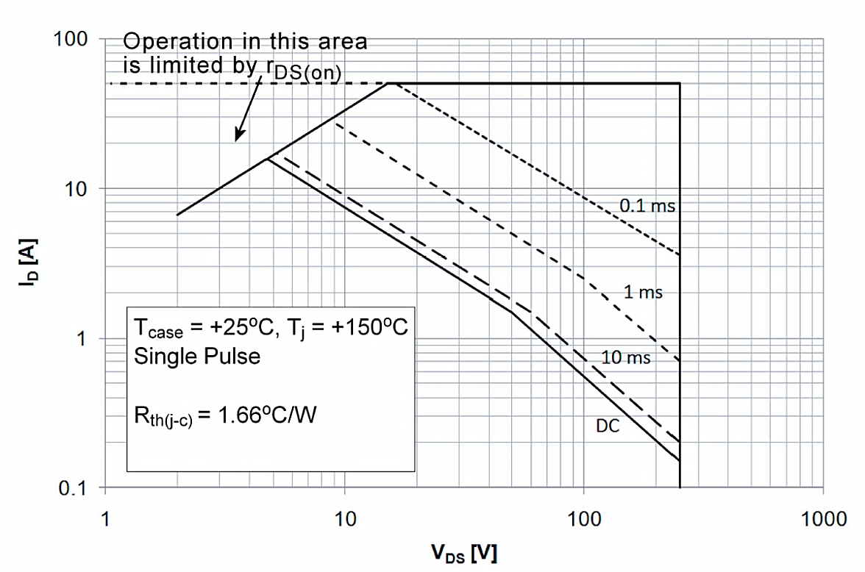
variantS 02, 04
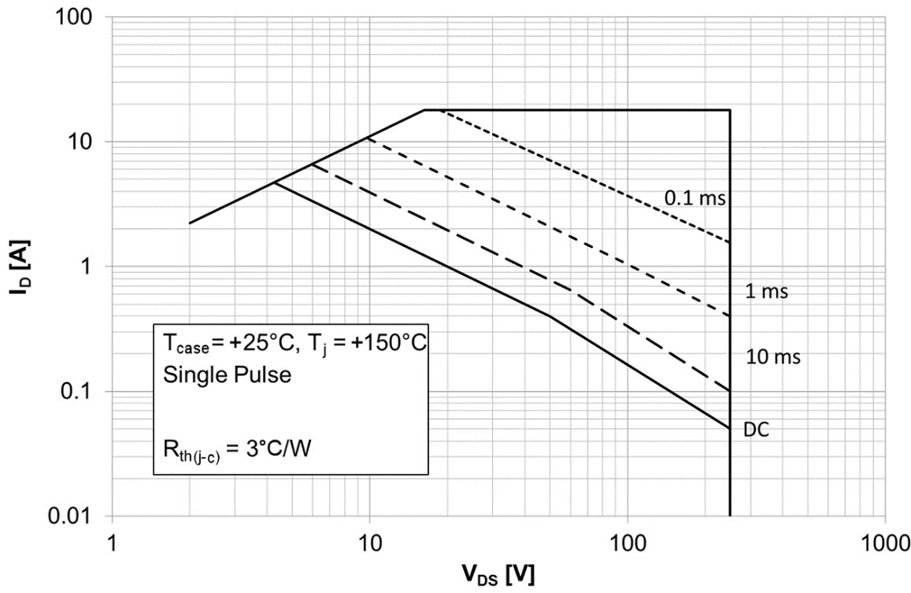
            - See Para. 1.4.2 for I_{DS} value.
            - T_{case} is measured on the PCB at the soldering point to the Drain terminal.
            - For T_{case} > +25°C, derate as follows:
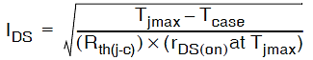
where r_{DS(on)} at T_{jmax} =
- Variants 01, 03: 490mΩ
- Variants 02, 04: 2.15Ω.
            - For T_{case} > +25°C, derate linearly to 0W at T_{case} = +150°C.
            - Duration 10 seconds maximum and the same terminal shall not be resoldered until 3 minutes have elapsed.

HANDLING PRECAUTIONS
These devices are susceptible to damage by electrostatic discharge. Therefore, suitable precautions shall be employed for protection during all phases of manufacture, testing, packaging, shipment and any handling.
These components are categorised as Class 1 per ESCC Basic Specification No. 23800 with a Minimum Critical Path Failure Voltage of 1000V for Variants 01, 03, 900V for Variant 02 and 700V for Variant 04.

PHYSICAL DIMENSIONS AND TERMINAL IDENTIFICATION

Leadless Chip Carrier Package (SMD0.5) - 3 Terminals
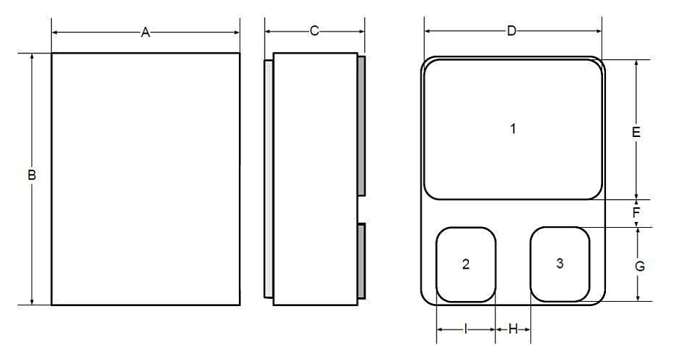
Symbols | Dimensions mm
Symbols | Min | Max
A | 7.35 | 7.69
B | 9.97 | 10.41
C | - | 3.3
D | 7.14 | 7.39
E | 5.59 | 5.84
F | 0.76 | -
G | 2.92 | 3.18
H | 0.76 | -
I | 2.29 | 2.54
NOTES:
            - The terminal identification is specified by the component’s geometry. Terminal identification: terminal 1 = Drain, terminal 2 = Gate, terminal 3 = Source.

FUNCTIONAL DIAGRAM
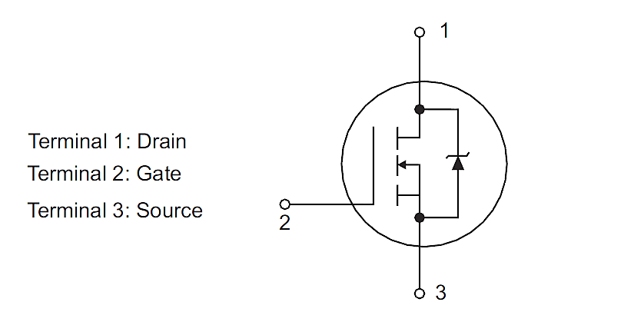
NOTES:
            - The case is not connected to any terminal.

MATERIALS AND FINISHES
Materials and finishes shall be as follows:
          - Case
The case shall be hermetically sealed and have a ceramic/metal body.
          - Terminals
The terminal material and finish shall be Q14 in accordance with the requirements of ESCC Basic Specification No. 23500.

REQUIREMENTS

GENERAL
The complete requirements for procurement of the components specified herein are as stated in this specification and the ESCC Generic Specification. Permitted deviations from the Generic Specification, applicable to this specification only, are listed below.
Permitted deviations from the Generic Specification and this Detail Specification, formally agreed with specific Manufacturers on the basis that the alternative requirements are equivalent to the ESCC requirement and do not affect the component’s reliability, are listed in the appendices attached to this specification.

Deviations from the Generic Specification

Deviations from Screening Tests - Chart F3
          - Verification of Safe Operating Area: The Safe Operating Area shall be verified by performing the Thermal Impedance (Z_{th(j-s)}) ΔV_{SD} test specified in Para. 2.4.1 Room Temperature Electrical Measurements.
          - Particle Impact Noise Detection may be performed at any point after Temperature Cycling, prior to Seal.
          - Power Burn-in: A high temperature steady-state gate bias test (HTGB) (see Para. 2.8) shall be performed instead of Power Burn-in.

Deviations from Qualification and Periodic Tests - Chart F4
          - Terminal Strength is not applicable.

MARKING
The marking shall be in accordance with the requirements of ESCC Basic Specification No. 21700 and as follows.
The information to be marked on the component shall be:
          - The ESCC qualified components symbol (for ESCC qualified components only).
          - The ESCC Component Number (see Para. 1.4.1).
          - Traceability information.

WAFER LOT ACCEPTANCE
A SEM inspection shall be performed as specified in the ESCC Generic Specification.

ELECTRICAL MEASUREMENTS AT ROOM, HIGH AND LOW TEMPERATURES
Electrical measurements shall be performed at room, high and low temperatures. Consolidated notes are given in Para. 2.4.3.

Room Temperature Electrical Measurements
Unless otherwise specified, the measurements shall be performed at T_{amb} = +25 ±3°C.
Characteristics | Symbols | MIL-STD-750 Test Method | Test Conditions | Limits |  | Units
 |  |  |  | Min | Max | Units
Drain-to-Source Breakdown Voltage | V_{(BR)DSS} | 3407 | V_{GS} = 0V, I_{D} = 0.25mA  Bias condition C | 250 | - | V
Gate-to-Source Threshold Voltage | V_{GS(th)} | 3403 | V_{DS} ≥ V_{GS}, I_{D} = 1mA | 2 | 4 | V
Gate-to-Source Leakage Current | I_{GSS} | 3411 | V_{GS} = ±20V, V_{DS} = 0V  Bias condition C | -100 | +100 | nA
Drain Current | I_{DSS} | 3413 | V_{GS} = 0V, V_{DS} = 200V  Bias condition C | - | 25 | µA
Static Drain-to-Source On Resistance | r_{DS(on)} | 3421 | V_{GS} = 10V, Note 1  Variants 01, 03: I_{D} = 8A:  Variants 02, 04: I_{D} = 3A: | -  - | 130  400 | mΩ
Source-to-Drain Diode Forward Voltage | V_{SD} | 4011 | V_{GS} = 0V, I_{SD} = 12.4A, Note 1 | - | 1.2 | V
Thermal Impedance | Z_{th(j-c)} | 3161 | Note 2  Variants 01, 03:  Variants 02, 04: | -  - | 1.14  2.18 | °C/W
Turn-on Delay Time | t_{d(on)} | 3472 | V_{GS} = 10V, R_{G} = 4.7Ω  V_{DS} = 125V, Note 3  Variants 01, 03: I_{D} = 8A:  Variants 02, 04: I_{D} = 3A: | -  - | 25  14 | ns
Rise Time | t_{r} | 3472 | V_{GS} = 10V, R_{G} = 4.7Ω  V_{DS} = 125V, Note 3  Variants 01, 03: I_{D} = 8A:  Variants 02, 04: I_{D} = 3A: | -  - | 25  14 | ns
Turn-off Delay Time | t_{d(off)} | 3472 | V_{GS} = 10V, R_{G} = 4.7Ω  V_{DS} = 125V, Note 3  Variants 01, 03: I_{D} = 8A:  Variants 02, 04: I_{D} = 3A: | -  - | 35  20 | ns
Fall Time | t_{f} | 3472 | V_{GS} = 10V, R_{G} = 4.7Ω  V_{DS} = 125V, Note 3  Variants 01, 03: I_{D} = 8A:  Variants 02, 04: I_{D} = 3A: | -  - | 20  16 | ns
Reverse Recovery Time | t_{rr} | 3473 | V_{DD} ≤ 50V, di/dt = 100A/µs  Note 3  Variants 01, 03: I_{SD} = 12.4A:  Variants 02, 04: I_{SD} = 4.4A: | -  - | 400  250 | ns
Input Capacitance | C_{iss} | 3431 | V_{GS} = 0V, V_{DS} = 100V  f = 1MHz, Note 3  Variants 01, 03:  Variants 02, 04: | 1.3  - | 1.9  0.7 | nF
Output Capacitance | C_{oss} | 3453 | V_{GS} = 0V, V_{DS} = 100V  f = 1MHz, Note 3  Variants 01, 03:  Variants 02, 04: | 90  - | 150  60 | pF
Reverse Transfer Capacitance | C_{rss} | 3433 | V_{GS} = 0V, V_{DS} = 100V  f = 1MHz, Note 3  Variant 01:  Variant 02:  Variant 03:  Variant 04: | 1  -  -  - | 6  3  11  8 | pF
Total Gate Charge | Q_{g} | 3471 | V_{GS} = 10V, V_{DS} = 125V  Note 3  Variants 01, 03: I_{D} = 12.4A:  Variants 02, 04: I_{D} = 4.4A: | -  - | 42  10 | nC
Gate-to-Source Charge | Q_{gs} | 3471 | V_{GS} = 10V, V_{DS} = 125V  I_{D} = 12.4A, Note 3  Variants 01, 03:  Variants 02, 04: | -  - | 15  10 | nC
Gate-to-Drain Charge | Q_{gd} | 3471 | V_{GS} = 10V, V_{DS} = 125V  I_{D} = 12.4A, Note 3  Variants 01, 03:  Variants 02, 04: | -  - | 15  10 | nC

High and Low Temperatures Electrical Measurements
Characteristics | Symbols | MIL-STD-750 Test Method | Test Conditions  Note 4 | Limits |  | Units
 |  |  |  | Min | Max | Units
Gate-to-Source Threshold Voltage | V_{GS(th)} | 3403 | T_{amb} = +125 (+0 -5)°C  V_{DS} ≥ V_{GS}, I_{D} = 1mA | 1.5 | - | V
Gate-to-Source Threshold Voltage | V_{GS(th)} | 3403 | T_{amb} = -55 (+5 -0)°C  V_{DS} ≥ V_{GS}, I_{D} = 1mA | - | 5 | V
Gate-to-Source Leakage Current | I_{GSS} | 3411 | T_{amb} = +125 (+0 -5)°C  V_{GS} = ±20V, V_{DS} = 0V  Bias condition C | -200 | +200 | nA
Drain Current | I_{DSS} | 3413 | T_{amb} = +125 (+0 -5)°C  V_{GS} = 0V, V_{DS} = 200V  Bias condition C | - | 250 | µA
Static Drain-to-Source On Resistance | r_{DS(on)} | 3421 | T_{amb} = +125 (+0 -5)°C  V_{GS} = 10V, Note 1  Variants 01, 03: I_{D} = 8A:  Variants 02, 04: I_{D} = 3A: | -  - | 300  900 | mΩ

Notes to Room, High and Low Temperatures Electrical Measurements
            - Pulsed measurement: Pulse Width ≤ 300µs, Duty Cycle ≤ 2%.
            - The Z_{th(j-c)} limit is guaranteed by performing a ΔV_{SD} (go-no-go) test. The following test conditions and limits shall apply:
- V_{DS} = 20V
- t_{M} < 75µs
- I_{M} = 10mA
- t_{H} = 25ms
- I_{H} = 1.2A (Variants 01, 03), 0.67A (Variants 02, 04)
- V_{SD} = 40mV minimum, 60mV maximum
            - Read and record measurements shall be performed on a sample of 32 components with 0 failures allowed. Alternatively a 100% inspection may be performed.
            - Read and record measurements shall be performed on a sample of 5 components with 0 failures allowed. Alternatively a 100% inspection may be performed.

PARAMETER DRIFT VALUES
Unless otherwise specified, the measurements shall be performed at T_{amb} = +25 ±3°C.
The test methods and test conditions shall be as per the corresponding test defined in Para. 2.4.1 Room Temperature Electrical Measurements.
The drift values (Δ) shall not be exceeded for each characteristic specified. The corresponding absolute limit values for each characteristic shall not be exceeded.
Characteristics | Symbols | Limits |  |  | Units
Characteristics | Symbols | Drift  Value  Δ | Absolute |  | Units
Characteristics | Symbols | Drift  Value  Δ | Min | Max | Units
Gate-to-Source Threshold Voltage | V_{GS(th)} | ±20% | 2 | 4 | V
Gate-to-Source Leakage Current | I_{GSS} | ±20  or (1) ±100% | -100 | +100 | nA
Drain Current | I_{DSS} | ±10  or (1)  ±100% | - | 25 | µA
Static Drain-to-Source On Resistance (Note 2)  Variants 01, 03:  Variants 02, 04: | r_{DS(on)} | ±20% (3) | -  - | 130  400 | mΩ
NOTES:
            - Whichever is the greater.
            - Measured only prior to HTRB Burn-in and after HTGB Burn-in.
            - Referred to the measurement prior to HTRB Burn-in.

INTERMEDIATE AND END-POINT ELECTRICAL MEASUREMENTS
Unless otherwise specified, the measurements shall be performed at T_{amb} = +25 ±3°C.
The test methods and test conditions shall be as per the corresponding test defined in Para. 2.4.1 Room Temperature Electrical Measurements.
The limit values for each characteristic shall not be exceeded.
Characteristics | Symbols | Limits |  |  | Units
Characteristics | Symbols | Drift  Value  Δ | Absolute |  | Units
Characteristics | Symbols | Drift  Value  Δ | Min | Max | Units
Gate-to-Source Threshold Voltage | V_{GS(th)} | ±20% | 2 | 4 | V
Gate-to-Source Leakage Current | I_{GSS} | ±20  or (1) ±100% | -100 | +100 | nA
Drain Current | I_{DSS} | ±10  or (1)  ±100% | - | 25 | µA
Static Drain-to-Source On Resistance  Variants 01, 03:  Variants 02, 04: | r_{DS(on)} | ±20% | -  - | 130  400 | mΩ
NOTES:
            - Whichever is greater.

HIGH TEMPERATURE REVERSE BIAS BURN-IN CONDITIONS
HTRB Burn-in shall be performed in accordance with MIL-STD-750, Test Method 1042, Test Condition A with the following conditions:
Characteristics | Symbols | Test Conditions | Units
Ambient Temperature | T_{amb} | +150 (+0 -5) | °C
Drain-to-Source Voltage | V_{DS} | 200 (Note 1) | V
Gate-to-Source Voltage | V_{GS} | 0 | V
Duration | t | 240 minimum | hours
NOTES:
            - Voltage may be switched off during cool down.

HIGH TEMPERATURE STEADY-STATE GATE BIAS BURN-IN CONDITIONS
HTGB Burn-in shall be performed in accordance with MIL-STD-750, Test Method 1042, Test Condition B with the following conditions:
Characteristics | Symbols | Test Conditions | Units
Ambient Temperature | T_{amb} | +150 (+0 -5) | °C
Drain-to-Source Voltage | V_{DS} | 0 | V
Gate-to-Source Voltage | V_{GS} | 16 | V
Duration | t | 48 minimum | hours

OPERATING LIFE CONDITIONS
Operating Life shall consist of High Temperature Reverse Bias in accordance with MIL-STD-750, Test Method 1042, Test Condition A, followed by High Temperature Steady-State Gate Bias in accordance with MIL-STD-750, Test Method 1042, Test Condition B. The test conditions are as follows:
High Temperature Reverse Bias Conditions
Characteristics | Symbols | Test Conditions | Units
Ambient Temperature | T_{amb} | +150 (+0 -5) | °C
Drain-to-Source Voltage | V_{DS} | 200 (Note 1) | V
Gate-to-Source Voltage | V_{GS} | 0 | V
Duration | t | 1000 minimum | Hours
High Temperature Steady-State Gate Bias Conditions
Characteristics | Symbols | Test Conditions | Units
Ambient Temperature | T_{amb} | +150 (+0 -5) | °C
Drain-to-Source Voltage | V_{DS} | 0 | V
Gate-to-Source Voltage | V_{GS} | 16 | V
Duration | t | 1000 minimum | hours
NOTES:
            - Voltage may be switched off during cool down.

TOTAL DOSE RADIATION TESTING

Bias Conditions and Total Dose Level for Total Dose Radiation Testing
The following bias condition shall be used during irradiation testing:
V_{GS} = +15V
V_{DS} = 0V
The total dose level applied shall be as specified in Para. 1.4.2 or in the Purchase Order.

Electrical Measurements for Total Dose Radiation Testing
Prior to irradiation testing the devices shall have successfully met Para. 2.4.1 Room Temperature Electrical Measurements specified herein.
Unless otherwise stated the measurements shall be performed at T_{amb} = +25 ±3°C.
Unless otherwise specified the test methods and test conditions shall be as per the corresponding test defined in Para. 2.4.1 Room Temperature Electrical Measurements.
The parameters to be measured during and on completion of irradiation testing are shown below.
Characteristics | Symbols | Limits |  |  | Units
Characteristics | Symbols | Drift Value  (Δ) | Absolute |  | Units
Characteristics | Symbols | Drift Value  (Δ) | Min | Max | Units
Drain-to-Source Breakdown Voltage | V_{(BR)DSS} | ±20% | 250 | - | V
Gate-to-Source Threshold Voltage | V_{GS(th)} | +10%, -50% | 2 | 4 | V
Gate-to-Source Leakage Current | I_{GSS} | ±20 | -100 | +100 | nA
Drain Current | I_{DSS} | - | - | 25 | µA
Static Drain-to-Source On Resistance  Variants 01, 03:  Variants 02, 04: | r_{DS(on)} | ±20% | -  - | 130  400 | mΩ
Source-to-Drain Diode Forward Voltage | V_{SD} | ±10% | - | 1.2 | V

APPENDIX A
AGREED DEVIATIONS FOR INFINEON TECHNOLOGIES (D)
ITEMS AFFECTED | DESCRIPTION OF DEVIATIONS
Para. 1.4.2 Component Type Variants | The following note applies:  Variants 01, 02 originate from an 8 inch wafer process.  Variants 03, 04 originate from a 12 inch wafer process.
Para. 2.1.1 Deviations from the Generic Specification:  Production Control - Chart F2 | The 3 component sample Dimension Check need only be performed once on each component package production lot.
Para. 2.1.1.1 Deviations from Screening Tests - Chart F3 | Temperature Cycling shall be performed in accordance with MIL-STD-883, Test Method 1010, Test Condition C, 20 cycles at maximum storage temperature rating specified in the Detail Specification.
Para. 2.1.1.1 Deviations from Screening Tests - Chart F3 | High and Low Temperatures Electrical Measurements may be performed at any point after High Temperature Steady-State Gate Bias Burn-in, prior to Seal, but shall still count towards Check for Lot Failure.
Para. 2.1.1.1 Deviations from Screening Tests - Chart F3 | Radiographic Inspection is not applicable.
Para. 2.1.1.1 Deviations from Screening Tests - Chart F3 | Seal, Fine Leak shall be performed in accordance with MIL-STD-883, Test Method 1014, Test Condition A1 or A2.
Para. 2.1.1.1 Deviations from Screening Tests - Chart F3 | Solderability is not applicable unless otherwise stipulated in the Purchase Order.
Para. 2.1.1.2 Deviations from Qualification and Periodic Tests - Chart F4 | Temperature Cycling shall be performed in accordance with MIL-STD-883, Test Method 1010, Test Condition C, 100 cycles at maximum storage temperature rating specified in the Detail Specification.
 | Seal, Fine Leak shall be performed in accordance with MIL-STD-883, Test Method 1014, Test Condition A1 or A2.
Para. 2.2 Marking | For the purposes of marking of the ESCC Component Number on the body of the component, the Variant Number may be marked as a single digit (e.g. 1 for Variant 01). Otherwise, the full ESCC Component Number shall be used.
Para. 2.4.1 Room Temperature Electrical Measurements | The read and record 32 component sample electrical measurements for characteristics t_{d(on)}, t_{r}, t_{d(off)}, t_{f}, t_{rr}, C_{iss}, C_{oss}, C_{rss}, Q_{g}, Q_{gs} and Q_{gd} need only be performed once on each wafer lot used to supply components to this specification. Any failure shall result in rejection of the wafer lot. The sample measurement may be performed at any time during production.
ADDITIONAL DATA - INFINEON TECHNOLOGIES (D)
          - Derating for Space Application
These components are susceptible to Single Event Gate Rupture if operated in a space environment unless the following derating is applied:
Single Event Safe Operating Area - VARIANTS 01, 02
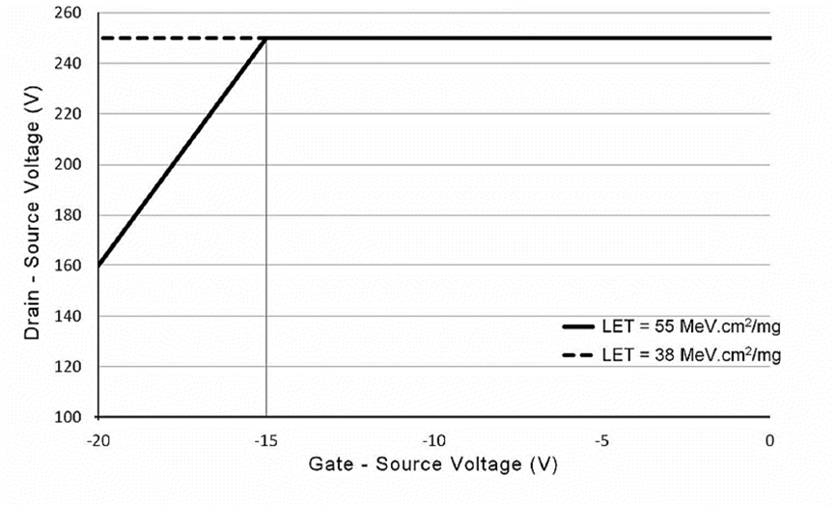
Single Event Safe Operating Area - VARIANTS 03, 04


