

Page 1 of 28

EXTERNAL VISUAL INSPECTION OF RESISTORS, HEATERS, FLEXIBLE

ESCC Basic Specification No. 2054009

Issue 5 Draft C | February 2023



Document Custodian: European Space Agency – see https://escies.org

Legal Disclaimer and Copyright
European Space Agency, Copyright © 2023. All rights reserved.
The European Space Agency disclaims any liability or responsibility, to any person or entity, with respect to any loss or damage caused, or alleged to be caused, directly or indirectly by the use and application of this ESCC publication.
This publication, without the prior permission of the European Space Agency and provided that it is not used for a commercial purpose, may be:
- copied in whole, in any medium, without alteration or modification.
- copied in part, in any medium, provided that the ESCC document identification, comprising the ESCC symbol, document number and document issue, is removed.

DOCUMENTATION CHANGE NOTICE
(Refer to https://escies.org for ESCC DCR content)
DCR No. | CHANGE DESCRIPTION
TBD | Specification upissued to incorporate changes per DCR.
Issue 5 Draft C  S.Thacker ESCC-TW  02/02/2023 | New revision Draft mark-up specification implementing additional changes agreed with per Rica (ref. email dated 01/02/23).  All changes from issue 4 are highlighted yellow for information.

TABLE OF CONTENTS
1 SCOPE 6
2 GENERAL REQUIREMENTS 6
2.1 APPLICABILITY 6
2.2 PROCEDURE 6
2.3 MAGNIFICATION 6
2.4 MOUNTING FIXTURES 6
2.5 ILLUMINATION 6
3 TERMS AND DEFINITIONS 7
4 DETAILED REQUIREMENTS 7
4.1 GENERAL 7
4.2 DIMENSIONS AND MARKING 8
4.3 MATERIALS 8
4.4 LEAD WIRES 8
4.4.1 Flattened Wire 8
4.4.2 Integrity 9
4.5 WELDED LEAD CONNECTIONS 9
4.5.1 Location of Lead Wire 9
4.5.2 Visual Aspect 10
4.5.3 Weld Window (if applicable) 11
4.6 CONDUCTOR ETCHING 12
4.6.1 General 12
4.6.2 Nicks and Protrusions 13
4.6.3 Metallic Islets and Inclusions 14
4.6.4 Lack of Metal 15
4.7 DEFORMATION 16
4.7.1 Folds 16
4.7.2 Slips 18
4.7.3 Local Deformation 19
4.8 BLISTERING AND DELAMINATION 20
4.8.1 Track Unsticking 20
4.8.2 Blistering/Delamination 21
4.9 Ragged Edges 22
4.10 ASPECT DEFECTS 23
4.10.1 Spots and Patches 23
4.10.2 Bubbles 24
4.10.3 Surface Defects 25
4.10.4 Non-Metallic Inclusions 26
4.10.5 Black Dots On/In the Insulation Layers/Protective Coating 27
4.10.6 Misregistration 28

SCOPE
This specification, to be read in conjunction with ESCC Basic Specification No. 20500, External Visual Inspection, contains additional requirements for Flexible Heaters (Resistors).
They shall apply, where relevant, to each component inspected.

GENERAL REQUIREMENTS

APPLICABILITY
The following criteria may not be varied or modified after commencing any inspection stage. Any ambiguity or proposed minor deviation shall be referred to the ESCC Executive for resolution and approval.

PROCEDURE
All items shall be examined in such a manner that a minimum of handling and movement of the component is involved. During handling of components, lint free gloves/finger cots shall be used.

MAGNIFICATION
All items shall be examined with a binocular or stereoscopic microscope under a magnification of between 2X and 15X depending upon track width.

MOUNTING FIXTURES
Suitable fixtures may be used to assist in the inspection process provided they do not of themselves cause damage to the device.

ILLUMINATION
The samples are illuminated in such a manner that all aspect defects listed below will be revealed.

TERMS AND DEFINITIONS
Blister | - | Delamination in the form of a localised swelling and separation between the conductive track and the substrate/insulation layers/protective coating.
Bubble | - | A void fully enclosed within the substrate/insulation layers/protective coating due to entrapment of air or gas (that does not result in the any blistering or delamination).
Deformation | - | All conductive track defects such as dents, folds, bumps.
Delamination | - | A separation between the conductive track and the substrate/insulation layers/protective coating.
Flattened wire | - | A wire that has become flat during pressing operations.
Inclusions | - | Foreign particles, metallic or non-metallic, entrapped within the heater.
Metallic islet | - | A metallic area entrapped within the heater that reduces the separation between two conductive tracks.
Misregistration | - | Imperfect registration.
Nick | - | A cut or other damage to the edge of a conductive track.
Notch | - | A cut in the wire insulation.
Pad | - | The metallic extension where wire is welded.
Pinhole | - | An imperfection in the form of a small hole that penetrates into a conductive track or the substrate/insulation layers/protective coating.
Protrusion | - | A protuberance of the conductive track at the track edge.
Ragged edge | - | Edge of the substrate/insulation layers/protective coating with cuts, tears, impacts or other damage.
Scratch | - | A narrow furrow or groove in a surface.
Slip | - | Slipping of conductive tracks that occurred during substrate/insulation layers/protective coating lamination cycle.
Spot or Patch | - | A blot on a conductive track or the substrate/insulation layers/protective coating.

DETAILED REQUIREMENTS

GENERAL
A component shall be rejected if it exhibits one or more of the defects listed in any of the following paragraphs. Where applicable, drawings are included to provide additional explanatory material.
The external visual inspection includes the verification of:
- Dimensions.
- Marking.
- Materials.
- Mechanical defects.

DIMENSIONS AND MARKING
Dimensions and marking shall be inspected in accordance with the requirements of ESCC Basic Specification No. 20500.
All letters and numbers shall be clearly legible without the use of optical resources.
Dimensional tolerances shall be as specified in the relevant ESCC Detail Specification.

MATERIALS
The materials used shall be verified for conformance to the requirements of the applicable ESCC Detail Specification.
The production records shall be checked to ensure that the specified material requirements are met.

LEAD WIRES

Flattened Wire
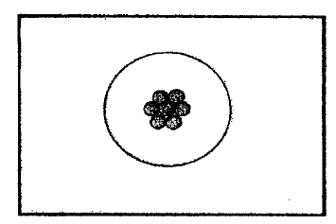 | GOOD  Wire is intact.
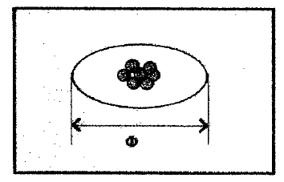 | ACCEPTABLE  Wire is slightly flattened.  Rule: Ø ≤ 1.4 × Nominal diameter.
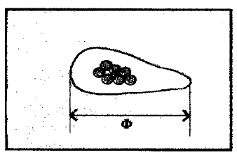 | REJECTED  Wire is flattened.  Rule: Ø > 1.4 × Nominal diameter.

Integrity
Notches and scratches on wire insulation.
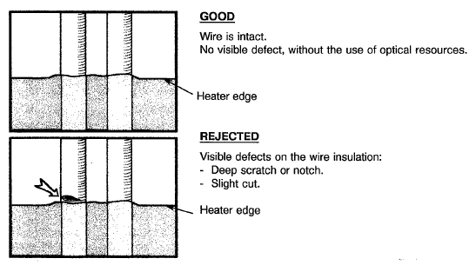

WELDED LEAD CONNECTIONS

Location of Lead Wire
          - Position in relation to heater edge.
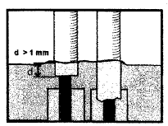 | GOOD  The wire insulation penetration under the protective coating is d ≥ 1mm.
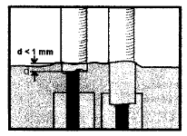 | REJECTED  The wire insulation penetration under the protective coating is d < 1mm.

          - Wire position on the connection pad.
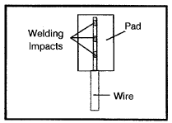 | GOOD  The wire is centred.  Twist is regular, strands are well joined (see also Para. 4.4.1).
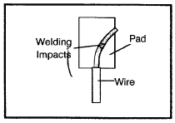 | REJECTED  Wire outside pad.  Welding impacts are insufficient (< 2).

Visual Aspect
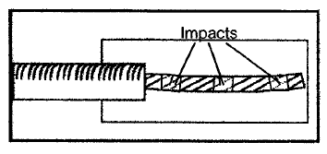 | GOOD  No discoloration on the welding area.  No broken strands.  No free element (detached or projecting).
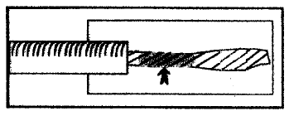 | REJECTED  Discoloration within the welding area.
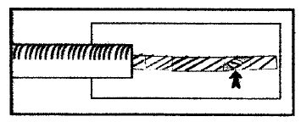 | REJECTED  Broken strand.

Weld Window (if applicable)
          - Examination of weld window itself and its environment.
+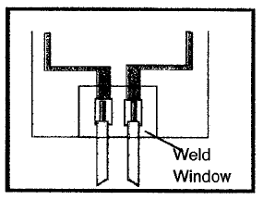 | GOOD  No unsticking.  No adhesive flow.  Good position. In particular the protective coating covering the welds shall also cover the opening of the upper insulation layer for double-sided heaters.  No bubbles in the adhesive.  Good wire encapsulation (no void at the end of the sheath next to bare areas).
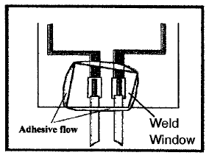 | ACCEPTABLE  Adhesive flow next to wires < 2mm.  Crosswise position but wire encapsulation is correct.  N.B.  Removal of excess adhesive with scalpel is not allowed.
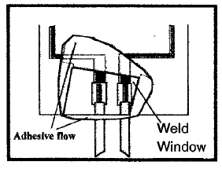 | REJECTED  Excessive adhesive flow ≥ 2mm next to wires.  Bad wire encapsulation.  Local unsticking.  Bad coverage of the opening of the upper insulation layer for double-sided heaters.  N.B.  Removal of excess adhesive with scalpel is not allowed.

CONDUCTOR ETCHING

General
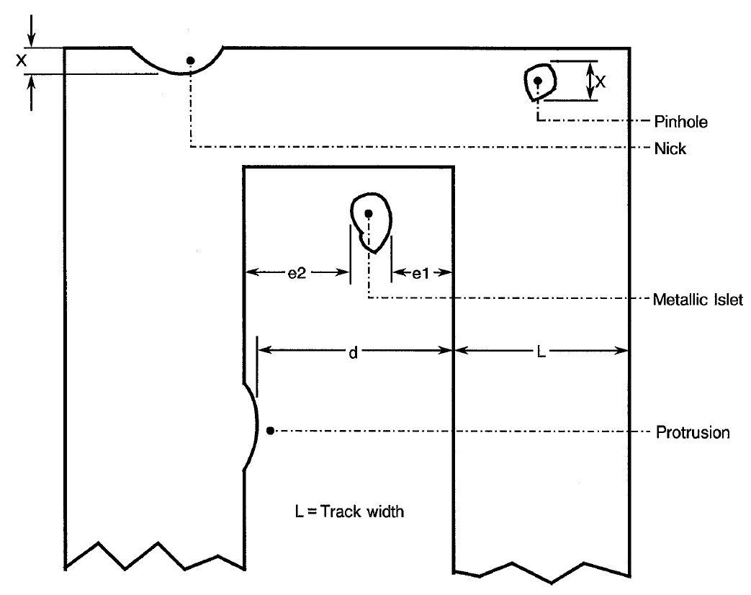

Nicks and Protrusions
Ref. Para. 4.6.1.
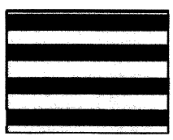 | GOOD  No nicks or protrusions
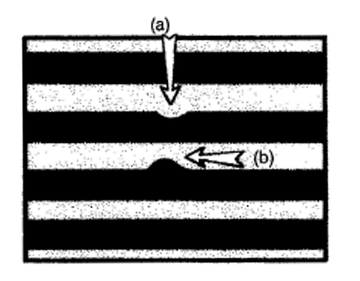 | ACCEPTABLE  - Track width reduction is: X ≤ 30% of the track width (L)  - Distance between tracks is: d ≥ 50µm
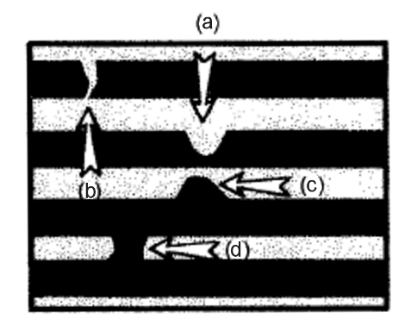 | REJECTED  - Track width reduction is: X > 30% of the track width (L)  - Cut through track  - Distance between tracks is: d < 50µm  - Short circuit between tracks

Metallic Islets and Inclusions
Ref. Para. 4.6.1.
Note: Metallic islets and inclusions are characterised by a bright appearance when using a bright-field light/magnification tool.
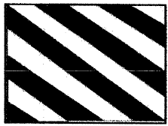 | GOOD  No metallic islet/inclusion between tracks
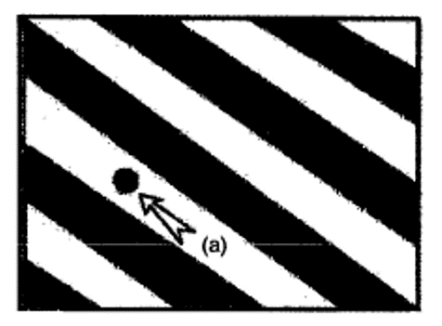 | ACCEPTABLE  - The total spacing between the metallic islet/inclusion and the two tracks is: e1 + e2 ≥ 50µm  When adjacent tracks are from different resistors, the spacing to each track shall be: e1 = e2 ≥ 50µm
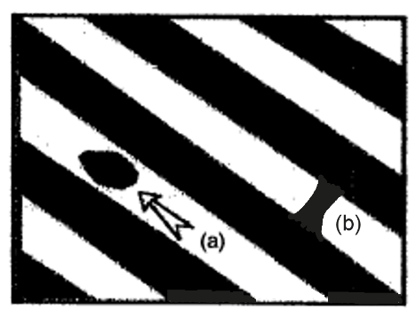 | REJECTED  - Any metallic islet/inclusion not meeting the specified Acceptable criteria as given above.  - Any metallic islet/inclusion resulting in a short circuit between tracks

Lack of Metal
Ref. Para. 4.6.1.
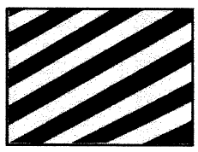 | GOOD  No pinholes, voids, nicks or other lack of metal on tracks
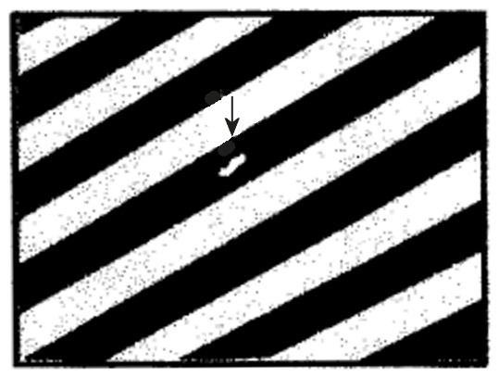 | ACCEPTABLE  Track width reduction is: X ≤ 30% of the track width (L)
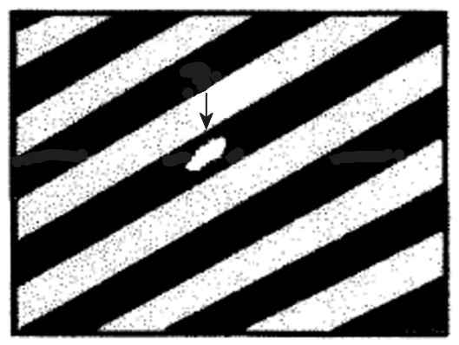 | REJECTED  Track width reduction is: X > 30% of the track width (L)

DEFORMATION

Folds
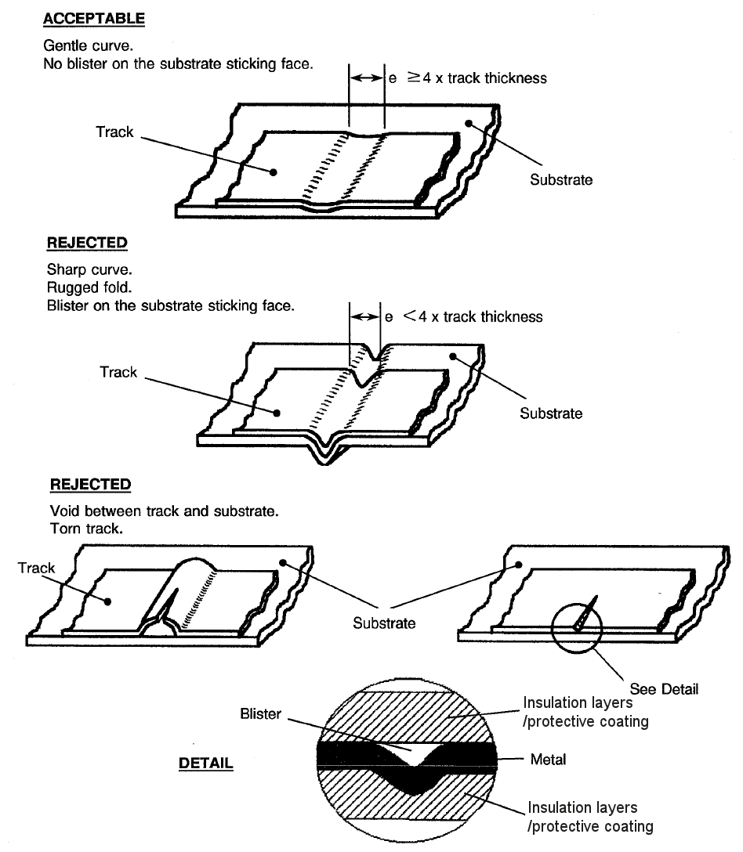
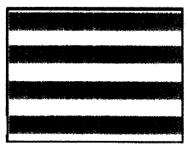 | GOOD  No visual defects.  No visible fold.
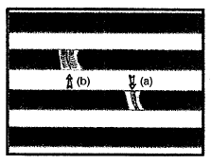 | ACCEPTABLE  - Fold is not very pronounced.  - Fold width is ≥ 4 x track thickness.  - No obvious delamination.  - No bump on heater surface.  - Fold does not result in an over-thickness.
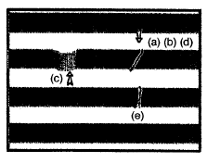 | REJECTED  - Fold is very pronounced.  - Rugged fold.  - Fold results in delamination.  - Nail detectable over-thickness.  - Pronounced deformation and fold width < 4 x track thickness.

Slips
 | GOOD  No track slippage.
 | ACCEPTABLE  Track slipped but the spacing between tracks is: ≥ 50µm.
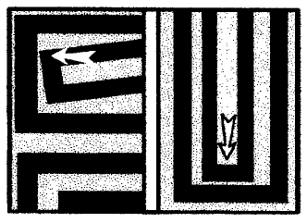 | REJECTED  Track slipped and the spacing between tracks is: < 50µm.

Local Deformation
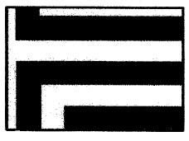 | GOOD  Tracks are smooth and without visible deformation.
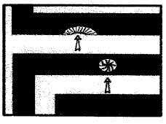 | ACCEPTABLE  Deformation is well localized  Bump involves:  - Neither over-thickness.  - Nor delamination.  N.B. Acceptance criteria: No nail detectable deformation.
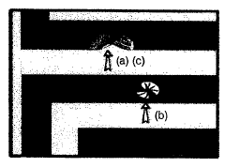 | REJECTED  - Excessive and large deformation.  - Visible marks of cracking.  - Nail detectable over-thickness.

BLISTERING AND DELAMINATION

Track Unsticking
 | GOOD  No track area unstuck from the substrate.
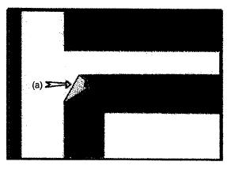 | REJECTED  - Moved and/or folded track corner.  - Unstuck track corner.  Insulation layer/protective coating perforated during the pressing step.

Blistering/Delamination
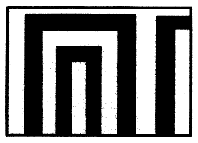 | GOOD  No visible blistering or delamination.
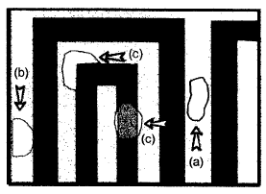 | REJECTED  Blisters that:  (a) result in delamination of the insulation layers/protective coating between the tracks.  (b) stretch from the track to heater edge.  (c) extend beyond the track edge.

Ragged Edges
N.B. General Rule: Minimum distance between a track and the heater edge: D = 0.4mm.
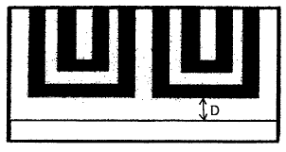 | GOOD  Minimum distance D is respected. Heater edge is without any cuts, tears, impacts or other damage.
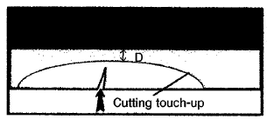 | ACCEPTABLE  The heater edge is damaged. This damage may be touched up (i.e. rounded off) subject to:  - The damage is not within 5mm of the lead wires, on both sides.  - The minimum distance D is respected.
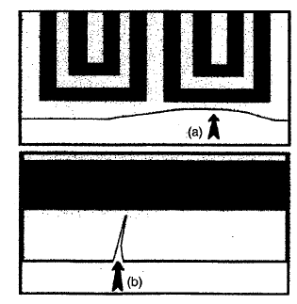 | REJECTED  - The minimum distance D is not respected.  - The damage is too severe and cannot be rounded off with regard to the minimum distance D.

ASPECT DEFECTS

Spots and Patches
 | GOOD  No spot or patch visible on the heater
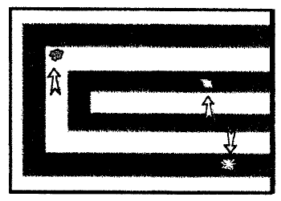 | ACCEPTABLE  Spots/patches are present but without any delamination  REJECTED  Spots or patches showing delamination

Bubbles
See also Para. 4.8.2.
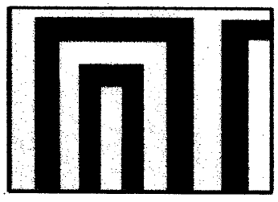 | GOOD  No bubble visible within the heater.
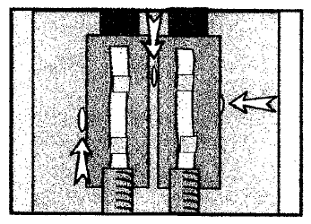 | ACCEPTABLE  Bubbles coupled with the metallic pad with the following criteria:  - Bubble maximum length: 200µm  - Quantity: 5 maximum
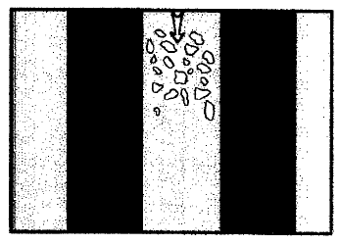 | REJECTED  Bubbles that make groups of white spots.

Surface Defects
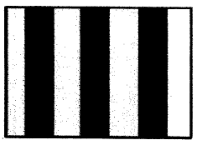 | GOOD  No evidence of any scratch, abrasion, pinhole or other defect on the surface of the insulation layer/protective coating of the heater
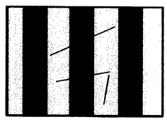 | ACCEPTABLE  Scratches, abrasions, pinholes or other defect on the surface of the insulation layer/protective coating of the heater that do not expose the track metal.
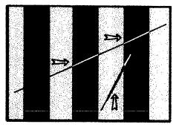 | REJECTED  Scratches, abrasions, pinholes or other defect on the surface of the insulation layer/protective coating of the heater that do expose the track metal.

Non-Metallic Inclusions
Ref. Para. 4.6.1.
Note: See Para. 4.6.3 for criteria for metallic inclusions
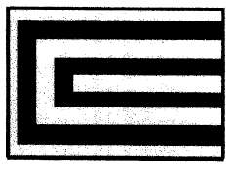 | GOOD  No evidence of any non-metallic inclusion on or between tracks.
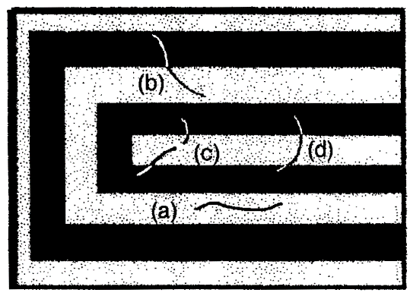 | ACCEPTABLE  - Any non-metallic inclusion respecting the total spacing between two tracks: e1 + e2 ≥ 50µm  When adjacent tracks are from different resistors, the spacing to each track shall be: e1 = e2 ≥ 50µm  - Any non-metallic inclusion that does not make a whole bridge between two tracks where the spacing to the unlinked track is ≥ 50µm  - Discontinuous non-metallic inclusions where the discontinuities between the tracks total ≥ 50µm  - Any non-metallic inclusion making a bridge between two tracks where:  - The inclusion length* ≤ 2mm for a track width plus track spacing (L + d) ≤ 0.6mm  - The inclusion length* ≤ 4mm for a track width plus track spacing (L + d) > 0.6mm  * The inclusion length shall be measured as the maximum distance (segment) between the 2 extreme points of the inclusion. Non-metallic inclusions may have any geometrical shape  - A maximum of 3 non-metallic inclusions are permitted in any area of 10cm²
REJECTED
Any non-metallic inclusion not meeting the specified Acceptable criteria as given above.

Black Dots On/In the Insulation Layers/Protective Coating
Ref. Para. 4.6.1.
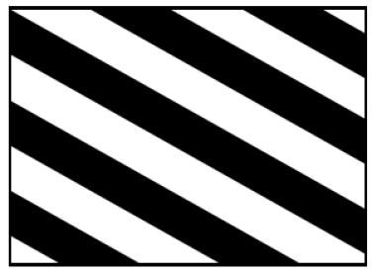 | GOOD  No black dot on/in the insulation layers/protective coating
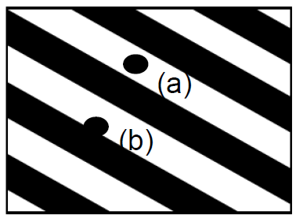 | ACCEPTABLE  - Any black dot on/in the insulation layers/protective coating where the total spacing between the black dot and the two tracks is e1 + e2 ≥ 50µm  - Any black dot on/in the insulation layers/protective coating, partially or totally above a track and with a length ≤ 150µm, where the spacing to the next unlinked track is ≥ 50µm
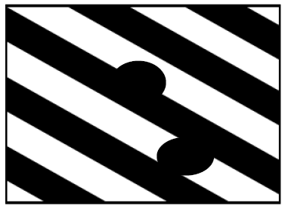 | REJECTED  Any black dot on/in the insulation layers/protective coating not meeting the specified Acceptable criteria as given above.

Misregistration
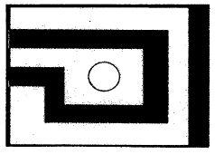 | GOOD  Perforations are well centred in relation to tracks.
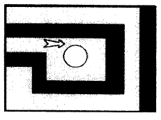 | ACCEPTABLE  Perforations are misregistered in relation to tracks, but the spacing between the perforation edge and the track is: ≥ 0.4mm
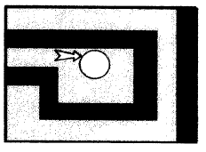 | REJECTED  Spacing between the perforation edge and the track is: < 0.4mm

