

Page 1 of 19

CAPACITOR FILTERS, C-TYPE, ELECTROMAGNETIC INTERFERENCE SUPPRESSION, NON-HERMETICALLY SEALED, SURFACE MOUNT
BASED ON TYPE SFCMS 35 TYPE C
ESCC Detail Specification No. 3008/034

Issue 4 Draft A | April 2022


Document Custodian: European Space Agency – see https://escies.org

Legal Disclaimer and Copyright
European Space Agency, Copyright © 2022. All rights reserved.
The European Space Agency disclaims any liability or responsibility, to any person or entity, with respect to any loss or damage caused, or alleged to be caused, directly or indirectly by the use and application of this ESCC publication.
This publication, without the prior permission of the European Space Agency and provided that it is not used for a commercial purpose, may be:
- copied in whole, in any medium, without alteration or modification.
- copied in part, in any medium, provided that the ESCC document identification, comprising the ESCC symbol, document number and document issue, is removed.

DOCUMENTATION CHANGE NOTICE
(Refer to https://escies.org for ESCC DCR content)
DCR No. | CHANGE DESCRIPTION
TBA | Specification upissued to incorporate editorial changes per DCR.

TABLE OF CONTENTS
1 GENERAL 6
1.1 SCOPE 6
1.2 COMPONENT TYPE VARIANTS AND RANGE OF COMPONENTS 6
1.3 MAXIMUM RATINGS 6
1.4 PARAMETER DERATING INFORMATION 6
1.5 PHYSICAL DIMENSIONS 6
1.6 FUNCTIONAL DIAGRAM 6
2 APPLICABLE DOCUMENTS 6
3 TERMS, DEFINITIONS, ABBREVIATIONS, SYMBOLS AND UNITS 6
4 REQUIREMENTS 10
4.1 GENERAL 10
4.2 DEVIATIONS FROM GENERIC SPECIFICATION 10
4.2.1 Deviations From Special In-Process Controls 10
4.2.2 Deviations from Final Production Tests (Chart II) 10
4.2.3 Deviations from Burn-in and Electrical Measurements (Chart III) 10
4.2.4 Deviations from Qualification Tests (Chart IV) 10
4.2.5 Deviations from Lot Acceptance Tests (Chart V) 10
4.3 MECHANICAL REQUIREMENTS 11
4.3.1 Dimension Check 11
4.3.2 Weight 11
4.3.3 Robustness of Terminations 11
4.3.4 Solderability 11
4.4 MATERIALS AND FINISHES 11
4.4.1 Case 11
4.4.2 Lead Material and Finish 11
4.5 MARKING 12
4.5.1 General 12
4.5.2 The ESCC Component Number 12
4.5.3 Electrical Characteristics and Ratings 12
4.5.4 Traceability Information 13
4.6 ELECTRICAL MEASUREMENTS 13
4.6.1 Electrical Measurements at Room Temperature 13
4.6.2 Electrical Measurements at High and Low Temperatures 13
4.6.3 Circuits for Electrical Measurements (Figure 4) 13
4.7 BURN-IN TESTS 13
4.7.1 Parameter Drift Values 13
4.7.2 Conditions for Burn-in 13
4.7.3 Electrical Circuits for Burn-in (Figure 5) 13
4.8 ENVIRONMENTAL AND ENDURANCE TESTS (CHARTs IV AND V OF ESCC GENERIC SPECIFICATION No. 3008) 16
4.8.1 Measurements and Inspections on Completion of Environmental Tests 16
4.8.2 Measurements and Inspections at Intermediate Points During Endurance Tests 16
4.8.3 Measurements and Inspections on Completion of Endurance Tests 16
4.8.4 Conditions for Operating Life 16
4.8.5 Electrical Circuit for Operating Life (Figure 5) 16

GENERAL

SCOPE
This specification details the ratings, physical and electrical characteristics, test and inspection data for a Capacitor Filter, C-Type, Electromagnetic Interference Suppression, Non-Hermetically Sealed, Surface Mount, based on type SFCMS 35 Type C. It shall be read in conjunction with ESCC Generic Specification No. 3008, the requirements of which are supplemented herein.

COMPONENT TYPE VARIANTS AND RANGE OF COMPONENTS
Variants of the basic type components and the range of components covered by this specification are given in Table 1(a).

MAXIMUM RATINGS
The maximum ratings, which shall not be exceeded at any time during use or storage, applicable to the components specified herein, are as scheduled in Table 1(b).

PARAMETER DERATING INFORMATION
The parameter derating information applicable to the components specified herein is shown in Figure 1.

PHYSICAL DIMENSIONS
The physical dimensions of the components specified herein are shown in Figure 2.

FUNCTIONAL DIAGRAM
The functional diagram of the components specified herein is shown in Figure 3.

APPLICABLE DOCUMENTS
The following documents form part of this specification and shall be read in conjunction with it:
          - ESCC Generic Specification No. 3008 for Capacitors and Capacitor Filters, Feedthrough.
          - MIL-STD-202, Test Methods for Electronic and Electrical Component Parts.

TERMS, DEFINITIONS, ABBREVIATIONS, SYMBOLS AND UNITS
For the purpose of this specification, the terms, definitions, abbreviations, symbols and units specified in ESCC Basic Specification No. 21300 shall apply.
TABLE 1(a) – TYPE VARIANTS AND RANGE OF COMPONENTS
Variant | Rated Voltage U_{R} (V) | Capacitance Range C (pF)  (±10%, 20%)  (E12 Series - see Table below) | Voltage Proof VP (V) | Weight max (g)
Variant | -55°C ≤ T_{amb} ≤ +85°C  Note 1 |  | Voltage Proof VP (V) | Weight max (g)
01, 04 | 50 | 470 to 22000 | 125 | 2 (Variants 01 to 03)  1 (Variants 04 to 06)
02, 05 | 100 | 470 to 18000 | 250 | 2 (Variants 01 to 03)  1 (Variants 04 to 06)
03, 06 | 200 | 470 to 8200 | 500 | 2 (Variants 01 to 03)  1 (Variants 04 to 06)
INSERTION LOSS VALUES ACCORDING TO THE CAPACITANCE VALUE
Capacitance  C (pF) | Insertion Loss I_{L} (dB)
Capacitance  C (pF) | 10MHz | 50MHz | 100MHz | 500MHz | 1GHz | 5GHz | 10GHz
470 | - | 8 | 14 | 28 | 34 | 48 | 54
560 | - | 9 | 15 | 29 | 35 | 49 | 55
680 | - | 11 | 17 | 31 | 37 | 51 | 57
820 | - | 13 | 19 | 33 | 39 | 53 | 59
1000 | - | 15 | 21 | 35 | 41 | 55 | 61
1200 | - | 16 | 22 | 36 | 42 | 56 | 62
1500 | - | 18 | 24 | 38 | 44 | 58 | 64
1800 | - | 19 | 25 | 39 | 46 | 59 | 66
2200 | - | 21 | 27 | 41 | 48 | 61 | 68
2700 | 9 | 23 | 29 | 43 | 50 | 63 | 70
3300 | 11 | 25 | 31 | 45 | 52 | 60 | 70
3900 | 12 | 26 | 32 | 46 | 53 | 66 | 70
4700 | 14 | 28 | 34 | 48 | 54 | 68 | 70
5600 | 15 | 29 | 35 | 49 | 55 | 69 | 70
6800 | 17 | 31 | 37 | 51 | 57 | 70 | 70
8200 | 19 | 33 | 39 | 53 | 59 | 70 | 70
10000 | 21 | 35 | 41 | 43 | 61 | 70 | 70
12000 | 23 | 37 | 43 | 45 | 63 | 70 | 70
15000 | 25 | 39 | 45 | 47 | 65 | 70 | 70
18000 | 26 | 40 | 46 | 52 | 66 | 70 | 70
22000 | 28 | 42 | 48 | 54 | 68 | 70 | 70
NOTES:
            - U_{R} is derated +85°C < T_{amb} ≤ +125°C. See Figure 1.
TABLE 1(b) – maximum RATINGS
No. | Characteristics | Symbol | Maximum Ratings | Unit | Remarks
1 | Rated DC Voltage | U_{R} | See Table 1(a) | V | Note 1
2 | Voltage Drop | V_{dr} | 50 | mV
3 | DC Resistance | R_{S} | 5 | mΩ
4 | DC and Low Frequency Current | I_{R} | 10 | A
5 | Operating Temperature Range | T_{op} | -55 to +125 | °C | T_{amb}
6 | Storage Temperature Range | T_{stg} | -55 to +125 | °C
7 | Soldering Temperature | T_{sol} | +260 | °C | Note 2
notes:
            - The addition of DC applied voltage and ripple voltage shall never exceed the rated DC voltage.
            - Duration 6 seconds maximum and the same termination, or the case, shall not be resoldered until 3 minutes have elapsed.
FIGURE 1 - PARAMETER DERATING INFORMATION
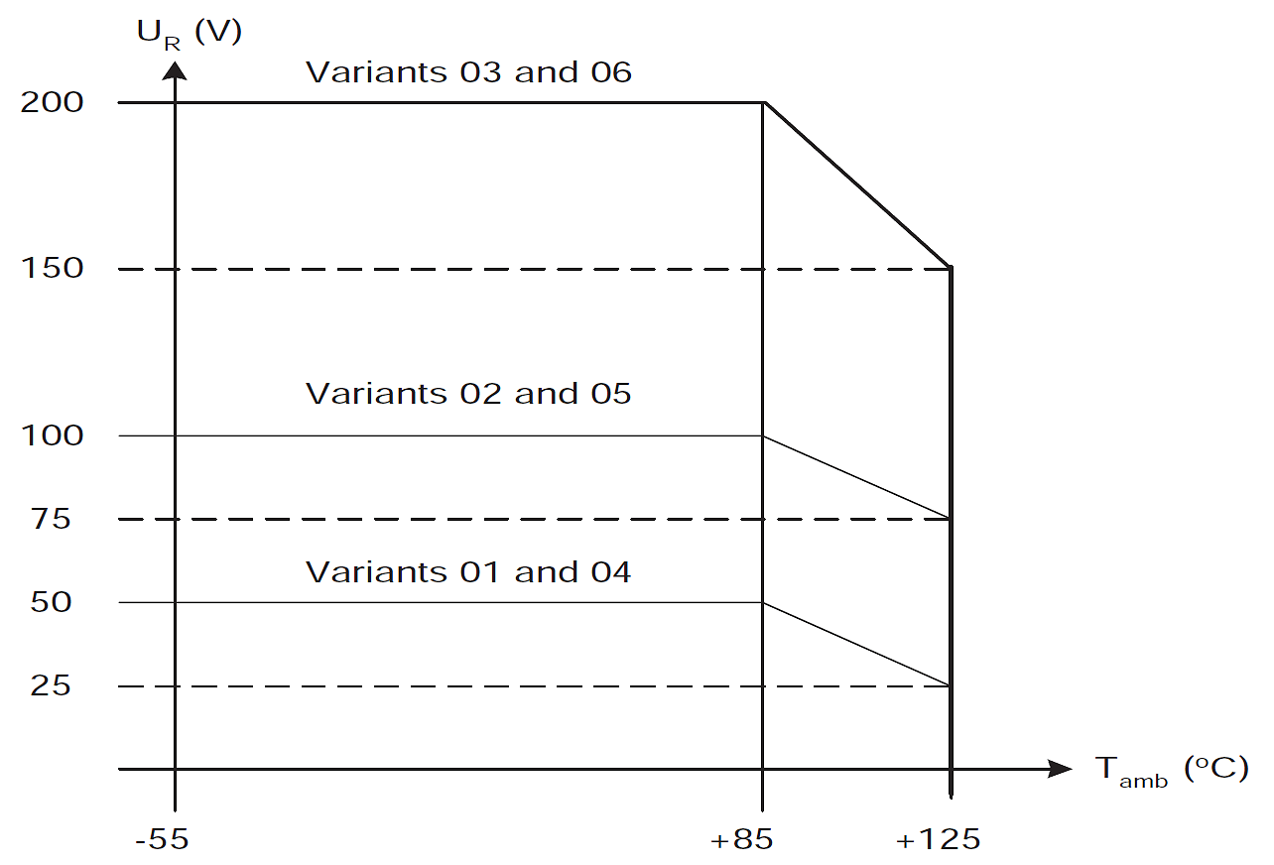
Rated Voltage versus temperature
FIGURE 2 – PHYSICAL DIMENSIONS
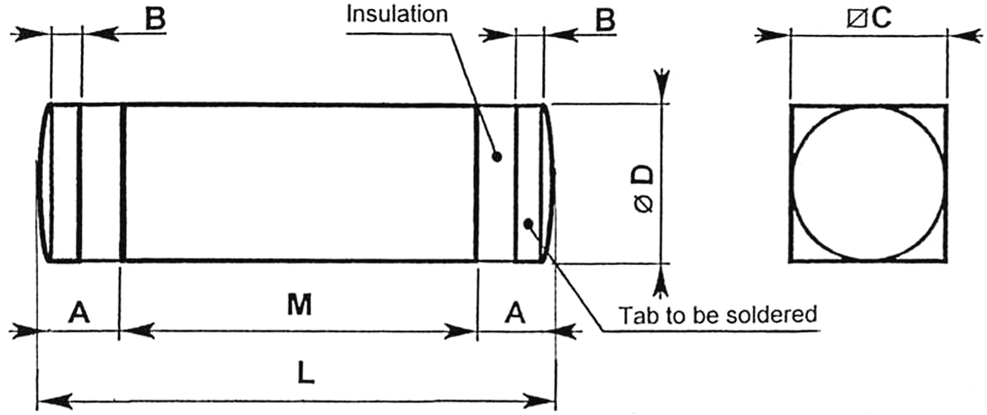
Symbol | Dimensions (mm) |  |  |  | Remarks
Symbol | Variants 01, 02 and 03 |  | Variants 04, 05 and 06 |  | Remarks
Symbol | Min | Max | Min | Max | Remarks
A | 1.9 | 2.6 | 1.9 | 2.6
B | 0.7 | 0.9 | 0.7 | 0.9
C | 3.5 | 3.6 | 3.5 | 3.6 | Note 1
ØD | 3.5 | 3.6 | 3.5 | 3.6 | Note 2
L | 11.3 | 12.7 | 6.5 | 8.5
M | 7.4 | 7.6 | 2.7 | 3.3
notes:
            - This dimension applies to the square-section case (Ground), over dimension M. One of the four faces shall bear marking in accordance with Para. 4.5.
            - This dimension (diameter) applies to both the tab termination and the insulation.
FIGURE 3 - FUNCTIONAL DIAGRAM
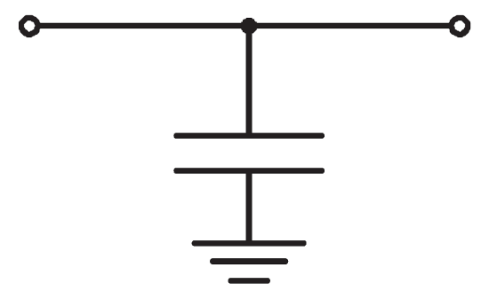

REQUIREMENTS

GENERAL
The complete requirements for procurement of the components specified herein are stated in this specification and ESCC Generic Specification No. 3008 for Capacitors and Capacitor Filters, Feedthrough. Deviations from the Generic Specification, applicable to this specification only, are detailed in Para. 4.2.
Deviations from the applicable Generic Specification and this Detail Specification, formally agreed with specific Manufacturers on the basis that the alternative requirements are equivalent to the ESCC requirements and do not affect the components' reliability, are listed in the appendices attached to this specification.

DEVIATIONS FROM GENERIC SPECIFICATION

Deviations From Special In-Process Controls
None.

Deviations from Final Production Tests (Chart II)
          - Para. 9.4.1.5, Voltage Drop: Shall be performed as a DC resistance measurement in accordance with MIL-STD-202, Method 303.
          - Para. 9.2, Rapid Change of Temperature: The Components may not be mounted.
          - Para. 9.3, Vibration: Not applicable.

Deviations from Burn-in and Electrical Measurements (Chart III)
          - Para. 9.4.1.5, Voltage Drop: Shall be performed as a DC resistance measurement in accordance with MIL-STD-202, Method 303.
          - Paras. 9.4.3, Electrical Measurements at High and Low Temperature and 9.4.4, Electrical Measurements at Room Temperature: Insertion Loss is considered as destructive and the parts so tested cannot be delivered as flight models. Therefore, these tests shall be performed at the end of Chart III and parts rejected during External Visual Inspection, or Radiographic Inspection, but electrically acceptable after Burn-in, may be used.

Deviations from Qualification Tests (Chart IV)
          - Para. 9.4.1.5, Voltage Drop: Shall be performed as a DC resistance measurement in accordance with MIL-STD-202, Method 303.
          - Para. 9.12, Accelerated Damp Heat: Voltage Proof and Insertion Loss shall not be performed.
          - Para. 9.14, Robustness of Terminations: Only test Ua is applicable.
          - Para. 9.15, Immersion: Not applicable.
          - Para. 9.17, Resistance to Soldering Heat: May be performed prior to Para. 9.11, Vibration. Capacitance is performed in lieu of Insertion Loss at Final Measurements.
          - Para. 9.18, Solderability: May be performed prior to Para. 9.10, Shock.
          - Para. 9.19, Operating Life (Intermediate and End Data Points): Insertion Loss shall not be performed.

Deviations from Lot Acceptance Tests (Chart V)
          - Para. 9.4.1.5, Voltage Drop: Shall be performed as a DC resistance measurement in accordance with MIL-STD-202, Method 303.
          - Para. 9.14, Robustness of Terminations: Only test Ua is applicable.
          - Para. 9.15, Immersion: Not applicable.
          - Para. 9.18, Solderability: May be performed prior to Para. 9.10, Shock.
          - Para. 9.19, Operating Life (Intermediate and End Data Points): Insertion Loss shall not be performed.

MECHANICAL REQUIREMENTS

Dimension Check
The dimensions of the components specified herein shall be verified in accordance with the requirements set out in Para. 9.5 of ESCC Generic Specification No. 3008 and they shall conform to those shown in Figure 2 of this specification.

Weight
The maximum weight of the components specified herein shall be as given in Table 1(a).

Robustness of Terminations
The requirements for the robustness of terminations tests are specified in Para. 9.14 of the Generic Specification and below.
Add to Para. 9.14.1 of the Generic Specification
For surface mount components, capacitors shall be mounted on a suitable substrate. After mounting, examination shall be made for good tinning as evidenced by flowing of the solder with wetting of the terminations.
Add to Para. 9.14.2 (for method Ua) of the Generic Specification
For surface mount components, a force of 10N shall be applied on the terminations normal to the length of the case and in a plane parallel to the substrate, duration = 10s.
Add to Para. 9.14.3 of the Generic Specification
For surface mount components there shall be no evidence of damage or loosening of the components from the substrate.

Solderability
The requirements for solderability testing are specified in Para. 9.18 of the Generic Specification and below.
The test shall be carried out in accordance with IEC 68-2-20 standard with the following conditions:
- Test Ta, Method 1
- Temperature: +235 ±3°C
- Immersion time: 3 ±0.3 seconds
The terminations shall be immersed to the distance B defined in Figure 2.

MATERIALS AND FINISHES
The materials and finishes shall be as specified herein. Where a definite material is not specified, a material which will enable the components specified herein to meet the performance requirements of this specification shall be used. Acceptance or approval of any constituent material does not guarantee acceptance of the finished product.

Case
The case shall be silver plated brass.

Lead Material and Finish
The tab material shall be brass with tin-lead layer (tin content 50% minimum and 97% maximum, remainder lead) with Nickel and Silver underplating.

MARKING

General
The marking of components delivered to this specification shall be in accordance with the requirements of ESCC Basic Specification No. 21700 and the following paragraphs. When the component is too small to accommodate all of the marking specified, as much as space permits shall be marked and the marking information, in full, shall accompany the component in its primary package.
The information to be marked and the order of precedence, shall be as follows:
          - The ESCC Component Number.
          - Electrical Characteristics and Ratings.
          - Traceability Information.

The ESCC Component Number
The ESCC Component Number shall be constituted and marked as follows:
Example: 300803401B
- Detail Specification Reference: 3008034
- Component Type Variant Number: 01 (as required)
- Testing level (B or C, as applicable)

Electrical Characteristics and Ratings
The electrical characteristics and ratings to be marked in the following order of precedence are:
          - Capacitance Value
          - Tolerance
          - Rated Voltage
The information shall be constituted and marked as follows:
Example: 682KC
- Capacitance Value (6800pF): 682
- Tolerance (±10%): K
- Rated Voltage (50V): C

Capacitance Value
The capacitance values shall be expressed by means of the following codes. The unit quantity for marking shall be picofarads (pF).
Capacitance Value (pF) | Code
XX10¹ | XX1
XX10² | XX2
XX10³ | XX3

Tolerance
The tolerance on capacitance value shall be indicated by the code letters specified hereafter.
Tolerance (±%) | Code Letter
10 | K
20 | M

Rated Voltage
The rated voltage shall be indicated by the code letters specified hereafter.
Rated Voltage (U_{R}) (V) | Code Letter
50 | C
100 | E
200 | G

Traceability Information
Each component shall be marked in respect of traceability information in accordance with the requirements of ESCC Basic Specification No. 21700.

ELECTRICAL MEASUREMENTS

Electrical Measurements at Room Temperature
The parameters to be measured at room temperature are scheduled in Table 2. Unless otherwise specified, measurements shall be performed at T_{amb} = +22 ±3°C.

Electrical Measurements at High and Low Temperatures
The parameters to be measured at high and low temperatures are scheduled in Table 3. Measurements shall be performed at T_{amb} = +125 (+0 -5)°C and -55 (+5 -0)°C respectively.

Circuits for Electrical Measurements (Figure 4)
Not applicable.

BURN-IN TESTS

Parameter Drift Values
The parameter drift values applicable to burn-in are specified in Table 4 of this specification. Unless otherwise stated, measurements shall be performed at T_{amb} = +22 ±3°C. The parameter drift values (Δ) applicable to the parameters scheduled shall not be exceeded. In addition to these drift value requirements for a given parameter, the appropriate limit value specified in Table 2 shall not be exceeded.

Conditions for Burn-in
The requirements for burn-in are specified in Section 7 of ESCC Generic Specification No. 3008. The conditions for burn-in shall be as specified in Table 5(a) of this specification.

Electrical Circuits for Burn-in (Figure 5)
Not applicable.
TABLE 2 – ELECTRICAL MEASUREMENTS AT ROOM TEMPERATURE – DC PARAMETERS
No. | Characteristics | Symbol | ESCC 3008  Test Method | Test Conditions | Limits |  | Unit
 |  |  |  |  | Min | Max | Unit
1 | DC Resistance | R_{S} | MIL-STD-202 Method 303 | - | - | 5 | mΩ
2 | Voltage Proof | VP | Para. 9.4.1.2 | V = 2.5U_{R}  Note 2 | Note 1 | - | V
3 | Insulation Resistance | Ri | Para. 9.4.1.3 | Para. 9.4.1.3 | 104 | - | MΩ
TABLE 2 – ELECTRICAL MEASUREMENTS AT ROOM TEMPERATURE – AC PARAMETERS
No. | Characteristics | Symbol | ESCC 3008 Test Method | Test Conditions | Limits |  | Unit
 |  |  |  |  | Min | Max | Unit
4 | Insertion Loss, Note 6 | I_{L1} | Para. 9.4.1.4 | f = 10MHz, Note 4 | Note 1 | - | dB
5 | Insertion Loss | I_{L2} | Para. 9.4.1.4 | f = 50MHz, Note 3 | Note 1 | - | dB
6 | Insertion Loss, Note 6 | I_{L3} | Para. 9.4.1.4 | f = 100MHz, Note 4 | Note 1 | - | dB
7 | Insertion Loss | I_{L4} | Para. 9.4.1.4 | f = 500MHz, Note 3 | Note 1 | - | dB
8 | Insertion Loss, Note 6 | I_{L5} | Para. 9.4.1.4 | f = 1GHz, Note 4 | Note 1 | - | dB
9 | Insertion Loss | I_{L6} | Para. 9.4.1.4 | f = 5GHz, Note 3 | Note 1 | - | dB
10 | Insertion Loss | I_{L7} | Para. 9.4.1.4 | f = 10GHz, Note 3 | Note 1 | - | dB
11 | Capacitance | C | Para. 9.4.1.1 | f = 1kHz ±100Hz  V = 0.1 to 1.2Vrms | Note 1 | - | pF
TABLE 3 - ELECTRICAL MEASUREMENTS AT HIGH AND LOW TEMPERATURES
No. | Characteristics | Symbol | ESCC 3008  Test Method | Test Conditions | Limits |  | Unit
 |  |  |  |  | Min | Max | Unit
3 | Insulation Resistance Note 5 | Ri | Para. 9.4.1.3 | Para. 9.4.1.3  T_{amb} = +125 (+0 -5)°C | 10³ | - | MΩ
4 | Insertion Loss, Note 6 | I_{L1} | Para. 9.4.1.4 | f = 10MHz, No current | Note 1 | - | dB
6 | Insertion Loss, Note 6 | I_{L3} | Para. 9.4.1.4 | f = 100MHz, No current | Note 1 | - | dB
8 | Insertion Loss, Note 6 | I_{L5} | Para. 9.4.1.4 | f = 1GHz, No current | Note 1 | - | dB
Notes TO TABLES 2 and 3:
            - See Table 1(a).
            - See Table 1(a) for value of U_{R}.
            - Measurements at this frequency to be made only during Chart IV testing.
            - Measurements at rated current to made only during Chart IV testing. Measurements without load current to be made during Charts III and V. NB: Not performed during Chart II testing.
            - This measurement must be carried out at the end of the Burn-in in accordance with Para. 9.23 of ESCC Generic Specification No. 3008 and shall not be carried out again.
            - Measurements at Room, High and Low Temperatures to be made on a sample of 5 parts per lot. If one or more failures occur then another 5 samples shall be tested. If one or more of the additional 5 samples fails then the lot shall be rejected. The samples shall be mounted on a suitable substrate prior to measurements. See also Para. 4.2.3.
FIGURE 4 – CIRCUITS FOR ELECTRICAL MEASUREMENTS
Not applicable.
TABLE 4 – PARAMETER DRIFT VALUES
No. | Characteristics | Symbol | Spec. and/or Test Method | Test Conditions | Change Limits (Δ) | Unit
11 | Capacitance Change | ΔC/C | As per Table 2 | As per Table 2 | ±10 | %
TABLE 5(a) – CONDITIONS FOR BURN-IN
No. | Characteristic | Symbol | Condition | Unit
1 | Ambient Temperature | T_{amb} | +125 (+0 -3) | °C
2 | Test Voltage | V_{T} | 2 × U_{R} at +125°C  Note 1 | V
notes:
            - Applied between one terminal and the case. See Column 2(b) of Table 1(a) for value of U_{R}.
TABLE 5(b) – CONDITIONS FOR OPERATING LIFE
No. | Characteristic | Symbol | Condition | Unit
1 | Ambient Temperature | T_{amb} | +125 (+0 -3) | °C
2 | Test Voltage | V_{T} | 2 × U_{R} at +125°C  Note 1 | V
3 | Rated Current | I_{R} | 10 | A
notes:
            - Applied between one terminal and the case. See Column 2(b) of Table 1(a) for value of U_{R}.
FIGURE 5 – ELECTRICAL CIRCUIT FOR BURN-IN AND OPERATING LIFE
Not applicable.

ENVIRONMENTAL AND ENDURANCE TESTS (CHARTs IV AND V OF ESCC GENERIC SPECIFICATION No. 3008)

Measurements and Inspections on Completion of Environmental Tests
The parameters to be measured and inspections to be performed on completion of environmental tests are scheduled in Table 6. Unless otherwise stated, the measurements shall be performed at T_{amb} = +22 ±3°C.

Measurements and Inspections at Intermediate Points During Endurance Tests
The parameters to be measured and inspections to be performed at intermediate points during endurance tests are scheduled in Table 6. Unless otherwise stated, the measurements shall be performed at T_{amb} = +22 ±3°C.

Measurements and Inspections on Completion of Endurance Tests
The parameters to be measured and inspections to be performed on completion of endurance tests are scheduled in Table 6. Unless otherwise stated, the measurements shall be performed at T_{amb} = +22 ±3°C.

Conditions for Operating Life
The requirements for operating life test are specified in Section 9 of ESCC Generic Specification No. 3008. The conditions for operating life testing shall be as specified in Table 5(b) of this specification.

Electrical Circuit for Operating Life (Figure 5)
Not applicable.
TABLE 6 – MEASUREMENTS AND INSPECTIONS ON COMPLETION OF ENVIRONMENTAL TESTS AND AT INTERMEDIATE POINTS AND ON COMPLETION OF ENDURANCE TESTING
No. | ESCC Generic Spec. No. 3008 |  | Measurements and Inspections |  | Symbol | Limits |  | Unit
No. | Environmental and Endurance Tests (1) | Test Methods and Conditions | Identification | Conditions | Symbol | Min | Max | Unit
01 | Seal Test  (Hermetically Sealed) | Para. 9.6 | Not applicable
02 | External Visual Inspection | Para. 9.7 | Final Measurements  Visual Inspection | ESCC No. 20500 | - | - | - | -
03 | Temperature Rise | Para. 9.9 | Temperature Rise | Rated Current (3) | - | - | 25 | °C
04 | Shock | Para. 9.10 | Measurements during Tests | 100% U_{R} (2) applied  No Open or Short Circuits >100µs
 |  |  | Final Measurements
 |  |  | Visual Examination | No Mechanical Damage | - | - | - | -
 |  |  | Insertion Loss | Table 2 Items 4 to 10 | I_{L} | Table 2 | - | dB
05 | Vibration | Para. 9.11 | Measurements during Tests  During last cycle | Current (7) and 100% U_{R} (2) applied  No Open or Short Circuits >100µs
 |  |  | Final Measurements
 |  |  | Visual Examination | No Mechanical Damage | - | - | - | -
 |  |  | Insertion Loss | Table 2 Items 4 to 10 | I_{L} | Table 2 | - | dB
06 | Accelerated Damp Heat | Para. 9.12 and Para. 4.2.4 of this spec. | Final Measurements | After recovery of 4 to 24 hours
 |  | Para. 9.12 and Para. 4.2.4 of this spec. | Visual Examination | No corrosion or obliteration of marking | - | - | - | -
 |  | Para. 9.12 and Para. 4.2.4 of this spec. | Insulation Resistance | Table 2 Item 3 | Ri | (5) | - | MΩ
07 | Low Air Pressure | Para. 9.13 | Measurements during Tests | during last 5 minutes
 |  |  | Voltage Proof | Table 2 Item 2 | VP | 125% U_{R}  (2) | - | V
 |  |  | Visual Examination | No breakdown, flashover, deformation or seepage | - | - | - | -
 |  |  | Final Measurements
 |  |  | Visual Examination | No breakdown, flashover, deformation or seepage | - | - | - | -
08 | Robustness of Terminations | Para. 9.14 and Paras. 4.2.4, 4.2.5 and 4.3.3 of this spec. | Final Measurements
 |  | Para. 9.14 and Paras. 4.2.4, 4.2.5 and 4.3.3 of this spec. | Visual Examination | No damage | - | - | - | -
 |  | Para. 9.14 and Paras. 4.2.4, 4.2.5 and 4.3.3 of this spec. | DC Resistance | Table 2 Item 1 | R_{S} | - | Table 2 | mΩ
09 | Immersion | Para. 9.15 and Paras. 4.2.4 and 4.2.5 of this spec. | Not applicable
10 | Overload | Para. 9.16 |  | 140% of Rated Current (3) for 15 mins min.
 |  |  | Final Measurements
 |  |  | Insulation Resistance | Table 2 Item 3 | Ri | Table 2 | - | MΩ
 |  |  | DC Resistance | Table 2 Item 1 | R_{S} | - | Table 2 | mΩ
 |  |  | Visual Examination | No damage | - | - | - | -
11 | Resistance to Soldering Heat | Para. 9.17 and Para. 4.2.4(b) of this spec. | Final Measurements | After recovery of 1 to 2 hrs
 |  | Para. 9.17 and Para. 4.2.4(b) of this spec. | Visual Examination | No damage | - | - | - | -
 |  | Para. 9.17 and Para. 4.2.4(b) of this spec. | Insulation Resistance | Table 2 Item 3 | Ri | Table 2 | - | MΩ
 |  | Para. 9.17 and Para. 4.2.4(b) of this spec. | Capacitance | Table 2 Item 11 | C | Table 2 | - | pF
12 | Solderability | Para. 9.18 and Para. 4.3.4 of this spec | Final Measurements
 |  | Para. 9.18 and Para. 4.3.4 of this spec | Visual Examination | IEC No. 68-2-20 Para. 4.6.4, 4.7.4 or 4.9.3 | - | - | - | -
13 | Operating Life | Para. 9.19 and Paras. 4.2.4 and 4.2.5 of this spec. | During tests | Open or short Circuit |  | - | -
 |  | Para. 9.19 and Paras. 4.2.4 and 4.2.5 of this spec. | Initial Measurements
 |  | Para. 9.19 and Paras. 4.2.4 and 4.2.5 of this spec. | Voltage Drop | ESCC 3008, Para. 9.4.1.5 | V_{dr} | - | (6) | V
 |  |  | Voltage Proof | Table 2, Item 2 | VP | 90% U_{R} (2) | - | V
 |  |  | Insulation Resistance | Table 2, Item 3 | Ri | Table 2 | - | MΩ
 |  |  | Capacitance | Table 2, Item 11 | C | Table 2 | - | pF
 |  |  | Intermediate Measurements
 |  |  | Insulation Resistance | Table 3, Item 3 | Ri | Table 3 | - | MΩ
 |  |  |  | After 24 hours recovery
 |  |  | Voltage Drop | ESCC 3008, Para. 9.4.1.5 | V_{dr} | - | (6) | V
 |  |  | Voltage Proof | Table 2, Item 2 | VP | 90% U_{R} (2) | - | V
 |  |  | Insulation Resistance | Table 2, Item 3 | Ri | (4) | - | MΩ
 |  |  | Capacitance | Table 2, Item 11 | C | Table 2 | - | pF
 |  |  | Capacitance Change | Table 2, Item 11 | ΔC/C | - | Table 4 | %
 |  |  | Final Measurements
 |  |  | Insulation Resistance | Table 3, Item 3 | Ri | Table 3 | - | MΩ
 |  |  |  | After 24 hours recovery
 |  |  | Voltage Drop | ESCC 3008, Para. 9.4.1.5 | V_{dr} | - | (6) | V
 |  |  | Voltage Proof | Table 2, Item 2 | VP | 90% U_{R} (2) | - | V
 |  |  | Insulation Resistance | Table 2, Item 3 | Ri | (4) | - | MΩ
 |  |  | Capacitance | Table 2, Item 11 | C | Table 2 | - | pF
 |  |  | Capacitance Change | Table 2, Item 11 | ΔC/C | - | Table 4 | %
14 | Corrosion | Para. 9.20 | Final Measurements
 |  |  | Visual Examination | No corrosion, damage or obliteration of marking | - | - | - | -
15 | Permanence of Marking | Para. 9.21 | Final Measurements
 |  |  | Visual Examination | No corrosion or obliteration of marking | - | - | - | -
16 | Damp Heat  (Non-hermetically Sealed) | Para. 9.24 | Final Measurements | After 4 hours recovery
 | Damp Heat  (Non-hermetically Sealed) |  | Visual Examination | No cracking or encapsulant separation | - | - | - | -
 |  |  | Insulation Resistance | Under 1.5V | Ri | (5) | - | MΩ
notes:
            - The tests in this Table refer to either Chart IV or V and shall be used as applicable.
            - For U_{R}, see Table 1(a).
            - For I_{R}, see Table 1(a).
            - Greater than 50% of the value given in Table 2.
            - Greater than 10% of the value given in Table 2.
            - For Voltage Drop limit, see Table 1(a).
            - The minimum current required for monitoring purposes shall be applied (see Para. 9.11.3 of ESCC Generic Specification No. 3008).

