DCR generated by S LEROY --- SMITHS INTERCONNECT ------ 5/4/2022

Standard ESCC 3401- 065
We have inside the standard - the guide 121 for contacts 30 /31
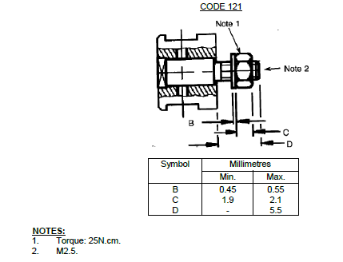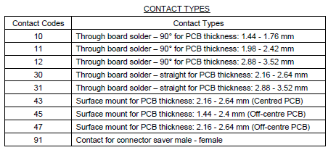

We purpose to update the ESCC 3401-065 to incorporate the guide 122 just after code 121 sheet 26
This guide 122 is more suitable for contact code 31 and often required by our customers (Airbus, Crisa, Tesat …).
Until now, we provide these connectors (example MHD2004431122) in “according to” to ours customers : AIRBUS, CRISA, TESAT, FILCON, TECNOBIT, THALES SPAIN
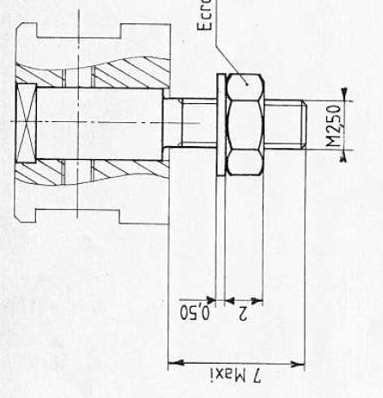
CODE 122
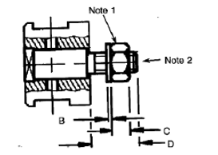

Symbol | millimetres
Symbol | Min. | Max.
B | 0,45 | 0,55
C | 1,9 | 2,1
D | _ | 7

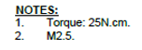

We need also update the Guidind and locking devices sheet 7
Guiding and Locking Devices code | Mounting On | Max, Weight (g)
110 | Plug | 0,55
111 | Plug | 1,35
121 | Receptacle | 0,65
122 | Receptacle | 0,68
124 | Receptacle | 1,5
134 | Receptacle | 1,3
201 | Saver Receptacle | _

