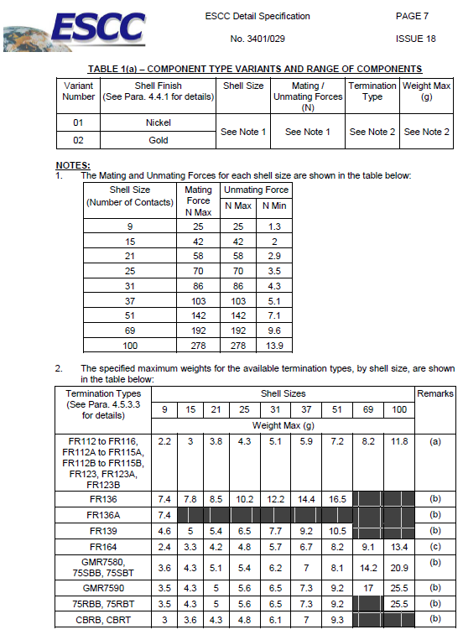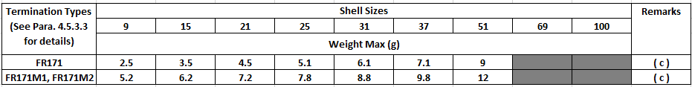

FIGURE 2.2AO – CONNECTORS TYPE – FR171
PLUG MALE CONTACTS
Shell Size | A | B |  | C | D | E | F | G | H
Shell Size | Max. | Min. | Max. | Max. | Max. | Max. | Max. | Max. | Max.
9 | 19.94 | 14.22 | 14.48 | 8.48 | 8.84 | 7.82 | 6.86 | 4.69 | 8.9
15 | 23.75 | 18.03 | 18.29 | 12.29 | 12.65 | 7.82 | 6.86 | 4.69 | 8.9
21 | 27.56 | 21.84 | 22.1 | 16.1 | 16.46 | 7.82 | 6.86 | 4.69 | 8.9
25 | 30.1 | 24.38 | 24.64 | 18.64 | 19 | 7.82 | 6.86 | 4.69 | 8.9
31 | 33.91 | 28.19 | 28.45 | 22.45 | 22.81 | 7.82 | 6.86 | 4.69 | 8.9
37 | 37.72 | 32 | 32.26 | 26.26 | 26.62 | 7.82 | 6.86 | 4.69 | 8.9
Shell Size | J | K Typ. | K1 Typ. | L |  | M |  | ØN
Shell Size | Max. | K Typ. | K1 Typ. | Min. | Max. | Min. | Max. | Min. | Max.
9 | 4.72 | 1.905 | 7.29 | 2.23 | 2.49 | 5.7 | 6.3 | 2.23 | 2.44
15 | 4.72 | 1.905 | 7.29 | 2.23 | 2.49 | 5.7 | 6.3 | 2.23 | 2.44
21 | 4.72 | 1.905 | 7.29 | 2.23 | 2.49 | 5.7 | 6.3 | 2.23 | 2.44
25 | 4.72 | 1.905 | 7.29 | 2.23 | 2.49 | 5.7 | 6.3 | 2.23 | 2.44
31 | 4.72 | 1.905 | 7.29 | 2.23 | 2.49 | 5.7 | 6.3 | 2.23 | 2.44
37 | 4.72 | 1.905 | 7.29 | 2.23 | 2.49 | 5.7 | 6.3 | 2.23 | 2.44

NOTES:
1. All dimensions are in millimetres.
2. For ØP refer to ØD in Figure 2.4.
3. For floating mount and captive nut mounting options, see Figures 2.7 and 2.8 respectively.
FIGURE 2.2AP – CONNECTORS TYPE – FR171
RECEPTACLE FEMALE CONTACTS
Shell Size | A | B |  | C | D | E | F | G | H
Shell Size | Max. | Min. | Max. | Max. | Max. | Max. | Max. | Max. | Max.
9 | 19.94 | 14.22 | 14.48 | 10.16 | 8.84 | 7.82 | 6.86 | 6.38 | 9.06
15 | 23.75 | 18.03 | 18.29 | 13.97 | 12.65 | 7.82 | 6.86 | 6.38 | 9.06
21 | 27.56 | 21.84 | 22.1 | 17.78 | 16.46 | 7.82 | 6.86 | 6.38 | 9.06
25 | 30.1 | 24.38 | 24.64 | 20.32 | 19 | 7.82 | 6.86 | 6.38 | 9.06
31 | 33.91 | 28.19 | 28.45 | 24.13 | 22.81 | 7.82 | 6.86 | 6.38 | 9.06
37 | 37.72 | 32 | 32.26 | 27.94 | 26.62 | 7.82 | 6.86 | 6.38 | 9.06
Shell Size | J | K Typ. | K1 Typ. | L |  | M |  | ØN
Shell Size | Max. | K Typ. | K1 Typ. | Min. | Max. | Min. | Max. | Min. | Max.
9 | 5.05 | 1.905 | 7.29 | 2.23 | 2.49 | 5.7 | 6.3 | 2.23 | 2.44
15 | 5.05 | 1.905 | 7.29 | 2.23 | 2.49 | 5.7 | 6.3 | 2.23 | 2.44
21 | 5.05 | 1.905 | 7.29 | 2.23 | 2.49 | 5.7 | 6.3 | 2.23 | 2.44
25 | 5.05 | 1.905 | 7.29 | 2.23 | 2.49 | 5.7 | 6.3 | 2.23 | 2.44
31 | 5.05 | 1.905 | 7.29 | 2.23 | 2.49 | 5.7 | 6.3 | 2.23 | 2.44
37 | 5.05 | 1.905 | 7.29 | 2.23 | 2.49 | 5.7 | 6.3 | 2.23 | 2.44

NOTES:
1. All dimensions are in millimetres.
2. For ØP refer to ØD in Figure 2.4.
3. For floating mount and captive nut mounting options, see Figures 2.7 and 2.8 respectively.
FIGURE 2.2AQ – CONNECTORS TYPE – FR171
PLUG MALE CONTACTS (SIZE 51)

Shell Size | A | B |  | C | D | E | F | G | H
Shell Size | Max. | Min. | Max. | Max. | Max. | Max. | Max. | Max. | Max.
51 | 36.45 | 30.73 | 30.99 | 24.99 | 25.35 | 8.92 | 7.87 | 5.79 | 8.9
Shell Size | J | K Typ. | K1 Typ. | L |  | M |  | ØN
Shell Size | Max. | K Typ. | K1 Typ. | Min. | Max. | Min. | Max. | Min. | Max.
51 | 4.72 | 1.905 | 7.29 | 2.23 | 2.49 | 5.7 | 6.3 | 2.23 | 2.44

NOTES:
1. All dimensions are in millimetres.
2. For ØP refer to ØD in Figure 2.4.
3. For floating mount and captive nut mounting options, see Figures 2.7 and 2.8 respectively.

FIGURE 2.2AR – CONNECTORS TYPE – FR171
RECEPTACLE FEMALE CONTACTS (SIZE 51)
Shell Size | A | B |  | C | D | E | F | G | H
Shell Size | Max. | Min. | Max. | Max. | Max. | Max. | Max. | Max. | Max.
51 | 36.45 | 30.73 | 30.99 | 26.67 | 25.35 | 8.92 | 7.87 | 7.52 | 9.06
Shell Size | J | K Typ. | K1 Typ. | L |  | M |  | ØN
Shell Size | Max. | K Typ. | K1 Typ. | Min. | Max. | Min. | Max. | Min. | Max.
51 | 5.05 | 1.905 | 7.29 | 2.23 | 2.49 | 5.7 | 6.3 | 2.23 | 2.44

NOTES:
1. All dimensions are in millimetres.
2. For ØP refer to ØD in Figure 2.4.
3. For floating mount and captive nut mounting options, see Figures 2.7 and 2.8 respectively.

FIGURE 2.2AS – CONNECTORS TYPE – FR171M1 / FR171M2
PLUG MALE CONTACTS
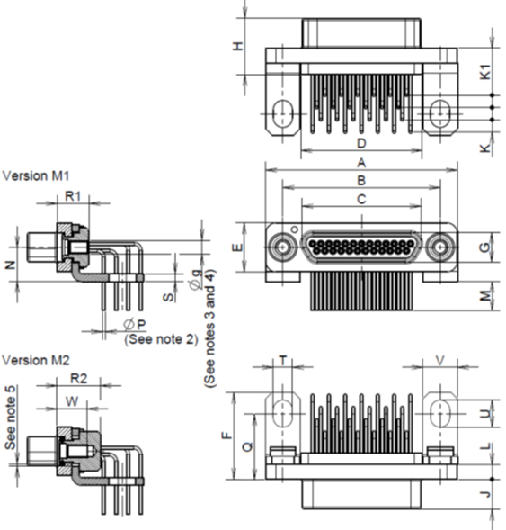
Shell Size | A | B |  | C | D | E | F | G | H | J
Shell Size | Max. | Min. | Max. | Max. | Max. | Max. | Max. | Max. | Max. | Max.
9 | 19.94 | 14.22 | 14.48 | 8.48 | 8.84 | 7.82 | 13.8 | 4.69 | 8.9 | 4.72
15 | 23.75 | 18.03 | 18.29 | 12.29 | 12.65 | 7.82 | 13.8 | 4.69 | 8.9 | 4.72
21 | 27.56 | 21.84 | 22.1 | 16.1 | 16.46 | 7.82 | 13.8 | 4.69 | 8.9 | 4.72
25 | 30.1 | 24.38 | 24.64 | 18.64 | 19 | 7.82 | 13.8 | 4.69 | 8.9 | 4.72
31 | 33.91 | 28.19 | 28.45 | 22.45 | 22.81 | 7.82 | 13.8 | 4.69 | 8.9 | 4.72
37 | 37.72 | 32 | 32.26 | 26.26 | 26.62 | 7.82 | 13.8 | 4.69 | 8.9 | 4.72
Shell Size | K Typ. | K1 Typ. | L |  | M |  | N |  | Q
Shell Size | K Typ. | K1 Typ. | Min. | Max. | Min. | Max. | Min. | Max. | Min. | Max.
9 | 1.905 | 7.29 | 2.23 | 2.49 | 4 | 5 | 5.15 | 5.45 | 10 | 10.4
15 | 1.905 | 7.29 | 2.23 | 2.49 | 4 | 5 | 5.15 | 5.45 | 10 | 10.4
21 | 1.905 | 7.29 | 2.23 | 2.49 | 4 | 5 | 5.15 | 5.45 | 10 | 10.4
25 | 1.905 | 7.29 | 2.23 | 2.49 | 4 | 5 | 5.15 | 5.45 | 10 | 10.4
31 | 1.905 | 7.29 | 2.23 | 2.49 | 4 | 5 | 5.15 | 5.45 | 10 | 10.4
37 | 1.905 | 7.29 | 2.23 | 2.49 | 4 | 5 | 5.15 | 5.45 | 10 | 10.4
Shell Size | R1 | R2 | S | T |  | U |  | V | W
Shell Size | Max. | Max. | Max. | Min. | Max. | Min. | Max. | Max. | Min.
9 | 5.3 | 7.1 | 1.3 | 2.95 | 3.05 | 4.15 | 4.25 | 5.6 | 4.55
15 | 5.3 | 7.1 | 1.3 | 2.95 | 3.05 | 4.15 | 4.25 | 5.6 | 4.55
21 | 5.3 | 7.1 | 1.3 | 2.95 | 3.05 | 4.15 | 4.25 | 5.6 | 4.55
25 | 5.3 | 7.1 | 1.3 | 2.95 | 3.05 | 4.15 | 4.25 | 5.6 | 4.55
31 | 5.3 | 7.1 | 1.3 | 2.95 | 3.05 | 4.15 | 4.25 | 5.6 | 4.55
37 | 5.3 | 7.1 | 1.3 | 2.95 | 3.05 | 4.15 | 4.25 | 5.6 | 4.55

NOTES:
1. All dimensions are in millimetres.
2. For ØP refer to ØD in Figure 2.4.
3. Øg: 2-56-UNC-2B.
4. Torque 0.44 Nm min / 0.48 max.
5. Total lateral float : 0.6 mm (typical) for M2 version only.

FIGURE 2.2AT – CONNECTORS TYPE – FR171M1 / FR171M2
RECEPTACLE FEMALE CONTACTS
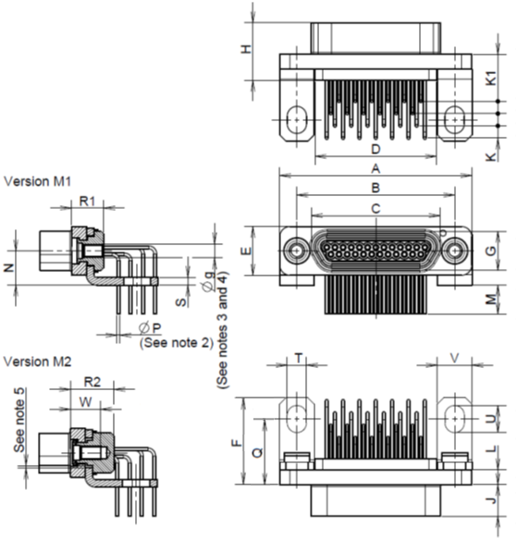
Shell Size | A | B |  | C | D | E | F | G | H | J
Shell Size | Max. | Min. | Max. | Max. | Max. | Max. | Max. | Max. | Max. | Max.
9 | 19.94 | 14.22 | 14.48 | 10.16 | 8.84 | 7.82 | 13.8 | 6.38 | 9.06 | 5.05
15 | 23.75 | 18.03 | 18.29 | 13.97 | 12.65 | 7.82 | 13.8 | 6.38 | 9.06 | 5.05
21 | 27.56 | 21.84 | 22.1 | 17.78 | 16.46 | 7.82 | 13.8 | 6.38 | 9.06 | 5.05
25 | 30.1 | 24.38 | 24.64 | 20.32 | 19 | 7.82 | 13.8 | 6.38 | 9.06 | 5.05
31 | 33.91 | 28.19 | 28.45 | 24.13 | 22.81 | 7.82 | 13.8 | 6.38 | 9.06 | 5.05
37 | 37.72 | 32 | 32.26 | 27.94 | 26.62 | 7.82 | 13.8 | 6.38 | 9.06 | 5.05
Shell Size | K Typ. | K1 Typ. | L |  | M |  | N |  | Q
Shell Size | K Typ. | K1 Typ. | Min. | Max. | Min. | Max. | Min. | Max. | Min. | Max.
9 | 1.905 | 7.29 | 2.23 | 2.49 | 4 | 5 | 5.15 | 5.45 | 10 | 10.4
15 | 1.905 | 7.29 | 2.23 | 2.49 | 4 | 5 | 5.15 | 5.45 | 10 | 10.4
21 | 1.905 | 7.29 | 2.23 | 2.49 | 4 | 5 | 5.15 | 5.45 | 10 | 10.4
25 | 1.905 | 7.29 | 2.23 | 2.49 | 4 | 5 | 5.15 | 5.45 | 10 | 10.4
31 | 1.905 | 7.29 | 2.23 | 2.49 | 4 | 5 | 5.15 | 5.45 | 10 | 10.4
37 | 1.905 | 7.29 | 2.23 | 2.49 | 4 | 5 | 5.15 | 5.45 | 10 | 10.4
Shell Size | R1 | R2 | S | T |  | U |  | V | W
Shell Size | Max. | Max. | Max. | Min. | Max. | Min. | Max. | Max. | Min.
9 | 5.3 | 7.1 | 1.3 | 2.95 | 3.05 | 4.15 | 4.25 | 5.6 | 4.55
15 | 5.3 | 7.1 | 1.3 | 2.95 | 3.05 | 4.15 | 4.25 | 5.6 | 4.55
21 | 5.3 | 7.1 | 1.3 | 2.95 | 3.05 | 4.15 | 4.25 | 5.6 | 4.55
25 | 5.3 | 7.1 | 1.3 | 2.95 | 3.05 | 4.15 | 4.25 | 5.6 | 4.55
31 | 5.3 | 7.1 | 1.3 | 2.95 | 3.05 | 4.15 | 4.25 | 5.6 | 4.55
37 | 5.3 | 7.1 | 1.3 | 2.95 | 3.05 | 4.15 | 4.25 | 5.6 | 4.55

NOTES:
1. All dimensions are in millimetres.
2. For ØP refer to ØD in Figure 2.4.
3. Øg: 2-56-UNC-2B.
4. Torque 0.44 Nm min / 0.48 max.
5. Total lateral float : 0.6 mm (typical) for M2 version only.

FIGURE 2.2AU – CONNECTORS TYPE – FR171M1 / FR171M2
PLUG MALE CONTACTS (SIZE 51)
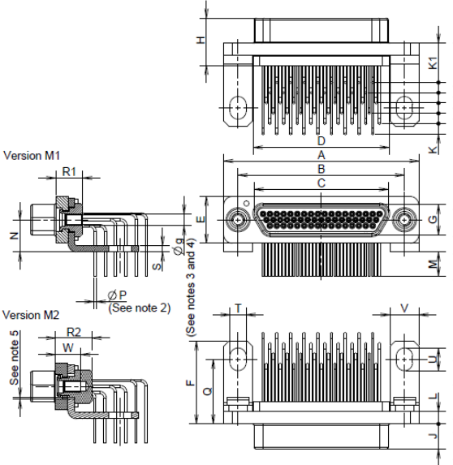
Shell Size | A | B |  | C | D | E | F | G | H | J
Shell Size | Max. | Min. | Max. | Max. | Max. | Max. | Max. | Max. | Max. | Max.
51 | 36.45 | 30.73 | 30.99 | 24.99 | 25.35 | 8.92 | 15.7 | 5.79 | 8.9 | 4.72
Shell Size | K Typ. | K1 Typ. | L |  | M |  | N |  | Q
Shell Size | K Typ. | K1 Typ. | Min. | Max. | Min. | Max. | Min. | Max. | Min. | Max.
51 | 1.905 | 7.29 | 2.23 | 2.49 | 4 | 5 | 5.81 | 6.11 | 11.8 | 12.2
Shell Size | R1 | R2 | S | T |  | U |  | V | W
Shell Size | Max. | Max. | Max. | Min. | Max. | Min. | Max. | Max. | Min.
51 | 5.3 | 7.1 | 1.3 | 2.95 | 3.05 | 4.15 | 4.25 | 5.6 | 4.55

NOTES:
1. All dimensions are in millimetres.
2. For ØP refer to ØD in Figure 2.4.
3. Øg: 2-56-UNC-2B.
4. Torque 0.44 Nm min / 0.48 max.
5. Total lateral float : 0.6 mm (typical) for M2 version only.
FIGURE 2.2AV – CONNECTORS TYPE – FR171M1 / FR171M2
RECEPTACLE FEMALE CONTACTS (SIZE 51)
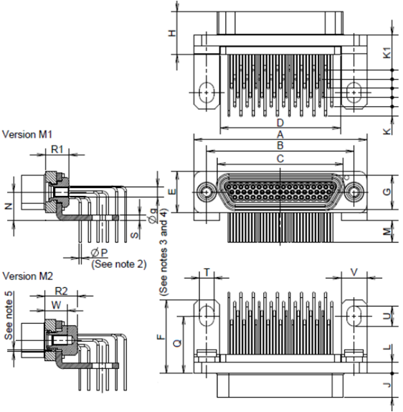
Shell Size | A | B |  | C | D | E | F | G | H | J
Shell Size | Max. | Min. | Max. | Max. | Max. | Max. | Max. | Max. | Max. | Max.
51 | 36.45 | 30.73 | 30.99 | 26.67 | 25.35 | 8.92 | 15.7 | 7.52 | 9.06 | 5.05
Shell Size | K Typ. | K1 Typ. | L |  | M |  | N |  | Q
Shell Size | K Typ. | K1 Typ. | Min. | Max. | Min. | Max. | Min. | Max. | Min. | Max.
51 | 1.905 | 7.29 | 2.23 | 2.49 | 4 | 5 | 5.81 | 6.11 | 11.8 | 12.2
Shell Size | R1 | R2 | S | T |  | U |  | V | W
Shell Size | Max. | Max. | Max. | Min. | Max. | Min. | Max. | Max. | Min.
51 | 5.3 | 7.1 | 1.3 | 2.95 | 3.05 | 4.15 | 4.25 | 5.6 | 4.55

NOTES:
1. All dimensions are in millimetres.
2. For ØP refer to ØD in Figure 2.4.
3. Øg: 2-56-UNC-2B.
4. Torque 0.44 Nm min / 0.48 max.
5. Total lateral float : 0.6 mm (typical) for M2 version
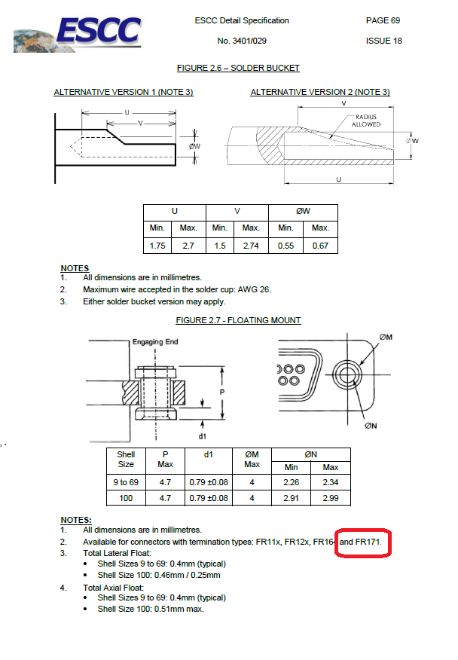
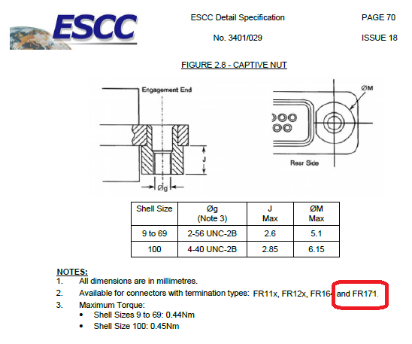
4.4.8 Captive Nuts, Washers, Rivets and Brackets
These shall be made of passivated stainless steel, type 303 or 316.



