

Page 1 of 13

RF COAXIAL CONNECTORS, TNC, VERY HIGH POWER, 50 OHMS (FEMALE INTERFACE)
BASED ON TYPE TNC-VHP
ESCC Detail Specification No. 3402/027
Issue 3 Draft A | June 2021



Document Custodian: European Space Agency – see https://escies.org

LEGAL DISCLAIMER AND COPYRIGHT
European Space Agency, Copyright © 2021. All rights reserved.
The European Space Agency disclaims any liability or responsibility, to any person or entity, with respect to any loss or damage caused, or alleged to be caused, directly or indirectly by the use and application of this ESCC publication.
This publication, without the prior permission of the European Space Agency and provided that it is not used for a commercial purpose, may be:
- copied in whole, in any medium, without alteration or modification.
- copied in part, in any medium, provided that the ESCC document identification, comprising the ESCC symbol, document number and document issue, is removed.

DOCUMENTATION CHANGE NOTICE
(Refer to https://escies.org for ESCC DCR content)
DCR No. | CHANGE DESCRIPTION
TBA | Specification updated to incorporate changes per DCR.
Draft 3A  S.Thacker ESCC-TW  08/07/2021 | Initial draft converted Detail spec to make it consistent with the newly published, converted Generic spec: ESCC No. 3402 issue 5.  Changes in this specification from the published issue 2 are mainly editorial in nature so have not been highlighted. Any actual technical changes, including those resulting from the new Generic spec, are highlighted yellow for information.

TABLE OF CONTENTS

1 GENERAL 5
1.1 SCOPE 5
1.2 APPLICABLE DOCUMENTS 5
1.3 TERMS, DEFINITIONS, ABBREVIATIONS, SYMBOLS AND UNITS 5
1.4 THE ESCC COMPONENT NUMBER AND COMPONENT TYPE VARIANTS 5
1.4.1 The ESCC Component Number 5
1.4.2 Component Type Variants 6
1.5 MAXIMUM RATINGS 6
1.6 PHYSICAL DIMENSIONS (SEE ALSO PARA. 3) 7
1.6.1 Connector Interface Dimensions and Connector Interface Gauge Dimensions 7
1.7 MATERIALS AND FINISHES 7
2 REQUIREMENTS 7
2.1 GENERAL 7
2.1.1 Deviations from the Generic Specification 8
2.2 MARKING 8
2.3 ENVIRONMENTAL AND MECHANICAL TESTS 9
2.4 Room Temperature Electrical Measurements 9
2.5 INTERMEDIATE AND END-POINT ELECTRICAL MEASUREMENTS 10
3 COMPONENT TYPE VARIANTS – DETAIL REQUIREMENTS 11
3.1 VARIANT 01 - Square Flange Female Receptacle, Round Post Termination 11
3.2 VARIANT 02 - Square Flange Female Receptacle, for PCB TRANSMISSION Line WITH PIN Ø1.73mm 12
APPENDIX A 13

GENERAL

SCOPE
This specification details the ratings, physical and electrical characteristics, and test and inspection data for the component type variants and/or the range of components specified below. It supplements the requirements of, and shall be read in conjunction with, the ESCC Generic Specification listed under Applicable Documents.

APPLICABLE DOCUMENTS
The following documents form part of this specification and shall be read in conjunction with it:
          - ESCC Generic Specification No. 3402.
          - ESCC Generic Specification No. 3408.
          - MIL-STD-348, Department of Defence Interface Standard: Radio Frequency Connector Interfaces.

TERMS, DEFINITIONS, ABBREVIATIONS, SYMBOLS AND UNITS
For the purpose of this specification, the terms, definitions, abbreviations, symbols and units specified in ESCC Basic Specification No. 21300 shall apply.

THE ESCC COMPONENT NUMBER AND COMPONENT TYPE VARIANTS

The ESCC Component Number
The ESCC Component Number shall be constituted as follows:
          - For components with a fixed configuration (see Paras. 1.4.2 and 3):
Example: 340202702
- Detail Specification Reference: 3402027
- Component Type Variant Number: 02
          - For components with a variable configuration where the rear contact and insert dimensions E and D shall be selected by the Orderer (see Paras. 1.4.2 and 3):
Example: 34020270113D007D5
- Detail Specification Reference: 3402027
- Component Type Variant Number: 01
- Characteristic code: Dimension E: Rear contact length (13mm): 13D0 (as required)
- Characteristic code: Dimension D: Rear insert length (7.5mm): 07D5 (as required)

Characteristics Codes
Characteristics to be codified as part of the ESCC Component Number (as applicable) shall be as follows:
          - Dimension D and E: Rear insert and contact lengths (see Para. 3) expressed by the following codes. The unit quantity shall be mm:
Dimension D or E Length (mm) | Code
XX.X | XXDX
NOTES:
            - Dimension E shall always be greater than D. Both values shall always be positive.

Component Type Variants
The component type variants applicable to this specification are as follows:
Variant Number | Description (Notes 1, 2) | Configuration Type (Note 2)
01 | Square Flange Female Receptacle, Round Post Termination | Variable
02 | Square Flange Female Receptacle, for PCB Transmission Line with Pin Ø1.73mm | Fixed
NOTES:
            - See Para. 3 for details.
            - See Paras. 1.4.1, 1.4.1.1(a) and 3.

MAXIMUM RATINGS
The maximum ratings shall not be exceeded at any time during use or storage.
Maximum ratings shall only be exceeded during testing to the extent specified in this specification and when stipulated in Test Methods and Procedures of the ESCC Generic Specification.
Characteristics | Symbol | Maximum Ratings | Unit | Remarks
RF Power (Continuous) | P_{rf} | 400 | W | Notes 1, 2, 3
Nominal Impedance | Z | 50 | Ω | -
Operating Frequency Range | f | DC to 8 | GHz | -
Operating Voltage | V_{op} | 500 | Vrms | -
Operating Temperature Range | T_{op} | See Para. 3 | °C | -
Storage Temperature Range | T_{stg} | As per T_{op} | °C | -
Coupling Nut Torque | Tq | 339 | N.cm | Coupling Proof Torque Note 4
NOTES:
            - Derating with pressure is not required for ≤ 1.5mPa.
            - At f = 2GHz. For f > 2GHz, derate as follows. Load VSWR is better than 1.3.
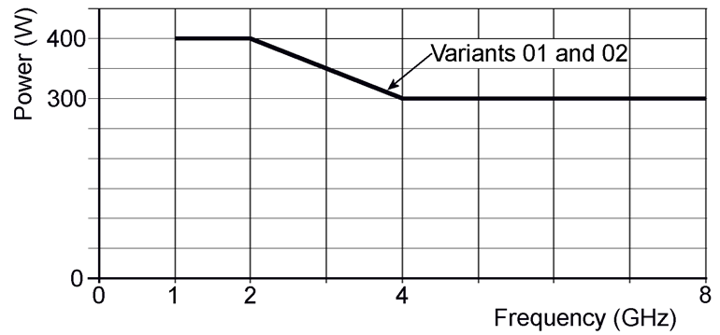
            - At T_{amb} = +100°C. For T_{amb} > +100°C, derate as follows. For operation under vacuum, T_{amb} shall be the temperature of the equipment the component is mounted on.
            - Whenever a test is performed on mated pairs of connectors, the pairs shall be torqued at 265 ±10N.cm.

PHYSICAL DIMENSIONS (SEE ALSO PARA. 3)

Connector Interface Dimensions and Connector Interface Gauge Dimensions
          - TNC Female Connector Interface: compatible with series TNC socket contact interface as specified in MIL-STD-348.
          - TNC Male Gauge Interface: compatible with series TNC pin contact test connector interface as specified in MIL-STD-348.

MATERIALS AND FINISHES
          - Shell, Centre Contact: beryllium copper, plated gold 2.5μm minimum over copper 2.5μm minimum.
          - Insulator: PTFE and Fluoroloy H.

REQUIREMENTS

GENERAL
The complete requirements for procurement of the components specified herein are as stated in this specification and the ESCC Generic Specification. Permitted deviations from the Generic Specification, applicable to this specification only, are listed below.
Permitted deviations from the Generic Specification and this Detail Specification, formally agreed with specific Manufacturers on the basis that the alternative requirements are equivalent to the ESCC requirement and do not affect the component’s reliability, are listed in the appendices attached to this specification.

Deviations from the Generic Specification

Deviations from Screening Tests – Chart F3
          - Coupling Proof Torque: shall not be performed.

Deviations from Qualification and Periodic Testing – Chart F4
          - The following additional subgroup test sequence shall be performed on a mated pair of connectors; no failures are allowed:
- Multipaction: shall be performed as specified in ESCC Generic Specification No. 3408. The multipaction classification applicable to these components is type 2. The test requirements are specified in Para. 3 herein.
- RF Power Handling: shall be performed as specified in ESCC Generic Specification No. 3408. The following test conditions shall apply:
- Test temperature: T_{amb} = +100°C.
- Corona: shall be performed as specified in ESCC Generic Specification No. 3408. The test requirements are specified in Para. 3 herein.
- External Visual Inspection: shall be performed as specified in ESCC Generic Specification No. 3408.
NOTE: Testing per this additional subgroup is not required to be performed during Periodic Testing if there has been no change in the materials, processes or design of the component since qualification, subject to technical justification being provided by the Manufacturer and agreed by the ESCC Executive.

MARKING
The marking shall be in accordance with the requirements of ESCC Basic Specification No. 21700 and as follows.
The information to be marked on the component or the primary package shall be:
          - The ESCC qualified components symbol (for ESCC qualified components only).
          - The ESCC Component Number (see Para. 1.4.1).
          - Traceability information.

ENVIRONMENTAL AND MECHANICAL TESTS
The following requirements apply to tests performed on the connector (and contact) lot as specified in the ESCC Generic Specification:
          - Para. 8.1, Contact Engagement and Separation Forces:
 | Oversize Test Pin Test | Maximum Diameter Test Pin Test | Minimum Diameter Test Pin Test
Test Pin Diameter (mm) (1) | 1.384 to 1.388 | 1.372 to 1.376 | 1.308 to 1.321
Engagement Depth (mm) (1) | 2 to 2.5 | 3 to 3.5 | 3 to 3.5
Engagement Force (N) | - | 9 maximum | -
Separation Force (N) | - | - | 0.56 minimum
NOTES:
            - Test Pins details:
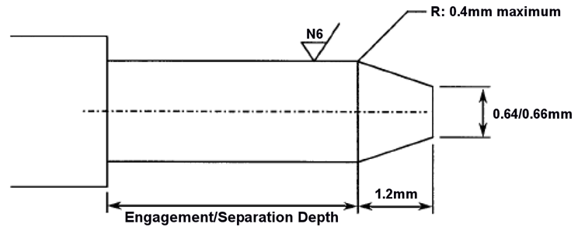
          - Para. 8.10, Coupling Proof Torque: See Para. 1.5.
          - Para. 8.11, Mating and Unmating Forces: Maximum torque: 22.6N.cm.
          - Para. 8.12, Centre Contact Retention: See Para. 3.
          - Para. 8.13, Seal: See Para. 3.
          - Para. 8.19, Endurance:
- During Qualification Testing: 500 cycles.
- During Periodic Testing: 100 cycles

Room Temperature Electrical Measurements
The measurements shall be performed at T_{amb} = +22 ±3°C.
Characteristics | Symbols | Test Method and  Conditions | Limits |  | Units
Characteristics | Symbols | Test Method and  Conditions | Min | Max
Insulation Resistance | R_{I} | ESCC No. 3402 | 5 | - | GΩ
Voltage Proof | V_{P} | ESCC No. 3402, Note 1 | See Para. 3 | - | V
Voltage Proof Leakage Current | I_{L} | ESCC No. 3402, Notes 1, 2 | - | 2 | mA
NOTES:
            - Between centre contact and shell.
            - Measured during Voltage Proof.

INTERMEDIATE AND END-POINT ELECTRICAL MEASUREMENTS
Unless otherwise specified, the measurements shall be performed at T_{amb} = +22 ±3°C.
Unless otherwise specified, the test methods and test conditions shall be as per the corresponding test defined in Para. 2.4 Room Temperature Electrical Measurements.
Test Reference per ESCC No. 3402 | Characteristics and Test Conditions  Ref. ESCC No. 3402 | Symbols | Limits |  | Units
Test Reference per ESCC No. 3402 | Characteristics and Test Conditions  Ref. ESCC No. 3402 | Symbols | Min | Max | Units
Random Vibration | Contact Resistance: I_{T} = 10mA, V_{T} = 20mV  Centre Contact: | R_{ctc} | - | 4 | mΩ
Mechanical Shock | Contact Resistance: I_{T} = 10mA, V_{T} = 20mV  Centre Contact: | R_{ctc} | - | 4 | mΩ
Temperature Cycling | Contact Resistance: I_{T} = 10mA, V_{T} = 20mV  Centre Contact: | R_{ctc} | - | 4 | mΩ
 | Voltage Proof: | V_{P} | Note 1
 | Voltage Proof Leakage Current: | I_{L} | Note 1
Electrical Measurements at Room Temperature | Insulation Resistance: | R_{I} | Note 1
Electrical Measurements at Room Temperature | Voltage Proof: | V_{P} | Note 1
Electrical Measurements at Room Temperature | Voltage Proof Leakage Current: | I_{L} | Note 1
Electrical Measurements at Room Temperature | Contact Resistance: I_{T} = 10mA, V_{T} = 20mV  Centre Contact:  Shell: | R_{ctc}  R_{cts} | -  - | 4  4 | mΩ  mΩ
Electrical Measurements at Room Temperature | VSWR: | VSWR | Note 2
Electrical Measurements at Room Temperature | Insertion Loss: | LI | Note 2
Endurance | Contact Resistance: I_{T} = 10mA, V_{T} = 20mV  Centre Contact:  Shell: | R_{ctc}  R_{cts} | -  - | 4  4 | mΩ  mΩ
NOTES:
            - As specified in Para. 2.4.
            - As specified in Para. 3.

COMPONENT TYPE VARIANTS – DETAIL REQUIREMENTS

VARIANT 01 - Square Flange Female Receptacle, Round Post Termination
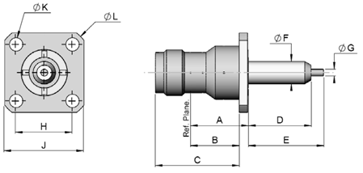  NOTES:  - Lengths D and E are variable; see Para. 1.4.1.1. The tolerance on specified length is ±0.1mm.
  Symbols | Dimensions (mm) |  | Remarks
  Symbols | Min | Max | Remarks
  A | 13.65 | 13.85
  B | 11.55 | 11.75
  C | 19.9 | 20.1
  D | 7.5 | 20 | Note 1
  E | 7.5 | 30 | Note 1
  ØF | 5.31 | 5.41
  ØG | 1.59 | 1.69
  H | 13.45 | 13.55
  J | 18.9 | 19.1
  ØK | 3.1 | 3.3 | 4 holes
  ØL | 24.4 | 24.6
Electrical Characteristics | Values | Units
Voltage Standing Wave Ratio (VSWR) | ≤ 1.1 + 0.02 x f (GHz) | -
RF Insertion loss | ≤ 0.04 x √f (GHz) | dB
Voltage Proof | ≥ 1500 | Vrms
Multipaction Threshold (pulse width 20µs; PRF: 1kHz) | ≥ 2000 at 1GHz | Wpp
Mechanical Characteristics | Values | Units
Centre Contact Retention Force (Axial) | ≥ 27.2 | N
Centre Contact Retention Torque (Rotational) | ≥ 2.8 | N.cm
Weight | ≤ 18 | g
Other Characteristics | Values | Units
Operating Temperature Range | -65 to +165 | °C
Seal: Maximum leakage | Not applicable | -
Solderability | On centre contact only | -

VARIANT 02 - Square Flange Female Receptacle, for PCB TRANSMISSION Line WITH PIN Ø1.73mm
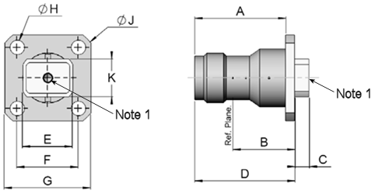  NOTES:  - Accept pin Ø 1.73mm.
  Symbols | Dimensions (mm) |  | Remarks
  Symbols | Min | Max | Remarks
  A | 19.9 | 20.1
  B | 13.6 | 13.8
  C | 3.05 | 3.25
  D | 21.9 | 22.1
  E | 10.95 | 11.05
  F | 13.45 | 13.55
  G | 18.9 | 19.1
  ØH | 3.1 | 3.3 | 4 holes
  ØJ | 24.4 | 24.6
  K | 8.2 | 8.4
Electrical Characteristics | Values | Units
Voltage Standing Wave Ratio (VSWR) | ≤ 1.1 + 0.02 x f (GHz) | -
RF Insertion loss | ≤ 0.04 x √f (GHz) | dB
Voltage Proof | ≥ 1500 | Vrms
Multipaction Threshold (pulse width 20µs; PRF: 1kHz) | ≥ 2000 at 1GHz | Wpp
Mechanical Characteristics | Values | Units
Centre Contact Retention Force (Axial) | ≥ 27.2 | N
Centre Contact Retention Torque (Rotational) | ≥ 2.8 | N.cm
Weight | ≤ 16 | g
Other Characteristics | Values | Units
Operating Temperature Range | -65 to +165 | °C
Seal: Maximum leakage | Not applicable | -
Solderability | Not Applicable | -

APPENDIX A
AGREED DEVIATIONS FOR RADIALL (F)
Items Affected | Description of Deviations
Para. 2.1.1.2 Deviations from Qualification and Periodic Testing – Chart F4 | The test requirements applicable to Qualification and Periodic Testing may be replaced by testing in accordance with Radiall test specification RAD-GEN-CONN-004 as specified in the PID and outlined in the schedule below.  For each subgroup, the sample size and, for Periodic Testing, the period between successive subgroup testing, are given in the schedule.  No failures are allowed.  NOTE: The test methods and requirements for each test in the schedule are as specified in the PID agreed by the ESCC Executive.  Qualification and PERIODIC TESTING SCHEDULE  (total 20 connectors representative of the connector range)  - Subgroup I (8 connectors; 24 month period)  - Endurance: 50 mating/unmating cycles  - Vibration: Sine and Random  - Mechanical Shock  - Rapid Change of Temperature  - Endurance: 450 mating/unmating cycles  - Permanence of Marking  - External Visual Inspection  - DPA (on 2 connectors)  - Subgroup II (6 connectors; 12 month period)  - RF Insertion Loss  - VSWR  - Coupling Proof Torque  - Mating/Unmating Forces  - Contact Resistance  - External Visual Inspection  - Subgroup III (4 connectors per type; 24 month period)  - Residual Magnetism  - Soldering Proof  - RF Leakage  - High Temperature Storage  - External Visual Inspection  - Subgroup IV (2 connectors; 24 month period) (Note 1)  - Multipactor  - Power Handling  - Corona  - External Visual Inspection  NOTES:  - Subgroup IV testing is not required to be performed during Periodic Testing if there has been no change in the materials, processes or design, or sub-contractor, of the component since qualification.

