

Page 1 of 16

RF COAXIAL ADAPTORS AND CONNECTING PIECES
BASED ON TYPE SMA 2.9
ESCC Detail Specification No. 3402/023
Issue 8 Draft A | July 2021



Document Custodian: European Space Agency – see https://escies.org

LEGAL DISCLAIMER AND COPYRIGHT
European Space Agency, Copyright © 2021. All rights reserved.
The European Space Agency disclaims any liability or responsibility, to any person or entity, with respect to any loss or damage caused, or alleged to be caused, directly or indirectly by the use and application of this ESCC publication.
This publication, without the prior permission of the European Space Agency and provided that it is not used for a commercial purpose, may be:
- copied in whole, in any medium, without alteration or modification.
- copied in part, in any medium, provided that the ESCC document identification, comprising the ESCC symbol, document number and document issue, is removed.

DOCUMENTATION CHANGE NOTICE
(Refer to https://escies.org for ESCC DCR content)
DCR No. | CHANGE DESCRIPTION
TBA | Specification updated to incorporate changes per DCR.
Draft 8A  S.Thacker ESCC-TW  13/07/2021 | Initial draft converted Detail spec to make it consistent with the newly published, converted Generic spec: ESCC No. 3402 issue 5.  Changes in this specification from the published issue 7 are mainly editorial in nature so have not been highlighted. Any actual technical changes, including those resulting from the new Generic spec, are highlighted yellow for information.

TABLE OF CONTENTS

1 GENERAL 5
1.1 SCOPE 5
1.2 APPLICABLE DOCUMENTS 5
1.3 TERMS, DEFINITIONS, ABBREVIATIONS, SYMBOLS AND UNITS 5
1.4 THE ESCC COMPONENT NUMBER AND COMPONENT TYPE VARIANTS 5
1.4.1 The ESCC Component Number 5
1.4.2 Component Type Variants 5
1.5 MAXIMUM RATINGS 6
1.6 PHYSICAL DIMENSIONS (SEE ALSO PARA. 3) 7
1.6.1 Connector Interface Dimensions and Connector Interface Gauge Dimensions 7
1.7 MATERIALS AND FINISHES 8
2 REQUIREMENTS 8
2.1 GENERAL 8
2.1.1 Deviations from the Generic Specification 8
2.2 MARKING 9
2.3 ENVIRONMENTAL AND MECHANICAL TESTS 9
2.4 Room Temperature Electrical Measurements 10
2.5 INTERMEDIATE AND END-POINT ELECTRICAL MEASUREMENTS 10
3 COMPONENT TYPE VARIANTS – DETAIL REQUIREMENTS 11
3.1 variant 01 – STRAIGHT Adaptor, Male - male 11
3.2 variant 02 – STRAIGHT Adaptor, FEMale - FEmale 12
3.3 variant 03 – STRAIGHT Adaptor, Male - FEmale 13
3.4 variant 04 – RIGHT ANGLE Adaptor, Male - male 14
3.5 variant 05 – RIGHT ANGLE Adaptor, FEMale - FEmale 15
3.6 variant 06 – RIGHT ANGLE Adaptor, Male - FEmale 16

GENERAL

SCOPE
This specification details the ratings, physical and electrical characteristics, and test and inspection data for the component type variants and/or the range of components specified below. It supplements the requirements of, and shall be read in conjunction with, the ESCC Generic Specification listed under Applicable Documents.

APPLICABLE DOCUMENTS
The following documents form part of this specification and shall be read in conjunction with it:
          - ESCC Generic Specification No. 3402.

TERMS, DEFINITIONS, ABBREVIATIONS, SYMBOLS AND UNITS
For the purpose of this specification, the terms, definitions, abbreviations, symbols and units specified in ESCC Basic Specification No. 21300 shall apply.

THE ESCC COMPONENT NUMBER AND COMPONENT TYPE VARIANTS

The ESCC Component Number
The ESCC Component Number shall be constituted as follows:
Example: 340202301
- Detail Specification Reference: 3402023
- Component Type Variant Number: 01 (as required)

Component Type Variants
The component type variants applicable to this specification are as follows:
Variant Number | Description (Note 1)
01 | Straight Adaptor, Male - Male
02 | Straight Adaptor, Female - Female
03 | Straight Adaptor, Male - Female
04 | Right Angle Adaptor, Male - Male
05 | Right Angle Adaptor, Female - Female
06 | Right Angle Adaptor, Male - Female
NOTES:
            - See Para. 3 for details.

MAXIMUM RATINGS
The maximum ratings shall not be exceeded at any time during use or storage.
Maximum ratings shall only be exceeded during testing to the extent specified in this specification and when stipulated in Test Methods and Procedures of the ESCC Generic Specification.
Characteristics | Symbol | Maximum Ratings | Unit | Remarks
Power | P | Notes 1, 2 | W | -
Nominal Impedance | Z | 50 | Ω | -
Operating Frequency Range | f | See Para. 3 | GHz | Note 2
Operating Voltage | V_{op} | 350 | Vrms | -
Operating Temperature Range | T_{op} | See Para. 3 | °C | -
Storage Temperature Range | T_{stg} | As per T_{op} | °C | -
Coupling Nut Torque | Tq | 170 | N.cm | Coupling Proof Torque Note 3
NOTES:
            - Derate Power with respect to Operating Frequency as follows:
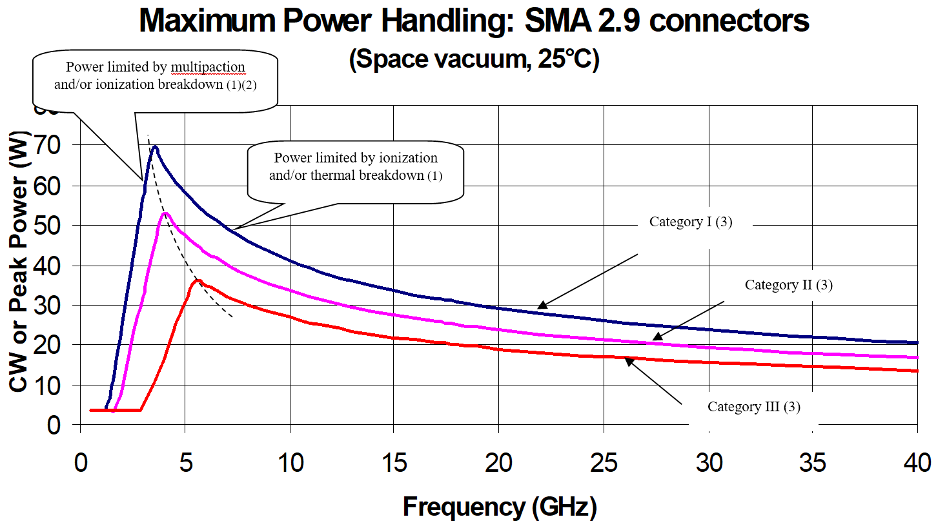
- Load VSWR is better than 1.30:1.
- The part of the curve limited by multipaction takes into account a 6dB margin.
- See Para. 3 for applicability of power handling categories to the different Variants.
            - Derate Power with respect to Operating Temperature as follows:
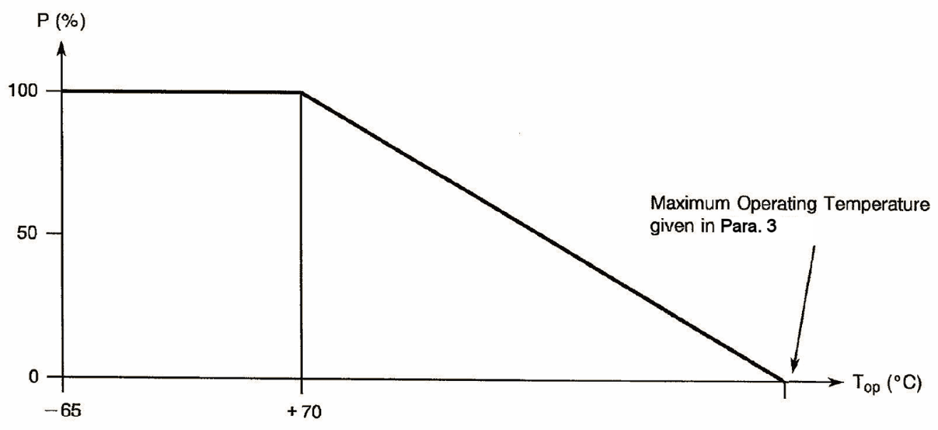
            - Whenever a test is performed on mated pairs of connectors, the pairs shall be torqued at 80 to 115N.cm.

PHYSICAL DIMENSIONS (SEE ALSO PARA. 3)

Connector Interface Dimensions and Connector Interface Gauge Dimensions

SMA 2.9 Female Connector Interface and Gauge Interface
Symbol | Dimensions mm
Symbol | Min | Max
1 | 2.87 | 3.27
2 | 1.88 | 1.98
3 | 0.65 | 0.95
4 | 2.4 | 2.68
5 | 0 | 0.08
ØA | 4.6 | 4.63
ØB | 5.3 | 5.35
ØC | ¼ - 36 UNS 2A
ØD | 2.9 | 2.94

SMA 2.9 Male Connector Interface and Gauge Interface
Symbol | Dimensions mm
Symbol | Min | Max
6 | 2.63 | 3.25
7 | 0.9 | 1.1
8 | 0 | 0.08
9 | 0.49 | 0.78
10 | 1.22 | 1.4
ØC | ¼ - 36 UNS 2B
ØD | 2.9 | 2.94
ØE | 6.6 | 6.7
ØF | 4.55 | 4.58
ØG | 0.92 | 0.94
ØH | 0.2 | 0.34

MATERIALS AND FINISHES
          - Shell, Coupling Nut: Amagnetic stainless steel, electro-passivated.
          - Centre Contact: Beryllium copper, plated gold 1.3μm minimum over nickel 2μm minimum.
          - Insulator: ULTEM 1000.
          - Gasket, Front: Silicone.

REQUIREMENTS

GENERAL
The complete requirements for procurement of the components specified herein are as stated in this specification and the ESCC Generic Specification. Permitted deviations from the Generic Specification, applicable to this specification only, are listed below.
Permitted deviations from the Generic Specification and this Detail Specification, formally agreed with specific Manufacturers on the basis that the alternative requirements are equivalent to the ESCC requirement and do not affect the component’s reliability, are listed in the appendices attached to this specification.

Deviations from the Generic Specification

Deviations from Screening Tests – Chart F3
          - Coupling Proof Torque: shall not be performed on connectors with a female contact; it shall be performed on connectors with a male contact.

MARKING
The marking shall be in accordance with the requirements of ESCC Basic Specification No. 21700 and as follows.
The information to be marked on the component or the primary package shall be:
          - The ESCC qualified components symbol (for ESCC qualified components only).
          - The ESCC Component Number (see Para. 1.4.1).
          - Traceability information.

ENVIRONMENTAL AND MECHANICAL TESTS
The following requirements apply to tests performed on the connector (and contact) lot as specified in the ESCC Generic Specification:
          - Para. 8.1, Contact Engagement and Separation Forces:
 | Oversize Test Pin Test | Maximum Diameter Test Pin Test | Minimum Diameter Test Pin Test
Test Pin Diameter (mm) (1) | 0.95 to 0.955 | 0.94 to 0.946 | 0.89 to 0.902
Engagement Depth (mm) (1) | 0.76 to 1.14 | 1.27 to 1.91 | 1.27 to 1.91
Engagement Force (N) | - | 13.53 maximum | -
Separation Force (N) | - | - | 0.27 minimum
NOTES:
            - Test Pins details:
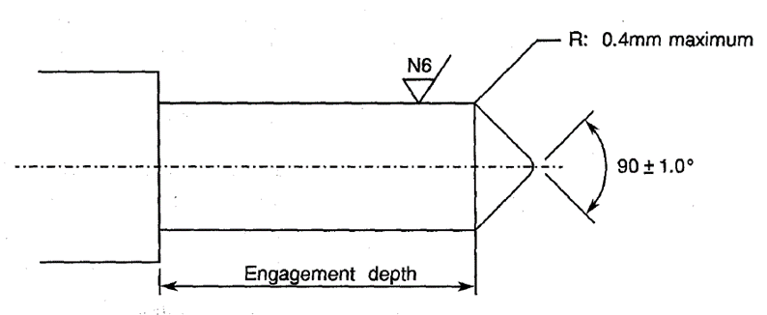
          - Para. 8.10, Coupling Proof Torque: See Para. 1.5.
          - Para. 8.11, Mating and Unmating Forces: Maximum torque: 23N.cm.
          - Para. 8.12, Centre Contact Retention: See Para. 3.
          - Para. 8.13, Seal: See Para. 3.
          - Para. 8.19, Endurance:
- During Qualification Testing: 500 cycles.
- During Periodic Testing: 100 cycles

Room Temperature Electrical Measurements
The measurements shall be performed at T_{amb} = +22 ±3°C.
Characteristics | Symbols | Test Method and  Conditions | Limits |  | Units
Characteristics | Symbols | Test Method and  Conditions | Min | Max | Units
Insulation Resistance | R_{I} | ESCC No. 3402 | 5 | - | GΩ
Voltage Proof Leakage Current | I_{L} | ESCC No. 3402  See Para. 3  Note 1 | - | 2 | mA
NOTES:
            - Between centre contact and shell.

INTERMEDIATE AND END-POINT ELECTRICAL MEASUREMENTS
Unless otherwise specified, the measurements shall be performed at T_{amb} = +22 ±3°C.
Unless otherwise specified, the test methods and test conditions shall be as per the corresponding test defined in Para. 2.4 Room Temperature Electrical Measurements.
Test Reference per ESCC No. 3402 | Characteristics and Test Conditions  Ref. ESCC No. 3402 | Symbols | Limits |  | Units
Test Reference per ESCC No. 3402 | Characteristics and Test Conditions  Ref. ESCC No. 3402 | Symbols | Min | Max | Units
Random Vibration | Contact Resistance: I_{T} = 10mA, V_{T} = 6V  Centre Contact: | R_{ctc} | - | 3 | mΩ
Mechanical Shock | Contact Resistance: I_{T} = 10mA, V_{T} = 6V  Centre Contact: | R_{ctc} | - | 3 | mΩ
Temperature Cycling | Contact Resistance: I_{T} = 10mA, V_{T} = 6V  Centre Contact: | R_{ctc} | - | 3 | mΩ
 | Voltage Proof Leakage Current: | I_{L} | Note 1
Electrical Measurements at Room Temperature | Insulation Resistance: | R_{I} | Note 1
Electrical Measurements at Room Temperature | Voltage Proof Leakage Current: | I_{L} | Note 1
Electrical Measurements at Room Temperature | Contact Resistance: I_{T} = 10mA, V_{T} = 6V  Centre Contact:  Shell: | R_{ctc}  R_{cts} | -  - | 3  2 | mΩ  mΩ
Electrical Measurements at Room Temperature | VSWR: | VSWR | Note 2
Electrical Measurements at Room Temperature | Insertion Loss: | LI | Note 2
Endurance | Contact Resistance: I_{T} = 10mA, V_{T} = 6V  Centre Contact:  Shell | R_{ctc}  R_{cts} | -  - | 4  3 | mΩ  mΩ
NOTES:
            - As specified in Para. 2.4.
            - As specified in Para. 3.

COMPONENT TYPE VARIANTS – DETAIL REQUIREMENTS

variant 01 – STRAIGHT Adaptor, Male - male
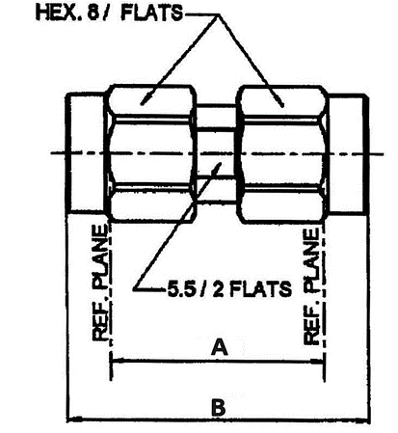
  Symbol | Dimensions mm
  Symbol | Min | Max
  A | 14.03 | 14.09
  B | 17.1 | 20.6
N.B.: All dimensions are in mm.
ELECTRICAL CHARACTERISTICS | VALUES | UNITS
Frequency range | 0 to 40 | GHz
Maximum voltage standing wave ratio (VSWR) | 1.05 + 0.003 f (GHz)
Maximum insertion loss | 0.03 √f (GHz) | dB
Voltage proof | 750 | Vrms
Power Handling Category (see Para. 1.5 Note 1) | Category I
MECHANICAL CHARACTERISTICS | VALUES | UNITS
Minimum centre contact retention force (axial) | 27 | N
Minimum centre contact retention torque | Not applicable
Maximum weight | 5.5 | g
OTHER CHARACTERISTICS | VALUES | UNITS
Operating temperature range | -65 to +165 | °C
Seal: Maximum leakage | Not applicable

variant 02 – STRAIGHT Adaptor, FEMale - FEmale
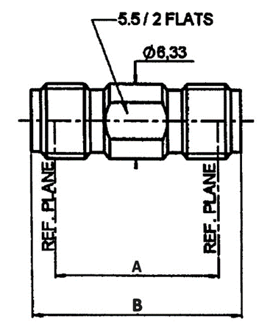
  Symbol | Dimensions mm
  Symbol | Min | Max
  A | 14.03 | 14.09
  B | 17.82 | 18.01
N.B.: All dimensions are in mm.
ELECTRICAL CHARACTERISTICS | VALUES | UNITS
Frequency range | 0 to 40 | GHz
Maximum voltage standing wave ratio (VSWR) | 1.05 + 0.003 f (GHz)
Maximum insertion loss | 0.03 √f (GHz) | dB
Voltage proof | 750 | Vrms
Power Handling Category (see Para. 1.5 Note 1) | Category I
MECHANICAL CHARACTERISTICS | VALUES | UNITS
Minimum centre contact retention force (axial) | 27 | N
Minimum centre contact retention torque | Not applicable
Maximum weight | 3 | g
OTHER CHARACTERISTICS | VALUES | UNITS
Operating temperature range | -65 to +165 | °C
Seal: Maximum leakage | Not applicable

variant 03 – STRAIGHT Adaptor, Male - FEmale
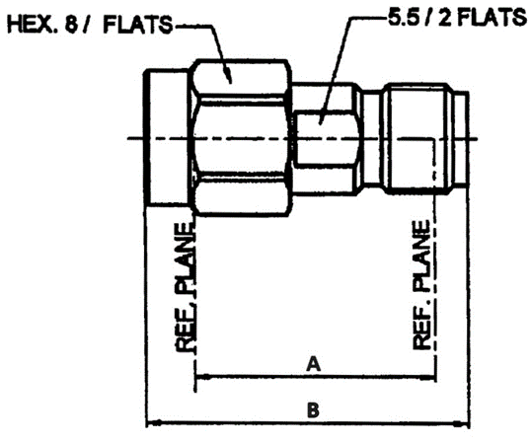
  Symbol | Dimensions mm
  Symbol | Min | Max
  A | 14.03 | 14.09
  B | 18.2 | 19.3
N.B.: All dimensions are in mm.
ELECTRICAL CHARACTERISTICS | VALUES | UNITS
Frequency range | 0 to 40 | GHz
Maximum voltage standing wave ratio (VSWR) | 1.05 + 0.003 f (GHz)
Maximum insertion loss | 0.03 √f (GHz) | dB
Voltage proof | 750 | Vrms
Power Handling Category (see Para. 1.5 Note 1) | Category I
MECHANICAL CHARACTERISTICS | VALUES | UNITS
Minimum centre contact retention force (axial) | 27 | N
Minimum centre contact retention torque | Not applicable
Maximum weight | 4.1 | g
OTHER CHARACTERISTICS | VALUES | UNITS
Operating temperature range | -65 to +165 | °C
Seal: Maximum leakage | Not applicable

variant 04 – RIGHT ANGLE Adaptor, Male - male
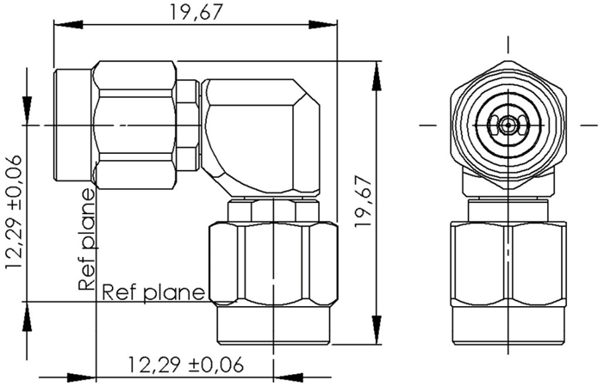
N.B.: All dimensions are in mm.
ELECTRICAL CHARACTERISTICS | VALUES | UNITS
Frequency range | 0 to 40 | GHz
Maximum voltage standing wave ratio (VSWR)  DC to 32GHz:  32 to 40GHz: | 1.20  1.50
Maximum insertion loss  DC to 32GHz:  32 to 40GHz: | 0.07 √f (GHz)  0.09 √f (GHz) | dB
Voltage proof | 750 | Vrms
Power Handling Category (see Para. 1.5 Note 1) | Category I
MECHANICAL CHARACTERISTICS | VALUES | UNITS
Minimum centre contact retention force (axial) | 27 | N
Minimum centre contact retention torque | Not applicable
Maximum weight | 7.5 | g
OTHER CHARACTERISTICS | VALUES | UNITS
Operating temperature range | -65 to +165 | °C
Seal: Maximum leakage | Not applicable

variant 05 – RIGHT ANGLE Adaptor, FEMale - FEmale
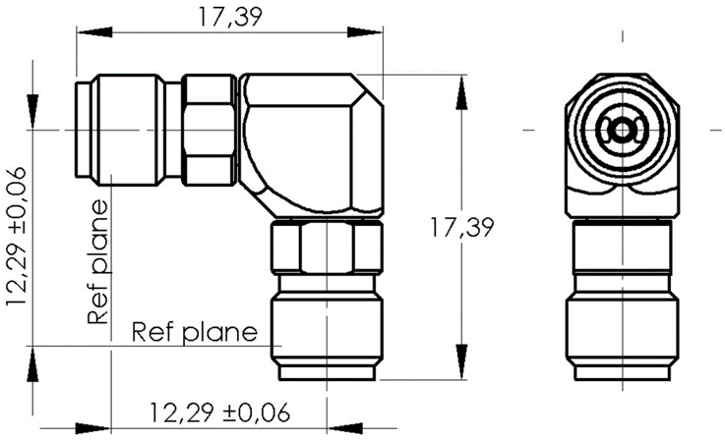
N.B.: All dimensions are in mm.
ELECTRICAL CHARACTERISTICS | VALUES | UNITS
Frequency range | 0 to 40 | GHz
Maximum voltage standing wave ratio (VSWR)  DC to 32GHz:  32 to 40GHz: | 1.20  1.50
Maximum insertion loss  DC to 32GHz:  32 to 40GHz: | 0.07 √f (GHz)  0.09 √f (GHz) | dB
Voltage proof | 750 | Vrms
Power Handling Category (see Para. 1.5 Note 1) | Category I
MECHANICAL CHARACTERISTICS | VALUES | UNITS
Minimum centre contact retention force (axial) | 27 | N
Minimum centre contact retention torque | Not applicable
Maximum weight | 5.5 | g
OTHER CHARACTERISTICS | VALUES | UNITS
Operating temperature range | -65 to +165 | °C
Seal: Maximum leakage | Not applicable

variant 06 – RIGHT ANGLE Adaptor, Male - FEmale
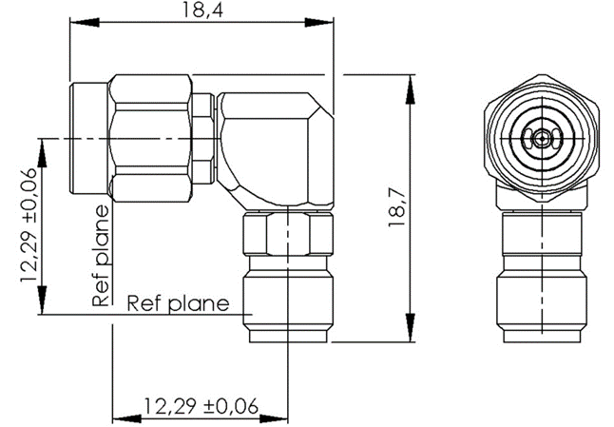
N.B.: All dimensions are in mm.
ELECTRICAL CHARACTERISTICS | VALUES | UNITS
Frequency range | 0 to 40 | GHz
Maximum voltage standing wave ratio (VSWR)  DC to 32GHz:  32 to 40GHz: | 1.20  1.50
Maximum insertion loss  DC to 32GHz:  32 to 40GHz: | 0.07 √f (GHz)  0.09 √f (GHz) | dB
Voltage proof | 750 | Vrms
Power Handling Category (see Para. 1.5 Note 1) | Category I
MECHANICAL CHARACTERISTICS | VALUES | UNITS
Minimum centre contact retention force (axial) | 27 | N
Minimum centre contact retention torque | Not applicable
Maximum weight | 7 | g
OTHER CHARACTERISTICS | VALUES | UNITS
Operating temperature range | -65 to +165 | °C
Seal: Maximum leakage | Not applicable

