

Page 1 of 26

RF COAXIAL ADAPTORS AND CONNECTING PIECES
BASED ON TYPE SMA
ESCC Detail Specification No. 3402/003
Issue 5 Draft A | June 2021



Document Custodian: European Space Agency – see https://escies.org

LEGAL DISCLAIMER AND COPYRIGHT
European Space Agency, Copyright © 2021. All rights reserved.
The European Space Agency disclaims any liability or responsibility, to any person or entity, with respect to any loss or damage caused, or alleged to be caused, directly or indirectly by the use and application of this ESCC publication.
This publication, without the prior permission of the European Space Agency and provided that it is not used for a commercial purpose, may be:
- copied in whole, in any medium, without alteration or modification.
- copied in part, in any medium, provided that the ESCC document identification, comprising the ESCC symbol, document number and document issue, is removed.

DOCUMENTATION CHANGE NOTICE
(Refer to https://escies.org for ESCC DCR content)
DCR No. | CHANGE DESCRIPTION
TBA | Specification updated to incorporate changes per DCR.
Draft 5A  S.Thacker ESCC-TW  21/06/2021 | Initial draft converted Detail spec to make it consistent with the newly published, converted Generic spec: ESCC No. 3402 issue 5.  Changes in this specification from the published issue 4 are mainly editorial in nature so have not been highlighted. Any actual technical changes, including those resulting from the new Generic spec, are highlighted yellow for information.

TABLE OF CONTENTS

1 GENERAL 6
1.1 SCOPE 6
1.2 APPLICABLE DOCUMENTS 6
1.3 TERMS, DEFINITIONS, ABBREVIATIONS, SYMBOLS AND UNITS 6
1.4 THE ESCC COMPONENT NUMBER AND COMPONENT TYPE VARIANTS 6
1.4.1 The ESCC Component Number 6
1.4.2 Component Type Variants 7
1.5 MAXIMUM RATINGS 7
1.6 PHYSICAL DIMENSIONS (SEE ALSO PARA. 3) 9
1.6.1 Connector Interface Dimensions and Connector Interface Gauge Dimensions 9
1.7 MATERIALS AND FINISHES 9
1.7.2 Type 1 9
1.7.3 Type 2 9
1.7.4 Type 3 10
1.7.5 Type 4 10
2 REQUIREMENTS 10
2.1 GENERAL 10
2.1.1 Deviations from the Generic Specification 10
2.2 MARKING 10
2.3 ENVIRONMENTAL AND MECHANICAL TESTS 11
2.4 Room Temperature Electrical Measurements 11
2.5 INTERMEDIATE AND END-POINT ELECTRICAL MEASUREMENTS 12
3 COMPONENT TYPE VARIANTS – DETAIL REQUIREMENTS 13
3.1 variant 01 – STRAIGHT Adaptor, Male - male 13
3.2 variant 02 – STRAIGHT adaptor, male - Female 14
3.3 variant 03 – STRAIGHT Adaptor, Female - Female 15
3.4 variant 04 – STRAIGHT Bulkhead adaptor, female - female 16
3.5 variant 05 – Elbow adaptor, male - female 17
3.6 variant 06 – T-adaptor, female – female/male 18
3.7 variant 07 – hermetic adaptor, female - female 19
3.8 variant 08 – T-adaptor, female – female/female 20
3.9 variant 09 – Straight flange adaptor, male - female 21
3.10 variant 10 – straight flange adaptor, female – female 22
3.11 variant 11 – STRAIGHT adaptor, male - male 23
3.12 variant 12 – STRAIGHT adaptor, male - Female 24
3.13 variant 03 – STRAIGHT Adaptor, Female - Female 25
3.14 variant 14 – STRAIGHT Bulkhead adaptor, female - female 26

GENERAL

SCOPE
This specification details the ratings, physical and electrical characteristics, and test and inspection data for the component type variants and/or the range of components specified below. It supplements the requirements of, and shall be read in conjunction with, the ESCC Generic Specification listed under Applicable Documents.

APPLICABLE DOCUMENTS
The following documents form part of this specification and shall be read in conjunction with it:
          - ESCC Generic Specification No. 3402.
          - MIL-STD-348, Department of Defence Interface Standard: Radio Frequency Connector Interfaces.

TERMS, DEFINITIONS, ABBREVIATIONS, SYMBOLS AND UNITS
For the purpose of this specification, the terms, definitions, abbreviations, symbols and units specified in ESCC Basic Specification No. 21300 shall apply.

THE ESCC COMPONENT NUMBER AND COMPONENT TYPE VARIANTS

The ESCC Component Number
The ESCC Component Number shall be constituted as follows:
Example: 3402003012
- Detail Specification Reference: 3402003
- Component Type Variant Number: 01 (as required)
- Characteristic code: Material/Plating (Type 2): 2 (as required)

Characteristics Codes
Characteristics to be codified as part of the ESCC Component Number (as applicable) shall be as follows:
          - Material/Plating: Connector material and plating (see Para. 1.7) expressed by means of the following codes:
Material/Plating | Code
Beryllium Copper, Gold plated, Copper underplate (Type 1) | 1
Beryllium Copper, Gold plated, Nickel underplate (Type 2) | 2
Amagnetic Stainless Steel, Electro-passivated (Type 3) | 3
Amagnetic Stainless Steel, Gold plated (Type 4) | 4

Component Type Variants
The component type variants applicable to this specification are as follows:
Variant Number | Description (Notes 1, 2)
01 | Straight Adaptor, Male - Male (Note 3)
02 | Straight Adaptor, Male - Female (Note 3)
03 | Straight Adaptor, Female - Female (Note 3)
04 | Straight Bulkhead Adaptor, Female - Female (Note 3)
05 | Elbow Adaptor, Male - Female
06 | T-Adaptor, Female - Female/Male
07 | Hermetic Adaptor, Female - Female
08 | T-Adaptor, Female - Female/Female
09 | Straight Flange Adaptor, Male - Female
10 | Straight Flange Adaptor, Female - Female
11 | Straight Adaptor, Male – Male (Maximum Operating Temperature = +165°C) (Note 3)
12 | Straight Adaptor, Male – Female (Maximum Operating Temperature = +165°C) (Note 3)
13 | Straight Adaptor, Female – Female (Maximum Operating Temperature = +165°C) (Note 3)
14 | Straight Bulkhead Adaptor Female – Female (Maximum Operating Temperature = +165°C) (Note 3)
NOTES:
            - See Para. 3 for details.
            - For available connector materials and finishes, see Paras. 1.4.1.1(a) and 1.7.
            - Variants 11 to 14 are high temperature capability versions of Variants 01 to 04 respectively.

MAXIMUM RATINGS
The maximum ratings shall not be exceeded at any time during use or storage.
Maximum ratings shall only be exceeded during testing to the extent specified in this specification and when stipulated in Test Methods and Procedures of the ESCC Generic Specification.
Characteristics | Symbol | Maximum Ratings | Unit | Remarks
Peak Power at +25°C | P_{max} | 20 | kW | For duration 1µs max.
Power | P | 2 | kW | Notes 1, 2
Nominal Impedance | Z | 50 | Ω | -
Operating Frequency Range | f | See Para. 3 | GHz | Note 2
Operating Voltage | V_{op} | 335 | Vrms | -
Operating Temperature Range | T_{op} | See Para. 3 | °C | -
Storage Temperature Range | T_{stg} | As per T_{op} | °C | -
Coupling Nut Torque | Tq | 170 | N.cm | Coupling Proof Torque Note 3
NOTES:
            - Derate Power with respect to Operating Temperature as follows:
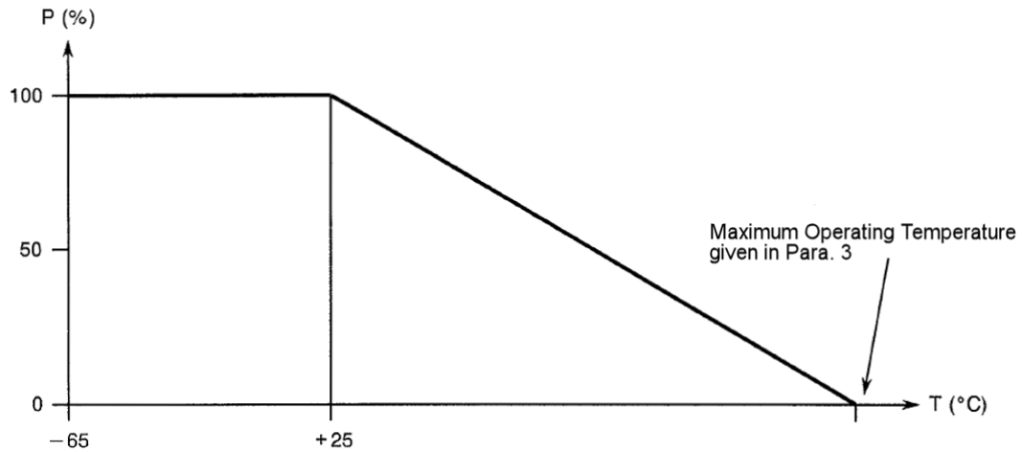
            - Derate Power with respect to Operating Frequency as follows:
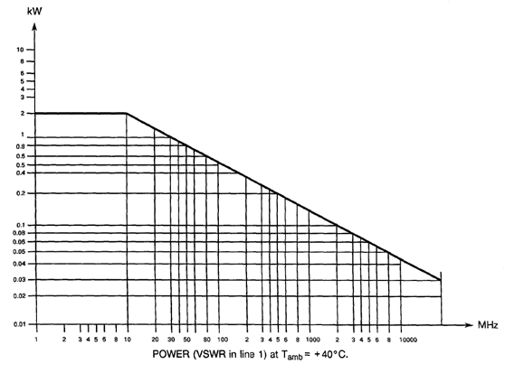
            - Whenever a test is performed on mated pairs of connectors, the pairs shall be torqued at 100 ±20N.cm.

PHYSICAL DIMENSIONS (SEE ALSO PARA. 3)

Connector Interface Dimensions and Connector Interface Gauge Dimensions
          - SMA Male Connector Interface: compatible with series SMA pin contact interface as specified in MIL-STD-348.
          - SMA Female Connector Interface: compatible with series SMA socket contact interface as specified in MIL-STD-348.
          - SMA Male Gauge Interface: compatible with series SMA pin contact test connector interface as specified in MIL-STD-348.
          - SMA Female Gauge Interface: compatible with series SMA socket contact test connector interface as specified in MIL-STD-348.

MATERIALS AND FINISHES
Materials and finishes shall be as follows (as applicable, see Para. 3):
Type | Description
1 | Beryllium Copper, Gold plated, Copper underplate (see Para. 1.7.2)
2 | Beryllium Copper, Gold plated, Nickel underplate (see Para. 1.7.3)
3 | Amagnetic Stainless Steel, Electro-passivated (see Para. 1.7.4)
4 | Amagnetic Stainless Steel, Gold plated (see Para. 1.7.5)

Type 1
          - Shell, Coupling Nut: beryllium copper, plated gold 2.5μm minimum over copper 2.5μm minimum.
          - Centre Contact:
- Male: Brass, plated gold 2.5μm minimum over copper 2.5μm minimum.
- Female: Beryllium copper, plated gold 2.5μm minimum over copper 2.5μm minimum.
          - Insulator: PTFE.
          - Gasket, Front: Silicone.
          - Rear Nut: brass or copper, plated gold 2.5μm minimum over copper 2.5μm minimum.
          - Washers: copper alloy, plated gold 0.5μm minimum over nickel 2μm minimum.

Type 2
          - Shell, Coupling Nut: beryllium copper, plated gold 1.27μm minimum over nickel 2μm minimum.
          - Centre Contact:
- Male: Brass, plated gold 1.27μm minimum over nickel 2μm minimum.
- Female: Beryllium copper, plated gold 1.27μm minimum over nickel 2μm minimum.
          - Insulator: PTFE.
          - Gasket, Front: Silicone.
          - Rear Nut: brass or copper, plated gold 0.5μm minimum over nickel 2μm minimum.
          - Washers: copper alloy, plated gold 0.5μm minimum over nickel 2μm minimum.

Type 3
          - Shell, Coupling Nut: Amagnetic stainless steel, electro-passivated.
          - Centre Contact:
- Male: Brass, plated gold 1.27μm minimum over nickel 2μm minimum.
- Female: Beryllium copper, plated gold 1.27μm minimum over nickel 2μm minimum.
          - Insulator: PTFE.
          - Gasket, Front: Silicone.
          - Rear Nut: stainless steel, electro-passivated.
          - Washers: copper alloy, plated nickel 2μm minimum.

Type 4
          - Shell, Coupling Nut: Amagnetic stainless steel, plated gold 1.27μm minimum over nickel 2μm minimum.
          - Centre Contact:
- Male: Brass, plated gold 1.27μm minimum over nickel 2μm minimum.
- Female: Beryllium copper, plated gold 1.27μm minimum over nickel 2μm minimum.
          - Insulator: PTFE.
          - Gasket, Front: Silicone.
          - Rear Nut: stainless steel, plated gold 0.5μm minimum over nickel 2μm minimum.
          - Washers: copper alloy, plated gold 0.5μm minimum over nickel 2μm minimum.

REQUIREMENTS

GENERAL
The complete requirements for procurement of the components specified herein are as stated in this specification and the ESCC Generic Specification. Permitted deviations from the Generic Specification, applicable to this specification only, are listed below.
Permitted deviations from the Generic Specification and this Detail Specification, formally agreed with specific Manufacturers on the basis that the alternative requirements are equivalent to the ESCC requirement and do not affect the component’s reliability, are listed in the appendices attached to this specification.

Deviations from the Generic Specification

Deviations from Screening Tests – Chart F3
          - Coupling Proof Torque: shall not be performed on connectors with a female contact; it shall be performed on connectors with a male contact.

MARKING
The marking shall be in accordance with the requirements of ESCC Basic Specification No. 21700 and as follows.
The information to be marked on the component or the primary package shall be:
          - The ESCC qualified components symbol (for ESCC qualified components only).
          - The ESCC Component Number (see Para. 1.4.1).
          - Traceability information.

ENVIRONMENTAL AND MECHANICAL TESTS
The following requirements apply to tests performed on the connector (and contact) lot as specified in the ESCC Generic Specification:
          - Para. 8.1, Contact Engagement and Separation Forces:
 | Oversize Test Pin Test | Maximum Diameter Test Pin Test | Minimum Diameter Test Pin Test
Test Pin Diameter (mm) (1) | 0.9525 to 0.955 | 0.94 to 0.942 | 0.902 to 0.904
Engagement Depth (mm) (1) | 0.76 to 1.14 | 1.27 to 1.91 | 1.27 to 1.91
Engagement Force (N) | - | 13.34 maximum | -
Separation Force (N) | - | - | 0.28 minimum
NOTES:
            - Test Pins details:
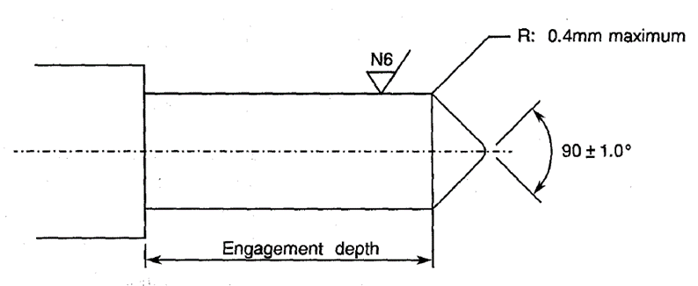
          - Para. 8.10, Coupling Proof Torque: See Para. 1.5.
          - Para. 8.11, Mating and Unmating Forces: Maximum torque: 24N.cm.
          - Para. 8.12, Centre Contact Retention: See Para. 3.
          - Para. 8.13, Seal: See Para. 3.
          - Para. 8.19, Endurance:
- During Qualification Testing: 500 cycles.
- During Periodic Testing: 100 cycles

Room Temperature Electrical Measurements
The measurements shall be performed at T_{amb} = +22 ±3°C.
Characteristics | Symbols | Test Method and  Conditions | Limits |  | Units
Characteristics | Symbols | Test Method and  Conditions | Min | Max | Units
Insulation Resistance | R_{I} | ESCC No. 3402 | 5 | - | GΩ
Voltage Proof Leakage Current | I_{L} | ESCC No. 3402  See Para. 3  Note 1 | - | 2 | mA
NOTES:
            - Between centre contact and shell.

INTERMEDIATE AND END-POINT ELECTRICAL MEASUREMENTS
Unless otherwise specified, the measurements shall be performed at T_{amb} = +22 ±3°C.
Unless otherwise specified, the test methods and test conditions shall be as per the corresponding test defined in Para. 2.4 Room Temperature Electrical Measurements.
Test Reference per ESCC No. 3402 | Characteristics and Test Conditions  Ref. ESCC No. 3402 | Symbols | Limits |  | Units
Test Reference per ESCC No. 3402 | Characteristics and Test Conditions  Ref. ESCC No. 3402 | Symbols | Min | Max | Units
Random Vibration | Contact Resistance: I_{T} = 10mA, V_{T} = 6V  Centre Contact: | R_{ctc} | - | 3 | mΩ
Mechanical Shock | Contact Resistance: I_{T} = 10mA, V_{T} = 6V  Centre Contact: | R_{ctc} | - | 3 | mΩ
Temperature Cycling | Contact Resistance: I_{T} = 10mA, V_{T} = 6V  Centre Contact: | R_{ctc} | - | 3 | mΩ
 | Voltage Proof Leakage Current: | I_{L} | Note 1
Electrical Measurements at Room Temperature | Insulation Resistance: | R_{I} | Note 1
Electrical Measurements at Room Temperature | Voltage Proof Leakage Current: | I_{L} | Note 1
Electrical Measurements at Room Temperature | Contact Resistance: I_{T} = 10mA, V_{T} = 6V  Centre Contact:  Shell: | R_{ctc}  R_{cts} | -  - | 3  2 | mΩ  mΩ
Electrical Measurements at Room Temperature | VSWR: | VSWR | Note 2
Electrical Measurements at Room Temperature | Insertion Loss: | LI | Note 2
Endurance | Contact Resistance: I_{T} = 10mA, V_{T} = 6V  Centre Contact:  Shell | R_{ctc}  R_{cts} | -  - | 4  3 | mΩ  mΩ
NOTES:
            - As specified in Para. 2.4.
            - As specified in Para. 3.

COMPONENT TYPE VARIANTS – DETAIL REQUIREMENTS

variant 01 – STRAIGHT Adaptor, Male - male
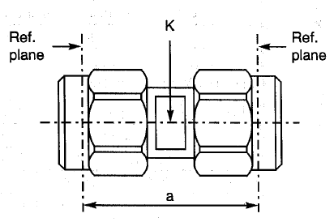
  Symbol | Dimensions mm |  | Notes
  Symbol | Min | Max | Notes
  a | 14.9 | 15.1
  K | - | 5.5 | 2 flats
ELECTRICAL CHARACTERISTICS | VALUES | UNITS
Frequency range | 0 to 18 | GHz
Maximum voltage standing wave ratio (VSWR) | 1.1 + 0.008 f (GHz)
Maximum insertion loss | 0.06 √f (GHz) | dB
Voltage proof | 1000 | Vrms
MECHANICAL CHARACTERISTICS | VALUES | UNITS
Minimum centre contact retention force (axial) | 27 | N
Minimum centre contact retention torque | Not applicable
Maximum weight | 4.9 | g
OTHER CHARACTERISTICS | VALUES | UNITS
Operating temperature range | -65 to +105 | °C
Seal: Maximum leakage | Not applicable

variant 02 – STRAIGHT adaptor, male - Female
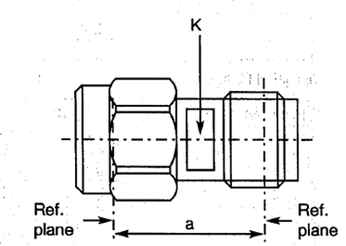
  Symbol | Dimensions mm |  | Notes
  Symbol | Min | Max | Notes
  a | 12.4 | 12.65
  K | 5.4 | 5.5 | 2 flats
ELECTRICAL CHARACTERISTICS | VALUES | UNITS
Frequency range | 0 to 18 | GHz
Maximum voltage standing wave ratio (VSWR) | 1.1 + 0.008 f (GHz)
Maximum insertion loss | 0.06 √f (GHz) | dB
Voltage proof | 1000 | Vrms
MECHANICAL CHARACTERISTICS | VALUES | UNITS
Minimum centre contact retention force (axial) | 27 | N
Minimum centre contact retention torque | Not applicable
Maximum weight | 3.5 | g
OTHER CHARACTERISTICS | VALUES | UNITS
Operating temperature range | -65 to +105 | °C
Seal: Maximum leakage | Not applicable

variant 03 – STRAIGHT Adaptor, Female - Female
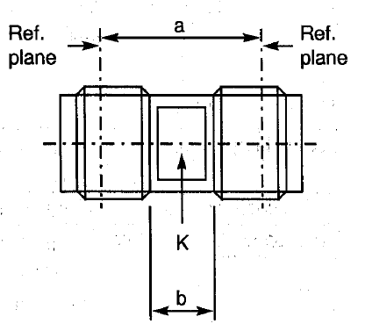
  Symbol | Dimensions mm |  | Notes
  Symbol | Min | Max | Notes
  a | 10.1 | 10.3
  b | 4.4 | -
  K | 5.4 | 5.5 | 2 flats
ELECTRICAL CHARACTERISTICS | VALUES | UNITS
Frequency range | 0 to 18 | GHz
Maximum voltage standing wave ratio (VSWR) | 1.1 + 0.008 f (GHz)
Maximum insertion loss | 0.06 √f (GHz) | dB
Voltage proof | 1000 | Vrms
MECHANICAL CHARACTERISTICS | VALUES | UNITS
Minimum centre contact retention force (axial) | 27 | N
Minimum centre contact retention torque | Not applicable
Maximum weight | 1.9 | g
OTHER CHARACTERISTICS | VALUES | UNITS
Operating temperature range | -65 to +105 | °C
Seal: Maximum leakage | Not applicable

variant 04 – STRAIGHT Bulkhead adaptor, female - female
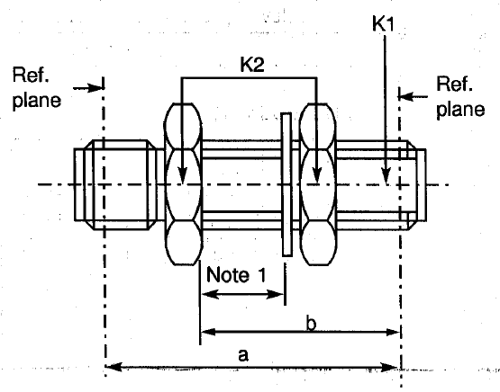
  Symbol | Dimensions mm |  | Notes
  Symbol | Min | Max | Notes
  a | - | 18.4
  b | 12.5 | 12.85
  K1 | - | 6 | 1 flat
  K2 | - | 8 | Hex.
NOTES:
            - Maximum panel thickness: 6mm
ELECTRICAL CHARACTERISTICS | VALUES | UNITS
Frequency range | 0 to 18 | GHz
Maximum voltage standing wave ratio (VSWR) | 1.1 + 0.008 f (GHz)
Maximum insertion loss | 0.06 √f (GHz) | dB
Voltage proof | 1000 | Vrms
MECHANICAL CHARACTERISTICS | VALUES | UNITS
Minimum centre contact retention force (axial) | 27 | N
Minimum centre contact retention torque | Not applicable
Maximum weight | 3.9 | g
OTHER CHARACTERISTICS | VALUES | UNITS
Operating temperature range | -65 to +105 | °C
Seal: Maximum leakage | Not applicable

variant 05 – Elbow adaptor, male - female
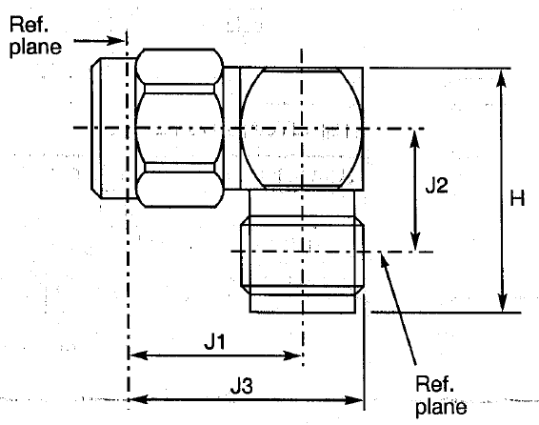
  Symbol | Dimensions mm
  Symbol | Min | Max
  H | 14.2 | 15.9
  J1 | 9.1 | 9.5
  J2 | 9.1 | 9.5
  J3 | 12.2 | 12.95
ELECTRICAL CHARACTERISTICS | VALUES | UNITS
Frequency range | 0 to 12.4 | GHz
Maximum voltage standing wave ratio (VSWR) | 1.05 + 0.01 f (GHz)
Maximum insertion loss | 0.05 √f (GHz) | dB
Voltage proof | 1000 | Vrms
MECHANICAL CHARACTERISTICS | VALUES | UNITS
Minimum centre contact retention force (axial) | 27 | N
Minimum centre contact retention torque | 2.8 | N.cm
Maximum weight | 4.9 | g
OTHER CHARACTERISTICS | VALUES | UNITS
Operating temperature range | -65 to +105 | °C
Seal: Maximum leakage | Not applicable

variant 06 – T-adaptor, female – female/male
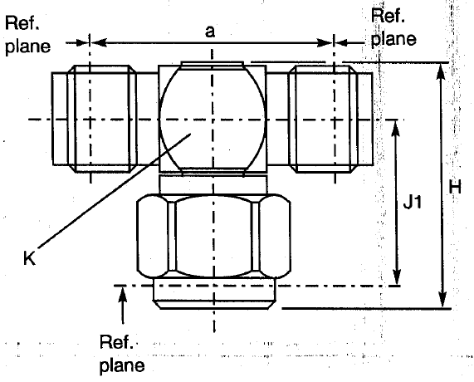
  Symbol | Dimensions mm |  | Notes
  Symbol | Min | Max | Notes
  a | 14.09 | 14.2
  H | 15.7 | 16.75
  J1 | 9.75 | 10
  K | - | 7 | Across flat
ELECTRICAL CHARACTERISTICS | VALUES | UNITS
Frequency range | 0 to 12.4 | GHz
Maximum voltage standing wave ratio (VSWR) | Not applicable
Maximum insertion loss | Not applicable
Voltage proof | 1000 | Vrms
MECHANICAL CHARACTERISTICS | VALUES | UNITS
Minimum centre contact retention force (axial) | 27 | N
Minimum centre contact retention torque | 2.8 | N.cm
Maximum weight | 5.9 | g
OTHER CHARACTERISTICS | VALUES | UNITS
Operating temperature range | -65 to +165 | °C
Seal: Maximum leakage | Not applicable

variant 07 – hermetic adaptor, female - female
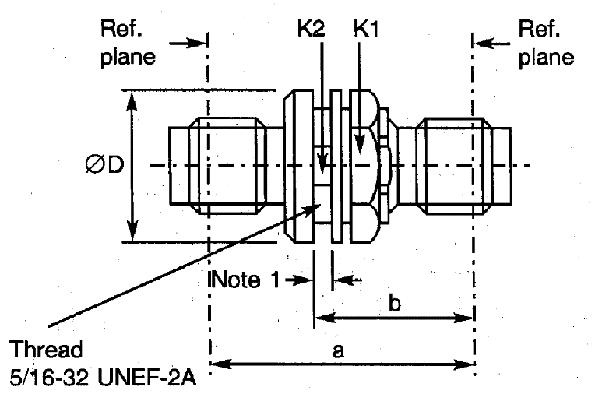
  Symbol | Dimensions mm |  | Notes
  Symbol | Min | Max | Notes
  a | 12.4 | 12.65
  K | 5.4 | 5.5 | 2 flats
  a | 18.5 | 18.9
  b | 11.7 | 13.2
  ØD | 12.9 | 14.2
NOTES:
            - Maximum panel thickness: 4.3mm
ELECTRICAL CHARACTERISTICS | VALUES | UNITS
Frequency range | 0 to 12.4 | GHz
Maximum voltage standing wave ratio (VSWR) | 1.1 + 0.015 f (GHz)
Maximum insertion loss | 0.15 √f (GHz) | dB
Voltage proof | 1000 | Vrms
MECHANICAL CHARACTERISTICS | VALUES | UNITS
Minimum centre contact retention force (axial) | Not applicable
Minimum centre contact retention torque | Not applicable
Maximum weight | 6.5 | g
OTHER CHARACTERISTICS | VALUES | UNITS
Operating temperature range | -40 to +165 | °C
Seal: Maximum leakage | 10⁻⁸ | atm.cm³/s

variant 08 – T-adaptor, female – female/female
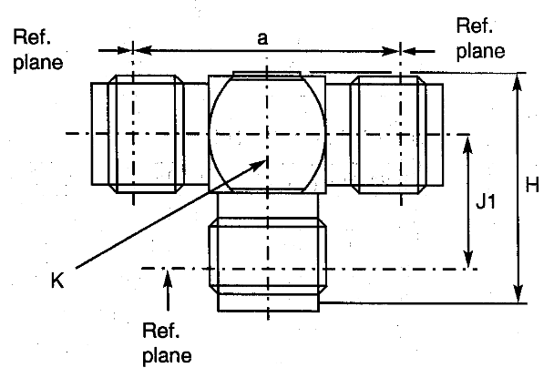
  Symbol | Dimensions mm |  | Notes
  Symbol | Min | Max | Notes
  a | 14 | 14.2
  H | 13.25 | 13.65
  J1 | 7.9 | 8.2
  K | - | 7 | 2 flats
ELECTRICAL CHARACTERISTICS | VALUES | UNITS
Frequency range | 0 to 12.4 | GHz
Maximum voltage standing wave ratio (VSWR) | Not applicable
Maximum insertion loss | Not applicable
Voltage proof | 1000 | Vrms
MECHANICAL CHARACTERISTICS | VALUES | UNITS
Minimum centre contact retention force (axial) | 27 | N
Minimum centre contact retention torque | Not applicable
Maximum weight | 5.9 | g
OTHER CHARACTERISTICS | VALUES | UNITS
Operating temperature range | -65 to +165 | °C
Seal: Maximum leakage | Not applicable

variant 09 – Straight flange adaptor, male - female
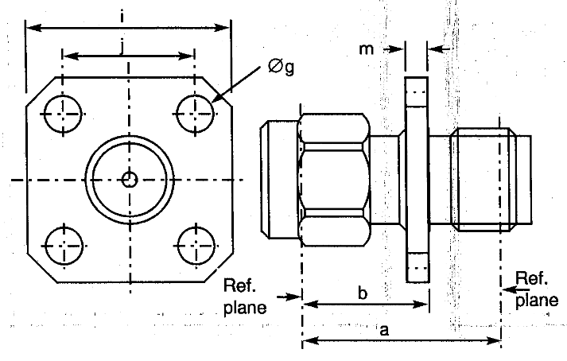
  Symbol | Dimensions mm |  | Notes
  Symbol | Min | Max | Notes
  a | 17.05 | 17.1
  b | 9.45 | 9.55
  Øg | 2.55 | 2.7 | 4 holes
  i | 12.6 | 12.8
  j | 8.59 | 8.69
  m | 1.4 | 1.8
ELECTRICAL CHARACTERISTICS | VALUES | UNITS
Frequency range | 0 to 18 | GHz
Maximum voltage standing wave ratio (VSWR) | 1.1 + 0.008 f (GHz)
Maximum insertion loss | 0.06 √f (GHz) | dB
Voltage proof | 1000 | Vrms
MECHANICAL CHARACTERISTICS | VALUES | UNITS
Minimum centre contact retention force (axial) | 27 | N
Minimum centre contact retention torque | Not applicable
Maximum weight | 3.3 | g
OTHER CHARACTERISTICS | VALUES | UNITS
Operating temperature range | -65 to +105 | °C
Seal: Maximum leakage | Not applicable

variant 10 – straight flange adaptor, female – female
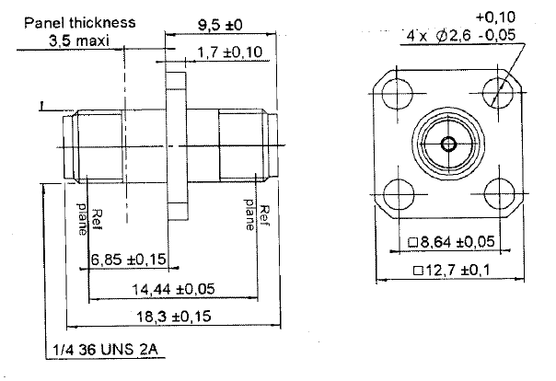
ELECTRICAL CHARACTERISTICS | VALUES | UNITS
Frequency range | 0 to 12.4 | GHz
Maximum voltage standing wave ratio (VSWR) | 1.1 + 0.008 f (GHz)
Maximum insertion loss | 0.06 √f (GHz) | dB
Voltage proof | 1000 | Vrms
MECHANICAL CHARACTERISTICS | VALUES | UNITS
Minimum centre contact retention force (axial) | 27 | N
Minimum centre contact retention torque | Not applicable
Maximum weight | 4.2 | g
OTHER CHARACTERISTICS | VALUES | UNITS
Operating temperature range | -65 to +165 | °C
Seal: Maximum leakage | Not applicable
NOTES:
            - All dimensions are in mm.

variant 11 – STRAIGHT adaptor, male - male
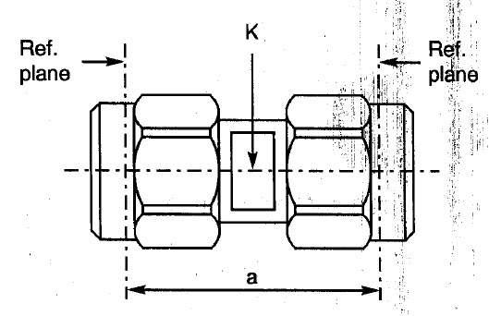
  Symbol | Dimensions mm |  | Notes
  Symbol | Min | Max | Notes
  a | 14.9 | 15.1
  K | - | 5.5 | 2 flats
ELECTRICAL CHARACTERISTICS | VALUES | UNITS
Frequency range | 0 to 18 | GHz
Maximum voltage standing wave ratio (VSWR) | 1.1 + 0.008 f (GHz)
Maximum insertion loss | 0.06 √f (GHz) | dB
Voltage proof | 1000 | Vrms
MECHANICAL CHARACTERISTICS | VALUES | UNITS
Minimum centre contact retention force (axial) | 27 | N
Minimum centre contact retention torque | Not applicable
Maximum weight | 4.9 | g
OTHER CHARACTERISTICS | VALUES | UNITS
Operating temperature range | -65 to +165 | °C
Seal: Maximum leakage | Not applicable

variant 12 – STRAIGHT adaptor, male - Female
Symbol | Dimensions mm |  | Notes
Symbol | Min | Max | Notes
a | 12.4 | 12.65
K | 5.4 | 5.5 | 2 flats

ELECTRICAL CHARACTERISTICS | VALUES | UNITS
Frequency range | 0 to 18 | GHz
Maximum voltage standing wave ratio (VSWR) | 1.1 + 0.008 f (GHz)
Maximum insertion loss | 0.06 √f (GHz) | dB
Voltage proof | 1000 | Vrms
MECHANICAL CHARACTERISTICS | VALUES | UNITS
Minimum centre contact retention force (axial) | 27 | N
Minimum centre contact retention torque | Not applicable
Maximum weight | 3.5 | g
OTHER CHARACTERISTICS | VALUES | UNITS
Operating temperature range | -65 to +165 | °C
Seal: Maximum leakage | Not applicable

variant 03 – STRAIGHT Adaptor, Female - Female
Symbol | Dimensions mm |  | Notes
Symbol | Min | Max | Notes
a | 10.1 | 10.3
b | 4.4 | -
K | 5.4 | 5.5 | 2 flats

ELECTRICAL CHARACTERISTICS | VALUES | UNITS
Frequency range | 0 to 18 | GHz
Maximum voltage standing wave ratio (VSWR) | 1.1 + 0.008 f (GHz)
Maximum insertion loss | 0.06 √f (GHz) | dB
Voltage proof | 1000 | Vrms
MECHANICAL CHARACTERISTICS | VALUES | UNITS
Minimum centre contact retention force (axial) | 27 | N
Minimum centre contact retention torque | Not applicable
Maximum weight | 1.9 | g
OTHER CHARACTERISTICS | VALUES | UNITS
Operating temperature range | -65 to +165 | °C
Seal: Maximum leakage | Not applicable

variant 14 – STRAIGHT Bulkhead adaptor, female - female
Symbol | Dimensions mm |  | Notes
Symbol | Min | Max | Notes
a | - | 18.4
b | 12.5 | 12.85
K1 | - | 6 | 1 flat
K2 | - | 8 | Hex.

NOTES:
            - Maximum panel thickness: 6mm
ELECTRICAL CHARACTERISTICS | VALUES | UNITS
Frequency range | 0 to 18 | GHz
Maximum voltage standing wave ratio (VSWR) | 1.1 + 0.008 f (GHz)
Maximum insertion loss | 0.06 √f (GHz) | dB
Voltage proof | 1000 | Vrms
MECHANICAL CHARACTERISTICS | VALUES | UNITS
Minimum centre contact retention force (axial) | 27 | N
Minimum centre contact retention torque | Not applicable
Maximum weight | 3.9 | g
OTHER CHARACTERISTICS | VALUES | UNITS
Operating temperature range | -65 to +165 | °C
Seal: Maximum leakage | Not applicable

