

Page 1 of 103

RF COAXIAL CONNECTORS WITH FEMALE CONTACT
BASED ON TYPE SMA
ESCC Detail Specification No. 3402/002
Issue 9 Draft A | July 2021



Document Custodian: European Space Agency – see https://escies.org

LEGAL DISCLAIMER AND COPYRIGHT
European Space Agency, Copyright © 2021. All rights reserved.
The European Space Agency disclaims any liability or responsibility, to any person or entity, with respect to any loss or damage caused, or alleged to be caused, directly or indirectly by the use and application of this ESCC publication.
This publication, without the prior permission of the European Space Agency and provided that it is not used for a commercial purpose, may be:
- copied in whole, in any medium, without alteration or modification.
- copied in part, in any medium, provided that the ESCC document identification, comprising the ESCC symbol, document number and document issue, is removed.

DOCUMENTATION CHANGE NOTICE
(Refer to https://escies.org for ESCC DCR content)
DCR No. | CHANGE DESCRIPTION
TBA | Specification updated to incorporate changes per DCR.
Draft 9A  S.Thacker ESCC-TW  05/07/2021 | Initial draft converted Detail spec to make it consistent with the newly published, converted Generic spec: ESCC No. 3402 issue 5.  Changes in this specification from the published issue 8 are mainly editorial in nature so have not been highlighted. Any actual technical changes, including those resulting from the new Generic spec, are highlighted yellow for information.

TABLE OF CONTENTS

1 GENERAL 8
1.1 SCOPE 8
1.2 APPLICABLE DOCUMENTS 8
1.3 TERMS, DEFINITIONS, ABBREVIATIONS, SYMBOLS AND UNITS 8
1.4 THE ESCC COMPONENT NUMBER AND COMPONENT TYPE VARIANTS 8
1.4.1 The ESCC Component Number 8
1.4.2 Component Type Variants 9
1.5 MAXIMUM RATINGS 12
1.6 PHYSICAL DIMENSIONS (SEE ALSO PARA. 3) 14
1.6.1 Connector Interface Dimensions and Connector Interface Gauge Dimensions 14
1.7 MATERIALS AND FINISHES 14
1.7.1 Type 1 14
1.7.2 Type 2 14
1.7.3 Type 3 15
1.7.4 Type 4 15
2 REQUIREMENTS 15
2.1 GENERAL 15
2.1.1 Deviations from the Generic Specification 15
2.2 MARKING 16
2.3 ENVIRONMENTAL AND MECHANICAL TESTS 16
2.4 ROOM TEMPERATURE ELECTRICAL MEASUREMENTS (NOTE 1) 17
2.5 INTERMEDIATE AND END-POINT ELECTRICAL MEASUREMENTS 17
3 COMPONENT TYPE VARIANTS – DETAIL REQUIREMENTS 18
3.1 VARIANT 01 – STRAIGHT JACK, SOLDER-TYPE, FOR SEMI-RIGID CABLE Ø2.2MM 18
3.2 VARIANT 02 - STRAIGHT JACK, SOLDER-TYPE, FOR SEMI-RIGID CABLE Ø3.58MM 19
3.3 VARIANT 03 - STRAIGHT JACK WITH CABLE CLAMP, SOLDER-TYPE, FOR SEMI-RIGID CABLE Ø6.35MM 20
3.4 VARIANT 04 - STRAIGHT JACK WITH CABLE CLAMP, SOLDER-TYPE, FOR SEMI-RIGID MICROPOROUS CABLE Ø6.35MM 21
3.5 VARIANT 05 - STRAIGHT JACK, CRIMP-TYPE, SQUARE FLANGE 22
3.6 VARIANT 06 - STRAIGHT JACK, CRIMP-TYPE 23
3.7 VARIANT 07 - STRAIGHT JACK, CRIMP-TYPE, FOR CABLE Ø5MM, SINGLE BRAID 24
3.8 VARIANT 08 - STRAIGHT JACK, CRIMP-TYPE, FOR CABLE Ø5MM, DOUBLE BRAID 25
3.9 VARIANT 09 - STRAIGHT JACK, SOLDER-TYPE, BACK MOUNTING, 2-HOLE, FLANGE-MOUNTED, FOR SEMI-RIGID CABLE Ø2.2MM 26
3.10 VARIANT 10 - STRAIGHT JACK, SOLDER-TYPE, BACK MOUNTING, 2-HOLE, FLANGE-MOUNTED, FOR SEMI-RIGID CABLE Ø3.58MM 27
3.11 VARIANT 11 - STRAIGHT JACK, CRIMP-TYPE, SQUARE FLANGE 28
3.12 VARIANT 12 - STRAIGHT JACK, CRIMP-TYPE, SQUARE FLANGE, FOR 50 CIS CABLE 29
3.13 VARIANT 13 - STRAIGHT JACK, CRIMP- OR SOLDER-TYPE, SQUARE FLANGE 30
3.14 VARIANT 14 - STRAIGHT JACK, CRIMP- OR SOLDER-TYPE, SQUARE FLANGE, DOUBLE BRAID CABLE 31
3.15 VARIANT 15 - SQUARE FLANGE RECEPTACLE, FRONT MOUNTING 32
3.16 VARIANT 16 – 2-HOLE FLANGE RECEPTACLE FOR MICRO-STRIP, FRONT MOUNTING 33
3.17 VARIANT 17 - 2-HOLE FLANGE RECEPTACLE, FRONT MOUNTING 34
3.18 VARIANT 18 - 2-HOLE FLANGE RECEPTACLE FOR MICRO-STRIP, FRONT MOUNTING 35
3.19 VARIANT 19 - SQUARE FLANGE RECEPTACLE FOR MICRO-STRIP, FRONT MOUNTING, OFF-SET TAB 36
3.20 VARIANT 20 - 2-HOLE FLANGE RECEPTACLE FOR MICRO-STRIP, FRONT MOUNTING 37
3.21 VARIANT 21 - SQUARE FLANGE RECEPTACLE FOR STRIP-LINE, FRONT MOUNTING 38
3.22 VARIANT 22 - SQUARE FLANGE RECEPTACLE FOR MICRO-STRIP, FRONT MOUNTING 39
3.23 VARIANT 23 - BULKHEAD RECEPTACLE 40
3.24 VARIANT 24 - BULKHEAD RECEPTACLE WITH COMPRESSION GASKET 41
3.25 VARIANT 25 - HERMETIC BULKHEAD RECEPTACLE 42
3.26 VARIANT 26 - HERMETIC RECEPTACLE, SOLDER-TYPE 43
3.27 VARIANT 27 - ELBOW RECEPTACLE, SQUARE FLANGE 44
3.28 VARIANT 28 - ELBOW RECEPTACLE, SQUARE FLANGE 45
3.29 VARIANT 29 - SQUARE FLANGE RECEPTACLE 46
3.30 VARIANT 30 - 2-HOLE FLANGE RECEPTACLE 47
3.31 VARIANT 31 - SQUARE FLANGE RECEPTACLE 48
3.32 VARIANT 32 - 2-HOLE FLANGE RECEPTACLE 49
3.33 VARIANT 34 - FLANGE RECEPTACLE, TRIPLATE LAUNCHER 50
3.34 VARIANT 36 - SQUARE FLANGE RECEPTACLE 51
3.35 VARIANT 37 - FLANGE RECEPTACLE, TRIPLATE LAUNCHER 52
3.36 VARIANT 38 - FLANGE RECEPTACLE, TRIPLATE LAUNCHER 53
3.37 VARIANT 39 - SQUARE FLANGE RECEPTACLE 54
3.38 VARIANT 40 - SQUARE FLANGE RECEPTACLE, LOW RF LEAKAGE 55
3.39 VARIANT 41 - SQUARE FLANGE RECEPTACLE, LOW RF LEAKAGE 56
3.40 VARIANT 42 - SQUARE FLANGE RECEPTACLE, LOW RF LEAKAGE 57
3.41 VARIANT 43 - SQUARE FLANGE RECEPTACLE, LOW RF LEAKAGE 58
3.42 VARIANT 44 - BULKHEAD RECEPTACLE 59
3.43 VARIANT 45 - SQUARE FLANGE RECEPTACLE FOR MICRO-STRIP 60
3.44 VARIANT 46 - 2-HOLE FLANGE RECEPTACLE FOR STRIP-LINE 61
3.45 VARIANT 47 - 2-HOLE FLANGE RECEPTACLE FOR STRIP-LINE 62
3.46 VARIANT 48 - SQUARE FLANGE MALE RECEPTACLE FOR MICRO-STRIP 63
3.47 VARIANT 49 - 2-HOLE FLANGE RECEPTACLE 64
3.48 VARIANT 50 - SQUARE FLANGE RECEPTACLE 65
3.49 VARIANT 51 - SQUARE FLANGE RECEPTACLE 66
3.50 VARIANT 53 - STRAIGHT JACK, SOLDER TYPE, FOR SHF 5 CABLE 67
3.51 VARIANT 54 - 2-HOLE FLANGE RECEPTACLE, LOW RF LEAKAGE 68
3.52 VARIANT 55 - ELBOW RECEPTACLE, ROUND FLANGE, TRIPLATE LAUNCHER 69
3.53 VARIANT 56 - SQUARE FLANGE RECEPTACLE, LOW RF LEAKAGE 70
3.54 VARIANT 57 - ROUND FLANGE RECEPTACLE, TRIPLATE LAUNCHER 71
3.55 VARIANT 58 - SQUARE FLANGE RECEPTACLE, LOW RF LEAKAGE 72
3.56 VARIANT 59 - 2-HOLE FLANGE MALE RECEPTACLE, WITH HERMETIC GLASS SEAL Ø0.46MM AND EMI GASKET 73
3.57 VARIANT 60 - BULKHEAD RECEPTACLE, WITH HERMETIC GLASS SEAL Ø0.3MM 74
3.58 VARIANT 61 - BULKHEAD RECEPTACLE, WITH HERMETIC GLASS SEAL Ø0.46MM 75
3.59 VARIANT 62 - HERMETIC BULKHEAD RECEPTACLE, WITH COMPRESSION GASKET 76
3.60 VARIANT 63 - HERMETIC BULKHEAD RECEPTACLE, WITH COMPRESSION GASKET 77
3.61 VARIANT 64 - HERMETIC BULKHEAD RECEPTACLE, WITH COMPRESSION GASKET 78
3.62 VARIANT 65 - 2-HOLE FLANGE MALE RECEPTACLE, WITH HERMETIC GLASS SEAL Ø0.3MM AND EMI GASKET 79
3.63 VARIANT 66 - BULKHEAD JACK, SOLDER-TYPE, FOR SHF 3 CABLE 80
3.64 VARIANT 67 - BULKHEAD JACK, SOLDER-TYPE, FOR SHF 8 CABLE 81
3.65 VARIANT 68 - STRAIGHT JACK, SOLDER-TYPE, BACK MOUNTING, FLANGE-MOUNTED, FOR SEMI-RIGID CABLE Ø2.2MM 82
3.66 VARIANT 69 - STRAIGHT JACK, SOLDER-TYPE, BACK MOUNTING, FLANGE-MOUNTED, FOR SEMI-RIGID CABLE Ø3.58MM 83
3.67 VARIANT 70 - STRAIGHT JACK, CRIMP-TYPE, FOR 50 CIS CABLE 84
3.68 VARIANT 71 - ELBOW RECEPTACLE, SQUARE FLANGE (SOLID CONTACT) 85
3.69 VARIANT 72 - SQUARE FLANGE RECEPTACLE TAB CONTACT, LOW RF LEAKAGE 86
3.70 VARIANT 73 - SQUARE FLANGE RECEPTACLE, FRONT MOUNTING 87
3.71 VARIANT 74 - 2-HOLE FLANGE RECEPTACLE, FRONT MOUNTING 88
3.72 VARIANT 75 - 2-HOLE FLANGE RECEPTACLE FOR MICRO-STRIP, FRONT MOUNTING 89
3.73 VARIANT 76 - SQUARE FLANGE RECEPTACLE FOR MICRO-STRIP, FRONT MOUNTING 90
3.74 VARIANT 77 - SQUARE FLANGE RECEPTACLE 91
3.75 VARIANT 78 - 2-HOLE FLANGE RECEPTACLE 92
3.76 VARIANT 79 - SQUARE FLANGE RECEPTACLE 93
3.77 VARIANT 80 - 2-HOLE FLANGE RECEPTACLE 94
3.78 VARIANT 81 - SQUARE FLANGE RECEPTACLE, LOW RF LEAKAGE 95
3.79 VARIANT 82 - 2-HOLE FLANGE RECEPTACLE, LOW RF LEAKAGE 96
3.80 VARIANT 83 - BULKHEAD RECEPTACLE, WITH HERMETIC GLASS SEAL Ø0.3MM 97
3.81 VARIANT 84 - BULKHEAD RECEPTACLE, WITH HERMETIC GLASS SEAL Ø0.46MM 98
3.82 VARIANT 85 - ELBOW RECEPTACLE, SQUARE FLANGE (SOLID CONTACT) 99
3.83 VARIANT 86 - SQUARE FLANGE RECEPTACLE, LOW VSWR, EXTENDED FREQUENCY RANGE 100
3.84 VARIANT 87 - SQUARE FLANGE RECEPTACLE, LOW VSWR, EXTENDED FREQUENCY RANGE 101
3.85 VARIANT 88 - SQUARE FLANGE RECEPTACLE, LOW VSWR, EXTENDED FREQUENCY RANGE 102
3.86 VARIANT 89 - SQUARE FLANGE RECEPTACLE, LOW VSWR, EXTENDED FREQUENCY RANGE 103

GENERAL

SCOPE
This specification details the ratings, physical and electrical characteristics, and test and inspection data for the component type variants and/or the range of components specified below. It supplements the requirements of, and shall be read in conjunction with, the ESCC Generic Specification listed under Applicable Documents.

APPLICABLE DOCUMENTS
The following documents form part of this specification and shall be read in conjunction with it:
          - ESCC Generic Specification No. 3402.
          - MIL-STD-348, Department of Defence Interface Standard: Radio Frequency Connector Interfaces.

TERMS, DEFINITIONS, ABBREVIATIONS, SYMBOLS AND UNITS
For the purpose of this specification, the terms, definitions, abbreviations, symbols and units specified in ESCC Basic Specification No. 21300 shall apply.

THE ESCC COMPONENT NUMBER AND COMPONENT TYPE VARIANTS

The ESCC Component Number
The ESCC Component Number shall be constituted as follows:
          - For components with a fixed configuration (see Paras. 1.4.2 and 3):
Example: 3402002012
- Detail Specification Reference: 3402002
- Component Type Variant Number: 01 (as required)
- Characteristic code: Material/Plating (Type 2): 2 (as required)
          - For components with a variable configuration where the rear contact and insert dimensions A and B shall be selected by the Orderer (see Paras. 1.4.2 and 3):
Example: 340200215213D00W02D50C
- Detail Specification Reference: 3402002
- Component Type Variant Number: 15 (as required)
- Characteristic code: Material/Plating (Type 2): 2 (as required)
- Characteristic code: Dimension A: Rear contact length (13mm): 13D00 (as required)
- Characteristic code: Dimension A tolerance (±0.05mm): W (as required)
- Characteristic code: Dimension B: Rear insert length (2.5mm): 02D50 (as required)
- Characteristic code: Dimension B tolerance (±0.25mm): C (as required)

Characteristics Codes
Characteristics to be codified as part of the ESCC Component Number (as applicable) shall be as follows:
          - Material/Plating: Connector material and plating (see Para. 1.7) expressed by means of the following codes:
Material/Plating | Code
Beryllium Copper, Gold plated, Copper underplate (Type 1) | 1
Beryllium Copper, Gold plated, Nickel underplate (Type 2) | 2
Amagnetic Stainless Steel, Electro-passivated (Type 3) | 3
Amagnetic Stainless Steel, Gold plated (Type 4) | 4
          - Dimension A and B: Rear contact and insert lengths (see Para. 3) expressed by the following codes. The unit quantity shall be mm:
Dimension A or B Length (mm) | Code
XX.XX | XXDXX
NOTES:
            - Dimension A shall always be greater than B. Both values shall always be positive.
            - When dimension B (insert) is flush with the flange (B = 0), the insert length shall be marked 00D00 with the appropriate tolerance.
          - Dimension A and B tolerance: Tolerances on contact and insert lengths (see Para. 3) expressed by the following codes. The unit quantity shall be mm:
Dimension A or B Tolerance (mm) | Code
±0.05 | W
±0.1 | B
±0.25 | C

Component Type Variants
The component type variants applicable to this specification are as follows:
Variant Number | Description (Notes 1, 2) | Configuration Type (Note 3)
01 | Straight Jack, Solder-Type, for Semi-Rigid Cable Ø2.2mm | Fixed
02 | Straight Jack, Solder-Type, for Semi-Rigid Cable Ø3.58mm | Fixed
03 | Straight Jack with Cable Clamp, Solder-Type, for Semi-Rigid Cable Ø6.35mm | Fixed
04 | Straight Jack with Cable Clamp, Solder-Type, for Semi-Rigid Microporous Cable Ø6.35mm | Fixed
05 | Straight Jack, Crimp-Type, Square Flange | Fixed
06 | Straight Jack, Crimp-Type | Fixed
07 | Straight Jack, Crimp-Type, Cable Ø5mm, Single Braid | Fixed
08 | Straight Jack, Crimp-Type, Cable Ø5mm, Double Braid | Fixed
09 | Straight Jack, Solder-Type, Back Mounting, 2-Hole, Flange-Mounted, for Semi-Rigid Cable Ø2.2mm | Fixed
10 | Straight Jack, Solder-Type, Back Mounting, 2-Hole, Flange-Mounted, for Semi-Rigid Cable Ø3.58mm | Fixed
11 | Straight Jack, Crimp-Type, Square Flange | Fixed
12 | Straight Jack, Crimp-Type, Square Flange, for 50 CIS Cable | Fixed
13 | Straight Jack, Crimp- or Solder-Type, Square Flange | Fixed
14 | Straight Jack, Crimp- or Solder-Type, Square Flange, Double Braid Cable | Fixed
15 | Square Flange Receptacle, Front Mounting (Note 4) | Variable
16 | 2-Hole Flange Receptacle for Micro-Strip, Front Mounting | Fixed
17 | 2-Hole Flange Receptacle, Front Mounting (Note 4) | Variable
18 | 2-Hole Flange Receptacle for Micro-Strip, Front Mounting (Note 4) | Fixed
19 | Square Flange Receptacle for Micro-Strip, Front Mounting, Off-Set Tab | Fixed
20 | 2-Hole Flange Receptacle for Strip-Line, Front Mounting | Fixed
21 | Square Flange Receptacle for Strip-Line, Front Mounting | Fixed
22 | Square Flange Receptacle for Micro-Strip, Front Mounting (Note 4) | Fixed
23 | Bulkhead Receptacle | Fixed
24 | Bulkhead Receptacle, with Compression Gasket | Fixed
25 | Hermetic Bulkhead Receptacle | Fixed
26 | Hermetic Receptacle, Solder-Type | Fixed
27 | Elbow Receptacle, Square Flange | Fixed
28 | Elbow Receptacle, Square Flange | Variable
29 | Square Flange Receptacle (Note 4) | Variable
30 | 2-Hole Flange Receptacle (Note 4) | Variable
31 | Square Flange Receptacle (Note 4) | Fixed
32 | 2-Hole Flange Receptacle (Note 4) | Fixed
34 | Flange Receptacle, Triplate Launcher | Fixed
36 | Square Flange Receptacle | Fixed
37 | Flange Receptacle, Triplate Launcher | Fixed
38 | Flange Receptacle, Triplate Launcher | Fixed
39 | Square Flange Receptacle | Fixed
40 | Square Flange Receptacle, Low RF Leakage (Note 4) | Variable
41 | Square Flange Receptacle, Low RF Leakage | Fixed
42 | Square Flange Receptacle, Low RF Leakage | Fixed
43 | Square Flange Receptacle, Low RF Leakage | Fixed
44 | Bulkhead Receptacle | Variable
45 | Square Flange Receptacle for Micro-Strip | Variable
46 | 2-Hole Flange Receptacle for Strip-Line | Fixed
47 | 2-Hole Flange Receptacle for Strip-Line | Fixed
48 | Square Flange Male Receptacle for Micro-Strip | Fixed
49 | 2-Hole Flange Receptacle | Fixed
50 | Square Flange Receptacle | Fixed
51 | Square Flange Receptacle | Variable
53 | Straight Jack, Solder-Type, for SHF 5 Cable | Fixed
54 | 2-Hole Flange Receptacle, Low RF Leakage (Note 4) | Variable
55 | Elbow Receptacle, Round Flange, Triplate Launcher | Fixed
56 | Square Flange Receptacle, Low RF Leakage | Variable
57 | Round Flange Receptacle, Triplate Launcher | Fixed
58 | Square Flange Receptacle, Low RF Leakage | Variable
59 | 2-Hole Flange Male Receptacle, with Hermetic Glass Seal Ø0.46mm and EMI Gasket | Fixed
60 | Bulkhead Receptacle, with Hermetic Glass Seal Ø0.3mm (Note 4) | Fixed
61 | Bulkhead Receptacle, with Hermetic Glass Seal Ø0.46mm (Note 4) | Fixed
62 | Hermetic Bulkhead Receptacle, with Compression Gasket | Fixed
63 | Hermetic Bulkhead Receptacle, with Compression Gasket | Fixed
64 | Hermetic Bulkhead Receptacle, with Compression Gasket | Fixed
65 | 2-Hole Flange Male Receptacle, with Hermetic Glass Seal Ø0.3mm and EMI Gasket | Fixed
66 | Bulkhead Jack, Solder-Type, for SHF 3 Cable | Fixed
67 | Bulkhead Jack, Solder-Type, for SHF 8 Cable | Fixed
68 | Straight Jack, Solder-Type, Back Mounting, Flange-Mounted, For Semi-Rigid Cable Ø2.2mm | Fixed
69 | Straight Jack, Solder-Type, Back Mounting, Flange-Mounted, For Semi-Rigid Cable Ø3.58mm | Fixed
70 | Straight Jack, Crimp-Type, for 50 CIS Cable | Fixed
71 | Elbow Receptacle, Square Flange (Solid Contact) (Note 4) | Variable
72 | Square Flange Receptacle, Tab Contact, Low RF Leakage | Fixed
73 | Square Flange Receptacle, Front Mounting, Maximum Operating Temperature = +165ºC (Note 4) | Variable
74 | 2-Hole Flange receptacle, Front Mounting, Maximum Operating Temperature = +165ºC (Note 4) | Variable
75 | 2-Hole Flange Receptacle for Micro-Strip, Front Mounting, Maximum Operating Temperature = +165ºC (Note 4) | Fixed
76 | Square Flange Receptacle for Micro-Strip, Front Mounting, Maximum Operating Temperature = +165ºC (Note 4) | Fixed
77 | Square Flange Receptacle, Maximum Operating Temperature = +165ºC (Note 4) | Variable
78 | 2-Hole Flange Receptacle, Maximum Operating Temperature = +165ºC (Note 4) | Variable
79 | Square Flange Receptacle, Maximum Operating Temperature = +165ºC (Note 4) | Fixed
80 | 2-Hole Flange Receptacle, Maximum Operating Temperature = +165ºC (Note 4) | Fixed
81 | Square Flange Receptacle, Low RF Leakage, Maximum Operating Temperature = +165ºC (Note 4) | Variable
82 | 2-Hole Flange Receptacle, Low RF Leakage, Maximum Operating Temperature = +165ºC (Note 4) | Variable
83 | Bulkhead Receptacle, with Hermetic Glass Seal Ø0.3mm, Maximum Operating Temperature = +165ºC (Note 4) | Fixed
84 | Bulkhead Receptacle, with Hermetic Glass Seal Ø0.46mm, Maximum Operating Temperature = +165ºC (Note 4) | Fixed
85 | Elbow Receptacle, Square Flange (Solid Contact), Maximum Operating Temperature = +165ºC (Note 4) | Variable
86 | Square Flange Receptacle, Low VSWR, Extended Frequency Range | Fixed
87 | Square Flange Receptacle, Low VSWR, Extended Frequency Range | Fixed
88 | Square Flange Receptacle, Low VSWR, Extended Frequency Range | Fixed
89 | Square Flange Receptacle, Low VSWR, Extended Frequency Range | Fixed
NOTES:
            - See Para. 3 for details.
            - For available connector materials and finishes, see Paras. 1.4.1.1(a) and 1.7.
            - See Paras. 1.4.1, 1.4.1.1(b), 1.4.1.1(c) and 3.
            - Variants 73 to 85 inclusive are high temperature capability versions of Variants 15, 17, 18, 22, 29, 30, 31, 32, 40, 54, 60, 61, 71 respectively.

MAXIMUM RATINGS
The maximum ratings shall not be exceeded at any time during use or storage.
Maximum ratings shall only be exceeded during testing to the extent specified in this specification and when stipulated in Test Methods and Procedures of the ESCC Generic Specification.
Characteristics | Symbol | Maximum Ratings | Unit | Remarks
Peak Power at +25°C | P_{max} | 20 | kW | For duration 1µs max.
Power | P | 2 | kW | Notes 1, 2
Nominal Impedance | Z | 50 | Ω | -
Operating Frequency Range | f | See Para. 3 | GHz | Note 2
Operating Voltage | V_{op} | 335 | Vrms | -
Operating Temperature Range | T_{op} | See Para. 3 | °C | -
Storage Temperature Range | T_{stg} | As per T_{op} | °C | -
Coupling Nut Torque | Tq | 170 | N.cm | Coupling Proof Torque Note 3
NOTES:
            - Derate Power with respect to Operating Temperature as follows:
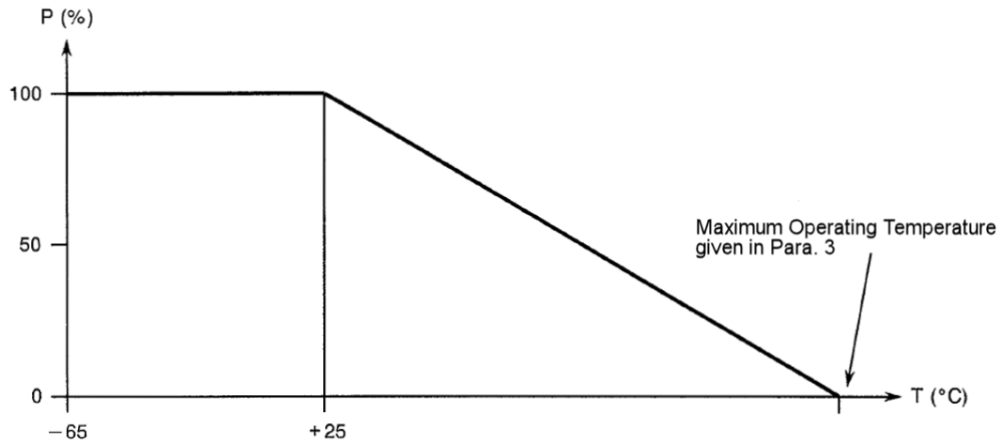
            - Derate Power with respect to Operating Frequency as follows:
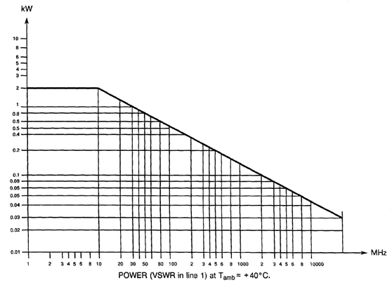
            - Whenever a test is performed on mated pairs of connectors, the pairs shall be torqued at 100 ±20N.cm.

PHYSICAL DIMENSIONS (SEE ALSO PARA. 3)

Connector Interface Dimensions and Connector Interface Gauge Dimensions
          - SMA Female Connector Interface: compatible with series SMA socket contact interface as specified in MIL-STD-348.
          - SMA Male Gauge Interface: compatible with series SMA pin contact test connector interface as specified in MIL-STD-348.

MATERIALS AND FINISHES
Materials and finishes shall be as follows (as applicable, see Para. 3):
Type | Description
1 | Beryllium Copper, Gold plated, Copper underplate (see Para. 1.7.1)
2 | Beryllium Copper, Gold plated, Nickel underplate (see Para. 1.7.2)
3 | Amagnetic Stainless Steel, Electro-passivated (see Para. 1.7.3)
4 | Amagnetic Stainless Steel, Gold plated (see Para. 1.7.4)

Type 1
          - Shell: beryllium copper, plated gold 2.5μm minimum over copper 2.5μm minimum.
          - Centre Contact: beryllium copper, plated gold 2.5μm minimum over copper 2.5μm minimum.
          - Insulator: PTFE.
          - Gaskets:
- EMI: TBA.
- Compression: TBA.
          - Crimping and soldering elements: brass or copper, plated gold 2.5μm minimum over copper 2.5μm minimum.
          - Rear Nut: brass or copper, plated gold 2.5μm minimum over copper 2.5μm minimum.
          - Washers: copper alloy, plated gold 0.5μm minimum over nickel 2μm minimum.
          - Hermetic Glass Seal:
- Shell, Centre Contact: iron-nickel alloy, plated gold 1.27μm minimum over nickel 2μm minimum.
- Insulator: glass.

Type 2
          - Shell: beryllium copper, plated gold 1.27μm minimum over nickel 2μm minimum.
          - Centre Contact: beryllium copper, plated gold 1.27μm minimum over nickel 2μm minimum.
          - Insulator: PTFE.
          - Gaskets:
- EMI: TBA.
- Compression: TBA.
          - Crimping and soldering elements: brass or copper, plated gold 0.5μm minimum over nickel 2μm minimum.
          - Rear Nut: brass or copper, plated gold 0.5μm minimum over nickel 2μm minimum.
          - Washers: copper alloy, plated gold 0.5μm minimum over nickel 2μm minimum.
          - Hermetic Glass Seal:
- Shell, Centre Contact: iron-nickel alloy, plated gold 1.27μm minimum over nickel 2μm minimum.
- Insulator: glass.

Type 3
          - Shell: Amagnetic stainless steel, electro-passivated.
NOTE: For solder-type connectors, the rear part of the shell shall be plated gold 1.27μm minimum over nickel 2μm minimum.
          - Centre Contact: beryllium copper, plated gold 1.27μm minimum over nickel 2μm.
          - Insulator: PTFE.
          - Gaskets:
- EMI: TBA.
- Compression: TBA.
          - Crimping elements: brass or copper, plated nickel 2μm minimum.
          - Soldering elements: brass or copper, plated gold 0.5μm minimum over nickel 2μm minimum.
          - Rear Nut: Amagnetic stainless steel, electro-passivated.
          - Washers: beryllium copper, plated nickel 2μm minimum.
          - Hermetic Glass Seal:
- Shell, Centre Contact: iron-nickel alloy, plated gold 1.27μm minimum over nickel 2μm minimum.
- Insulator: glass

Type 4
          - Shell: Amagnetic stainless steel, plated gold 1.27μm minimum over nickel 2μm minimum.
          - Centre Contact: beryllium copper, plated gold 1.27μm minimum over nickel 2μm minimum.
          - Insulator: PTFE.
          - Gaskets:
- EMI: TBA.
- Compression: TBA.
          - Crimping and soldering elements: brass or copper, plated gold 0.5μm minimum over nickel 2μm minimum.
          - Rear Nut: Amagnetic stainless steel, plated gold 0.5μm minimum over nickel 2μm minimum.
          - Washers: copper alloy, plated gold 0.5μm minimum over nickel 2μm minimum.
          - Hermetic Glass Seal:
- Shell, Centre Contact: iron-nickel alloy, plated gold 1.27μm minimum over nickel 2μm minimum.
- Insulator: glass

REQUIREMENTS

GENERAL
The complete requirements for procurement of the components specified herein are as stated in this specification and the ESCC Generic Specification. Permitted deviations from the Generic Specification, applicable to this specification only, are listed below.
Permitted deviations from the Generic Specification and this Detail Specification, formally agreed with specific Manufacturers on the basis that the alternative requirements are equivalent to the ESCC requirement and do not affect the component’s reliability, are listed in the appendices attached to this specification.

Deviations from the Generic Specification

Deviations from Screening Tests – Chart F3
          - Coupling Proof Torque: shall not be performed.

MARKING
The marking shall be in accordance with the requirements of ESCC Basic Specification No. 21700 and as follows.
The information to be marked on the component or the primary package shall be:
          - The ESCC qualified components symbol (for ESCC qualified components only).
          - The ESCC Component Number (see Para. 1.4.1).
          - Traceability information.

ENVIRONMENTAL AND MECHANICAL TESTS
The following requirements apply to tests performed on the connector (and contact) lot as specified in the ESCC Generic Specification:
          - Para. 8.1, Contact Engagement and Separation Forces:
 | Oversize Test Pin Test | Maximum Diameter Test Pin Test | Minimum Diameter Test Pin Test
Test Pin Diameter (mm) (1) | 0.9525 to 0.955 | 0.94 to 0.942 | 0.902 to 0.904
Engagement Depth (mm) (1) | 0.76 to 1.14 | 1.27 to 1.91 | 1.27 to 1.91
Engagement Force (N) | - | 13.34 maximum | -
Separation Force (N) | - | - | 0.28 minimum
NOTES:
            - Test Pins details:
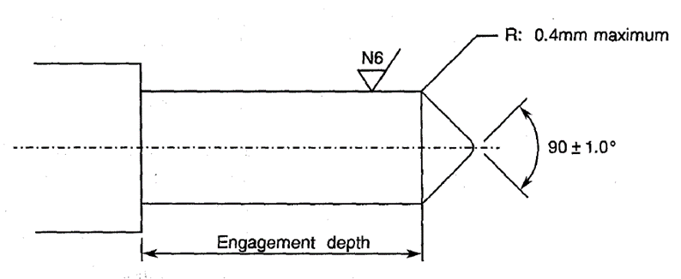
          - Para. 8.10, Coupling Proof Torque: See Para. 1.5.
          - Para. 8.11, Mating and Unmating Forces: Maximum torque: 24N.cm.
          - Para. 8.12, Centre Contact Retention: See Para. 3.
          - Para. 8.13, Seal: See Para. 3.
          - Para. 8.19, Endurance:
- During Qualification Testing: 500 cycles.
- During Periodic Testing: 100 cycles

ROOM TEMPERATURE ELECTRICAL MEASUREMENTS (NOTE 1)
The measurements shall be performed at T_{amb} = +22 ±3°C.
Characteristics | Symbols | Test Method and  Conditions | Limits |  | Units
Characteristics | Symbols | Test Method and  Conditions | Min | Max | Units
Insulation Resistance | R_{I} | ESCC No. 3402 | 5 | - | GΩ
Voltage Proof Leakage Current | I_{L} | ESCC No. 3402  See Para. 3  Note 2 | - | 2 | mA
NOTES:
            - For Variants 01, 02, 03, 04, 09, 10, 20, 46, 47, 48, 53, 55, 57, 66, 67 measurements shall not be performed during Chart F3; see Para. 3.
            - Between centre contact and shell.

INTERMEDIATE AND END-POINT ELECTRICAL MEASUREMENTS
Unless otherwise specified, the measurements shall be performed at T_{amb} = +22 ±3°C.
Unless otherwise specified, the test methods and test conditions shall be as per the corresponding test defined in Para. 2.4 Room Temperature Electrical Measurements.
Test Reference per ESCC No. 3402 | Characteristics and Test Conditions  Ref. ESCC No. 3402 | Symbols | Limits |  | Units
Test Reference per ESCC No. 3402 | Characteristics and Test Conditions  Ref. ESCC No. 3402 | Symbols | Min | Max | Units
Random Vibration | Contact Resistance: I_{T} = 10mA, V_{T} = 6V  Centre Contact: | R_{ctc} | - | 3 | mΩ
Mechanical Shock | Contact Resistance: I_{T} = 10mA, V_{T} = 6V  Centre Contact: | R_{ctc} | - | 3 | mΩ
Temperature Cycling | Contact Resistance: I_{T} = 10mA, V_{T} = 6V  Centre Contact: | R_{ctc} | - | 3 | mΩ
 | Voltage Proof Leakage Current: | I_{L} | Note 1
Electrical Measurements at Room Temperature | Insulation Resistance: | R_{I} | Note 1
Electrical Measurements at Room Temperature | Voltage Proof Leakage Current: | I_{L} | Note 1
Electrical Measurements at Room Temperature | Contact Resistance: I_{T} = 10mA, V_{T} = 6V  Centre Contact:  Shell:  Hermetic Glass Seal (Centre Contact): | R_{ctc}  R_{cts}  R_{hgs} | -  -  - | 3  2  10 | mΩ  mΩ  mΩ
Electrical Measurements at Room Temperature | VSWR: | VSWR | Note 2
Electrical Measurements at Room Temperature | Insertion Loss: | LI | Note 2
Endurance | Contact Resistance: I_{T} = 10mA, V_{T} = 6V  Centre Contact:  Shell:  Hermetic Glass Seal (Centre Contact): | R_{ctc}  R_{cts}  R_{hgs} | -  -  - | 4  3  12 | mΩ  mΩ  mΩ
NOTES:
            - As specified in Para. 2.4.
            - As specified in Para. 3.

COMPONENT TYPE VARIANTS – DETAIL REQUIREMENTS

VARIANT 01 – STRAIGHT JACK, SOLDER-TYPE, FOR SEMI-RIGID CABLE Ø2.2MM
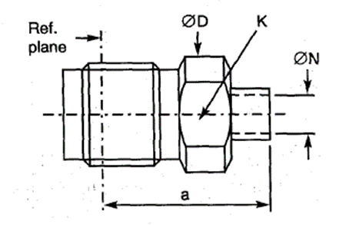
  Symbol | Dimensions mm |  | Notes
  Symbol | Min | Max
  a | 10.5 | 11
  ØD | 6.6 | 6.8
  K | - | 6 | 2 flats
  ØN | 2.25 | 2.35
NOTES:
            - Components are delivered with the centre contact and insulator not mounted in the connector.
ELECTRICAL CHARACTERISTICS | VALUES | UNITS
Frequency range | 0 to 18 | GHz
Maximum voltage standing wave ratio (VSWR) | 1.1 + 0.01 f (GHz)
Maximum insertion loss | 0.02 √f (GHz) | dB
Voltage proof | 750 | Vrms
MECHANICAL CHARACTERISTICS | VALUES | UNITS
Minimum centre contact retention force (axial) | Not applicable
Minimum centre contact retention torque | Not applicable
Maximum weight | 1.5 | g
OTHER CHARACTERISTICS | VALUES | UNITS
Operating temperature range | -65 to +165 | °C
Seal: Maximum leakage | Not applicable
Solderability | Applicable
Cables used | KS 1, RG 405/U, (Ø2.2mm)

VARIANT 02 - STRAIGHT JACK, SOLDER-TYPE, FOR SEMI-RIGID CABLE Ø3.58MM
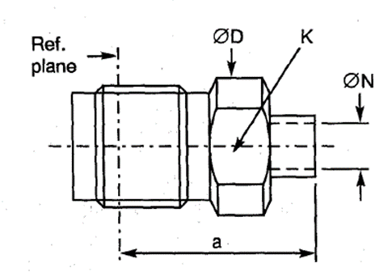
  Symbol | Dimensions mm |  | Notes
  Symbol | Min | Max
  a | 10.5 | 11
  ØD | 6.6 | 6.8
  K | - | 6 | 2 flats
  ØN | 3.65 | 3.75
NOTES:
            - Components are delivered with the centre contact and insulator not mounted in the connector.
ELECTRICAL CHARACTERISTICS | VALUES | UNITS
Frequency range | 0 to 18 | GHz
Maximum voltage standing wave ratio (VSWR) | 1.05 + 0.004 f (GHz)
Maximum insertion loss | 0.02 √f (GHz) | dB
Voltage proof | 1000 | Vrms
MECHANICAL CHARACTERISTICS | VALUES | UNITS
Minimum centre contact retention force (axial) | Not applicable
Minimum centre contact retention torque | Not applicable
Maximum weight | 1.6 | g
OTHER CHARACTERISTICS | VALUES | UNITS
Operating temperature range | -65 to +165 | °C
Seal: Maximum leakage | Not applicable
Solderability | Applicable
Cables used | KS 2, RG 402/U, (Ø3.58mm)

VARIANT 03 - STRAIGHT JACK WITH CABLE CLAMP, SOLDER-TYPE, FOR SEMI-RIGID CABLE Ø6.35MM
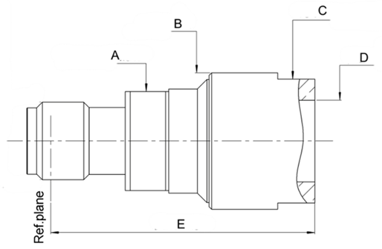
  Symbol | Dimensions mm |  | Notes
  Symbol | Min | Max
  A | - | 8 | 2 flats
  ØB | 10.9 | 11
  C | - | 10 | 2 flats
  ØD | 6.45 | 6.7
  E | - | 22.5
NOTES:
            - Components are delivered with the centre contact and insulator not mounted in the connector.
ELECTRICAL CHARACTERISTICS | VALUES | UNITS
Frequency range | 0 to 18 | GHz
Maximum voltage standing wave ratio (VSWR) | 1.05 + 0.015 f (GHz)
Maximum insertion loss | 0.02 √f (GHz) | dB
Voltage proof | 1000 | Vrms
MECHANICAL CHARACTERISTICS | VALUES | UNITS
Minimum centre contact retention force (axial) | Not applicable
Minimum centre contact retention torque | Not applicable
Maximum weight | 7.8 | g
OTHER CHARACTERISTICS | VALUES | UNITS
Operating temperature range | -65 to +165 | °C
Seal: Maximum leakage | Not applicable
Solderability | On centre contact only
Cables used | KS 3, RG 401/U, (Ø6.35mm)

VARIANT 04 - STRAIGHT JACK WITH CABLE CLAMP, SOLDER-TYPE, FOR SEMI-RIGID MICROPOROUS CABLE Ø6.35MM
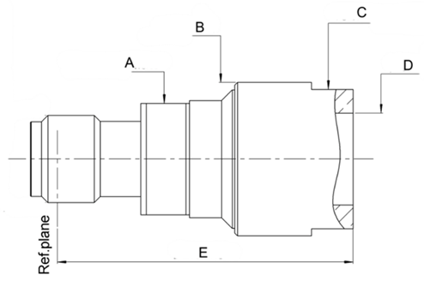
  Symbol | Dimensions mm |  | Notes
  Symbol | Min | Max
  A | - | 8 | 2 flats
  ØB | 10.9 | 11
  C | - | 10 | 2 flats
  ØD | 6.45 | 6.7
  E | - | 22.5
NOTES:
            - Components are delivered with the centre contact and insulator not mounted in the connector.
ELECTRICAL CHARACTERISTICS | VALUES | UNITS
Frequency range | 0 to 18 | GHz
Maximum voltage standing wave ratio (VSWR) | 1.05 + 0.015 f (GHz)
Maximum insertion loss | 0.02 √f (GHz) | dB
Voltage proof | 1000 | Vrms
MECHANICAL CHARACTERISTICS | VALUES | UNITS
Minimum centre contact retention force (axial) | Not applicable
Minimum centre contact retention torque | Not applicable
Maximum weight | 7.8 | g
OTHER CHARACTERISTICS | VALUES | UNITS
Operating temperature range | -65 to +165 | °C
Seal: Maximum leakage | Not applicable
Solderability | Applicable
Cables used | Microporous Ø6.35mm

VARIANT 05 - STRAIGHT JACK, CRIMP-TYPE, SQUARE FLANGE
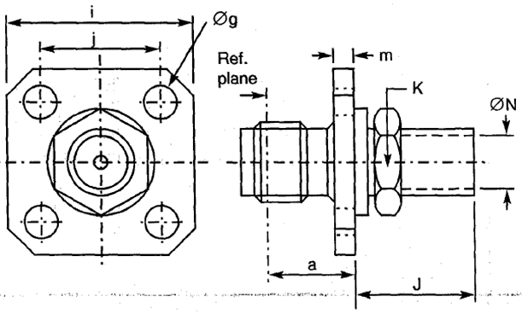
  Symbol | Dimensions mm |  |  | Notes
  Symbol | Min | Max
  a | 7.4 | 7.75
  Øg | 2.55 | 2.7 |  | 4 holes
  i | 12.6 | 12.8
  j | 8.59 | 8.69
  J | - | 17.3
  K | - | 7 |  | 2 flats
  m | 1.4 | 1.8
  ØN | 2.55 | 2.65
ELECTRICAL CHARACTERISTICS | VALUES | UNITS
Frequency range | 0 to 12.4 | GHz
Maximum voltage standing wave ratio (VSWR) | 1.1 + 0.015 f (GHz)
Maximum insertion loss | 0.03 √f (GHz) | dB
Voltage proof | 750 | Vrms
MECHANICAL CHARACTERISTICS | VALUES | UNITS
Minimum centre contact retention force (axial) | 27 | N
Minimum centre contact retention torque | 0.5 | N.cm
Maximum weight | 4.9 | g
OTHER CHARACTERISTICS | VALUES | UNITS
Operating temperature range | -65 to +165 | °C
Seal: Maximum leakage | Not applicable
Solderability | Applicable
Cables used | KX 21A, RG 178/U

VARIANT 06 - STRAIGHT JACK, CRIMP-TYPE
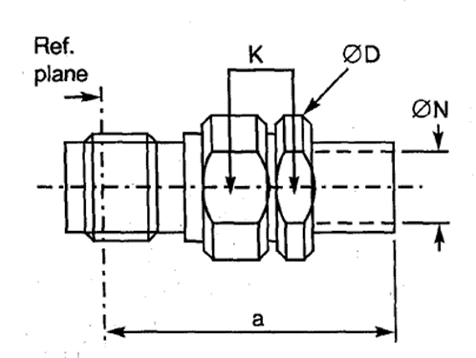
  Symbol | Dimensions mm |  | Notes
  Symbol | Min | Max | Notes
  a | 22.7 | 24.15
  ØD | 7.5 | 7.9
  K | - | 7 | 2 flats
  ØN | 3.15 | 3.35
ELECTRICAL CHARACTERISTICS | VALUES | UNITS
Frequency range | 0 to 12.4 | GHz
Maximum voltage standing wave ratio (VSWR) | 1.05 + 0.015 f (GHz)
Maximum insertion loss | 0.03 √f (GHz) | dB
Voltage proof | 750 | Vrms
MECHANICAL CHARACTERISTICS | VALUES | UNITS
Minimum centre contact retention force (axial) | 27 | N
Minimum centre contact retention torque | 0.5 | N.cm
Maximum weight | 4.5 | g
OTHER CHARACTERISTICS | VALUES | UNITS
Operating temperature range | -65 to +165 | °C
Seal: Maximum leakage | Not applicable
Solderability | Applicable
Cables used | KX 3B, KX 22A, RG 174/U, RG 316/U

VARIANT 07 - STRAIGHT JACK, CRIMP-TYPE, FOR CABLE Ø5MM, SINGLE BRAID
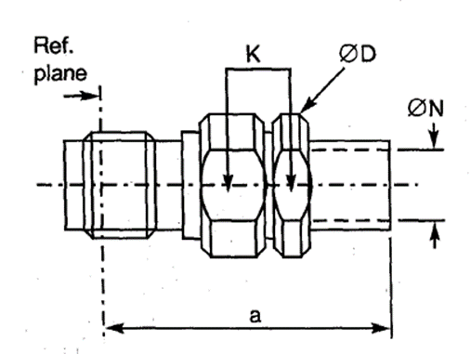
  Symbol | Dimensions mm |  | Notes
  Symbol | Min | Max | Notes
  a | 24.9 | 26.15
  ØD | 7.5 | 7.9
  K | - | 7 | 2 flats
  ØN | 5.55 | 5.65
ELECTRICAL CHARACTERISTICS | VALUES | UNITS
Frequency range | 0 to 12.4 | GHz
Maximum voltage standing wave ratio (VSWR) | 1.15 + 0.01 f (GHz)
Maximum insertion loss | 0.03 √f (GHz) | dB
Voltage proof | 1000 | Vrms
MECHANICAL CHARACTERISTICS | VALUES | UNITS
Minimum centre contact retention force (axial) | 27 | N
Minimum centre contact retention torque | 0.5 | N.cm
Maximum weight | 5.1 | g
OTHER CHARACTERISTICS | VALUES | UNITS
Operating temperature range | -65 to +165 | °C
Seal: Maximum leakage | Not applicable
Solderability | Applicable
Cables used | KX 15, RG 58 C/U, RG 141 A/U

VARIANT 08 - STRAIGHT JACK, CRIMP-TYPE, FOR CABLE Ø5MM, DOUBLE BRAID
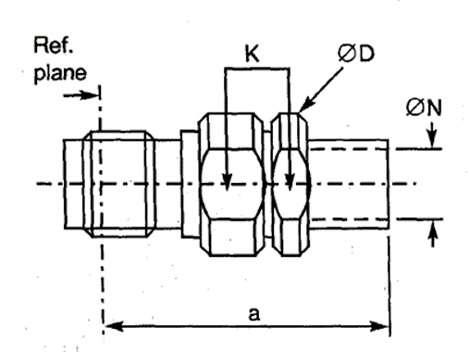
  Symbol | Dimensions mm |  | Notes
  Symbol | Min | Max | Notes
  a | 24.9 | 26.15
  ØD | 7.5 | 7.9
  K | - | 7 | 2 flats
  ØN | 5.55 | 5.65
ELECTRICAL CHARACTERISTICS | VALUES | UNITS
Frequency range | 0 to 12.4 | GHz
Maximum voltage standing wave ratio (VSWR) | 1.15 + 0.01 f (GHz)
Maximum insertion loss | 0.03 √f (GHz) | dB
Voltage proof | 1000 | Vrms
MECHANICAL CHARACTERISTICS | VALUES | UNITS
Minimum centre contact retention force (axial) | 27 | N
Minimum centre contact retention torque | 0.5 | N.cm
Maximum weight | 5.1 | g
OTHER CHARACTERISTICS | VALUES | UNITS
Operating temperature range | -65 to +165 | °C
Seal: Maximum leakage | Not applicable
Solderability | Applicable
Cables used | KX 23, RG 142 B/U, RG 223/U

VARIANT 09 - STRAIGHT JACK, SOLDER-TYPE, BACK MOUNTING, 2-HOLE, FLANGE-MOUNTED, FOR SEMI-RIGID CABLE Ø2.2MM
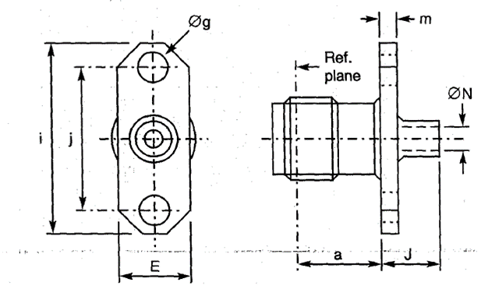
  Symbol | Dimensions mm |  | Notes
  Symbol | Min | Max | Notes
  a | 5.87 | 6.12
  E | 5.5 | 5.8
  Øg | 2.55 | 2.7 | 2 holes
  i | 15.9 | 16.1
  j | 12.1 | 12.3
  J | 4.6 | 5
  m | 1.4 | 1.8
  ØN | 2.25 | 2.35
NOTES:
            - Components are delivered with the centre contact and insulator not mounted in the connector.
            - Maximum panel thickness: 2.3mm.
ELECTRICAL CHARACTERISTICS | VALUES | UNITS
Frequency range | 0 to 18 | GHz
Maximum voltage standing wave ratio (VSWR) | 1.1 + 0.01 f (GHz)
Maximum insertion loss | 0.02 √f (GHz) | dB
Voltage proof | 750 | Vrms
MECHANICAL CHARACTERISTICS | VALUES | UNITS
Minimum centre contact retention force (axial) | Not applicable
Minimum centre contact retention torque | Not applicable
Maximum weight | 3 | g
OTHER CHARACTERISTICS | VALUES | UNITS
Operating temperature range | -65 to +165 | °C
Seal: Maximum leakage | Not applicable
Solderability | Applicable
Cables used | KS 1, RG 405/U (Ø2.2mm)

VARIANT 10 - STRAIGHT JACK, SOLDER-TYPE, BACK MOUNTING, 2-HOLE, FLANGE-MOUNTED, FOR SEMI-RIGID CABLE Ø3.58MM
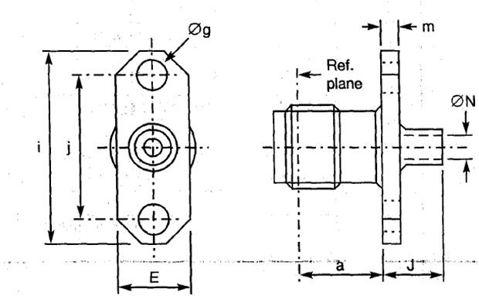
  Symbol | Dimensions mm |  | Notes
  Symbol | Min | Max | Notes
  a | 5.87 | 6.12
  E | 5.5 | 5.8
  Øg | 2.55 | 2.7 | 2 holes
  i | 15.9 | 16.1
  j | 12.1 | 12.3
  J | 4.6 | 5
  m | 1.4 | 1.8
  ØN | 3.65 | 3.75
NOTES:
            - Components are delivered with the centre contact and insulator not mounted in the connector.
            - Maximum panel thickness: 2.3mm
ELECTRICAL CHARACTERISTICS | VALUES | UNITS
Frequency range | 0 to 18 | GHz
Maximum voltage standing wave ratio (VSWR) | 1.05 + 0.04 f (GHz)
Maximum insertion loss | 0.02 √f (GHz) | dB
Voltage proof | 1000 | Vrms
MECHANICAL CHARACTERISTICS | VALUES | UNITS
Minimum centre contact retention force (axial) | Not applicable
Minimum centre contact retention torque | Not applicable
Maximum weight | 3 | g
OTHER CHARACTERISTICS | VALUES | UNITS
Operating temperature range | -65 to +165 | °C
Seal: Maximum leakage | Not applicable
Solderability | Applicable
Cables used | KS 2, RG 402/U (Ø3.58mm)

VARIANT 11 - STRAIGHT JACK, CRIMP-TYPE, SQUARE FLANGE
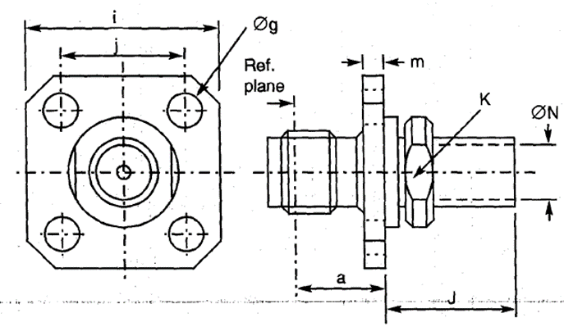
  Symbol | Dimensions mm |  | Notes
  Symbol | Min | Max | Notes
  a | 7.4 | 7.75
  Øg | 2.55 | 2.7 | 4 holes
  i | 12.6 | 12.8
  j | 8.59 | 8.69
  J | 15.1 | 17.6
  K | - | 7 | 2 flats
  m | 1.4 | 1.8
  ØN | 3.25 | 3.35
ELECTRICAL CHARACTERISTICS | VALUES | UNITS
Frequency range | 0 to 12.4 | GHz
Maximum voltage standing wave ratio (VSWR) | 1.1 + 0.015 f (GHz)
Maximum insertion loss | 0.03 √f (GHz) | dB
Voltage proof | 750 | Vrms
MECHANICAL CHARACTERISTICS | VALUES | UNITS
Minimum centre contact retention force (axial) | 27 | N
Minimum centre contact retention torque | 0.5 | N.cm
Maximum weight | 5.2 | g
OTHER CHARACTERISTICS | VALUES | UNITS
Operating temperature range | -65 to +165 | °C
Seal: Maximum leakage | Not applicable
Solderability | Applicable
Cables used | KX 3B, KX 22A, RG 174/U, RG 316/U

VARIANT 12 - STRAIGHT JACK, CRIMP-TYPE, SQUARE FLANGE, FOR 50 CIS CABLE
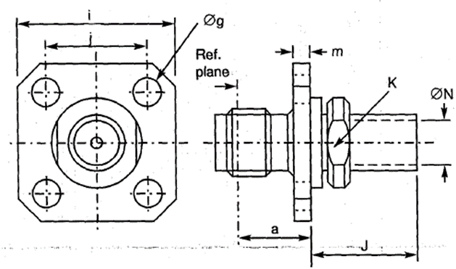
  Symbol | Dimensions mm |  | Notes
  Symbol | Min | Max | Notes
  a | 7.4 | 7.75
  Øg | 2.55 | 2.7 | 4 holes
  i | 12.6 | 12.8
  j | 8.59 | 8.69
  J | 15.1 | 17.6
  K | - | 7 | 2 flats
  m | 1.4 | 1.8
  ØN | 2 | 2.2
ELECTRICAL CHARACTERISTICS | VALUES | UNITS
Frequency range | 0 to 12.4 | GHz
Maximum voltage standing wave ratio (VSWR) | 1.1 + 0.015 f (GHz)
Maximum insertion loss | 0.03 √f (GHz) | dB
Voltage proof | 750 | Vrms
MECHANICAL CHARACTERISTICS | VALUES | UNITS
Minimum centre contact retention force (axial) | 27 | N
Minimum centre contact retention torque | 0.5 | N.cm
Maximum weight | 4.4 | g
OTHER CHARACTERISTICS | VALUES | UNITS
Operating temperature range | -65 to +165 | °C
Seal: Maximum leakage | Not applicable
Solderability | Applicable
Cables used | 50 CIS

VARIANT 13 - STRAIGHT JACK, CRIMP- OR SOLDER-TYPE, SQUARE FLANGE
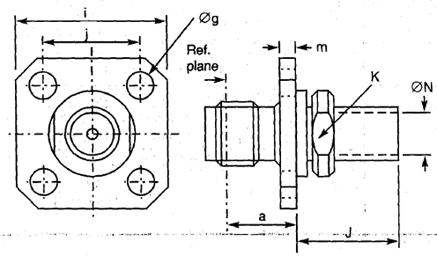
  Symbol | Dimensions mm |  | Notes
  Symbol | Min | Max | Notes
  a | 7.4 | 7.75
  Øg | 2.55 | 2.7 | 4 holes
  i | 12.6 | 12.8
  j | 8.59 | 8.69
  J | 17.1 | 20.4
  K | - | 7 | 2 flats
  m | 1.4 | 1.8
  ØN | 5.55 | 5.65
ELECTRICAL CHARACTERISTICS | VALUES | UNITS
Frequency range | 0 to 12.4 | GHz
Maximum voltage standing wave ratio (VSWR) | 1.1 + 0.012 f (GHz)
Maximum insertion loss | 0.03 √f (GHz) | dB
Voltage proof | 1000 | Vrms
MECHANICAL CHARACTERISTICS | VALUES | UNITS
Minimum centre contact retention force (axial) | 27 | N
Minimum centre contact retention torque | 0.5 | N.cm
Maximum weight | 5.8 | g
OTHER CHARACTERISTICS | VALUES | UNITS
Operating temperature range | -65 to +165 | °C
Seal: Maximum leakage | Not applicable
Solderability | Applicable
Cables used | KX15, RG 58C/U, RG 141A/U

VARIANT 14 - STRAIGHT JACK, CRIMP- OR SOLDER-TYPE, SQUARE FLANGE, DOUBLE BRAID CABLE
Symbol | Dimensions mm |  | Notes
Symbol | Min | Max | Notes
a | 7.4 | 7.75
Øg | 2.55 | 2.7 | 4 holes
i | 12.6 | 12.8
j | 8.59 | 8.69
J | 17.1 | 20.4
K | - | 7 | 2 flats
m | 1.4 | 1.8
ØN | 5.55 | 5.65

ELECTRICAL CHARACTERISTICS | VALUES | UNITS
Frequency range | 0 to 12.4 | GHz
Maximum voltage standing wave ratio (VSWR) | 1.1 + 0.012 f (GHz)
Maximum insertion loss | 0.03 √f (GHz) | dB
Voltage proof | 1000 | Vrms
MECHANICAL CHARACTERISTICS | VALUES | UNITS
Minimum centre contact retention force (axial) | 27 | N
Minimum centre contact retention torque | 0.5 | N.cm
Maximum weight | 5.5 | g
OTHER CHARACTERISTICS | VALUES | UNITS
Operating temperature range | -65 to +165 | °C
Seal: Maximum leakage | Not applicable
Solderability | Applicable
Cables used | KX 23, RG 142B/U, RG 223/U

VARIANT 15 - SQUARE FLANGE RECEPTACLE, FRONT MOUNTING
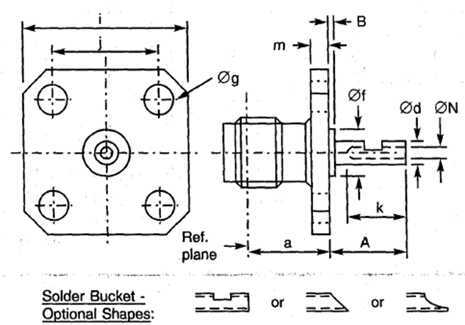
  Symbol | Dimensions mm |  | Notes
  Symbol | Min | Max | Notes
  a | 7.5 | 7.7
  A |  | 35 | Note 1
  B | - | 20 | Note 1
  Ød | 1.24 | 1.3
  Øf | 4 | 4.2
  Øg | 2.55 | 2.7 | 4 holes
  i | 12.6 | 12.8
  j | 8.59 | 8.69
  k | 2.4 | -
  m | 1.4 | 1.8
  ØN | 0.7 | 1
NOTES:
            - Contact and Insert dimensions A and B shall be selected by the Orderer; see Para. 1.4.1(b).
ELECTRICAL CHARACTERISTICS | VALUES | UNITS
Frequency range | 0 to 18 | GHz
Maximum voltage standing wave ratio (VSWR) (Note 2) | 1.05 + 0.003 f (GHz)
Maximum insertion loss (Note 2) | 0.03 √f (GHz) | dB
Voltage proof | 1000 | Vrms
MECHANICAL CHARACTERISTICS | VALUES | UNITS
Minimum centre contact retention force (axial) | 27 | N
Minimum centre contact retention torque | 2.8 | N.cm
Maximum weight | 3.3 | g
OTHER CHARACTERISTICS | VALUES | UNITS
Operating temperature range | -65 to +105 | °C
Seal: Maximum leakage | Not applicable
Solderability | On centre contact only
Cables used | Not applicable
NOTES:
            - For information purposes only.

VARIANT 16 – 2-HOLE FLANGE RECEPTACLE FOR MICRO-STRIP, FRONT MOUNTING
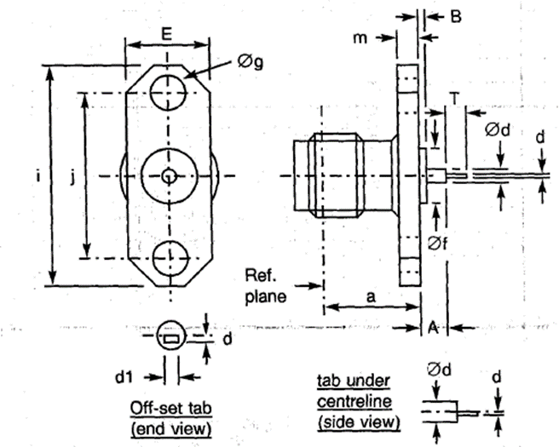
  Symbol | Dimensions mm |  | Notes
  Symbol | Min | Max | Notes
  a | 7.5 | 7.6
  A | 3.1 | 3.3
  B | 0.15 | 0.35
  d | 0.2 | 0.3
  Ød | 0.7 | 0.9
  d1 | 0.4 | 0.5
  Øf | 1.75 | 1.8
  E | 5.5 | 5.8
  Øg | 2.55 | 2.7 | 2 holes
  i | 15.9 | 16.1
  j | 12.1 | 12.3
  m | 1.4 | 1.8
  T | 0.70 | 0.95
ELECTRICAL CHARACTERISTICS | VALUES | UNITS
Frequency range | 0 to 18 | GHz
Maximum voltage standing wave ratio (VSWR) (Note 1) | 1.05 + 0.005 f (GHz)
Maximum insertion loss (Note 1) | 0.03 √f (GHz) | dB
Voltage proof | 1000 | Vrms
MECHANICAL CHARACTERISTICS | VALUES | UNITS
Minimum centre contact retention force (axial) | 27 | N
Minimum centre contact retention torque | 2.8 | N.cm
Maximum weight | 1.8 | g
OTHER CHARACTERISTICS | VALUES | UNITS
Operating temperature range | -65 to +105 | °C
Seal: Maximum leakage | Not applicable
Solderability | On centre contact only
Cables used | Not applicable
NOTES:
            - For information purposes only.

VARIANT 17 - 2-HOLE FLANGE RECEPTACLE, FRONT MOUNTING
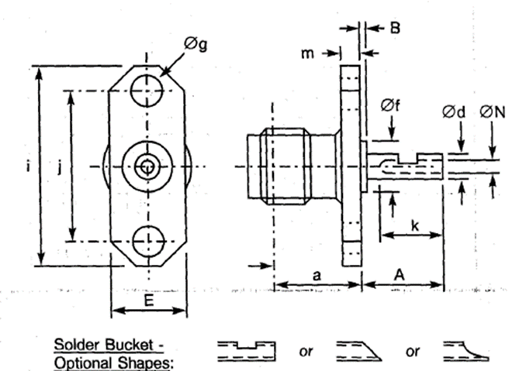
  Symbol | Dimensions mm |  | Notes
  Symbol | Min | Max | Notes
  a | 7.5 | 7.7
  A | - | 35 | Note 1
  B | - | 20 | Note 1
  Ød | 1.24 | 1.3
  E | 5.5 | 5.8
  Øf | 4 | 4.2
  Øg | 2.55 | 2.7 | 2 holes
  i | 15.9 | 16.1
  j | 12.1 | 12.3
  k | 2.4 | -
  m | 1.4 | 1.8
  ØN | 0.7 | 1
NOTES:
            - Contact and Insert dimensions A and B shall be selected by the Orderer; see Para. 1.4.1(b).
ELECTRICAL CHARACTERISTICS | VALUES | UNITS
Frequency range | 0 to 18 | GHz
Maximum voltage standing wave ratio (VSWR) (Note 2) | 1.05 + 0.003 f (GHz)
Maximum insertion loss (Note 2) | 0.03 √f (GHz) | dB
Voltage proof | 1000 | Vrms
MECHANICAL CHARACTERISTICS | VALUES | UNITS
Minimum centre contact retention force (axial) | 27 | N
Minimum centre contact retention torque | 2.8 | N.cm
Maximum weight | 2 | g
OTHER CHARACTERISTICS | VALUES | UNITS
Operating temperature range | -65 to +105 | °C
Seal: Maximum leakage | Not applicable
Solderability | On centre contact only
Cables used | Not applicable
NOTES:
            - For information purposes only.

VARIANT 18 - 2-HOLE FLANGE RECEPTACLE FOR MICRO-STRIP, FRONT MOUNTING
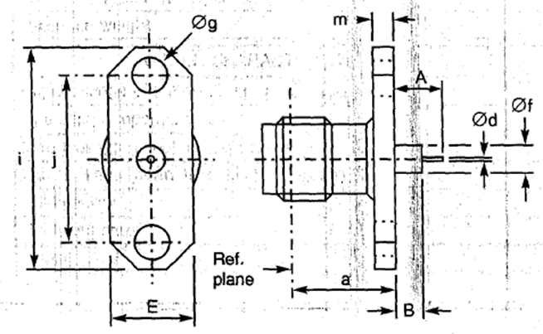
  Symbol | Dimensions mm |  | Notes
  Symbol | Min | Max | Notes
  a | 7.5 | 7.6
  A | 4.5 | 5
  B | 3.05 | 3.3
  Ød | 0.2 | 0.3
  E | 5.5 | 5.8
  Øf | 2.1 | 2.2
  Øg | 2.55 | 2.7 | 2 holes
  i | 15.9 | 16.1
  j | 12.1 | 12.3
  m | 1.4 | 1.8
ELECTRICAL CHARACTERISTICS | VALUES | UNITS
Frequency range | 0 to 12.4 | GHz
Maximum voltage standing wave ratio (VSWR) (Note 1) | 1.04 + 0.018 f (GHz)
Maximum insertion loss (Note 1) | 0.03√f (GHz) | dB
Voltage proof | 1000 | Vrms
MECHANICAL CHARACTERISTICS | VALUES | UNITS
Minimum centre contact retention force (axial) | 27 | N
Minimum centre contact retention torque | 2.8 | N.cm
Maximum weight | 2 | g
OTHER CHARACTERISTICS | VALUES | UNITS
Operating temperature range | -65 to +105 | °C
Seal: Maximum leakage | Not applicable
Solderability | On centre contact only
Cables used | Not applicable
NOTES:
            - For information purposes only.

VARIANT 19 - SQUARE FLANGE RECEPTACLE FOR MICRO-STRIP, FRONT MOUNTING, OFF-SET TAB
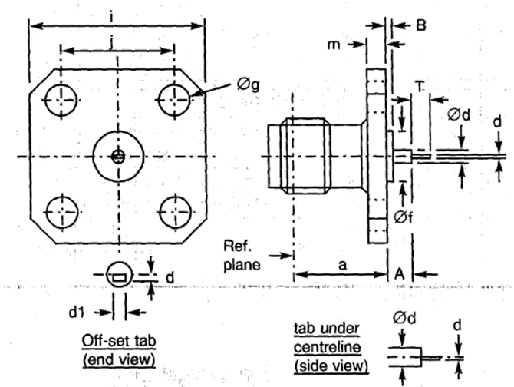
  Symbol | Dimensions mm |  | Notes
  Symbol | Min | Max | Notes
  a | 7.5 | 7.7
  A | 3.1 | 3.3
  B | 0.15 | 0.35
  d | 0.2 | 0.3
  Ød | 0.7 | 0.9
  d1 | 0.4 | 0.5
  Øf | 1.75 | 1.8
  Øg | 2.55 | 2.7 | 4 holes
  i | 12.6 | 12.8
  j | 8.59 | 8.69
  m | 1.4 | 1.8
  T | 0.7 | 0.95
ELECTRICAL CHARACTERISTICS | VALUES | UNITS
Frequency range | 0 to 18 | GHz
Maximum voltage standing wave ratio (VSWR) (Note 1) | 1.05 + 0.05 f (GHz)
Maximum insertion loss (Note 1) | 0.03√f (GHz) | dB
Voltage proof | 1000 | Vrms
MECHANICAL CHARACTERISTICS | VALUES | UNITS
Minimum centre contact retention force (axial) | 27 | N
Minimum centre contact retention torque | 2.8 | N.cm
Maximum weight | 2.6 | g
OTHER CHARACTERISTICS | VALUES | UNITS
Operating temperature range | -65 to +105 | °C
Seal: Maximum leakage | Not applicable
Solderability | On centre contact only
Cables used | Not applicable
NOTES:
            - For information purposes only.

VARIANT 20 - 2-HOLE FLANGE RECEPTACLE FOR MICRO-STRIP, FRONT MOUNTING
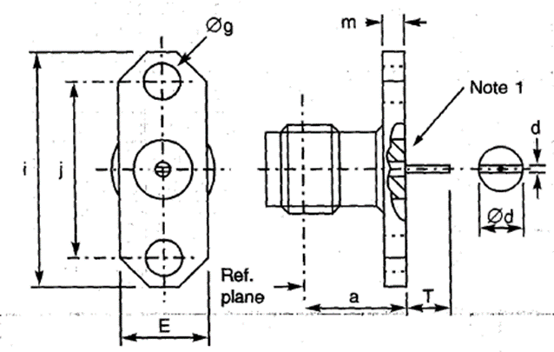
  Symbol | Dimensions mm |  | Notes
  Symbol | Min | Max | Notes
  a | 7.5 | 7.7
  d | 0.1 | 0.2 | Tab thickness
  Ød | 1.24 | 1.3
  E | 5.5 | 5.8
  Øg | 2.55 | 2.7 | 2 holes
  i | 15.9 | 16.1
  j | 12.1 | 12.3
  m | 1.4 | 1.8
  T | 2.35 | 2.7
NOTES:
            - Insert may stand proud of, or be recessed from, the flange by 0.05mm.
            - Components are delivered with the centre contact and insulator not mounted in the connector.
ELECTRICAL CHARACTERISTICS | VALUES | UNITS
Frequency range | 0 to 18 | GHz
Maximum voltage standing wave ratio (VSWR) (Note 3) | 1.05 + 0.005 f (GHz)
Maximum insertion loss (Note 3) | 0.03√f (GHz) | dB
Voltage proof | 1000 | Vrms
MECHANICAL CHARACTERISTICS | VALUES | UNITS
Minimum centre contact retention force (axial) | Not applicable
Minimum centre contact retention torque | Not applicable
Maximum weight | 2 | g
OTHER CHARACTERISTICS | VALUES | UNITS
Operating temperature range | -65 to +165 | °C
Seal: Maximum leakage | Not applicable
Solderability | On centre contact only
Cables used | Not applicable
NOTES:
            - For information purposes only.

VARIANT 21 - SQUARE FLANGE RECEPTACLE FOR STRIP-LINE, FRONT MOUNTING
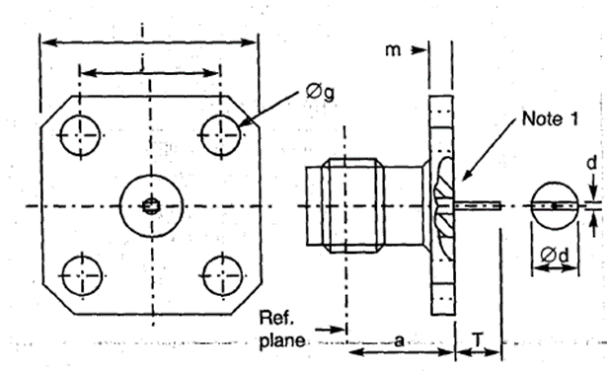
  Symbol | Dimensions mm |  | Notes
  Symbol | Min | Max | Notes
  a | 7.5 | 7.7
  d | 0.1 | 0.2 | Tab thickness
  Ød | 1.24 | 1.3
  Øg | 2.55 | 2.7 | 4 holes
  i | 12.6 | 12.8
  j | 8.59 | 8.69
  m | 1.4 | 1.8
  T | 2.35 | 2.7
NOTES:
            - Insert may stand proud of, or be recessed from, the flange by 0.05mm.
ELECTRICAL CHARACTERISTICS | VALUES | UNITS
Frequency range | 0 to 18 | GHz
Maximum voltage standing wave ratio (VSWR) (Note 2) | 1.05 + 0.005 f (GHz)
Maximum insertion loss (Note 2) | 0.03 √f (GHz) | dB
Voltage proof | 1000 | Vrms
MECHANICAL CHARACTERISTICS | VALUES | UNITS
Minimum centre contact retention force (axial) | 27 | N
Minimum centre contact retention torque | 2.8 | N.cm
Maximum weight | 3.2 | g
OTHER CHARACTERISTICS | VALUES | UNITS
Operating temperature range | -65 to +105 | °C
Seal: Maximum leakage | Not applicable
Solderability | On centre contact only
Cables used | Not applicable
NOTES:
            - For information purposes only.

VARIANT 22 - SQUARE FLANGE RECEPTACLE FOR MICRO-STRIP, FRONT MOUNTING
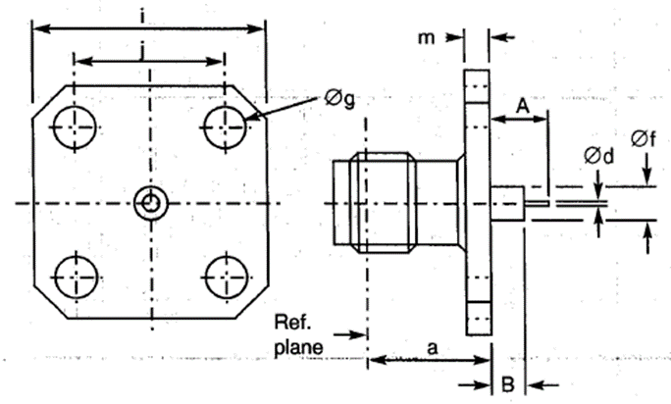
  Symbol | Dimensions mm |  | Notes
  Symbol | Min | Max | Notes
  a | 7.5 | 7.6
  A | 4.6 | 4.9
  B | 3.05 | 3.3
  Ød | 0.2 | 0.3
  Øf | 2.1 | 2.2
  Øg | 2.55 | 2.7 | 4 holes
  i | 12.6 | 12.8
  j | 8.59 | 8.69
  m | 1.4 | 1.8
ELECTRICAL CHARACTERISTICS | VALUES | UNITS
Frequency range | 0 to 12.4 | GHz
Maximum voltage standing wave ratio (VSWR) (Note 1) | 1.04 + 0.018 f (GHz)
Maximum insertion loss (Note 1) | 0.03 √f (GHz) | dB
Voltage proof | 1000 | Vrms
MECHANICAL CHARACTERISTICS | VALUES | UNITS
Minimum centre contact retention force (axial) | 27 | N
Minimum centre contact retention torque | 2.8 | N.cm
Maximum weight | 3.2 | g
OTHER CHARACTERISTICS | VALUES | UNITS
Operating temperature range | -65 to +105 | °C
Seal: Maximum leakage | Not applicable
Solderability | On centre contact only
Cables used | Not applicable
NOTES:
            - For information purposes only.

VARIANT 23 - BULKHEAD RECEPTACLE
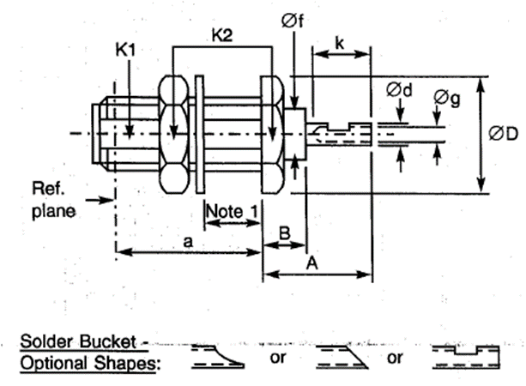
  Symbol | Dimensions mm |  | Notes
  Symbol | Min | Max | Notes
  a | 9.4 | 9.85
  A | 5.4 | 5.7
  B | 2.6 | 3.15
  Ød | 1.24 | 1.3
  ØD | - | 9.1
  Øf | 4 | 4.2
  Øg | 0.75 | -
  k | 2.4 | -
  K1 | - | 6 | 2 flats
  K2 | - | 8
NOTES:
            - Maximum panel thickness: 3.4mm.
ELECTRICAL CHARACTERISTICS | VALUES | UNITS
Frequency range | 0 to 18 | GHz
Maximum voltage standing wave ratio (VSWR) (Note 2) | 1.05 + 0.06 f (GHz)
Maximum insertion loss (Note 2) | 0.03 √f (GHz) | dB
Voltage proof | 1000 | Vrms
MECHANICAL CHARACTERISTICS | VALUES | UNITS
Minimum centre contact retention force (axial) | 27 | N
Minimum centre contact retention torque | 2.8 | N.cm
Maximum weight | 2.6 | g
OTHER CHARACTERISTICS | VALUES | UNITS
Operating temperature range | -65 to +105 | °C
Seal: Maximum leakage | Not applicable
Solderability | On centre contact only
Cables used | Not applicable
NOTES:
            - For information purposes only.

VARIANT 24 - BULKHEAD RECEPTACLE WITH COMPRESSION GASKET
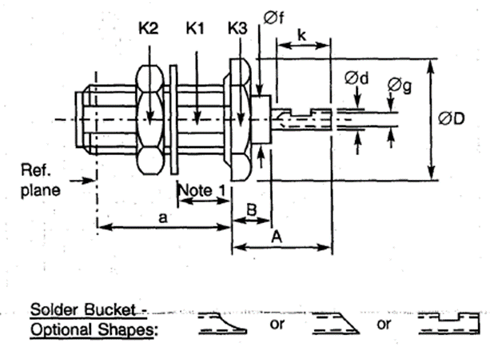
  Symbol | Dimensions mm |  | Notes
  Symbol | Min | Max | Notes
  a | 10.9 | 11.3
  A | 6.1 | 6.4
  B | 2.8 | 3
  Ød | 1.24 | 1.3
  ØD | - | 12.5
  Øf | 4 | 4.2
  Øg | 0.8 | -
  k | 2.4 | -
  K1 | - | 6 | 2 flats
  K2 | - | 9
  K3 | - | 11
NOTES:
            - Maximum panel thickness: 3.4mm.
ELECTRICAL CHARACTERISTICS | VALUES | UNITS
Frequency range | 0 to 18 | GHz
Maximum voltage standing wave ratio (VSWR) (Note 2) | 1.05 + 0.06 f (GHz)
Maximum insertion loss (Note 2) | 0.03 √f (GHz) | dB
Voltage proof | 1000 | Vrms
MECHANICAL CHARACTERISTICS | VALUES | UNITS
Minimum centre contact retention force (axial) | 27 | N
Minimum centre contact retention torque | 2.8 | N.cm
Maximum weight | 3.5 | g
OTHER CHARACTERISTICS | VALUES | UNITS
Operating temperature range | -65 to +105 | °C
Seal: Maximum leakage (panel-sealed) | Applicable
Solderability | On centre contact only
Cables used | Not applicable
NOTES:
            - For information purposes only.

VARIANT 25 - HERMETIC BULKHEAD RECEPTACLE
Symbol | Dimensions mm |  | Notes
Symbol | Min | Max | Notes
a | 10.5 | 10.85
A | 2.95 | 4
b | 12.9 | 13.25
ØD | - | 13.5
D1 | 1.9 | 2.1
Øg | 1 | -
K1 | - | 6 | 1 flat
K2 | - | 9 | Hex.
K3 | - | 12 | Hex.

NOTES:
            - Maximum panel thickness: 4mm.
ELECTRICAL CHARACTERISTICS | VALUES | UNITS
Frequency range | 0 to 18 | GHz
Maximum voltage standing wave ratio (VSWR) | Not applicable
Maximum insertion loss | Not applicable
Voltage proof | 1000 | Vrms
MECHANICAL CHARACTERISTICS | VALUES | UNITS
Minimum centre contact retention force (axial) | 27 | N
Minimum centre contact retention torque | 2.8 | N.cm
Maximum weight | 4.4 | g
OTHER CHARACTERISTICS | VALUES | UNITS
Operating temperature range | -40 to +100 | °C
Seal: Maximum leakage | 10⁻⁸ | atm.cm³/s
Solderability | On centre contact only
Cables used | Not applicable

VARIANT 26 - HERMETIC RECEPTACLE, SOLDER-TYPE
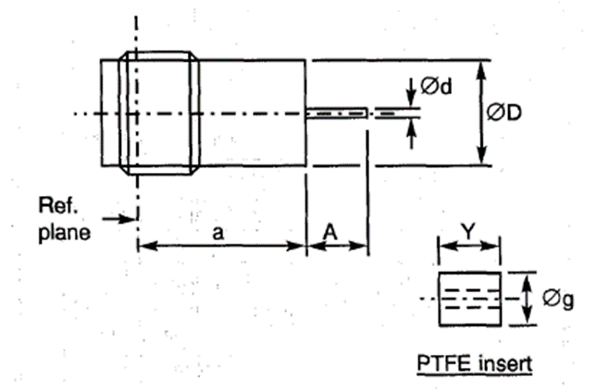
  Symbol | Dimensions mm
  Symbol | Min | Max
  a | 8.15 | 8.45
  A | 2.8 | 3.2
  Ød | 0.45 | 0.55
  ØD | 5.2 | 5.4
  Øg | 4 | 4.2
  Y | 6.25 | 6.3
ELECTRICAL CHARACTERISTICS | VALUES | UNITS
Frequency range | 0 to 18 | GHz
Maximum voltage standing wave ratio (VSWR) (Note 1) | 1.05 + 0.015 f (GHz)
Maximum insertion loss (Note 1) | 0.03 √f (GHz) | dB
Voltage proof | 1000 | Vrms
MECHANICAL CHARACTERISTICS | VALUES | UNITS
Minimum centre contact retention force (axial) | Not applicable
Minimum centre contact retention torque | Not applicable
Maximum weight | 4.4 | g
OTHER CHARACTERISTICS | VALUES | UNITS
Operating temperature range | -65 to +165 | °C
Seal: Maximum leakage | 10⁻⁸ | atm.cm³/s
Solderability | Applicable
Cables used | Not applicable
NOTES:
            - For information purposes only.

VARIANT 27 - ELBOW RECEPTACLE, SQUARE FLANGE
Symbol | Dimensions mm |  | Notes
Symbol | Min | Max | Notes
a1 | 7.1 | 9.4
a2 | 9.2 | 9.4
A | 4.25 | 4.75
B | 1.4 | 1.7
Ød | 1.25 | 1.3
Øf | 4 | 4.2
Øg | 2.55 | 2.7 | 4 holes
i | 12.6 | 12.8
j | 8.59 | 8.69
k | 2.3 | -
m | 1.4 | 1.8
ØN | 0.75 | -

ELECTRICAL CHARACTERISTICS | VALUES | UNITS
Frequency range | 0 to 18 | GHz
Maximum voltage standing wave ratio (VSWR) (Note 1) | 1.05 + 0.01 f (GHz)
Maximum insertion loss (Note 1) | 0.03 √f (GHz) | dB
Voltage proof | 1000 | Vrms
MECHANICAL CHARACTERISTICS | VALUES | UNITS
Minimum centre contact retention force (axial) | 27 | N
Minimum centre contact retention torque | 2.8 | N.cm
Maximum weight | 5.2 | g
OTHER CHARACTERISTICS | VALUES | UNITS
Operating temperature range | -65 to +165 | °C
Seal: Maximum leakage | Not applicable
Solderability | On centre contact only
Cables used | Not applicable
NOTES:
            - For information purposes only.

VARIANT 28 - ELBOW RECEPTACLE, SQUARE FLANGE
Symbol | Dimensions mm |  | Notes
Symbol | Min | Max | Notes
a1 | 7.9 | 8.1
a2 | 9.2 | 9.4
A | - | 15 | Note 1
B | - | 10 | Note 1
Ød | 1.25 | 1.3
Øf | 4 | 4.2
Øg | 2.55 | 2.7 | 4 holes
i | 12.6 | 12.8
j | 8.59 | 8.69
k | 2.3 | -
m | 1.4 | 1.8
ØN | 0.75 | -

NOTES:
            - Contact and Insert dimensions A and B shall be selected by the Orderer; see Para. 1.4.1(b).
ELECTRICAL CHARACTERISTICS | VALUES | UNITS
Frequency range | 0 to 18 | GHz
Maximum voltage standing wave ratio (VSWR) (Note 2) | 1.05 + 0.01 f (GHz)
Maximum insertion loss (Note 2) | 0.03 √f (GHz) | dB
Voltage proof | 1000 | Vrms
MECHANICAL CHARACTERISTICS | VALUES | UNITS
Minimum centre contact retention force (axial) | 27 | N
Minimum centre contact retention torque | 2.8 | N.cm
Maximum weight | 5.5 | g
OTHER CHARACTERISTICS | VALUES | UNITS
Operating temperature range | -65 to +105 | °C
Seal: Maximum leakage | Not applicable
Solderability | On centre contact only
Cables used | Not applicable
NOTES:
            - For information purposes only.

VARIANT 29 - SQUARE FLANGE RECEPTACLE
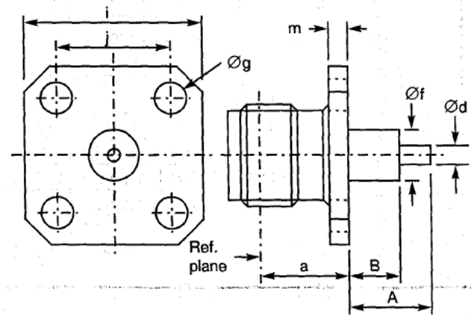
  Symbol | Dimensions mm |  | Notes
  Symbol | Min | Max
  a | 7.5 | 7.7
  A | - | 40.1 | Note 1
  B | - | 30 | Note 1
  Ød | 1.25 | 1.3
  Øf | 4 | 4.2
  Øg | 2.55 | 2.7 | 4 holes
  i | 12.6 | 12.8
  j | 8.59 | 8.69
  m | 1.4 | 1.8
NOTES:
            - Contact and Insert dimensions A and B shall be selected by the Orderer; see Para. 1.4.1(b).
ELECTRICAL CHARACTERISTICS | VALUES | UNITS
Frequency range | 0 to 18 | GHz
Maximum voltage standing wave ratio (VSWR) (Note 2) | 1.05 + 0.003 f (GHz)
Maximum insertion loss (Note 2) | 0.03 √f(GHz) | dB
Voltage proof | 1000 | Vrms
MECHANICAL CHARACTERISTICS | VALUES | UNITS
Minimum centre contact retention force (axial) | 27 | N
Minimum centre contact retention torque | 2.8 | N.cm
Maximum weight | 4.1 | g
OTHER CHARACTERISTICS | VALUES | UNITS
Operating temperature range | -65 to +105 | °C
Seal: Maximum leakage | Not applicable
Solderability | On centre contact only
Cables used | Not applicable
NOTES:
            - For information purposes only.

VARIANT 30 - 2-HOLE FLANGE RECEPTACLE
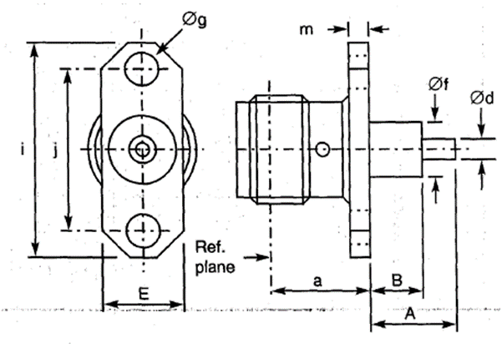
  Symbol | Dimensions mm |  | Notes
  Symbol | Min | Max | Notes
  a | 7.5 | 7.6
  A | - | 40.1 | Note 1
  B | - | 20 | Note 1
  Ød | 1.25 | 1.3
  E | 5.5 | 5.8
  Øf | 4 | 4.2
  Øg | 2.55 | 2.7 | 2 holes
  i | 15.9 | 16.1
  j | 12.1 | 12.3
  m | 1.4 | 1.8
NOTES:
            - Contact and Insert dimensions A and B shall be selected by the Orderer; see Para. 1.4.1(b).
ELECTRICAL CHARACTERISTICS | VALUES | UNITS
Frequency range | 0 to 18 | GHz
Maximum voltage standing wave ratio (VSWR) (Note 2) | 1.05 + 0.003 f (GHz)
Maximum insertion loss (Note 2) | 0.03 √f (GHz) | dB
Voltage proof | 1000 | Vrms
MECHANICAL CHARACTERISTICS | VALUES | UNITS
Minimum centre contact retention force (axial) | 27 | N
Minimum centre contact retention torque | 2.8 | N.cm
Maximum weight | 3.2 | g
OTHER CHARACTERISTICS | VALUES | UNITS
Operating temperature range | -65 to +105 | °C
Seal: Maximum leakage | Not applicable
Solderability | On centre contact only
Cables used | Not applicable
NOTES:
            - For information purposes only.

VARIANT 31 - SQUARE FLANGE RECEPTACLE
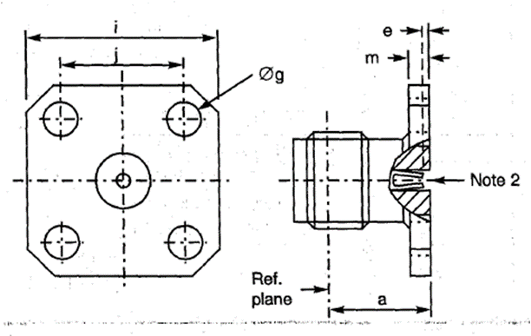
  Symbol | Dimensions mm |  | Notes
  Symbol | Min | Max | Notes
  a | 7.5 | 7.7
  e | 0.18 | 0.41
  Øg | 2.55 | 2.7 | 4 holes
  i | 12.6 | 12.8
  j | 8.59 | 8.69
  m | 1.4 | 1.8
ELECTRICAL CHARACTERISTICS | VALUES | UNITS
Frequency range | 0 to 18 | GHz
Maximum voltage standing wave ratio (VSWR) | 1.06 + 0.007 f (GHz)
Maximum insertion loss (Note 1) | 0.03 √f (GHz) | dB
Voltage proof | 1000 | Vrms
MECHANICAL CHARACTERISTICS | VALUES | UNITS
Minimum centre contact retention force (axial) | 27 | N
Minimum centre contact retention torque | Not applicable
Maximum weight | 2.6 | g
OTHER CHARACTERISTICS | VALUES | UNITS
Operating temperature range | -65 to +105 | °C
Seal: Maximum leakage | Not applicable
Solderability | Not applicable
Cables used | Not applicable
NOTES:
            - For information purposes only.
            - Contact Engagement and Separation Forces shall be measured on the rear contact (see Para. 2.3(a)).

VARIANT 32 - 2-HOLE FLANGE RECEPTACLE
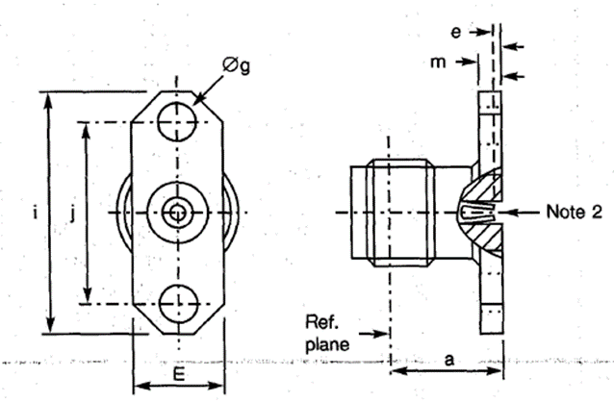
  Symbol | Dimensions mm |  | Notes
  Symbol | Min | Max | Notes
  a | 7.5 | 7.6
  e | 0.18 | 0.41
  E | 5.5 | 5.8
  Øg | 2.55 | 2.7 | 2 holes
  i | 15.9 | 16.1
  j | 12.1 | 12.3
  m | 1.4 | 1.8
ELECTRICAL CHARACTERISTICS | VALUES | UNITS
Frequency range | 0 to 18 | GHz
Maximum voltage standing wave ratio (VSWR) | 1.06 + 0.006 f (GHz)
Maximum insertion loss (Note 1) | 0.03 √f (GHz) | dB
Voltage proof | 1000 | Vrms
MECHANICAL CHARACTERISTICS | VALUES | UNITS
Minimum centre contact retention force (axial) | 27 | N
Minimum centre contact retention torque | 2.8 | N.cm
Maximum weight | 2.3 | g
OTHER CHARACTERISTICS | VALUES | UNITS
Operating temperature range | -65 to +105 | °C
Seal: Maximum leakage | Not applicable
Solderability | Not applicable
Cables used | Not applicable
NOTES:
            - For information purposes only.
            - Contact Engagement and Separation Forces shall be measured on the rear contact (see Para. 2.3(a)).

VARIANT 34 - FLANGE RECEPTACLE, TRIPLATE LAUNCHER
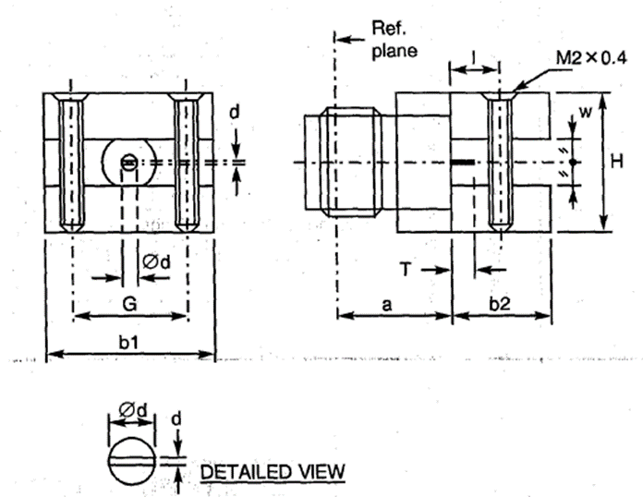
  Symbol | Dimensions mm
  Symbol | Min | Max
  a | 7.8 | 8.1
  b1 | 13.8 | 14.1
  b2 | 5.60 | 5.85
  d | 0.1 | 0.15
  Ød | 1.25 | 1.3
  G | 7.45 | -
  H | 9.35 | 9.85
  I | 2.6 | 2.85
  T | 1.8 | 2.6
  w | - | 3.17
ELECTRICAL CHARACTERISTICS | VALUES | UNITS
Frequency range | 0 to 4 | GHz
Maximum voltage standing wave ratio (VSWR) | 1.2
Maximum insertion loss | Not applicable
Voltage proof | 750 | Vrms
MECHANICAL CHARACTERISTICS | VALUES | UNITS
Minimum centre contact retention force (axial) | 27 | N
Minimum centre contact retention torque | 2.8 | N.cm
Maximum weight | 15 | g
OTHER CHARACTERISTICS | VALUES | UNITS
Operating temperature range | -65 to +105 | °C
Seal: Maximum leakage | Not applicable
Solderability | Not applicable
Cables used | Not applicable

VARIANT 36 - SQUARE FLANGE RECEPTACLE
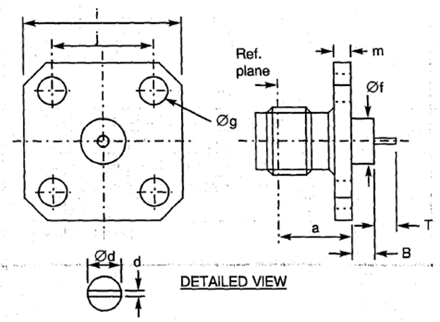
  Symbol | Dimensions mm |  | Notes
  Symbol | Min | Max | Notes
  a | 7.5 | 7.7
  B | 3.1 | 3.3
  d | 0.1 | 0.35
  Ød | 1.25 | 1.3
  Øf | 4 | 4.2
  Øg | 2.55 | 2.7 | 4 holes
  i | 12.6 | 12.8
  j | 8.59 | 8.69
  m | 1.4 | 1.8
  T | 2.1 | 2.3
ELECTRICAL CHARACTERISTICS | VALUES | UNITS
Frequency range | 0 to 18 | GHz
Maximum voltage standing wave ratio (VSWR) (Note 1) | 1.05 + 0.003 f (GHz)
Maximum insertion loss (Note 1) | 0.03 √f (GHz) | dB
Voltage proof | 1000 | Vrms
MECHANICAL CHARACTERISTICS | VALUES | UNITS
Minimum centre contact retention force (axial) | 27 | N
Minimum centre contact retention torque | 2.8 | N.cm
Maximum weight | 3 | g
OTHER CHARACTERISTICS | VALUES | UNITS
Operating temperature range | -65 to +105 | °C
Seal: Maximum leakage | Not applicable
Solderability | On centre contact only
Cables used | Not applicable
NOTES:
            - For information purposes only.

VARIANT 37 - FLANGE RECEPTACLE, TRIPLATE LAUNCHER
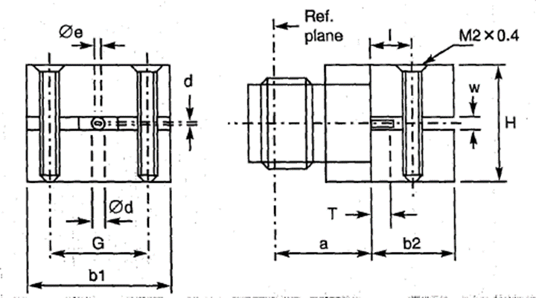
  Symbol | Dimensions mm
  Symbol | Min | Max
  a | 7.8 | 8.1
  b1 | 13.9 | 14.1
  b2 | 5.6 | 5.85
  d | 0.1 | 0.15
  Ød | 1.25 | 1.3
  Øe | 0.4 | 0.6
  G | 7.45 | -
  H | 9.35 | 9.85
  I | 2.6 | 2.9
  T | 1.8 | 2.6
  w | 1.5 | 1.65
ELECTRICAL CHARACTERISTICS | VALUES | UNITS
Frequency range | 0 to 8 | GHz
Maximum voltage standing wave ratio (VSWR) | 1.2
Maximum insertion loss | Not applicable
Voltage proof | 150 | Vrms
MECHANICAL CHARACTERISTICS | VALUES | UNITS
Minimum centre contact retention force (axial) | 27 | N
Minimum centre contact retention torque | 2.8 | N.cm
Maximum weight | 15 | g
OTHER CHARACTERISTICS | VALUES | UNITS
Operating temperature range | -65 to +105 | °C
Seal: Maximum leakage | Not applicable
Solderability | Not applicable
Cables used | Not applicable

VARIANT 38 - FLANGE RECEPTACLE, TRIPLATE LAUNCHER
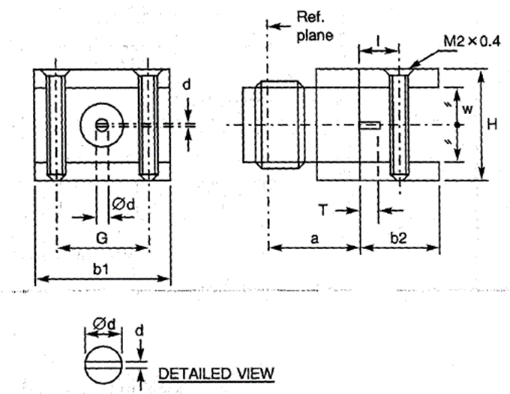
  Symbol | Dimensions mm
  Symbol | Min | Max
  a | 7.8 | 8.1
  b1 | 13.9 | 14.1
  b2 | 5.6 | 5.85
  d | 0.1 | 0.15
  Ød | - | 1.3
  G | 7.45 | -
  H | 9.35 | 9.85
  I | 2.7 | 2.9
  T | 2.4 | 2.6
  w | 6.3 | 6.4
ELECTRICAL CHARACTERISTICS | VALUES | UNITS
Frequency range | 0 to 2 | GHz
Maximum voltage standing wave ratio (VSWR) | 1.2
Maximum insertion loss | Not applicable
Voltage proof | 1000 | Vrms
MECHANICAL CHARACTERISTICS | VALUES | UNITS
Minimum centre contact retention force (axial) | 27 | N
Minimum centre contact retention torque | 2.8 | N.cm
Maximum weight | 15 | g
OTHER CHARACTERISTICS | VALUES | UNITS
Operating temperature range | -65 to +105 | °C
Seal: Maximum leakage | Not applicable
Solderability | Not applicable
Cables used | Not applicable

VARIANT 39 - SQUARE FLANGE RECEPTACLE
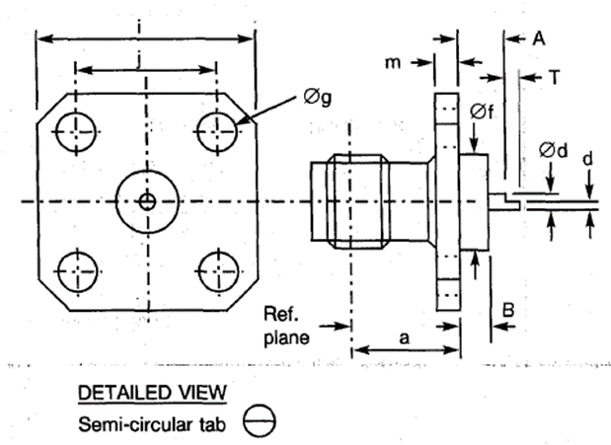
  Symbol | Dimensions mm |  | Notes
  Symbol | Min | Max
  a | 7.5 | 7.7
  A | 0.7 | 0.9
  b | 0.2 | 0.4
  d | 0.59 | 0.65
  Ød | 1.25 | 1.3
  Øf | 4 | 4.2
  Øg | 2.55 | 2.7 | 4 holes
  i | 12.6 | 12.8
  j | 8.59 | 8.69
  m | 1.4 | 1.8
  T | 1.2 | 1.4
ELECTRICAL CHARACTERISTICS | VALUES | UNITS
Frequency range | 0 to 18 | GHz
Maximum voltage standing wave ratio (VSWR) (Note 1) | 1.05 + 0.003 f (GHz)
Maximum insertion loss (Note 1) | 0.03 √f (GHz) | dB
Voltage proof | 1000 | Vrms
MECHANICAL CHARACTERISTICS | VALUES | UNITS
Minimum centre contact retention force (axial) | 27 | N
Minimum centre contact retention torque | 2.8 | N.cm
Maximum weight | 3 | g
OTHER CHARACTERISTICS | VALUES | UNITS
Operating temperature range | -65 to +165 | °C
Seal: Maximum leakage | Not applicable
Solderability | On centre contact only
Cables used | Not applicable
NOTES:
            - For information purposes only.

VARIANT 40 - SQUARE FLANGE RECEPTACLE, LOW RF LEAKAGE
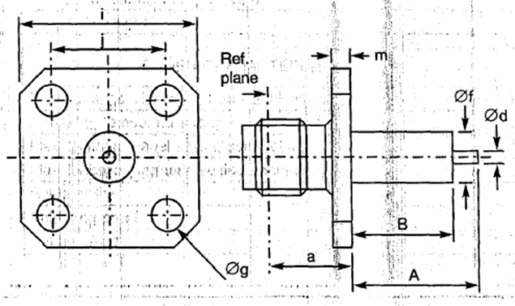
  Symbol | Dimensions mm |  | Notes
  Symbol | Min | Max
  a | 7.5 | 7.7
  A | - | 35 | Note 1
  B | - | 20 | Note 1
  Ød | 1.25 | 1.3
  Øf | 4 | 4.2
  Øg | 2.55 | 2.7 | 4 holes
  i | 12.6 | 12.8
  j | 8.59 | 8.69
  m | 1.4 | 1.8
NOTES:
            - Contact and Insert dimensions A and B shall be selected by the Orderer; see Para. 1.4.1(b).
ELECTRICAL CHARACTERISTICS | VALUES | UNITS
Frequency range | 0 to 18 | GHz
Maximum voltage standing wave ratio (VSWR) (Note 2) | 1.05 + 0.003 f (GHz)
Maximum insertion loss (Note 2) | 0.03 √f (GHz) | dB
Voltage proof | 1000 | Vrms
MECHANICAL CHARACTERISTICS | VALUES | UNITS
Minimum centre contact retention force (axial) | 27 | N
Minimum centre contact retention torque | 2.8 | N.cm
Maximum weight | 3 | g
OTHER CHARACTERISTICS | VALUES | UNITS
Operating temperature range | -65 to +105 | °C
Seal: Maximum leakage | Not applicable
Solderability | On centre contact only
Cables used | Not applicable
NOTES:
            - For information purposes only.

VARIANT 41 - SQUARE FLANGE RECEPTACLE, LOW RF LEAKAGE
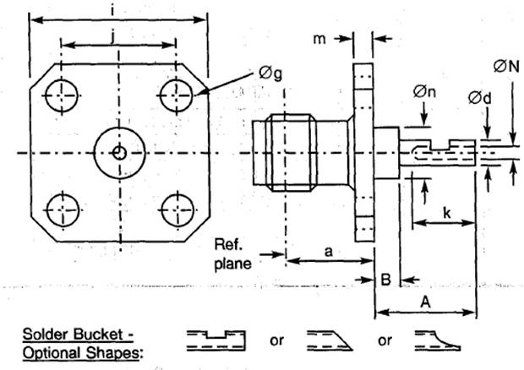
  Symbol | Dimensions mm |  | Notes
  Symbol | Min | Max
  a | 7.5 | 7.7
  A | 6 | 6.2
  B | 0.9 | 1
  Ød | 1.25 | 1.3
  Øg | 2.55 | 2.7 | 4 holes
  i | 12.6 | 12.8
  j | 8.59 | 8.69
  k | 2.4 | -
  m | 1.4 | 1.8
  Øn | 4 | 4.2
  ØN | 0.75 | -
ELECTRICAL CHARACTERISTICS | VALUES | UNITS
Frequency range | 0 to 18 | GHz
Maximum voltage standing wave ratio (VSWR) (Note 1) | 1.05 + 0.003 f (GHz)
Maximum insertion loss (Note 1) | 0.03 √f (GHz) | dB
Voltage proof | 1000 | Vrms
MECHANICAL CHARACTERISTICS | VALUES | UNITS
Minimum centre contact retention force (axial) | 27 | N
Minimum centre contact retention torque | 2.8 | N.cm
Maximum weight | 3 | g
OTHER CHARACTERISTICS | VALUES | UNITS
Operating temperature range | -65 to +105 | °C
Seal: Maximum leakage | Not applicable
Solderability | On centre contact only
Cables used | Not applicable
NOTES:
            - For information purposes only.

VARIANT 42 - SQUARE FLANGE RECEPTACLE, LOW RF LEAKAGE
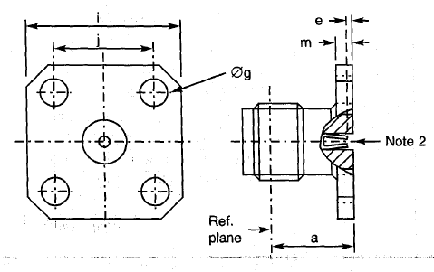
  Symbol | Dimensions mm |  | Notes
  Symbol | Min | Max
  a | 7.5 | 7.7
  e | 0.18 | 0.41
  Øg | 2.55 | 2.7 | 4 holes
  i | 12.6 | 12.8
  j | 8.59 | 8.69
  m | 1.4 | 1.8
ELECTRICAL CHARACTERISTICS | VALUES | UNITS
Frequency range | 0 to 18 | GHz
Maximum voltage standing wave ratio (VSWR) (Note 1) | 1.06 + 0.007 f (GHz)
Maximum insertion loss (Note 1) | 0.03 √f (GHz) | dB
Voltage proof | 1000 | Vrms
MECHANICAL CHARACTERISTICS | VALUES | UNITS
Minimum centre contact retention force (axial) | 27 | N
Minimum centre contact retention torque | 2.8 | N.cm
Maximum weight | 3 | g
OTHER CHARACTERISTICS | VALUES | UNITS
Operating temperature range | -65 to +165 | °C
Seal: Maximum leakage | Not applicable
Solderability | Not applicable
Cables used | Not applicable
NOTES:
            - For information purposes only.
            - Contact Engagement and Separation Forces shall be measured on the rear contact (see Para. 2.3(a)).

VARIANT 43 - SQUARE FLANGE RECEPTACLE, LOW RF LEAKAGE
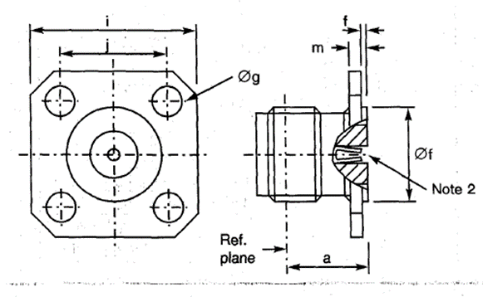
  Symbol | Dimensions mm |  | Notes
  Symbol | Min | Max
  a | 7.5 | 7.7
  e | 0.18 | 0.41
  f | 0.3 | 0.5
  Øf | 5.9 | 6.1
  Øg | 2.55 | 2.7 | 4 holes
  i | 12.6 | 12.8
  j | 8.59 | 8.69
  m | 1.4 | 1.8
ELECTRICAL CHARACTERISTICS | VALUES | UNITS
Frequency range | 0 to 18 | GHz
Maximum voltage standing wave ratio (VSWR) | 1.06 +0.007 f (GHz)
Maximum insertion loss (Note 1) | 0.03 √f (GHz) | dB
Voltage proof | 1000 | Vrms
MECHANICAL CHARACTERISTICS | VALUES | UNITS
Minimum centre contact retention force (axial) | 27 | N
Minimum centre contact retention torque | Not applicable
Maximum weight | 2.6 | g
OTHER CHARACTERISTICS | VALUES | UNITS
Operating temperature range | -65 to +105 | °C
Seal: Maximum leakage | Not applicable
Solderability | Not applicable
Cables used | Not applicable
NOTES:
            - For information purposes only.
            - Contact Engagement and Separation Forces shall be measured on the rear contact (see Para. 2.3(a)).

VARIANT 44 - BULKHEAD RECEPTACLE
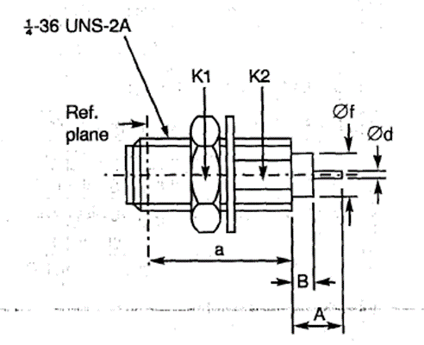
  Symbol | Dimensions mm |  | Notes
  Symbol | Min | Max
  a | 10.65 | 10.9
  A | - | 40.1 | Note 1
  B | - | 20 | Note 1
  Ød | 1.25 | 1.3
  Øf | 4 | 4.2
  K1 | - | 8 | 2 flats
  K2 | - | 5.4 | 2 flats
NOTES:
            - Contact and Insert dimensions A and B shall be selected by the Orderer; see Para. 1.4.1(b).
ELECTRICAL CHARACTERISTICS | VALUES | UNITS
Frequency range | 0 to 18 | GHz
Maximum voltage standing wave ratio (VSWR) (Note 2) | 1.05 + 0.06 f (GHz)
Maximum insertion loss (Note 2) | 0.03 √f (GHz) | dB
Voltage proof | 1000 | Vrms
MECHANICAL CHARACTERISTICS | VALUES | UNITS
Minimum centre contact retention force (axial) | 27 | N
Minimum centre contact retention torque | 2.8 | N.cm
Maximum weight | 2.3 | g
OTHER CHARACTERISTICS | VALUES | UNITS
Operating temperature range | -65 to +105 | °C
Seal: Maximum leakage | Not applicable
Solderability | On centre contact only
Cables used | Not applicable
NOTES:
            - For information purposes only.

VARIANT 45 - SQUARE FLANGE RECEPTACLE FOR MICRO-STRIP
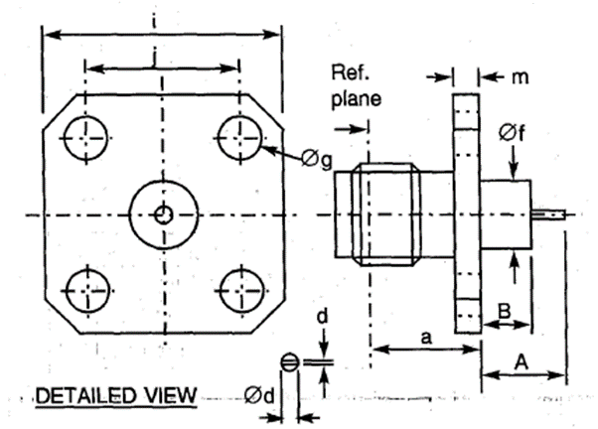
  Symbol | Dimensions mm |  | Notes
  Symbol | Min | Max
  a | 7.5 | 7.7
  A | - | 35 | Note 1
  B | - | 20 | Note 1
  Ød | 1.25 | 1.3
  d | 0.1 | 0.15
  d1 | 0.55 | 0.65
  Øf | 4 | 4.2
  Øg | 2.55 | 2.7 | 4 holes
  i | 12.6 | 12.8
  j | 8.59 | 8.69
  m | 1.4 | 1.8
NOTES:
            - Contact and Insert dimensions A and B shall be selected by the Orderer; see Para. 1.4.1(b).
ELECTRICAL CHARACTERISTICS | VALUES | UNITS
Frequency range | 0 to 12.4 | GHz
Maximum voltage standing wave ratio (VSWR) (Note 2) | 1.05 + 0.035 f (GHz)
Maximum insertion loss (Note 2) | 0.03 √f (GHz) | dB
Voltage proof | 1000 | Vrms
MECHANICAL CHARACTERISTICS | VALUES | UNITS
Minimum centre contact retention force (axial) | 27 | N
Minimum centre contact retention torque | 2.8 | N.cm
Maximum weight | 3 | g
OTHER CHARACTERISTICS | VALUES | UNITS
Operating temperature range | -65 to +105 | °C
Seal: Maximum leakage | Not applicable
Solderability | On centre contact only
Cables used | Not applicable
NOTES:
            - For information purposes only.

VARIANT 46 - 2-HOLE FLANGE RECEPTACLE FOR STRIP-LINE
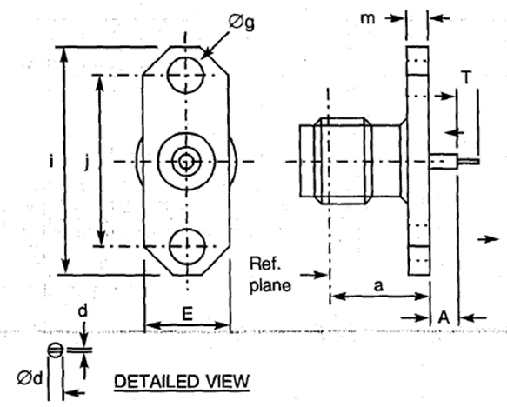
  Symbol | Dimensions mm |  | Notes
  Symbol | Min | Max
  a | 7.5 | 7.7
  A | 2.4 | 2.7
  d | 0.1 | 0.15
  Ød | 1.25 | 1.3
  E | 5.5 | 5.8
  Øg | 2.55 | 2.7 | 2 holes
  i | 15.9 | 16.1
  j | 12.1 | 12.3
  m | 1.4 | 1.8
  T | 2.4 | 2.65
NOTES:
            - Components are delivered with the centre contact and insulator not mounted in the connector.
ELECTRICAL CHARACTERISTICS | VALUES | UNITS
Frequency range | 0 to 18 | GHz
Maximum voltage standing wave ratio (VSWR) | Not applicable
Maximum insertion loss | Not applicable
Voltage proof | 1000 | Vrms
MECHANICAL CHARACTERISTICS | VALUES | UNITS
Minimum centre contact retention force (axial) | Not applicable
Minimum centre contact retention torque | Not applicable
Maximum weight | 2.6 | g
OTHER CHARACTERISTICS | VALUES | UNITS
Operating temperature range | -65 to +165 | °C
Seal: Maximum leakage | Not applicable
Solderability | On centre contact only
Cables used | Not applicable

VARIANT 47 - 2-HOLE FLANGE RECEPTACLE FOR STRIP-LINE
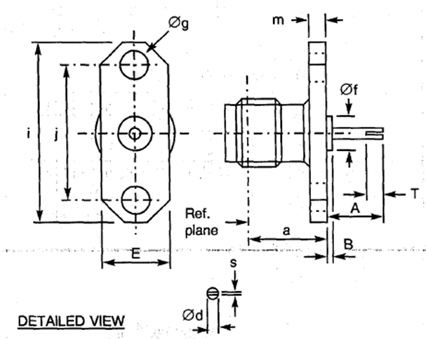
  Symbol | Dimensions mm |  | Notes
  Symbol | Min | Max
  a | 7.5 | 7.7
  A | 6.2 | 6.7
  Ød | 1.25 | 1.3
  B | 0.4 | 0.65
  E | 5.5 | 5.8
  Øf | 4 | 4.2
  Øg | 2.55 | 2.7 | 2 holes
  i | 15.9 | 16.1
  j | 12.1 | 12.3
  m | 1.4 | 1.8
  s | 0.6 | -
  T | 2.4 | 2.65
NOTES:
            - Components are delivered with the centre contact and insulator not mounted in the connector.
ELECTRICAL CHARACTERISTICS | VALUES | UNITS
Frequency range | 0 to 18 | GHz
Maximum voltage standing wave ratio (VSWR) | Not applicable
Maximum insertion loss | Not applicable
Voltage proof | 1000 | Vrms
MECHANICAL CHARACTERISTICS | VALUES | UNITS
Minimum centre contact retention force (axial) | Not applicable
Minimum centre contact retention torque | Not applicable
Maximum weight | 2.6 | g
OTHER CHARACTERISTICS | VALUES | UNITS
Operating temperature range | -65 to +165 | °C
Seal: Maximum leakage | Not applicable
Solderability | On centre contact only
Cables used | Not applicable

VARIANT 48 - SQUARE FLANGE MALE RECEPTACLE FOR MICRO-STRIP
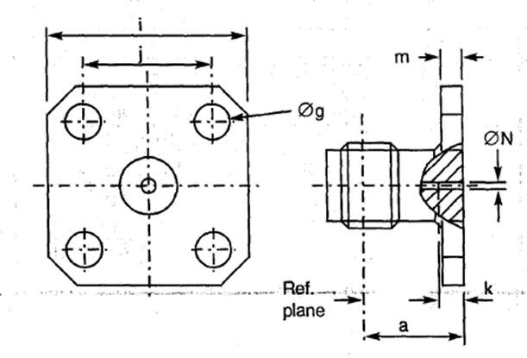
  Symbol | Dimensions mm |  | Notes
  Symbol | Min | Max
  a | 7.5 | 7.7
  Øg | 2.55 | 2.7 | 4 holes
  i | 12.6 | 12.8
  j | 8.59 | 8.69
  k | 2.3 | 2.7
  m | 1.4 | 1.8
  ØN | 0.7 | 0.9
NOTES:
            - Components are delivered with the centre contact and insulator not mounted in the connector.
ELECTRICAL CHARACTERISTICS | VALUES | UNITS
Frequency range | 0 to 18 | GHz
Maximum voltage standing wave ratio (VSWR) | Not applicable
Maximum insertion loss | Not applicable
Voltage proof | 1000 | Vrms
MECHANICAL CHARACTERISTICS | VALUES | UNITS
Minimum centre contact retention force (axial) | Not applicable
Minimum centre contact retention torque | Not applicable
Maximum weight | 2.6 | g
OTHER CHARACTERISTICS | VALUES | UNITS
Operating temperature range | -65 to +165 | °C
Seal: Maximum leakage | Not applicable
Solderability | On centre contact only
Cables used | Not applicable

VARIANT 49 - 2-HOLE FLANGE RECEPTACLE
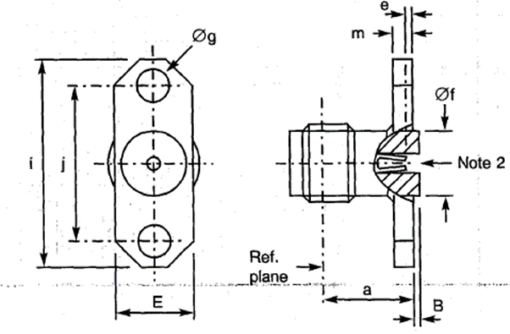
  Symbol | Dimensions mm |  | Notes
  Symbol | Min | Max | Notes
  a | 7.5 | 7.7
  B | 0.15 | 0.25
  e | 0.18 | 0.41
  E | 5.5 | 5.8
  Øf | 4 | 4.2
  Øg | 2.55 | 2.7 | 2 holes
  i | 15.9 | 16.1
  j | 12.1 | 12.3
  m | 1.4 | 1.8
ELECTRICAL CHARACTERISTICS | VALUES | UNITS
Frequency range | 0 to 18 | GHz
Maximum voltage standing wave ratio (VSWR) (Note 1) | 1.06 + 0.006 f (GHz)
Maximum insertion loss (Note 1) | 0.03 √f (GHz) | dB
Voltage proof | 1000 | Vrms
MECHANICAL CHARACTERISTICS | VALUES | UNITS
Minimum centre contact retention force (axial) | 27 | N
Minimum centre contact retention torque | 2.8 | N.cm
Maximum weight | 2 | g
OTHER CHARACTERISTICS | VALUES | UNITS
Operating temperature range | -65 to +105 | °C
Seal: Maximum leakage | Not applicable
Solderability | Not applicable
Cables used | Not applicable
NOTES:
            - For information purposes only.
            - Contact Engagement and Separation Forces shall be measured on the rear contact (see Para. 2.3(a)).

VARIANT 50 - SQUARE FLANGE RECEPTACLE
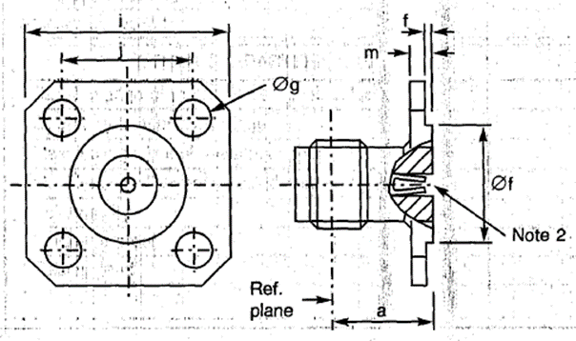
  Symbol | Dimensions mm |  | Notes
  Symbol | Min | Max | Notes
  a | 7.5 | 7.70
  e | 0.18 | 0.41
  f | 0.3 | 0.5
  Øf | 5.9 | 6.1
  Øg | 2.55 | 2.7 | 4 holes
  i | 12.6 | 12.8
  j | 8.59 | 8.69
  m | 1.4 | 1.8
ELECTRICAL CHARACTERISTICS | VALUES | UNITS
Frequency range | 0 to 18 | GHz
Maximum voltage standing wave ratio (VSWR) (Note 1) | 1.06 + 0.007 f (GHz)
Maximum insertion loss (Note 1) | 0.03 √f (GHz) | dB
Voltage proof | 1000 | Vrms
MECHANICAL CHARACTERISTICS | VALUES | UNITS
Minimum centre contact retention force (axial) | 27 | N
Minimum centre contact retention torque | Not applicable
Maximum weight | 2.6 | g
OTHER CHARACTERISTICS | VALUES | UNITS
Operating temperature range | -65 to +105 | °C
Seal: Maximum leakage | Not applicable
Solderability | Not applicable
Cables used | Not applicable
NOTES:
            - For information purposes only.
            - Contact Engagement and Separation Forces shall be measured on the rear contact (see Para. 2.3(a)).

VARIANT 51 - SQUARE FLANGE RECEPTACLE
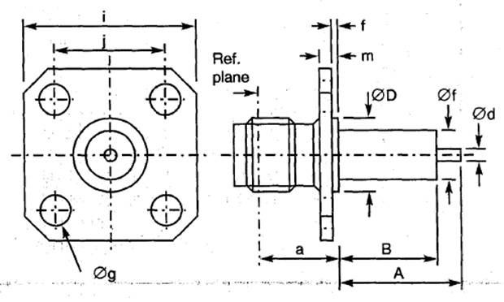
  Symbol | Dimensions mm |  | Notes
  Symbol | Min | Max | Notes
  a | 7.5 | 7.7
  A | - | 40.1 | Note 1
  B | - | 30 | Note 1
  Ød | 1.25 | 1.3
  ØD | 5.9 | 6.1
  f | 0.3 | 0.5
  Øf | 4 | 4.2
  Øg | 2.55 | 2.7 | 4 holes
  i | 12.6 | 12.8
  j | 8.59 | 8.69
  m | 1.4 | 1.8
NOTES:
            - Contact and Insert dimensions A and B shall be selected by the Orderer; see Para. 1.4.1(b).
ELECTRICAL CHARACTERISTICS | VALUES | UNITS
Frequency range | 0 to 18 | GHz
Maximum voltage standing wave ratio (VSWR) (Note 2) | 1.05 + 0.003 f (GHz)
Maximum insertion loss (Note 2) | 0.03 √f (GHz) | dB
Voltage proof | 1000 | Vrms
MECHANICAL CHARACTERISTICS | VALUES | UNITS
Minimum centre contact retention force (axial) | 27 | N
Minimum centre contact retention torque | 2.8 | N.cm
Maximum weight | 3 | g
OTHER CHARACTERISTICS | VALUES | UNITS
Operating temperature range | -65 to +105 | °C
Seal: Maximum leakage | Not applicable
Solderability | On centre contact only
Cables used | Not applicable
NOTES:
            - For information purposes only.

VARIANT 53 - STRAIGHT JACK, SOLDER TYPE, FOR SHF 5 CABLE
Symbol | Dimensions mm |  | Notes
Symbol | Min | Max | Notes
a | 14.2 | 14.45
ØD | 10.9 | 11.1
K1 | - | 8 | Hexagon
K2 | - | 5.9 | 1 flat
ØN | 5.9 | -

NOTES:
            - Maximum panel thickness: 5.4mm
            - Components are delivered with the centre contact and insulator not mounted in the connector.
ELECTRICAL CHARACTERISTICS | VALUES | UNITS
Frequency range | 0 to 18 | GHz
Maximum voltage standing wave ratio (VSWR) | 1.15
Maximum insertion loss | 0.06 √f (GHz) | dB
Voltage proof | 1000 | Vrms
MECHANICAL CHARACTERISTICS | VALUES | UNITS
Minimum centre contact retention force (axial) | Not applicable
Minimum centre contact retention torque | Not applicable
Maximum weight | 7 | g
OTHER CHARACTERISTICS | VALUES | UNITS
Operating temperature range | -65 to +165 | °C
Seal: Maximum leakage | Not applicable
Solderability | Applicable
Cables used | F 1703.145

VARIANT 54 - 2-HOLE FLANGE RECEPTACLE, LOW RF LEAKAGE
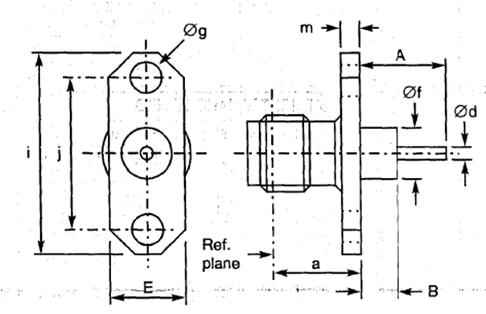
  Symbol | Dimensions mm |  | Notes
  Symbol | Min | Max | Notes
  a | 7.5 | 7.7
  A | - | 40.1 | Note 1
  B | - | 20 | Note 1
  Ød | 1.25 | 1.3
  E | 5.5 | 5.8
  Øf | 4 | 4.2
  Øg | 2.55 | 2.7 | 2 holes
  i | 15.9 | 16.1
  j | 12.1 | 12.3
  m | 1.4 | 1.8
NOTES:
            - Contact and Insert dimensions A and B shall be selected by the Orderer; see Para. 1.4.1(b).
ELECTRICAL CHARACTERISTICS | VALUES | UNITS
Frequency range | 0 to 18 | GHz
Maximum voltage standing wave ratio (VSWR) (Note 2) | 1.05 + 0.003 f (GHz)
Maximum insertion loss (Note 2) | 0.03 √f (GHz) | dB
Voltage proof | 1000 | Vrms
MECHANICAL CHARACTERISTICS | VALUES | UNITS
Minimum centre contact retention force (axial) | 27 | N
Minimum centre contact retention torque | 2.8 | N.cm
Maximum weight | 3 | g
OTHER CHARACTERISTICS | VALUES | UNITS
Operating temperature range | -65 to +105 | °C
Seal: Maximum leakage | Not applicable
Solderability | On centre contact only
Cables used | Not applicable
NOTES:
            - For information purposes only.

VARIANT 55 - ELBOW RECEPTACLE, ROUND FLANGE, TRIPLATE LAUNCHER
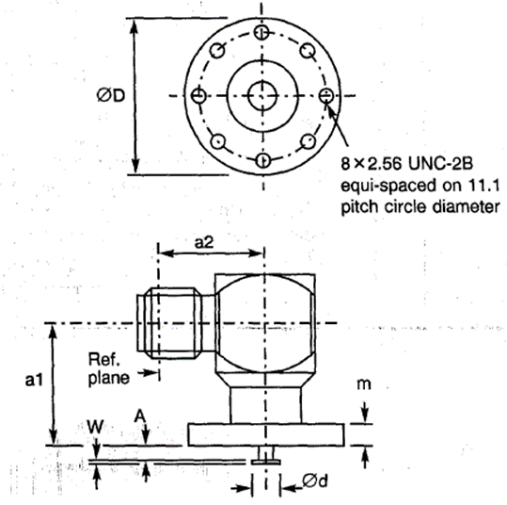
  Symbol | Dimensions mm
  Symbol | Min | Max
  a1 | 9.15 | 9.4
  a2 | 9.2 | 9.4
  A | 0.94 | 1.7
  Ød | 1.7 | 1.9
  ØD | 14 | 14.4
  m | 1.95 | 2.3
  w | 0.15 | 0.35
ELECTRICAL CHARACTERISTICS | VALUES | UNITS
Frequency range | 0 to 4 | GHz
Maximum voltage standing wave ratio (VSWR) | 1.2
Maximum insertion loss | Not applicable
Voltage proof | 750 | Vrms
MECHANICAL CHARACTERISTICS | VALUES | UNITS
Minimum centre contact retention force (axial) | Not applicable
Minimum centre contact retention torque | Not applicable
Maximum weight | 5.8 | g
OTHER CHARACTERISTICS | VALUES | UNITS
Operating temperature range | -65 to +105 | °C
Seal: Maximum leakage | Not applicable
Solderability | Applicable
Cables used | Not applicable

VARIANT 56 - SQUARE FLANGE RECEPTACLE, LOW RF LEAKAGE
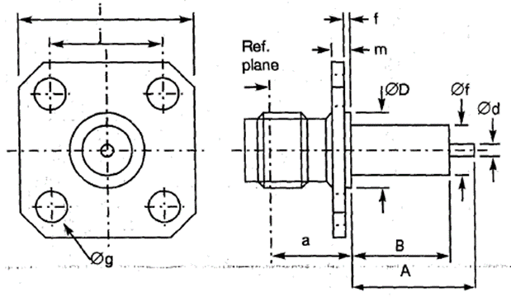
  Symbol | Dimensions mm |  | Notes
  Symbol | Min | Max | Notes
  a | 7.5 | 7.7
  A | - | 40.1 | Note 1
  B | - | 20 | Note 1
  Ød | 1.25 | 1.5
  ØD | 5.9 | 6.1
  f | 0.3 | 0.4
  Øf | 4 | 4.2
  Øg | 2.55 | 2.7 | 4 holes
  i | 12.6 | 12.8
  j | 8.59 | 8.69
  m | 1.4 | 1.9
NOTES:
            - Contact and Insert dimensions A and B shall be selected by the Orderer; see Para. 1.4.1(b).
ELECTRICAL CHARACTERISTICS | VALUES | UNITS
Frequency range | 0 to 18 | GHz
Maximum voltage standing wave ratio (VSWR) (Note 2) | 1.05 + 0.003 f (GHz)
Maximum insertion loss (Note 2) | 0.03 √f (GHz) | dB
Voltage proof | 1000 | Vrms
MECHANICAL CHARACTERISTICS | VALUES | UNITS
Minimum centre contact retention force (axial) | 27 | N
Minimum centre contact retention torque | 2.8 | N.cm
Maximum weight | 3 | g
OTHER CHARACTERISTICS | VALUES | UNITS
Operating temperature range | -65 to +105 | °C
Seal: Maximum leakage | Not applicable
Solderability | On centre contact only
Cables used | Not applicable
NOTES:
            - For information purposes only.

VARIANT 57 - ROUND FLANGE RECEPTACLE, TRIPLATE LAUNCHER
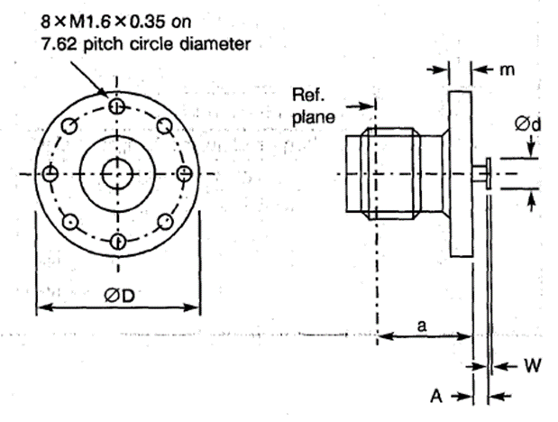
  Symbol | Dimensions mm |  | Notes
  Symbol | Min | Max | Notes
  a | 7.5 | 7.7
  A | 3 | 3.4 | After assembly
  Ød | 1.7 | 1.9
  ØD | 10.1 | 10.5
  m | 2.1 | 2.25
  W | 0.2 | 0.3
ELECTRICAL CHARACTERISTICS | VALUES | UNITS
Frequency range | 0 to 2 | GHz
Maximum voltage standing wave ratio (VSWR) | 1.2
Maximum insertion loss | Not applicable
Voltage proof | 1000 | Vrms
MECHANICAL CHARACTERISTICS | VALUES | UNITS
Minimum centre contact retention force (axial) | Not applicable
Minimum centre contact retention torque | Not applicable
Maximum weight | 2.6 | g
OTHER CHARACTERISTICS | VALUES | UNITS
Operating temperature range | -65 to +165 | °C
Seal: Maximum leakage | Not applicable
Solderability | Applicable
Cables used | Not applicable

VARIANT 58 - SQUARE FLANGE RECEPTACLE, LOW RF LEAKAGE
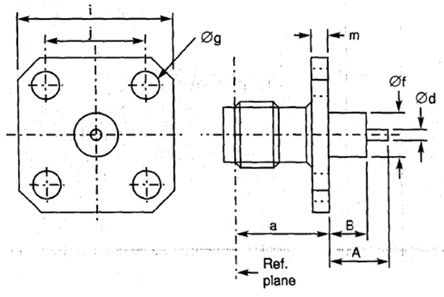
  Symbol | Dimensions mm |  | Notes
  Symbol | Min | Max | Notes
  a | 7.45 | 7.7
  A | - | 40.1 | Note 1
  B | - | 20 | Note 1
  Ød | 0.4 | 0.6
  Øf | 4 | 4.2
  Øg | 2.55 | 2.7 | 4 holes
  i | 12.6 | 12.8
  j | 8.59 | 8.69
  m | 1.4 | 1.8
NOTES:
            - Contact and Insert dimensions A and B shall be selected by the Orderer; see Para. 1.4.1(b).
ELECTRICAL CHARACTERISTICS | VALUES | UNITS
Frequency range | 0 to 18 | GHz
Maximum voltage standing wave ratio (VSWR) (Note 2) | 1.05 + 0.003 f (GHz)
Maximum insertion loss (Note 2) | 0.03 √f (GHz) | dB
Voltage proof | 1000 | Vrms
MECHANICAL CHARACTERISTICS | VALUES | UNITS
Minimum centre contact retention force (axial) | 27 | N
Minimum centre contact retention torque | 2.8 | N.cm
Maximum weight | 3 | g
OTHER CHARACTERISTICS | VALUES | UNITS
Operating temperature range | -65 to +105 | °C
Seal: Maximum leakage | Not applicable
Solderability | On centre contact only
Cables used | Not applicable
NOTES:
            - For information purposes only.

VARIANT 59 - 2-HOLE FLANGE MALE RECEPTACLE, WITH HERMETIC GLASS SEAL Ø0.46MM AND EMI GASKET
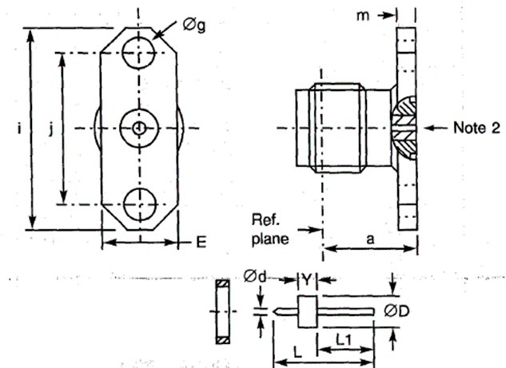
  Symbol | Dimensions mm |  | Notes
  Symbol | Min | Max | Notes
  a | 7.45 | 7.7
  Ød | - | 0.47
  ØD | - | 2.86
  E | 5.41 | 5.91
  Øg | 2.55 | 2.7 | 2 holes
  i | 15.9 | 16.1
  j | 12.1 | 12.3
  L | 7.8 | 8.2
  L1 | 4.45 | 4.7
  m | 1.4 | 1.8
  Y | 1.55 | 1.65
ELECTRICAL CHARACTERISTICS | VALUES | UNITS
Frequency range | 0 to 18 | GHz
Maximum voltage standing wave ratio (VSWR) (Note 1) | 1.06 + 0.01 f (GHz)
Maximum insertion loss (Note 1) | 0.3 | dB
Voltage proof | 1000 | Vrms
MECHANICAL CHARACTERISTICS | VALUES | UNITS
Minimum centre contact retention force (axial) | 27 | N
Minimum centre contact retention torque | Not applicable
Maximum weight | 2.1 | g
OTHER CHARACTERISTICS | VALUES | UNITS
Operating temperature range | -65 to +105 | °C
Seal: Maximum leakage | 10⁻⁸ (hermetic glass seal only) | atm.cm³/s
Solderability | On centre contact only
Cables used | Not applicable
NOTES:
            - For information purposes only.
            - Accept contact Ø0.46mm.

VARIANT 60 - BULKHEAD RECEPTACLE, WITH HERMETIC GLASS SEAL Ø0.3MM
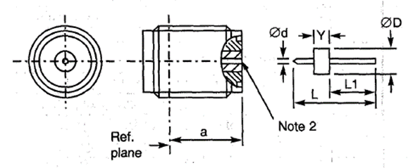
  Symbol | Dimensions mm
  Symbol | Min | Max
  a | 7.05 | 8.05
  Ød | - | 0.31
  ØD | - | 2.53
  L | 7.8 | 8.2
  L1 | 4.45 | 4.7
  Y | 1.55 | 1.65
ELECTRICAL CHARACTERISTICS | VALUES | UNITS
Frequency range | 0 to 18 | GHz
Maximum voltage standing wave ratio (VSWR) (Note 1) | 1.06 + 0.01 f (GHz)
Maximum insertion loss (Note 1) | 0.3 | dB
Voltage proof | 1000 | Vrms
MECHANICAL CHARACTERISTICS | VALUES | UNITS
Minimum centre contact retention force (axial) | 27 | N
Minimum centre contact retention torque | Not applicable
Maximum weight | 1.7 | g
OTHER CHARACTERISTICS | VALUES | UNITS
Operating temperature range | -65 to +105 | °C
Seal: Maximum leakage | 10⁻⁸ (hermetic glass seal only) | atm.cm³/s
Solderability | On centre contact only
Cables used | Not applicable
NOTES:
            - For information purposes only.
            - Accept contact Ø0.3mm.

VARIANT 61 - BULKHEAD RECEPTACLE, WITH HERMETIC GLASS SEAL Ø0.46MM
Symbol | Dimensions mm
Symbol | Min | Max
a | 7.05 | 8.05
Ød | - | 0.47
ØD | - | 2.86
L | 7.8 | 8.2
L1 | 4.45 | 4.7
Y | 1.55 | 1.65

ELECTRICAL CHARACTERISTICS | VALUES | UNITS
Frequency range | 0 to 18 | GHz
Maximum voltage standing wave ratio (VSWR) (Note 1) | 1.06 + 0.01 f (GHz)
Maximum insertion loss (Note 1) | 0.3 | dB
Voltage proof | 1000 | Vrms
MECHANICAL CHARACTERISTICS | VALUES | UNITS
Minimum centre contact retention force (axial) | 27 | N
Minimum centre contact retention torque | Not applicable
Maximum weight | 1.7 | g
OTHER CHARACTERISTICS | VALUES | UNITS
Operating temperature range | -65 to +105 | °C
Seal: Maximum leakage | 10⁻⁸ (hermetic glass seal only) | atm.cm³/s
Solderability | On centre contact only
Cables used | Not applicable
NOTES:
            - For information purposes only.
            - Accept contact Ø0.46mm.

VARIANT 62 - HERMETIC BULKHEAD RECEPTACLE, WITH COMPRESSION GASKET
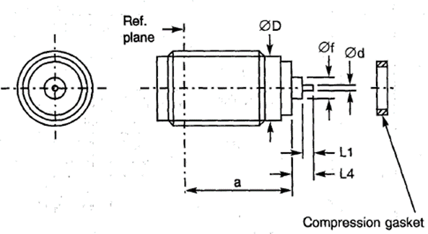
  Symbol | Dimensions mm
  Symbol | Min | Max
  a | 9.05 | 10.05
  Ød | - | 0.51
  ØD | 5.3 | 5.4
  L | - | 1.67
  L1 | 0.62 | 1.25
  L4 | 1.72 | 2.25
ELECTRICAL CHARACTERISTICS | VALUES | UNITS
Frequency range | 0 to 18 | GHz
Maximum voltage standing wave ratio (VSWR) (Note 1) | 1.06 + 0.01 f (GHz)
Maximum insertion loss (Note 1) | 0.3 | dB
Voltage proof | 1000 | Vrms
MECHANICAL CHARACTERISTICS | VALUES | UNITS
Minimum centre contact retention force (axial) | 27 | N
Minimum centre contact retention torque | Not applicable
Maximum weight | 2 | g
OTHER CHARACTERISTICS | VALUES | UNITS
Operating temperature range | -65 to +105 | °C
Seal: Maximum leakage | 10⁻⁸ | atm.cm³/s
Solderability | On centre contact only
Cables used | Not applicable
NOTES:
            - For information purposes only.

VARIANT 63 - HERMETIC BULKHEAD RECEPTACLE, WITH COMPRESSION GASKET
Symbol | Dimensions mm
Symbol | Min | Max
a | 9.05 | 10.05
Ød | 0.45 | 0.55
Ød2 | 0.65 | 0.95
Ød3 | 1.3 | 1.5
ØD | 5.3 | 5.4
L | - | 4.25
L1 | 0.7 | -

ELECTRICAL CHARACTERISTICS | VALUES | UNITS
Frequency range | 0 to 18 | GHz
Maximum voltage standing wave ratio (VSWR) (Note 1) | 1.06 + 0.01 f (GHz)
Maximum insertion loss (Note 1) | 0.3 | dB
Voltage proof | 1000 | Vrms
MECHANICAL CHARACTERISTICS | VALUES | UNITS
Minimum centre contact retention force (axial) | 27 | N
Minimum centre contact retention torque | Not applicable
Maximum weight | 2 | g
OTHER CHARACTERISTICS | VALUES | UNITS
Operating temperature range | -65 to +105 | °C
Seal: Maximum leakage | 10⁻⁸ | atm.cm³/s
Solderability | On centre contact only
Cables used | Not applicable
NOTES:
            - For information purposes only.

VARIANT 64 - HERMETIC BULKHEAD RECEPTACLE, WITH COMPRESSION GASKET
Symbol | Dimensions mm
Symbol | Min | Max
a | 9.05 | 10.05
d | 0.1 | 0.2
Ød | 0.45 | 0.55
Ød2 | 0.7 | 0.8
Ød3 | 1.3 | 1.5
ØD | 5.3 | 5.4
L | - | 4.25
L1 | 0.7 | -

ELECTRICAL CHARACTERISTICS | VALUES | UNITS
Frequency range | 0 to 18 | GHz
Maximum voltage standing wave ratio (VSWR) | 1.06 + 0.01 f (GHz)
Maximum insertion loss | 0.3 | dB
Voltage proof | 1000 | Vrms
MECHANICAL CHARACTERISTICS | VALUES | UNITS
Minimum centre contact retention force (axial) | 27 | N
Minimum centre contact retention torque | Not applicable
Maximum weight | 2 | g
OTHER CHARACTERISTICS | VALUES | UNITS
Operating temperature range | -65 to +105 | °C
Seal: Maximum leakage | 10⁻⁸ | atm.cm³/s
Solderability | On centre contact only
Cables used | Not applicable

VARIANT 65 - 2-HOLE FLANGE MALE RECEPTACLE, WITH HERMETIC GLASS SEAL Ø0.3MM AND EMI GASKET
Symbol | Dimensions mm |  | Notes
Symbol | Min | Max | Notes
a | 7.45 | 7.65
Ød | - | 0.31
ØD | - | 2.53
E | 5.41 | 5.91
Øg | 2.55 | 2.7 | 2 holes
i | 15.9 | 16.1
j | 12.1 | 12.3
L | 7.8 | 8.2
L1 | 4.45 | 4.7
m | 1.4 | 1.8
Y | 1.55 | 1.65

NOTES:
            - Accept contact Ø0.3mm.
ELECTRICAL CHARACTERISTICS | VALUES | UNITS
Frequency range | 0 to 18 | GHz
Maximum voltage standing wave ratio (VSWR) | 1.06 + 0.01 f (GHz)
Maximum insertion loss | 0.3 | dB
Voltage proof | 1000 | Vrms
MECHANICAL CHARACTERISTICS | VALUES | UNITS
Minimum centre contact retention force (axial) | 27 | N
Minimum centre contact retention torque | Not applicable
Maximum weight | 2.1 | g
OTHER CHARACTERISTICS | VALUES | UNITS
Operating temperature range | -65 to +105 | °C
Seal: Maximum leakage | 10⁻⁷ (hermetic glass seal only) | atm.cm³/s
Solderability | On centre contact only
Cables used | Not applicable

VARIANT 66 - BULKHEAD JACK, SOLDER-TYPE, FOR SHF 3 CABLE
Symbol | Dimensions mm |  | Notes
Symbol | Min | Max | Notes
a | 10.4 | 10.8
b | 25.05 | 27.1
ØD | 11.8 | 12.2
K1 | - | 8 | Hexagon
K2 | - | 5.9 | 1 flat
K3 | - | 11 | 2 flats

NOTES:
            - Maximum panel thickness: 2.3mm
ELECTRICAL CHARACTERISTICS | VALUES | UNITS
Frequency range | 0 to 17 | GHz
Maximum voltage standing wave ratio (VSWR) | 1.15
Maximum insertion loss | 0.06 √ f (GHz) | dB
Voltage proof | 750 | Vrms
MECHANICAL CHARACTERISTICS | VALUES | UNITS
Minimum centre contact retention force (axial) | Not applicable
Minimum centre contact retention torque | Not applicable
Maximum weight | 7 | g
OTHER CHARACTERISTICS | VALUES | UNITS
Operating temperature range | -65 to +165 | °C
Seal: Maximum leakage | Not applicable
Solderability | Applicable
Cables used | F1703.143

VARIANT 67 - BULKHEAD JACK, SOLDER-TYPE, FOR SHF 8 CABLE
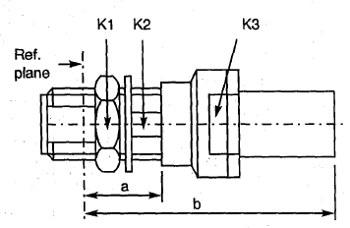
  Symbol | Dimensions mm |  | Notes
  Symbol | Min | Max | Notes
  a | 11.8 | 12.2
  b | 40.85 | 42.4
  K1 | - | 8 | Hexagon
  K2 | - | 5.9 | 1 flat
  K3 | - | 13 | 2 flats
ELECTRICAL CHARACTERISTICS | VALUES | UNITS
Frequency range | 0 to 18 | GHz
Maximum voltage standing wave ratio (VSWR) | 1.15
Maximum insertion loss | 0.06 √ f (GHz) | dB
Voltage proof | 1000 | Vrms
MECHANICAL CHARACTERISTICS | VALUES | UNITS
Minimum centre contact retention force (axial) | Not applicable
Minimum centre contact retention torque | Not applicable
Maximum weight | 25.3 | g
OTHER CHARACTERISTICS | VALUES | UNITS
Operating temperature range | -65 to +165 | °C
Seal: Maximum leakage | Not applicable
Solderability | Applicable
Cables used | F1703.148

VARIANT 68 - STRAIGHT JACK, SOLDER-TYPE, BACK MOUNTING, FLANGE-MOUNTED, FOR SEMI-RIGID CABLE Ø2.2MM
Symbol | Dimensions mm |  | Notes
Symbol | Min | Max | Notes
a | 5.87 | 6.12
Øg | 2.55 | 2.7 | 4 holes
i | 12.6 | 12.8
j | 8.59 | 8.69
J | 4.6 | 5
m | 1.4 | 1.8
ØN | 2.25 | 2.35

NOTES:
            - Maximum panel thickness: 2.3mm
ELECTRICAL CHARACTERISTICS | VALUES | UNITS
Frequency range | 0 to 18 | GHz
Maximum voltage standing wave ratio (VSWR) | 1.1 + 0.01 f (GHz)
Maximum insertion loss | 0.02 √ f (GHz) | dB
Voltage proof | 750 | Vrms
MECHANICAL CHARACTERISTICS | VALUES | UNITS
Minimum centre contact retention force (axial) | Not applicable
Minimum centre contact retention torque | Not applicable
Maximum weight | 4 | g
OTHER CHARACTERISTICS | VALUES | UNITS
Operating temperature range | -65 to +165 | °C
Seal: Maximum leakage | Not applicable
Solderability | Applicable
Cables used | KS 1, RG 405/U (Ø2.2mm)

VARIANT 69 - STRAIGHT JACK, SOLDER-TYPE, BACK MOUNTING, FLANGE-MOUNTED, FOR SEMI-RIGID CABLE Ø3.58MM
Symbol | Dimensions mm |  | Notes
Symbol | Min | Max | Notes
a | 5.87 | 6.12
Øg | 2.55 | 2.7 | 4 holes
i | 12.6 | 12.8
j | 8.59 | 8.69
J | 4.6 | 5
m | 1.4 | 1.8
ØN | 3.65 | 3.75

NOTES:
            - Maximum panel thickness: 2.3mm
ELECTRICAL CHARACTERISTICS | VALUES | UNITS
Frequency range | 0 to 18 | GHz
Maximum voltage standing wave ratio (VSWR) | 1.05 + 0.04 f (GHz)
Maximum insertion loss | 0.02 √ f (GHz) | dB
Voltage proof | 1000 | Vrms
MECHANICAL CHARACTERISTICS | VALUES | UNITS
Minimum centre contact retention force (axial) | Not applicable
Minimum centre contact retention torque | Not applicable
Maximum weight | 4 | g
OTHER CHARACTERISTICS | VALUES | UNITS
Operating temperature range | -65 to +165 | °C
Seal: Maximum leakage | Not applicable
Solderability | Applicable
Cables used | KS 2, RG 402/U (Ø3.58mm)

VARIANT 70 - STRAIGHT JACK, CRIMP-TYPE, FOR 50 CIS CABLE
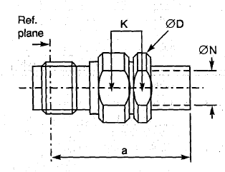
  Symbol | Dimensions mm |  | Notes
  Symbol | Min | Max | Notes
  a | 22.7 | 24.15
  ØD | 7.5 | 7.9
  K | - | 7 | 2 flats
  ØN | 2 | 2.2
ELECTRICAL CHARACTERISTICS | VALUES | UNITS
Frequency range | 0 to 12.4 | GHz
Maximum voltage standing wave ratio (VSWR) | 1.05 + 0.015 f (GHz)
Maximum insertion loss | 0.03 √ f (GHz) | dB
Voltage proof | 750 | Vrms
MECHANICAL CHARACTERISTICS | VALUES | UNITS
Minimum centre contact retention force (axial) | 27 | N
Minimum centre contact retention torque | 0.5 | N.cm
Maximum weight | 4.5 | g
OTHER CHARACTERISTICS | VALUES | UNITS
Operating temperature range | -65 to +165 | °C
Seal: Maximum leakage | Not applicable
Solderability | Applicable
Cables used | 50 CIS

VARIANT 71 - ELBOW RECEPTACLE, SQUARE FLANGE (SOLID CONTACT)
Symbol | Dimensions mm |  | Notes
Symbol | Min | Max | Notes
a1 | 7.9 | 8.1
a2 | 9.2 | 9.4
A | - | 25 | Note 1
B | - | 20 | Note 1
Ød | 1.25 | 1.3
Øf | 4 | 4.2
Øg | 2.55 | 2.7 | 4 holes
i | 12.6 | 12.8
j | 8.59 | 8.69
m | 1.4 | 1.8

NOTES:
            - Contact and Insert dimensions A and B shall be selected by the Orderer; see Para. 1.4.1(b).
ELECTRICAL CHARACTERISTICS | VALUES | UNITS
Frequency range | 0 to 18 | GHz
Maximum voltage standing wave ratio (VSWR) (Note 2) | 1.05 + 0.01 f (GHz)
Maximum insertion loss (Note 2) | 0.03 √f (GHz) | dB
Voltage proof | 1000 | Vrms
MECHANICAL CHARACTERISTICS | VALUES | UNITS
Minimum centre contact retention force (axial) | 27 | N
Minimum centre contact retention torque | 2.8 | N.cm
Maximum weight | 4.9 | g
OTHER CHARACTERISTICS | VALUES | UNITS
Operating temperature range | -65 to +105 | °C
Seal: Maximum leakage | Not applicable
Solderability | On centre contact only
Cables used | Not applicable
NOTES:
            - For information purposes only.

VARIANT 72 - SQUARE FLANGE RECEPTACLE TAB CONTACT, LOW RF LEAKAGE
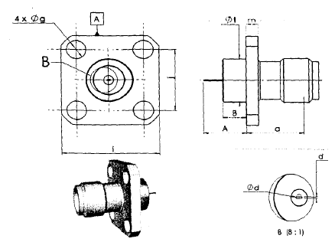
  Symbol | Dimensions mm |  | Notes
  Symbol | Min | Max | Notes
  a | 7.5 | 7.7
  A | 5.7 | 5.9
  B | 3.13 | 3.32
  d | 0.11 | 0.15 | Tab Thickness
  Ød | 0.45 | 0.55
  Øf | 6.05 | 6.15
  Øg | 2.55 | 2.7 | 4 holes
  i | 12.6 | 12.8
  j | 8.59 | 8.69
  m | 1.4 | 1.8
ELECTRICAL CHARACTERISTICS | VALUES | UNITS
Frequency range | 0 to 18 | GHz
Maximum voltage standing wave ratio (VSWR) (Note 1) | 1.1 + 0.001 f (GHz)
Maximum voltage standing wave ratio (VSWR) (Notes 1, 2) | 1.05 + 0.005 f (GHz)
Maximum insertion loss (Note 1) | 0.05 √ f (GHz) | dB
Maximum insertion loss (Notes 1, 2) | 0.03 √ f (GHz) | dB
Voltage proof | 1000 | Vrms
MECHANICAL CHARACTERISTICS | VALUES | UNITS
Minimum centre contact retention force (axial) | 27 | N
Minimum centre contact retention torque | 2.8 | N.cm
Maximum weight | 3.5 | g
OTHER CHARACTERISTICS | VALUES | UNITS
Operating temperature range | -65 to +105 | °C
Seal: Maximum leakage | Not applicable
Solderability | On centre contact only
Cables used | Not applicable
NOTES:
            - For information purposes only.
            - Between 0 and 5 GHz only.

VARIANT 73 - SQUARE FLANGE RECEPTACLE, FRONT MOUNTING
Symbol | Dimensions mm |  | Notes
Symbol | Min | Max | Notes
a | 7.5 | 7.7
A |  | 35 | Note 1
B | - | 20 | Note 1
Ød | 1.24 | 1.3
Øf | 4 | 4.2
Øg | 2.55 | 2.7 | 4 holes
i | 12.6 | 12.8
j | 8.59 | 8.69
k | 2.4 | -
m | 1.4 | 1.8
ØN | 0.7 | 1

NOTES:
            - Contact and Insert dimensions A and B shall be selected by the Orderer; see Para. 1.4.1(b).
ELECTRICAL CHARACTERISTICS | VALUES | UNITS
Frequency range | 0 to 18 | GHz
Maximum voltage standing wave ratio (VSWR) (Note 2) | 1.05 + 0.003 f (GHz)
Maximum insertion loss (Note 2) | 0.03 √f (GHz) | dB
Voltage proof | 1000 | Vrms
MECHANICAL CHARACTERISTICS | VALUES | UNITS
Minimum centre contact retention force (axial) | 27 | N
Minimum centre contact retention torque | 2.8 | N.cm
Maximum weight | 3 | g
OTHER CHARACTERISTICS | VALUES | UNITS
Operating temperature range | -65 to +165 | °C
Seal: Maximum leakage | Not applicable
Solderability | On centre contact only
Cables used | Not applicable
NOTES:
            - For information purposes only.

VARIANT 74 - 2-HOLE FLANGE RECEPTACLE, FRONT MOUNTING
Symbol | Dimensions mm |  | Notes
Symbol | Min | Max | Notes
a | 7.5 | 7.7
A | - | 35 | Note 1
B | - | 20 | Note 1
Ød | 1.24 | 1.3
E | 5.5 | 5.8
Øf | 4 | 4.2
Øg | 2.55 | 2.7 | 2 holes
i | 15.9 | 16.1
j | 12.1 | 12.3
k | 2.4 | -
m | 1.4 | 1.8
ØN | 0.7 | 1

NOTES:
            - Contact and Insert dimensions A and B shall be selected by the Orderer; see Para. 1.4.1(b).
ELECTRICAL CHARACTERISTICS | VALUES | UNITS
Frequency range | 0 to 18 | GHz
Maximum voltage standing wave ratio (VSWR) (Note 2) | 1.05 + 0.003 f (GHz)
Maximum insertion loss (Note 2) | 0.03 √f (GHz) | dB
Voltage proof | 1000 | Vrms
MECHANICAL CHARACTERISTICS | VALUES | UNITS
Minimum centre contact retention force (axial) | 27 | N
Minimum centre contact retention torque | 2.8 | N.cm
Maximum weight | 2.3 | g
OTHER CHARACTERISTICS | VALUES | UNITS
Operating temperature range | -65 to +165 | °C
Seal: Maximum leakage | Not applicable
Solderability | On centre contact only
Cables used | Not applicable
NOTES:
            - For information purposes only.

VARIANT 75 - 2-HOLE FLANGE RECEPTACLE FOR MICRO-STRIP, FRONT MOUNTING
Symbol | Dimensions mm |  | Notes
Symbol | Min | Max | Notes
a | 7.5 | 7.6
A | 4.5 | 5
B | 3.05 | 3.3
Ød | 0.2 | 0.3
E | 5.5 | 5.8
Øf | 2.1 | 2.2
Øg | 2.55 | 2.7 | 2 holes
i | 15.9 | 16.1
j | 12.1 | 12.3
m | 1.4 | 1.8

ELECTRICAL CHARACTERISTICS | VALUES | UNITS
Frequency range | 0 to 12.4 | GHz
Maximum voltage standing wave ratio (VSWR) (Note 1) | 1.04 + 0.018 f (GHz)
Maximum insertion loss (Note 1) | 0.03√f (GHz) | dB
Voltage proof | 1000 | Vrms
MECHANICAL CHARACTERISTICS | VALUES | UNITS
Minimum centre contact retention force (axial) | 27 | N
Minimum centre contact retention torque | 2.8 | N.cm
Maximum weight | 2.3 | g
OTHER CHARACTERISTICS | VALUES | UNITS
Operating temperature range | -65 to +165 | °C
Seal: Maximum leakage | Not applicable
Solderability | On centre contact only
Cables used | Not applicable
NOTES:
            - For information purposes only.

VARIANT 76 - SQUARE FLANGE RECEPTACLE FOR MICRO-STRIP, FRONT MOUNTING
Symbol | Dimensions mm |  | Notes
Symbol | Min | Max | Notes
a | 7.5 | 7.6
A | 4.6 | 4.9
B | 3.05 | 3.3
Ød | 0.2 | 0.3
Øf | 2.1 | 2.2
Øg | 2.55 | 2.7 | 4 holes
i | 12.6 | 12.8
j | 8.59 | 8.69
m | 1.4 | 1.8

ELECTRICAL CHARACTERISTICS | VALUES | UNITS
Frequency range | 0 to 12.4 | GHz
Maximum voltage standing wave ratio (VSWR) (Note 1) | 1.04 + 0.018 f (GHz)
Maximum insertion loss (Note 1) | 0.03 √f (GHz) | dB
Voltage proof | 1000 | Vrms
MECHANICAL CHARACTERISTICS | VALUES | UNITS
Minimum centre contact retention force (axial) | 27 | N
Minimum centre contact retention torque | 2.8 | N.cm
Maximum weight | 3 | g
OTHER CHARACTERISTICS | VALUES | UNITS
Operating temperature range | -65 to +165 | °C
Seal: Maximum leakage | Not applicable
Solderability | On centre contact only
Cables used | Not applicable
NOTES:
            - For information purposes only.

VARIANT 77 - SQUARE FLANGE RECEPTACLE
Symbol | Dimensions mm |  | Notes
Symbol | Min | Max
a | 7.5 | 7.7
A | - | 40.1 | Note 1
B | - | 30 | Note 1
Ød | 1.25 | 1.3
Øf | 4 | 4.2
Øg | 2.55 | 2.7 | 4 holes
i | 12.6 | 12.8
j | 8.59 | 8.69
m | 1.4 | 1.8

NOTES:
            - Contact and Insert dimensions A and B shall be selected by the Orderer; see Para. 1.4.1(b).
ELECTRICAL CHARACTERISTICS | VALUES | UNITS
Frequency range | 0 to 18 | GHz
Maximum voltage standing wave ratio (VSWR) (Note 2) | 1.05 + 0.003 f (GHz)
Maximum insertion loss (Note 2) | 0.03 √f(GHz) | dB
Voltage proof | 1000 | Vrms
MECHANICAL CHARACTERISTICS | VALUES | UNITS
Minimum centre contact retention force (axial) | 27 | N
Minimum centre contact retention torque | 2.8 | N.cm
Maximum weight | 5 | g
OTHER CHARACTERISTICS | VALUES | UNITS
Operating temperature range | -65 to +155 | °C
Seal: Maximum leakage | Not applicable
Solderability | On centre contact only
Cables used | Not applicable
NOTES:
            - For information purposes only.

VARIANT 78 - 2-HOLE FLANGE RECEPTACLE
Symbol | Dimensions mm |  | Notes
Symbol | Min | Max | Notes
a | 7.5 | 7.6
A | - | 40.1 | Note 1
B | - | 20 | Note 1
Ød | 1.25 | 1.3
E | 5.5 | 5.8
Øf | 4 | 4.2
Øg | 2.55 | 2.7 | 2 holes
i | 15.9 | 16.1
j | 12.1 | 12.3
m | 1.4 | 1.8

NOTES:
            - Contact and Insert dimensions A and B shall be selected by the Orderer; see Para. 1.4.1(b).
ELECTRICAL CHARACTERISTICS | VALUES | UNITS
Frequency range | 0 to 18 | GHz
Maximum voltage standing wave ratio (VSWR) (Note 2) | 1.05 + 0.003 f (GHz)
Maximum insertion loss (Note 2) | 0.03 √f (GHz) | dB
Voltage proof | 1000 | Vrms
MECHANICAL CHARACTERISTICS | VALUES | UNITS
Minimum centre contact retention force (axial) | 27 | N
Minimum centre contact retention torque | 2.8 | N.cm
Maximum weight | 4 | g
OTHER CHARACTERISTICS | VALUES | UNITS
Operating temperature range | -65 to +165 | °C
Seal: Maximum leakage | Not applicable
Solderability | On centre contact only
Cables used | Not applicable
NOTES:
            - For information purposes only.

VARIANT 79 - SQUARE FLANGE RECEPTACLE
Symbol | Dimensions mm |  | Notes
Symbol | Min | Max | Notes
a | 7.5 | 7.7
e | 0.18 | 0.41
Øg | 2.55 | 2.7 | 4 holes
i | 12.6 | 12.8
j | 8.59 | 8.69
m | 1.4 | 1.8

ELECTRICAL CHARACTERISTICS | VALUES | UNITS
Frequency range | 0 to 18 | GHz
Maximum voltage standing wave ratio (VSWR) | 1.06 + 0.007 f (GHz)
Maximum insertion loss (Note 1) | 0.03 √f (GHz) | dB
Voltage proof | 1000 | Vrms
MECHANICAL CHARACTERISTICS | VALUES | UNITS
Minimum centre contact retention force (axial) | 27 | N
Minimum centre contact retention torque | Not applicable
Maximum weight | 3 | g
OTHER CHARACTERISTICS | VALUES | UNITS
Operating temperature range | -65 to +165 | °C
Seal: Maximum leakage | Not applicable
Solderability | Not applicable
Cables used | Not applicable
NOTES:
            - For information purposes only.
            - Contact Engagement and Separation Forces shall be measured on the rear contact (see Para. 2.3(a)).

VARIANT 80 - 2-HOLE FLANGE RECEPTACLE
Symbol | Dimensions mm |  | Notes
Symbol | Min | Max | Notes
a | 7.5 | 7.6
e | 0.18 | 0.41
E | 5.5 | 5.8
Øg | 2.55 | 2.7 | 2 holes
i | 15.9 | 16.1
j | 12.1 | 12.3
m | 1.4 | 1.8

ELECTRICAL CHARACTERISTICS | VALUES | UNITS
Frequency range | 0 to 18 | GHz
Maximum voltage standing wave ratio (VSWR) | 1.06 + 0.006 f (GHz)
Maximum insertion loss (Note 1) | 0.03 √f (GHz) | dB
Voltage proof | 1000 | Vrms
MECHANICAL CHARACTERISTICS | VALUES | UNITS
Minimum centre contact retention force (axial) | 27 | N
Minimum centre contact retention torque | 2.8 | N.cm
Maximum weight | 2.3 | g
OTHER CHARACTERISTICS | VALUES | UNITS
Operating temperature range | -65 to +165 | °C
Seal: Maximum leakage | Not applicable
Solderability | Not applicable
Cables used | Not applicable
NOTES:
            - For information purposes only.
            - Contact Engagement and Separation Forces shall be measured on the rear contact (see Para. 2.3(a)).

VARIANT 81 - SQUARE FLANGE RECEPTACLE, LOW RF LEAKAGE
Symbol | Dimensions mm |  | Notes
Symbol | Min | Max
a | 7.5 | 7.7
A | - | 35 | Note 1
B | - | 20 | Note 1
Ød | 1.25 | 1.3
Øf | 4 | 4.2
Øg | 2.55 | 2.7 | 4 holes
i | 12.6 | 12.8
j | 8.59 | 8.69
m | 1.4 | 1.8

NOTES:
            - Contact and Insert dimensions A and B shall be selected by the Orderer; see Para. 1.4.1(b).
ELECTRICAL CHARACTERISTICS | VALUES | UNITS
Frequency range | 0 to 18 | GHz
Maximum voltage standing wave ratio (VSWR) (Note 2) | 1.05 + 0.003 f (GHz)
Maximum insertion loss (Note 2) | 0.03 √f (GHz) | dB
Voltage proof | 1000 | Vrms
MECHANICAL CHARACTERISTICS | VALUES | UNITS
Minimum centre contact retention force (axial) | 27 | N
Minimum centre contact retention torque | 2.8 | N.cm
Maximum weight | 4 | g
OTHER CHARACTERISTICS | VALUES | UNITS
Operating temperature range | -65 to +165 | °C
Seal: Maximum leakage | Not applicable
Solderability | On centre contact only
Cables used | Not applicable
NOTES:
            - For information purposes only.

VARIANT 82 - 2-HOLE FLANGE RECEPTACLE, LOW RF LEAKAGE
Symbol | Dimensions mm |  | Notes
Symbol | Min | Max | Notes
a | 7.5 | 7.7
A | - | 40.1 | Note 1
B | - | 20 | Note 1
Ød | 1.25 | 1.3
E | 5.5 | 5.8
Øf | 4 | 4.2
Øg | 2.55 | 2.7 | 2 holes
i | 15.9 | 16.1
j | 12.1 | 12.3
m | 1.4 | 1.8

NOTES:
            - Contact and Insert dimensions A and B shall be selected by the Orderer; see Para. 1.4.1(b).
ELECTRICAL CHARACTERISTICS | VALUES | UNITS
Frequency range | 0 to 18 | GHz
Maximum voltage standing wave ratio (VSWR) (Note 2) | 1.05 + 0.003 f (GHz)
Maximum insertion loss (Note 2) | 0.03 √f (GHz) | dB
Voltage proof | 1000 | Vrms
MECHANICAL CHARACTERISTICS | VALUES | UNITS
Minimum centre contact retention force (axial) | 27 | N
Minimum centre contact retention torque | 2.8 | N.cm
Maximum weight | 3.3 | g
OTHER CHARACTERISTICS | VALUES | UNITS
Operating temperature range | -65 to +165 | °C
Seal: Maximum leakage | Not applicable
Solderability | On centre contact only
Cables used | Not applicable
NOTES:
            - For information purposes only.

VARIANT 83 - BULKHEAD RECEPTACLE, WITH HERMETIC GLASS SEAL Ø0.3MM
Symbol | Dimensions mm
Symbol | Min | Max
a | 7.05 | 8.05
Ød | - | 0.31
ØD | - | 2.53
L | 7.8 | 8.2
L1 | 4.45 | 4.7
Y | 1.55 | 1.65

ELECTRICAL CHARACTERISTICS | VALUES | UNITS
Frequency range | 0 to 18 | GHz
Maximum voltage standing wave ratio (VSWR) (Note 1) | 1.06 + 0.01 f (GHz)
Maximum insertion loss (Note 1) | 0.03 √ f (GHz) | dB
Voltage proof | 1000 | Vrms
MECHANICAL CHARACTERISTICS | VALUES | UNITS
Minimum centre contact retention force (axial) | 27 | N
Minimum centre contact retention torque | Not applicable
Maximum weight | 1.7 | g
OTHER CHARACTERISTICS | VALUES | UNITS
Operating temperature range | -65 to +165 | °C
Seal: Maximum leakage | 10⁻⁸ (hermetic glass seal only) | atm.cm³/s
Solderability | On centre contact only
Cables used | Not applicable
NOTES:
            - For information purposes only.
            - Accept contact Ø0.3mm.

VARIANT 84 - BULKHEAD RECEPTACLE, WITH HERMETIC GLASS SEAL Ø0.46MM
Symbol | Dimensions mm
Symbol | Min | Max
a | 7.05 | 8.05
Ød | - | 0.47
ØD | - | 2.86
L | 7.8 | 8.2
L1 | 4.45 | 4.7
Y | 1.55 | 1.65

ELECTRICAL CHARACTERISTICS | VALUES | UNITS
Frequency range | 0 to 18 | GHz
Maximum voltage standing wave ratio (VSWR) (Note 1) | 1.06 + 0.01 f (GHz)
Maximum insertion loss (Note 1) | 0.03 √ f (GHz) | dB
Voltage proof | 1000 | Vrms
MECHANICAL CHARACTERISTICS | VALUES | UNITS
Minimum centre contact retention force (axial) | 27 | N
Minimum centre contact retention torque | Not applicable
Maximum weight | 1.7 | g
OTHER CHARACTERISTICS | VALUES | UNITS
Operating temperature range | -65 to +165 | °C
Seal: Maximum leakage | 10⁻⁸ (hermetic glass seal only) | atm.cm³/s
Solderability | On centre contact only
Cables used | Not applicable
NOTES:
            - For information purposes only.
            - Accept contact Ø0.46mm.

VARIANT 85 - ELBOW RECEPTACLE, SQUARE FLANGE (SOLID CONTACT)
Symbol | Dimensions mm |  | Notes
Symbol | Min | Max | Notes
a1 | 7.9 | 8.1
a2 | 9.2 | 9.4
A | - | 25 | Note 1
B | - | 20 | Note 1
Ød | 1.25 | 1.3
Øf | 4 | 4.2
Øg | 2.55 | 2.7 | 4 holes
i | 12.6 | 12.8
j | 8.59 | 8.69
m | 1.4 | 1.8

NOTES:
            - Contact and Insert dimensions A and B shall be selected by the Orderer; see Para. 1.4.1(b).
ELECTRICAL CHARACTERISTICS | VALUES | UNITS
Frequency range | 0 to 18 | GHz
Maximum voltage standing wave ratio (VSWR) (Note 2) | 1.05 + 0.01 f (GHz)
Maximum insertion loss (Note 2) | 0.03 √f (GHz) | dB
Voltage proof | 1000 | Vrms
MECHANICAL CHARACTERISTICS | VALUES | UNITS
Minimum centre contact retention force (axial) | 27 | N
Minimum centre contact retention torque | 2.8 | N.cm
Maximum weight | 5.3 | g
OTHER CHARACTERISTICS | VALUES | UNITS
Operating temperature range | -65 to +165 | °C
Seal: Maximum leakage | Not applicable
Solderability | On centre contact only
Cables used | Not applicable
NOTES:
            - For information purposes only.

VARIANT 86 - SQUARE FLANGE RECEPTACLE, LOW VSWR, EXTENDED FREQUENCY RANGE
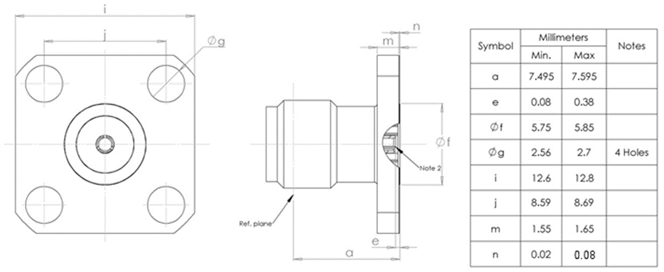
ELECTRICAL CHARACTERISTICS | VALUES | UNITS
Frequency range | 0 to 22 | GHz
Maximum voltage standing wave ratio (VSWR) | 1.05 + 0.0027 f (GHz)
Maximum insertion loss (Note 1) | 0.03 + 0.02 √f (GHz) | dB
Voltage proof | 1000 | Vrms
MECHANICAL CHARACTERISTICS | VALUES | UNITS
Minimum centre contact retention force (axial) | 27 | N
Minimum centre contact retention torque | < 0.2 | N.cm
Maximum weight | 2.8 | g
OTHER CHARACTERISTICS | VALUES | UNITS
Operating temperature range | -65 to +165 | °C
Seal: Maximum leakage | Not applicable
Solderability | Not applicable
Cables used | Not applicable
NOTES:
            - For information purposes only.
            - Contact Engagement and Separation Forces shall be measured on the rear contact (see Para. 2.3(a)).

VARIANT 87 - SQUARE FLANGE RECEPTACLE, LOW VSWR, EXTENDED FREQUENCY RANGE
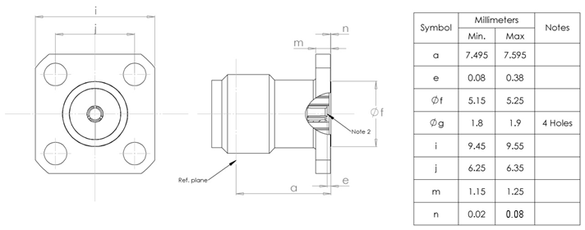
ELECTRICAL CHARACTERISTICS | VALUES | UNITS
Frequency range | 0 to 22 | GHz
Maximum voltage standing wave ratio (VSWR) | 1.05 + 0.0027 f (GHz)
Maximum insertion loss (Note 1) | 0.03 + 0.02 √f (GHz) | dB
Voltage proof | 1000 | Vrms
MECHANICAL CHARACTERISTICS | VALUES | UNITS
Minimum centre contact retention force (axial) | 27 | N
Minimum centre contact retention torque | < 0.2 | N.cm
Maximum weight | 1.8 | g
OTHER CHARACTERISTICS | VALUES | UNITS
Operating temperature range | -65 to +165 | °C
Seal: Maximum leakage | Not applicable
Solderability | Not applicable
Cables used | Not applicable
NOTES:
            - For information purposes only.
            - Contact Engagement and Separation Forces shall be measured on the rear contact (see Para. 2.3(a)).

VARIANT 88 - SQUARE FLANGE RECEPTACLE, LOW VSWR, EXTENDED FREQUENCY RANGE
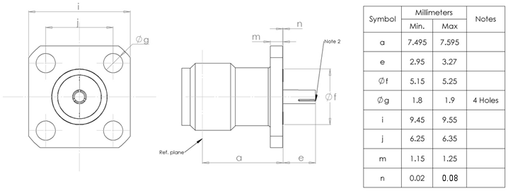
ELECTRICAL CHARACTERISTICS | VALUES | UNITS
Frequency range | 0 to 22 | GHz
Maximum voltage standing wave ratio (VSWR) | 1.05 + 0.0027 f (GHz)
Maximum insertion loss (Note 1) | 0.03 + 0.02 √f (GHz) | dB
Voltage proof | 1000 | Vrms
MECHANICAL CHARACTERISTICS | VALUES | UNITS
Minimum centre contact retention force (axial) | 27 | N
Minimum centre contact retention torque | < 0.2 | N.cm
Maximum weight | 1.8 | g
OTHER CHARACTERISTICS | VALUES | UNITS
Operating temperature range | -65 to +165 | °C
Seal: Maximum leakage | Not applicable
Solderability | Not applicable
Cables used | Not applicable
NOTES:
            - For information purposes only.
            - Contact Engagement and Separation Forces shall be measured on the rear contact (see Para. 2.3(a)).

VARIANT 89 - SQUARE FLANGE RECEPTACLE, LOW VSWR, EXTENDED FREQUENCY RANGE
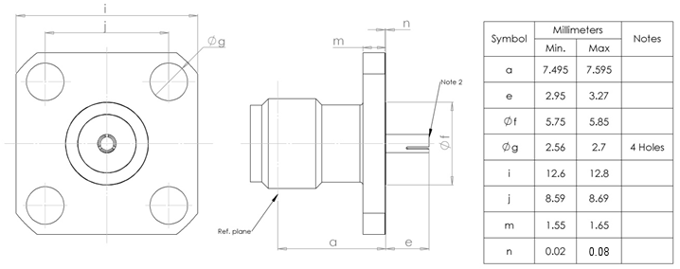
ELECTRICAL CHARACTERISTICS | VALUES | UNITS
Frequency range | 0 to 22 | GHz
Maximum voltage standing wave ratio (VSWR) | 1.05 + 0.0027 f (GHz)
Maximum insertion loss (Note 1) | 0.03 + 0.02 √f (GHz) | dB
Voltage proof | 1000 | Vrms
MECHANICAL CHARACTERISTICS | VALUES | UNITS
Minimum centre contact retention force (axial) | 27 | N
Minimum centre contact retention torque | < 0.2 | N.cm
Maximum weight | 1.8 | g
OTHER CHARACTERISTICS | VALUES | UNITS
Operating temperature range | -65 to +165 | °C
Seal: Maximum leakage | Not applicable
Solderability | Not applicable
Cables used | Not applicable
NOTES:
            - For information purposes only.
            - Contact Engagement and Separation Forces shall be measured on the rear contact (see Para. 2.3(a)).

