

Page 1 of 16

SWITCHES, THERMOSTATIC, BIMETALLIC, SPST WITH SNAP ACTION, WITH OPENING OR CLOSING CONTACT
BASED ON TYPE TH47
ESCC Detail Specification No. 3702/001
Issue 8 Draft B | June 2021



Document Custodian: European Space Agency – see https://escies.org

LEGAL DISCLAIMER AND COPYRIGHT
European Space Agency, Copyright © 2021. All rights reserved.
The European Space Agency disclaims any liability or responsibility, to any person or entity, with respect to any loss or damage caused, or alleged to be caused, directly or indirectly by the use and application of this ESCC publication.
This publication, without the prior permission of the European Space Agency and provided that it is not used for a commercial purpose, may be:
- copied in whole, in any medium, without alteration or modification.
- copied in part, in any medium, provided that the ESCC document identification, comprising the ESCC symbol, document number and document issue, is removed.

DOCUMENTATION CHANGE NOTICE
(Refer to https://escies.org for ESCC DCR content)
DCR No. | CHANGE DESCRIPTION
1400 | Specification upissued to incorporate changes per DCR.

TABLE OF CONTENTS

1 GENERAL 5
1.1 SCOPE 5
1.2 APPLICABLE DOCUMENTS 5
1.3 TERMS, DEFINITIONS, ABBREVIATIONS, SYMBOLS AND UNITS 5
1.4 THE ESCC COMPONENT NUMBER AND COMPONENT TYPE VARIANTS 5
1.4.1 The ESCC Component Number 5
1.4.2 Component Type Variants and Range of Components 6
1.5 MAXIMUM RATINGS 8
1.6 PHYSICAL DIMENSIONS 9
1.6.1 Case without Fixings (Variant 01) 9
1.6.2 Case with 2 Hole Flange Mount (Variant 02) 10
1.6.3 Case with 5mm M4 Mounting Stud (Variant 03) 11
1.7 FUNCTIONAL DIAGRAM 11
1.8 MATERIALS AND FINISHES 12
1.8.1 Case 12
1.8.2 Terminal Material and Finish 12
2 REQUIREMENTS 12
2.1 GENERAL 12
2.1.1 Deviations from the Generic Specification 12
2.2 MARKING 12
2.3 ROBUSTNESS OF TERMINATIONS 12
2.4 Thermal Measurements 13
2.5 Electrical Measurements 13
2.6 PARAMETER DRIFT VALUES 14
2.7 INTERMEDIATE AND END-POINT THERMAL AND ELECTRICAL MEASUREMENTS 14
APPENDIX A 16

GENERAL

SCOPE
This specification details the ratings, physical and electrical characteristics, and test and inspection data for the component type variants and/or the Component Type Variants and Range of Components specified below. It supplements the requirements of, and shall be read in conjunction with, the ESCC Generic Specification listed under Applicable Documents.

APPLICABLE DOCUMENTS
The following documents form part of this specification and shall be read in conjunction with it:
          - ESCC Generic Specification No. 3702.

TERMS, DEFINITIONS, ABBREVIATIONS, SYMBOLS AND UNITS
For the purpose of this specification, the terms, definitions, abbreviations, symbols and units specified in ESCC Basic Specification No. 21300 shall apply. In addition the definitions specified in the Generic Specification shall apply.

THE ESCC COMPONENT NUMBER AND COMPONENT TYPE VARIANTS

The ESCC Component Number
The ESCC Component Number shall be constituted as follows:
Example: 370200101B026020HY
- Detail Specification Reference: 3702001
- Component Type Variant Number: 01 (as required)
- Characteristic code: contact type (opening): B (as required)
- Characteristic code: nominal functioning temperature, TNF (+26°C): 026 (as required)
- Characteristic code: nominal restoring temperature, TNR (+20°C): 020 (as required)
- Characteristic code: switching temperature tolerance, Tol (±3°C): H (as required)
- Characteristic code: grade: Y (as required)

Characteristics Codes
Characteristics to be codified as part of the ESCC Component Number shall be as follows:
          - Contact Type expressed by means of the following codes:
Contact Type | Code
Switch with Opening Contact:  A component where the switch contact will open when the temperature rises to a value equal to or greater than the upper of the two switching temperatures | B
Switch with Closing Contact:  A component where the switch contact will close when the temperature rises to a value equal to or greater than the upper of the two switching temperatures | C
          - Nominal functioning temperature, TNF, and nominal restoring temperature, TNR, each expressed by means of the following codes (see Para. 1.4.2 Note 2). The unit quantity shall be °C.
Nominal Functioning and Restoring Temperature  TNF, TNR  (°C) | Code
+XXX | XXX
+XX | 0XX
+X | 00X
0 | 000
-X | 60X
-XX | 6XX
          - The switching temperature tolerance, Tol, relative to TNF and TNR, expressed by the following codes (see Para. 1.4.2 Note 2):
Temperature Tolerance  Tol  (± °C) | Code
2 | B
3 | H
5 | J
          - Component grade expressed by the following codes (see Para. 1.4.2 Note 2):
Grade Description | Code
A switch designed to operate within the specified switching temperatures tolerance that also maintains a minimum actual temperature differential | Y
A switch designed to operate within the specified switching temperatures tolerance that also maintains both a minimum and a maximum actual temperature differential | Z

Component Type Variants and Range of Components
The Component Type Variants and Range of Components applicable to this specification are as follows:
Variant  Number | Mounting Details (See Note 1) | Thermal Switching Characteristics  (TNF, TNR, Tol, Nom Diff, Act Diff) | Weight Max  (g)
01 | Case without Fixings | See Note 2 | 7.5
02 | Case with 2 Hole Flange Mount | See Note 2 | 7.5
03 | Case with 5mm M4 Mounting Stud | See Note 2 | 8
NOTES:
            - See Para. 1.6.
            - The following thermal switching characteristic details apply to the available range of components:
Grade Y:
Nominal Functioning Temperature  TNF  (°C) | Nominal Restoring Temperature  TNR  (°C) | Temperature Tolerance  Tol  (± °C) | Nominal Temperature Differential  Nom Diff  (TNF – TNR)  (°C) | Actual Temperature Differential  Act Diff  (TF – TR)  (°C)
 |  |  |  | Min | Max
-36 to -31 | -45 to -40 | 5 | 9 to 14 | 4 | Nom Diff + 2Tol
-30 to +99 | -44 to +94 | 3 | 5 to 14 | 4 | Nom Diff + 2Tol
 | -40 to +94 | 2 | 5 to 10 | 4 | Nom Diff + 2Tol
+100 to +150 | +85 to +140 | 5 | 10 to 15 | 4 | Nom Diff + 2Tol
Grade Z:
Nominal Functioning Temperature  TNF  (°C) | Nominal Restoring Temperature  TNR  (°C) | Temperature Tolerance  Tol  (± °C) | Nominal Temperature Differential  Nom Diff  (TNF – TNR)  (°C) | Actual Temperature Differential  Act Diff  (TF – TR)  (°C)
 |  |  |  | Min | Max
-35 to -31 | -45 to -41 | 5 | 10 | 4 | 18
 |  | 3 |  | 4 | 14
 | -44 to -40 | 3 | 9 | 4 | 13
 | -43 to -39 | 3 | 8 | 4 | 12
 | -42 to -38 | 3 | 7 | 4 | 11
-30 to +99 | -40 to +89 | 3 | 10 | 4 | 13
 |  | 2 |  | 4 | 12
 | -39 to +90 | 3 | 9 | 4 | 12
 |  | 2 |  | 4 | 11
 | -38 to +91 | 3 | 8 | 4 | 11
 |  | 2 |  | 4 | 10
 | -37 to +92 | 3 | 7 | 4 | 10
 |  | 2 |  | 4 | 9
 | -36 to +93 | 3 | 6 | 4 | 9
 |  | 2 |  | 4 | 8
 | -35 to +94 | 3 | 5 | 4 | 8
 |  | 2 |  | 4 | 7.5
+100 to +150 | +90 to +140 | 5 | 10 | 4 | 17
 |  | 3 |  | 4 | 13
 | +91 to +141 | 3 | 9 | 4 | 12
 | +92 to +142 | 3 | 8 | 4 | 11
 | +93 to +143 | 3 | 7 | 4 | 10

MAXIMUM RATINGS
The maximum ratings shall not be exceeded at any time during use or storage.
Maximum ratings shall only be exceeded during testing to the extent specified in this specification and when stipulated in Test Methods and Procedures of the ESCC Generic Specification.
Characteristics | Symbols | Maximum Ratings | Units | Remarks
Rated Current | I_{R} | 4 | A | V ≤ 30V resistive  100000 switching cycles  Note 1
Overload Current | I_{overload} | 6 | A | V ≤ 30V resistive
Rated Voltage | V_{R} | 120 | V | I ≤ 0.3A resistive  100000 switching cycles  Note 1
Operating Temperature Range | T_{op} | -50 to +155 | °C
Storage Temperature Range | T_{stg} | -65 to +175 | °C
Soldering Temperature | T_{sol} | +260 | °C | Note 2
Notes:
            - Derate as follows:
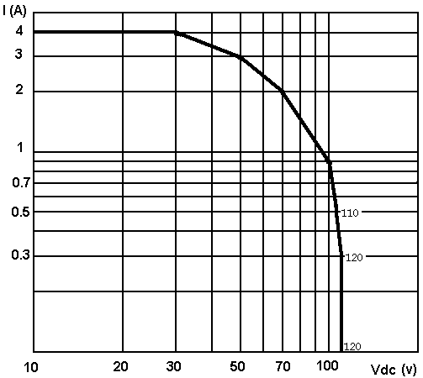
            - Duration 10 seconds maximum, greater than 1.5mm from the body; the same terminal shall not be resoldered until 3 minutes have elapsed.

PHYSICAL DIMENSIONS

Case without Fixings (Variant 01)
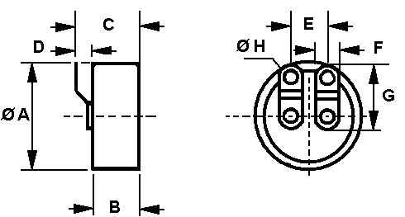
Symbol | Dimension (mm)
Symbol | Min | Max
ØA | 15.3 | 15.5
B | 7.3 | 7.5
C | - | 11
D | 2.5 | -
E | 6.25 | 6.45
F | 3.8 | 4
G | - | 10
ØH | 1.9 | 2.1

Case with 2 Hole Flange Mount (Variant 02)
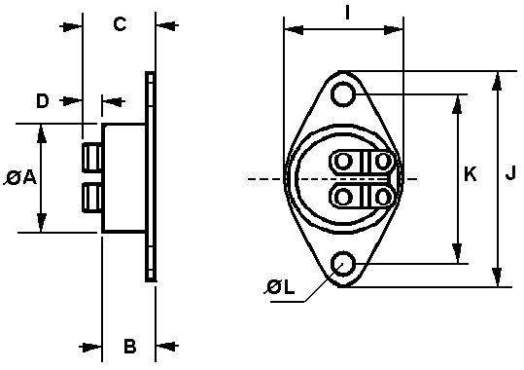
Symbol | Dimension (mm) (Note 1)
Symbol | Min | Max
ØA | 15.3 | 15.5
B | 7.8 | 8
C | - | 11.5
D | 2.5 | -
I | 16 | 16.2
J | 30 | 30.2
K | 23.7 | 23.9
ØL | 3.5 | 3.7
NOTES:
            - Dimensions E, F, G, ØH from Para. 1.6.1 also apply.

Case with 5mm M4 Mounting Stud (Variant 03)
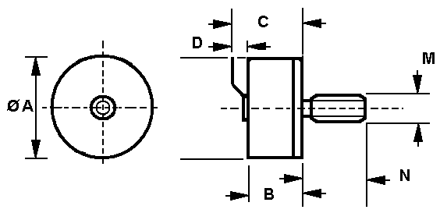
Symbol | Dimension (mm)
Symbol | Min | Max
ØA | 15.3 | 15.5
B | 8.1 | 8.3
C | - | 11.8
D | 2.5 | -
M | M4
N | 4.9 | 5.1
NOTES:
            - Dimensions E, F, G, ØH from Para. 1.6.1 also apply.

FUNCTIONAL DIAGRAM
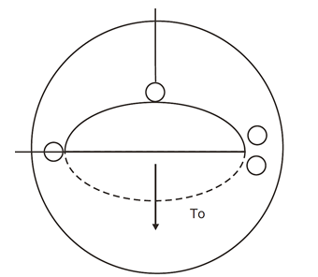
NOTES:
            - Contact opens or closes with increasing temperature (see Para. 1.4.1.1(a)).
            - The terminals are isolated from the case.

MATERIALS AND FINISHES

Case
The case shall Nickel-iron alloy, with electroless nickel plating, hermetically sealed, welded construction. Neither electro-deposited tin nor any paint shall be used.

Terminal Material and Finish
Terminal material shall be Type D with Type 19 finish in accordance with the requirements of ESCC Basic Specification No. 23500.

REQUIREMENTS

GENERAL
The complete requirements for procurement of the components specified herein are as stated in this specification and the ESCC Generic Specification. Permitted deviations from the Generic Specification, applicable to this specification only, are listed below.
Permitted deviations from the Generic Specification and this Detail Specification, formally agreed with specific Manufacturers on the basis that the alternative requirements are equivalent to the ESCC requirement and do not affect the component’s reliability, are listed in the appendices attached to this specification.

Deviations from the Generic Specification

Deviations from Screening Tests - Chart F3
          - Seal, Fine Leak: The maximum helium measured leak rate shall be: R = 1 x10⁻⁸ atm.cm³/s maximum.

Deviations from Qualification and Periodic Testing - Chart F4
          - Seal, Fine Leak: The maximum helium measured leak rate shall be: R = 1 x10⁻⁸ atm.cm³/s maximum.
          - Solderability: For test method 2, soldering iron size B shall apply.

MARKING
The marking shall be in accordance with the requirements of ESCC Basic Specification No. 21700. The information to be marked shall be:
          - The ESCC qualified components symbol (for ESCC qualified components only).
          - The ESCC Component Number (see Para. 1.4.1).
          - Traceability information.

ROBUSTNESS OF TERMINATIONS
The test conditions for Robustness of Terminations, tested as specified in the Generic Specification, shall be as follows:
- Test Ua₁ (tensile): applied force: 20N, in the axis of the terminals.

Thermal Measurements
Characteristics | Symbols | Test Method and Conditions | Limits  (Note 1) |  | Units
Characteristics | Symbols | Test Method and Conditions | Min | Max | Units
Functioning Temperature | TF | ESCC No. 3702  Note 1 | TNF – Tol | TNF + Tol | °C
Restoring Temperature | TR | ESCC No. 3702  Note 1 | TNR – Tol | TNR + Tol | °C
Actual Temperature Differential | Act Diff | = TF – TR | Act Diff Min | Act Diff Max | °C
NOTES:
            - See Para. 1.4.2 Note 2 for characteristic limits
            - The following temperature gradient shall apply for measurements:
- 0.33°C/ minute minimum; 1°C/ minute maximum.

Electrical Measurements
Characteristics | Symbols | Test Method and Conditions | Limits |  | Units
Characteristics | Symbols | Test Method and Conditions | Min | Max | Units
Voltage Proof | V_{P} | ESCC No. 3702  T ≥ T2 or T ≤ T3 (Note 1)  Between contacts & case:  Between open contacts: | 1000  100 | -  - | Vrms
Insulation Resistance | R_{I} | ESCC No. 3702  T ≥ T2 or T ≤ T3 (Note 1)  V = 100Vdc  Between contacts & case:  Between open contacts: | 500  500 | -  - | MΩ
Contact Resistance | R_{C} | ESCC No. 3702  T ≥ T2 or T ≤ T3 (Note 1) | - | 50 | mΩ
NOTES:
            - See the Generic Specification for definition of T2 and T3.

PARAMETER DRIFT VALUES
The test methods and test conditions shall be as per the corresponding test defined in Para. 2.4 Thermal Measurements.
The drift values (Δ) shall not be exceeded for each characteristic specified. The corresponding absolute limit values for each characteristic shall not be exceeded.
Characteristics | Symbols | Limits |  |  | Units
Characteristics | Symbols | Drift  Value  Δ | Absolute |  | Units
Characteristics | Symbols | Drift  Value  Δ | Min | Max | Units
Functioning Temperature | TF | ±1 | TNF – Tol | TNF + Tol | °C
Restoring Temperature | TR | ±1 | TNR – Tol | TNR + Tol | °C

INTERMEDIATE AND END-POINT THERMAL AND ELECTRICAL MEASUREMENTS
Unless otherwise specified the test methods and test conditions shall be as per the corresponding test defined in Para. 2.4 Thermal Measurements and Para. 2.5 Electrical Measurements.
Test Reference per  ESCC No. 3702 | Characteristics | Symbols | Limits |  | Units
Test Reference per  ESCC No. 3702 | Characteristics | Symbols | Min | Max | Units
Rapid Change of Temperature
Initial Measurements (Note 1) | Functioning Temperature | TF | See Para. 2.4 |  | °C
 | Restoring Temperature | TR | See Para. 2.4 |  | °C
 | Actual Temperature Differential | Act Diff | See Para. 2.4 |  | °C
Vibration
During Testing | No intermittent contact ≥ 1ms, or improper open or short circuit | - | - |  | -
Mechanical Shock
During Testing | No intermittent contact ≥ 1ms, or improper open or short circuit | - | - |  | -
Thermal and Electrical Measurements | Voltage Proof | V_{P} | See Para. 2.5 |  | Vrms
Thermal and Electrical Measurements | Insulation Resistance | R_{I} | See Para. 2.5 |  | MΩ
Thermal and Electrical Measurements | Contact Resistance | R_{C} | See Para. 2.5 |  | mΩ
 | Functioning Temperature | TF | See Para. 2.4 |  | °C
 | Change of Functioning Temperature | ΔTF | -1.7 | +1.7 | °C
 | Restoring Temperature | TR | See Para. 2.4 |  | °C
 | Change of Restoring Temperature | ΔTR | -1.7 | +1.7 | °C
 | Actual Temperature Differential | Act Diff | See Para. 2.4 |  | °C
 | Change of Actual Temperature Differential | ΔAct Diff | -1.7 | +1.7 | °C
Resistance to Soldering Heat
Initial Measurements (Note 1) | Functioning Temperature | TF | See Para. 2.4 |  | °C
 | Restoring Temperature | Tr | See Para. 2.4 |  | °C
 | Actual Temperature Differential | Act Diff | See Para. 2.4 |  | °C
Response Time
Initial Measurements (Note 1) | Functioning Temperature | TF | See Para. 2.4 |  | °C
During Testing | Response Time | trp | - | 20 | s
Operating Life (4A, 30Vdc, resistive)
Initial Measurements (Note 1) | Functioning Temperature | TF | See Para. 2.4 |  | °C
 | Restoring Temperature | TR | See Para. 2.4 |  | °C
 | Actual Temperature Differential | Act Diff | See Para. 2.4 |  | °C
During Testing | Monitor for correct switching and voltage during 50% of closure period | - | - |  | -
Intermediate Measurements (25000 and 50000 cycles) | Functioning Temperature | TF | See Para. 2.4 |  | °C
Intermediate Measurements (25000 and 50000 cycles) | Change of Functioning Temperature | ΔTF | -1.7 | +1.7 | °C
 | Restoring Temperature | TR | See Para. 2.4 |  | °C
 | Change of Restoring Temperature | ΔTR | -1.7 | +1.7 | °C
Final Measurements | Voltage Proof | V_{P} | See Para. 2.5 |  | Vrms
 | Insulation Resistance | R_{I} | See Para. 2.5 |  | MΩ
 | Contact Resistance | R_{C} | - | 100 | mΩ
 | Functioning Temperature | TF | See Para. 2.4 |  | °C
 | Change of Functioning Temperature | ΔTF | -1.7 | +1.7 | °C
 | Restoring Temperature | TR | See Para. 2.4 |  | °C
 | Change of Restoring Temperature | ΔTR | -1.7 | +1.7 | °C
 | Actual Temperature Differential | Act Diff | See Para. 2.4 |  | °C
 | Change of Actual Temperature Differential | ΔAct Diff | -1.7 | +1.7 | °C
Overload (6A, 30Vdc, resistive)
Initial Measurements (Note 1) | Functioning Temperature | TF | See Para. 2.4 |  | °C
 | Restoring Temperature | TR | See Para. 2.4 |  | °C
 | Actual Temperature Differential | Act Diff | See Para. 2.4 |  | °C
High and Low Temperature Storage
Initial Measurements (Note 1) | Functioning Temperature | TF | See Para. 2.4 |  | °C
 | Restoring Temperature | TR | See Para. 2.4 |  | °C
 | Actual Temperature Differential | Act Diff | See Para. 2.4 |  | °C
NOTES:
            - Final measurements from Thermal Measurements in Chart F3, Screening Tests, of the Generic Specification may be used as initial measurements.

APPENDIX A
AGREED DEVIATIONS FOR COMEPA (F)
Items Affected | Description of Deviations
Para. 2.1.1.1, Deviations from the Generic Specification:  Screening Tests - Chart F3 | Creepage: may be performed using creepage detection equipment in accordance with Comepa specification POT4711 with Creepage limit: 5ms maximum.
Para. 2.1.1.2, Deviations from the Generic Specification:  Deviations from Qualification and Periodic Testing - Chart F4 | Para. 8.17, Permanence of Marking  This test is not applicable as all marking uses a permanent engraving process.
Para. 2.1.1, Deviations from the Generic Specification:  Data Documentation | Para. 9.3, List of Equipment Used  The list of equipment used shall not be delivered to the Orderer but shall available for review at Comepa’s facilities.

