

Page 1 of 59

RF COAXIAL CONNECTOR WITH MALE CONTACT
BASED ON TYPE SMA
ESCC Detail Specification No. 3402/001
Issue 4 Draft A | June 2021



Document Custodian: European Space Agency – see https://escies.org

LEGAL DISCLAIMER AND COPYRIGHT
European Space Agency, Copyright © 2021. All rights reserved.
The European Space Agency disclaims any liability or responsibility, to any person or entity, with respect to any loss or damage caused, or alleged to be caused, directly or indirectly by the use and application of this ESCC publication.
This publication, without the prior permission of the European Space Agency and provided that it is not used for a commercial purpose, may be:
- copied in whole, in any medium, without alteration or modification.
- copied in part, in any medium, provided that the ESCC document identification, comprising the ESCC symbol, document number and document issue, is removed.

DOCUMENTATION CHANGE NOTICE
(Refer to https://escies.org for ESCC DCR content)
DCR No. | CHANGE DESCRIPTION
TBA | Specification updated to incorporate changes per DCR.
Draft 4A  S.Thacker ESCC-TW  07/06/2021 | Initial draft converted Detail spec to make it consistent with the newly published, converted Generic spec: ESCC No. 3402 issue 5.  Changes in this specification from the published issue 3 are mainly editorial in nature so have not been highlighted. Any actual technical changes, including those resulting from the new Generic spec, are highlighted yellow for information.

TABLE OF CONTENTS

1 GENERAL 6
1.1 SCOPE 6
1.2 APPLICABLE DOCUMENTS 6
1.3 TERMS, DEFINITIONS, ABBREVIATIONS, SYMBOLS AND UNITS 6
1.4 THE ESCC COMPONENT NUMBER AND COMPONENT TYPE VARIANTS 6
1.4.1 The ESCC Component Number 6
1.4.2 Component Type Variants 8
1.5 MAXIMUM RATINGS 9
1.6 PHYSICAL DIMENSIONS (SEE ALSO PARA. 3) 11
1.6.1 Connector Interface Dimensions and Connector Interface Gauge Dimensions 11
1.7 MATERIALS AND FINISHES 11
1.7.2 Type 1 11
1.7.3 Type 2 12
1.7.4 Type 3 12
1.7.5 Type 4 13
2 REQUIREMENTS 13
2.1 GENERAL 13
2.1.1 Deviations from the Generic Specification 13
2.2 MARKING 13
2.3 ENVIRONMENTAL AND MECHANICAL TESTS 14
2.4 Room Temperature Electrical Measurements (NOTE 1) 14
2.5 INTERMEDIATE AND END-POINT ELECTRICAL MEASUREMENTS 15
3 COMPONENT TYPE VARIANTS – DETAIL REQUIREMENTS 16
3.1 variant 01 – Straight Plug, Solder-Type, for Semi-Rigid Cable Ø2.2mm 16
3.2 variant 02 - STRAIGHT PLUG, SOLDER-TYPE, FOR SEMI-RIGID CABLE Ø3.58mm 17
3.3 variant 03 - STRAIGHT PLUG with cable clamp, SOLDER-TYPE, FOR SEMI-RIGID CABLE Ø6.35mm 18
3.4 variant 04 - STRAIGHT PLUG with cable clamp, SOLDER-TYPE, FOR SEMI-RIGID microporous CABLE, Ø6.35mm 19
3.5 variant 05 - STRAIGHT PLUG, Crimp-type 20
3.6 variant 06 - STRAIGHT PLUG, Crimp-type, for 50 CIS Cable 21
3.7 variant 07 - STRAIGHT PLUG, Crimp- or SOLDER-TYPE, cable Ø5mm/50Ω, single braid 22
3.8 variant 08 - STRAIGHT PLUG, Crimp- or SOLDER-TYPE, CABLE Ø5mm/50Ω, DOUBLE BRAID 23
3.9 variant 09 - Right angle PLUG, SOLDER-TYPE, FOR SEMI-RIGID CABLE Ø2.2mm 24
3.10 variant 10 - right angle PLUG, SOLDER-TYPE, FOR SEMI-RIGID CABLE Ø3.58mm 25
3.11 variant 12 - RIGHT ANGLE PLUG, CRIMP-TYPE 26
3.12 variant 13 - RIGHT ANGLE PLUG, CRIMP-TYPE 27
3.13 variant 14 - RIGHT ANGLE PLUG, CRIMP-TYPE, FOR CABLE Ø5mm/50Ω, DOUBLE BRAID 28
3.14 variant 15 - SQUARE FLANGE MALE RECEPTACLE 29
3.15 variant 16 - 2-HOLE FLANGE MALE RECEPTACLE 30
3.16 variant 17 - square flange male receptacle 31
3.17 variant 18 - male flange receptacle, triplate launcher 32
3.18 variant 20 - MALE FLANGE RECEPTACLE, TRIPLATE LAUNCHER 33
3.19 variant 21 - MALE FLANGE RECEPTACLE, TRIPLATE LAUNCHER 34
3.20 variant 22 - SQUARE FLANGE MALE RECEPTACLE, LOW RF LEAKAGE 35
3.21 variant 22 - SQUARE FLANGE MALE RECEPTACLE, LOW RF LEAKAGE 36
3.22 variant 24 - SQUARE FLANGE MALE RECEPTACLE, LOW RF LEAKAGE 37
3.23 variant 25 - SQUARE FLANGE MALE RECEPTACLE 38
3.24 variant 26 - STRAIGHT PLUG, CRIMP-TYPE 39
3.25 variant 27 - SQUARE FLANGE MALE RECEPTACLE 40
3.26 variant 28 - 2-HOLE FLANGE MALE RECEPTACLE 41
3.27 variant 29 - STRAIght PLUg, SOLDER-TYPE FOR SHF 5 CABLE 42
3.28 variant 30 - 2-HOLE FLANGE MALE RECEPTACLE 43
3.29 variant 32 - 2-Hole Flange Male Receptacle, with Hermetic Glass Seal Contact Ø0.3mm and EMI Gasket 44
3.30 variant 33 - 2-Hole Flange Male Receptacle, with Hermetic Glass Seal Contact Ø0.46mm and EMI Gasket 45
3.31 variant 34 - BULKHEAD RECEPTACLE, with Hermetic Glass Seal Contact Ø0.3mm 46
3.32 variant 35 - BULKHEAD RECEPTACLE, with Hermetic Glass Seal Contact Ø0.46mm 47
3.33 variant 36 - HERMETIC BULKHEAD RECEPTACLE, with COMPRESSION GASKET 48
3.34 variant 37 - STRAIght PLUg, SOLDER-TYPE FOR SHF 3 CABLE 49
3.35 variant 38 - STRAIght PLUg, SOLDER-TYPE FOR SHF 8 CABLE 50
3.36 variant 39 - RIGHT ANGLE PLUG, SOLDER-TYPE, FOR SHF 3 CABLE 51
3.37 variant 40 - RIGHT ANGLE PLUG, SOLDER-TYPE, FOR SHF 5 CABLE 52
3.38 variant 41 - ELBOW PLUG, SOLDER-TYPE, FOR SHF 3 CABLE 53
3.39 variant 42 - ELBOW PLUG, SOLDER-TYPE, FOR SHF 5 CABLE 54
3.40 variant 43 - ELBOW PLUG, SOLDER-TYPE, FOR SHF 8 CABLE 55
3.41 variant 44 - RIGHT ANGLE PLUG, CRIMP-TYPE, FOR 50 CIS CABLE 56
3.42 variant 45 - SQUARE FLANGE MALE RECEPTACLE 57
3.43 variant 46 - 2-HOLE FLANGE MALE RECEPTACLE 58
3.44 variant 47 - RIGHT ANGLE PLUG, CRIMP-TYPE, FOR 50 CIS CABLE 59

GENERAL

SCOPE
This specification details the ratings, physical and electrical characteristics, and test and inspection data for the component type variants and/or the range of components specified below. It supplements the requirements of, and shall be read in conjunction with, the ESCC Generic Specification listed under Applicable Documents.

APPLICABLE DOCUMENTS
The following documents form part of this specification and shall be read in conjunction with it:
          - ESCC Generic Specification No. 3402.
          - MIL-STD-348, Department of Defence Interface Standard: Radio Frequency Connector Interfaces.

TERMS, DEFINITIONS, ABBREVIATIONS, SYMBOLS AND UNITS
For the purpose of this specification, the terms, definitions, abbreviations, symbols and units specified in ESCC Basic Specification No. 21300 shall apply.

THE ESCC COMPONENT NUMBER AND COMPONENT TYPE VARIANTS

The ESCC Component Number
The ESCC Component Number shall be constituted as follows:
          - For components with a fixed configuration (see Paras. 1.4.2 and 3): Variants 01 to 10, 12 to 18, 20 to 23, 25, 26, 39, 30, 32 to 44, 47:
Example: 340200101201
- Detail Specification Reference: 3402001
- Component Type Variant Number: 01 (as required)
- Characteristic code: Material/Plating (Type 2): 2 (as required)
- Characteristic code: Fixed configuration identifier: 01 (see Note 1)
NOTES:
- For components with a fixed configuration, this code shall always be 01.
          - For components with a variable configuration where the rear contact and insert dimensions A and B shall be selected by the Orderer (see Paras. 1.4.2 and 3): Variants 24, 27, 28, 45, 46:
Example: 340200124213D00W02D50C
- Detail Specification Reference: 3402001
- Component Type Variant Number: 24 (as required)
- Characteristic code: Material/Plating (Type 2): 2 (as required)
- Characteristic code: Dimension A: Rear contact length (13mm): 13D00 (as required)
- Characteristic code: Dimension A tolerance (±0.05mm): W (as required)
- Characteristic code: Dimension B: Rear insert length (2.5mm): 02D50 (as required)
- Characteristic code: Dimension B tolerance (±0.25mm): C (as required)

Characteristics Codes
Characteristics to be codified as part of the ESCC Component Number (as applicable) shall be as follows:
          - Material/Plating: Connector material and plating (see Para. 1.7) expressed by means of the following codes:
Material/Plating | Code
Beryllium Copper, Gold plated, Copper underplate (amagnetic version) (Type 1) | 1
Beryllium Copper, Gold plated, Nickel underplate (standard version) (Type 2) | 2
Stainless Steel, Electro-passivated (Type 3) | 3
Stainless Steel, Gold plated (Type 4) | 4
          - Dimension A and B: Rear contact and insert lengths (see Para. 3) expressed by the following codes. The unit quantity shall be mm:
Dimension A or B Length (mm) | Code
XX.XX | XXDXX
NOTES:
            - Dimension A shall always be greater than B. Both values shall always be positive.
            - When dimension B (insert) is flush with the flange (B = 0), the insert length shall be marked 00D00 with the appropriate tolerance.
          - Dimension A and B tolerance: Tolerances on contact and insert lengths (see Para. 3) expressed by the following codes. The unit quantity shall be mm:
Dimension A or B Tolerance (mm) | Code
±0.05 | W
±0.1 | B
±0.25 | C

Component Type Variants
The component type variants applicable to this specification are as follows:
Variant Number | Description (Notes 1, 2) | Configuration Type (Note 3)
01 | Straight Plug, Solder-Type, for Semi-Rigid Cable Ø2.2mm | Fixed
02 | Straight Plug, Solder-Type, for Semi-Rigid Cable Ø3.58mm | Fixed
03 | Straight Plug with Cable Clamp, Solder-Type, for Semi-Rigid Cable Ø6.35mm | Variable
04 | Straight Plug with Cable Clamp, Solder-Type, for Semi-Rigid Microporous Cable Ø6.35mm | Fixed
05 | Straight Plug, Crimp-Type | Fixed
06 | Straight Plug, Crimp-Type, for 50 CIS Cable | Fixed
07 | Straight Plug, Crimp- or Solder-Type, Cable Ø5mm/50Ω, Single Braid | Fixed
08 | Straight Plug, Crimp- or Solder-Type, Cable Ø5mm/50Ω, Double Braid | Fixed
09 | Right Angle Plug, Solder-Type for Semi-Rigid Cable Ø2.2mm | Fixed
10 | Right Angle Plug, Solder-Type for Semi-Rigid Cable Ø3.58mm | Fixed
12 | Right Angle Plug, Crimp-Type | Fixed
13 | Right Angle Plug, Crimp-Type | Fixed
14 | Right Angle Plug, Crimp-Type, for Cable Ø5mm/50Ω, Double Braid | Fixed
15 | Square Flange Male Receptacle | Fixed
16 | 2-Hole Flange Male Receptacle | Fixed
17 | Square Flange Male Receptacle | Fixed
18 | Male Flange Receptacle, Triplate Launcher | Fixed
20 | Male Flange Receptacle, Triplate Launcher | Fixed
21 | Male Flange Receptacle, Triplate Launcher | Fixed
22 | Square Flange Male Receptacle, Low RF Leakage | Fixed
23 | Square Flange Male Receptacle, Low RF Leakage | Fixed
24 | Square Flange Male Receptacle, Low RF Leakage | Variable
25 | Square Flange Male Receptacle | Fixed
26 | Straight Plug, Crimp-Type | Fixed
27 | Square Flange Male Receptacle (Note 4) | Variable
28 | 2-Hole Flange Male Receptacle (Note 4) | Variable
29 | Straight Plug, Solder-Type for SHF 5 Cable | Fixed
30 | 2-Hole Flange Male Receptacle | Fixed
32 | 2-Hole Flange Male Receptacle, with Hermetic Glass Seal Contact Ø0.3mm and EMI Gasket | Fixed
33 | 2-Hole Flange Male Receptacle, with Hermetic Glass Seal Contact Ø0.46mm and EMI Gasket | Fixed
34 | Bulkhead Receptacle, with Hermetic Glass Seal Contact Ø0.3mm | Fixed
35 | Bulkhead Receptacle, with Hermetic Glass Seal Contact Ø0.46mm | Fixed
36 | Hermetic Bulkhead Receptacle, with Compression Gasket | Fixed
37 | Straight Plug, Solder-Type, for SHF 3 Cable | Fixed
38 | Straight Plug, Solder-Type, for SHF 8 Cable | Fixed
39 | Right Angle Plug, Solder-Type, for SHF 3 Cable | Fixed
40 | Right Angle Plug, Solder-Type, for SHF 5 Cable | Fixed
41 | Elbow Plug, Solder-Type, for SHF 3 Cable | Fixed
42 | Elbow Plug, Solder-Type, for SHF 5 Cable | Fixed
43 | Elbow Plug, Solder-Type, for SHF 8 Cable | Fixed
44 | Right Angle Plug, Crimp-Type, for 50 CIS Cable (Note 4) | Fixed
45 | Square Flange Male Receptacle, Maximum Operating Temperature = +165°C (Note 4) | Variable
46 | 2-Hole Flange Male Receptacle, Maximum Operating Temperature = +165°C (Note 4) | Variable
47 | Right Angle Plug, Crimp-Type, for 50 CIS Cable, Maximum Operating Temperature = +165°C (Note 4) | Fixed
NOTES:
            - See Para. 3 for details.
            - For available connector materials and finishes, see Paras. 1.4.1.2(a) and 1.7.
            - See Paras. 1.4.1, 1.4.1.2(b), 1.4.1.2(c) and 3.
            - Variants 45, 46 and 47 are high temperature capability versions of Variants 27, 28 and 44 respectively

MAXIMUM RATINGS
The maximum ratings shall not be exceeded at any time during use or storage.
Maximum ratings shall only be exceeded during testing to the extent specified in this specification and when stipulated in Test Methods and Procedures of the ESCC Generic Specification.
Characteristics | Symbol | Maximum Ratings | Unit | Remarks
Peak Power at +25°C | P_{max} | 20 | kW | For duration 1µs max.
Power | P | 2 | kW | Notes 1, 2
Nominal Impedance | Z | 50 | Ω | -
Operating Frequency Range | f | See Para. 3 | GHz | Note 2
Operating Voltage | V_{op} | 335 | Vrms | -
Operating Temperature Range | T_{op} | See Para. 3 | °C | -
Storage Temperature Range | T_{stg} | As per T_{op} | °C | -
Coupling Nut Torque | Tq | 170 | N.cm | Coupling Proof Torque Note 3
NOTES:
            - Derate Power with respect to Operating Temperature as follows:
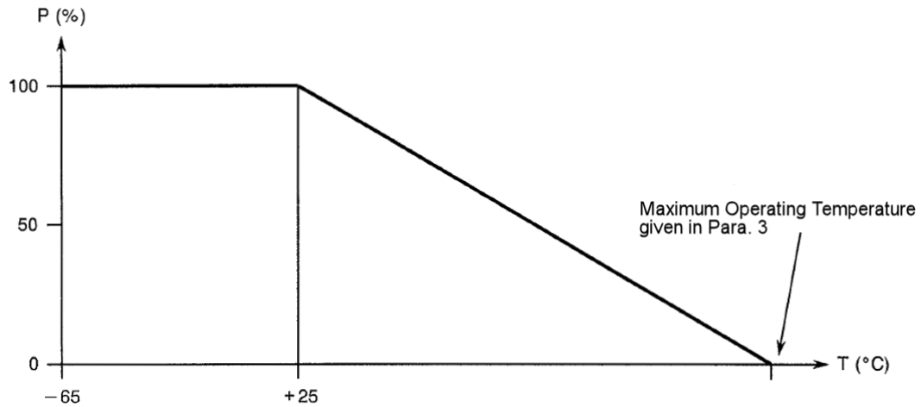
            - Derate Power with respect to Operating Frequency as follows:
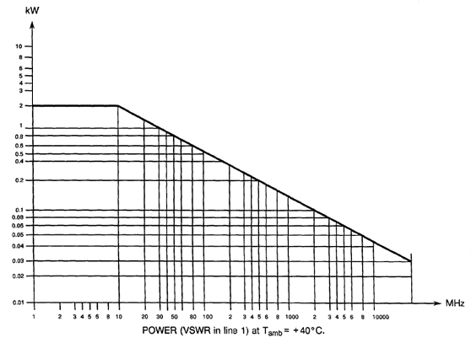
            - Whenever a test is performed on mated pairs of connectors, the pairs shall be torqued at 100 ±20N.cm.

PHYSICAL DIMENSIONS (SEE ALSO PARA. 3)

Connector Interface Dimensions and Connector Interface Gauge Dimensions
          - SMA Male Connector Interface: compatible with series SMA pin contact interface as specified in MIL-STD-348.
          - SMA Female Gauge Interface: compatible with series SMA socket contact test connector interface as specified in MIL-STD-348.

MATERIALS AND FINISHES
Materials and finishes shall be as follows (as applicable, see Para. 3):
Type | Description
1 | Beryllium Copper, Gold plated, Copper underplate - Amagnetic Version (Note 1) (see Para. 3)
2 | Beryllium Copper, Gold plated, Nickel underplate - Standard Version (Note 1) (see Para. 1.7.3)
3 | Stainless Steel, Electro-passivated (see Para. 1.7.4)
4 | Stainless Steel, Gold plated (see Para. 1.7.5)
NOTES:
            - For information purposes, the residual magnetism of types 1 and 2 components, which is guaranteed but not tested, is as follows:
- Type 1 ≤ 20 gamma.
- Type 2 ≤ 2000 gamma.

Type 1
          - Shell, Coupling Nut: beryllium copper, plated gold 2.5μm minimum over copper 2.5μm minimum.
          - Centre Contact: beryllium copper (or brass for male contact only), plated gold 2.5μm minimum over copper 2.5μm minimum.
          - Insulator: PTFE.
          - Gaskets:
- Front: Silicone.
- EMI: TBA.
- Compression: TBA.
          - Crimping and soldering elements: brass or copper, plated gold 2.5μm minimum over copper 2.5μm minimum.
          - Rear Nut: brass or copper, plated gold 2.5μm minimum over copper 2.5μm minimum.
          - Washers: TBA.
          - Hermetic Glass Seal:
- Shell: iron/nickel alloy, plated gold 1.27μm minimum over nickel 2μm minimum.
- Centre Contact: steel, plated gold 1.27μm minimum over nickel 2μm minimum.
- Insulator: glass.

Type 2
          - Shell, Coupling Nut: beryllium copper, plated gold 1.27μm minimum over nickel 2μm minimum.
          - Centre Contact: Beryllium copper (or brass for male contact only), plated gold 1.27μm minimum over nickel 2μm.
          - Insulator: PTFE.
          - Gaskets:
- Front: Silicone.
- EMI: TBA.
- Compression: TBA.
          - Crimping and soldering elements: brass or copper, plated gold 0.5μm minimum over nickel 2μm.
          - Rear Nut: brass or copper, plated gold 0.5μm minimum over nickel 2μm.
          - Washers: TBA.
          - Hermetic Glass Seal:
- Shell: iron/nickel alloy, plated gold 1.27μm minimum over nickel 2μm minimum.
- Centre Contact: steel, plated gold 1.27μm minimum over nickel 2μm minimum.
- Insulator: glass.

Type 3
          - Shell, Coupling Nut: stainless steel, electro-passivated.
NOTE: For solder-type connectors, the rear part of the shell shall be plated gold 1.27μm minimum over nickel 2μm minimum.
          - Centre Contact: beryllium copper (or brass for male contact only), plated gold 1.27μm minimum over nickel 2μm.
          - Insulator: PTFE.
          - Gaskets:
- Front: Silicone.
- EMI: TBA.
- Compression: TBA.
          - Crimping elements: brass or copper, plated nickel 2μm.
          - Soldering elements: brass or copper, plated gold 0.5μm minimum over nickel 2μm.
          - Rear Nut: stainless steel, electro-passivated.
          - Washers: beryllium copper, plated nickel 2μm.
          - Hermetic Glass Seal:
- Shell: iron/nickel alloy, plated gold 1.27μm minimum over nickel 2μm minimum.
- Centre Contact: steel, plated gold 1.27μm minimum over nickel 2μm minimum.
- Insulator: glass

Type 4
          - Shell, Coupling Nut: stainless steel, plated gold 1.27μm minimum over nickel 2μm.
          - Centre Contact: beryllium copper (or brass for male contact only), plated gold 1.27μm minimum over nickel 2μm.
          - Insulator: PTFE.
          - Gaskets:
- Front: Silicone.
- EMI: TBA.
- Compression: TBA.
          - Crimping and soldering elements: brass or copper, plated gold 0.5μm minimum over nickel 2μm.
          - Rear Nut: stainless steel, plated gold 0.5μm minimum over nickel 2μm.
          - Washers: beryllium copper, plated gold 0.5μm minimum over nickel 2μm.
          - Hermetic Glass Seal:
- Shell: iron/nickel alloy, plated gold 1.27μm minimum over nickel 2μm minimum.
- Centre Contact: steel, plated gold 1.27μm minimum over nickel 2μm minimum.
- Insulator: glass

REQUIREMENTS

GENERAL
The complete requirements for procurement of the components specified herein are as stated in this specification and the ESCC Generic Specification. Permitted deviations from the Generic Specification, applicable to this specification only, are listed below.
Permitted deviations from the Generic Specification and this Detail Specification, formally agreed with specific Manufacturers on the basis that the alternative requirements are equivalent to the ESCC requirement and do not affect the component’s reliability, are listed in the appendices attached to this specification.

Deviations from the Generic Specification
None.

MARKING
The marking shall be in accordance with the requirements of ESCC Basic Specification No. 21700 and as follows.
The information to be marked on the component or the primary package shall be:
          - The ESCC qualified components symbol (for ESCC qualified components only).
          - The ESCC Component Number (see Para. 1.4.1).
          - Traceability information.

ENVIRONMENTAL AND MECHANICAL TESTS
The following requirements apply to tests performed on the connector (and contact) lot as specified in the ESCC Generic Specification:
          - Para. 8.1, Contact Engagement and Separation Forces:
 | Oversize Test Pin Test | Minimum Diameter Test Pin Test
Engagement Force (N) | 138 maximum | -
Separation Force (N) | - | 2.9 minimum
Oversize Test Pin Diameter (mm) (1) | 0.9525 to 0.955 | -
Maximum Diameter Test Pin Diameter (mm) (1) | 0.94 to 0.942 | -
Minimum Diameter Test Pin Diameter (mm) (1) | - | 0.902 to 0.904
Engagement Depth (mm) (1) | 1.27 to 1.91 | 1.27 to 1.91
NOTES:
            - Test Pin details:
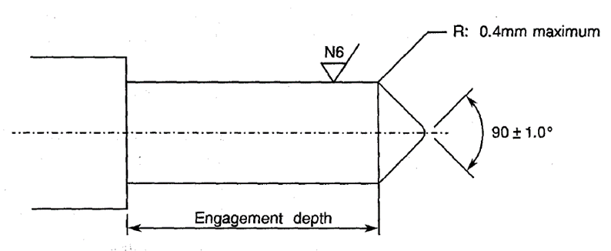
          - Para. 8.10, Coupling Proof Torque: See Para. 1.5.
          - Para. 8.11, Mating and Unmating Forces: Maximum torque: 24N.cm.
          - Para. 8.12, Centre Contact Retention: See Para. 3.
          - Para. 8.13, Seal: See Para. 3.
          - Para. 8.19, Endurance:
- During Qualification Testing: 500 cycles.
- During Periodic Testing: 100 cycles

Room Temperature Electrical Measurements (NOTE 1)
The measurements shall be performed at T_{amb} = +22 ±3°C.
Characteristics | Symbols | Test Method and  Conditions | Limits |  | Units
Characteristics | Symbols | Test Method and  Conditions | Min | Max | Units
Insulation Resistance | R_{I} | ESCC No. 3402 | 5 | - | GΩ
Voltage Proof Leakage Current | I_{L} | ESCC No. 3402  See Para. 3  Note 2 | - | 2 | mA
NOTES:
            - For Variants 01, 02, 03, 04, 29, 37, 38, 39, 40, 41, 42, 43 measurements shall not be performed during Chart F3; see Para. 3.
            - Between centre contact and the body.

INTERMEDIATE AND END-POINT ELECTRICAL MEASUREMENTS
Unless otherwise specified, the measurements shall be performed at T_{amb} = +22 ±3°C.
Unless otherwise specified, the test methods and test conditions shall be as per the corresponding test defined in Para. 2.4 Room Temperature Electrical Measurements.
Test Reference per ESCC No. 3402 | Characteristics and Test Conditions  Ref. ESCC No. 3402 | Symbols | Limits |  | Units
Test Reference per ESCC No. 3402 | Characteristics and Test Conditions  Ref. ESCC No. 3402 | Symbols | Min | Max | Units
Random Vibration | Contact Resistance: I_{T} = 10mA, V_{T} = 6V  Centre contact: | R_{ctc} | - | 3 | mΩ
Mechanical Shock | Contact Resistance: I_{T} = 10mA, V_{T} = 6V  Centre contact: | R_{ctc} |  | 3 | mΩ
Temperature Cycling | Contact Resistance: I_{T} = 10mA, V_{T} = 6V  Centre contact: | R_{ctc} |  | 3 | mΩ
 | Voltage Proof Leakage Current: | I_{L} | Note 1
Electrical Measurements at Room Temperature | Insulation Resistance: | R_{I} | Note 1
Electrical Measurements at Room Temperature | Voltage Proof Leakage Current: | I_{L} | Note 1
Electrical Measurements at Room Temperature | Contact Resistance: I_{T} = 10mA, V_{T} = 6mV  Centre contact:  Shell:  Hermetic Glass Seal Centre Contact: | R_{ctc}  R_{cts}  R_{hgs} | -  -  - | 3  2  10 | mΩ  mΩ  mΩ
Electrical Measurements at Room Temperature | VSWR: | VSWR | Note 2
Electrical Measurements at Room Temperature | Insertion Loss: | LI | Note 2
Endurance | Contact Resistance: I_{T} = 10mA, V_{T} = 6mV  Centre contact:  Shell:  Hermetic Glass Seal Centre Contact: | R_{ctc}  R_{cts}  R_{hgs} | -  -  - | 4  3  12 | mΩ  mΩ  mΩ
NOTES:
            - As specified in Para. 2.4.
            - As specified in Para. 3.

COMPONENT TYPE VARIANTS – DETAIL REQUIREMENTS

variant 01 – Straight Plug, Solder-Type, for Semi-Rigid Cable Ø2.2mm
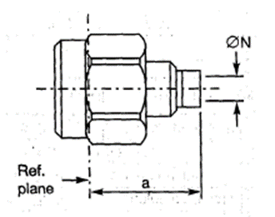
  Symbol | Dimensions mm
  Symbol | Min | Max
  a | 8.4 | 8.7
  ØN | 2.25 | 2.35
NOTES:
            - Removable coupling nut.
            - Components are delivered with the centre contact and insulator not mounted in the connector.
ELECTRICAL CHARACTERISTICS | VALUES | UNITS
Frequency range | 0 to 18 | GHz
Maximum voltage standing wave ratio (VSWR) | 1.07 + 0.008 f (GHz)
Maximum insertion loss | 0.02 √f (GHz) | dB
RF leakage (Note 3) | - [100 - f (GHz)] | dB
Voltage proof | 750 | Vrms
Corona level (Note 3) | 190 | Vrms
MECHANICAL CHARACTERISTICS | VALUES | UNITS
Mini centre contact retention force (axial) | Not applicable
Mini centre contact retention torque | Not applicable
Mini cable retention force (Note 3) | 200 | N
Mini cable retention torque value (Note 3) | 11.5 | N.cm
Maximum weight | 2.3 | g
OTHER CHARACTERISTICS | VALUES | UNITS
Rapid change of temperature - peak value | +200 | °C
Operating temperature range | -65 to +165 | °C
Seal: Maximum leakage | Not applicable
Solderability | Applicable
Cables used | KS 1, RG 405/U, (Ø2.2mm)
NOTES:
            - For information purposes only.

variant 02 - STRAIGHT PLUG, SOLDER-TYPE, FOR SEMI-RIGID CABLE Ø3.58mm
Symbol | Dimensions mm
Symbol | Min | Max
a | 8.4 | 8.7
ØN | 3.65 | 3.75

NOTES:
            - Removable coupling nut.
            - Components are delivered with the centre contact and insulator not mounted in the connector.
ELECTRICAL CHARACTERISTICS | VALUES | UNITS
Frequency range | 0 to 18 | GHz
Maximum voltage standing wave ratio (VSWR) | 1.05 + 0.004 f (GHz)
Maximum insertion loss | 0.02 √f (GHz) | dB
RF leakage (Note 3) | - [100 - f (GHz)] | dB
Voltage proof | 1000 | Vrms
Corona level (Note 3) | 250 | Vrms
MECHANICAL CHARACTERISTICS | VALUES | UNITS
Mini centre contact retention force (axial) | Not applicable
Mini centre contact retention torque | Not applicable
Mini cable retention force (Note 3) | 500 | N
Mini cable retention torque value (Note 3) | 39.6 | N.cm
Maximum weight | 2.4 | g
OTHER CHARACTERISTICS | VALUES | UNITS
Rapid change of temperature - peak value | +200 | °C
Operating temperature range | -65 to +165 | °C
Seal: Maximum leakage | Not applicable
Solderability | Applicable
Cables used | KS 2, RG 402/U, (Ø3.58mm)
NOTES:
            - For information purposes only.

variant 03 - STRAIGHT PLUG with cable clamp, SOLDER-TYPE, FOR SEMI-RIGID CABLE Ø6.35mm
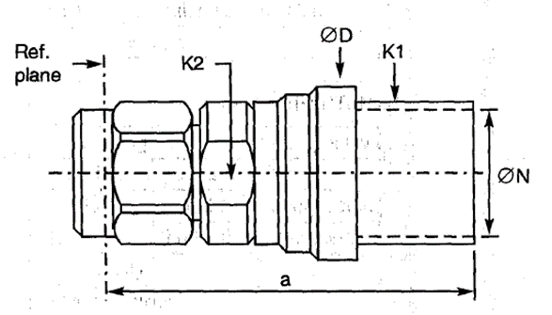
  Symbol | Dimensions mm |  | Notes
  Symbol | Min | Max
  a | 21.5 | 22.5
  ØD | 10.9 | 11
  K1 | - | 10 | 2 flats
  K2 | - | 8 | 2 flats
  ØN | 6.45 | 6.7
NOTES:
            - Components are delivered with the centre contact and insulator not mounted in the connector.
ELECTRICAL CHARACTERISTICS | VALUES | UNITS
Frequency range | 0 to 18 | GHz
Maximum voltage standing wave ratio (VSWR) | 1.05 + 0.004 f (GHz)
Maximum insertion loss | 0.02 √f (GHz) | dB
RF leakage (Note 2) | - [100 - f (GHz)] | dB
Voltage proof | 1000 | Vrms
Corona level (Note 2) | 250 | Vrms
MECHANICAL CHARACTERISTICS | VALUES | UNITS
Mini centre contact retention force (axial) | Not applicable
Mini centre contact retention torque | Not applicable
Mini cable retention force (Note 2) | 500 | N
Mini cable retention torque value (Note 2) | 39.6 | N.cm
Maximum weight | 2.4 | g
OTHER CHARACTERISTICS | VALUES | UNITS
Rapid change of temperature - peak value | +200 | °C
Operating temperature range | -65 to +165 | °C
Seal: Maximum leakage | Not applicable
Solderability | Applicable
Cables used | KS 2, RG 402/U, (Ø3.58mm)
NOTES:
            - For information purposes only.

variant 04 - STRAIGHT PLUG with cable clamp, SOLDER-TYPE, FOR SEMI-RIGID microporous CABLE, Ø6.35mm
Symbol | Dimensions mm |  | Notes
Symbol | Min | Max
a | - | 22.5
ØD | 10.9 | 11.1
K1 | - | 10 | 2 flats
K2 | - | 8 | 2 flats
ØN | 6.45 | 6.7

NOTES:
            - Components are delivered with the centre contact and insulator not mounted in the connector.
ELECTRICAL CHARACTERISTICS | VALUES | UNITS
Frequency range | 0 to 18 | GHz
Maximum voltage standing wave ratio (VSWR) | 1.05 + 0.015 f (GHz)
Maximum insertion loss | 0.02 √f (GHz) | dB
RF leakage (Note 2) | - [95 - f (GHz)] | dB
Voltage proof | 1000 | Vrms
Corona level (Note 2) | 250 | Vrms
MECHANICAL CHARACTERISTICS | VALUES | UNITS
Mini centre contact retention force (axial) | Not applicable
Mini centre contact retention torque | Not applicable
Mini cable retention force (Note 2) | 300 | N
Mini cable retention torque value (Note 2) | 39.6 | N.cm
Maximum weight | 8.2 | g
OTHER CHARACTERISTICS | VALUES | UNITS
Rapid change of temperature - peak value | +200 | °C
Operating temperature range | -65 to +165 | °C
Seal: Maximum leakage | Not applicable
Solderability | Applicable
Cables used | Microporous Ø6.35mm
NOTES:
            - For information purposes only.

variant 05 - STRAIGHT PLUG, Crimp-type
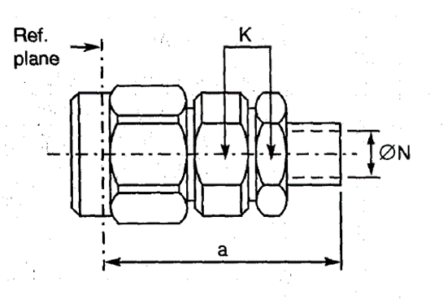
  Symbol | Dimensions mm |  | Notes
  Symbol | Min | Max | Notes
  a | 23.1 | 23.95
  K | - | 7 | 2 flats
  ØN | 3.15 | 3.35
ELECTRICAL CHARACTERISTICS | VALUES | UNITS
Frequency range | 0 to 12.4 | GHz
Maximum voltage standing wave ratio (VSWR) | 1.1 + 0.015 f (GHz)
Maximum insertion loss | 0.03 √f (GHz) | dB
RF leakage (Note 1) | - [95 - f (GHz)] | dB
Voltage proof | 750 | Vrms
Corona level (Note 1) | 190 | Vrms
MECHANICAL CHARACTERISTICS | VALUES | UNITS
Mini centre contact retention force (axial) | 27
Mini centre contact retention torque | 0.5
Mini cable retention force (Note 1) | 90 | N
Mini cable retention torque value (Note 1) | 2 x 180° @ point 50 x ØN | N.cm
Maximum weight | 5 | g
OTHER CHARACTERISTICS | VALUES | UNITS
Rapid change of temperature - peak value | +200 | °C
Operating temperature range | -65 to +165 | °C
Seal: Maximum leakage | Not applicable
Solderability | Applicable
Cables used | KX 3B, KX 22A, RG 174/U, RG 316/U
NOTES:
            - For information purposes only.

variant 06 - STRAIGHT PLUG, Crimp-type, for 50 CIS Cable
Symbol | Dimensions mm |  | Notes
Symbol | Min | Max | Notes
a | 23.1 | 23.95
K | - | 7 | 2 flats
ØN | 2 | 2.2

ELECTRICAL CHARACTERISTICS | VALUES | UNITS
Frequency range | 0 to 12.4 | GHz
Maximum voltage standing wave ratio (VSWR) | 1.1 + 0.015 f (GHz)
Maximum insertion loss | 0.03 √f (GHz) | dB
RF leakage (Note 1) | - [95 - f (GHz)] | dB
Voltage proof | 750 | Vrms
Corona level (Note 1) | 190 | Vrms
MECHANICAL CHARACTERISTICS | VALUES | UNITS
Mini centre contact retention force (axial) | 27
Mini centre contact retention torque | 0.5
Mini cable retention force (Note 1) | 80 | N
Mini cable retention torque value (Note 1) | 2 x 180° @ point 50 x ØN | N.cm
Maximum weight | 4.9 | g
OTHER CHARACTERISTICS | VALUES | UNITS
Rapid change of temperature - peak value | +200 (see cables used) | °C
Operating temperature range | -65 to +165 | °C
Seal: Maximum leakage | Not applicable
Solderability | Applicable
Cables used | 50 CIS
NOTES:
            - For information purposes only.

variant 07 - STRAIGHT PLUG, Crimp- or SOLDER-TYPE, cable Ø5mm/50Ω, single braid
Symbol | Dimensions mm |  | Notes
Symbol | Min | Max | Notes
a | 25.1 | 25.95
K | - | 7 | 2 flats
ØN | 5.55 | 5.65

ELECTRICAL CHARACTERISTICS | VALUES | UNITS
Frequency range | 0 to 12.4 | GHz
Maximum voltage standing wave ratio (VSWR) | 1.15 + 0.01 f (GHz)
Maximum insertion loss | 0.03 √f (GHz) | dB
RF leakage (Note 1) | - [95 - f (GHz)] | dB
Voltage proof | 1000 | Vrms
Corona level (Note 1) | 250 | Vrms
MECHANICAL CHARACTERISTICS | VALUES | UNITS
Mini centre contact retention force (axial) | 27
Mini centre contact retention torque | 0.5
Mini cable retention force (Note 1) | 180 | N
Mini cable retention torque value (Note 1) | 2 x 180° @ point 50 x ØN | N.cm
Maximum weight | 6 | g
OTHER CHARACTERISTICS | VALUES | UNITS
Rapid change of temperature - peak value | +200 (see cables used) | °C
Operating temperature range | -65 to +165 | °C
Seal: Maximum leakage | Not applicable
Solderability | Applicable
Cables used | KX 15, RG 58 C/U, RG 141 A/U
NOTES:
            - For information purposes only.

variant 08 - STRAIGHT PLUG, Crimp- or SOLDER-TYPE, CABLE Ø5mm/50Ω, DOUBLE BRAID
Symbol | Dimensions mm |  | Notes
Symbol | Min | Max | Notes
a | 25.1 | 25.95
K | - | 7 | 2 flats
ØN | 5.55 | 5.65

ELECTRICAL CHARACTERISTICS | VALUES | UNITS
Frequency range | 0 to 12.4 | GHz
Maximum voltage standing wave ratio (VSWR) | 1.15 + 0.01 f (GHz)
Maximum insertion loss | 0.03 √f (GHz) | dB
RF leakage (Note 1) | - [95 - f (GHz)] | dB
Voltage proof | 1000 | Vrms
Corona level (Note 1) | 250 | Vrms
MECHANICAL CHARACTERISTICS | VALUES | UNITS
Mini centre contact retention force (axial) | 27
Mini centre contact retention torque | 0.5
Mini cable retention force (Note 1) | 180 | N
Mini cable retention torque value (Note 1) | 2 x 180° @ point 50 x ØN | N.cm
Maximum weight | 6 | g
OTHER CHARACTERISTICS | VALUES | UNITS
Rapid change of temperature - peak value | +200 (see cables used) | °C
Operating temperature range | -65 to +165 | °C
Seal: Maximum leakage | Not applicable
Solderability | Applicable
Cables used | KX 23, RG 142 B/U, RG 223/U
NOTES:
            - For information purposes only.

variant 09 - Right angle PLUG, SOLDER-TYPE, FOR SEMI-RIGID CABLE Ø2.2mm
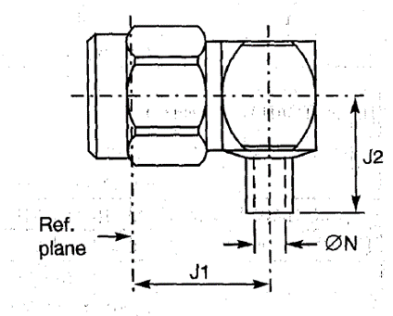
  Symbol | Dimensions mm
  Symbol | Min | Max
  J1 | 10 | 10.4
  J2 | 7.25 | 7.7
  ØN | 2.25 | 2.35
ELECTRICAL CHARACTERISTICS | VALUES | UNITS
Frequency range | 0 to 12.4 | GHz
Maximum voltage standing wave ratio (VSWR) | 1.1 + 0.01 f (GHz)
Maximum insertion loss | 0.02 √f (GHz) | dB
RF leakage (Note 3) | - [95 - f (GHz)] | dB
Voltage proof | 750 | Vrms
Corona level (Note 3) | 190 | Vrms
MECHANICAL CHARACTERISTICS | VALUES | UNITS
Mini centre contact retention force (axial) | 27
Mini centre contact retention torque | 2.8
Mini cable retention force (Note 3) | 200 | N
Mini cable retention torque value (Note 3) | 11.5 | N.cm
Maximum weight | 5 | g
OTHER CHARACTERISTICS | VALUES | UNITS
Rapid change of temperature - peak value | +115 | °C
Operating temperature range | -65 to +105 | °C
Seal: Maximum leakage | Not applicable
Solderability | Applicable
Cables used | KS 1, RG 405/U (Ø2.2mm)
NOTES:
            - For information purposes only.

variant 10 - right angle PLUG, SOLDER-TYPE, FOR SEMI-RIGID CABLE Ø3.58mm
Symbol | Dimensions mm
Symbol | Min | Max
J1 | 10 | 10.4
J2 | 7.25 | 7.7
ØN | 3.65 | 3.75

ELECTRICAL CHARACTERISTICS | VALUES | UNITS
Frequency range | 0 to 12.4 | GHz
Maximum voltage standing wave ratio (VSWR) | 1.1 + 0.01 f (GHz)
Maximum insertion loss | 0.15 √f (GHz) | dB
RF leakage (Note 3) | - [95 - f (GHz)] | dB
Voltage proof | 1000 | Vrms
Corona level (Note 3) | 250 | Vrms
MECHANICAL CHARACTERISTICS | VALUES | UNITS
Mini centre contact retention force (axial) | 27
Mini centre contact retention torque | 2.8
Mini cable retention force (Note 3) | 500 | N
Mini cable retention torque value (Note 3) | 39.6 | N.cm
Maximum weight | 4.1 | g
OTHER CHARACTERISTICS | VALUES | UNITS
Rapid change of temperature - peak value | +115 | °C
Operating temperature range | -65 to +105 | °C
Seal: Maximum leakage | Not applicable
Solderability | Applicable
Cables used | KS 2, RG 402/U (Ø3.58mm)
NOTES:
            - For information purposes only.

variant 12 - RIGHT ANGLE PLUG, CRIMP-TYPE
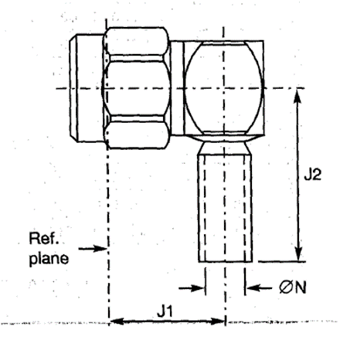
  Symbol | Dimensions mm
  Symbol | Min | Max
  J1 | 10 | 10.4
  J2 | - | 16.8
  ØN | 3.25 | 3.3
ELECTRICAL CHARACTERISTICS | VALUES | UNITS
Frequency range | 0 to 12.4 | GHz
Maximum voltage standing wave ratio (VSWR) | 1.1 + 0.025 f (GHz)
Maximum insertion loss | 0.03 √f (GHz) | dB
RF leakage (Note 3) | - [95 - f (GHz)] | dB
Voltage proof | 750 | Vrms
Corona level (Note 3) | 190 | Vrms
MECHANICAL CHARACTERISTICS | VALUES | UNITS
Mini centre contact retention force (axial) | 27
Mini centre contact retention torque | 2.8
Mini cable retention force (Note 3) | 90 | N
Mini cable retention torque value (Note 3) | 2 x 180º @ point 50 x ØN | N.cm
Maximum weight | 4.8 | g
OTHER CHARACTERISTICS | VALUES | UNITS
Rapid change of temperature - peak value | +115 (see cables used) | °C
Operating temperature range | -65 to +105 | °C
Seal: Maximum leakage | Not applicable
Solderability | Applicable
Cables used | KX 3B, KX 22A, RG 174/U, RG 316/U
NOTES:
            - For information purposes only.

variant 13 - RIGHT ANGLE PLUG, CRIMP-TYPE
Symbol | Dimensions mm
Symbol | Min | Max
J1 | 10 | 10.4
J2 | - | 18
ØN | 5.55 | 5.65

ELECTRICAL CHARACTERISTICS | VALUES | UNITS
Frequency range | 0 to 12.4 | GHz
Maximum voltage standing wave ratio (VSWR) | 1.1 + 0.02 f (GHz)
Maximum insertion loss | 0.03 √f (GHz) | dB
RF leakage (Note 3) | - [95 - f (GHz)] | dB
Voltage proof | 1000 | Vrms
Corona level (Note 3) | 250 | Vrms
MECHANICAL CHARACTERISTICS | VALUES | UNITS
Mini centre contact retention force (axial) | 27
Mini centre contact retention torque | 2.8
Mini cable retention force (Note 3) | 180 | N
Mini cable retention torque value (Note 3) | 2 x 180º @ point 50 x ØN | N.cm
Maximum weight | 4.9 | g
OTHER CHARACTERISTICS | VALUES | UNITS
Rapid change of temperature - peak value | +115 (see cables used) | °C
Operating temperature range | -65 to +105 | °C
Seal: Maximum leakage | Not applicable
Solderability | Applicable
Cables used | KX 15, RG 58C/U, RG 141A/U
NOTES:
            - For information purposes only.

variant 14 - RIGHT ANGLE PLUG, CRIMP-TYPE, FOR CABLE Ø5mm/50Ω, DOUBLE BRAID
Symbol | Dimensions mm
Symbol | Min | Max
J1 | 10 | 10.4
J2 | - | 18
ØN | 5.55 | 5.65

ELECTRICAL CHARACTERISTICS | VALUES | UNITS
Frequency range | 0 to 12.4 | GHz
Maximum voltage standing wave ratio (VSWR) | 1.1 + 0.02 f (GHz)
Maximum insertion loss | 0.03 √f (GHz) | dB
RF leakage (Note 3) | - [95 - f (GHz)] | dB
Voltage proof | 1000 | Vrms
Corona level (Note 3) | 250 | Vrms
MECHANICAL CHARACTERISTICS | VALUES | UNITS
Mini centre contact retention force (axial) | 27
Mini centre contact retention torque | 2.8
Mini cable retention force (Note 3) | 180 | N
Mini cable retention torque value (Note 3) | 2 x 180º @ point 50 x ØN | N.cm
Maximum weight | 4.1 | g
OTHER CHARACTERISTICS | VALUES | UNITS
Rapid change of temperature - peak value | +115 (see cables used) | °C
Operating temperature range | -65 to +105 | °C
Seal: Maximum leakage | Not applicable
Solderability | Applicable
Cables used | KX 23, RG 142 B/U, RG 223/U
NOTES:
            - For information purposes only.

variant 15 - SQUARE FLANGE MALE RECEPTACLE
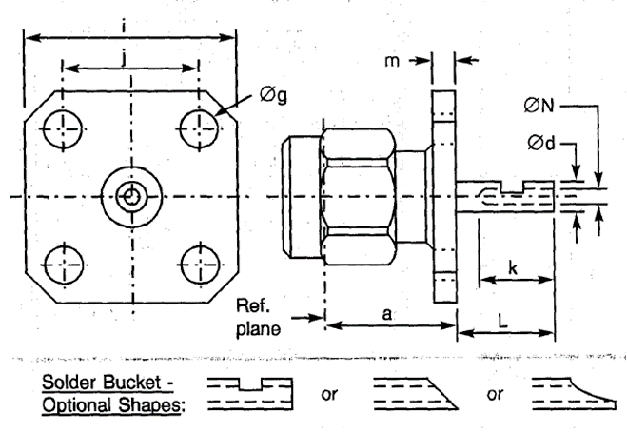
  Symbol | Dimensions mm |  | Notes
  Symbol | Min | Max | Notes
  a | 9.45 | 9.55
  Ød | 1.24 | 1.3
  Øg | 2.55 | 2.7 | 4 holes
  i | 12.6 | 12.8
  j | 8.59 | 8.69
  k | 2.4 | -
  L | 4.75 | 5.25
  m | 1.4 | 1.8
  ØN | 0.7 | 1
ELECTRICAL CHARACTERISTICS | VALUES | UNITS
Frequency range | 0 to 18 | GHz
Maximum voltage standing wave ratio (VSWR) (Note 1) | 1.05 + 0.003 f (GHz)
Maximum insertion loss (Note 1) | 0.03 √f (GHz) | dB
RF leakage (Note 1) | - [95 - f (GHz)] | dB
Voltage proof | 1000 | Vrms
Corona level (Note 1) | Not applicable | Vrms
MECHANICAL CHARACTERISTICS | VALUES | UNITS
Mini centre contact retention force (axial) | 27
Mini centre contact retention torque | 2.8
Mini cable retention force (Note 1) | Not applicable | N
Mini cable retention torque value (Note 1) | Not applicable | N.cm
Maximum weight | 4.2 | g
OTHER CHARACTERISTICS | VALUES | UNITS
Rapid change of temperature - peak value | +115 | °C
Operating temperature range | -65 to +105 | °C
Seal: Maximum leakage | Not applicable
Solderability | On centre contact only
Cables used | Not applicable
NOTES:
            - For information purposes only.

variant 16 - 2-HOLE FLANGE MALE RECEPTACLE
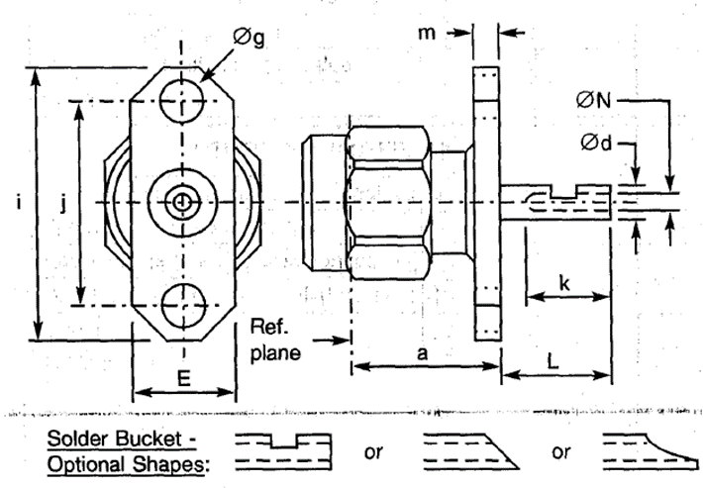
  Symbol | Dimensions mm |  | Notes
  Symbol | Min | Max | Notes
  a | 9.45 | 9.55
  Ød | 1.24 | 1.3
  E | 5.5 | 5.8
  Øg | 2.55 | 2.7 | 2 holes
  i | 15.9 | 16.1
  j | 12.1 | 12.3
  k | 2.4 | -
  L | 4.75 | 5.25
  m | 1.4 | 1.8
  ØN | 0.7 | 1
ELECTRICAL CHARACTERISTICS | VALUES | UNITS
Frequency range | 0 to 18 | GHz
Maximum voltage standing wave ratio (VSWR) (Note 1) | 1.05 + 0.003 f (GHz)
Maximum insertion loss (Note 1) | 0.03 √f (GHz) | dB
RF leakage (Note 1) | - [95 - f (GHz)] | dB
Voltage proof | 1000 | Vrms
Corona level (Note 1) | Not applicable | Vrms
MECHANICAL CHARACTERISTICS | VALUES | UNITS
Mini centre contact retention force (axial) | 27
Mini centre contact retention torque | 2.8
Mini cable retention force (Note 1) | Not applicable | N
Mini cable retention torque value (Note 1) | Not applicable | N.cm
Maximum weight | 3.4 | g
OTHER CHARACTERISTICS | VALUES | UNITS
Rapid change of temperature - peak value | +115 | °C
Operating temperature range | -65 to +105 | °C
Seal: Maximum leakage | Not applicable
Solderability | On centre contact only
Cables used | Not applicable
NOTES:
            - For information purposes only.

variant 17 - square flange male receptacle
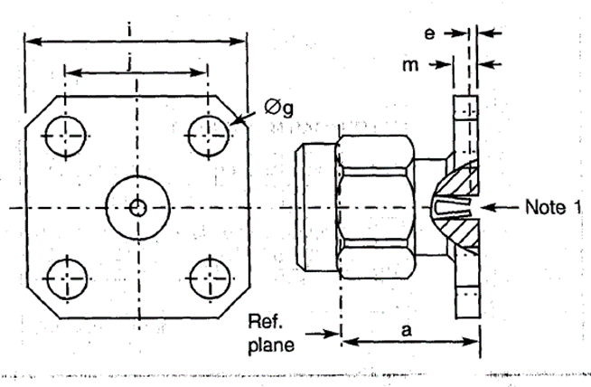
  Symbol | Dimensions mm |  | Notes
  Symbol | Min | Max | Notes
  a | 9.45 | 9.55
  e | 0.18 | 0.41
  Øg | 2.55 | 2.7 | 4 holes
  i | 12.6 | 12.8
  j | 8.59 | 8.69
  m | 1.4 | 1.8
NOTES:
            - Contact Engagement and Separation Forces shall be measured on the rear contact (see Para. 2.3(d)).
ELECTRICAL CHARACTERISTICS | VALUES | UNITS
Frequency range | 0 to 18 | GHz
Maximum voltage standing wave ratio (VSWR) (Note 2) | 1.06 + 0.007 f (GHz)
Maximum insertion loss (Note 2) | 0.03 √f (GHz) | dB
RF leakage (Note 2) | - [95 - f (GHz)] | dB
Voltage proof | 1000 | Vrms
Corona level (Note 2) | Not applicable | Vrms
MECHANICAL CHARACTERISTICS | VALUES | UNITS
Mini centre contact retention force (axial) | 27
Mini centre contact retention torque | Not applicable
Mini cable retention force (Note 2) | Not applicable | N
Mini cable retention torque value (Note 2) | Not applicable | N.cm
Maximum weight | 4.2 | g
OTHER CHARACTERISTICS | VALUES | UNITS
Rapid change of temperature - peak value | +115 | °C
Operating temperature range | -65 to +105 | °C
Seal: Maximum leakage | Not applicable
Solderability | Not applicable
Cables used | Not applicable
NOTES:
            - For information purposes only.

variant 18 - male flange receptacle, triplate launcher
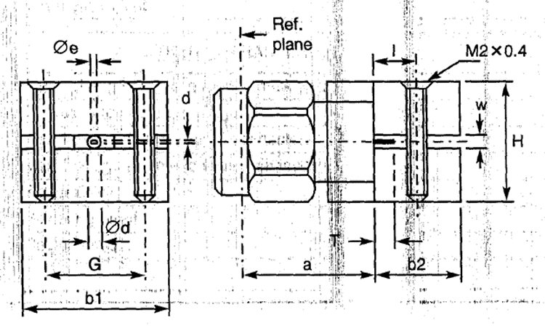
  Symbol | Dimensions mm
  Symbol | Min | Max
  a | 9.9 | 10.1
  b1 | 13.9 | 14.1
  b2 | 5.6 | 5.8
  d | 0.1 | 0.15
  Ød | 1.25 | 1.3
  Øe | 0.4 | 0.6
  G | 9.4 | 9.6
  H | 9.4 | 9.6
  I | 2.7 | 2.9
  T | 0.9 | 1.1
  w | 1.55 | 1.6
ELECTRICAL CHARACTERISTICS | VALUES | UNITS
Frequency range | 0 to 4 | GHz
Maximum voltage standing wave ratio (VSWR) | 1.2
Maximum insertion loss | Not applicable | dB
RF leakage (Note 1) | Not applicable | dB
Voltage proof | 750 | Vrms
Corona level (Note 1) | Not applicable | Vrms
MECHANICAL CHARACTERISTICS | VALUES | UNITS
Mini centre contact retention force (axial) | 27
Mini centre contact retention torque | 2.8
Mini cable retention force (Note 1) | Not applicable | N
Mini cable retention torque value (Note 1) | Not applicable | N.cm
Maximum weight | 16 | g
OTHER CHARACTERISTICS | VALUES | UNITS
Rapid change of temperature - peak value | +115 | °C
Operating temperature range | -65 to +105 | °C
Seal: Maximum leakage | Not applicable
Solderability | Not applicable
Cables used | Not applicable
NOTES:
            - For information purposes only.

variant 20 - MALE FLANGE RECEPTACLE, TRIPLATE LAUNCHER
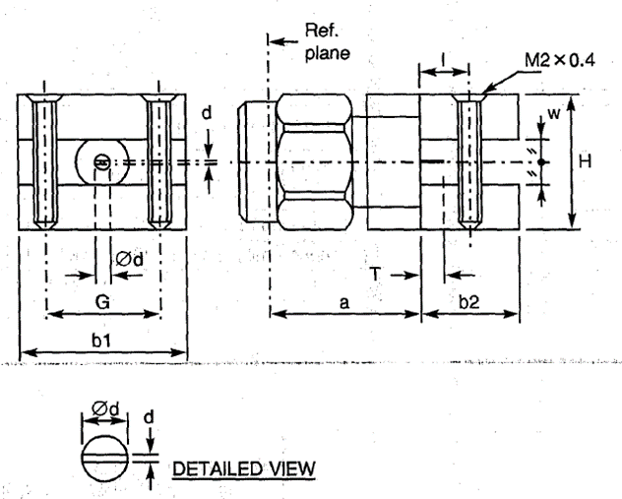
  Symbol | Dimensions mm
  Symbol | Min | Max
  a | 9.9 | 10.1
  b1 | 13.9 | 14.1
  b2 | 5.6 | 5.8
  d | 0.1 | 0.15
  Ød | 1.25 | 1.3
  G | 9.4 | 9.6
  H | 9.4 | 9.6
  I | 2.7 | 2.9
  T | 2.4 | 2.6
  w | 3.15 | 3.2
ELECTRICAL CHARACTERISTICS | VALUES | UNITS
Frequency range | 0 to 4 | GHz
Maximum voltage standing wave ratio (VSWR) | 1.2
Maximum insertion loss | Not applicable | dB
RF leakage (Note 1) | Not applicable | dB
Voltage proof | 150 | Vrms
Corona level (Note 1) | Not applicable | Vrms
MECHANICAL CHARACTERISTICS | VALUES | UNITS
Mini centre contact retention force (axial) | 27
Mini centre contact retention torque | 2.8
Mini cable retention force (Note 1) | Not applicable | N
Mini cable retention torque value (Note 1) | Not applicable | N.cm
Maximum weight | 16 | g
OTHER CHARACTERISTICS | VALUES | UNITS
Rapid change of temperature - peak value | +115 | °C
Operating temperature range | -65 to +105 | °C
Seal: Maximum leakage | Not applicable
Solderability | Not applicable
Cables used | Not applicable
NOTES:
            - For information purposes only.

variant 21 - MALE FLANGE RECEPTACLE, TRIPLATE LAUNCHER
Symbol | Dimensions mm
Symbol | Min | Max
a | 9.9 | 10.1
b1 | 13.9 | 14.1
b2 | 5.6 | 5.8
d | 0.1 | 0.15
Ød | 1.25 | 1.3
G | 9.4 | 9.6
H | 9.4 | 9.6
I | 2.7 | 2.9
T | 2.4 | 2.6
w | 6.35 | 6.4

ELECTRICAL CHARACTERISTICS | VALUES | UNITS
Frequency range | 0 to 2 | GHz
Maximum voltage standing wave ratio (VSWR) | 1.2
Maximum insertion loss | Not applicable | dB
RF leakage (Note 1) | Not applicable | dB
Voltage proof | 1000 | Vrms
Corona level (Note 1) | Not applicable | Vrms
MECHANICAL CHARACTERISTICS | VALUES | UNITS
Mini centre contact retention force (axial) | 27
Mini centre contact retention torque | 2.8
Mini cable retention force (Note 1) | Not applicable | N
Mini cable retention torque value (Note 1) | Not applicable | N.cm
Maximum weight | 16 | g
OTHER CHARACTERISTICS | VALUES | UNITS
Rapid change of temperature - peak value | +115 | °C
Operating temperature range | -65 to +105 | °C
Seal: Maximum leakage | Not applicable
Solderability | Not applicable
Cables used | Not applicable
NOTES:
            - For information purposes only.

variant 22 - SQUARE FLANGE MALE RECEPTACLE, LOW RF LEAKAGE
Symbol | Dimensions mm |  | Notes
Symbol | Min | Max | Notes
a | 9.45 | 9.55
e | 0.18 | 0.41
Øg | 2.55 | 2.7 | 4 holes
i | 12.6 | 12.8
j | 8.59 | 8.69
m | 1.4 | 1.8

NOTES:
            - Contact Engagement and Separation Forces shall be measured on the rear contact (see Para. 2.3(d)).
ELECTRICAL CHARACTERISTICS | VALUES | UNITS
Frequency range | 0 to 18 | GHz
Maximum voltage standing wave ratio (VSWR) (Note 2) | 1.06 + 0.007 f (GHz)
Maximum insertion loss (Note 2) | 0.03 √f (GHz) | dB
RF leakage (Note 2) | -120 at 10GHz | dB
Voltage proof | 1000 | Vrms
Corona level (Note 2) | Not applicable | Vrms
MECHANICAL CHARACTERISTICS | VALUES | UNITS
Mini centre contact retention force (axial) | 27
Mini centre contact retention torque | Not applicable
Mini cable retention force (Note 2) | Not applicable | N
Mini cable retention torque value (Note 2) | Not applicable | N.cm
Maximum weight | 4.2 | g
OTHER CHARACTERISTICS | VALUES | UNITS
Rapid change of temperature - peak value | +115 | °C
Operating temperature range | -65 to +105 | °C
Seal: Maximum leakage | Not applicable
Solderability | Not applicable
Cables used | Not applicable
NOTES:
            - For information purposes only.

variant 22 - SQUARE FLANGE MALE RECEPTACLE, LOW RF LEAKAGE
Symbol | Dimensions mm |  | Notes
Symbol | Min | Max | Notes
a | 9.45 | 9.55
ØD | 5.9 | 6.1
e | 0.18 | 0.41
f | 0.3 | 0.5
Øg | 2.55 | 2.7 | 4 holes
i | 12.6 | 12.8
j | 8.59 | 8.69
m | 1.4 | 1.8

NOTES:
            - Contact Engagement and Separation Forces shall be measured on the rear contact (see Para. 2.3(d)).
ELECTRICAL CHARACTERISTICS | VALUES | UNITS
Frequency range | 0 to 18 | GHz
Maximum voltage standing wave ratio (VSWR) (Note 2) | 1.06 + 0.007 f (GHz)
Maximum insertion loss (Note 2) | 0.03 √f (GHz) | dB
RF leakage (Note 2) | -120 at 10GHz | dB
Voltage proof | 1000 | Vrms
Corona level (Note 2) | Not applicable | Vrms
MECHANICAL CHARACTERISTICS | VALUES | UNITS
Mini centre contact retention force (axial) | 27
Mini centre contact retention torque | Not applicable
Mini cable retention force (Note 2) | Not applicable | N
Mini cable retention torque value (Note 2) | Not applicable | N.cm
Maximum weight | 4.2 | g
OTHER CHARACTERISTICS | VALUES | UNITS
Rapid change of temperature - peak value | +115 | °C
Operating temperature range | -65 to +105 | °C
Seal: Maximum leakage | Not applicable
Solderability | Not applicable
Cables used | Not applicable
NOTES:
            - For information purposes only.

variant 24 - SQUARE FLANGE MALE RECEPTACLE, LOW RF LEAKAGE
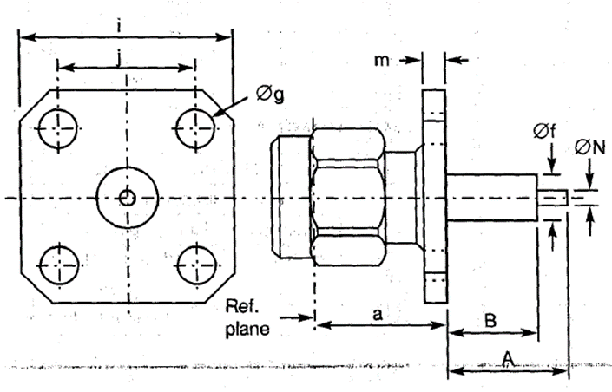
  Symbol | Dimensions mm |  | Notes
  Symbol | Min | Max | Notes
  a | 9.45 | 9.55
  A | - | 40.1 | Note 1
  B | - | 20 | Note 1
  Øf | 4 | 4.2
  Øg | 2.55 | 2.7 | 4 holes
  i | 12.6 | 12.8
  j | 8.59 | 8.69
  m | 1.4 | 1.8
  ØN | 1.25 | 1.3
NOTES:
            - Contact and Insert dimensions A and B shall be selected by the Orderer; see Para. 1.4.1(b).
ELECTRICAL CHARACTERISTICS | VALUES | UNITS
Frequency range | 0 to 18 | GHz
Maximum voltage standing wave ratio (VSWR) (Note 2) | 1.05 + 0.003 f (GHz)
Maximum insertion loss (Note 2) | 0.03 √f (GHz) | dB
RF leakage (Note 2) | -120 at 10GHz | dB
Voltage proof | 1000 | Vrms
Corona level (Note 2) | Not applicable | Vrms
MECHANICAL CHARACTERISTICS | VALUES | UNITS
Mini centre contact retention force (axial) | 27
Mini centre contact retention torque | 2.8
Mini cable retention force (Note 2) | Not applicable | N
Mini cable retention torque value (Note 2) | Not applicable | N.cm
Maximum weight | 5.1 | g
OTHER CHARACTERISTICS | VALUES | UNITS
Rapid change of temperature - peak value | +115 | °C
Operating temperature range | -65 to +105 | °C
Seal: Maximum leakage | Not applicable
Solderability | On centre contact only
Cables used | Not applicable
NOTES:
            - For information purposes only.

variant 25 - SQUARE FLANGE MALE RECEPTACLE
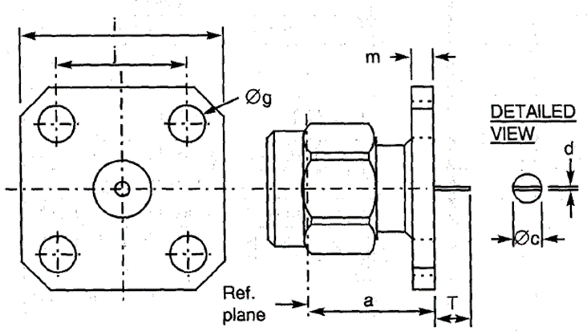
  Symbol | Dimensions mm |  | Notes
  Symbol | Min | Max | Notes
  a | 9.45 | 9.55
  Øc | 1.24 | 1.3
  d | 0.1 | 0.2
  Øg | 2.55 | 2.7 | 4 holes
  i | 12.6 | 12.8
  j | 8.59 | 8.69
  m | 1.4 | 1.8
  T | 2.1 | 2.55
ELECTRICAL CHARACTERISTICS | VALUES | UNITS
Frequency range | 0 to 18 | GHz
Maximum voltage standing wave ratio (VSWR) (Note 1) | 1.05 + 0.003 f (GHz)
Maximum insertion loss (Note 1) | 0.03 √f (GHz) | dB
RF leakage (Note 1) | - [95 - f (GHz)] | dB
Voltage proof | 1000 | Vrms
Corona level (Note 1) | Not applicable | Vrms
MECHANICAL CHARACTERISTICS | VALUES | UNITS
Mini centre contact retention force (axial) | 27
Mini centre contact retention torque | 2.8
Mini cable retention force (Note 1) | Not applicable | N
Mini cable retention torque value (Note 1) | Not applicable | N.cm
Maximum weight | 4.2 | g
OTHER CHARACTERISTICS | VALUES | UNITS
Rapid change of temperature - peak value | +115 | °C
Operating temperature range | -65 to +105 | °C
Seal: Maximum leakage | Not applicable
Solderability | On centre contact only
Cables used | Not applicable
NOTES:
            - For information purposes only.

variant 26 - STRAIGHT PLUG, CRIMP-TYPE
Symbol | Dimensions mm |  | Notes
Symbol | Min | Max | Notes
a | 22.9 | 24.1
K | - | 7 | 2 flats
ØN | 2.55 | 2.65

ELECTRICAL CHARACTERISTICS | VALUES | UNITS
Frequency range | 0 to 12.4 | GHz
Maximum voltage standing wave ratio (VSWR) | 1.1 + 0.015 f (GHz)
Maximum insertion loss | 0.03 √f (GHz) | dB
RF leakage (Note 1) | - [95 - f (GHz)] | dB
Voltage proof | 750 | Vrms
Corona level (Note 1) | 190 | Vrms
MECHANICAL CHARACTERISTICS | VALUES | UNITS
Mini centre contact retention force (axial) | 27
Mini centre contact retention torque | 0.5
Mini cable retention force (Note 1) | 80 | N
Mini cable retention torque value (Note 1) | 2 x 180° @ point 50 x ØN | N.cm
Maximum weight | 4.3 | g
OTHER CHARACTERISTICS | VALUES | UNITS
Rapid change of temperature - peak value | +200 (see cables used) | °C
Operating temperature range | -65 to +165 | °C
Seal: Maximum leakage | Not applicable
Solderability | Applicable
Cables used | RG 178/U, KX 21A
NOTES:
            - For information purposes only.

variant 27 - SQUARE FLANGE MALE RECEPTACLE
Symbol | Dimensions mm |  | Notes
Symbol | Min | Max | Notes
a | 9.45 | 9.55
A | - | 40.1 | Note 1
B | - | 20 | Note 1
Øf | 4 | 4.2
Øg | 2.55 | 2.7 | 4 holes
i | 12.6 | 12.8
j | 8.59 | 8.69
m | 1.4 | 1.8
ØN | 1.25 | 1.3

NOTES:
            - Contact and Insert dimensions A and B shall be selected by the Orderer; see Para. 1.4.1(b).
ELECTRICAL CHARACTERISTICS | VALUES | UNITS
Frequency range | 0 to 18 | GHz
Maximum voltage standing wave ratio (VSWR) (Note 2) | 1.05 + 0.003 f (GHz)
Maximum insertion loss (Note 2) | 0.03 √f (GHz) | dB
RF leakage (Note 2) | -120 at 10GHz | dB
Voltage proof | 1000 | Vrms
Corona level (Note 2) | Not applicable | Vrms
MECHANICAL CHARACTERISTICS | VALUES | UNITS
Mini centre contact retention force (axial) | 27
Mini centre contact retention torque | 2.8
Mini cable retention force (Note 2) | Not applicable | N
Mini cable retention torque value (Note 2) | Not applicable | N.cm
Maximum weight | 4.2 | g
OTHER CHARACTERISTICS | VALUES | UNITS
Rapid change of temperature - peak value | +115 | °C
Operating temperature range | -65 to +105 | °C
Seal: Maximum leakage | Not applicable
Solderability | On centre contact only
Cables used | Not applicable
NOTES:
            - For information purposes only.

variant 28 - 2-HOLE FLANGE MALE RECEPTACLE
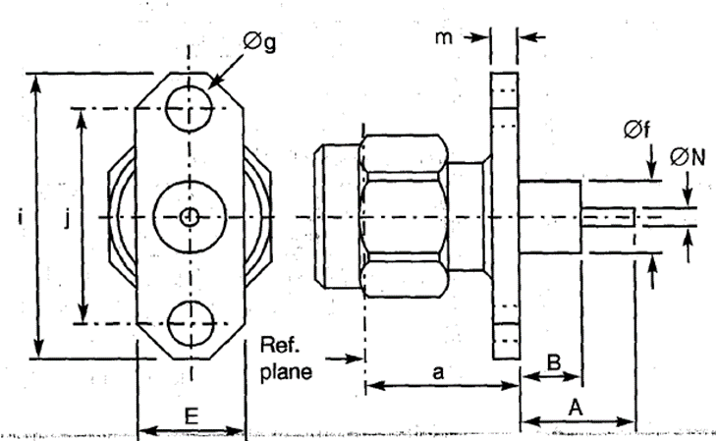
  Symbol | Dimensions mm |  | Notes
  Symbol | Min | Max | Notes
  a | 9.45 | 9.55
  A | - | 40.1 | Note 1
  B | - | 20 | Note 1
  E | 5.5 | 5.8
  Øf | 4 | 4.2
  Øg | 2.55 | 2.7 | 2 holes
  i | 15.9 | 16.1
  j | 12.1 | 12.3
  m | 1.4 | 1.8
  ØN | 1.25 | 1.3
NOTES:
            - Contact and Insert dimensions A and B shall be selected by the Orderer; see Para. 1.4.1(b).
ELECTRICAL CHARACTERISTICS | VALUES | UNITS
Frequency range | 0 to 18 | GHz
Maximum voltage standing wave ratio (VSWR) (Note 2) | 1.05 + 0.003 f (GHz)
Maximum insertion loss (Note 2) | 0.03 √f (GHz) | dB
RF leakage (Note 2) | - [95 - f (GHz)] | dB
Voltage proof | 1000 | Vrms
Corona level (Note 2) | Not applicable | Vrms
MECHANICAL CHARACTERISTICS | VALUES | UNITS
Mini centre contact retention force (axial) | 27
Mini centre contact retention torque | 2.8
Mini cable retention force (Note 2) | Not applicable | N
Mini cable retention torque value (Note 2) | Not applicable | N.cm
Maximum weight | 3.4 | g
OTHER CHARACTERISTICS | VALUES | UNITS
Rapid change of temperature - peak value | +115 | °C
Operating temperature range | -65 to +105 | °C
Seal: Maximum leakage | Not applicable
Solderability | On centre contact only
Cables used | Not applicable
NOTES:
            - For information purposes only.

variant 29 - STRAIght PLUg, SOLDER-TYPE FOR SHF 5 CABLE
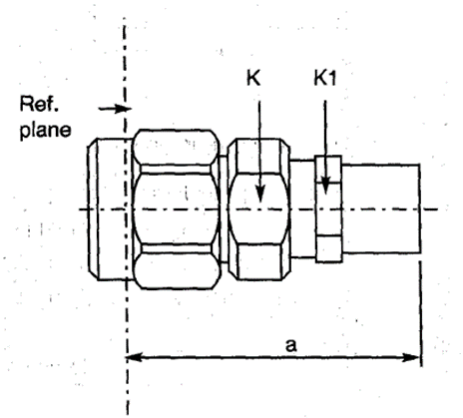
  Symbol | Dimensions mm |  | Notes
  Symbol | Min | Max
  a | 20.8 | 21.15
  K | - | 8.5 | 2 flats
  K1 | - | 8 | 2 flats
NOTES:
            - Components are delivered with the centre contact and insulator not mounted in the connector.
ELECTRICAL CHARACTERISTICS | VALUES | UNITS
Frequency range | 0 to 18 | GHz
Maximum voltage standing wave ratio (VSWR) | 1.15
Maximum insertion loss | 0.06 √f (GHz) | dB
RF leakage (Note 2) | - [95 - f (GHz)] | dB
Voltage proof | 1000 | Vrms
Corona level (Note 2) | 250 | Vrms
MECHANICAL CHARACTERISTICS | VALUES | UNITS
Mini centre contact retention force (axial) | Not applicable
Mini centre contact retention torque | Not applicable
Mini cable retention force (Note 2) | 10 | N
Mini cable retention torque value (Note 2) | Not applicable | N.cm
Maximum weight | 5.6 | g
OTHER CHARACTERISTICS | VALUES | UNITS
Rapid change of temperature - peak value | +200 | °C
Operating temperature range | -65 to +165 | °C
Seal: Maximum leakage | Not applicable
Solderability | Applicable
Cables used | 1703-145
NOTES:
            - For information purposes only.

variant 30 - 2-HOLE FLANGE MALE RECEPTACLE
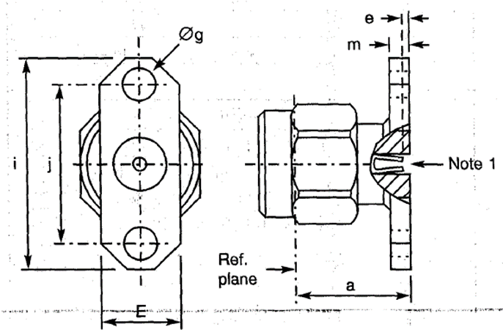
  Symbol | Dimensions mm |  | Notes
  Symbol | Min | Max | Notes
  a | 9.45 | 9.55
  e | 0.18 | 0.41
  E | 5.5 | 5.8
  Øg | 2.55 | 2.7 | 2 holes
  i | 15.9 | 16.1
  j | 12.1 | 12.3
  m | 1.4 | 1.8
  a | 9.45 | 9.55
NOTES:
            - Contact Engagement and Separation Forces shall be measured on the rear contact (see Para. 2.3(d)).
ELECTRICAL CHARACTERISTICS | VALUES | UNITS
Frequency range | 0 to 18 | GHz
Maximum voltage standing wave ratio (VSWR) (Note 2) | 1.06 + 0.007 f (GHz)
Maximum insertion loss (Note 2) | 0.03 √f (GHz) | dB
RF leakage (Note 2) | - [95 - f (GHz)] | dB
Voltage proof | 1000 | Vrms
Corona level (Note 2) | Not applicable | Vrms
MECHANICAL CHARACTERISTICS | VALUES | UNITS
Mini centre contact retention force (axial) | 27
Mini centre contact retention torque | Not applicable
Mini cable retention force (Note 2) | Not applicable | N
Mini cable retention torque value (Note 2) | Not applicable | N.cm
Maximum weight | 4.2 | g
OTHER CHARACTERISTICS | VALUES | UNITS
Rapid change of temperature - peak value | +115 | °C
Operating temperature range | -65 to +105 | °C
Seal: Maximum leakage | Not applicable
Solderability | Not applicable
Cables used | Not applicable
NOTES:
            - For information purposes only.

variant 32 - 2-Hole Flange Male Receptacle, with Hermetic Glass Seal Contact Ø0.3mm and EMI Gasket
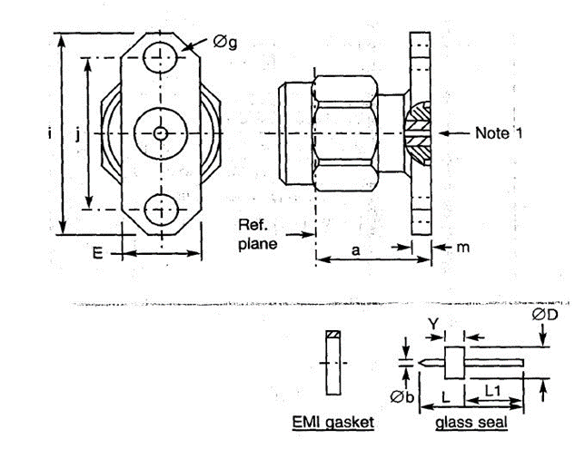
  Symbol | Dimensions mm |  | Notes
  Symbol | Min | Max | Notes
  a | 9.4 | 9.55
  Øb | 0.25 | 0.35
  ØD | 2.47 | 2.57
  E | 5.5 | 5.8
  Øg | 2.55 | 2.7 | 2 holes
  i | 15.9 | 16.1
  j | 12.1 | 12.3
  L | 7.8 | 8.2
  L1 | 4.45 | 4.7
  m | 1.4 | 1.8
  Y | 1.55 | 1.65
ELECTRICAL CHARACTERISTICS | VALUES | UNITS
Frequency range | 0 to 18 | GHz
Maximum voltage standing wave ratio (VSWR) | 1.06 + 0.01 f (GHz)
Maximum insertion loss (Note 1) | 0.3 | dB
RF leakage (Note 1) | -70 | dB
Voltage proof | 1000 | Vrms
Corona level (Note 1) | Not applicable | Vrms
MECHANICAL CHARACTERISTICS | VALUES | UNITS
Mini centre contact retention force (axial) | 27
Mini centre contact retention torque | Not applicable
Mini cable retention force (Note 1) | Not applicable | N
Mini cable retention torque value (Note 1) | Not applicable | N.cm
Maximum weight | 3.7 | g
OTHER CHARACTERISTICS | VALUES | UNITS
Rapid change of temperature - peak value | +115 | °C
Operating temperature range | -65 to +105 | °C
Seal: Maximum leakage | 10⁻⁸ (hermetic glass seal only) | atm.cm³/s
Solderability | On centre contact only
Cables used | Not applicable
NOTES:
            - For information purposes only.

variant 33 - 2-Hole Flange Male Receptacle, with Hermetic Glass Seal Contact Ø0.46mm and EMI Gasket
Symbol | Dimensions mm |  | Notes
Symbol | Min | Max | Notes
a | 9.4 | 9.55
Øb | 0.41 | 0.51
ØD | 2.47 | 2.57
E | 5.5 | 5.8
Øg | 2.55 | 2.7 | 2 holes
i | 15.9 | 16.1
j | 12.1 | 12.3
L | 7.8 | 8.2
L1 | 4.45 | 4.7
m | 1.4 | 1.8
Y | 1.55 | 1.65

ELECTRICAL CHARACTERISTICS | VALUES | UNITS
Frequency range | 0 to 18 | GHz
Maximum voltage standing wave ratio (VSWR) | 1.06 + 0.01 f (GHz)
Maximum insertion loss (Note 1) | 0.3 | dB
RF leakage (Note 1) | -70 | dB
Voltage proof | 1000 | Vrms
Corona level (Note 1) | Not applicable | Vrms
MECHANICAL CHARACTERISTICS | VALUES | UNITS
Mini centre contact retention force (axial) | 27
Mini centre contact retention torque | Not applicable
Mini cable retention force (Note 1) | Not applicable | N
Mini cable retention torque value (Note 1) | Not applicable | N.cm
Maximum weight | 3.7 | g
OTHER CHARACTERISTICS | VALUES | UNITS
Rapid change of temperature - peak value | +115 | °C
Operating temperature range | -65 to +105 | °C
Seal: Maximum leakage | 10⁻⁸ (hermetic glass seal only) | atm.cm³/s
Solderability | On centre contact only
Cables used | Not applicable
NOTES:
            - For information purposes only.

variant 34 - BULKHEAD RECEPTACLE, with Hermetic Glass Seal Contact Ø0.3mm
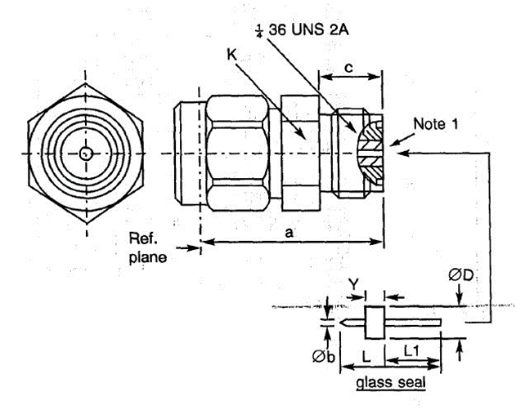
  Symbol | Dimensions mm |  | Notes
  Symbol | Min | Max | Notes
  a | 12.95 | 13.95
  c | 4.3 | 4.5
  Øb | 0.25 | 0.35
  ØD | 2.47 | 2.57
  K | - | 7 | 2 flats
  L | 7.8 | 8.2
  L1 | 4.45 | 4.7
  Y | 1.55 | 1.65
ELECTRICAL CHARACTERISTICS | VALUES | UNITS
Frequency range | 0 to 18 | GHz
Maximum voltage standing wave ratio (VSWR) | 1.06 + 0.01 f (GHz)
Maximum insertion loss (Note 1) | 0.3 | dB
RF leakage (Note 1) | -70 | dB
Voltage proof | 1000 | Vrms
Corona level (Note 1) | Not applicable | Vrms
MECHANICAL CHARACTERISTICS | VALUES | UNITS
Mini centre contact retention force (axial) | 27
Mini centre contact retention torque | Not applicable
Mini cable retention force (Note 1) | Not applicable | N
Mini cable retention torque value (Note 1) | Not applicable | N.cm
Maximum weight | 4.2 | g
OTHER CHARACTERISTICS | VALUES | UNITS
Rapid change of temperature - peak value | +115 | °C
Operating temperature range | -65 to +105 | °C
Seal: Maximum leakage | 10⁻⁸ (hermetic glass seal only) | atm.cm³/s
Solderability | On centre contact only
Cables used | Not applicable
NOTES:
            - For information purposes only.

variant 35 - BULKHEAD RECEPTACLE, with Hermetic Glass Seal Contact Ø0.46mm
Symbol | Dimensions mm |  | Notes
Symbol | Min | Max | Notes
a | 12.95 | 13.95
c | 4.3 | 4.5
Øb | 0.41 | 0.51
ØD | 2.8 | 2.9
K | - | 7 | 2 flats
L | 7.8 | 8.2
L1 | 4.45 | 4.7
Y | 1.55 | 1.65

ELECTRICAL CHARACTERISTICS | VALUES | UNITS
Frequency range | 0 to 18 | GHz
Maximum voltage standing wave ratio (VSWR) | 1.06 + 0.01 f (GHz)
Maximum insertion loss (Note 1) | 0.3 | dB
RF leakage (Note 1) | -70 | dB
Voltage proof | 1000 | Vrms
Corona level (Note 1) | Not applicable | Vrms
MECHANICAL CHARACTERISTICS | VALUES | UNITS
Mini centre contact retention force (axial) | 27
Mini centre contact retention torque | Not applicable
Mini cable retention force (Note 1) | Not applicable | N
Mini cable retention torque value (Note 1) | Not applicable | N.cm
Maximum weight | 4.2 | g
OTHER CHARACTERISTICS | VALUES | UNITS
Rapid change of temperature - peak value | +115 | °C
Operating temperature range | -65 to +105 | °C
Seal: Maximum leakage | 10⁻⁸ (hermetic glass seal only) | atm.cm³/s
Solderability | On centre contact only
Cables used | Not applicable
NOTES:
            - For information purposes only.

variant 36 - HERMETIC BULKHEAD RECEPTACLE, with COMPRESSION GASKET
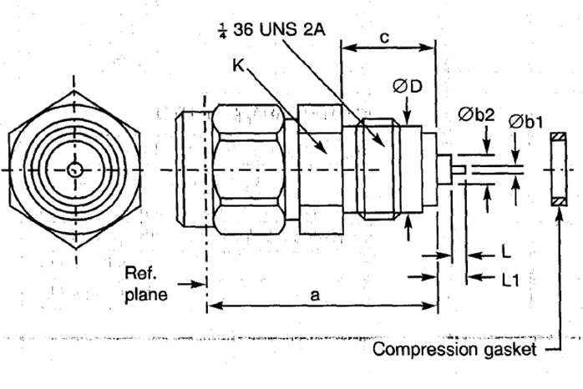
  Symbol | Dimensions mm |  | Notes
  Symbol | Min | Max | Notes
  a | 14.65 | 15.65
  Øb1 | 0.45 | 0.55
  Øb2 | 1.62 | 1.72
  c | 5.95 | 6.25
  ØD | 5.3 | 5.4
  K | - | 7 | 2 flats
  L | 1.3 | 1.5
  L1 | 3.1 | 3.35
ELECTRICAL CHARACTERISTICS | VALUES | UNITS
Frequency range | 0 to 18 | GHz
Maximum voltage standing wave ratio (VSWR) | 1.06 + 0.01 f (GHz)
Maximum insertion loss (Note 1) | 0.3 | dB
RF leakage (Note 1) | -70 | dB
Voltage proof | 1000 | Vrms
Corona level (Note 1) | Not applicable | Vrms
MECHANICAL CHARACTERISTICS | VALUES | UNITS
Mini centre contact retention force (axial) | 27
Mini centre contact retention torque | Not applicable
Mini cable retention force (Note 1) | Not applicable | N
Mini cable retention torque value (Note 1) | Not applicable | N.cm
Maximum weight | 4.4 | g
OTHER CHARACTERISTICS | VALUES | UNITS
Rapid change of temperature - peak value | +115 | °C
Operating temperature range | -65 to +105 | °C
Seal: Maximum leakage | 10⁻⁸ | atm.cm³/s
Solderability | On centre contact only
Cables used | Not applicable
NOTES:
            - For information purposes only.

variant 37 - STRAIght PLUg, SOLDER-TYPE FOR SHF 3 CABLE
Symbol | Dimensions mm |  | Notes
Symbol | Min | Max
a | 18.7 | 19.1
K | - | 6.5 | 2 flats
K1 | - | 5 | 2 flats

NOTES:
            - Components are delivered with the centre contact and insulator not mounted in the connector.
ELECTRICAL CHARACTERISTICS | VALUES | UNITS
Frequency range | 0 to 17 | GHz
Maximum voltage standing wave ratio (VSWR) | 1.15
Maximum insertion loss | 0.06 √f (GHz) | dB
RF leakage (Note 2) | - [95 - f (GHz)] | dB
Voltage proof | 750 | Vrms
Corona level (Note 2) | 190 | Vrms
MECHANICAL CHARACTERISTICS | VALUES | UNITS
Mini centre contact retention force (axial) | Not applicable
Mini centre contact retention torque | Not applicable
Mini cable retention force (Note 2) | 30 | N
Mini cable retention torque value (Note 2) | Not applicable | N.cm
Maximum weight | 3.8 | g
OTHER CHARACTERISTICS | VALUES | UNITS
Rapid change of temperature - peak value | +165 | °C
Operating temperature range | -65 to +165 | °C
Seal: Maximum leakage | Not applicable
Solderability | Applicable
Cables used | 1703-143
NOTES:
            - For information purposes only.

variant 38 - STRAIght PLUg, SOLDER-TYPE FOR SHF 8 CABLE
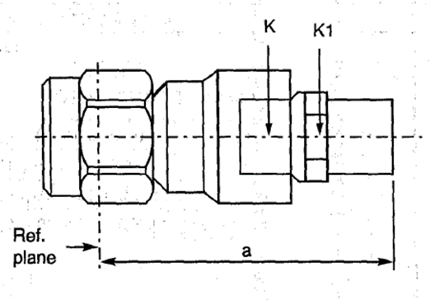
  Symbol | Dimensions mm |  | Notes
  Symbol | Min | Max
  a | 34.8 | 35.4
  K | - | 13 | 2 flats
  K1 | - | 12 | 2 flats
NOTES:
            - Components are delivered with the centre contact and insulator not mounted in the connector.
ELECTRICAL CHARACTERISTICS | VALUES | UNITS
Frequency range | 0 to 18 | GHz
Maximum voltage standing wave ratio (VSWR) | 1.15
Maximum insertion loss | 0.06 √f (GHz) | dB
RF leakage (Note 2) | - [95 - f (GHz)] | dB
Voltage proof | 1000 | Vrms
Corona level (Note 2) | 250 | Vrms
MECHANICAL CHARACTERISTICS | VALUES | UNITS
Mini centre contact retention force (axial) | Not applicable
Mini centre contact retention torque | Not applicable
Mini cable retention force (Note 2) | 50 | N
Mini cable retention torque value (Note 2) | Not applicable | N.cm
Maximum weight | 24 | g
OTHER CHARACTERISTICS | VALUES | UNITS
Rapid change of temperature - peak value | +165 | °C
Operating temperature range | -65 to +165 | °C
Seal: Maximum leakage | Not applicable
Solderability | Applicable
Cables used | 1703-148
NOTES:
            - For information purposes only.

variant 39 - RIGHT ANGLE PLUG, SOLDER-TYPE, FOR SHF 3 CABLE
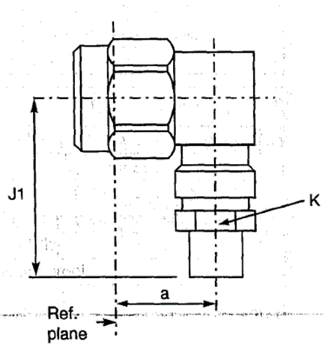
  Symbol | Dimensions mm |  | Notes
  Symbol | Min | Max
  a | 8.65 | 10
  J1 | 23.3 | 23.65
  K | - | 5 | 2 flats
NOTES:
            - Components are delivered with the centre contact and insulator not mounted in the connector.
ELECTRICAL CHARACTERISTICS | VALUES | UNITS
Frequency range | 0 to 17 | GHz
Maximum voltage standing wave ratio (VSWR) | 1.3 from 0 to 14.5 GHz  1.4 from 14.5 to 17 GHz
Maximum insertion loss | 0.06 √f (GHz) | dB
RF leakage (Note 2) | - [95 - f (GHz)] | dB
Voltage proof | 750 | Vrms
Corona level (Note 2) | 190 | Vrms
MECHANICAL CHARACTERISTICS | VALUES | UNITS
Mini centre contact retention force (axial) | Not applicable
Mini centre contact retention torque | Not applicable
Mini cable retention force (Note 2) | 30 | N
Mini cable retention torque value (Note 2) | Not applicable | N.cm
Maximum weight | 7.5 | g
OTHER CHARACTERISTICS | VALUES | UNITS
Rapid change of temperature - peak value | +165 | °C
Operating temperature range | -65 to +165 | °C
Seal: Maximum leakage | Not applicable
Solderability | Applicable
Cables used | 1703-143
NOTES:
            - For information purposes only.

variant 40 - RIGHT ANGLE PLUG, SOLDER-TYPE, FOR SHF 5 CABLE
Symbol | Dimensions mm |  | Notes
Symbol | Min | Max
a | 8.65 | 10
J1 | 25.25 | 25.7
K | - | 8 | 2 flats

NOTES:
            - Components are delivered with the centre contact and insulator not mounted in the connector.
ELECTRICAL CHARACTERISTICS | VALUES | UNITS
Frequency range | 0 to 18 | GHz
Maximum voltage standing wave ratio (VSWR) | 1.3 from 0 to 14.5 GHz  1.4 from 14.5 to 17 GHz
Maximum insertion loss | 0.06 √f (GHz) | dB
RF leakage (Note 2) | - [95 - f (GHz)] | dB
Voltage proof | 1000 | Vrms
Corona level (Note 2) | 250 | Vrms
MECHANICAL CHARACTERISTICS | VALUES | UNITS
Mini centre contact retention force (axial) | Not applicable
Mini centre contact retention torque | Not applicable
Mini cable retention force (Note 2) | 40 | N
Mini cable retention torque value (Note 2) | Not applicable | N.cm
Maximum weight | 10.3 | g
OTHER CHARACTERISTICS | VALUES | UNITS
Rapid change of temperature - peak value | +165 | °C
Operating temperature range | -65 to +165 | °C
Seal: Maximum leakage | Not applicable
Solderability | Applicable
Cables used | 1703-145
NOTES:
            - For information purposes only.

variant 41 - ELBOW PLUG, SOLDER-TYPE, FOR SHF 3 CABLE
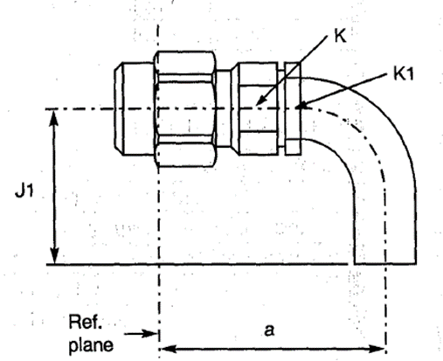
  Symbol | Dimensions mm |  | Notes
  Symbol | Min | Max
  a | 21.2 | 23.5
  J1 | 19.75 | 22
  K | - | 6.5 | 2 flats
  K1 | - | 5 | 2 flats
NOTES:
            - Components are delivered with the centre contact and insulator not mounted in the connector.
ELECTRICAL CHARACTERISTICS | VALUES | UNITS
Frequency range | 0 to 17 | GHz
Maximum voltage standing wave ratio (VSWR) | 1.15
Maximum insertion loss | 0.06 √f (GHz) | dB
RF leakage (Note 2) | - [95 - f (GHz)] | dB
Voltage proof | 750 | Vrms
Corona level (Note 2) | 190 | Vrms
MECHANICAL CHARACTERISTICS | VALUES | UNITS
Mini centre contact retention force (axial) | Not applicable
Mini centre contact retention torque | Not applicable
Mini cable retention force (Note 2) | 30 | N
Mini cable retention torque value (Note 2) | Not applicable | N.cm
Maximum weight | 4.5 | g
OTHER CHARACTERISTICS | VALUES | UNITS
Rapid change of temperature - peak value | +165 | °C
Operating temperature range | -65 to +165 | °C
Seal: Maximum leakage | Not applicable
Solderability | Applicable
Cables used | 1703-143
NOTES:
            - For information purposes only.

variant 42 - ELBOW PLUG, SOLDER-TYPE, FOR SHF 5 CABLE
Symbol | Dimensions mm |  | Notes
Symbol | Min | Max
a | 21.8 | 27.1
J1 | 23.45 | 25.75
K | - | 8.5 | 2 flats
K1 | - | 8 | 2 flats

NOTES:
            - Components are delivered with the centre contact and insulator not mounted in the connector.
ELECTRICAL CHARACTERISTICS | VALUES | UNITS
Frequency range | 0 to 18 | GHz
Maximum voltage standing wave ratio (VSWR) | 1.15
Maximum insertion loss | 0.06 √f (GHz) | dB
RF leakage (Note 2) | - [95 - f (GHz)] | dB
Voltage proof | 1000 | Vrms
Corona level (Note 2) | 250 | Vrms
MECHANICAL CHARACTERISTICS | VALUES | UNITS
Mini centre contact retention force (axial) | Not applicable
Mini centre contact retention torque | Not applicable
Mini cable retention force (Note 2) | 40 | N
Mini cable retention torque value (Note 2) | Not applicable | N.cm
Maximum weight | 7.5 | g
OTHER CHARACTERISTICS | VALUES | UNITS
Rapid change of temperature - peak value | +165 | °C
Operating temperature range | -65 to +165 | °C
Seal: Maximum leakage | Not applicable
Solderability | Applicable
Cables used | 1703-145
NOTES:
            - For information purposes only.

variant 43 - ELBOW PLUG, SOLDER-TYPE, FOR SHF 8 CABLE
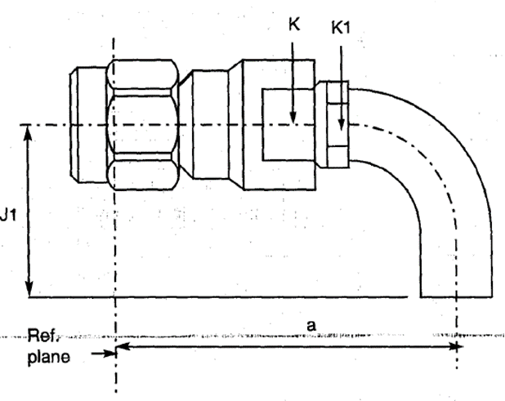
  Symbol | Dimensions mm |  | Notes
  Symbol | Min | Max
  a | 38.35 | 40.6
  J1 | 35 | 37
  K | - | 13 | 2 flats
  K1 | - | 12 | 2 flats
NOTES:
            - Components are delivered with the centre contact and insulator not mounted in the connector.
ELECTRICAL CHARACTERISTICS | VALUES | UNITS
Frequency range | 0 to 18 | GHz
Maximum voltage standing wave ratio (VSWR) | 1.15
Maximum insertion loss | 0.06 √f (GHz) | dB
RF leakage (Note 2) | - [95 - f (GHz)] | dB
Voltage proof | 1000 | Vrms
Corona level (Note 2) | 250 | Vrms
MECHANICAL CHARACTERISTICS | VALUES | UNITS
Mini centre contact retention force (axial) | Not applicable
Mini centre contact retention torque | Not applicable
Mini cable retention force (Note 2) | 50 | N
Mini cable retention torque value (Note 2) | Not applicable | N.cm
Maximum weight | 30.4 | g
OTHER CHARACTERISTICS | VALUES | UNITS
Rapid change of temperature - peak value | +165 | °C
Operating temperature range | -65 to +165 | °C
Seal: Maximum leakage | Not applicable
Solderability | Applicable
Cables used | 1703-148
NOTES:
            - For information purposes only.

variant 44 - RIGHT ANGLE PLUG, CRIMP-TYPE, FOR 50 CIS CABLE
Symbol | Dimensions mm
Symbol | Min | Max
J1 | 10 | 10.4
J2 | - | 16.8
ØN | 2 | 2.2

ELECTRICAL CHARACTERISTICS | VALUES | UNITS
Frequency range | 0 to 12.4 | GHz
Maximum voltage standing wave ratio (VSWR) | 1.1 + 0.02 f (GHz)
Maximum insertion loss | 0.03 √f (GHz) | dB
RF leakage (Note 3) | - [95 - f (GHz)] | dB
Voltage proof | 750 | Vrms
Corona level (Note 3) | 190 | Vrms
MECHANICAL CHARACTERISTICS | VALUES | UNITS
Mini centre contact retention force (axial) | 27
Mini centre contact retention torque | 2.8
Mini cable retention force (Note 3) | 80 | N
Mini cable retention torque value (Note 3) | 2 x 180º @ point 50 x ØN | N.cm
Maximum weight | 4.8 | g
OTHER CHARACTERISTICS | VALUES | UNITS
Rapid change of temperature - peak value | +115 (see cables used) | °C
Operating temperature range | -65 to +105 | °C
Seal: Maximum leakage | Not applicable
Solderability | Applicable
Cables used | 50 CIS
NOTES:
            - For information purposes only.

variant 45 - SQUARE FLANGE MALE RECEPTACLE
Symbol | Dimensions mm |  | Notes
Symbol | Min | Max | Notes
a | 9.45 | 9.55
A | - | 40.1 | Note 1
B | - | 20 | Note 1
Øf | 4 | 4.2
Øg | 2.55 | 2.7 | 4 holes
i | 12.6 | 12.8
j | 8.59 | 8.69
m | 1.4 | 1.8
ØN | 1.25 | 1.3

NOTES:
            - Contact and Insert dimensions A and B shall be selected by the Orderer; see Para. 1.4.1(b).
ELECTRICAL CHARACTERISTICS | VALUES | UNITS
Frequency range | 0 to 18 | GHz
Maximum voltage standing wave ratio (VSWR) (Note 2) | 1.05 + 0.003 f (GHz)
Maximum insertion loss (Note 2) | 0.03 √f (GHz) | dB
RF leakage (Note 2) | -120 at 10GHz | dB
Voltage proof | 1000 | Vrms
Corona level (Note 2) | Not applicable | Vrms
MECHANICAL CHARACTERISTICS | VALUES | UNITS
Mini centre contact retention force (axial) | 27
Mini centre contact retention torque | 2.8
Mini cable retention force (Note 2) | Not applicable | N
Mini cable retention torque value (Note 2) | Not applicable | N.cm
Maximum weight | 5.5 | g
OTHER CHARACTERISTICS | VALUES | UNITS
Rapid change of temperature - peak value | +180 | °C
Operating temperature range | -65 to +165 | °C
Seal: Maximum leakage | Not applicable
Solderability | On centre contact only
Cables used | Not applicable
NOTES:
            - For information purposes only.

variant 46 - 2-HOLE FLANGE MALE RECEPTACLE
Symbol | Dimensions mm |  | Notes
Symbol | Min | Max | Notes
a | 9.45 | 9.55
A | - | 40.1 | Note 1
B | - | 20 | Note 1
E | 5.5 | 5.8
Øf | 4 | 4.2
Øg | 2.55 | 2.7 | 2 holes
i | 15.9 | 16.1
j | 12.1 | 12.3
m | 1.4 | 1.8
ØN | 1.25 | 1.3

NOTES:
            - Contact and Insert dimensions A and B shall be selected by the Orderer; see Para. 1.4.1(b).
ELECTRICAL CHARACTERISTICS | VALUES | UNITS
Frequency range | 0 to 18 | GHz
Maximum voltage standing wave ratio (VSWR) (Note 2) | 1.05 + 0.003 f (GHz)
Maximum insertion loss (Note 2) | 0.03 √f (GHz) | dB
RF leakage (Note 2) | - [95 - f (GHz)] | dB
Voltage proof | 1000 | Vrms
Corona level (Note 2) | Not applicable | Vrms
MECHANICAL CHARACTERISTICS | VALUES | UNITS
Mini centre contact retention force (axial) | 27
Mini centre contact retention torque | 2.8
Mini cable retention force (Note 2) | Not applicable | N
Mini cable retention torque value (Note 2) | Not applicable | N.cm
Maximum weight | 4.5 | g
OTHER CHARACTERISTICS | VALUES | UNITS
Rapid change of temperature - peak value | +180 | °C
Operating temperature range | -65 to +165 | °C
Seal: Maximum leakage | Not applicable
Solderability | On centre contact only
Cables used | Not applicable
NOTES:
            - For information purposes only.

variant 47 - RIGHT ANGLE PLUG, CRIMP-TYPE, FOR 50 CIS CABLE
Symbol | Dimensions mm
Symbol | Min | Max
J1 | 10 | 10.4
J2 | - | 16.8
ØN | 2 | 2.2

ELECTRICAL CHARACTERISTICS | VALUES | UNITS
Frequency range | 0 to 12.4 | GHz
Maximum voltage standing wave ratio (VSWR) | 1.1 + 0.02 f (GHz)
Maximum insertion loss | 0.03 √f (GHz) | dB
RF leakage (Note 3) | - [95 - f (GHz)] | dB
Voltage proof | 750 | Vrms
Corona level (Note 3) | 190 | Vrms
MECHANICAL CHARACTERISTICS | VALUES | UNITS
Mini centre contact retention force (axial) | 27
Mini centre contact retention torque | 2.8
Mini cable retention force (Note 3) | 80 | N
Mini cable retention torque value (Note 3) | 2 x 180º @ point 50 x ØN | N.cm
Maximum weight | 4.8 | g
OTHER CHARACTERISTICS | VALUES | UNITS
Rapid change of temperature - peak value | +185 | °C
Operating temperature range | -65 to +165 | °C
Seal: Maximum leakage | Not applicable
Solderability | Applicable
Cables used | 50 CIS
NOTES:
            - For information purposes only.

