

Page 1 of 22
TRANSISTORS, HIGH POWER, PNP
BASED ON TYPE 2N5153
ESCC Detail Specification No. 5204/002

Issue 10 Draft A | June 2021



Document Custodian: European Space Agency – see https://escies.org

Legal Disclaimer and Copyright
European Space Agency, Copyright © 2021. All rights reserved.
The European Space Agency disclaims any liability or responsibility, to any person or entity, with respect to any loss or damage caused, or alleged to be caused, directly by the use and application of this ESCC publication.
This publication, without prior permission of the European Space Agency and provided it is not used for a commercial purpose, may be:
- copied in whole, in any medium, without alteration or modification.
- copied in part, in any medium, provided that the ESCC document identification, comprising the ESCC symbol, document number and document issue, is removed.

DOCUMENTATION CHANGE NOTICE
(Refer to https://escies.org for ESCC DCR content)
DCR No. | CHANGE DESCRIPTION
TBD | Specification updated to incorporate changes per DCR.
Draft 10A  S.Thacker  11/06/21 | Initial draft mark-up implementing changes requested by STM in email dated 10/06/21.  All changes from issue 9 are highlighted yellow for information.

TABLE OF CONTENTS
1 General 6
1.1 SCOPE 6
1.2 APPLICABLE DOCUMENTS 6
1.3 TERMS, DEFINITIONS, ABBREVIATIONS, SYMBOLS AND UNITS 6
1.4 THE ESCC COMPONENT NUMBER AND COMPONENT TYPE VARIANTS 6
1.4.1 The ESCC Component Number 6
1.4.2 Component Type Variants 7
1.5 MAXIMUM RATINGS 8
1.6 HANDLING PRECAUTIONS 9
1.7 PHYSICAL DIMENSIONS AND TERMINAL IDENTIFICATION 10
1.7.1 Metal Can Package (TO-39) - 3 lead 10
1.7.2 Metal Flange Mount Package (TO-257) - 3 lead 11
1.7.3 Surface Mount Package (SMD.5) - 3 terminal 12
1.7.4 Die 13
1.8 FUNCTIONAL DIAGRAM 14
1.9 MATERIALS AND FINISHES 14
1.9.1 Materials and Finishes of Packaged Components 14
1.9.2 Materials and Finishes of Die Components 14
2 REQUIREMENTS 15
2.1 GENERAL 15
2.1.1 Deviations from the Generic Specification 15
2.2 MARKING 15
2.3 CASE ISOLATION 15
2.4 TERMINAL STRENGTH 15
2.5 VERIFICATION OF SAFE OPERATING AREA 16
2.6 ELECTRICAL MEASUREMENTS AT ROOM, HIGH AND LOW TEMPERATURES 16
2.6.1 Room Temperature Electrical Measurements 16
2.6.2 High and Low Temperatures Electrical Measurements 18
2.7 PARAMETER DRIFT VALUES 19
2.8 INTERMEDIATE AND END-POINT ELECTRICAL MEASUREMENTS 19
2.9 HIGH TEMPERATURE REVERSE BIAS BURN-IN CONDITIONS 19
2.10 Power Burn-in Conditions 20
2.10.1 Power Burn-in Conditions (TO-39) 20
2.10.2 Power Burn-in Conditions (TO-257 and SMD.5) 20
2.11 OPERATING LIFE CONDITIONS 20
2.12 TOTAL DOSE RADIATION TESTING 20
2.12.1 Bias Conditions and Total Dose Level for Total dose Radiation Testing 20
2.12.2 Electrical Measurements for Radiation Testing 21
APPENDIX ‘A’ 22

General

SCOPE
This specification details the ratings, physical and electrical characteristics and test and inspection data for the component type variants and/or the range of components specified below. It supplements the requirements of, and shall be read in conjunction with, the ESCC Generic Specification listed under Applicable Documents.

APPLICABLE DOCUMENTS
The following documents form part of this specification and shall be read in conjunction with it:
          - ESCC Generic Specification No. 5000
          - MIL-STD-750, Test Methods and Procedures for Semiconductor Devices

TERMS, DEFINITIONS, ABBREVIATIONS, SYMBOLS AND UNITS
For the purpose of this specification, the terms, definitions, abbreviations, symbols and units specified in ESCC Basic Specification No. 21300 shall apply.

THE ESCC COMPONENT NUMBER AND COMPONENT TYPE VARIANTS

The ESCC Component Number
The ESCC Component Number shall be constituted as follows:
Example: 520400201R
- Detail Specification Reference: 5204002
- Component Type Variant Number: 01 (as required)
- Total Dose Radiation Level Letter: R (as required)

Component Type Variants
The component type variants applicable to this specification are as follows:
Variant Number | Based on Type | Case | Lead/Terminal Material and Finish  (Note 1) | Weight  max g | Total Dose Radiation Level Letter  (Note 2)
01 | 2N5153 | TO-39 | D2 | 1.5 | R [100kRAD(Si)]
02 | 2N5153 | TO-39 | D3 or D4 | 1.5 | R [100kRAD(Si)]
03 | 2N5153 | TO-39 | D7 | 1.5 | R [100kRAD(Si)]
04 | 2N5153 | TO-257 | H2 | 5 | R [100kRAD(Si)]
05 | 2N5153 | TO-257 | H4 | 5 | R [100kRAD(Si)]
06 (Note 3) | 2N5153 | SMD.5 | Q14 | 2 | R [100kRAD(Si)]
07 (Note 3) | 2N5153 | SMD.5 | Q14 | 2 | R [100kRAD(Si)]
08 | 2N5153 | Die | N/A | N/A | R [100kRAD(Si)]
09 (Note 3) | 2N5153 | SMD.5 | Q4 | 2 | R [100kRAD(Si)]
10  (Note 3) | 2N5153 | SMD.5 | Q4 | 2 | R [100kRAD(Si)]
NOTES:
            - The lead/terminal material and finish shall be in accordance with the requirements of ESCC Basic Specification No. 23500.
            - Total dose radiation level letters are defined in ESCC Basic Specification No. 22900. If an alternative radiation test level is specified in the Purchase Order, the letter shall be changed accordingly.
            - See Para. 1.7.3 (and Para. 1.8) for terminal identification.

MAXIMUM RATINGS
The maximum ratings shall not be exceeded at any time during use or storage.
Maximum ratings shall only be exceeded during testing to the extent specified in this specification and when stipulated in Test Methods and Procedures of the ESCC Generic Specification.
Characteristics | Symbols | Maximum Ratings | Unit | Remarks
Collector-Base Voltage | V_{CBO} | -100 | V | Over T_{op}
Collector-Emitter Voltage | V_{CEO} | -80 | V | Over T_{op}  Note 5
Emitter-Base Voltage | V_{EBO} | -5.5 | V | Over T_{op}
Collector Current | I_{C} | -5 | A | Continuous  Note 5
Power Dissipation  For TO-39  For TO-257 and SMD.5 | P_{tot1} | 1  3.3 | W | At T_{amb} ≤ +25°C  Note 1
For TO-39  For TO-257 and SMD.5 | P_{tot2} | 10  35 | W | At T_{case} ≤ +25°C  Note 1
Thermal Resistance,  Junction-to-Ambient  For TO-39  For TO-257 and SMD.5 | R_{th(j-a)} | 175  53 | °C/W
Thermal Resistance,  Junction-to-Case  For TO-39  For TO-257 and SMD.5 | R_{th(j-c)} | 17.5  5 | °C/W
Operating Temperature Range | T_{op} | -65 to +200 | °C | Note 2
Storage Temperature Range | T_{stg} | -65 to +200 | °C | Note 2
Soldering Temperature  For TO-39 and TO-257  For SMD.5 | T_{sol} | +260  +245 | °C | Note 3  Note 4
NOTES:
            - For T_{amb} or T_{case} > +25°C, derate linearly to 0W at +200°C.
            - For Variants with tin-lead plating or hot solder dip lead finish all testing, and any handling, performed at T_{amb} > +125°C shall be carried out in a 100% inert atmosphere.
            - Duration 10 seconds maximum at a distance of not less than 1.5mm from the device body and the same lead shall not be resoldered until 3 minutes have elapsed.
            - Duration 5 seconds maximum and the same package shall not be resoldered until 3 minutes have elapsed.
            - Safe Operating Area applies as follows:
Maximum Safe Operating Area Graph
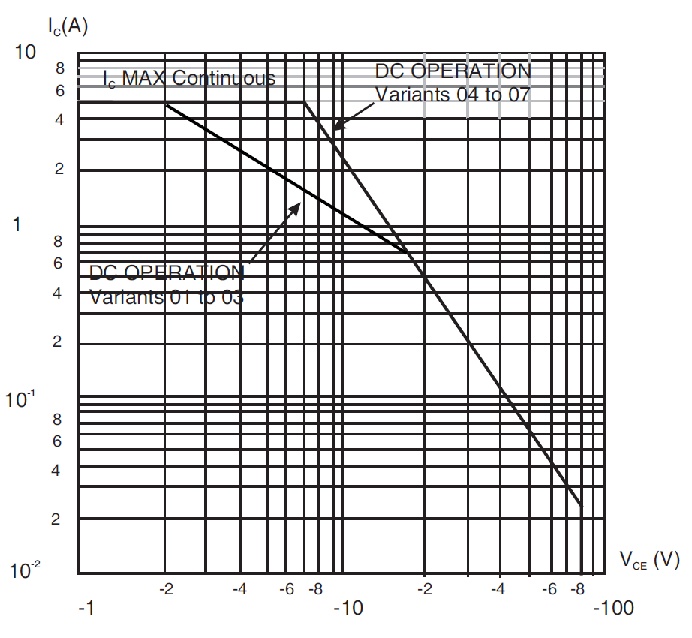

HANDLING PRECAUTIONS
The TO-257 package contains Beryllium Oxide (BeO) and therefore it must not be ground, machined, sandblasted or subjected to any mechanical operation which will produce dust. The case must not be subjected to any chemical process (e.g. etching) which will produce fumes.

PHYSICAL DIMENSIONS AND TERMINAL IDENTIFICATION

Metal Can Package (TO-39) - 3 lead
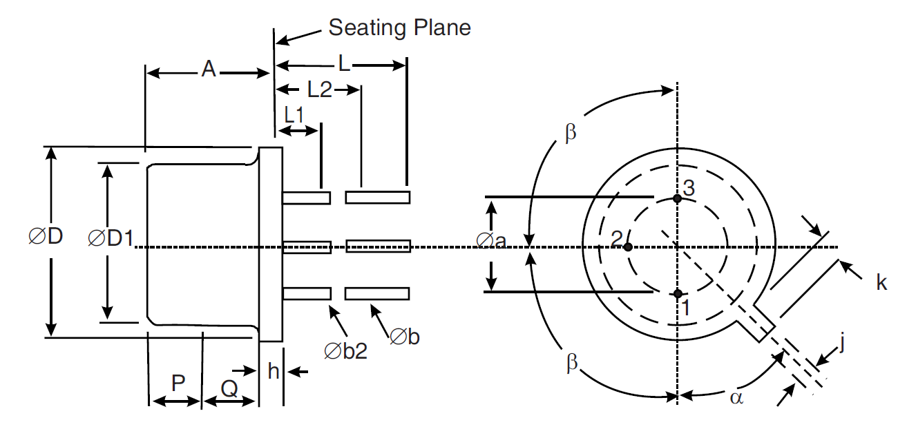
Symbols | Dimensions mm |  | Notes
Symbols | Min | Max | Notes
Øa | 4.83 | 5.35
A | 6 | 6.6
Øb | 0.4 | 0.533 | 2, 3
Øb2 | 0.4 | 0.483 | 2, 3
ØD | 8.31 | 9.4
ØD1 | 7.75 | 8.51
h | 0.229 | 3.18
j | 0.71 | 0.864
k | 0.737 | 1.14 | 4
L | 12.7 | 19 | 2
L1 | - | 1.27 | 2, 3
L2 | 6.35 | - | 2, 3
P | 2.54 | - | 5
Q | - | - | 6
α | 45° BSC |  | 1, 7
β | 90° BSC |  | 1
NOTES:
            - Terminal identification is specified by reference to the tab position where Lead 1 = emitter, Lead 2 = base and Lead 3 = collector.
            - Applies to all leads.
            - Øb2 applies between L1 and L2. Øb applies between L1 and 12.7mm from the seating plane. Diameter is uncontrolled within L1 and beyond 12.7mm from the seating plane.
            - Measured from the maximum diameter of the actual device.
            - This zone is controlled for automatic handling. The variation in actual diameter within this zone shall not exceed 0.254mm.
            - The details of outline in this zone are optional.
            - Measured from the tab centreline.

Metal Flange Mount Package (TO-257) - 3 lead
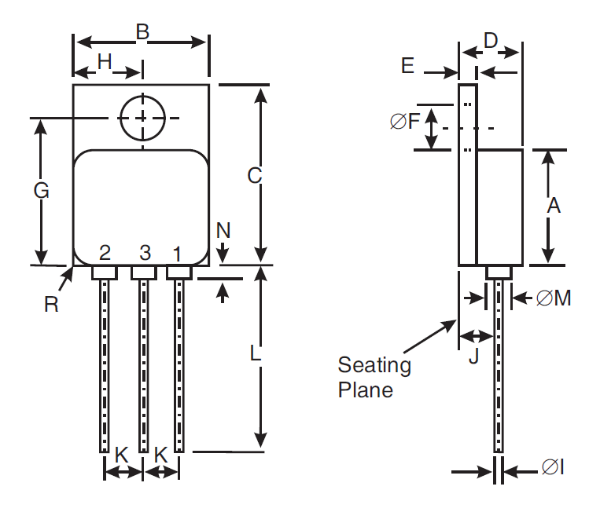
Symbols | Dimensions mm |  | Notes
Symbols | Min | Max | Notes
A | 10.41 | 10.67
B | 10.41 | 10.67
C | 16.51 | 16.76
D | 4.7 | 5.33
E | 0.89 | 1.14
ØF | 3.56 | 3.81
G | 13.39 | 13.64
H | 5.13 | 5.38
ØI | 0.64 | 0.89 | 2
J | 2.92 | 3.18
K | 2.41 | 2.67
L | 15.24 | 16.51
ØM | 2.29 Typical |  | 2
N | - | 0.71 | 2
R | 1.65 Typical |  | 3
NOTES:
            - Terminal identification is specified by the components geometry where Lead 1 = emitter, Lead 2 = base and Lead 3 = collector.
            - Applies to all leads.
            - Radius of body corner, 4 places.

Surface Mount Package (SMD.5) - 3 terminal
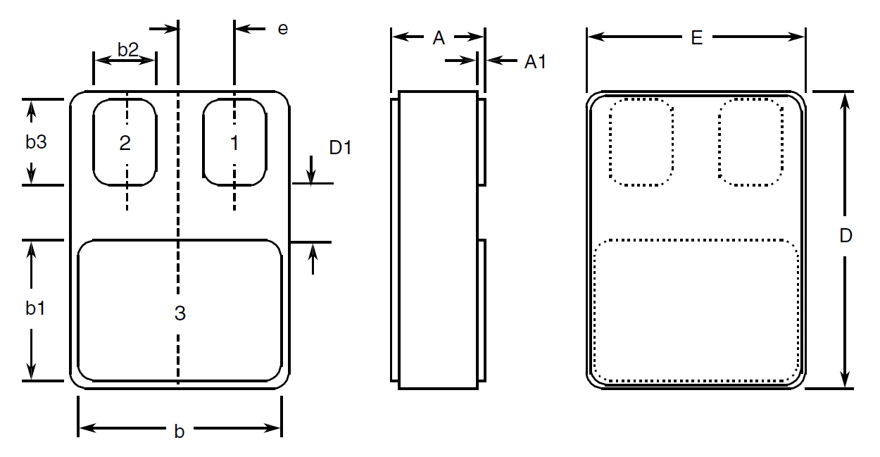
Symbols | Dimensions mm |  | Notes
Symbols | Min | Max | Notes
A | 2.84 | 3.3
A1 | 0.25 | 0.51
b | 7.13 | 7.39
b1 | 5.58 | 5.84
b2 | 2.28 | 2.54 | 2
b3 | 2.92 | 3.18 | 2
D | 10.03 | 10.28
D1 | 0.76 | - | 2
E | 7.39 | 7.64
e | 1.91 BSC |  | 2
NOTES:
            - Terminal identification is specified by the components geometry where Terminal 1 = emitter (base for Variants 07, 10), Terminal 2 = base (emitter for Variants 07, 10) and Terminal 3 = collector.
            - 2 places.

Die
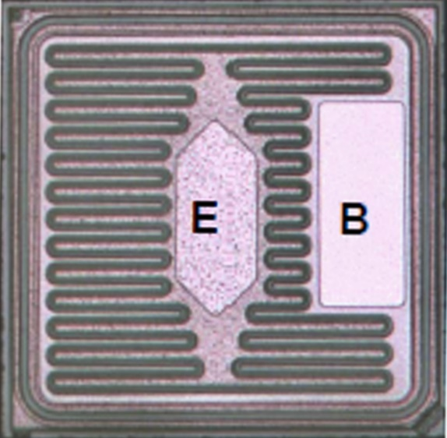
NOTES:
            - Die materials and dimensions:
- Die substrate: Silicon
- Die length: 1510 µm
- Die width: 1500 µm
- Die thickness: 230 ±20μm
- Top Glassivation:
- P-Vapox with thickness: 720 ±80nm and
- Nitride with thickness 540 ±60nm
- Top metallisation: Al/Si (1%) with thickness: 2 ±0.2μm (Typ.)
- Backside metallisation: Au/As with thickness: 1.485 ±0.165μm
- Emitter pad dimensions: 275 × 707 μm
- Base pad dimensions: 300 × 540 μm
            - Terminal identification and Bias details: B = Base, E = Emitter, Backside contact = Collector

FUNCTIONAL DIAGRAM
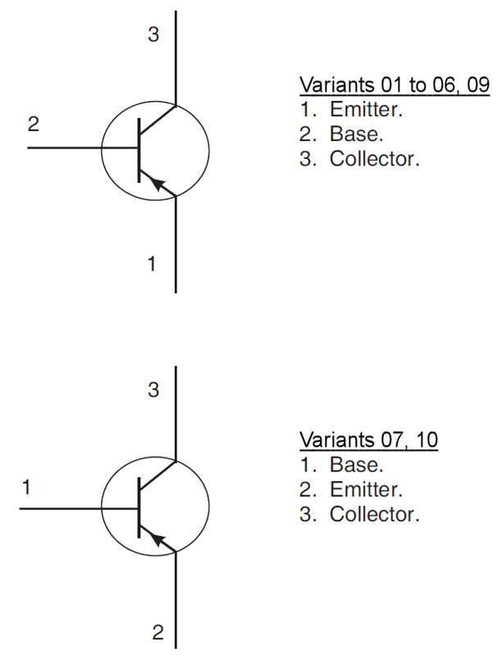
NOTES:
            - For TO-39 (Variants 01, 02, 03), the collector is internally connected to the case.
            - For TO-257 (Variants 04, 05), the case is not connected to any lead.
            - For SMD.5 (Variants 06, 07, 09, 10), the lid is not connected to any terminal.
            - For Die Components (Variant 08), the terminal numbering is not applicable.

MATERIALS AND FINISHES

Materials and Finishes of Packaged Components
For Variants 01 to 07, 09, 10 the materials and finishes shall be as follows:
          - Case
For the metal can package the case shall be hermetically sealed and have a metal body with hard glass seals.
For the metal flange mount package the case shall be hermetically sealed and have a metal body. The leads pass through ceramic eyelets brazed into the frame and the lid shall be welded.
For the surface mount package the case shall be hermetically sealed and have a ceramic body with a Kovar lid.
          - Leads/Terminals
As specified in Para. 1.4.2.

Materials and Finishes of Die Components
For Variant 08, the materials and finishes shall be as specified in Para. 1.7.4.

REQUIREMENTS

GENERAL
The complete requirements for procurement of the components specified herein are as stated in this specification and the ESCC Generic Specification. Permitted deviations from the Generic Specification, applicable to this specification only, are listed below.
Permitted deviations from the Generic Specification and this Detail Specification, formally agreed with specific Manufacturers on the basis that the alternative requirements are equivalent to the ESCC requirement and do not affect the component’s reliability, are listed in the appendices attached to this specification.

Deviations from the Generic Specification
None.

MARKING
The marking shall be in accordance with the requirements of ESCC Basic Specification No. 21700 and as follows.
The information to be marked on the component or its primary package shall be:
          - The ESCC qualified components symbol (for ESCC qualified components only).
          - The ESCC Component Number (see Para. 1.4.1).
          - Traceability information.
          - Warning sign for Beryllium Oxide (TO-257 only).

CASE ISOLATION
For Variants 04 and 05, Case Isolation shall be performed as specified in the ESCC Generic Specification and as follows:
- Test Conditions:
- Test voltage: 500Vdc
- Duration of application of test voltage: 1s
- Points of application of test voltage: between case metal tab and all terminals connected together.
- Maximum leakage current: 10nA

TERMINAL STRENGTH
The test conditions for terminal strength, tested as specified in the ESCC Generic Specification, shall be as follows:
- For TO-39, Test Condition: E, lead fatigue.
- For TO-257, Test Condition: A, tension, with an applied force of 10N for a duration of 10s.

VERIFICATION OF SAFE OPERATING AREA
The Safe Operating Area shall be verified as specified in the ESCC Generic Specification and Para. 1.5 Maximum Ratings herein. The test conditions shall be:
- Test Method = MIL-STD-750, Method 3051, Continuous DC
- T_{case} = +25°C
- V_{CE} = -18V
- I_{C} = -500mA
- Operating Time ≤ 50ms

ELECTRICAL MEASUREMENTS AT ROOM, HIGH AND LOW TEMPERATURES
Electrical measurements shall be performed at room, high and low temperatures.

Room Temperature Electrical Measurements
The measurements shall be performed at T_{amb} = +22 ±3°C.
Characteristics | Symbols | MIL-STD-750  Test Method | Test Conditions | Limits |  | Units
 |  |  |  | Min | Max | Units
Collector-Emitter Breakdown Voltage | V_{(BR)CEO} | 3011 | I_{C} = -100mA  Bias condition D  Note 1 | -80 | - | V
Collector-Emitter Cut-off Current | I_{CES} | 3041 | V_{CE} = -60V  Bias condition C | - | -1 | µA
Collector-Emitter Cut-off Current | I_{CEO} | 3041 | V_{CE} = -40V  Bias condition D | - | -50 | µA
Emitter-Base Cut-off Current | I_{EBO1} | 3061 | V_{EB} = -4V  Bias condition D | - | -1 | µA
Emitter-Base Cut-off Current | I_{EBO2} | 3061 | V_{EB} = -5.5V  Bias condition D | - | -1 | mA
Forward-Current Transfer Ratio | h_{FE1} | 3076 | V_{CE} = -5V; I_{C} = -50mA Note 1 | 50 | - | -
Forward-Current Transfer Ratio | h_{FE2} | 3076 | V_{CE} = -5V; I_{C} = -2.5A Note 1 | 70 | 200 | -
Forward-Current Transfer Ratio | h_{FE3} | 3076 | V_{CE} = -5V; I_{C} = -5A  Note 1 | 40 | - | -
Collector-Emitter Saturation Voltage | V_{CE(sat)} | 3071 | I_{C} = -5A  I_{B} = -500mA  Note 1, 2 | - | -1.5 | V
Base-Emitter Saturation Voltage | V_{BE(sat)1} | 3066 | I_{C} = -2.5A  I_{B} = -250mA  Test condition A  Note 1, 2 | - | -1.45 | V
Base-Emitter Saturation Voltage | V_{BE(sat)2} | 3066 | I_{C} = -5A  I_{B} = -500mA  Test condition A  Note 1, 2 | - | -2.2 | V
High Frequency Small Signal Current Gain | h_{fe} | 3306 | V_{CE} = -5V,  I_{C} = -500mA  f = 20MHz  Notes 3, 4 | 3.5 | - | -
Output Capacitance | C_{obo} | 3236 | V_{CB} = -10V,  I_{E} = 0A  f = 1MHz  Notes 3, 4 | - | 250 | pF
Turn-on Time | t_{on} | - | I_{C} = -5A,  I_{B1} = -500mA  I_{B2} = 500mA  V_{CC} = -30V  V_{BB} = 4V  V_{IN} ≈ -51V  Notes 3, 4, 5 | - | 500 | ns
Turn-off Time | t_{off} | - | I_{C} = -5A,  I_{B1} = -500mA  I_{B2} = 500mA  V_{CC} = -30V  V_{BB} = 4V  V_{IN} ≈ -51V  Notes 3, 4, 5 | - | 1.3 | µs
NOTES:
            - Pulse measurement: Pulse Width ≤ 300µs, Duty Cycle ≤ 2%
            - For TO-39, saturation voltages are measured 6mm from header.
            - For Packaged Components (Variants 01 to 07, 09, 10) all AC characteristics read and record measurements shall be performed on a sample of 32 components with 0 failures allowed. Alternatively a 100% inspection may be performed.
            - For Die Components (Variant 08) all AC characteristics read and record measurements shall be performed on either a sample of 32 components or 100% of the Packaged Test Sublot, whichever is less, with 0 failures allowed
            - t_{on} and t_{off} shall be measured using the following test circuit. The input waveform shall be supplied by a pulse generator with the following characteristics: t_{r} ≤ 20ns, Pulse Width = 10µs, Duty Cycle = 1%. The sampling oscilloscope for CH.A and CH.B shall have the characteristics Z_{IN} ≥ 100kΩ, C_{IN} ≤ 12pF and t_{r} ≤ 5ns. Adjustment of V_{IN} shall be made with a suitable current probe to achieve the specified I_{B1} and I_{B2} test conditions, where I_{B1} is the on-state base current and I_{B2} is the post off-state base current.
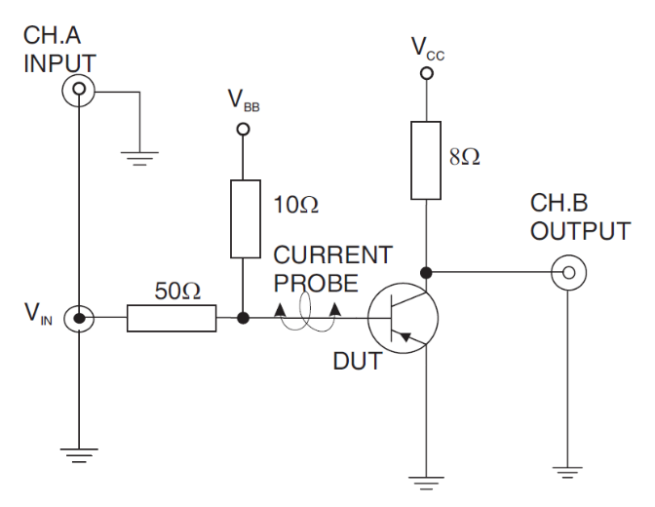
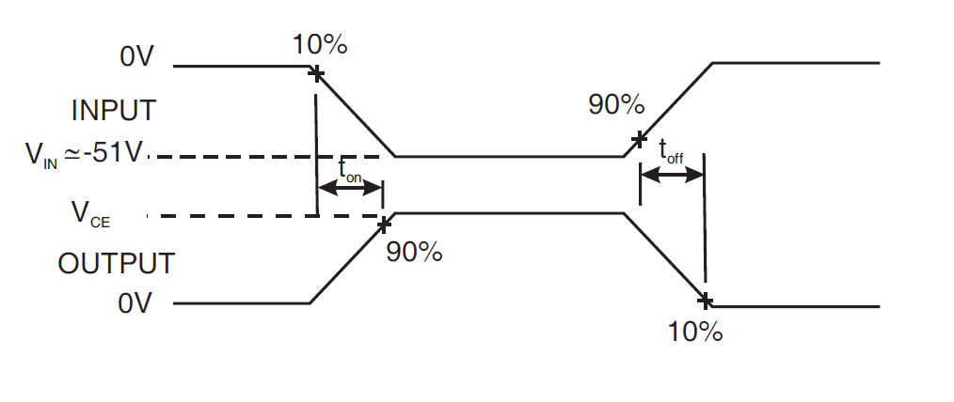

High and Low Temperatures Electrical Measurements
Characteristics | Symbols | MIL-STD-750  Test Method | Test Conditions  Note 1 | Limits |  | Units
 |  |  |  | Min | Max | Units
Collector-Base Cut-off Current | I_{CES} | 3041 | T_{amb} = +150 (+0 -5)°C  V_{CE} = -60V,  Bias Condition C | - | -10 | µA
Forward-Current Transfer Ratio 2 | h_{FE2} | 3076 | T_{amb} = -55 (+5 -0)°C  V_{CE} = -5V  I_{C} = -2.5A  Note 2 | 35 | - | -
NOTES:
            - Measurements shall be performed on a sample basis as specified in the Generic Specification.
            - Pulsed measurement: Pulse Width ≤ 300µs, Duty Cycle ≤ 2%.

PARAMETER DRIFT VALUES
Unless otherwise specified, the measurements shall be performed at T_{amb} = +22 ±3°C.
The test methods and test conditions shall be as per the corresponding test defined in Para. 2.6.1, Room Temperature Electrical Measurements.
The drift values (Δ) shall not be exceeded for each characteristic specified. The corresponding absolute limit values for each characteristic shall not be exceeded.
Characteristics | Symbols | Limits |  |  | Units
Characteristics | Symbols | Drift  Value  Δ | Absolute |  | Units
Characteristics | Symbols | Drift  Value  Δ | Min | Max | Units
Collector-Emitter Cut-off Current | I_{CES} | ±100 | - | -1000 | nA
Forward-Current Transfer Ratio 2 | h_{FE2} | ±25% | 70 | 200 | -
Collector-Emitter Saturation Voltage | V_{CE(sat)} | ±100 | - | -1500 | mV

INTERMEDIATE AND END-POINT ELECTRICAL MEASUREMENTS
Unless otherwise specified, the measurements shall be performed at T_{amb} = +22 ±3°C.
The test methods and test conditions shall be as per the corresponding test defined in Para. 2.6.1, Room Temperature Electrical Measurements.
The limit values for each characteristic shall not be exceeded.
Characteristics | Symbols | Limits |  | Units
Characteristics | Symbols | Min | Max | Units
Collector-Emitter Cut-off Current | I_{CES} | - | -1 | µA
Forward-Current Transfer Ratio 2 | h_{FE2} | 70 | 200 | -
Collector-Emitter Saturation Voltage | V_{CE(sat)} | - | -1.5 | V

HIGH TEMPERATURE REVERSE BIAS BURN-IN CONDITIONS
Characteristics | Symbols | Conditions | Units
Ambient Temperature | T_{amb} | +150 | °C
Emitter-Base Voltage | V_{EB} | -4.5 | V
Collector-Base Voltage | V_{CB} | -60 | V
Duration | t | 48 | hours

Power Burn-in Conditions

Power Burn-in Conditions (TO-39)
Characteristics | Symbols | Conditions | Units
Ambient Temperature | T_{amb} | +20 to +50 (1) | °C
Power Dissipation | P_{tot} | As per Para. 1.5 Maximum Ratings. Derate P_{tot1} at the chosen T_{amb} using the specified R_{th(j-a)}. | W
Collector-Base Voltage | V_{CB} | -20 | V
NOTES:
            - No heat sink nor forced air directly on the device shall be permitted.

Power Burn-in Conditions (TO-257 and SMD.5)
Characteristics | Symbols | Conditions | Units
Case Temperature | T_{case} | +100 (+0 -5) | °C
Power Dissipation | P_{tot} | As per Para. 1.5 Maximum Ratings. Derate P_{tot2} at the specified T_{case} using the specified R_{th(j-c)}. | W
Collector-Base Voltage | V_{CB} | -20 | V

OPERATING LIFE CONDITIONS
The conditions shall be as specified in Para. 2.10 Power Burn-in Conditions.

TOTAL DOSE RADIATION TESTING
All lots shall be irradiated in accordance with ESCC Basic Specification No. 22900, low dose rate (window 2: 36 to 360 RAD/h).

Bias Conditions and Total Dose Level for Total dose Radiation Testing
The following bias conditions shall be used for Total Dose Radiation Testing:
Characteristics | Symbols | Test Conditions | Units
Ambient Temperature | T_{amb} | +20 ±5 | °C
Bias Condition 1:  Collector-Emitter Voltage | V_{CES} | ≥ 80% V_{(BR)CEO} | V
Bias Condition 2:  Collector-Emitter Voltage | V_{CES} | 0 | V
The total dose level applied shall be as specified in Para. 1.4.2 or in the Purchase Order.

Electrical Measurements for Radiation Testing
Prior to irradiation testing the devices shall have successfully met Room Temperature Electrical Measurements specified in Para. 2.6.1.
Unless otherwise stated the measurements shall be performed at T_{amb} = +22 ±3°C.
Unless otherwise specified the test methods and test conditions shall be as per the corresponding test defined in Para. 2.6.1, Room Temperature Electrical Measurements.
The parameters to be measured during and on completion of irradiation testing are shown below.
Characteristics | Symbols | MIL-STD-750  Test Method | Test Conditions | Limits |  | Units
 |  |  |  | Min | Max | Units
Collector-Emitter Breakdown Voltage | V_{(BR)CEO} | See Para. 2.6.1 | See Para. 2.6.1 | -80 | - | V
Collector-Emitter  Cut-off Current | I_{CES} | See Para. 2.6.1  See Para. 2.6.1 | See Para. 2.6.1  See Para. 2.6.1 | - | -1 | µA
Collector-Emitter  Cut-off Current | I_{CEO} | See Para. 2.6.1  See Para. 2.6.1 | See Para. 2.6.1  See Para. 2.6.1 | - | -50 | µA
Emitter – Base  Cutoff Current | I_{EBO1} | See Para. 2.6.1  See Para. 2.6.1 | See Para. 2.6.1  See Para. 2.6.1 | - | -1 | µA
Emitter – Base  Cutoff Current | I_{EBO2} | See Para. 2.6.1  See Para. 2.6.1 | See Para. 2.6.1  See Para. 2.6.1 | - | -1 | mA
Collector-Emitter  Saturation Voltage | V_{CE(sat)} | See Para. 2.6.1 | See Para. 2.6.1 | - | -1.5 | V
Base-Emitter  Saturation Voltage | V_{BE(sat)1} | See Para. 2.6.1 | See Para. 2.6.1 | - | -1.45 | V
Base-Emitter  Saturation Voltage | V_{BE(sat)2} | See Para. 2.6.1 | See Para. 2.6.1 | - | -2.2 | V
Forward-Current  Transfer Ratio  (post irradiation gain calculation)  (Note 1) | [h_{FE1}] | 3076 | V_{CE} = -5V, I_{C} = -50mA | [25] | - | -
 | [h_{FE2}] | 3076 | V_{CE} = -5V, I_{C} = -2.5A | [35] | 200 | -
 | [h_{FE3}] | 3076 | V_{CE} = -5V, I_{C} = -5A | [20] | - | -
NOTES:
            - The post-irradiation gain calculation of [h_{FE}], made using h_{FE} measurements from prior to and on completion of irradiation testing and after each annealing step if any, shall be as specified in MIL-STD-750 Method 1019.

APPENDIX ‘A’
AGREED DEVIATIONS FOR STMICROELECTRONICS (F)
ITEMS AFFECTED | DESCRIPTION OF DEVIATIONS
Para. 2.1.1, Deviations from the Generic Specification: Para. 8, Test Methods and Procedures | For qualification and qualification maintenance, or procurement of qualified or unqualified components, the following replacement test method specifications shall be used instead of the following ESCC Basic Specifications:  - No. 20400, Internal Visual Inspection: replaced by MIL-STD-750 Test Method 2072.  - No. 20500, External Visual Inspection: replaced by MIL-STD-750 Test Method 2071.  - No. 20900, Radiographic Inspection of Electronic Components: replaced by MIL-STD-750 Test Method 2076.
Para. 2.1.1, Deviations from the Generic Specification: Screening Tests - Chart F3 | Solderability is not applicable unless specifically stipulated in the Purchase Order.
Para. 2.6.1, Room Temperature Electrical Measurements | All AC characteristics (Para. 2.6.1, Notes 3 and 4) may be considered guaranteed but not tested if successful pilot lot testing has been performed on the wafer lot which includes AC characteristic measurements per the Detail Specification.  A summary of the pilot lot testing shall be provided if required by the Purchase Order.
Para. 2.6.2, High and Low Temperatures Electrical Measurements | All characteristics specified may be considered guaranteed but not tested if successful pilot lot testing has been performed on the wafer lot which includes characteristic measurements at high and low temperatures per the Detail Specification.  A summary of the pilot lot testing shall be provided if required by the Purchase Order.
Para. 2.10.2, Power Burn-in Conditions | For TO-257 and SMD.5 packaged Variants (Variants 04 to 07, 09, 10), the following alternate Power Burn-in conditions may be applied:  - Ambient Temperature (T_{amb}): +20 to +50°C (Note 1)  - Power Dissipation (P_{tot}): As per Para. 1.5 Maximum Ratings. Derate P_{tot1} at the chosen T_{amb} using the specified R_{th(j-a)} (W)  - Collector-Base Voltage (VCB): 20 to 40V  - Note 1: No heat sink nor forced air directly on the device shall be permitted.

