

Page 1 of 16

RF COAXIAL CONNECTORS
(FEMALE CONTACT)
BASED ON TYPE TNC
ESCC Detail Specification No. 3402/009
Issue 5 Draft A | March 2021



Document Custodian: European Space Agency – see https://escies.org

LEGAL DISCLAIMER AND COPYRIGHT
European Space Agency, Copyright © 2021. All rights reserved.
The European Space Agency disclaims any liability or responsibility, to any person or entity, with respect to any loss or damage caused, or alleged to be caused, directly or indirectly by the use and application of this ESCC publication.
This publication, without the prior permission of the European Space Agency and provided that it is not used for a commercial purpose, may be:
- copied in whole, in any medium, without alteration or modification.
- copied in part, in any medium, provided that the ESCC document identification, comprising the ESCC symbol, document number and document issue, is removed.

DOCUMENTATION CHANGE NOTICE
(Refer to https://escies.org for ESCC DCR content)
DCR No. | CHANGE DESCRIPTION
TBA | Specification updated to incorporate changes per DCR.
Draft 5A  S.Thacker ESCC-TW  04/03/2021 | Initial draft converted Detail spec to assist the review of DCR for conversion of ESCC Generic Spec No. 3402.  Once the DCR on the Generic has been approved, a DCR will be raised to change this and all other ESCC 3402/xxx Detail specs in a similar way as detailed herein.  Changes in this specification from the published issue 4 are mainly editorial in nature so have not been highlighted. Any actual technical changes herein, resulting from the proposed amended Generic, are highlighted yellow for information.

TABLE OF CONTENTS

1 GENERAL 5
1.1 SCOPE 5
1.2 APPLICABLE DOCUMENTS 5
1.3 TERMS, DEFINITIONS, ABBREVIATIONS, SYMBOLS AND UNITS 5
1.4 THE ESCC COMPONENT NUMBER AND COMPONENT TYPE VARIANTS 5
1.4.1 The ESCC Component Number 5
1.4.2 Component Type Variants 6
1.5 MAXIMUM RATINGS 7
1.6 PHYSICAL DIMENSIONS (SEE ALSO PARA. 3) 9
1.6.1 Connector Interface Dimensions and Connector Interface Gauge Dimensions 9
1.7 MATERIALS AND FINISHES 9
2 REQUIREMENTS 9
2.1 GENERAL 9
2.1.1 Deviations from the Generic Specification 9
2.2 MARKING 9
2.3 ENVIRONMENTAL AND MECHANICAL TESTS 10
2.4 Room Temperature Electrical Measurements 10
2.5 INTERMEDIATE AND END-POINT ELECTRICAL MEASUREMENTS 11
2.6 BURN-IN 12
3 COMPONENT TYPE VARIANTS – DETAIL REQUIREMENTS 13
3.1 variant 01 – STRAIGHT JACK, solder type, for semi-rigid cable Ø3.58mm (0.141”) 13
3.2 variant 02 – STRAIGHT JACK, solder type, for semi-rigid cable 6.35mm (0.25”) 14
3.3 variant 03 – SQUARE Flange Receptacle 15
APPENDIX A 16

GENERAL

SCOPE
This specification details the ratings, physical and electrical characteristics, and test and inspection data for the component type variants and/or the range of components specified below. It supplements the requirements of, and shall be read in conjunction with, the ESCC Generic Specification listed under Applicable Documents.

APPLICABLE DOCUMENTS
The following documents form part of this specification and shall be read in conjunction with it:
          - ESCC Generic Specification No. 3402.
          - MIL-STD-348, Department of Defence Interface Standard: Radio Frequency Connector Interfaces.

TERMS, DEFINITIONS, ABBREVIATIONS, SYMBOLS AND UNITS
For the purpose of this specification, the terms, definitions, abbreviations, symbols and units specified in ESCC Basic Specification No. 21300 shall apply.

THE ESCC COMPONENT NUMBER AND COMPONENT TYPE VARIANTS

The ESCC Component Number
The ESCC Component Number shall be constituted as follows:
          - For components with a fixed configuration; Variants 01, 02 (see Para. 3):
Example: 340200901301
- Detail Specification Reference: 3402009
- Component Type Variant Number: 01 (as required)
- Characteristic code: Type of plating/material (amagnetic stainless steel): 3
- Characteristic code: Fixed configuration identifier (shall always be 01): 01
          - For components where the contact and insert dimensions A and B shall be selected by the Orderer: Variant 03 (see Para. 3):
Example: 340200903313D0A02D5C
- Detail Specification Reference: 3402009
- Component Type Variant Number: 03 (as required)
- Characteristic code: type of plating/material (amagnetic stainless steel): 3
- Characteristic code: Dimension A: Contact length (13mm): 13D0 (as required)
- Characteristic code: Dimension A tolerance (±0.05mm): A (as required)
- Characteristic code: Dimension B: Insert length (2.5mm): 02D5 (as required)
- Characteristic code: Dimension B tolerance (±0.25mm): C (as required)

Characteristics Codes
Characteristics to be codified as part of the ESCC Component Number (as applicable) shall be as follows:
          - Type of Plating/Material (see Para. 1.7) expressed by means of the following codes:
Type of Plating/Material | Code
Electro-passivated, Amagnetic Stainless Steel | 3
          - Contact and Insert lengths (see Para. 3) expressed by the following codes. The unit quantity shall be mm:
Dimension A or B Length (mm) | Code
XX.X | XXDX
NOTES:
            - Dimension A shall always be greater than B. Both values shall always be positive.
            - When dimension B (insert) is flush with the flange (B = 0), the insert length shall be marked 00D0 with the appropriate tolerance.
          - Tolerances on Contact and Insert lengths (see Para. 3) expressed by the following codes. The unit quantity shall be mm:
Dimension A or B Tolerance (mm) | Code Letter
±0.05 | A
±0.1 | B
±0.25 | C

Component Type Variants
The component type variants applicable to this specification are as follows:
Variant Number | Description (Note 1) | Weight Max (g)
01 | Straight Jack, Solder Type, for Semi-Rigid Cable Ø3.58mm (0.141”) | Note 1
02 | Straight Jack, Solder Type, for Semi-Rigid Cable Ø6.35mm (0.25”) | Note 1
03 | Square Flange Receptacle with a range of rear contact and insert lengths | Note 1
NOTES:
            - See Para. 3 for details.

MAXIMUM RATINGS
The maximum ratings shall not be exceeded at any time during use or storage.
Maximum ratings shall only be exceeded during testing to the extent specified in this specification and when stipulated in Test Methods and Procedures of the ESCC Generic Specification.
Characteristics | Symbol | Maximum Ratings | Unit | Remarks
Peak Power at +25°C | P_{max} | 20 | kW | For duration 1µs max.
Power | P | See Para. 3 | kW | Notes 1, 2, 3
Nominal Impedance | Z | 50 | Ω | -
Operating Frequency Range | f | See Para. 3 | GHz | Note 2
Operating Voltage | V_{op} | 500 | Vrms | -
Operating Temperature Range | T_{op} | See Para. 3 | °C | -
Storage Temperature Range | T_{stg} | As per T_{op} | °C | -
Coupling Nut Torque | Tq | 339 | N.cm | Coupling Proof Torque
NOTES:
            - Derate Power with respect to Operating Temperature as follows:
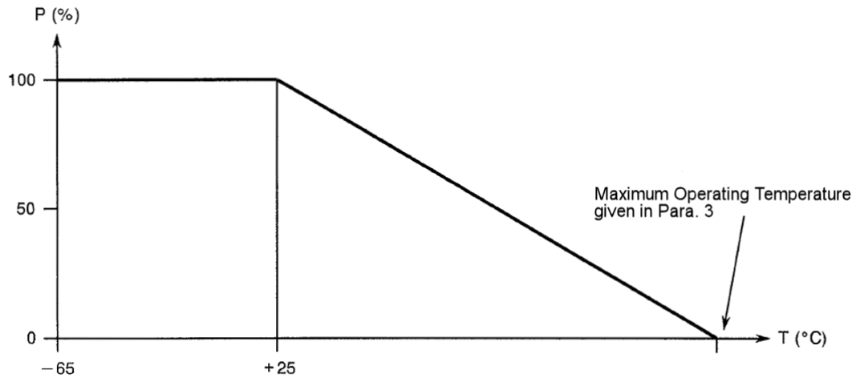
            - Derate Power with respect to Frequency as follows:
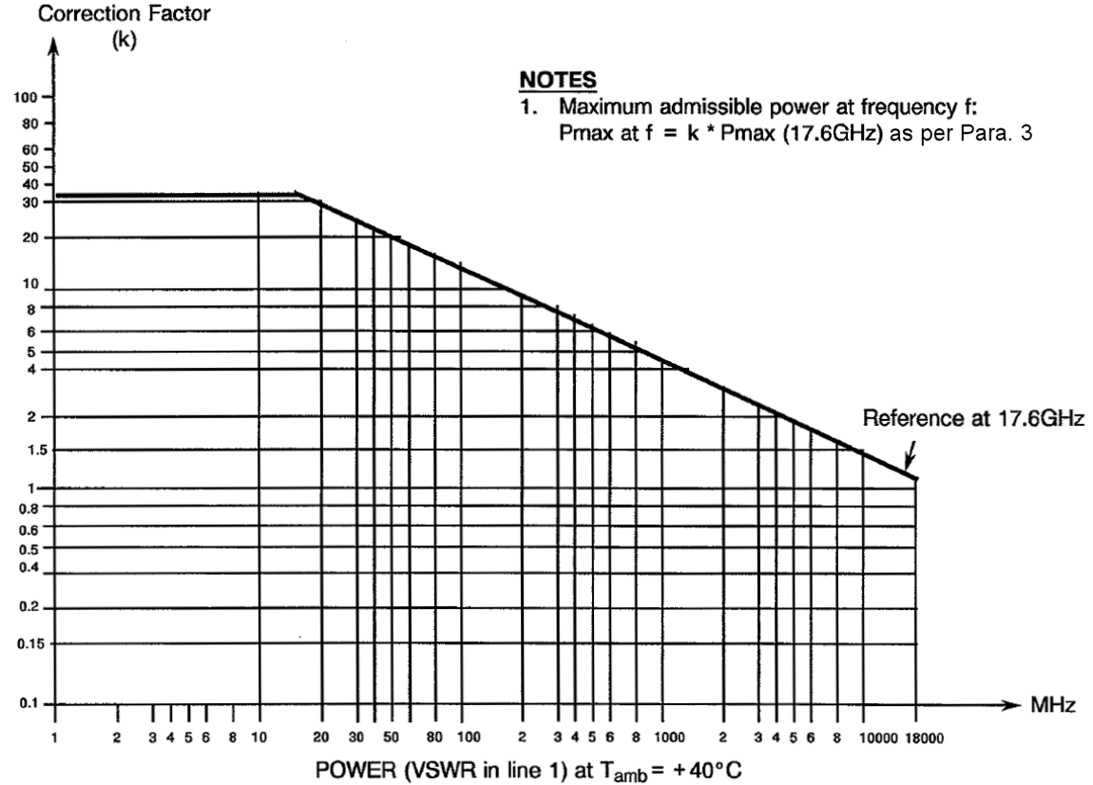
            - Derate Power with respect to ambient Pressure as follows:
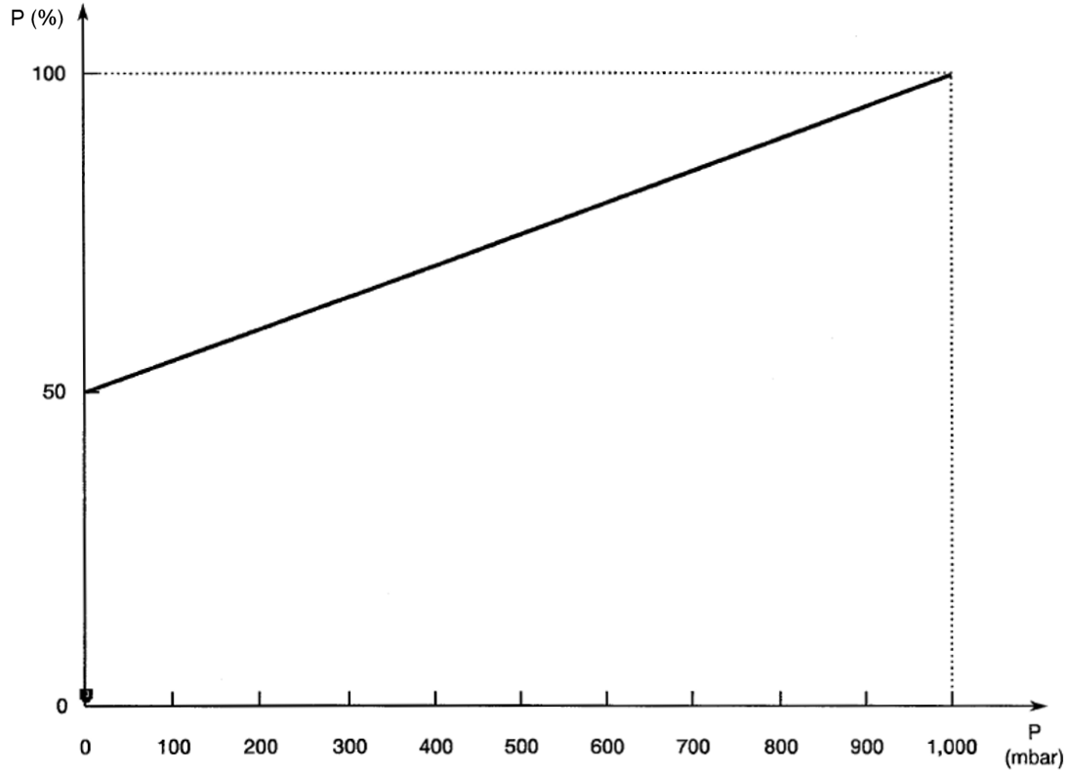
            - Whenever a test is performed on mated pairs of connectors, the pairs shall be torqued at 265 ±10N.cm.

PHYSICAL DIMENSIONS (SEE ALSO PARA. 3)

Connector Interface Dimensions and Connector Interface Gauge Dimensions
          - TNC Female Connector Interface: compatible with series TNC socket contact interface as specified in MIL-STD-348 Figure 42.
          - TNC Male Gauge Interface: compatible with series TNC pin contact interface as specified in MIL-STD-348 Figure 43.

MATERIALS AND FINISHES
Materials and finishes shall be as follows (as applicable):
          - Shell: Amagnetic stainless steel, electro-passivated.
NOTE: For solder-type connectors: rear part of shell shall be protected by an adequate coating for solderability.
          - Centre Contact: Copper alloy; plated gold 1.27μm minimum over nickel 2μm minimum.
          - Insulator: PTFE and polyetherimid resin.
          - Gaskets: Silicone and fluoro silicone.
          - Crimping and soldering elements: Brass and amagnetic stainless steel; plated nickel 2μm minimum.
          - Rear Nut: Amagnetic stainless steel, electro-passivated.
          - Washer and Clip: Copper alloy; plated nickel 2μm minimum.

REQUIREMENTS

GENERAL
The complete requirements for procurement of the components specified herein are as stated in this specification and the ESCC Generic Specification. Permitted deviations from the Generic Specification, applicable to this specification only, are listed below.
Permitted deviations from the Generic Specification and this Detail Specification, formally agreed with specific Manufacturers on the basis that the alternative requirements are equivalent to the ESCC requirement and do not affect the component’s reliability, are listed in the appendices attached to this specification.

Deviations from the Generic Specification

Deviations from Screening Tests – Chart F3
          - Coupling Proof Torque: shall not be performed.

MARKING
The marking shall be in accordance with the requirements of ESCC Basic Specification No. 21700 and as follows.
The information to be marked on the component or the primary package shall be:
          - The ESCC qualified components symbol (for ESCC qualified components only).
          - The ESCC Component Number (see Para. 1.4.1).
          - Traceability information.

ENVIRONMENTAL AND MECHANICAL TESTS
The following requirements apply to tests performed on the connector (and contact) lot as specified in the ESCC Generic Specification:
          - Para. 5.2.5, Solderability: See Para. 3.
          - Para. 8.1, Contact Engagement and Separation Forces:
 | Oversize Test Pin Test | Minimum Diameter Test Pin Test
Engagement Force (N) | 9 maximum | -
Separation Force (N) | - | 0.56 minimum
Oversize Test Pin Diameter (mm) (1) | 1.384 to 1.388 | -
Maximum Diameter Test Pin Diameter (mm) (1) | 1.372 to 1.376 | -
Minimum Diameter Test Pin Diameter (mm) (1) | - | 1.308 to 1.321
Engagement Depth (mm) (1) | 3 to 3.5 | 3 to 3.5
NOTES:
            - Test Pin details:
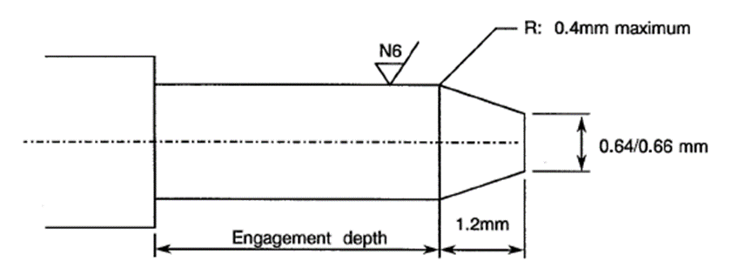
          - Para. 8.10, Coupling Proof Torque (only during Chart F4): See Para. 1.5.
          - Para. 8.11, Mating and Unmating Forces: Maximum torque: 22.6N.cm.
          - Para. 8.12, Centre Contact Retention: See Para. 3.
          - Para. 8.13, Seal: See Para. 3.
          - Para. 8.17, Thermal Stability of Insertion Loss: See Para. 3.
          - Para. 8.18, Shielding Effectiveness: See Para. 3.
          - Para. 8.19, Endurance:
- During Qualification Testing: 500 cycles.
- During Periodic Testing: 100 cycles

Room Temperature Electrical Measurements
The measurements shall be performed at T_{amb} = +22 ±3°C.
Characteristics | Symbols | Test Method and  Conditions | Limits |  | Units
Characteristics | Symbols | Test Method and  Conditions | Min | Max | Units
Insulation Resistance | R_{I} | ESCC No. 3402 | 5 | - | GΩ
Voltage Proof Leakage Current | I_{L} | ESCC No. 3402  See Para. 3. | - | 2 | mA

INTERMEDIATE AND END-POINT ELECTRICAL MEASUREMENTS
Unless otherwise specified, the measurements shall be performed at T_{amb} = +22 ±3°C.
Unless otherwise specified, the test methods and test conditions shall be as per the corresponding test defined in Para. 2.4 Room Temperature Electrical Measurements.
Test Reference per ESCC No. 3402 | Characteristics and Test Conditions  Ref. ESCC No. 3402 | Symbols | Limits |  | Units
Test Reference per ESCC No. 3402 | Characteristics and Test Conditions  Ref. ESCC No. 3402 | Symbols | Min | Max
Random Vibration | Contact Resistance:  I_{T} = 10mA, V_{T} = 20mV  Centre contact: | R_{ctc} | - | 1.5 | mΩ
Mechanical Shock | Contact Resistance:  I_{T} = 10mA, V_{T} = 20mV  Centre contact: | R_{ctc} |  | 1.5 | mΩ
Temperature Cycling | Contact Resistance:  I_{T} = 10mA, V_{T} = 20mV  Centre contact: | R_{ctc} |  | 1.5 | mΩ
 | Voltage Proof Leakage Current: | I_{L} | Note 1
Thermal Stability of Insertion Loss | Insertion Loss: | LI | Note 2
Shielding Effectiveness | Shielding Effectiveness: | SE | Note 2
Electrical Measurements at Room Temperature | Insulation Resistance: | R_{I} | Note 1
 | Voltage Proof Leakage Current: | I_{L} | Note 1
 | Contact Resistance:  I_{T} = 10mA, V_{T} = 20mV  Centre contact:  Shell: | R_{ctc}  R_{cts} | -  - | 1.5  0.7 | mΩ  mΩ
 | VSWR: | VSWR | Note 2
 | Insertion Loss: | LI | Note 2
Endurance | Contact Resistance Drift (Note 3):  I_{T} = 10mA, V_{T} = 20mV  Centre contact:  Shell: | ΔR_{ctc}  ΔR_{cts} | -  - | 2  2 | mΩ  mΩ
NOTES:
            - As specified in Para. 2.4.
            - As specified in Para. 3.
            - Parameter Drift shall be calculated referenced to the measurement immediately prior to the test in question.

COMPONENT TYPE VARIANTS – DETAIL REQUIREMENTS

variant 01 – STRAIGHT JACK, solder type, for semi-rigid cable Ø3.58mm (0.141”)
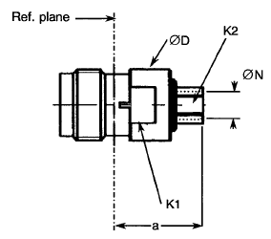 | Symbol | Millimetres |  | Notes
 | Symbol | Min. | Max. | Notes
 | a | 13.73 | 14.08
 | ØD | 10.8 | 11
 | K1 | - | 9.5 | 2 flats
 | K2 | - | 5 | Hexagon
 | ØN | 3.65 | 3.7
ELECTRICAL CHARACTERISTICS | VALUES | UNITS
Continuous max. power at 17.6 GHz at +22°C | 75 | W
Frequency range | 0 to 18 | GHz
Maximum voltage standing wave ratio (VSWR) | 1.1 + 0.005 f (GHz) up to 12.4 GHz  1.16 + 0.008 f (GHz) up to 18 GHz
Maximum insertion loss | 0.06 √f (GHz) | dB
Thermal Stability of Insertion Loss | Not applicable
Shielding Effectiveness | -115 + 20 log f (GHz) | dB
Voltage proof | 1500 | Vrms
Corona level (Note 1) | 375 | Vrms
MECHANICAL CHARACTERISTICS | VALUES | UNITS
Mini centre contact retention force (axial) | Not applicable
Mini centre contact retention torque | Not applicable
Mini cable retention force (Note 1) | 272 | N
Mini cable retention torque value (Note 1) | 40 | N.cm
Maximum weight | 8 | g
OTHER CHARACTERISTICS | VALUES | UNITS
Rapid change of temperature - peak value | +115 | °C
Operating temperature range | -65 to +105 | °C
Maxi leakage (panel sealed connectors) | Not applicable
Maxi leakage (hermetic sealed connector) | Not applicable
Solderability | Applicable
Cables used | KS 2, RG 402
NOTES:
            - For information purposes only.

variant 02 – STRAIGHT JACK, solder type, for semi-rigid cable 6.35mm (0.25”)
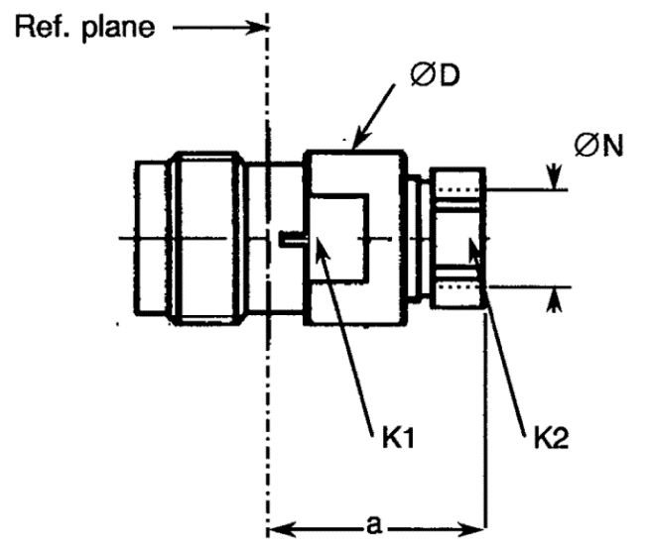 | Symbol | Millimetres |  | Notes
 | Symbol | Min. | Max. | Notes
 | a | 13.73 | 14.08
 | ØD | 10.8 | 11
 | K1 | - | 9.5 | 2 flats
 | K2 | - | 8 | Hexagon
 | ØN | 6.45 | 6.5
ELECTRICAL CHARACTERISTICS | VALUES | UNITS
Continuous max. power at 17.6 GHz at +22°C | 90 | W
Frequency range | 0 to 18 | GHz
Maximum voltage standing wave ratio (VSWR) | 1.1 + 0.005 f (GHz) up to 12.4 GHz  1.16 + 0.008 f (GHz) up to 18 GHz
Maximum insertion loss | 0.06 √f (GHz) | dB
Thermal Stability of Insertion Loss | Not applicable
Shielding Effectiveness | -115 + 20 log f (GHz) | dB
Voltage proof | 1500 | Vrms
Corona level (Note 1) | 500 | Vrms
MECHANICAL CHARACTERISTICS | VALUES | UNITS
Mini centre contact retention force (axial) | Not applicable
Mini centre contact retention torque | Not applicable
Mini cable retention force (Note 1) | 408 | N
Mini cable retention torque value (Note 1) | 50 | N.cm
Maximum weight | 9 | g
OTHER CHARACTERISTICS | VALUES | UNITS
Rapid change of temperature - peak value | +90 | °C
Operating temperature range | -65 to +90 | °C
Maxi leakage (panel sealed connectors) | Not applicable
Maxi leakage (hermetic sealed connector) | Not applicable
Solderability | Applicable
Cables used | KS 3, RG 402
NOTES:
            - For information purposes only.

variant 03 – SQUARE Flange Receptacle
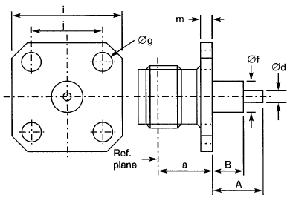 | Symbol | Millimetres |  | Notes
 | Symbol | Min | Max | Notes
 | a | 6.26 | 6.34
 | A | - | 40 | Note 1
 | B | - | 20 | Note 1
 | Ød | 1.59 | 1.69
 | Øf | 5.15 | 5.35
 | Øg | 3.1 | 3.3 | 4 holes
 | i | 18.9 | 19.1
 | j | 13.45 | 13.55
 | m | 1.9 | 2.1

ELECTRICAL CHARACTERISTICS | VALUES | UNITS
Continuous max. power at 17.6 GHz at +22°C | 100 | W
Frequency range | 0 to 18 | GHz
Maximum voltage standing wave ratio (VSWR) | 1.1 + 0.01 f (GHz)
Maximum insertion loss | 0.06 √f (GHz) | dB
Thermal Stability of Insertion Loss | Not applicable
Shielding Effectiveness | -80 + 20 log f (GHz) | dB
Voltage proof | 1500 | Vrms
MECHANICAL CHARACTERISTICS | VALUES | UNITS
Mini centre contact retention force (axial) | 27.2 | N
Mini centre contact retention torque | 2.8 | N.cm
Mini cable retention force | Not applicable
Mini cable retention torque value | Not applicable
Maximum weight | 12 | g
OTHER CHARACTERISTICS | VALUES | UNITS
Rapid change of temperature - peak value | +115 | °C
Operating temperature range | -65 to +105 | °C
Maxi leakage (panel sealed connectors) | Not applicable
Maxi leakage (hermetic sealed connector) | Not applicable
Solderability | Applicable
Cables used | Not applicable
NOTES:
            - Contact and Insert dimensions A and B shall be selected by the Orderer; see Para. 1.4.1(b).
            - For information purposes only.

