

Page 1 of 22

Page 1 of 22
Crystal Oscillators, Class 2, 4MHz to 100MHz, AHCMOS AND ACMOS COMPATIBLE OUTPUT, RAD-HARD
BASED ON TYPE RK135
ESCC Detail Specification No. 3503/001

Issue 4 Draft C | March 2021



Document Custodian: European Space Agency – see https://escies.org

Legal Disclaimer and Copyright
European Space Agency, Copyright © 2021. All rights reserved.
The European Space Agency disclaims any liability or responsibility, to any person or entity, with respect to any loss or damage caused, or alleged to be caused, directly or indirectly by the use and application of this ESCC publication.
This publication, without the prior permission of the European Space Agency and provided that it is not used for a commercial purpose, may be:
- copied in whole, in any medium, without alteration or modification.
- copied in part, in any medium, provided that the ESCC document identification, comprising the ESCC symbol, document number and document issue, is removed.

DOCUMENTATION CHANGE NOTICE
(Refer to https://escies.org for ESCC DCR content)
DCR No. | CHANGE DESCRIPTION
TBD | Specification upissued to incorporate changes per DCR
Draft 4A S.Thacker / ESCC-TW  28/01/2021 | Initial draft revision in response to Rakon’s request in email dated 27/01/21 for additional output waveform options.  This draft highlights in yellow the proposed changes.  Rakon to review and advise their comments plus details of any additional changes required.
Draft 4B S.Thacker / ESCC-TW  29/01/2021 | New revision that implements the additional changes requested by Rakon in email dated 29/01/2021 after review of Draft 4A.  This draft highlights in yellow all the proposed changes.  Note: additional change related to implemented DCR1349, on Appendix A is added here (to be added to this DCR) see green highlight
Draft 4C S.Thacker / ESCC-TW  02/03/2021 | New revision that implements the additional changes resulting from Rakon email dated 02/03/2021 on output waveform shape.  This draft highlights in yellow all the proposed changes.  Note: additional change related to implemented DCR1349, on Appendix A is added here (to be added to this DCR) see green highlight

TABLE OF CONTENTS
1 General 6
1.1 SCOPE 6
1.2 APPLICABLE DOCUMENTS 6
1.3 TERMS, DEFINITIONS, ABBREVIATIONS, SYMBOLS AND UNITS 6
1.4 THE ESCC COMPONENT NUMBER AND COMPONENT TYPE VARIANTS 6
1.4.1 The ESCC Component Number 6
1.4.2 Characteristics Codes 6
1.4.3 Component Type Variants 7
1.5 MAXIMUM RATINGS 8
1.6 PHYSICAL DIMENSIONS AND TERMINAL IDENTIFICATION 9
1.6.1 Flat Package (FP1) – 14 leads 9
1.6.2 Flat Package (FP2) – 20 leads 10
1.6.3 Flat Package (FP3) – 12 leads 11
1.6.4 Flat Package (FP4) – 16 leads 12
1.6.5 Dual-in–Line Package (DIL1) – 14 leads 13
1.6.6 J-Lead Package (JL2) – 4 leads 14
1.7 FUNCTIONAL DIAGRAM 15
1.8 MATERIALS AND FINISHES 15
2 REQUIREMENTS 16
2.1 GENERAL 16
2.1.1 Oscillator Class 16
2.1.2 Deviations from the Generic Specification 16
2.1.2.1 Deviations from Qualification and Periodic Tests - Chart F4 16
2.2 MARKING 16
2.3 ELECTRICAL MEASUREMENTS AT ROOM, HIGH AND LOW TEMPERATURES 17
2.3.1 Room Temperature Electrical Measurements 17
2.3.2 High and Low Temperatures Electrical Measurements 18
2.3.3 Notes to Paras. 2.3.1 and 2.3.2 Room, High and Low Electrical Measurements 18
2.4 PARAMETER DRIFT VALUES 19
2.5 INTERMEDIATE AND END-POINT ELECTRICAL MEASUREMENTS 20
2.6 BURN-IN CONDITIONS 20
2.7 Frequency Ageing Conditions 21
2.8 OPERATING LIFE CONDITIONS 21
2.9 TOTAL DOSE RADIATION TESTING 21
2.9.1 Bias Conditions and Total Dose Level for Total Dose Radiation Testing 21
2.9.2 Electrical Measurements for Total Dose Radiation Testing 22
APPENDIX ‘A’ 23

General

SCOPE
This specification details the ratings, physical and electrical characteristics and test and inspection data for the component type variants and/or the range of components specified below. It supplements the requirements of, and shall be read in conjunction with, the ESCC Generic Specification listed under Applicable Documents.

APPLICABLE DOCUMENTS
The following documents form part of this specification and shall be read in conjunction with it:
          - ESCC Generic Specification No. 3503.

TERMS, DEFINITIONS, ABBREVIATIONS, SYMBOLS AND UNITS
For the purpose of this specification, the terms, definitions, abbreviations, symbols and units specified in ESCC Basic Specification No. 21300 shall apply.

THE ESCC COMPONENT NUMBER AND COMPONENT TYPE VARIANTS

The ESCC Component Number
The ESCC Component Number shall be constituted as follows:
Example: 350300101R100M000000HC
- Detail Specification Reference: 3503001
- Component Type Variant Number: 01 (as required)
- Total Dose Radiation Level Letter (100krad(Si)): R (as required)
- Characteristic code: Nominal Frequency (100MHz): 100M000000 (as required)
- Characteristic code: Output Waveform (AHCMOS): HC (as required)

Characteristics Codes
Characteristics to be codified as part of the ESCC Component Number shall be as follows:
          - Nominal Frequency expressed by means of the following codes. The unit quantity shall be MHz:
Nominal Frequency f_{Nom} (MHz) | Code
X.XXXXXX | XMXXXXXX
XX.XXXXXX | XXMXXXXXX
XXX.XXXXXX | XXXMXXXXXX
          - Output Waveform type expressed by means of the following codes:
Output Waveform | Code
AHCMOS | HC
ACMOS | AC

Component Type Variants
The component type variants applicable to this specification are as follows:
Variant Number | Nominal Output Frequency f_{Nom}  (MHz) | Case | Nominal Supply Voltage  V_{CCNom}  (V) | Output Waveform | Terminal Material and Finish | Weight  max g | Total Dose Radiation Level Letter
01 | 4 to 100 | FP1 | 3.3 | AHCMOS, ACMOS | D2 | 5 | R [100krad(Si)]
02 | 4 to 100 | FP2 | 3.3 | AHCMOS, ACMOS | D2 | 5 | R [100krad(Si)]
03 | 4 to 100 | FP3 | 3.3 | AHCMOS, ACMOS | D2 | 5 | R [100krad(Si)]
04 | 4 to 100 | FP4 | 3.3 | AHCMOS, ACMOS | D2 | 5 | R [100krad(Si)]
05 | 4 to 100 | DIL1 | 3.3 | AHCMOS, ACMOS | G2 | 5 | R [100krad(Si)]
06 | 4 to 100 | JL2 | 3.3 | AHCMOS, ACMOS | D2 | 2 | R [100krad(Si)]
07 | 4 to 100 | FP1 | 5 | AHCMOS, ACMOS | D2 | 5 | R [100krad(Si)]
08 | 4 to 100 | FP2 | 5 | AHCMOS, ACMOS | D2 | 5 | R [100krad(Si)]
09 | 4 to 100 | FP3 | 5 | AHCMOS, ACMOS | D2 | 5 | R [100krad(Si)]
10 | 4 to 100 | FP4 | 5 | AHCMOS, ACMOS | D2 | 5 | R [100krad(Si)]
11 | 4 to 100 | DIL1 | 5 | AHCMOS, ACMOS | G2 | 5 | R [100krad(Si)]
12 | 4 to 100 | JL2 | 5 | AHCMOS, ACMOS | D2 | 2 | R [100krad(Si)]
The terminal material and finish shall be in accordance with the requirements of ESCC Basic Specification No. 23500.
Total dose radiation level letters are defined in ESCC Basic Specification No. 22900. If an alternative radiation test level is specified in the Purchase Order the letter shall be changed accordingly.

MAXIMUM RATINGS
The maximum ratings shall not be exceeded at any time during use or storage.
Maximum ratings shall only be exceeded during testing to the extent specified in this specification and when stipulated in Test Methods and Procedures of the ESCC Generic Specification.
Characteristics | Symbols | Maximum Ratings | Unit | Remarks
Supply Voltage | V_{cc} | -0.5 to +7 | V | Note 1
Load Impedance | C_{L} | 50 | pF | Note 2
Operating Temperature Range | T_{op} | -55 to +110 | °C | T_{amb}
Storage Temperature Range | T_{stg} | -55 to +110 | °C
Soldering Temperature | T_{sol} | +260 | °C | Note 3
Notes:
            - Device is functional as follows:
- Variants 01 to 06: +2.97V ≤ V_{CC} ≤ +3.63V (where nominal V_{CC}, V_{CCNom} = +3.3V)
- Variants 07 to 12: +4.5V ≤ V_{CC} ≤ +5.5V (where nominal V_{CC}, V_{CCNom} = +5V)
            - Device is functional as follows:
Variant Number | Output Waveform | Frequency Range | Load Impedance
01 to 06 | AHCMOS | 4MHz ≤ f_{Nom} < 80MHz | C_{LMin} = 13pF ≤ C_{L} ≤ C_{LMax} = 18pF (load in parallel with R_{L} = 1kΩ) (where nominal C_{L}, C_{LNom} = 15pF)
01 to 06 | AHCMOS | 80MHz ≤ f_{Nom} ≤ 100MHz | C_{LMin} = 8.2pF ≤ C_{L} ≤ C_{LMax} = 11pF (load in parallel with R_{L} = 1kΩ) (where nominal C_{L}, C_{LNom} = 10pF)
07 to 12 | AHCMOS | 4MHz ≤ f_{Nom} < 100MHz | C_{LMin} = 13pF ≤ C_{L} ≤ C_{LMax} = 18pF (load in parallel with R_{L} = 1kΩ) ) (where nominal C_{L}, C_{LNom} = 15pF)
01 to 12 | ACMOS | 4MHz ≤ f_{Nom} < 100MHz | C_{LMin} = 13pF ≤ C_{L} ≤ C_{LMax} = 18pF (load in parallel with R_{L} = 1kΩ) (where nominal C_{L}, C_{LNom} = 15pF)
            - Hand soldering: duration 10 seconds maximum at a distance of not less than 1.5mm from the device body and the same lead shall not be resoldered until 3 minutes have elapsed.

PHYSICAL DIMENSIONS AND TERMINAL IDENTIFICATION

Flat Package (FP1) – 14 leads
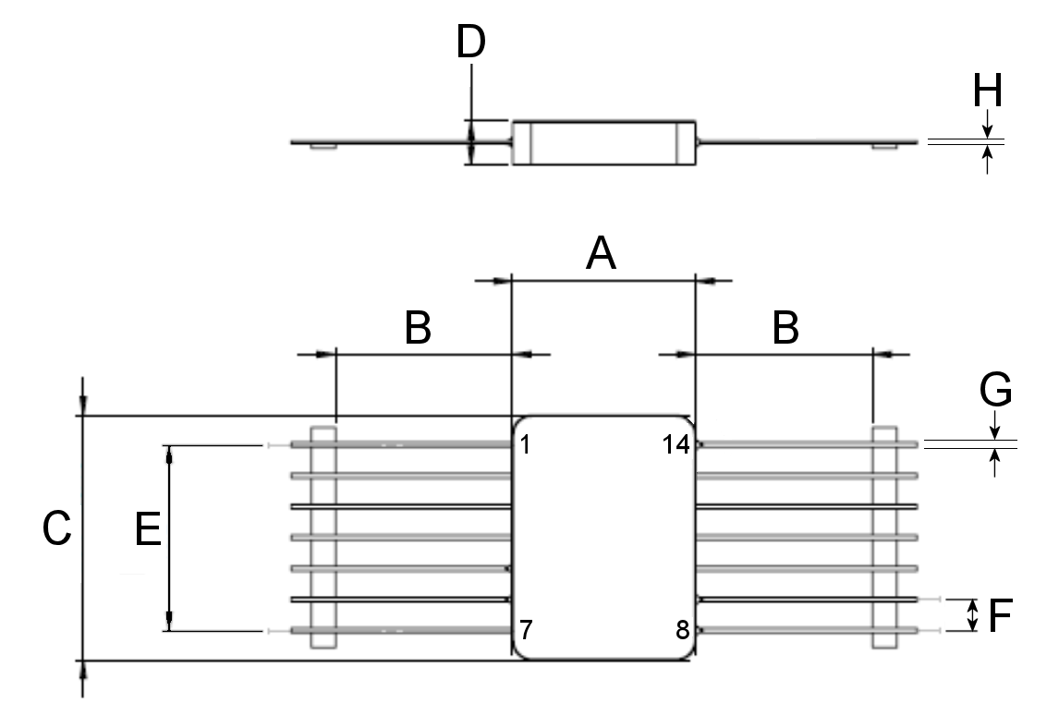
Symbols | Dimensions mm |  | Notes
Symbols | Min | Max | Notes
A | 14.86 | 15.12
B | 14 | 15
C | 19.94 | 20.2
D | - | 3.71
E | 15.24 BSC |  | 2 places
F | 2.54 BSC |  | All leads
G | 0.28 | 0.48 | All leads
H | 0.15 | 0.35 | All leads
NOTES:
            - The terminal identification is specified by marking of the terminal number on the lid as shown. See Para. 1.7 for the terminal connections.

Flat Package (FP2) – 20 leads
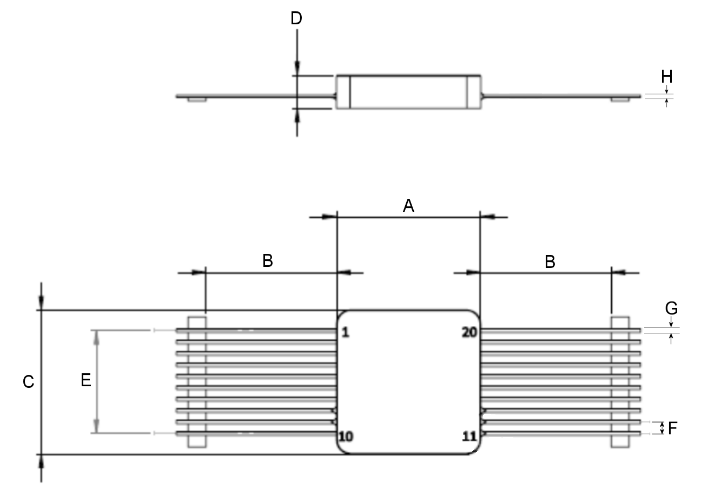
Symbols | Dimensions mm |  | Notes
Symbols | Min | Max | Notes
A | 15.75 | 16.01
B | 14 | 15
C | 15.75 | 16.01
D | - | 3.83
E | 11.43 BSC |  | 2 places
F | 1.27 BSC |  | All leads
G | 0.28 | 0.48 | All leads
H | 0.15 | 0.35 | All leads
NOTES:
            - The terminal identification is specified by marking of the terminal number on the lid as shown. See Para. 1.7 for the terminal connections.

Flat Package (FP3) – 12 leads
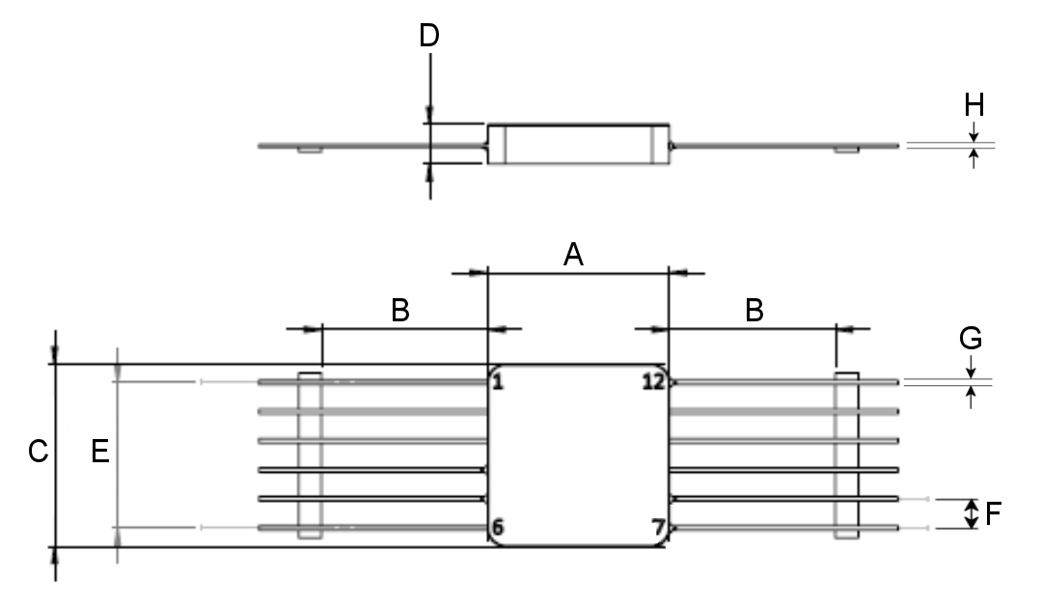
Symbols | Dimensions mm |  | Notes
Symbols | Min | Max | Notes
A | 15.75 | 16.01
B | 14 | 15
C | 15.75 | 16.01
D | - | 3.58
E | 12.7 BSC |  | 2 places
F | 2.54 BSC |  | All leads
G | 0.28 | 0.48 | All leads
H | 0.15 | 0.35 | All leads
NOTES:
            - The terminal identification is specified by marking of the terminal number on the lid as shown. See Para. 1.7 for the terminal connections.

Flat Package (FP4) – 16 leads
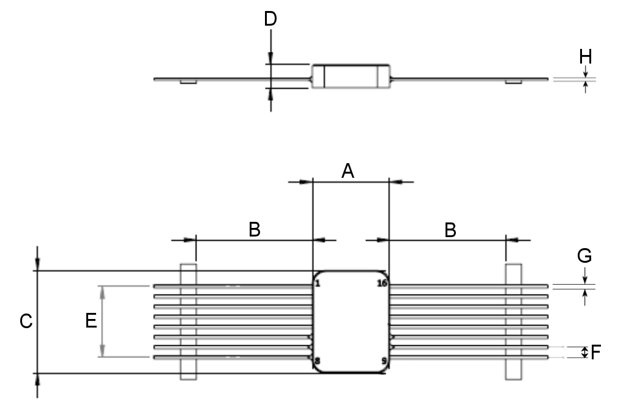
Symbols | Dimensions mm |  | Notes
Symbols | Min | Max | Notes
A | - | 9.66
B | 13.9 | 15.1
C | - | 12.83
D | - | 3.1
E | 8.89 BSC |  | 2 places
F | 1.27 BSC |  | All leads
G | 0.28 | 0.48 | All leads
H | 0.15 | 0.35 | All leads
NOTES:
            - The terminal identification is specified by marking of the terminal number on the lid as shown. See Para. 1.7 for the terminal connections.

Dual-in–Line Package (DIL1) – 14 leads
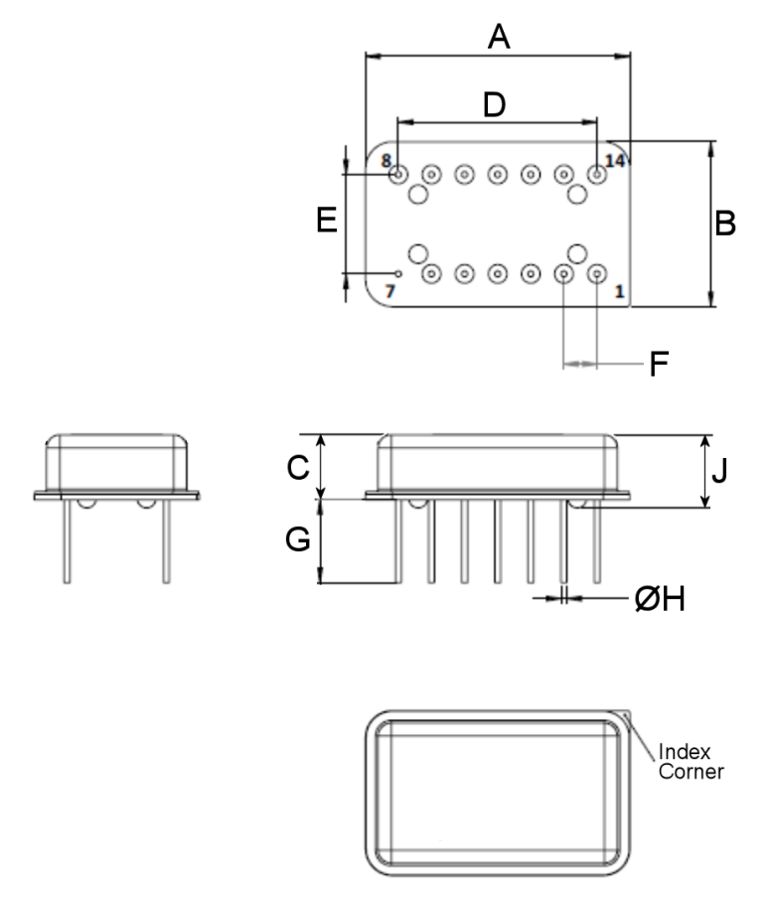
Symbols | Dimensions mm |  | Notes
Symbols | Min | Max | Notes
A | - | 20.7
B | - | 13.1
C | - | 5.45
D | 15.24 BSC  5.18 |  | 2 places
E | 7.62 BSC |  | All leads
F | 2.54 BSC |  | All leads
G | 6.22 | 6.48 | All leads
ØH | 0.25 | 0.65 | All leads
J | - | 6 | 4 places
NOTES:
            - The terminal identification is specified by reference to the index corner as shown. See Para. 1.7 for the terminal connections.

J-Lead Package (JL2) – 4 leads
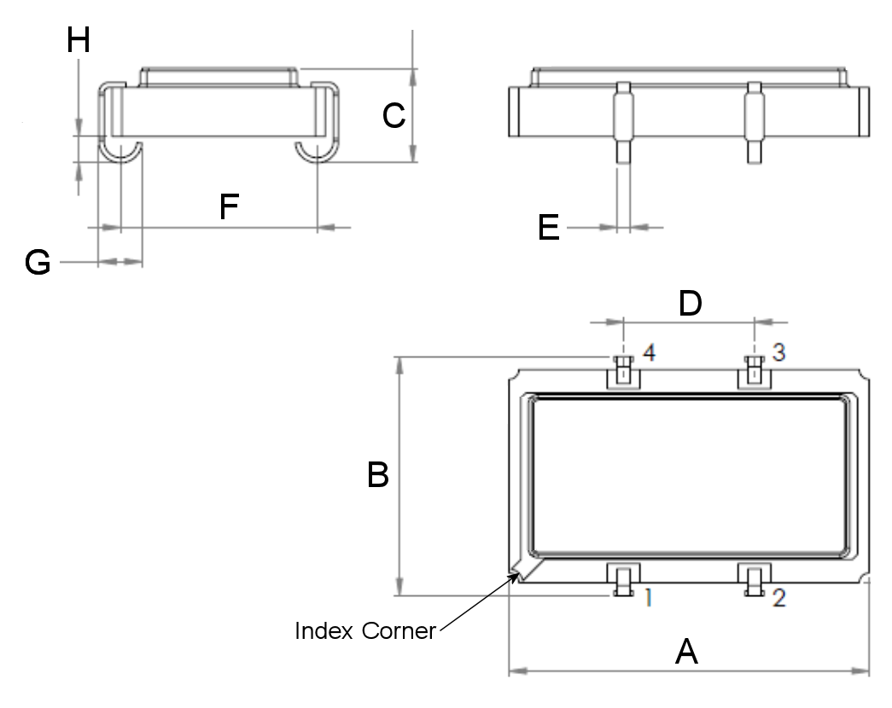
Symbols | Dimensions mm |  | Notes
Symbols | Min | Max | Notes
A | 13.72 | 14.22
B | 8.8 | 9.8 | 2 places
C | - | 4.2 | All leads
D | 4.93 | 5.23 | 2 places
E | 0.46 | 0.56 | All leads
F | 7.42 | 7.82 | All leads
G | 1.58 | 1.78 | All leads
H | 0.89 | 1.15 | All leads
NOTES:
            - The terminal identification is specified by reference to the index corner as shown. See Para. 1.7 for the terminal connections.

FUNCTIONAL DIAGRAM
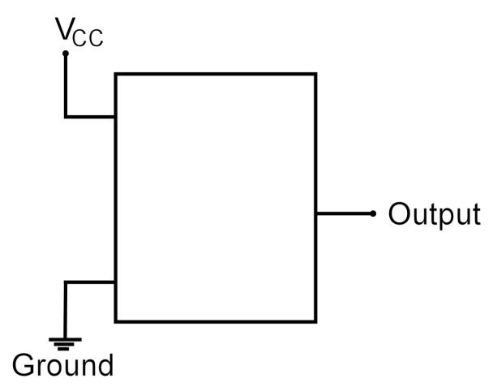
Variant Number | Case | Terminal Number |  |  |  | Notes
Variant Number | Case | Output | V_{CC} | Ground | Not Connected | Notes
01, 07 | FP1 | 8 | 14 | 1, 2, 3, 4, 7, 10, 11, 12, 13 | 5, 6, 9 | 1, 2
02, 08 | FP2 | 11 | 13 | 1, 2, 3, 4, 5, 6, 7, 10, 14, 15, 16, 17, 18, 19, 20 | 8, 9, 12 | 1, 2
03, 09 | FP3 | 7 | 12 | 1, 2, 3, 6, 9, 10, 11 | 4, 5, 8 | 1, 2
04, 10 | FP4 | 10 | 8 | 1, 2, 3, 4, 5, 9, 12, 13, 14, 15, 16 | 6, 7, 11 | 1, 2
05, 11 | DIL1 | 8 | 14 | 7 | 1, 2, 3, 4, 5, 6, 9, 10, 11, 12, 13 | 1, 2
06, 12 | JL2 | 3 | 4 | 2 | 1 | 1, 2
NOTES:
            - The case is connected to Ground.
            - Not connected pins must be connected to a potential (e.g. Ground)

MATERIALS AND FINISHES
Materials and finishes shall be as follows:
          - Case
The FP1, FP2, FP3, FP4 and DIL1 cases shall be hermetically sealed, and have a metal body with hard glass seals and a seam sealed metal lid.
The JL2 case shall be hermetically sealed, and have a ceramic body with brazed leads and a seam sealed lid.
          - Terminals
As specified in Para. 1.4.3 Component Type Variants.

REQUIREMENTS

GENERAL
The complete requirements for procurement of the components specified herein are as stated in this specification and the ESCC Generic Specification. Permitted deviations from the Generic Specification, applicable to this specification only, are listed below.
Permitted deviations from the Generic Specification and this Detail Specification, formally agreed with specific Manufacturers on the basis that the alternative requirements are equivalent to the ESCC requirement and do not affect the component’s reliability, are listed in the appendices attached to this specification.

Oscillator Class
The components specified herein shall satisfy the requirements Class 2 Oscillators in accordance with the Generic Specification.

Deviations from the Generic Specification

Deviations from Qualification and Periodic Tests - Chart F4
          - Mechanical Shock: the following test conditions shall apply:
MIL-STD-202, Test Method 213, Test Condition F except that the tests condition values shall be: 2000g, 0.3ms, half-sine.
          - Random Vibration: the following test conditions shall apply:
MIL-STD-202, Test Method 214, Test Condition I-J (37.8grms overall), 3 minutes per axis.

MARKING
The marking shall be in accordance with the requirements of ESCC Basic Specification No. 21700 and as follows.
The information to be marked on the component shall be:
          - Terminal identification (see Para. 1.6).
          - The ESCC Qualified Component symbol (for ESCC qualified components only).
          - The ESCC Component Number (see Para. 1.4.1).
          - Traceability information.

ELECTRICAL MEASUREMENTS AT ROOM, HIGH AND LOW TEMPERATURES
Electrical measurements shall be performed at room, high and low temperatures. Consolidated notes are given in Para. 2.3.3.

Room Temperature Electrical Measurements
Characteristics | Symbols | Test Method | Test Conditions  Note 1 | Limits |  | Units
 |  |  |  | Min | Max | Units
Input Current | I_{IN} | ESCC No. 24200 | For 4MHz ≤ f_{Nom} < 20MHz:  For 20MHz ≤ f_{Nom} < 50MHz:  For 50MHz ≤ f_{Nom} ≤ 100MHz: | -  -  - | 20  25  30 | mA
Output Waveform  (AHCMOS and ACMOS) | - | ESCC No. 24200 |  | Symmetrical Square Wave (Note 2) |  | -
Output Voltage High Level  Variants 01 to 06:  Variants 07 to 12: | V_{OH} | ESCC No. 24200 |  | 2.4  4.5 | -  - | V
Output Voltage Low Level  Variants 01 to 06:  Variants 07 to 12: | V_{OL} | ESCC No. 24200 |  | -  - | 0.4  0.5 | V
Frequency Accuracy | Δf/f_{Nom} | ESCC No. 24200 | At T_{amb} = +25 ±1°C  Referred to f_{Nom} | - | ±25 | ppm
Frequency-Voltage Tolerance  Variants 01 to 06:  Variants 07 to 12: | Δf/f(V) | ESCC No. 24200 | At T_{amb} = +25 ±1°C  Referred to f at V_{CCNom}  For 2.97V, 3.3V & 3.63V:  For 4.5V, 5V & 5.5V: | -  - | ±3  ±3 | ppm
Frequency-Load Tolerance | Δf/f(L) | ESCC No. 24200 | At T_{amb} = +25 ±1°C  For C_{L} = C_{LMin}, C_{LNom} & C_{LMax}, R_{L} = 1kΩ,  Referred to f at C_{LNom} | - | ±5 | ppm
Startup Time | t_{su} | ESCC No. 24200 |  | - | 10 | ms
Rise Time | t_{r} | ESCC No. 24200 | For 4MHz ≤ f_{Nom} < 16MHz:  For 16MHz ≤ f_{Nom} ≤ 100MHz: | -  - | 10  7 | ns
Fall Time | t_{f} | ESCC No. 24200 | For 4MHz ≤ f_{Nom} < 16MHz:  For 16MHz ≤ f_{Nom} ≤ 100MHz: | -  - | 10  7 | ns
Duty Cycle | DC | ESCC No. 24200 |  | 45 | 55 | %
Ageing Analysis | Δf/f | ESCC No. 3503 | Ageing Period = 1 year  Ageing Period = 18 years  Note 3 | -  - | ±5  ±15 | ppm

High and Low Temperatures Electrical Measurements
Characteristics | Symbols | Test Method | Test Conditions  Note 1 | Limits |  | Units
 |  |  |  | Min | Max
Input Current | I_{IN} | ESCC No. 24200 | At T_{amb} = -55 (+5 -0)°C and +110 (+0 -5)°C  For 4MHz ≤ f_{Nom} < 20MHz:  For 20MHz ≤ f_{Nom} < 50MHz:  For 50MHz ≤ f_{Nom} ≤ 100MHz: | -  -  - | 20  25  30 | mA
Output Waveform | - | ESCC No. 24200 | At T_{amb} = -55 (+5 -0)°C and +110 (+0 -5)°C | Symmetrical Square Wave |  | -
Output Voltage High Level  Variants 01 to 06:  Variants 07 to 12: | V_{OH} | ESCC No. 24200 | At T_{amb} = -55 (+5 -0)°C and +110 (+0 -5)°C | 2.4  4.5 | -  - | V
Output Voltage Low Level  Variants 01 to 06:  Variants 07 to 12: | V_{OL} | ESCC No. 24200 | At T_{amb} = -55 (+5 -0)°C and +110 (+0 -5)°C | -  - | 0.4  0.5 | V
Frequency-Temperature Stability | Δf/f(T) | ESCC No. 24200 | At T_{amb} = -55 (+1 -0)°C to +110 (+0 -1)°C. Note 4  Referred to f at T_{amb} = +25 ±1°C | - | ±30 | ppm
Frequency-Voltage Tolerance  Variants 01 to 06:  Variants 07 to 12: | Δf/f(V) | ESCC No. 24200 | At T_{amb} = -55 (+1 -0)°C to +110 (+0 -1)°C  Referred to f at V_{CCNom}  For 2.97V, 3.3V & 3.63V:  For 4.5V, 5V & 5.5V: | -  - | ±3  ±3 | ppm
Startup Time | t_{su} | ESCC No. 24200 | At T_{amb} = -55 (+5 -0)°C and +110 (+0 -5)°C |  | 10 | ms
Rise Time | t_{r} | ESCC No. 24200 | At T_{amb} = -55 (+5 -0)°C and +110 (+0 -5)°C  For 4MHz ≤ f_{Nom} < 16MHz:  For 16MHz ≤ f_{Nom} ≤ 100MHz: | -  - | 10  7 | ns
Fall Time | t_{f} | ESCC No. 24200 | At T_{amb} = -55 (+5 -0)°C and +110 (+0 -5)°C  For 4MHz ≤ f_{Nom} < 16MHz:  For 16MHz ≤ f_{Nom} ≤ 100MHz: | -  - | 10  7 | ns
Duty Cycle | DC | ESCC No. 24200 | At T_{amb} = -55 (+5 -0)°C and +110 (+0 -5)°C | 45 | 55 | %

Notes to Paras. 2.3.1 and 2.3.2 Room, High and Low Electrical Measurements
            - Unless otherwise specified, the measurements shall be performed at T_{amb} = +22 ±3°C and the component under test shall be operated at V_{CCNom} with an output load of C_{LNom} in parallel with R_{L} = 1kΩ. V_{CCNom} and C_{LNom} are specified in Para. 1.5 Maximum Ratings.
            - The shape of the output waveform shall comform to the requirements specified in the Manufacturer’s PID, as applicable for AHCMOS or ACMOS (see Para. 1.4.2(b)).
            - All measurements aquired during Frequency Ageing shall be taken into account when performing Ageing Analysis.
            - Frequency-Temperature Stability shall be measured at a minimum of 10 equally spaced increments over the specified temperature range.

PARAMETER DRIFT VALUES
Unless otherwise specified, the measurements shall be performed at T_{amb} = +22 ±3°C.
The test methods and test conditions shall be as per the corresponding test defined in Para. 2.3.1 Room Temperature Electrical Measurements.
The drift values (Δ) shall not be exceeded for each characteristic specified. The corresponding absolute limit values for each characteristic shall not be exceeded.
Characteristics | Symbols | Limits |  |  | Units
Characteristics | Symbols | Drift  Value  Δ | Absolute |  | Units
Characteristics | Symbols | Drift  Value  Δ | Min | Max | Units
Input Current  For 4MHz ≤ f_{Nom} < 20MHz:  For 20MHz ≤ f_{Nom} < 50MHz:  For 50MHz ≤ f_{Nom} ≤ 100MHz: | I_{IN} | ±5%  ±5%  ±5% | -  -  - | 20  25  30 | mA
Frequency Accuracy  Initial measurement:  Final measurement: | Δf/f_{Nom} | ±10 | -  - | ±15  ±25 | ppm

INTERMEDIATE AND END-POINT ELECTRICAL MEASUREMENTS
Unless otherwise specified, the measurements shall be performed at T_{amb} = +22 ±3 °C.
The test methods and test conditions shall be as per the corresponding test defined in Para. 2.3.1 Room Temperature Electrical Measurements or Para. 2.3.2 High and Low Temperatures Electrical Measurements, as follows.
The drift values (Δ) shall not be exceeded for each characteristic specified. Unless otherwise specified, the corresponding absolute limit values for each characteristic shall not be exceeded.
Characteristics | Symbols | Test Conditions | Limits |  |  | Units
Characteristics | Symbols | Test Conditions | Drift  Value  Δ | Absolute |  | Units
 |  |  |  | Min | Max | Units
Input Current  For 4MHz ≤ f_{Nom} < 20MHz:  For 20MHz ≤ f_{Nom} < 50MHz:  For 50MHz ≤ f_{Nom} ≤ 100MHz: | I_{IN} | As per Para. 2.3.1 | -  -  - | -  -  - | 20  25  30 | mA
Output Waveform | - | As per Para. 2.3.1 | - | Symmetrical Square Wave |  | -
Output Voltage High Level  Variants 01 to 06:  Variants 07 to 12: | V_{OH} | As per Para. 2.3.1 | -  - | 2.4  4.5 | -  - | V
Output Voltage Low Level  Variants 01 to 06:  Variants 07 to 12: | V_{OL} | As per Para. 2.3.1 | -  - | -  - | 0.4  0.5 | V
Frequency Accuracy | Δf/f_{Nom} | As per Para. 2.3.1 | ±8.5 (1) | - | ±25 (2) | ppm
Frequency-Temperature Stability | Δf/f(T) | As per Para. 2.3.1 |  | - | ±30 | ppm
Rise Time  For 4MHz ≤ f_{Nom} < 16MHz:  For 16MHz ≤ f_{Nom} ≤ 100MHz: | t_{r} | As per Para. 2.3.1 | -  - | -  - | 10  7 | ns
Fall Time  For 4MHz ≤ f_{Nom} < 16MHz:  For 16MHz ≤ f_{Nom} ≤ 100MHz: | t_{r} | As per Para. 2.3.1 | -  - | -  - | 10  7 | ns
Duty Cycle | DC | As per Para. 2.3.1 | - | 45 | 55 | %
NOTES:
            - Drift value (Δ) is only applicable to testing during the Endurance Subgroup.
            - Absolute limit is only applicable to testing during the Environmental/Mechanical Subgroup.

BURN-IN CONDITIONS
The test conditions for Burn-in, tested as specified in the ESCC Generic Specification, shall be as follows:
          - Ouptut Load: C_{LNom} in parallel with R_{L} = 1kΩ. C_{LNom} is specified in Para. 1.5 Maximum Ratings.

Frequency Ageing Conditions
The test conditions for Frequency Ageing, tested as specified in the ESCC Generic Specification, shall be as follows:
          - Ouptut Load: C_{LNom} in parallel with R_{L} = 1kΩ. C_{LNom} is specified in Para. 1.5 Maximum Ratings.

OPERATING LIFE CONDITIONS
The test conditions for Operating Life, tested as specified in the ESCC Generic Specification, shall be as follows:
          - Ouptut Load: C_{LNom} in parallel with R_{L} = 1kΩ. C_{LNom} is specified in Para. 1.5 Maximum Ratings.

TOTAL DOSE RADIATION TESTING
All lots shall be irradiated in accordance with ESCC Basic Specification No. 22900, low dose rate (window 2: 36rad(Si) to 360rad(Si) per hour).

Bias Conditions and Total Dose Level for Total Dose Radiation Testing
The following bias condition (worst-case) shall be used for Total Dose Radiation Testing at T_{amb} = +22 ±3°C:
With Supply Voltage:
- Variants 01 to 06: V_{CC} = 3.63V during irradiation.
- Variants 07 to 12: V_{CC} = 5.5V during irradiation.
The total dose level applied shall be as specified in Para. 1.4.3 or in the Purchase Order.

Electrical Measurements for Total Dose Radiation Testing
Prior to irradiation testing the devices shall have successfully met Para. 2.3.1 Room Temperature Electrical Measurements specified herein.
Unless otherwise specified, the measurements shall be performed at T_{amb} = +22 ±3°C.
Unless otherwise specified, the test methods and test conditions shall be as per the corresponding test defined in Para. 2.3.1 Room Temperature Electrical Measurements.
The parameters to be measured during irradiation testing, on completion of irradiation testing, after 24 hours anneal at Room Temperature and after 168 hours anneal at T_{amb} = +100 ±3°C are shown below.
Characteristics | Symbols | Limits |  | Units
Characteristics | Symbols | Absolute |  | Units
Characteristics | Symbols | Min | Max | Units
Input Current  For 4MHz ≤ f_{Nom} < 20MHz:  For 20MHz ≤ f_{Nom} < 50MHz:  For 50MHz ≤ f_{Nom} ≤ 100MHz: | I_{IN} | -  -  - | 20  25  30 | mA
Output Waveform | - | Symmetrical Square Wave |  | -
Output Voltage High Level  Variants 01 to 06:  Variants 07 to 12: | V_{OH} | 2.4  4.5 | -  - | V
Output Voltage Low Level  Variants 01 to 06:  Variants 07 to 12: | V_{OL} | -  - | 0.4  0.5 | V
Frequency Accuracy | Δf/f_{Nom} | - | ±25 | ppm
Rise Time  For 4MHz ≤ f_{Nom} < 16MHz:  For 16MHz ≤ f_{Nom} ≤ 100MHz: | t_{r} | -  - | 10  7 | ns
Fall Time  For 4MHz ≤ f_{Nom} < 16MHz:  For 16MHz ≤ f_{Nom} ≤ 100MHz: | t_{f} | -  - | 10  7 | ns
Duty Cycle | DC | 45 | 55 | %

APPENDIX ‘A’
AGREED DEVIATIONS FOR RAKON FRANCE SAS (F)
ITEMS AFFECTED | DESCRIPTION OF DEVIATIONS
Para. 1.4.3 Component Type Variants | Oscillators with ACMOS outputs (output waveform code AC) are available from Rakon but only with specific frequencies.  Customers should contact Rakon to confirm feasibility and availability.

