

Page 1 of 14

CAPACITORS, LEADLESS SURFACE MOUNTED, TANTALUM, SOLID ELECTROLYTE
BASED ON TYPE CTC21E
ESCC Detail Specification No. 3012/003
Issue 5 Draft C | July 2020



Document Custodian: European Space Agency – see https://escies.org

LEGAL DISCLAIMER AND COPYRIGHT
European Space Agency, Copyright © 2020. All rights reserved.
The European Space Agency disclaims any liability or responsibility, to any person or entity, with respect to any loss or damage caused, or alleged to be caused, directly or indirectly by the use and application of this ESCC publication.
This publication, without the prior permission of the European Space Agency and provided that it is not used for a commercial purpose, may be:
- copied in whole, in any medium, without alteration or modification.
- copied in part, in any medium, provided that the ESCC document identification, comprising the ESCC symbol, document number and document issue, is removed.

DOCUMENTATION CHANGE NOTICE
(Refer to https://escies.org for ESCC DCR content)
DCR No. | CHANGE DESCRIPTION
TBD | Specification upissued to incorporate changes per DCR.
Draft 5A  S.Thacker (TW)  03/03/2017 | Draft 5A created per converted format to go with converted Generic 3012 Draft 4A.
Draft 5C  S.Thacker (TW)  27/07/2020 | New revision updated from Draft 5A for DCR review (based around the final converted Generic 3012 issue 4)(replaces Draft 5B).

TABLE OF CONTENTS

1 GENERAL 5
1.1 SCOPE 5
1.2 APPLICABLE DOCUMENTS 5
1.3 TERMS, DEFINITIONS, ABBREVIATIONS, SYMBOLS AND UNITS 5
1.4 THE ESCC COMPONENT NUMBER AND Component Type Variants 5
1.4.1 The ESCC Component Number 5
1.4.2 Component Type Variants and Range of Components 6
1.5 MAXIMUM RATINGS 8
1.6 PHYSICAL DIMENSIONS and terminal identification 10
1.7 FUNCTIONAL DIAGRAM 10
2 REQUIREMENTS 10
2.1 GENERAL 11
2.1.1 Deviations from the Generic Specification 11
2.2 MARKING 11
2.3 ELECTRICAL MEASUREMENTS AT ROOM, HIGH AND LOW TEMPERATURES 12
2.3.1 Room Temperature Electrical Measurements 12
2.3.2 High and Low Temperatures Electrical Measurements 12
2.4 INTERMEDIATE AND END-POINT ELECTRICAL MEASUREMENTS 13

GENERAL

SCOPE
This specification details the ratings, physical and electrical characteristics, and test and inspection data for the component type variants and/or the Component Type Variants and Range of Components specified below. It supplements the requirements of, and shall be read in conjunction with, the ESCC Generic Specification listed under Applicable Documents.

APPLICABLE DOCUMENTS
The following documents form part of this specification and shall be read in conjunction with it:
          - ESCC Generic Specification No. 3012.

TERMS, DEFINITIONS, ABBREVIATIONS, SYMBOLS AND UNITS
For the purpose of this specification, the terms, definitions, abbreviations, symbols and units specified in ESCC Basic Specification No. 21300 shall apply.

THE ESCC COMPONENT NUMBER AND Component Type Variants

The ESCC Component Number
The ESCC Component Number shall be constituted as follows:
Example: 301200301277KB
- Detail Specification Reference: 3012003
- Component Type Variant Number: 01 (as required)
- Characteristic code: Rated Capacitance (270μF): 277 (as required)
- Characteristic code: Capacitance Tolerance (±10%): K
- Rating code: DC Rated Voltage (6.3V): B (as required)

Characteristics and Ratings Codes
Characteristics and ratings to be codified as part of the ESCC Component Number shall be as follows:
          - Rated Capacitance, C_{n}, expressed by means of the following codes in accordance with ESCC Basic Specification No. 21700. The unit quantity shall be picofarad (pF).
Capacitance Value C  (pF) | Code
XX 10⁶ | XX6
XX 10⁷ | XX7
          - Capacitance Tolerance expressed by the following codes in accordance with ESCC Basic Specification No. 21700:
Tolerance  (± %) | Code
10 | K
20 | M
          - DC Rated Voltage, U_{R}, expressed by the following codes:
DC Rated Voltage U_{R}  (V) | Code
6.3 | B
10 | D
16 | E
20 | F
25 | G
40 | K
50 | L
63 | N

Component Type Variants and Range of Components
The Component Type Variants and Range of Components applicable to this specification are as follows:
Variant  Number | Terminal Finish  (Note 1) | Case Code  (Note 2) | Capacitance Range  C_{n} (µF)  (Notes 3, 4) | DC Rated Voltage  U_{R} (V)  (Note 3) | Weight Max  (g)
01 | 9 | C, D | 12 to 680 | 6.3 to 63 | Case Code C: 2
 |  |  |  |  | Case Code D: 3.6
03 | 10 | C, D | 12 to 680 | 6.3 to 63 | Case Code C: 2
 |  |  |  |  | Case Code D: 3.6
04 | 18 | C, D | 12 to 680 | 6.3 to 63 | Case Code C: 2
 |  |  |  |  | Case Code D: 3.6
NOTES:
            - See Para. 1.8.2.
            - See Para. 1.6.
            - The following Rated Capacitance (C_{n}) and DC Rated Voltage (U_{R}) are available in the following cases (and with the following characteristics; see Paras. 2.3.1 and 2.3.2):
(1)  DC Rated  Voltage  (U_{R})  (V) | (2)  Cap.  Value  (C_{n})  (µF) | (3)  Case  Size | DC Leakage Current (I_{L}) |  |  | Dissipation Factor (DF) |  |  | (10)  Equivalent Series Resistance  (ESR)  (mΩ)
(1)  DC Rated  Voltage  (U_{R})  (V) | (2)  Cap.  Value  (C_{n})  (µF) | (3)  Case  Size | (4)  +22ºC  (µA) | (5)  +85ºC  (µA) | (6)  +125ºC  (µA) | (7)  -55ºC  (%) | (8)  +22ºC  (%) | (9)  +85ºC and +125ºC  (%) | (10)  Equivalent Series Resistance  (ESR)  (mΩ)
6.3 | 270 | C | 17 | 170 | 212 | 32 | 16 | 24 | 45
6.3 | 330 | C | 20.8 | 208 | 260 | 40 | 20 | 30 | 45
6.3 | 560 | D | 35.3 | 353 | 441 | 48 | 24 | 36 | 35
6.3 | 680 | D | 42.8 | 428 | 535 | 60 | 30 | 45 | 35
10 | 180 | C | 18 | 180 | 225 | 24 | 12 | 18 | 50
10 | 220 | C | 22 | 220 | 275 | 24 | 12 | 18 | 45
10 | 390 | D | 39 | 390 | 487 | 40 | 20 | 30 | 35
10 | 470 | D | 47 | 470 | 587 | 44 | 22 | 33 | 35
16 | 120 | C | 19.2 | 192 | 240 | 20 | 10 | 15 | 55
16 | 150 | C | 24 | 240 | 300 | 24 | 12 | 18 | 50
16 | 270 | D | 43.2 | 432 | 540 | 32 | 16 | 24 | 45
16 | 330 | D | 52.8 | 528 | 660 | 40 | 20 | 30 | 45
20 | 82 | C | 16.4 | 164 | 205 | 12 | 6 | 9 | 65
20 | 100 | C | 20 | 200 | 250 | 16 | 8 | 12 | 60
20 | 180 | D | 36 | 360 | 450 | 24 | 12 | 18 | 50
20 | 220 | D | 44 | 440 | 550 | 24 | 12 | 18 | 45
25 | 39 | C | 9.7 | 97 | 121 | 10 | 5 | 7.5 | 95
25 | 47 | C | 11.7 | 117 | 146 | 12 | 6 | 9 | 85
25 | 82 | D | 20.5 | 205 | 256 | 12 | 6 | 9 | 65
25 | 100 | D | 25 | 250 | 312 | 16 | 8 | 12 | 60
40 | 33 | C | 13.2 | 132 | 165 | 10 | 5 | 7.5 | 100
40 | 56 | D | 22.4 | 224 | 280 | 12 | 6 | 9 | 80
40 | 68 | D | 27.2 | 272 | 340 | 12 | 6 | 9 | 75
50 | 22 | C | 11 | 110 | 137 | 10 | 5 | 7.5 | 125
50 | 47 | D | 23.5 | 235 | 293 | 12 | 6 | 9 | 85
63 | 12 | C | 7.5 | 75 | 93 | 10 | 5 | 7.5 | 160
63 | 15 | C | 9.4 | 94 | 118 | 10 | 5 | 7.5 | 145
63 | 33 | D | 20.8 | 208 | 260 | 10 | 5 | 7.5 | 100
            - The following Capacitance Tolerances are available:
- ±10% (K)
- ±20% (M)

MAXIMUM RATINGS
The maximum ratings shall not be exceeded at any time during use or storage.
Maximum ratings shall only be exceeded during testing to the extent specified in this specification and when stipulated in Test Methods and Procedures of the ESCC Generic Specification.
Characteristics | Symbols | Maximum Ratings | Units | Remarks
DC Rated Voltage | U_{R} | See Para. 1.4.2 | V | Note 1
DC Surge Voltage | U_{S} | 1.3 x U_{R} | V | T_{amb} ≤ +85°C
DC Category Voltage | U_{C} | 0.66 x U_{R} | V
Ripple Current | I_{ripple} | See Note 2 | A | Note 3
Operating Temperature Range | T_{op} | -55 to +125 | °C | T_{amb}
Rated Temperature | T_{R} | +85 | °C
Upper Category Temperature | T_{C} | +125 | °C
Storage Temperature Range | T_{stg} | -55 to +125 | °C
Soldering Temperature | T_{sol} | +260 | °C | Note 4
Notes:
            - At T_{amb} ≤ +85°C. For T_{amb} > +85°C, derate linearly to U_{C} at T_{amb} = +125°C.
            - Maximum I_{ripple}, which depends on C_{n} and U_{R}, shall be as follows at T_{amb} ≤ +25°C:
(1)  DC Rated Voltage  U_{R} (V) | (2)  Capacitance  C_{n} (µF) | (3)  Maximum Ripple Current  f = 500kHz  I_{ripple} (A) | (4)  Maximum Ripple Current  f = 1kHz  I_{ripple} (A)
6.3 | 270 | 2.9 | 2
6.3 | 330 | 2.9 | 2
6.3 | 560 | 3.6 | 2.5
6.3 | 680 | 3.6 | 2.5
10 | 180 | 2.7 | 1.9
10 | 220 | 2.9 | 2
10 | 390 | 3.6 | 2.5
10 | 470 | 3.6 | 2.5
16 | 120 | 2.6 | 1.8
16 | 150 | 2.9 | 2
16 | 270 | 3.5 | 2.3
16 | 330 | 3.6 | 2.5
20 | 82 | 2.4 | 1.7
20 | 100 | 2.5 | 1.7
20 | 180 | 3 | 2.1
20 | 220 | 3.1 | 2.2
25 | 39 | 2 | 1.4
25 | 47 | 2.1 | 1.5
25 | 82 | 2.6 | 1.8
25 | 100 | 2.7 | 1.9
40 | 33 | 1.9 | 1.3
40 | 56 | 2.3 | 1.6
40 | 68 | 2.4 | 1.7
50 | 22 | 1.7 | 1.2
50 | 47 | 2,3 | 1.6
63 | 12 | 1.5 | 1.1
63 | 15 | 1.6 | 1.1
63 | 33 | 2.1 | 1.5
            - At T_{amb} ≤ +25°C. For T_{amb} > +25°C, derate maximum I_{ripple} as follows:
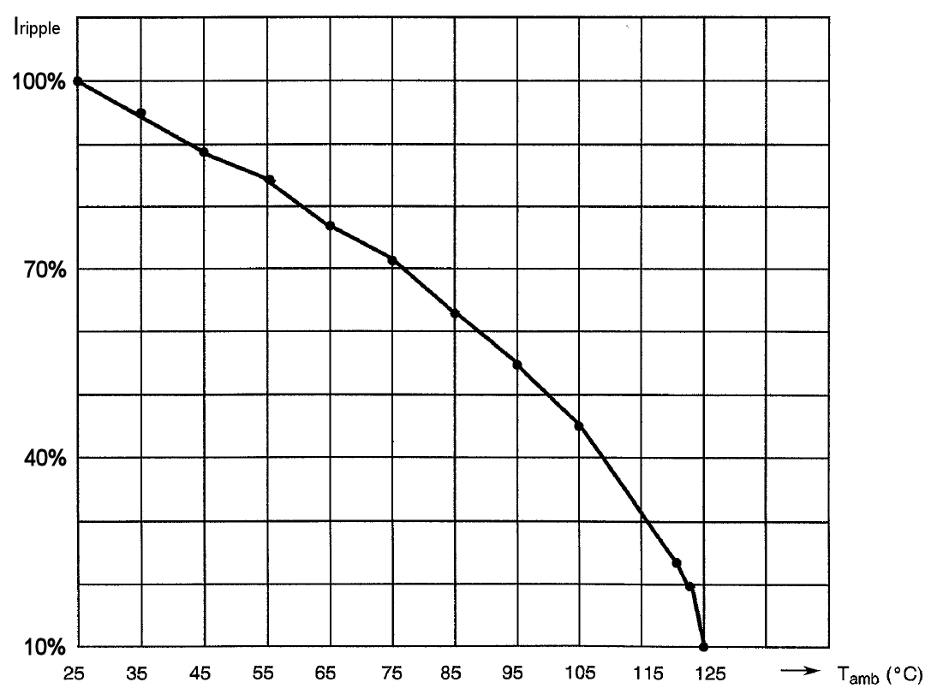
            - Duration 5 seconds maximum for wave soldering and 10 seconds maximum for reflow soldering. The solderable area is the terminal pad and up to 1/3 the height of the L-shape terminal (see Para. 1.6).

PHYSICAL DIMENSIONS and terminal identification
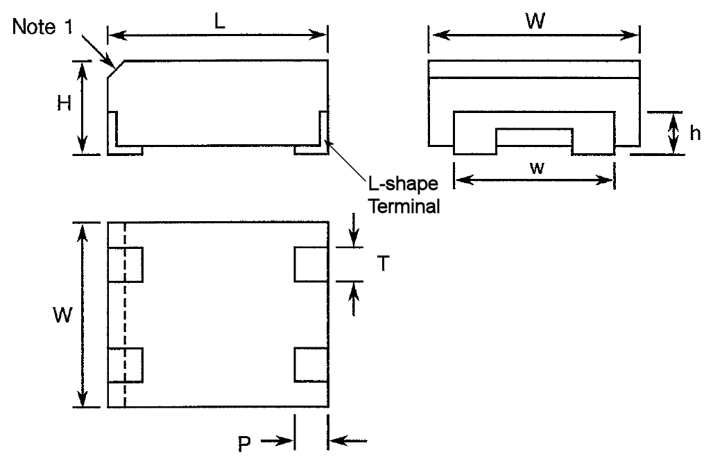
Case  Code | Dimensions (mm)
Case  Code | L |  | H |  | h |  | W |  | w |  | P |  | T
Case  Code | Min | Max | Min | Max | Min | Max | Min | Max | Min | Max | Min | Max | Min | Max
C | 10.9 | 11.9 | 4.4 | 5.4 | 2 | - | 8.9 | 9.5 | 6.7 | 7.3 | 1.2 | 1.8 | 1.7 | 2.3
D | 10.9 | 11.9 | 5.4 | 6.4 | 2 | - | 12.4 | 13 | 10.2 | 10.8 | 1.2 | 1.8 | 2.7 | 3.3
NOTES:
            - Terminal identification: The anode terminal shall be indicated by a 0.8mm 45° chamfer on the body of the component as indicated.

FUNCTIONAL DIAGRAM
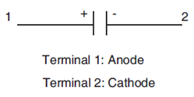

Materials and Finishes

Case
The case shall be moulded epoxy.

Terminal Material and Finish
Terminal material shall be brass. Terminal finish shall be as specified in Para. 1.4.2 in accordance with the requirements of ESCC Basic Specification No. 23500.

REQUIREMENTS

GENERAL
The complete requirements for procurement of the components specified herein are as stated in this specification and the ESCC Generic Specification. Permitted deviations from the Generic Specification, applicable to this specification only, are listed below.
Permitted deviations from the Generic Specification and this Detail Specification, formally agreed with specific Manufacturers on the basis that the alternative requirements are equivalent to the ESCC requirement and do not affect the component’s reliability, are listed in the appendices attached to this specification.

Deviations from the Generic Specification

Qualification and Periodic Testing - Chart F4
          - Ripple Current
For Qualification Testing and Periodic Testing, an additional subgroup of 12 components with period 24 months shall be added to Chart F4. Where more than 4 test vehicles are selected for the Qualification Test Lot, the minimum quantity of components per test vehicle for this subgroup shall be 3. No failures are allowed. The components in this subgroup shall be submitted to a ripple current test. The following details shall apply:
- Test Conditions:
- Test temperature: T_{amb} = +22 ±3°C. Components suitably mounted in still air.
- Applied voltage and current: V_{AC} at 100 ±2kHz superimposed on 50% DC Rated Voltage, U_{R}, such that the peak voltage does not exceed U_{R}. Rated Ripple Current, I_{ripple} (see Para. 1.5, Note 2, Column 3), shall be applied continuously.
The DC voltage shall be supplied by a regulated power supply, free from surges, having a low internal resistance, and shall be applied to each capacitor through a separate resistor. DC power supply regulation shall remain within ±2% or less. AC power supply shall be within ±5% of the specified ripple current with less than 10% distortion
- Test duration: 240 hours minimum.
- Data Points
On completion of testing, components shall be visually examined. There shall be no evidence of damage.
Capacitance, DC Leakage Current, Dissipation Factor and Equivalent Series Resistance shall be measured as specified in Intermediate and End-Point Electrical Measurements.

MARKING
The marking shall be in accordance with the requirements of ESCC Basic Specification No. 21700. The information to be marked shall be:
          - Terminal Identification (see Para. 1.6).
          - The ESCC qualified components symbol (for ESCC qualified components only).
          - The ESCC Component Number (see Para. 1.4.1).
          - Traceability information.

ELECTRICAL MEASUREMENTS AT ROOM, HIGH AND LOW TEMPERATURES
Electrical measurements shall be performed at room, high and low temperatures.

Room Temperature Electrical Measurements
The measurements shall be performed at T_{amb} = +22 ±3°C.
Characteristics | Symbols | Test Method and Conditions | Tolerance | Limits |  | Units
 |  |  |  | Min | Max | Units
Capacitance | C | ESCC No. 3012  f = 1000 ±50Hz  V_{p} ≤ 2.2V  V_{ACmax} ≤ 1Vrms | ±10%  ±20% | 0.9C_{n}  0.8C_{n} | 1.1C_{n}  1.2C_{n} | µF
DC Leakage Current | I_{L} | ESCC No. 3012 | All | - | Note 1 | µA
Dissipation Factor | DF | ESCC No. 3012  f = 1000 ±50Hz | All | - | Note 2 | %
Equivalent Series  Resistance | ESR | ESCC No. 3012 | All |  | Note 3 | mΩ
NOTES:
            - See Para. 1.4.2, Note 3, Column 4.
            - See Para. 1.4.2, Note 3, Column 8.
            - See Para. 1.4.2, Note 3, Column 10.

High and Low Temperatures Electrical Measurements
Characteristics | Symbols | Test Method and Conditions  (Note 1) | Tolerance | Limits |  | Units
 |  |  |  | Min | Max | Units
Capacitance | C | ESCC No. 3012, f = 1000 ±50Hz  V_{p} ≤ 2.2V, V_{ACmax} ≤ 1Vrms |  |  |  | µF
Capacitance | C | T_{amb} = -55 (+3 -0)°C: | ±10%  ±20% | 0.81C_{n}  0.72C_{n} | 1.21C_{n}  1.32C_{n} | µF
Capacitance | C | T_{amb} = +85 ±3°C: | ±10%  ±20% | 0.828C_{n}  0.736C_{n} | 1.188C_{n}  1.296C_{n} | µF
Capacitance | C | T_{amb} = +125 (+0 -3)°C: | ±10%  ±20% | 0.792C_{n}  0.704C_{n} | 1.232C_{n}  1.344C_{n} | µF
DC Leakage Current | I_{L} | ESCC No. 3012 | All |  |  | µA
DC Leakage Current | I_{L} | T_{amb} = +85 ±3°C, V = U_{R} ±2%: |  | - | Note 2 | µA
 | I_{L} | T_{amb} = +125 (+0 -3)°C, V = U_{C} ±2%: |  | - | Note 3 | µA
Dissipation Factor | DF | ESCC No. 3012, f = 1000 ±50Hz | All |  |  | %
Dissipation Factor | DF | T_{amb} = -55 (+3 -0)°C: |  | - | Note 4 | %
Dissipation Factor |  | T_{amb} = +85 ±3°C: |  | - | Note 5 | %
Dissipation Factor |  | T_{amb} = +125 (+0 -3)°C: |  | - | Note 5 | %
NOTES:
            - Measurements shall be performed on a sample of 5 components from each manufacturing lot and each capacitance value with 0 failures allowed. In the event of any failure a 100% inspection may be performed.
            - See Para. 1.4.2, Note 3, Column 5.
            - See Para. 1.4.2, Note 3, Column 6.
            - See Para. 1.4.2, Note 3, Column 7.
            - See Para. 1.4.2, Note 3, Column 9.

INTERMEDIATE AND END-POINT ELECTRICAL MEASUREMENTS
Unless otherwise specified, the measurements shall be performed at T_{amb} = +22 ±3°C.
Unless otherwise specified the test methods and test conditions shall be as per the corresponding test defined in Para. 2.3.1 Room Temperature Electrical Measurements.
Test Reference per ESCC No. 3012 | Characteristics | Symbols | Limits |  | Units
Test Reference per ESCC No. 3012 | Characteristics | Symbols | Min | Max | Units
Mounting
Final Measurements | Capacitance | C | Record Value |  | µF
 | DC Leakage Current | I_{L} | - | Note 1 | µA
 | Dissipation Factor | DF | - | Note 1 | %
Robustness of Terminations
Initial Measurements | Capacitance | C | Note 2 |  | µF
Final Measurements | Capacitance | C | Record Value |  | µF
 | Capacitance Change | ΔC/C | -5 | +5 | % (2)
Rapid Change of Temperature
Initial Measurements | Capacitance | C | Note 2 |  | µF
Final Measurements | Capacitance | C | Record Value |  | µF
 | Capacitance Change | ΔC/C | -5 | +5 | % (2)
 | DC Leakage Current | I_{L} | - | Note 1 | µA
 | Dissipation Factor | DF | - | Note 1 | %
Vibration
During Last Sweep Cycle | No intermittent contact ≥ 0.5ms, arcing, or open/short circuits | - | - | - | -
Climatic Sequence
Initial Measurements | Capacitance | C | Note 2 |  | µF
Dry Heat | DC Leakage Current (at +125°C; U_{C}) | I_{L} | - | Note 3 | µA
Final Measurements | Capacitance | C | Record Value |  | µF
 | Capacitance Change | ΔC/C | -10 | +10 | % (2)
 | DC Leakage Current | I_{L} | - | Note 1 | µA
 | Dissipation Factor | DF | - | Note 4 | %
High and Low Temperature Stability
Step 1 (at +22°C) | Note 1 (All Charateristics) | Note 1 | Note 1
Step 2 (at -55°C) | Note 3 (All Charateristics) | Note 3 | Note 3
Step 3 (at +22°C) | Note 1 (All Charateristics) | Note 1 | Note 1
Step 4 (at +85°C) | Note 3 (All Charateristics) | Note 3 | Note 3
Step 5 (at +125°C) | Note 3 (All Charateristics) | Note 3 | Note 3
Step 6 (at +22°C) | Note 1 (All Charateristics) | Note 1 | Note 1
Surge Voltage
Initial Measurements | Capacitance | C | Note 2 |  | µF
Final Measurements | Capacitance | C | Record Value |  | µF
 | Capacitance Change | ΔC/C | -10 | +10 | % (2)
 | DC Leakage Current | I_{L} | - | Note 1 | µA
 | Dissipation Factor | DF | - | Note 1 | %
Damp Heat, Steady State
Initial Measurements | Capacitance | C | Note 2 |  | µF
Final Measurements | Capacitance | C | Record Value |  | µF
 | Capacitance Change | ΔC/C | -10 | +10 | % (2)
 | DC Leakage Current | I_{L} | - | Note 1 | µA
 | Dissipation Factor | DF | - | Note 4 | %
Operating Life
Initial Measurements | Capacitance | C | Note 2 |  | µF
Intermediate Measurements (250h and 1000h)(Note 8) | DC Leakage Current (at T1 = +85°C) | I_{L} | - | Note 5 | µA
Intermediate Measurements (250h and 1000h)(Note 8) | DC Leakage Current (at T2 = +125°C) | I_{L} | - | Note 5 | µA
Intermediate Measurements (250h)(Note 9) | DC Leakage Current (at T1 = +85°C) | I_{L} | - | Note 5 | µA
Final Measurements (1000h or 2000h)(Note 10) | Capacitance | C | Record Value |  | µF
Final Measurements (1000h or 2000h)(Note 10) | Capacitance Change | ΔC/C | -10 | +10 | % (2)
 | DC Leakage Current | I_{L} | - | Note 6 | µA
 | Dissipation Factor | DF | - | Note 7 | %
Ripple Current (Para. 2.1.1.1(a))
Final Measurements | Capacitance | C | Note 1 |  | µF
 | DC Leakage Current | I_{L} | - | Note 1 | µA
 | Dissipation Factor | DF | - | Note 1 | %
 | Equivalent Series Resistance | ESR | - | Note 1 | mΩ
NOTES:
            - As specified in Para. 2.3.1.
            - Capacitance measured during the final measurements during Mounting may be used as the initial measurement for other tests. In this case, Capacitance Change shall be referred to this initial measurement.
            - As specified in Para. 2.3.2.
            - 1.2× the limit specified in Para. 2.3.1.
            - 1.25× the limit specified in Para. 2.3.2.
            - 2× the limit specified in Para. 2.3.1.
            - 1.5× the limit specified in Para. 2.3.1.
            - Applicable to Qualification Testing, and to Periodic Testing for renewal of qualification after lapse.
            - Applicable to Periodic Testing for extension of qualification.
            - 1000 hours is applicable to Periodic Testing for extension of qualification. 2000 hours is applicable to Qualification Testing, and to Periodic Testing for renewal of qualification after lapse.

