PAGE 7

1.7 FUNCTIONAL DIAGRAM

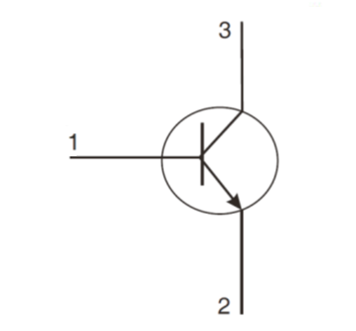

PAGE 10

3. ton and toff shall be measured as follows:



