

Page 1 of 20

TRANSISTORS, MATCHED DUAL, PNP
BASED ON TYPE 2N3810
ESCC Detail Specification No. 5207/005

Issue 8 | September 2020


Document Custodian: European Space Agency – see https://escies.org

Legal Disclaimer and Copyright
European Space Agency, Copyright © 2020. All rights reserved.
The European Space Agency disclaims any liability or responsibility, to any person or entity, with respect to any loss or damage caused, or alleged to be caused, directly or indirectly by the use and application of this ESCC publication.
This publication, without the prior permission of the European Space Agency and provided that it is not used for a commercial purpose, may be:
- copied in whole, in any medium, without alteration or modification.
- copied in part, in any medium, provided that the ESCC document identification, comprising the ESCC symbol, document number and document issue, is removed.

DOCUMENTATION CHANGE NOTICE
(Refer to https://escies.org for ESCC DCR content)
DCR No. | CHANGE DESCRIPTION
TBA | Specification upissued to incorporate changes per DCR.
Draft 8A  01/09/2020  S.Thacker/ESCC-TW | See Page 14, Para 2.4.1: Base-Emitter Voltage Differential units corrected

TABLE OF CONTENTS
1 General 5
1.1 SCOPE 5
1.2 APPLICABLE DOCUMENTS 5
1.3 TERMS, DEFINITIONS, ABBREVIATIONS, SYMBOLS AND UNITS 5
1.4 THE ESCC COMPONENT NUMBER AND COMPONENT TYPE VARIANTS 5
1.4.1 The ESCC Component Number 5
1.4.2 Component Type Variants 6
1.5 MAXIMUM RATINGS 7
1.6 PHYSICAL DIMENSIONS AND TERMINAL IDENTIFICATION 8
1.6.1 Metal Can Package (TO-78) - 6 lead 8
1.6.2 Chip Carrier Package (CCP) - 6 terminal 9
1.6.3 Flat package (FP) – 8 Pin 10
1.6.4 Die (Variant 12) 11
1.7 FUNCTIONAL DIAGRAM 12
1.8 MATERIALS AND FINISHES 12
1.8.1 Materials and Finishes of Packaged Components 12
1.8.2 Materials and Finishes of Die Components 12
2 REQUIREMENTS 12
2.1 GENERAL 12
2.1.1 Deviations from the Generic Specification 13
2.1.1.1 Deviation from Production Control – Chart F2 13
2.2 MARKING 13
2.3 TERMINAL STRENGTH 13
2.4 ELECTRICAL MEASUREMENTS AT ROOM, HIGH AND LOW TEMPERATURES 13
2.4.1 Room Temperature Electrical Measurements 13
2.4.2 High and Low Temperatures Electrical Measurements 16
2.5 PARAMETER DRIFT VALUES 16
2.6 INTERMEDIATE AND END-POINT ELECTRICAL MEASUREMENTS 17
2.7 HIGH TEMPERATURE REVERSE BIAS BURN-IN CONDITIONS 17
2.8 POWER BURN-IN CONDITIONS 17
2.9 OPERATING LIFE CONDITIONS 18
2.10 total Dose Radiation Testing 18
2.10.1 Bias Conditions and Total Dose Level for Total dose Radiation Testing 18
2.10.2 Electrical Measurements for Radiation Testing 19
Appendix ‘A’ 20

General

SCOPE
This specification details the ratings, physical and electrical characteristics and test and inspection data for the component type variants and/or the range of components specified below. It supplements the requirements of, and shall be read in conjunction with, the ESCC Generic Specification listed under Applicable Documents.

APPLICABLE DOCUMENTS
The following documents form part of this specification and shall be read in conjunction with it:
          - ESCC Generic Specification No. 5000
          - MIL-STD-750, Test Methods and Procedures for Semiconductor Devices

TERMS, DEFINITIONS, ABBREVIATIONS, SYMBOLS AND UNITS
For the purpose of this specification, the terms, definitions, abbreviations, symbols and units specified in ESCC Basic Specification No. 21300 shall apply.

THE ESCC COMPONENT NUMBER AND COMPONENT TYPE VARIANTS

The ESCC Component Number
The ESCC Component Number shall be constituted as follows:
Example: 520700501R
- Detail Specification Reference: 5207005
- Component Type Variant Number: 01 (as required)
- Total Dose Radiation Level Letter: R (as required)

Component Type Variants
The component type variants applicable to this specification are as follows:
Variant Number | Based on Type | Case | Lead/Terminal Material and/or Finish (Note 1) | Weight  max g | Total Dose Radiation  Level Letter  (Note 2)
01 | 2N3810 | TO-78 | D2 | 0.95 | R [100krad(Si)]
02 | 2N3810 | TO-78 | D3 or D4 | 0.95 | R [100krad(Si)]
05 | 2N3810 | TO-78 | D7 | 0.95 | R [100krad(Si)]
07 | 2N3810 | CCP | 2 | 0.2 | R [100krad(Si)]
09 | 2N3810 | CCP | 4 | 0.2 | R [100krad(Si)]
10 | 2N3810 | FP | G2 | 0.7 | R [100krad(Si)]
11 | 2N3810 | FP | G4 | 0.7 | R [100krad(Si)]
12 | 2N3810 | Die  (Note 3) | N/A | N/A | R [100krad(Si)]
NOTES:
            - The lead/terminal material and/or finish shall be in accordance with the requirements of ESCC Basic Specification No. 23500.
            - Total dose radiation level letters are defined in ESCC Basic Specification No. 22900. If an alternative radiation test level is specified in the Purchase Order, the letter shall be changed accordingly.
            - Variant 12 is a single transistor die; this Variant shall be ordered, tested and delivered in matched pairs. See Para. 1.6.4.

MAXIMUM RATINGS
The maximum ratings shall not be exceeded at any time during use or storage.
Maximum ratings shall only be exceeded during testing to the extent specified in this specification and when stipulated in Test Methods and Procedures of the ESCC Generic Specification.
Characteristics | Symbols | Maximum Ratings | Unit | Remarks
Collector-Base Voltage | V_{CBO} | -60 | V | Over entire operating temperature range
Collector-Emitter Voltage | V_{CEO} | -60 | V | Over entire operating temperature range
Emitter-Base Voltage | V_{EBO} | -5 | V | Over entire operating temperature range
Collector Current | I_{C} | 50 | mA | Continuous
Power Dissipation (One Section)  For TO-78, CCP and FP  For TO-78 | P_{totO1}  P_{totO2} | 0.5  0.5 | W  W | At T_{amb} ≤ +25°C  At T_{case} ≤ +25°C
Power Dissipation (Both Sections)  For TO-78, CCP and FP  For TO-78 | P_{totB1}  P_{totB2} | 0.6  0.6 | W  W | At T_{amb} ≤ +25°C  At T_{case} ≤ +25°C
Thermal Resistance,  Junction-to-Ambient | R_{th(j-a)} | 350  291.7 | °C/W | For one section  For both sections
Thermal Resistance,  Junction-to-Case | R_{th(j-c)} | 350  291.7 | °C/W | For one section  For both sections  Note 1
Operating Temperature Range | T_{op} | -55 to +200 | °C | Note 2
Storage Temperature Range | T_{stg} | -65 to +200 | °C | Note 2
Soldering Temperature  For FP  For TO-78  For CCP | T_{sol} | +265  +260  +245 | °C | Note 3  Note 3  Note 4
NOTES:
            - Thermal Resistance, Junction-to-Case only applies to TO-78 packaged Variants.
            - For Variants with tin-lead plating or hot solder dip lead finish all testing, and any handling, performed at T_{amb} > +125°C shall be carried out in a 100% inert atmosphere.
            - Duration 10 seconds maximum at a distance of not less than 1.5mm from the device body and the same lead shall not be resoldered until 3 minutes have elapsed.
            - Duration 5 seconds maximum and the same terminal shall not be resoldered until 3 minutes have elapsed.

PHYSICAL DIMENSIONS AND TERMINAL IDENTIFICATION

Metal Can Package (TO-78) - 6 lead
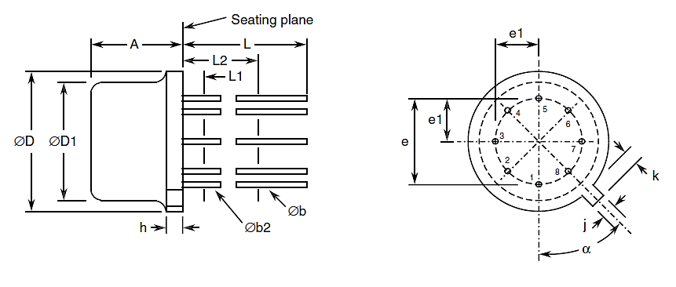
Symbols | Dimensions mm |  | Notes
Symbols | Min | Max | Notes
A | 4.19 | 4.7
Øb | 0.406 | 0.533 | 2, 3
Øb2 | 0.406 | 0.483 | 2, 3
ØD | 8.51 | 9.4
ØD1 | 7.75 | 8.51
e | 5.08 BSC |  | 4
e1 | 2.54 BSC |  | 4
h | - | 1.02
j | 0.711 | 0.864
k | 0.737 | 1.14 | 5
L | 12.7 | - | 2
L1 | - | 1.27 | 3
L2 | 6.35 | - | 3
α | 45° BSC |  | 1, 4, 6
NOTES:
            - Terminal identification is specified by reference to the tab position where lead 1 = collector 1, lead 2 = base 1, lead 3 = emitter 1, lead 5 = emitter 2, lead 6 = base 2 and lead 7 = collector 2. Lead numbers 4 and 8 are not present on the actual package; they are shown in the drawing for information only.
            - Applies to all leads.
            - Øb2 applies between L1 and L2. Øb applies between L2 and 12.7mm from the seating plane. Diameter is uncontrolled within L1 and beyond 12.7mm from the seating plane.
            - Leads having maximum diameter 0.483mm measured in the gauging plane 1.37 (+0.025, -0) mm below the seating plane of the device shall be within 0.178mm of their true position relative to a maximum-width-tab.
            - Measured from the maximum diameter of the actual device.
            - Tab centreline.

Chip Carrier Package (CCP) - 6 terminal
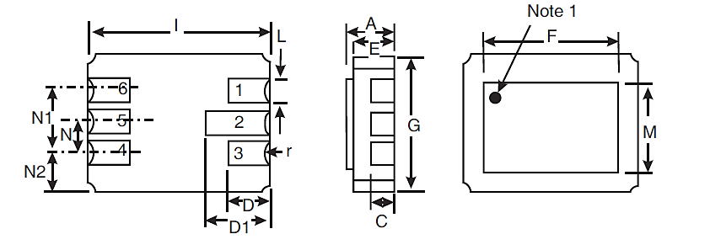
Symbols | Dimensions mm |  | Notes
Symbols | Min | Max | Notes
A | 1.53 | 1.96
C | 0.89 TYPICAL |  | 2
D | 1.52 | 1.78
D1 | 2.08 | 2.49
E | 1.24 | 1.55
F | 5.76 | 5.92
G | 4.19 | 4.45
I | 6.1 | 6.35
L | 0.55 | 0.71 | 2
M | 3.86 | 4.01
N | 1.14 | 1.4
N1 | 2.41 | 2.67
N2 | 0.89 TYPICAL
r | 0.23 TYPICAL |  | 2
NOTES:
            - Terminal identification is specified, when viewing the top side of the package, by reference to a black ink dot adjacent to terminal 1 = base 2. Terminal 2 = collector 2, terminal 3 = emitter 2, terminal 4 = emitter 1, terminal 5 = collector 1 and terminal 6 = base 1.
            - Applies to all terminals.

Flat package (FP) – 8 Pin
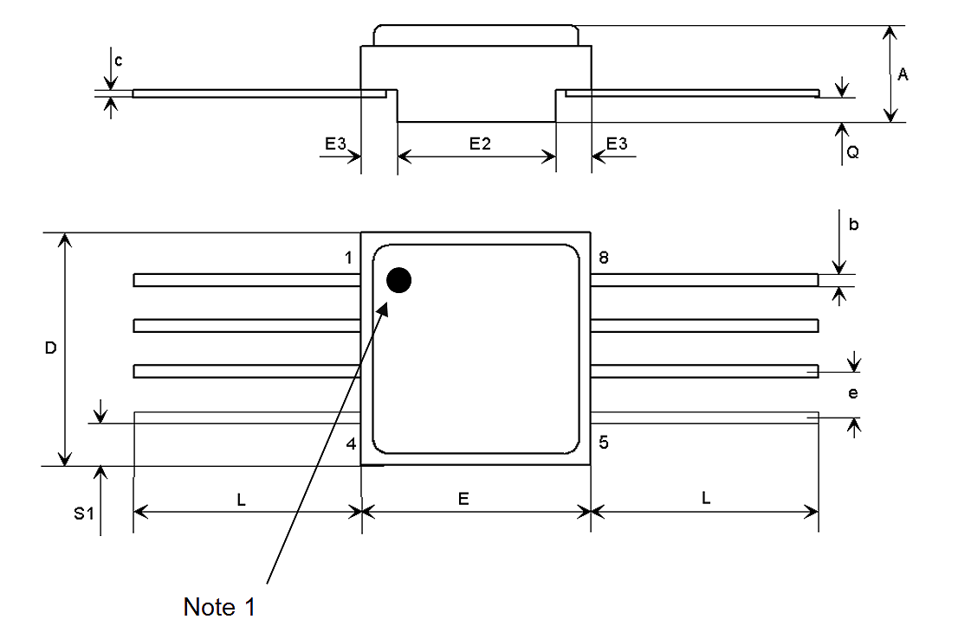
Symbols | Dimensions mm |  | Notes
Symbols | Min | Max | Notes
A | 2.24 | 2.64
b | 0.38 | 0.48 | 2
c | 0.10 | 0.16 | 2
D | 6.35 | 6.61
E | 6.35 | 6.61
E2 | 4.32 | 4.58
E3 | 0.88 | 1.14
e | 1.27 TYPICAL |  | 4
L | 3 TYPICAL |  | 2
Q | 0.66 | 0.92
S1 | 0.92 | 1.32 | 3
notes:
            - Terminal identification is specified, when viewing the top side of the package, by reference to a black ink dot adjacent to terminal 1 = collector 1, terminal 2 = base 1, terminal 3 = emitter 1, terminal 6 = emitter 2 terminal 7 = base 2, terminal 8 = collector 2, terminals 4 and 5 are connected to seal ring and lid.
            - Applies to all pins.
            - 4 places.
            - 6 places.

Die (Variant 12)
Single Transistor Die Shown
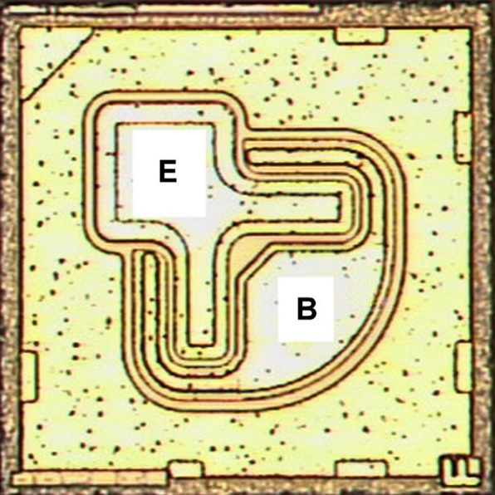
NOTES:
            - Variant 12 shall be ordered, tested and delivered in matched pairs. For delivery, each matched pair shall be identifiable by their location within the primary package.
            - Die materials and dimensions:
- Die substrate: Silicon
- Die length: 660 µm
- Die width: 660 µm
- Die thickness: 230 ±25μm
- Top Glassivation:
- P-Vapox with thickness 720 ±80nm and
- Nitride with thickness 540 ±60nm
- Top metallisation: Al/Si (1%) with thickness: 1.9 ±0.1μm (Typ.)
- Backside metallisation: Au with thickness: 1.485 ±0.165μm
- Emitter pad dimensions: 90 × 90 μm
- Base pad dimensions: 109 × 109 μm
            - Terminal identification: B = Base, E = Emitter
            - Bias details: backside contact = Collector

FUNCTIONAL DIAGRAM
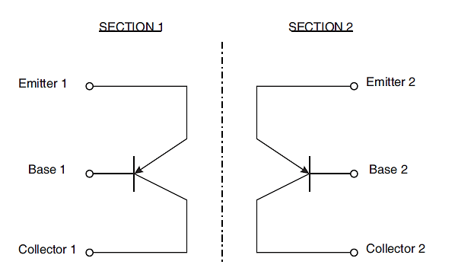
NOTES:
            - For TO-78 (Variants 01, 02, 05), the case is not connected to any lead.
            - For CCP (Variants 07, 09), the lid is not connected to any terminal.
            - For FP (Variants 10, 11), the seal ring and the lid are connected to terminals 4 and 5.
            - For Die (Variant 12), each Section as shown is a single die of each matched pair.

MATERIALS AND FINISHES

Materials and Finishes of Packaged Components
For Variants 01, 02, 05, 07, 09, 10 and 11, the materials and finishes shall be as follows:
          - Case
For the metal can package the case shall be hermetically sealed and have a metal body with hard glass seals.
For the chip carrier package and the flat package, the case shall be hermetically sealed and have a ceramic body with a Kovar lid.
          - Leads/Terminals
As specified in Para. 1.4.2, Component Type Variants.

Materials and Finishes of Die Components
For Variant 12, the materials and finishes shall be as specified in Para. 1.6.4.

REQUIREMENTS

GENERAL
The complete requirements for procurement of the components specified herein are as stated in this specification and the ESCC Generic Specification. Permitted deviations from the Generic Specification, applicable to this specification only, are listed below.
Permitted deviations from the Generic Specification and this Detail Specification, formally agreed with specific Manufacturers on the basis that the alternative requirements are equivalent to the ESCC requirement and do not affect the component’s reliability, are listed in the appendices attached to this specification.

Deviations from the Generic Specification

Deviation from Production Control – Chart F2
Special in-process controls – assembly of the packaged test sublot: For Variant 12, each packaged test sublot sample shall contain two dice in a matched pair.
For procurement, the quantity of matched pairs of dice to be assembled, n, shall be selected at the Manufacturer’s discretion from one of the four specified sampling plans (a), (b), (c) or (d).
For qualification and maintenance of qualification, the quantity of matched pairs of dice to be assembled, n, shall be selected at the Manufacturer’s discretion from one of the specified sampling plans (c) or (d).

MARKING
The marking shall be in accordance with the requirements of ESCC Basic Specification No. 21700 and as follows.
The information to be marked on the component or its primary package shall be:
          - Terminal identification (see Para. 1.6; applies to CCP and FP packages only).
          - The ESCC qualified components symbol (for ESCC qualified components only).
          - The ESCC Component Number (see Para. 1.4.1).
          - Traceability information.

TERMINAL STRENGTH
The test conditions for terminal strength, tested as specified in the ESCC Generic Specification, shall be as follows:
- For TO-78, Test Condition: E, lead fatigue.
- For FP, Test Condition: E, lead fatigue. The applied weight shall be 3 ounces (85g), with three bends of 15°.

ELECTRICAL MEASUREMENTS AT ROOM, HIGH AND LOW TEMPERATURES
Electrical measurements shall be performed at room, high and low temperatures.

Room Temperature Electrical Measurements
The measurements shall be performed at T_{amb} = +22 ±3°C.
Characteristics | Symbols | MIL-STD-750  Test Method | Test Conditions | Limits |  | Units
 |  |  |  | Min | Max | Units
Collector-Base Breakdown Voltage | V_{(BR)CBO} | 3001 | I_{C} = -10µA,  Bias condition D | -60 | - | V
Collector-Emitter Breakdown Voltage | V_{(BR)CEO} | 3011 | I_{C} = -10mA,  Bias condition D,  Note 1 | -60 | - | V
Emitter-Base Breakdown Voltage | V_{(BR)EBO} | 3026 | I_{E} = -10µA,  Bias condition D | -5 | - | V
Collector-Base Cut-off Current | I_{CBO} | 3036 | V_{CB} = -50V,  Bias condition D | - | -10 | nA
Emitter-Base  Cut-off Current | I_{EBO} | 3061 | V_{EB} = -4V,  Bias condition D | - | -20 | nA
Collector-Emitter Saturation Voltage | V_{CE(sat)1} | 3071 | I_{C} = -100µA  I_{B} = -10µA  Note 1 | - | -200 | mV
Collector-Emitter Saturation Voltage | V_{CE(sat)2} | 3071 | I_{C} = -1mA  I_{B} = -100µA  Note 1 | - | -250 | mV
Base-Emitter Saturation Voltage | V_{BE(sat)1} | 3066 | I_{C} = -100µA  I_{B} = -10µA  Test Condition A  Note 1 | - | -700 | mV
Base-Emitter Saturation Voltage | V_{BE(sat)2} | 3066 | I_{C} = -1mA  I_{B} = -100µA  Test Condition A  Note 1 | - | -800 | mV
Forward-Current Transfer Ratio | h_{FE1} | 3076 | V_{CE} = -5V; I_{C} = -10µA | 100 | - | -
Forward-Current Transfer Ratio | h_{FE2} | 3076 | V_{CE} = -5V; I_{C} = -100µA | 150 | 450 | -
Forward-Current Transfer Ratio | h_{FE3} | 3076 | V_{CE} = -5V; I_{C} = -500µA | 150 | 450 | -
Forward-Current Transfer Ratio | h_{FE4} | 3076 | V_{CE} = -5V; I_{C} = -1mA | 150 | 450 | -
Forward-Current Transfer Ratio | h_{FE5} | 3076 | V_{CE} = -5V; I_{C} = -10mA | 125 | - | -
Forward-Current Transfer Ratio Comparison | h_{FE2-1}/  h_{FE2-2} | 3076 | V_{CE} = -5V; I_{C}= -100µA | 0.9 | 1.1 | -
Base-Emitter Voltage Differential | |V_{BE1}-V_{BE2}|1 | 3066 | I_{C} = -10µA  V_{CE} = -5V  Test Condition B  Note 2 | - | 5 | mV
Base-Emitter Voltage Differential | |V_{BE1}-V_{BE2}|2 | 3066 | I_{C} = -100µA  V_{CE} = -5V  Test Condition B  Note 2 | - | 3 | mV
Base-Emitter Voltage Differential | |V_{BE1}-V_{BE2}|3 | 3066 | I_{C} = -10mA  V_{CE} = -5V  Test Condition B  Note 2 | - | 5 | mV
Leakage Current Between Sections | I_{LS(e-e)} | - | -50V to Emitter 2  0V to Emitter 1 | - | 5 | µA
Leakage Current Between Sections | I_{LS(b-b)} | - | -50V to Base 2  0V to Base 1 | - | 5 | µA
Leakage Current Between Sections | I_{LS(c-c)} | - | -50V to Collector 2  0V to Collector 1 | - | 5 | µA
Current Gain Bandwidth Product | f_{T} | 3206 | V_{CE} = -5V,  I_{C} = -1mA  f = 100MHz  Notes 3, 4 | 80 | 500 | MHz
Small-Signal Short-Circuit Forward-Current Transfer Ratio | h_{fe} | 3206 | I_{C} = -1mA, V_{CE} = -10V  f = 1kHz  Notes 3, 4 | 150 | 600 | -
Spot Noise Figure | NF1 | 3246 | V_{CE} = -5V  I_{C} = -200µA  R_{s} = 2kΩ  f = 100Hz  BW = 20Hz  Notes 3, 4 | - | 7 | dB
Spot Noise Figure | NF2 | 3246 | V_{CE} = -5V  I_{C} = -200µA  R_{s} = 2kW  f = 1kHz  BW = 200Hz  Notes 3, 4 | - | 3 | dB
Wide-Band Noise Figure | NF_{w} | 3246 | V_{CE} = -5V  I_{C} = -200µA  R_{s} = 2kΩ  10Hz ≤ f ≤ 15.7kHz  Notes 3, 4 | - | 3.5 | dB
Output Capacitance | C_{obo} | 3236 | V_{CB} = -5V,  I_{E} = 0A  100kHz ≤ f ≤ 1MHz  Notes 3, 4 | - | 6 | pF
Input Capacitance | C_{ibo} | 3240 | V_{EB} = -500mV,  I_{C} = 0A  100kHz ≤ f ≤ 1MHz  Notes 3, 4 | - | 15 | pF
Small-Signal Input Impedance | h_{ie} | 3201 | V_{CE} = -10V  I_{C} = -1mA  f = 1kHz  Notes 3, 4 | 3 | 30 | kΩ
NOTES:
            - Pulsed measurement: Pulse Width ≤ 300µs, Duty Cycle ≤ 2%.
            - Any device whose measurement values exceed the specified limits shall be removed from the lot, but only count for PDA when such values exceed twice the specified limits (i.e. > 10mV or > 6mV).
            - For Variants 01, 02, 05, 07, 09, 10 and 11, all AC characteristics read and record measurements shall be performed on a sample of 32 components with 0 failures allowed. Alternatively a 100% inspection may be performed.
            - For Variant 12, all AC characteristics read and record measurements shall be performed on either a sample of 32 matched pairs (64 dice) or 100% of the Packaged Test Sublot, whichever is less, with 0 failures allowed.

High and Low Temperatures Electrical Measurements
Characteristics | Symbols | MIL-STD-750  Test Method | Test Conditions  Note 1 | Limits |  | Units
 |  |  |  | Min | Max | Units
Collector-Base Cut-off Current | I_{CBO} | 3036 | T_{amb} = +150 (+0 -5)°C  V_{CB} = -50V,  Bias Condition D | - | -10 | µA
Forward-Current Transfer Ratio 2 | h_{FE2} | 3076 | T_{amb} = -55 (+5 -0)°C V_{CE} = -5V  I_{C} = -100µA | 60 | - | -
Forward-Current Transfer Ratio Comparison | h_{FE2-1}/h_{FE2-2} | 3076 | T_{amb} = -55 to +125°C  V_{CE} = -5V, I_{C} = -100µA | 0.85 | 1.18 | -
Base-Emitter Voltage Differential Change | |Δ(V_{BE1}-V_{BE2})ΔT_{amb}|1 | 3066 | T_{amb} = -55 (+5 -0)°C to +25 ±3°C  V_{CE} = -5V  I_{C} = -100µA  Test condition B | - | 800 | µV
Base-Emitter Voltage Differential Change | |Δ(V_{BE1}-V_{BE2})ΔT_{amb}|2 | 3066 | T_{amb} = +25 ±3°C to +125 (+0 -5) °C  V_{CE} = -5V  I_{C} = -100µA  Test condition B | - | 1000 | µV
NOTES:
            - Measurements shall be performed on a sample basis as specified in the Generic Specification.

PARAMETER DRIFT VALUES
Unless otherwise specified, the measurements shall be performed at T_{amb} = +22 ±3°C.
The test methods and test conditions shall be as per the corresponding test defined in Para. 2.4.1, Room Temperature Electrical Measurements.
The drift values (Δ) shall not be exceeded for each characteristic specified. The corresponding absolute limit values for each characteristic shall not be exceeded.
Characteristics | Symbols | Limits |  |  | Units
Characteristics | Symbols | Drift  Value  Δ | Absolute |  | Units
Characteristics | Symbols | Drift  Value  Δ | Min | Max | Units
Collector-Base Cut-off Current | I_{CBO} | ±2  or (1) ±100% | - | -10 | nA
Collector-Emitter Saturation Voltage 2 | V_{CE(sat)2} | ±15  or (1) ±10% | - | -250 | mV
Forward-Current Transfer Ratio 2 | h_{FE2} | ±15% | 150 | 450 | -
NOTES:
            - Whichever is the greater referred to the initial value.

INTERMEDIATE AND END-POINT ELECTRICAL MEASUREMENTS
Unless otherwise specified, the measurements shall be performed at T_{amb} = +22 ±3°C.
The test methods and test conditions shall be as per the corresponding test defined in either Para. 2.4.1, Room Temperature Electrical Measurements or Para. 2.4.2, High and Low Temperatures Electrical Measurements, as applicable.
The limit values for each characteristic shall not be exceeded.
Characteristics | Symbols | Limits |  | Units
Characteristics | Symbols | Min | Max | Units
Collector-Base Cut-off Current | I_{CBO} | - | -20 | nA
Collector-Emitter Saturation Voltage 2 | V_{CE(sat)2} | - | -250 | mV
Forward-Current Transfer Ratio 2 | h_{FE2} | 150 | 450 | -
Forward-Current Transfer Ratio Comparison | h_{FE2-1}/h_{FE2-2} | 0.85 | 1.18 | -
Base-Emitter Voltage Differential 2 | |V_{BE1}-V_{BE2}|2 | - | 6 | mV
Base-Emitter Voltage Differential Change (Note 1) | |Δ(V_{BE1}-V_{BE2})ΔT_{amb}|1 | - | 1 | mV
Base-Emitter Voltage Differential Change (Note 1) | |Δ(V_{BE1}-V_{BE2})ΔT_{amb}|2 | - | 1.2 | mV
NOTES:
            - Measured after Operating Life test only.

HIGH TEMPERATURE REVERSE BIAS BURN-IN CONDITIONS
Characteristics | Symbols | Test Conditions | Units
Ambient Temperature | T_{amb} | +150 (+0 -5) | °C
Collector-Base Voltage (Note 1) | V_{CB} | -45 | V
Duration | t | 72 Minimum | hrs
NOTES:
            - On completion of High Temperature Reverse Bias Burn-in, the collector-base voltage shall continue to be applied until T_{case} < +30°C.

POWER BURN-IN CONDITIONS
Characteristics | Symbols | Test Conditions | Units
Ambient Temperature | T_{amb} | +25 to +50 | °C
Power Dissipation (Both Sections) | P_{totB} | As per Maximum Ratings. Derate P_{totB1} at the chosen T_{amb} using the specified R_{th(j-a)}. | W
Collector-Base Voltage | V_{CB} | -45 | V

OPERATING LIFE CONDITIONS
The conditions shall be as specified in Para. 2.8, Power Burn-in.

total Dose Radiation Testing
All lots shall be irradiated in accordance with ESCC Basic Specification No. 22900, low dose rate (window 2: 36rad(Si) to 360rad(Si) per hour).

Bias Conditions and Total Dose Level for Total dose Radiation Testing
The following bias conditions shall be used for Total Dose Radiation Testing:
Characteristics | Symbols | Test Conditions | Units
Ambient Temperature | T_{amb} | +20 ±5 | °C
Bias Condition 1:  Collector-Emitter Voltage | V_{CES} | ≥ 80% V_{(BR)CEO} | V
Bias Condition 2:  Collector-Emitter Voltage | V_{CES} | 0 | V
The total dose level applied shall be as specified in Para. 1.4.2 or in the Purchase Order.

Electrical Measurements for Radiation Testing
Prior to irradiation testing the devices shall have successfully met Room Temperature Electrical Measurements specified in Para. 2.4.1.
Unless otherwise stated the measurements shall be performed at T_{amb} = +22 ±3°C.
Unless otherwise specified the test methods and test conditions shall be as per the corresponding test defined in Para. 2.4.1, Room Temperature Electrical Measurements.
The parameters to be measured during and on completion of irradiation testing are shown below.
Characteristics | Symbols | MIL-STD-750 Test Method | Test Conditions | Limits |  | Units
 |  |  |  | Min | Max | Units
Collector-Base Breakdown Voltage | V_{(BR)CBO} | Para. 2.4.1 | Para. 2.4.1 | -60 | - | V
Collector-Emitter Breakdown Voltage | V_{(BR)CEO} | Para. 2.4.1 | Para. 2.4.1 | -60 | - | V
Emitter-Base Breakdown Voltage | V_{(BR)EBO} | Para. 2.4.1 | Para. 2.4.1 | -5 | - | V
Collector-Base  Cut-off Current | I_{CBO} | Para. 2.4.1 | Para. 2.4.1 | - | -10 | nA
Emitter-Base  Cut-off Current | I_{EBO} | Para. 2.4.1 | Para. 2.4.1 | - | -20 | nA
Collector-Emitter  Saturation Voltage | V_{CE(sat)1} | Para. 2.4.1 | Para. 2.4.1 | - | -200 | mV
Collector-Emitter  Saturation Voltage | V_{CE(sat)2} | Para. 2.4.1 | Para. 2.4.1 | - | -250 | mV
Base-Emitter  Saturation Voltage | V_{BE(sat)1} | Para. 2.4.1 | Para. 2.4.1 | - | -700 | mV
Base-Emitter  Saturation Voltage | V_{BE(sat)2} | Para. 2.4.1 | Para. 2.4.1 | - | -800 | mV
Forward-Current  Transfer Ratio  (post irradiation gain calculation) (Note 1) | [h_{FE1}] | 3076 | V_{CE} = -5V, I_{C} = -10µA | [50] | - | -
 | [h_{FE2}] | 3076 | V_{CE} = -5V, I_{C} = -100µA | [75] | 450 | -
 | [h_{FE3}] | 3076 | V_{CE} = -5V, I_{C} = -500µA | [75] | 450 | -
 | [h_{FE4}] | 3076 | V_{CE} = -5V, I_{C} = -1mA | [75] | 450 | -
 | [h_{FE5}] | 3076 | V_{CE} = -5V, I_{C} = -10mA | [65] | - | -
NOTES:
            - The post-irradiation gain calculation of [h_{FE}], made using h_{FE} measurements from prior to and on completion of irradiation testing and after each annealing step if any, shall be as specified in MIL-STD-750 Method 1019.

Appendix ‘A’
AGREED DEVIATIONS FOR STMICROELECTRONICS (F)
ITEMS AFFECTED | DESCRIPTION OF DEVIATIONS
Para. 2.1.1.1, Deviations from the Generic Specification: Production Control - Chart F2 | Special In-Process Controls - Internal Visual Inspection.  For CCP packages the criteria specified for voids in the fillet and minimum die mounting material around the visible die perimeter for die mounting defects may be omitted providing that a radiographic inspection to verify the die-attach process is performed on a sample basis in accordance with STMicroelectronics procedure 0076637.
Para. 2.1.1, Deviations from the Generic Specification: Screening Tests - Chart F3 | Solderability is not applicable unless specifically stipulated in the Purchase Order.
Para. 2.4.1, Room Temperature Electrical Measurements | All AC characteristics (Para. 2.4.1, Notes 2 and 3) may be considered guaranteed but not tested if successful pilot lot testing has been performed on the wafer lot which includes AC characteristic measurements per the Detail Specification.  A summary of the pilot lot testing shall be provided if required by the Purchase Order.
Para. 2.4.2, High and Low Temperatures Electrical Measurements | All characteristics specified may be considered guaranteed but not tested if successful pilot lot testing has been performed on the wafer lot which includes characteristic measurements at high and low temperatures per the Detail Specification.  A summary of the pilot lot testing shall be provided if required by the Purchase Order.

