Page 1 of 40

CONNECTORS AND SAVERS, ELECTRICAL, RECTANGULAR, NON-REMOVABLE PCB CONTACTS
BASED ON TYPE MHD
ESCC Detail Specification No. 3401/065

Issue 6 Draft A | May 2020



Document Custodian: European Space Agency – see https://escies.org

Legal Disclaimer and Copyright
European Space Agency, Copyright © 2020. All rights reserved.
The European Space Agency disclaims any liability or responsibility, to any person or entity, with respect to any loss or damage caused, or alleged to be caused, directly or indirectly by the use and application of this ESCC publication.
This publication, without prior permission of the European Space Agency and provided it is not used for a commercial purpose, may be:
- copied in whole, in any medium, without alteration or modification.
- copied in part, in any medium, provided that the ESCC document identification, comprising the ESCC symbol, document number and document issue, is removed.

DOCUMENTATION CHANGE NOTICE
(Refer to https://escies.org for ESCC DCR content)
DCR No. | CHANGE DESCRIPTION
1338 | Specification updated to incorporate changes per DCR.

TABLE OF CONTENTS
1 GENERAL 6
1.1 SCOPE 6
1.2 RANGE OF COMPONENTS 6
1.3 MAXIMUM RATINGS 6
1.4 PARAMETER DERATING INFORMATION 6
1.5 PHYSICAL DIMENSIONS 6
2 APPLICABLE DOCUMENTS 6
3 TERMS, DEFINITIONS, ABBREVIATIONS, SYMBOLS AND UNITS 6
4 REQUIREMENTS 32
4.1 GENERAL 32
4.2 DEVIATIONS FROM GENERIC SPECIFICATION 32
4.2.1 Deviations from Special In-process Controls 32
4.2.2 Deviations from Final Production Tests (Chart II) 32
4.2.3 Deviations from Burn-in and Electrical Measurements (Chart III) 32
4.2.4 Deviations from Qualification Tests (Chart IV) 32
4.2.5 Deviations from Lot Acceptance Tests (Chart V) 32
4.3 MECHANICAL REQUIREMENTS 33
4.3.1 Dimension Check 33
4.3.2 Weight 33
4.3.3 Contact Capability 33
4.3.4 Contact Retention (In Insert) 33
4.3.5 Mating and Unmating Forces 33
4.3.6 Insert Retention (In Shell) 33
4.3.7 Jackscrew Retention 33
4.3.8 Contact Insertion and Withdrawal Forces 33
4.3.9 Engagement and Separation Forces 34
4.3.10 Oversize Pin Exclusion 34
4.3.11 Probe Damage 34
4.3.12 Solderability 34
4.4 MATERIALS AND FINISHES 34
4.4.1 Shells 34
4.4.2 Inserts 34
4.4.3 Contacts 34
4.4.4 Contact Retaining Clip 35
4.4.5 Guiding and Locking Devices 35
4.4.6 Magnetism Level 35
4.5 MARKING 35
4.5.1 General 35
4.5.2 Contact Position 35
4.5.3 The ESCC Component Number 35
4.5.4 Characteristics 35
4.5.5 Traceability Information 36
4.6 ELECTRICAL MEASUREMENTS 36
4.6.1 Electrical Measurements at Room Temperature 36
4.6.2 Electrical Measurements at High and Low Temperatures (Table 3) 36
4.6.3 Circuits for Electrical Measurements (Figure 4) 36
4.7 BURN-IN AND ELECTRICAL MEASUREMENTS (TABLES 4 AND 5) 36
4.8 ENVIRONMENTAL AND ENDURANCE TESTS (CHARTS IV AND V OF ESCC GENERIC SPECIFICATION NO. 3401) 36
4.8.1 Measurements and Inspections on Completion of Environmental Tests 36
4.8.2 Measurements and Inspections at Intermediate Points during Endurance Tests 36
4.8.3 Measurements and Inspections on Completion of Endurance Tests 37
4.8.4 Conditions for Operating Life Test (Part of Endurance Testing) 37
4.8.5 Electrical Circuits for Operating Life Test 37
4.8.6 Conditions for High Temperature Storage Test (Part of Endurance Testing) 37

GENERAL

SCOPE
This specification details the ratings, physical and electrical characteristics, test and inspection data for Connectors and Savers, Electrical, Rectangular, with Non-Removable PCB Contacts, Based on Type MHD. It shall be read in conjunction with:
- ESCC Generic Specification No. 3401, Connectors, Electrical, Non-Filtered, Circular and Rectangular,
the requirements of which are supplemented herein.

RANGE OF COMPONENTS
The different configurations of the connectors specified herein and guiding and locking devices, which are also covered by this specification, are given in Table 1(a).

MAXIMUM RATINGS
The maximum ratings applicable to the connectors specified herein, which shall not be exceeded at any time during use or storage, are scheduled in Table 1(b).

PARAMETER DERATING INFORMATION
The applicable derating information for the connectors specified herein is shown in Figure 1.

PHYSICAL DIMENSIONS
The physical dimensions of the connectors, plugs and receptacles, guiding and locking devices specified herein, and the contact mounting configurations, are shown in Figures 2(a), 2(b) and 2(c).

APPLICABLE DOCUMENTS
The following documents form part of this specification and shall be read in conjunction with it:
          - ESCC Generic Specification No. 3401, Connectors, Electrical, Non-Filtered, Circular and Rectangular.

TERMS, DEFINITIONS, ABBREVIATIONS, SYMBOLS AND UNITS
For the purpose of this specification, the terms, definitions, abbreviations, symbols and units specified in ESCC Basic Specification No. 21300 shall apply.

Table 1(a) – RANGe OF COMPONEnts
NUMBER OF CONTACTS
No. of  Contacts  (Note 1) | Max. Weight (2)  (g) |  | Max.  Engagement  Force | Separation Force  (N)
 | Plug | Receptacle | (N Max.) | N Min. | N Max.
52 | 14 | 8 | 36.4 | 2.6 | 36.4
100 | 20 | 15 | 70 | 5 | 70
152 | 32 | 22 | 106.4 | 7.6 | 106.4
200 | 38 | 28 | 140 | 10 | 140
252 | 50 | 36 | 176.4 | 12.6 | 176.4
300 | 56 | 42 | 210 | 15 | 210
352 | 65 | 47 | 246.4 | 17.6 | 246.4
400 | 75 | 55 | 280 | 20 | 280
NOTES:
            - See Figure 2(a).
            - Weights with contacts and without accessories.
CONTACT TYPES
Contact Codes | Contact Types
10 | Through board solder – 90° for PCB thickness: 1.44 - 1.76 mm
11 | Through board solder – 90° for PCB thickness: 1.98 - 2.42 mm
12 | Through board solder – 90° for PCB thickness: 2.88 - 3.52 mm
30 | Through board solder – straight for PCB thickness: 2.16 - 2.64 mm
31 | Through board solder – straight for PCB thickness: 2.88 - 3.52 mm
43 | Surface mount for PCB thickness: 2.16 - 2.64 mm (Centred PCB)
45 | Surface mount for PCB thickness: 1.44 - 2.4 mm (Off-centre PCB)
47 | Surface mount for PCB thickness: 2.16 - 2.64 mm (Off-centre PCB)
91 | Contact for connector saver male - female
NOTES:
            - See Figure 2(c).
GUIDING AND LOCKING DEVICES
Guiding and Locking Devices Code | Mounting On | Max. Weight  (g)
110 | Plug | 0.55
111 | Plug | 1.35
121 | Receptacle | 0.65
124 | Receptacle | 1.5
134 | Receptacle | 1.3
201 | Saver Receptacle | -
NOTES:
            - See Figure 2(b).

Table 1(b) – MAXIMUM Ratings
No. | Characteristic | Symbol | Maximum Rating | Unit | Remarks
1 | Working Voltage Sea Level | V | 200 | Vrms | Note 1
2 | Rated Current | I_{R} | 2 | A
3 | Operating Temperature Range | T_{op} | -55 to +125 | °C | T_{amb}
4 | Storage Temperature Range | T_{stg} | -55 to +125 | °C
5 | Soldering Temperature | T_{sol} | +260 | °C | Note 2
NOTES:
            - Between contacts and shell.
            - Duration 10 seconds minimum and the same contact shall not be resoldered until 3 minutes have elapsed.
Figure 1 – PARAMETER Derating Information
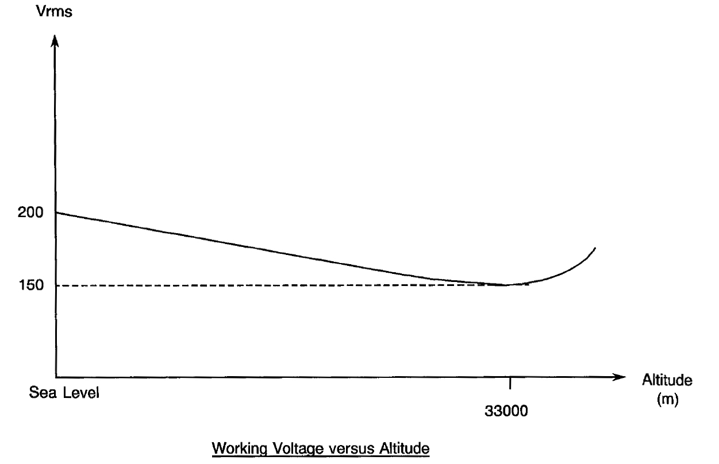

Figure 2 – Physical Dimensions
figure 2(a) – INSERTS: PLUGS AND rECepTACleS
receptacle, 52 CONTACTS
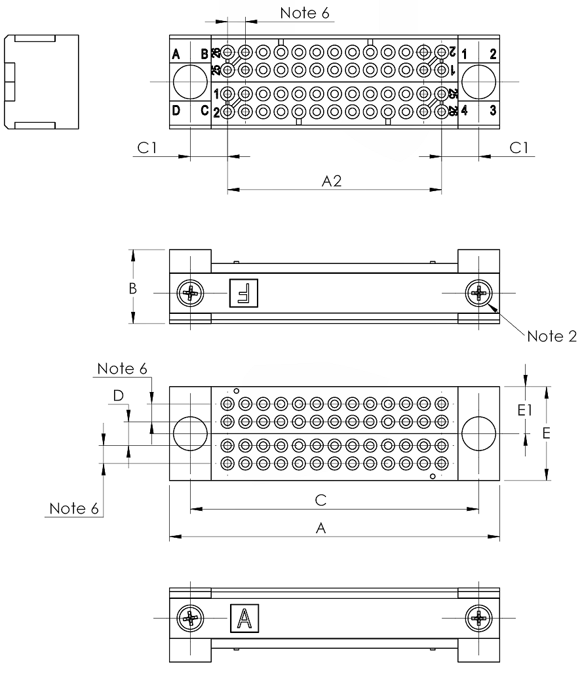
Symbol /  Dim. (1) | A | A2 | B | C | C1 | D | E | E1
Min. | 35.1 | 22.66 | 7.75 | 30.65 | 3.77 | 2.34 | 9.9 | 4.9
Max. | 35.4 | 23.06 | 8.05 | 30.95 | 4.17 | 2.74 | 10.1 | 5.1
notes:
            - All dimensions are in millimetres.
            - Torque: 10N.cm.
            - Underlined dimensions, in table, are critical to ensure intermateability.
            - The front of the insert shall be marked with the minimum marking shown.
            - Orientation of labelling of contacts and guiding devices is not a true representation.
            - Pitch: 1.905mm.

receptacle, 100 CONTACTS
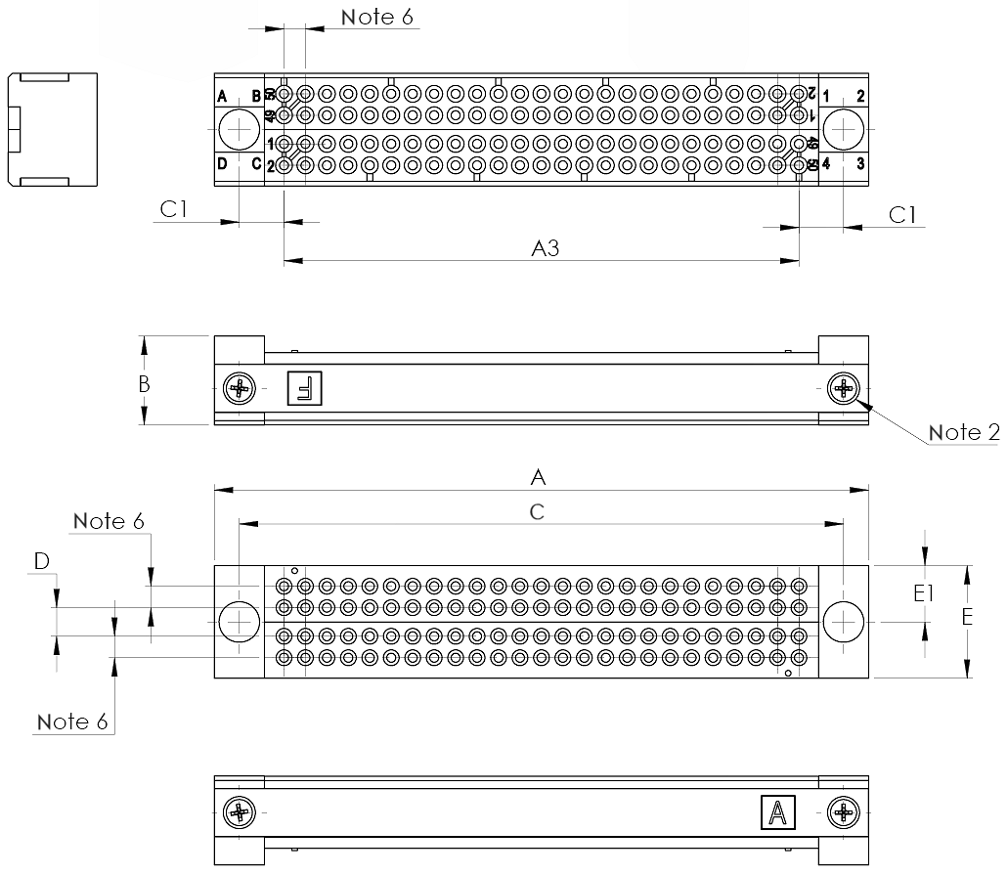
Symbol /  Dim. (1) | A | A3 | B | C | C1 | D | E | E1
Min. | 57.9 | 45.52 | 7.75 | 53.51 | 3.77 | 2.34 | 9.9 | 4.9
Max. | 58.2 | 45.92 | 8.05 | 53.81 | 4.17 | 2.74 | 10.1 | 5.1
notes:
            - All dimensions are in millimetres.
            - Torque: 10N.cm.
            - Underlined dimensions, in table, are critical to ensure intermateability.
            - The front of the insert shall be marked with the minimum marking shown.
            - Orientation of labelling of contacts and guiding devices is not a true representation.
            - Pitch: 1.905mm.

RECEPTACLE, 152 CONTACTS
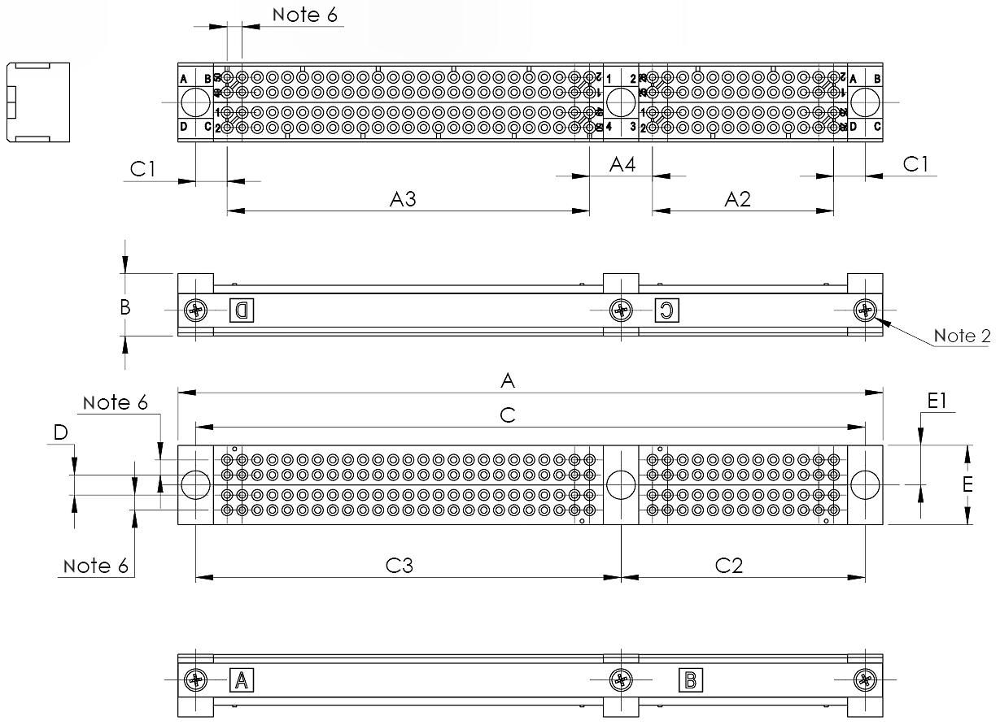
Symbol /  Dim. (1) | A | A2 | A3 | A4 | B | C | C1 | C2 | C3 | D | E | E1
Min. | 88.8 | 22.66 | 45.52 | 7.74 | 7.75 | 84.3 | 3.77 | 30.65 | 53.51 | 2.34 | 9.9 | 4.9
Max. | 89.1 | 23.06 | 45.92 | 8.14 | 8.05 | 84.6 | 4.17 | 30.95 | 53.81 | 2.74 | 10.1 | 5.1
notes:
            - All dimensions are in millimetres.
            - Torque: 10N.cm.
            - Underlined dimensions, in table, are critical to ensure intermateability.
            - The front of the insert shall be marked with the minimum marking shown.
            - Orientation of labelling of contacts and guiding devices is not a true representation.
            - Pitch: 1.905mm.

RECEPTACLE, 200 CONTACTS
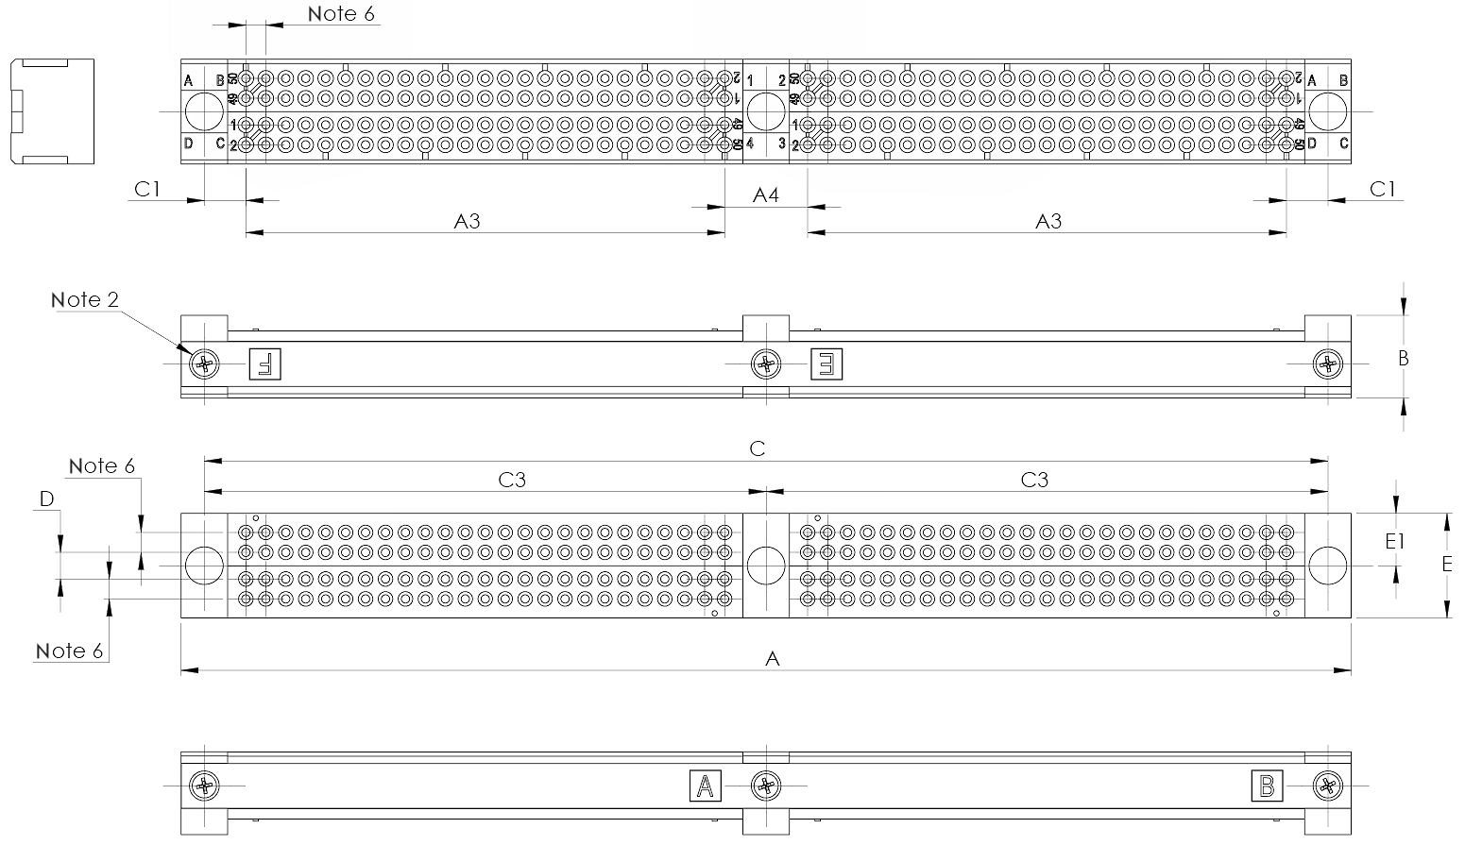
Symbol /  Dim. (1) | A | A3 | A4 | B | C | C1 | C3 | D | E | E1
Min. | 111.6 | 45.52 | 7.74 | 7.75 | 107.16 | 3.77 | 53.51 | 2.34 | 9.9 | 4.9
Max. | 111.9 | 45.92 | 8.14 | 8.05 | 107.46 | 4.17 | 53.81 | 2.74 | 10.1 | 5.1
notes:
            - All dimensions are in millimetres.
            - Torque: 10N.cm.
            - Underlined dimensions, in table, are critical to ensure intermateability.
            - The front of the insert shall be marked with the minimum marking shown.
            - Orientation of labelling of contacts and guiding devices is not a true representation.
            - Pitch: 1.905mm.

RECEPTACLE, 252 CONTACTS
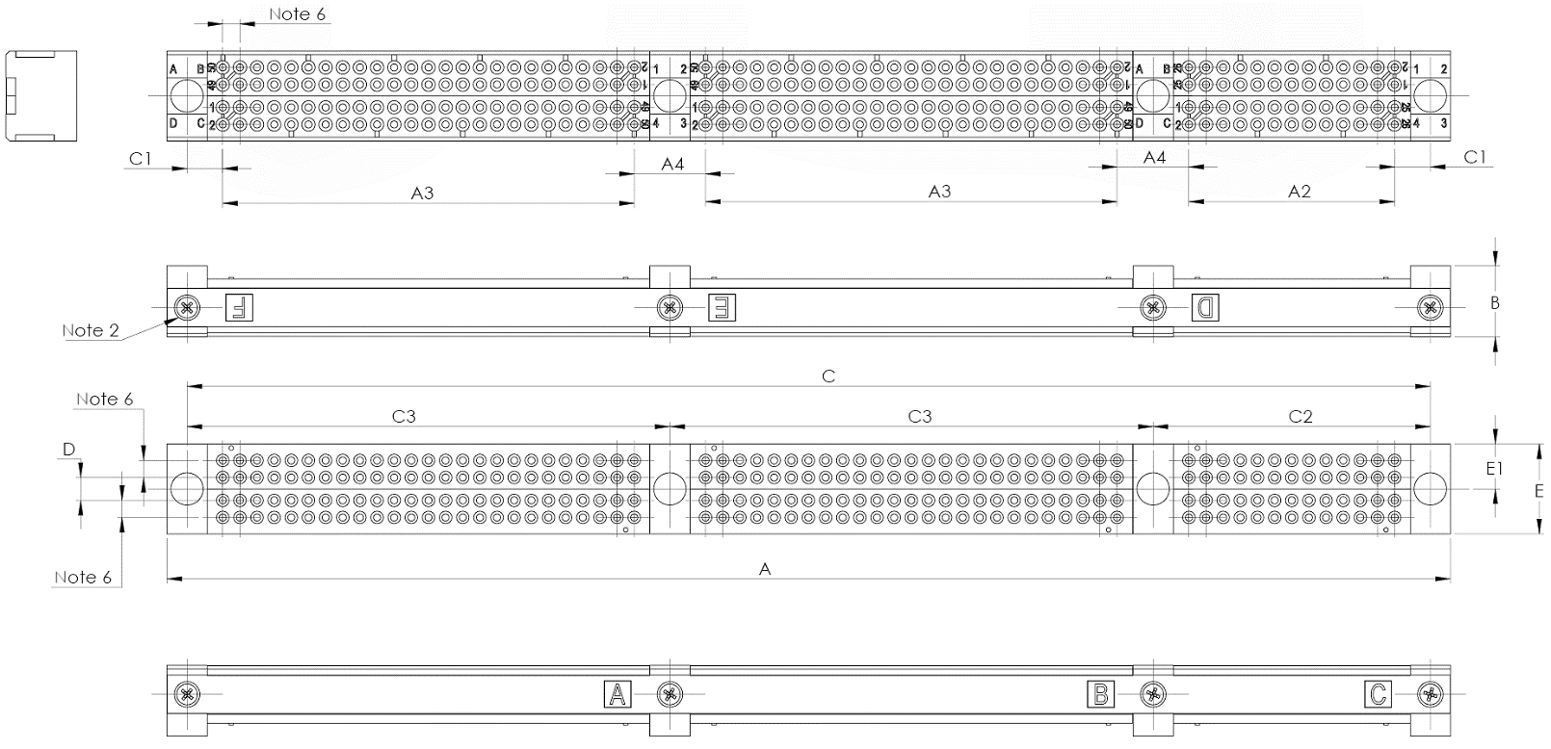
Symbol /  Dim. (1) | A | A2 | A3 | A4 | B | C | C1 | C2 | C3 | D | E | E1
Min. | 142.5 | 22.66 | 45.52 | 7.74 | 7.75 | 137.96 | 3.77 | 30.65 | 53.51 | 2.34 | 9.9 | 4.9
Max. | 142.8 | 23.06 | 45.92 | 8.14 | 8.05 | 138.26 | 4.17 | 30.95 | 53.81 | 2.74 | 10.1 | 5.1
notes:
            - All dimensions are in millimetres.
            - Torque: 10N.cm.
            - Underlined dimensions, in table, are critical to ensure intermateability.
            - The front of the insert shall be marked with the minimum marking shown.
            - Orientation of labelling of contacts and guiding devices is not a true representation.
            - Pitch: 1.905mm.

RECEPTACLE, 300 CONTACTS
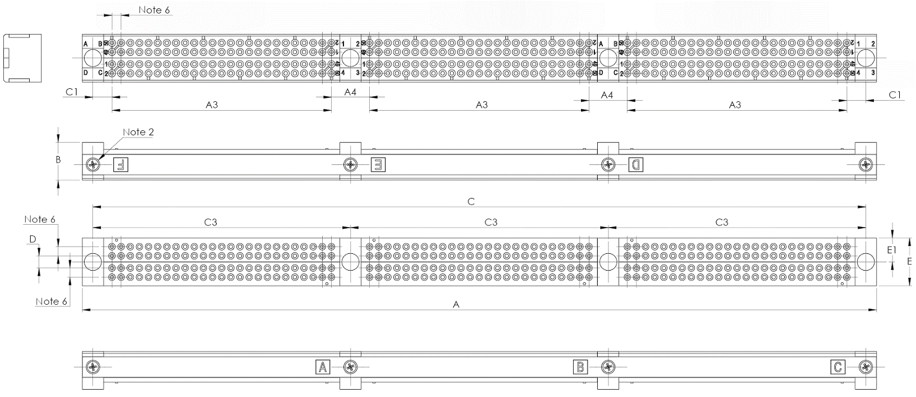
Symbol /  Dim. (1) | A | A3 | A4 | B | C | C1 | C3 | D | E | E1
Min. | 165.3 | 45.52 | 7.74 | 7.75 | 160.82 | 3.77 | 53.51 | 2.34 | 9.9 | 4.9
Max. | 165.6 | 45.92 | 8.14 | 8.05 | 161.12 | 4.17 | 53.81 | 2.74 | 10.1 | 5.1
notes:
            - All dimensions are in millimetres.
            - Torque: 10N.cm.
            - Underlined dimensions, in table, are critical to ensure intermateability.
            - The front of the insert shall be marked with the minimum marking shown.
            - Orientation of labelling of contacts and guiding devices is not a true representation.
            - Pitch: 1.905mm.

RECEPTACLE, 352 CONTACTS
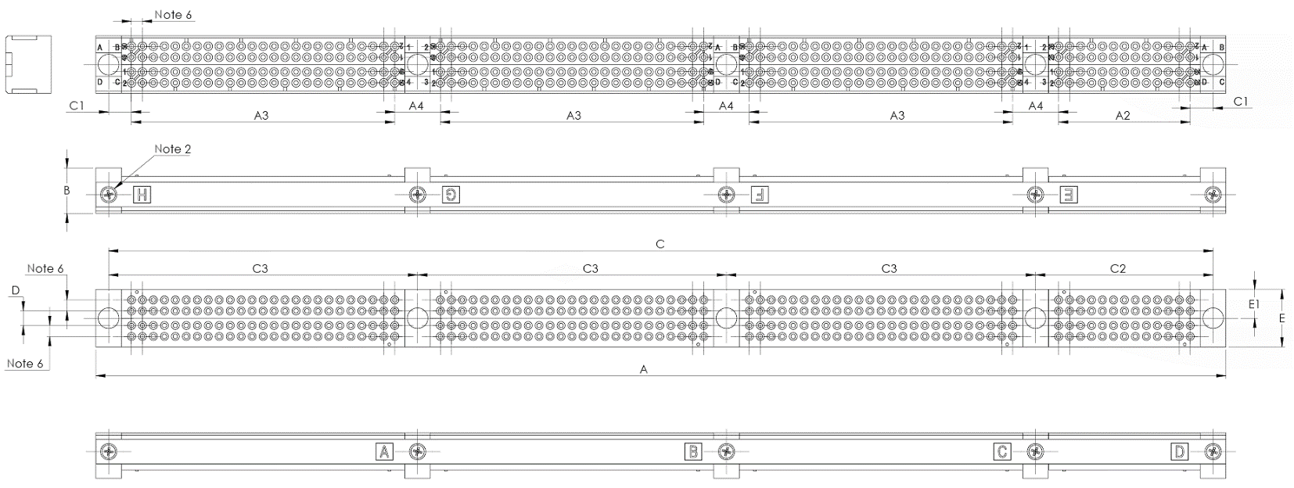
Symbol /  Dim. (1) | A | A2 | A3 | A4 | B | C | C1 | C2 | C3 | D | E | E1
Min. | 196.2 | 22.66 | 45.52 | 7.74 | 7.75 | 191.62 | 3.77 | 30.65 | 53.51 | 2.34 | 9.9 | 4.9
Max. | 196.8 | 23.06 | 45.92 | 8.14 | 8.05 | 191.92 | 4.17 | 30.95 | 53.81 | 2.74 | 10.1 | 5.1
notes:
            - All dimensions are in millimetres.
            - Torque: 10N.cm.
            - Underlined dimensions, in table, are critical to ensure intermateability.
            - The front of the insert shall be marked with the minimum marking shown.
            - Orientation of labelling of contacts and guiding devices is not a true representation.
            - Pitch: 1.905mm.

RECEPTACLE, 400 CONTACTS
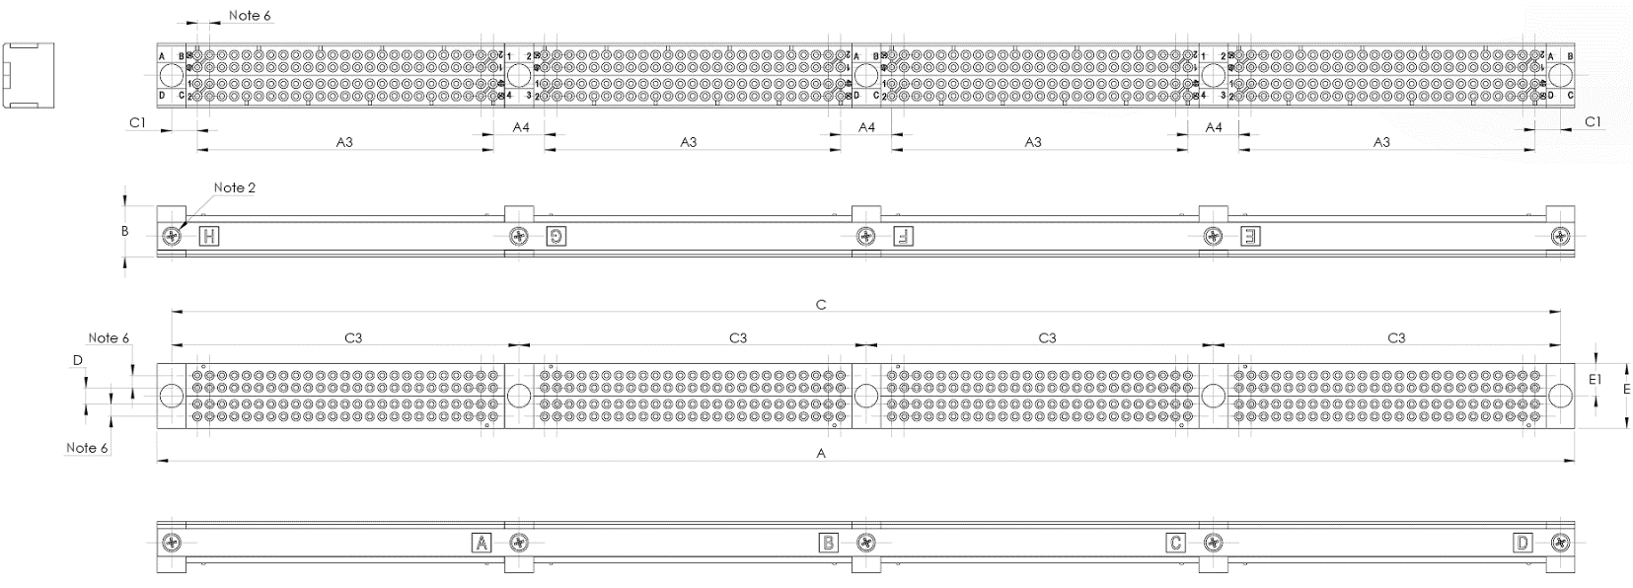

Symbol /  Dim. (1) | A | A3 | A4 | B | C | C1 | C3 | D | E | E1
Min. | 219 | 45.52 | 7.74 | 7.75 | 214.48 | 3.77 | 53.51 | 2.34 | 9.9 | 4.9
Max. | 219.3 | 45.92 | 8.14 | 8.05 | 214.78 | 4.17 | 53.81 | 2.74 | 10.1 | 5.1
notes:
            - All dimensions are in millimetres.
            - Torque: 10N.cm.
            - Underlined dimensions, in table, are critical to ensure intermateability.
            - The front of the insert shall be marked with the minimum marking shown.
            - Orientation of labelling of contacts and guiding devices is not a true representation.
            - Pitch: 1.905mm.

PLUG, 52 CONTACTS
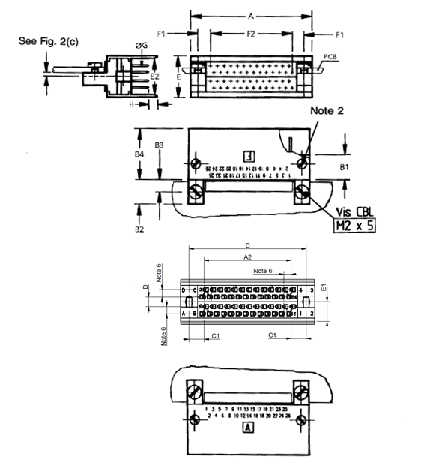
Symbol /  Dim. (1) | A | A2 | B1 | B2 | B3 | B4 | C | C1 | D | E | E1 | E2 | F1 | F2 | ØG | H
Min. | 35.1 | 22.66 | 7 | - | 3.5 | 14.3 | 30.65 | 3.77 | 2.34 | - | 5.05 | 10.2 | 3.29 | 23.61 | 0.42 | 2
Max. | 35.4 | 23.06 | 7.2 | 7.4 | 3.6 | 14.6 | 30.95 | 4.17 | 2.74 | 12 | 5.25 | 10.45 | 3.69 | 24.01 | 0.44 | 3
notes:
            - All dimensions are in millimetres.
            - Torque: 10N.cm.
            - Underlined dimensions, in table, are critical to ensure intermateability.
            - The front of the insert shall be marked with the minimum marking shown.
            - Orientation of labelling of contacts and guiding devices is not a true representation.
            - Pitch: 1.905mm.

PLUG, 100 CONTACTS
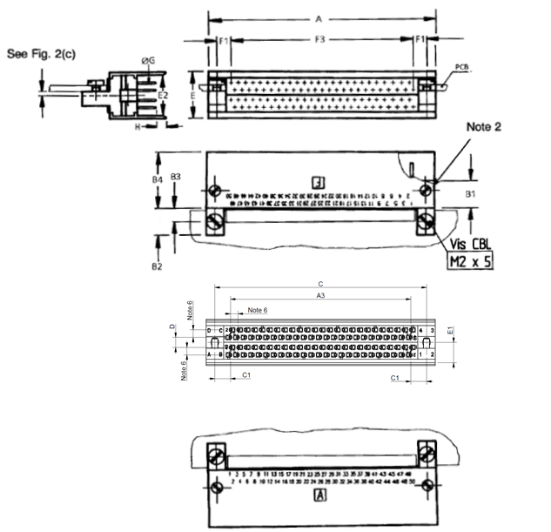
Symbol /  Dim. (1) | A | A3 | B1 | B2 | B3 | B4 | C | C1 | D | E | E1 | E2 | F1 | F3 | ØG | H
Min. | 57.9 | 45.52 | 7 | - | 3.5 | 14.3 | 53.51 | 3.77 | 2.34 | - | 5.05 | 10.2 | 3.29 | 46.47 | 0.42 | 2
Max. | 58.2 | 45.92 | 7.2 | 7.4 | 3.6 | 14.6 | 53.81 | 4.17 | 2.74 | 12 | 5.25 | 10.45 | 3.69 | 46.87 | 0.44 | 3
notes:
            - All dimensions are in millimetres.
            - Torque: 10N.cm.
            - Underlined dimensions, in table, are critical to ensure intermateability.
            - The front of the insert shall be marked with the minimum marking shown.
            - Orientation of labelling of contacts and guiding devices is not a true representation.
            - Pitch: 1.905mm.

PLUG, 152 CONTACTS
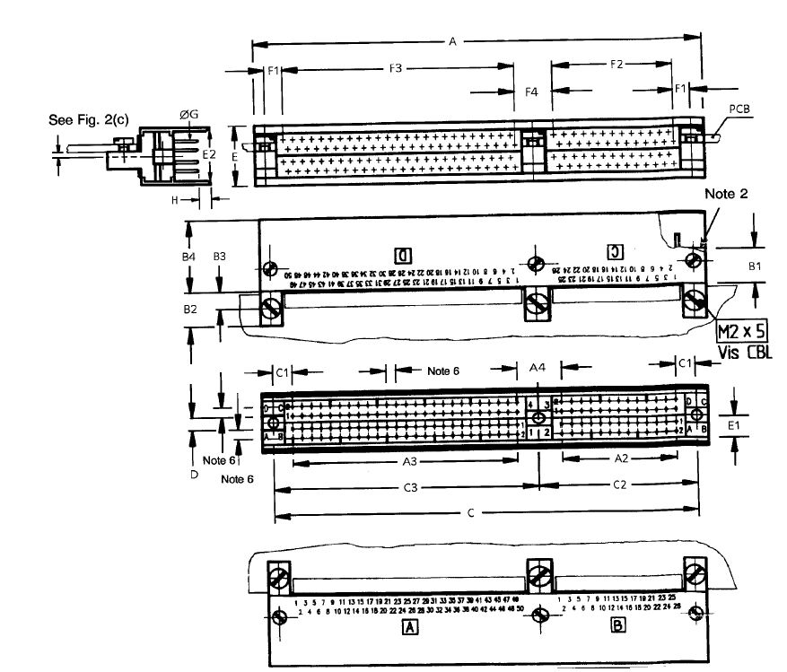
Symbol /  Dim. (1) | A | A2 | A3 | A4 | B1 | B2 | B3 | B4 | C | C1 | C2 | C3 | D | E | E1 | E2 | F1 | F2 | F3 | F4 | ØG | H
Min. | 88.8 | 22.66 | 45.52 | 7.74 | 7 | - | 3.5 | 14.3 | 84.305 | 3.77 | 30.65 | 53.51 | 2.34 | - | 5.05 | 10.2 | 3.29 | 23.61 | 46.47 | 6.79 | 0.42 | 2
Max. | 89.1 | 23.06 | 45.92 | 8.14 | 7.2 | 7.4 | 3.6 | 14.6 | 84.605 | 4.17 | 30.95 | 53.81 | 2.74 | 12 | 5.25 | 10.45 | 3.69 | 24.01 | 46.87 | 7.19 | 0.44 | 3
notes:
            - All dimensions are in millimetres.
            - Torque: 10N.cm.
            - Underlined dimensions, in table, are critical to ensure intermateability.
            - The front of the insert shall be marked with the minimum marking shown.
            - Orientation of labelling of contacts and guiding devices is not a true representation.
            - Pitch: 1.905mm.

PLUG, 200 CONTACTS
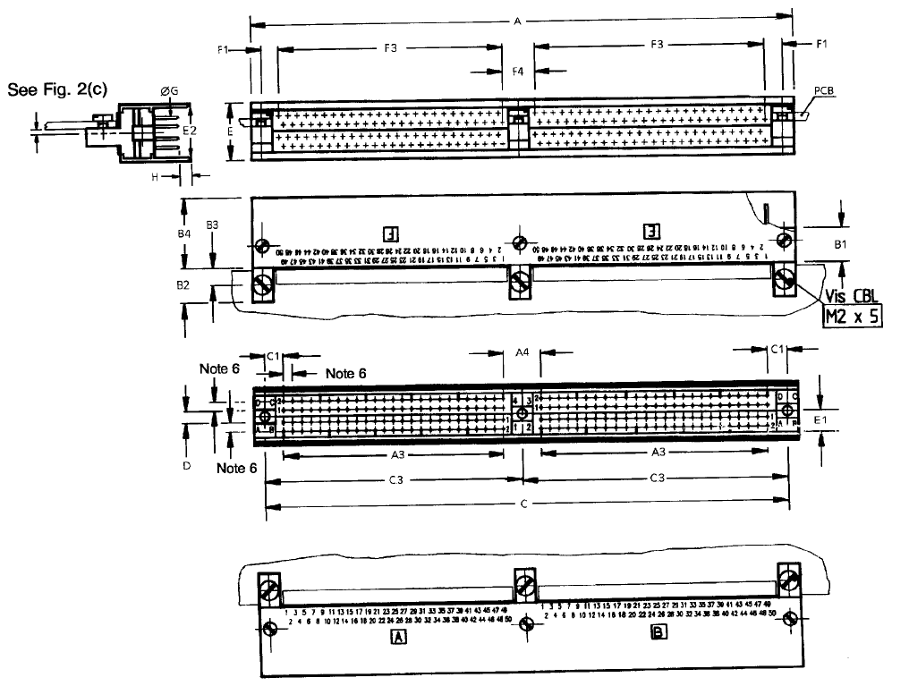
Symbol /  Dim. (1) | A | A3 | A4 | B1 | B2 | B3 | B4 | C | C1 | C3 | D | E | E1 | E2 | F1 | F3 | F4 | ØG | H
Min. | 111.6 | 45.52 | 7.74 | 7 | - | 3.5 | 14.3 | 107.17 | 3.77 | 53.51 | 2.34 | - | 5.05 | 10.2 | 3.29 | 46.47 | 6.79 | 0.42 | 2
Max. | 111.9 | 45.92 | 8.14 | 7.2 | 7.4 | 3.6 | 14.6 | 107.47 | 4.17 | 53.81 | 2.74 | 12 | 5.25 | 10.45 | 3.69 | 46.87 | 7.19 | 0.44 | 3
notes:
            - All dimensions are in millimetres.
            - Torque: 10N.cm.
            - Underlined dimensions, in table, are critical to ensure intermateability.
            - The front of the insert shall be marked with the minimum marking shown.
            - Orientation of labelling of contacts and guiding devices is not a true representation.
            - Pitch: 1.905mm.

PLUG, 252 CONTACTS
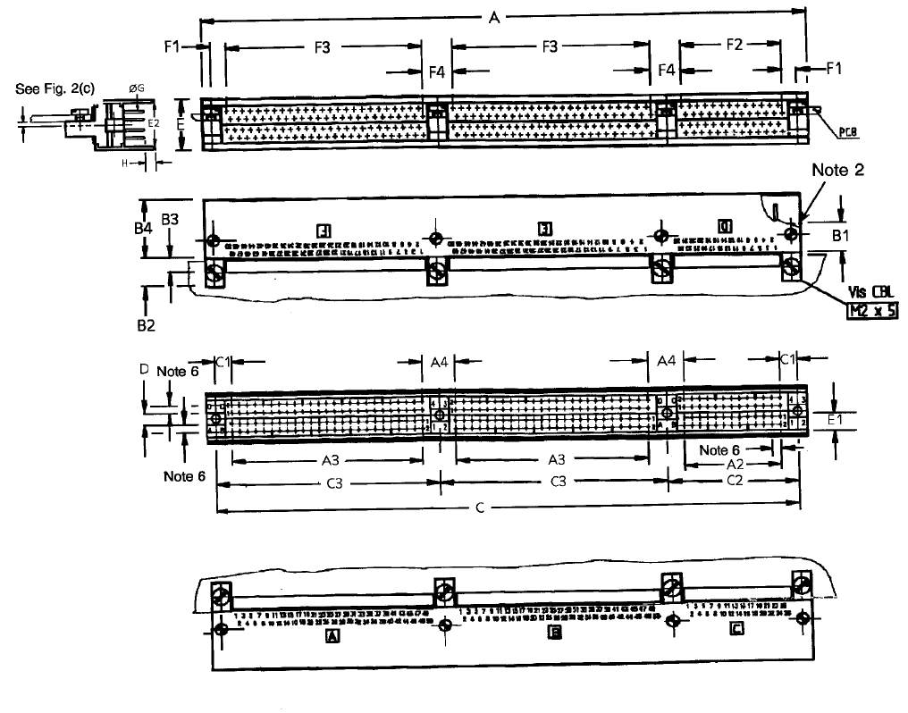
Symbol /  Dim. (1) | A | A2 | A3 | A4 | B1 | B2 | B3 | B4 | C | C1 | C2 | C3 | D | E | E1 | E2 | F1 | F2 | F3 | F4 | ØG | H
Min. | 142.5 | 22.66 | 45.52 | 7.74 | 7 | - | 3.5 | 14.3 | 137.96 | 3.77 | 30.65 | 53.51 | 2.34 | - | 5.05 | 10.2 | 3.29 | 23.61 | 46.47 | 6.79 | 0.42 | 2
Max. | 142.8 | 23.06 | 45.92 | 8.14 | 7.2 | 7.4 | 3.6 | 14.6 | 138.26 | 4.17 | 30.95 | 53.81 | 2.74 | 12 | 5.25 | 10.45 | 3.69 | 24.01 | 46.87 | 7.19 | 0.44 | 3
notes:
            - All dimensions are in millimetres.
            - Torque: 10N.cm.
            - Underlined dimensions, in table, are critical to ensure intermateability.
            - The front of the insert shall be marked with the minimum marking shown.
            - Orientation of labelling of contacts and guiding devices is not a true representation.
            - Pitch: 1.905mm.

PLUG, 300 CONTACTS
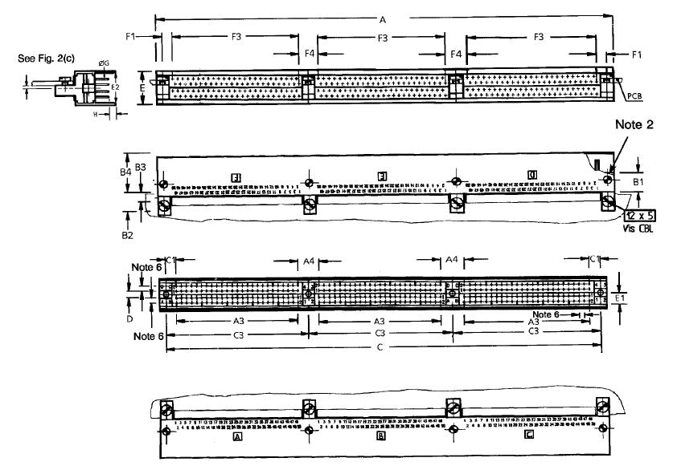
Symbol /  Dim. (1) | A | A3 | A4 | B1 | B2 | B3 | B4 | C | C1 | C3 | D | E | E1 | E2 | F1 | F3 | F4 | ØG | H
Min. | 165.3 | 45.52 | 7.74 | 7 | - | 3.5 | 14.3 | 160.82 | 3.77 | 53.51 | 2.34 | - | 5.05 | 10.2 | 3.29 | 46.47 | 6.79 | 0.42 | 2
Max. | 165.6 | 45.92 | 8.14 | 7.2 | 7.4 | 3.6 | 14.6 | 161.12 | 4.17 | 53.81 | 2.74 | 12 | 5.25 | 10.45 | 3.69 | 46.87 | 7.19 | 0.44 | 3
notes:
            - All dimensions are in millimetres.
            - Torque: 10N.cm.
            - Underlined dimensions, in table, are critical to ensure intermateability.
            - The front of the insert shall be marked with the minimum marking shown.
            - Orientation of labelling of contacts and guiding devices is not a true representation.
            - Pitch: 1.905mm.

PLUG, 352 CONTACTS
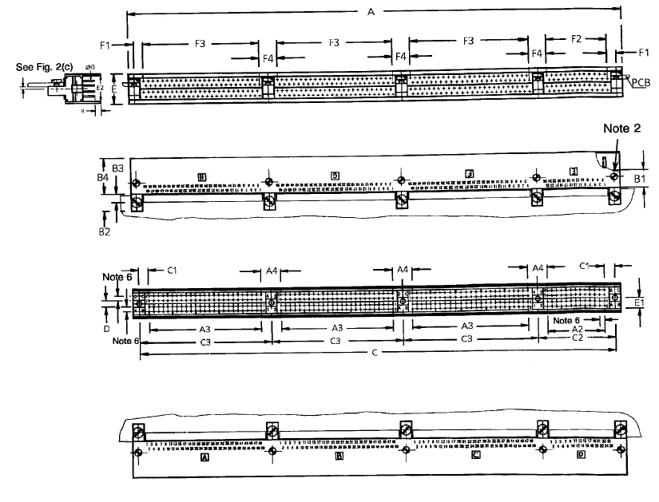
Symbol /  Dim. (1) | A | A2 | A3 | A4 | B1 | B2 | B3 | B4 | C | C1 | C2 | C3 | D | E | E1 | E2 | F1 | F2 | F3 | F4 | ØG | H
Min. | 196.2 | 22.66 | 45.52 | 7.74 | 7 | - | 3.5 | 14.3 | 191.62 | 3.77 | 30.65 | 53.51 | 2.34 | - | 5.05 | 10.2 | 3.29 | 23.61 | 46.47 | 6.79 | 0.42 | 2
Max. | 196.5 | 23.06 | 45.92 | 8.14 | 7.2 | 7.4 | 3.6 | 14.6 | 191.92 | 4.17 | 30.95 | 53.81 | 2.74 | 12 | 5.25 | 10.45 | 3.69 | 24.01 | 46.87 | 7.19 | 0.44 | 3
notes:
            - All dimensions are in millimetres.
            - Torque: 10N.cm.
            - Underlined dimensions, in table, are critical to ensure intermateability.
            - The front of the insert shall be marked with the minimum marking shown.
            - Orientation of labelling of contacts and guiding devices is not a true representation.
            - Pitch: 1.905mm.

PLUG, 400 CONTACTS
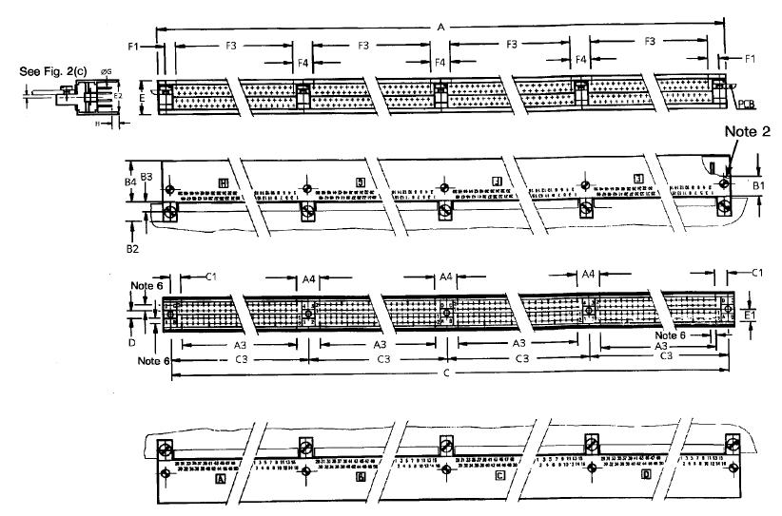
Symbol /  Dim. (1) | A | A3 | A4 | B1 | B2 | B3 | B4 | C | C1 | C3 | D | E | E1 | E2 | F1 | F3 | F4 | ØG | H
Min. | 219 | 45.52 | 7.74 | 7 | - | 3.5 | 14.3 | 214.48 | 3.77 | 53.51 | 2.34 | - | 5.05 | 10.2 | 3.29 | 46.47 | 6.79 | 0.42 | 2
Max. | 219.3 | 45.92 | 8.14 | 7.2 | 7.4 | 3.6 | 14.6 | 214.78 | 4.17 | 53.81 | 2.74 | 12 | 5.25 | 10.45 | 3.69 | 46.87 | 7.19 | 0.44 | 3
notes:
            - All dimensions are in millimetres.
            - Torque: 10N.cm.
            - Underlined dimensions, in table, are critical to ensure intermateability.
            - The front of the insert shall be marked with the minimum marking shown.
            - Orientation of labelling of contacts and guiding devices is not a true representation.
            - Pitch: 1.905mm.

figure 2(b) – gUIdiNG AnD lOCKInG DEVICEs
CODE 110
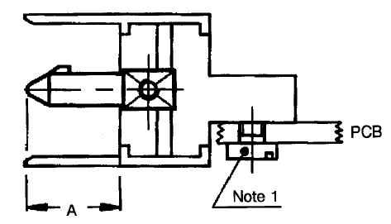
Symbol | Millimetres
Symbol | Min. | Max.
A | 7 | 7.35
NOTES:
            - Torque: 15N.cm.
code 111
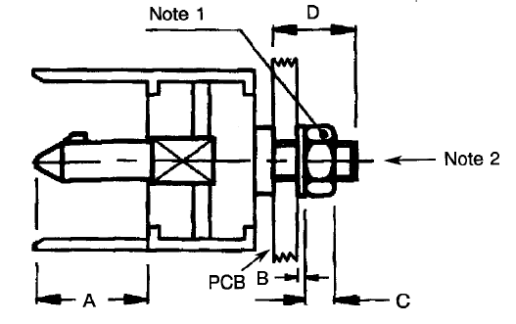
Symbol | Millimetres
Symbol | Min. | Max.
A  B  C  D | 7  0.45  1.9  - | 7.35  0.55  2.1  5.5
NOTES:
            - Torque: 25N.cm.
            - M2.5.

CODE 121
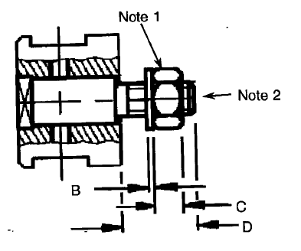
Symbol | Millimetres
Symbol | Min. | Max.
B  C  D | 0.45  1.9  - | 0.55  2.1  5.5
NOTES:
            - Torque: 25N.cm.
            - M2.5.
CODES 124 AND 134
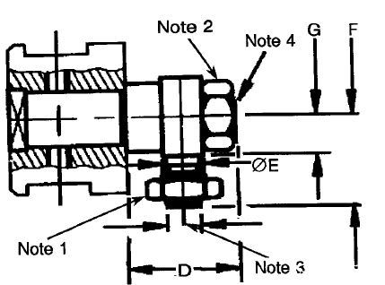
Symbol | Millimetres |  | Notes
 | Min. | Max.
D | - | 7
ØE | 2.45 | 2.55
F | - | 6 | Code 124
F | - | 6.6 | Code 134
G | 2.6 | 2.7
NOTES:
            - Torque: 15N.cm.
            - Torque: 25N.cm.
            - M2.
            - M2.5.
code 201
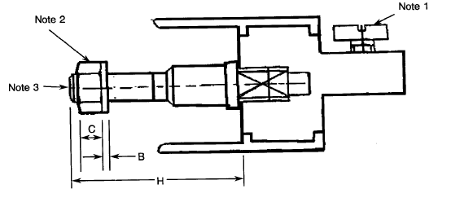
Symbol | Millimetres
Symbol | Min. | Max.
B  C  H | 0.45  1.9  - | 0.55  2.1  15
NOTES:
            - Torque: 15N.cm.
            - Torque: 25N.cm.
            - M2.5.

FIGURE 2(c) – CONTACT MOUNTING CONFIGURATIONS – VIEW OF REAR PART OF CONNECTOR
CODEs 10, 11 AND 12
right-angle solder contacts
RECEPTACLE SIDE PLUG SIDE
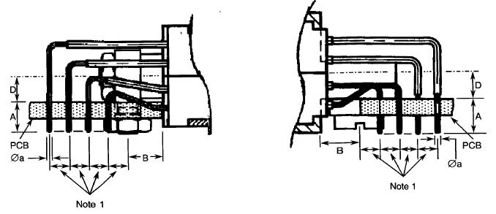
 |  | Code 10 |  | Code 11 |  | Code 12
 |  | Plug and Receptacle |  | Receptacle Only |  | Plug Only
 |  | Millimetres
Symbol |  | Min. | Max. | Min. | Max. | Min. | Max.
A |  | 2.6 | 3.8 | 3.1 | 4.3 | 4.1 | 5.3
B | Plug | 3.4 | 3.6 | - | - | 3.4 | 3.6
B | Recept. | 3.2 | 3.8 | 3.2 | 3.8 | - | -

Symbol | Millimetres
 | Minimum | Maximum
Øa | 0.36 | 0.44
D | 2.6 | 2.7
NOTES:
            - Pitch: 1.905mm.

CODEs 30 and 31
straight solder contacts
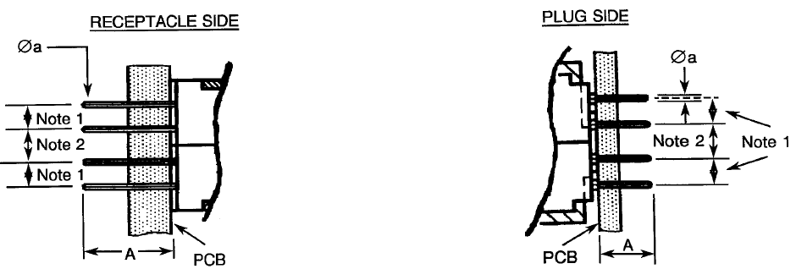
 | Code 30 |  | Code 31 |  | Code 31
 | Plug and Receptacle |  | Receptacle |  | Plug
 | Millimetres
Symbol | Min. | Max. | Min. | Max. | Min. | Max.
A | 3.5 | 4 | 6.1 | 6.6 | 4.6 | 5.1

Symbol | Millimetres
 | Minimum | Maximum
Øa | 0.36 | 0.44
NOTES:
            - Pitch: 1.905mm.
            - Pitch: 2.54mm.
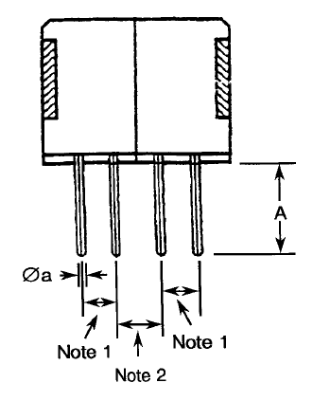
Code 91 – saver

Symbol | Millimetres
 | Minimum | Maximum
A | 4.5 | 5.5
Øa | 0.42 | 0.44
NOTES:
            - Pitch: 1.905mm.
            - Pitch: 2.54mm.

Code 43
surface mount – applicable to plugs only
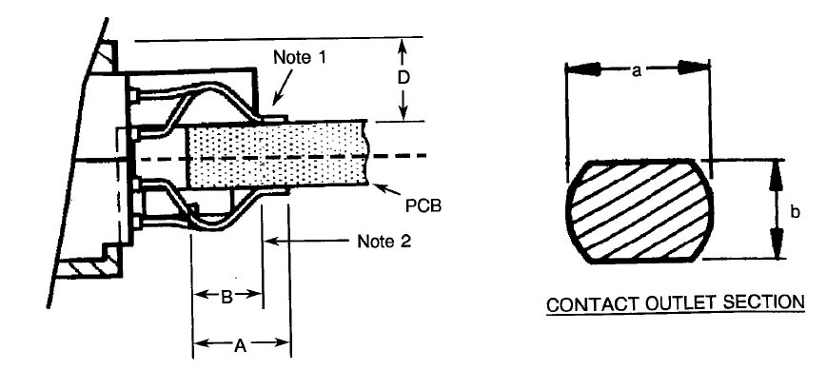
Symbol | Millimetres
 | Min. | Max.
a | 0.25 | 0.45
A | - | 5.5
b | 0.2 | 0.4
B | 3 | 4.1
D | - | 4.8
NOTES:
            - See section. Pitch: 0.9525mm.
            - Contact point.

CODES 45 and 47
surface mount off-centre – applicable to plugs only
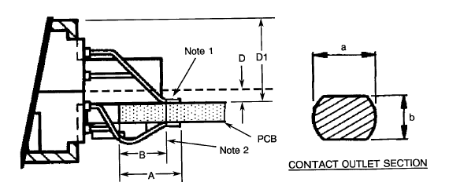
 | Code 45 |  | Code 47
 | Millimetres
Symbol | Min. | Max. | Min. | Max.
A | - | 5 | - | 5

Symbol | Millimetres
 | Minimum | Maximum
a | 0.25 | 0.45
b | 0.2 | 0.4
B | 3 | 4.1
D | 0.9 | 1.2
D1 | - | 7
E1 | 0.7 | -
E2 | 0 | 0.18
NOTES:
            - See section. Pitch: 0.9525mm.
            - Contact point. Details as follows:
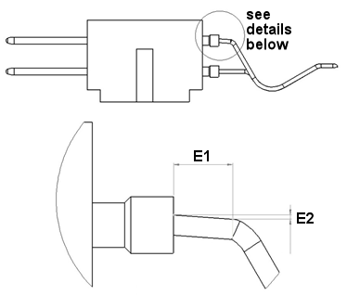

REQUIREMENTS

GENERAL
The complete requirements for procurement of the connectors specified herein are stated in this specification and ESCC Generic Specification No. 3401. Deviations from the Generic Specification, applicable to this specification only, are listed in Para. 4.2.
Deviations from the applicable Generic Specification and this Detail Specification, formally agreed with specific Manufacturers on the basis that the alternative requirements are equivalent to the ESCC requirements and do not affect the components' reliability, are listed in the appendices attached to this specification.

DEVIATIONS FROM GENERIC SPECIFICATION

Deviations from Special In-process Controls
None.

Deviations from Final Production Tests (Chart II)
          - Para. 9.1.1.4, Mated Shell Conductivity: Not applicable.
          - Para. 9.4, Contact Capability: Sampling in accordance with Para. 9.6 of ESCC No. 3401.
          - Para. 9.5, Magnetism Level: Not applicable.
          - Para. 9.9, Seal Test: Not applicable.

Deviations from Burn-in and Electrical Measurements (Chart III)
Chart III is not applicable.

Deviations from Qualification Tests (Chart IV)
          - Para. 9.1.1.4, Mated Shell Conductivity: Not applicable.
          - Para. 9.9, Seal Test: Not applicable.
          - Para. 9.15, Joint Strength: Not applicable.
          - Para. 9.24, Jackscrew Retention: Not applicable.
          - Para. 9.27, Maintenance Aging: Not applicable
          - Para. 9.30, Probe Damage: Not applicable.

Deviations from Lot Acceptance Tests (Chart V)
          - Para. 9.1.1.4, Mated Shell Conductivity: Not applicable.
          - Para. 9.9, Seal Test: Not applicable.
          - Para. 9.15, Joint Strength: Not applicable.
          - Para. 9.27, Maintenance Aging: Not applicable.
          - Para. 9.30, Probe Damage: Not applicable.

MECHANICAL REQUIREMENTS

Dimension Check
The dimensions of the connectors specified herein shall be verified in accordance with the requirements set out in Para. 9.6 of ESCC Generic Specification No. 3401 and shall conform to those shown in Figure 2 of this specification. Only the following dimensions shall be checked during procurement:
Figure 2(a):
- Between centres of guiding or locking device. (Dimensions C, C2 and C3).
- Dimension E1 (where applicable).
Figure 2(b):
- Protrusion of guiding/locking devices.
- Overall dimensions of guiding/locking devices.
Figure 2(c):
- All dimensions, except pitch.

Weight
The maximum weight of the connectors, with contacts and guiding and locking devices specified herein, shall be as specified in Table 1(a).

Contact Capability
For the purpose of this test, the pick-up and drop weights shall be as follows.
 | Pick-up Weight | Drop Weight
Weight (g) | 5 | 70
Pin Diameter (mm) | 0.415 - 0.42 | 0.44 - 0.445
Insertion Depth (mm) | 5 | 5

Contact Retention (In Insert)
The contact retention force (compression) within the insert shall be 40N.

Mating and Unmating Forces
The forces applied for mating and unmating of the connectors shall not exceed the values specified in Table 1(a).

Insert Retention (In Shell)
Connector inserts shall withstand a pressure of 25N/cm² without being dislodged from the shell.

Jackscrew Retention
Not applicable.

Contact Insertion and Withdrawal Forces
Not applicable.

Engagement and Separation Forces
The diameter of the test pin and the engagement and separation forces of the female contacts shall be as specified hereunder.
 | Diameter (mm) |  | Engagement | Separation (N)
 | Min. | Max. | Max. (N) | Min. | Max.
Minimum Diameter Test Pin | 0.415 | 0.42 | - | 0.05 | -
Maximum Diameter Test Pin | 0.44 | 0.445 | 0.7 | - | 0.7

Oversize Pin Exclusion
The diameter of the test pin shall be 0.598mm minimum and 0.602mm maximum and the force applied to it shall be 0.7N.

Probe Damage
Not applicable.

Solderability
No special conditions.

MATERIALS AND FINISHES
The materials and finishes shall be as specified herein. Where a definite material is not specified, a material which will enable the connectors specified herein to meet the performance requirements of this specification shall be used. Acceptance or approval of any constituent material does not guarantee acceptance of the finished product.

Shells
Shells shall be made of aluminium alloy with an appropriate surface treatment against corrosion.

Inserts
The inserts shall be made of glass-fibre-filled diallylphthalate resin.

Contacts

Body
The contact body shall be made of copper alloy.
- Male Contact and Saver: The plating shall be 1.27µm minimum gold over 1.27µm minimum nickel.
- Female Contact: The plating shall be 0.25µm minimum gold over 1.27µm minimum nickel.

Female Contact Wire
The wire shall be made of copper alloy.
The plating shall be 1.27µm minimum gold over 0.2µm minimum nickel.

Female Contact Sleeve
The sleeve shall be made of copper alloy. The plating shall be 0.25µm minimum gold over 0.8µm minimum nickel.

Tinned Terminations (Insert Codes 46 and 57)
Solder dipped, tin/lead 63/37, minimum thickness 1µm, minimum length 3.5mm.

Contact Retaining Clip
Not applicable.

Guiding and Locking Devices
Guiding and locking devices shall be made of brass (nickel-plated), stainless steel or arcap alloy.

Magnetism Level
Not applicable.

MARKING

General
The marking of all components delivered to this specification shall be in accordance with the requirements of ESCC Basic Specification No. 21700 and the following paragraphs. When the component is too small to accommodate all of the marking as specified, as much as space permits shall be marked and the marking information, in full, shall accompany the component in its primary package.
The information to be marked, and the order of precedence, shall be as follows:
          - Contact Position.
          - The ESCC Component Number.
          - Characteristics.
          - Traceability information.

Contact Position
Contact position shall be marked on the inserts in accordance with Figure 2(a).

The ESCC Component Number
Each component shall be marked with the ESCC Component Number which shall be constituted and marked as follows:
Example: 340106501B
- Detail Specification Number: 3401065
- Type Variant (Note 1): 01
- Testing Level: B
notes:
            - Marking of the Type Variant is mandatory. No further reference to type variants is made in this specification.

Characteristics
The characteristics to be marked in the following order of precedence are (example):
052 44 10 110
- Number of contacts (52): 052
- Insert type: 44
- Type of contacts: 10
- Guiding and locking devices: 110

Number of Contacts
052 – 100 – 152 – 200 – 252 – 300 – 352 – 400.

Insert
Inserts shall be designated by the following code numbers.
Code No. | Description
44 | Receptacle (female contacts)
46 | Receptacle (female contact pre-tinned termination)
55 | Plug (male contacts)
57 | Plug (male contact pre-tinned termination)

Contacts
Contact rear configurations shall be designated by the codes given in Table 1(a) and Figure 2(c).

Guiding and Locking Devices
Guiding and locking devices shall be designated by the codes given in Figure 2(b).
N.B.
If the purchase order does not specify any guiding or locking devices, receptacles shall be delivered without.

Traceability Information
Traceability information shall be marked in accordance with the requirements of ESCC Basic Specification No. 21700.

ELECTRICAL MEASUREMENTS

Electrical Measurements at Room Temperature
The parameters to be measured in respect of electrical characteristics are scheduled in Table 2. Unless otherwise specified, the measurements shall be performed at T_{amb} = +22 ±3°C.

Electrical Measurements at High and Low Temperatures (Table 3)
Not applicable.

Circuits for Electrical Measurements (Figure 4)
Not applicable.

BURN-IN AND ELECTRICAL MEASUREMENTS (TABLES 4 AND 5)
Not applicable.

ENVIRONMENTAL AND ENDURANCE TESTS (CHARTS IV AND V OF ESCC GENERIC SPECIFICATION NO. 3401)

Measurements and Inspections on Completion of Environmental Tests
The parameters to be measured and inspections to be performed on completion of environmental testing shall be those specified in Table 6. Unless otherwise specified, the measurements shall be performed at T_{amb} = +22 ±3°C.

Measurements and Inspections at Intermediate Points during Endurance Tests
Not applicable.

Measurements and Inspections on Completion of Endurance Tests
The parameters to be measured and inspections to be performed on completion of endurance testing are scheduled in Table 6. Unless otherwise specified, the measurements shall be performed at T_{amb} = +22 ±3°C.

Conditions for Operating Life Test (Part of Endurance Testing)
Not applicable.

Electrical Circuits for Operating Life Test
Not applicable.

Conditions for High Temperature Storage Test (Part of Endurance Testing)
The requirements for the high temperature storage test are specified in Section 9 of ESCC Generic Specification No. 3401. The conditions for high temperature storage testing shall be the maximum storage temperature specified in Table 1(b) of this specification.
TABLE 2 – ELECTRICAL MEASUREMENTS AT ROOM TEMPERATURE
No. | Characteristics | Symbol | Spec. and/or | Test Condition | Limits |  | Unit
No. | Characteristics | Symbol | Test Method |  | Min. | Max.
1 | Insulation Resistance | Ri | ESCC No. 3401 Para. 9.1.1.1 | Para. 9.1.1.1 | 10000 | - | MΩ
2 | Voltage Proof Leakage Current (Sea Level) | I_{L} | ESCC No. 3401 Para. 9.1.1.2 | 800Vrms |  | 1 | mA
3 | Mated Shell Conductivity (Voltage Drop) | Vd | ESCC No. 3401 Para. 9.1.1.4 | Para. 9.1.1.4 | Not applicable |  | mV
4 | Contact Resistance  (Low Level Current) | Rcl | ESCC No. 3401 Para. 9.1.1.3 | All | - | 12 | mΩ
5 | Contact Resistance  (Rated Current) (1) | Rcr | ESCC No. 3401  Para. 9.1.1.3 | 2A | - | 12 | mΩ
NOTES:
            - Contact Resistance at Rated Current is guaranteed but not tested during Final Production Tests (Chart II).
TABLes 3, 4 and 5
Not applicable.

Table 6 – Measurements and Inspections on Completion of Environmental and Endurance TestS
No. | ESCC Generic No. 3401 |  | Measurements and Inspections |  | Symbol | Limits |  | Unit
 | Environmental  and Endurance Tests (1) | Test Method and Conditions | Identification | Conditions |  | Min. | Max.
01 | Seal Test | Para. 9.9 | Not applicable |  |  | Not applicable
02 | Wiring | Para. 9.10 |  |  |  | - | -
03 | Vibration | Para. 9.11 | Initial Measurements
 |  |  | Coupling Screw(s) Unlocking Torque | - | - | Record Values
 |  |  | Final Measurements
 |  |  | Full Engagement | -
 |  |  | Coupling Screw(s) Unlocking Torque Drift | - | Δ | -25 | +25 | %
 |  |  | Visual Examination | - | - | - | -
04 | Shock or Bump | Para. 9.12 | Full Engagement  Visual Examination | - | - | - | -
05 | Climatic Sequence | Para. 9.13 | Dry Heat
 |  |  | Insulation Resistance | Table 2 Item 1 | Ri | 1000 | - | MΩ
 |  |  | Low Air Pressure
 |  |  | Voltage Proof Leakage Curr. | Figure 1 | I_{L} | ESCC 3401  Para. 9.13.5
 |  |  | Damp Heat | Immediately after test
 |  |  | Insulation Resistance | Table 2 Item 1 | Ri | 100 | - | MΩ
 |  |  | Final Measurements | After 1-24 hrs Recovery
 |  |  | External Visual Inspection | ESCC 3401 Para. 9.7 | - | ESCC 3401  Para. 9.7
 |  |  | Insulation Resistance | Table 2 Item 1 | Ri | Table 2 Item 1
 |  |  | Voltage Proof Leakage Curr. | Table 2 Item 2 | I_{L} | Table 2 Item 2
06 | Plating Thickness | Para. 9.14 | Thickness |  |  | Para. 4.4.3 of this spec.
07 | Joint Strength | Para. 9.15 | ESCC 3401 Para. 9.15 |  |  | Not applicable
08 | Rapid Change of Temperature | Para. 9.16 | Visual Examination | - | - | - | -
 | Rapid Change of Temperature |  | Insulation Resistance | Table 2 Item 1 | Ri | Table 2 Item 1
 |  |  | Voltage Proof Leakage Curr. | Table 2 Item 2 | I_{L} | Table 2 Item 2
09 | Contact Retention  (In Insert) | Para. 9.17 & Para. 4.3.4 of spec. | Contact Displacement | - | - | ESCC 3401  Para. 9.17
10 | Endurance | Para. 9.18 | Initial Measurements
 |  |  | Mating/Unmating Forces | - | F | Para. 4.3.5 of this spec.
 |  |  | Low Level Contact Resist. | Table 2 Item 4 | Rcl | Record Values
 |  |  | Mated Shell Conductivity | Table 2 Item 3 | Vd | Not applicable
 |  |  | Final Measurements
 |  |  | Visual Examination | - | - | - | -
 |  |  | Mating/Unmating Forces | - | F | Para. 4.3.5 of this spec.
 |  |  | Low Level Contact Resistance Drift | Table 2 Item 4 | ΔRcl | - | 4 | mΩ
 |  |  | Mated Shell Conductivity | Table 2 Item 3 | Vd | Table 2 Item 3
 |  |  | Insulation Resistance | Table 2 Item 1 | Ri | Table 2 Item 1
 |  |  | Voltage Proof Leakage Curr. | Table 2 Item 2 | I_{L} | Table 2 Item 2
11 | Permanence of Marking | Para. 9.19 | As applicable | - | - | - | -
12 | Mating/Unmating Forces | Para. 9.20 | Force | - | F | Para. 4.3.5 of this spec.
13 | High Temperature  Storage | Para. 9.21 | Initial Measurements
 | High Temperature  Storage |  | Low Level Contact Resist. | Table 2 Item 4 | Rcl | Record Values
 |  |  | Mated Shell Conductivity | Table 2 Item 3 | Vd | Not applicable
 |  |  | Final Measurements
 |  |  | Visual Examination | - | - | - | -
 |  |  | Mating/Unmating Forces | - | F | Para. 4.3.5 of this spec.
 |  |  | Low Level Contact Resistance Drift | Table 2 Item 4 | ΔRcl | - | 4 | mΩ
 |  |  | Rated Current Contact Resistance | Table 2 Item 5 | Rcr | Table 2 Item 5
 |  |  | Mated Shell Conductivity | Table 2 Item 3 | Vd | Not applicable
 |  |  | Insulation Resistance | Table 2 Item 1 | Ri | Table 2 Item 1
 |  |  | Voltage Proof Leakage Curr. | Table 2 Item 2 | I_{L} | Table 2 Item 2
 |  |  | Contact Retention (In Insert) | Para. 4.3.4 of this spec. | - | ESCC 3401  Para. 9.17
14 | Corrosion | Para. 9.22 | Visual Examination | - | - | Not applicable
15 | Insert Retention  (In Shell) | Para. 9.23 & Para. 4.3.6 of this spec. | Visual Examination | - | - | Para. 4.3.6 of this spec.
16 | Jackscrew Retention | Para. 9.24 & Para. 4.3.7 of this spec. | Visual Examination | - | - | Not applicable
17 | High Temperature Measurements | Para. 9.25 | Insulation Resistance | Table 2 Item 1 | Ri | 500 | - | MΩ
18 | Overload Test | Para. 9.26 | Internal Temperature |  | T | - | +100 | °C
 |  |  | Rated Current Contact Resistance | Table 2 Item 5 | Rcr | Table 2 Item 5
 |  |  | Mated Shell Conductivity | Table 2 Item 3 | Vd | Not applicable
 |  |  | Insulation Resistance | Table 2 Item 1 | Ri | Table 2 Item 1
 |  |  | Voltage Proof Leakage Curr. | Table 2 Item 2 | I_{L} | Table 2 Item 2
19 | Maintenance Aging | Para. 9.27 | Visual Examination | - | - | - | -
 |  |  | Contact Retention | Para. 4.3.4 of this spec. |  | Not applicable
 |  |  | Contact Insertion and Withdrawal Forces | Para. 4.3.8 of this spec. |  | Not applicable
20 | Engage/Separation Forces | Para. 9.28 & Para. 4.3.9 of this spec. | Force | - | F | Para. 4.3.9 of this spec.
21 | Oversize Pin Exclusion | Para. 9.29 & Para. 4.3.10 of this spec. | - | - | - | ESCC 3401  Para. 9.29
22 | Probe Damage | Para. 9.30 & Para. 4.3.11 of this spec. | Contact Separation Force | Para. 4.3.9 of this spec. | - | Not applicable
23 | Solderability | Para. 9.31 & Para. 4.3.12 of this spec. | - | - | - | ESCC 3401  Para. 9.31
notes:
            - The tests in this Table refer to either Chart IV or V and shall be used as applicable.

