

Page 1 of 18
ACCESSORIES FOR RECTANGULAR CONNECTORS 3401/001, 3401/002, 3401/XXX AND CONNECTOR SAVERS 3401/020, 3401/080
ESCC Detail Specification No. 3401/022

Issue 13 | June 2019



Document Custodian: European Space Agency – see https://escies.org

Legal Disclaimer and Copyright
European Space Agency, Copyright © 2019. All rights reserved.
The European Space Agency disclaims any liability or responsibility, to any person or entity, with respect to any loss or damage caused, or alleged to be caused, directly or indirectly by the use and application of this ESCC publication.
This publication, without the prior permission of the European Space Agency and provided that it is not used for a commercial purpose, may be:
- copied in whole, in any medium, without alteration or modification.
- copied in part, in any medium, provided that the ESCC document identification, comprising the ESCC symbol, document number and document issue, is removed.

DOCUMENTATION CHANGE NOTICE
(Refer to https://escies.org for ESCC DCR content)
DCR No. | CHANGE DESCRIPTION
1271 | Specification upissued to incorporate changes per DCR.

TABLE OF CONTENTS
1 General 5
1.1 SCOPE 5
1.2 COMPONENT TYPE VARIANTS 5
1.3 MAXIMUM RATINGS 5
1.4 PARAMETER DERATING INFORMATION 5
1.5 PHYSICAL DIMENSIONS 5
2 APPLICABLE DOCUMENTS 5
3 TERMS, DEFINITIONS, ABBREVIATIONS, SYMBOLS AND UNITS 5
4 REQUIREMENTS 16
4.1 GENERAL 16
4.2 DEVIATIONS FROM GENERIC SPECIFICATION 16
4.2.1 Deviations from Special In-Process Controls 16
4.2.2 Deviations from Final Production Tests (Chart II) 17
4.2.3 Deviations from Burn-in and Electrical Measurements (Chart III) 17
4.2.4 Deviations from Qualification Tests (Chart IV) 17
4.2.5 Deviations from Lot Acceptance Tests (Chart V) 17
4.3 MECHANICAL REQUIREMENTS 17
4.3.1 Dimension Check 17
4.3.2 Weight 17
4.3.3 Torque Value 17
4.4 MATERIALS AND FINISHES 17
4.4.1 Screw Lock Assemblies, Potting Shells, Back Shells, Clamps 17
4.4.2 Dust Caps 17
4.4.3 Magnetism Level 17
4.5 MARKING 18
4.5.1 General 18
4.5.2 The ESCC Component Number 18
4.5.3 Characteristics 18
4.5.3.1 Magnetism Level (For Variants 01 to 06, 17 to 47, 58, 60 to 72, 81 to 83 and 86 to 97) 18
4.5.4 Traceability Information 18
4.6 ELECTRICAL MEASUREMENTS (TABLES 2 AND 3) 18
4.7 BURN-IN AND ELECTRICAL MEASUREMENTS (TABLES 4 AND 5) 18
4.8 ENVIRONMENTAL AND ENDURANCE TESTS (TABLE 6) 18

General

SCOPE
This specification details the ratings, physical and electrical characteristics, test and inspection data for Accessories for Rectangular Connectors (D*M and D*MA) and Connector Savers (D*BM and D*BMA). It shall be read in conjunction with ESCC Generic Specification No. 3401, the requirements of which are supplemented herein and ESCC Detail Specifications Nos. 3401/001, 3401/002, 3401/020 and 3401/080.

COMPONENT TYPE VARIANTS
The type variants of accessories covered by this specification are given in Table 1(a).

MAXIMUM RATINGS
The maximum ratings, which shall not be exceeded at any time during use or storage, applicable to the accessories specified herein, are given in Table 1(b).

PARAMETER DERATING INFORMATION
Not applicable.

PHYSICAL DIMENSIONS
The physical dimensions of the accessories specified herein are shown in Figure 2.

APPLICABLE DOCUMENTS
The following documents form part of this specification and shall be read in conjunction with it:
          - ESCC Generic Specification No. 3401, Connectors, Electrical, Non-Filtered, Circular and Rectangular.
          - ESCC Detail Specification No. 3401/001, Connectors, Electrical, Rectangular, Miniature, Non-removable Solder Bucket, PCB and Wire-Wrap Contacts and Removable Coaxial and Power Contacts, based on Type D*M.
          - ESCC Detail Specification No. 3401/002, Connectors, Electrical, Rectangular, Removable Crimp Contacts, based on type D*MA.
          - ESCC Detail Specification No. 3401/XXX Connectors, Electrical, Rectangular, Non-Removable Press-Fit, Signal And Removable Press-Fit Power Contacts Based On Type D*M
          - ESCC Detail Specification No. 3401/020, Connector Savers, Electrical, Rectangular, Miniature, Removable Contacts, based on type D*BMA.
          - ESCC Detail Specification No. 3401/080, Connector Savers, Electrical, Rectangular, Miniature, Non-removable Signal Contacts and Removable Coaxial and Power Contacts, based on type D*BM.

TERMS, DEFINITIONS, ABBREVIATIONS, SYMBOLS AND UNITS
For the purpose of this specification, the terms, definitions, abbreviations, symbols and units specified in ESCC Basic Specification No. 21300 shall apply.

TABLE 1(a) - TYPE VARIANTS
Variant | Description |  | Weight (g)
01 | Screw Lock Assembly Brass (Female) (4-40) | - | 1.9
02 | Screw Lock Assembly Brass (Male/slotted head screw) | Without Back Shell | 0.85
03 | Screw Lock Assembly Brass (Male/slotted head screw) | Without Back Shell | 0.85
04 | Screw Lock Assembly Brass (Male/slotted head screw) | Without Back Shell | 1
05 | Screw Lock Assembly Brass (Male/slotted head screw) | Without Back Shell | 1
06 | Screw Lock Assembly Brass (Female) for Savers (4-40) | - | 2
07 | Dust Cap (Female) | Size E | N/A
08 | Dust Cap (Male) | Size E | N/A
09 | Dust Cap (Female) | Size A | N/A
10 | Dust Cap (Male) | Size A | N/A
11 | Dust Cap (Female) | Size B | N/A
12 | Dust Cap (Male) | Size B | N/A
13 | Dust Cap (Female) | Size C | N/A
14 | Dust Cap (Male) | Size C | N/A
15 | Dust Cap (Female) | Size D | N/A
16 | Dust Cap (Male) | Size D | N/A
17 | Potting Shell | Size A | N/A
18 | Potting Shell | Size B | N/A
19 | Potting Shell | Size C | N/A
20 | Potting Shell | Size D | N/A
21 | Back-Shell for Strapped Connections | Size A | 8.6
22 | Back-Shell for Strapped Connections | Size B | 11.6
23 | Back-Shell for Strapped Connections | Size C | 15.5
24 | Back-Shell for Strapped Connections | Size D | 17.1
25 | Cable Clamp, Straight | Size A | 11.7
26 | Cable Clamp, Straight | Size B | 14.7
27 | Cable Clamp, Straight | Size C | 20
28 | Cable Clamp, Straight | Size D | 21.2
29 | Cable Clamp, Round | Size E | 9.7
30 | Cable Clamp, Round | Size A | 11
31 | Cable Clamp, Round | Size B | 13.3
32 | Cable Clamp, Round | Size C | 15.6
33 | Cable Clamp, Round | Size D | 16.5
34 | Deep Straight Clamp | Size E | 13.6
35 | Deep Straight Clamp | Size A | 17.2
36 | Deep Straight Clamp | Size B | 27.1
37 | Deep Straight Clamp | Size C | 39
38 | Deep Straight Clamp | Size D | 40.8
39 | Right Angle Clamp | Size E | 14.6
40 | Right Angle Clamp | Size A | 17.2
41 | Right Angle Clamp | Size B | 24.2
42 | Right Angle Clamp | Size C | 33.5
43 | Right Angle Clamp | Size D | 38.8
44 | Screw Lock Assembly Brass (Male/slotted head screw) | With Back Shell | 0.85
45 | Screw Lock Assembly Brass (Male/slotted head screw) | With Back Shell | 0.85
46 | Screw Lock Assembly Brass (Male/slotted head screw) | With Back Shell | 1
47 | Screw Lock Assembly Brass (Male/slotted head screw) | With Back Shell | 1
48 | Screw Lock Assembly Stainless Steel (Female) (4-40) | - | 1.8
49 | Screw Lock Assembly Stainless Steel (Male/slotted head screw) | Without Back Shell | 0.8
50 | Screw Lock Assembly Stainless Steel (Male/slotted head screw) | Without Back Shell | 0.8
51 | Screw Lock Assembly Stainless Steel (Male/slotted head screw) | Without Back Shell | 1
52 | Screw Lock Assembly Stainless Steel (Male/slotted head screw) | Without Back Shell | 1
53 | Screw Lock Assembly Stainless Steel (Female) for Savers (4-40) |  | 1.9
54 | Screw Lock Assembly Stainless Steel (Male/slotted head screw) | With Back Shell | 0.8
55 | Screw Lock Assembly Stainless Steel (Male/slotted head screw) | With Back Shell | 0.8
56 | Screw Lock Assembly Stainless Steel (Male/slotted head screw) | With Back Shell | 1
57 | Screw Lock Assembly Stainless Steel (Male/slotted head screw) | With Back Shell | 1
58 | Screw Lock Assembly Brass (Female) for Feedthrough (4-40) | - | 2
59 | Screw Lock Assembly Stainless Steel (Female) for  Feedthrough (4-40) | - | 1.86
60 | 60º Angled Clamp | Size E | 9
61 | 60º Angled Clamp | Size A | 11
62 | 60º Angled Clamp | Size B | 12
63 | 60º Angled Clamp | Size C | 15
64 | 60º Angled Clamp | Size D | 16
65 | Screw Lock Assembly Brass (male/hex. hole head screw) | Without Back Shell | 0.85
66 | Screw Lock Assembly Brass (male/hex. hole head screw) | Without Back Shell | 0.85
67 | Screw Lock Assembly Brass (male/hex. hole head screw) | Without Back Shell | 1
68 | Screw Lock Assembly Brass (male/hex. hole head screw) | Without Back Shell | 1
69 | Screw Lock Assembly Brass (male/hex. hole head screw) | With Back Shell | 0.85
70 | Screw Lock Assembly Brass (male/hex. hole head screw) | With Back Shell | 0.85
71 | Screw Lock Assembly Brass (male/hex. hole head screw) | With Back Shell | 1
72 | Screw Lock Assembly Brass (male/hex. hole head screw) | With Back Shell | 1
73 | Screw Lock Assembly Stainless Steel (Male/hex. hole head screw) | Without Back Shell | 0.8
74 | Screw Lock Assembly Stainless Steel (Male/hex. hole head screw) | Without Back Shell | 0.8
75 | Screw Lock Assembly Stainless Steel (Male/hex. hole head screw) | Without Back Shell | 1
76 | Screw Lock Assembly Stainless Steel (Male/hex. hole head screw) | Without Back Shell | 1
77 | Screw Lock Assembly Stainless Steel (Male/hex. hole head screw) | With Back Shell | 0.8
78 | Screw Lock Assembly Stainless Steel (Male/hex. hole head screw) | With Back Shell | 0.8
79 | Screw Lock Assembly Stainless Steel (Male/hex. hole head screw) | With Back Shell | 1
80 | Screw Lock Assembly Stainless Steel (Male/hex. hole head screw) | With Back Shell | 1
81 | Potting shell | Size E | N/A
82 | Back-Shell for Strapped Connections | Size E | 6.7
83 | Cable Clamp, Straight | Size E | 9
84 | Dust Cap (Female) | Size F | N/A
85 | Dust Cap (Male) | Size F | N/A
86 | Screw Lock Assembly Brass (Male/slotted head screw) | Without Back Shell | 0.8
87 | Screw Lock Assembly Brass (Male/slotted head screw) | With Back Shell | 1
88 | Screw Lock Assembly Brass (Male/hex. hole head screw) | Without Back Shell | 0.8
89 | Screw Lock Assembly Brass (Male/hex. hole head screw) | With Back Shell | 1
90 | Potting shell | Size F | N/A
91 | Back-Shell for Strapped Connections | Size F | 36
92 | Cable Clamp, Straight | Size F | 42
93 | Cable Clamp, Round | Size F | 21
94 | Deep Straight Clamp | Size F | 58
95 | Right Angle Clamp | Size F | 48
96 | Screw Lock Assembly Brass (Female) (Hybrid 4-40/M3) | - | 1.9
97 | Screw Lock Assembly Brass (Female) (4-40) | With Back Shell | 1.9
98 | Screw Lock Assembly Brass (Female) (4-40) | - | 1.9
99 | Screw Lock Assembly (Male/slotted head screw) | - | 1
TABLE 1(b) - MAXIMUM RATINGS
No. | Characteristic | Symbol | Maximum Ratings |  | Unit | Remarks
1 | Operating Temperature  Range | T_{op} | -55 to +125 (1) |  | °C | T_{amb}
2 | Storage Temperature  Range | T_{stg} | -55 to +125 (1) |  | °C
3 | Torque Value for Screws | Tqe | BRASS  5.5  3.3 | S.S.  6.6  4.4 | cm.daN  cm.daN | For Female (2) For Male
NOTES:
            - Except for dust cap: +100ºC.
            - Except for Variants 6, 53, 58 and 59 which shall be tightened to the torque specified for the Male.
FIGURE 1 - PARAMETER DERATING INFORMATION
Not applicable.
FIGURE 2 - PHYSICAL DIMENSIONS
FIGURE 2(a) - SCREW LOCK ASSEMBLIES (all dimensions in millimetres)
MATED SPACING BETWEEN SHELL FRONT SURFACES
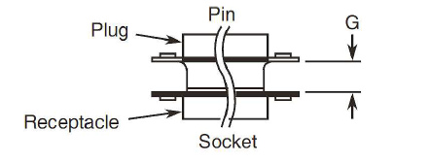
Screw Lock Assembly (Female) (4-40) (Note 1)
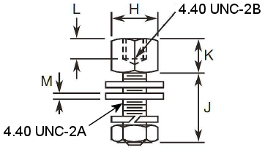
Dimension | Min. | Max. | Notes
G | 6.35  6.12 | 7.11  6.88 | 3  4
H | 4.37 | 5.13 | -
J | 4.4  7.5  14.35  15.49 | 6  8.3  14.65  16.25 | 10  5  6  7
K | 4.6 | 5.1 | -
L | 3.05 | - | -
M | 0.35 | 0.86 | 8

Screw Lock Assembly (Female) (Hybrid 4-40/M3) (Note 2)
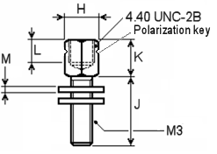
Dimension | Min. | Max. | Notes
G | 6.35  6.12 | 7.11  6.88 | 3  4
H | 4.52 | 4.62 | -
J | 7.8 | 8.04 | 5
K | 4.8 | 4.9 | -
L | 3.18 | - | -
M | 0.78 | 0.82 | 8
NOTES:
            - Variants 01, 06, 48, 53, 58 & 59; to be used with A7N, B7N, C7N & D7N connectors.
            - Variant 96; to be used with A9N, B9N, C9N & D9N and L9 3401/001 connectors
            - For shell sizes E and A.
            - For shell sizes B, C and D.
            - Variants 01, 48 and 96 (standard). To be used with all sizes of shells, P or S, with or without backshell.
            - Variants 06 and 53 (for savers). To be used with all sizes of shells.
            - Variants 58 and 59 (for feedthrough). To be used with all sizes of shells.
            - The spacing between the reference planes of 2 mated connectors shall be adjusted by the use of 3 washers maximum so the spacing is equal to dimension G.
            - Variant 97 shall be identical to Variant 01 with an additional specific washer as follows:
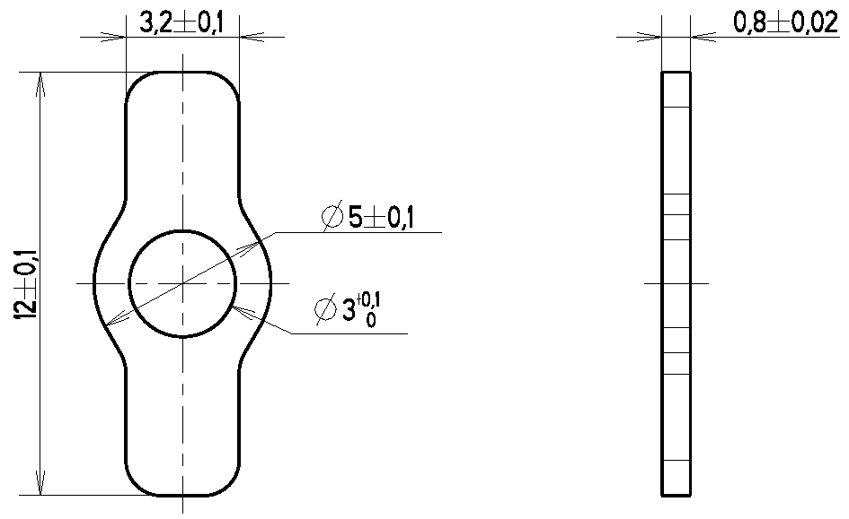
            - Variants 98. To be used with all sizes of shells.

SCREW LOCK ASSEMBLY (male)
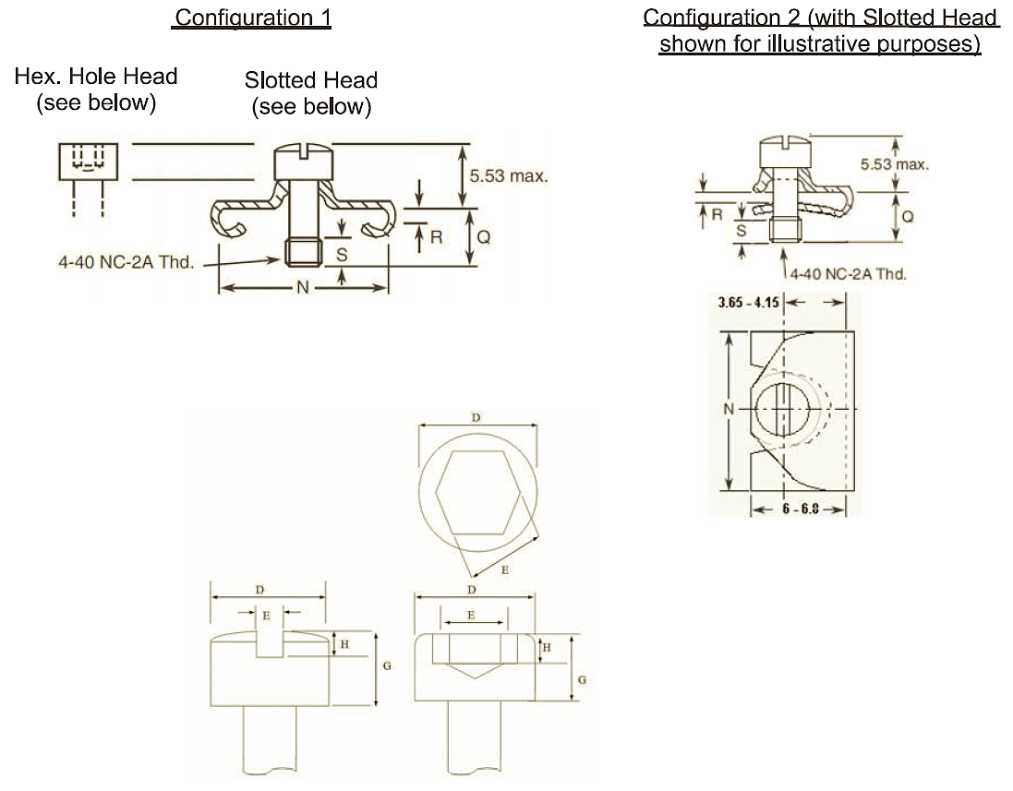
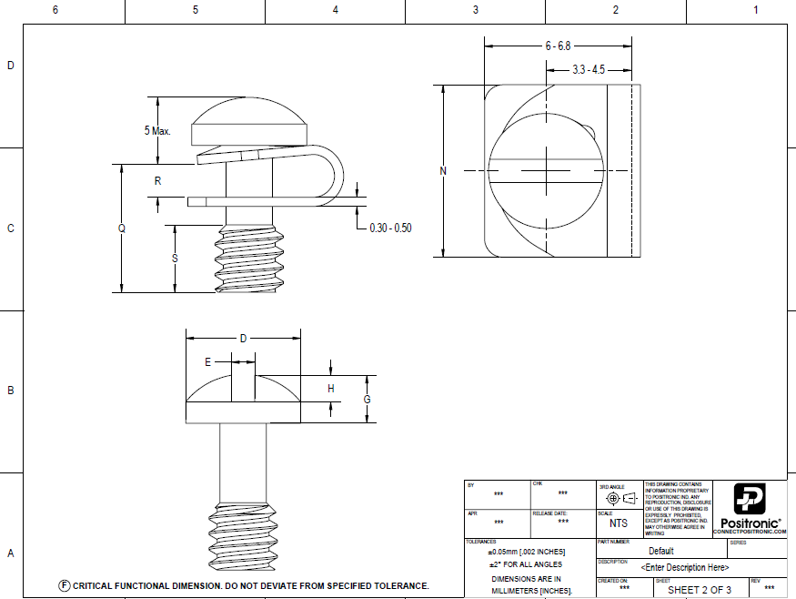
 | D |  | E (Note 1) |  | G |  | H
 | MIN | MAX | MIN | MAX | MIN | MAX | MIN | MAX
Slotted  Head | 3.9 | 4.9 | 0.75 | 1.1 | 1.78 | 2.71 | 0.75 | 1.3
Hex. Hole  Head | 4.32 | 4.6 | 2.02 | 2.08 | 2.36 | 2.9 | 1 | 1.4
NOTES
            - Measured across flats (Hex. Hole Head only).

 | VARIANT |  |  |  | USE WITH SHELL SIZE | N |  | Q |  | R |  | S
 | BRASS |  | S.S. |  | USE WITH SHELL SIZE | MIN. | MAX. | MIN. | MAX. | MIN. | MAX. | MIN.
CONFIGURATION 1 | Slot. | Hex. | Slot. | Hex. | Without Back Shell
CONFIGURATION 1 | 02 | 65 | 49 | 73 | DA DE: (P or S) DB, DC: S | 12.96 | 13.72 | 3.22 | 3.98 | 0.75 | 0.95 | 2.8
CONFIGURATION 1 | 03 | 66 | 50 | 74 | DB DC: P | 12.96 | 13.72 | 3.22 | 3.98 | 0.75 | 0.95 | 2.8
CONFIGURATION 1 | 04 | 67 | 51 | 75 | DD: S | 15.75 | 16.26 | 3.22 | 3.98 | 0.75 | 0.95 | 2.8
CONFIGURATION 1 | 05 | 68 | 52 | 76 | DD: P | 15.75 | 16.26 | 3.22 | 3.98 | 0.75 | 0.95 | 2.8
CONFIGURATION 1 | Slot. | Hex. | Slot. | Hex. | With Back Shell
CONFIGURATION 1 | 44 | 69 | 54 | 77 | DA DE: (P or S) DB, DC: S | 12.96 | 13.72 | 4.02 | 4.78 | 1.75 | 1.95 | 2.8
CONFIGURATION 1 | 45 | 70 | 55 | 78 | DB DC: P | 12.96 | 13.72 | 4.02 | 4.78 | 1.75 | 1.95 | 2.8
CONFIGURATION 1 | 46 | 71 | 56 | 79 | DD: S | 15.75 | 16.26 | 4.02 | 4.78 | 1.75 | 1.95 | 2.8
CONFIGURATION 1 | 47 | 72 | 57 | 80 | DD: P | 15.75 | 16.26 | 4.02 | 4.78 | 1.75 | 1.95 | 2.8
CONFIG. 2 | Slot. | Hex. | Slot. | Hex.
CONFIG. 2 | 86 | 88 | - | - | All Sizes Without Back Shell | 12.17 | 12.93 | 3.22 | 3.98 | 0.7 | 0.9 | 2.8
CONFIG. 2 | 87 | 89 | - | - | All Sizes With Back Shell | 12.17 | 12.93 | 4.02 | 4.78 | 1.3 | 1.5 | 2.8
CONFIG. 2 | 99 | - | - | - | All Sizes Without Back Shell | 7 | 7.4 | 5 | 5.5 | 1 | 1.5 | 2.5
FIGURE 2(b) - DUST CAPS (all dimensions in millimetres)
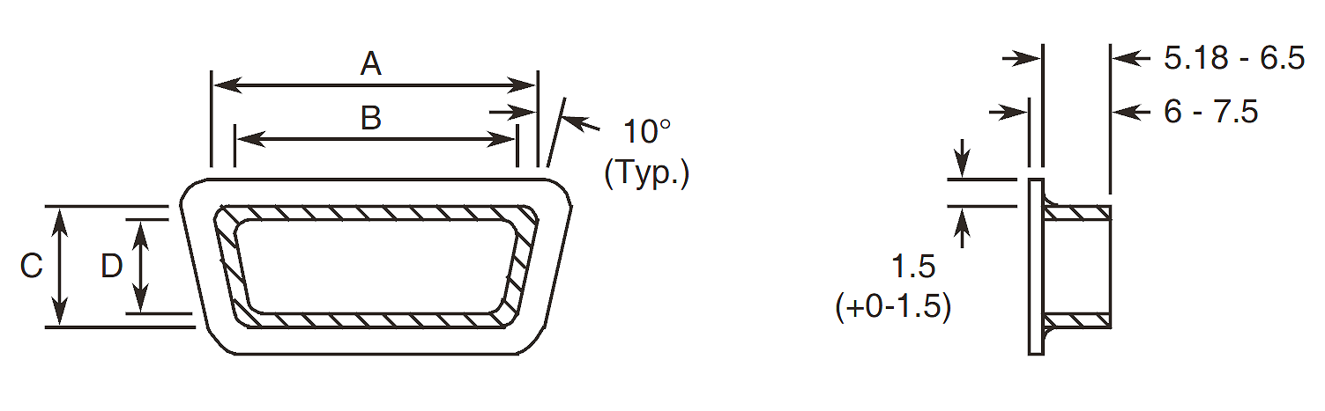
Variant | A |  | B |  | C |  | D
Variant | Min. | Max. | Min. | Max. | Min. | Max. | Min. | Max.
07 | 17.3 | 17.9 | 15.6 | 16.2 | 8.9 | 9.5 | 7.2 | 7.8
08 | 18.7 | 19.3 | 17 | 17.6 | 10.2 | 10.8 | 8.5 | 9.1
09 | 25.7 | 26.3 | 24 | 24.6 | 8.9 | 9.5 | 7.2 | 7.8
10 | 27.1 | 27.7 | 25.4 | 26 | 10.2 | 10.8 | 8.5 | 9.1
11 | 39.4 | 40 | 37.7 | 38.3 | 8.9 | 9.5 | 7.2 | 7.8
12 | 41.2 | 41.8 | 39.5 | 40.1 | 10.2 | 10.8 | 8.9 | 9.6
13 | 55.8 | 56.4 | 54.1 | 54.7 | 8.9 | 9.5 | 7.2 | 7.8
14 | 57.6 | 58.2 | 56 | 56 | 10.2 | 10.8 | 8.9 | 9.6
15 | 53.4 | 54 | 51.7 | 52.3 | 11.7 | 12.3 | 10 | 10.6
16 | 55 | 55.6 | 53.3 | 53.9 | 13.3 | 13.9 | 11.6 | 12.2
84 | 57 | 57.6 | 55.3 | 55.9 | 13.4 | 14 | 11.7 | 12.3
85 | 58.9 | 59.5 | 57.2 | 57.8 | 15.4 | 16 | 13.7 | 14.3

FIGURE 2(c) - POTTING SHELLS (all dimensions in millimetres)
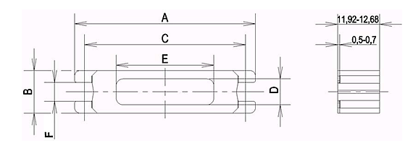
NOTES:
            - Weight: Not applicable because not on board.

Variant | A |  | B |  | C |  | D |  | E |  | F
Variant | Min. | Max. | Min. | Max. | Min. | Max. | Min. | Max. | Min. | Max. | Min. | Max.
81 | 30.32 | 31.08 | 12.32 | 13.08 | 24.74 | 25.24 | 7.1 | 8.1 | 8.48 | 9.52 | 5.5 | 5.7
17 | 38.51 | 39.27 | 12.32 | 13.08 | 33.08 | 33.58 | 7.1 | 8.1 | 14.4 | 15.44 | 5.5 | 5.7
18 | 52.4 | 53.16 | 12.32 | 13.08 | 46.79 | 47.29 | 7.1 | 8.1 | 28 | 29.08 | 5.5 | 5.7
19 | 68.66 | 69.42 | 12.32 | 13.08 | 63.25 | 63.75 | 7.1 | 8.1 | 43.94 | 45 | 5.5 | 5.7
20 | 66.29 | 67.05 | 15.09 | 15.85 | 60.86 | 61.36 | 9.4 | 10.4 | 43.94 | 45 | 5.5 | 5.7
90 | 68.84 | 69.6 | 17.09 | 17.85 | 63.15 | 63.65 | 10.5 | 11.5 | 43.47 | 44.53 | 2.92 | 3.18
FIGURE 2(d) - BACK SHELLS (FOR STRAPPED CONNECTIONS) (all dimensions in millimetres)
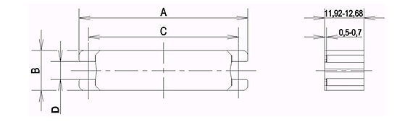
Variant | A |  | B |  | C |  | D
Variant | Min. | Max. | Min. | Max. | Min. | Max. | Min. | Max.
82 | 30.32 | 31.08 | 12.32 | 13.08 | 24.74 | 25.24 | 5.5 | 5.7
21 | 38.51 | 39.27 | 12.32 | 13.08 | 33.08 | 33.58 | 5.5 | 5.7
22 | 52.4 | 53.16 | 12.32 | 13.08 | 46.79 | 47.29 | 5.5 | 5.7
23 | 68.66 | 69.42 | 12.32 | 13.08 | 63.25 | 63.75 | 5.5 | 5.7
24 | 66.29 | 67.05 | 15.09 | 15.85 | 60.86 | 61.36 | 5.5 | 5.7
91 | 68.84 | 69.6 | 17.09 | 17.85 | 63.15 | 63.55 | 2.92 | 3.18
FIGURE 2(e) - CABLE CLAMPS (all dimensions in millimetres)
STRAIGHT CLAMP
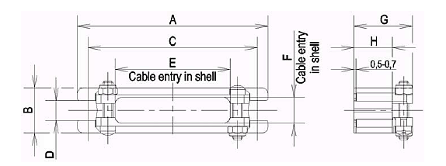
Variant | No. of Cable Locking Screws Required | A |  | B |  | C |  | D |  | E |  | F |  | G |  | H
Variant | No. of Cable Locking Screws Required | Min. | Max. | Min. | Max. | Min. | Max. | Min. | Max. | Min. | Max. | Min. | Max. | Min. | Max. | Min. | Max.
83 | 2 | 30.32 | 31.08 | 12.32 | 13.08 | 24.74 | 25.24 | 5.5 | 5.7 | 10.62 | 11.38 | 7.12 | 7.88 | 15.7 | 16.7 | 10.32 | 11.08
25 | 2 | 38.51 | 39.27 | 12.32 | 13.08 | 33.08 | 33.58 | 5.5 | 5.7 | 18.62 | 19.38 | 7.12 | 7.88 | 15.7 | 16.7 | 10.32 | 11.08
26 | 2 | 52.4 | 53.16 | 12.32 | 13.08 | 46.79 | 47.29 | 5.5 | 5.7 | 31.62 | 32.38 | 7.12 | 7.88 | 15.7 | 16.7 | 10.32 | 11.08
27 | 3 | 68.66 | 69.42 | 12.32 | 13.08 | 63.25 | 63.75 | 5.5 | 5.7 | 47.62 | 48.38 | 7.12 | 7.88 | 15.7 | 16.7 | 10.32 | 11.08
28 | 3 | 66.29 | 67.05 | 15.09 | 15.85 | 60.86 | 61.36 | 5.5 | 5.7 | 45.62 | 46.38 | 9.52 | 10.28 | 17.3 | 18.3 | 11.92 | 12.68
92 | 3 | 68.84 | 69.6 | 17.09 | 18.85 | 63.15 | 63.65 | 2.92 | 3.18 | 43.47 | 44.53 | 10.5 | 11.5 | 32.1 | 33.1 | 24.62 | 25.38
ROUND CLAMP
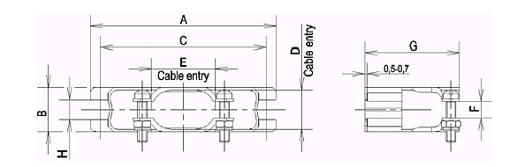
Variant | A |  | B |  | C |  | D |  | E |  | F |  | G |  | H
Variant | Min. | Max. | Min. | Max. | Min. | Max. | Min. | Max. | Min. | Max. | Min. | Max. | Min. | Max. | Min. | Max.
29 | 30.32 | 31.08 | 12.32 | 13.08 | 24.74 | 25.24 | 10.12 | 10.88 | 10.12 | 10.88 | 2.82 | 3.58 | 25.4 | 27 | 5.5 | 5.7
30 | 38.51 | 39.27 | 12.32 | 13.08 | 33.08 | 33.58 | 10.72 | 11.48 | 10.72 | 11.48 | 2.82 | 3.58 | 25.4 | 27 | 5.5 | 5.7
31 | 52.4 | 53.16 | 12.32 | 13.08 | 46.79 | 47.29 | 10.72 | 11.48 | 17.72 | 18.48 | 4.32 | 5.08 | 26.2 | 27.8 | 5.5 | 5.7
32 | 68.66 | 69.42 | 12.32 | 13.08 | 63.25 | 63.75 | 10.72 | 11.48 | 24.72 | 25.48 | 5.92 | 6.73 | 26.2 | 27.8 | 5.5 | 5.7
33 | 66.29 | 67.05 | 15.09 | 15.85 | 60.86 | 61.36 | 13.62 | 14.28 | 26.52 | 27.28 | 7.52 | 8.28 | 26.2 | 27.8 | 5.5 | 5.7
93 | 68.84 | 69.6 | 17.09 | 17.85 | 63.15 | 63.65 | 15.62 | 16.28 | 22.92 | 23.68 | 7.52 | 8.28 | 31.2 | 32.8 | 2.92 | 3.18
DEEP STRAIGHT CLAMP
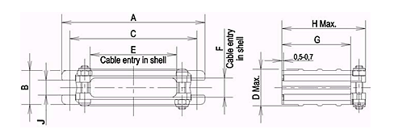
Variant | A |  | B |  | C |  | D | E |  | F |  | G |  | H | J
Variant | Min. | Max. | Min. | Max. | Min. | Max. | Max. | Min. | Max. | Min. | Max. | Min. | Max. | Max. | Min. | Max.
34 | 30.32 | 31.08 | 12.32 | 13.08 | 24.74 | 25.24 | 14.7 | 10.62 | 11.38 | 7.12 | 7.88 | 18.62 | 19.38 | 31.7 | 5.5 | 5.7
35 | 38.51 | 39.27 | 12.32 | 13.08 | 33.08 | 33.58 | 14.7 | 18.62 | 19.38 | 7.12 | 7.88 | 18.62 | 19.38 | 31.7 | 5.5 | 5.7
36 | 52.4 | 53.16 | 12.32 | 13.08 | 46.79 | 47.29 | 14.7 | 31.62 | 32.38 | 7.12 | 7.88 | 25.02 | 25.78 | 39.7 | 5.5 | 5.7
37 | 68.66 | 69.42 | 12.32 | 13.08 | 63.25 | 63.75 | 14.7 | 47.62 | 48.38 | 7.12 | 7.88 | 25.02 | 25.78 | 39.7 | 5.5 | 5.7
38 | 66.29 | 67.05 | 15.09 | 15.85 | 60.86 | 61.36 | 17.4 | 45.62 | 46.38 | 9.52 | 10.28 | 28.22 | 28.98 | 42.9 | 5.5 | 5.7
94 | 68.84 | 69.6 | 17.09 | 17.85 | 63.15 | 63.65 | 19.4 | 43.47 | 44.53 | 10.5 | 11.5 | 36.42 | 37.18 | 53.2 | 2.92 | 3.18
RIGHT ANGLE CLAMP
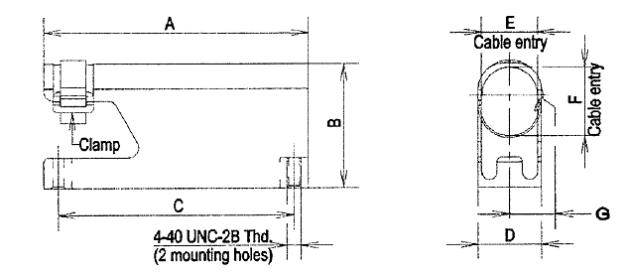
Variant | A |  | B |  | C |  | D |  | E |  | F |  | G
Variant | Min. | Max. | Min. | Max. | Min. | Max. | Min. | Max. | Min. | Max. | Min. | Max. | Max.
39 | 30.32 | 31.08 | 17.4 | 19 | 24.74 | 25.24 | 12.32 | 13.08 | 10.3 | 11.9 | 10.3 | 11.9 | 7.9
40 | 38.51 | 39.27 | 17.4 | 19 | 33.08 | 33.58 | 12.32 | 13.08 | 10.3 | 11.9 | 10.3 | 11.9 | 7.9
41 | 52.4 | 53.16 | 23.8 | 25.4 | 46.79 | 47.29 | 12.32 | 13.08 | 10.3 | 11.9 | 15.1 | 16.7 | 7.9
42 | 68.66 | 69.42 | 29.3 | 30.9 | 63.25 | 63.75 | 12.32 | 13.08 | 10.3 | 11.9 | 19.8 | 21.4 | 7.9
43 | 66.29 | 67.05 | 30.9 | 32.5 | 60.86 | 61.36 | 15.09 | 15.85 | 13.5 | 15.1 | 22.3 | 23.9 | 7.9
95 | 68.84 | 69.6 | 32.2 | 33.8 | 63.15 | 63.65 | 17.09 | 17.85 | 15.5 | 17.1 | 24.3 | 25.9 | 10
60º ANGLED CLAMP
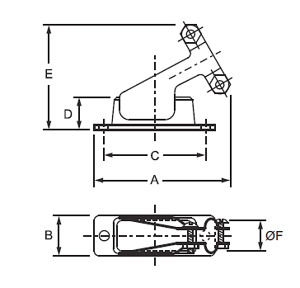
Variant | A |  | B |  | C |  | D |  | E |  | ØF
Variant | Min. | Max. | Min. | Max. | Min. | Max. | Min. | Max. | Min. | Max. | Min. | Max.
60 | 38.75 | 39.25 | 12.45 | 12.95 | 24.74 | 25.24 | 12.05 | 12.55 | 30.35 | 30.85 | 9.75 | 10.25
61 | 42.85 | 43.35 | 12.45 | 12.95 | 32.07 | 32.57 | 12.05 | 12.55 | 32.25 | 32.75 | 9.75 | 10.25
62 | 55.15 | 55.65 | 12.45 | 12.95 | 46.79 | 47.29 | 12.05 | 12.55 | 34.25 | 34.75 | 14.75 | 15.25
63 | 75.05 | 75.55 | 12.45 | 12.95 | 63.25 | 63.75 | 12.05 | 12.55 | 37.25 | 37.75 | 17.75 | 18.25
64 | 72.55 | 73.05 | 15.15 | 15.65 | 60.86 | 61.36 | 12.05 | 12.55 | 37.35 | 37.85 | 19.75 | 20.25

REQUIREMENTS

GENERAL
The complete requirements for procurement of the accessories specified herein are stated in this specification and ESCC Generic Specification No. 3401. Deviations from the Generic Specification, applicable to this specification only, are listed in Para. 4.2.
Deviations from the applicable Generic Specification and this Detail Specification, formally agreed with specific Manufacturers on the basis that the alternative requirements are equivalent to the ESCC requirements and do not affect the components’ reliability, are listed in the appendices attached to this specification.

DEVIATIONS FROM GENERIC SPECIFICATION

Deviations from Special In-Process Controls
          - Para. 5.2.2, Gold Plating Porosity: Not applicable.
          - Para. 5.2.3, Plating Thickness: Not applicable.

Deviations from Final Production Tests (Chart II)
Only the following tests shall be performed:
          - Para. 4.4, Marking.
          - Para. 9.6, Dimension Check.
          - Para. 9.7, External Visual Inspection. The magnification shall be X3.

Deviations from Burn-in and Electrical Measurements (Chart III)
Chart III is not applicable.

Deviations from Qualification Tests (Chart IV)
Not applicable.

Deviations from Lot Acceptance Tests (Chart V)
Not applicable.

MECHANICAL REQUIREMENTS

Dimension Check
The dimensions of the accessories specified herein shall be verified in accordance with the requirements set out in Para. 9.6 of ESCC Generic Specification No. 3401 and shall conform to those shown in Figure 2 of this specification.

Weight
The maximum weight of the accessories specified herein shall be as shown in Table 1(a) of this specification.

Torque Value
The torque value to be used for tightening the screws of the accessories specified herein shall be as mentioned in Table 1(b) of this specification.

MATERIALS AND FINISHES
The materials and finishes shall be as specified herein. Where a definite material is not specified, a material which will enable the components specified herein to meet the performance requirements of this specification shall be used. Acceptance or approval of any constituent material does not guarantee acceptance of the finished product.

Screw Lock Assemblies, Potting Shells, Back Shells, Clamps
Screw lock assemblies (brass), potting shells, back shells and clamps shall be made of brass with gold (0.7μm minimum) over copper (1μm minimum) plating.
Screw lock assemblies (stainless steel) shall be made of passivated stainless steel.

Dust Caps
Material: Red, black or white polyethelene.

Magnetism Level
The allowable value of magnetism shall not exceed that specified for the relevant level (see Para. 4.5.3.1).

MARKING

General
The marking of components delivered to this specification shall be in accordance with the requirements of ESCC Basic Specification No. 21700 and the following paragraphs. When the component is too small to accommodate all of the marking as specified, as much as space permits shall be marked and the marking information, in full, shall accompany the component in its primary package.
The information to be marked and the order of precedence, shall be as follows:
          - The ESCC Component Number.
          - Characteristics.
          - Traceability Information.

The ESCC Component Number
Each component shall bear the ESCC Component Number which shall be constituted and marked as follows:
Example: 340102201B
- Detail Specification Number: 3401022
- Type Variant (See Table 1(a)): 01
- Testing Level: B

Characteristics
The characteristics to be marked in the following order of precedence are:
          - Magnetism Level.

Magnetism Level (For Variants 01 to 06, 17 to 47, 58, 60 to 72, 81 to 83 and 86 to 97)
The following codes shall be used for magnetism level:
Code | Definition
NMA | Magnetism Level: ≤ 2000 gamma
NMB | Magnetism Level: ≤ 200 gamma
NMC | Magnetism Level: ≤ 20 gamma
NMD | Magnetism Level: ≤ 2 gamma

Traceability Information
Traceability information shall be marked in accordance with ESCC Basic Specification No. 21700.

ELECTRICAL MEASUREMENTS (TABLES 2 AND 3)
Not applicable.

BURN-IN AND ELECTRICAL MEASUREMENTS (TABLES 4 AND 5)
Not applicable.

ENVIRONMENTAL AND ENDURANCE TESTS (TABLE 6)
Not applicable.

