

Page 1 of 13
DIODES, MICROWAVE, SILICON, PIN
BASED ON TYPE bXy42
ESCC Detail Specification No. 5513/017

Issue 7 Draft C | July 2020



Document Custodian: European Space Agency – see https://escies.org

Legal Disclaimer and Copyright
European Space Agency, Copyright © 2020. All rights reserved.
The European Space Agency disclaims any liability or responsibility, to any person or entity, with respect to any loss or damage caused, or alleged to be caused, directly or indirectly by the use and application of this ESCC publication.
This publication, without the prior permission of the European Space Agency and provided that it is not used for a commercial purpose, may be:
- copied in whole, in any medium, without alteration or modification.
- copied in part, in any medium, provided that the ESCC document identification, comprising the ESCC symbol, document number and document issue, is removed.

DOCUMENTATION CHANGE NOTICE
(Refer to https://escies.org for ESCC DCR content)
DCR No. | CHANGE DESCRIPTION
TBA | Specification upissued to incorporate changes per DCR.
Draft 7C  S.Thacker  ESCC TW  23/7/2020 | New revision implementing changes proposed by Infineon per their draft spec Draft 7B per email dated 21/07/2020.  Note: Changes from previous published issue 6 are highlighted yellow

TABLE OF CONTENTS
1 General 5
1.1 SCOPE 5
1.2 APPLICABLE DOCUMENTS 5
1.3 TERMS, DEFINITIONS, ABBREVIATIONS, SYMBOLS AND UNITS 5
1.4 THE ESCC COMPONENT NUMBER AND COMPONENT TYPE VARIANTS 5
1.4.1 The ESCC Component Number 5
1.4.2 Component Type Variants 5
1.5 MAXIMUM RATINGS 6
1.6 handling precautions 6
1.7 PHYSICAL DIMENSIONS AND TERMINAL IDENTIFICATION 7
1.7.1 Case Type T1 7
1.7.2 Case Type T 8
1.8 FUNCTIONAL DIAGRAM 8
1.9 MATERIALS AND FINISHES 8
2 REQUIREMENTS 8
2.1 GENERAL 8
2.1.1 Deviations from the Generic Specification 8
2.1.1.1 Deviations from Screening Tests - Chart F3 8
2.1.1.2 Deviations from Qualification and Periodic Tests - Chart F4 9
2.2 MARKING 9
2.3 Die Shear 9
2.4 TERMINAL STRENGTH 9
2.5 ELECTRICAL MEASUREMENTS AT ROOM, HIGH AND LOW TEMPERATURES 9
2.5.1 Room Temperature Electrical Measurements 9
2.5.2 High and Low Temperatures Electrical Measurements 10
2.6 PARAMETER DRIFT VALUES 10
2.7 INTERMEDIATE AND END-POINT ELECTRICAL MEASUREMENTS 11
2.8 BURN-IN 1 CONDITIONS 11
2.9 BURN-IN 2 CONDITIONS 11
2.10 OPERATING LIFE CONDITIONS 11
2.11 TOTAL DOSE RADIATION TESTING 12
2.11.1 Bias Conditions and Total Dose Level for Total Dose Radiation Testing 12
2.11.2 Electrical Measurements for Total Dose Radiation Testing 12
APPENDIX A 13

General

SCOPE
This specification details the ratings, physical and electrical characteristics and test and inspection data for the component type variants and/or the range of components specified below. It supplements the requirements of, and shall be read in conjunction with, the ESCC Generic Specification listed under Applicable Documents.

APPLICABLE DOCUMENTS
The following documents form part of this specification and shall be read in conjunction with it:
          - ESCC Generic Specification No. 5010
          - MIL-STD-750, Test Methods and Procedures for Semiconductor Devices

TERMS, DEFINITIONS, ABBREVIATIONS, SYMBOLS AND UNITS
For the purpose of this specification, the terms, definitions, abbreviations, symbols and units specified in ESCC Basic Specification No. 21300 shall apply.

THE ESCC COMPONENT NUMBER AND COMPONENT TYPE VARIANTS

The ESCC Component Number
The ESCC Component Number shall be constituted as follows:
Example: 551301701R
- Detail Specification Reference: 5513017
- Component Type Variant Number: 01 (as required)
- Total Dose Radiation Level Letter: R (as required)

Component Type Variants
The component type variants applicable to this specification are as follows:
Variant Number | Based on Type | Total Capacitance  C_{T} (pF) | Case | Terminal Material and Finish | Weight  max g | Total Dose Radiation Level Letter
01 | BXY42 | See Para. 2.5.1 | T1 | E2 | 0.02 | R [100krad(Si)]
02 | BXY42 | See Para. 2.5.1 | T | D2 | 0.02 | R [100krad(Si)]
03 | BXY42 | See Para. 2.5.1 | T1 | E2 | 0.02 | R [100krad(Si)]
04 | BXY42 | See Para. 2.5.1 | T | D2 | 0.02 | R [100krad(Si)]
The terminal material and finish shall be in accordance with the requirements of ESCC Basic Specification No. 23500.
The total dose radiation level letter shall be as defined in ESCC Basic Specification No. 22900. If an alternative radiation test level is specified in the Purchase Order the letter shall be changed accordingly.

MAXIMUM RATINGS
The maximum ratings shall not be exceeded at any time during use or storage.
Maximum ratings shall only be exceeded during testing to the extent specified in this specification and when stipulated in Test Methods and Procedures of the ESCC Generic Specification.
Characteristics | Symbols | Maximum Ratings | Units | Remarks
DC Reverse Voltage | V_{R} | -50 | V
Peak Forward Current (Pulsed) | I_{FM} | 5 | A | Note 1
Power Dissipation  Variants 01, 03  Variants 02, 04 | P_{D} | 350  600 | mW | T_{case} ≤ +52.5°C  T_{case} ≤ +55°C Note 2
Operating Temperature Range | T_{op} | -55 to +175 | °C | T_{case}
Storage Temperature Range | T_{stg} | -65 to +175 | °C
Soldering Temperature | T_{sol} | +250 | °C | Note 3
Junction Temperature | T_{j} | +175 | °C
Thermal Resistance,  Junction-to-Case  Variants 01, 03  Variants 02, 04 | R_{th(j-c)} | 350  200 | °C/W
NOTES:
            - Pulse duration = 1µs, duty cycle = 0.001%.
            - For T_{case} greater than specified, derate linearly to 0W at T_{case} = +175°C.
            - Duration 5 seconds maximum and the same termination shall not be resoldered until 5 minutes have elapsed.

handling precautions
These devices are susceptible to damage by electrostatic discharge. Therefore suitable precautions shall be employed for protection during all phases of manufacture test, packaging, shipping and handling.
These components are categorised as Class 1 per ESCC Basic Specification No. 23800 with a Minimum Critical Path Failure Voltage of 250V.

PHYSICAL DIMENSIONS AND TERMINAL IDENTIFICATION

Case Type T1
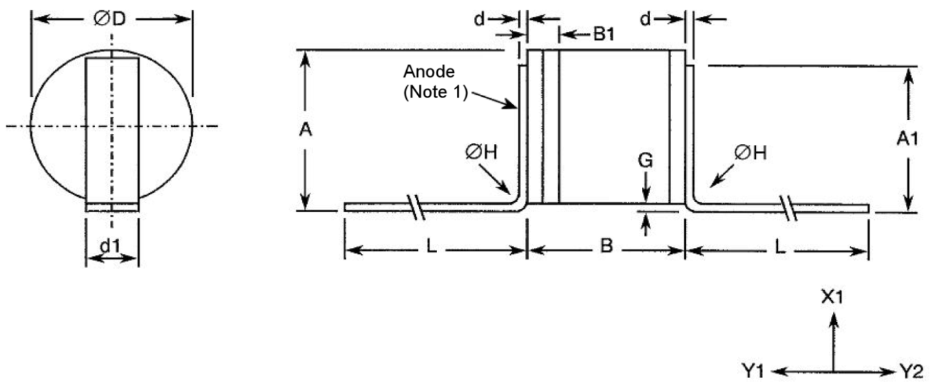
Symbols | Dimensions mm |  | Notes
Symbols | Min | Max | Notes
A | 1.4 | 1.95
A1 | 1.05 | 1.25
B | 1.15 | 1.35
B1 | - | 0.4 | 1
d | 0.06 | 0.1
d1 | 0.4 | 0.6
ØD | 1.3 | 1.45
G | 0.1 | 0.5
ØH | - | 0.3
L | 5.5 | -
NOTES:
            - The anode terminal is identified by the sealing ring and lid (dimension B1).
    - Case Type T
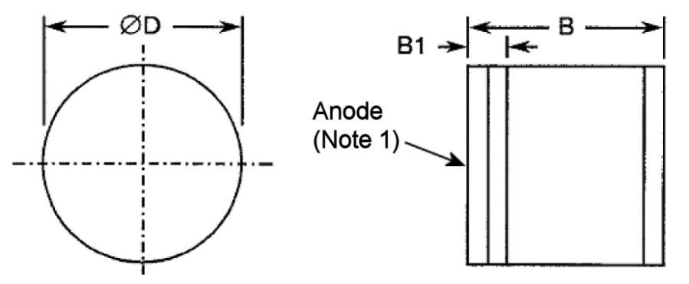
Symbols | Dimensions mm |  | Notes
Symbols | Min | Max | Notes
B | 1.15 | 1.35
B1 | - | 0.4 | 1
ØD | 1.3 | 1.45
notes:
            - The anode terminal is identified by the sealing ring and lid (dimension B1).

FUNCTIONAL DIAGRAM
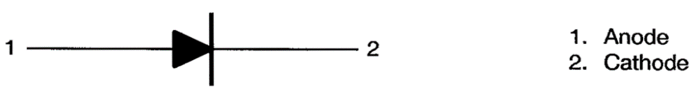

MATERIALS AND FINISHES
Materials and finishes shall be as follows:
          - Case
The case shall be hermetically sealed, have a ceramic body and a metal sealing ring and lid.
          - Terminals
As specified in Para. 1.4.2 Component Type Variants.

REQUIREMENTS

GENERAL
The complete requirements for procurement of the components specified herein are as stated in this specification and the ESCC Generic Specification. Permitted deviations from the Generic Specification, applicable to this specification only, are listed below.
Permitted deviations from the Generic Specification and this Detail Specification, formally agreed with specific Manufacturers on the basis that the alternative requirements are equivalent to the ESCC requirement and do not affect the component’s reliability, are listed in the appendices attached to this specification.

Deviations from the Generic Specification

Deviations from Screening Tests - Chart F3
          - Radiographic Inspection: shall be performed in the X and Z axes only.

Deviations from Qualification and Periodic Tests - Chart F4
          - Mechanical Shock: Not applicable.
          - Vibration: Not applicable.
          - Constant Acceleration: Not applicable.

MARKING
The marking shall be in accordance with the requirements of ESCC Basic Specification No. 21700. The information to be marked and the order of precedence shall be as follows:
          - The ESCC qualified components symbol (for ESCC qualified components only).
          - The ESCC Component Number (see Para. 1.4.1).
          - Traceability information.

Die Shear
In those cases where package clearances are such that a die shear test is not practicable, the die shall be pushed away with a suitable tool. The force required to remove the die need not be recorded. The die attachment area shall be inspected and the component shall be considered acceptable if more than 50% of the semiconductor material remains.

TERMINAL STRENGTH
The test conditions for Terminal Strength, tested as specified in the ESCC Generic Specification, shall be as follows:
- Variant 01: Test Condition A, tension, with a force of 1.5N and a duration of 5s.

ELECTRICAL MEASUREMENTS AT ROOM, HIGH AND LOW TEMPERATURES

Room Temperature Electrical Measurements
The measurements shall be performed at T_{amb} = +25 ±3°C.
Characteristics | Symbols | MIL-STD-750 Test Method | Test Conditions | Limits |  | Units
 |  |  |  | Min | Max | Units
Reverse Current 1 | I_{R1} | 4016 | V_{R} = -50V | - | 10 | µA
Reverse Current 2 | I_{R2} | 4016 | V_{R} = -40V | - | 5 | nA
Forward Voltage | V_{F} | 4011 | I_{F} = 100mA | - | 1.1 | V
Total Capacitance | C_{T} | 4001 | V_{R} = -20V, f = 1MHz  Variants 01, 02  Variants 03, 04 | -  - | 0.24  0.28 | pF
Forward Resistance 1 | R_{F1} | 4056 | f = 100MHz, I_{F1} = 1mA | - | 3.5 | Ω
Forward Resistance 2 | R_{F2} | 4056 | f = 100MHz, I_{F2} = 10mA | - | 2.5 | Ω
Minority Carrier  Lifetime | τ_{L} | - | I_{F} = 10mA, I_{R} = -6mA  Note 1 | 35 | - | ns
NOTES:
            - Pulsed measurement, duration = 1µs, duty cycle ≤ 33%. The input pulse shall be provided by a suitable pulse generator with t_{r} ≤ 5ns.
τ_{L} is measured across the 50% I_{R} points of the output waveform.

High and Low Temperatures Electrical Measurements
The measurements shall be performed only at T_{amb} = +125 (+0 -5)°C.
Characteristics | Symbols | MIL-STD-750 Test Method | Test Conditions  (Note 1) | Limits |  | Units
 |  |  |  | Min | Max | Units
Reverse Current 2 | I_{R2} | 4016 | V_{R} = -40V | - | 100 | nA
NOTES:
            - Measurements shall be performed on a sample of 5 components. In the event of any failure, a 100% inspection shall be performed.

PARAMETER DRIFT VALUES
Unless otherwise specified, the measurements shall be performed at T_{amb} = +25 ±3°C.
The test methods and test conditions shall be as per the corresponding test defined in Para. 2.5.1 Room Temperature Electrical Measurements.
The drift values (Δ) shall not be exceeded for each characteristic specified. The corresponding absolute limit values for each characteristic shall not be exceeded.
Characteristics | Symbols | Limits |  |  | Units
Characteristics | Symbols | Drift  Value (1)  Δ | Absolute |  | Units
Characteristics | Symbols | Drift  Value (1)  Δ | Min | Max | Units
Reverse Current 2 | I_{R2} | ±3 | - | 5 | nA
Forward Voltage | V_{F} | ±20  or (2)  ±5% | - | 1.1 | mV
Forward Resistance 1 | R_{F1} | ±15% | - | 3.5 | Ω
NOTES:
            - Δ1 = Δ2.
            - Whichever is the greater.

INTERMEDIATE AND END-POINT ELECTRICAL MEASUREMENTS
Unless otherwise specified, the measurements shall be performed at T_{amb} = +25 ±3°C.
The test methods and test conditions shall be as per the corresponding test defined in Para. 2.5.1 Room Temperature Electrical Measurements.
The limit values for each characteristic shall not be exceeded.
Characteristics | Symbols | Limits |  | Units
Characteristics | Symbols | Min | Max | Units
Reverse Current 1 | I_{R1} | - | 10 | µA
Reverse Current 2 | I_{R2} | - | 5 | nA
Forward Voltage | V_{F} | - | 1.1 | V
Total Capacitance  Variants 01, 02  Variants 03, 04 | C_{T} | -  - | 0.24  0.28 | pF
Forward Resistance 1 | R_{F1} | - | 3.5 | Ω
Forward Resistance 2 | R_{F2} | - | 2.5 | Ω

BURN-IN 1 CONDITIONS
Characteristics | Symbols | Test Conditions | Units
Ambient Temperature | T_{amb} | +150 (+0 -5) | °C
Reverse Voltage | V_{R} | -40 (Note 1) | V
NOTES:
            - After the burn-in period, the components shall be allowed to cool until T_{amb} = +25 ±3°C; the V_{R} bias shall be maintained until T_{amb} < +35°C.

BURN-IN 2 CONDITIONS
Characteristics | Symbols | Test Conditions  (Note 1) | Units
Junction Temperature | T_{j} | +175 (+0 -3) | °C
Power Dissipation | P_{D} | ≤ P_{D} given in Para. 1.5 Maximum Ratings | mW
notes:
            - T_{case} shall be adjusted to attain the specified T_{j}.

OPERATING LIFE CONDITIONS
The conditions shall be as specified in Para. 2.9 for Burn-in 2.
  - TOTAL DOSE RADIATION TESTING
    - Bias Conditions and Total Dose Level for Total Dose Radiation Testing
Continuous bias shall be applied during irradiation testing as specified below:
- Ambient Temperature: +25 ±3°C
- Reverse Voltage: -10V
The total dose level applied shall be as specified in Para. 1.4.2 Component Type Variants or in the Purchase Order.
    - Electrical Measurements for Total Dose Radiation Testing
Prior to irradiation testing, the devices shall have successfully met Para. 2.5.1 Room Temperature Electrical Measurements.
Unless otherwise stated the measurements shall be performed at T_{amb} = +25 ±3°C.
The test methods and test conditions shall be as per the corresponding test defined in Para. 2.5.1 Room Temperature Electrical Measurements.
The parameters to be measured during and on completion of irradiation testing are shown below.
Characteristics | Symbols | Limits |  |  | Units
Characteristics | Symbols | Drift  Value  Δ | Absolute |  | Units
Characteristics | Symbols | Drift  Value  Δ | Min | Max | Units
Reverse Current 1 | I_{R1} | ±1 | - | 10 | µA
Forward Resistance 1 | R_{F1} | ±50% | - | 3.5 | Ω

APPENDIX A
AGREED DEVIATIONS FOR INFINEON Technologies AG (D)
Items Affected | Description of Deviations
Para. 1.4.2 Component Type Variants | The following note applies:  Variants 01 and 02 originate from a 3 inch wafer process.  Variants 03 and 04 originate from a 6 inch wafer process.
Para. 2.1.1 Deviations from Generic Specification:  Special In-Process Controls - Chart F2 | Bond Strength: The following pre-seal bond strength shall apply:  - 0.05N minimum
 | Dimension Check: May be performed during Chart F3 testing.
Para. 2.1.1 Deviations from Generic Specification:  Final Customer Source Inspection | Final Customer Source Inspection shall be limited to witnessing of the DC parameters specified in Para. 2.5.1 Room Temperature Electrical Measurements.
Para. 2.1.1 Deviations from Generic Specification:  Data Documentation | Additional Documentation and Wafer Lot Acceptance Data:  If Wafer Lot Acceptance Data is stipulated in the Purchase Order, such data will not be delivered but will be available for review at lnfineon Technologies AG.
Para. 2.1.1.1 Deviations from  Screening Tests - Chart F3 | Temperature Cycling: Shall be replaced by a Thermal Shock test in accordance with MIL-STD-202, Test Method 107, Test Condition B, 20 cycles.
Para. 2.1.1.2 Deviations from Qualification and Periodic Tests - Chart F4 | Temperature Cycling: Shall be replaced by a Thermal Shock test in accordance with MIL-STD-202, Test Method 107, Test Condition B, 100 cycles.
Assembly Capability Subgroup tests:
In addition to the permitted use of empty packages or electrical rejects as test samples, components rejected during the following Screening Tests:
- Radiographic Inspection
- Seal
- External Visual Inspection
may be used on the condition that the cause for rejection has no possible impact on the tests, and they have been subjected to the same screening as the packages of the assembly lot with which they are associated.
Bond Strength: The following post-seal bond strength shall apply:
- 0.04N minimum

