

Page 1 of 31

CAPACITORS, FIXED, SELF-HEALING, NON-INDUCTIVE, POLYETHYLENE TEREPHTALATE DIELECTRIC
BASED ON TYPE PM907S
ESCC Detail Specification No. 3006/025
Issue 3 Draft A | July 2020



Document Custodian: European Space Agency – see https://escies.org

LEGAL DISCLAIMER AND COPYRIGHT
European Space Agency, Copyright © 2020. All rights reserved.
The European Space Agency disclaims any liability or responsibility, to any person or entity, with respect to any loss or damage caused, or alleged to be caused, directly or indirectly by the use and application of this ESCC publication.
This publication, without the prior permission of the European Space Agency and provided that it is not used for a commercial purpose, may be:
- copied in whole, in any medium, without alteration or modification.
- copied in part, in any medium, provided that the ESCC document identification, comprising the ESCC symbol, document number and document issue, is removed.

DOCUMENTATION CHANGE NOTICE
(Refer to https://escies.org for ESCC DCR content)
DCR No. | CHANGE DESCRIPTION
TBA | Specification updated to incorporate changes per DCR.

TABLE OF CONTENTS

1 GENERAL 5
1.1 SCOPE 5
1.2 APPLICABLE DOCUMENTS 5
1.3 TERMS, DEFINITIONS, ABBREVIATIONS, SYMBOLS AND UNITS 5
1.4 THE ESCC COMPONENT NUMBER AND Component Type Variants 5
1.4.1 The ESCC Component Number 5
1.4.1.1 Characteristics and Ratings Codes 5
1.4.2 Component Type Variants and Range of Components 6
1.5 MAXIMUM RATINGS 20
1.6 PHYSICAL DIMENSIONS and terminal identification 21
1.6.1 Component Type Variants 01 to 08 (PM907S) 21
1.6.2 Component Type Variants 09 to 16 (PM907SR1) 22
1.6.3 Component Type Variants 17 to 24 (PM907SR2) 23
1.6.4 Component Type Variants 25 to 29 (PM907NS with 2 Rows of 7 Terminals) 24
1.6.5 Component Type Variants 30 to 32 (PM907NS with 2 Rows of 11 Terminals) 25
1.7 FUNCTIONAL DIAGRAM 25
1.8 MATERIALS AND FINISHES 26
1.8.1 Lead/Terminal Material 26
1.8.2 Lead/Terminal Finish 26
2 REQUIREMENTS 26
2.1 GENERAL 26
2.1.1 Deviations from the Generic Specification 26
2.1.1.1 Deviations from Qualification and Periodic Tests – Chart F4 26
2.2 MARKING 26
2.3 Robustness of terminations 27
2.4 ELECTRICAL MEASUREMENTS AT ROOM, HIGH AND LOW TEMPERATURES 27
2.4.1 Room Temperature Electrical Measurements 27
2.4.2 High and Low Temperatures Electrical Measurements 28
2.5 INTERMEDIATE AND END-POINT ELECTRICAL MEASUREMENTS 28
2.6 BURN-IN conditions 30
APPENDIX ‘A’ 31

GENERAL

SCOPE
This specification details the ratings, physical and electrical characteristics, and test and inspection data for the component type variants and/or the Component Type Variants and Range of Components specified below. It supplements the requirements of, and shall be read in conjunction with, the ESCC Generic Specification listed under Applicable Documents.

APPLICABLE DOCUMENTS
The following documents form part of this specification and shall be read in conjunction with it:
          - ESCC Generic Specification No. 3006.

TERMS, DEFINITIONS, ABBREVIATIONS, SYMBOLS AND UNITS
For the purpose of this specification, the terms, definitions, abbreviations, symbols and units specified in ESCC Basic Specification No. 21300 shall apply.

THE ESCC COMPONENT NUMBER AND Component Type Variants

The ESCC Component Number
The ESCC Component Number shall be constituted as follows:
Example: 300602501155KH
- Detail Specification Reference: 3006025
- Component Type Variant Number: 01 (as required)
- Characteristic code: Capacitance Value (1.5µF): 155 (as required)
- Characteristic code: Capacitance Tolerance (±10%): K (as required)
- Rating code: Rated Voltage (250V): H (as required)

Characteristics and Ratings Codes
Characteristics and ratings to be codified as part of the ESCC Component Number shall be as follows:
          - Capacitance Value, C, expressed by means of the following codes in accordance with ESCC Basic Specification No. 21700. The unit quantity shall be picofarads (pF).
Capacitance Value C  (pF) | Code
XX 10³ | XX3
XX 10⁴ | XX4
XX 10⁵ | XX5
XX 10⁶ | XX6
XX 10⁷ | XX7
          - Capacitance Tolerance expressed by the following codes in accordance with ESCC Basic Specification No. 21700:
Tolerance  (± %) | Code Letter
10 | K
20 | M
          - DC Rated Voltage, U_{R}, expressed by the following codes:
DC Rated Voltage U_{R}  (V) | Code Letter
50 | C
63 | D
100 | E
170 | F
200 | G
250 | H
400 | K
500 | L
630 | Z
800 | P
1000 | Q
1250 | R

Component Type Variants and Range of Components
The Component Type Variants and Range of Components applicable to this specification are as follows:
Type Variants  (Notes 1, 2) | Capacitance Value  C  (µF) | Capacitance Tolerance  (± %) | DC Rated Voltage  (U_{R})  (V)  (Note 2) | AC Current  (I_{RA})  (Arms)  Max | Weight Max  (g)
01 | 15 | 10, 20 | 50 | 5.2 | 4.9
01 | 8.2 | 10 | 63 | 3.2 | 4.9
01 | 10 | 10, 20 | 63 | 4 | 4.9
01 | 12 | 10 | 63 | 5 | 4.9
01 | 4.7 | 10, 20 | 100 | 2.5 | 4.9
01 | 5.6 | 10 | 100 | 3.2 | 4.9
01 | 6.8 | 10, 20 | 100 | 4.3 | 4.9
01 | 8.2 | 10 | 100 | 5.2 | 4.9
01 | 3.3 | 10, 20 | 170 | 2 | 4.9
01 | 3.9 | 10 | 170 | 2.5 | 4.9
01 | 4.7 | 10, 20 | 170 | 3.1 | 4.9
01 | 2.2 | 10, 20 | 200 | 2 | 4.9
01 | 2.7 | 10 | 200 | 2.4 | 4.9
01 | 3.3 | 10, 20 | 200 | 2.8 | 4.9
01 | 1.5 | 10, 20 | 250 | 1.5 | 4.9
01 | 2.2 | 10, 20 | 250 | 2.2 | 4.9
01 | 2.7 | 10 | 250 | 2.4 | 4.9
01 | 0.82 | 10 | 400 | 2.5 | 4.9
01 | 1 | 10, 20 | 400 | 3.1 | 4.9
01 | 0.39 | 10 | 500 | 1.1 | 4.9
01 | 0.47 | 10, 20 | 500 | 1.3 | 4.9
01 | 0.56 | 10 | 500 | 1.5 | 4.9
01 | 0.68 | 10, 20 | 500 | 1.9 | 4.9
01 | 0.22 | 10, 20 | 630 | 0.8 | 4.9
01 | 0.27 | 10 | 630 | 0.9 | 4.9
01 | 0.33 | 10, 20 | 630 | 1.1 | 4.9
01 | 0.39 | 10 | 630 | 1.3 | 4.9
01 | 0.22 | 10, 20 | 800 | 0.9 | 4.9
02 | 18 | 10 | 50 | 6.2 | 6
02 | 22 | 10, 20 | 50 | 7.6 | 6
02 | 15 | 10, 20 | 63 | 6.3 | 6
02 | 10 | 10, 20 | 100 | 6.4 | 6
02 | 5.6 | 10 | 170 | 4 | 6
02 | 6.8 | 10, 20 | 170 | 5 | 6
02 | 3.9 | 10 | 200 | 3.5 | 6
02 | 4.7 | 10, 20 | 200 | 4 | 6
02 | 3.3 | 10, 20 | 250 | 2.6 | 6
02 | 1.2 | 10 | 400 | 3.2 | 6
02 | 1.5 | 10, 20 | 400 | 4 | 6
02 | 0.82 | 10 | 500 | 2.3 | 6
02 | 1 | 10, 20 | 500 | 2.8 | 6
02 | 0.47 | 10, 20 | 630 | 1.6 | 6
02 | 0.56 | 10 | 630 | 2 | 6
02 | 0.27 | 10 | 800 | 1.1 | 6
02 | 0.33 | 10, 20 | 800 | 1.4 | 6
02 | 0.15 | 10, 20 | 1000 | 0.8 | 6
02 | 0.22 | 10, 20 | 1000 | 1.1 | 6
02 | 0.082 | 10 | 1250 | 0.5 | 6
02 | 0.1 | 10, 20 | 1250 | 0.7 | 6
03 | 27 | 10 | 50 | 9.4 | 9.5
03 | 33 | 10, 20 | 50 | 11.5 | 9.5
03 | 18 | 10 | 63 | 7.6 | 9.5
03 | 22 | 10, 20 | 63 | 8 | 9.5
03 | 12 | 10 | 100 | 6.4 | 9.5
03 | 15 | 10, 20 | 100 | 8 | 9.5
03 | 18 | 10 | 100 | 8 | 9.5
03 | 22 | 10, 20 | 100 | 8 | 9.5
03 | 8.2 | 10 | 170 | 6 | 9.5
03 | 10 | 10, 20 | 170 | 7.3 | 9.5
03 | 5.6 | 10 | 200 | 5 | 9.5
03 | 6.8 | 10, 20 | 200 | 6 | 9.5
03 | 8.2 | 10 | 200 | 7 | 9.5
03 | 3.9 | 10 | 250 | 3.1 | 9.5
03 | 4.7 | 10, 20 | 250 | 3.7 | 9.5
03 | 5.6 | 10 | 250 | 4.4 | 9.5
03 | 1.8 | 10 | 400 | 4 | 9.5
03 | 2.2 | 10, 20 | 400 | 4.5 | 9.5
03 | 2.7 | 10 | 400 | 5 | 9.5
03 | 1.2 | 10 | 500 | 3.3 | 9.5
03 | 1.5 | 10, 20 | 500 | 4.2 | 9.5
03 | 0.68 | 10, 20 | 630 | 2.5 | 9.5
03 | 0.82 | 10 | 630 | 3 | 9.5
03 | 1 | 10, 20 | 630 | 3.2 | 9.5
03 | 0.39 | 10 | 800 | 1.6 | 9.5
03 | 0.47 | 10, 20 | 800 | 1.9 | 9.5
03 | 0.56 | 10 | 800 | 2.3 | 9.5
03 | 0.68 | 10, 20 | 800 | 2.8 | 9.5
03 | 0.27 | 10 | 1000 | 1.4 | 9.5
03 | 0.33 | 10, 20 | 1000 | 1.7 | 9.5
03 | 0.39 | 10 | 1000 | 3 | 9.5
03 | 0.12 | 10 | 1250 | 0.8 | 9.5
03 | 0.15 | 10, 20 | 1250 | 1 | 9.5
03 | 0.18 | 10 | 1250 | 1.2 | 9.5
03 | 0.22 | 10, 20 | 1250 | 1.5 | 9.5
04 | 47 | 10, 20 | 50 | 12.5 | 13.6
04 | 56 | 10 | 50 | 12.5 | 13.6
04 | 68 | 10, 20 | 50 | 12.5 | 13.6
04 | 27 | 10 | 63 | 10 | 13.6
04 | 33 | 10, 20 | 63 | 10 | 13.6
04 | 39 | 10 | 63 | 11.8 | 13.6
04 | 27 | 10 | 100 | 10 | 13.6
04 | 33 | 10, 20 | 100 | 10 | 13.6
04 | 12 | 10 | 170 | 8 | 13.6
04 | 15 | 10, 20 | 170 | 10 | 13.6
04 | 18 | 10 | 170 | 10 | 13.6
04 | 10 | 10, 20 | 200 | 7.5 | 13.6
04 | 12 | 10 | 200 | 9.5 | 13.6
04 | 6.8 | 10, 20 | 250 | 5.4 | 13.6
04 | 8.2 | 10 | 250 | 6.5 | 13.6
04 | 10 | 10, 20 | 250 | 7.9 | 13.6
04 | 3.3 | 10, 20 | 400 | 5 | 13.6
04 | 3.9 | 10 | 400 | 5.9 | 13.6
04 | 4.7 | 10, 20 | 400 | 7.1 | 13.6
04 | 1.8 | 10 | 500 | 5 | 13.6
04 | 2.2 | 10, 20 | 500 | 6.3 | 13.6
04 | 2.7 | 10 | 500 | 6.3 | 13.6
04 | 1.2 | 10 | 630 | 3.9 | 13.6
04 | 1.5 | 10, 20 | 630 | 5 | 13.6
04 | 1.8 | 10 | 630 | 5.8 | 13.6
04 | 0.82 | 10 | 800 | 3.4 | 13.6
04 | 1 | 10, 20 | 800 | 4.1 | 13.6
04 | 0.47 | 10, 20 | 1000 | 2.5 | 13.6
04 | 0.56 | 10 | 1000 | 2.9 | 13.6
04 | 0.68 | 10, 20 | 1000 | 3.4 | 13.6
04 | 0.27 | 10 | 1250 | 1.8 | 13.6
04 | 0.33 | 10, 20 | 1250 | 2.2 | 13.6
04 | 0.39 | 10 | 1250 | 2.6 | 13.6
05 | 82 | 10 | 50 | 12.5 | 20.4
05 | 100 | 10, 20 | 50 | 12.5 | 20.4
05 | 47 | 10, 20 | 63 | 12.5 | 20.4
05 | 56 | 10 | 63 | 12.5 | 20.4
05 | 39 | 10 | 100 | 12.5 | 20.4
05 | 47 | 10, 20 | 100 | 12.5 | 20.4
05 | 22 | 10, 20 | 170 | 10 | 20.4
05 | 27 | 10 | 170 | 12.5 | 20.4
05 | 33 | 10, 20 | 170 | 12.5 | 20.4
05 | 15 | 10, 20 | 200 | 10 | 20.4
05 | 18 | 10 | 200 | 12.5 | 20.4
05 | 22 | 10, 20 | 200 | 12.5 | 20.4
05 | 12 | 10 | 250 | 9.5 | 20.4
05 | 15 | 10, 20 | 250 | 11.9 | 20.4
05 | 18 | 10 | 250 | 12.5 | 20.4
05 | 5.6 | 10 | 400 | 7.9 | 20.4
05 | 6.8 | 10, 20 | 400 | 9.6 | 20.4
05 | 8.2 | 10 | 400 | 11.5 | 20.4
05 | 3.3 | 10, 20 | 500 | 6.3 | 20.4
05 | 3.9 | 10 | 500 | 8 | 20.4
05 | 4.7 | 10, 20 | 500 | 8 | 20.4
05 | 2.2 | 10, 20 | 630 | 7.2 | 20.4
05 | 2.7 | 10 | 630 | 8.8 | 20.4
05 | 3.3 | 10, 20 | 630 | 10.8 | 20.4
05 | 1.2 | 10 | 800 | 5 | 20.4
05 | 1.5 | 10, 20 | 800 | 6.2 | 20.4
05 | 0.82 | 10 | 1000 | 4.3 | 20.4
05 | 1 | 10, 20 | 1000 | 5.2 | 20.4
05 | 0.47 | 10, 20 | 1250 | 3.1 | 20.4
05 | 0.56 | 10 | 1250 | 3.7 | 20.4
06 | 39 | 10 | 63 | 8.5 | 21.2
06 | 47 | 10, 20 | 63 | 10.3 | 21.2
06 | 56 | 10 | 63 | 12.2 | 21.2
06 | 33 | 10, 20 | 100 | 9.1 | 21.2
06 | 39 | 10 | 100 | 10.7 | 21.2
06 | 47 | 10, 20 | 100 | 13 | 21.2
06 | 22 | 10, 20 | 170 | 7.7 | 21.2
06 | 27 | 10 | 170 | 9.5 | 21.2
06 | 33 | 10, 20 | 170 | 11.4 | 21.2
06 | 15 | 10, 20 | 200 | 7.1 | 21.2
06 | 18 | 10 | 200 | 8.9 | 21.2
06 | 22 | 10, 20 | 200 | 10.1 | 21.2
06 | 12 | 10 | 250 | 5.4 | 21.2
06 | 15 | 10, 20 | 250 | 6.7 | 21.2
06 | 18 | 10 | 250 | 8.1 | 21.2
06 | 5.6 | 10 | 400 | 6.3 | 21.2
06 | 6.8 | 10, 20 | 400 | 7.6 | 21.2
06 | 8.2 | 10 | 400 | 9.2 | 21.2
06 | 3.3 | 10, 20 | 500 | 4.5 | 21.2
06 | 3.9 | 10 | 500 | 5.3 | 21.2
06 | 4.7 | 10, 20 | 500 | 6.4 | 21.2
06 | 2.2 | 10, 20 | 630 | 3.9 | 21.2
06 | 2.7 | 10 | 630 | 4.8 | 21.2
06 | 3.3 | 10, 20 | 630 | 5.9 | 21.2
06 | 1 | 10, 20 | 800 | 2.2 | 21.2
06 | 1.2 | 10 | 800 | 2.6 | 21.2
06 | 1.5 | 10, 20 | 800 | 3.3 | 21.2
06 | 0.68 | 10, 20 | 1000 | 1.9 | 21.2
06 | 0.82 | 10 | 1000 | 2.3 | 21.2
06 | 1 | 10, 20 | 1000 | 2.9 | 21.2
06 | 0.39 | 10 | 1250 | 1.4 | 21.2
06 | 0.47 | 10, 20 | 1250 | 1.7 | 21.2
06 | 0.56 | 10 | 1250 | 2 | 21.2
07 | 68 | 10, 20 | 63 | 15 | 37.3
07 | 82 | 10 | 63 | 15 | 37.3
07 | 100 | 10, 20 | 63 | 15 | 37.3
07 | 120 | 10 | 63 | 15 | 37.3
07 | 56 | 10 | 100 | 15 | 37.3
07 | 68 | 10, 20 | 100 | 15 | 37.3
07 | 82 | 10 | 100 | 15 | 37.3
07 | 100 | 10, 20 | 100 | 15 | 37.3
07 | 39 | 10 | 170 | 15 | 37.3
07 | 47 | 10, 20 | 170 | 15 | 37.3
07 | 56 | 10 | 170 | 15 | 37.3
07 | 27 | 10 | 200 | 15 | 37.3
07 | 33 | 10, 20 | 200 | 15 | 37.3
07 | 39 | 10 | 200 | 15 | 37.3
07 | 22 | 10, 20 | 250 | 9.9 | 37.3
07 | 27 | 10 | 250 | 12.1 | 37.3
07 | 33 | 10, 20 | 250 | 14.9 | 37.3
07 | 10 | 10, 20 | 400 | 11.2 | 37.3
07 | 12 | 10 | 400 | 13.4 | 37.3
07 | 15 | 10, 20 | 400 | 15 | 37.3
07 | 5.6 | 10 | 500 | 7.9 | 37.3
07 | 6.8 | 10, 20 | 500 | 9.6 | 37.3
07 | 8.2 | 10 | 500 | 11.5 | 37.3
07 | 10 | 10, 20 | 500 | 14 | 37.3
07 | 3.9 | 10 | 630 | 7 | 37.3
07 | 4.7 | 10, 20 | 630 | 8.5 | 37.3
07 | 5.6 | 10 | 630 | 10.1 | 37.3
07 | 1.8 | 10 | 800 | 4.3 | 37.3
07 | 2.2 | 10, 20 | 800 | 5.2 | 37.3
07 | 2.7 | 10 | 800 | 6.4 | 37.3
07 | 3.3 | 10, 20 | 800 | 7.8 | 37.3
07 | 1.2 | 10 | 1000 | 3.4 | 37.3
07 | 1.5 | 10, 20 | 1000 | 4.3 | 37.3
07 | 1.8 | 10 | 1000 | 5.1 | 37.3
07 | 2.2 | 10, 20 | 1000 | 6.2 | 37.3
07 | 0.68 | 10, 20 | 1250 | 2.4 | 37.3
07 | 0.82 | 10 | 1250 | 3 | 37.3
07 | 1 | 10, 20 | 1250 | 3.6 | 37.3
07 | 1.2 | 10 | 1250 | 4.3 | 37.3
07 | 2.2 | 10, 20 | 1250 | 7.9 | 54.2
08 | 150 | 10, 20 | 63 | 15 | 54.2
08 | 180 | 10 | 63 | 15 | 54.2
08 | 120 | 10 | 100 | 15 | 54.2
08 | 150 | 10, 20 | 100 | 15 | 54.2
08 | 68 | 10, 20 | 170 | 15 | 54.2
08 | 82 | 10 | 170 | 15 | 54.2
08 | 100 | 10, 20 | 170 | 15 | 54.2
08 | 47 | 10, 20 | 200 | 15 | 54.2
08 | 56 | 10 | 200 | 15 | 54.2
08 | 68 | 10, 20 | 200 | 15 | 54.2
08 | 39 | 10 | 250 | 15 | 54.2
08 | 47 | 10, 20 | 250 | 15 | 54.2
08 | 56 | 10 | 250 | 15 | 54.2
08 | 18 | 10 | 400 | 15 | 54.2
08 | 22 | 10, 20 | 400 | 15 | 54.2
08 | 12 | 10 | 500 | 15 | 54.2
08 | 15 | 10, 20 | 500 | 15 | 54.2
08 | 6.8 | 10, 20 | 630 | 12.3 | 54.2
08 | 8.2 | 10 | 630 | 14.7 | 54.2
08 | 10 | 10, 20 | 630 | 15 | 54.2
08 | 3.9 | 10 | 800 | 9.2 | 54.2
08 | 4.7 | 10, 20 | 800 | 11 | 54.2
08 | 5.6 | 10 | 800 | 12.5 | 54.2
08 | 2.7 | 10 | 1000 | 7.7 | 54.2
08 | 3.3 | 10, 20 | 1000 | 9.4 | 54.2
08 | 3.9 | 10 | 1000 | 11 | 54.2
08 | 1.5 | 10, 20 | 1250 | 5.4 | 37.3
08 | 1.8 | 10 | 1250 | 6.5 | 54.2
09, 17, 25 | 15 | 10, 20 | 50 | 5.2 | 4.9
09, 17, 25 | 8.2 | 10 | 63 | 3.2 | 4.9
09, 17, 25 | 10 | 10, 20 | 63 | 4 | 4.9
09, 17, 25 | 12 | 10 | 63 | 5 | 4.9
09, 17, 25 | 4.7 | 10, 20 | 100 | 2.5 | 4.9
09, 17, 25 | 5.6 | 10 | 100 | 3.2 | 4.9
09, 17, 25 | 6.8 | 10, 20 | 100 | 4.3 | 4.9
09, 17, 25 | 8.2 | 10 | 100 | 5.2 | 4.9
09, 17, 25 | 3.3 | 10, 20 | 170 | 2 | 4.9
09, 17, 25 | 3.9 | 10 | 170 | 2.5 | 4.9
09, 17, 25 | 4.7 | 10, 20 | 170 | 3.1 | 4.9
09, 17, 25 | 2.2 | 10, 20 | 200 | 2 | 4.9
09, 17, 25 | 2.7 | 10 | 200 | 2.4 | 4.9
09, 17, 25 | 3.3 | 10, 20 | 200 | 2.8 | 4.9
09, 17, 25 | 1.5 | 10, 20 | 250 | 1.5 | 4.9
09, 17, 25 | 2.2 | 10, 20 | 250 | 2.2 | 4.9
09, 17, 25 | 2.7 | 10 | 250 | 2.4 | 4.9
09, 17, 25 | 0.82 | 10 | 400 | 2.5 | 4.9
09, 17, 25 | 1 | 10, 20 | 400 | 3.1 | 4.9
09, 17, 25 | 0.39 | 10 | 500 | 1.1 | 4.9
09, 17, 25 | 0.47 | 10, 20 | 500 | 1.3 | 4.9
09, 17, 25 | 0.56 | 10 | 500 | 1.5 | 4.9
09, 17, 25 | 0.68 | 10, 20 | 500 | 1.9 | 4.9
09, 17, 25 | 0.22 | 10, 20 | 630 | 0.8 | 4.9
09, 17, 25 | 0.27 | 10 | 630 | 0.9 | 4.9
09, 17, 25 | 0.33 | 10, 20 | 630 | 1.1 | 4.9
09, 17, 25 | 0.39 | 10 | 630 | 1.3 | 4.9
09, 17, 25 | 0.22 | 10, 20 | 800 | 0.9 | 4.9
10, 18, 26 | 18 | 10 | 50 | 6.2 | 6
10, 18, 26 | 22 | 10, 20 | 50 | 7.6 | 6
10, 18, 26 | 15 | 10, 20 | 63 | 6.3 | 6
10, 18, 26 | 10 | 10, 20 | 100 | 6.4 | 6
10, 18, 26 | 5.6 | 10 | 170 | 4 | 6
10, 18, 26 | 6.8 | 10, 20 | 170 | 5 | 6
10, 18, 26 | 3.9 | 10 | 200 | 3.5 | 6
10, 18, 26 | 4.7 | 10, 20 | 200 | 4 | 6
10, 18, 26 | 3.3 | 10, 20 | 250 | 2.6 | 6
10, 18, 26 | 1.2 | 10 | 400 | 3.2 | 6
10, 18, 26 | 1.5 | 10, 20 | 400 | 4 | 6
10, 18, 26 | 0.82 | 10 | 500 | 2.3 | 6
10, 18, 26 | 1 | 10, 20 | 500 | 2.8 | 6
10, 18, 26 | 0.47 | 10, 20 | 630 | 1.6 | 6
10, 18, 26 | 0.56 | 10 | 630 | 2 | 6
10, 18, 26 | 0.27 | 10 | 800 | 1.1 | 6
10, 18, 26 | 0.33 | 10, 20 | 800 | 1.4 | 6
10, 18, 26 | 0.15 | 10, 20 | 1000 | 0.8 | 6
10, 18, 26 | 0.22 | 10, 20 | 1000 | 1.1 | 6
10, 18, 26 | 0.082 | 10 | 1250 | 0.5 | 6
10, 18, 26 | 0.1 | 10, 20 | 1250 | 0.7 | 6
11, 19, 27 | 27 | 10 | 50 | 9.4 | 9.5
11, 19, 27 | 33 | 10, 20 | 50 | 11.5 | 9.5
11, 19, 27 | 18 | 10 | 63 | 7.6 | 9.5
11, 19, 27 | 22 | 10, 20 | 63 | 8 | 9.5
11, 19, 27 | 12 | 10 | 100 | 6.4 | 9.5
11, 19, 27 | 15 | 10, 20 | 100 | 8 | 9.5
11, 19, 27 | 18 | 10 | 100 | 8 | 9.5
11, 19, 27 | 22 | 10, 20 | 100 | 8 | 9.5
11, 19, 27 | 8.2 | 10 | 170 | 6 | 9.5
11, 19, 27 | 10 | 10, 20 | 170 | 7.3 | 9.5
11, 19, 27 | 5.6 | 10 | 200 | 5 | 9.5
11, 19, 27 | 6.8 | 10, 20 | 200 | 6 | 9.5
11, 19, 27 | 8.2 | 10 | 200 | 7 | 9.5
11, 19, 27 | 3.9 | 10 | 250 | 3.1 | 9.5
11, 19, 27 | 4.7 | 10, 20 | 250 | 3.7 | 9.5
11, 19, 27 | 5.6 | 10 | 250 | 4.4 | 9.5
11, 19, 27 | 1.8 | 10 | 400 | 4 | 9.5
11, 19, 27 | 2.2 | 10, 20 | 400 | 4.5 | 9.5
11, 19, 27 | 2.7 | 10 | 400 | 5 | 9.5
11, 19, 27 | 1.2 | 10 | 500 | 3.3 | 9.5
11, 19, 27 | 1.5 | 10, 20 | 500 | 4.2 | 9.5
11, 19, 27 | 0.68 | 10, 20 | 630 | 2.5 | 9.5
11, 19, 27 | 0.82 | 10 | 630 | 3 | 9.5
11, 19, 27 | 1 | 10, 20 | 630 | 3.2 | 9.5
11, 19, 27 | 0.39 | 10 | 800 | 1.6 | 9.5
11, 19, 27 | 0.47 | 10, 20 | 800 | 1.9 | 9.5
11, 19, 27 | 0.56 | 10 | 800 | 2.3 | 9.5
11, 19, 27 | 0.68 | 10, 20 | 800 | 2.8 | 9.5
11, 19, 27 | 0.27 | 10 | 1000 | 1.4 | 9.5
11, 19, 27 | 0.33 | 10, 20 | 1000 | 1.7 | 9.5
11, 19, 27 | 0.39 | 10 | 1000 | 3 | 9.5
11, 19, 27 | 0.12 | 10 | 1250 | 0.8 | 9.5
11, 19, 27 | 0.15 | 10, 20 | 1250 | 1 | 9.5
11, 19, 27 | 0.18 | 10 | 1250 | 1.2 | 9.5
11, 19, 27 | 0.22 | 10, 20 | 1250 | 1.5 | 9.5
12, 20, 28 | 47 | 10, 20 | 50 | 12.5 | 13.6
12, 20, 28 | 56 | 10 | 50 | 12.5 | 13.6
12, 20, 28 | 68 | 10, 20 | 50 | 12.5 | 13.6
12, 20, 28 | 27 | 10 | 63 | 10 | 13.6
12, 20, 28 | 33 | 10, 20 | 63 | 10 | 13.6
12, 20, 28 | 39 | 10 | 63 | 11.8 | 13.6
12, 20, 28 | 27 | 10 | 100 | 10 | 13.6
12, 20, 28 | 33 | 10, 20 | 100 | 10 | 13.6
12, 20, 28 | 12 | 10 | 170 | 8 | 13.6
12, 20, 28 | 15 | 10, 20 | 170 | 10 | 13.6
12, 20, 28 | 18 | 10 | 170 | 10 | 13.6
12, 20, 28 | 10 | 10, 20 | 200 | 7.5 | 13.6
12, 20, 28 | 12 | 10 | 200 | 9.5 | 13.6
12, 20, 28 | 6.8 | 10, 20 | 250 | 5.4 | 13.6
12, 20, 28 | 8.2 | 10 | 250 | 6.5 | 13.6
12, 20, 28 | 10 | 10, 20 | 250 | 7.9 | 13.6
12, 20, 28 | 3.3 | 10, 20 | 400 | 5 | 13.6
12, 20, 28 | 3.9 | 10 | 400 | 5.9 | 13.6
12, 20, 28 | 4.7 | 10, 20 | 400 | 7.1 | 13.6
12, 20, 28 | 1.8 | 10 | 500 | 5 | 13.6
12, 20, 28 | 2.2 | 10, 20 | 500 | 6.3 | 13.6
12, 20, 28 | 2.7 | 10 | 500 | 6.3 | 13.6
12, 20, 28 | 1.2 | 10 | 630 | 3.9 | 13.6
12, 20, 28 | 1.5 | 10, 20 | 630 | 5 | 13.6
12, 20, 28 | 1.8 | 10 | 630 | 5.8 | 13.6
12, 20, 28 | 0.82 | 10 | 800 | 3.4 | 13.6
12, 20, 28 | 1 | 10, 20 | 800 | 4.1 | 13.6
12, 20, 28 | 0.47 | 10, 20 | 1000 | 2.5 | 13.6
12, 20, 28 | 0.56 | 10 | 1000 | 2.9 | 13.6
12, 20, 28 | 0.68 | 10, 20 | 1000 | 3.4 | 13.6
12, 20, 28 | 0.27 | 10 | 1250 | 1.8 | 13.6
12, 20, 28 | 0.33 | 10, 20 | 1250 | 2.2 | 13.6
12, 20, 28 | 0.39 | 10 | 1250 | 2.6 | 13.6
13, 21, 29 | 82 | 10 | 50 | 12.5 | 20.4
13, 21, 29 | 100 | 10, 20 | 50 | 12.5 | 20.4
13, 21, 29 | 47 | 10, 20 | 63 | 12.5 | 20.4
13, 21, 29 | 56 | 10 | 63 | 12.5 | 20.4
13, 21, 29 | 39 | 10 | 100 | 12.5 | 20.4
13, 21, 29 | 47 | 10, 20 | 100 | 12.5 | 20.4
13, 21, 29 | 22 | 10, 20 | 170 | 10 | 20.4
13, 21, 29 | 27 | 10 | 170 | 12.5 | 20.4
13, 21, 29 | 33 | 10, 20 | 170 | 12.5 | 20.4
13, 21, 29 | 15 | 10, 20 | 200 | 10 | 20.4
13, 21, 29 | 18 | 10 | 200 | 12.5 | 20.4
13, 21, 29 | 22 | 10, 20 | 200 | 12.5 | 20.4
13, 21, 29 | 12 | 10 | 250 | 9.5 | 20.4
13, 21, 29 | 15 | 10, 20 | 250 | 11.9 | 20.4
13, 21, 29 | 18 | 10 | 250 | 12.5 | 20.4
13, 21, 29 | 5.6 | 10 | 400 | 7.9 | 20.4
13, 21, 29 | 6.8 | 10, 20 | 400 | 9.6 | 20.4
13, 21, 29 | 8.2 | 10 | 400 | 11.5 | 20.4
13, 21, 29 | 3.3 | 10, 20 | 500 | 6.3 | 20.4
13, 21, 29 | 3.9 | 10 | 500 | 8 | 20.4
13, 21, 29 | 4.7 | 10, 20 | 500 | 8 | 20.4
13, 21, 29 | 2.2 | 10, 20 | 630 | 7.2 | 20.4
13, 21, 29 | 2.7 | 10 | 630 | 8.8 | 20.4
13, 21, 29 | 3.3 | 10, 20 | 630 | 10.8 | 20.4
13, 21, 29 | 1.2 | 10 | 800 | 5 | 20.4
13, 21, 29 | 1.5 | 10, 20 | 800 | 6.2 | 20.4
13, 21, 29 | 0.82 | 10 | 1000 | 4.3 | 20.4
13, 21, 29 | 1 | 10, 20 | 1000 | 5.2 | 20.4
13, 21, 29 | 0.47 | 10, 20 | 1250 | 3.1 | 20.4
13, 21, 29 | 0.56 | 10 | 1250 | 3.7 | 20.4
14, 22, 30 | 39 | 10 | 63 | 8.5 | 21.2
14, 22, 30 | 47 | 10, 20 | 63 | 10.3 | 21.2
14, 22, 30 | 56 | 10 | 63 | 12.2 | 21.2
14, 22, 30 | 33 | 10, 20 | 100 | 9.1 | 21.2
14, 22, 30 | 39 | 10 | 100 | 10.7 | 21.2
14, 22, 30 | 47 | 10, 20 | 100 | 13 | 21.2
14, 22, 30 | 22 | 10, 20 | 170 | 7.7 | 21.2
14, 22, 30 | 27 | 10 | 170 | 9.5 | 21.2
14, 22, 30 | 33 | 10, 20 | 170 | 11.4 | 21.2
14, 22, 30 | 15 | 10, 20 | 200 | 7.1 | 21.2
14, 22, 30 | 18 | 10 | 200 | 8.9 | 21.2
14, 22, 30 | 22 | 10, 20 | 200 | 10.1 | 21.2
14, 22, 30 | 12 | 10 | 250 | 5.4 | 21.2
14, 22, 30 | 15 | 10, 20 | 250 | 6.7 | 21.2
14, 22, 30 | 18 | 10 | 250 | 8.1 | 21.2
14, 22, 30 | 5.6 | 10 | 400 | 6.3 | 21.2
14, 22, 30 | 6.8 | 10, 20 | 400 | 7.6 | 21.2
14, 22, 30 | 8.2 | 10 | 400 | 9.2 | 21.2
14, 22, 30 | 3.3 | 10, 20 | 500 | 4.5 | 21.2
14, 22, 30 | 3.9 | 10 | 500 | 5.3 | 21.2
14, 22, 30 | 4.7 | 10, 20 | 500 | 6.4 | 21.2
14, 22, 30 | 2.2 | 10, 20 | 630 | 3.9 | 21.2
14, 22, 30 | 2.7 | 10 | 630 | 4.8 | 21.2
14, 22, 30 | 3.3 | 10, 20 | 630 | 5.9 | 21.2
14, 22, 30 | 1 | 10, 20 | 800 | 2.2 | 21.2
14, 22, 30 | 1.2 | 10 | 800 | 2.6 | 21.2
14, 22, 30 | 1.5 | 10, 20 | 800 | 3.3 | 21.2
14, 22, 30 | 0.68 | 10, 20 | 1000 | 1.9 | 21.2
14, 22, 30 | 0.82 | 10 | 1000 | 2.3 | 21.2
14, 22, 30 | 1 | 10, 20 | 1000 | 2.9 | 21.2
14, 22, 30 | 0.39 | 10 | 1250 | 1.4 | 21.2
14, 22, 30 | 0.47 | 10, 20 | 1250 | 1.7 | 21.2
14, 22, 30 | 0.56 | 10 | 1250 | 2 | 21.2
15, 23, 31 | 68 | 10, 20 | 63 | 15 | 37.3
15, 23, 31 | 82 | 10 | 63 | 15 | 37.3
15, 23, 31 | 100 | 10, 20 | 63 | 15 | 37.3
15, 23, 31 | 120 | 10 | 63 | 15 | 37.3
15, 23, 31 | 56 | 10 | 100 | 15 | 37.3
15, 23, 31 | 68 | 10, 20 | 100 | 15 | 37.3
15, 23, 31 | 82 | 10 | 100 | 15 | 37.3
15, 23, 31 | 100 | 10, 20 | 100 | 15 | 37.3
15, 23, 31 | 39 | 10 | 170 | 15 | 37.3
15, 23, 31 | 47 | 10, 20 | 170 | 15 | 37.3
15, 23, 31 | 56 | 10 | 170 | 15 | 37.3
15, 23, 31 | 27 | 10 | 200 | 15 | 37.3
15, 23, 31 | 33 | 10, 20 | 200 | 15 | 37.3
15, 23, 31 | 39 | 10 | 200 | 15 | 37.3
15, 23, 31 | 22 | 10, 20 | 250 | 9.9 | 37.3
15, 23, 31 | 27 | 10 | 250 | 12.1 | 37.3
15, 23, 31 | 33 | 10, 20 | 250 | 14.9 | 37.3
15, 23, 31 | 10 | 10, 20 | 400 | 11.2 | 37.3
15, 23, 31 | 12 | 10 | 400 | 13.4 | 37.3
15, 23, 31 | 15 | 10, 20 | 400 | 15 | 37.3
15, 23, 31 | 5.6 | 10 | 500 | 7.9 | 37.3
15, 23, 31 | 6.8 | 10, 20 | 500 | 9.6 | 37.3
15, 23, 31 | 8.2 | 10 | 500 | 11.5 | 37.3
15, 23, 31 | 10 | 10, 20 | 500 | 14 | 37.3
15, 23, 31 | 3.9 | 10 | 630 | 7 | 37.3
15, 23, 31 | 4.7 | 10, 20 | 630 | 8.5 | 37.3
15, 23, 31 | 5.6 | 10 | 630 | 10.1 | 37.3
15, 23, 31 | 1.8 | 10 | 800 | 4.3 | 37.3
15, 23, 31 | 2.2 | 10, 20 | 800 | 5.2 | 37.3
15, 23, 31 | 2.7 | 10 | 800 | 6.4 | 37.3
15, 23, 31 | 3.3 | 10, 20 | 800 | 7.8 | 37.3
15, 23, 31 | 1.2 | 10 | 1000 | 3.4 | 37.3
15, 23, 31 | 1.5 | 10, 20 | 1000 | 4.3 | 37.3
15, 23, 31 | 1.8 | 10 | 1000 | 5.1 | 37.3
15, 23, 31 | 2.2 | 10, 20 | 1000 | 6.2 | 37.3
15, 23, 31 | 0.68 | 10, 20 | 1250 | 2.4 | 37.3
15, 23, 31 | 0.82 | 10 | 1250 | 3 | 37.3
15, 23, 31 | 1 | 10, 20 | 1250 | 3.6 | 37.3
15, 23, 31 | 1.2 | 10 | 1250 | 4.3 | 37.3
15, 23, 31 | 2.2 | 10, 20 | 1250 | 7.9 | 54.2
16, 24, 32 | 150 | 10, 20 | 63 | 15 | 54.2
16, 24, 32 | 180 | 10 | 63 | 15 | 54.2
16, 24, 32 | 120 | 10 | 100 | 15 | 54.2
16, 24, 32 | 150 | 10, 20 | 100 | 15 | 54.2
16, 24, 32 | 68 | 10, 20 | 170 | 15 | 54.2
16, 24, 32 | 82 | 10 | 170 | 15 | 54.2
16, 24, 32 | 100 | 10, 20 | 170 | 15 | 54.2
16, 24, 32 | 47 | 10, 20 | 200 | 15 | 54.2
16, 24, 32 | 56 | 10 | 200 | 15 | 54.2
16, 24, 32 | 68 | 10, 20 | 200 | 15 | 54.2
16, 24, 32 | 39 | 10 | 250 | 15 | 54.2
16, 24, 32 | 47 | 10, 20 | 250 | 15 | 54.2
16, 24, 32 | 56 | 10 | 250 | 15 | 54.2
16, 24, 32 | 18 | 10 | 400 | 15 | 54.2
16, 24, 32 | 22 | 10, 20 | 400 | 15 | 54.2
16, 24, 32 | 12 | 10 | 500 | 15 | 54.2
16, 24, 32 | 15 | 10, 20 | 500 | 15 | 54.2
16, 24, 32 | 6.8 | 10, 20 | 630 | 12.3 | 54.2
16, 24, 32 | 8.2 | 10 | 630 | 14.7 | 54.2
16, 24, 32 | 10 | 10, 20 | 630 | 15 | 54.2
16, 24, 32 | 3.9 | 10 | 800 | 9.2 | 54.2
16, 24, 32 | 4.7 | 10, 20 | 800 | 11 | 54.2
16, 24, 32 | 5.6 | 10 | 800 | 12.5 | 54.2
16, 24, 32 | 2.7 | 10 | 1000 | 7.7 | 54.2
16, 24, 32 | 3.3 | 10, 20 | 1000 | 9.4 | 54.2
16, 24, 32 | 3.9 | 10 | 1000 | 11 | 54.2
16, 24, 32 | 1.5 | 10, 20 | 1250 | 5.4 | 37.3
16, 24, 32 | 1.8 | 10 | 1250 | 6.5 | 54.2
NOTES:
            - See Para. 1.6.
            - The allowable voltage variation for each combination of Type Variant and DC Rated Voltage is shown below.
ALLOWABLE VOLTAGE VARIATION dV/dt (V/µs)
Type Variants | DC Rated Voltage (U_{R})
Type Variants | 50V | 63V | 100V | 170V | 200V | 250V | 400V | 500V | 630V | 800V | 1000V | 1250V
01 to 05  09 to 13  17 to 21  25 to 29 | 15 | 20 | 30 | 35 | 40 | 45 | 65 | 85 | 105 | 150 | 200 | 250
06, 07, 08  14, 15, 16  22, 23, 24  30, 31, 32 | N/A | 10 | 15 | 20 | 25 | 25 | 40 | 45 | 55 | 80 | 100 | 120

MAXIMUM RATINGS
The maximum ratings shall not be exceeded at any time during use or storage.
Maximum ratings shall only be exceeded during testing to the extent specified in this specification and when stipulated in Test Methods and Procedures of the ESCC Generic Specification.
Characteristics | Symbols | Maximum Ratings | Units | Remarks
DC Rated Voltage | U_{R} | 50, 63, 100, 170, 200, 250, 400, 500, 630, 800, 1000, 1250 | V | Notes 1, 2
DC Category Voltage | U_{C} | Note 2 | V | Over T_{op}
AC Current | I_{RA} | See Para. 1.4.2 | Arms | f = 300kHz  Note 3
Operating Temperature Range | T_{op} | -55 to +125 | °C | T_{amb}
Storage Temperature Range | T_{stg} | -55 to +125 | °C
Soldering Temperature | T_{sol} | +260 | °C | Notes 4, 5
NOTES:
            - As required; See Para. 1.4.2.
            - The DC Rated Voltage is also the DC Category Voltage when T_{op} is between -55°C (T_{amb}) and +100°C (T_{amb}). For T_{op} > +100°C (T_{amb}) only the DC Category Voltage applies, and derating must be observed as follows:
- U_{C} derates linearly from 100%U_{C} at T_{amb} = +100°C to 80%U_{C} at T_{amb} = +125°C.
            - The AC Ripple Current I_{Ripple} (Arms) is 100%I_{RA} when -55°C < T_{amb} ≤ +105°C. For T_{amb} > +105°C derating of I_{Ripple} must be observed as follows:
- I_{Ripple} derates linearly from 100%I_{RA} at T_{amb} = +105°C to 10%I_{RA} at T_{amb} = +125°C.
            - For Solderability and Resistance to Soldering Heat, for Component Type Variants 01 to 08, 25 to 32:
- Maximum soldering time: 5s
- Minimum soldering distance: 1mm
            - For Solderability and Resistance to Soldering Heat, for Component Type Variants 09 to 24, the soldering time shall be < 5s and only the part of the terminals which are designed to be soldered shall be tested.

PHYSICAL DIMENSIONS and terminal identification

Component Type Variants 01 to 08 (PM907S)
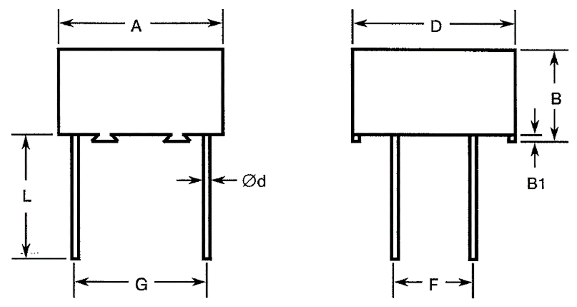
Type  Variant | Dimensions (mm)
Type  Variant | A |  | B  Max. | B1  Min. | D |  | Ød |  | F |  | G |  | L  Min.
Type  Variant | Min. | Max. | B  Max. | B1  Min. | Min. | Max. | Min. | Max. | Min. | Max. | Min. | Max. | L  Min.
01 | 19.5 | 20.5 | 6.5 | 0.25 | 19.5 | 20.5 | 0.95 | 1.1 | 9.66 | 10.66 | 17.3 | 18.3 | 20
02 | 19.5 | 20.5 | 8 | 0.25 | 19.5 | 20.5 | 0.95 | 1.1 | 9.66 | 10.66 | 17.3 | 18.3 | 20
03 | 19.5 | 20.5 | 12.5 | 0.25 | 19.5 | 20.5 | 0.95 | 1.1 | 9.66 | 10.66 | 17.3 | 18.3 | 20
04 | 19.5 | 20.5 | 20 | 0.25 | 19.5 | 20.5 | 0.95 | 1.1 | 9.66 | 10.66 | 17.3 | 18.3 | 20
05 | 19.5 | 20.5 | 30 | 0.25 | 19.5 | 20.5 | 0.95 | 1.1 | 9.66 | 10.66 | 17.3 | 18.3 | 20
06 | 30.5 | 31.5 | 12.5 | 0.4 | 31.5 | 32.5 | 0.95 | 1.1 | 14.74 | 15.74 | 27.44 | 28.44 | 20
07 | 30.5 | 31.5 | 22 | 0.4 | 31.5 | 32.5 | 0.95 | 1.1 | 14.74 | 15.74 | 27.44 | 28.44 | 20
08 | 30.5 | 31.5 | 32 | 0.4 | 31.5 | 32.5 | 0.95 | 1.1 | 14.74 | 15.74 | 27.44 | 28.44 | 20
NOTES:
            - Terminal identification: A voltage polarity “+” symbol shall be marked on the top of the body to indicate the row of terminals which should be connected to the highest potential.

Component Type Variants 09 to 16 (PM907SR1)
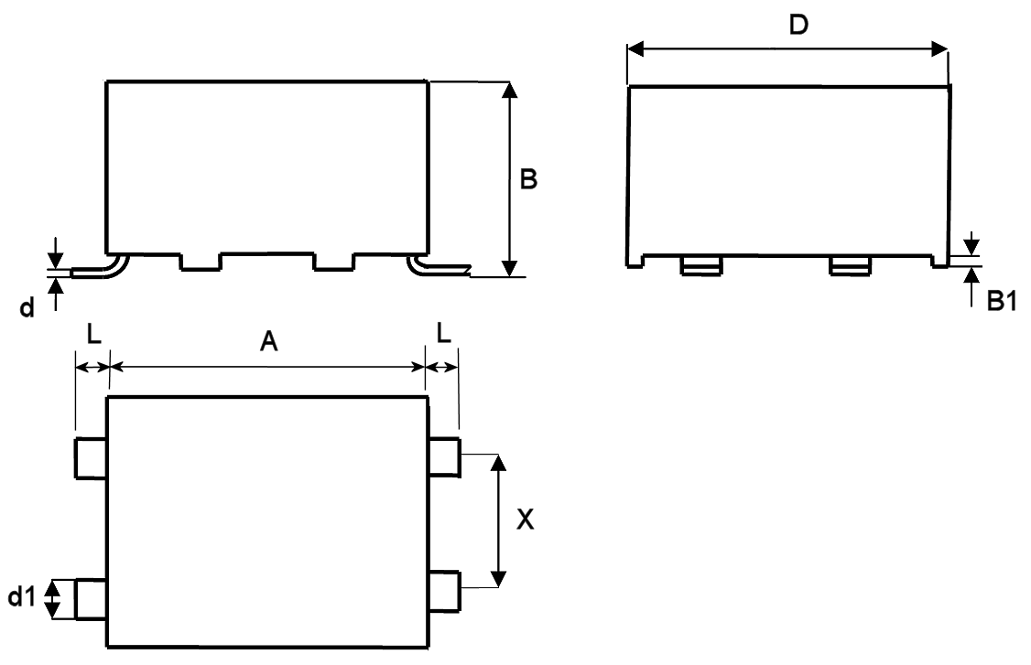
Type  Variant | Dimensions (mm)
Type  Variant | A |  | B |  | B1 Min. | D |  | d  Max. | d1 |  | X |  | L
Type  Variant | Min. | Max. | Min. | Max. | B1 Min. | Min. | Max. | d  Max. | Min. | Max. | Min. | Max. | Min. | Max.
09 | 19.5 | 20.5 | 6.5 | 7.5 | 0.25 | 19.5 | 20.5 | 0.3 | 2.45 | 2.75 | 9.5 | 10.5 | 2.75 | 3.25
10 | 19.5 | 20.5 | 8 | 9 | 0.25 | 19.5 | 20.5 | 0.3 | 2.45 | 2.75 | 9.5 | 10.5 | 2.75 | 3.25
11 | 19.5 | 20.5 | 12.5 | 13.5 | 0.25 | 19.5 | 20.5 | 0.3 | 2.45 | 2.75 | 9.5 | 10.5 | 2.75 | 3.25
12 | 19.5 | 20.5 | 20 | 21 | 0.25 | 19.5 | 20.5 | 0.3 | 2.45 | 2.75 | 9.5 | 10.5 | 2.75 | 3.25
13 | 19.5 | 20.5 | 30 | 31 | 0.25 | 19.5 | 20.5 | 0.3 | 2.45 | 2.75 | 9.5 | 10.5 | 2.75 | 3.25
14 | 30.5 | 31.5 | 12.5 | 13.5 | 0.4 | 31.5 | 32.5 | 0.3 | 3.95 | 4.4 | 14.5 | 15.5 | 2.75 | 3.25
15 | 30.5 | 31.5 | 22 | 23 | 0.4 | 31.5 | 32.5 | 0.3 | 3.95 | 4.4 | 14.5 | 15.5 | 2.75 | 3.25
16 | 30.5 | 31.5 | 32 | 33 | 0.4 | 31.5 | 32.5 | 0.3 | 3.95 | 4.4 | 14.5 | 15.5 | 2.75 | 3.25
notes:
            - Terminal identification: A voltage polarity “+” symbol shall be marked on the top of the body to indicate the row of terminals which should be connected to the highest potential.

Component Type Variants 17 to 24 (PM907SR2)
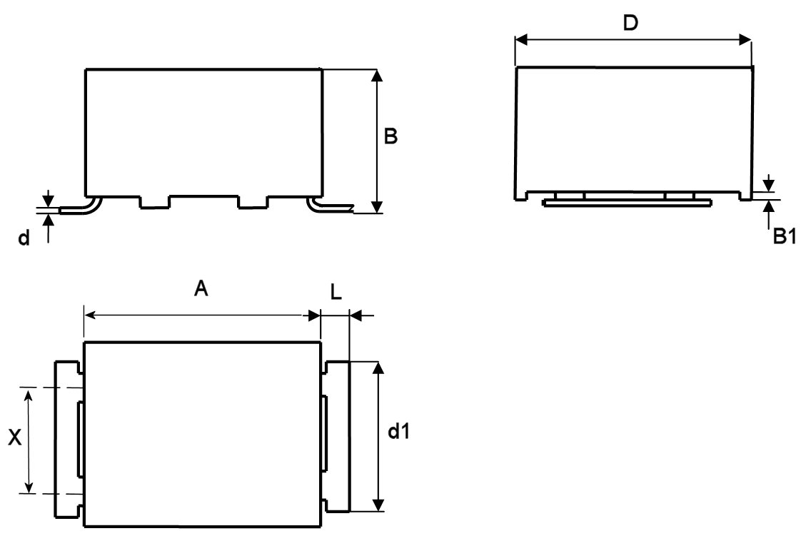
Type  Variant | Dimensions (mm)
Type  Variant | A |  | B |  | B1 Min. | D |  | d  Max. | d1 |  | X |  | L
Type  Variant | Min. | Max. | Min. | Max. | B1 Min. | Min. | Max. | d  Max. | Min. | Max. | Min. | Max. | Min. | Max.
17 | 19.5 | 20.5 | 6.5 | 7.5 | 0.25 | 19.5 | 20.5 | 0.3 | 14.5 | 15.5 | 9.5 | 10.5 | 2.75 | 3.25
18 | 19.5 | 20.5 | 8 | 9 | 0.25 | 19.5 | 20.5 | 0.3 | 14.5 | 15.5 | 9.5 | 10.5 | 2.75 | 3.25
19 | 19.5 | 20.5 | 12.5 | 13.5 | 0.25 | 19.5 | 20.5 | 0.3 | 14.5 | 15.5 | 9.5 | 10.5 | 2.75 | 3.25
20 | 19.5 | 20.5 | 20 | 21 | 0.25 | 19.5 | 20.5 | 0.3 | 14.5 | 15.5 | 9.5 | 10.5 | 2.75 | 3.25
21 | 19.5 | 20.5 | 30 | 31 | 0.25 | 19.5 | 20.5 | 0.3 | 14.5 | 15.5 | 9.5 | 10.5 | 2.75 | 3.25
22 | 30.5 | 31.5 | 12.5 | 13.5 | 0.4 | 31.5 | 32.5 | 0.3 | 23.5 | 24.5 | 14.5 | 15.5 | 2.75 | 3.25
23 | 30.5 | 31.5 | 22 | 23 | 0.4 | 31.5 | 32.5 | 0.3 | 23.5 | 24.5 | 14.5 | 15.5 | 2.75 | 3.25
24 | 30.5 | 31.5 | 32 | 33 | 0.4 | 31.5 | 32.5 | 0.3 | 23.5 | 24.5 | 14.5 | 15.5 | 2.75 | 3.25
NOTES:
            - Terminal identification: A voltage polarity “+” symbol shall be marked on the top of the body to indicate the terminal which should be connected to the highest potential.

Component Type Variants 25 to 29 (PM907NS with 2 Rows of 7 Terminals)
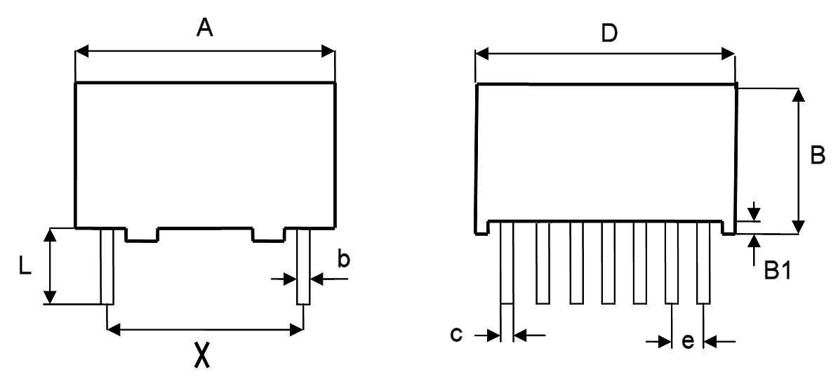
Type Variant | A |  | D |  | B  Max. | B1  Min. | X |  | b |  | c |  | e |  | L  Min.
Type Variant | Min. | Max. | Min. | Max. | B  Max. | B1  Min. | Min. | Max. | Min. | Max. | Min. | Max. | Min. | Max. | L  Min.
25 | 19.5 | 20.5 | 19.5 | 20.5 | 6.5 | 0.25 | 17.3 | 18.3 | 0.15 | 0.35 | 0.4 | 0.6 | 2.34 | 2.74 | 5
26 | 19.5 | 20.5 | 19.5 | 20.5 | 8 | 0.25 | 17.3 | 18.3 | 0.15 | 0.35 | 0.4 | 0.6 | 2.34 | 2.74 | 5
27 | 19.5 | 20.5 | 19.5 | 20.5 | 12.5 | 0.25 | 17.3 | 18.3 | 0.15 | 0.35 | 0.4 | 0.6 | 2.34 | 2.74 | 5
28 | 19.5 | 20.5 | 19.5 | 20.5 | 20 | 0.25 | 17.3 | 18.3 | 0.15 | 0.35 | 0.4 | 0.6 | 2.34 | 2.74 | 5
29 | 19.5 | 20.5 | 19.5 | 20.5 | 30 | 0.25 | 17.3 | 18.3 | 0.15 | 0.35 | 0.4 | 0.6 | 2.34 | 2.74 | 5
notes:
            - Terminal identification: A voltage polarity “+” symbol shall be marked on the top of the body to indicate the row of terminals which should be connected to the highest potential.

Component Type Variants 30 to 32 (PM907NS with 2 Rows of 11 Terminals)
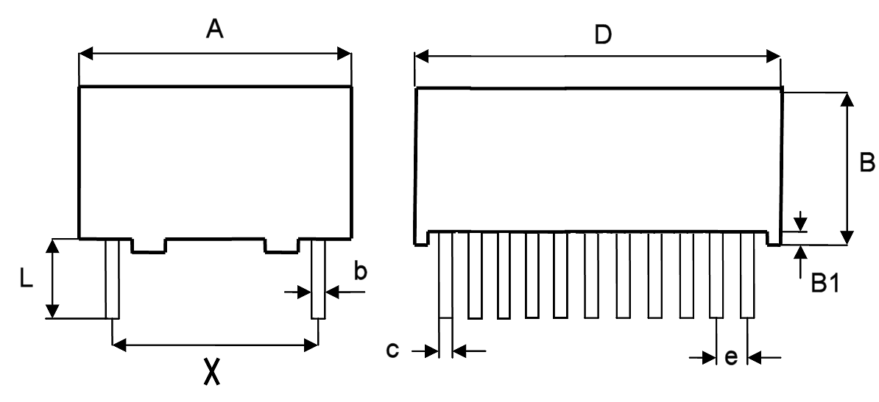
Type Variant | A |  | D |  | B  Max. | B1  Min. | X |  | b |  | c |  | e |  | L  Min.
Type Variant | Min. | Max. | Min. | Max. | B  Max. | B1  Min. | Min. | Max. | Min. | Max. | Min. | Max. | Min. | Max. | L  Min.
30 | 30.5 | 31.5 | 31.5 | 32.5 | 12.5 | 0.4 | 27.44 | 28.44 | 0.15 | 0.35 | 0.4 | 0.6 | 2.34 | 2.74 | 5
31 | 30.5 | 31.5 | 31.5 | 32.5 | 22 | 0.4 | 27.44 | 28.44 | 0.15 | 0.35 | 0.4 | 0.6 | 2.34 | 2.74 | 5
32 | 30.5 | 31.5 | 31.5 | 32.5 | 32 | 0.4 | 27.44 | 28.44 | 0.15 | 0.35 | 0.4 | 0.6 | 2.34 | 2.74 | 5
notes:
            - Terminal identification: A voltage polarity “+” symbol shall be marked on the top of the body to indicate the row of terminals which should be connected to the highest potential.

FUNCTIONAL DIAGRAM
notes:
            - These capacitors are not polarised; however, marking includes the voltage polarity symbol (see Para. 1.6) which should be respected in use.
            - For Component Type Variants 01 to 16 and 25 to 32, each row of terminals is connected internally to a single electrode.

MATERIALS AND FINISHES

Lead/Terminal Material
The lead/terminal materials shall be as follows:
- Variants 01 to 08: Type A in accordance with the requirements of ESCC Basic Specification No. 23500.
- Variants 09 to 32: Brass.

Lead/Terminal Finish
The lead/terminal finishes shall be as follows:
- Variants 01 to 08: Tin-lead plating with a maximum tin content of 97%.
- Variants 09 to 32: Type 3 or Type 4 in accordance with the requirements of ESCC Basic Specification No. 23500.

REQUIREMENTS

GENERAL
The complete requirements for procurement of the components specified herein are as stated in this specification and the ESCC Generic Specification. Permitted deviations from the Generic Specification, applicable to this specification only, are listed below.
Permitted deviations from the Generic Specification and this Detail Specification, formally agreed with specific Manufacturers on the basis that the alternative requirements are equivalent to the ESCC requirement and do not affect the component’s reliability, are listed in the appendices attached to this specification.

Deviations from the Generic Specification

Deviations from Qualification and Periodic Tests – Chart F4
          - Operating Life:
- Test Condition (c), Applied voltage: 1.25×U_{C}, where U_{C} is the applicable Category Voltage per Paras. 1.5 and 1.4.2.
          - Robustness of Terminations: for Component Type Variants 09 to 24 Robustness of Terminations shall be performed as follows:
The components shall be mounted on a suitable substrate. After mounting, examination shall be made for good tinning as evidenced by flowing of the solder with wetting of the terminations. A force of 10N shall be applied normal to the line joining the terminals and in a plane parallel to the substrate, for a duration of 10 ±1s. The components shall then be examined and there shall be no evidence of damage or loosening of the components from the substrate.

MARKING
The marking shall be in accordance with the requirements of ESCC Basic Specification No. 21700 and as follows. The information to be marked on the component shall be:
          - Terminal Identification (see Para. 1.6).
          - The ESCC qualified components symbol (for ESCC qualified components only).
          - The ESCC Component Number (see Para. 1.4.1).
          - Traceability information.

Robustness of terminations
The terminals of the components are rigid.
For Component Type Variants 01 to 08 and 25 to 32 the test conditions for Robustness of Terminations shall be as specified in the ESCC Generic Specification and as follows:
- Test Ua1, tensile:
- Applied force for Component Type Variants 01 to 08: 10N
- Applied force for Component Type Variants 25 to 32: 20N
- Duration: 7.5 ±2.5s
All terminals of the component shall be tested.

ELECTRICAL MEASUREMENTS AT ROOM, HIGH AND LOW TEMPERATURES
Electrical measurements shall be performed at room, high and low temperatures.

Room Temperature Electrical Measurements
The measurements shall be performed at T_{amb} = +22 ±3°C.
Characteristics | Symbols | Test Method and  Conditions | Limits |  | Units
Characteristics | Symbols | Test Method and  Conditions | Min | Max | Units
Capacitance | C | ESCC No. 3006  Test Frequency = 1kHz | Note 1 | Note 2 | µF
Tangent of Loss Angle | tgδ | ESCC No. 3006  Test Frequency = 1kHz | - | 100×10⁻⁴ | -
Insulation Resistance, Dielectric | R_{I} | ESCC No. 3006
Insulation Resistance, Dielectric | R_{I} | C ≤ 0.33µF  C > 0.33µF | 7500  2500 | -  - | MΩ  MΩ.µF
Voltage Proof,  Terminal-to-Terminal | VP | ESCC No. 3006 | 1.6×U_{R}  (Note 3) | - | V
NOTES:
            - Capacitance Value of the component minus the applicable Tolerance (see Para. 1.4.2).
            - Capacitance Value of the component plus the applicable Tolerance (see Para. 1.4.2).
            - For the applicable Rated Voltage (U_{R}) see Para. 1.4.2.

High and Low Temperatures Electrical Measurements
Characteristics | Symbols | Test Method and Conditions  (Note 1) | Limits |  | Units
Characteristics | Symbols | Test Method and Conditions  (Note 1) | Min | Max | Units
Temperature Coefficient | ΔC/C | ESCC No. 3006  Test Frequency = 1kHz
Temperature Coefficient | ΔC/C | T_{amb} = -55 (+3 -0)°C | - | -10  (Note 2) | %
Temperature Coefficient | ΔC/C | T_{amb} = +125 (+0 -3)°C | - | +18  (Note 2) | %
NOTES:
            - The measurements shall be performed on a sample of 6 components from each manufacturing lot with 0 failures allowed. In the event of any failure a 100% inspection may be performed.
            - The Temperature Coefficient limits are with respect to the capacitance at +22 ±2°C (reference point temperature).

INTERMEDIATE AND END-POINT ELECTRICAL MEASUREMENTS
Unless otherwise specified, the measurements shall be performed at T_{amb} = +22 ±3°C.
Unless otherwise specified the test methods and test conditions shall be as per the corresponding test defined in Para. 2.4.1, Room Temperature Electrical Measurements.
Test Reference per ESCC No. 3006 | Characteristics | Symbols | Limits |  | Units
Test Reference per ESCC No. 3006 | Characteristics | Symbols | Min | Max | Units
Resistance to Soldering Heat
Initial Measurements | Capacitance | C | Note 1 |  | µF
Final Measurements | Capacitance | C | Note 1 |  | µF
 | Change in Capacitance | ΔC/C | -3 | +3 | %
 | Insulation Resistance, Dielectric | R_{I}
 | C ≤ 0.33µF  C > 0.33µF |  | Note 1  Note 1 | -  - | MΩ  MΩ.µF
 | Tangent of Loss Angle | tgδ | - | Note 2 | -
Temperature Coefficient | Temperature Coefficient  (Note 3) | ΔC/C | Note 4 |  | %
Rapid Change of Temperature
Initial Measurements | Capacitance | C | Note 1 |  | µF
Final Measurements | Capacitance | C | Note 1 |  | µF
 | Change in Capacitance | ΔC/C | -3 | +3 | %
 | Tangent of Loss Angle | tgδ | - | Note 1 | -
Climatic Sequence
Initial Measurements | Capacitance | C | Note 1 |  | µF
Final Measurements | Capacitance | C | Note 1 |  | µF
 | Change in Capacitance | ΔC/C | -3 | +3 | %
 | Tangent of Loss Angle | tgδ | - | Note 2 | -
 | Voltage Proof,  Terminal-to-Terminal | VP | Note 1 | - | V
 | Insulation Resistance, Dielectric | R_{I}
 | C ≤ 0.33µF  C > 0.33µF |  | Note 5  Note 5 | -  - | MΩ  MΩ.µF
Operating Life
Initial Measurements | Capacitance | C | Note 1 |  | µF
Intermediate Measurements  (1000 hours) | Capacitance | C | Note 1 |  | µF
Intermediate Measurements  (1000 hours) | Change in Capacitance | ΔC/C | -5 | +5 | %
Final Measurements  (1000 or 2000 hours) (Note 6) | Capacitance | C | Note 1 |  | µF
Final Measurements  (1000 or 2000 hours) (Note 6) | Change in Capacitance | ΔC/C | -5 | +5 | %
 | Tangent of Loss Angle | tgδ | - | Note 2 | -
 | Insulation Resistance, Dielectric | R_{I}
 | C ≤ 0.33µF  C > 0.33µF |  | Note 5  Note 5 | -  - | MΩ  MΩ.µF
NOTES:
            - As specified in Para. 2.4.1.
            - 1.5× the limit specified in Para. 2.4.1.
            - The test method and test conditions shall be as specified in Para. 2.4.2.
            - As specified in Para. 2.4.2.
            - 50% of the limit specified in Para. 2.4.1.
            - 1000 hours is applicable to Periodic Testing for extension of qualification. 2000 hours is applicable to Qualification Testing, and to Periodic Testing for renewal of qualification after lapse.

BURN-IN conditions
Characteristics | Symbols | Conditions (Note 1) | Units
Ambient Temperature | T_{amb} | +125 (+0 -5) | °C
Test Voltage | V_{T} | 1.25×U_{C} (Note 2) | V
NOTES:
            - On completion of Burn-in the components shall be removed from the burn-in chamber and allowed to cool, under normal atmospheric conditions, for recovery for 24 ±2 hours.
            - U_{C} is the applicable Category Voltage; see Paras. 1.5 and 1.4.2.

APPENDIX ‘A’
AGREED DEVIATIONS FOR EXXELIA TECHNOLOGIES (F)
Items Affected | Description of Deviations
Para. 2.1.1, Deviations from the Generic Specification: Deviations from Screening Tests – Chart F3 | All procurement lots shall have 100% Serialisation carried out at any point during Chart F3 testing prior to the performance of High and Low Temperatures Electrical Measurements.
 | If a particular lot is required to undergo testing in accordance with Chart F4, then the Temperature Coefficient measurements, made during High and Low Temperatures Electrical Measurements on a sample of 6 randomly-selected serialised capacitors, shall be Read-and-Record measurements. See “Deviations from Qualification and Periodic Tests – Chart F4” below.
Para. 2.1.1.1, Deviations from Qualification and Periodic Tests – Chart F4 | The Temperature Coefficient testing specified in Subgroup 2B of Chart F4 may not be performed.  In instances when Temperature Coefficient testing per Subgroup 2B of Chart F4 is not performed, the Read-and-Record measurements data obtained during High and Low Temperature Electrical Measurements (part of Chart F3, Screening Tests) shall be submitted instead.

