

Page 1 of 40
ACCESSORIES FOR CONNECTORS, MICROMINIATURE 3401/029, 3401/077 AND CONNECTOR SAVERS 3401/041

ESCC Detail Specification No. 3401/032

Issue 12 Draft C | October 2019



Document Custodian: European Space Agency – see https://escies.org

Legal Disclaimer and Copyright
European Space Agency, Copyright © 2019. All rights reserved.
The European Space Agency disclaims any liability or responsibility, to any person or entity, with respect to any loss or damage caused, or alleged to be caused, directly or indirectly by the use and application of this ESCC publication.
This publication, without the prior permission of the European Space Agency and provided that it is not used for a commercial purpose, may be:
- copied in whole, in any medium, without alteration or modification.
- copied in part, in any medium, provided that the ESCC document identification, comprising the ESCC symbol, document number and document issue, is removed.

DOCUMENTATION CHANGE NOTICE
(Refer to https://escies.org for ESCC DCR content)
DCR No. | CHANGE DESCRIPTION
1287 | Specification upissued to include changes per DCR.
Draft 12A  S.Thacker  10/07/2019 | Initial draft revision of spec to incorporate changes proposed by Glenair (in DCR1287)  Changes in this draft from issue 11 are highlighted yellow for information  Draft 12B
Draft 12B  S.Thacker  10/09/2019 | New draft revision of spec to incorporate additional changes proposed by Glenair in email dated 14/08/19. (in DCR1287)  Await C&K review and agreement to all changes (ref. email to C&K 14/08/19).  Changes in this draft from issue 11 are highlighted blue for information.
Draft 12C  S.Thacker  11/10/19 | New additions requested by Glenair via new DCRTBA 11/10/19 (ref. Glenair email dated 07/10/19).  these additions in Table 1(a) & Figure 2 are highlighted pink for information (i.e. new Variants 59 to 68).  Note:  Additional correction added in Table 1(a) page 6 to Variant 11

TABLE OF CONTENTS
1 General 5
1.1 SCOPE 5
1.2 ComponEnT TYPE VARIANTS 5
1.3 MAXIMUM RATINGS 5
1.4 PARAMETER DERATING INFORMATION 5
1.5 PHYSICAL DIMENSIONS 5
1.6 FUNCTIONAL DIAGRAM 5
2 APPLICABLE DOCUMENTS 38
3 TERMS, DEFINITIONS, ABBREVIATIONS, SYMBOLS AND UNITS 38
4 REQUIREMENTS 38
4.1 GENERAL 38
4.2 DEVIATIONS FROM GENERIC SPECIFICATION 38
4.2.1 Deviations from Special In-process Controls 38
4.2.2 Deviations from Final Production Tests (Chart II) 38
4.2.3 Deviations from Burn-in and Electrical Measurements (Chart III) 38
4.2.4 Deviations from Qualification, Environmental and Endurance Tests (Chart IV) 38
4.2.5 Deviations from Lot Acceptance Tests (Chart V) 38
4.3 MECHANICAL REQUIREMENTS 39
4.3.1 Dimension Check 39
4.3.2 Weight 39
4.3.3 Torque Value 39
4.4 MATERIALS AND FINISHES 39
4.4.1 Screw Lock Assemblies and Brackets 39
4.4.2 Interfacial Seals 39
4.5 MARKING 39
4.5.1 General 39
4.5.2 The ESCC Component Number 39
4.5.3 Traceability Information 39
4.6 ELECTRICAL MEASUREMENTS 40
4.7 SCREENING TESTS (TABLES 4 AND 5) 40
4.8 ENVIRONMENTAL AND ENDURANCE TESTS 40

General

SCOPE
This specification details the ratings, physical and electrical characteristics, test and inspection data of Accessories for Microminiature Connectors 3401/029 (Type MDM), Connector Savers 3401/041 and Microminiature Connectors with Removable Contacts 3401/077 (Type MDMA).
It shall be read in conjunction with:
- ESCC Generic Specification No. 3401, Connectors, Electrical, Circular and Rectangular.
- ESCC Detail Specification No. 3401/029, Connectors, Electrical, Rectangular, Microminiature, based on Type MDM.
- ESCC Detail Specification No. 3401/041, Connector Savers, Electrical, Rectangular, Microminiature, based on type MDM.
- ESCC Detail Specification No. 3401/077, Connectors, Electrical, Rectangular, Microminiature, Removable Contacts, based on type MDMA.
- ESCC Detail Specification No. 3401/087, Lightweight Accessories for Rectangular, Microminiature Connectors, 3401/029 and 3401/077
the requirements of which are supplemented herein.

ComponEnT TYPE VARIANTS
The type variants of accessories covered by this specification are given in Table 1(a).

MAXIMUM RATINGS
The maximum ratings, which shall not be exceeded at any time during use or storage, applicable to the accessories specified herein, are as scheduled in Table 1(b).

PARAMETER DERATING INFORMATION
Not applicable.

PHYSICAL DIMENSIONS
The physical dimensions of the accessories specified herein are shown in Figure 2.

FUNCTIONAL DIAGRAM
Not applicable.
TABLE 1(a) – TYPE VARIANTS
Variant | Description (1) | For Use With (2)
03 | 90° Mounting Bracket, Shell Size 9 to 37 | ESCC 3401/029 Variants 01, 02  ESCC 3401/077 Variants 01, 02
04 | 90° Mounting Bracket, Shell Size 51, 69 | ESCC 3401/029 Variants 01, 02
07 | Screw Sub-Assembly, Slot Head, Shell Size 9 to 69 | ESCC 3401/029 Variants 01, 02  ESCC 3401/077 Variants 01, 02
08 | Screwlock Sub-Assembly (Front Panel Mounting) with Nut and Lock-Washer, Shell Size 9 to 69 | ESCC 3401/029 Variants 01, 02  ESCC 3401/077 Variants 01, 02
09 | Screwlock Sub-Assembly (Rear Panel Mounting) with Nut and Lock-Washer, Shell Size 9 to 69, Panel Thickness 1.6mm | ESCC 3401/029 Variants 01, 02  ESCC 3401/077 Variants 01, 02
10 | Screwlock Assembly for Connector Savers, Shell Size 9 to 69 | ESCC 3401/041 Variants 01 to 08
11 | Screwlock for Connectors FR136, FR139, Shell Size 9 to 51 | ESCC 3401/029 Variants 01, 02
12 | Interfacial Seals for MDMA Female Connectors, Shell Size 9 | ESCC 3401/077 Variants 01, 02
13 | Interfacial Seals for MDMA Female Connectors, Shell Size 15 | ESCC 3401/077 Variants 01, 02
14 | Interfacial Seals for MDMA Female Connectors, Shell Size 21 | ESCC 3401/077 Variants 01, 02
15 | Interfacial Seals for MDMA Female Connectors, Shell Size 25 | ESCC 3401/077 Variants 01, 02
16 | Interfacial Seals for MDMA Female Connectors, Shell Size 31 | ESCC 3401/077 Variants 01, 02
17 | Interfacial Seals for MDMA Female Connectors, Shell Size 37 | ESCC 3401/077 Variants 01, 02
18 | Screw Sub-Assembly for Lightweight Backshell, Slot Head, Shell Size 9 to 69 | ESCC 3401/087 All Variants for the specified Shell Sizes
19 | Interfacial Seals for MDMA Female Connectors, Shell Size 51 | ESCC 3401/077 Variants 01, 02
20 | Screwlock Sub-Assembly (Front Panel Mounting) with Self-Locking Nut, Shell Size 9 to 69 | ESCC 3401/029 Variants 01, 02  ESCC 3401/077 Variants 01, 02
21 | Screwlock Sub-Assembly (Rear Panel Mounting) with Self-Locking Nut, Shell Size 9 to 69, Panel Thickness 1.6mm | ESCC 3401/029 Variants 01, 02  ESCC 3401/077 Variants 01, 02
22 | Screw Sub-Assembly, Shell Size 9 to 69, Hex. Hole Head | ESCC 3401/029 Variants 01, 02  ESCC 3401/077 Variants 01, 02
23 | Screwlock Sub-Assembly (Rear Panel Mounting) with Nut and Lock-Washer, Shell Size 9 to 69, Panel Thickness 0.8mm | ESCC 3401/029 Variants 01, 02  ESCC 3401/077 Variants 01, 02
24 | Screwlock Sub-Assembly (Rear Panel Mounting) with Nut and Lock-Washer, Shell Size 9 to 69, Panel Thickness 1.2mm | ESCC 3401/029 Variants 01, 02  ESCC 3401/077 Variants 01, 02
25 | Screwlock Sub-Assembly (Rear Panel Mounting) with Nut and Lock-Washer, Shell Size 9 to 69, Panel Thickness 2mm | ESCC 3401/029 Variants 01, 02  ESCC 3401/077 Variants 01, 02
26 | Screwlock Sub-Assembly (Rear Panel Mounting) with Nut and Lock-Washer, Shell Size 9 to 69, Panel Thickness 2.4mm | ESCC 3401/029 Variants 01, 02  ESCC 3401/077 Variants 01, 02
27 | Screwlock for Connectors 75SBT, Shell Size 9 to 69 | ESCC 3401/029 Variants 01, 02
28 | Screwlock for Connectors 75SBT (Rear Panel Mounting), Shell Size 9 to 69, Panel Thickness 0.8mm | ESCC 3401/029 Variants 01, 02
29 | Screwlock for Connectors 75SBT (Rear Panel Mounting, Shell Size 9 to 69, Panel Thickness 1.2mm | ESCC 3401/029 Variants 01, 02
30 | Screwlock for Connectors 75SBT (Rear Panel Mounting), Shell Size 9 to 69, Panel Thickness 1.6mm | ESCC 3401/029 Variants 01, 02
31 | Screwlock for Connectors 75SBT (Rear Panel Mounting), Shell Size 9 to 69, Panel Thickness 2mm | ESCC 3401/029 Variants 01, 02
32 | Screwlock for Connectors 75SBT (Rear Panel Mounting), Shell Size 9 to 69, Panel Thickness 2.4mm | ESCC 3401/029 Variants 01, 02
33 | Screwlock for Connectors 75RB/CBR, Shell Size 9 to 51 | ESCC 3401/029 Variants 01, 02
34 | Screwlock for Connectors 75RB/CBR (Rear Panel Mounting), Shell Size 9 to 51, Panel Thickness 0.8mm | ESCC 3401/029 Variants 01, 02
35 | Screwlock for Connectors 75RB/CBR (Rear Panel Mounting), Shell Size 9 to 51, Panel Thickness 1.2mm | ESCC 3401/029 Variants 01, 02
36 | Screwlock for Connectors 75RB/CBR (Rear Panel Mounting), Shell Size 9 to 51, Panel Thickness 1.6mm | ESCC 3401/029 Variants 01, 02
37 | Screwlock for Connectors 75RB/CBR (Rear Panel Mounting), Shell Size 9 to 51, Panel Thickness 2mm | ESCC 3401/029 Variants 01, 02
38 | Screwlock for Connectors 75RB/CBR (Rear Panel Mounting), Shell Size 9 to 51, Panel Thickness 2.4mm | ESCC 3401/029 Variants 01, 02
39 | Screw Sub-Assembly, Slot Head, Shell Size 100 | ESCC 3401/029 Variants 01, 02
40 | Screw Sub-Assembly, Hex. Hole Head, Shell Size 100 | ESCC 3401/029 Variants 01, 02
41 | Screwlock Assembly for Connector Savers, Shell Size 100 | ESCC 3401/041 Variant 09
42 | Screwlock for Connectors GMR7580, GMR7590, Shell Size 9 to 69 | ESCC 3401/029 Variants 01, 02
43 | Screwlock for Connectors GMR7580, GMR7590, Shell Size 100 | ESCC 3401/029 Variants 01, 02
44 | Screw Sub-Assembly for Lightweight Backshell, Hex. Hole Head, Shell Size 9 to 69 | ESCC 3401/087 All applicable Variants
45 | Screw Sub-Assembly for Lightweight Backshell, Slot Head, Shell Size 100 | ESCC 3401/087 All Variants for the specified Shell Size
46 | Screw Sub-Assembly for Lightweight Backshell, Hex. Hole Head, Shell Size 100 | ESCC 3401/087 All Variants for the specified Shell Size
47 | Screwlock Sub-Assembly (Front Panel Mounting) with Nut and Split Ring, Shell Size 9 to 69 | ESCC 3401/029 Variants 01, 02
48 | Screwlock Sub-Assembly (Front Panel Mounting) with Nut and Split Ring, Shell Size 100 | ESCC 3401/029 Variants 01, 02
49 | Screwlock Sub-Assembly (Rear Panel Mounting) with Nut and Split Ring, Shell Size 9 to 69, Panel Thickness 0.8mm | ESCC 3401/029 Variants 01, 02
50 | Screwlock Sub-Assembly (Rear Panel Mounting) with Nut and Split Ring, Shell Size 9 to 69, Panel Thickness 1.2mm | ESCC 3401/029 Variants 01, 02
51 | Screwlock Sub-Assembly (Rear Panel Mounting) with Nut and Split Ring, Shell Size 9 to 69, Panel Thickness 1.6mm | ESCC 3401/029 Variants 01, 02
52 | Screwlock Sub-Assembly (Rear Panel Mounting) with Nut and Split Ring, Shell Size 9 to 69, Panel Thickness 2mm | ESCC 3401/029 Variants 01, 02
53 | Screwlock Sub-Assembly (Rear Panel Mounting) with Nut and Split Ring, Shell Size 9 to 69, Panel Thickness 2.4mm | ESCC 3401/029 Variants 01, 02
54 | Screwlock Sub-Assembly (Rear Panel Mounting) with Nut and Split Ring, Shell Size 100, Panel Thickness 0.8mm | ESCC 3401/029 Variants 01, 02
55 | Screwlock Sub-Assembly (Rear Panel Mounting) with Nut and Split Ring, Shell Size 100, Panel Thickness 1.2mm | ESCC 3401/029 Variants 01, 02
56 | Screwlock Sub-Assembly (Rear Panel Mounting) with Nut and Split Ring, Shell Size 100, Panel Thickness 1.6mm | ESCC 3401/029 Variants 01, 02
57 | Screwlock Sub-Assembly (Rear Panel Mounting) with Nut and Split Ring, Shell Size 100, Panel Thickness 2mm | ESCC 3401/029 Variants 01, 02
58 | Screwlock Sub-Assembly (Rear Panel Mounting) with Nut and Split Ring, Shell Size 100, Panel Thickness 2.4mm | ESCC 3401/029 Variants 01, 02
59 | Screwlock for Connectors GMR7580, GMR7590 (Rear Panel Mounting), Shell Size 9 to 69, Panel Thickness 0.8mm | ESCC 3401/029 Variants 01, 02
60 | Screwlock for Connectors GMR7580, GMR7590 (Rear Panel Mounting), Shell Size 9 to 69, Panel Thickness 1.2mm | ESCC 3401/029 Variants 01, 02
61 | Screwlock for Connectors GMR7580, GMR7590 (Rear Panel Mounting), Shell Size 9 to 69, Panel Thickness 1.6mm | ESCC 3401/029 Variants 01, 02
62 | Screwlock for Connectors GMR7580, GMR7590 (Rear Panel Mounting), Shell Size 9 to 69, Panel Thickness 2mm | ESCC 3401/029 Variants 01, 02
63 | Screwlock for Connectors GMR7580, GMR7590 (Rear Panel Mounting), Shell Size 9 to 69, Panel Thickness 2.4mm | ESCC 3401/029 Variants 01, 02
64 | Screwlock for Connectors GMR7580, GMR7590 (Rear Panel Mounting), Shell Size 100, Panel Thickness 0.8mm | ESCC 3401/029 Variants 01, 02
65 | Screwlock for Connectors GMR7580, GMR7590 (Rear Panel Mounting), Shell Size 100, Panel Thickness 1.2mm | ESCC 3401/029 Variants 01, 02
66 | Screwlock for Connectors GMR7580, GMR7590 (Rear Panel Mounting), Shell Size 100, Panel Thickness 1.6mm | ESCC 3401/029 Variants 01, 02
67 | Screwlock for Connectors GMR7580, GMR7590 (Rear Panel Mounting), Shell Size 100, Panel Thickness 2mm | ESCC 3401/029 Variants 01, 02
68 | Screwlock for Connectors GMR7580, GMR7590 (Rear Panel Mounting), Shell Size 100, Panel Thickness 2.4mm | ESCC 3401/029 Variants 01, 02
NOTES:
            - See Figure 2 for details.
            - The applicable shell sizes are the same as given in the description column (if specified in the referenced specification).
Table 1(b) - MAXIMUM RATINGS
No. | Characteristics | Symbol | Maximum Ratings | Unit
1 | Operating Temperature Range | T_{op} | -55 to +125 | °C
2 | Storage Temperature Range | T_{stg} | -55 to +125 | °C
3 | Torque Value | T | See Figure 2 | Nm
FIGURE 1
Not applicable.

FIGURE 2 - PHYSICAL DIMENSIONS
VARIANTS 03 & 04 - 90° MOUNTING BRACKET (FOR SHELL SIZE 9 TO 69)
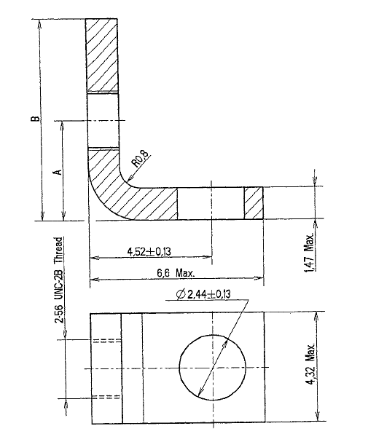
Variant | Shell Size | A  ±0.13 | B  Max
03 | 9 to 37 | 3.73 | 7.82
04 | 51, 69 | 4.29 | 8.89
NOTES:
            - All dimensions in mm.
            - Weight:
- Variant 03 0.42g
- Variant 04 0.45g
VARIANT 07 - SCREW SUB-ASSEMBLY, SLOT HEAD (FOR SHELL SIZE 9 TO 69)
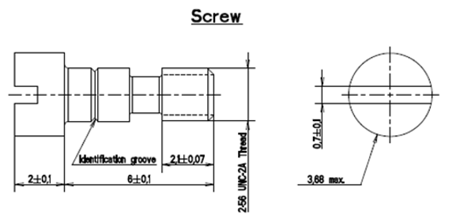

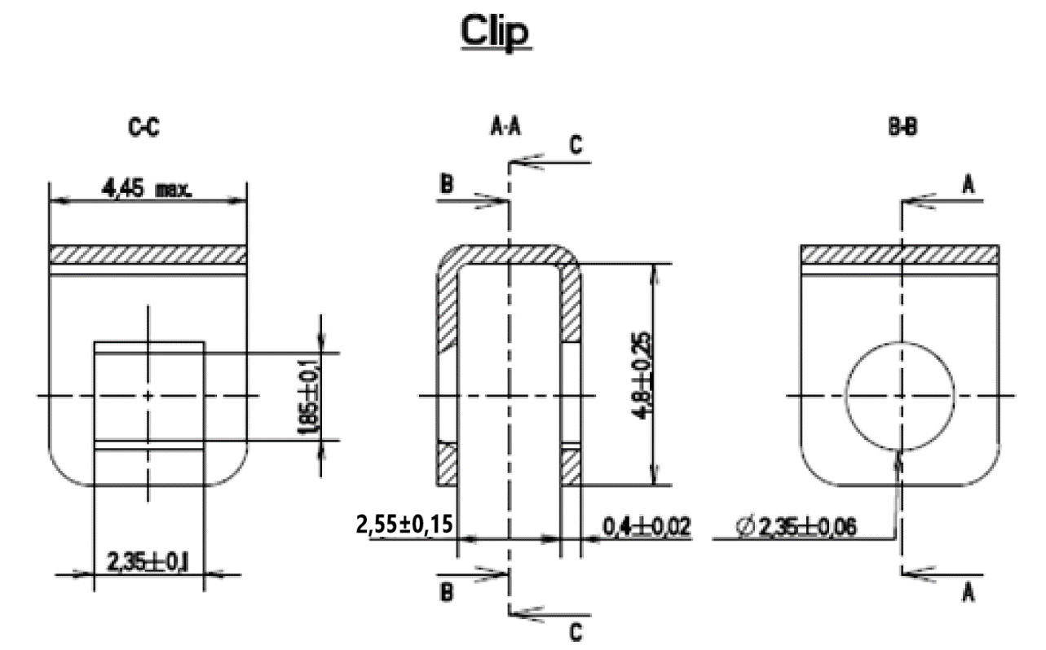
NOTES:
            - All dimensions in mm.
            - Weight:
- Screw 0.3g
- Clip 0.14g

Torque Values | Min (Nm) | Max (Nm)
Screw | 0.28 | 0.32

VARIANT 08 - SCREWLOCK SUB-ASSEMBLY (FRONT PANEL MOUNTING) WITH NUT AND LOCK-WASHER (FOR SHELL SIZE 9 TO 69)
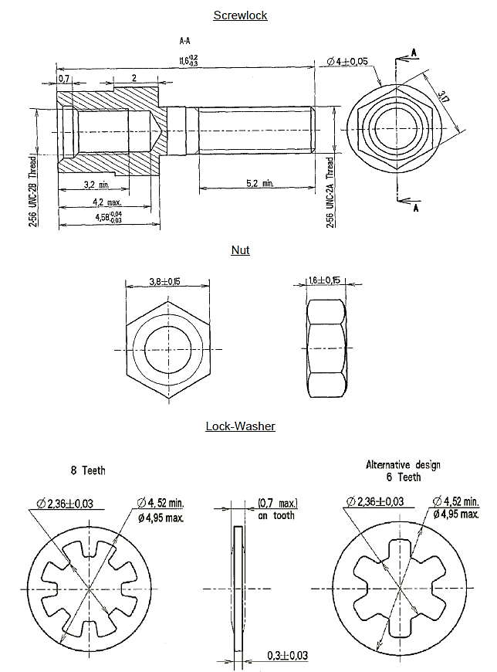
NOTES:
            - All dimensions in mm.
            - Weight:
- Screwlock 0.51g
- Nut 0.13g
- Lock-Washer 0.02g

Torque Values | Min (Nm) | Max (Nm)
Screwlock male side | 0.44 | 0.48
Screwlock female side | 0.28 | 0.32
Nut | 0.44 | 0.48

VARIANTS 09 & 23 TO 26 - SCREWLOCK SUB-ASSEMBLY (REAR PANEL MOUNTING) WITH NUT AND LOCK-WASHER (FOR SHELL SIZE 9 TO 69) PANEL THICKNESS 0.8 TO 2.4mm
Screwlock
Variant | 23 | 24 | 09 | 25 | 26
Panel Thickness (+0.2 -0) | 0.8 | 1.2 | 1.6 | 2 | 2.4
Dimension A | 0.7 | 1.1 | 1.5 | 1.9 | 2.3
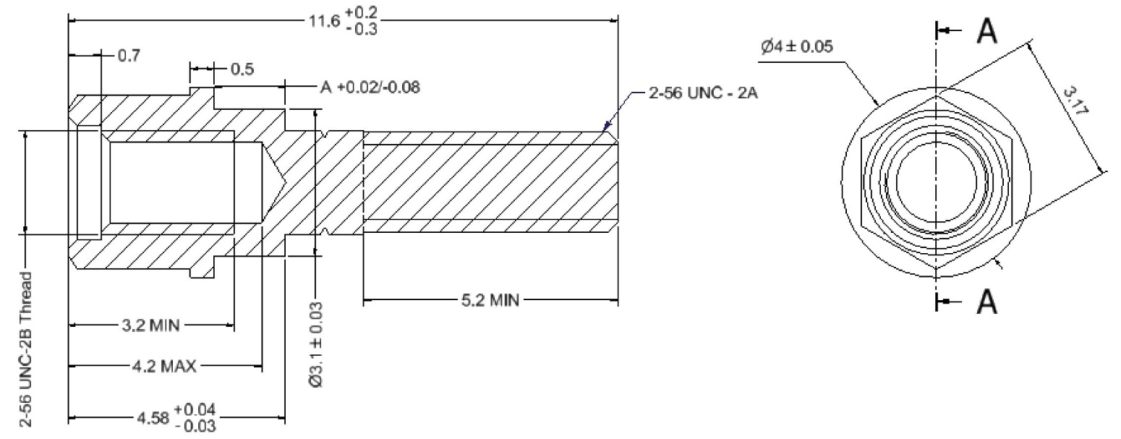
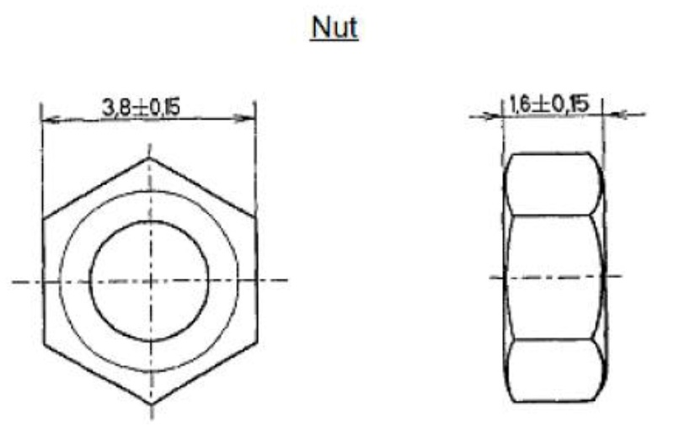
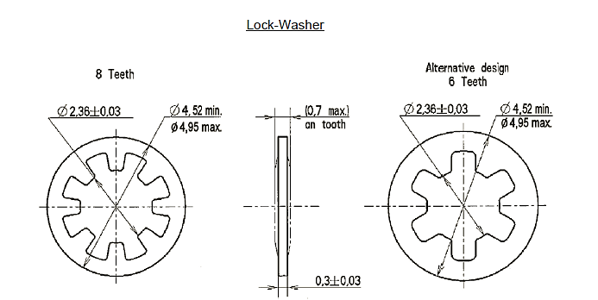
NOTES:
            - All dimensions in mm.
            - Weight:
- Screwlock 0.45g
- Nut 0.13g
- Lock-Washer 0.02g

Torque Values | Min (Nm) | Max (Nm)
Screwlock male side | 0.44 | 0.48
Screwlock female side | 0.28 | 0.32
Nut | 0.44 | 0.48

VARIANT 10 - SCREWLOCK ASSEMBLY FOR CONNECTOR SAVERS (FOR SHELL SIZE 9 TO 69)
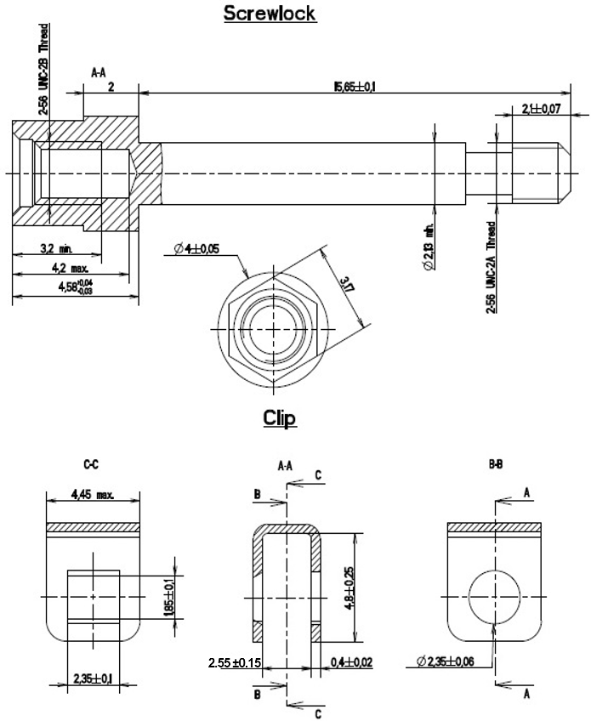
NOTES:
            - All dimensions in mm.
            - Weight:
- Screwlock 0.79g
- Clip 0.14g

Torque Values | Min (Nm) | Max (Nm)
Screwlock male side | 0.36 | 0.4
Screwlock female side | 0.28 | 0.32
VARIANT 11 - SCREWLOCK FOR CONNECTORS FR136, FR139 (FOR SHELL SIZE 9 TO 69)
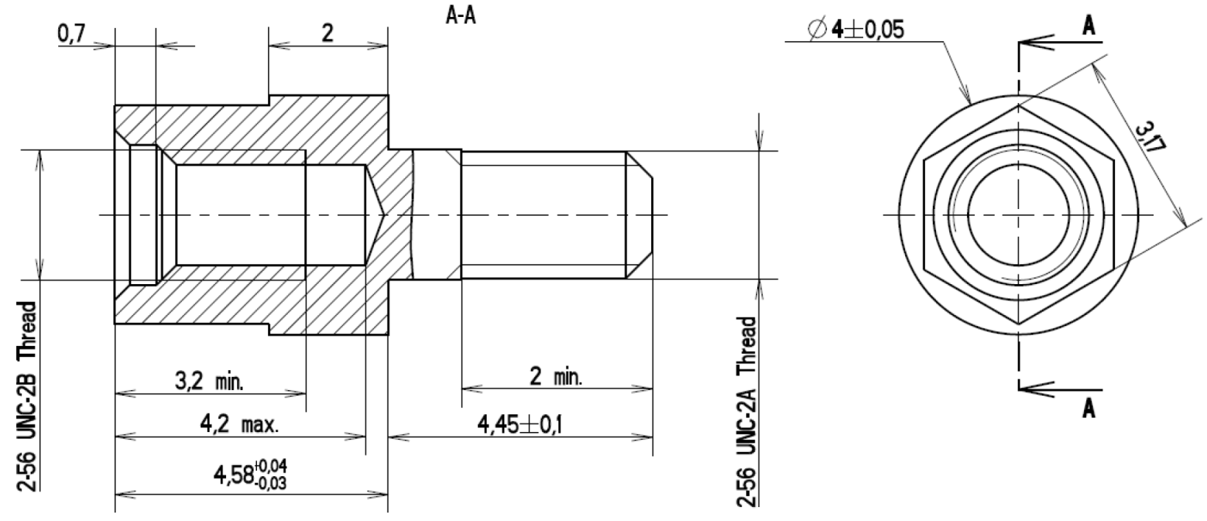
NOTES:
            - All dimensions in mm.
            - Weight:
- Screwlock 0.43g

Torque Values | Min (Nm) | Max (Nm)
Screwlock male side | 0.44 | 0.48
Screwlock female side | 0.28 | 0.32

VARIANTS 12 TO 17 & 19 - INTERFACIAL SEALS FOR MDMA FEMALE CONNECTORS (PER ESCC 3401/077 Variants 01, 02)
VARIANT 15 (SHELL SIZE 25) SHOWN FOR ILLUSTRATIVE PURPOSES
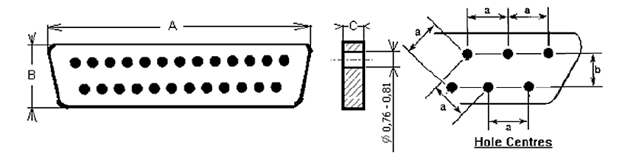
Variant | Shell Size | Dimensions (mm) |  |  |  |  |  | Weight  Max.  (g)
Variant | Shell Size | A |  | B |  | C |  | Weight  Max.  (g)
Variant | Shell Size | Min | Max | Min | Max | Min | Max | Weight  Max.  (g)
12 | 9 | 8.33 | 8.73 | 4.6 | 4.8 | 0.6 | 0.7 | 0.02
13 | 15 | 12.14 | 12.54 | 4.6 | 4.8 | 0.6 | 0.7 | 0.03
14 | 21 | 15.95 | 16.35 | 4.6 | 4.8 | 0.6 | 0.7 | 0.04
15 | 25 | 18.49 | 18.89 | 4.6 | 4.8 | 0.6 | 0.7 | 0.05
16 | 31 | 22.3 | 22.7 | 4.6 | 4.8 | 0.6 | 0.7 | 0.07
17 | 37 | 26.11 | 26.51 | 4.6 | 4.8 | 0.6 | 0.7 | 0.08
19 | 51 | 24.84 | 25.24 | 5.7 | 5.9 | 0.6 | 0.7 | 0.09
NOTES:
            - a = Distance between hole centres: 1.27mm typical.
            - b = Distance between rows: 1.09mm typical.

VARIANT 18 – SCREW SUB-ASSEMBLY FOR LIGHTWEIGHT BACKSHELL, SLOT HEAD (FOR SHELL SIZE 9 TO 69)
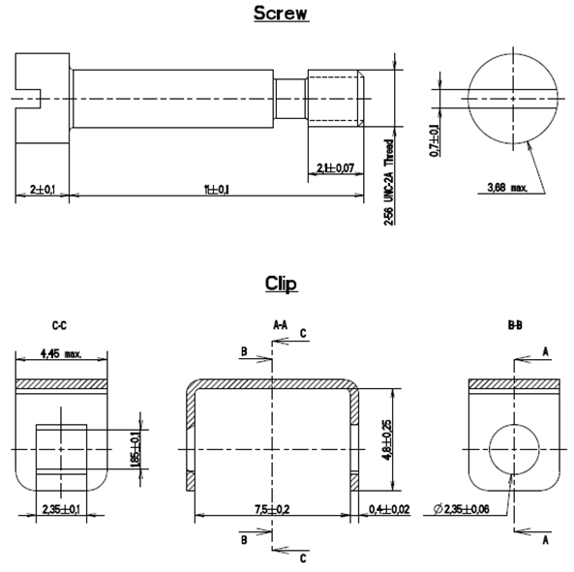
NOTES:
            - All dimensions in mm.
            - Weight:
- Screw 0.6g
- Clip 0.2g

Torque Values | Min (Nm) | Max (Nm)
Screw | 0.28 | 0.32
VARIANT 20 - SCREWLOCK SUB-ASSEMBLY (FRONT PANEL MOUNTING) WITH SELF-LOCKING NUT (FOR SHELL SIZE 9 TO 69)
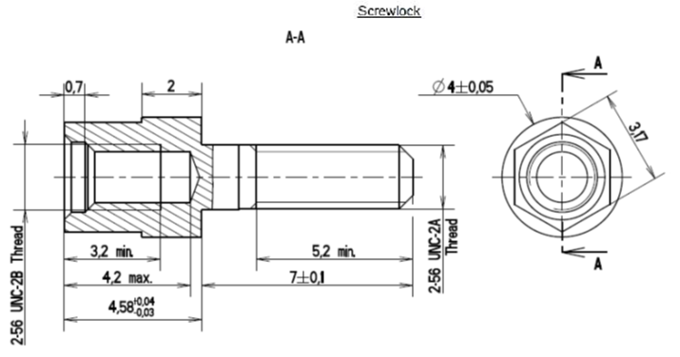
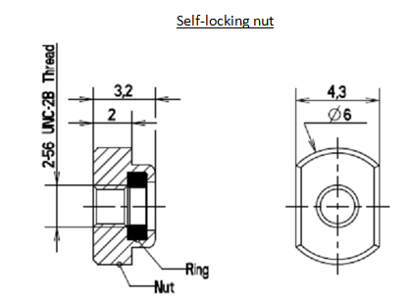
NOTES:
            - All dimensions in mm.
            - Weight:
- Screwlock 0.51g
- Self-locking Nut 0.4 g

Torque Values | Min (Nm) | Max (Nm)
Screwlock male side | 0.44 | 0.48
Screwlock female side | 0.28 | 0.32
Self-locking Nut | 0.44 | 0.48
VARIANT 21 - SCREWLOCK SUB-ASSEMBLY (REAR PANEL MOUNTING) WITH SELF-LOCKING NUT (FOR SHELL SIZE 9 TO 69) PANEL THICKNESS 1.6mm
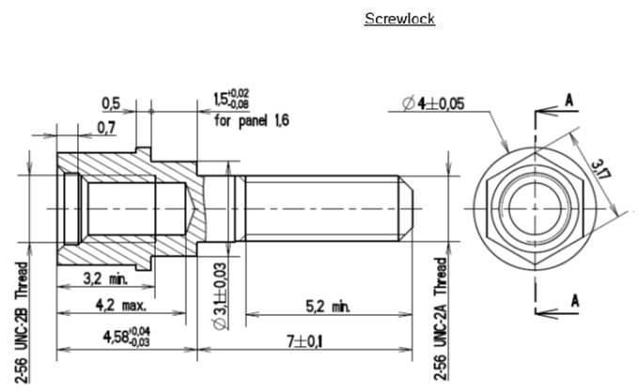
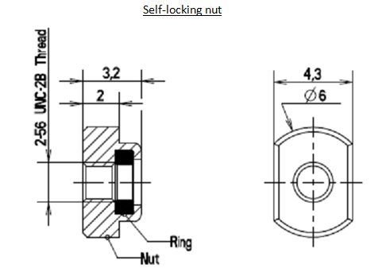
NOTES:
            - All dimensions in mm.
            - Weight:
- Screwlock 0.45g
- Self-Locking Nut 0.4 g

Torque Values | Min (Nm) | Max (Nm)
Screwlock male side | 0.44 | 0.48
Screwlock female side | 0.28 | 0.32
Self-locking Nut | 0.44 | 0.48
VARIANT 22 – SCREW SUB-ASSEMBLY (FOR SHELL SIZE 9 TO 69) HEX. HOLE HEAD
Screw
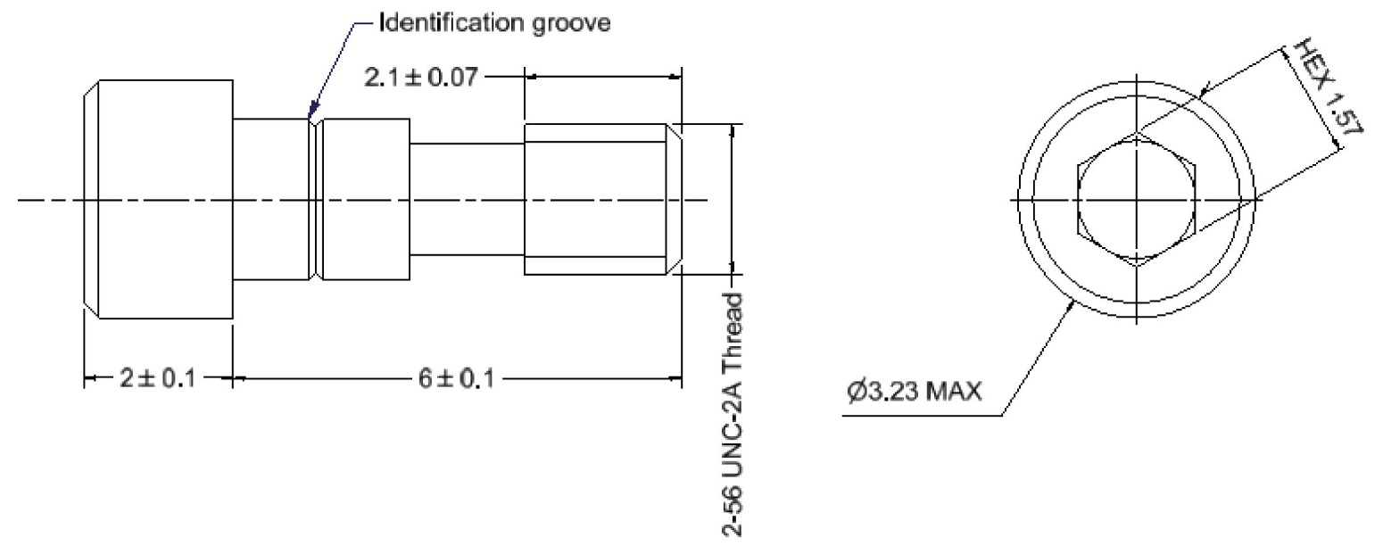
NOTES:
            - All dimensions in mm.
            - Weight:
- Screw 0.3g
- Clip 0.14g

Torque Values | Min (Nm) | Max (Nm)
Screw | 0.28 | 0.32
VARIANT 27 – SCREWLOCK FOR CONNECTORS 75SBT (FOR SHELL SIZE 9 TO 69)
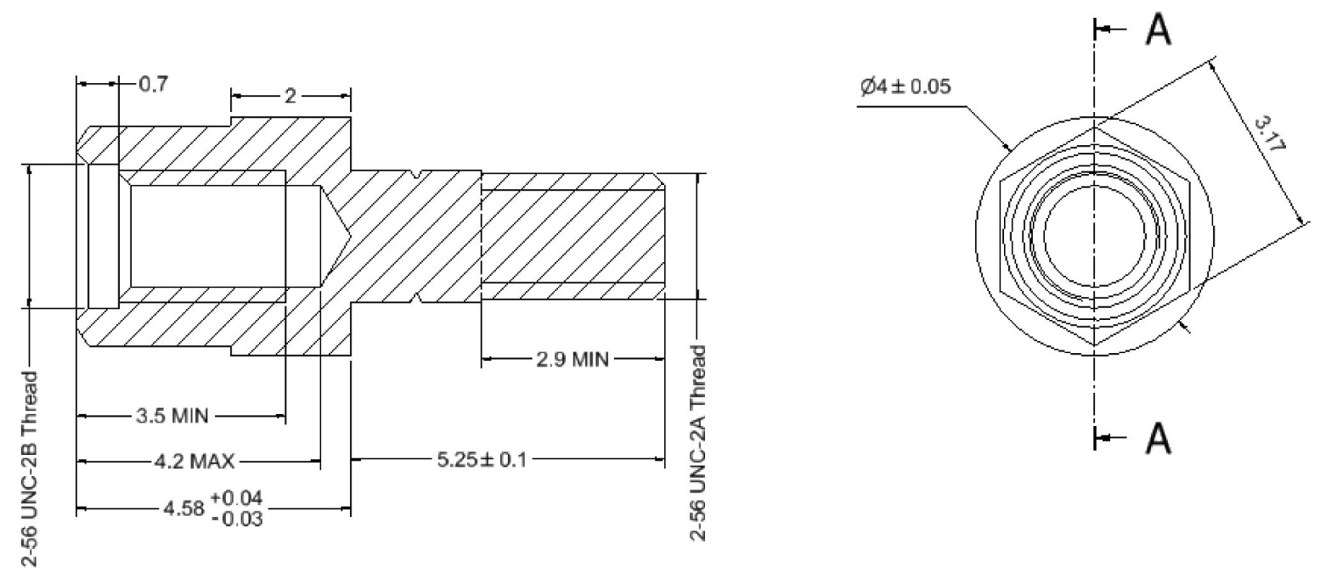
NOTES:
            - All dimensions in mm.
            - Weight:
- Screwlock 0.43g

Torque Values | Min (Nm) | Max (Nm)
Screwlock male side | 0.44 | 0.48
Screwlock female side | 0.28 | 0.32

VARIANTS 28 TO 32 – SCREWLOCK FOR CONNECTORS 75SBT (REAR PANEL MOUNT) (FOR SHELL SIZE 9 TO 69) PANEL THICKNESS 0.8 TO 2.4mm
Variant | 28 | 29 | 30 | 31 | 32
Panel Thickness (+0.2 -0) | 0.8 | 1.2 | 1.6 | 2 | 2.4
Dimension A | 0.7 | 1.1 | 1.5 | 1.9 | 2.3
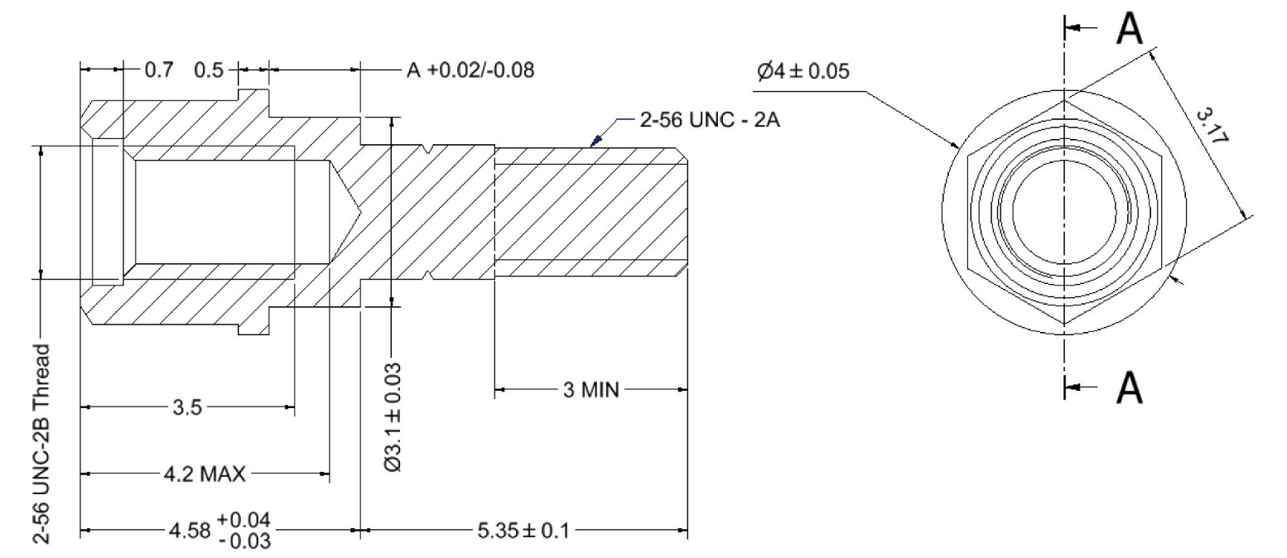
NOTES:
            - All dimensions in mm.
            - Weight:
- Screwlock 0.43g

Torque Values | Min (Nm) | Max (Nm)
Screwlock male side | 0.44 | 0.48
Screwlock female side | 0.28 | 0.32

VARIANT 33 – SCREWLOCK FOR CONNECTORS 75RB/CBR (FOR SHELL SIZE 9 TO 51)
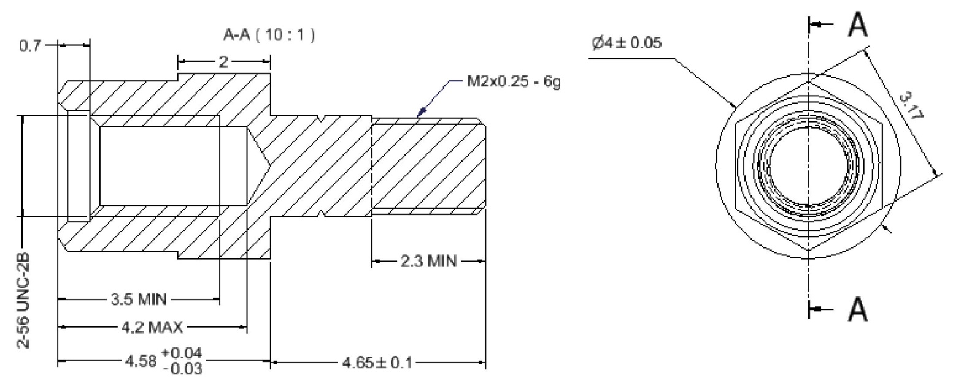
NOTES:
            - All dimensions in mm.
            - Weight:
- Screwlock 0.43g

Torque Values | Min (Nm) | Max (Nm)
Screwlock male side | 0.44 | 0.48
Screwlock female side | 0.28 | 0.32

VARIANTS 34 TO 38 – SCREWLOCK FOR CONNECTORS 75RB/CBR (REAR PANEL MOUNT) (FOR SHELL SIZES 9 TO 51) PANEL THICKNESS 0.8 TO 2.4mm
Variant | 34 | 35 | 36 | 37 | 38
Panel Thickness (+0.2 -0) | 0.8 | 1.2 | 1.6 | 2 | 2.4
Dimension A | 0.7 | 1.1 | 1.5 | 1.9 | 2.3
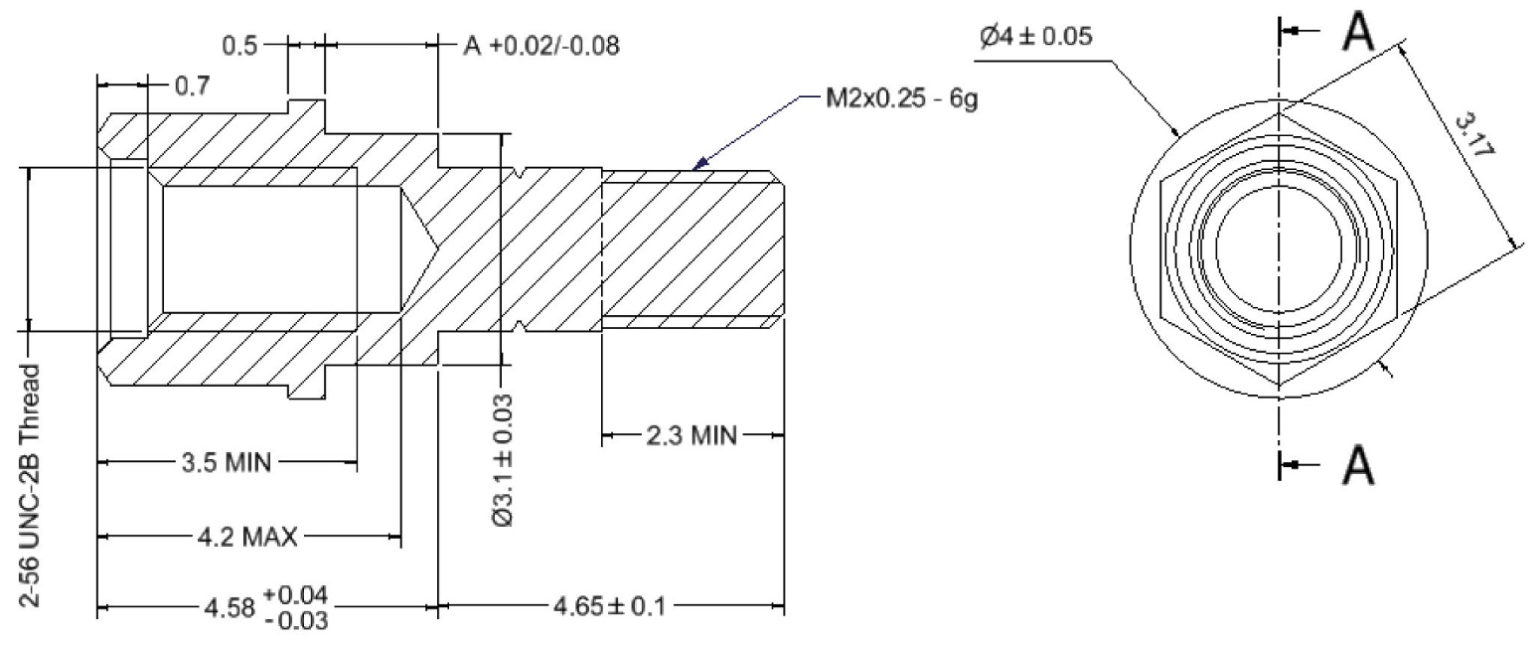
NOTES:
            - All dimensions in mm.
            - Weight:
- Screwlock 0.43g

Torque Values | Min (Nm) | Max (Nm)
Screwlock male side | 0.44 | 0.48
Screwlock female side | 0.28 | 0.32

VARIANT 39 - SCREW SUB-ASSEMBLY, SLOT HEAD (FOR SHELL SIZE 100)
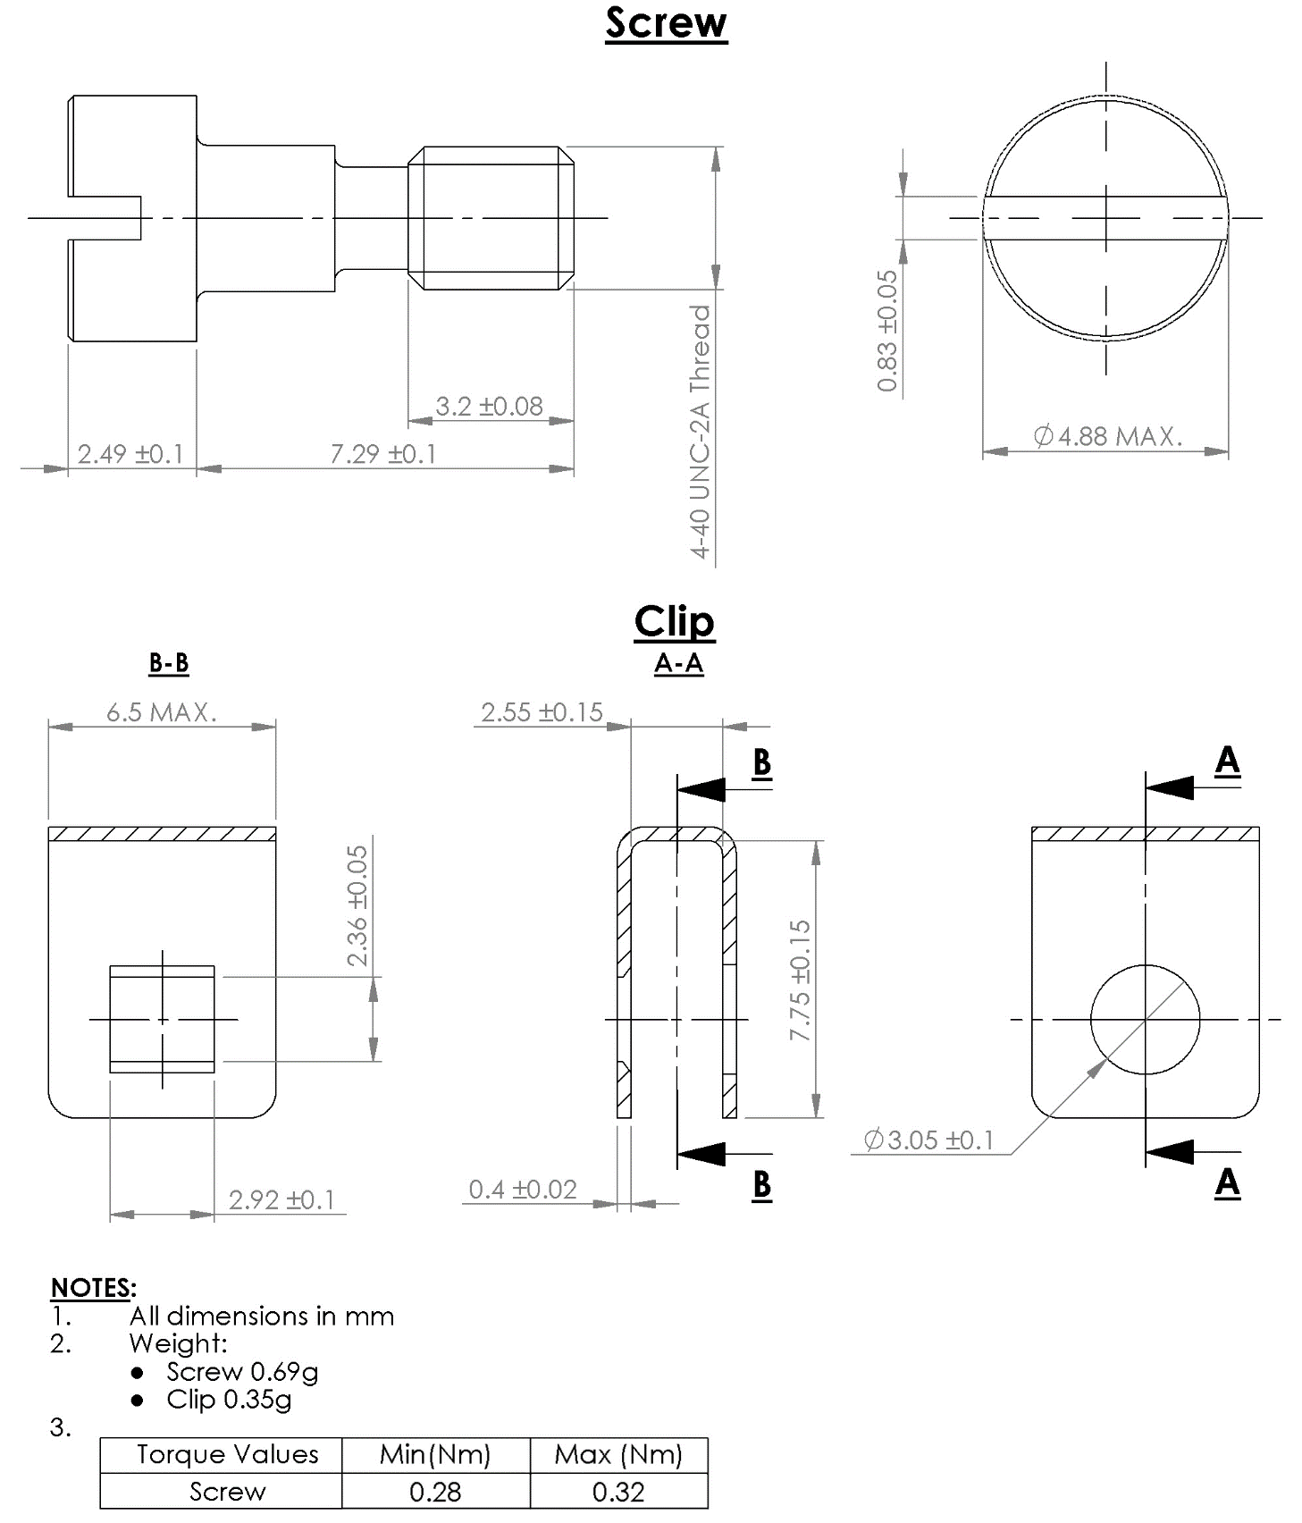

VARIANT 40 - SCREW SUB-ASSEMBLY, HEX. HOLE HEAD (FOR SHELL SIZE 100)
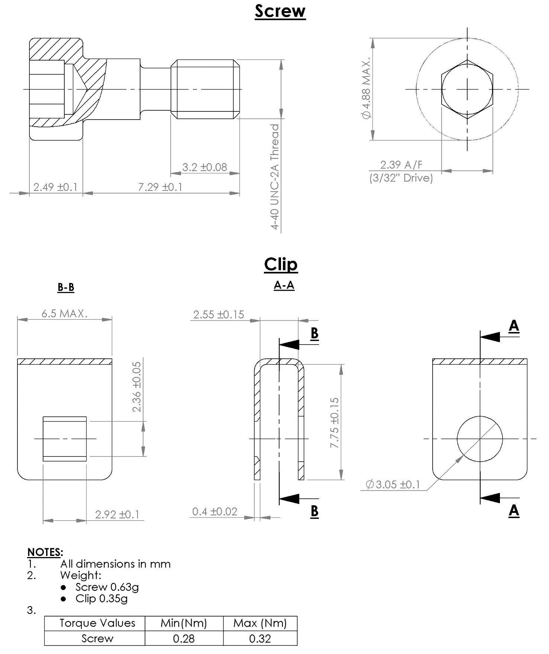

VARIANT 41 - SCREWLOCK ASSEMBLY FOR CONNECTOR SAVERS (FOR SHELL SIZE 100)
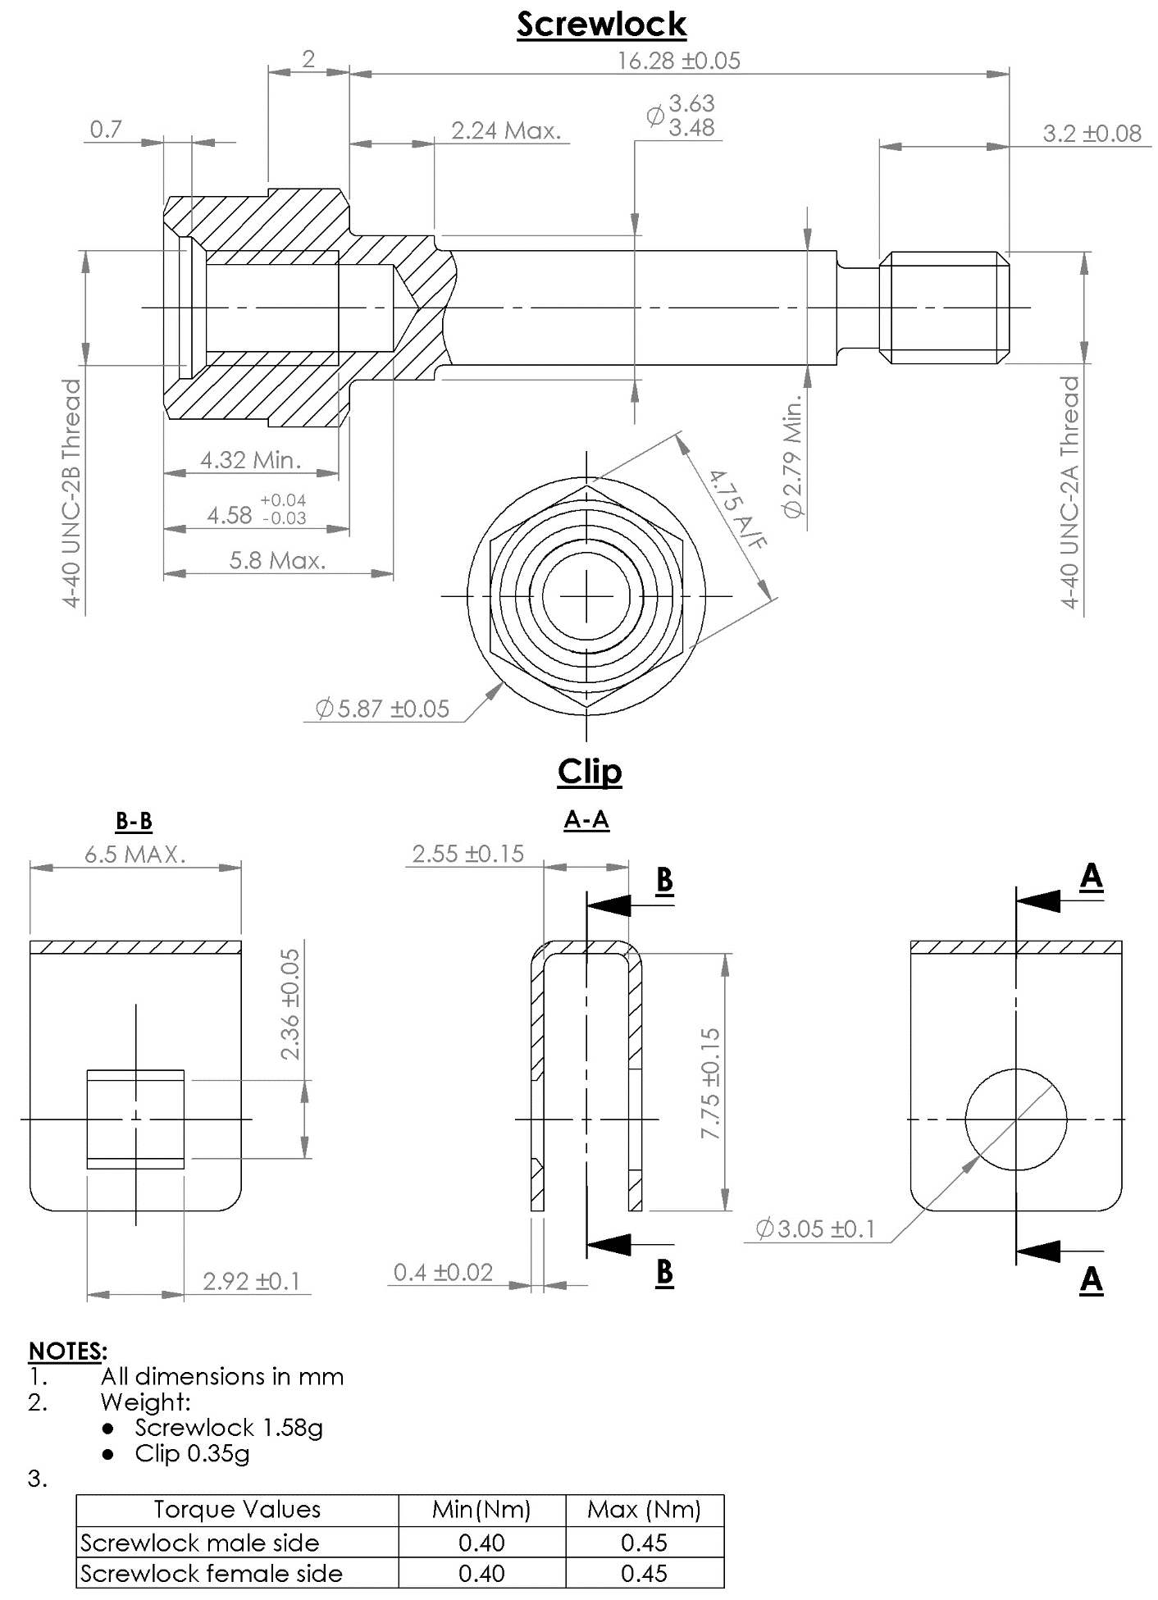

VARIANT 42 - SCREWLOCK FOR CONNECTORS GMR7580, GMR7590 (FOR SHELL SIZE 9 TO 69)
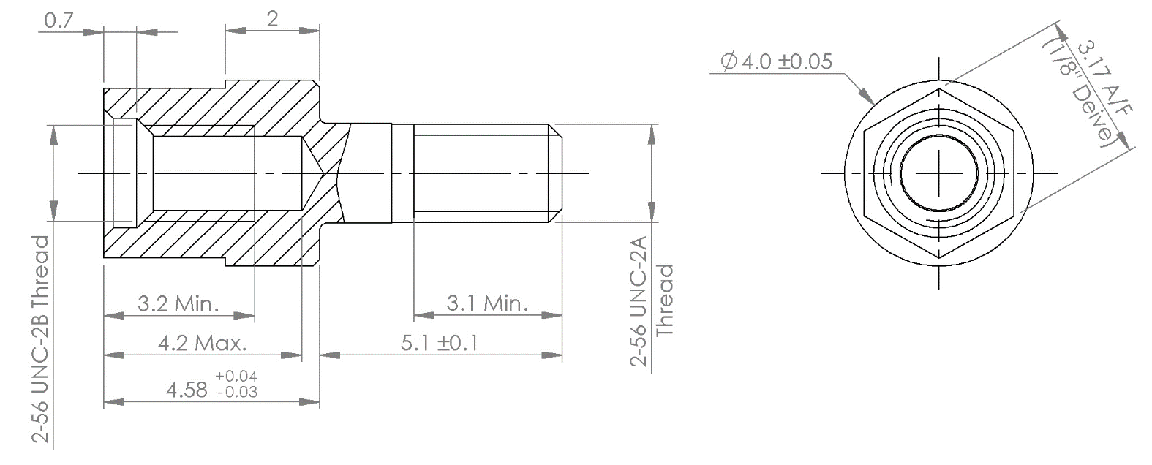
NOTES:
            - All dimensions in mm.
            - Weight:
- Screwlock 0.48g

Torque Values | Min (Nm) | Max (Nm)
Screwlock male side | 0.44 | 0.48
Screwlock female side | 0.28 | 0.32

VARIANT 43 - SCREWLOCK FOR CONNECTORS GMR7580, GMR7590 (FOR SHELL SIZE 100)
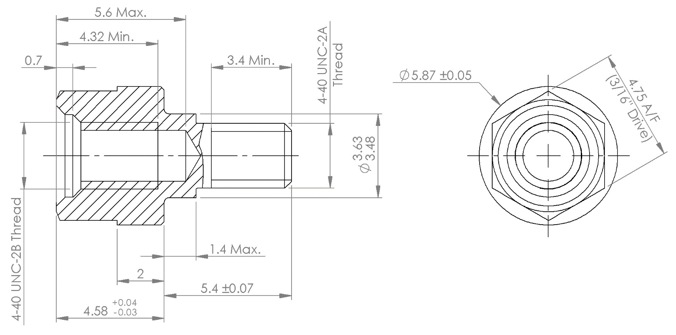
NOTES:
            - All dimensions in mm.
            - Weight:
- Screwlock 1g

Torque Values | Min (Nm) | Max (Nm)
Screwlock male side | 0.4 | 0.45
Screwlock female side | 0.4 | 0.45

VARIANT 44 – SCREW SUB-ASSEMBLY FOR LIGHTWEIGHT BACKSHELL, HEX. HOLE HEAD (FOR SHELL SIZE 9 TO 69)
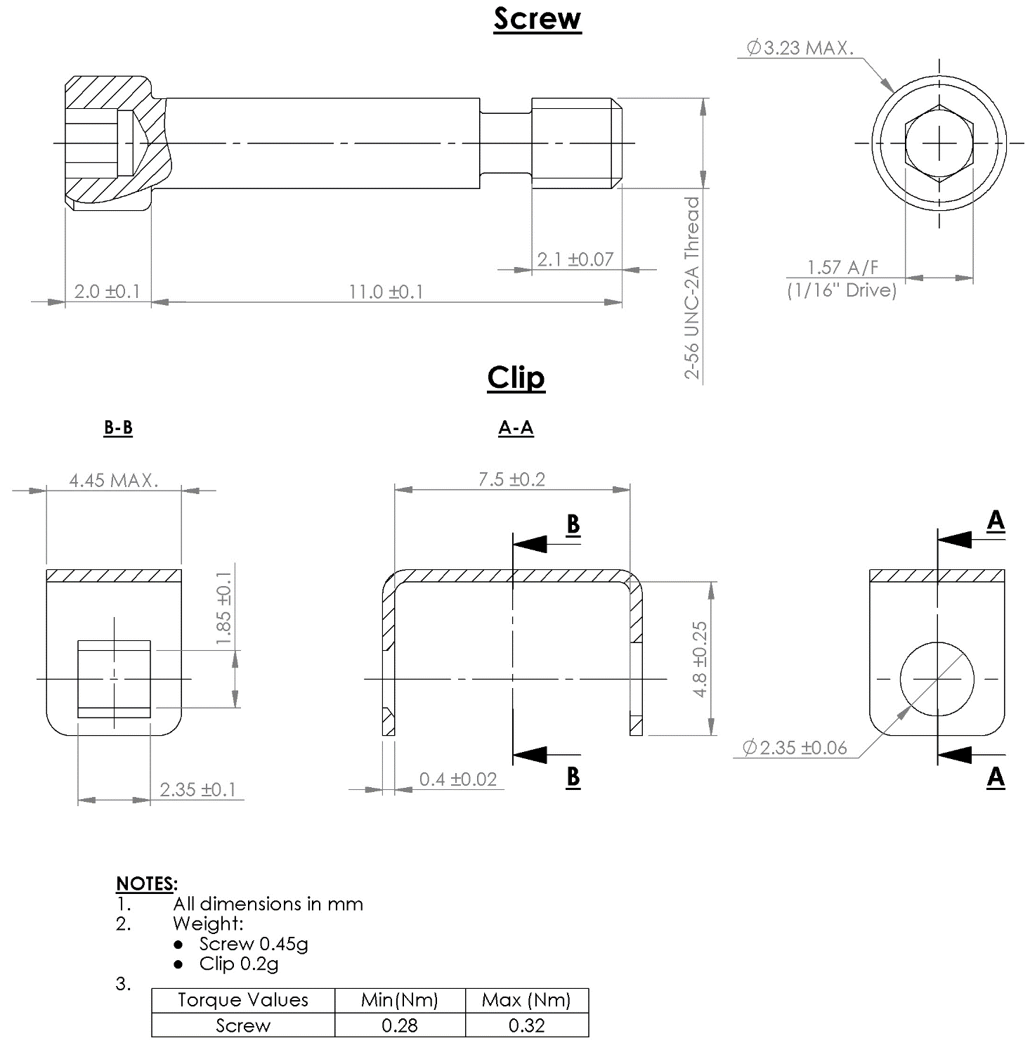
VARIANT 45 – SCREW SUB-ASSEMBLY FOR LIGHTWEIGHT BACKSHELL, SLOT HEAD (FOR SHELL SIZE 100)
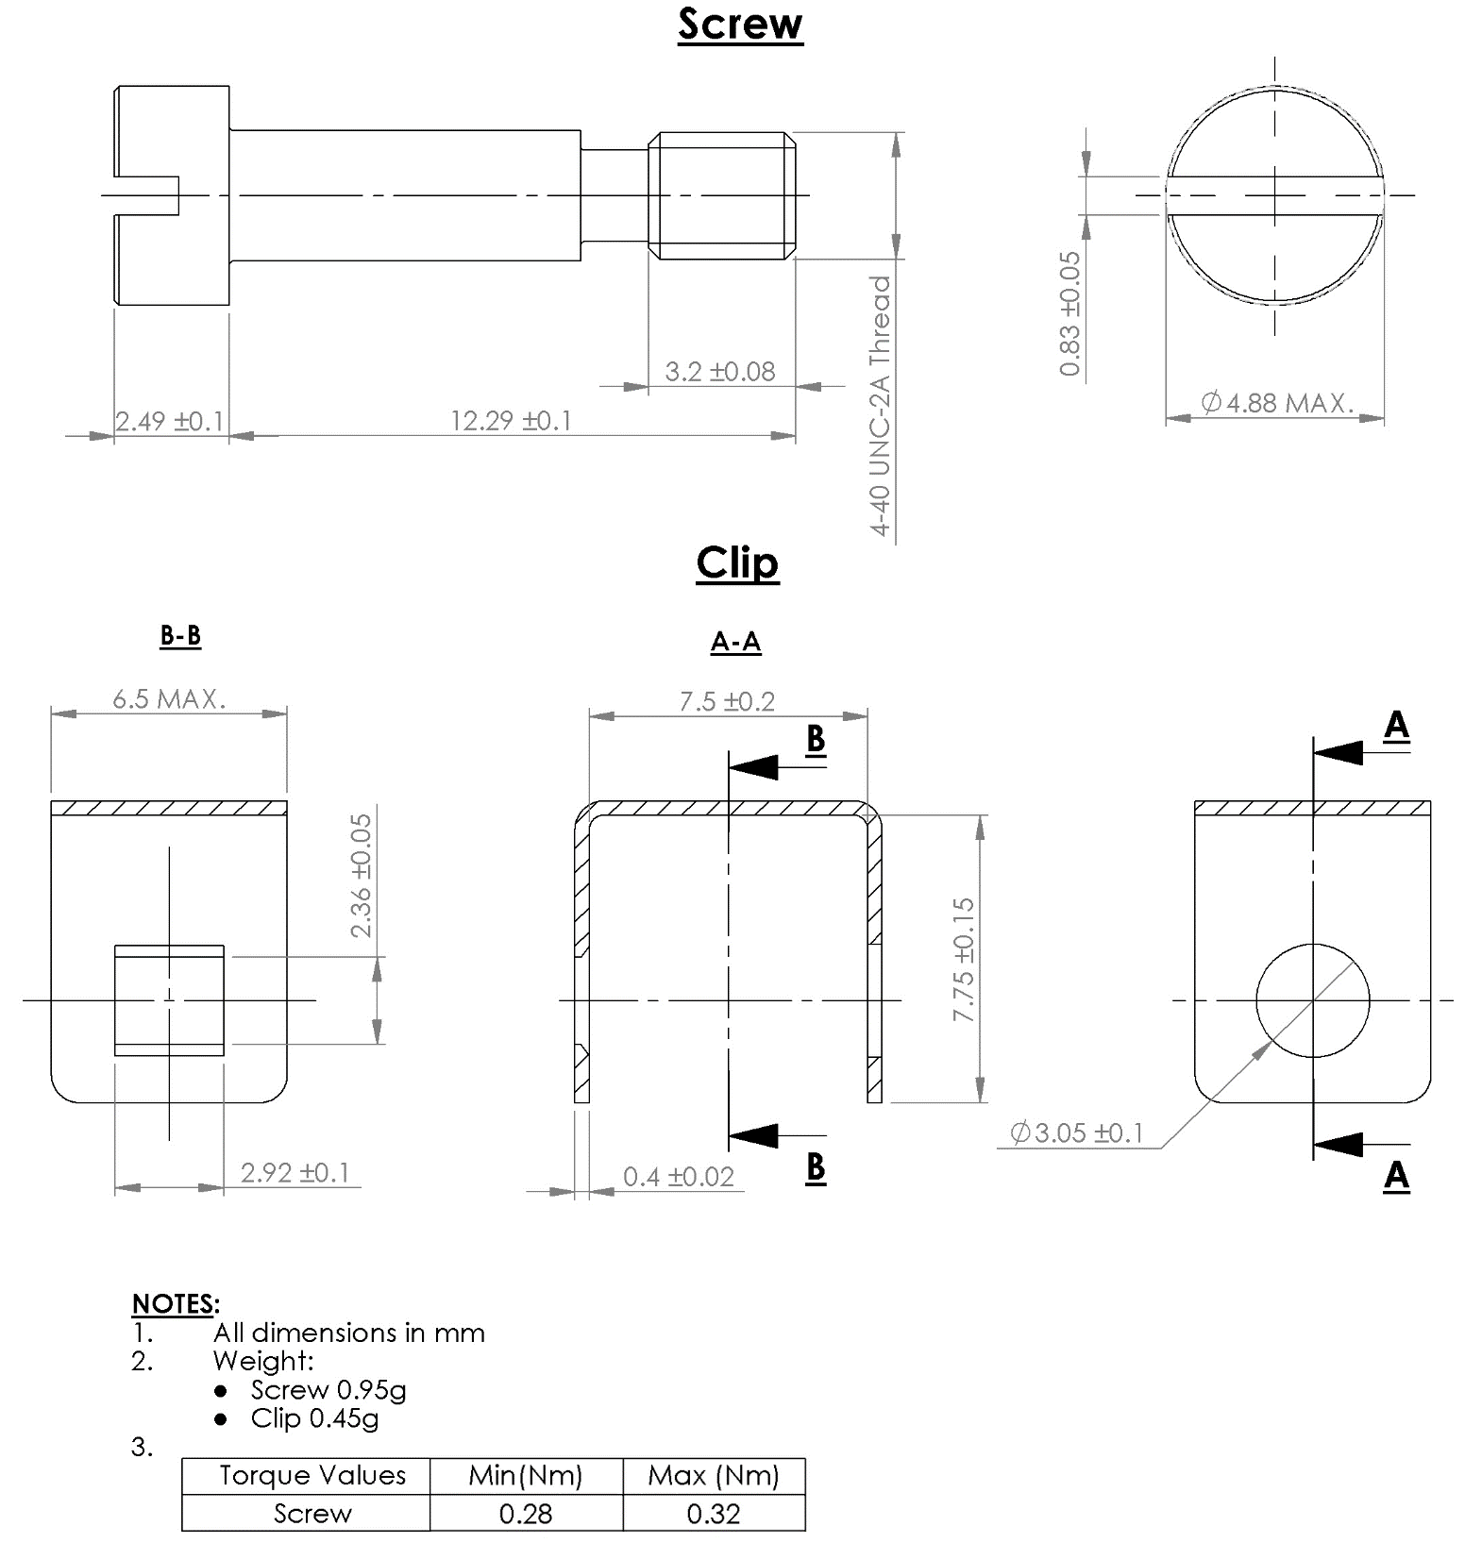

VARIANT 46 – SCREW SUB-ASSEMBLY FOR LIGHTWEIGHT BACKSHELL, HEX. HOLE HEAD (FOR SHELL SIZE 100)
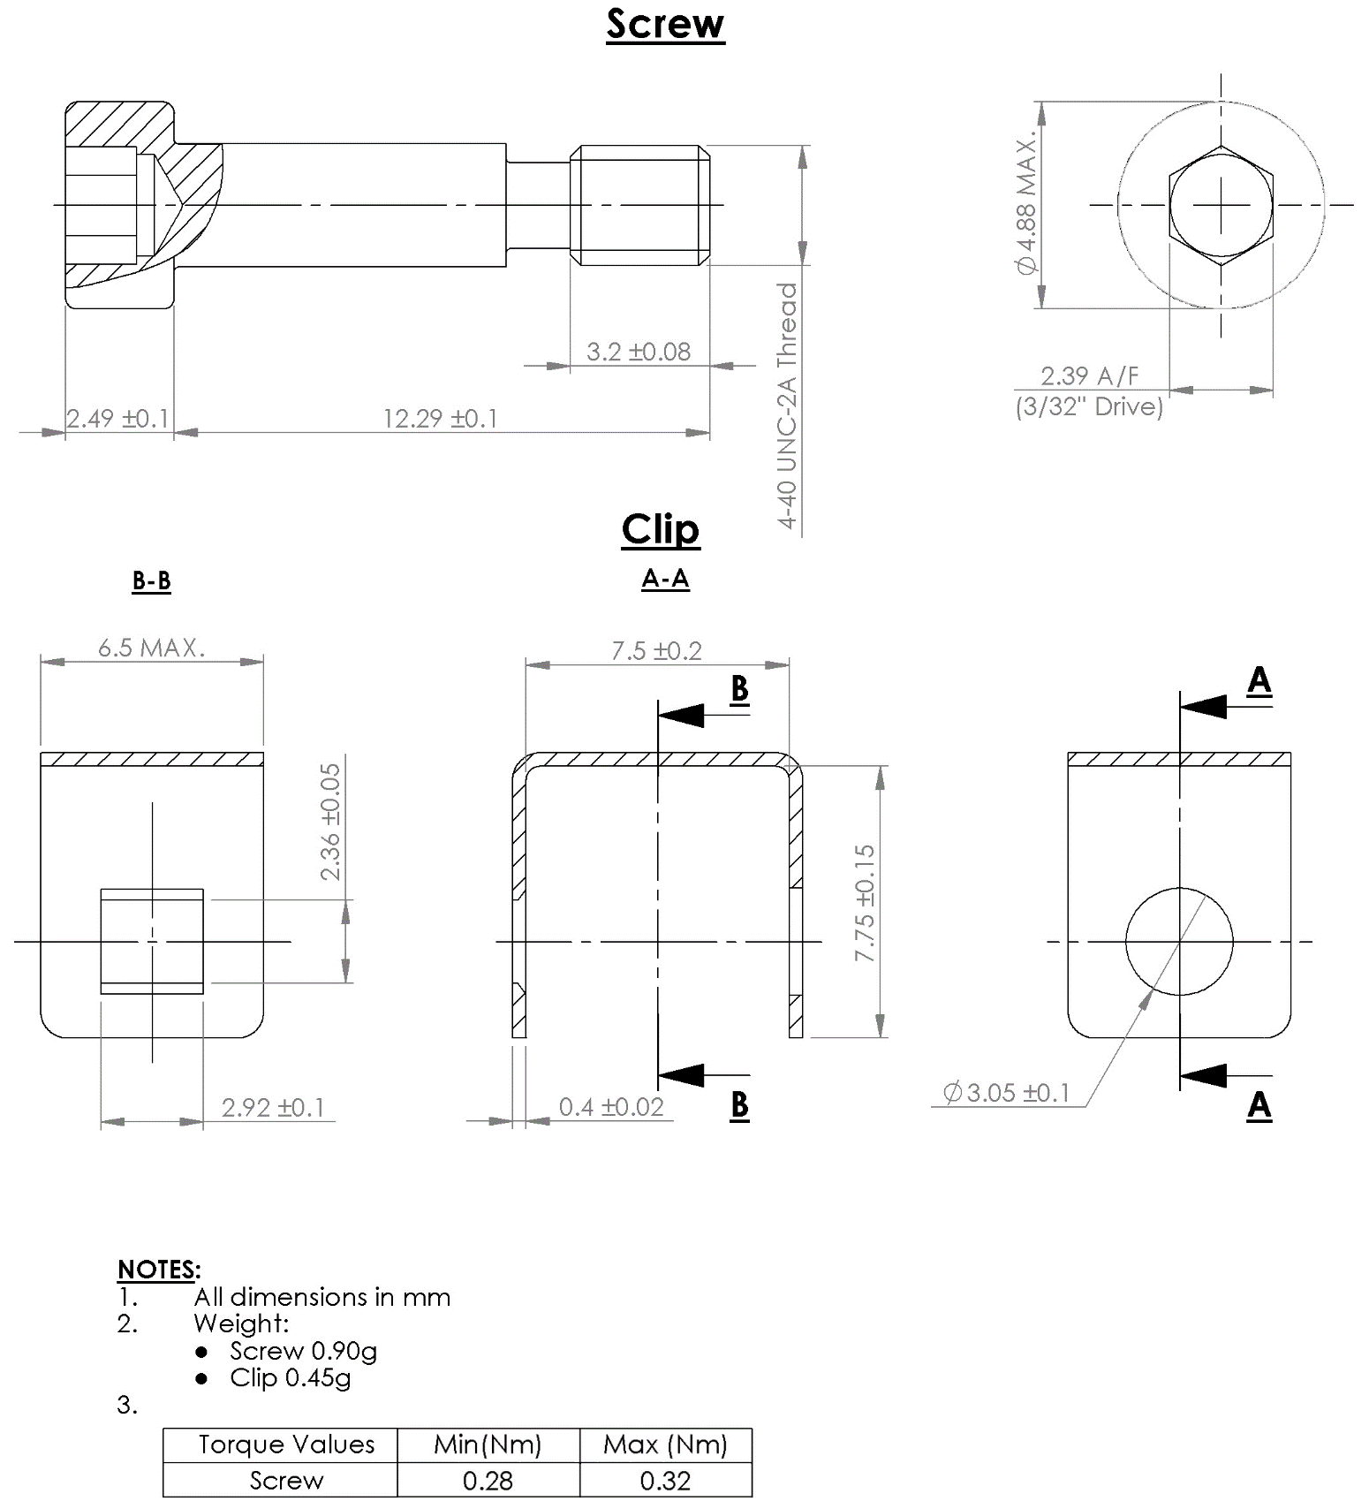

VARIANT 47 - SCREWLOCK SUB-ASSEMBLY (FRONT PANEL MOUNTING) WITH NUT AND SPLIT RING (FOR SHELL SIZE 9 TO 69)
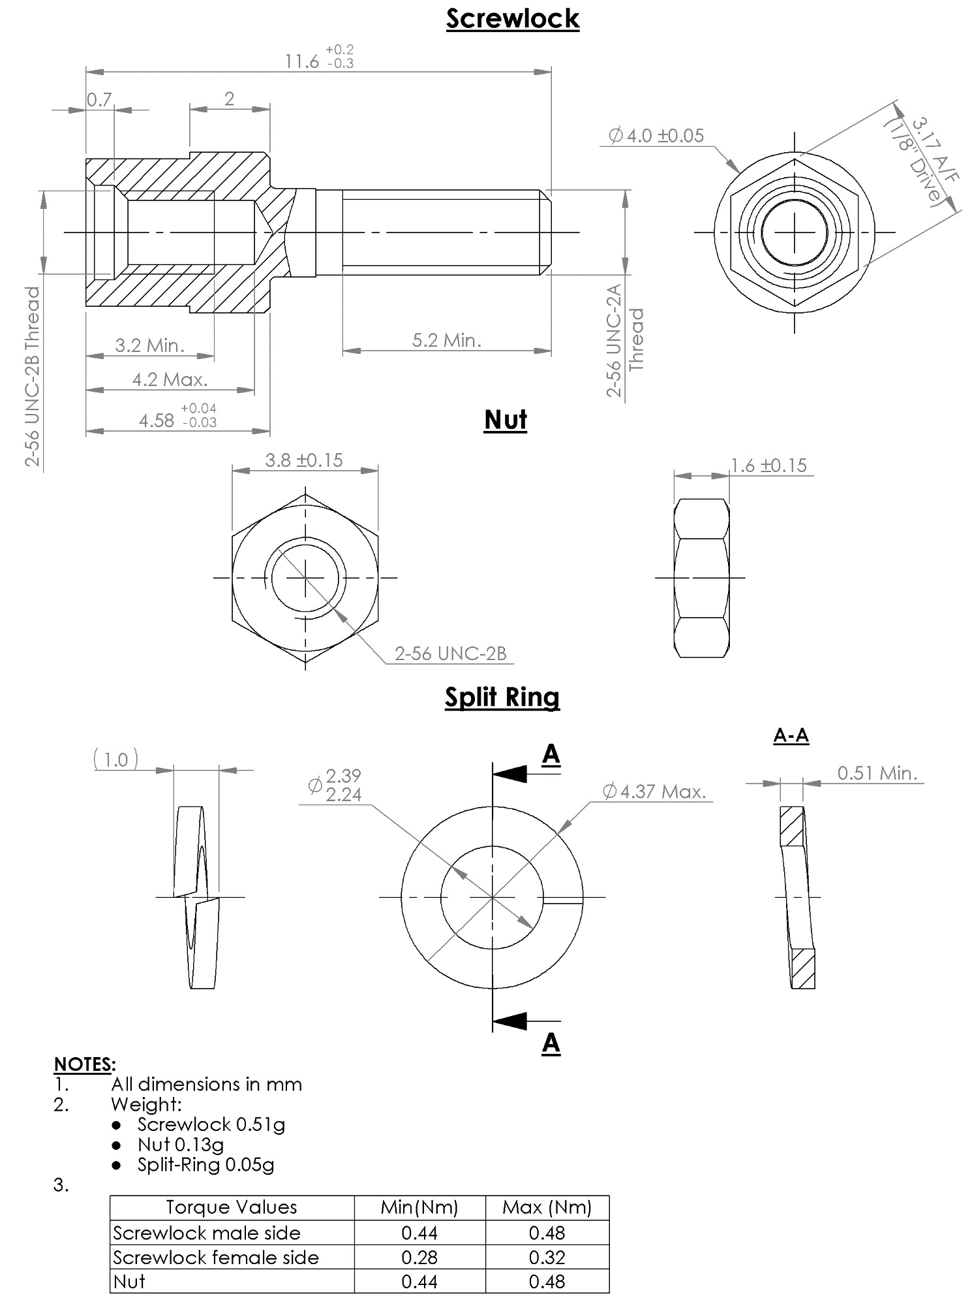
VARIANT 48 - SCREWLOCK SUB-ASSEMBLY (FRONT PANEL MOUNTING) WITH NUT AND SPLIT RING (FOR SHELL SIZE 100)
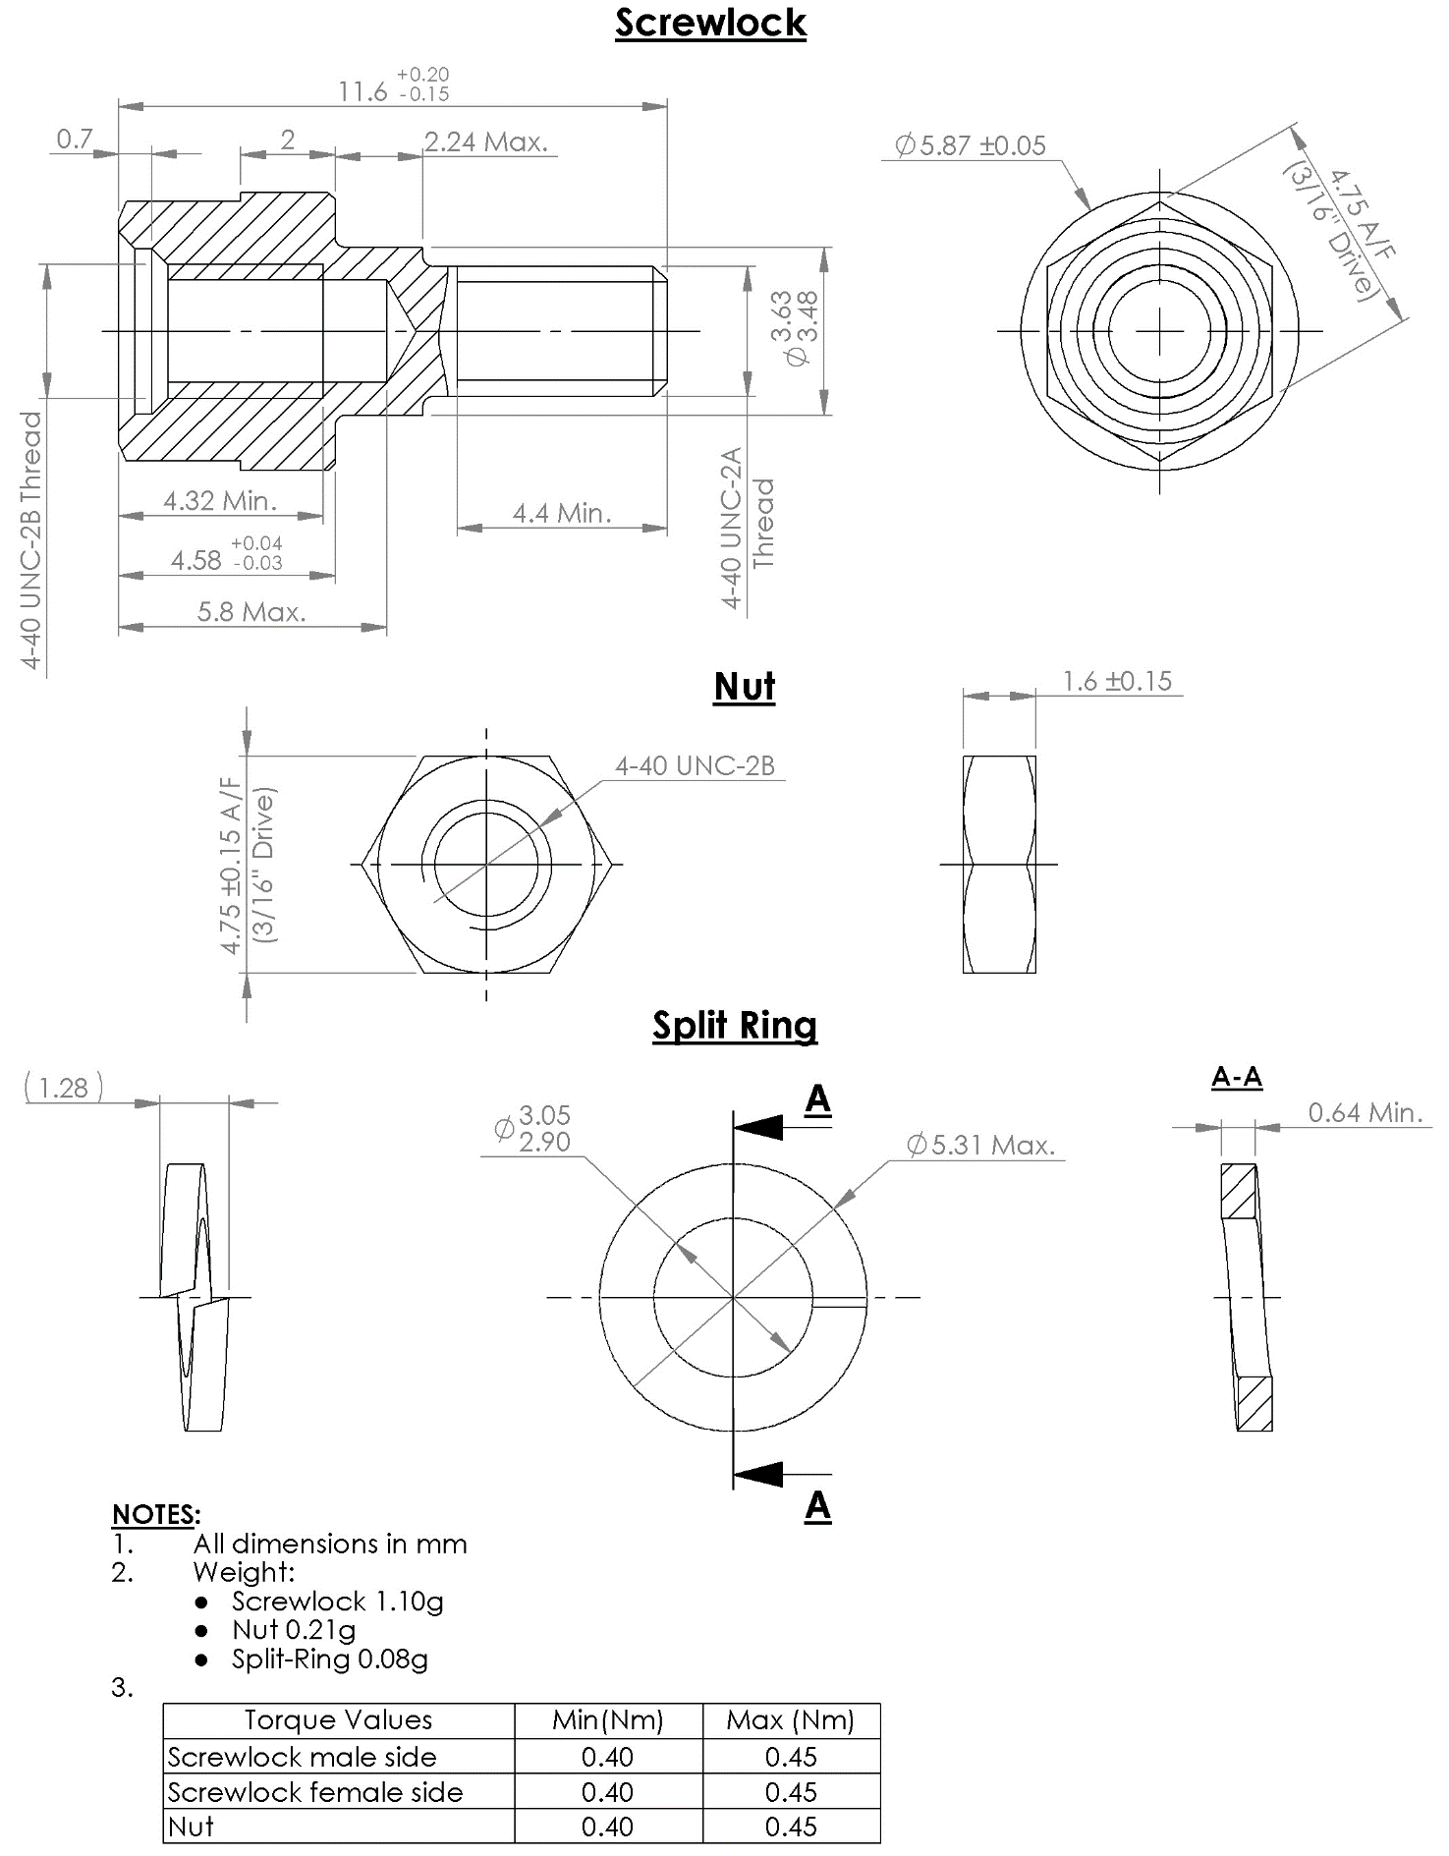
VARIANTS 49 TO 53 - SCREWLOCK SUB-ASSEMBLY (REAR PANEL MOUNTING) WITH NUT AND SPLIT RING (FOR SHELL SIZE 9 TO 69) PANEL THICKNESS 0.8 TO 2.4mm
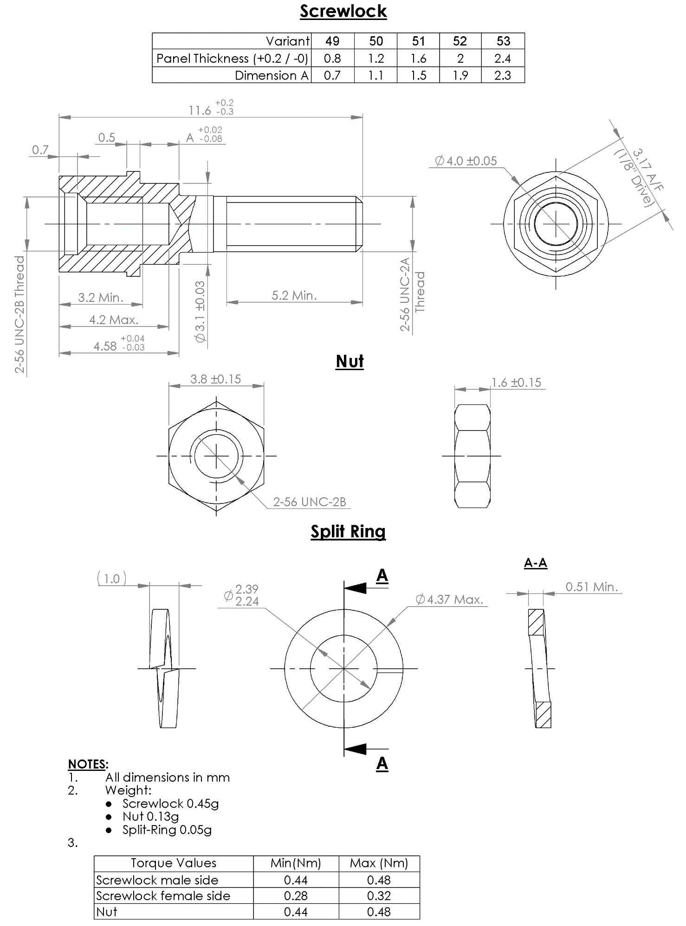
VARIANTS 54 TO 58 - SCREWLOCK SUB-ASSEMBLY (REAR PANEL MOUNTING) WITH NUT AND SPLIT RING (FOR SHELL SIZE 100) PANEL THICKNESS 0.8 TO 2.4mm
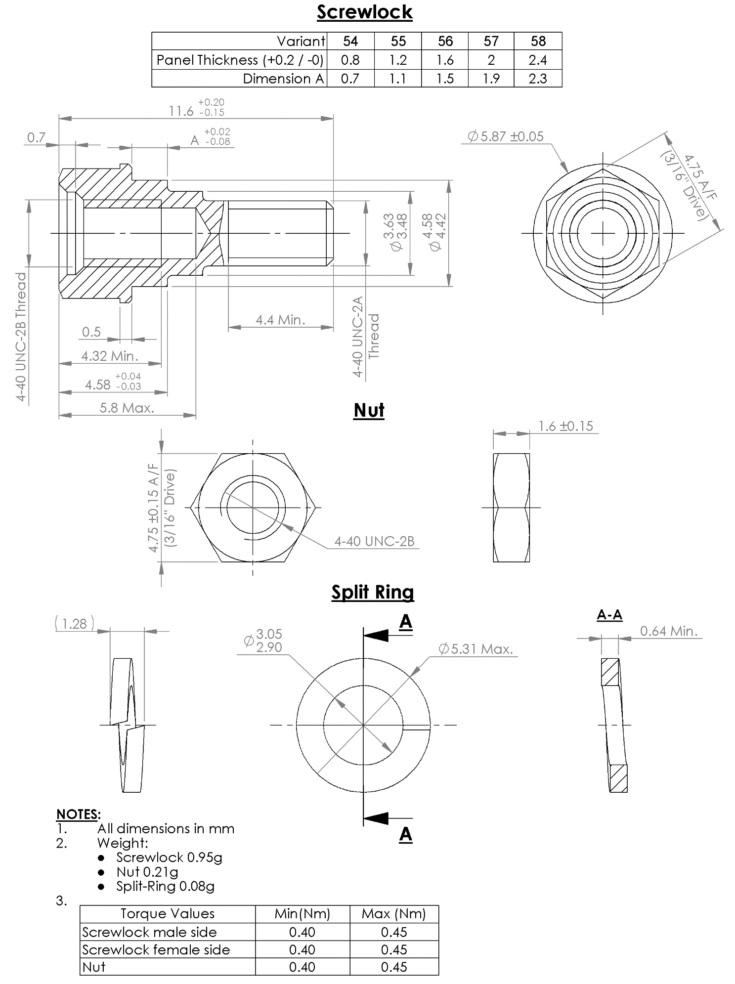
VARIANTS 59 TO 63 - SCREWLOCK FOR CONNECTORS GMR7580, GMR7590 (REAR PANEL MOUNTING) (SHELL SIZE 9 TO 69), PANEL THICKNESS 0.8 TO 2.4MM
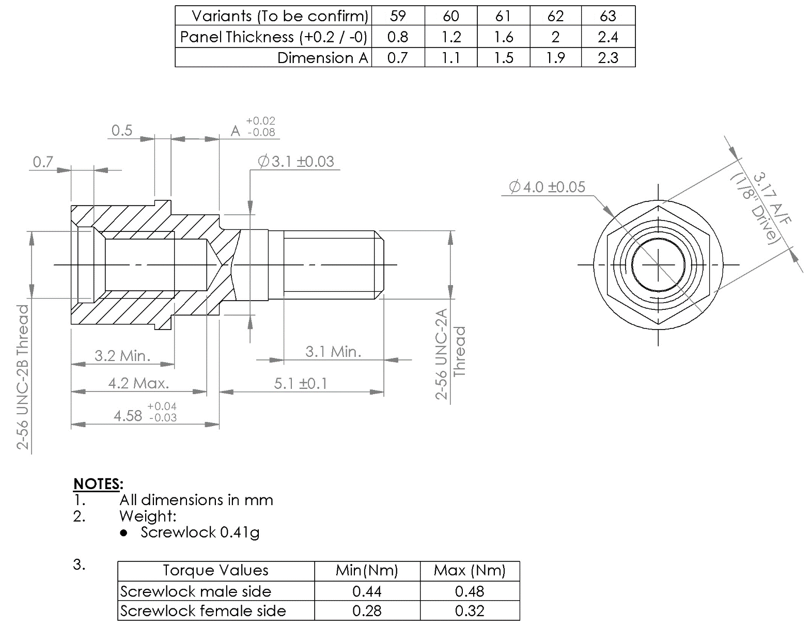
VARIANTS 64 TO 68 - SCREWLOCK FOR CONNECTORS GMR7580, GMR7590 (REAR PANEL MOUNTING) (SHELL SIZE 100), PANEL THICKNESS 0.8 TO 2.4MM
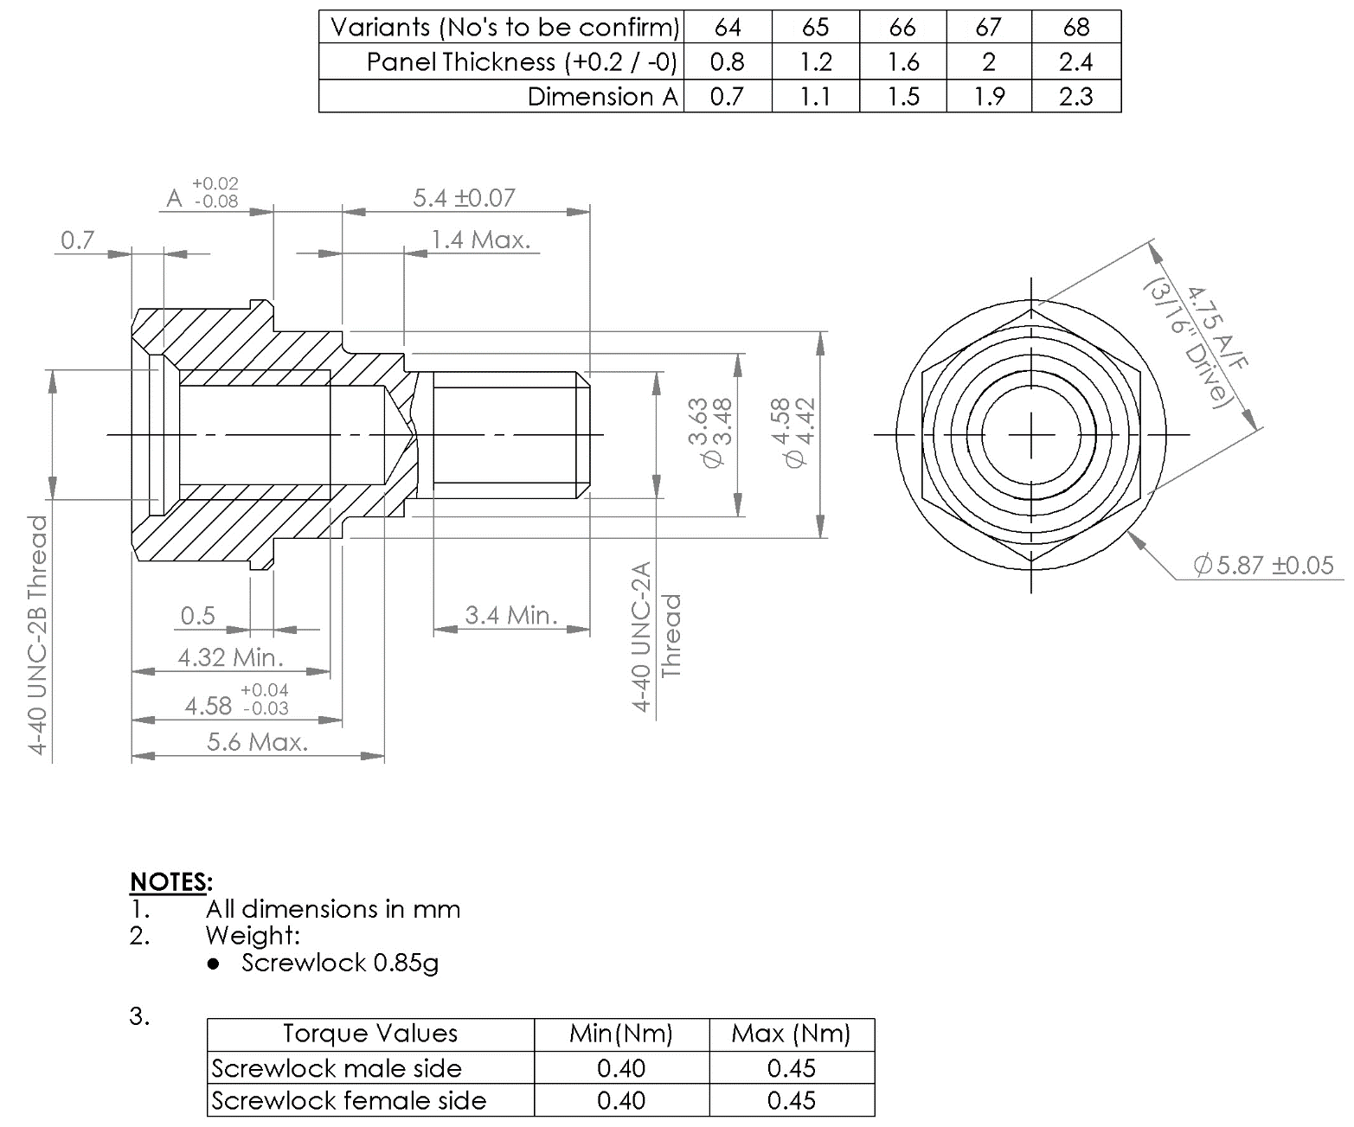

APPLICABLE DOCUMENTS
The following documents form part of this specification and shall be read in conjunction with it:
          - ESCC Generic Specification No. 3401, Connectors, Electrical, Circular and Rectangular.
          - ESCC Detail Specification No. 3401/029, Connectors, Electrical, Rectangular, Microminiature, based on Type MDM.
          - ESCC Detail Specification No. 3401/041, Connector Savers, Electrical, Rectangular, Microminiature, based on type MDM.
          - ESCC Detail Specification No. 3401/077, Connectors, Electrical, Rectangular, Microminiature, Removable Contacts, based on Type MDMA.
          - ESCC Detail Specification No. 3401/087, Lightweight Accessories for Rectangular, Microminiature Connectors, 3401/029 and 3401/077.

TERMS, DEFINITIONS, ABBREVIATIONS, SYMBOLS AND UNITS
For the purpose of this specification, the terms, definitions, abbreviations, symbols and units specified in ESCC Basic Specification No. 21300 shall apply.

REQUIREMENTS

GENERAL
The complete requirements for procurement of the accessories specified herein are stated in this specification and ESCC Generic Specification No. 3401. Deviations from the Generic Specification, applicable to this specification only, are listed in Para. 4.2.
Deviations from the applicable Generic Specification and this Detail Specification, formally agreed with specific Manufacturers on the basis that the alternative requirements are equivalent to the ESCC requirements and do not affect the components’ reliability, are listed in the appendices attached to this specification.

DEVIATIONS FROM GENERIC SPECIFICATION

Deviations from Special In-process Controls
Only Para. 5.2.1 shall apply.

Deviations from Final Production Tests (Chart II)
Only the following tests shall be performed:
          - Para. 9.6, Dimension Check.
          - Para. 9.7, External Visual Inspection. The magnification shall be x3.

Deviations from Burn-in and Electrical Measurements (Chart III)
Chart III is not applicable.

Deviations from Qualification, Environmental and Endurance Tests (Chart IV)
Chart IV is not applicable.

Deviations from Lot Acceptance Tests (Chart V)
Chart V is not applicable.

MECHANICAL REQUIREMENTS

Dimension Check
The dimensions of the accessories specified herein shall be verified in accordance with the requirements set out in Para. 9.6 of ESCC Generic Specification No. 3401 and Para. 4.2.2 of this specification; they shall conform to those shown in Figure 2.

Weight
The maximum weight of the accessories specified herein shall be as specified in Figure 2.

Torque Value
The torque value to be used for tightening the screws of the accessories specified herein shall be as specified in Table 1(b).

MATERIALS AND FINISHES
The materials and finishes shall be as specified herein. Where a definite material is not specified, a material which will enable the components specified herein to meet the performance requirements of this specification shall be used. Acceptance or approval of any constituent material does not guarantee acceptance of the finished product.

Screw Lock Assemblies and Brackets
These shall be made of passivated stainless steel, type 303.

Interfacial Seals
These shall be made of silicon base rubber.

MARKING

General
The marking of components delivered to this specification shall be in accordance with the requirements of ESCC Basic Specification No. 21700 and the following paragraphs. Each component shall be marked in respect of:
          - The ESCC qualified components symbol (for ESCC qualified components only).
          - The ESCC Component Number.
          - Traceability Information.
These components being too small to accommodate the marking specified above, the ESCC marking information shall accompany the component in its primary package.

The ESCC Component Number
The ESCC Component Number shall be constituted and marked as follows:
Example: 340103203B
- Detail Specification Number: 3401032
- Type Variant (See Figure 2): 03
- Testing Level: B

Traceability Information
Traceability information shall be marked in accordance with ESCC Basic Specification No. 21700.

ELECTRICAL MEASUREMENTS
Not applicable.

SCREENING TESTS (TABLES 4 AND 5)
Not applicable.

ENVIRONMENTAL AND ENDURANCE TESTS
Not applicable.

