

Page 1 of 84

CONNECTORS, ELECTRICAL, RECTANGULAR,
MICROMINIATURE
BASED ON TYPE MDM

ESCC Detail Specification No. 3401/029

Issue 17 Draft A | July 2019



Document Custodian: European Space Agency – see https://escies.org

Legal Disclaimer and Copyright
European Space Agency, Copyright © 2019. All rights reserved.
The European Space Agency disclaims any liability or responsibility, to any person or entity, with respect to any loss or damage caused, or alleged to be caused, directly or indirectly by the use and application of this ESCC publication.
This publication, without the prior permission of the European Space Agency and provided that it is not used for a commercial purpose, may be:
- copied in whole, in any medium, without alteration or modification.
- copied in part, in any medium, provided that the ESCC document identification, comprising the ESCC symbol, document number and document issue, is removed.

DOCUMENTATION CHANGE NOTICE
(Refer to https://escies.org for ESCC DCR content)
DCR No. | CHANGE DESCRIPTION
TBA | Specification upissued to incorporate changes per DCR.
Draft 17A  S.Thacker  03/07/2019 | Initial draft revision of spec to incorporate changes proposed by Glenair.  Changes in this draft from issue 16 are highlighted yellow for information

TABLE OF CONTENTS
1 General 6
1.1 SCOPE 6
1.2 COMPONENT TYPE VARIANTS AND RANGE OF COMPONENTS 6
1.2.1 Connector Termination Type and Associated Mounting Hardware 6
1.3 MAXIMUM RATINGS 6
1.4 PARAMETER DERATING INFORMATION 6
1.5 PHYSICAL DIMENSIONS 6
1.6 CONTACT ARRANGEMENTS 6
2 APPLICABLE DOCUMENTS 72
3 TERMS, DEFINITIONS, ABBREVIATIONS, SYMBOLS AND UNITS 72
4 REQUIREMENTS 72
4.1 GENERAL 72
4.2 DEVIATIONS FROM GENERIC SPECIFICATION 73
4.2.1 Deviations from Special In-Process Controls 73
4.2.2 Deviations from Final Production Tests (Chart II) 73
4.2.3 Deviations from Burn-in and Electrical Measurements (Chart III) 73
4.2.4 Deviations from Qualification Tests (Chart IV) 73
4.2.5 Deviations from Lot Acceptance Tests (Chart V) 73
4.3 MECHANICAL REQUIREMENTS 73
4.3.1 Dimension Check 73
4.3.2 Weight 73
4.3.3 Contact Capability 74
4.3.4 Contact Retention (in Insert) 74
4.3.5 Mating and Unmating Forces 74
4.3.6 Insert Retention (in Shell) 74
4.3.7 Jackscrew Retention 74
4.3.8 Contact Insertion and Withdrawal Forces 74
4.3.9 Engagement and Separation Forces (Male Contacts) 74
4.3.10 Oversize Pin Exclusion 74
4.3.11 Probe Damage 74
4.3.12 Solderability 74
4.4 MATERIALS AND FINISHES 75
4.4.1 Shells 75
4.4.2 Inserts 75
4.4.3 Contacts 75
4.4.3.1 Female Contacts 75
4.4.3.2 Male Contacts 75
4.4.4 Interfacial Seals 75
4.4.5 Insulated Wires 75
4.4.6 Uninsulated Solid Wire 75
4.4.7 Rear Potting 75
4.5 MARKING 76
4.5.1 General 76
4.5.2 The ESCC Component Number 76
4.5.3 Characteristics 76
4.5.3.1 Shell Size 76
4.5.3.2 Contact Type 76
4.5.3.3 Termination Type 77
4.5.3.4 Mounting 77
4.5.4 Traceability Information 77
4.6 ELECTRICAL MEASUREMENTS 78
4.6.1 Electrical Measurements at Room Temperature 78
4.6.2 Electrical Measurements at High and Low Temperatures 78
4.6.3 Circuits for Electrical Measurements 78
4.7 BURN-IN AND ELECTRICAL MEASUREMENTS (TABLES 4 AND 5) 78
4.8 ENVIRONMENTAL AND ENDURANCE TESTS (CHARTS IV AND V OF ESCC GENERIC SPECIFICATION No. 3401) 80
4.8.1 Measurements and Inspections on Completion of Environmental Tests 80
4.8.2 Measurements and Inspections at Intermediate Points during Endurance Tests 80
4.8.3 Measurements and Inspections on Completion of Endurance Tests 80
4.8.4 Conditions for Operating Life Test (Part of Endurance Testing) 80
4.8.5 Electrical Circuit for Operating Life Test 80
4.8.6 Conditions for High Temperature Storage Test (Part of Endurance Testing) 80
APPENDIX ‘A’ 84

General

SCOPE
This specification details the ratings, physical and electrical characteristics, test and inspection data for Electrical, Rectangular, Microminiature Connectors with Non-Removable Crimp-type Contacts and their associated insulated wires and uninsulated solid wires, and Solder Bucket Contacts, based on type MDM.
It shall be read in conjunction with:
- ESCC Generic Specification No. 3401, Connectors, Electrical, Rectangular and Circular.
- ESCC Detail Specification No. 3401/032, Accessories for Connectors, Microminiature, 3401/029, 3401/077 and Connector Savers 3401/041.
- ESCC Detail Specification No. 3401/087, Lightweight Accessories for Rectangular, Microminiature Connectors, 3401/029 and 3401/077.
the requirements of which are supplemented herein.

COMPONENT TYPE VARIANTS AND RANGE OF COMPONENTS
Variants of the basic type connectors specified herein and their different sizes, which are also covered by this specification, together with their mechanical characteristics, are scheduled in Table 1(a). The different sizes of associated insulated wires and uninsulated solid wires are given in Figure 2.

Connector Termination Type and Associated Mounting Hardware
Care must be taken during procurement to ensure that the threads of mounting hardware are applicable to the threaded holes, or threaded inserts, in the flange/body of the respective connector. The thread dimensions of the various connector termination types are specified in Figure 2.2 herein.
It is recommended that the mating connectors and the hardware are from the same manufacturer.

MAXIMUM RATINGS
The maximum ratings, which shall not be exceeded at any time during use or storage, applicable to the connectors specified herein, are given in Table 1(b).

PARAMETER DERATING INFORMATION
The derating information applicable to the connectors specified herein is shown in Figure 1.

PHYSICAL DIMENSIONS
The physical characteristics of the connectors, insulated wires and uninsulated solid wires specified herein are shown in Figure 2.

CONTACT ARRANGEMENTS
Contact arrangements are shown in Figure 3.

TABLE 1(a) – COMPONENT TYPE VARIANTS AND RANGE OF COMPONENTS
Variant Number | Shell Finish  (See Para. 4.4.1 for details) | Shell Size | Mating / Unmating Forces (N) | Termination Type | Weight Max  (g)
01 | Nickel | See Note 1 | See Note 1 | See Note 2 | See Note 2
02 | Gold
NOTES:
            - The Mating and Unmating Forces for each shell size are shown in the table below:
Shell Size  (Number of Contacts) | Mating Force  N Max | Unmating Force
Shell Size  (Number of Contacts) | Mating Force  N Max | N Max | N Min
9 | 25 | 25 | 1.3
15 | 42 | 42 | 2
21 | 58 | 58 | 2.9
25 | 70 | 70 | 3.5
31 | 86 | 86 | 4.3
37 | 103 | 103 | 5.1
51 | 142 | 142 | 7.1
69 | 192 | 192 | 9.6
100 | 278 | 278 | 13.9
            - The specified maximum weights for the available termination types, by shell size, are shown in the table below:
Termination Types  (See Para. 4.5.3.3 for details) | Shell Sizes
Termination Types  (See Para. 4.5.3.3 for details) | 9 | 15 | 21 | 25 | 31 | 37 | 51 | 69 | 100
Termination Types  (See Para. 4.5.3.3 for details) | Weight Max (g)
FR112 to FR116, FR112A to FR115A, FR112B to FR115B, FR123, FR123A, FR123B | 2.2 | 3 | 3.8 | 4.3 | 5.1 | 5.9 | 7.2 | 6.6 | 9.5
FR136 | 7.4 | 7.8 | 8.5 | 10.2 | 12.2 | 14.4 | 16.5
FR136A | 7.4
FR139 | 4.6 | 5 | 5.4 | 6.5 | 7.7 | 9.2 | 10.5
FR164 | 2.4 | 3.3 | 4.2 | 4.8 | 5.7 | 6.7 | 8.2 | 6.8 | 10
GMR7580, 75SBB, 75SBT | 3.6 | 4.3 | 5.1 | 5.4 | 6.2 | 7 | 8.1 | 14.2 | 20.9
GMR7590 | 3.5 | 4.3 | 5 | 5.6 | 6.5 | 7.3 | 9.2 | 17 | 25.5
75RBB, 75RBT | 3.5 | 4.3 | 5 | 5.6 | 6.5 | 7.3 | 9.2 |  | 25.5
CBRB, CBRT | 3 | 3.6 | 4.3 | 4.8 | 6.1 | 7 | 9.3
- For FR112 to FR116, FR112A to FR115A, FR112B to FR115B, FR123, FR123A and FR123B, the specified maximum weight only applies to the connector with contacts and rear potting. It does not apply to cables, floating eyelets and captive nuts. Add 0.4g for connectors with floating mounts and 1g for connectors with captive nuts. See Figures 2.4 and 2.5 for the weight of cable.
- For FR136, FR136A, FR139 and FR164, the specified maximum weight applies to the connector with contacts and rear potting.
TABLE 1(b) - MAXIMUM RATINGS
No. | Characteristic | Symbol | Maximum Rating | Unit | Remarks
1 | Working Voltage Sea Level | U_{R} | 150 | Vrms | Note 1
2 | Rated Current:  (AWG26 and uninsulated solid wire) | I_{R} | 2.5 | A | -
3 | Rated Current:  (AWG28) | I_{R} | 1.5 | A | -
4 | Operating Temperature Range | T_{op} | -55 to +125 | °C | -
5 | Storage Temperature Range | T_{stg} | -55 to +125 | °C | -
6 | Soldering Temperature | T_{sol} | +260 | °C | Note 2
NOTES:
            - Between contacts, and contact and shell.
            - Duration 10s maximum and the same contact shall not be resoldered until 3 minutes have elapsed.

FIGURE 1 - PARAMETER DERATING INFORMATION
FIGURE 1(a) - WORKING VOLTAGE VERSUS ALTITUDE
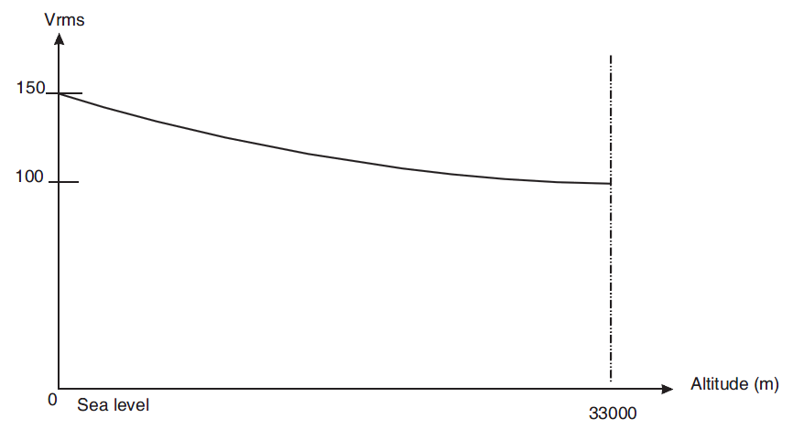
FIGURE 1(b) - MAXIMUM CURRENT VERSUS NUMBER OF CONTACTS
NUMBER OF CURRENT-CARRYING CONTACTS PER CONNECTOR | MAXIMUM CURRENT PER CONTACT (A)
NUMBER OF CURRENT-CARRYING CONTACTS PER CONNECTOR | WIRE SIZE
NUMBER OF CURRENT-CARRYING CONTACTS PER CONNECTOR | AWG26 AND UNINSULATED SOLID WIRE | AWG 28
2 - 4 | 2 | 1.4
5 - 14 | 1.8 | 1.2
15 and over | 1.4 | 0.9

FIGURE 2 - PHYSICAL DIMENSIONS
Figure 2.0 – male and female interface dimensions
FEMALE RECEPTACLE
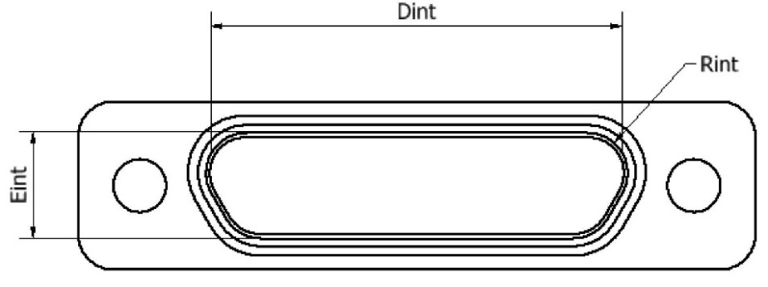
MALE PLUG
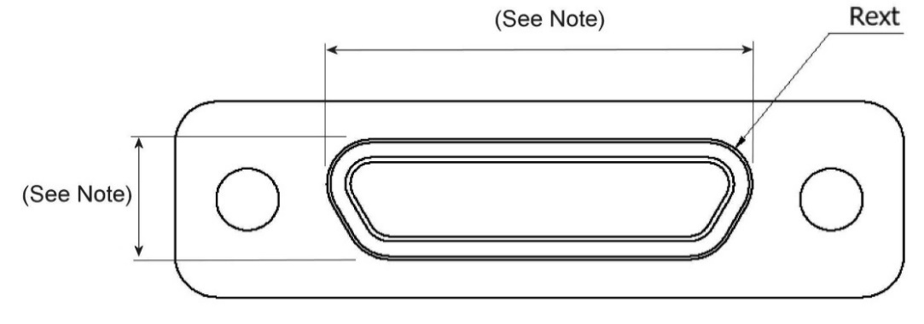
NOTE: These dimensions are specified in the PLUG MALE CONTACTS Figures on the following pages.
Shell Size | Dint Min. | Eint Min. | Rint Min. | Rext Max.
9 | 8.49 | 4.7 | 1.704 | 1.699
15 | 12.3 | 4.7 | 1.704 | 1.699
21 | 16.11 | 4.7 | 1.704 | 1.699
25 | 18.65 | 4.7 | 1.704 | 1.699
31 | 22.46 | 4.7 | 1.704 | 1.699
37 | 26.27 | 4.7 | 1.704 | 1.699
51 | 25 | 5.8 | 1.704 | 1.699
69 | 32.67 | 5.85 | 1.704 | 1.699
100 | 35.19 | 6.78 | 1.704 | 1.699
Figure 2.1A Connector Shells - Plug Male Contact – FR11x to FR12x
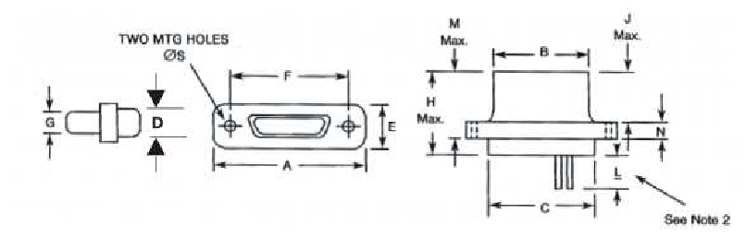
Shell Size | A  Max. | B  Max. | C  Max. | D  Max. | E  Max. | F |  | G  Max. | H  Max. | J  Max. | M  Max. | N |  | ØS
 |  |  |  |  |  | Min. | Max. |  |  |  |  | Min. | Max. | Min. | Max.
9 | 19.94 | 8.48 | 10.16 | 6.86 | 7.82 | 14.22 | 14.48 | 4.69 | 10.57 | 4.72 | 7.26 | 2.23 | 2.49 | 2.23 | 2.44
15 | 23.75 | 12.29 | 13.97 | 6.86 | 7.82 | 18.03 | 18.29 | 4.69 | 10.57 | 4.72 | 7.26 | 2.23 | 2.49 | 2.23 | 2.44
21 | 27.56 | 16.1 | 17.78 | 6.86 | 7.82 | 21.84 | 22.1 | 4.69 | 10.57 | 4.72 | 7.26 | 2.23 | 2.49 | 2.23 | 2.44
25 | 30.1 | 18.64 | 20.32 | 6.86 | 7.82 | 24.38 | 24.64 | 4.69 | 10.57 | 4.72 | 7.26 | 2.23 | 2.49 | 2.23 | 2.44
31 | 33.91 | 22.45 | 24.13 | 6.86 | 7.82 | 28.19 | 28.45 | 4.69 | 10.57 | 4.72 | 7.26 | 2.23 | 2.49 | 2.23 | 2.44
37 | 37.72 | 26.26 | 27.94 | 6.86 | 7.82 | 32 | 32.26 | 4.69 | 10.57 | 4.72 | 7.26 | 2.23 | 2.49 | 2.23 | 2.44
51 | 36.45 | 24.99 | 26.67 | 7.87 | 8.92 | 30.73 | 30.99 | 5.78 | 10.57 | 4.72 | 7.26 | 2.23 | 2.49 | 2.23 | 2.44
69 | 44.07 | 32.61 | 34.29 | 7.87 | 8.92 | 38.35 | 38.61 | 5.79 | 10.57 | 4.72 | 7.21 | 2.24 | 2.49 | 2.23 | 2.39
100 | 55.12 | 35.15 | 36.63 | 9.14 | 10.01 | 45.59 | 45.85 | 6.88 | 10.57 | 4.72 | 7.21 | 2.24 | 2.49 | 3.73 | 3.86
NOTES:
            - All dimensions are in millimetres.
            - For wire dimensions including Length L, refer to Para. 4.5.3.3 and Figures 2.4 and 2.5, as applicable.

Figure 2.1B Connector Shells - Receptacle Female Contacts – FR11x to FR12x
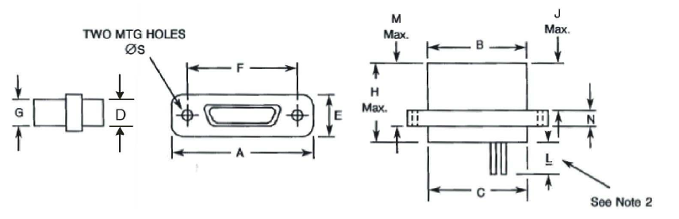
Shell Size | A  Max. | B  Max. | C  Max. | D  Max. | E  Max. | F |  | G  Max. | H  Max. | J  Max. | M  Max. | N |  | ØS
 |  |  |  |  |  | Min. | Max. |  |  |  |  | Min. | Max. | Min. | Max.
9 | 19.94 | 10.16 | 10.16 | 6.86 | 7.82 | 14.22 | 14.48 | 6.38 | 10.9 | 5.05 | 7.59 | 2.23 | 2.49 | 2.23 | 2.44
15 | 23.75 | 13.97 | 13.97 | 6.86 | 7.82 | 18.03 | 18.29 | 6.38 | 10.9 | 5.05 | 7.59 | 2.23 | 2.49 | 2.23 | 2.44
21 | 27.56 | 17.78 | 17.78 | 6.86 | 7.82 | 21.84 | 22.1 | 6.38 | 10.9 | 5.05 | 7.59 | 2.23 | 2.49 | 2.23 | 2.44
25 | 30.1 | 20.32 | 20.32 | 6.86 | 7.82 | 24.38 | 24.64 | 6.38 | 10.9 | 5.05 | 7.59 | 2.23 | 2.49 | 2.23 | 2.44
31 | 33.91 | 24.13 | 24.13 | 6.86 | 7.82 | 28.19 | 28.45 | 6.38 | 10.9 | 5.05 | 7.59 | 2.23 | 2.49 | 2.23 | 2.44
37 | 37.72 | 27.94 | 27.94 | 6.86 | 7.82 | 32 | 32.26 | 6.38 | 10.9 | 5.05 | 7.59 | 2.23 | 2.49 | 2.23 | 2.44
51 | 36.45 | 26.67 | 26.67 | 7.87 | 8.92 | 30.73 | 30.99 | 7.47 | 10.9 | 5.05 | 7.59 | 2.23 | 2.49 | 2.23 | 2.44
69 | 44.07 | 34.29 | 34.29 | 7.87 | 8.92 | 38.35 | 38.61 | 7.52 | 10.9 | 5.03 | 7.52 | 2.24 | 2.49 | 2.23 | 2.39
100 | 55.12 | 38.3 | 36.63 | 9.14 | 10.01 | 45.59 | 45.85 | 10.01 | 10.9 | 5.03 | 7.52 | 2.24 | 2.49 | 3.73 | 3.86
NOTES:
            - All dimensions are in millimetres.
            - For wire dimensions including Length L, refer to Para. 4.5.3.3 and Figures 2.4 and 2.5, as applicable.
FIGURE 2.2A - CONNECTORS TYPE - FR136
PLUG MALE CONTACTS
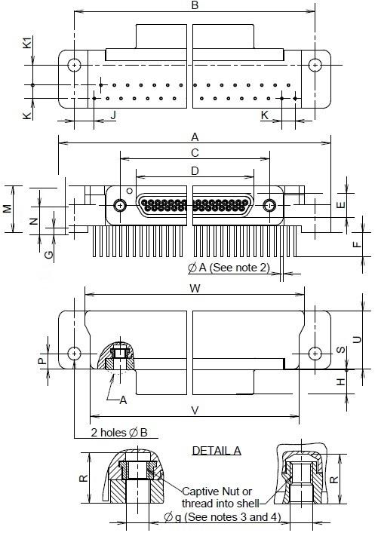
Shell Size | A  Max. | B |  | ØB (4) |  | C |  | D  Max. | E  Max. | F |  | G |  | H  Max. | J  Typ.
Shell Size | A  Max. | Min. | Max. | Min. | Max. | Min. | Max. | D  Max. | E  Max. | Min. | Max. | Min. | Max. | H  Max. | J  Typ.
9 | 35.31 | 29.03 | 29.39 | 2.31 | 2.59 | 14.22 | 14.48 | 8.48 | 4.69 | 4.15 | 4.85 | 0 | 1.7 | 4.72 | 9.53
15 | 39.12 | 32.84 | 33.2 | 2.31 | 2.59 | 18.03 | 18.29 | 12.29 | 4.69 | 4.15 | 4.85 | 0 | 1.7 | 4.72 | 7.62
21 | 42.93 | 36.65 | 37.01 | 2.31 | 2.59 | 21.84 | 22.1 | 16.1 | 4.69 | 4.15 | 4.85 | 0 | 1.7 | 4.72 | 5.72
25 | 45.47 | 39.19 | 39.55 | 2.31 | 2.59 | 24.38 | 24.64 | 18.64 | 4.69 | 4.15 | 4.85 | 0 | 1.7 | 4.72 | 4.45
31 | 51.82 | 45.54 | 45.9 | 2.31 | 2.59 | 28.19 | 28.45 | 22.45 | 4.69 | 4.15 | 4.85 | 0 | 1.7 | 4.72 | 3.81
37 | 59.44 | 53.16 | 53.52 | 2.31 | 2.59 | 32 | 32.26 | 26.26 | 4.69 | 4.15 | 4.85 | 0 | 1.7 | 4.72 | 3.81

Shell Size | K  Typ. | K1 |  | M |  | N |  | P |  | R  Min. | S
Shell Size | K  Typ. | Min. | Max. | Min. | Max. | Min. | Max. | Min. | Max. | R  Min. | Min. | Max.
9 | 2.54 | 3.56 | 4.06 | 9 | 9.2 | 5.15 | 5.45 | 2.79 | 3.55 | 4.55 | 0.2 | 0.5
15 | 2.54 | 3.56 | 4.06 | 9 | 9.2 | 5.15 | 5.45 | 2.79 | 3.55 | 4.55 | 0.2 | 0.5
21 | 2.54 | 3.56 | 4.06 | 9 | 9.2 | 5.15 | 5.45 | 2.79 | 3.55 | 4.55 | 0.2 | 0.5
25 | 2.54 | 3.56 | 4.06 | 9 | 9.2 | 5.15 | 5.45 | 2.79 | 3.55 | 4.55 | 0.2 | 0.5
31 | 2.54 | 3.56 | 4.06 | 9 | 9.2 | 5.15 | 5.45 | 2.79 | 3.55 | 4.55 | 0.2 | 0.5
37 | 2.54 | 3.56 | 4.06 | 9 | 9.2 | 5.15 | 5.45 | 2.79 | 3.55 | 4.55 | 0.2 | 0.5

Shell Size | U  Max. | V |  | W
Shell Size | U  Max. | Min. | Max. | Min. | Max.
9 | 11.56 | 23.05 | 23.25 | 24.9 | 25.2
15 | 11.56 | 26.85 | 27.05 | 28.7 | 29
21 | 11.56 | 30.8 | 31 | 32.55 | 32.85
25 | 11.56 | 33.3 | 33.5 | 35.15 | 35.45
31 | 11.56 | 39.5 | 39.7 | 41.45 | 41.75
37 | 11.56 | 47.15 | 47.35 | 49 | 49.3
NOTES:
            - All dimensions are in millimetres.
            - For ØA refer to ØD in Figure 2.4.
            - Øg: 2-56-UNC-2B.
            - Torque 0.44 Nm min / 0.48 max.

FIGURE 2.2B - CONNECTORS TYPE - FR136
RECEPTACLE FEMALE CONTACTS
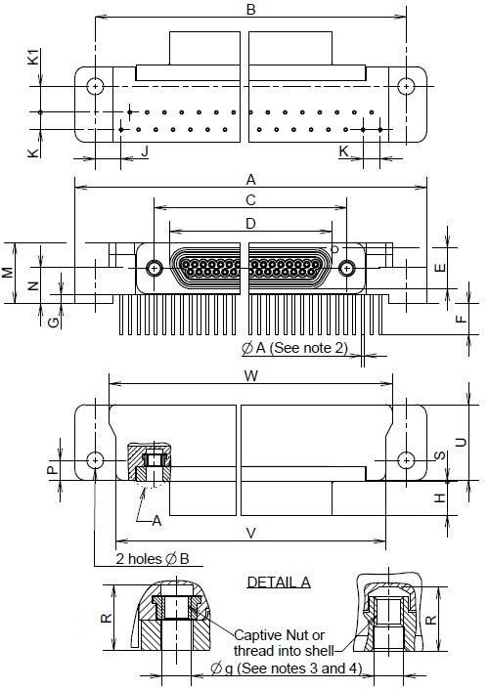
Shell Size | A  Max. | B |  | ØB (4) |  | C |  | D  Max. | E  Max. | F |  | G |  | H  Max. | J  Typ.
Shell Size | A  Max. | Min. | Max. | Min. | Max. | Min. | Max. | D  Max. | E  Max. | Min. | Max. | Min. | Max. | H  Max. | J  Typ.
9 | 35.31 | 29.03 | 29.39 | 2.31 | 2.59 | 14.22 | 14.48 | 10.16 | 6.38 | 4.15 | 4.85 | 0 | 1.7 | 5.05 | 9.53
15 | 39.12 | 32.84 | 33.2 | 2.31 | 2.59 | 18.03 | 18.29 | 13.97 | 6.38 | 4.15 | 4.85 | 0 | 1.7 | 5.05 | 7.62
21 | 42.93 | 36.65 | 37.01 | 2.31 | 2.59 | 21.84 | 22.1 | 17.78 | 6.38 | 4.15 | 4.85 | 0 | 1.7 | 5.05 | 5.72
25 | 45.47 | 39.19 | 39.55 | 2.31 | 2.59 | 24.38 | 24.64 | 20.32 | 6.38 | 4.15 | 4.85 | 0 | 1.7 | 5.05 | 4.45
31 | 51.82 | 45.54 | 45.9 | 2.31 | 2.59 | 28.19 | 28.45 | 24.13 | 6.38 | 4.15 | 4.85 | 0 | 1.7 | 5.05 | 3.81
37 | 59.44 | 53.16 | 53.52 | 2.31 | 2.59 | 32 | 32.26 | 27.94 | 6.38 | 4.15 | 4.85 | 0 | 1.7 | 5.05 | 3.81

Shell  Size | K  Typ. | K1 |  | M |  | N |  | P |  | R  Min. | S
Shell  Size | K  Typ. | Min. | Max. | Min. | Max. | Min. | Max. | Min. | Max. | R  Min. | Min. | Max.
9 | 2.54 | 3.56 | 4.06 | 9 | 9.2 | 5.15 | 5.45 | 2.79 | 3.55 | 4.55 | 0.2 | 0.5
15 | 2.54 | 3.56 | 4.06 | 9 | 9.2 | 5.15 | 5.45 | 2.79 | 3.55 | 4.55 | 0.2 | 0.5
21 | 2.54 | 3.56 | 4.06 | 9 | 9.2 | 5.15 | 5.45 | 2.79 | 3.55 | 4.55 | 0.2 | 0.5
25 | 2.54 | 3.56 | 4.06 | 9 | 9.2 | 5.15 | 5.45 | 2.79 | 3.55 | 4.55 | 0.2 | 0.5
31 | 2.54 | 3.56 | 4.06 | 9 | 9.2 | 5.15 | 5.45 | 2.79 | 3.55 | 4.55 | 0.2 | 0.5
37 | 2.54 | 3.56 | 4.06 | 9 | 9.2 | 5.15 | 5.45 | 2.79 | 3.55 | 4.55 | 0.2 | 0.5

Shell  Size | U  Max. | V |  | W
Shell  Size | U  Max. | Min. | Max. | Min. | Max.
9 | 11.56 | 23.05 | 23.25 | 24.9 | 25.2
15 | 11.56 | 26.85 | 27.05 | 28.7 | 29
21 | 11.56 | 30.8 | 31 | 32.55 | 32.85
25 | 11.56 | 33.3 | 33.5 | 35.15 | 35.45
31 | 11.56 | 39.5 | 39.7 | 41.45 | 41.75
37 | 11.56 | 47.15 | 47.35 | 49 | 49.3
NOTES:
            - All dimensions are in millimetres.
            - For ØA refer to ØD in Figure 2.4.
            - Øg: 2-56-UNC-2B.
            - Torque 0.44 Nm min / 0.48 Nm max.
FIGURE 2.2C - CONNECTORS TYPE - FR136
PLUG MALE CONTACTS (Size 51)
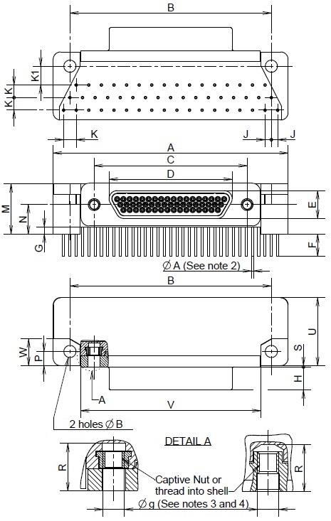
Shell Size | A  Max. | B |  | ØB (4) |  | C |  | D  Max. | E  Max. | F |  | G |  | H  Max. | J  Typ.
Shell Size | A  Max. | Min. | Max. | Min. | Max. | Min. | Max. | D  Max. | E  Max. | Min. | Max. | Min. | Max. | H  Max. | J  Typ.
51 | 47.63 | 40.46 | 40.82 | 2.31 | 2.59 | 30.73 | 30.99 | 24.99 | 5.78 | 4.15 | 4.85 | 0 | 1.7 | 4.72 | 1.27

Shell  Size | K  Typ. | K1 |  | M |  | N |  | P |  | R  Min. | S |  | U  Max. | V |  | W
Shell  Size | K  Typ. | Min. | Max. | Min. | Max. | Min. | Max. | Min. | Max. | R  Min. | Min. | Max. | U  Max. | Min. | Max. | Min. | Max.
51 | 2.54 | 3.56 | 4.06 | 10.1 | 10.4 | 5.81 | 6.11 | 2.79 | 3.55 | 4.55 | 0.2 | 0.5 | 14.35 | 36.34 | 36.54 | 5.3 | 5.5
NOTES:
            - All dimensions are in millimetres.
            - For ØA refer to ØD in Figure 2.4.
            - Øg: 2-56-UNC-2B.
            - Torque 0.44 Nm min / 0.48 Nm max.

FIGURE 2.2D - CONNECTORS TYPE - FR136
RECEPTACLE FEMALE CONTACTS (Size 51)
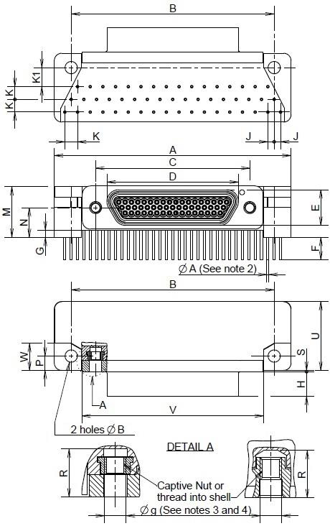
Shell Size | A  Max. | B |  | ØB (4) |  | C |  | D  Max. | E  Max. | F |  | G |  | H  Max. | J  Typ.
Shell Size | A  Max. | Min. | Max. | Min. | Max. | Min. | Max. | D  Max. | E  Max. | Min. | Max. | Min. | Max. | H  Max. | J  Typ.
51 | 47.63 | 40.46 | 40.82 | 2.31 | 2.59 | 30.73 | 30.99 | 26.67 | 7.47 | 4.15 | 4.85 | 0 | 1.7 | 5.05 | 1.27

Shell  Size | K  Typ. | K1 |  | M |  | N |  | P |  | R  Min. | S |  | U  Max. | V |  | W
Shell  Size | K  Typ. | Min. | Max. | Min. | Max. | Min. | Max. | Min. | Max. | R  Min. | Min. | Max. | U  Max. | Min. | Max. | Min. | Max.
51 | 2.54 | 3.56 | 4.06 | 10.1 | 10.4 | 5.81 | 6.11 | 2.79 | 3.55 | 4.55 | 0.2 | 0.5 | 14.35 | 36.34 | 36.54 | 5.3 | 5.5
NOTES:
            - All dimensions are in millimetres.
            - For ØA refer to ØD in Figure 2.4.
            - Øg: 2-56-UNC-2B.
            - Torque 0.44 Nm min / 0.48 Nm max.
FIGURE 2.2E - CONNECTORS TYPE - FR136A
PLUG MALE CONTACTS
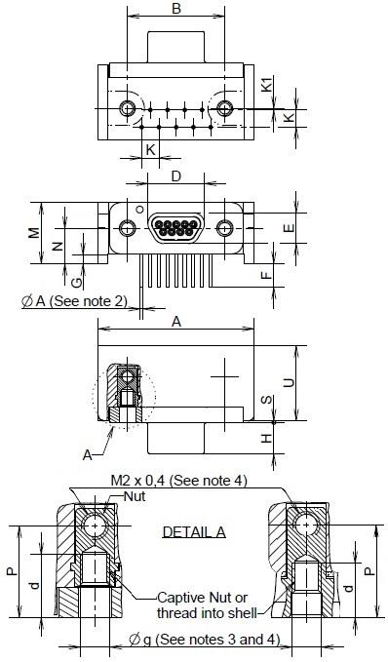
Shell Size | A  Max. | B |  | d  Min. | D  Max. | E  Max. | F |  | G |  | H  Max. | K  Typ. | K1  Typ.
Shell Size | A  Max. | Min. | Max. | d  Min. | D  Max. | E  Max. | Min. | Max. | Min. | Max. | H  Max. | K  Typ. | K1  Typ.
9 | 23.12 | 14.22 | 14.48 | 4.55 | 8.48 | 4.69 | 3.3 | 3.7 | 0 | 1.7 | 4.72 | 2.54 | 0.2

Shell  Size | M |  | N |  | P |  | S |  | U  Max.
Shell  Size | Min. | Max. | Min. | Max. | Min. | Max. | Min. | Max. | U  Max.
9 | 9 | 9.2 | 5.15 | 5.45 | 6.48 | 7.24 | 0.2 | 0.5 | 11.56
NOTES:
            - All dimensions are in millimetres.
            - For ØA refer to ØD in Figure 2.4.
            - Øg: 2-56-UNC-2B
            - Torque 0.44 Nm min / 0.48 Nm max.
FIGURE 2.2F - CONNECTORS TYPE - FR136A
RECEPTACLE FEMALE CONTACTS
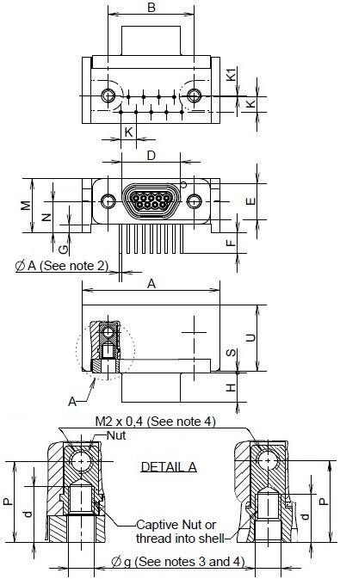
Shell Size | A  Max. | B |  | d  Min. | D  Max. | E  Max. | F |  | G |  | H  Max. | K  Typ. | K1  Typ.
Shell Size | A  Max. | Min. | Max. | d  Min. | D  Max. | E  Max. | Min. | Max. | Min. | Max. | H  Max. | K  Typ. | K1  Typ.
9 | 23.12 | 14.22 | 14.48 | 4.55 | 10.16 | 6.38 | 3.3 | 3.7 | 0 | 1.7 | 5.05 | 2.54 | 0.2

Shell  Size | M |  | N |  | P |  | S |  | U  Max.
Shell  Size | Min. | Max. | Min. | Max. | Min. | Max. | Min. | Max. | U  Max.
9 | 9 | 9.2 | 5.15 | 5.45 | 6.48 | 7.24 | 0.2 | 0.5 | 11.56
NOTES:
            - All dimensions are in millimetres.
            - For ØA refer to ØD in Figure 2.4.
            - Øg: 2-56-UNC-2B.
            - Torque 0.44 Nm min / 0.48 Nm max.
FIGURE 2.2G - CONNECTORS TYPE - FR139
PLUG MALE CONTACTS
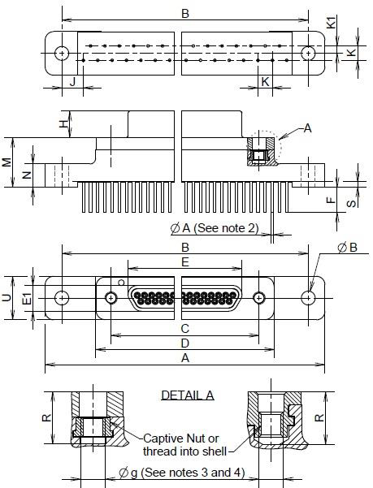
Shell Size | A  Max. | B |  | ØB (4) |  | C |  | D  Max. | E  Max. | E1  Max. | F |  | H  Max. | J  Typ.
Shell Size | A  Max. | Min. | Max. | Min. | Max. | Min. | Max. | D  Max. | E  Max. | E1  Max. | Min. | Max. | H  Max. | J  Typ.
9 | 35.31 | 29.03 | 29.39 | 2.31 | 2.59 | 14.22 | 14.48 | 19.94 | 8.48 | 4.69 | 4.15 | 4.85 | 4.72 | 9.53
15 | 35.31 | 29.03 | 29.39 | 2.31 | 2.59 | 18.03 | 18.29 | 23.75 | 12.29 | 4.69 | 4.15 | 4.85 | 4.72 | 5.72
21 | 42.93 | 36.65 | 37.01 | 2.31 | 2.59 | 21.84 | 22.1 | 27.56 | 16.1 | 4.69 | 4.15 | 4.85 | 4.72 | 5.72
25 | 44.2 | 37.92 | 38.28 | 2.31 | 2.59 | 24.38 | 24.64 | 30.1 | 18.64 | 4.69 | 4.15 | 4.85 | 4.72 | 3.81
31 | 51.82 | 45.54 | 45.9 | 2.31 | 2.59 | 28.19 | 28.45 | 33.91 | 22.45 | 4.69 | 4.15 | 4.85 | 4.72 | 3.81
37 | 59.44 | 53.16 | 53.52 | 2.31 | 2.59 | 32 | 32.26 | 37.72 | 26.26 | 4.69 | 4.15 | 4.85 | 4.72 | 3.81

Shell  Size | K  Typ. | K1  Typ. | M |  | N |  | R  Min. | S |  | U  Max.
Shell  Size | K  Typ. | K1  Typ. | Min. | Max. | Min. | Max. | R  Min. | Min. | Max. | U  Max.
9 | 2.54 | 1.27 | 8.62 | 9.02 | 4 | 4.3 | 4.55 | 0 | 1.1 | 7.82
15 | 2.54 | 1.27 | 8.62 | 9.02 | 4 | 4.3 | 4.55 | 0 | 1.1 | 7.82
21 | 2.54 | 1.27 | 8.62 | 9.02 | 4 | 4.3 | 4.55 | 0 | 1.1 | 7.82
25 | 2.54 | 1.27 | 8.62 | 9.02 | 4 | 4.3 | 4.55 | 0 | 1.1 | 7.82
31 | 2.54 | 1.27 | 8.62 | 9.02 | 4 | 4.3 | 4.55 | 0 | 1.1 | 7.82
37 | 2.54 | 1.27 | 8.62 | 9.02 | 4 | 4.3 | 4.55 | 0 | 1.1 | 7.82
NOTES:
            - All dimensions are in millimetres.
            - For ØA refer to ØD in Figure 2.4.
            - Øg: 2-56-UNC-2B.
            - Torque 0.44 Nm min / 0.48 Nm max.

FIGURE 2.2H - CONNECTORS TYPE - FR139
RECEPTACLE FEMALE CONTACTS
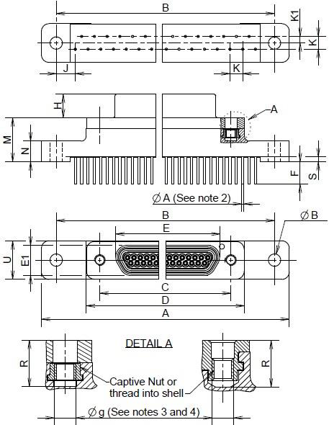
Shell Size | A  Max. | B |  | ØB (4) |  | C |  | D  Max. | E  Max. | E1  Max. | F |  | H  Max. | J  Typ.
Shell Size | A  Max. | Min. | Max. | Min. | Max. | Min. | Max. | D  Max. | E  Max. | E1  Max. | Min. | Max. | H  Max. | J  Typ.
9 | 35.31 | 29.03 | 29.39 | 2.31 | 2.59 | 14.22 | 14.48 | 19.94 | 10.16 | 6.38 | 4.15 | 4.85 | 5.05 | 9.53
15 | 35.31 | 29.03 | 29.39 | 2.31 | 2.59 | 18.03 | 18.29 | 23.75 | 13.97 | 6.38 | 4.15 | 4.85 | 5.05 | 5.72
21 | 42.93 | 36.65 | 37.01 | 2.31 | 2.59 | 21.84 | 22.1 | 27.56 | 17.78 | 6.38 | 4.15 | 4.85 | 5.05 | 5.72
25 | 44.2 | 37.92 | 38.28 | 2.31 | 2.59 | 24.38 | 24.64 | 30.1 | 20.32 | 6.38 | 4.15 | 4.85 | 5.05 | 3.81
31 | 51.82 | 45.54 | 45.9 | 2.31 | 2.59 | 28.19 | 28.45 | 33.91 | 24.13 | 6.38 | 4.15 | 4.85 | 5.05 | 3.81
37 | 59.44 | 53.16 | 53.52 | 2.31 | 2.59 | 32 | 32.26 | 37.72 | 27.94 | 6.38 | 4.15 | 4.85 | 5.05 | 3.81

Shell  Size | K  Typ. | K1  Typ. | M |  | N |  | R  Min. | S |  | U  Max.
Shell  Size | K  Typ. | K1  Typ. | Min. | Max. | Min. | Max. | R  Min. | Min. | Max. | U  Max.
9 | 2.54 | 1.27 | 8.62 | 9.02 | 4 | 4.3 | 4.55 | 0 | 1.1 | 7.82
15 | 2.54 | 1.27 | 8.62 | 9.02 | 4 | 4.3 | 4.55 | 0 | 1.1 | 7.82
21 | 2.54 | 1.27 | 8.62 | 9.02 | 4 | 4.3 | 4.55 | 0 | 1.1 | 7.82
25 | 2.54 | 1.27 | 8.62 | 9.02 | 4 | 4.3 | 4.55 | 0 | 1.1 | 7.82
31 | 2.54 | 1.27 | 8.62 | 9.02 | 4 | 4.3 | 4.55 | 0 | 1.1 | 7.82
37 | 2.54 | 1.27 | 8.62 | 9.02 | 4 | 4.3 | 4.55 | 0 | 1.1 | 7.82
NOTES:
            - All dimensions are in millimetres.
            - For ØA refer to ØD in Figure 2.4.
            - Øg: 2-56-UNC-2B.
            - Torque 0.44 Nm min / 0.48 Nm max.

FIGURE 2.2I - CONNECTORS TYPE - FR139
PLUG MALE CONTACTS - SIZE 51
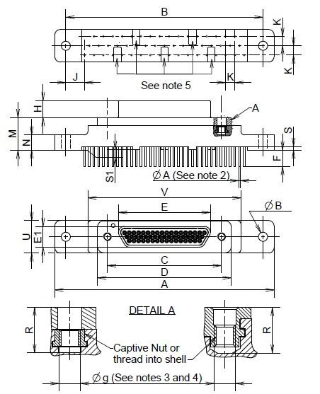
Shell Size | A  Max. | B |  | ØB (4) |  | C |  | D  Max. | E  Max. | E1  Max. | F |  | H  Max. | J  Typ.
Shell Size | A  Max. | Min. | Max. | Min. | Max. | Min. | Max. | D  Max. | E  Max. | E1  Max. | Min. | Max. | H  Max. | J  Typ.
51 | 59.44 | 53.16 | 53.52 | 2.31 | 2.59 | 30.73 | 30.99 | 36.5 | 24.99 | 5.78 | 4.15 | 4.85 | 4.72 | 5.08

Shell  Size | K  Typ. | M |  | N |  | R  Min. | S |  | S1 (5) |  | U  Max. | V  Max.
Shell  Size | K  Typ. | Min. | Max. | Min. | Max. | R  Min. | Min. | Max. | Min. | Max. | U  Max. | V  Max.
51 | 2.54 | 8.62 | 9.02 | 4 | 4.3 | 4.55 | 0 | 1.1 | 0 | 0.2 | 9 | 41.5
NOTES:
            - All dimensions are in millimetres.
            - For ØA refer to ØD in Figure 2.4.
            - Øg: 2-56-UNC-2B.
            - Torque 0.44 Nm min / 0.48 Nm max.
            - Standoffs (5 places): 4.25 x 2.1 max.
FIGURE 2.2J - CONNECTORS TYPE - FR139
RECEPTACLE FEMALE CONTACTS - SIZE 51
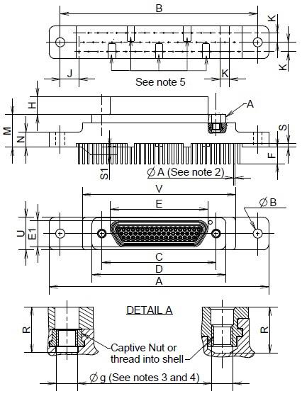
Shell Size | A  Max. | B |  | ØB (4) |  | C |  | D  Max. | E  Max. | E1  Max. | F |  | H  Max. | J  Typ.
Shell Size | A  Max. | Min. | Max. | Min. | Max. | Min. | Max. | D  Max. | E  Max. | E1  Max. | Min. | Max. | H  Max. | J  Typ.
51 | 59.44 | 53.16 | 53.52 | 2.31 | 2.59 | 30.73 | 30.99 | 36.5 | 26.67 | 7.47 | 4.15 | 4.85 | 5.05 | 5.08

Shell  Size | K  Typ. | M |  | N |  | R  Min. | S |  | S1 (5) |  | U  Max. | V  Max.
Shell  Size | K  Typ. | Min. | Max. | Min. | Max. | R  Min. | Min. | Max. | Min. | Max. | U  Max. | V  Max.
51 | 2.54 | 8.62 | 9.02 | 4 | 4.3 | 4.55 | 0 | 1.1 | 0 | 0.2 | 9 | 41.5
NOTES:
            - All dimensions are in millimetres.
            - For ØA refer to ØD in Figure 2.4.
            - Øg: 2-56-UNC-2B.
            - Torque 0.44 Nm min / 0.48 Nm max.
            - Standoffs (5 places): 4.25 x 2.1 max.
FIGURE 2.2K CONNECTORS TYPE FR164 - PLUG MALE CONTACTS
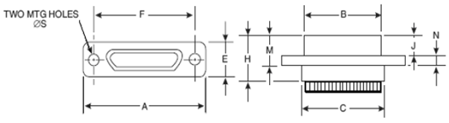
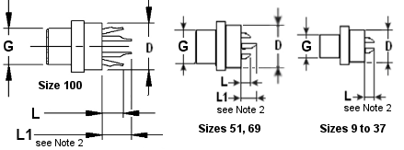
Shell  Size | A  Max. | B  Max. | C  Max. | D  Max. | E  Max. | F |  | G  Max. | H  Max. | J  Max. | M  Max. | N |  | ØS
 |  |  |  |  |  | Min. | Max. |  |  |  |  | Min. | Max. | Min. | Max.
9 | 19.94 | 8.48 | 10.16 | 6.86 | 7.82 | 14.22 | 14.48 | 4.69 | 10.57 | 4.72 | 7.26 | 2.23 | 2.49 | 2.23 | 2.44
15 | 23.75 | 12.29 | 13.97 | 6.86 | 7.82 | 18.03 | 18.29 | 4.69 | 10.57 | 4.72 | 7.26 | 2.23 | 2.49 | 2.23 | 2.44
21 | 27.56 | 16.1 | 17.78 | 6.86 | 7.82 | 21.84 | 22.1 | 4.69 | 10.57 | 4.72 | 7.26 | 2.23 | 2.49 | 2.23 | 2.44
25 | 30.1 | 18.64 | 20.32 | 6.86 | 7.82 | 24.38 | 24.64 | 4.69 | 10.57 | 4.72 | 7.26 | 2.23 | 2.49 | 2.23 | 2.44
31 | 33.91 | 22.45 | 24.13 | 6.86 | 7.82 | 28.19 | 28.45 | 4.69 | 10.57 | 4.72 | 7.26 | 2.23 | 2.49 | 2.23 | 2.44
37 | 37.72 | 26.26 | 27.94 | 6.86 | 7.82 | 32 | 32.26 | 4.69 | 10.57 | 4.72 | 7.26 | 2.23 | 2.49 | 2.23 | 2.44
51 | 36.45 | 24.99 | 26.67 | 7.87 | 8.92 | 30.73 | 30.99 | 5.78 | 10.57 | 4.72 | 7.26 | 2.23 | 2.49 | 2.23 | 2.44
69 | 44.07 | 32.61 | 34.29 | 7.87 | 8.92 | 38.35 | 38.61 | 5.79 | 10.57 | 4.72 | 7.21 | 2.24 | 2.49 | 2.23 | 2.39
100 | 55.12 | 35.15 | 36.63 | 9.14 | 10.01 | 45.59 | 45.85 | 6.88 | 10.57 | 4.72 | 7.21 | 2.24 | 2.49 | 3.73 | 3.86
NOTES:
            - All dimensions are in millimetres.
            - L = 2.79 max (all sizes).
L1 = 5.08 max (sizes 51, 69, 100 only).
For details of solder bucket, see Figure 2.6.

FIGURE 2.2L CONNECTORS TYPE FR164 - Receptacle FeMALE CONTACTS
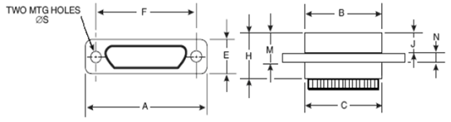
Shell  Size | A  Max. | B  Max. | C  Max. | D  Max. | E  Max. | F |  | G  Max. | H  Max. | J  Max. | M  Max. | N |  | ØS
 |  |  |  |  |  | Min. | Max. |  |  |  |  | Min. | Max. | Min. | Max.
9 | 19.94 | 10.16 | 10.16 | 6.86 | 7.82 | 14.22 | 14.48 | 6.38 | 10.9 | 5.05 | 7.59 | 2.23 | 2.49 | 2.23 | 2.44
15 | 23.75 | 13.97 | 13.97 | 6.86 | 7.82 | 18.03 | 18.29 | 6.38 | 10.9 | 5.05 | 7.59 | 2.23 | 2.49 | 2.23 | 2.44
21 | 27.56 | 17.78 | 17.78 | 6.86 | 7.82 | 21.84 | 22.1 | 6.38 | 10.9 | 5.05 | 7.59 | 2.23 | 2.49 | 2.23 | 2.44
25 | 30.1 | 20.32 | 20.32 | 6.86 | 7.82 | 24.38 | 24.64 | 6.38 | 10.9 | 5.05 | 7.59 | 2.23 | 2.49 | 2.23 | 2.44
31 | 33.91 | 24.13 | 24.13 | 6.86 | 7.82 | 28.19 | 28.45 | 6.38 | 10.9 | 5.05 | 7.59 | 2.23 | 2.49 | 2.23 | 2.44
37 | 37.72 | 27.94 | 27.94 | 6.86 | 7.82 | 32 | 32.26 | 6.38 | 10.9 | 5.05 | 7.59 | 2.23 | 2.49 | 2.23 | 2.44
51 | 36.45 | 26.67 | 26.67 | 7.87 | 8.92 | 30.73 | 30.99 | 7.47 | 10.9 | 5.05 | 7.59 | 2.23 | 2.49 | 2.23 | 2.44
69 | 44.07 | 34.29 | 34.29 | 7.87 | 8.92 | 38.35 | 38.61 | 7.52 | 10.9 | 5.03 | 7.52 | 2.24 | 2.49 | 2.23 | 2.39
100 | 55.12 | 38.3 | 36.63 | 9.14 | 10.01 | 45.59 | 45.85 | 10.01 | 10.9 | 5.03 | 7.52 | 2.24 | 2.49 | 3.73 | 3.86
NOTES
            - All dimensions are in millimetres.
            - L = 2.79 max (all sizes).
L1 = 5.08 max (sizes 51, 69, 100 only).
For details of solder bucket, see Figure 2.6.
FIGURE 2.2M - CONNECTORS TYPE – GMR7590
Plug male Contacts
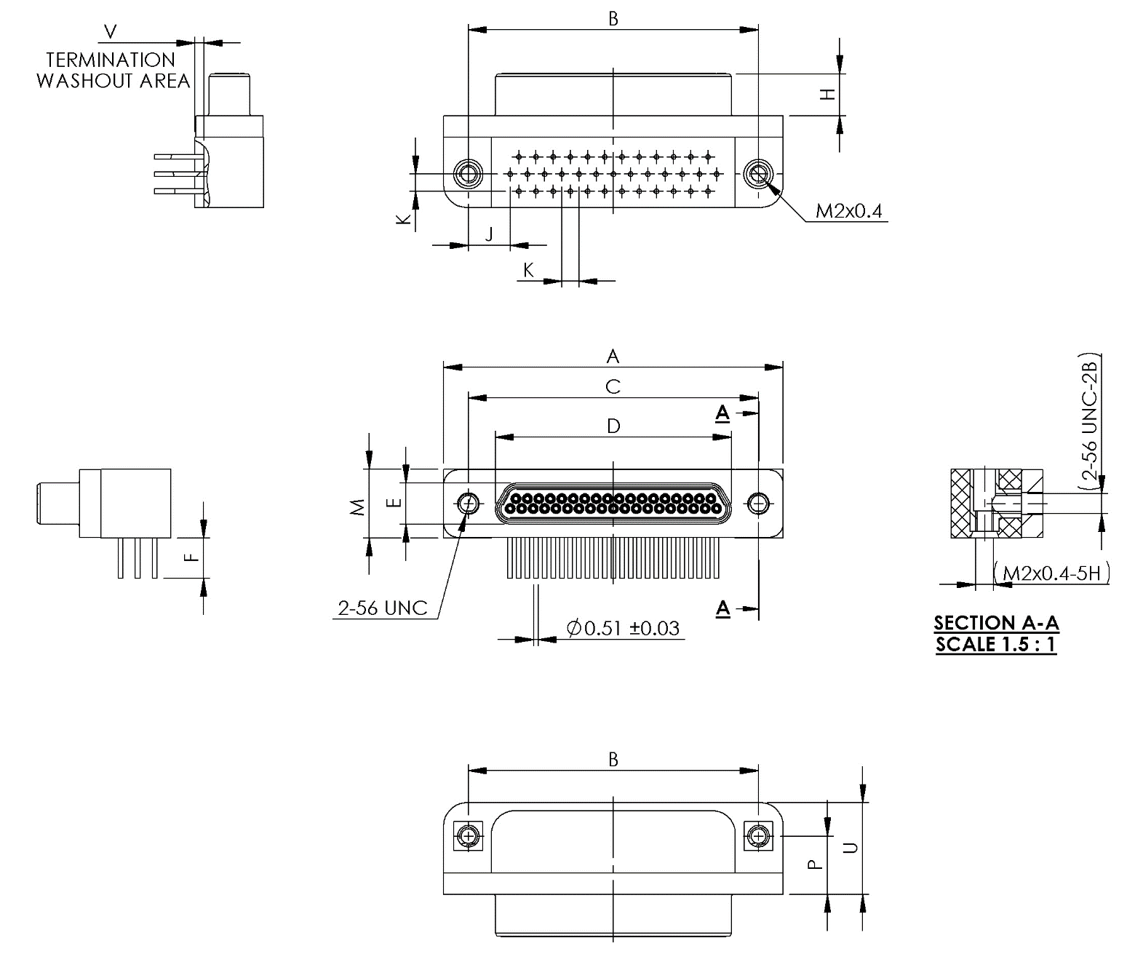
Shell Size | A  Max. | B |  | C |  | D  Max. | E  Max. | F
Shell Size | A  Max. | Min. | Max. | Min. | Max. | D  Max. | E  Max. | Min. | Max.
9 | 19.94 | 14.22 | 14.48 | 14.22 | 14.48 | 8.48 | 4.69 | 4.45 | 5.21
15 | 23.75 | 18.03 | 18.29 | 18.03 | 18.29 | 12.29 | 4.69 | 4.45 | 5.21
21 | 27.55 | 21.84 | 22.1 | 21.84 | 22.1 | 16.1 | 4.69 | 4.45 | 5.21
25 | 30.1 | 24.38 | 24.64 | 24.38 | 24.64 | 18.64 | 4.69 | 4.45 | 5.21
31 | 33.91 | 28.19 | 28.45 | 28.19 | 28.45 | 22.45 | 4.69 | 4.45 | 5.21
37 | 37.72 | 32 | 32.26 | 32 | 32.26 | 26.26 | 4.69 | 4.45 | 5.21

Shell  Size | H |  | J  Typ. | K  Typ. | M  Max. | P |  | U  Max. | V
Shell  Size | Min. | Max. | J  Typ. | K  Typ. | M  Max. | Min. | Max. | U  Max. | Min. | Max.
9 | 4.57 | 4.73 | 3.37 | 1.905 | 7.87 | 6.1 | 6.6 | 10.16 | 0.89 | 1.15
15 | 4.57 | 4.73 | 4.32 | 1.905 | 7.87 | 6.1 | 6.6 | 10.16 | 0.89 | 1.15
21 | 4.57 | 4.73 | 4.32 | 1.905 | 7.87 | 6.1 | 6.6 | 10.16 | 0.89 | 1.15
25 | 4.57 | 4.73 | 4.64 | 1.905 | 7.87 | 6.1 | 6.6 | 10.16 | 0.89 | 1.15
31 | 4.57 | 4.73 | 4.64 | 1.905 | 7.87 | 6.1 | 6.6 | 10.16 | 0.89 | 1.15
37 | 4.57 | 4.73 | 4.64 | 1.905 | 7.87 | 6.1 | 6.6 | 10.16 | 0.89 | 1.15
NOTES:
            - All dimensions are in millimetres.

FIGURE 2.2N - CONNECTORS TYPE – GMR7590
Receptacle Female Contacts
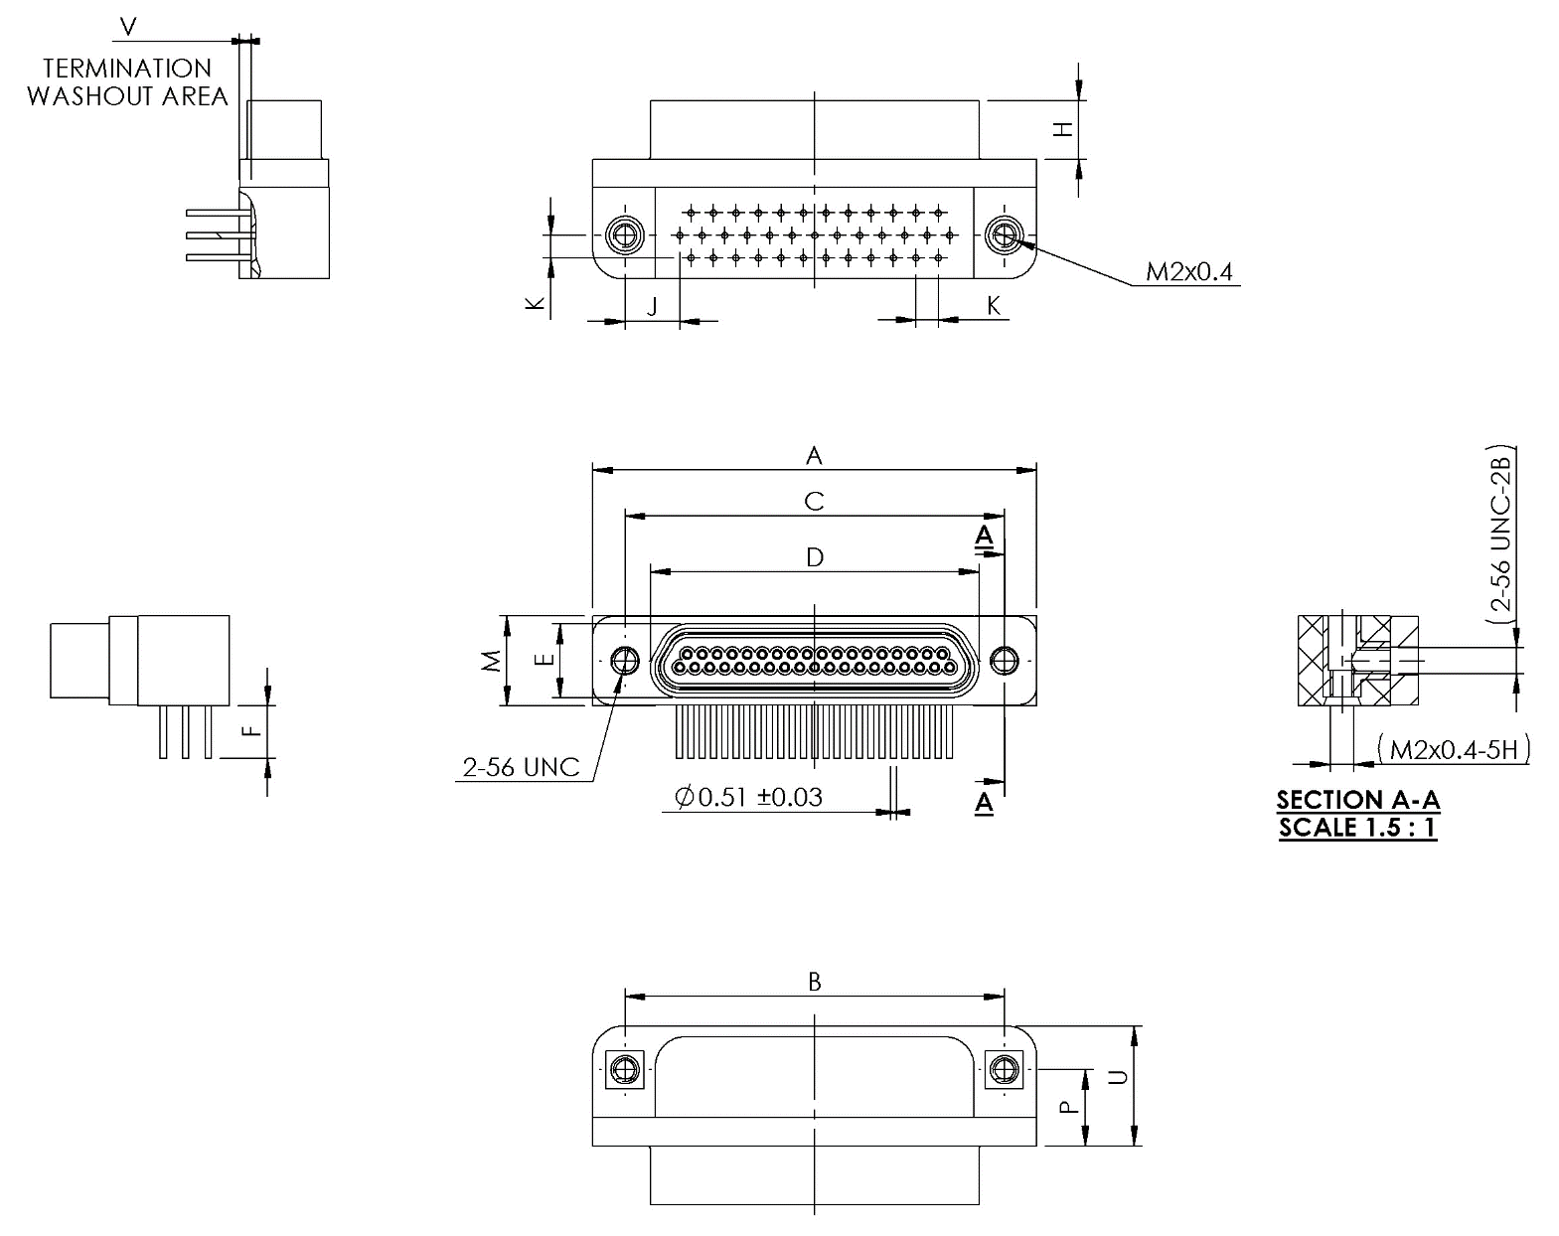
Shell Size | A  Max. | B |  | C |  | D  Max. | E  Max. | F
Shell Size | A  Max. | Min. | Max. | Min. | Max. | D  Max. | E  Max. | Min. | Max.
9 | 19.94 | 14.22 | 14.48 | 14.22 | 14.48 | 10.16 | 6.38 | 4.45 | 5.21
15 | 23.75 | 18.03 | 18.29 | 18.03 | 18.29 | 13.97 | 6.38 | 4.45 | 5.21
21 | 27.56 | 21.83 | 22.1 | 21.83 | 22.1 | 17.78 | 6.38 | 4.45 | 5.21
25 | 30.1 | 24.38 | 24.64 | 24.38 | 24.64 | 20.32 | 6.38 | 4.45 | 5.21
31 | 33.91 | 28.19 | 28.45 | 28.19 | 28.45 | 24.13 | 6.38 | 4.45 | 5.21
37 | 37.72 | 32 | 32.26 | 32 | 32.26 | 27.94 | 6.38 | 4.45 | 5.21

Shell  Size | H |  | J  Typ. | K  Typ. | M  Max. | P |  | U  Max. | V
Shell  Size | Min. | Max. | J  Typ. | K  Typ. | M  Max. | Min. | Max. | U  Max. | Min. | Max.
9 | 4.87 | 5.03 | 3.37 | 1.905 | 7.87 | 6.1 | 6.6 | 10.16 | 0.89 | 1.15
15 | 4.87 | 5.03 | 4.32 | 1.905 | 7.87 | 6.1 | 6.6 | 10.16 | 0.89 | 1.15
21 | 4.87 | 5.03 | 4.32 | 1.905 | 7.87 | 6.1 | 6.6 | 10.16 | 0.89 | 1.15
25 | 4.87 | 5.03 | 4.64 | 1.905 | 7.87 | 6.1 | 6.6 | 10.16 | 0.89 | 1.15
31 | 4.87 | 5.03 | 4.64 | 1.905 | 7.87 | 6.1 | 6.6 | 10.16 | 0.89 | 1.15
37 | 4.87 | 5.03 | 4.64 | 1.905 | 7.87 | 6.1 | 6.6 | 10.16 | 0.89 | 1.15
NOTES:
            - All dimensions are in millimetres.

FIGURE 2.2O - CONNECTORS TYPE – GMR7590
Plug male Contacts
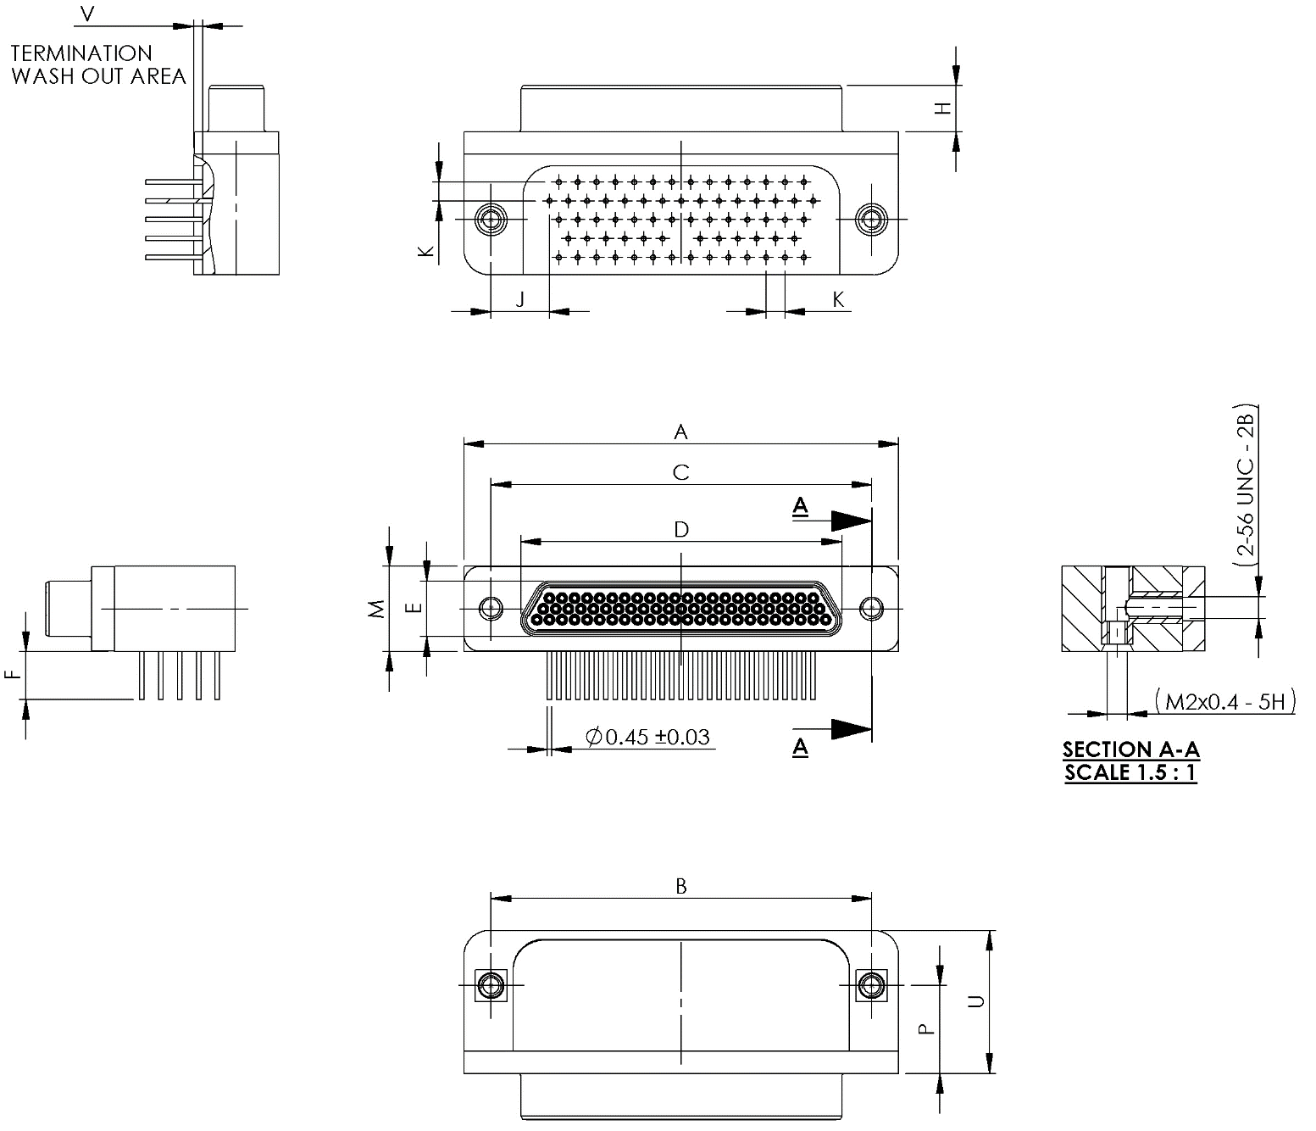
Shell Size | A  Max. | B |  | C |  | D  Max. | E  Max. | F
Shell Size | A  Max. | Min. | Max. | Min. | Max. | D  Max. | E  Max. | Min. | Max.
51 | 36.45 | 30.73 | 30.99 | 30.73 | 30.99 | 24.99 | 5.79 | 4.45 | 5.21
69 | 44.07 | 38.35 | 38.61 | 38.35 | 38.61 | 32.61 | 5.79 | 4.45 | 5.21

Shell  Size | H |  | J  Typ. | K  Typ. | M  Max. | P |  | U  Max. | V
Shell  Size | Min. | Max. | J  Typ. | K  Typ. | M  Max. | Min. | Max. | U  Max. | Min. | Max.
51 | 4.57 | 4.73 | 3.05 | 1.905 | 8.92 | 7.37 | 7.87 | 12.45 | 0.89 | 1.15
69 | 4.57 | 4.73 | 5.91 | 1.905 | 8.92 | 8.64 | 9.14 | 14.5 | 0.77 | 0.9
NOTES:
            - All dimensions are in millimetres.

FIGURE 2.2P - CONNECTORS TYPE – GMR7590
Receptacle Female Contacts
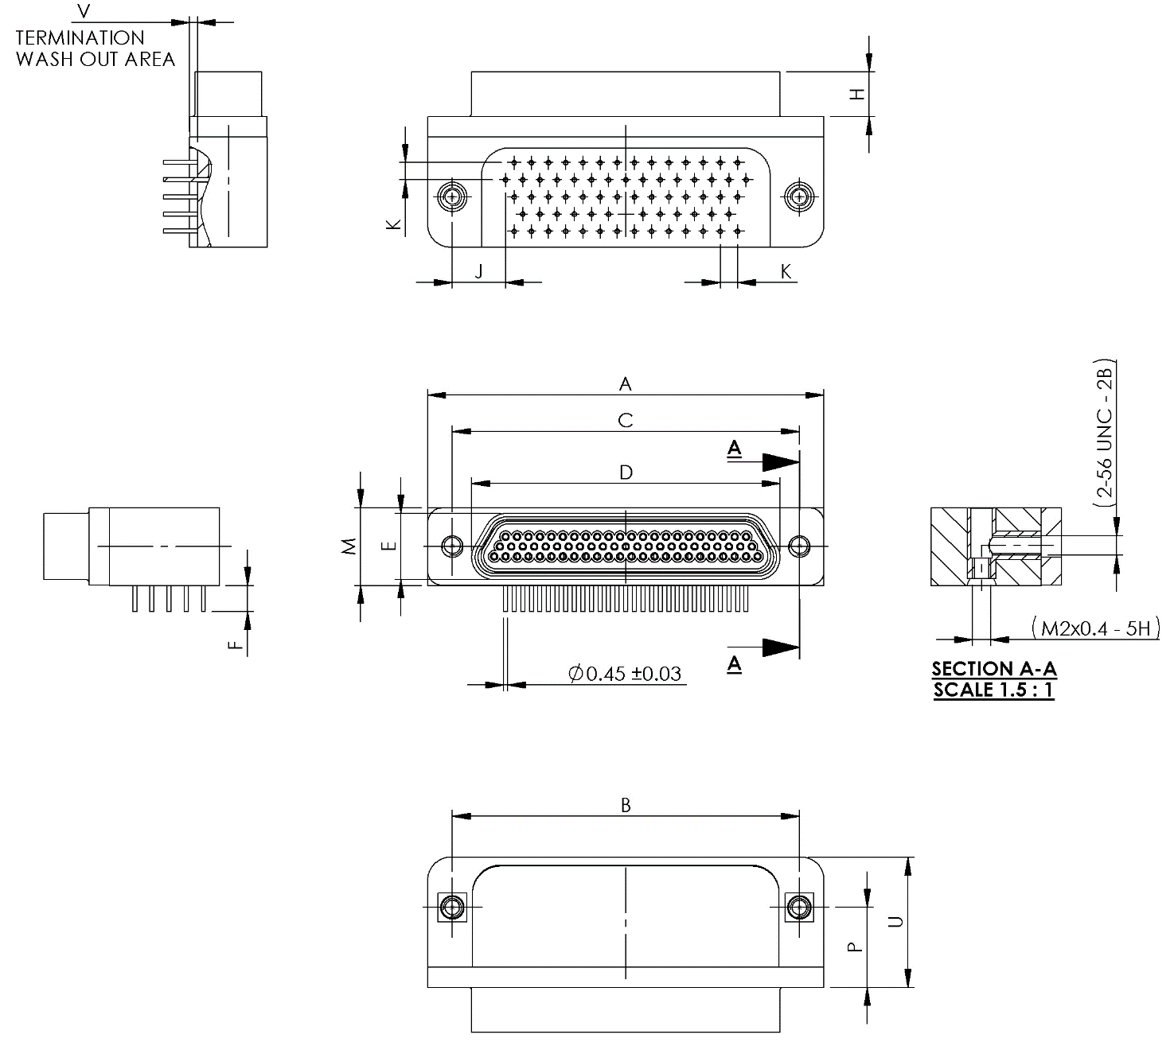
Shell Size | A  Max. | B |  | C |  | D  Max. | E  Max. | F
Shell Size | A  Max. | Min. | Max. | Min. | Max. | D  Max. | E  Max. | Min. | Max.
51 | 36.45 | 30.73 | 30.99 | 30.73 | 30.99 | 26.67 | 7.52 | 4.45 | 5.21
69 | 44.07 | 38.35 | 38.61 | 38.35 | 38.61 | 34.29 | 7.52 | 4.45 | 5.21

Shell  Size | H |  | J  Typ. | K  Typ. | M  Max. | P |  | U  Max. | V
Shell  Size | Min. | Max. | J  Typ. | K  Typ. | M  Max. | Min. | Max. | U  Max. | Min. | Max.
51 | 4.88 | 5.03 | 3.05 | 1.905 | 8.92 | 7.37 | 7.87 | 12.45 | 0.89 | 1.15
69 | 4.88 | 5.03 | 5.91 | 1.905 | 8.92 | 8.64 | 9.14 | 14.5 | 0.77 | 0.9
NOTES:
            - All dimensions are in millimetres.

FIGURE 2.2Q - CONNECTORS TYPE – GMR7590
Plug male Contacts
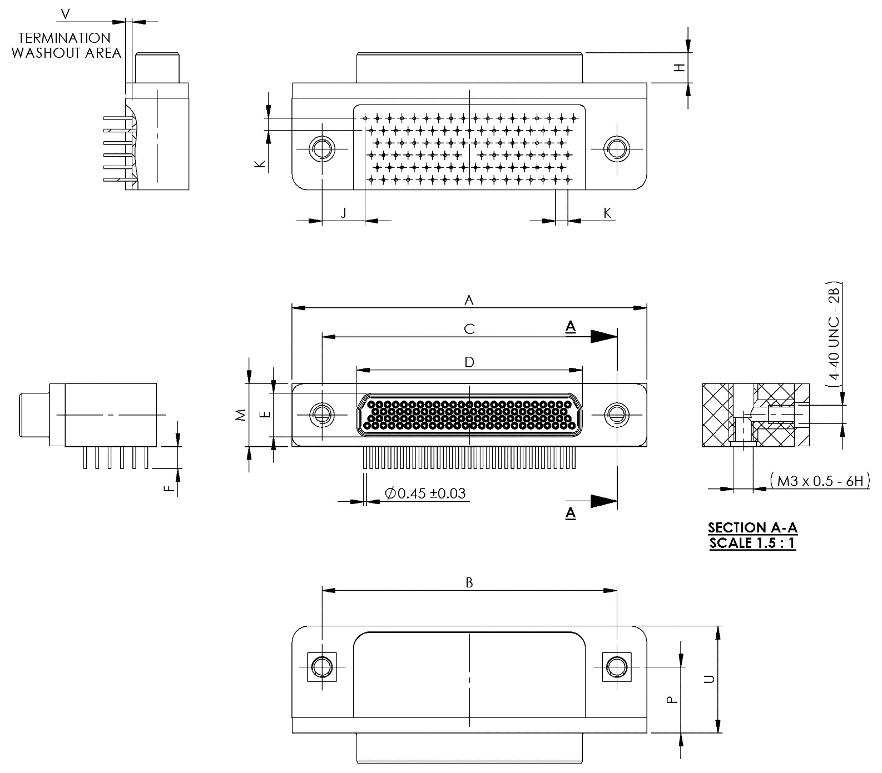
Shell Size | A  Max. | B |  | C |  | D  Max. | E  Max. | F
Shell Size | A  Max. | Min. | Max. | Min. | Max. | D  Max. | E  Max. | Min. | Max.
100 | 55.12 | 45.59 | 45.85 | 45.59 | 45.85 | 35.15 | 6.88 | 4.45 | 5.21

Shell  Size | H |  | J  Typ. | K  Typ. | M  Max. | P |  | U  Max. | V
Shell  Size | Min. | Max. | J  Typ. | K  Typ. | M  Max. | Min. | Max. | U  Max. | Min. | Max.
100 | 4.57 | 4.72 | 6.67 | 1.905 | 10.01 | 9.91 | 10.41 | 16.76 | 0.89 | 1.15
NOTES:
            - All dimensions are in millimetres.

FIGURE 2.2R - CONNECTORS TYPE – GMR7590
Receptacle Female Contacts
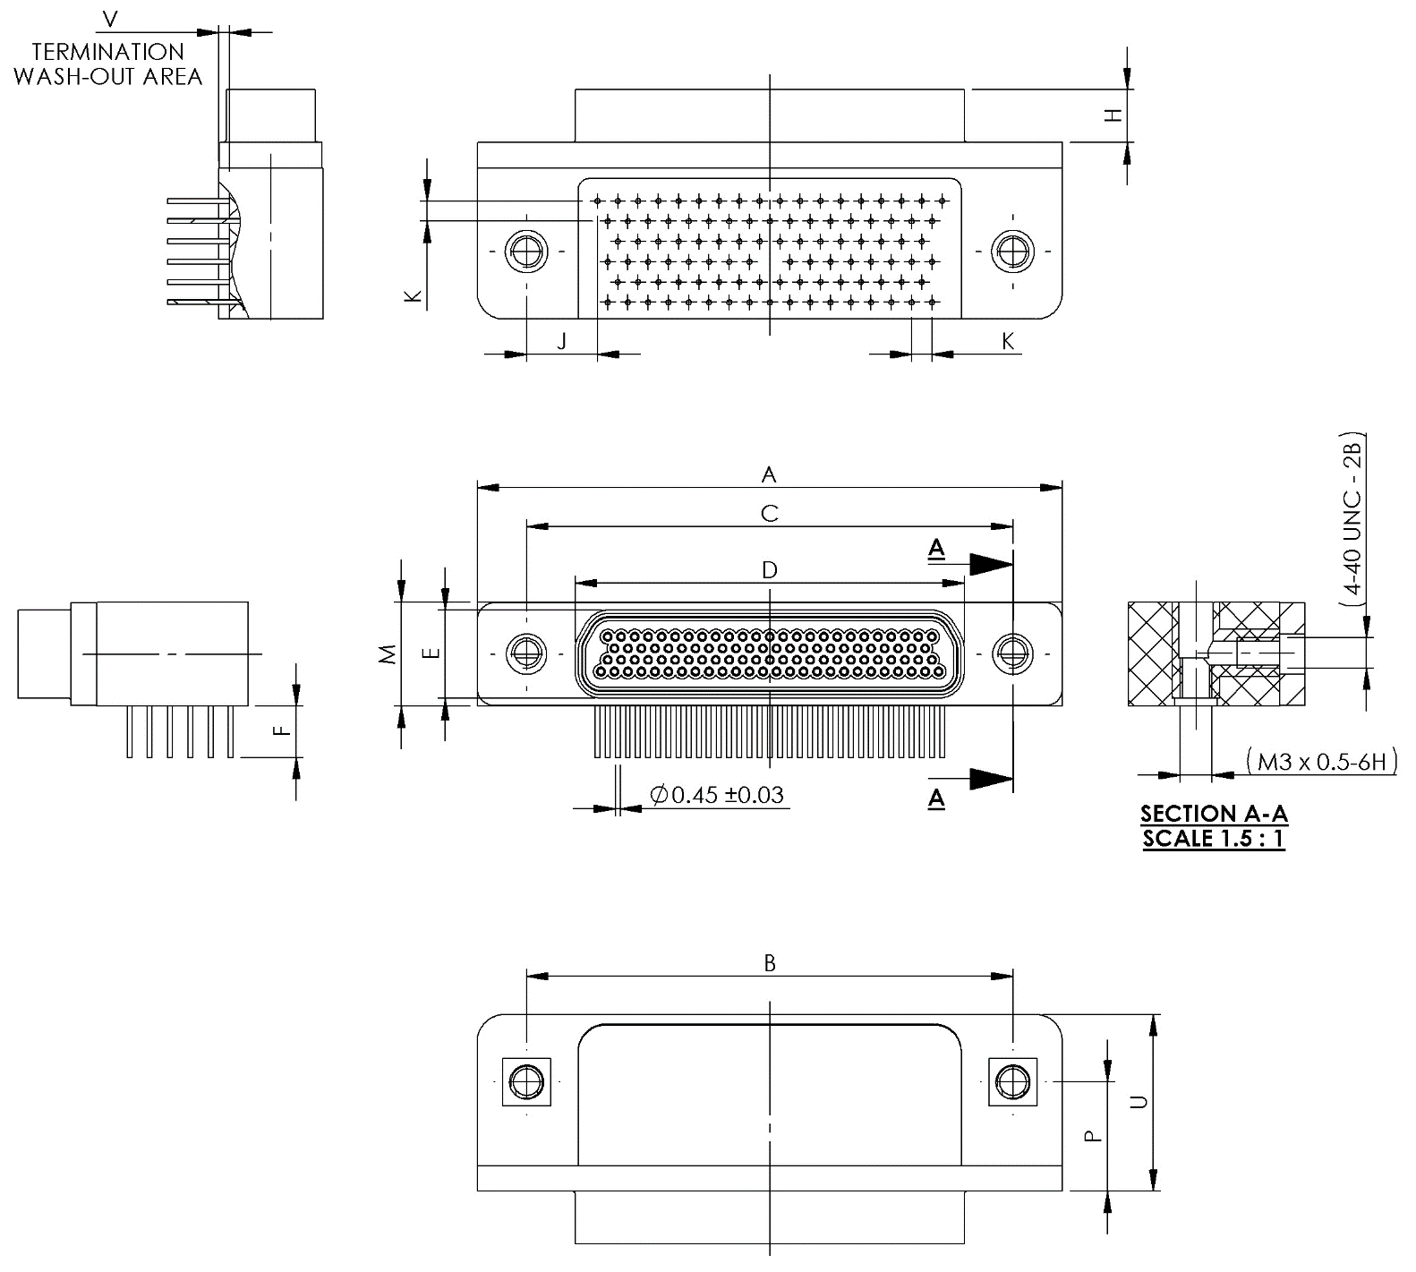
Shell Size | A  Max. | B |  | C |  | D  Max. | E  Max. | F
Shell Size | A  Max. | Min. | Max. | Min. | Max. | D  Max. | E  Max. | Min. | Max.
100 | 55.12 | 45.59 | 45.85 | 45.59 | 45.85 | 38.3 | 10.01 | 4.45 | 5.21

Shell  Size | H |  | J  Typ. | K  Typ. | M  Max. | P |  | U  Max. | V
Shell  Size | Min. | Max. | J  Typ. | K  Typ. | M  Max. | Min. | Max. | U  Max. | Min. | Max.
100 | 4.88 | 5.03 | 6.67 | 1.905 | 10.01 | 9.91 | 10.41 | 16.76 | 0.89 | 1.15
NOTES:
            - All dimensions are in millimetres.

FIGURE 2.2S - CONNECTORS TYPE – GMR7580
Plug male Contacts
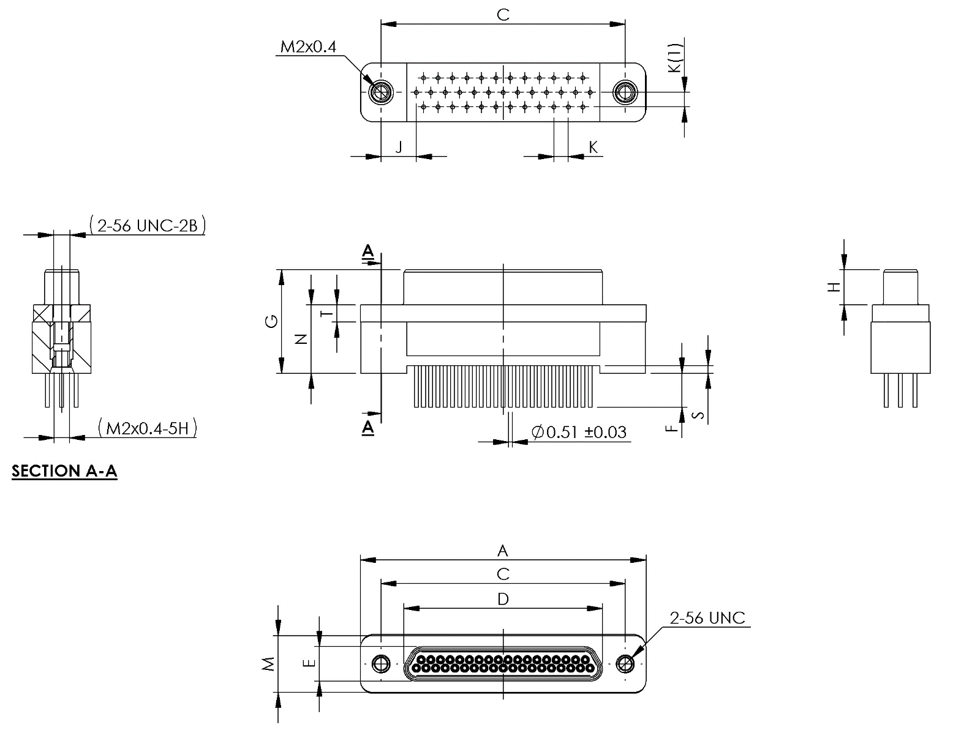
Shell Size | A  Max. | C |  | D  Max. | E  Max. | F |  | G  Max. | H
Shell Size | A  Max. | Min. | Max. | D  Max. | E  Max. | Min. | Max. | G  Max. | Min. | Max.
9 | 19.94 | 14.22 | 14.48 | 8.48 | 4.69 | 4.45 | 5.21 | 13.97 | 4.57 | 4.73
15 | 23.75 | 18.03 | 18.29 | 12.29 | 4.69 | 4.45 | 5.21 | 13.97 | 4.57 | 4.73
21 | 27.56 | 21.84 | 22.1 | 16.1 | 4.69 | 4.45 | 5.21 | 13.97 | 4.57 | 4.73
25 | 30.1 | 24.38 | 24.64 | 18.64 | 4.69 | 4.45 | 5.21 | 13.97 | 4.57 | 4.73
31 | 33.91 | 28.19 | 28.45 | 22.45 | 4.69 | 4.45 | 5.21 | 13.97 | 4.57 | 4.73
37 | 37.72 | 32 | 32.26 | 26.26 | 4.69 | 4.45 | 5.21 | 13.97 | 4.57 | 4.73

Shell  Size | J  Typ. | K  Typ. | K(1)  Typ. | M  Max. | N |  | S |  | T
 |  |  |  |  | Min. | Max. | Min. | Max. | Min. | Max.
9 | 3.37 | 1.905 | 1.905 | 7.82 | 8.76 | 9.02 | 0.89 | 1.15 | 2.24 | 2.49
15 | 4.32 | 1.905 | 1.905 | 7.82 | 8.76 | 9.02 | 0.89 | 1.15 | 2.24 | 2.49
21 | 4.32 | 1.905 | 1.905 | 7.82 | 8.76 | 9.02 | 0.89 | 1.15 | 2.24 | 2.49
25 | 4.64 | 1.905 | 1.905 | 7.82 | 8.76 | 9.02 | 0.89 | 1.15 | 2.24 | 2.49
31 | 4.64 | 1.905 | 1.905 | 7.82 | 8.76 | 9.02 | 0.89 | 1.15 | 2.24 | 2.49
37 | 4.64 | 1.905 | 1.905 | 7.82 | 8.76 | 9.02 | 0.89 | 1.15 | 2.24 | 2.49
NOTES:
            - All dimensions are in millimetres.

FIGURE 2.2T - CONNECTORS TYPE – GMR7580
Receptacle Female Contacts
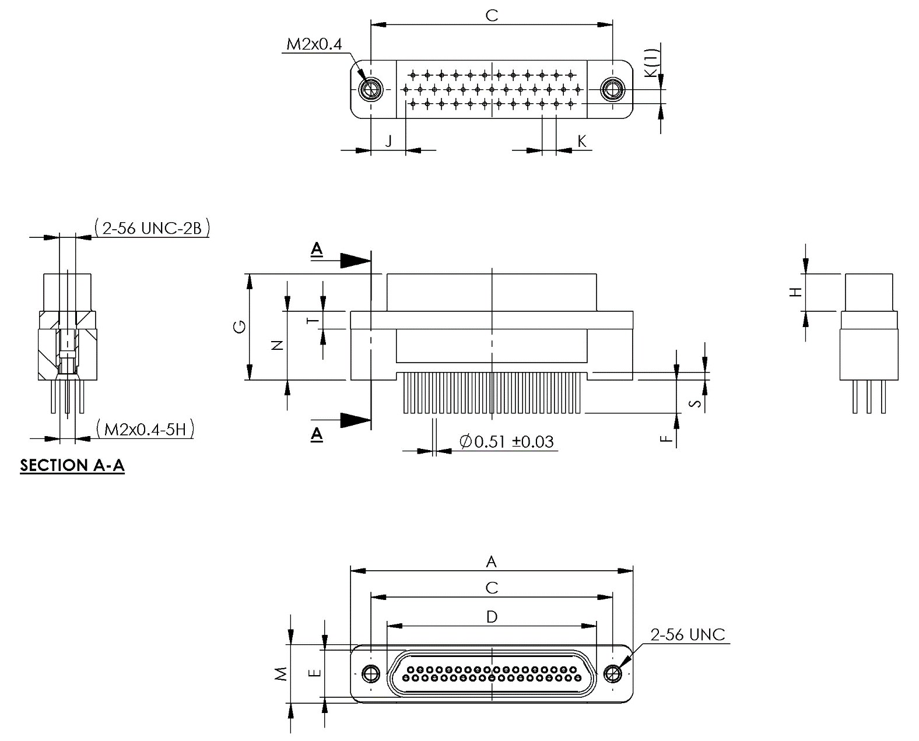
Shell Size | A  Max. | C |  | D  Max. | E  Max. | F |  | G  Max. | H
Shell Size | A  Max. | Min. | Max. | D  Max. | E  Max. | Min. | Max. | G  Max. | Min. | Max.
9 | 19.94 | 14.22 | 14.48 | 10.16 | 6.38 | 4.45 | 5.21 | 14.1 | 4.87 | 5.03
15 | 23.75 | 18.03 | 18.29 | 13.97 | 6.38 | 4.45 | 5.21 | 14.1 | 4.87 | 5.03
21 | 27.56 | 21.84 | 22.1 | 17.78 | 6.38 | 4.45 | 5.21 | 14.1 | 4.87 | 5.03
25 | 30.1 | 24.38 | 24.64 | 20.32 | 6.38 | 4.45 | 5.21 | 14.1 | 4.87 | 5.03
31 | 33.91 | 28.19 | 28.45 | 24.13 | 6.38 | 4.45 | 5.21 | 14.1 | 4.87 | 5.03
37 | 37.72 | 32 | 32.26 | 27.94 | 6.38 | 4.45 | 5.21 | 14.1 | 4.87 | 5.03

Shell  Size | J  Typ. | K  Typ. | K(1)  Typ. | M  Max. | N |  | S |  | T
 |  |  |  |  | Min. | Max. | Min. | Max. | Min. | Max.
9 | 3.37 | 1.905 | 1.905 | 7.87 | 8.76 | 9.02 | 0.89 | 1.02 | 2.24 | 2.49
15 | 4.32 | 1.905 | 1.905 | 7.87 | 8.76 | 9.02 | 0.89 | 1.02 | 2.24 | 2.49
21 | 4.35 | 1.905 | 1.905 | 7.87 | 8.76 | 9.02 | 0.89 | 1.02 | 2.24 | 2.49
25 | 4.64 | 1.905 | 1.905 | 7.87 | 8.76 | 9.02 | 0.89 | 1.02 | 2.24 | 2.49
31 | 4.64 | 1.905 | 1.905 | 7.87 | 8.76 | 9.02 | 0.89 | 1.02 | 2.24 | 2.49
37 | 4.64 | 1.905 | 1.905 | 7.87 | 8.76 | 9.02 | 0.89 | 1.02 | 2.24 | 2.49
NOTES:
            - All dimensions are in millimetres.

FIGURE 2.2U - CONNECTORS TYPE – GMR7580
Plug male Contacts
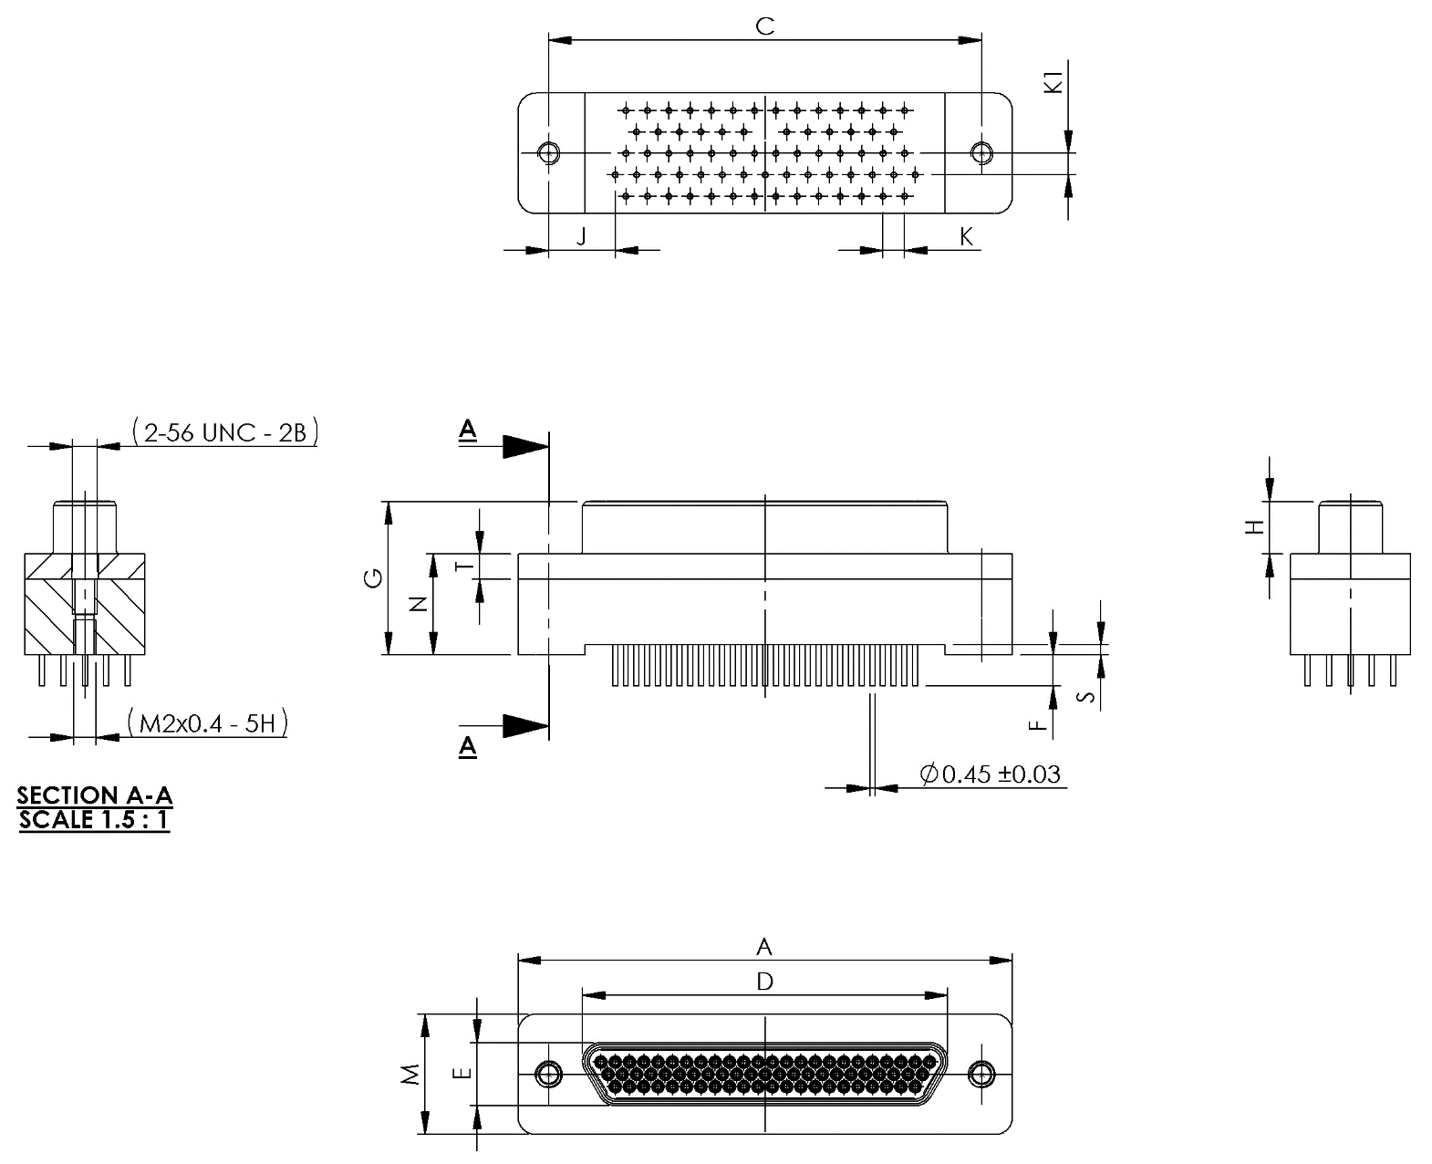
Shell Size | A  Max. | C |  | D  Max. | E  Max. | F |  | G  Max. | H
Shell Size | A  Max. | Min. | Max. | D  Max. | E  Max. | Min. | Max. | G  Max. | Min. | Max.
51 | 36.45 | 30.73 | 30.99 | 24.99 | 5.79 | 4.45 | 5.21 | 13.74 | 4.57 | 4.72
69 | 44.07 | 38.35 | 38.61 | 32.61 | 5.79 | 4.45 | 5.21 | 13.74 | 4.57 | 4.72

Shell  Size | J  Typ. | K  Typ. | K(1)  Typ. | M  Max. | N |  | S |  | T
 |  |  |  |  | Min. | Max. | Min. | Max. | Min. | Max.
51 | 3.05 | 1.905 | 1.905 | 8.92 | 8.76 | 9.02 | 0.77 | 0.9 | 2.24 | 2.49
69 | 5.91 | 1.905 | 1.905 | 10.83 | 8.76 | 9.02 | 0.77 | 0.9 | 2.24 | 2.49
NOTES:
            - All dimensions are in millimetres.

FIGURE 2.2V - CONNECTORS TYPE – GMR7580
Receptacle Female Contacts
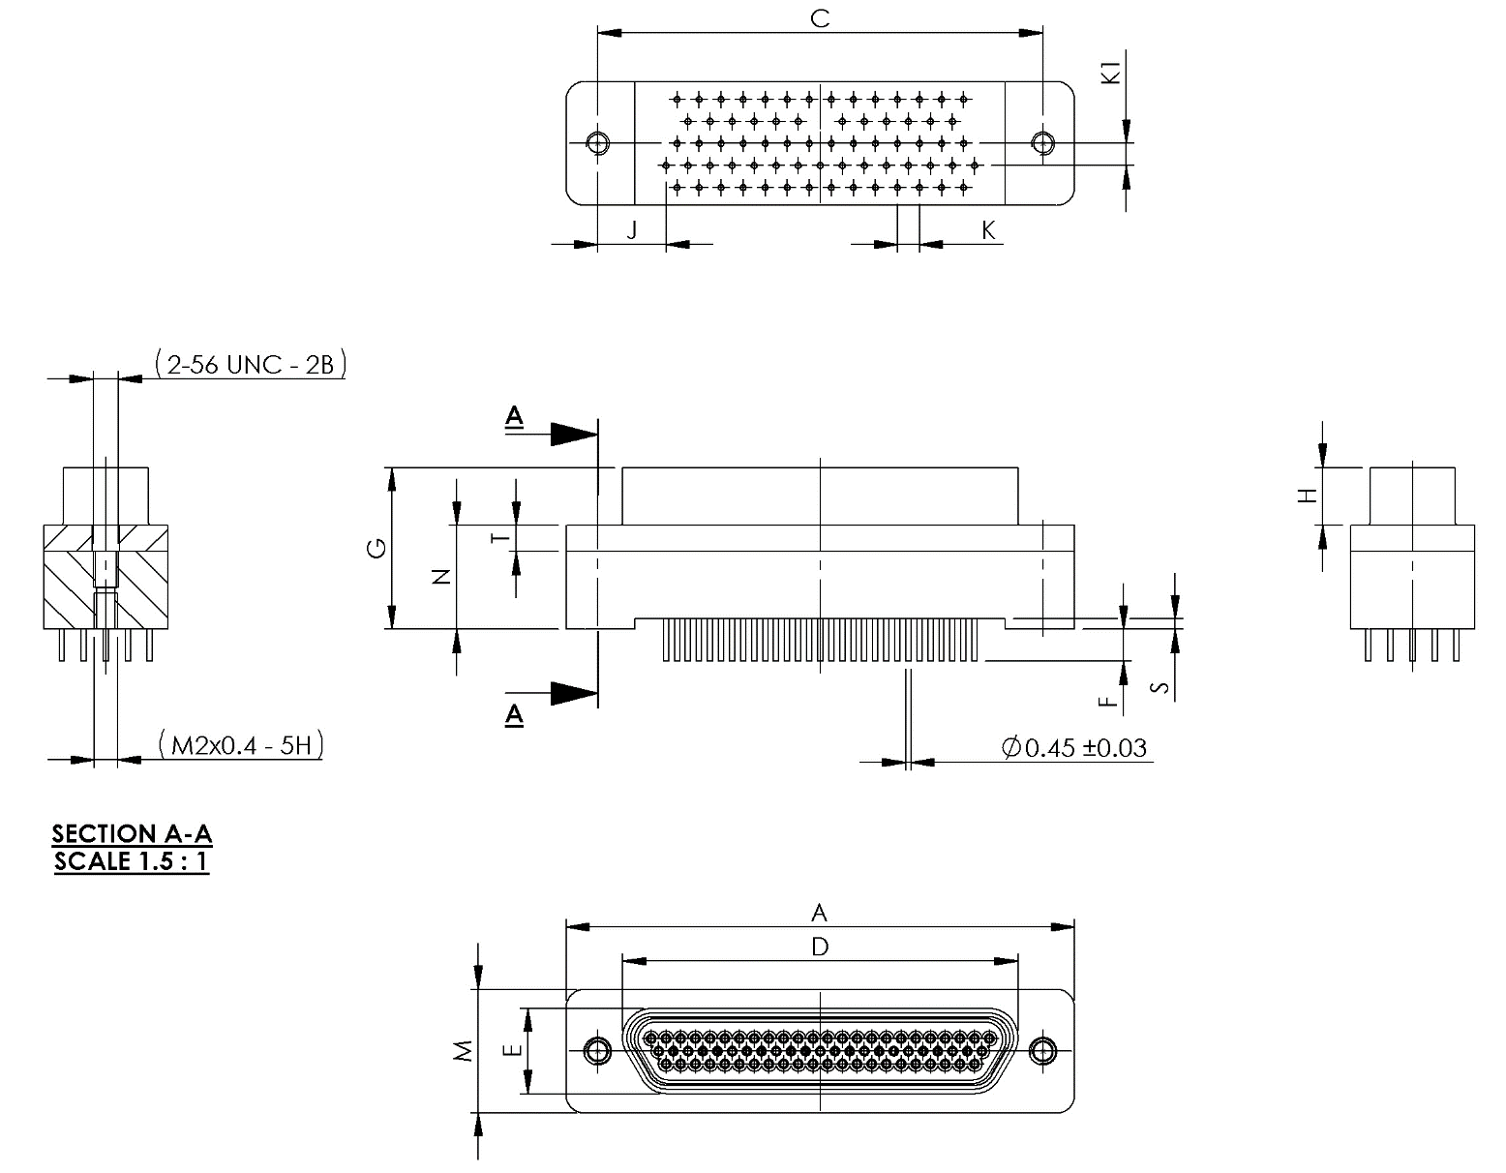
Shell Size | A  Max. | C |  | D  Max. | E  Max. | F |  | G  Max. | H
Shell Size | A  Max. | Min. | Max. | D  Max. | E  Max. | Min. | Max. | G  Max. | Min. | Max.
51 | 36.45 | 30.73 | 30.99 | 26.67 | 7.52 | 4.45 | 5.21 | 14.05 | 4.88 | 5.03
69 | 44.07 | 38.35 | 38.61 | 34.29 | 7.52 | 4.45 | 5.21 | 14.05 | 4.88 | 5.03

Shell  Size | J  Typ. | K  Typ. | K(1)  Typ. | M  Max. | N |  | S |  | T
 |  |  |  |  | Min. | Max. | Min. | Max. | Min. | Max.
51 | 3.05 | 1.905 | 1.905 | 8.92 | 8.76 | 9.02 | 0.77 | 0.9 | 2.24 | 2.49
69 | 5.91 | 1.905 | 1.905 | 10.83 | 8.76 | 9.02 | 0.77 | 0.9 | 2.24 | 2.49
NOTES:
            - All dimensions are in millimetres.

FIGURE 2.2W - CONNECTORS TYPE – GMR7580
Plug male Contacts
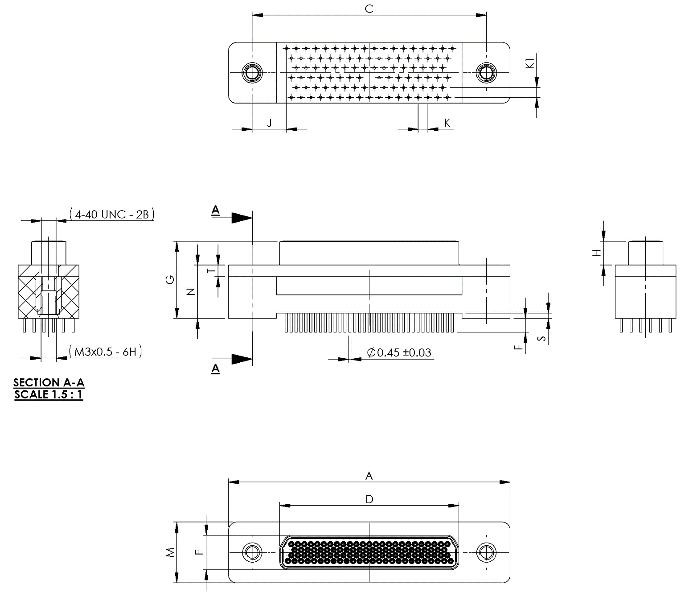
Shell Size | A  Max. | C |  | D  Max. | E  Max. | F |  | G  Max. | H
Shell Size | A  Max. | Min. | Max. | D  Max. | E  Max. | Min. | Max. | G  Max. | Min. | Max.
100 | 52.12 | 45.59 | 45.85 | 35.15 | 6.88 | 4.45 | 5.21 | 15.64 | 4.57 | 4.72

Shell  Size | J  Typ. | K  Typ. | K(1)  Typ. | M  Max. | N |  | S |  | T
 |  |  |  |  | Min. | Max. | Min. | Max. | Min. | Max.
100 | 6.67 | 1.905 | 1.905 | 11.99 | 10.24 | 10.92 | 0.89 | 1.15 | 2.24 | 2.49
NOTES:
            - All dimensions are in millimetres.

FIGURE 2.2X - CONNECTORS TYPE – GMR7580
Receptacle Female Contacts
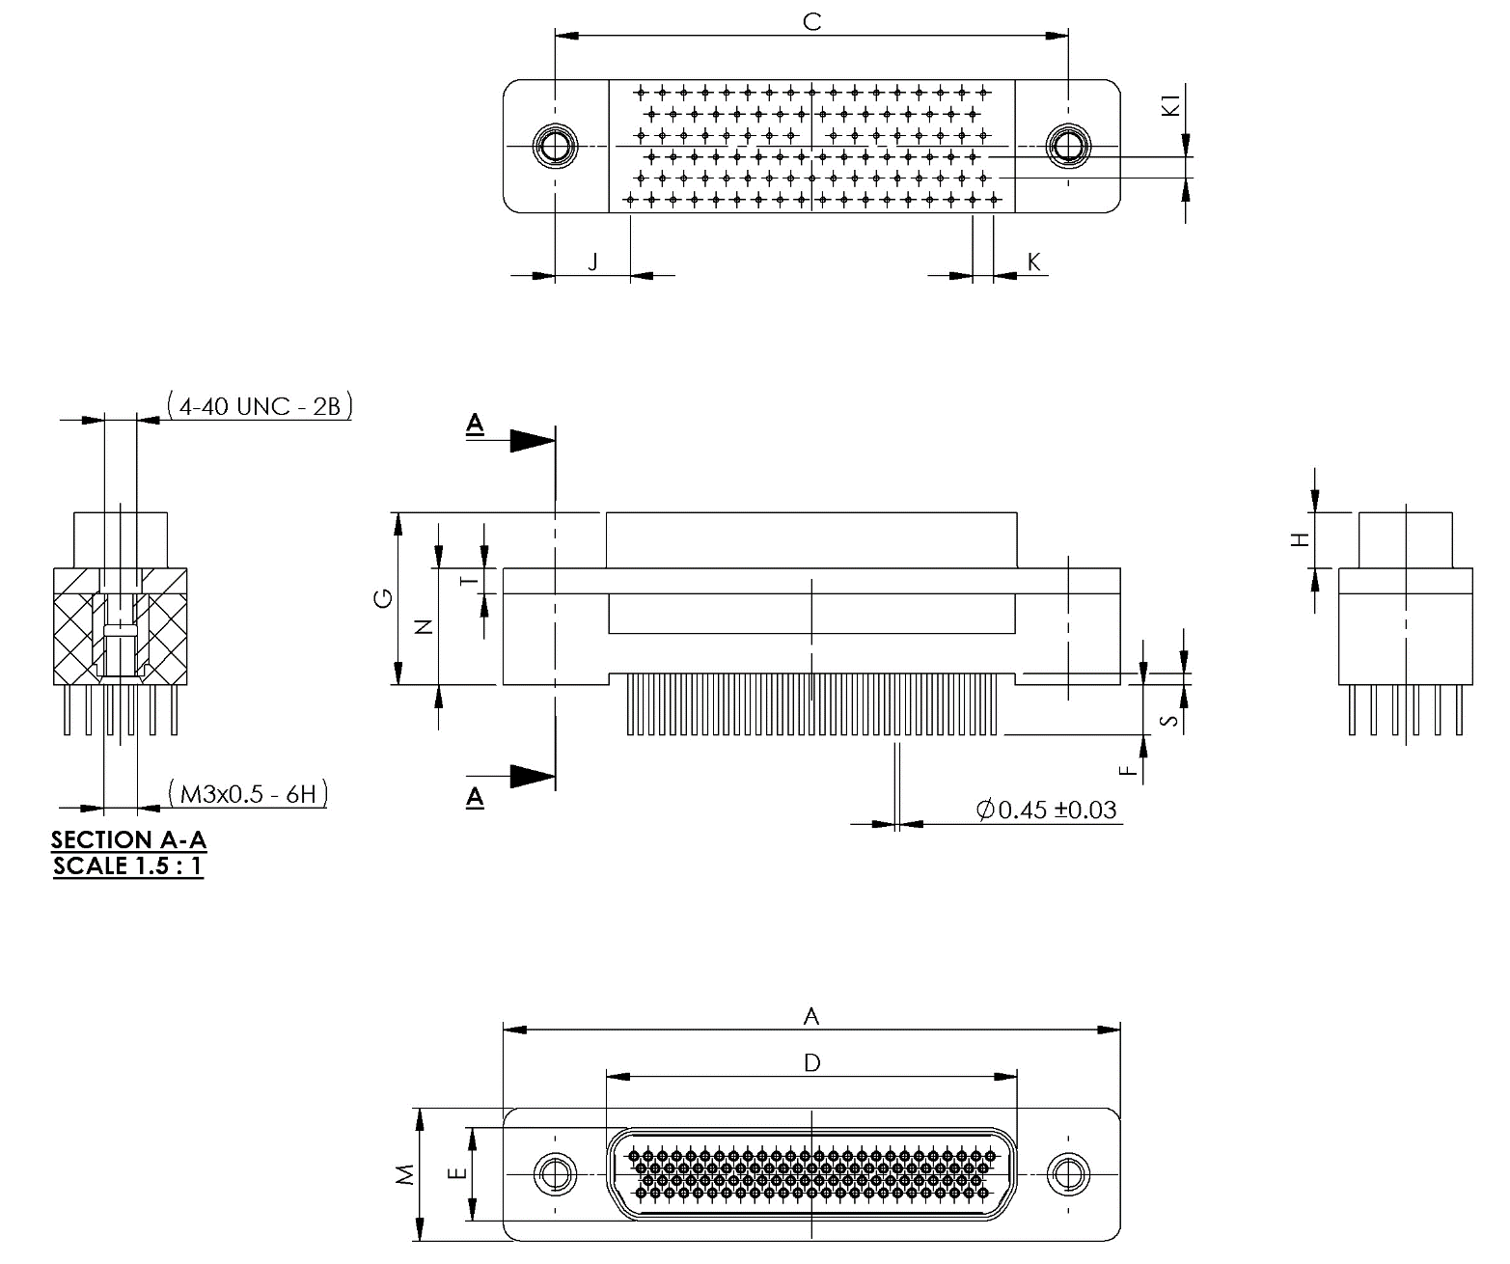
Shell Size | A  Max. | C |  | D  Max. | E  Max. | F |  | G  Max. | H
Shell Size | A  Max. | Min. | Max. | D  Max. | E  Max. | Min. | Max. | G  Max. | Min. | Max.
100 | 55.12 | 45.59 | 45.85 | 38.3 | 10.01 | 4.45 | 5.21 | 15.95 | 4.88 | 5.03

Shell  Size | J  Typ. | K  Typ. | K(1)  Typ. | M  Max. | N |  | S |  | T
 |  |  |  |  | Min. | Max. | Min. | Max. | Min. | Max.
100 | 6.67 | 1.905 | 1.905 | 11.99 | 10.24 | 10.92 | 0.89 | 1.15 | 2.24 | 2.49
NOTES:
            - All dimensions are in millimetres.

Figure 2.2y - Connectors type – 75RBB AND 75RBT
PLUG MALE CONTACTS
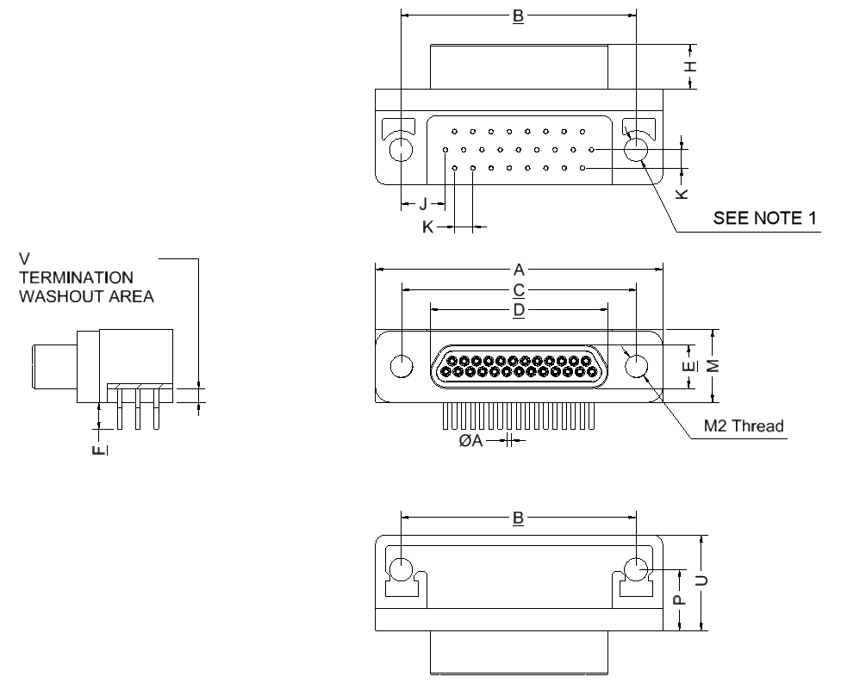
Shell Size | A  Max. | B |  | C |  | D  Max. | E  Max. | F
Shell Size | A  Max. | Min. | Max. | Min. | Max. | D  Max. | E  Max. | Min. | Max.
9 | 19.94 | 14.22 | 14.48 | 14.22 | 14.48 | 8.48 | 4.69 | 4.45 | 5.21
15 | 23.75 | 18.03 | 18.29 | 18.03 | 18.29 | 12.29 | 4.69 | 4.45 | 5.21
21 | 27.56 | 21.84 | 22.1 | 21.84 | 22.1 | 16.1 | 4.69 | 4.45 | 5.21
25 | 30.1 | 24.38 | 24.64 | 24.38 | 24.64 | 18.64 | 4.69 | 4.45 | 5.21
31 | 33.91 | 28.19 | 28.45 | 28.19 | 28.45 | 22.45 | 4.69 | 4.45 | 5.21
37 | 37.72 | 32 | 32.26 | 32 | 32.26 | 26.26 | 4.69 | 4.45 | 5.21

Shell Size | H |  | J  Typ. | K  Typ. | M |  | P |  | U  Max. | V
Shell Size | Min. | Max. | J  Typ. | K  Typ. | Min. | Max. | Min. | Max. | U  Max. | Min. | Max.
9 | 4.57 | 4.72 | 3.38 | 1.905 | 7.61 | 7.87 | 6.1 | 6.6 | 10.16 | 0.89 | 1.55
15 | 4.57 | 4.72 | 4.32 | 1.905 | 7.61 | 7.87 | 6.1 | 6.6 | 10.16 | 0.89 | 1.55
21 | 4.57 | 4.72 | 4.32 | 1.905 | 7.61 | 7.87 | 6.1 | 6.6 | 10.16 | 0.89 | 1.55
25 | 4.57 | 4.72 | 4.65 | 1.905 | 7.61 | 7.87 | 6.1 | 6.6 | 10.16 | 0.89 | 1.55
31 | 4.57 | 4.72 | 4.65 | 1.905 | 7.61 | 7.87 | 6.1 | 6.6 | 10.16 | 0.89 | 1.55
37 | 4.57 | 4.72 | 4.65 | 1.905 | 7.61 | 7.87 | 6.1 | 6.6 | 10.34 | 0.89 | 1.55
NOTES:
            - 75RBB is the code for a connector body with smooth holes of diameter 2.44 ±0.08mm.
75RBT is the code for a connector body with threaded (2-56 UNC 2B) inserts.
            - All dimensions are in millimetres.
            - For ØA refer to ØD in Figure 2.4.
            - Torque 0.44 Nm min / 0.48 Nm max.

FIGURE 2.2Z - Connectors type – 75RBB AND 75RBT
RECEPTACLE FEMALE CONTACTS
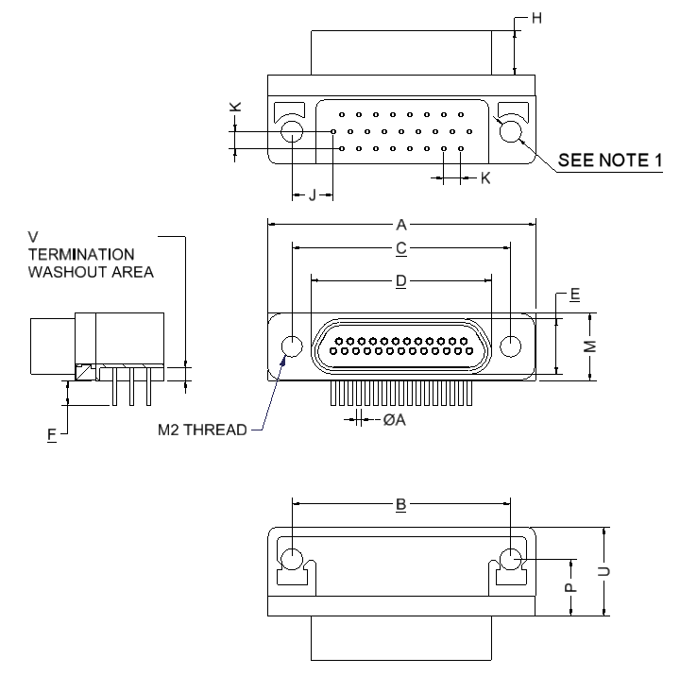
Shell Size | A  Max. | B |  | C |  | D  Max. | E  Max. | F
Shell Size | A  Max. | Min. | Max. | Min. | Max. | D  Max. | E  Max. | Min. | Max.
9 | 19.94 | 14.22 | 14.48 | 14.22 | 14.48 | 10.16 | 6.38 | 4.45 | 5.21
15 | 23.75 | 18.03 | 18.29 | 18.03 | 18.29 | 13.97 | 6.38 | 4.45 | 5.21
21 | 27.56 | 21.84 | 22.1 | 21.84 | 22.1 | 17.78 | 6.38 | 4.45 | 5.21
25 | 30.1 | 24.38 | 24.64 | 24.38 | 24.64 | 20.32 | 6.38 | 4.45 | 5.21
31 | 33.91 | 28.19 | 28.45 | 28.19 | 28.45 | 24.13 | 6.38 | 4.45 | 5.21
37 | 37.72 | 32 | 32.26 | 32 | 32.26 | 27.94 | 6.38 | 4.45 | 5.21

Shell Size | H |  | J  Typ. | K  Typ. | M |  | P |  | U  Max. | V
Shell Size | Min. | Max. | J  Typ. | K  Typ. | Min. | Max. | Min. | Max. | U  Max. | Min. | Max.
9 | 4.87 | 5.05 | 3.38 | 1.905 | 7.61 | 7.87 | 6.1 | 6.6 | 10.16 | 0.89 | 1.55
15 | 4.87 | 5.05 | 4.32 | 1.905 | 7.61 | 7.87 | 6.1 | 6.6 | 10.16 | 0.89 | 1.55
21 | 4.87 | 5.05 | 4.32 | 1.905 | 7.61 | 7.87 | 6.1 | 6.6 | 10.16 | 0.89 | 1.55
25 | 4.87 | 5.05 | 4.65 | 1.905 | 7.61 | 7.87 | 6.1 | 6.6 | 10.16 | 0.89 | 1.55
31 | 4.87 | 5.05 | 4.65 | 1.905 | 7.61 | 7.87 | 6.1 | 6.6 | 10.16 | 0.89 | 1.55
37 | 4.87 | 5.05 | 4.65 | 1.905 | 7.61 | 7.87 | 6.1 | 6.6 | 10.34 | 0.89 | 1.55
NOTES:
            - 75RBB is the code for a connector body with smooth holes of diameter 2.44 ±0.08mm.
75RBT is the code for a connector body with threaded (2-56 UNC 2B) inserts.
            - All dimensions are in millimetres.
            - For ØA refer to ØD in Figure 2.4.
            - Torque 0.44 Nm min / 0.48 Nm max.

Figure 2.2AA - Connectors type – 75RBB AND 75RBT
PLUG MALE CONTACTS
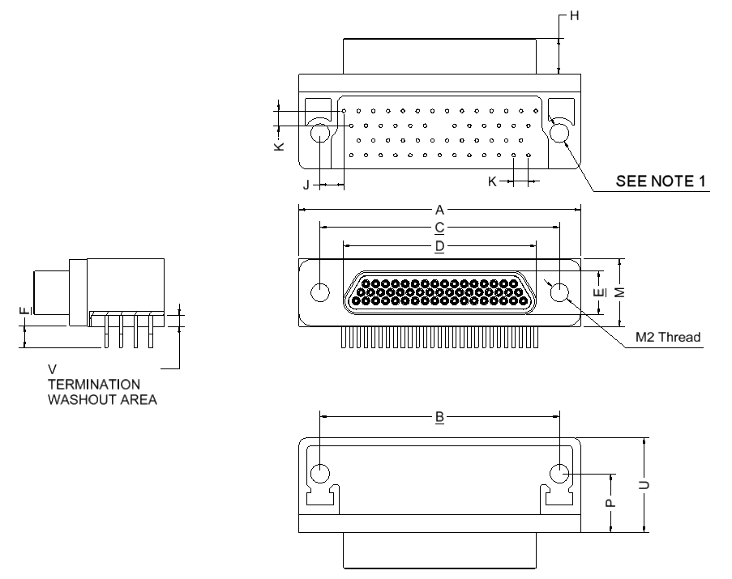
Shell Size | A  Max. | B |  | C |  | D  Max. | E  Max. | F
Shell Size | A  Max. | Min. | Max. | Min. | Max. | D  Max. | E  Max. | Min. | Max.
51 | 36.45 | 30.73 | 30.99 | 30.73 | 30.99 | 24.99 | 5.79 | 4.45 | 5.21

Shell Size | H |  | J  Typ. | K  Typ. | M |  | P |  | U  Max. | V
Shell Size | Min. | Max. | J  Typ. | K  Typ. | Min. | Max. | Min. | Max. | U  Max. | Min. | Max.
51 | 4.57 | 4.72 | 3.05 | 1.905 | 8.66 | 8.92 | 7.37 | 7.87 | 12.45 | 0.89 | 1.55
NOTES:
            - 75RBB is the code for a connector body with smooth holes of diameter 2.44 ±0.08mm.
75RBT is the code for a connector body with threaded (2-56 UNC 2B) inserts.
            - All dimensions are in millimetres.
            - For ØA refer to ØD in Figure 2.4.
            - Torque 0.44 Nm min / 0.48 Nm max.

FIGURE 2.2AB - Connectors type – 75RBB AND 75RBT
RECEPTACLE FEMALE CONTACTS
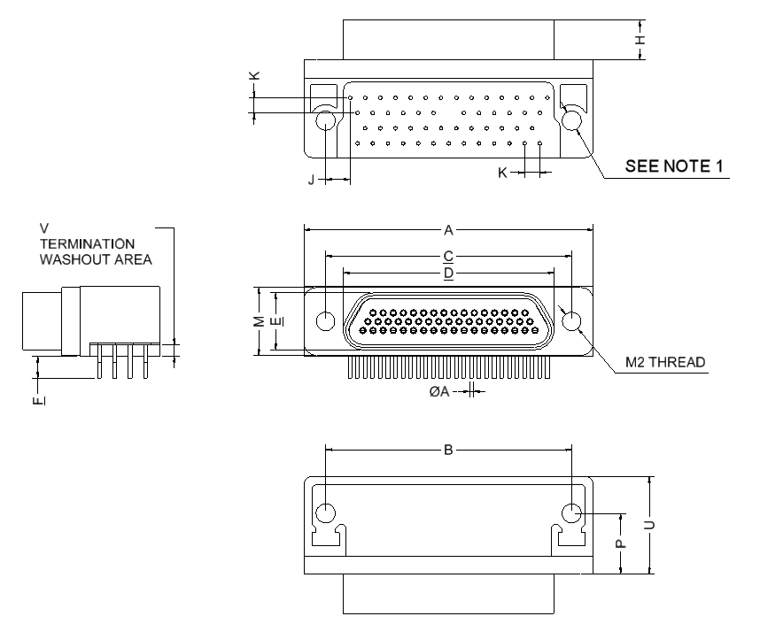
Shell Size | A  Max. | B |  | C |  | D  Max. | E  Max. | F
Shell Size | A  Max. | Min. | Max. | Min. | Max. | D  Max. | E  Max. | Min. | Max.
51 | 36.45 | 30.73 | 30.99 | 30.73 | 30.99 | 26.7 | 7.44 | 4.45 | 5.21

Shell Size | H |  | J  Typ. | K  Typ. | M |  | P |  | U  Max. | V
Shell Size | Min. | Max. | J  Typ. | K  Typ. | Min. | Max. | Min. | Max. | U  Max. | Min. | Max.
51 | 4.87 | 5.05 | 3.05 | 1.905 | 8.66 | 8.92 | 7.37 | 7.87 | 12.45 | 0.89 | 1.55
NOTES:
            - 75RBB is the code for a connector body with smooth holes of diameter 2.44 ±0.08mm.
75RBT is the code for a connector body with threaded (2-56 UNC 2B) inserts.
            - All dimensions are in millimetres.
            - For ØA refer to ØD in Figure 2.4.
            - Torque 0.44 Nm min / 0.48 Nm max.

Figure 2.2AC - Connectors type – 75RBB AND 75RBT
PLUG MALE CONTACTS
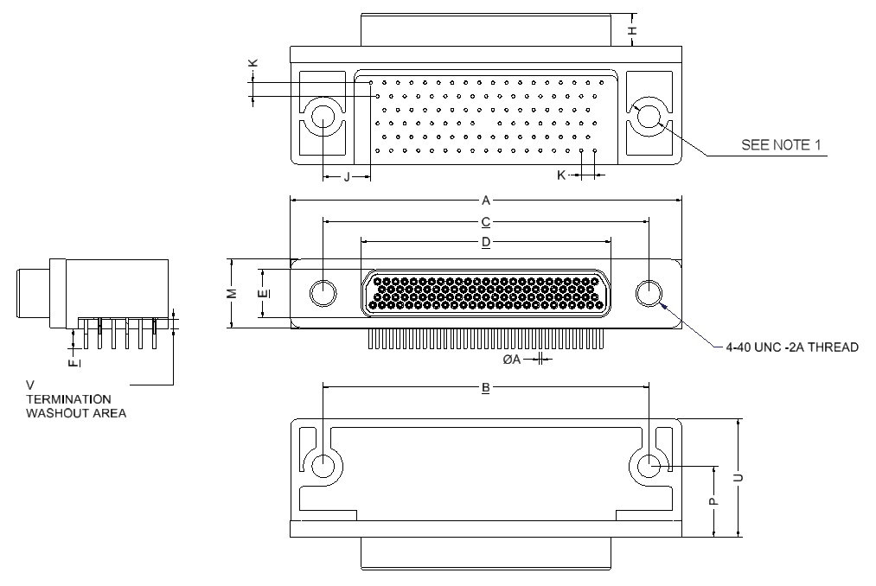
Shell Size | A  Max. | B |  | C |  | D  Max. | E  Max. | F
Shell Size | A  Max. | Min. | Max. | Min. | Max. | D  Max. | E  Max. | Min. | Max.
100 | 55.12 | 45.59 | 45.85 | 45.59 | 45.85 | 35.15 | 6.88 | 4.45 | 5.21

Shell Size | H |  | J  Typ. | K  Typ. | M |  | P |  | U  Max. | V
Shell Size | Min. | Max. | J  Typ. | K  Typ. | Min. | Max. | Min. | Max. | U  Max. | Min. | Max.
100 | 4.57 | 4.73 | 6.68 | 1.905 | 9.68 | 10 | 9.91 | 10.4 | 16.76 | 0.89 | 1.55
NOTES:
            - 75RBB is the code for a connector body with smooth holes of diameter 3.18 ±0.08mm.
75RBT is the code for a connector body with threaded (4-40 UNC 2B) inserts.
            - All dimensions are in millimetres.
            - For ØA refer to ØD in Figure 2.4.
            - Torque 0.44 Nm min / 0.48 Nm max.

FIGURE 2.2AD - Connectors type – 75RBB AND 75RBT
RECEPTACLE FEMALE CONTACTS
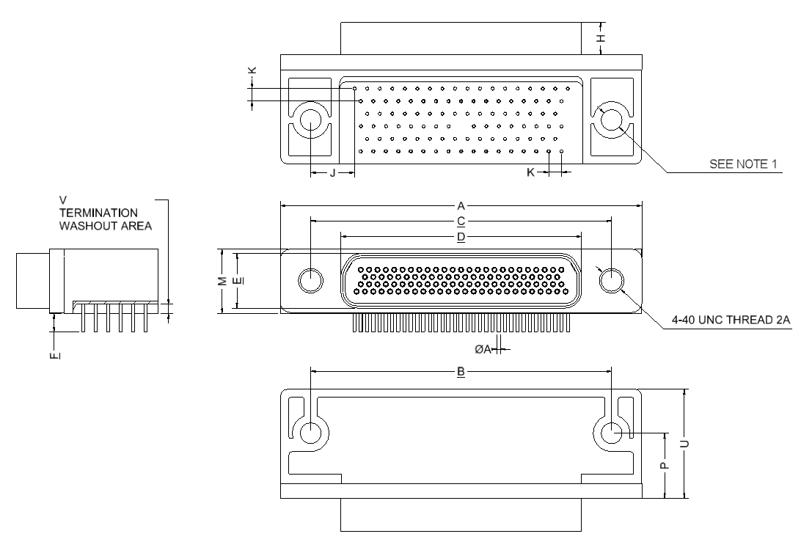
Shell Size | A  Max. | B |  | C |  | D  Max. | E  Max. | F
Shell Size | A  Max. | Min. | Max. | Min. | Max. | D  Max. | E  Max. | Min. | Max.
100 | 55.12 | 45.59 | 45.85 | 45.59 | 45.85 | 36.86 | 10 | 4.45 | 5.21

Shell Size | H |  | J  Typ. | K  Typ. | M |  | P |  | U  Max. | V
Shell Size | Min. | Max. | J  Typ. | K  Typ. | Min. | Max. | Min. | Max. | U  Max. | Min. | Max.
100 | 4.87 | 5.05 | 6.68 | 1.905 | 9.68 | 10 | 9.91 | 10.41 | 16.76 | 0.89 | 1.55
NOTES:
            - 75RBB is the code for a connector body with smooth holes of diameter 3.18 ±0.08mm.
75RBT is the code for a connector body with threaded (4-40 UNC 2B) inserts.
            - All dimensions are in millimetres.
            - For ØA refer to ØD in Figure 2.4.
            - Torque 0.44 Nm min / 0.48 Nm max.

FIGURE 2.2AE - CONNECTORS TYPE – 75SBB AND 75SBT
PLUG MALE CONTACTS
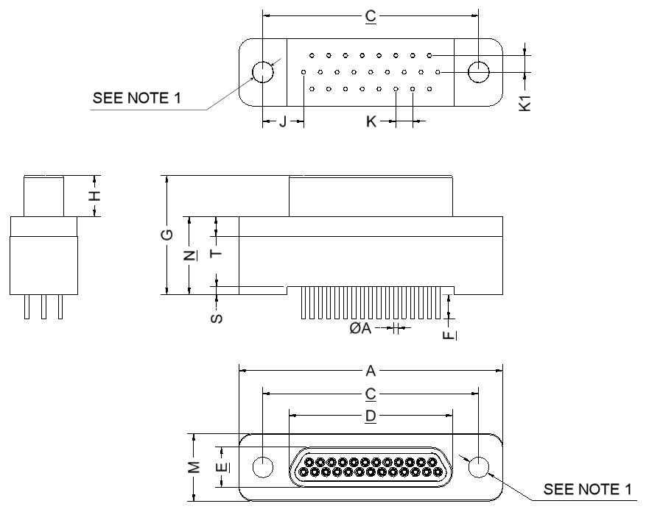
Shell Size | A  Max. | C |  | D  Max. | E  Max. | F |  | G  Max. | H
Shell Size | A  Max. | Min. | Max. | D  Max. | E  Max. | Min. | Max. | G  Max. | Min. | Max.
9 | 19.94 | 14.22 | 14.48 | 8.48 | 4.69 | 4.45 | 5.21 | 13.97 | 4.57 | 4.72
15 | 23.75 | 18.03 | 18.29 | 12.29 | 4.69 | 4.45 | 5.21 | 13.97 | 4.57 | 4.72
21 | 27.56 | 21.84 | 22.1 | 16.1 | 4.69 | 4.45 | 5.21 | 13.97 | 4.57 | 4.72
25 | 30.1 | 24.38 | 24.64 | 18.64 | 4.69 | 4.45 | 5.21 | 13.97 | 4.57 | 4.72
31 | 33.91 | 28.19 | 28.45 | 22.45 | 4.69 | 4.45 | 5.21 | 13.97 | 4.57 | 4.72
37 | 37.72 | 32 | 32.26 | 26.26 | 4.69 | 4.45 | 5.21 | 13.97 | 4.57 | 4.72

Shell Size | J  Typ. | K  Typ. | K1  Typ. | M |  | N |  | S |  | T
 |  |  |  | Min. | Max. | Min. | Max. | Min. | Max. | Min. | Max.
9 | 3.38 | 1.905 | 1.905 | 7.61 | 7.87 | 8.73 | 9.03 | 0.38 | 1.02 | 2.23 | 2.44
15 | 4.32 | 1.905 | 1.905 | 7.61 | 7.87 | 8.73 | 9.03 | 0.38 | 1.02 | 2.23 | 2.44
21 | 4.32 | 1.905 | 1.905 | 7.61 | 7.87 | 8.73 | 9.03 | 0.38 | 1.02 | 2.23 | 2.44
25 | 4.65 | 1.905 | 1.905 | 7.61 | 7.87 | 8.73 | 9.03 | 0.38 | 1.02 | 2.23 | 2.44
31 | 4.65 | 1.905 | 1.905 | 7.61 | 7.87 | 8.73 | 9.03 | 0.38 | 1.02 | 2.23 | 2.44
37 | 4.65 | 1.905 | 1.905 | 7.61 | 7.87 | 8.73 | 9.03 | 0.38 | 1.02 | 2.23 | 2.44
NOTES:
            - 75SBB is the code for a connector body with smooth holes of diameter 2.36 ±0.08mm.
75SBT is the code for a connector body with threaded (2-56 UNC 2B) inserts.
            - All dimensions are in millimetres.
            - For ØA refer to ØD in Figure 2.4.
            - Torque 0.44 Nm min / 0.48 Nm max.

FIGURE 2.2AF - CONNECTORS TYPE – 75SBB AND 75SBT
RECEPTACLE FEMALE CONTACTS
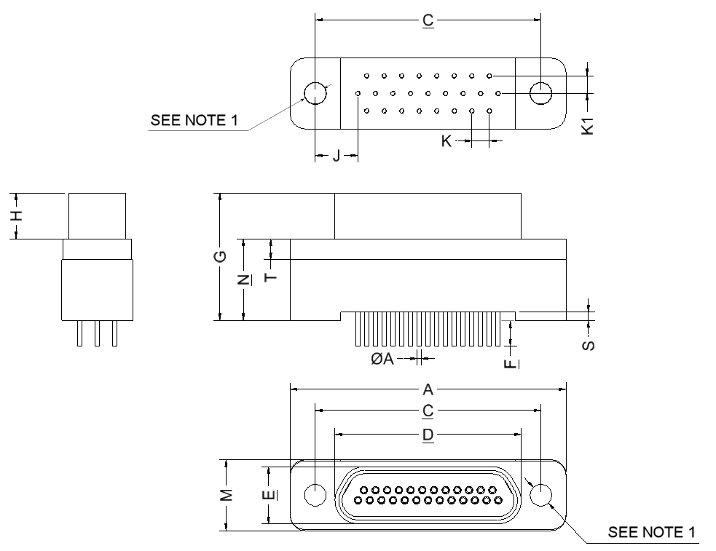
Shell Size | A  Max. | C |  | D  Max. | E  Max. | F |  | G  Max. | H
Shell Size | A  Max. | Min. | Max. | D  Max. | E  Max. | Min. | Max. | G  Max. | Min. | Max.
9 | 19.94 | 14.22 | 14.48 | 10.16 | 6.38 | 4.45 | 5.21 | 14.1 | 4.87 | 5.05
15 | 23.75 | 18.03 | 18.29 | 13.97 | 6.38 | 4.45 | 5.21 | 14.1 | 4.87 | 5.05
21 | 27.56 | 21.84 | 22.1 | 17.78 | 6.38 | 4.45 | 5.21 | 14.1 | 4.87 | 5.05
25 | 30.1 | 24.38 | 24.64 | 20.32 | 6.38 | 4.45 | 5.21 | 14.1 | 4.87 | 5.05
31 | 33.91 | 28.19 | 28.45 | 24.13 | 6.38 | 4.45 | 5.21 | 14.1 | 4.87 | 5.05
37 | 37.72 | 32 | 32.26 | 27.94 | 6.38 | 4.45 | 5.21 | 14.1 | 4.87 | 5.05

Shell Size | J  Typ. | K  Typ. | K1  Typ. | M |  | N |  | S |  | T
 |  |  |  | Min. | Max. | Min. | Max. | Min. | Max. | Min. | Max.
9 | 3.38 | 1.905 | 1.905 | 7.61 | 7.87 | 8.73 | 9.03 | 0.38 | 1.02 | 2.23 | 2.44
15 | 4.32 | 1.905 | 1.905 | 7.61 | 7.87 | 8.73 | 9.03 | 0.38 | 1.02 | 2.23 | 2.44
21 | 4.32 | 1.905 | 1.905 | 7.61 | 7.87 | 8.73 | 9.03 | 0.38 | 1.02 | 2.23 | 2.44
25 | 4.65 | 1.905 | 1.905 | 7.61 | 7.87 | 8.73 | 9.03 | 0.38 | 1.02 | 2.23 | 2.44
31 | 4.65 | 1.905 | 1.905 | 7.61 | 7.87 | 8.73 | 9.03 | 0.38 | 1.02 | 2.23 | 2.44
37 | 4.65 | 1.905 | 1.905 | 7.61 | 7.87 | 8.73 | 9.03 | 0.38 | 1.02 | 2.23 | 2.44
NOTES:
            - 75SBB is the code for a connector body with smooth holes of diameter 2.36 ±0.08mm.
75SBT is the code for a connector body with threaded (2-56 UNC 2B) inserts.
            - All dimensions are in millimetres.
            - For ØA refer to ØD in Figure 2.4.
            - Torque 0.44 Nm min / 0.48 Nm max.

FIGURE 2.2AG - CONNECTORS TYPE – 75SBB AND 75SBT
PLUG MALE CONTACTS
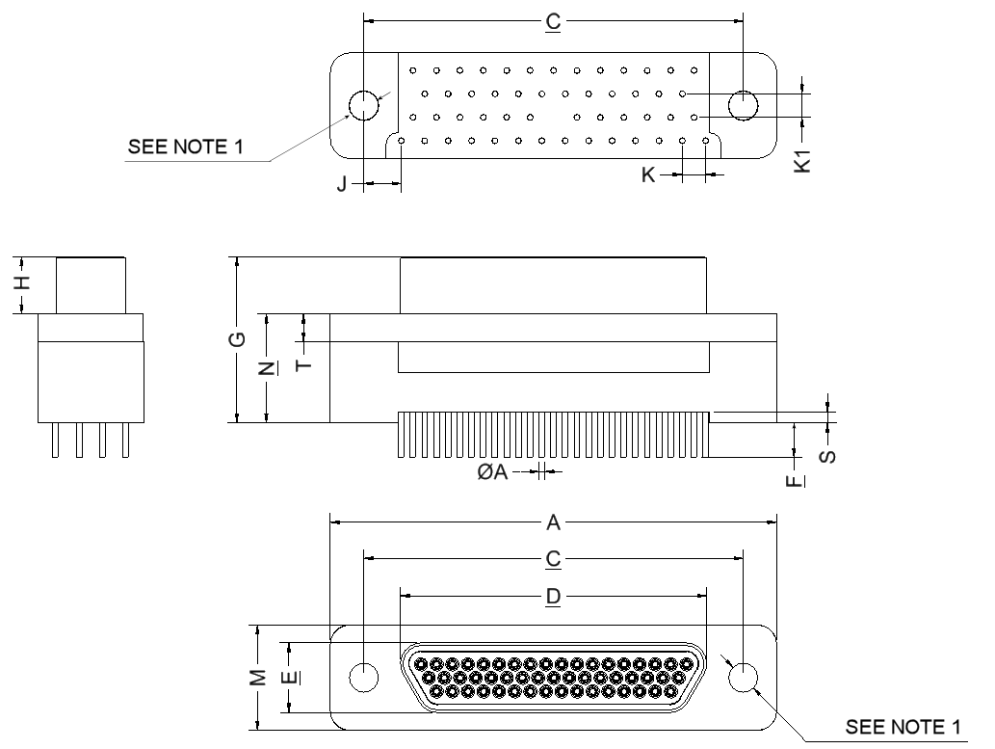
Shell Size | A  Max. | C |  | D  Max. | E  Max. | F |  | G  Max. | H
Shell Size | A  Max. | Min. | Max. | D  Max. | E  Max. | Min. | Max. | G  Max. | Min. | Max.
51 | 36.45 | 30.73 | 30.99 | 24.99 | 5.79 | 4.45 | 5.21 | 13.97 | 4.57 | 4.73
69 | 44.07 | 38.35 | 38.61 | 32.55 | 5.79 | 4.45 | 5.21 | 13.97 | 4.57 | 4.73

Shell Size | J  Typ. | K  Typ. | K1  Typ. | M |  | N |  | S |  | T
 |  |  |  | Min. | Max. | Min. | Max. | Min. | Max. | Min. | Max.
51 | 3.05 | 1.905 | 1.905 | 8.5 | 8.92 | 8.73 | 9.03 | 0.38 | 1.02 | 2.23 | 2.44
69 | 5.91 | 1.905 | 1.905 | 9.9 | 10.83 | 8.73 | 9.03 | 0.38 | 1.02 | 2.23 | 2.44
NOTES:
            - 75SBB is the code for a connector body with smooth holes of diameter 2.36 ±0.08mm.
75SBT is the code for a connector body with threaded (2-56 UNC 2B) inserts.
            - All dimensions are in millimetres.
            - For ØA refer to ØD in Figure 2.4.
            - Torque 0.44 Nm min / 0.48 Nm max.

FIGURE 2.2AH - CONNECTORS TYPE – 75SBB AND 75SBT
RECEPTACLE FEMALE CONTACTS
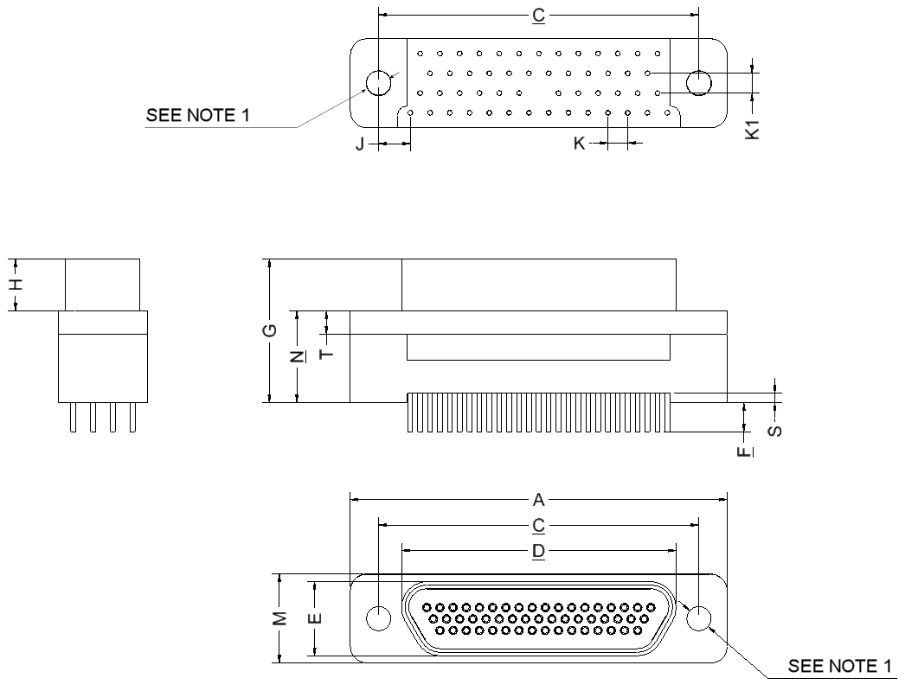
Shell Size | A  Max. | C |  | D  Max. | E  Max. | F |  | G  Max. | H
Shell Size | A  Max. | Min. | Max. | D  Max. | E  Max. | Min. | Max. | G  Max. | Min. | Max.
51 | 36.45 | 30.73 | 30.99 | 26.67 | 7.52 | 4.45 | 5.21 | 13.97 | 4.87 | 5.05
69 | 44.07 | 38.35 | 38.61 | 34.34 | 7.52 | 4.45 | 5.21 | 13.97 | 4.87 | 5.05

Shell Size | J  Typ. | K  Typ. | K1  Typ. | M |  | N |  | S |  | T
 |  |  |  | Min. | Max. | Min. | Max. | Min. | Max. | Min | Max.
51 | 3.05 | 1.905 | 1.905 | 8.5 | 8.92 | 8.73 | 9.03 | 0.38 | 1.02 | 2.23 | 2.44
69 | 5.91 | 1.905 | 1.905 | 9.9 | 10.8 | 8.73 | 9.03 | 0.38 | 1.02 | 2.23 | 2.44
NOTES:
            - 75SBB is the code for a connector body with smooth holes of diameter 2.36 ±0.08mm.
75SBT is the code for a connector body with threaded (2-56 UNC 2B) inserts.
            - All dimensions are in millimetres.
            - For ØA refer to ØD in Figure 2.4.
            - Torque 0.44 Nm min / 0.48 Nm max.

FIGURE 2.2AI - CONNECTORS TYPE – 75SBB AND 75SBT
PLUG MALE CONTACTS
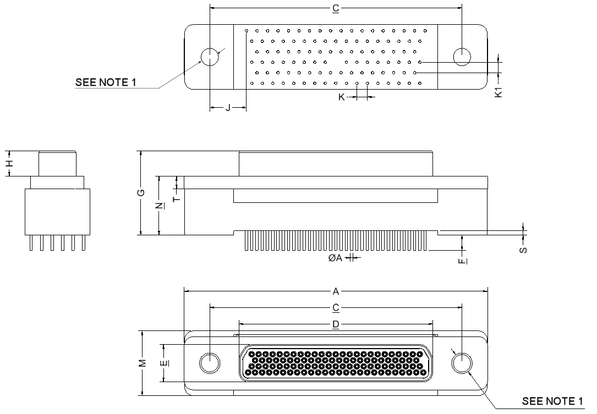
Shell Size | A  Max. | C |  | D  Max. | E  Max. | F |  | G  Max. | H
Shell Size | A  Max. | Min. | Max. | D  Max. | E  Max. | Min. | Max. | G  Max. | Min. | Max.
100 | 55.12 | 45.59 | 45.85 | 35.15 | 6.88 | 4.45 | 5.21 | 15.53 | 4.58 | 4.73

Shell Size | J  Typ. | K  Typ. | K1  Typ. | M |  | N |  | S |  | T
 |  |  |  | Min. | Max. | Min. | Max. | Min. | Max. | Min. | Max.
100 | 6.68 | 1.905 | 1.905 | 11.65 | 12.95 | 10.53 | 10.92 | 0.38 | 1.02 | 2.13 | 2.44
NOTES:
            - 75SBB is the code for a connector body with smooth holes of diameter 3.68mm minimum and 3.81mm maximum.
75SBT is the code for a connector body with threaded (4-40 UNC 2B) inserts.
            - All dimensions are in millimetres.
            - For ØA refer to ØD in Figure 2.4.
            - Torque 0.44 Nm min / 0.48 Nm max.

FIGURE 2.2AJ - CONNECTORS TYPE – 75SBB AND 75SBT
RECEPTACLE FEMALE CONTACTS
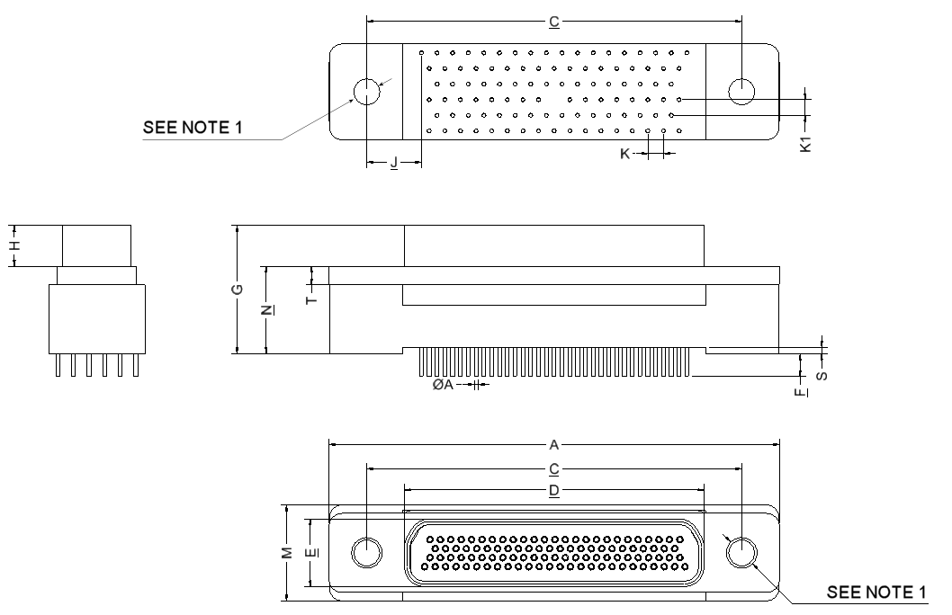
Shell Size | A  Max. | C |  | D  Max. | E  Max. | F |  | G  Max. | H
Shell Size | A  Max. | Min. | Max. | D  Max. | E  Max. | Min. | Max. | G  Max. | Min. | Max.
100 | 55.12 | 45.59 | 45.85 | 36.86 | 8.45 | 4.45 | 5.21 | 15.86 | 4.87 | 5.05

Shell Size | J  Typ. | K  Typ. | K1  Typ. | M |  | N |  | S |  | T
 |  |  |  | Min. | Max. | Min. | Max. | Min. | Max. | Min. | Max.
100 | 6.68 | 1.905 | 1.905 | 11.65 | 12.95 | 10.53 | 11.05 | 0.38 | 1.02 | 2.13 | 2.44
NOTES:
            - 75SBB is the code for a connector body with smooth holes of diameter 3.68mm minimum and 3.81mm maximum.
75SBT is the code for a connector body with threaded (4-40 UNC 2B) inserts.
            - All dimensions are in millimetres.
            - For ØA refer to ØD in Figure 2.4.
            - Torque 0.44 Nm min / 0.48 Nm max.

Figure 2.2ak - Connectors type – cbrB AND CBRT
PLUG malE CONTACTS
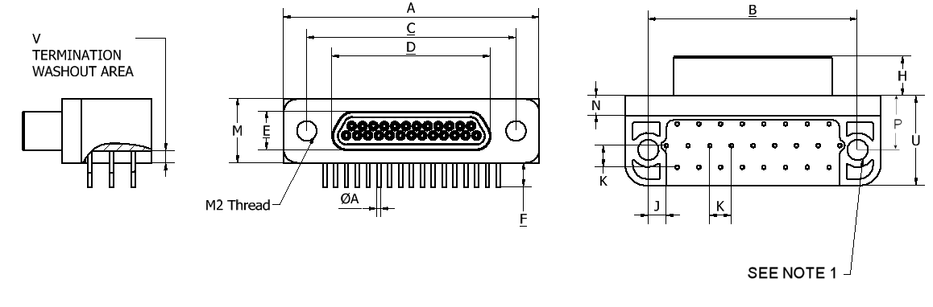
Shell Size | A  Max. | B |  | C |  | D  Max. | E  Max. | F |  | H  Max.
Shell Size | A  Max. | Min. | Max. | Min. | Max. | D  Max. | E  Max. | Min. | Max. | H  Max.
9 | 19.94 | 14.22 | 14.48 | 14.22 | 14.48 | 8.48 | 4.69 | 4.45 | 5.21 | 4.72
15 | 23.75 | 18.03 | 18.29 | 18.03 | 18.29 | 12.29 | 4.69 | 4.45 | 5.21 | 4.72
21 | 27.56 | 21.84 | 22.1 | 21.84 | 22.1 | 16.1 | 4.69 | 4.45 | 5.21 | 4.72
25 | 30.1 | 24.38 | 24.64 | 24.38 | 24.64 | 18.64 | 4.69 | 4.45 | 5.21 | 4.72

Shell Size | J  Typ. | K  Typ. | M |  | N |  | P |  | U  Max. | V
Shell Size | J  Typ. | K  Typ. | Min. | Max. | Min. | Max. | Min. | Max. | U  Max. | Min. | Max.
9 | 2.11 | 2.54 | 7.49 | 7.75 | 2.23 | 2.49 | 6.1 | 6.6 | 10.8 | 1.29 | 1.55
15 | 2.74 | 2.54 | 7.49 | 7.75 | 2.23 | 2.49 | 6.1 | 6.6 | 10.8 | 1.29 | 1.55
21 | 2.11 | 2.54 | 7.49 | 7.75 | 2.23 | 2.49 | 6.1 | 6.6 | 10.8 | 1.29 | 1.55
25 | 2.11 | 2.54 | 7.49 | 7.75 | 2.23 | 2.49 | 6.1 | 6.6 | 10.8 | 1.29 | 1.55
NOTES:
            - CBRB is the code for a connector body with smooth holes of diameter 2.44 ±0.08mm.
CBRT is the code for a connector body with threaded (2-56 UNC 2B) inserts.
            - All dimensions are in millimetres.
            - For ØA refer to ØD in Figure 2.4.
            - Torque 0.44 Nm min / 0.48 Nm max.

FIGURE 2.2AL - CONNECTORS TYPE – CBRB AND CBRT
RECEPTACLE FEMALE CONTACTS
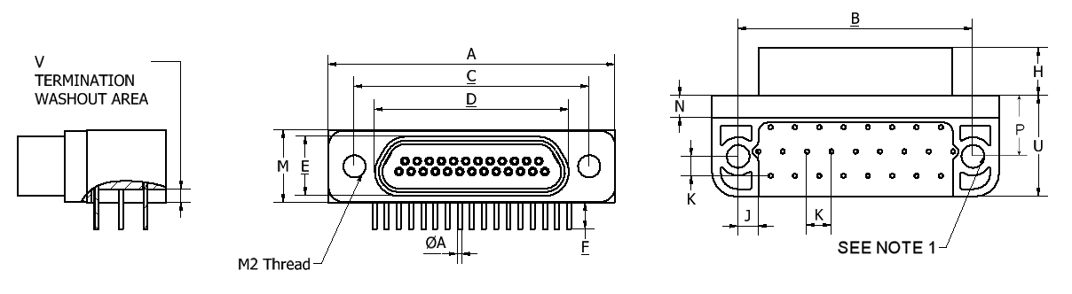
Shell Size | A  Max | B |  | C |  | D  Max. | E  Max. | F |  | H  Max.
Shell Size | A  Max | Min. | Max. | Min. | Max. | D  Max. | E  Max. | Min. | Max. | H  Max.
9 | 19.94 | 14.22 | 14.48 | 14.22 | 14.48 | 10.16 | 6.38 | 4.45 | 5.21 | 5.05
15 | 23.75 | 18.03 | 18.29 | 18.03 | 18.29 | 13.97 | 6.38 | 4.45 | 5.21 | 5.05
21 | 27.56 | 21.84 | 22.1 | 21.84 | 22.1 | 17.78 | 6.38 | 4.45 | 5.21 | 5.05
25 | 30.1 | 24.38 | 24.64 | 24.38 | 24.64 | 20.32 | 6.38 | 4.45 | 5.21 | 5.05

Shell Size | J  Typ. | K  Typ. | M |  | N |  | P |  | U  Max. | V
Shell Size | J  Typ. | K  Typ. | Min. | Max. | Min. | Max. | Min. | Max. | U  Max. | Min. | Max.
9 | 2.11 | 2.54 | 7.49 | 7.75 | 2.23 | 2.49 | 6.1 | 6.6 | 10.8 | 1.29 | 1.55
15 | 2.74 | 2.54 | 7.49 | 7.75 | 2.23 | 2.49 | 6.1 | 6.6 | 10.8 | 1.29 | 1.55
21 | 2.11 | 2.54 | 7.49 | 7.75 | 2.23 | 2.49 | 6.1 | 6.6 | 10.8 | 1.29 | 1.55
25 | 2.11 | 2.54 | 7.49 | 7.75 | 2.23 | 2.49 | 6.1 | 6.6 | 10.8 | 1.29 | 1.55
NOTES:
            - CBRB is the code for a connector body with smooth holes of diameter 2.44 ±0.08mm.
CBRT is the code for a connector body with threaded (2-56 UNC 2B) inserts.
            - All dimensions are in millimetres.
            - For ØA refer to ØD in Figure 2.4.
            - Torque 0.44 Nm min / 0.48 Nm max.

Figure 2.2aM - Connectors type – cbrB AND CBRT
PLUG malE CONTACTS
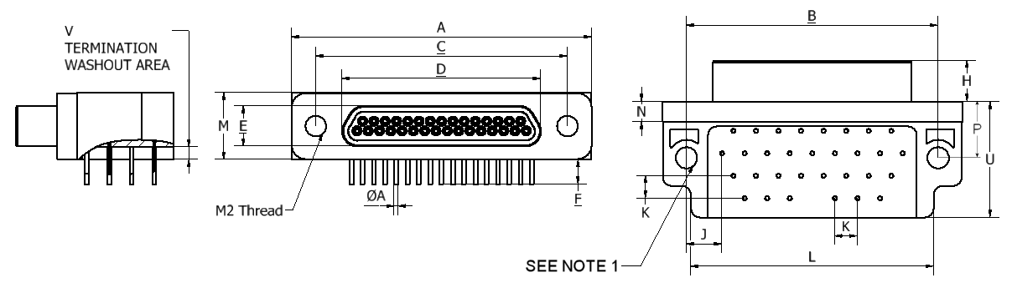
Shell Size | A  Max. | B |  | C |  | D  Max. | E  Max. | F |  | H  Max.
Shell Size | A  Max. | Min. | Max. | Min. | Max. | D  Max. | E  Max. | Min. | Max. | H  Max.
31 | 33.91 | 28.19 | 28.45 | 28.19 | 28.45 | 22.45 | 4.69 | 4.45 | 5.21 | 4.72
37 | 37.72 | 32 | 32.26 | 32 | 32.26 | 26.26 | 4.69 | 4.45 | 5.21 | 4.72
51 | 36.45 | 30.73 | 30.99 | 30.73 | 30.99 | 24.99 | 5.79 | 4.45 | 5.21 | 4.72

Shell Size | J  Typ. | K  Typ. | L  Max. | M |  | N |  | P |  | U  Max. | V
 |  |  |  | Min. | Max. | Min. | Max. | Min. | Max. | U  Max. | Min. | Max.
31 | 4.01 | 2.54 | 27.44 | 7.49 | 7.75 | 2.23 | 2.49 | 6.1 | 6.6 | 13.34 | 1.29 | 1.55
37 | 4.65 | 2.54 | 30.1 | 7.49 | 7.75 | 2.23 | 2.49 | 6.1 | 6.6 | 13.34 | 1.29 | 1.55
51 | 2.74 | 2.54 | 31.24 | 8.59 | 8.92 | 2.23 | 2.49 | 6.1 | 6.6 | 16.76 | 1.29 | 1.55
NOTES:
            - CBRB is the code for a connector body with smooth holes of diameter 2.44 ±0.08mm.
CBRT is the code for a connector body with threaded (2-56 UNC 2B) inserts.
            - All dimensions are in millimetres.
            - For ØA refer to ØD in Figure 2.4.
            - Torque 0.44 Nm min / 0.48 Nm max.

FIGURE 2.2AN - CONNECTORS TYPE – CBRB AND CBRT
RECEPTACLE FEMALE CONTACTS
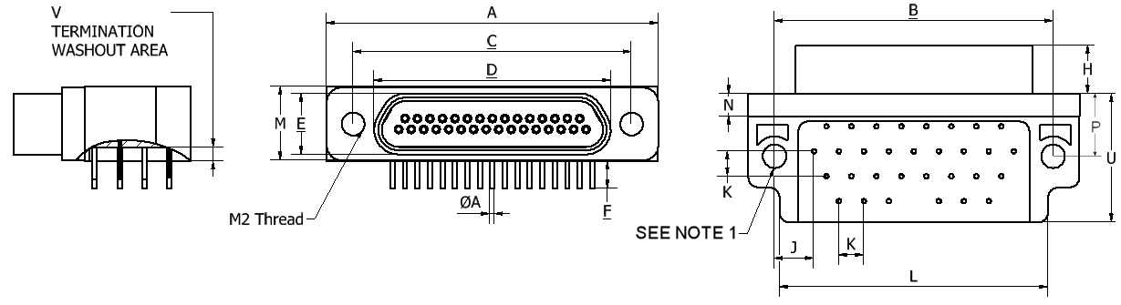
Shell Size | A  Max. | B |  | C |  | D  Max. | E  Max. | F |  | H  Max.
Shell Size | A  Max. | Min. | Max. | Min. | Max. | D  Max. | E  Max. | Min. | Max. | H  Max.
31 | 33.91 | 28.19 | 28.45 | 28.19 | 28.45 | 24.13 | 6.38 | 4.45 | 5.21 | 5.05
37 | 37.72 | 32 | 32.26 | 32 | 32.26 | 27.94 | 6.38 | 4.45 | 5.21 | 5.05
51 | 36.45 | 30.73 | 30.99 | 30.73 | 30.99 | 26.7 | 7.44 | 4.45 | 5.21 | 5.05

Shell Size | J  Typ. | K  Typ. | L  Max. | M |  | N |  | P |  | U  Max. | V
 |  |  |  | Min. | Max. | Min. | Max. | Min. | Max. | U  Max. | Min. | Max.
31 | 4.01 | 2.54 | 27.44 | 7.49 | 7.75 | 2.23 | 2.49 | 6.1 | 6.6 | 13.34 | 1.29 | 1.55
37 | 4.65 | 2.54 | 30.1 | 7.49 | 7.75 | 2.23 | 2.49 | 6.1 | 6.6 | 13.34 | 1.29 | 1.55
51 | 2.74 | 2.54 | 31.24 | 8.59 | 8.92 | 2.23 | 2.49 | 6.1 | 6.6 | 16.76 | 1.29 | 1.55
NOTES:
            - CBRB is the code for a connector body with smooth holes of diameter 2.44 ±0.08mm.
CBRT is the code for a connector body with threaded (2-56 UNC 2B) inserts.
            - All dimensions are in millimetres.
            - For ØA refer to ØD in Figure 2.4.
            - Torque 0.44 Nm min / 0.48 Nm max.

FIGURE 2.3 - CONTACT POSITIONS
Figure 2.3.1 - Mounting Condition
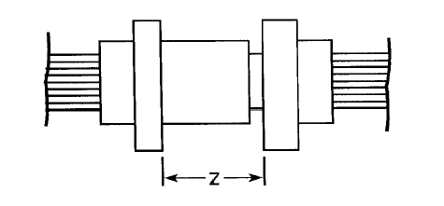
Figure 2.3.2 - Plug Male Contact
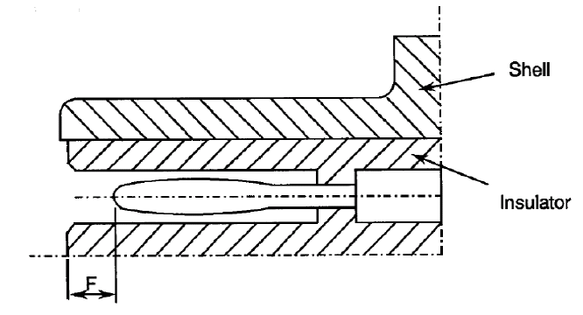
Figure 2.3.3 - Receptacle Female Contact
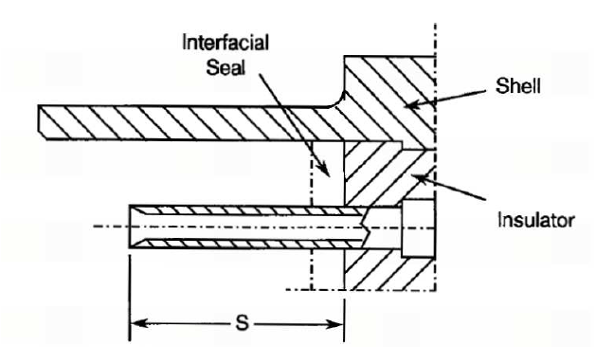
F (mm) |  | S (mm) |  | Z (mm)
Min. | Max. | Min. | Max. | Max.
0.25 | 0.91 | 3.3 | 3.66 | 5.49
FIGURE 2.4 - UNINSULATED SOLID WIRES
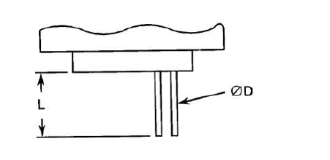
Wire Size (AWG) | 25
Max. Diameter D (mm) | 0.51
Min. Diameter D (mm) | 0.4
Max. Weight (g/m) | 1.6
Min. Length L | See Para. 4.5.3.3
FIGURE 2.5 - INSULATED WIRES
 |  | ESCC 3901/002 |  | ESCC 3901/013 |  | ESCC 3901/012
 |  | Wire Size (AWG)
 |  | 26 | 28 | 26 | 28 | 26 | 28
Conductor Characteristics | Maximum Diameter (mm) | 0.53 | 0.43 | 0.5 | 0.42 | 0.53 | 0.38
Conductor Characteristics | Nominal Cross-section (mm²) | 0.15 | 0.1 | 0.14 | 0.1 | 0.15 | 0.089
Wire Characteristics | Maximum Diameter (mm) | 0.78 | 0.68 | 0.89 | 0.82 | 0.86 | 0.7
Wire Characteristics | Maximum Weight (g/m) | 1.93 | 1.23 | 2.3 | 1.8 | 2.11 | 1.35
Wire Characteristics | Colour | Black | Brown | Natural | Blue | Red | White
Wire Characteristics | Minimum Length L | See Para. 4.5.3.3

FIGURE 2.6 – Solder Bucket
ALTERNATIVE VERSION 1 (Note 3)  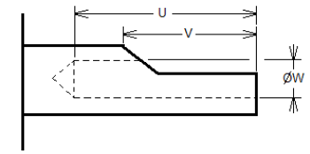 | ALTERNATIVE VERSION 2 (Note 3)  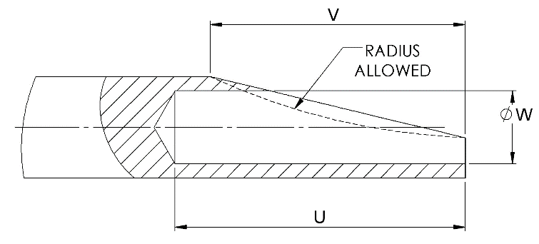

U |  | V |  | ØW
Min. | Max. | Min. | Max. | Min. | Max.
1.75 | 2.7 | 1.5 | 2.74 | 0.55 | 0.67
Notes
            - All dimensions are in millimetres.
            - Maximum wire accepted in the solder cup: AWG 26.
            - Either solder bucket version may apply.
FIGURE 2.7 - FLOATING MOUNT
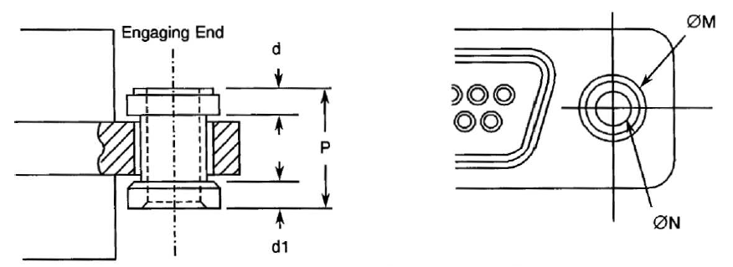
P  Max. | d | d1 | ØM  Max. | ØN  Min.
4.7 | 1.0 | 0.8 | 4 | 2.26
NOTES:
            - All dimensions are in millimetres.
            - Total Lateral Float 0.4 (typical).
            - Total Axial Float 0.4 (typical).
FIGURE 2.8 - CAPTIVE NUT
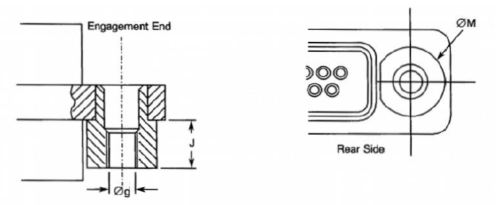
Øg | J  Max. | ØM  Max.
Note 2 | 2.6 | 5.1
NOTES:
            - All dimensions are in millimetres.
            - Øg: 2-56 UNC 2B, Maximum Torque 0.44Nm.
FIGURE 3 - CONTACT ARRANGEMENTS
FRONT VIEW OF MALE INSERT - USE MIRROR VIEW FOR FEMALE INSERT
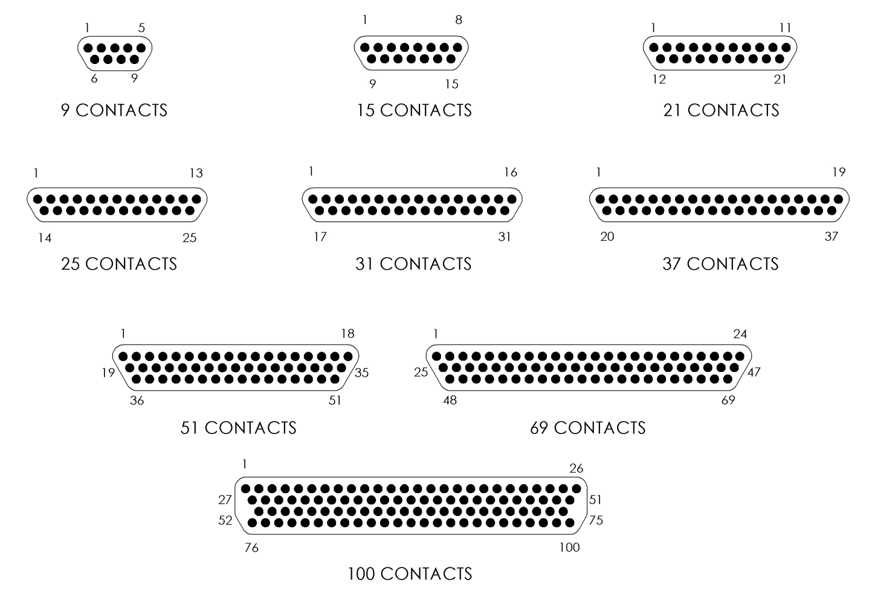
NOTES:
            - Only the outside contact cavities on each row are identified in the drawing, the remainder follow sequentially. Contact numbers are shown outside the insert for readability.
Contact Centres
9 to 69 Contacts (2 Rows / 3 Rows) | 100 Contacts (4 Rows)
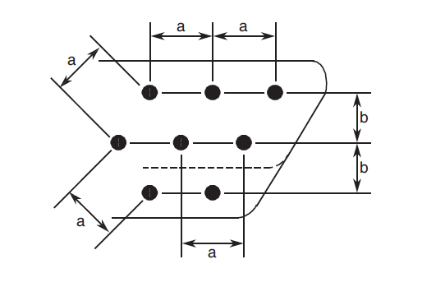 | 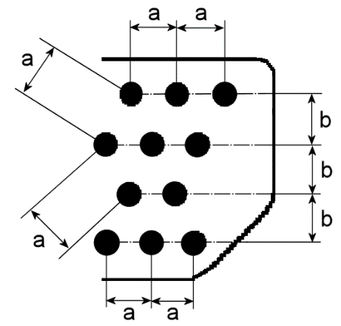
NOTES:
            - a = Distance between contact centres: 1.27mm (typical).
            - b = Distance between rows: 1.09mm (typical).

APPLICABLE DOCUMENTS
The following documents form part of this specification and shall be read in conjunction with it:
          - ESCC Generic Specification No. 3401, Connectors, Electrical, Circular and Rectangular.
          - ESCC Detail Specification No. 3401/032, Accessories for Connectors, Microminiature, 3401/029, 3401/077 and Connector Savers 3401/041.
          - ESCC Detail Specification No. 3401/087, Lightweight Accessories for Rectangular, Microminiature Connectors, 3401/029 and 3401/077.
          - ESCC Detail Specification No. 3901/002, Polyimide Insulated Wires and Cables, Low Frequency, 600V, -100 to +200°C.
          - ESCC Detail Specification No. 3901/012, Extruded, Cross-linked Fluoropolymer Insulated Wires and Cables on Silver-Plated Copper Conductor, Low Frequency, 600V, -100 to +200°C.
          - ESCC Detail Specification No. 3901/013, PTFE Insulated Wires and Cables, 600V, -100 to +200°C.
          - A-A-59551, Wire, Electrical, Copper (Uninsulated).
          - MIL-DTL-45204, Gold Plating, Electro-deposited.
          - SAE-AMS 2418, Copper Plating.
          - MIL-DTL-83513, Connectors Electrical, Rectangular, Microminiature, Polarised Shell, General Specification for.

TERMS, DEFINITIONS, ABBREVIATIONS, SYMBOLS AND UNITS
For the purpose of this specification, the terms, definitions, abbreviations, symbols and units specified in ESCC Basic Specification No. 21300 shall apply.

REQUIREMENTS

GENERAL
The complete requirements for procurement of the connectors specified herein are stated in this specification and ESCC Generic Specification No. 3401. Deviations from the Generic Specification, applicable to this specification only, are listed in Para. 4.2.
Deviations from the applicable Generic Specification and this Detail Specification, formally agreed with specific Manufacturers on the basis that the alternative requirements are equivalent to the ESCC requirements and do not affect the components’ reliability, are listed in the appendices attached to this specification.

DEVIATIONS FROM GENERIC SPECIFICATION

Deviations from Special In-Process Controls
Para. 9.15, Joint strength: the contacts shall be crimped to insulated stranded wire AWG26 and AWG28, and to uninsulated solid wire AWG25. The value of failure shall be recorded together with the information as to whether the failure was ‘pull-out’, ‘break in crimp’ or ‘break in wire’. The minimum tensile strength shall be as follows:
Wire | Male and Female Contacts
Wire | AWG26 | AWG28 | AWG25 - Solid Uninsulated
Tensile Strength (N) | 22 | 13 | 22

Deviations from Final Production Tests (Chart II)
          - Para. 9.4, Contact Capability: this test shall be performed on the male contacts. For details see Para. 4.3.3 of this specification.
          - Para. 9.5, Magnetism Level: Not applicable.

Deviations from Burn-in and Electrical Measurements (Chart III)
None (Chart III is not applicable).

Deviations from Qualification Tests (Chart IV)
          - Para. 9.15, Joint Strength: Not applicable.
          - Para. 9.17, Contact Retention (in insert): Not applicable with male contact.
          - Para. 9.27, Maintenance Ageing: Not applicable.
          - Para. 9.29, Oversize Pin Exclusion: Not applicable.
          - Para. 9.30, Probe Damage: Not applicable.
          - Para. 9.31, Solderability: Only applicable on FR164 termination.

Deviations from Lot Acceptance Tests (Chart V)
          - Para. 9.15, Joint Strength: Not applicable.
          - Para. 9.17, Contact Retention (in insert): Not applicable with male contact.
          - Para. 9.27, Maintenance Ageing: Not applicable.
          - Para. 9.29, Oversize Pin Exclusion: Not applicable.
          - Para. 9.30, Probe Damage: Not applicable.

MECHANICAL REQUIREMENTS

Dimension Check
The dimensions of the connectors specified herein shall be verified in accordance with the requirements set out in Para. 9.6 of ESCC Generic Specification No. 3401 and shall conform to those shown in Figure 2 of this specification. Only the underlined dimensions shall be checked during procurement.

Weight
The maximum weight of the connectors specified herein shall be calculated on the basis of, and be in accordance with the values given in Table 1(a) and in Figures 2.4 and 2.5 of this specification.

Contact Capability
For the purpose of this test, the pick-up and drop weights shall be as follows:
Measurements | Pick-Up Weight | Drop Weight
Weight (g) | 14 | 170
Inner Gauge Diameter (mm) (1) | 0.582 - 0.587 | 0.559 - 0.564
Insertion Depth (mm) | 1.5 | 1.5
NOTES:
            - See Figure 4 for ØA.

Contact Retention (in Insert)
Contact retention within the insert shall be 22.25 N. There shall be no displacement of the contact. Not applicable to male contacts.

Mating and Unmating Forces
The forces applied for the mating and unmating of the connectors shall conform to the values specified in Table 1(a).

Insert Retention (in Shell)
Connector inserts shall withstand a pressure of 34.4N/cm² applied from the mating side to the rear side.

Jackscrew Retention
Not applicable.

Contact Insertion and Withdrawal Forces
Not applicable.

Engagement and Separation Forces (Male Contacts)
The contact engagement and separation forces of the male contacts shall be tested to a depth of 1.5mm with the applicable test gauge fixtures specified in Figure 4 of this specification, and shall not exceed the values of the table hereunder:
Measurements | Inner Diameter (mm) |  | Separation Force Min. (N) | Engagement Force Max. (N)
Measurements | Min. | Max. | Separation Force Min. (N) | Engagement Force Max. (N)
Minimum Diameter Test Sleeve | 0.559 | 0.564 | - | 1.667
Maximum Diameter Test Sleeve | 0.582 | 0.587 | 0.137 | -

Oversize Pin Exclusion
Not applicable.

Probe Damage
Not applicable.

Solderability
Only applicable on FR164 termination. Size A soldering iron shall be used.

MATERIALS AND FINISHES
The materials and finishes shall be as specified herein. Where a definite material is not specified, a material which will enable the components specified herein to meet the performance requirements of this specification shall be used. Acceptance or approval of any constituent material does not guarantee acceptance of the finished product.

Shells
Shells shall be made of aluminium alloy. Variant 01 shall have a minimum plating thickness of 25.4µm of electroless nickel. The plating for Variant 02 shall be 0.7µm minimum of gold with 25.4µm minimum of electroless nickel underplating.

Inserts
Inserts shall be made of glass fibre-filled diallylphthalate resin or suitable thermoplastic material.

Contacts

Female Contacts
The contact body material and finish shall either be copper alloy with an underplate of 1µm minimum of copper to SAE-AMS 2418, gold plated with 1.27µm minimum of gold Type 2 Grade C of MIL-DTL-45204, or Type N2 with underplating in accordance with Para 3.3 note 3(b) of ESCC Basic Specification No. 23500. Measurement of thickness shall be performed at a distance of 1.5mm from the engagement end.

Male Contacts
The contact body and the bundle material and finish shall either be copper alloy with an underplate of 1µm minimum of copper to SAE-AMS 2418, gold plated with 1.27µm minimum of gold Type 2 Grade C of MIL-DTL-45204, or Type M2 with underplating in accordance with Para 3.3 note 3(b) of ESCC Basic Specification No. 23500. Measurement of thickness shall be performed at a distance of 1.5mm from the engagement end.

Interfacial Seals
Interfacial seals shall be made of silicon base rubber.

Insulated Wires
Wire materials and finishes shall be in accordance with the requirements specified in Para. 4.4 of ESCC Detail Specifications No. 3901/002, 3901/012 and 3901/013.

Uninsulated Solid Wire
Uninsulated solid wire material and finish shall either be copper alloy in accordance with Type S as specified in A-A-59551, gold-plated in accordance with Class 00 (i.e. thickness 0.5µm minimum) Grade C or D as specified in MIL-DTL-45204, or Type A14 (except the thickness of the gold-plating shall be 0.25µm minimum) in accordance with ESCC Basic Specification No. 23500.

Rear Potting
Rear potting shall be made of epoxy resin. For connectors Type FR136, Type FR136A and Type FR139, the rear container shall be made from glass-fibre filled diallylphthalate resin or suitable thermoplastic material.

MARKING

General
The marking of all components delivered to this specification shall be in accordance with the requirements of ESCC Basic Specification No. 21700 and the following paragraphs.
Each component shall be marked in respect of:
          - The ESCC Component Number.
          - Characteristics.
          - Traceability Information.

The ESCC Component Number
Each component shall bear the ESCC Component Number which shall be constituted and marked as follows:
340102901B
- Detail Specification Number: 3401029
- Type Variant (See Table 1(a)): 01
- Testing Level: B

Characteristics
The characteristics to be marked in the following order of precedence are:
          - Shell Size.
          - Contact Type.
          - Termination Type.
          - Mounting.
The information shall be constituted and marked as follows:
Example: 51PFR112F
- Shell size: 51
- Contact type: P
- Termination Type: FR112
- Mounting: F

Shell Size
Shell size shall be designated by the number of contacts.
Specified numbers are: 9, 15, 21, 25, 31, 37, 51, 69 and 100.

Contact Type
Contact types shall be indicated by the following code letters.
Code Letter | Contact Type
P | Male
S | Female

Termination Type
Codes defining the termination type and details according to Figures 2.1, 2.2, 2.4, 2.5 and 2.6 are as follows:
Code | Type | Min. Wire Length L (mm) | Reference Figure | Remarks
FR112 | AWG26 Wire 390101302B | 508 | 2.1A, 2.1B, 2.5
FR112A | AWG26 Wire 390100256B | 508 | 2.1A, 2.1B, 2.5
FR112B | AWG26 Wire 390101203B | 508 | 2.1A, 2.1B, 2.5
FR113 | AWG26 Wire 390101302B | 914 | 2.1A, 2.1B, 2.5
FR113A | AWG26 Wire 390100256B | 914 | 2.1A, 2.1B, 2.5
FR113B | AWG26 Wire 390101203B | 914 | 2.1A, 2.1B, 2.5
FR123 | AWG26 Wire 390101302B | 4000 | 2.1A, 2.1B, 2.5
FR123A | AWG26 Wire 390100256B | 4000 | 2.1A, 2.1B, 2.5
FR123B | AWG26 Wire 390101203B | 4000 | 2.1A, 2.1B, 2.5
FR114 | AWG28 Wire 390101301B | 508 | 2.1A, 2.1B, 2.5
FR114A | AWG28 Wire 390100261B | 508 | 2.1A, 2.1B, 2.5
FR114B | AWG28 Wire 390101202B | 508 | 2.1A, 2.1B, 2.5
FR115 | AWG28 Wire 390101301B | 914 | 2.1A, 2.1B, 2.5
FR115A | AWG28 Wire 390100261B | 914 | 2.1A, 2.1B, 2.5
FR115B | AWG28 Wire 390101202B | 914 | 2.1A, 2.1B, 2.5
FR116 | Uninsulated Wire | 25.4 | 2.1A, 2.1B, 2.4 | 25 AWG
FR136 | 90° Mounting on PCB, 2.54mm PCB termination pitch | - | 2.2A to 2.2D, 2.4 | 25 AWG
FR136A | 90° Mounting on PCB, 2.54mm PCB termination pitch | - | 2.2E, 2.2F, 2.4 | 25 AWG
FR139 | Straight Mounting on PCB, 2.54mm PCB termination pitch | - | 2.2G to 2.2J, 2.4 | 25 AWG
FR164 | Solder Bucket | - | 2.2K, 2.2L, 2.6
GMR7590 | Uninsulated wire formed for 90° Mounting on PCB, 1.905mm PCB termination pitch | - | 2.2M to 2.2R
GMR7580 | Uninsulated wire formed for Straight Mounting on PCB, 1.905mm PCB termination pitch | - | 2.2S to 2.2X
75SBB, 75SBT | Uninsulated wire formed for 90° Mounting on PCB, 1.905mm PCB termination pitch | - | 2.2Y to 2.2AD, 2.4 | 25 AWG
75RB, 75RBT | Uninsulated wire formed for Straight Mounting on PCB, 1.905mm PCB termination pitch | - | 2.2AE to 2.2AJ, 2.4 | 25 AWG
CBRB, CBRT | 90° Mounting on PCB, 2.54mm PCB termination pitch | - | 2.2AK to 2.2AN, 2.4 | 25 AWG

Mounting
The letter E indicates a captive nut.
The letter F shall indicate a floating mount.
If the shell has fixed mounting holes, these letters shall be omitted.

Traceability Information
Traceability information shall be marked in accordance with the requirements of ESCC Basic Specification No. 21700.

ELECTRICAL MEASUREMENTS

Electrical Measurements at Room Temperature
The parameters to be measured in respect of electrical characteristics are scheduled in Table 2. Unless otherwise specified, the measurements shall be performed at T_{amb} = +22 ±3°C.

Electrical Measurements at High and Low Temperatures
Not applicable.

Circuits for Electrical Measurements
Not applicable.

BURN-IN AND ELECTRICAL MEASUREMENTS (TABLES 4 AND 5)
Not applicable.
Table 2 - ELECTRICAL MEASUREMENTS AT ROOM TEMPERATURE
No. | Characteristic | Symbol | ESCC 3401  Test Method | Test Condition | Limits |  | Unit
 |  |  |  |  | Min | Max | Unit
1 | Insulation Resistance | R_{i} | Para. 9.1.1.1 | Para. 9.1.1.1 | 5000 | - | MΩ
2 | Voltage Proof Leakage Current | I_{L} | Para. 9.1.1.2 | 600Vrms | - | 2 | mA
3 | Mated Shell Conductivity (Voltage Drop) (Note 1) | V_{D} | Para. 9.1.1.4 | Para. 9.1.1.4 | Not applicable |  | mV
4 | Contact Resistance  (Low Level Current) | R_{cl} max. | Para. 9.1.1.3 | Para. 9.1.1.3 |  |  | mΩ
 |  |  |  |  | - | 6 (2) | mΩ
 |  |  |  |  | - | 25 (3) | mΩ
5 | Contact Resistance  (Rated Current) | R_{cr} max. | Para. 9.1.1.3 | Table 1(b) |  |  | mΩ
 |  |  |  |  | - | 5 (2) | mΩ
 |  |  |  |  | - | 25 (3) | mΩ
NOTES:
            - Applicable to mated connectors with grounding option.
            - For all termination types except FR136, FR136A, FR139.
            - For termination types FR136, FR136A, FR139. Measurement of Contact Resistance shall include all parts of the contact including the body and the wire.
TABLES 3, 4 AND 5
Not applicable.
FIGURE 4 - GAUGE FIXTURE
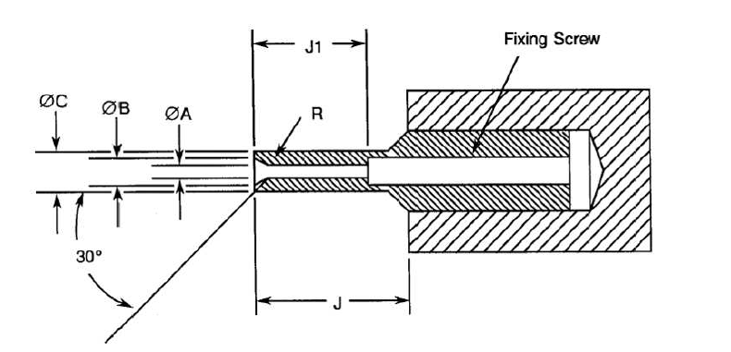
MINIMUM DIAMETER TEST SLEEVE
Weight (g) 170 |  |  | Remarks
Symbol | Min. | Max. | Remarks
ØA | 0.559 | 0.564 | Note 2
ØB | 0.749 | 0.775 | -
ØC | 0.813 | 0.825 | -
J | 4 | - | -
J1 | 3.13 | 3.23 | -
R | 0.381 | 0.483 | Note 1
MAXIMUM DIAMETER TEST SLEEVE
Weight (g) 14 |  |  | Remarks
Symbol | Min. | Max. | Remarks
ØA | 0.582 | 0.587 | Note 2
ØB | 0.749 | 0.775 | -
ØC | 0.813 | 0.825 | -
J | 4 | - | -
J1 | 3.13 | 3.23 | -
R | 0.381 | 0.483 | Note 1
NOTES:
            - Radius R, must be tangent to entry chamfer and ØA.
            - ØA and entry chamfer shall have a surface roughness of 3.2μm (roughness grade N8).
            - All dimensions are in millimetres.

ENVIRONMENTAL AND ENDURANCE TESTS (CHARTS IV AND V OF ESCC GENERIC SPECIFICATION No. 3401)

Measurements and Inspections on Completion of Environmental Tests
The parameters to be measured and inspections to be performed on completion of environmental testing shall be those specified in Table 6. Unless otherwise specified, these measurements shall be performed at T_{amb} = +22 ±3°C.

Measurements and Inspections at Intermediate Points during Endurance Tests
Not applicable.

Measurements and Inspections on Completion of Endurance Tests
The parameters to be measured and inspections to be performed on completion of endurance testing shall be those specified in Table 6. Unless otherwise specified, these measurements shall be performed at T_{amb} = +22 ±3°C.

Conditions for Operating Life Test (Part of Endurance Testing)
Not applicable.

Electrical Circuit for Operating Life Test
Not applicable.

Conditions for High Temperature Storage Test (Part of Endurance Testing)
The requirements for the high temperature storage test are specified in Section 9 of ESCC Generic Specification No. 3401. The temperature to be applied shall be the maximum storage temperature specified in Table 1(b) of this specification.

Table 6 - MEASUREMENTS AND INSPECTIONS ON COMPLETION OF ENVIRONMENTAL AND ENDURANCE TESTING
No. | ESCC Generic Spec. No. 3401 |  | Measurements and Inspections |  | Symbol | Limits |  | Unit
No. | Environmental and Endurance Tests Note 1 | Test Method and Conditions | Identification | Conditions | Symbol | Min | Max | Unit
01 | Seal Test | Para. 9.9 | ESCC 3401 Para. 9.9 | - | - | Not applicable |  | -
02 | Wiring | Para. 9.10 | Low Level Contact Resistance | Table 2 Item 4 | R_{cl} | Table 2, Item 4 |  | -
03 | Vibration | Para. 9.11 | Initial Measurements  Coupling screw(s)  Unlocking Torque | - | Tqe | Record Values |  | -
 |  |  | Final Measurements  Full Engagement  Coupling screw(s)  Unlocking Torque Drift  Visual Examination | -  - | ΔTqe/Tqe  - | -25  - | +25  - | %
04 | Shock or Bump | Para. 9.12 | Full Engagement  Visual Examination | - | - | - | - | -
05 | Climatic Sequence | Para. 9.13 | Dry Heat  Insulation Resistance | At High Temperature  Table 2, Item 1 (2) | R_{i} | 10 | - | MΩ
 |  |  | Low Air Pressure  Voltage Proof Leakage Current | Figure 1 | I_{L} | ESCC 3401 Para. 9.13.5 |  | mA
 |  |  | Damp Heat  Insulation Resistance | Immediately after test  Table 2, Item 1 | R_{i} | 100 | - | MΩ
 |  |  | Final Measurements  External Visual Inspection  Insulation Resistance  Voltage Proof Leakage Current | After 1-24 hrs Recovery  ESCC 3401  Para. 9.7  Table 2, Item 1  Table 2, Item 2 | -  R_{i}  I_{L} | ESCC 3401  Para. 9.7  Table 2, Item 1  Table 2, Item 2 |  | -  MΩ  mA
06 | Plating Thickness | Para. 9.14 | Thickness | - | - | Para. 4.4.3 of this spec. |  | -
07 | Joint Strength (N/A to solder contacts) | Para. 9.15 | ESCC 3401 Para. 9.15 | - | - | Not applicable |  | -
08 | Rapid Change of Temperature | Para. 9.16 | Visual Examination | - | - | - |  | -
08 | Rapid Change of Temperature | Para. 9.16 | Insulation Resistance  Voltage Proof Leakage Current | Table 2, Item 1  Table 2, Item 2 | R_{i}  I_{L} | Table 2, Item 1  Table 2, Item 2 |  | MΩ  mA
09 | Contact Retention (in Insert) | Para. 9.17 & Para. 4.3.4 of this spec. | Contact Displacement | - | - | ESCC 3401 Para. 9.17 |  | -
10 | Endurance | Para. 9.18 | Initial Measurements  Mating/Unmating Forces  Low Level Contact Resistance  Mated Shell Conductivity | -  Table 2, Item 4  Table 2, Item 3 | F  R_{cl}  V_{D} | Para. 4.3.5 of this spec.  Record Values  Not applicable |  | N  mΩ  mV
 |  |  | Final Measurements  Visual Examination | - | - | - | -
 |  |  | Mating/Unmating Forces | - | F | Para. 4.3.5 of this spec |  | N
 |  |  | Low Level Contact Resistance Drift | Table 2, Item 4 | ΔR_{cl} | - | 3 | mΩ
 |  |  | Rated Current Contact Resistance  Mated Shell Conductivity  Insulation Resistance  Voltage Proof Leakage Current | Table 2, Item 5  Table 2 Item 3  Table 2 Item 1  Table 2 Item 2 | R_{cr}  V_{D}  R_{i}  I_{L} | Table 2, Item 5  Not applicable  Table 2, Item 1  Table 2, Item 2 |  | mΩ  mV  MΩ  mA
11 | Permanence of Marking | Para. 9.19 | - | - | - | - |  | -
12 | Mating/Unmating Forces | Para. 9.20 | Force | - | F | Para. 4.3.5 of this spec |  | N
13 | High Temperature Storage | Para. 9.21 | Initial Measurements  Low Level Contact Resistance  Mated Shell Conductivity | Table 2, Item 4  Table 2, Item 3 | R_{cl}  V_{D} | Record Values  Not applicable |  | mΩ  mV
 |  |  | Final Measurements  Visual Examination | - | - | -
 |  |  | Mating/Unmating Forces | - | F | Para. 4.3.5 of this spec |  | N
 |  |  | Low Level Contact Resistance Drift | Table 2, Item 4 | ΔR_{cl} | - | 3 | mΩ
 |  |  | Rated Current Contact Resistance  Mated Shell Conductivity  Insulation Resistance  Voltage Proof Leakage Current | Table 2, Item 5  Table 2 Item 3  Table 2 Item 1  Table 2 Item 2 | R_{cr}  V_{D}  R_{i}  I_{L} | Table 2, Item 5  Not applicable  Table 2, Item 1  Table 2, Item 2 |  | mΩ  mV  MΩ  mA
 |  |  | Contact Retention (In insert) | Para. 4.3.4 of this spec. | - | ESCC 3401 Para. 9.17 |  | -
14 | Corrosion | Para. 9.22 | Visual Examination | - | - | - | - | -
15 | Insert Retention (in Shell) | Para. 9.23 & Para. 4.3.6 of this spec. | Visual Examination | - | - | Para. 4.3.6 of this spec. |  | -
16 | Jackscrew Retention | Para. 9.24 & Para. 4.3.7 of this spec | Visual Examination | - | - | Not applicable |  | -
17 | High Temperature Measurements | Para. 9.25 | Insulation Resistance | Table 2 Item 1 (2) | R_{i} | 10 | - | MΩ
18 | Overload Test | Para. 9.26 | Internal Temperature | - | T | - | +100 | ºC
 |  |  | Rated Current Contact Resistance  Mated Shell Conductivity  Insulation Resistance  Voltage Proof Leakage Current | Table 2, Item 5  Table 2 Item 3  Table 2 Item 1  Table 2 Item 2 | R_{cr}  V_{D}  R_{i}  I_{L} | Table 2, Item 5  Not applicable  Table 2, Item 1  Table 2, Item 2 |  | mΩ  mV  MΩ  mA
19 | Maintenance Ageing | Para. 9.27 | Visual Examination | - | - | - | - | -
 |  |  | Contact Retention (in Insert) | Para. 4.3.4 of this spec. | - | Not applicable |  | N
20 | Engage/Separation Forces | Para. 9.28 & Para. 4.3.9 of this spec. | Force | - | F | Para. 4.3.9 of this spec. |  | N
21 | Oversize Pin Exclusion | Para. 9.29 & Para. 4.3.10 of this spec. | Not applicable | - | - | - | - | -
22 | Probe Damage | Para. 9.30 & Para. 4.3.11 of this spec. | Not applicable | - | - | - | - | -
23 | Solderability | Para. 9.31 & Para. 4.3.12 of this spec. | - | - | - | ESCC 3401 Para. 9.31 |  | -
NOTES:
            - The tests in this Table refer to either Chart IV or V and shall be used as applicable.
            - T_{amb} = +125°C.

APPENDIX ‘A’
AGREED DEVIATIONS FOR C & K COMPONENTS (F)
ITEMS AFFECTED | DESCRIPTION OF DEVIATIONS
Para. 4.2.2, Deviations from Final Production Tests (Chart II) | Para. 9.4, Contact Capability: 100% Contact Capability Test may be omitted provided that a 100% visual inspection of the contacts is performed on each batch submitted to tests defined in the C&K PID requirements.

