Figure 2(b)-Variants (Continued)
VARIANT (R126.410.041) – SQUARE FLANGE RECEPTACLE (Low VSWR & frequency band extended)
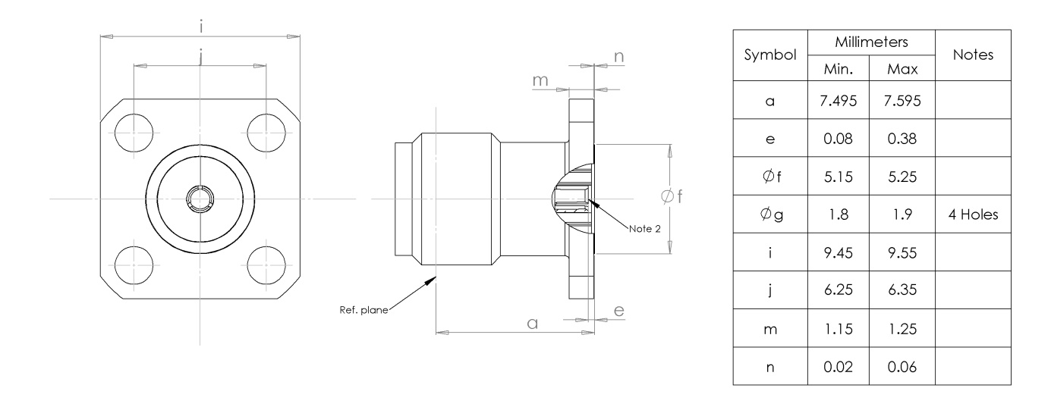
ELECTRICAL CHARACTERISTICS | VALUES | UNITS
Frequency range | 0 to 22 | GHz
Maximum voltage standing wave ratio (VSWR) | 1.05+0.0027 f (GHz)
Maximum reflection coefficient | 0.052
Maximum insertion loss ⁽¹⁾ | 0.03 +0.02√f (GHz) | dB
RF leakage ⁽¹⁾ | -120+f (GHz) | dB
Voltage proof | 1000 | Vrms
Corona level | NA | Vrms
Notes :
- For information only.
- Contact engagement and separation forces shall be measured on rear contact (see Para. 4.3.8)
MECANICAL CHARACTERISTICS | VALUES | UNITS
Minimum center contact retention force (axial) | 27 | N
Minimum center contact retention torque | <0.2 | N.cm
Minimum cable retention force | NA | N
Minimum cable retention torque | NA | N.cm
Maximum weight | 1.8 | g

OTHER CHARACTERISTICS | VALUES | UNITS
Rapid change of temperature – peak value | +180 | °C
Operating Temperature Range | -65 +165°C | °C
Maximum leakage (panel sealed connectors) | NA
Maximum leakage (hermetic sealed connectors) | NA
Solderability | NA
Soldering Proof | NA
Cables Used | NA

