These are the current figures for derating for the two Schurter types currently included in ESCC QPL.

4008/001. MGA-S | 4008/002. HCSF
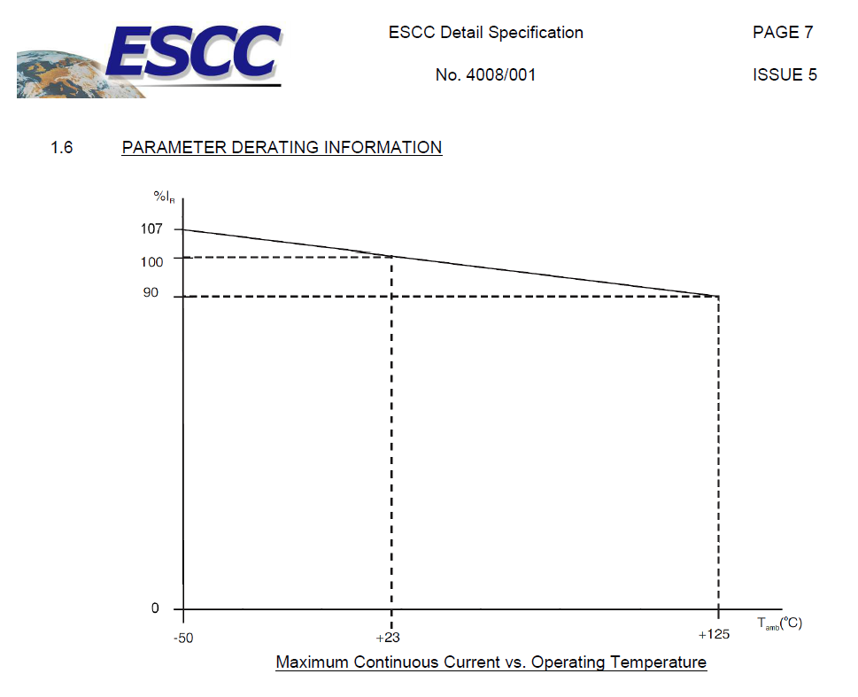 | 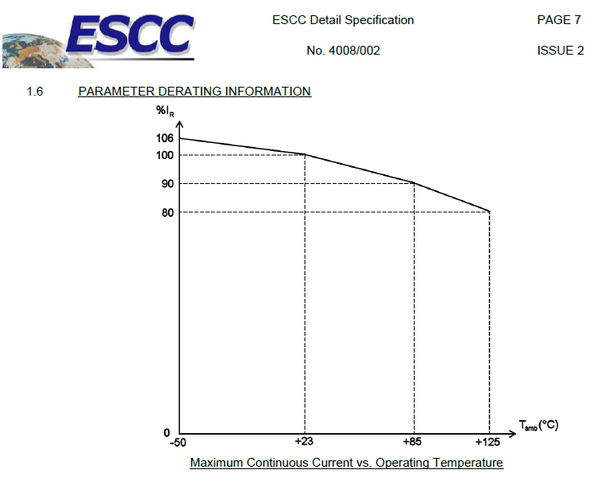

Answer from Schurter: “We recommend to improve the derating rules in ECSS-Q-ST-30-11 for fuses. Because: 1.) The SCHURTER MGA-S and HCSF are specifically designed for space and harsh environment. 2.) The derating factor is too high for SCHURTER space fuses, making it difficult for the designer to design the appropriate fuse.
Therefore, except the fuses specific temperature derating factor according to the detail specification only an additional constant derating factor of 0.8 for high reliability application is recommended – 0.8 full range instead of 0.65 up to 85°C and 0.5 up to 125°C according to ECSS-Q-ST-30-11.”



