

Page 1 of 25
CONNECTORS, ELECTRICAL, RECTANGULAR, MICROMINIATURE, REMOVABLE CRIMP CONTACTS
BASED ON TYPE MDMA
ESCC Detail Specification No. 3401/077

Issue 8 Draft A | November 2018


Document Custodian: European Space Agency – see https://escies.org

Legal Disclaimer and Copyright
European Space Agency, Copyright © 2018. All rights reserved.
The European Space Agency disclaims any liability or responsibility, to any person or entity, with respect to any loss or damage caused, or alleged to be caused, directly by the use and application of this ESCC publication.
This publication, without the prior permission of the European Space Agency and provided that it is not used for a commercial purpose, may be:
- copied in whole, in any medium, without alteration or modification.
- copied in part, in any medium, provided that the ESCC document identification, comprising the ESCC symbol, document number and document issue, is removed.

DOCUMENTATION CHANGE NOTICE
(Refer to https://escies.org for ESCC DCR content)
DCR No. | CHANGE DESCRIPTION
tba | Specification upissued to incorporate changes per DCR.

TABLE OF CONTENTS
1 GENERAL 6
1.1 SCOPE 6
1.2 COMPONENT TYPE VARIANTS AND RANGE OF COMPONENTS 6
1.3 MAXIMUM RATINGS 6
1.4 PARAMETER DERATING INFORMATION 6
1.5 PHYSICAL DIMENSIONS 6
1.6 Contact Arrangements 6
2 APPLICABLE DOCUMENTS 6
3 TERMS, DEFINITIONS, ABBREVIATIONS, SYMBOLS AND UNITS 6
4 REQUIREMENTS 16
4.1 GENERAL 16
4.2 DEVIATIONS FROM GENERIC SPECIFICATION 16
4.2.1 Deviations from Special In-process Controls 16
4.2.2 Deviations from Final Production Tests (Chart II) 16
4.2.3 Deviations from Burn-in and Electrical Measurements (Chart III) 17
4.2.4 Deviations from Qualification Tests (Chart IV) 17
4.2.5 Deviations from Lot Acceptance Tests (Chart V) 17
4.3 MECHANICAL REQUIREMENTS 17
4.3.1 Dimension Check 17
4.3.2 Weight 17
4.3.3 Contact Capability 17
4.3.4 Contact Retention (In insert) 17
4.3.5 Mating and Unmating Forces 17
4.3.6 Insert Retention (In shell) 17
4.3.7 Jackscrew Retention 17
4.3.8 Contact Insertion and Withdrawal Forces 17
4.3.9 Engagement and Separation Forces (Male Contacts) 17
4.3.10 Oversize Pin Exclusion 17
4.3.11 Probe Damage 18
4.3.12 Solderability 18
4.4 MATERIALS AND FINISHES 18
4.4.1 Shells 18
4.4.2 Inserts 18
4.4.3 Contacts 18
4.4.4 Contact Retaining Clip 18
4.5 MARKING 18
4.5.1 General 18
4.5.2 The ESCC Component Number 18
4.5.3 Series 18
4.5.4 Characteristics 19
4.5.4.1 Fixing Option 19
4.5.4.2 Shell Size 19
4.5.4.3 Contact Type 19
4.5.4.4 Contact Information 19
4.5.4.5 Traceability Information 19
4.6 ELECTRICAL MEASUREMENTS 19
4.6.1 Electrical Measurements at Room Temperature 19
4.6.2 Electrical Measurements at High and Low Temperatures 19
4.6.3 Circuits for Electrical Measurements 20
4.7 BURN-IN AND ELECTRICAL MEASUREMENTS (TABLES 4 AND 5) 20
4.8 ENVIRONMENTAL AND ENDURANCE TESTS (CHARTS IV AND V OF ESCC GENERIC SPECIFICATION No. 3401) 21
4.8.1 Measurements and Inspections on Completion of Environmental Tests 21
4.8.2 Measurements and Inspections at Intermediate Points during Endurance Tests 21
4.8.3 Measurements and Inspections on Completion of Endurance Tests 21
4.8.4 Conditions for Operating Life Test (Part of Endurance Testing) 21
4.8.5 Electrical Circuit for Operating Life Test 21
4.8.6 Conditions for High Temperature Storage Test (Part of Endurance Testing) 21
Appendix A 25

GENERAL

SCOPE
This specification details the ratings, physical and electrical characteristics, test and inspection data for Electrical, Rectangular, Microminiature Connectors with Removable Crimp Contacts, based on type MDMA. It shall be read in conjunction with:
- ESCC Generic Specification No. 3401, Connectors, Electrical, Rectangular and Circular.
- ESCC Detail Specification No. 3401/032, Accessories for Connectors, Microminiature, 3401/029, 3401/077 and Connector Savers 3401/041.
- ESCC Detail Specification No. 3401/078, Contacts, Electrical, Crimp, for 3401/077 Microminiature Connectors based on type MDMA.
- ESCC Detail Specification No. 3401/087, Lightweight Accessories for Rectangular, Microminiature Connectors, 3401/029 and 3401/077.
the requirements of which are supplemented herein.

COMPONENT TYPE VARIANTS AND RANGE OF COMPONENTS
The different sizes of the basic type connectors specified herein, together with their mechanical characteristics, are scheduled in Table 1(a).

MAXIMUM RATINGS
The maximum ratings, which shall not be exceeded at any time during use or storage, applicable to the connectors specified herein, are given in Table 1(b).

PARAMETER DERATING INFORMATION
The derating information applicable to the connectors specified herein is shown in Figure 1.

PHYSICAL DIMENSIONS
The physical characteristics of the connectors specified herein are shown in Figure 2.

Contact Arrangements
Contact arrangements are shown in Figure 3.

APPLICABLE DOCUMENTS
The following documents form part of this specification and shall be read in conjunction with it:
          - ESCC Generic Specification No. 3401, Connectors, Electrical, Circular and Rectangular.
          - ESCC Detail Specification No. 3401/032, Accessories for Connectors, Microminiature, 3401/029, 3401/077 and Connector Savers 3401/041.
          - ESCC Detail Specification No. 3401/078, Contacts, Electrical, Crimp, for 3401/077 Microminiature Connectors based on type MDMA.
          - ESCC Detail Specification No. 3401/087, Lightweight Accessories for Rectangular, Microminiature Connectors, 3401/029 and 3401/077.
          - MIL-DTL-45204, Gold Plating, Electro-deposited.

TERMS, DEFINITIONS, ABBREVIATIONS, SYMBOLS AND UNITS
For the purpose of this specification, the terms, definitions, abbreviations, symbols and units specified in ESCC Basic Specification No. 21300 shall apply.
TABLE 1(a) – COMPONENT TYPE VARIANTS AND range of components
Variants |  | Shell Size Note 1 | Weight Max. g Note 2 | Mating Force  N Max. | Unmating Force
Shell Finish
Nickel | Gold | Shell Size Note 1 | Weight Max. g Note 2 | Mating Force  N Max. | N Max. | N Min.
01 | 02 | 9 | 2.3 | 25 | 25 | 1.3
01 | 02 | 15 | 3.1 | 42 | 42 | 2
01 | 02 | 21 | 3.9 | 58 | 58 | 2.9
01 | 02 | 25 | 4.4 | 70 | 70 | 3.5
01 | 02 | 31 | 5.2 | 86 | 86 | 4.3
01 | 02 | 37 | 6 | 103 | 103 | 5.1
01 | 02 | 51 | 7.3 | 147 | 147 | 7.1
Notes:
            - See Figures 2.1(a) and 2.1(b).
            - Weight without cables, backshell, floating eyelets, captive nut and contacts (see Para. 4.5.4.4). Add 0.4 grammes for connectors with floating mounts and 1 gramme for connectors with captive nuts. See Figure 2.3 and ESCC Detail Specification Nos. 3901/002 and 3901/013 for the weight of cable and ESCC Detail Specification No. 3401/078 for contact weights.
TABLE 1(b) - MAXIMUM RATINGS
No. | Characteristic | Symbol | Maximum Rating | Unit | Remarks
1 | Working Voltage | U_{R} | 150 | Vrms | Note 1
2 | Rated Current with | I_{R} |  | A | Note 2
 | AWG24 wire |  | 3.5
 | AWG26 and uninsulated solid wire |  | 2.5
 | AWG28 wire |  | 1.5
3 | Operating Temperature Range | T_{op} | -55 to +125 | °C | T_{amb}
4 | Storage Temperature Range | T_{stg} | -65 to +125 | °C | -
NOTES:
            - At Sea Level, between contacts, and contact and shell. U_{R} requires derating at altitudes above sea level. See Figure 1(a).
            - I_{R} requires derating if the number of carrying contacts in the connector is 2 or greater. See Figure 1(b).
FIGURE 1 - PARAMETER DERATING INFORMATION
FIGURE 1(a) - WORKING VOLTAGE VERSUS ALTITUDE
FIGURE 1(b) - MAXIMUM CURRENT VERSUS NUMBER OF CONTACTS
Number of Current-Carrying Contacts per Connector | Maximum Current per Contact (A)
Number of Current-Carrying Contacts per Connector | Wire Size
Number of Current-Carrying Contacts per Connector | AWG24 | AWG26 and Uninsulated Solid Wire | AWG28
2 - 4 | 2.6 | 2 | 1.4
5 - 14 | 2.4 | 1.8 | 1.2
15 and over | 1.9 | 1.4 | 0.9

FIGURE 2 - PHYSICAL DIMENSIONS
Figure 2.0 – male and female interface dimensions
FEMALE RECEPTACLE
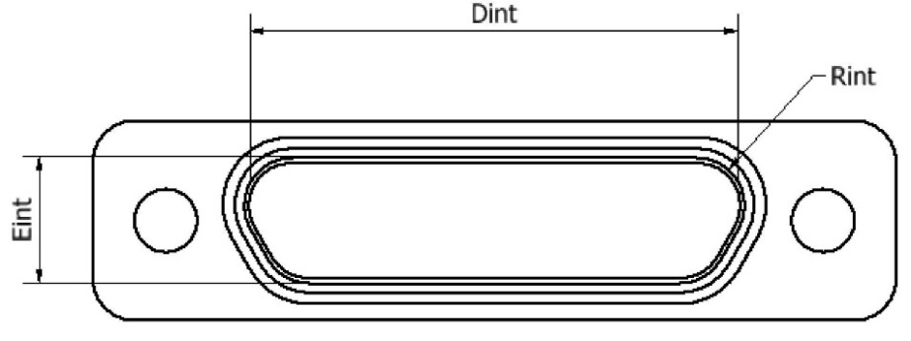
MALE PLUG
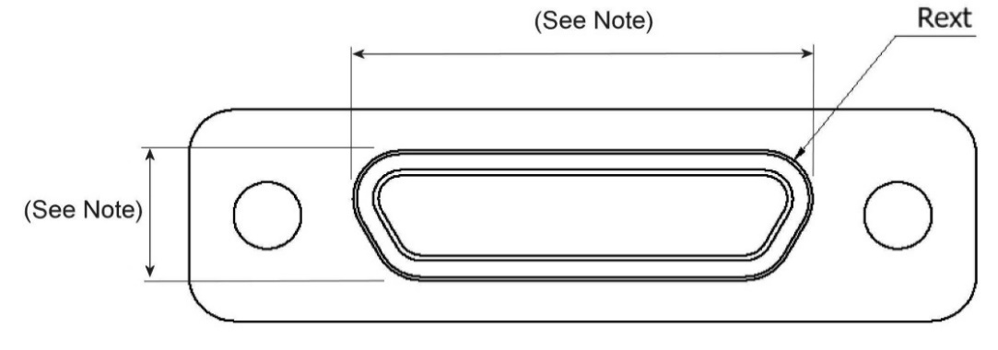
NOTE: These dimensions are specified in the Plug (Male Contacts) Figure on the following page.
Shell Size | Dint Min. | Eint Min. | Rint Min. | Rext Max.
9 | 8.49 | 4.7 | 1.704 | 1.699
15 | 12.3 | 4.7 | 1.704 | 1.699
21 | 16.11 | 4.7 | 1.704 | 1.699
25 | 18.65 | 4.7 | 1.704 | 1.699
31 | 22.46 | 4.7 | 1.704 | 1.699
37 | 26.27 | 4.7 | 1.704 | 1.699
51 | 25 | 5.8 | 1.704 | 1.699

Figure 2.1(a) – Connector Shells - Plug (Male Contacts)
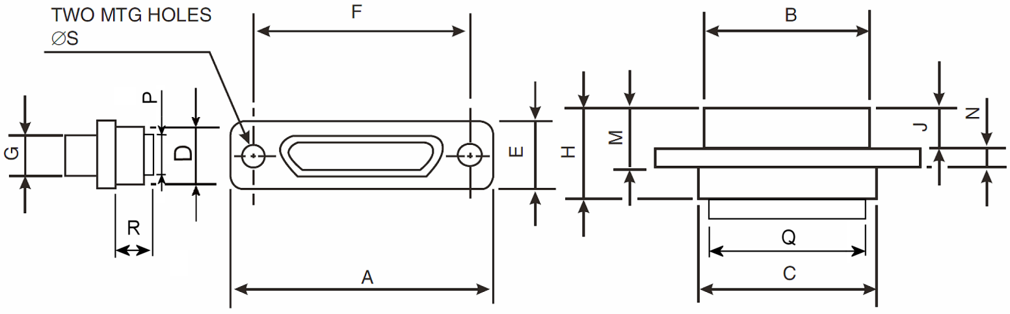
Shell  Size | A  Max. | B  Max. | C  Max. | D  Max. | E  Max. | F |  | G  Max. | H  Max. | J  Max. | M  Max. | N |  | ØS
 |  |  |  |  |  | Min. | Max. |  |  |  |  | Min. | Max. | Min. | Max.
9 | 19.94 | 8.48 | 10.16 | 6.86 | 7.82 | 14.22 | 14.48 | 4.69 | 10.57 | 4.72 | 7.26 | 2.23 | 2.49 | 2.23 | 2.44
15 | 23.75 | 12.29 | 13.97 | 6.86 | 7.82 | 18.03 | 18.29 | 4.69 | 10.57 | 4.72 | 7.26 | 2.23 | 2.49 | 2.23 | 2.44
21 | 27.56 | 16.1 | 17.78 | 6.86 | 7.82 | 21.84 | 22.1 | 4.69 | 10.57 | 4.72 | 7.26 | 2.23 | 2.49 | 2.23 | 2.44
25 | 30.1 | 18.64 | 20.32 | 6.86 | 7.82 | 24.38 | 24.64 | 4.69 | 10.57 | 4.72 | 7.26 | 2.23 | 2.49 | 2.23 | 2.44
31 | 33.91 | 22.45 | 24.13 | 6.86 | 7.82 | 28.19 | 28.45 | 4.69 | 10.57 | 4.72 | 7.26 | 2.23 | 2.49 | 2.23 | 2.44
37 | 37.72 | 26.26 | 27.94 | 6.86 | 7.82 | 32 | 32.26 | 4.69 | 10.57 | 4.72 | 7.26 | 2.23 | 2.49 | 2.23 | 2.44
51 | 36.45 | 24.99 | 26.67 | 7.87 | 8.92 | 30.73 | 30.99 | 5.78 | 10.57 | 4.72 | 7.26 | 2.23 | 2.49 | 2.23 | 2.44
Shell  Size | P  Max. | Q  Max. | R  Max.
9 | 4.4 | 7.8 | 5.7
15 | 4.4 | 11.6 | 5.7
21 | 4.4 | 15.4 | 5.7
25 | 4.4 | 17.95 | 5.7
31 | 4.4 | 21.75 | 5.7
37 | 4.4 | 25.6 | 5.7
51 | 5.3 | 24.3 | 5.7
NOTES:
            - All dimensions are in millimetres.
Figure 2.1(b) – Connector Shells - Receptacle (Female Contacts)
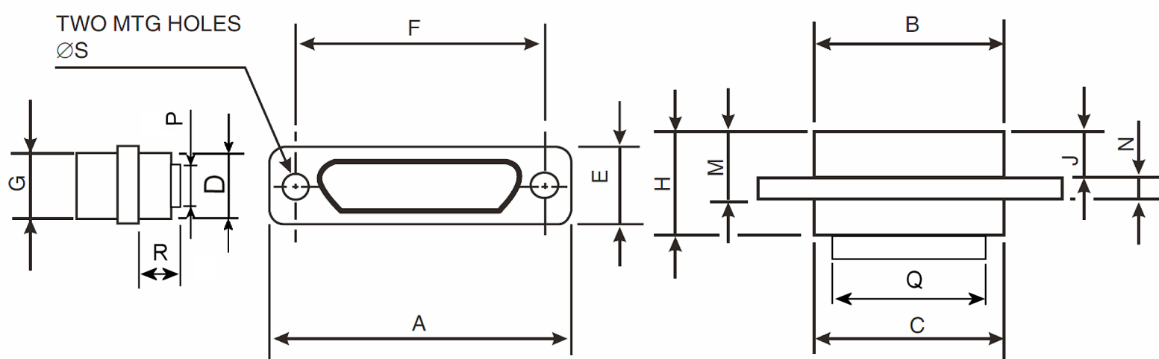
Shell  Size | A Max. | B  Max. | C  Max. | D  Max. | E  Max. | F |  | G  Max. | H  Max. | J  Max. | M  Max. | N |  | ØS
 |  |  |  |  |  | Min. | Max. |  |  |  |  | Min. | Max. | Min. | Max.
9 | 19.94 | 10.16 | 10.16 | 6.86 | 7.82 | 14.22 | 14.48 | 6.38 | 10.9 | 5.05 | 7.59 | 2.23 | 2.49 | 2.23 | 2.44
15 | 23.75 | 13.97 | 13.97 | 6.86 | 7.82 | 18.03 | 18.29 | 6.38 | 10.9 | 5.05 | 7.59 | 2.23 | 2.49 | 2.23 | 2.44
21 | 27.56 | 17.78 | 17.78 | 6.86 | 7.82 | 21.84 | 22.1 | 6.38 | 10.9 | 5.05 | 7.59 | 2.23 | 2.49 | 2.23 | 2.44
25 | 30.1 | 20.32 | 20.32 | 6.86 | 7.82 | 24.38 | 24.64 | 6.38 | 10.9 | 5.05 | 7.59 | 2.23 | 2.49 | 2.23 | 2.44
31 | 33.91 | 24.13 | 24.13 | 6.86 | 7.82 | 28.19 | 28.45 | 6.38 | 10.9 | 5.05 | 7.59 | 2.23 | 2.49 | 2.23 | 2.44
37 | 37.72 | 27.94 | 27.94 | 6.86 | 7.82 | 32 | 32.26 | 6.38 | 10.9 | 5.05 | 7.59 | 2.23 | 2.49 | 2.23 | 2.44
51 | 36.45 | 26.67 | 26.67 | 7.87 | 8.92 | 30.73 | 30.99 | 7.47 | 10.9 | 5.05 | 7.59 | 2.23 | 2.49 | 2.23 | 2.44
Shell  Size | P  Max. | Q  Max. | R  Max.
9 | 4.4 | 7.8 | 5.7
15 | 4.4 | 11.6 | 5.7
21 | 4.4 | 15.4 | 5.7
25 | 4.4 | 17.95 | 5.7
31 | 4.4 | 21.75 | 5.7
37 | 4.4 | 25.6 | 5.7
51 | 5.3 | 24.3 | 5.7
NOTES:
            - All dimensions are in millimetres.
FIGURE 2.2 – contact positionS
Figure 2.2.1 – Mounting Condition
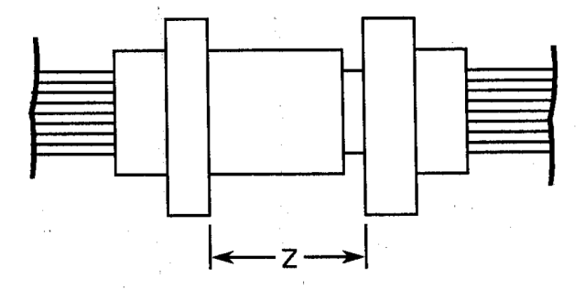
Figure 2.2.2 – Plug Male Contact
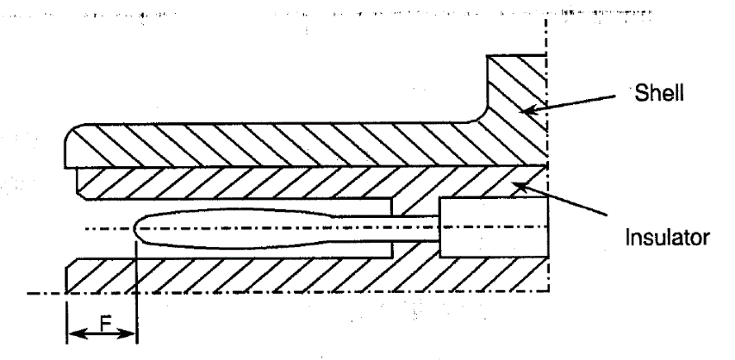
Figure 2.2.3 – Receptacle Female Contact
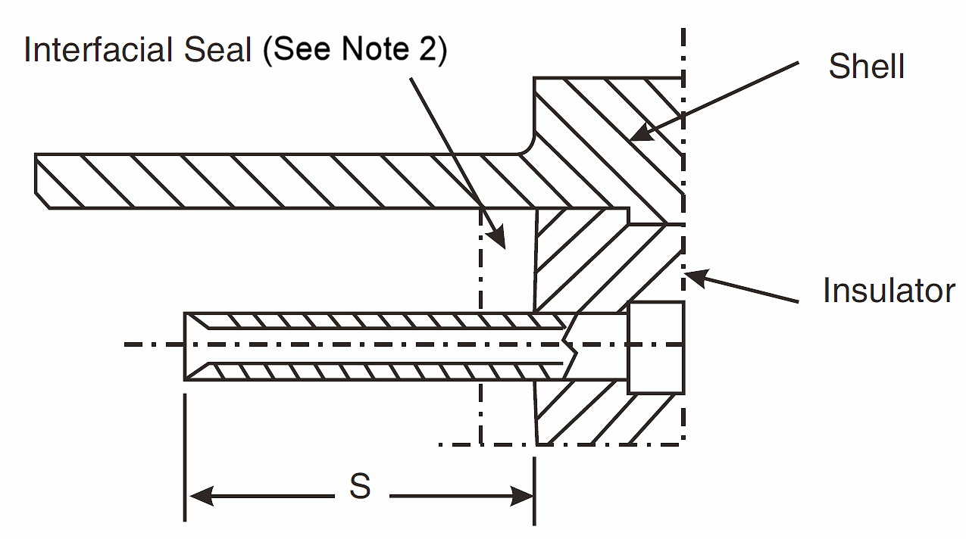
F |  | S |  | Z
Min. | Max. | Min. | Max. | Max.
0.25 | 0.91 | 3.3 | 3.66 | 5.49
NOTES:
            - All dimensions in millimetres.
            - The Interfacial Seal is optional and is specified in ESCC Detail Specification No. 3401/032.
figure 2.3 – uninsulated solid wires accepted
Wire Size AWG | 25
Max Diameter D mm | 0.51
Min Diameter D mm | 0.4
Min Gold Plating Thickness µm | 0.5
Max. Weight g/m | 1.6

figure 2.4 – insulated solid wires accepted
 | ESCC 3901/002 |  |  | ESCC 3901/013
 | Wire Size AWG
 | 24 | 26 | 28 | 24 (1) | 26 | 28
Maximum Conductor Diameter mm | 0.64 | 0.53 | 0.43 | 0.62 | 0.5 | 0.42
Maximum Wire Diameter mm | 0.88 | 0.78 | 0.68 | 1.04 | 0.89 | 0.82
Notes:
            - Not applicable for shell size 51 (3 rows of contacts).

FIGURE 2.5 – floating mount (Notes 2 and 3)
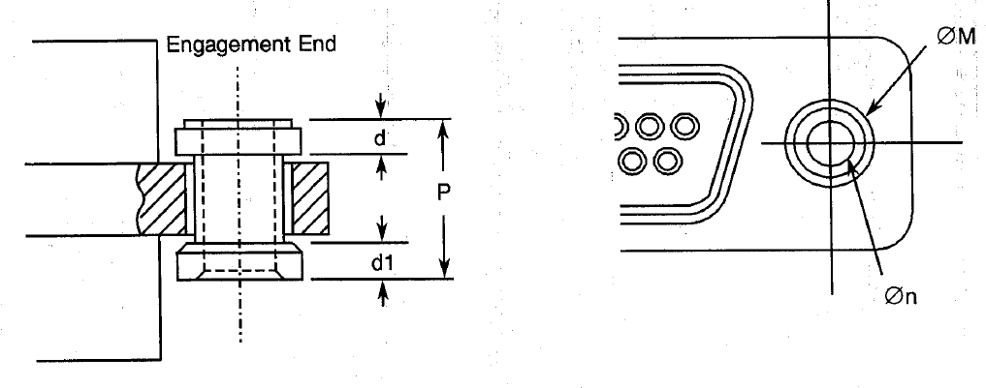
d | d1 | ØM  Max. | ØN  Min. | P  Max.
1 | 0.8 | 4 | 2.26 | 4.7
NOTES:
            - All dimensions are in millimetres.
            - Total Lateral Float 0.4 (typical).
            - Total Axial Float 0.4 (typical).
Figure 2.6 - Captive Nut
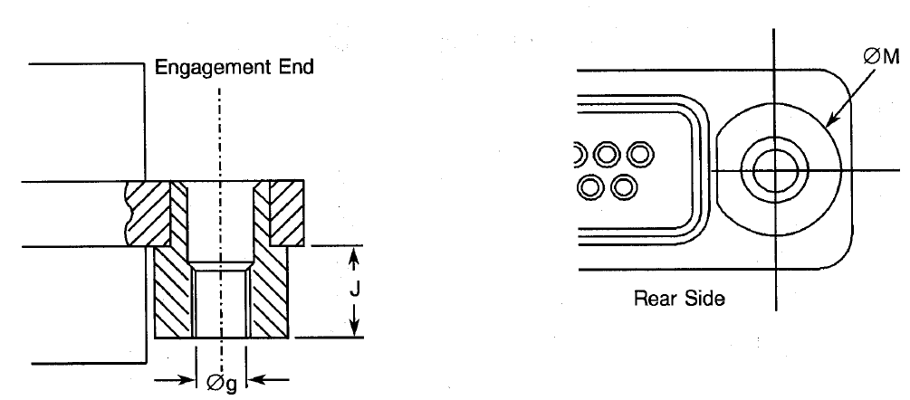
Øg | J  Max. | ØM  Max.
Note 2 | 2.6 | 5.1
NOTES:
            - All dimensions are in millimetres.
            - Øg: 2-56 UNC 28, Maximum Torque 0.44Nm.

FIGURE 3 – contact arrangements
front view of male insert – use mirror view for female insert
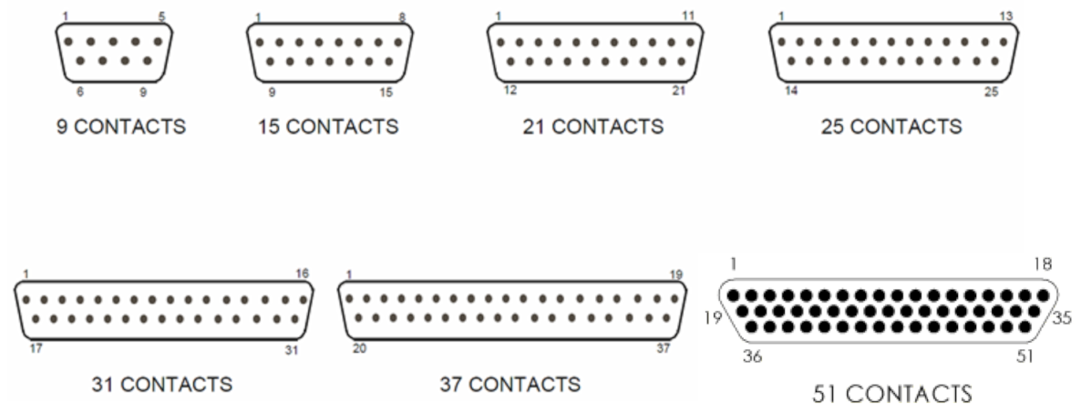
NOTES:
            - Only the outside contact cavities on each row are identified in the drawing, the remainder follow sequentially. Contact numbers are shown outside the insert for readability.
Contact Centres
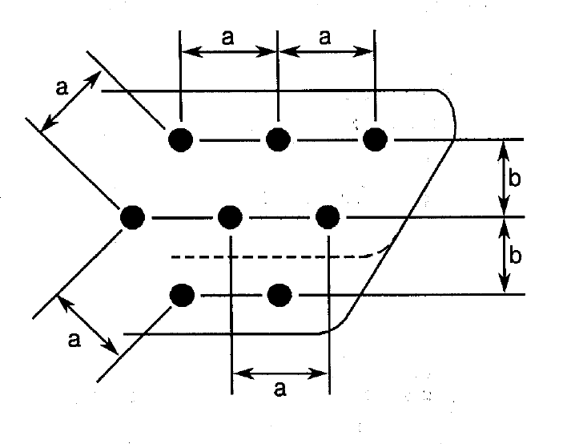
NOTES:
            - a = Distance between contact centres: 1.27mm (typical).
            - b = Distance between rows: 1.09mm (typical).
Figure 4 – Contact Removal Tool
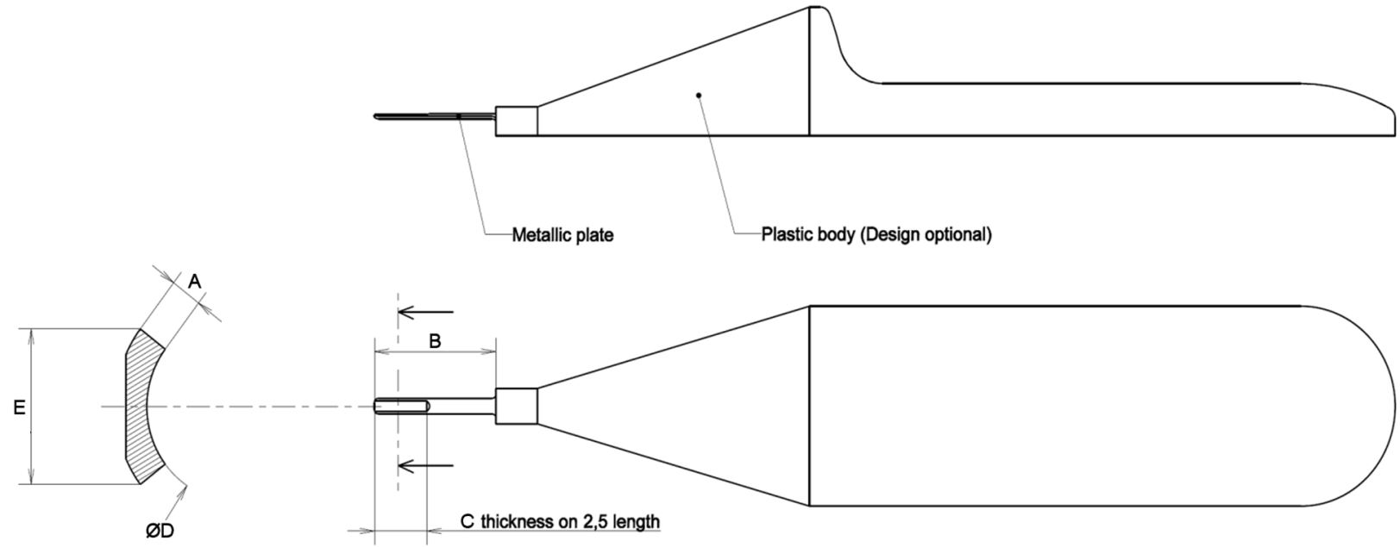
Shell Size | Dimensions (mm) |  |  |  |  |  |  |  |  | Notes
Shell Size | A |  | B |  | C |  | ØD |  | E | Notes
Shell Size | Min | Max | Min | Max | Min | Max | Min | Max | Max. | Notes
9 to 37 | 0.13 | 0.17 | 5.7 | 6 | 0.1 | 0.11 | 0.83 | 0.87 | 0.75 | 2 rows of contacts
51 | 0.07 | 0.09 | 5.7 | 6 | 0.06 | 0.07 | 0.83 | 0.87 | 0.75 | 3 rows of contacts

REQUIREMENTS

GENERAL
The complete requirements for procurement of the connectors specified herein are stated in this specification and ESCC Generic Specification No. 3401. Deviations from the Generic Specification, applicable to this specification only, are listed in Para. 4.2.
Deviations from the applicable Generic Specification and this Detail Specification, formally agreed with specific Manufacturers on the basis that the alternative requirements are equivalent to the ESCC requirements and do not affect the components’ reliability, are listed in the appendices attached to this specification.

DEVIATIONS FROM GENERIC SPECIFICATION

Deviations from Special In-process Controls
None.

Deviations from Final Production Tests (Chart II)
          - Para. 9.5, Magnetism Level: Not applicable.
          - Para. 9.2, Mating Verification: Not applicable.
          - Para. 9.3, Contact Retainer Test: Replaced by a 100% visual inspection with dedicated equipment.

Deviations from Burn-in and Electrical Measurements (Chart III)
Chart III is not applicable.

Deviations from Qualification Tests (Chart IV)
          - Para. 9.9, Seal Test: Not applicable.
          - Para. 9.29, Oversize Pin Exclusion: Not applicable.
          - Para. 9.30, Probe Damage: Not applicable.
          - Para. 9.31, Solderability: Not applicable.

Deviations from Lot Acceptance Tests (Chart V)
          - Para. 9.9, Seal Test: Not applicable.
          - Para. 9.29, Oversize Pin Exclusion: Not applicable.
          - Para. 9.30, Probe Damage: Not applicable.

MECHANICAL REQUIREMENTS

Dimension Check
The dimensions of the connectors specified herein shall be verified in accordance with the requirements set out in Para. 9.6 of ESCC Generic Specification No. 3401 and shall conform to those shown in Figure 2 of this specification. Only the underlined dimensions shall be checked during procurement.

Weight
The maximum weight of the connectors specified herein, without contacts and interfacial seals, shall be in accordance with the values given in Table 1(a) of this specification.

Contact Capability
As specified in ESCC Detail Specification No. 3401/078.

Contact Retention (In insert)
As specified in ESCC Detail Specification No. 3401/078.

Mating and Unmating Forces
The forces applied for the mating and unmating of the connectors shall conform to the values specified in Table 1(a).

Insert Retention (In shell)
Connector inserts shall withstand a pressure of 34.4N/cm² applied from the mating side to the rear side.

Jackscrew Retention
Not applicable.

Contact Insertion and Withdrawal Forces
As specified in ESCC Detail Specification No. 3401/078 with removal tool defined in Figure 4.

Engagement and Separation Forces (Male Contacts)
As specified in ESCC Detail Specification No. 3401/078.

Oversize Pin Exclusion
Not applicable.

Probe Damage
Not applicable.

Solderability
Not applicable.

MATERIALS AND FINISHES
The materials and finishes shall be as specified herein. Where a definite material is not specified, a material which will enable the components specified herein to meet the performance requirements of this specification shall be used. Acceptance or approval of any constituent material does not guarantee acceptance of the finished product.

Shells
Shells shall be made of aluminium alloy. Variant 01 shall have a minimum plating thickness of 25.4µm of electroless nickel. The plating for Variant 02 shall be 0.7µm minimum of gold with 25.4µm minimum electroless nickel underplating.

Inserts
Inserts shall be made of a suitable thermoplastic material.

Contacts
As specified in ESCC Detail Specification No. 3401/078.

Contact Retaining Clip
The retaining clip shall be made of beryllium copper or stainless steel.

MARKING

General
The marking of components delivered to this specification shall be in accordance with the requirements of ESCC Basic Specification No. 21700 and the following paragraphs.
Each component shall be marked in respect of:
          - The ESCC qualified components symbol (for ESCC qualified components only).
          - The ESCC Component Number.
          - Series.
          - Characteristics.
          - Traceability Information.

The ESCC Component Number
Each component shall bear the ESCC Component Number which shall be constituted and marked as follows:
Example: 340107701B
- Detail Specification Number: 3401077
- Type Variant (See Table 1(a)) : 01
- Testing Level: B

Series
The series of the connector, MDMA, shall be marked on the connector if space permits.

Characteristics
The characteristics to be marked in the following order of precedence are:
          - Mounting.
          - Shell Size.
          - Contact Type.
          - Contact Information.
The information shall be constituted and marked as follows (example): Y37P-FO
- Mounting: Y
- Shell size: 37
- Contact Type: P
- Contact Information: -FO

Fixing Option
The letter "Y" shall indicate a floating mount. The letter "E" shall indicate captive nuts. If the shell has standard mounting holes, the letter shall be omitted.

Shell Size
Shell size shall be designated by the number of contacts.
Specified numbers are: 9, 15, 21, 25, 31 and 37 and 51.

Contact Type
Contact types shall be indicated by the following code letters.
Code Letter | Contact Type
P | Male
S | Female

Contact Information
-FO = Connector ordered without contacts. This information shall not be marked on the connector; it is only included on the packaging and all relevant data documentation.
Contacts must be from the same Manufacturer as the connector in which they are fitted and this shall be verified prior to assembly.

Traceability Information
Traceability information shall be marked in accordance with the requirements of ESCC Basic Specification No. 21700.

ELECTRICAL MEASUREMENTS

Electrical Measurements at Room Temperature
The parameters to be measured in respect of electrical characteristics are scheduled in Table 2. Unless otherwise specified, the measurements shall be performed at T_{amb} = +22 ±3°C.

Electrical Measurements at High and Low Temperatures
Not applicable.

Circuits for Electrical Measurements
Not applicable.

BURN-IN AND ELECTRICAL MEASUREMENTS (TABLES 4 AND 5)
Not applicable.
TABLE 2 - ELECTRICAL MEASUREMENTS AT ROOM TEMPERATURE
No. | Characteristic | Symbol | ESCC 3401  Test Method | Test Condition | Limits |  | Unit
 |  |  |  |  | Min. | Max. | Unit
1 | Insulation Resistance | R_{i} | Para. 9.1.1.1 | Para. 9.1.1.1 | 5000 (Note 2) | - | MΩ
 |  |  |  |  | 2500 (Note 3) | - | MΩ
2 | Voltage Proof Leakage Current | I_{L} | Para. 9.1.1.2 | 600 Vrms Note 2 | - | 2 | mA
 |  |  |  | 450 Vrms Note 3 | - | 2 | mA
3 | Mated Shell Conductivity  (Voltage Drop) Note 1 | V_{D} | Para. 9.1.1.4 | Para. 9.1.1.4 | Not applicable |  | mV
NOTES:
            - Applicable to mated connectors with grounding option.
            - Applicable for shell sizes 9 to 37 (2 rows of contacts).
            - Applicable for shell size 51 (3 rows of contacts).

TABLES 3, 4 AND 5
Not applicable.

ENVIRONMENTAL AND ENDURANCE TESTS (CHARTS IV AND V OF ESCC GENERIC SPECIFICATION No. 3401)

Measurements and Inspections on Completion of Environmental Tests
The parameters to be measured and inspections to be performed on completion of environmental testing shall be those specified in Table 6. Unless otherwise specified, these measurements shall be performed at T_{amb} = +22 ±3°C.

Measurements and Inspections at Intermediate Points during Endurance Tests
Not applicable.

Measurements and Inspections on Completion of Endurance Tests
The parameters to be measured and inspections to be performed on completion of endurance testing shall be those specified in Table 6. Unless otherwise specified, these measurements shall be performed at T_{amb} = +22 ±3°C.

Conditions for Operating Life Test (Part of Endurance Testing)
Not applicable.

Electrical Circuit for Operating Life Test
Not applicable.

Conditions for High Temperature Storage Test (Part of Endurance Testing)
The requirements for the high temperature storage test are specified in Section 9 of ESCC Generic Specification No. 3401. The temperature to be applied shall be the maximum storage temperature specified in Table 1(b) of this specification.
TABLE 6 – MEASUREMENTS AND INSPECTIONS ON COMPLETION OF ENVIRONMENTAL AND ENDURANCE TESTING
No. | ESCC Generic Spec. No. 3401 |  | Measurements and Inspections |  | Symbol | Limits |  | Unit
No. | Environmental and Endurance Tests Note 1 | Test Method and Conditions | Identification | Conditions | Symbol | Min. | Max.
01 | Seal Test | Para. 9.9 | Not applicable | - | - | - | -
02 | Wiring | Para. 9.10 | ESCC 3401/078 | - | - | - | -
03 | Vibration | Para. 9.11 | Initial Measurements  Coupling Screw(s)  Unlocking Torque |  | Tqe | Record Values
Final Measurements
Full Engagement
 |  |  | Coupling Screw(s) Unlocking Torque Drift | - | ΔTqe/Tqe | -25 | +25 | %
 |  |  | Visual Examination | - | - | - | -
04 | Shock or Bump | Para. 9.12 | Full Engagement  Visual Examination | - | - | - | -
05 | Climatic Sequence | Para. 9.13 | Dry Heat  Insulation Resistance | At High Temperature  Table 2, Item 1 | R_{i} | 10 | - | MΩ
 | Climatic Sequence |  | Low Air Pressure  Voltage Proof Leakage Current | Figure 1 | I_{L} | ESCC 3401 Para. 9.13.5 |  | mA
 | Climatic Sequence |  | Damp Heat | Immediately after test
 | Climatic Sequence |  | Insulation Resistance | Table 2, Item 1 | R_{i} | 100 | - | MΩ
 |  |  | Final Measurements | After 1-24 hrs Recovery
 |  |  | External Visual Inspection | ESCC 3401 Para. 9.7 | - | ESCC 3401 Para. 9.7
 |  |  | Insulation Resistance | Table 2, Item 1 | R_{i} | Table 2, Item 1 |  | MΩ
 |  |  | Voltage Proof Leakage Current | Table 2, Item 2 | I_{L} | Table 2, Item 2 |  | mA
06 | Plating Thickness | Para. 9.14 | Thickness | - | - | -
07 | Joint Strength | Para. 9.15 | ESCC 3401/078 | - | - | -
08 | Rapid Change of Temperature | Para. 9.16 | Visual Examination | - | - | - | -
 | Rapid Change of Temperature |  | Insulation Resistance | Table 2, Item 1 | R_{i} | Table 2, Item 1 |  | MΩ
 | Rapid Change of Temperature |  | Voltage Proof Leakage Current | Table 2, Item 2 | I_{L} | Table 2, Item 2 |  | mA
09 | Contact Retention (in Insert) | Para. 9.17 & Para. 4.3.4 of this spec. | Contact Displacement | ESCC 3401/078 | - | ESCC 3401/078
10 | Endurance | Para. 9.18 | Initial Measurements
 |  |  | Mating/Unmating Forces | - | F | Para. 4.3.5 of this spec. |  | N
 |  |  | Low Level Contact Resistance | ESCC 3401/078 | R_{cl} | ESCC 3401/078 |  | mΩ
 |  |  | Mated Shell Conductivity | Table 2, Item 3 | V_{D} | Not applicable |  | mV
 |  |  | Final Measurements
 |  |  | Visual Examination | - | - | - | -
 |  |  | Mating/Unmating Forces | - | F | Para. 4.3.5 of this spec. |  | N
 |  |  | Low Level Contact Resistance Drift | ESCC 3401/078 | ΔR_{cl} | ESCC 3401/078 |  | mΩ
 |  |  | Mated Shell Conductivity | Table 2, Item 3 | V_{D} | Not applicable |  | mV
 |  |  | Insulation Resistance | Table 2, Item 1 | R_{i} | Table 2, Item 1 |  | MΩ
 |  |  | Voltage Proof Leakage Current | Table 2, Item 2 | I_{L} | Table 2, Item 2 |  | mA
11 | Permanence of Marking | Para. 9.19 | As applicable | - | - | -
12 | Mating / Unmating Forces | Para. 9.20 | Force | - | F | Para. 4.3.5 of this spec. |  | N
13 | High Temperature  Storage | Para. 9.21 | Initial Measurements
 | High Temperature  Storage |  | Low Level Contact Resistance | ESCC 3401/078 | R_{cl} | ESCC 3401/078 |  | mΩ
 | High Temperature  Storage |  | Mated Shell Conductivity | Table 2, Item 3 | V_{D} | Not applicable |  | mV
 |  |  | Final Measurements
 |  |  | Visual Examination | - | - | - | -
 |  |  | Mating/Unmating Forces | - | F | Para. 4.3.5 of this spec. |  | N
 |  |  | Low Level Contact Resistance Drift | ESCC 3401/078 | ΔR_{cl} | ESCC 3401/078 |  | mΩ
 |  |  | Rated Current Contact Resistance | ESCC 3401/078 | R_{cr} | ESCC 3401/078 |  | mΩ
 |  |  | Mated Shell Conductivity | Table 2, Item 3 | V_{D} | Not applicable |  | mV
 |  |  | Insulation Resistance | Table 2, Item 1 | R_{i} | Table 2, Item 1 |  | MΩ
 |  |  | Voltage Proof Leakage Current | Table 2, Item 2 | I_{L} | Table 2, Item 2 |  | mA
 |  |  | Contact Retention (In Insert) | ESCC 3401/078 |  | ESCC 3401/078 |  | N
14 | Corrosion | Para. 9.22 | Visual Examination | - | - | - | -
15 | Insert Retention (In Shell) | Para. 9.23 & Para. 4.3.6 of this spec. | Visual Examination | - | - | Para. 4.3.6 of this spec.
16 | Jackscrew Retention | Para. 9.24 & Para. 4.3.7 of this spec. | Not applicable | - | - | - | -
17 | High Temperature Measurements | Para. 9.25 | Insulation Resistance | Table 2 Item 1 | R_{i} | 10 | - | MΩ
18 | Overload Test | Para. 9.26 | Internal Temperature | - | T | - | +100 | ºC
 |  |  | Rated Current Contact Resistance | ESCC 3401/078 | R_{cr} | ESCC 3401/078 |  | mΩ
 |  |  | Mated Shell Conductivity | Table 2 Item 3 | V_{D} | Not applicable |  | mV
 |  |  | Insulation Resistance | Table 2 Item 1 | R_{i} | Table 2, Item 1 |  | MΩ
 |  |  | Voltage Proof Leakage Current | Table 2 Item 2 | I_{L} | Table 2, Item 2 |  | mA
19 | Maintenance Ageing | Para. 9.27 | Visual Examination | - | - | - | -
 |  |  | Contact Retention  (In insert) | ESCC 3401/078 | - | ESCC 3401/078 |  | N
 |  |  | Contact insertion and Withdrawal Forces | ESCC 3401/078 |  | ESCC 3401/078 |  | N
20 | Engage/Separation Forces | Para. 9.28 & Para. 4.3.9 of this spec. | Force | ESCC 3401/078 | F | ESCC 3401/078 |  | N
21 | Oversize Pin Exclusion | Para. 9.29 & Para. 4.3.10 of this spec. | Not applicable | - | - | - | -
22 | Probe Damage | Para. 9.30 & Para. 4.3.11 of this spec. | Not applicable | - | - | - | -
23 | Solderability | Para. 9.31 & Para. 4.3.12 of this spec. | Not applicable | - | - | - | -
NOTES:
            - The tests in this Table refer to either Chart IV or V and shall be used as applicable.

Appendix A
agreed deviations for c&K Components (F)
ITEMS AFFECTED | DESCRIPTION OF DEVIATIONS
Para. 4.2.2, Deviations from Final Production Tests (Chart II) | Para. 9.4, Contact Capability: 100% Contact Capability Test may be omitted provided that a 100% visual inspection of the contacts is performed on each batch submitted to tests defined in the C&K PID  requirements.

