

Page 1 of 23
CONNECTOR SAVERS, ELECTRICAL, RECTANGULAR, MICROMINIATURE
BASED ON TYPE MDM
ESCC Detail Specification No. 3401/041

Issue 6 Draft A | November 2018


Document Custodian: European Space Agency – see https://escies.org

Legal Disclaimer and Copyright
European Space Agency, Copyright © 2018. All rights reserved.
The European Space Agency disclaims any liability or responsibility, to any person or entity, with respect to any loss or damage caused, or alleged to be caused, directly or indirectly by the use and application of this ESCC publication.
This publication, without the prior permission of the European Space Agency and provided that it is not used for a commercial purpose, may be:
- copied in whole, in any medium, without alteration or modification.
- copied in part, in any medium, provided that the ESCC document identification, comprising the ESCC symbol, document number and document issue, is removed.

DOCUMENTATION CHANGE NOTICE
(Refer to https://escies.org for ESCC DCR content)
DCR No. | CHANGE DESCRIPTION
tba | Specification upissued to incorporate changes per DCR.

TABLE OF CONTENTS
1 General 6
1.1 SCOPE 6
1.2 TYPE VARIANTS 6
1.3 MAXIMUM RATINGS 6
1.4 PARAMETER DERATING INFORMATION 6
1.5 PHYSICAL DIMENSIONS 6
1.6 CONTACT ARRANGEMENTS 6
2 APPLICABLE DOCUMENTS 6
3 TERMS, DEFINITIONS, ABBREVIATIONS, SYMBOLS AND UNITS 7
4 REQUIREMENTS 13
4.1 GENERAL 13
4.2 DEVIATIONS FROM GENERIC SPECIFICATION 13
4.2.1 Deviations from Special In-Process Controls 13
4.2.2 Deviations from Final Production Tests (Chart II) 13
4.2.3 Deviations from Burn-in and Electrical Measurements (Chart III) 13
4.2.4 Deviations from Qualification Tests (Chart IV) 13
4.2.5 Deviations from Lot Acceptance Tests (Chart V) 13
4.3 MECHANICAL REQUIREMENTS 14
4.3.1 Dimension Check 14
4.3.2 Weight 14
4.3.3 Contact Capability 14
4.3.4 Contact Retention (in Insert) 14
4.3.5 Mating and Unmating Forces 14
4.3.6 Insert Retention (in Shell) 14
4.3.7 Jackscrew Retention 14
4.3.8 Contact Insertion and Withdrawal Forces 14
4.3.9 Engagement and Separation Forces (Male Contacts) 14
4.3.10 Oversize Pin Exclusion 15
4.3.11 Probe Damage 15
4.3.12 Solderability 15
4.4 MATERIALS AND FINISHES 15
4.4.1 Shells 15
4.4.2 Inserts 15
4.4.3 Contacts 15
4.4.3.1 Female Contacts 15
4.4.3.2 Male Contacts 15
4.4.4 Seals Interfacial 15
4.4.5 Uninsulated Solid Wire 15
4.4.6 Potting 15
4.5 MARKING 16
4.5.1 General 16
4.5.2 The ESCC Component Number 16
4.5.3 Characteristics 16
4.5.3.1 Shell Size 16
4.5.3.2 Type of Contact 16
4.5.4 Traceability Information 16
4.6 ELECTRICAL MEASUREMENTS 17
4.6.1 Electrical Measurements at Room Temperature 17
4.6.2 Electrical Measurements at High and Low Temperatures (Table 3) 17
4.6.3 Circuits for Electrical Measurements (Figure 4) 17
4.7 BURN-IN AND ELECTRICAL MEASUREMENTS (TABLES 4 AND 5) 17
4.8 ENVIRONMENTAL AND ENDURANCE TESTS (CHARTS IV AND V OF ESCC GENERIC SPECIFICATION NO. 3401) 19
4.8.1 Measurements and Inspections on Completion of Environmental Tests 19
4.8.2 Measurements and Inspections at Intermediate Points during Endurance Tests 19
4.8.3 Measurements and Inspections on Completion of Endurance Tests 19
4.8.4 Conditions for Operating Life Test (Part of Endurance Testing) 19
4.8.5 Electrical Circuit for Operating Life Test (Figure 5) 19
4.8.6 Conditions for High Temperature Storage Test (Part of Endurance Testing) 19
APPENDIX ‘A’ 23

General

SCOPE
This specification details the ratings, physical and electrical characteristics, test and inspection data for Connector Savers, Electrical, Rectangular, Microminiature with Non-removable Crimp-type Contacts, based on type MDM.
It shall be read in conjunction with:
          - ESCC Generic Specification No. 3401, Connectors, Electrical, Non-Filtered, Circular and Rectangular.
          - ESCC Detail Specification No. 3401/032, Accessories for Connectors, Microminiature, 3401/029, 3401/077 and Connector Savers 3401/041.
the requirements of which are supplemented herein.

TYPE VARIANTS
Variants of the basic type connector savers specified herein, which are also covered by this specification, together with their mechanical characteristics, are given in Table 1(a).

MAXIMUM RATINGS
The maximum ratings, which shall not be exceeded at any time during use or storage, applicable to the connector savers specified herein, are scheduled in Table 1(b).

PARAMETER DERATING INFORMATION
The derating information applicable to the connector savers specified herein is shown in Figure 1.

PHYSICAL DIMENSIONS
The physical dimensions of the connector savers specified herein are shown in Figure 2.

CONTACT ARRANGEMENTS
Contact arrangements are shown in Figure 3.

APPLICABLE DOCUMENTS
The following documents form part of this specification and shall be read in conjunction with it:
          - ESCC Generic Specification No. 3401, Connectors, Electrical, Non-Filtered, Circular and Rectangular.
          - ESCC Detail Specification No. 3401/032, Accessories for Connectors, Microminiature, 3401/029, 3401/077 and Connector Savers 3401/041.
          - A-A-59551, Wire, Electrical, Copper, Uninsulated.
          - MIL-DTL-45204, Gold Plating, Electro-deposited.
          - MIL-DTL-14550, Copper Plating, Electro-deposited.
          - MIL-DTL-83513, Connectors, Electrical, Rectangular, Microminiature, Polarised Shell, Generic Specification for.

TERMS, DEFINITIONS, ABBREVIATIONS, SYMBOLS AND UNITS
For the purpose of this specification, the terms, definitions, abbreviations, symbols and units specified in ESCC Basic Specification No. 21300 shall apply.
TABLE 1(a) - TYPE VARIANTS
Variant | Shell Size  Notes 1, 2 | Max. Weight  (g)  Note 3 | Max. Mating  Force  (N) | Unmating Force (N)
 |  |  |  | Max. | Min.
01 | 9 | 4 | 25 | 25 | 1.3
02 | 15 | 5.5 | 42 | 42 | 2
03 | 21 | 7 | 58 | 58 | 2.9
04 | 25 | 8 | 70 | 70 | 3.5
05 | 31 | 9.5 | 86 | 86 | 4.3
06 | 37 | 10 | 103 | 103 | 5.1
07 | 51 | 13.5 | 142 | 142 | 7.1
NOTES:
            - Contacts are fixed in the connector saver.
            - Shell Size 51 is not applicable to MDMA connectors.
            - Connector saver with contacts and without screw-locks.
TABLE 1(b) - MAXIMUM RATINGS
No. | Characteristics | Symbol | Maximum Rating | Unit | Remarks
1 | Working Voltage (Sea Level) | U_{R} | 150 | Vrms | Note 1
2 | Rated Current: (uninsulated solid wire) | I_{R} | 2.5 | A | Note 2
3 | Operating Temperature Range | T_{op} | -55 to +125 | ºC
4 | Storage Temperature Range | T_{stg} | -55 to +125 | ºC
NOTES:
            - Between contacts, and contact and shell.
            - I_{R} requires derating if the number of current-carrying contacts in the connector saver is 2 or greater. See Figure 1(b).

FIGURE 1 - PARAMETER DERATING INFORMATION
FIGURE 1(a) - Working Voltage Versus Altitude
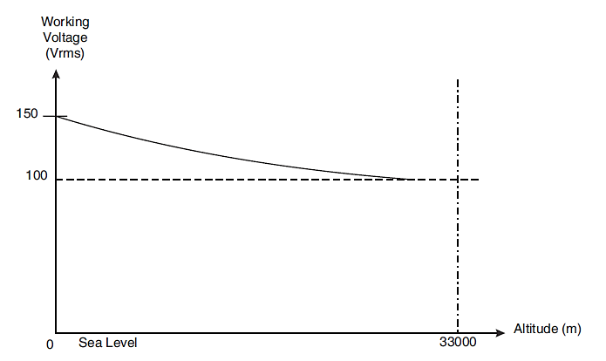
FIGURE 1(b) - Maximum Current Versus Number Of Contacts
Number of Current-Carrying  Contacts per Connector Saver | Maximum Current per Contact (A)
Number of Current-Carrying  Contacts per Connector Saver | Uninsulated Solid Wire
2 - 4 | 2
5 - 14 | 1.8
15 and over | 1.4

FIGURE 2 - PHYSICAL DIMENSIONS
Figure 2.0 – male and female interface dimensions
 | FEMALE RECEPTACLE
 | 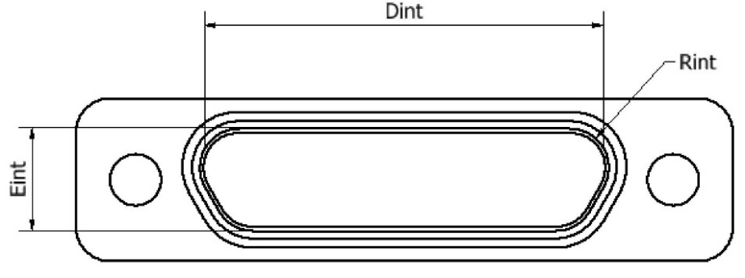
 | MALE PLUG
 | 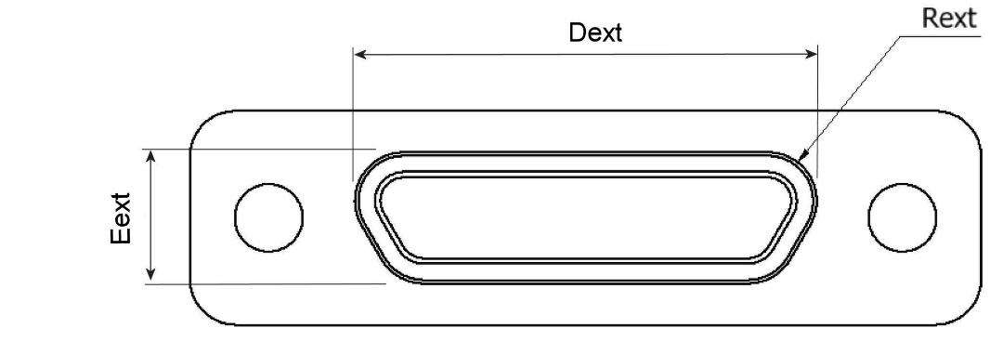
Shell Size |  | Dint Min. | Eint Min. | Rint Min. | Dext Max. | Eext Max. | Rext Max.
9 |  | 8.49 | 4.7 | 1.704 | 8.48 | 4.69 | 1.699
15 |  | 12.3 | 4.7 | 1.704 | 12.29 | 4.69 | 1.699
21 |  | 16.11 | 4.7 | 1.704 | 16.1 | 4.69 | 1.699
25 |  | 18.65 | 4.7 | 1.704 | 18.64 | 4.69 | 1.699
31 |  | 22.46 | 4.7 | 1.704 | 22.45 | 4.69 | 1.699
37 |  | 26.27 | 4.7 | 1.704 | 26.26 | 4.69 | 1.699
51 |  | 25 | 5.8 | 1.704 | 24.99 | 5.78 | 1.699
FIGURE 2.1 - CONNECTOR SAVER DIMENSIONS
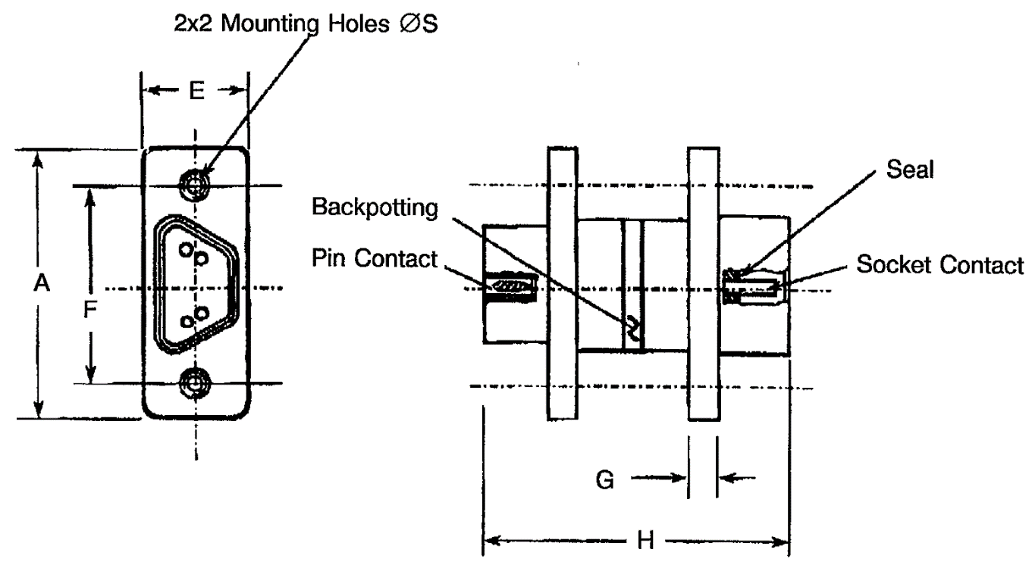
Variant | Size | A  Max. | E  Max. | F  Max. | G  Typical | H  Typical | ØS
 |  |  |  |  |  |  | Min. | Max.
01 | 09 | 19.94 | 7.75 | 14.35 | 2.29 | 22.86 | 2.23 | 2.44
02 | 15 | 23.75 | 7.75 | 18.16 | 2.29 | 22.86 | 2.23 | 2.44
03 | 21 | 27.56 | 7.75 | 21.97 | 2.29 | 22.86 | 2.23 | 2.44
04 | 25 | 30.1 | 7.75 | 24.51 | 2.29 | 22.86 | 2.23 | 2.44
05 | 31 | 33.91 | 7.75 | 28.32 | 2.29 | 22.86 | 2.23 | 2.44
06 | 37 | 37.72 | 7.75 | 32.13 | 2.29 | 22.86 | 2.23 | 2.44
07 | 51 | 36.45 | 7.75 | 30.86 | 2.29 | 22.86 | 2.23 | 2.44
NOTES:
            - All dimensions are in millimetres.
FIGURE 2.2 - CONTACT POSITION
Figure 2.2.1 - Mounting Condition
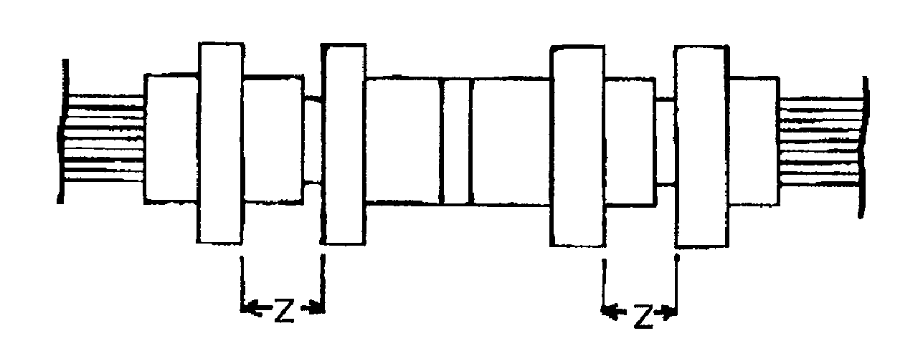
FIGURE 2.2.2 - Plug Male Contact
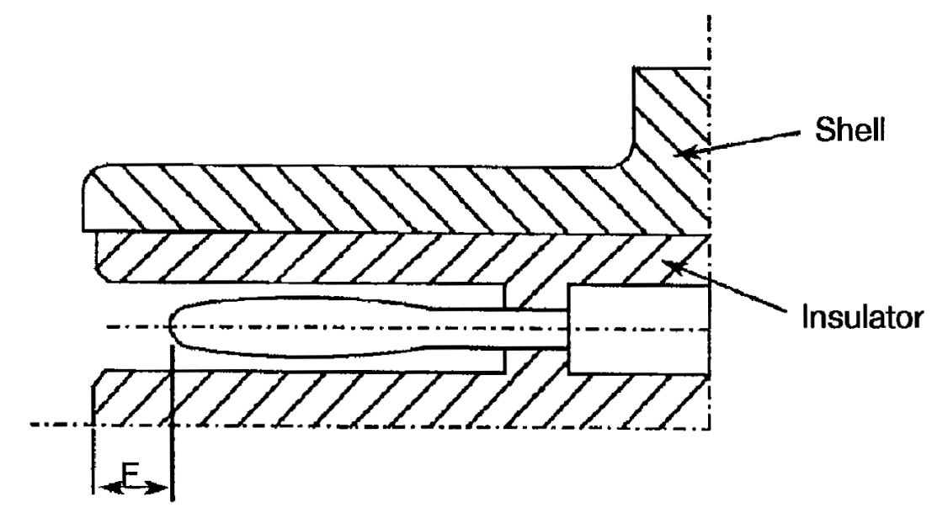
FIGURE 2.2.3 - Receptacle Female Contact
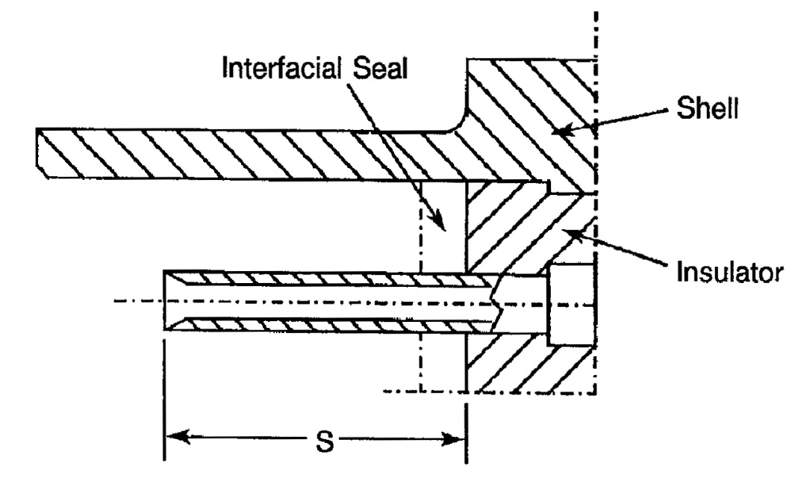
F |  | S |  | Z
Min. | Max. | Min. | Max. | Max.
0.25 | 0.91 | 3.3 | 3.66 | 5.49
NOTES:
            - All dimensions are in millimetres.

FIGURE 3 - CONTACT ARRANGEMENTS
FRONT VIEW OF MALE INSERT - USE MIRROR VIEW FOR FEMALE INSERT
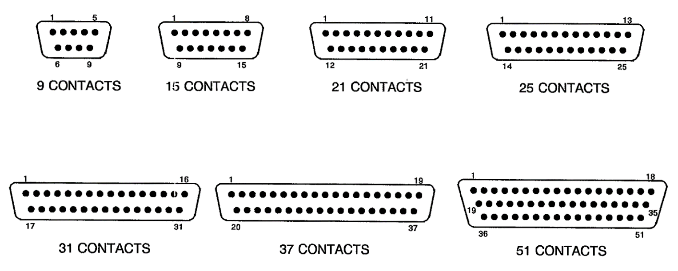
NOTES:
            - Only the outside contact cavities on each row are identified in the drawing, the remainder follow sequentially. Contact numbers are shown outside the insert for readability.
Contact Centres
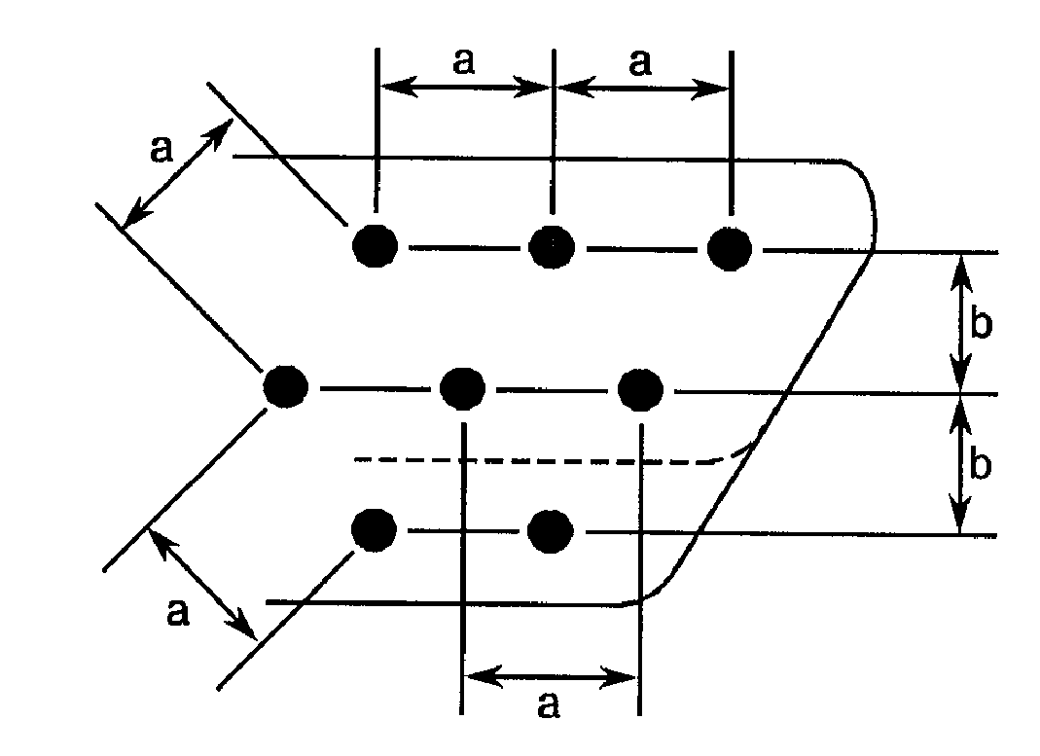
NOTES:
            - a = Distance between contact centres: 1.27mm typical.
            - b = Distance between rows: 1.09mm typical.

REQUIREMENTS

GENERAL
The complete requirements for procurement of the connector savers specified herein are stated in this specification and ESCC Generic Specification No. 3401. Deviations from the Generic Specification, applicable to this specification only, are listed in Para. 4.2.
Deviations from the applicable Generic Specification and this Detail Specification, formally agreed with specific Manufacturers on the basis that the alternative requirements are equivalent to the ESCC requirements and do not affect the components’ reliability, are listed in the appendices attached to this specification.

DEVIATIONS FROM GENERIC SPECIFICATION

Deviations from Special In-Process Controls
Para. 9.15, Joint Strength: The contacts shall be crimped to uninsulated solid wire AWG25. The value of failure shall be recorded together with the information to whether the failure was “pull-out”, “break in crimp” or “break in wire’. The minimum tensile strength shall be as follows:
Wire | Male and Female Contacts
Wire | AWG25 - Solid Uninsulated
Tensile Strength (N) | 22

Deviations from Final Production Tests (Chart II)
          - Para. 9.3, Contact Retainer Test: Not applicable.
          - Para. 9.4, Contact Capability: This test shall be performed on the male contacts. For details see Para. 4.3.3 of this specification.
          - Para. 9.5, Magnetism Level: Not applicable.

Deviations from Burn-in and Electrical Measurements (Chart III)
Chart III is not applicable.

Deviations from Qualification Tests (Chart IV)
          - Para. 9.9, Seal Test: Not applicable.
          - Para. 9.15, Joint Strength: Not applicable.
          - Para. 9.17, Contact Retention (in insert): Not applicable with male contact.
          - Para. 9.27, Maintenance Ageing: Not applicable.
          - Para. 9.29, Oversize Pin Exclusion: Not applicable.
          - Para. 9.30, Probe Damage: Not applicable.

Deviations from Lot Acceptance Tests (Chart V)
          - Para. 9.9, Seal Test: Not applicable.
          - Para. 9.15, Joint Strength: Not applicable.
          - Para. 9.17, Contact Retention (in insert): Not applicable with male contact.
          - Para. 9.27, Maintenance Ageing: Not applicable.
          - Para. 9.29, Oversize Pin Exclusion: Not applicable.
          - Para. 9.30, Probe Damage: Not applicable.

MECHANICAL REQUIREMENTS

Dimension Check
The dimensions of the connector savers specified herein shall be verified in accordance with the requirements set out in Para. 9.6 of ESCC Generic Specification No. 3401 and shall conform to those shown in Figure 2 of this specification. Only the underlined dimensions shall be checked during procurement.

Weight
The maximum weight of the connector savers specified herein shall be as specified in Table 1(a).

Contact Capability
For the purpose of this test, the pick-up and drop weights shall be as follows.
Measurements | Pick-up Weight | Drop Weight
Weight (g) | 14 | 170
Inner Gauge Diameter (mm) (1) | 0.582 - 0.587 | 0.559 - 0.564
Insertion Depth (mm) | 1.5 | 1.5
NOTES:
            - See Figure 4 for ØA.

Contact Retention (in Insert)
Contact retention within the insert shall be 22.25 Newtons. There shall be no displacement of the contact. Not applicable to male contacts.

Mating and Unmating Forces
The forces applied for the mating and unmating of the connector savers shall conform to the values specified in Table 1(a).

Insert Retention (in Shell)
Connector saver inserts shall withstand a pressure of 34.4N/cm² applied from the mating side to the rear side.

Jackscrew Retention
Not applicable.

Contact Insertion and Withdrawal Forces
Not applicable.

Engagement and Separation Forces (Male Contacts)
The contact engagement and separation forces of the male contacts shall be tested to a depth of 1.5mm with the applicable test gauge fixtures specified in Figure 4 of this specification, and shall not exceed the values of the table hereunder.
Measurements | Inner Diameter (mm) |  | Separation Force  Min. (N) | Engagement Force  Max. (N)
Measurements | Min. | Max. | Separation Force  Min. (N) | Engagement Force  Max. (N)
Minimum Diameter Test Sleeve | 0.559 | 0.564 | - | 1.667
Maximum Diameter Test Sleeve | 0.582 | 0.587 | 0.137 | -

Oversize Pin Exclusion
Not applicable.

Probe Damage
Not applicable.

Solderability
Not applicable.

MATERIALS AND FINISHES
The materials and finishes shall be as specified herein. Where a definite material is not specified, a material which will enable the components specified herein to meet the performance requirements of this specification shall be used. Acceptance or approval of any constituent material does not guarantee acceptance of the finished product.

Shells
Shells shall be made of aluminium alloy plated with a minimum thickness of 25.4μm of electroless nickel.

Inserts
Inserts shall be made of glass-fibre filled diallylphthalate resin or a suitable thermoplastic material.

Contacts

Female Contacts
The contact body shall be made of copper alloy with an underplate of 1μm minimum of copper to MIL-C-14550, gold plated with 1.27μm minimum of gold, Type 2, Grade C of MIL-DTL-45204. Measurement of thickness shall be performed at a distance of 1.5mm from the engagement end.

Male Contacts
The contact body and the bundle shall be made of copper alloy with an underplate of 1μm minimum of copper to MIL-C-14550, gold plated with 1.27μm minimum of gold, Type 2 Grade C of MIL-DTL-45204. Measurement of thickness shall be performed at a distance of 1.5mm from the engagement end.

Seals Interfacial
Interfacial seals shall be made of silicon base rubber.

Uninsulated Solid Wire
Uninsulated solid wires shall be made of copper alloy in accordance with Type S as specified in A-A-59551. They shall be gold-plated in accordance with Class 00, Grade C or D, as specified in MIL-DTL-45204.

Potting
Potting shall be made of epoxy resin.

MARKING

General
The marking of components delivered to this specification shall be in accordance with the requirements of ESCC Basic Specification No. 21700 and the following paragraphs. When the component is too small to accommodate all of the marking specified, as much as space permits shall be marked and the marking information, in full, shall accompany the component in its primary package.
The information to be marked and the order of precedence shall be as follows:
          - The ESCC Component Number.
          - Characteristics.
          - Traceability Information.

The ESCC Component Number
Each component shall bear the ESCC Component Number which shall be constituted and marked as follows:
Example: 340104101B
- Detail Specification Number: 3401041
- Type Variant (See Table 1(a)): 01
- Testing Level: B

Characteristics
The characteristics to be marked in the following order of precedence are:
          - Shell Size.
          - Type of Contact.
The information shall be constituted and marked as follows (example): 9PS
- Shell size: 9
- Type of Contact: PS

Shell Size
Shell size shall be designated by the number of contacts. Specified numbers are: 9, 15, 21, 25, 31, 37 and 51.

Type of Contact
The contact types shall be indicated by the following code letters.
Code Letter | Contact Type
PS | Male/Female

Traceability Information
Traceability information shall be marked in accordance with the requirements of ESCC Basic Specification No. 21700.

ELECTRICAL MEASUREMENTS

Electrical Measurements at Room Temperature
The parameters to be measured in respect of electrical characteristics are scheduled in Table 2. Unless otherwise specified, the measurements shall be performed at T_{amb} = +22 ±3 ºC.

Electrical Measurements at High and Low Temperatures (Table 3)
Not applicable.

Circuits for Electrical Measurements (Figure 4)
Not applicable.

BURN-IN AND ELECTRICAL MEASUREMENTS (TABLES 4 AND 5)
Not applicable.
Table 2 - ELECTRICAL MEASUREMENTS AT ROOM TEMPERATURE
No. | Characteristics | Symbol | ESCC 3401  Test Method | Test Condition | Limits |  | Unit
 |  |  |  |  | Min. | Max. | Unit
1 | Insulation Resistance | R_{i} | Para. 9.1.1.1 | Para. 9.1.1.1 | 5000 | - | MΩ
2 | Voltage Proof Leakage Current | I_{L} | Para. 9.1.1.2 | 600Vrms |  | 2 | mA
3 | Mated Shell Conductivity (Voltage Drop) Note 1 | V_{d} | Para. 9.1.1.4 | Para. 9.1.1.4 | Not applicable |  | mV
4 | Contact Resistance  Low Level Current | R_{cl} | Para. 9.1.1.3 | Para. 9.1.1.3 | - | 12 | mΩ
5 | Contact Resistance  Rated Current | R_{cr} | Para. 9.1.1.3 | Table 1(b) | - | 10 | mΩ
NOTES:
            - Applicable to mated connectors with grounding option.
TABLES 3, 4 AND 5
Not applicable.

FIGURE 4 - GAUGE FIXTURE
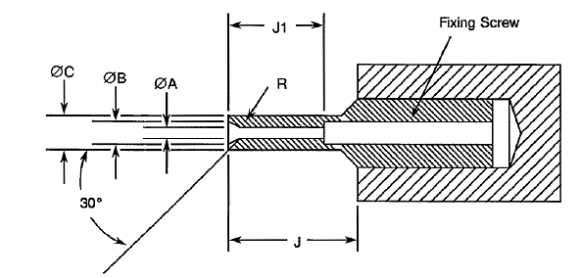
MINIMUM DIAMETER TEST SLEEVE
Weight (g) 170 |  |  | Remarks
 | Min. | Max. | Remarks
ØA | 0.559 | 0.564 | Note 2
ØB | 0.749 | 0.775 | -
ØC | 0.813 | 0.825 | -
J | 4 | - | -
J1 | 3.13 | 3.23 | -
R | 0.381 | 0.483 | Note 1
MAXIMUM DIAMETER TEST SLEEVE
Weight (g) 14 |  |  | Remarks
 | Min. | Max. | Remarks
ØA | 0.582 | 0.587 | Note 2
ØB | 0.749 | 0.775 | -
ØC | 0.813 | 0.825 | -
J | 4 | - | -
J1 | 3.13 | 3.23 | -
R | 0.381 | 0.483 | Note 1
NOTES:
            - Radius R, must be tangent to entry chamfer and ØA.
            - ØA and entry chamfer shall have a surface roughness of 3.2μm (roughness grade N8).

ENVIRONMENTAL AND ENDURANCE TESTS (CHARTS IV AND V OF ESCC GENERIC SPECIFICATION NO. 3401)

Measurements and Inspections on Completion of Environmental Tests
The parameters to be measured and inspections to be performed on completion of environmental testing shall be those specified in Table 6. Unless otherwise specified, these measurements shall be performed at T_{amb} = +22 ±3 ºC.

Measurements and Inspections at Intermediate Points during Endurance Tests
Not applicable.

Measurements and Inspections on Completion of Endurance Tests
The parameters to be measured and inspections to be performed on completion of endurance testing shall be those specified in Table 6. Unless otherwise specified, the measurements shall be performed at T_{amb} = +22 ±3 ºC.

Conditions for Operating Life Test (Part of Endurance Testing)
Not applicable.

Electrical Circuit for Operating Life Test (Figure 5)
Not applicable.

Conditions for High Temperature Storage Test (Part of Endurance Testing)
The requirements for the high temperature storage test are specified in Section 9 of ESCC Generic Specification No. 3401. The temperature to be applied shall be the maximum storage temperature specified in Table 1(b) of this specification.
Table 6 - MEASUREMENTS AND INSPECTIONS ON COMPLETION OF ENVIRONMENTAL AND ENDURANCE TESTING
No. | ESCC Generic Spec. No. 3401 |  | Measurements and Inspections |  | Symbol | Limits |  | Unit
No. | Environmental  and Endurance Tests (Note 1) | Test Method and Conditions | Identification | Conditions | Symbol | Min. | Max. | Unit
01 | Seal Test | Para. 9.9 | ESCC 3401 Para. 9.9 | - | - | Not applicable |  | -
02 | Wiring | Para. 9.10 | Low Level Contact Resistance | - | R_{cl} | Not applicable |  | -
03 | Vibration | Para. 9.11 | Initial Measurements
 |  |  | Coupling Screw(s) Unlocking Torque | - | - | Record Values |  | -
 |  |  | Final Measurements
 |  |  | Full Engagement
 |  |  | Coupling Screw(s) Unlocking Torque Drift | - | ΔTqe/Tqe | -25 | +25 | %
 |  |  | Visual Examination | - | - | - | - | -
04 | Shock or Bump | Para. 9.12 | Full Engagement  Visual Examination | - | - | - | - | -
05 | Climatic Sequence | Para. 9.13 | Dry Heat | At High Temperature
 |  |  | Insulation Resistance | Table 2 Item 1 | R_{i} | 10 | - | MΩ
 |  |  | Low Air Pressure
 |  |  | Voltage Proof Leakage Current | Figure 1 | I_{L} | ESCC 3401  Para. 9.13.5 |  | mA
 |  |  | Damp Heat | Immediately after test
 |  |  | Insulation Resistance | Table 2 Item 1 | R_{i} | 100 | - | MΩ
 |  |  | Final Measurements | After 1-24 hrs Recovery
 |  |  | External Visual Inspection | ESCC 3401 Para. 9.7 |  | ESCC 3401  Para. 9.7
 |  |  | Insulation Resistance | Table 2 Item 1 | R_{i} | Table 2 Item 1 |  | MΩ
 |  |  | Voltage Proof Leakage Current | Table 2 Item 2 | I_{L} | Table 2 Item 2 |  | mA
06 | Plating Thickness | Para. 9.14 | Thickness | - | - | Para. 4.4.3 of this spec. |  | -
07 | Joint Strength | Para. 9.15 | ESCC 3401 Para. 9.15 | - | - | Not applicable |  | -
08 | Rapid Change of Temperature | Para. 9.16 | Visual Examination | - | - | - | - | -
 | Rapid Change of Temperature |  | Insulation Resistance | Table 2 Item 1 | R_{i} | Table 2 Item 1 |  | MΩ
 |  |  | Voltage Proof Leakage Current | Table 2 Item 2 | I_{L} | Table 2 Item 2 |  | mA
09 | Contact Retention  (In Insert) | Para. 9.17 & Para. 4.3.4 of this spec. | Contact Displacement | Not applicable for male  contacts | - | ESCC 3401  Para. 9.17 |  | -
10 | Endurance | Para. 9.18 | Initial Measurements
 |  |  | Mating/Unmating Forces | - | F | Para. 4.3.5 of this spec. |  | N
 |  |  | Low Level Contact Resistance | Table 2 Item 4 | R_{cl} | Record Values |  | mΩ
 |  |  | Mated Shell Conductivity | Table 2 Item 3 | V_{d} | Not applicable |  | mV
 |  |  | Final Measurements
 |  |  | Visual Examination | - | - | - | - | -
 |  |  | Mating/Unmating Forces | - | F | Para. 4.3.5 of this spec. |  | N
 |  |  | Low Level Contact Resistance Drift | Table 2 Item 4 | ΔR_{cl} | - | 3 | mΩ
 |  |  | Mated Shell Conductivity | Table 2 Item 3 | V_{d} | Not applicable |  | mV
 |  |  | Insulation Resistance | Table 2 Item 1 | R_{i} | Table 2 Item 1 |  | MΩ
 |  |  | Voltage Proof Leakage Current | Table 2 Item 2 | I_{L} | Table 2 Item 2 |  | mA
11 | Permanence of Marking | Para. 9.19 | - | - | - | - | - | -
12 | Mating/Unmating Forces | Para. 9.20 | Force | - | F | Para. 4.3.5 of this spec. |  | N
13 | High Temperature  Storage | Para. 9.21 | Initial Measurements
 | High Temperature  Storage |  | Low Level Contact Resistance | Table 2 Item 4 | R_{cl} | Record Values |  | mΩ
 |  |  | Mated Shell Conductivity | Table 2 Item 3 | V_{d} | Not applicable |  | mV
 |  |  | Final Measurements
 |  |  | Visual Examination | - | - | - | - | -
 |  |  | Mating/Unmating Forces | - | F | Para. 4.3.5 of this spec. |  | N
 |  |  | Low Level Contact Resistance Drift | Table 2 Item 4 | ΔR_{cl} | - | 3 | mΩ
 |  |  | Rated Current Contact Resistance | Table 2 Item 5 | R_{cr} | Table 2 Item 5 |  | mV
 |  |  | Mated Shell Conductivity | Table 2 Item 3 | V_{d} | Not applicable |  | mV
 |  |  | Insulation Resistance | Table 2 Item 1 | R_{i} | Table 2 Item 1 |  | MΩ
 |  |  | Voltage Proof Leakage Current | Table 2 Item 2 | I_{L} | Table 2 Item 2 |  | mA
 |  |  | Contact Retention (In Insert) | Para. 4.3.4 of this spec. | - | ESCC 3401  Para. 9.17 |  | N
14 | Corrosion | Para. 9.22 | Visual Examination | - | - | - | - | -
15 | Insert Retention  (In Shell) | Para. 9.23 & Para. 4.3.6 of this spec. | Visual Examination | - | - | Para. 4.3.6 of this spec. |  | -
16 | Jackscrew Retention | Para. 9.24 & Para. 4.3.7 of this spec. | Visual Examination | - | - | Not applicable |  | -
17 | High Temperature Measurements | Para. 9.25 | Insulation Resistance | Table 2 Item 1 | R_{i} | 5000 | - | MΩ
18 | Overload Test | Para. 9.26 | Internal Temperature | - | T | - | +100 | °C
 |  |  | Rated Current Contact Resistance | Table 2 Item 5 | R_{cr} | Table 2 Item 5 |  | mΩ
 |  |  | Mated Shell Conductivity | Table 2 Item 3 | V_{d} | Not applicable |  | mV
 |  |  | Insulation Resistance | Table 2 Item 1 | R_{i} | Table 2 Item 1 |  | MΩ
 |  |  | Voltage Proof Leakage Current | Table 2 Item 2 | I_{L} | Table 2 Item 2 |  | mA
19 | Maintenance Aging | Para. 9.27 | - | - | - | Not applicable |  | -
20 | Engage/Separation Forces | Para. 9.28 & Para. 4.3.9 of this spec. | Force | - | F | Para. 4.3.9 of this spec. |  | N
21 | Oversize Pin Exclusion | Para. 9.29 & Para. 4.3.10 of this spec. | - | - | - | Not applicable |  | -
22 | Probe Damage | Para. 9.30 & Para. 4.3.11 of this spec. | Contact Separation Force | - | - | Not applicable |  | -
23 | Solderability | Para. 9.31 & Para. 4.3.12 of this spec. | - | - | - | Not applicable |  | -
NOTES:
            - The tests in this Table refer to either Chart IV or V and shall be used as applicable.

APPENDIX ‘A’
AGREED DEVIATIONS FOR C & K COMPONENTS (F)
ITEMS AFFECTED | DESCRIPTION OF DEVIATIONS
Para. 4.2.2, Deviations from Final Production Tests (Chart II) | Para. 9.4, Contact Capability: 100% Contact Capability Test may be omitted provided that a 100% visual inspection of the contacts is performed on each batch submitted to tests defined in the C&K PID requirements.

